**1. Introduction of Operating System**

An operating system acts as an intermediary between the user of a computer and computer hardware. The purpose of an operating system is to provide an environment in which a user can execute programs in a convenient and efficient manner. An operating system is a software that manages the computer hardware. The hardware must provide appropriate mechanisms to ensure the correct operation of the computer system and to prevent user programs from interfering with the proper operation of the system.

**1.1 Operating System – Definition:**

* An operating system is a program that controls the execution of application programs and acts as an interface between the user of a computer and the computer hardware.
* A more common definition is that the operating system is the one program running at all times on the computer (usually called the kernel), with all else being application programs.
* An operating system is concerned with the allocation of resources and services, such as memory, processors, devices, and information. The operating system correspondingly includes programs to manage these resources, such as a traffic controller, a scheduler, memory management module, I/O programs, and a file system.

**1.2 OS is designed to serve two basic purposes:**

1. It controls the allocation and use of the computing System’s resources among the various user and tasks.
2. It provides an interface between the computer hardware and the programmer that simplifies and makes feasible for coding, creation, debugging of application programs.

**1.3 Functions of Operating system –** Operating system performs three functions:

1. **Convenience:** An OS makes a computer more convenient to use.
2. **Efficiency:** An OS allows the computer system resources to be used in an efficient manner.
3. **Ability to Evolve:** An OS should be constructed in such a way as to permit the effective development, testing and introduction of new system functions at the same time without interfering with service.

**1.4 Operating system as User Interface –**

1. User
2. System and application programs
3. Operating system
4. Hardware

Every general-purpose computer consists of the hardware, operating system, system programs, and application programs. The hardware consists of memory, CPU, ALU, and I/O devices, peripheral device, and storage device. System program consists of compilers, loaders, editors, OS, etc. The application program consists of business programs, database programs.

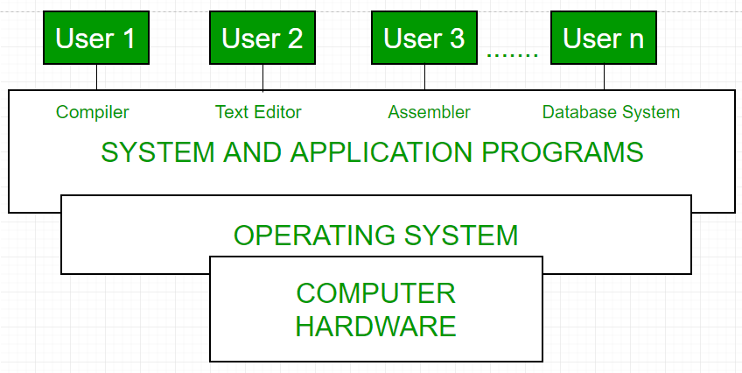

Fig1.1 Conceptual view of a computer system

Every computer must have an operating system to run other programs. The operating system coordinates the use of the hardware among the various system programs and application programs for various users. It simply provides an environment within which other programs can do useful work.

The operating system is a set of special programs that run on a computer system that allows it to work properly. It performs basic tasks such as recognizing input from the keyboard, keeping track of files and directories on the disk, sending output to the display screen and controlling peripheral devices.

**1.5 The Operating system must support the following tasks. The task are:**

1. Provides the facilities to create, modification of programs and data files using an editor.
2. Access to the compiler for translating the user program from high level language to machine language.
3. Provide a loader program to move the compiled program code to the computer’s memory for execution
4. Provide routines that handle the details of I/O programming.

**1.6 I/O System Management –**

The module that keeps track of the status of devices is called the I/O traffic controller. Each I/O device has a device handler that resides in a separate process associated with that device.  
The I/O subsystem consists of

1. A memory Management component that includes buffering caching and spooling.
2. A general device driver interface.

Drivers for specific hardware devices.

* **Assembler**   
  The input to an assembler is an assembly language program. The output is an object program plus information that enables the loader to prepare the object program for execution. At one time, the computer programmer had at his disposal a basic machine that interpreted, through hardware, certain fundamental instructions. He would program this computer by writing a series of ones and Zeros (Machine language), place them into the memory of the machine.
* **Compiler**   
  The High-level languages- examples are FORTRAN, COBOL, ALGOL and PL/I are processed by compilers and interpreters. A compiler is a program that accepts a source program in a “high-level language “and produces a corresponding object program. An interpreter is a program that appears to execute a source program as if it was machine language. The same name (FORTRAN, COBOL, etc.) is often used to designate both a compiler and its associated language.
* **Loader**   
  A Loader is a routine that loads an object program and prepares it for execution. There are various loading schemes: absolute, relocating and direct-linking. In general, the loader must load, relocate and link the object program. The loader is a program that places programs into memory and prepares them for execution. In a simple loading scheme, the assembler outputs the machine language translation of a program on a secondary device and a loader places it in the core. The loader places into memory the machine language version of the user’s program and transfers control to it. Since the loader program is much smaller than the assembler, those make more core available to the user’s program.

**1.7 History of Operating system –**  
Operating system has been evolving through the years. Following Table shows the history of OS.

|  |  |  |  |
| --- | --- | --- | --- |
| **GENERATION** | **YEAR** | **ELECTRONIC DEVICE USED** | **TYPES OF OS DEVICE** |
| First | 1945-55 | Vaccum Tubes | Plug Boards |
| Second | 1955-65 | Transistors | Batch Systems |
| Third | 1965-80 | Integrated Circuits(IC) | Multiprogramming |
| Fourth | Since 1980 | Large Scale Integration | PC |

**1.7.1**  **[Types of Operating System](https://www.geeksforgeeks.org/operating-system-types-operating-systems-awaiting-author/) –**

* Batch Operating System- Sequence of jobs in a program on a computer without manual interventions.
* Time sharing operating System- allows many users to share the computer resources.(Max utilization of the resources).
* Distributed operating System- Manages a group of different computers and make appear to be a single computer.
* Network operating system- computers running in different operating system can participate in common network (It is used for security purpose).
* Real time operating system – meant applications to fix the deadlines.

**1.8 Examples of Operating System are –**

* Windows (GUI based, PC)
* GNU/Linux (Personal, Workstations, ISP, File and print server, Three-tier client/Server)
* macOS (Macintosh), used for Apple’s personal computers and work stations (MacBook, iMac).
* Android (Google’s Operating System for smartphones/tablets/smartwatches)
* iOS (Apple’s OS for iPhone, iPad and iPod Touch)

**Installation of operating system**

**Step-by Step guide to install Windows 7:**

**Planning the Installation:**

As with any OS installation, we must first plan the installation process. When you run the Windows 7 Setup program, you must provide information about how to install and configure the operating system. Thorough planning can make your installation of Windows 7 more efficient by helping you to avoid potential problems during installation. An understanding of the configuration options will also help to ensure that you have properly configured your system.

Here are some of the most important things you should take into consideration when planning for your Windows 7 installation:

* Check System Requirements
* Check Hardware and Software Compatibility
* Determine Disk Partitioning Options
* Complete a Pre-Installation Checklist

Microsoft states the minimum recommended specs for Windows 7:

* 1 GHz 32-bit or 64-bit processor
* 1 GB of system memory
* 16 GB of available disk space
* Support for DirectX 9 graphics with 128 MB memory (to enable the Aero theme)
* DVD-R/W Drive
* Internet access (to activate and get updates)

**Type of Installation:**

Basically, there are 2 approaches to installing Windows 7:

1. **Upgrade**(In-place upgrade) – This option replaces your current version of Windows with Windows 7, and keeps your files, settings, and programs in place on your computer.
2. **Custom**(“fresh” installation) – This option replaces your current version of Windows with Windows 7, but doesn’t preserve your files, settings, and programs. It’s sometimes referred to as a clean installation for that reason.

As always, a fresh installation is much better and I strongly recommend taking that track. Even if you’ve got an existing Windows XP/Vista OS on your computer, I would strongly recommend that you format it and install a fresh copy of the OS.

**Step 1:**

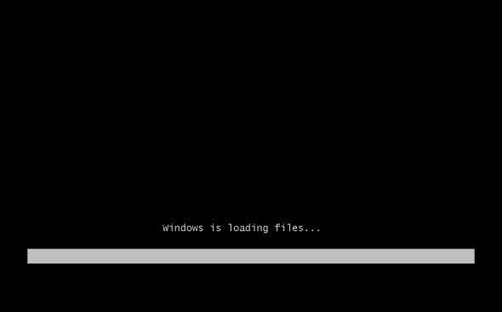When installing on a physical computer insert your Windows 7 DVD media into your DVD drive and reboot your computer. If you’re asked to press a key to boot from DVD or CD, press any key. A black window will appear momentarily while the DVD content is read.

Next, a **Starting Windows** screen will appear.

**Step 2:**

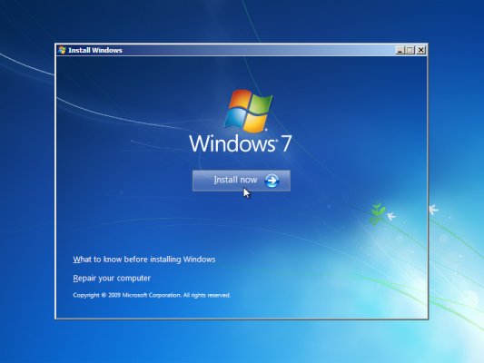Windows 7 will boot directly into the Graphical User Interface (GUI) mode.

Next, Click on the “Install now” button.

**Step 3:**

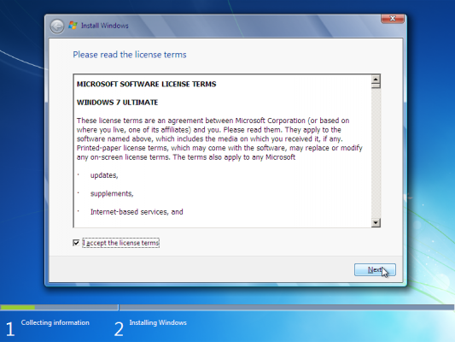Accept the license terms,

Next, Click on “Next”.

**Step 4:**

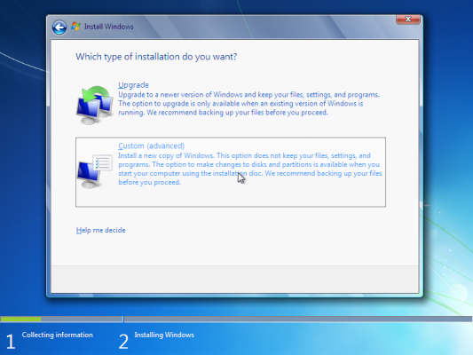Unless you’re upgrading an existing Windows installation, press the Custom (Advanced) installation type button.

Next, Phase is to pick the installation partition.

**Step 5:**

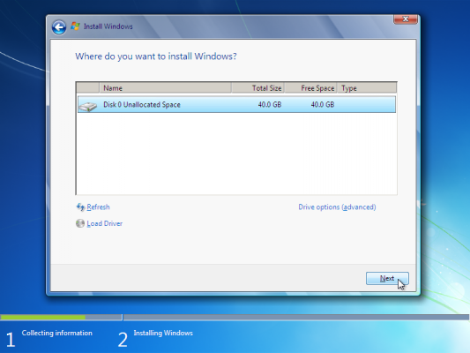Create specific partition to install Windows on, or create partitions on your hard disk as per your requirements.

Next, Click on “Next”.

**Step 6:**

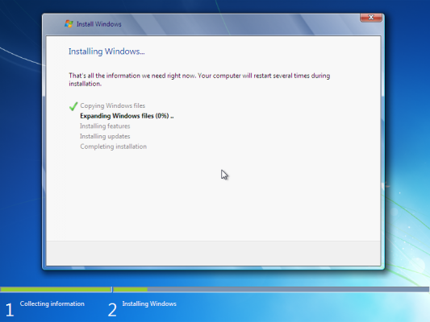The setup process will now begin to copy files from the installation DVD media to the hard disk.

Next, Process could take a while depending on the type of hardware your computer uses.

**Step 7:**

The computer will reboot, and the next thing you’ll see is the prompt to set the user’s and computer’s name. By default, the computer’s name will be username-PC, where username is the username you’ve entered.

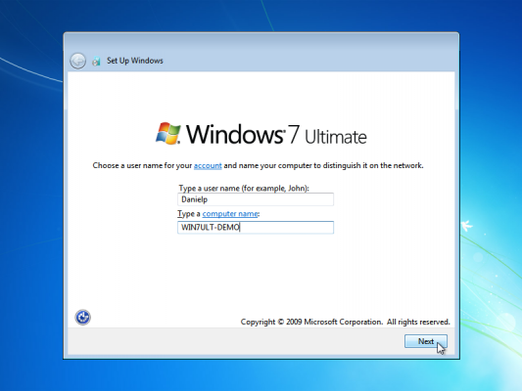

Next, Click on “Next”.

**Step 8:**

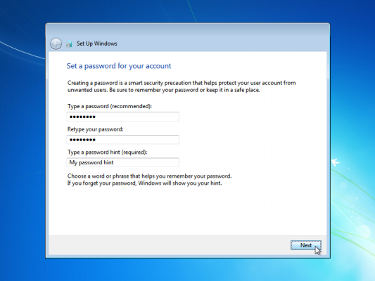Enter the user’s password.

Next, Click on “Next”.

**Step 9:**

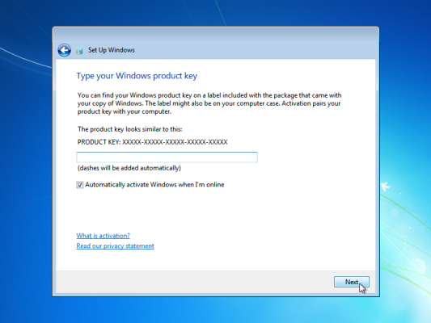Type your product key. If you do not have the product key at hand you can still proceed with the installation. You will be asked to enter the product key after Windows is installed.

Next, Click on “Next”.

**Step 10:**

Choose what sort of protection your computer gets.

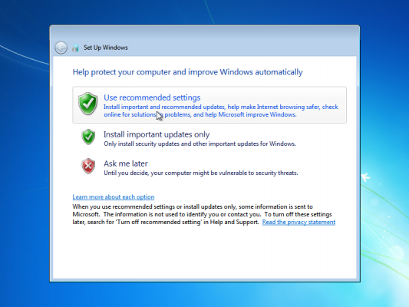

Next, Click on “Next”.

**Step 11:**

Choose your time zone and location.

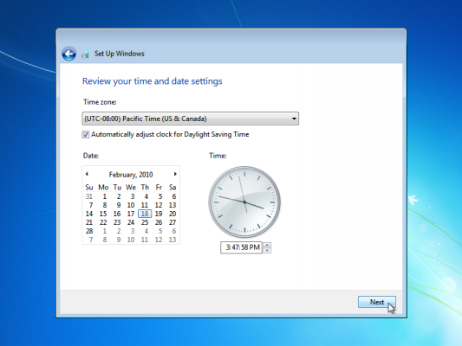

Next, Click on “Next”.

**Step 12:**

Select your network location type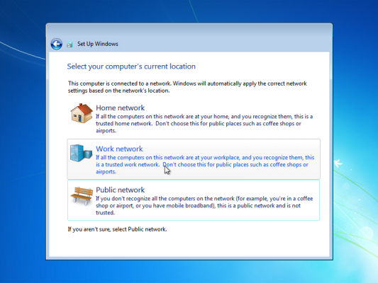

Next, Click on “Next”, The Windows Installation is almost complete.

**Step 13:**

Windows will finalize the settings and your desktop will appear.

