
SCHOOL OF COMPUTER SCIENCE ENGINEERING AND INFORMATION SYSTEMS
B.Tech – Information Technology
BITE305L - Computer Networks
Course Project Report
Slot: [Slot]

Performance Analysis and Evaluation of RIP OSPF and Enhanced Interior Gateway Routing Protocol

TEAM MEMBERS:
1. [Name] [Registration Number]
2. [Name] [Registration Number]
3. [Name] [Registration Number]

Faculty Name: [Faculty Name]
CONTENTS

Chapter No | Title | Page No
 | Abstract | 4
 | Introduction | 5
 | Objective | 7
 | Problem statement | 8
 | Literature Review 15 Papers  (Recent 3 Years) | 9
 | Architecture Diagram | 14
 | Proposed Methodologies | 16
 | Coding and Implementation | 19
 | Screenshots and Results | 22
 | Conclusion and Future Development | 24
 | References | 25

DECLARATION

We hereby declare that the report entitled “Performance Analysis and Evaluation of RIP OSPF and Enhanced Interior Gateway Routing Protocol” submitted by us, for BITE305L – Computer Networks to Vellore Institute of Technology is a record of bonafide work carried out by us under the supervision of [Faculty Name].

We further declare that the work reported in this report has not been submitted and will not be submitted, either in part or in full, for any other courses in this institute or any other institute or university.

Place : Vellore
Date : [DD/MM/YYYY]

Signature of the Candidate 1

Signature of the Candidate 2

Signature of the Candidate 3

Abstract
Dynamic routing allows a network to discover paths and respond to changes without manually configuring every route. Routing Information Protocol (RIP), Open Shortest Path First (OSPF), and Enhanced Interior Gateway Routing Protocol (EIGRP) approach this task through different metrics, information exchanges, and convergence mechanisms. Understanding their performance requires observing both the routes they select and the traffic delivered through those routes.
This project develops CN-Sim, a web-based routing laboratory with a custom topology editor and a backend that runs real FRRouting processes inside isolated Linux network namespaces. Users can construct networks, configure link bandwidth, delay and loss, select a protocol, generate controlled traffic, introduce a link failure, and inspect routing information and captured packets. The frontend presents packet-level observations, comparison tables, time-series charts and circular performance scores. JSON, CSV and PCAP exports support independent examination of the underlying evidence.
The evaluation framework considers packet delivery, loss, one-way delay, round-trip time, delay variation, payload goodput, routing overhead and convergence. A common topology and workload provide the basis for a comparison, while timer settings, routing metrics and measurement boundaries remain explicit. Startup convergence, routing-table convergence after a failure, and restoration of useful traffic are treated as separate observations.
The report explains the protocol concepts, system architecture, implementation and evaluation methodology. The discussion of results describes expected qualitative behavior and the interpretation of application outputs. The central outcome is an accessible and inspectable platform for studying how routing decisions affect network service. Protocol suitability depends on topology, configuration, traffic and implementation; a single score cannot establish a universal winner.
Keywords: RIP, OSPF, EIGRP, FRRouting, network emulation, convergence, packet tracing, performance evaluation.

Introduction

Dynamic routing in computer networks
A router forwards an IP packet by consulting its forwarding table and choosing a next hop toward the destination network. In a small static network, an administrator can specify these routes manually. As the number of routers and alternate links increases, maintaining consistent routes becomes difficult. A link failure may invalidate a previously usable path, and a new connection may create a better alternative. Dynamic routing protocols exchange information so that routers can learn destinations and adjust their forwarding decisions.
The control plane learns and computes routes, while the data plane forwards application packets using the installed routes. These two planes are related but do not always change at exactly the same instant. A router may detect a neighbor failure before every affected route is updated. Conversely, the chosen application flow may recover before every routing table in the network has reached a stable state. An evaluation should therefore examine both protocol activity and actual packet delivery.

Protocols considered
RIPv2 is a distance-vector protocol that represents route distance using hop count. It exchanges routing information with neighbors and uses mechanisms such as route poisoning and triggered updates to limit the effects of invalid routes. A metric of 16 represents an unreachable destination, which limits usable paths to 15 hops [16]. Its simplicity makes it useful for demonstrating the fundamentals of distributed routing.
OSPFv2 is a link-state interior gateway protocol. Routers build a link-state database and use shortest-path calculations to determine routes according to configured costs. Neighbor relationships, link-state advertisements and database synchronization provide the information needed for those calculations. Areas support hierarchical organization, although the current project uses a single area [17].
EIGRP is an advanced distance-vector protocol that uses the Diffusing Update Algorithm (DUAL). It maintains neighbor and topology information, selects successors, and may use feasible successors when the feasibility condition is satisfied. When a suitable local alternative is unavailable, query and reply exchanges participate in route computation. Its metric commonly incorporates bandwidth and delay [18].

Introduction continued

Why a practical comparison is necessary
A protocol description explains its rules but does not reveal every consequence of a particular network design. A minimum-hop route can contain slower links than a longer route. An OSPF cost configuration can make distinct physical links appear equally attractive. Neighbor timers can change failure detection time, while an administratively disabled interface can provide immediate local failure information. Traffic rate and packet size influence the amount of useful data delivered and the relative weight of routing traffic.
Property | RIPv2 | OSPFv2 | EIGRP
Routing approach | Distance vector | Link state | Advanced distance vector
Path basis | Hop count | Sum of link costs | Composite metric; commonly bandwidth and delay
Information exchange | Periodic and triggered route updates | Neighbor exchange and link-state advertisements | Hello, update, query, reply and acknowledgement mechanisms
Scope in CN-Sim | IPv4 RIPv2 | IPv4 area 0 | IPv4 autonomous system 100

Table 1. Protocol characteristics relevant to the project [16]–[18].

Project approach and scope
CN-Sim combines an editable browser canvas with actual routing software. Each virtual device receives an isolated Linux network stack. Virtual Ethernet links carry packets, and Linux traffic control applies configured link conditions. FRRouting learns routes through protocol messages rather than frontend animations or precomputed route selections. The browser requests experiments and displays the resulting observations [19].
The scope is a bounded educational laboratory rather than a complete replacement for a commercial network simulator. The implementation focuses on IPv4 routing, one selected protocol per experiment, controlled endpoint traffic and observable failures. It supports repeatable demonstrations while retaining the differences between protocol specifications, daemon behavior and the limitations of a shared host.

Objective
The primary objective is to design and implement a web-based platform for studying and comparing RIP, OSPF and EIGRP under a common experimental framework. The platform should connect protocol concepts to visible routing decisions, packet behavior and clearly defined performance measures.

Functional objectives
1. Provide a simple graphical workspace for creating routers and hosts, connecting devices, and configuring bandwidth, propagation delay, random loss and link state.
2. Deploy an independent virtual network for each trial and run the selected FRRouting protocol on the routers. Display route tables, neighbor information and generated configurations so that the network state can be inspected.
3. Generate controlled traffic between selected endpoints, record packet identifiers and timestamps, capture routing transmissions, and offer a packet inspector that follows observed packet movements.
4. Support both steady-state experiments and scheduled link failures. Present startup convergence, failure convergence and data-plane recovery as separate measures.
5. Produce understandable reports containing raw metrics, charts, explanatory circular scores and downloadable records. Preserve enough metadata to reproduce the scenario.

Evaluation and learning objectives
The evaluation should use consistent topology and traffic settings across protocols, document timer and metric choices, and support repeated trials. It should make measurement uncertainty visible and avoid equating an unavailable observation with a zero delay or instantaneous recovery. The learning objective is to explain why a route was selected and how that decision affected service, rather than simply assign a rank to each protocol.
A successful project therefore provides both an operational routing laboratory and a defensible method for interpreting its outputs. The proposed comparison is useful when a reader can trace a reported value back to the experiment settings, endpoint records, route snapshots or packet captures.

Problem statement
Students often study routing protocols through diagrams, configuration exercises and isolated command outputs. These resources explain individual mechanisms, but comparing protocols requires additional work: recreating the same topology, applying consistent link conditions, generating equivalent traffic, observing failures, calculating metrics and presenting the evidence. Manual repetition can introduce differences that are mistakenly attributed to the protocol.
A lightweight visual simulator may hide the actual control plane behind scripted route changes. At the other extreme, a full router laboratory can require substantial setup and leave measurement collection to external tools. The project addresses the need for an accessible web interface that retains real routing behavior and integrates experiment control, observation and reporting.

Formal problem definition
Given a connected IPv4 topology, link attributes, a selected routing protocol, endpoint traffic settings and an optional failure event, construct the network, allow routing to stabilize, execute the traffic workload, collect control-plane and data-plane observations, and derive a reproducible performance report. For comparison runs, repeat this procedure for RIP, OSPF and EIGRP with a fresh network for each trial.

Constraints and assumptions
The laboratory runs on a single Linux kernel through Docker. CPU scheduling, memory pressure and capture overhead can affect observations. Link conditions are emulated with traffic control and are not physical cable measurements. The supported scope is bounded to 20 devices and 40 links, with one active laboratory job at a time. End hosts use a single router connection, and the implemented routing scope is IPv4 with single-area OSPF.
Identical link attributes do not imply identical routing decisions because the protocols optimize different metrics. Faster configured timers also do not make their mechanisms identical. The report must preserve these distinctions, identify software limitations, and state what each metric measures. The resulting system should help explain performance differences without claiming hardware-level accuracy or universal protocol superiority.

Literature Review 15 Papers Recent 3 Years
The review covers publications from 2024 to 2026. Direct protocol comparisons are considered alongside related studies of routing metrics, service quality and emulation methodology. The latter inform system design and evaluation without being presented as comparisons of all three protocols.

1. Simulation-based comparison of the three protocols
Warpe, Giri and Jain (2026) compare RIP, EIGRP and OSPF through simulation scenarios and evaluate delivery, loss, throughput and convergence [1]. The authors report favorable EIGRP behavior within their chosen conditions. The paper is directly relevant because it treats comparison as a multi-metric task rather than a single routing-table exercise. Its conclusions remain dependent on the simulation platform and scenario design. For CN-Sim, the useful methodological lesson is to expose workload and topology settings alongside every comparison and to preserve packet-level evidence rather than transfer the paper’s ranking to a different implementation.

2. Interior gateway protocols in enterprise topologies
Al-Awami, Ben Srity and Abu Raas (2024) examine interior gateway protocols in large-scale enterprise topologies using GNS3, including RIP, EIGRP, OSPF and IS-IS [2]. Their comparison considers convergence and service-related measures such as latency and jitter. This work highlights the importance of topology size and redundancy when interpreting routing performance. CN-Sim adopts the idea of evaluating alternate paths and failures, but its bounded educational laboratory does not establish enterprise-scale capacity. The paper motivates future scale testing while reminding the project to describe the tested network size explicitly.

3. Performance evaluation under a common simulation setting
Yousif and Elnageeb (2025) present a comparison of RIP, EIGRP and OSPF that considers end-to-end delay, throughput and routing-update behavior [3]. Their reported results favor EIGRP in the conditions described. A common experimental setting is useful because changes in topology or offered traffic can otherwise dominate the comparison. CN-Sim follows this principle through a saved topology and reusable experiment configuration. However, a result from another platform is supporting literature rather than a measurement of this project. The implementation, version, timers and metric settings must be recorded before interpreting agreement or disagreement.

Literature Review continued

4. IPv6 load sharing and link failover
Shahid, Ahmad and Rizvi (2024) compare EIGRP, OSPF and BGP in IPv6 load-sharing and link-failover systems using an emulated environment and traffic-analysis tools [4]. Their work connects routing convergence with service measures such as delay, loss and jitter. It supports the inclusion of failure scenarios and application traffic in a routing study. The protocol set and address family differ from CN-Sim: this project evaluates IPv4 interior routing and does not implement BGP experiments. The relevant contribution is the evaluation structure, not a direct performance ranking that can be assumed to hold for the present laboratory.

5. OSPF reference bandwidth and route cost
Malik and Singh (2024) investigate the modification of OSPF reference bandwidth and its relationship to path metrics and convergence [5]. The work is relevant to networks with heterogeneous link capacities, where a cost policy determines whether different speeds are meaningfully distinguished. CN-Sim records the cost generated from each configured bandwidth and keeps that routing cost separate from traffic shaping. This distinction helps explain why increasing a link’s physical rate does not automatically produce a different route in every configuration. The paper motivates explicit reporting of reference and interface costs when presenting an OSPF comparison.

6. Alternative OSPF metric functions
Thaenchaikun and Kanjanasit (2025) study alternative OSPF metric functions for dynamic path selection in a network-security context [6]. They consider how metric design changes the balance between path characteristics and security-related objectives. The study shows that the meaning of an optimal route depends on the objective encoded in the metric. CN-Sim uses the standard FRRouting OSPF mechanism with a documented cost policy and does not claim to implement the paper’s security-aware algorithms. Its relevance is conceptual: a performance comparison must identify the metric being optimized before judging a selected route as better or worse.

Literature Review continued

7. Multi-area OSPF for an IoT monitoring system
Auliya and colleagues (2025) study multi-area OSPF in an IoT-based monitoring system [7]. The application setting connects routing design to the delivery needs of monitoring traffic and introduces area organization as a factor in network behavior. This provides context for extending the project beyond a single flat laboratory. CN-Sim currently places OSPF routers in area 0 and therefore does not evaluate inter-area route behavior. The paper supports multi-area OSPF as future work and suggests that later evaluation should consider application requirements as well as protocol-level convergence.

8. Quality of service and congestion-aware routing
Ali, Hong and Cheung (2024) examine quality of service and congestion control through policy-based routing in software-defined networking [8]. Their approach uses congestion-related information to influence route selection. Although it is not a direct comparison of the three interior gateway protocols, it is useful for distinguishing shortest-path routing from application-aware traffic management. CN-Sim measures delay, loss and goodput but does not automatically optimize routes for application quality. The study motivates controlled congestion scenarios and cautions against interpreting a shortest route or a stable routing table as sufficient evidence of good service.

9. Risk-aware modification of OSPF
Thaenchaikun and Kanjanasit (2026) investigate sigmoid-enhanced OSPF metrics for risk-aware adaptive routing [9]. Their study explores how metric parameters affect routing and performance trade-offs in secure-network scenarios. This reinforces the distinction between a protocol’s route-computation mechanism and the policy expressed through link costs. CN-Sim does not implement the proposed sigmoid metric. It can instead provide a baseline using ordinary OSPF behavior and explicit costs. The paper identifies a possible research extension in which alternative cost functions are compared under a fixed workload, with raw service measures retained alongside any composite score.

Literature Review continued

10. Fidelity in large distributed emulation
ElBouanani and colleagues (2024) address fidelity in large-scale distributed network emulation [10]. Emulation offers the ability to execute real networking software, but shared resources and deployment decisions affect the correspondence between the emulated environment and the target network. This is directly relevant to the project’s choice of Linux namespaces and real routing daemons. CN-Sim gains observable protocol messages and kernel forwarding, while remaining subject to host scheduling and resource limits. The study supports reporting the execution environment and avoiding claims that a single-host laboratory reproduces dedicated router hardware at arbitrary scale.

11. Real routing implementations and timer studies
Milani and colleagues (2024) use an emulation-based approach to study the Minimum Route Advertisement Interval in large BGP networks [11]. The protocol is outside the present project, but the methodology demonstrates why running routing software and documenting timing parameters can matter when studying convergence. CN-Sim applies that principle to interior routing by retaining generated configurations and separating startup behavior from failure recovery. BGP-specific conclusions are not transferred to RIP, OSPF or EIGRP. The relevance is the disciplined connection between timer policy, implementation behavior, observed events and the conditions under which a conclusion is drawn.

12. Control-plane realism with lower emulation cost
Xia and colleagues (2026) present REAL, a system that combines unmodified router control-plane software with a lightweight simulated data plane [12]. Their approach addresses the resource cost of retaining realistic routing behavior at scale. CN-Sim makes a different trade-off: both routing messages and application traffic traverse Linux virtual links, which simplifies packet inspection but limits scale on one host. The paper helps position the project within the wider design space between abstract simulation and full emulation. It also motivates future work on resource monitoring and more efficient execution without assuming that CN-Sim implements REAL’s architecture.

Literature Review continued

13. Flexible multi-protocol congestion simulation
Vanerio, Casas and Schmid (2025) introduce FREKit for probabilistic congestion and rerouting studies in multi-protocol networks [13]. The work emphasizes flexible exploration of traffic and routing scenarios. It is relevant to the separation between a rapid exploratory model and an environment that executes actual protocol software. CN-Sim prioritizes inspectable daemon behavior and captured traffic for a small teaching laboratory. FREKit suggests possible future additions such as broader workload models and congestion-oriented scenarios. Its simulation capabilities should not be treated as evidence that the current implementation supports every protocol or forwarding technology discussed in the paper.

14. IPv6 dynamic routing with virtual routers
Hadi and colleagues (2024) analyze IPv6 dynamic routing using MikroTik routers in a GNS3 environment [14]. Their study considers service and convergence measures for IPv6 routing variants. It provides a useful example of comparing deployed routing implementations rather than discussing algorithms alone. CN-Sim currently uses FRRouting and IPv4, so its outcomes cannot be assumed to match results from different router software or address families. The study motivates later cross-implementation and IPv6 experiments. Such extensions should preserve the same workload definitions and measurement boundaries to make differences interpretable.

15. Trace-driven network emulation
Tian and colleagues (2024) propose an eBPF-based trace-driven emulation method for satellite networks [15]. The work illustrates how measured traces can drive repeatable changes in network conditions. CN-Sim currently configures bandwidth, delay and random loss through Linux traffic control and schedules discrete link-state events; it does not implement the paper’s satellite model or eBPF mechanism. The relevance is the value of reproducible impairment profiles. A future version could accept time-varying link traces, while retaining a clear distinction between the source of the conditions and the traffic measurements produced by the experiment.

Architecture Diagram
The system separates interaction, experiment control, network execution and measurement analysis. The browser maintains the editable topology and sends structured requests to the backend. The controller validates those requests, creates a fresh laboratory, starts routing processes, schedules traffic and failures, and stores the resulting evidence. Figure 1 shows the main components and their relationships.
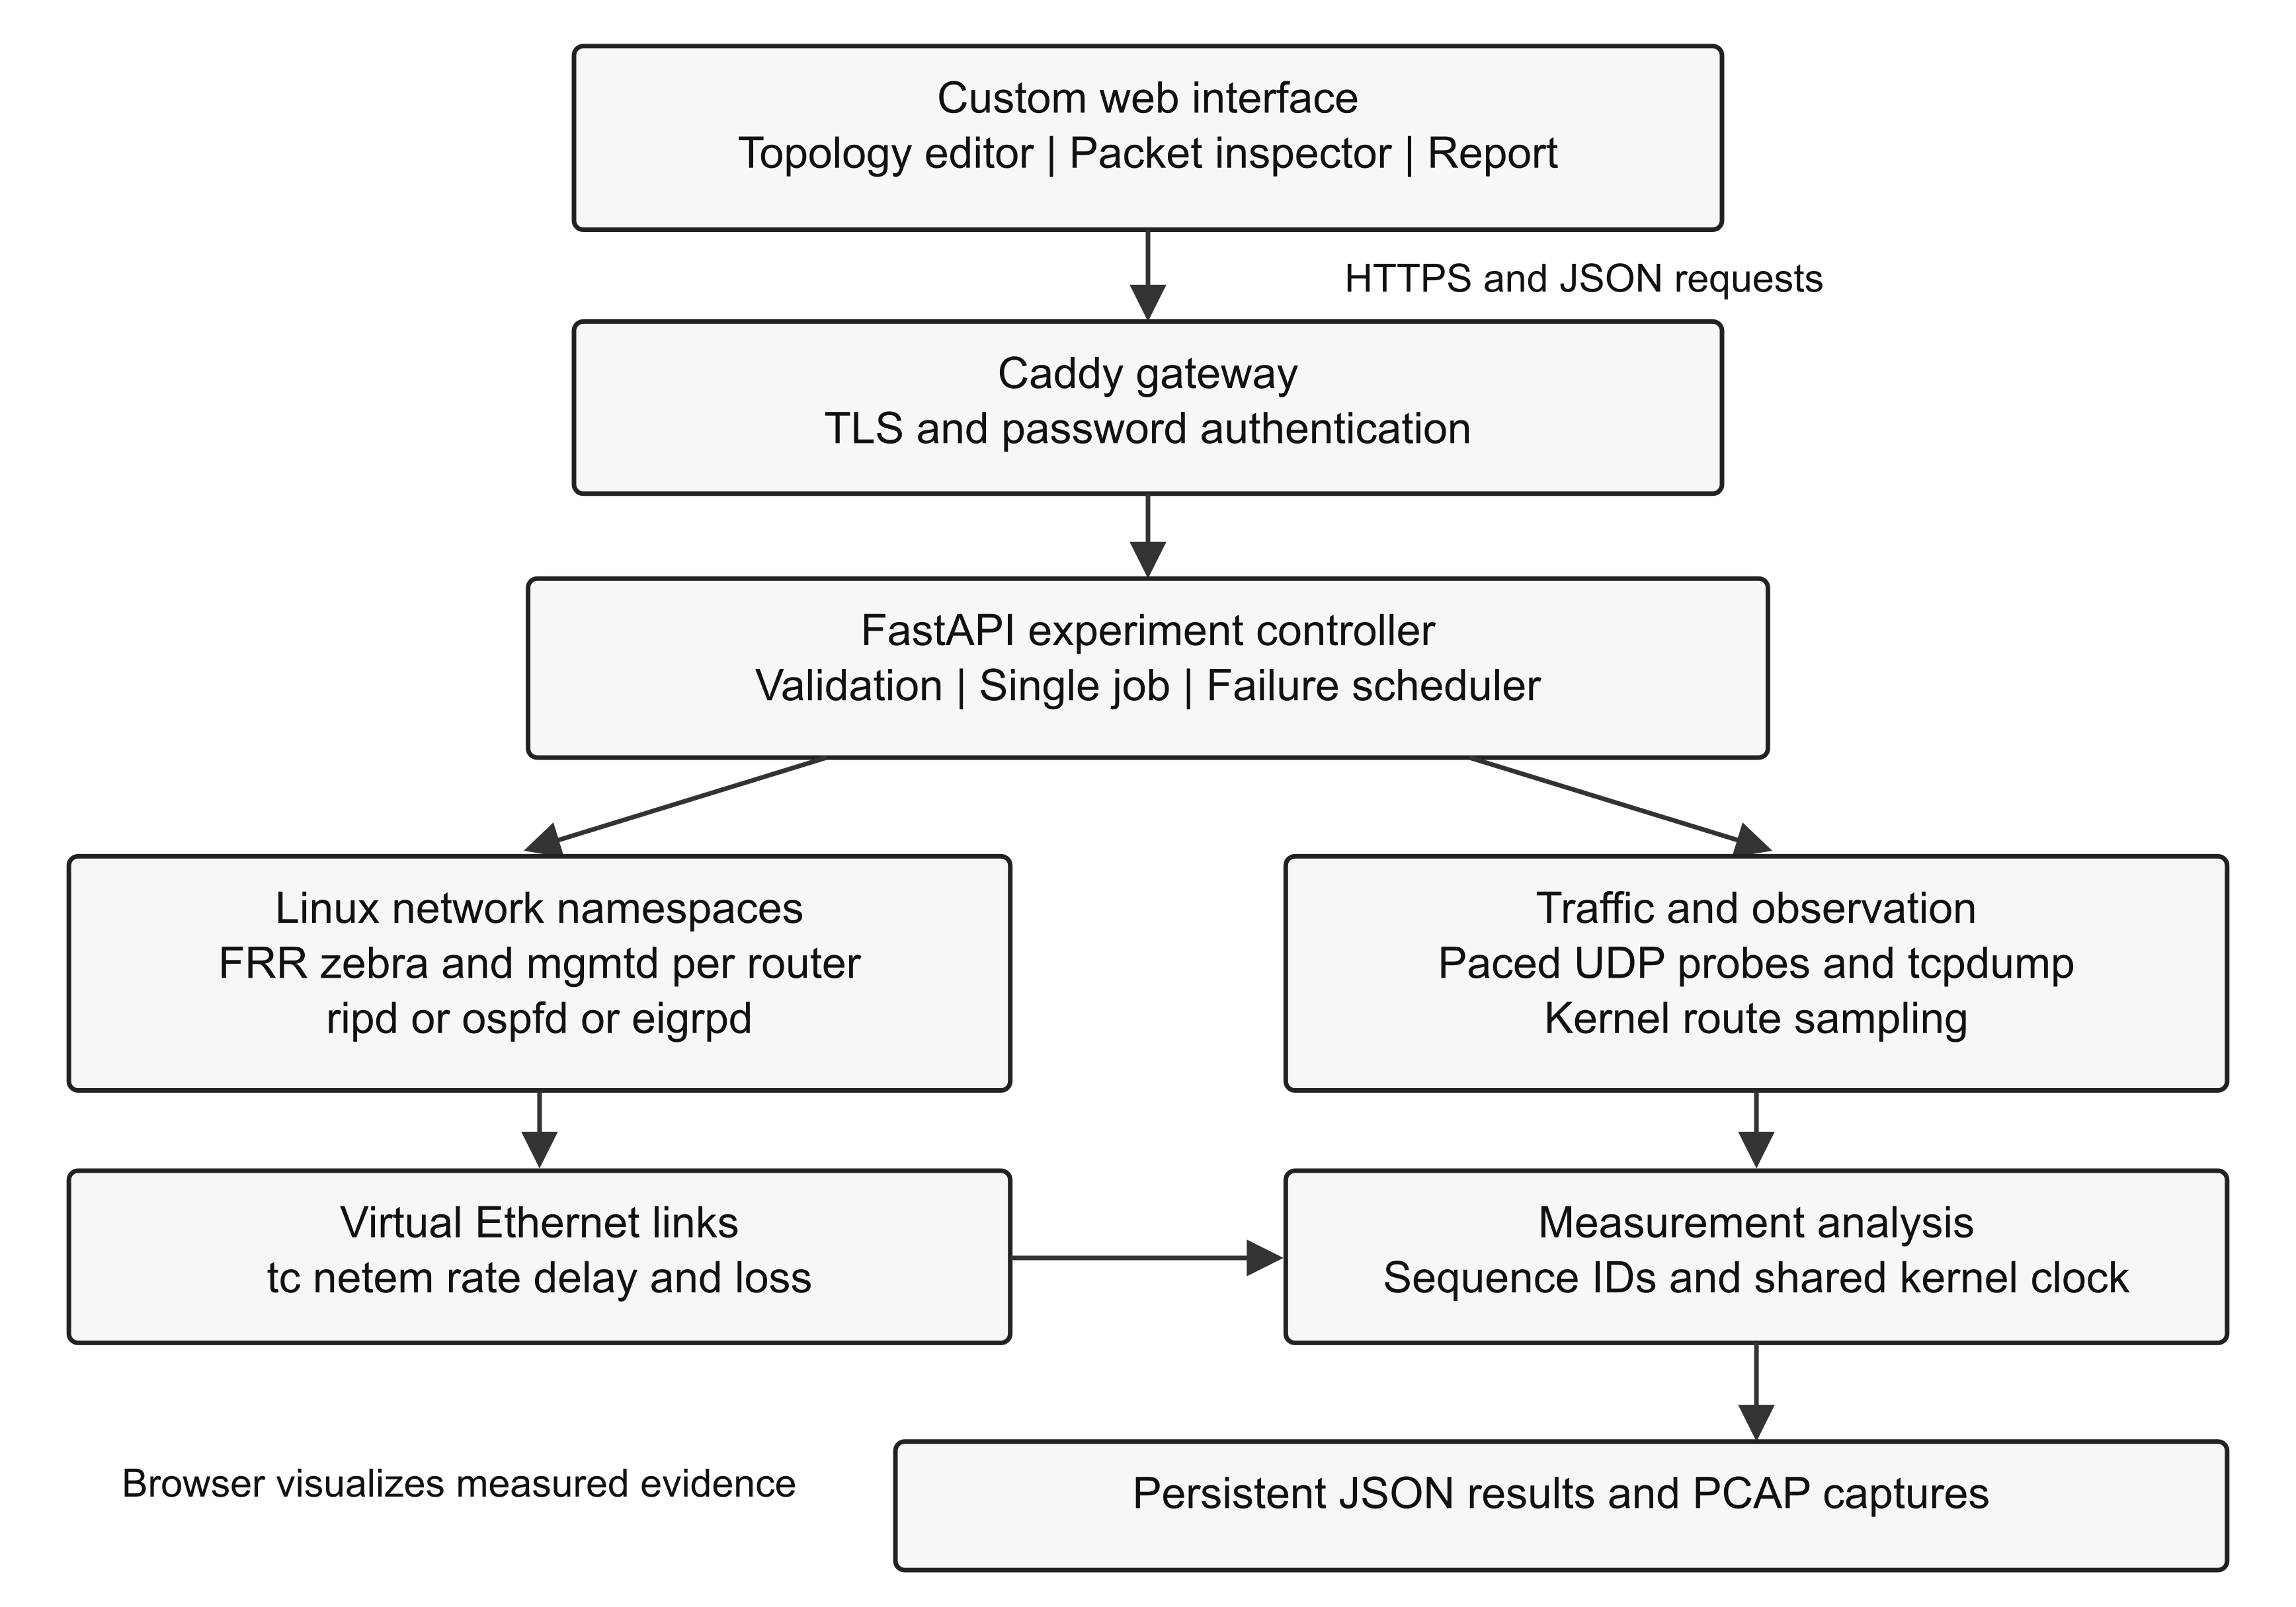
Figure 1. Architecture of the CN-Sim routing laboratory.
The hosted gateway supplies HTTPS and password authentication. It forwards requests to the application service, while the network laboratory operates inside a Docker container. Each router namespace contains its own routing processes and kernel routing table. Results remain available after an experiment ends; live namespaces are removed when the laboratory is stopped.

Architecture Diagram continued

Illustrative redundant topology
A six-router, two-host topology provides multiple paths between the traffic endpoints. Higher-bandwidth links form one branch and lower-bandwidth links form another, with cross-connections that allow alternate forwarding paths. Figure 2 is a scenario design rather than a measured performance result.
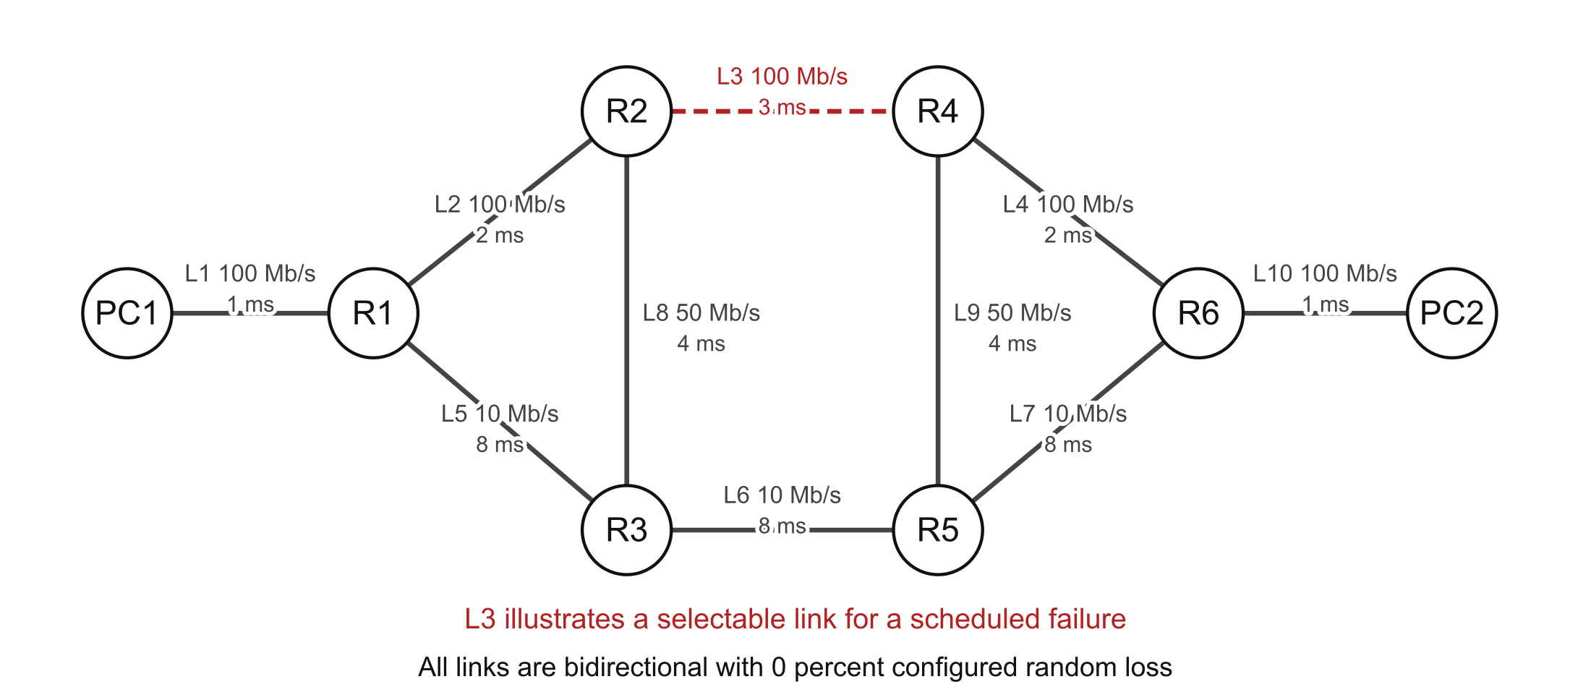
Figure 2. Example topology for studying path selection and link failure.
The endpoint links use 100 Mb/s with 1 ms configured delay. The upper router branch uses 100 Mb/s links with delays of 2, 3 and 2 ms; the lower branch uses 10 Mb/s links with 8 ms delay. Cross-links use 50 Mb/s and 4 ms. Configured random loss is zero in this example. Each direction receives its own traffic-control settings.
For a failure experiment, a selected router-to-router link is disabled during the traffic interval. The topology contains alternate graph paths, but their usability depends on the routes learned and installed by the daemon. A graph-level path is therefore not sufficient evidence of successful forwarding. Route snapshots and endpoint delivery observations provide complementary checks.

Data ownership and boundaries
The browser stores topology drafts and display settings locally. The backend owns live network state and completed experiment records. Packet captures are associated with devices and trials. The report joins these records through experiment and packet identifiers rather than inferring a path solely from the drawn topology.

Proposed Methodologies

Experiment lifecycle
The proposed workflow begins with a saved topology, traffic endpoints and a selected timer profile. The backend validates node identifiers, link endpoints, topology limits and workload bounds. Invalid requests are rejected before any namespace or routing process is created. A comparison batch uses the same accepted settings for each protocol.
During deployment, each device receives a network namespace and each link becomes a virtual Ethernet pair. The controller assigns interface addresses, enables forwarding on routers, applies traffic-control settings and starts FRRouting. Only the protocol selected for that trial is enabled. Router configurations are retained with the results so that the meaning of a route decision remains inspectable.
Readiness checks examine routes to graph-reachable endpoints and require complete, stable routes before traffic begins. The controller samples routing tables approximately every half second and uses a three-second stability interval for startup. This separates initial route learning from the service interval used to calculate delivery and delay.
The sender then generates paced UDP probes with sequence identifiers and monotonic timestamps. The receiver records arrivals and sends echoes for RTT observations. If a failure has been configured, the controller disables the selected link at the requested point in the traffic interval. Captures and route sampling continue through the event. A short drain interval permits late arrivals before analysis.
After a trial, the controller stops observation, derives metrics, writes a result record and releases network resources. Comparison trials are sequential. Later trials rotate protocol order to reduce systematic order effects, although resource variation can still remain. Cancelled trials are excluded from report averages.

Controlled comparison
Topology, endpoint selection, link conditions, traffic rate, payload size, duration and failure policy should remain constant across protocols. Protocol-specific metrics must still be documented, since a hop count, an OSPF cost and an EIGRP composite metric have different meanings. Repeated trials should report the number of valid observations, their mean and sample standard deviation.

Proposed Methodologies continued

Performance measures and observation boundaries
Measure | Definition and interpretation
Delivery and loss | Delivery = 100 × unique received probe IDs / generated probe IDs. Loss is the complement for the observation window. Local send errors are retained separately.
One-way delay | Receiver arrival time minus sender timestamp. The shared Linux monotonic clock avoids separate-host clock synchronization in this laboratory.
Round-trip time | Echo arrival at the sender minus original send time; reported separately from one-way delay.
Delay variation | Mean absolute change between successive delivered probes’ one-way delays. This is the project’s stated variation measure.
Payload goodput | Delivered application payload bytes × 8 / traffic duration. This excludes network headers and is not link capacity.
Routing overhead | Observed IPv4 routing bytes and packet transmissions at virtual-interface egress. A message forwarded across several links produces several transmissions.
Convergence and recovery | Routing-table stabilization and restoration of complete traffic delivery are distinct events with separate definitions.

Table 2. Principal measurement definitions used in the application.
The 95th-percentile delay uses the nearest-rank method on delivered probes. Missing observations remain unavailable rather than becoming zero. Captures are filtered to the selected routing protocol and probe traffic. An egress observation establishes a transmission at that device; the receiver log establishes endpoint receipt. The system does not treat captured outbound packets alone as proof that the application received them.
Failure route convergence requires complete routes that remain stable for at least two seconds after the last observed change. Data-plane recovery is the start of the first complete one-second send-time cohort after failure in which all expected probes are delivered. Routing-table sampling introduces timing uncertainty; neither measure should be described as an exact hardware event timestamp.

Proposed Methodologies continued

Scenario families
A baseline experiment studies initial route learning followed by steady-state traffic. A failure experiment introduces one selected link outage after the network becomes ready. Additional experiments can vary bandwidth, delay, loss or topology size while keeping other settings unchanged. These scenario families provide a structured evaluation plan; changing several factors at once makes causal interpretation difficult.

Timer and metric policy
The lab timer profile uses RIP update, timeout and garbage values of 5, 30 and 20 seconds. OSPF hello and dead intervals are 1 and 4 seconds, and EIGRP hello and hold intervals are also 1 and 4 seconds. The standard profile retains the configured FRRouting defaults. Timer policy is part of the experiment metadata. Administrative carrier loss must be distinguished from a failure detected only after neighbor timeout.
OSPF interface cost is generated as max(1, floor(100 / bandwidth in Mb/s)). EIGRP interface bandwidth is expressed in kb/s, and configured delay is converted to ten-microsecond units. Linux link shaping remains separate from these routing attributes. Altering a protocol metric changes path preference; altering traffic control changes the conditions experienced by packets.

Circular report scores
The interface converts selected measures to a project-defined score on a 0–100 scale. Let D be delivery percentage, L = 100 / (1 + mean one-way delay in ms / 50), C = 100 / (1 + convergence in seconds / 2), and E = 100 × data egress bytes / (data egress bytes + routing egress bytes). The overall score is 0.40D + 0.20L + 0.25C + 0.15E.
Green indicates scores of at least 80, yellow indicates 60 to below 80, and red indicates below 60. The circle arc covers the corresponding fraction of its circumference. Failure trials use failure route convergence; other trials use startup convergence. Missing delay or convergence contributes zero to that score component, while the raw metric remains unavailable. E is a capture byte ratio, not measured bandwidth utilization. These choices make the display understandable but do not create a standardized protocol efficiency percentage.

Coding and Implementation

Technology stack and module organization
The custom frontend uses HTML, CSS and JavaScript without a frontend build requirement. It supplies the topology canvas, experiment controls, live observations, packet inspector and report views. The Python FastAPI backend exposes structured API operations and coordinates Linux networking tools. Docker packages the application and its network dependencies into a reproducible environment.
Module | Responsibility
dist/app.js and views.js | Application state, interaction flow and workspace/report views.
dist/ui.js | Reusable interface elements, topology rendering, charts and score calculations.
backend/models.py | Topology schema, identifiers, link attributes and bounded workload validation.
backend/lab.py | Namespaces, virtual links, addressing, traffic control and FRRouting lifecycle.
backend/controller.py | Background job, readiness, traffic scheduling, failure events and cleanup.
backend/probe.py and capture.py | Probe transmission/receipt, echo timestamps and packet capture parsing.
backend/analysis.py | Sequence correlation, delay and delivery metrics, convergence and report records.

Table 3. Main source modules and their roles.
Separating network execution from analysis makes the measurement rules easier to examine. The frontend does not decide that a packet arrived because an animation reached its destination. It renders observations supplied by the receiver and capture records. Similarly, topology reachability informs readiness checks, while forwarding behavior is verified through actual traffic.

Coding and Implementation continued

Real routing backend
A Linux network namespace provides a separate set of interfaces, addresses and routing tables for each device. Virtual Ethernet pairs connect namespaces. Router-to-router and router-to-host links use individual /30 IPv4 subnets, and routers receive loopback addresses. End hosts use a default gateway through their connected router. IP forwarding is enabled on router namespaces.
FRRouting 10.7.1 is pinned for the project. Each router runs zebra and the management daemon, together with ripd, ospfd or eigrpd. Separate pathspaces and sockets isolate the routing instances. The controller applies generated configurations through FRRouting’s management interfaces. This arrangement produces real neighbor exchanges, route advertisements and kernel-installed forwarding entries [19].
Traffic control applies rate, delay and random loss per direction. tcpdump captures filtered egress traffic on virtual interfaces. Routing traffic is recognized using UDP port 520 for RIP, IPv4 protocol 89 for OSPF and IPv4 protocol 88 for EIGRP. Probe traffic uses UDP port 49000. The parser correlates packet identifiers while keeping routing transmission counts distinct from unique end-to-end application packets.

Measurement logic
The analysis forms sets of generated and received sequence identifiers, removes duplicate receipt records for delivery calculations, and derives delay from matching timestamps. Echo records supply RTT. Send-time cohorts support charts and recovery calculations without silently assigning a late packet to the wrong offered-load interval. Result records retain settings, event timestamps, generated configurations, route snapshots, metrics and warnings.
A missing recovery observation is represented as an unavailable value. This is necessary when the observation window ends before recovery is confirmed. It avoids the misleading interpretation that a blank or absent measurement means immediate recovery. The raw record remains available for checking the reason behind the display.

Coding and Implementation continued

Frontend workflow and API
Users add and move devices on the canvas, connect endpoints and edit link attributes. Undo, zoom, import and export support repeated topology work. The selected protocol, endpoints, timer profile, traffic duration, packet rate, payload and optional failure event form the experiment request. The interface displays deployment progress before presenting live observations and completed results.
Operation | API role
/api/lab/deploy and /api/lab/stop | Create or remove the live network.
/api/lab/node/{id} | Read a device’s routing and configuration information.
/api/experiments | Start a controlled protocol experiment or comparison.
/api/results/{id} and /api/comparison | Retrieve completed observations and comparative summaries.
/api/export/{id}/json or csv | Download structured evidence for later analysis.
/api/capture/{id}/{node} | Download a device-specific packet capture.

Table 4. Representative application interfaces.

Deployment and verification
The application can run locally through Docker Compose or on an Ubuntu cloud server. The hosted configuration uses Caddy for HTTPS and password protection, with the backend bound behind the gateway. The domain packetsim.imakshat.com provides browser access. One active laboratory is shared by the deployment; it is not an independent per-user network service.
Verification covers input validation, capture parsing, metric calculations, score handling, real route learning, traffic forwarding, exports, cancellation and resource cleanup. API checks also cover host and origin restrictions. The known FRRouting EIGRP failure behavior is recorded as a warning when recovery is not confirmed. Such a software observation must not be converted into a claim that EIGRP as a protocol is incapable of recovery.

Screenshots and Results

Application interface
The application organizes the demonstration into Workspace, Packet inspector, Report and Methodology views. The white layout keeps the topology and measurements central, while protocol colors and green, yellow and red indicators help readers locate outcomes. Figure 3 illustrates the report interface from an example application session; its displayed values are not used here to establish comparative experimental findings.
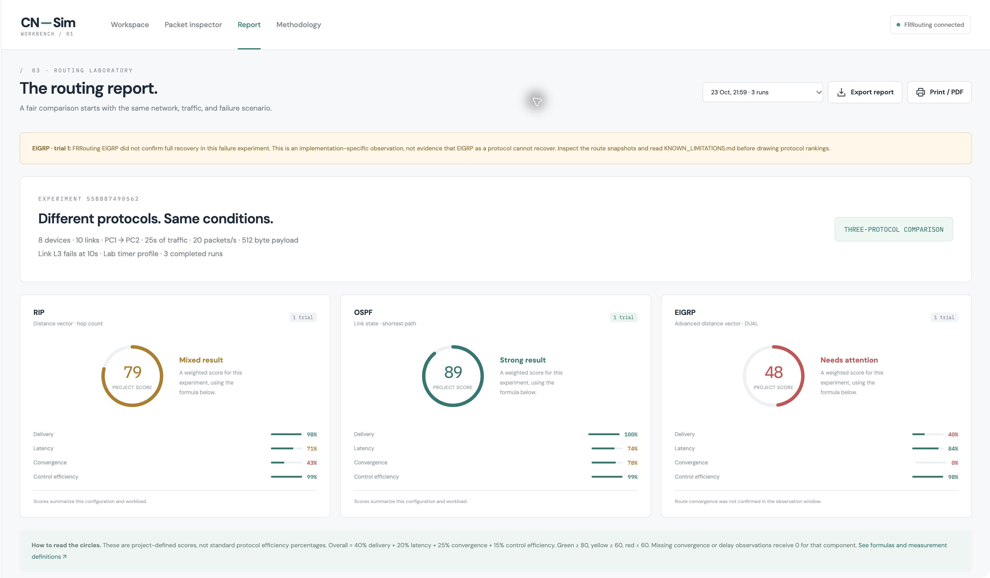
Figure 3. Illustrative report interface with circular scores and supporting measures.

Outputs available for analysis
The report identifies the topology, endpoints, workload, timer profile and any scheduled failure before displaying protocol summaries. Raw delivery, delay, overhead and convergence values accompany the score. Charts show behavior across the traffic interval, allowing a reader to look for interruptions or changes after an event. The packet ledger and downloadable captures provide a route from a summary value to the underlying observations.
For repeated trials, mean and sample standard deviation help describe variation. An unavailable metric is displayed explicitly, and warnings remain part of the result. A score should therefore be read together with its component values, observation counts and implementation notes.

Screenshots and Results continued

Expected qualitative behavior
RIP selects routes through hop count. In a heterogeneous topology, a route with fewer hops can include slower or more delayed links than an alternative. Periodic updates and failure handling may affect the time required to remove invalid information. The exact outcome depends on the timer profile and whether the failure produces a local interface event or is learned through a neighbor [16].
OSPF selects paths according to accumulated costs. When costs reflect link capacity differences, a higher-capacity branch may become preferable. Link-state changes lead to updated database information and route calculations. The relationship between convergence and packet service still depends on the particular failure, installed routes and traffic conditions; stable OSPF state alone is not proof of zero loss [17].
EIGRP uses its metric and DUAL state to select and maintain routes. A feasible successor can permit a local alternative, while other cases may require query and reply activity. Its performance cannot be inferred from its label as an advanced distance-vector protocol alone. Neighbor state, metric values, topology and daemon implementation all matter [18].

Interpreting comparative outputs
Higher delivery and useful goodput generally indicate better service for the offered workload. Lower delay is desirable only when read with loss and delivery: a run that loses many slow packets can show a low mean delay for the packets that survive. Routing overhead should be compared over the same capture boundary and duration. A low overhead ratio is not meaningful evidence of a healthy network if useful traffic is not being delivered.
Convergence and recovery answer different questions. Routing-table convergence describes a stable and complete control-plane state under the project’s sampling rule. Data-plane recovery describes restored delivery for the selected flow. Their values need not match. The appropriate conclusion is a scenario-specific explanation supported by route changes, packet events and raw measurements, rather than a universal ranking based on a single circular indicator.

Conclusion and Future Development
CN-Sim provides a custom web interface for constructing small networks and observing RIP, OSPF and EIGRP through real routing software. Linux namespaces and virtual links supply isolated network stacks, FRRouting supplies the control plane, and paced probes and packet captures supply evidence of forwarding behavior. The integrated workflow reduces the manual effort needed to move from a topology to a structured report.
The project’s main contribution is the connection between network configuration, protocol state, packet-level observations and clearly defined performance measures. Delivery, delay, goodput, overhead and convergence describe different aspects of service. Presenting them together supports a more useful comparison than assigning a protocol a single unexplained percentage. The score provides an accessible overview while the underlying values and warnings remain available for interpretation.
The laboratory also has practical limits. It uses shared host resources, bounded topology size and a single active job. The supported protocol scope is IPv4, with single-area OSPF. Routing-table sampling limits timing precision, and the tested EIGRP daemon can retain stale next hops in a failure scenario. These constraints define the conditions under which results should be assessed.

Future development
Future work can add IPv6 through RIPng and OSPFv3, multi-area OSPF, broader topologies and traffic patterns, and automatic resource monitoring. Time-varying impairment profiles would permit repeatable studies of changing links. Confidence intervals and sensitivity analysis could extend the present repeated-trial summaries and show how score weights influence rankings.
Further work should validate EIGRP failure recovery across software versions and independent router implementations. Per-user laboratory isolation and a queue would improve hosted use. Each extension should preserve the central principle of the project: a performance claim should be explainable through explicit settings and observable network evidence.

References
[1] S. Warpe, M. Giri, and S. Jain, “Simulation-Based Performance Evaluation of Layer 3 Routing Protocols: RIP, EIGRP, and OSPF,” International Journal of Artificial Intelligence and Machine Learning, vol. 6, no. 2, pp. 399–404, 2026. doi: 10.51483/IJAIML.6.2.2026.399-404.
[2] S. H. Al-Awami, E. A. Ben Srity, and A. T. Abu Raas, “A Comparative Analysis of Interior Gateway Protocols in Large-Scale Enterprise Topologies,” Journal of Engineering Research and Sciences, vol. 3, no. 11, pp. 60–73, 2024. doi: 10.55708/js0311005.
[3] Y. E. Yousif and O. A. O. Elnageeb, “Performance Evaluation and Comparison of RIP, EIGRP and OSPF Routing Protocols,” European Journal of Applied Science, Engineering and Technology, vol. 3, no. 3, pp. 303–308, 2025. doi: 10.59324/ejaset.2025.3(3).21.
[4] K. Shahid, S. N. Ahmad, and S. T. H. Rizvi, “Optimizing Network Performance: A Comparative Analysis of EIGRP, OSPF, and BGP in IPv6-Based Load-Sharing and Link-Failover Systems,” Future Internet, vol. 16, no. 9, art. 339, 2024. doi: 10.3390/fi16090339.
[5] D. Malik and B. Singh, “Optimising OSPF Path Metric with Reference Bandwidth Modification and Convergence Analysis,” International Journal of Computer Applications, vol. 186, no. 25, pp. 1–7, 2024. doi: 10.5120/ijca2024923711.
[6] C. Thaenchaikun and K. Kanjanasit, “A Comparative Study of OSPF Metrics in Routing Algorithms for Dynamic Path Selection in Network Security,” ASEAN Journal of Scientific and Technological Reports, vol. 28, no. 2, e256556, 2025. doi: 10.55164/ajstr.v28i2.256556.

References continued
[7] Y. A. Auliya et al., “Impact of Multi Area OSPF Routing Protocols on IoT-Based Monitoring System,” International Journal of Communication Networks and Information Security, vol. 17, no. 2, pp. 55–64, 2025. Available: https://www.ijcnis.org/index.php/ijcnis/article/view/7944.
[8] I. Ali, S. Hong, and T. Cheung, “Quality of Service and Congestion Control in Software-Defined Networking Using Policy-Based Routing,” Applied Sciences, vol. 14, no. 19, art. 9066, 2024. doi: 10.3390/app14199066.
[9] C. Thaenchaikun and K. Kanjanasit, “Performance Analysis of Sigmoid-Enhanced OSPF for Risk-Aware Adaptive Routing in Secure Networks,” Network, vol. 6, no. 3, art. 52, 2026. doi: 10.3390/network6030052.
[10] H. ElBouanani, C. Barakat, W. Dabbous, and T. Turletti, “Fidelity-aware large-scale distributed network emulation,” Computer Networks, vol. 250, art. 110531, 2024. doi: 10.1016/j.comnet.2024.110531.
[11] M. Milani, M. Segata, L. Baldesi, M. Nesler, R. Lo Cigno, and L. Maccari, “Optimizing MRAI on large scale BGP networks: An emulation-based approach,” Computer Communications, vol. 228, art. 107940, 2024. doi: 10.1016/j.comcom.2024.107940.
[12] Z. Xia et al., “REAL: Emulating Control Plane at Simulator’s Cost,” in Proceedings of the 23rd USENIX Symposium on Networked Systems Design and Implementation (NSDI 26), pp. 1861–1877, 2026. Available: https://www.usenix.org/conference/nsdi26/presentation/xia.

References continued
[13] J. Vanerio, P. Casas, and S. Schmid, “FREKit: A Flexible Simulator for Probabilistic Congestion and Rerouting in Multi-Protocol Networks,” in 2025 9th Network Traffic Measurement and Analysis Conference (TMA), pp. 1–4, 2025. doi: 10.23919/TMA66427.2025.11096995.
[14] N. T. Hadi, M. P. Muslim, N. Maulana, and H. K. Prabu, “Performance Analysis of IPv6 Dynamic Routing Protocol Using Mikrotik Routers,” in 2024 International Conference on Informatics, Multimedia, Cyber and Information System (ICIMCIS), pp. 1067–1071, 2024. doi: 10.1109/ICIMCIS63449.2024.10956345.
[15] W. Tian, Y. Li, J. Zhao, S. Wu, and J. Pan, “An eBPF-Based Trace-Driven Emulation Method for Satellite Networks,” IEEE Networking Letters, vol. 6, no. 3, pp. 188–192, 2024. doi: 10.1109/LNET.2024.3472034.
[16] G. Malkin, “RIP Version 2,” RFC 2453, November 1998. Available: https://www.rfc-editor.org/rfc/rfc2453.
[17] J. Moy, “OSPF Version 2,” RFC 2328, April 1998. Available: https://www.rfc-editor.org/rfc/rfc2328.
[18] D. Savage, J. Ng, S. Moore, D. Slice, P. Paluch, and R. White, “Cisco’s Enhanced Interior Gateway Routing Protocol (EIGRP),” RFC 7868, Informational, May 2016. Available: https://www.rfc-editor.org/rfc/rfc7868.
[19] FRRouting Project, “FRRouting User Guide,” RIP, OSPF and EIGRP documentation. Available: https://docs.frrouting.org/en/latest/. Accessed: 24 October 2026.

