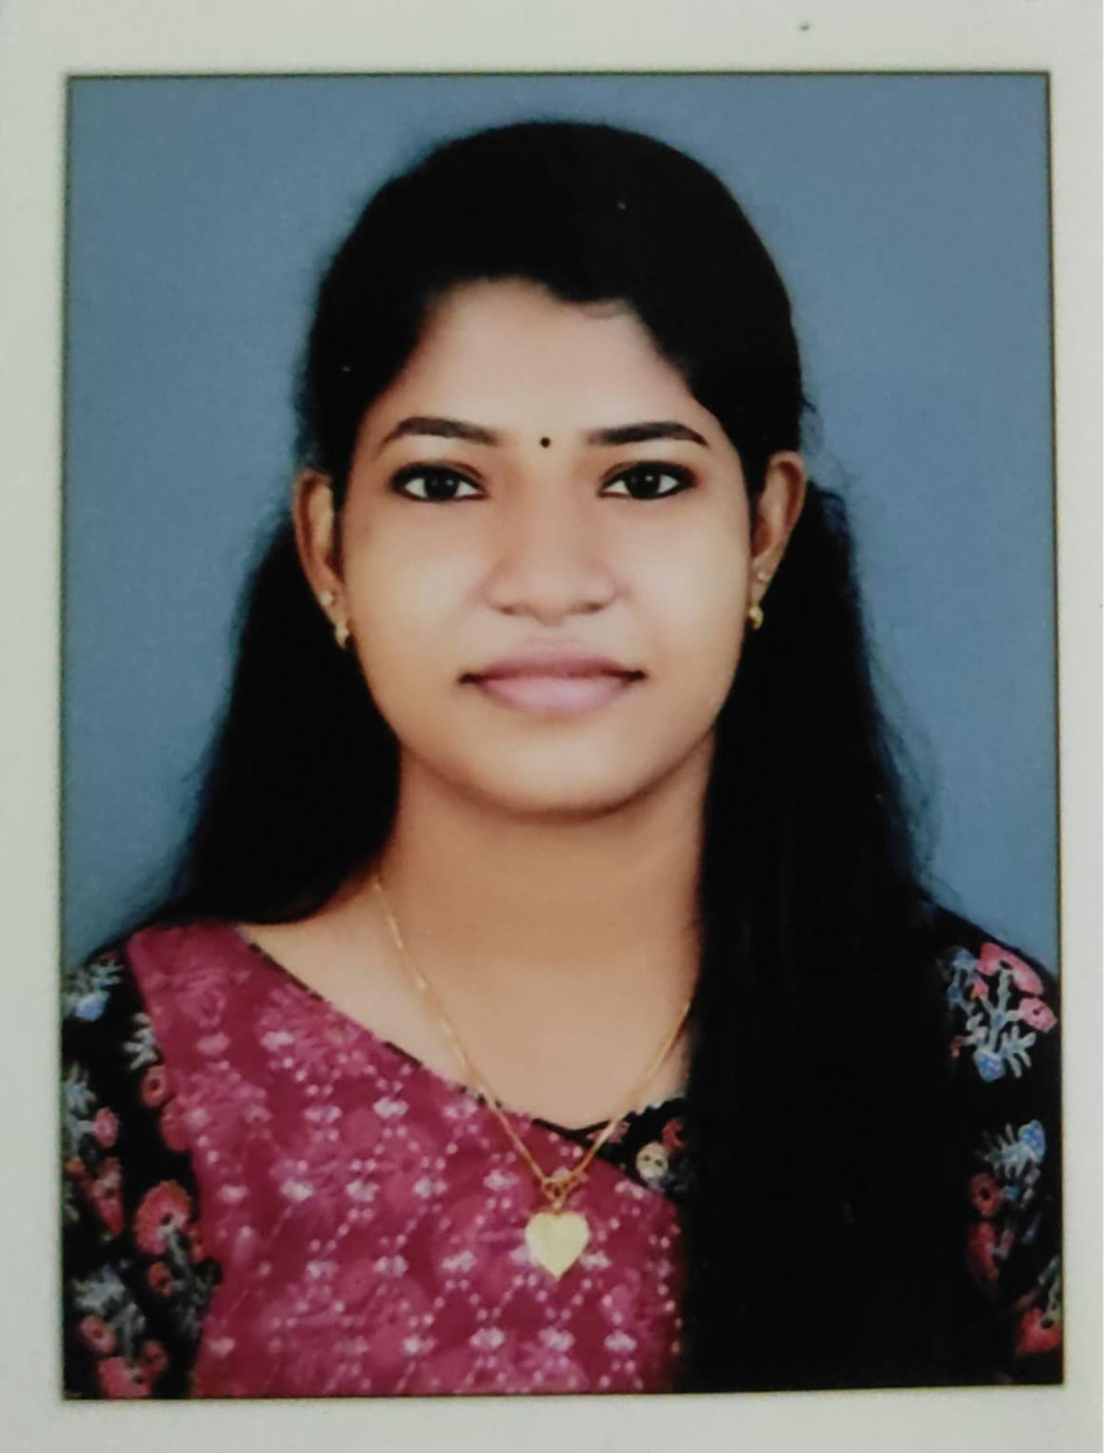Thekkevila Veedu, Keezhattingal,

P.O Kadakkavoor, 695306

(+91) 9961531763

anupriyaambadi012@gmail.com

Anupriya P M

A long, thin rectangle to divide sections of the document

# OBJECTIVE

Highly-organized and self-motivated pharmacy graduate seeking a full-time pharmacist position with Wiley Drugstore to leverage my educational background and customer-service skills in providing medication and exceptional healthcare advice to clients.

SKILLS

* Inventory management
* Medication distribution
* Quality assurance
* Detail-oriented
* Communication
* Time-management
* Teamwork

EXPERIENCE

## Government Taluk Hospital, Attingal *— Pharmacist Trainee*

February 2021 - July 2021

## Aswas Community Pharmacy, Avanavncheri *— Pharmacist*

October 2021 - PRESENT

# EDUCATION

## Govt. Girls Higher Secondary School, Attingal *— SSLC*

March 2011

## Govt. Vocational Higher Secondary School, Vakkom *— +2*

March 2013

## Sree Narayana College, Chempazhanthy *— B.Sc.Zoology*

June 2016

## John Enoch College of Pharmacy, Karamana *— D.pham*

September 2021

# LANGUAGE

* Malayalam
* English
* Hindi

# DECLARATION

I sincerely declare that the fact and information provided in this resume are true and correct to 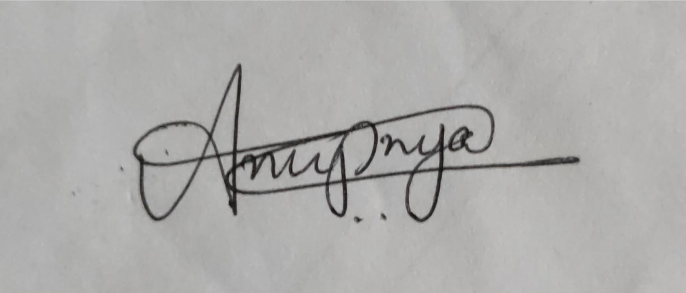the best of my belief and knowledge.

Anupriya P M