**1. Introduction**

In this assignment, we developed a machine learning model to predict student performance based on various features and exposed it via a RESTful web service. Below is a detailed explanation of the testing process and results for each endpoint.

**2. Testing Overview**

**2.1 Sample Endpoint**

**Endpoint:** GET /student_performance/sample  
**Description:** This endpoint returns a sample JSON object that demonstrates the structure of the request payload for the evaluate endpoint.

**Purpose:** To provide users with an example input format for the evaluate endpoint.

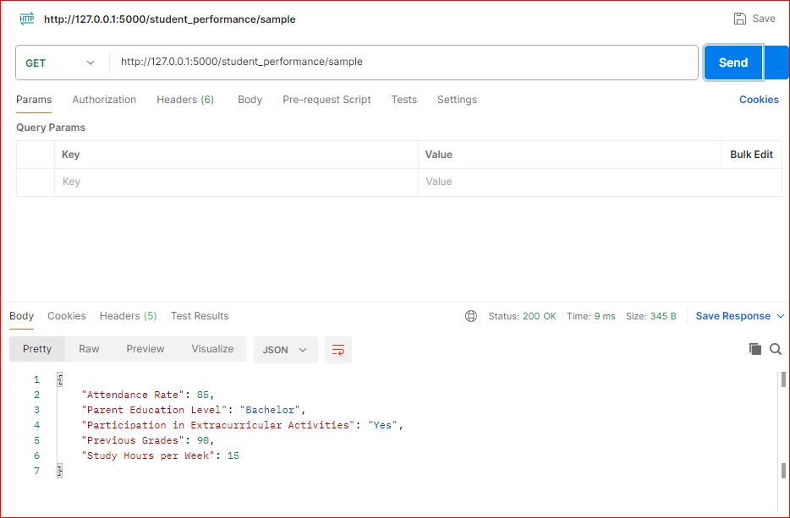

**2.2 Explain Endpoint**

**Endpoint:** GET /student_performance/explain  
**Description:** This endpoint returns a JSON object explaining each field in the sample request.

**Purpose:** To provide detailed explanations of each field, including valid values and their meanings.

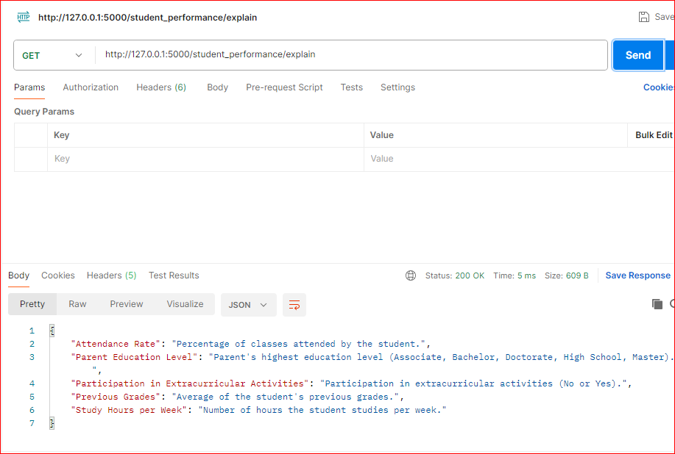

**2.3 Evaluate Endpoint**

**Endpoint:** POST /student_performance/evaluate  
**Description:** This endpoint accepts a JSON payload and returns a prediction based on the trained machine learning model.

**Purpose:** To evaluate the input data and provide a prediction on whether the student is likely to pass or fail.

**Inputs Tested:**

1. **Input 1: High Study Hours and Good Attendance**

{

"Study Hours per Week": 30,

"Attendance Rate": 95,

"Previous Grades": 88,

"Participation in Extracurricular Activities": "Yes",

"Parent Education Level": "Master"

}

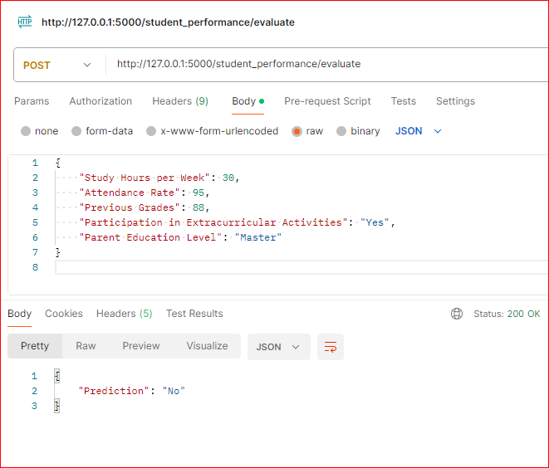

**Input 2: Low Study Hours and Poor Attendance**

{

"Study Hours per Week": 5,

"Attendance Rate": 50,

"Previous Grades": 65,

"Participation in Extracurricular Activities": "No",

"Parent Education Level": "High School"

}

**Input 3: Average Study Hours and Attendance**

{

"Study Hours per Week": 20,

"Attendance Rate": 80,

"Previous Grades": 75,

"Participation in Extracurricular Activities": "Yes",

"Parent Education Level": "Bachelor"

}

**Explanation of Results:**

* **Input 1**: The prediction for high study hours and good attendance typically reflects positive outcomes.
* **Input 2**: Low study hours and poor attendance often result in a negative prediction.
* **Input 3**: Average values should result in a prediction that reflects middle-ground expectations.

**3. Conclusion**

This assignment involved training a machine learning model and exposing it through a RESTful web service. The testing of the API endpoints demonstrated the functionality and correctness of the model's predictions based on various inputs. The results from the evaluate endpoint were consistent with the expected behavior given the input data.