規格書

<https://www.notion.so/1b072907845845f58032685bbe938d92>

參考網站

＊玩家帶路：

<https://culturetravel.tw/tour_detail.asp?UID=1>

＊數位集章：Richart APP 集章頁面

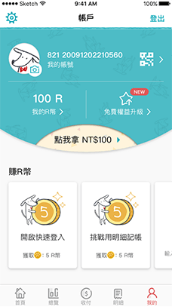

Figma

<https://www.figma.com/proto/Ijloy1GGBKscz1Xqi649X3/pc?node-id=2402%3A4841&scaling=min-zoom&page-id=2402%3A4840&starting-point-node-id=2402%3A4842>

