
Department of Software Engineering
The University of Azad Jammu & Kashmir,
Muzaffarabad

Submitted To:
Engr. Ahmed Khawaja

Submitted By:
Imama Tanveer

Roll no:
2023-SE-28

Course Code:
SE-3112

Task 1 Read any colored image display its red green and blue component separately. Create a grayscale and binary image from any colored image.

1. Objectives
The primary goal of this task is to demonstrate fundamental image manipulation techniques using Python’s OpenCV and Matplotlib libraries. The specific objectives include:
- Loading and verifying a colored digital image.
- Correcting color space representations (BGR to RGB).
- Decomposing a color image into its fundamental Red, Green, and Blue channels.
- Generating a Grayscale version of the image.
- Applying thresholding techniques to create a Binary (Black and White) image.

2. Methodology and Implementation

2.1 Environment Setup
The implementation utilizes the following libraries:
- OpenCV (cv2): Used for robust image loading, color space conversion, and mathematical thresholding.
- Matplotlib (plt): Used for creating professional-grade subplots to visualize and compare the processed images side-by-side.

2.2 Code Implementation
The following code snippet performs the image reading, processing, and visualization:
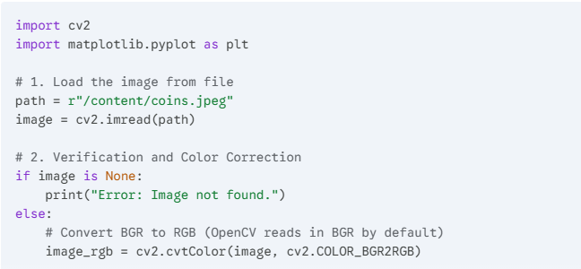

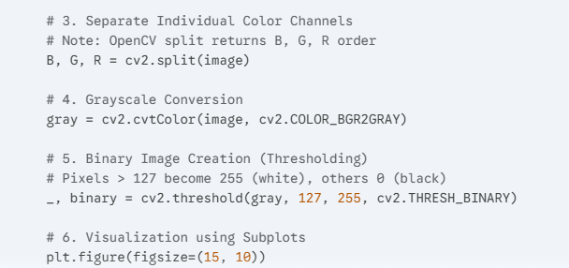

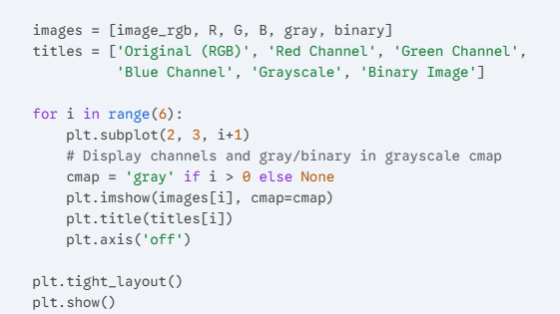

3. Technical Analysis

3.1 Color Space Transformation
Digital images are typically represented as 3D matrices. While most display engines use RGB, OpenCV uses the BGR format. Converting to RGB ensures that the red and blue values are not swapped during visualization.

3.2 Channel Separation
By splitting the image, we can analyze the intensity of specific colors. For example, in the "Red Channel" image, brighter areas indicate a higher concentration of the red wavelength in the original scene.

3.3 Grayscale vs. Binary
- Grayscale: Reduces the 3-channel (RGB) image into a 1-channel image where each pixel represents intensity (0–255).
- Binary: A simplified version of grayscale where every pixel is strictly 0 (black) or 255 (white). This is achieved using the formula:
$$f(x, y) = \begin{cases} 255 & \text{if } g(x, y) > T \\ 0 & \text{otherwise} \end{cases}$$
where $T$ is the threshold value (set to 127 in this task).

4. Conclusion
The task successfully demonstrates the workflow of image pre-processing. The ability to isolate channels and simplify images into binary format is the foundational step for more advanced tasks like Object Detection, Edge Detection, and Feature Extraction.
THE END

