SQL:

Structured Query Language (SQL), as we all know, is the database language by the use of which we can perform certain operations on the existing database, and also we can use this language to create a database.

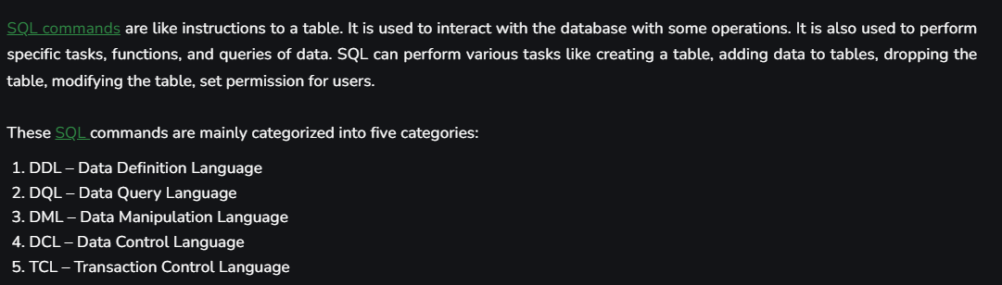

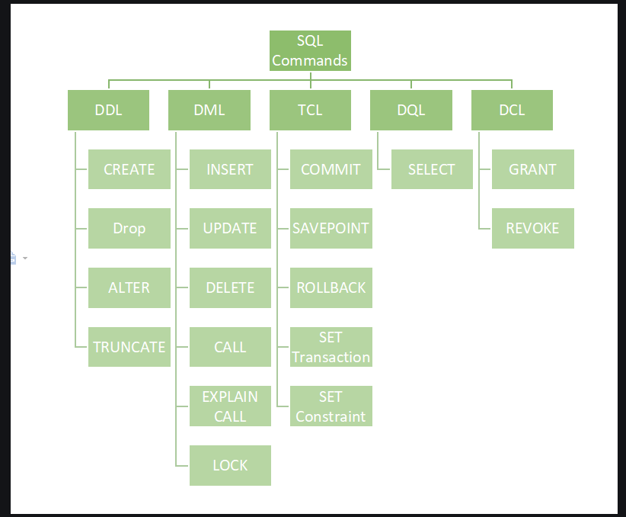

[DDL](https://www.geeksforgeeks.org/features-of-structured-query-language-sql/) or Data Definition Language actually consists of the SQL commands that can be used to define the database schema.

List of DDL commands:

* [**CREATE**](https://www.geeksforgeeks.org/sql-create/): This command is used to create the database or its objects (like table, index, function, views, store procedure, and triggers).
* [**DROP**](https://www.geeksforgeeks.org/sql-drop-truncate/): This command is used to delete objects from the database.
* [**ALTER**](https://www.geeksforgeeks.org/sql-alter-add-drop-modify/)**:**This is used to alter the structure of the database.
* [**TRUNCATE**](https://www.geeksforgeeks.org/sql-drop-truncate/)**:**This is used to remove all records from a table, including all spaces allocated for the records are removed.
* [**COMMENT**](https://www.geeksforgeeks.org/sql-comments/): This is used to add comments to the data dictionary.
* [**RENAME**](https://www.geeksforgeeks.org/sql-alter-rename/)**:**This is used to rename an object existing in the database.

**DQL**statements are used for performing queries on the data within schema objects. The purpose of the DQL Command is to get some schema relation based on the query passed to it.

* [**SELECT**](https://www.geeksforgeeks.org/sql-select-clause/)**:**It is used to retrieve data from the database.

The SQL commands that deal with the manipulation of data present in the database belong to DML or Data Manipulation Language and this includes most of the SQL statements. It is the component of the SQL statement that controls access to data and to the database

List of DML commands:

* [**INSERT**](https://www.geeksforgeeks.org/sql-insert-statement/): It is used to insert data into a table.
* [**UPDATE**](https://www.geeksforgeeks.org/sql-update-statement/)**:** It is used to update existing data within a table.
* [**DELETE**](https://www.geeksforgeeks.org/sql-delete-statement/): It is used to delete records from a database table.

Transactions group a set of tasks into a single execution unit. Each transaction begins with a specific task and ends when all the tasks in the group are successfully completed.

**BEGIN:** Opens a Transaction.

[**COMMIT**](https://www.geeksforgeeks.org/sql-transactions/)**:**Commits a Transaction.

[**ROLLBACK**](https://www.geeksforgeeks.org/sql-transactions/)**:**Rollbacks a transaction in case of any error occurs.

-------------------------------------------------------------------------

-- Date: 13 Feb 2024

-- Create table

create table school_record2 (

student_id int,

class int,

fees float,

section varchar(10)

);

insert into school_record2 values (1,6,5000,"B");

insert into school_record2 values (2, 7,20000, "A");

insert into school_record2 values (3, 8,200.67, "C");

select * from school_record2;

-- Commenting: If you want to provide some extra info corr to your query

-- * stands for selecting ALL in SQL

-- Fot Doing Multiline commenting we use ctrl + /

-- svjrbv

-- rgtiugeri

-- rgietrhviutr

-- rhgiuehtrbiv

-- for fetching specific columns

select student_id, fees from school_record2;

insert into school_record2 values (11,8,15000,"B");

insert into school_record2 values (24, 9,120000, "A");

insert into school_record2 values (30, 10,2000.96, "C");

-- In stands for membership operator

select * from school_record2

where section in ('C','A');

select * from school_record2

where section !='B';

select * from school_record2

where section !='C'

and fees<100000;

select * from school_record2

order by fees ASC;

select * from school_record2

order by fees DESC;

select * from school_record2

order by fees DESC

limit 4;

insert into school_record2 values (4, 3,2007.67, "F");

-- celing function

-- floor function

Write a query to find the second highest fees from school_records2 table?