SALESFORCE PROCESS MAPPING
AND DOCUMENTATION
Week 1 Project Report | Process Audit Simulation

Prepared as a learning simulation using standard Salesforce CRM concepts

Project details | Description
Project scope | Lead management, opportunity tracking, and case resolution
Method | As-is workflow simulation, risk/inefficiency review, and to-be recommendations
Platform context | Salesforce Sales Cloud and Service Cloud concepts; no live org data accessed
Deliverables | Process maps, workflow descriptions, improvement plan, KPIs, and governance controls

1. Executive Summary
This report maps three business-critical CRM processes commonly supported by Salesforce: lead management, opportunity tracking, and customer case resolution. The purpose is to document a simulated current-state workflow, identify likely friction points, and recommend practical improvements that can be configured and measured. Because no client Salesforce org or operational dataset was supplied, the “current state” in this report is a representative baseline for a training exercise—not a claim about a specific company’s configuration.
The review highlights recurring risks found in CRM workflows: incomplete records, duplicate data, inconsistent ownership, unclear stage-exit criteria, delayed escalation, manual handoffs, and limited performance visibility. Recommended improvements include mandatory-field and duplicate controls, criteria-based assignment, guided stage progression, SLA-driven case routing, knowledge reuse, automated reminders, dashboards, and regular data-quality reviews. Each recommendation should be validated with process owners before configuration.

2. Objectives and Scope
- Map inputs, activities, decisions, outputs, and exception paths for at least three Salesforce processes.
- Describe a representative current workflow and identify operational inefficiencies, risks, and control gaps.
- Recommend prioritized improvements that can be implemented through configuration, automation, reporting, and governance.
- Define practical KPIs and a rollout approach to assess whether changes improve outcomes.

In scope
Lead capture and qualification; opportunity progression and forecasting; customer support case intake, routing, escalation, and closure. The report also considers data quality, ownership, automation, reporting, and change management.

Out of scope and assumptions
This is a simulated audit, not a live Salesforce configuration review. Objects, stages, fields, queues, SLAs, and approval thresholds vary by organization and must be confirmed. No actual customer records, sales figures, service levels, or system settings were accessed.

3. Approach and Process-Mapping Method
- Define the process trigger, required inputs, key activities, decision points, outputs, and owner.
- Represent the typical happy path and important exception paths in a flow diagram.
- Assess issues against impact, likelihood, control strength, and ease of improvement.
- Recommend controls and automation while preserving human judgment for complex exceptions.
- Track outcomes using baseline measurements and agreed KPIs after implementation.
Notation: rounded boxes represent process steps or start/end points; diamond shapes represent decisions. A production map should be validated in workshops with Sales, Marketing, Support, Operations, and Salesforce administration stakeholders.

4. Process 1 — Lead Management
Purpose: capture prospective customers, verify data, route leads to an appropriate owner, qualify interest, and convert sales-ready leads into account, contact, and opportunity records.
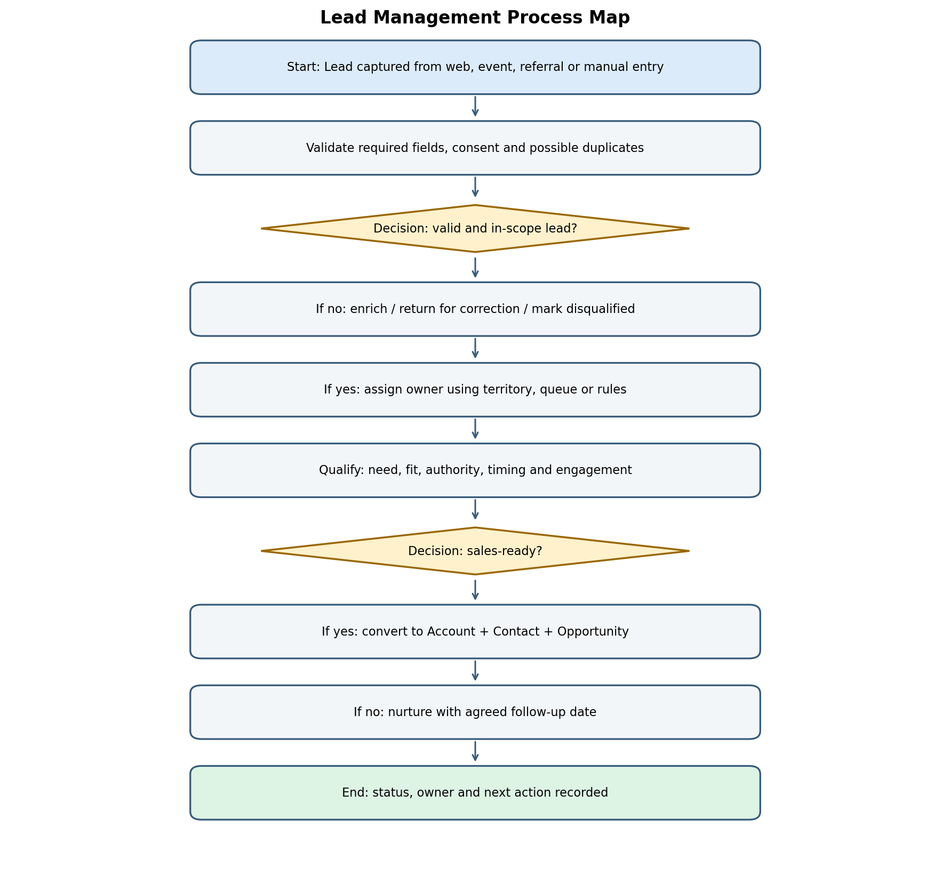

4.1 Inputs, outputs, roles and controls
Element | Description
Inputs | Web forms, campaign/event lists, referrals, manual entries; contact details, consent status, source, company and interest
Primary roles | Marketing operations, SDR/BDR or sales representative, sales manager, Salesforce administrator
Key decisions | Is the record valid and in scope? Is it sales-ready? Is it a duplicate?
Outputs | Assigned lead with status and next action; qualified lead converted to Account, Contact and Opportunity; or disqualification/nurture record
Suggested controls | Required-field validation, duplicate matching rules, consent handling, assignment rules/queues, aging alerts and documented disqualification reasons

4.2 Representative current workflow
A lead enters Salesforce through a digital form, import, event list, referral, or manual entry. A user or automated rule checks required information and assigns the record. The assigned representative attempts contact and records qualification activity. A qualified lead is converted; a lead that is not ready remains in nurture with a follow-up date; an invalid or out-of-scope lead is disqualified with a reason.

4.3 Potential inefficiencies and recommendations
Observed risk in a typical baseline | Business impact | Recommended optimization | Priority
Duplicate or incomplete leads | Wasted outreach; unreliable funnel reporting | Configure matching/duplicate rules; validate required fields at capture; establish merge ownership | High
Manual or unclear assignment | Slow first response; leads can remain unowned | Use assignment rules, queues, territory logic and an unassigned-lead alert | High
Inconsistent qualification | Different teams convert leads using different standards | Define qualification criteria and conversion checklist; coach users and audit samples | High
No next-step discipline | Leads become stale with no visible follow-up | Require a next action/date for active leads; use aging reports and task reminders | Medium
Missing source or consent data | Weak attribution and compliance risk | Standardize source values; capture consent where applicable; restrict access to sensitive fields | High

5. Process 2 — Opportunity Tracking
Purpose: manage a potential sale from qualification through discovery, solution validation, commercial approval, close, and handoff. Stage definitions should reflect the organization’s actual sales methodology.
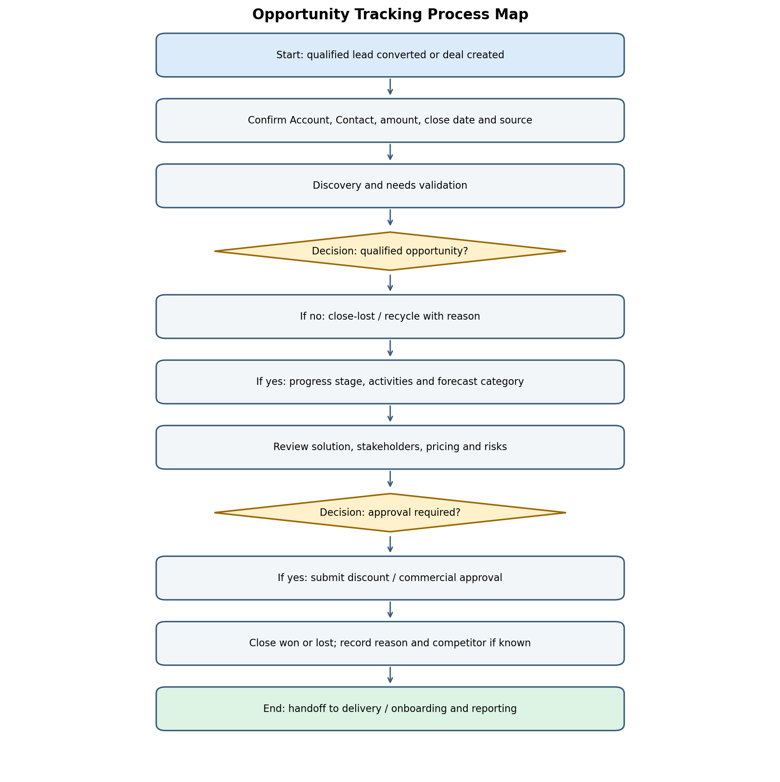

5.1 Inputs, outputs, roles and controls
Element | Description
Inputs | Qualified lead or manually created deal; account/contact; need, estimated value, close date, products and activity history
Primary roles | Account executive, sales manager, solution/technical specialist, finance or commercial approver, delivery/onboarding
Key decisions | Is the deal qualified? Is an approval required? Is the opportunity won or lost?
Outputs | Stage and forecast updated; closed-won handoff or closed-lost record with reason; pipeline and forecast reporting
Suggested controls | Stage exit criteria, required close date/value fields, approval workflow, loss reasons, forecast review and stale-opportunity alerts

5.2 Representative current workflow
A representative creates or receives an opportunity and records the account, contact, expected value, close date, and source. The sales team conducts discovery, validates business fit, identifies stakeholders, and advances the opportunity as evidence is collected. Pricing or discount exceptions may require approval. The opportunity is closed won or lost, and the outcome is documented for reporting and handoff.

5.3 Potential inefficiencies and recommendations
Observed risk in a typical baseline | Business impact | Recommended optimization | Priority
Stages used inconsistently | Pipeline and conversion metrics become unreliable | Document stage definitions and exit criteria; add guided prompts and required fields | High
Close dates repeatedly pushed | Forecast instability and hidden deal risk | Create close-date-change reporting; require a reason after repeated changes | High
Approvals occur through email/chat | Slow decisions and weak audit trail | Use Salesforce approval processes or Flow for defined thresholds and approval history | High
Stale opportunities remain open | Inflated pipeline and poor forecast accuracy | Automated inactivity alerts; manager review; close/recycle criteria | Medium
Lost reasons are blank or generic | Limited insight into win/loss patterns | Require a controlled loss-reason picklist and periodic qualitative review | Medium

6. Process 3 — Case Resolution
Purpose: receive customer issues, classify urgency and ownership, resolve or escalate the case, communicate progress, and capture a reliable closure outcome.
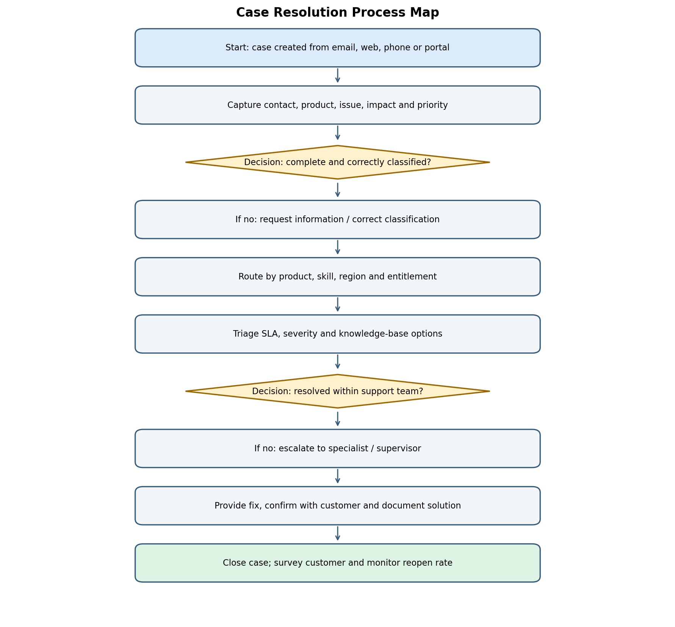

6.1 Inputs, outputs, roles and controls
Element | Description
Inputs | Email, web form, phone, portal or internal handoff; customer/contact, issue description, product, impact and attachments
Primary roles | Support agent, queue lead, specialist team, supervisor, knowledge manager, Salesforce administrator
Key decisions | Is the case complete? What priority and routing apply? Is escalation needed? Has the customer confirmed resolution?
Outputs | Resolved and documented case; escalation record where needed; customer feedback; reusable knowledge candidate
Suggested controls | Case classification, assignment rules, entitlement/milestone controls where licensed, SLA alerts, escalation paths and closure validation

6.2 Representative current workflow
A case is created through an available support channel. The team checks required details, classifies the issue, sets priority according to impact and urgency, and routes it to an agent or queue. The agent uses troubleshooting steps and approved knowledge articles. Complex or overdue cases are escalated. Once the solution is documented and communicated, the case is closed and feedback or reopen activity is monitored.

6.3 Potential inefficiencies and recommendations
Observed risk in a typical baseline | Business impact | Recommended optimization | Priority
Cases arrive with insufficient details | Repeated customer contact and longer resolution | Use channel-specific forms and guided intake; validate contact, category and description | High
Routing relies on manual triage | Misrouted work and slower response | Configure assignment rules by product, skill, region, priority or entitlement | High
SLA breaches discovered late | Customer dissatisfaction and contractual risk | Use milestone/SLA timers, warning notifications and escalation paths where applicable | High
Known issues solved repeatedly from scratch | Higher handling time and inconsistent answers | Promote approved knowledge articles; track article use and gaps | Medium
Cases closed without clear resolution notes | Poor auditability and avoidable reopenings | Require resolution category and summary; monitor reopen rate and customer feedback | Medium

7. Cross-Process Findings
Theme | Risk / inefficiency | Cross-process recommendation
Data quality | Incomplete, duplicate or inconsistent records weaken automation and reporting | Define field ownership, validation, picklists, duplicate handling and periodic data-quality checks
Ownership | Records can sit in queues or with inactive users | Set ownership rules, fallback queues, aging alerts and reassignment procedures
Automation design | Manual reminders and handoffs consume time; overly complex automation is hard to maintain | Automate high-volume, rule-based tasks first; document Flow logic, error paths and named owners
Reporting | Teams may use conflicting definitions of “qualified,” “stale,” “resolved” or “on time” | Create a shared metric dictionary, dashboard definitions and report access standards
Governance | Uncontrolled field/flow changes can break processes | Use sandbox testing, change approval, release notes, regression tests and rollback plans
User adoption | Users may bypass fields or automation if the process is burdensome | Co-design with users, explain benefits, provide short job aids and monitor adoption

8. Prioritized Optimization Roadmap
Phase | Timeline (illustrative) | Actions | Exit criteria
1. Discover and baseline | Week 1 | Confirm stakeholders; validate process maps; collect baseline data; agree KPI definitions | Approved current-state maps and baseline measures
2. Quick wins | Weeks 2–3 | Fix critical required fields, duplicate rules, ownership fallbacks, stale-record alerts and basic dashboards | Changes tested in sandbox; owners trained
3. Workflow improvements | Weeks 4–6 | Configure stage guidance, approval automation, case routing and SLA escalations where applicable | UAT sign-off; exception paths tested
4. Pilot and refine | Weeks 7–8 | Pilot with selected users/queues; review defects, adoption and early outcomes | No critical defects; agreed adoption threshold reached
5. Govern and optimize | Ongoing | Monthly KPI review, quarterly process audit, release/change management and knowledge upkeep | Named process owners and recurring review cadence

9. Key Performance Indicators (KPIs)
Process | KPI | Definition / measurement note | Suggested review
Lead | Time to first response | Median elapsed time from lead creation to first meaningful outreach | Weekly
Lead | Lead-to-opportunity conversion | Converted leads that create opportunities divided by eligible leads in cohort | Monthly
Lead | Duplicate rate | Records identified as duplicates divided by leads created | Monthly
Opportunity | Stage conversion rate | Opportunities entering a stage that advance to the next stage in a defined cohort | Monthly
Opportunity | Forecast accuracy | Compare forecast value to actual closed value for the same period and category | Monthly/quarterly
Opportunity | Stale opportunity rate | Open opportunities with no meaningful activity beyond agreed threshold | Weekly
Case | First response time | Elapsed time from case creation to first agent response, segmented by priority/channel | Daily/weekly
Case | First-contact resolution | Cases resolved without transfer/reopen under the agreed definition | Monthly
Case | SLA attainment | Cases meeting the applicable response/resolution milestone divided by eligible cases | Daily/weekly
Case | Reopen rate | Closed cases reopened within a defined window divided by closed cases | Monthly

Targets should be set only after a reliable baseline is available and business owners agree on definitions, exclusions, time zones, and cohort rules. Avoid comparing teams with different case mixes or lead sources without segmentation.

10. Risk and Control Register
Risk | Likelihood / impact (initial qualitative view) | Control / mitigation | Owner
Poor data quality leads to bad routing or reporting | Medium / High | Validation, duplicate rules, monitoring dashboard and steward review | Salesforce admin + process owner
Automation misroutes records or fails silently | Medium / High | Sandbox tests, fault notifications, fallback queues, periodic flow review | Salesforce admin
Unauthorized access to customer or commercial data | Low–Medium / High | Least-privilege profiles/permission sets, field-level security and access reviews | Security / platform owner
Unapproved discount or commercial terms | Medium / High | Approval thresholds, delegated approvers and audit trail | Sales leadership / Finance
SLA breach or unresolved high-impact case | Medium / High | Priority rules, milestone alerts, escalation ownership and exception report | Support manager
Low adoption or workarounds | Medium / Medium | User testing, training, feedback channel and adoption metrics | Change lead + managers

11. Testing, Governance and Change Management
- Test normal paths, missing data, duplicates, reassignment, rejected approvals, escalations, reopened cases, and automation errors.
- Use a sandbox or equivalent safe environment before production changes; confirm integrations and permission behavior.
- Record test cases, expected outcomes, actual results, defects, owner, severity, and sign-off.
- Maintain a field dictionary, process owner list, Flow/automation inventory, release notes, and rollback approach.
- Train users by role and provide short reference guides that explain what changed and why.
- Review KPI trends after rollout and adjust rules only with documented approval.

12. Conclusion
The three maps show how Salesforce can support a consistent lifecycle from lead capture to sales execution and customer support. The greatest opportunities in this simulated baseline are improving data quality, making ownership explicit, standardizing decision criteria, and automating timely follow-up and escalation. Improvements should be prioritized by business impact and verified through a controlled pilot. The next step is to validate these representative workflows with actual stakeholders and Salesforce configuration before implementing changes.

Appendix A — Workshop Questions
- Which channels create leads, opportunities and cases, and which systems feed Salesforce?
- Who owns each stage or queue, and what happens when the owner is unavailable?
- What minimum information is required before a record can move forward?
- What are the official stage definitions, SLA commitments, approval thresholds and exception rules?
- Which reports are trusted today, and how are key metrics calculated?
- What privacy, retention, consent, entitlement or audit requirements apply?

Appendix B — Reference Frameworks
This report is an original training simulation informed by commonly used Salesforce CRM concepts and general process-improvement practices. For implementation, consult current official Salesforce Help documentation for Leads and Lead Conversion, Opportunities and Forecasting, Case Management, Assignment Rules, Duplicate Management, Flow, Approval Processes, Reports and Dashboards, and Entitlement/Milestone Management. Confirm features and licensing in the target Salesforce edition before relying on them.

