Home SOC Lab - Traffic Monitoring & Log Analysis
VirtualBox + Ubuntu Server (Target) + Kali Linux (Attacker) | Wireshark + SSH Logs

1. Lab Summary (What You Are Building)
This home lab simulates a small internal network and demonstrates entry-level SOC workflows: generating authentication events (successful and failed SSH logins), observing network behavior in Wireshark, and validating evidence in host logs (/var/log/auth.log). The goal is to practice traffic + log correlation in an isolated environment.
- Attacker VM: Kali Linux (simulates an internal workstation generating recon/authentication attempts).
- Target VM: Ubuntu Server (runs OpenSSH server; logs all authentication outcomes).
- Isolation: Host-only network so only the VMs can communicate (no internet required for the core lab).

2. Lab Architecture
Recommended private subnet example (your IPs may differ): 192.168.56.0/24
- Kali-Attacker: 192.168.56.X
- Ubuntu-Target: 192.168.56.X
- SSH Service: TCP/22 on Ubuntu-Target

3. Requirements & Downloads

3.1 Hardware Requirements (Recommended)
- RAM: 16 GB recommended (8 GB minimum).
- CPU: 2+ cores available for VMs (enable AMD-V/SVM in BIOS).
- Disk space: 40-60 GB free (Kali + Ubuntu virtual disks).

3.2 Software Downloads (Official Links)
- Oracle VirtualBox: https://www.virtualbox.org/wiki/Downloads
- VirtualBox Extension Pack (same page): https://www.virtualbox.org/wiki/Downloads
- Ubuntu Server LTS ISO: https://ubuntu.com/download/server
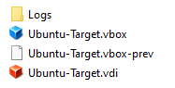
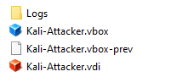

- Kali Linux ISO: https://www.kali.org/get-kali/

4. VirtualBox Setup

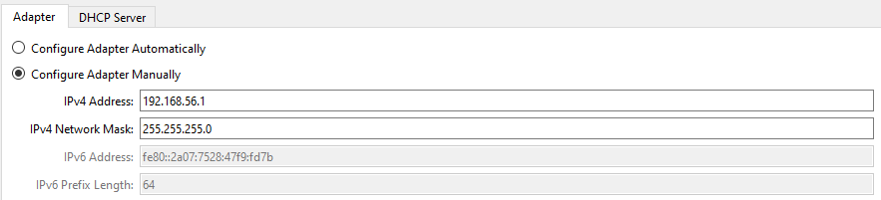
4.1 Create a Host-Only Network (Isolated Lab Network)
- VirtualBox -> Tools -> Network -> Host-only Networks -> Create.
- Select the new network (often vboxnet0) -> Edit.
- IPv4 Address: 192.168.56.1 | Mask: 255.255.255.0
- Disable DHCP server (OFF).
- Save/OK.

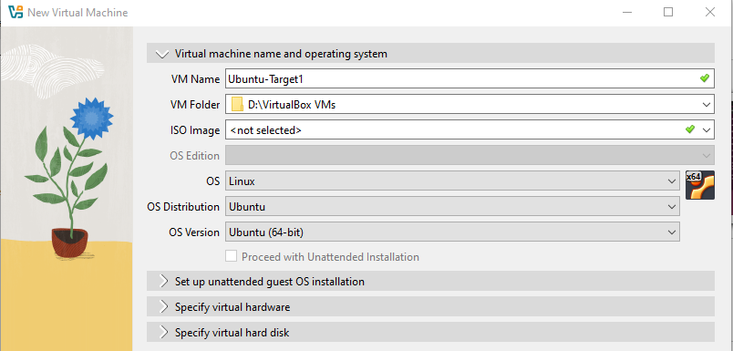
5. Create & Install Ubuntu-Target (Ubuntu Server)

5.1 Create the VM
- VirtualBox -> New.
- Name: Ubuntu-Target | Type: Linux | Version: Ubuntu (64-bit).
- Memory: 2048 MB | CPUs: 2.
- Create disk: VDI -> Dynamically allocated -> 20-25 GB.

5.2 Attach Ubuntu ISO & Set Network
- Settings -> Storage -> Optical Drive -> Choose disk file -> select Ubuntu Server ISO.
- Settings -> Network -> Adapter 1 -> Host-only Adapter -> select your host-only network (vboxnet0).

5.3 Install Ubuntu Server
- Start Ubuntu-Target.
- Complete installer prompts (language, keyboard, username/password).
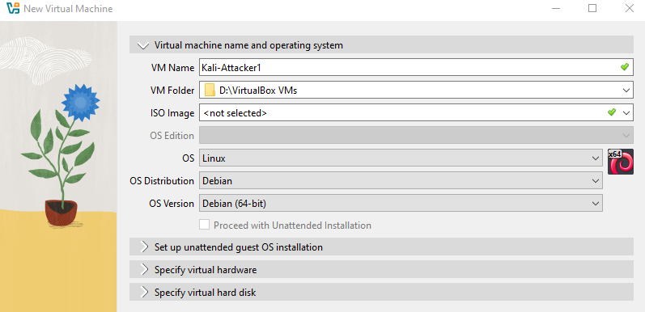
- After install, remove ISO: Devices -> Optical Drives -> Remove disk from virtual drive, then reboot.

6. Create & Install Kali-Attacker

6.1 Create the VM
- VirtualBox -> New.
- Name: Kali-Attacker | Type: Linux | Version: Debian (64-bit).
- Memory: 2048-4096 MB | CPUs: 2.
- Create disk: VDI -> Dynamically allocated -> 20-25 GB.

6.2 Attach Kali ISO & Set Network
- Settings -> Storage -> Optical Drive -> Choose disk file -> select Kali ISO.
- Settings -> Network -> Adapter 1 -> Host-only Adapter -> select vboxnet0.

6.3 Install Kali
- Start Kali-Attacker -> choose 'Graphical install'.
- Hostname: kali-attacker | Domain: leave blank.
- If warned about 'no default route': choose Yes to continue (Host-only has no internet).
- Partition disks: Guided - use entire disk -> All files in one partition -> Write changes: Yes.
- Install GRUB to /dev/sda when prompted.
- After install, remove ISO: Devices -> Optical Drives -> Remove disk from virtual drive -> reboot.

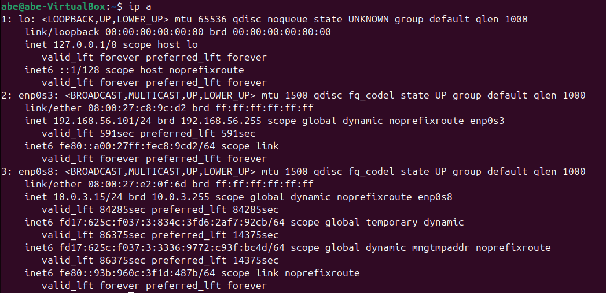
7. Verify Network Connectivity

7.1 Identify IP Addresses
Run on BOTH VMs. Record the IPv4 address shown under the
main interface (e.g., enp0s3/eth0).
Ubuntu-Target:
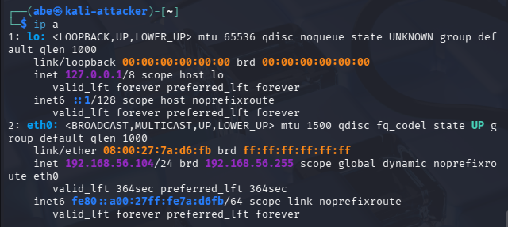
ip a
- Recorded Ubuntu IP: 192.168.56.101
Kali-Attacker:
ip a
- Recorded Kali IP: 192.168.56.104

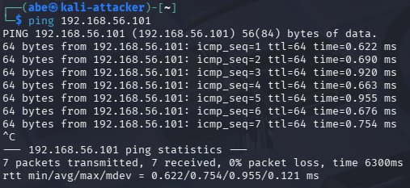
7.2 Ping Test (Kali -> Ubuntu)
From Kali-Attacker, ping the Ubuntu-Target IP:
ping -c 4 <UBUNTU_IP>
Expected: 4 replies (0% packet loss). Stop continuous ping with Ctrl+C.

8. Enable SSH on Ubuntu-Target
On Ubuntu-Target, install and start the OpenSSH server:
sudo apt update
sudo apt install -y openssh-server
sudo systemctl enable --now ssh
sudo systemctl status ssh
Expected: status shows 'active (running)'.
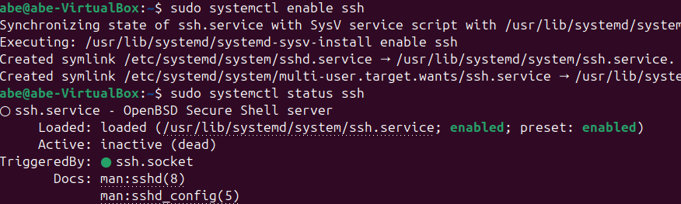

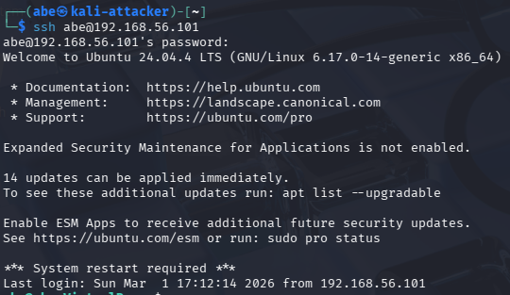
9. Baseline SSH Login (Normal Activity)
From Kali-Attacker, attempt a normal SSH login to Ubuntu-Target:
ssh <ubuntu_username>@<UBUNTU_IP>
If prompted to trust the host key, type: yes
Enter the Ubuntu password when prompted.
Logout (disconnect) from the SSH session with either command:
exit
# or press Ctrl+D

10. Simulate Failed SSH Logins (Suspicious Activity)
This simulates repeated failed authentication attempts (brute-force-like behavior).
- From Kali-Attacker, run the SSH command again.
- Enter an incorrect password 3 times (SSH usually disconnects after 3 failures).
- Repeat the SSH command again and perform additional failed attempts (e.g., total 6-12 failed tries).
ssh <ubuntu_username>@<UBUNTU_IP>
# enter wrong password when prompted
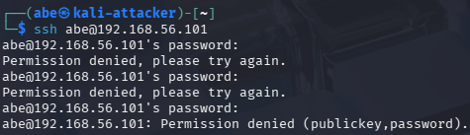

11. Investigate Evidence in Ubuntu Logs

11.1 Search for Failed Password Entries
On Ubuntu-Target, search authentication logs for failures:
sudo grep "Failed password" /var/log/auth.log
Expected: log lines showing 'Failed password' and the Kali source IP.
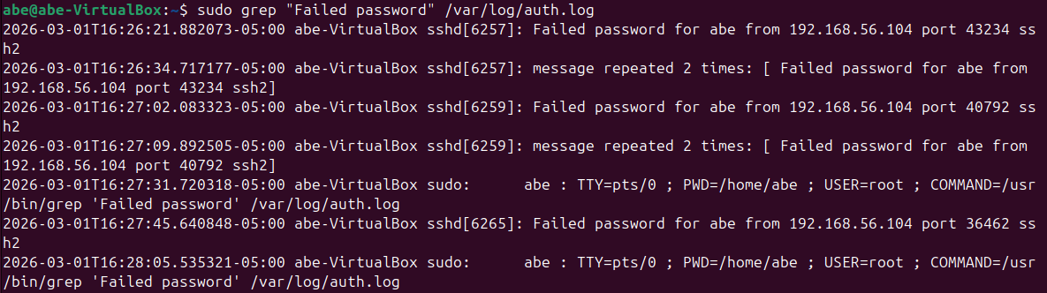

11.2 Search for Successful Logins
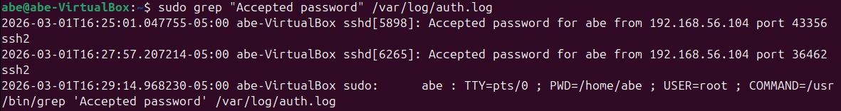
sudo grep "Accepted password" /var/log/auth.log

11.3 Live Monitoring
Watch logs in real time, then attempt SSH again from Kali:
sudo tail -f /var/log/auth.log
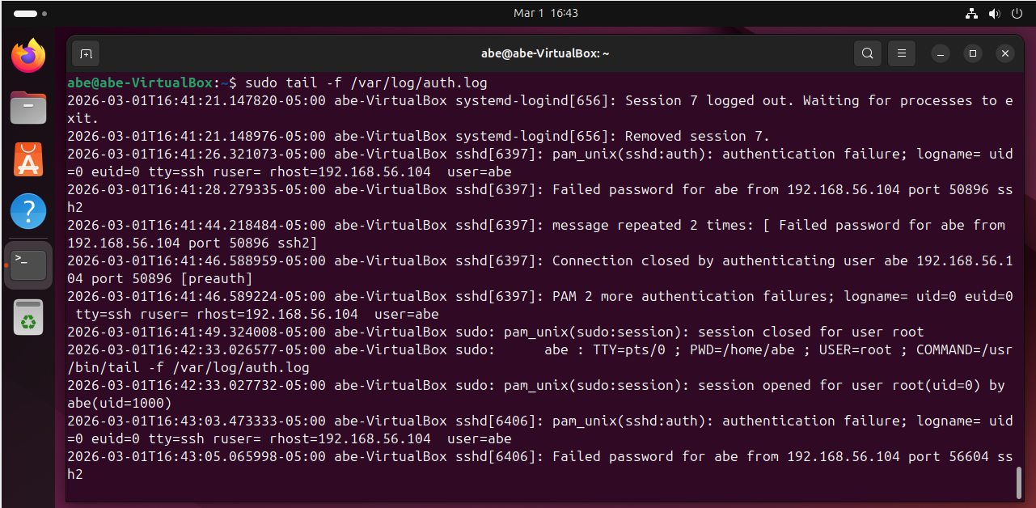
Stop tail with Ctrl+C.

12. Network Recon Simulation (Nmap Scan)
From Kali-Attacker, perform a basic TCP SYN scan against Ubuntu-Target:
sudo nmap -sS <UBUNTU_IP>
Expected: port 22/tcp open (ssh).
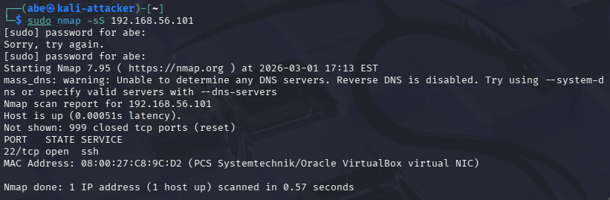

13. Packet Capture (Wireshark)
Goal: correlate network traffic (packets) with host logs.

13.1 Install Wireshark (if needed)
Kali typically includes Wireshark; if not:
sudo apt update
sudo apt install -y wireshark

13.2 Capture Filters
Start capture on Kali's interface (usually eth0). Useful display filters:
ssh
tcp.port == 22
ip.addr == <UBUNTU_IP>
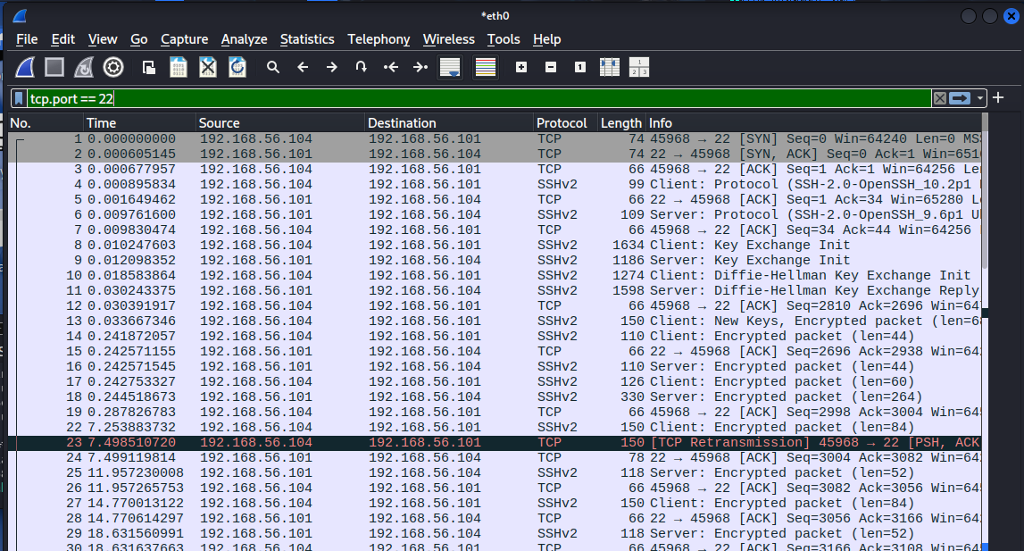

13.3 What You Should Observe
- TCP three-way handshake: SYN -> SYN/ACK -> ACK before the SSH session.
- Repeated connection attempts when you retry failed SSH logins.
- Nmap scan traffic: SYN packets to multiple ports (if running nmap).

