Konfigurasi Core Router

|  |  |
| --- | --- |
| Hostname | Core Router |
| IP Address | 192.168.1.1/24 (FastEthernet 0/0) 192.168.7.1/24 (Gigabit Ethernet 9/0) 192.168.2.1/24 (Gigabit Ethernet 7/0) |
| Subnet mask | 255.255.255.0 |
| Gateway | to 192.168.5.0 via 192.168.2.2 to 192.168.6.0 via 192.168.2.2 to 192.168.9.0 via 192.168.7.1 |
| DNS Server | 192.168.9.53 |

Routing Table Core-Router

|  |  |  |  |  |
| --- | --- | --- | --- | --- |
| Network Destination | Netmask | Gateway | Interface | Metric |
| 192.168.1.0/24 | 255.255.255.0 | Directly connected | FastEthernet0/0 | 1 |
| 192.168.2.0/24 | 255.255.255.0 | Directly  Connected | Gigabit Ethernet9/0 | 1 |
| 192.168.5.0/24 | 255.255.255.0 | 192.168.2.2 | Gigabit Ethernet 7/0 | 1 |
| 192.168.6.0/24 | 255.255.255.0 | 292.168.2.2 | Gigabit Ethernet 6/0 | 1 |
| 192.168.7.0/24 | 255.255.255.0 | Directly connected | Gigabit Ethernet 9/0 | 1 |
| 192.168.9.0/24 | 255.255.255.0 | 192.168.7.1 | Gigabit Ethernet 9/0 | 1 |

Konfigurasi Router 8

|  |  |
| --- | --- |
| Hostname | Router 8 |
| IP Address | 192.168.7.1 (Gig0/0/0) 192.168.9.1 (Gig0/0/1) |
| Subnet mask | 255.255.255.0 |
| Gateway | to 192.168.1.0/24 via 192.168.7.2 to 192.168.2.0/24 via 192.168.7.2 to 192.168.5.0/24 via 192.168.7.2 to 192.168.6.0/24 via 192.168.7.2 |
| DNS Server | 192.168.9.53 |

Routing Table Router 8

|  |  |  |  |  |
| --- | --- | --- | --- | --- |
| Network Destination | Netmask | Gateway | Interface | Metric |
| 192.168.1.0/24 | 255.255.255.0 | 192.168.7.2 | Gig0/0/0 | 1 |
| 192.168.2.0/24 | 255.255.255.0 | 192.168.7.2 | Gig0/0/0 | 1 |
| 192.168.5.0/24 | 255.255.255.0 | 192.168.7.2 | Gig0/0/0 | 1 |
| 192.168.6.0/24 | 255.255.255.0 | 192.168.7.2 | Gig0/0/0 | 1 |
| 192.168.7.0/24 | 255.255.255.0 | Directly Connected | Gig0/0/0 | 1 |
| 192.168.9.0/24 | 255.255.255.0 | Directly Connected | Gig0/0/1 | 1 |

Konfigurasi Distribution Router

|  |  |
| --- | --- |
| Hostname | Distribution Router |
| IP Address | 192.168.2.2/24 (GigabitEthernet6/0) 192.168.3.1/24 (FastEthernet0/0) 192.168.4.1/24 (FastEthernet1/0) |
| Subnet mask | 255.255.255.0 |
| Gateway | to 192.168.1.0/24 via 192.168.2.1 to 192.168.5.0/24 via 192.168.3.2 to 192.168.6.0/24 via 192.168.4.2 to 192.168.7.0/24 via 192.168.2.1 to 192.168.9.0/24 via 192.168.2.1 |
| DNS Server | 192.168.9.53 |

Routing Table Distribution Router

|  |  |  |  |  |
| --- | --- | --- | --- | --- |
| Network Destination | Netmask | Gateway | Interface | Metric |
| 192.168.1.0/24 | 255.255.255.0 | 192.168.2.1 | Gigabit Ethernet 6/0 | 1 |
| 192.168.2.0/24 | 255.255.255.0 | Directly Connected | Gigabit Ethernet 6/0 | 1 |
| 192.168.2.0/24 | 255.255.255.0 | Directly connected | Fast Ethernet 0/0 | 1 |
| 192.168.4.0/24 | 255.255.255.0 | Directly connected | Fast Ethernet 1/0 | 1 |
| 192.168.5.0/24 | 255.255.255.0 | 192.168.3.2 | Fast Ethernet 0/0 | 1 |
| 192.168.6.0/24 | 255.255.255.0 | 192.168.4.2 | Fast Ethernet 1/0 | 1 |
| 192.168.7.0/24 | 255.255.255.0 | 192.168.2.1 | Gigabit Ethernet 6/0 | 1 |
| 192.168.9.0/24 | 255.255.255.0 | 192.168.2.1 | Gigabit Ethernet 6/0 | 1 |

Konfigurasi Access Router A-1

|  |  |
| --- | --- |
| Hostname | Access Router A-1 |
| IP Address | 192.168.3.2/24 (GigabitEthernet0/0) 192.168.5.1/24 (GigabitEthernet1/0) |
| Subnet mask | 255.255.255.0 |
| Gateway | to 192.168.1.0/24 via 192.168.3.1 to 192.168.2.0/24 via 192.168.3.1 to 192.168.4.0/24 via 192.168.3.1 to 192.168.5.0/24 via 192.168.3.1 to 192.168.6.0/24 via 192.168.3.1 to 192.168.7.0/24 via 192.168.3.1 to 192.168.9.0/24 via 192.168.3.1 |
| DNS Server | 192.168.9.53 |

Routing Table Access Router A-1

|  |  |  |  |  |
| --- | --- | --- | --- | --- |
| Network Destination | Netmask | Gateway | Interface | Metric |
| 192.168.1.0/24 | 255.255.255.0 | 192.168.3.1 | Gigabit Ethernet 0/0 | 1 |
| 192.168.2.0/24 | 255.255.255.0 | 192.168.3.1 | Gigabit Ethernet 0/0 | 1 |
| 192.168.3.0/24 | 255.255.255.0 | Directly Connected | Gigabit Ethernet 0/0 | 1 |
| 192.168.4.0/24 | 255.255.255.0 | 192.168.3.1 | Gigabit Ethernet 0/0 | 1 |
| 192.168.5.0/24 | 255.255.255.0 | Directly Connected | Gigabit Ethernet 1/0 | 1 |
| 192.168.6.0/24 | 255.255.255.0 | 192.168.3.1 | Gigabit Ethernet 0/0 | 1 |
| 192.168.7.0/24 | 255.255.255.0 | 192.168.3.1 | Gigabit Ethernet 0/0 | 1 |
| 192.168.9.0/24 | 255.255.255.0 | 192.168.3.1 | Gigabit Ethernet 0/0 | 1 |

Konfigurasi Access Router A-2

|  |  |
| --- | --- |
| Hostname | Access Router A-2 |
| IP Address | 192.168.4.2 (Gigabit Ethernet 0/0) 192.168.6.1 (Gigabit Ethernet 0/1) |
| Subnet mask | 255.255.255.0 |
| Gateway | to 192.168.1.0/4 via 192.168.4.1 to 192.168.2.0/4 via 192.168.4.1 to 192.168.3.0/4 via 192.168.4.1 to 192.168.5.0/4 via 192.168.4.1 to 192.168.7.0/4 via 192.168.4.1 to 192.168.9.0/4 via 192.168.4.1 |
| DNS Server | 192.168.9.53 |

Routing Table Access Router A-2

|  |  |  |  |  |
| --- | --- | --- | --- | --- |
| Network Destination | Netmask | Gateway | Interface | Metric |
| 192.168.1.0/24 | 255.255.255.0 | 192.168.4.1 | Gigabit Ethernet 0/0 | 1 |
| 192.168.2.0/24 | 255.255.255.0 | 192.168.4.1 | Gigabit Ethernet 0/0 | 1 |
| 192.168.3.0/24 | 255.255.255.0 | 192.168.4.1 | Gigabit Ethernet 0/0 | 1 |
| 192.168.4.0/24 | 255.255.255.0 | Directly connected | Gigabit Ethernet 0/0 | 1 |
| 192.168.5.0/24 | 255.255.255.0 | 192.168.4.1 | Gigabit Ethernet 0/0 | 1 |
| 192.168.6.0/24 | 255.255.255.0 | Directly connected | Gigabit Ethernet 0/1 | 1 |
| 192.168.7.0/24 | 255.255.255.0 | 192.168.4.1 | Gigabit Ethernet 0/0 | 1 |
| 192.168.9.0/24 | 255.255.255.0 | 192.168.4.1 | Gigabit Ethernet 0/0 | 1 |

Konfigurasi Main Web Server

|  |  |
| --- | --- |
| Hostname | [www.jarkom.org](http://www.jarkom.org) |
| IP Address | 192.168.9.80 |
| Subnet mask | 255.255.255.0 |
| Gateway | 192.168.9.1 |
| DNS Server | 192.168.9.53 |

Konfigurasi DNS Server

|  |  |
| --- | --- |
| Hostname | ns.jarkom.org |
| IP Address | 192.168.9.53 |
| Subnet mask | 255.255.255.0 |
| Gateway | 192.168.9.1 |
| DNS Server | 192.168.9.53 |

Konfigurasi DHCP Server A-2

|  |  |
| --- | --- |
| Hostname | dhcp-a2.jarkom.org |
| IP Address | 192.168.6.2 |
| Subnet mask | 255.255.255.0 |
| Gateway | 192.168.6.1 |
| DNS Server | 192.168.9.53 |

Konfigurasi PC0

|  |  |
| --- | --- |
| Hostname | PC0 |
| IP Address | 192.168.5.2 |
| Subnet mask | 255.255.255.0 |
| Gateway | 192.168.5.1 |
| DNS Server | 192.168.9.53 |

Konfigurasi PC1

|  |  |
| --- | --- |
| Hostname | PC1 |
| IP Address | 192.168.5.3 |
| Subnet mask | 255.255.255.0 |
| Gateway | 192.168.5.1 |
| DNS Server | 192.168.9.53 |

Konfigurasi PC0(2)

|  |  |
| --- | --- |
| Hostname | PC0(2) |
| IP Address | 192.168.6.3 |
| Subnet mask | 255.255.255.0 |
| Gateway | 192.168.6.1 |
| DNS Server | 192.168.9.53 |

Konfigurasi PC1(2)

|  |  |
| --- | --- |
| Hostname | PC1(2) |
| IP Address | 192.168.6.4 |
| Subnet mask | 255.255.255.0 |
| Gateway | 192.168.6.1 |
| DNS Server | 192.168.9.53 |

Konfigurasi AP-1

|  |  |
| --- | --- |
| Hostname | AP A-1 |
| IP Address | 192.168.5.4 |
| Subnet mask | 255.255.255.0 |
| Gateway | 192.168.5.1 |
| DNS Server | 192.168.9.53 |
| WLAN Security | WPA2-PSK |
| SSID | AP A1 |
| SSID Key | 12345678 |

Konfigurasi AP-2

|  |  |
| --- | --- |
| Hostname | AP A-2 |
| IP Address | 192.168.6.5 |
| Subnet mask | 255.255.255.0 |
| Gateway | 192.168.6.1 |
| DNS Server | 192.168.9.53 |
| WLAN Security | WPA2-PSK |
| SSID | AP A2 |
| SSID Key | 12345678 |

**Hasil Screenshot :**

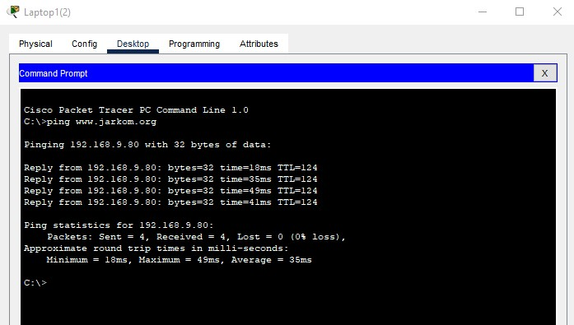

(Tes ping dari Laptop 1(2) ke [www.jarkom.org](http://www.jarkom.org) )

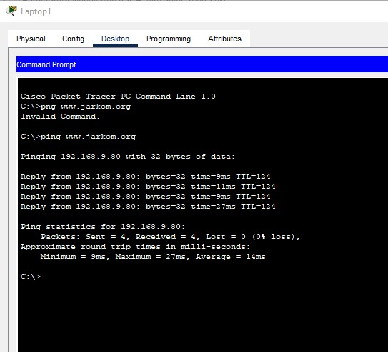

(Tes ping dari Laptop 1 ke www.jarkom.org)

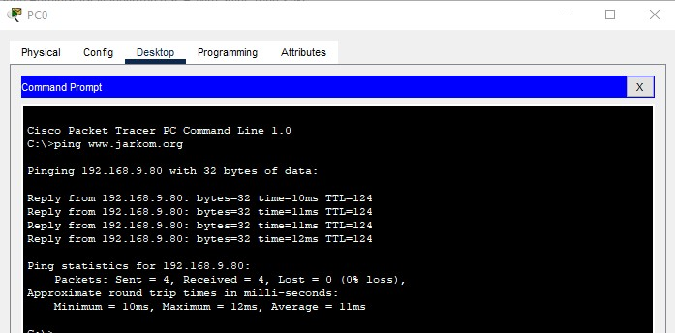

(Tes Ping dari PC0 ke www.jarkom.org)

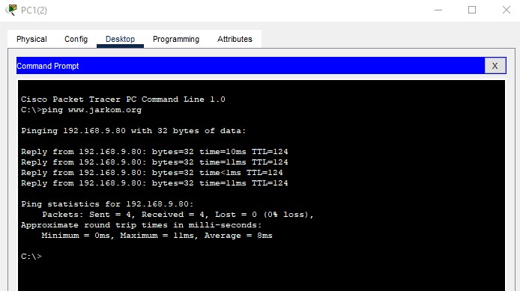

(Tes Ping dari PC1(2) ke www.jarkom.org)

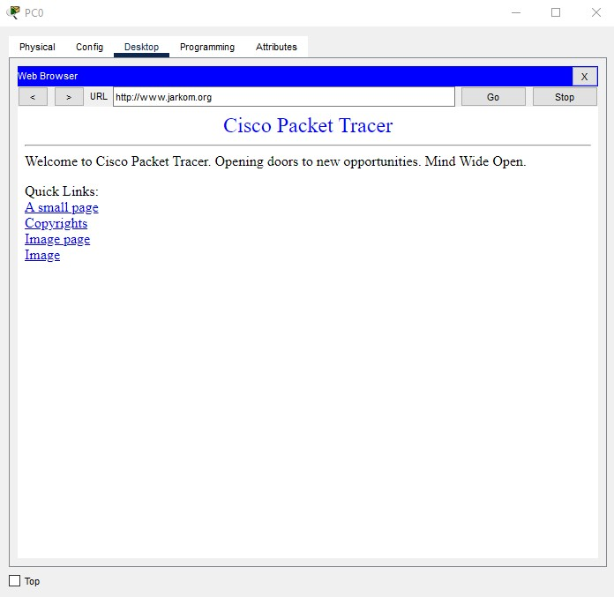

(Tes akses web [www.jarkom.org](http://www.jarkom.org) dari PC0)