 | Mizān – A Workload Management Web App  Phase 2 – Data Access Layer using a Database (weight 10%)
Group Id: |  | 11
Group Members: |  | Tamara Bassim – 202103791  Fatima Elzahra Mahgoub - 202007684  Dina Ayad - 202003969  Iman Khabaz – 202206112  Emails:  ta2103791@qu.edu.qa  fm2003969@qu.edu.qa  da2003969@qu.edu.qa  ik2206112@qu.edu.qa

Grading Rubric - In the Functionality column please specify either:
Working (completed x%), Not Working (completed x%) or Not done.
Criteria |  | % | Functionality* | Quality of the implementation
- Entity-Relation (ER) Diagram |  | 8% | Done (completed 100%)
- Seed Database |  | 10% | Done (completed 100%)
2) DB Repositories implementation |  | 76% | Done (completed 100%)
 |  Login | 5 | Done (completed 100%)
 |  Add Assessment | 10 | Done (completed 100%)
 |  Update Assessment | 6 | Done (completed 100%)
 |  Delete Assessment | 6 | Done (completed 100%)
 |  Get Assessments | 15 | Done (completed 100%)
 |  Add Course Comment (including reply to a comment) | 14 | Done (completed 100%)
 | Get Course Comments | 8 | Done (completed 100%)
 | Courses Workload Summary Report | 12 | Done (completed 100%)
3) Testing documentation using screen shots illustrating the app testing.  - Discussion of the project contribution of each team member [-10pts if not done] |  | 6% | Done (completed 100%)
Total |  | 100 | 100%
Copying and/or plagiarism or not being able to explain or answer questions about the implementation |  | -  100
* Possible grading for functionality - Working (get 70% of the assigned grade), Not working (lose 40% of assigned grade and Not done (get 0). The remaining grade is assigned to the quality of the implementation.
In case your implementation is not working then 40% of the grade will be lost and the remaining 60% will be determined based on of the code quality and how close your solution to the working implementation.
Solution quality also includes meaningful naming of identifiers (according to Web Dev naming conventions), no redundant code, simple and efficient design, clean implementation without unnecessary files/code, use of comments where necessary, proper code formatting and indentation.
Marks will be reduced for code duplication, poor/inefficient coding practices, poor naming of identifiers, unclean/untidy submission, and unnecessary complex/poor user interface design.

Entity-Relation (ER) Diagram
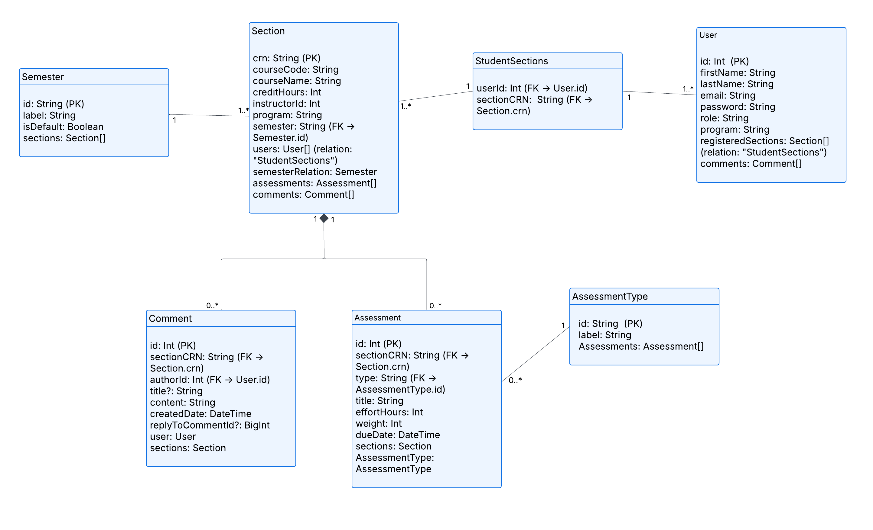

Testing
For each use case, include as evidence of a working solution both a screenshot of the app UI and a screenshot from Prisma studio of the content of database tables used.

Login
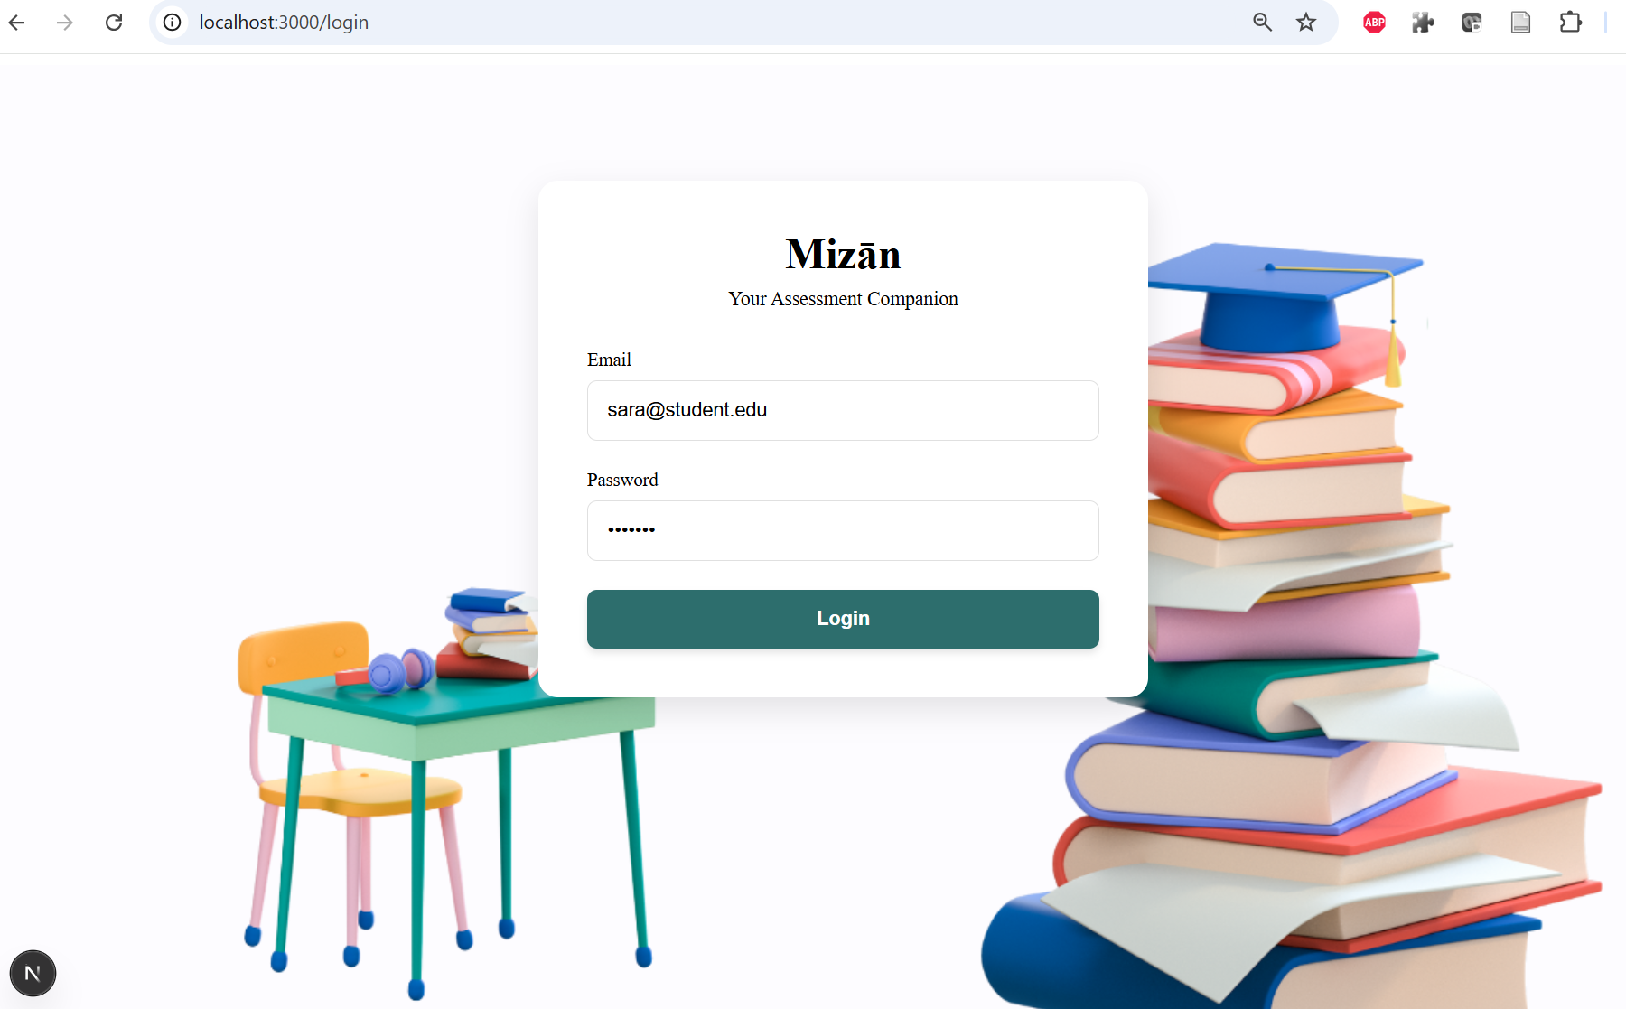

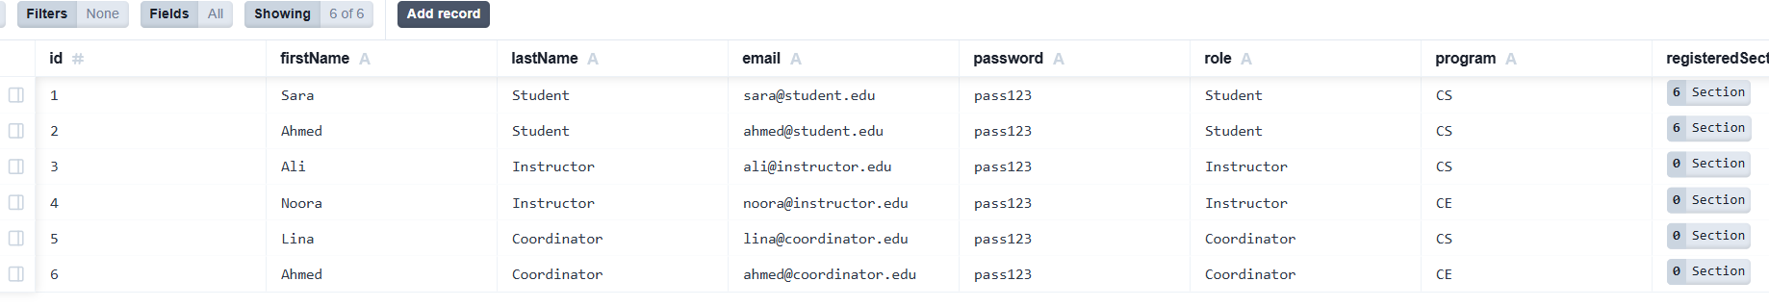

Add Assessment
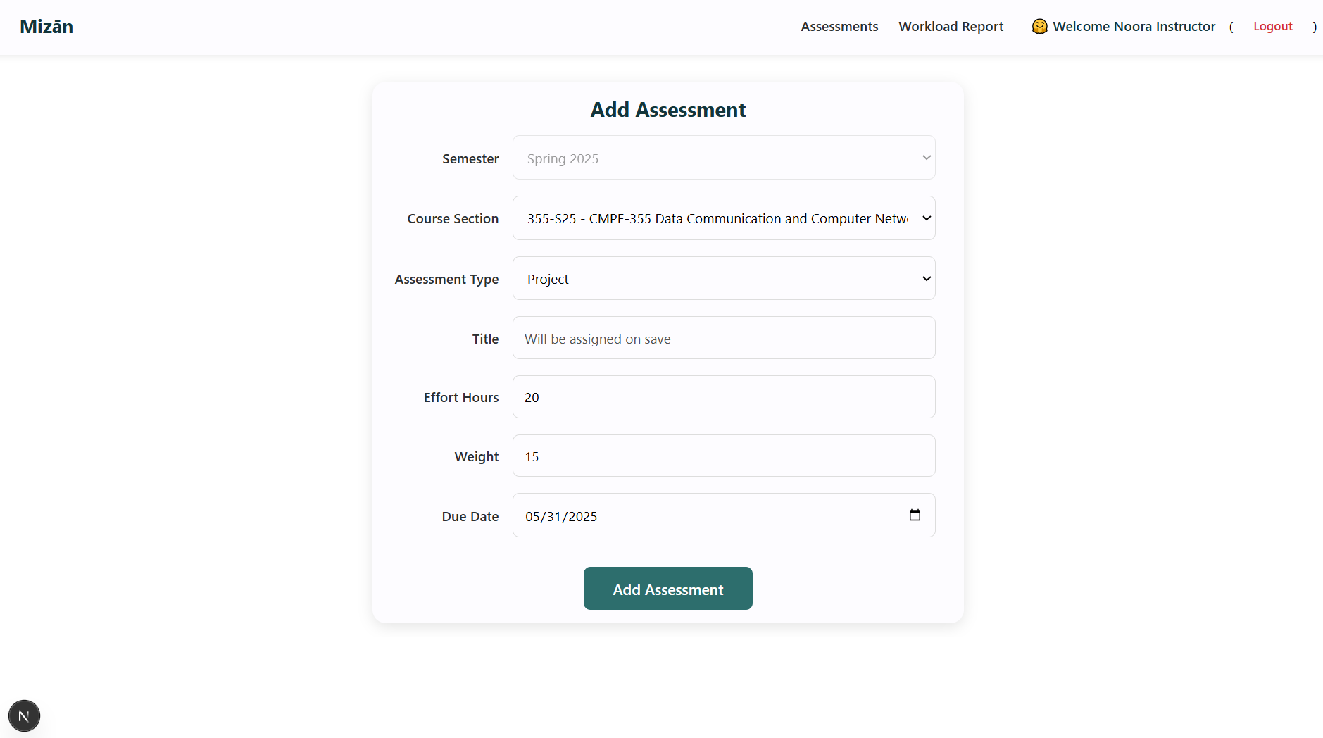
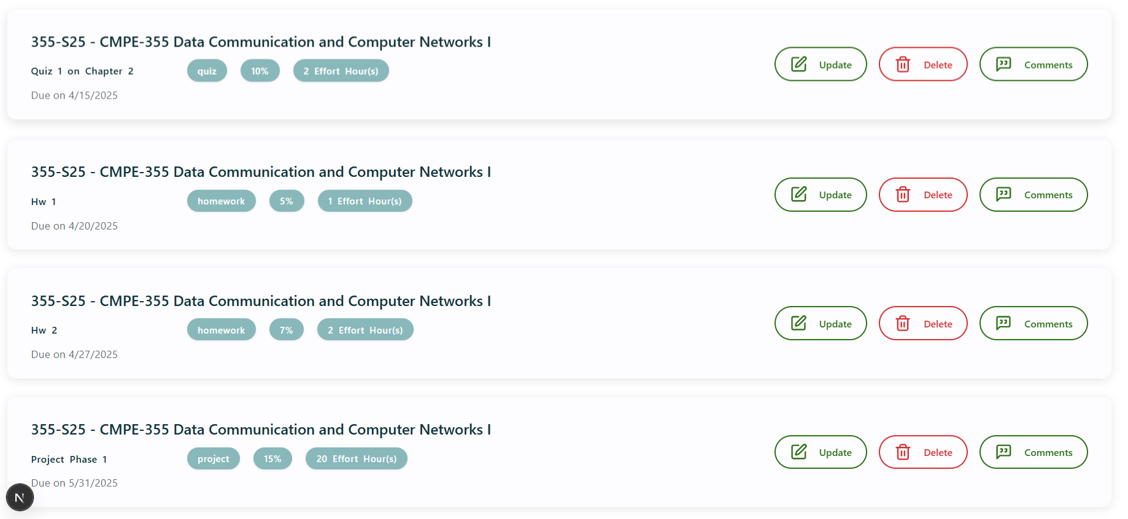
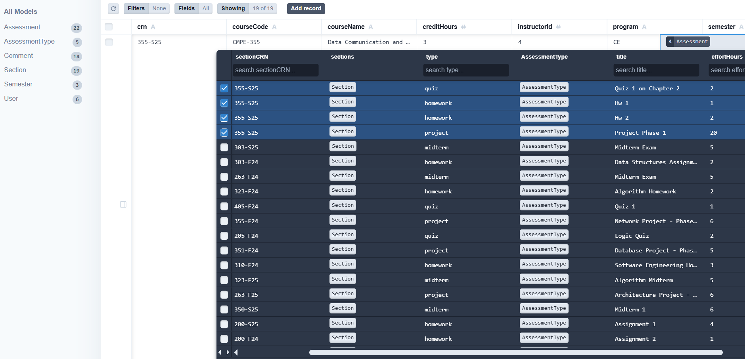

Update Assessment
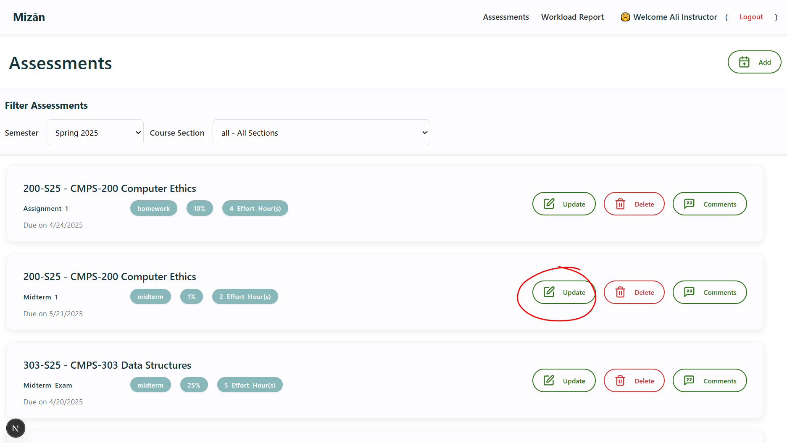
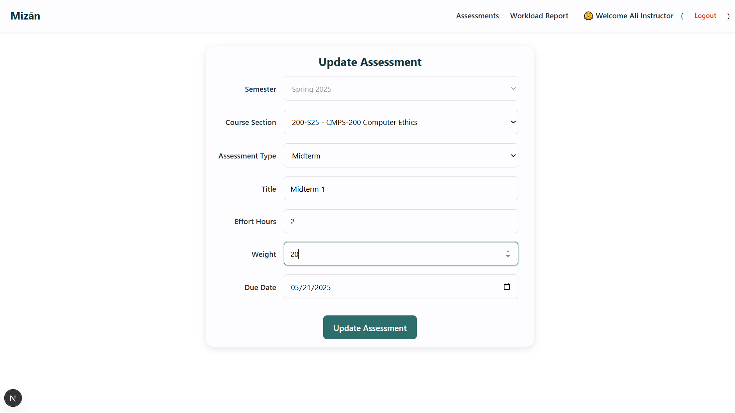
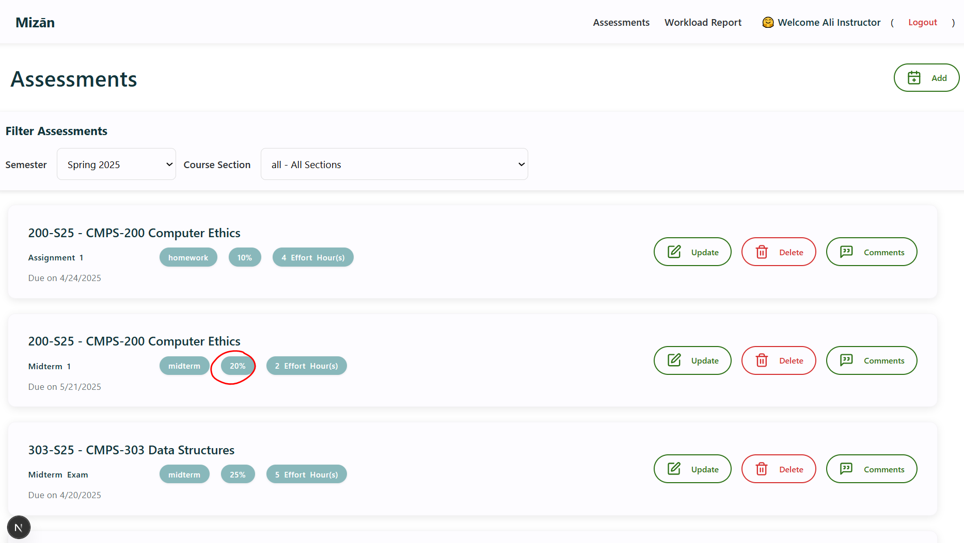
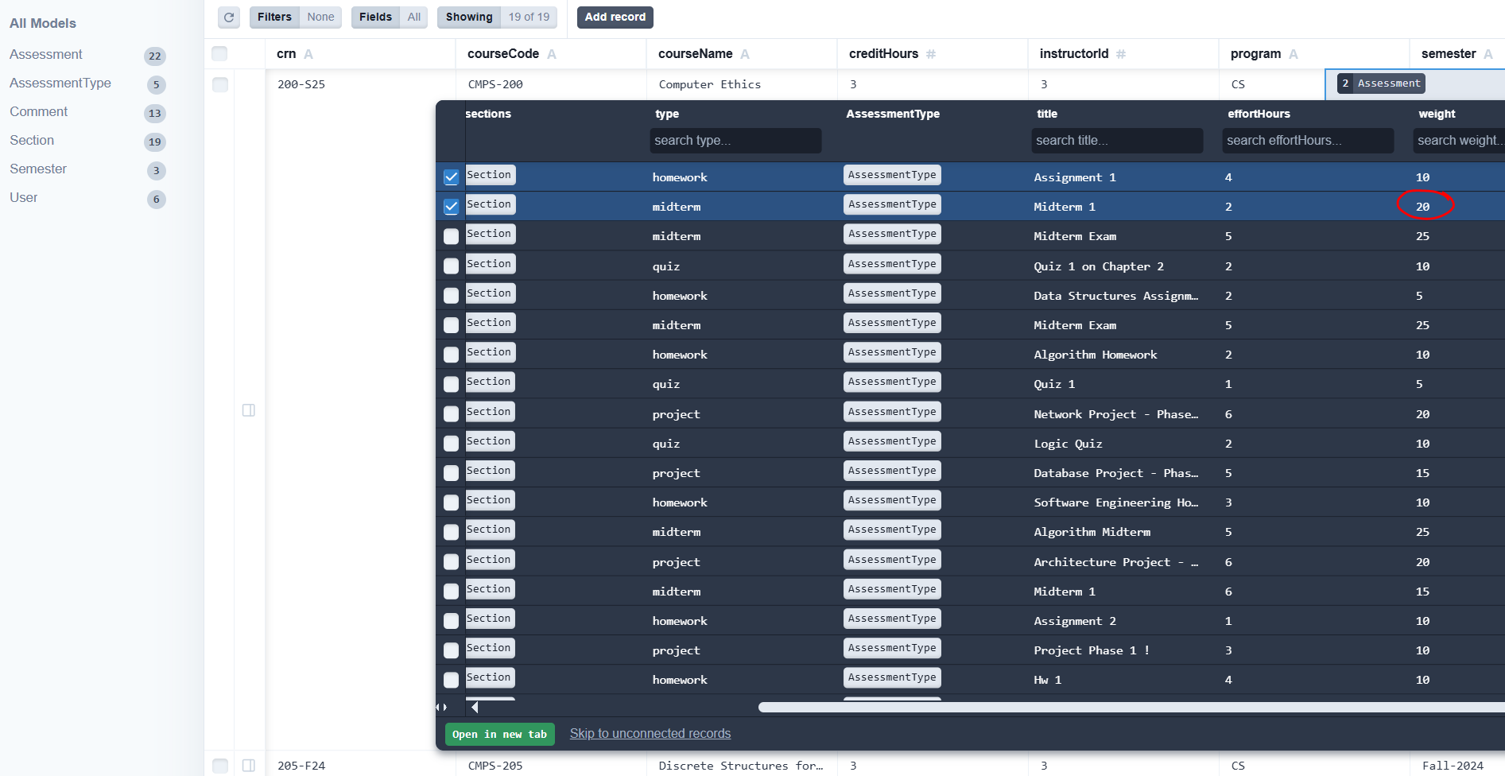

Delete Assessment
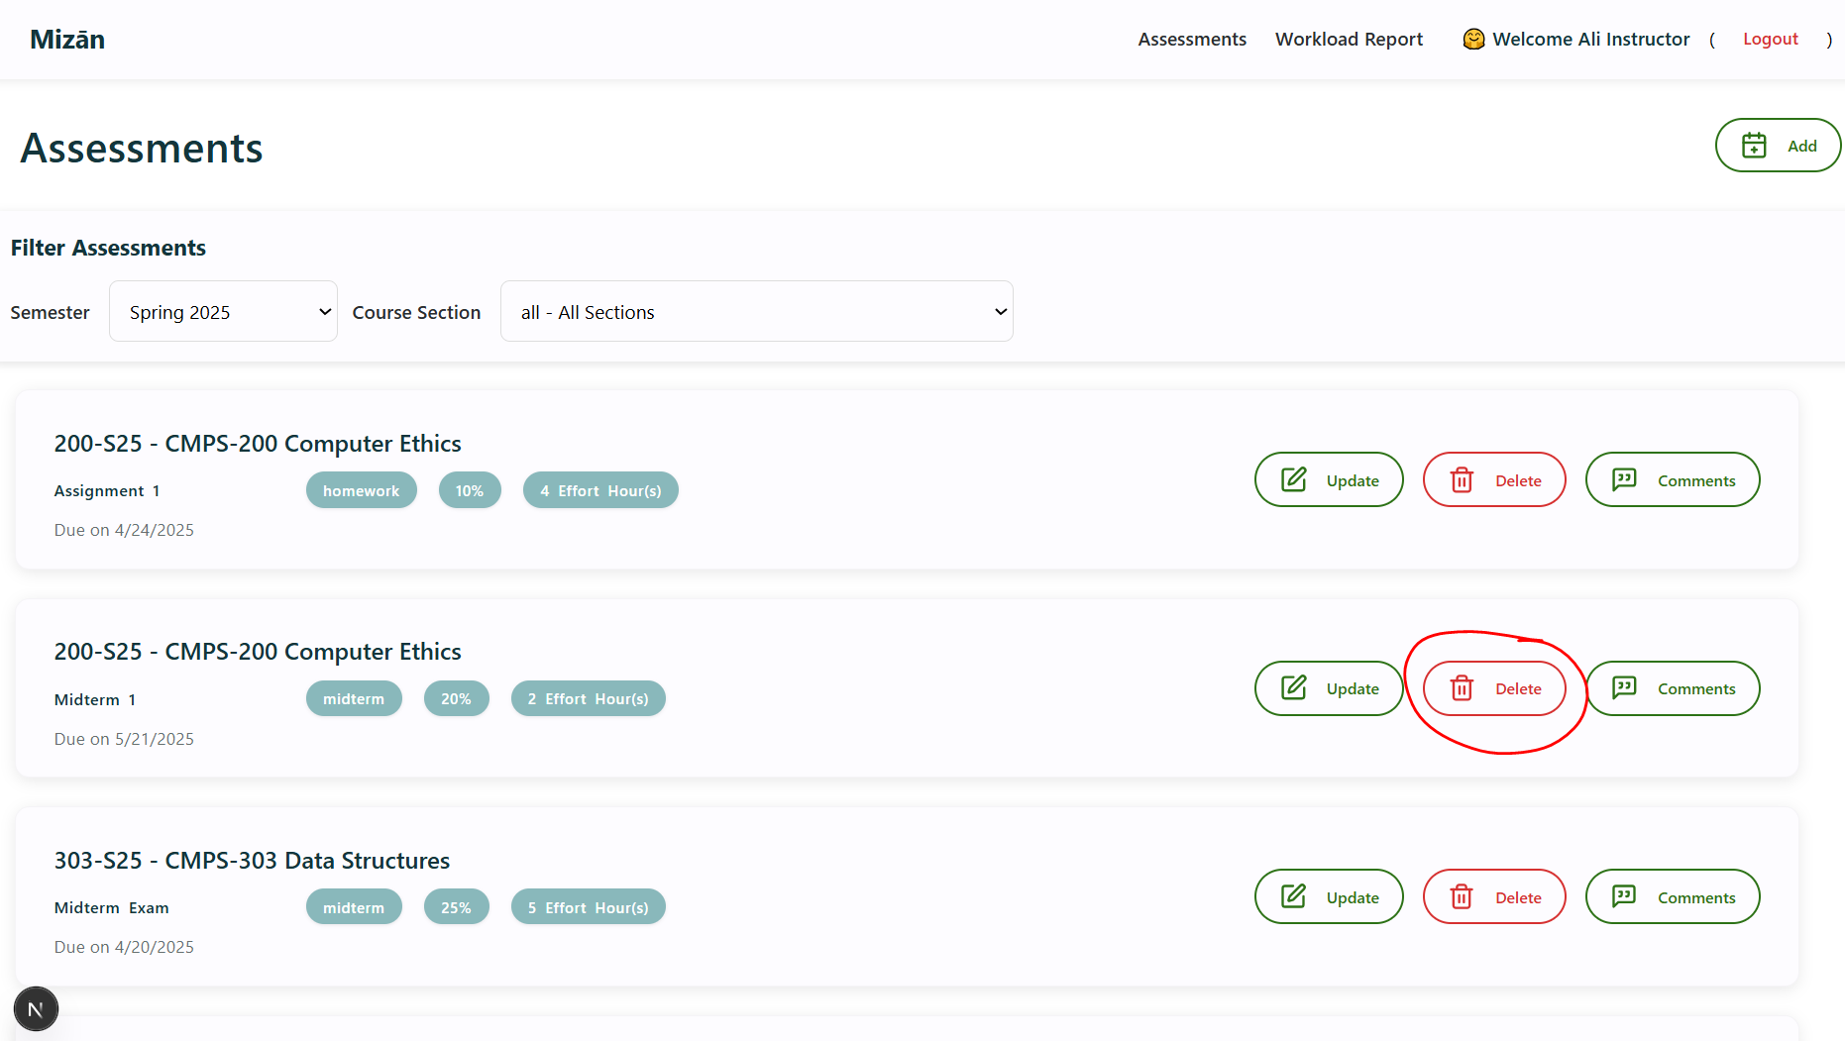
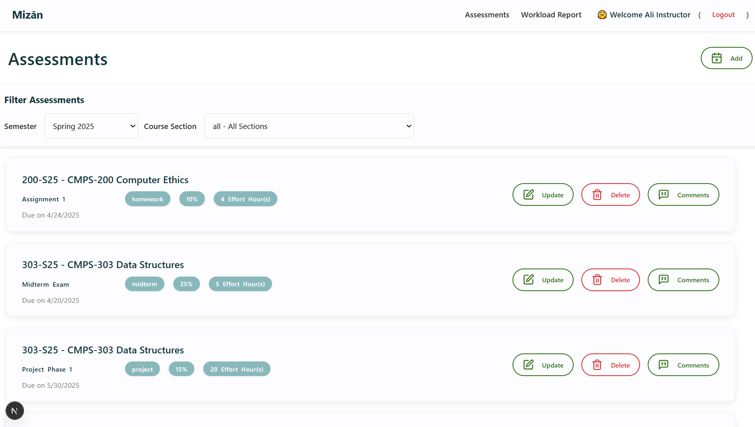
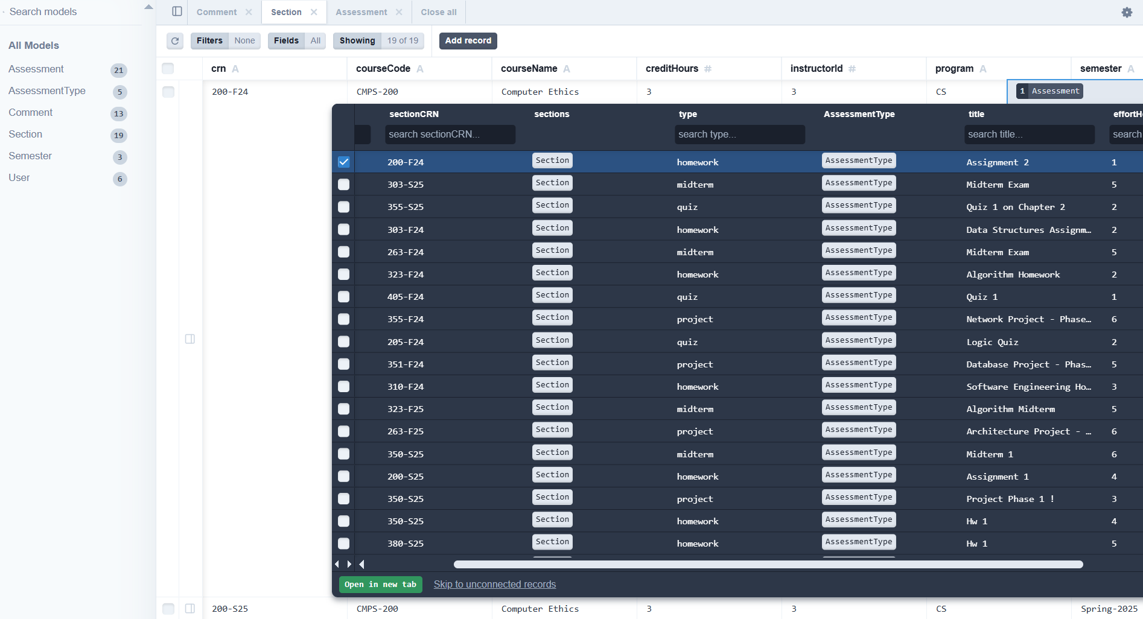

Get Assessments
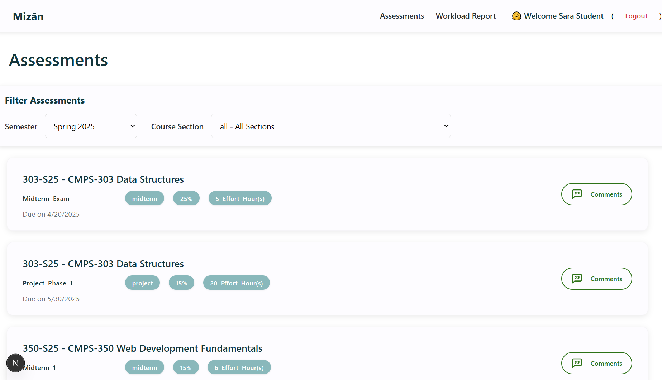

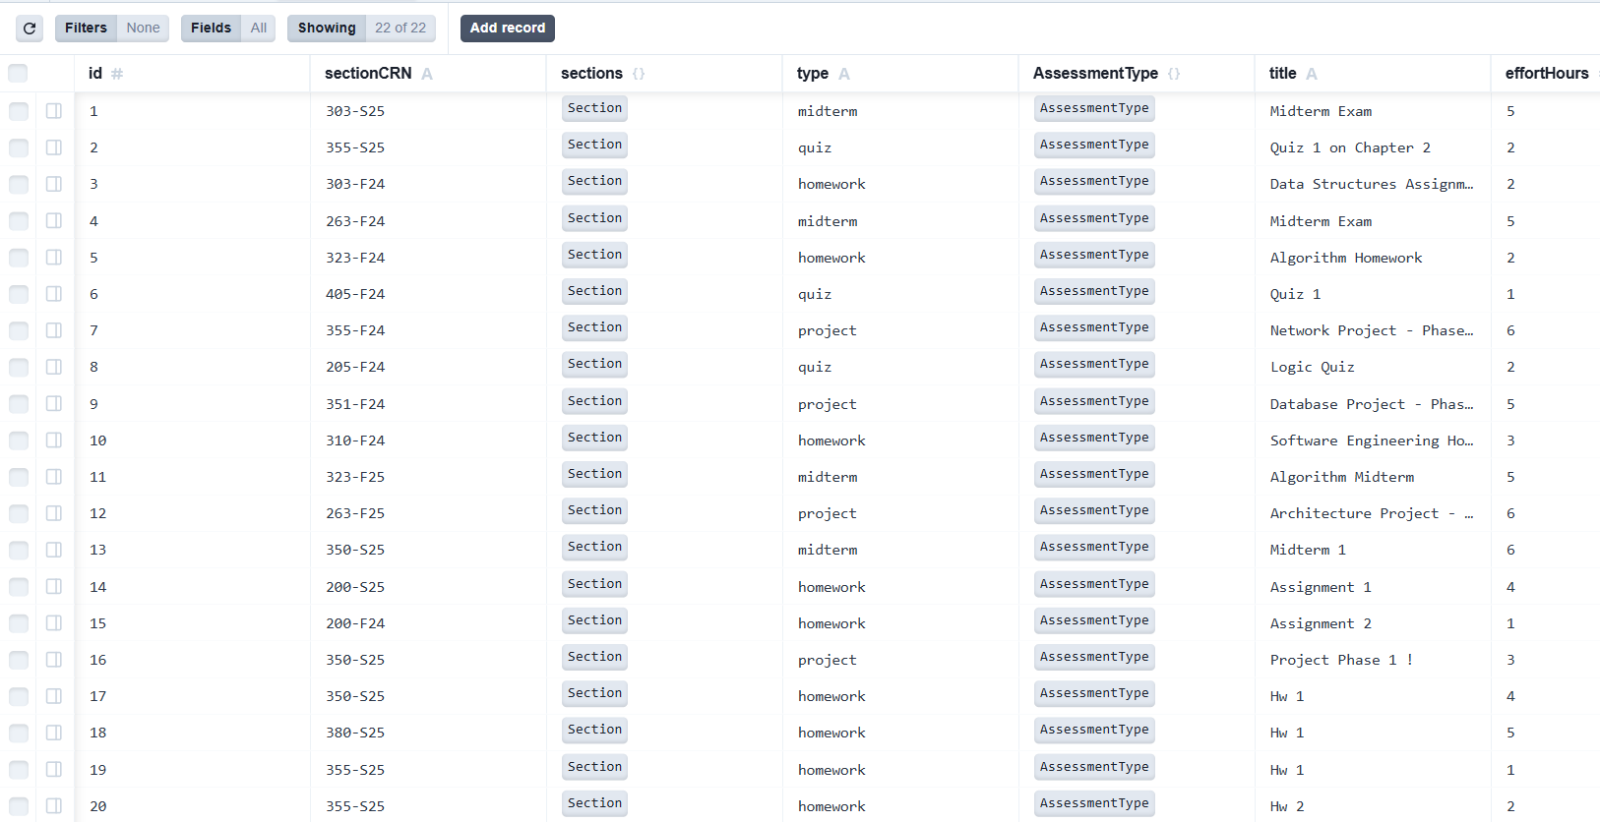

Add Course Comment (including reply to a comment)
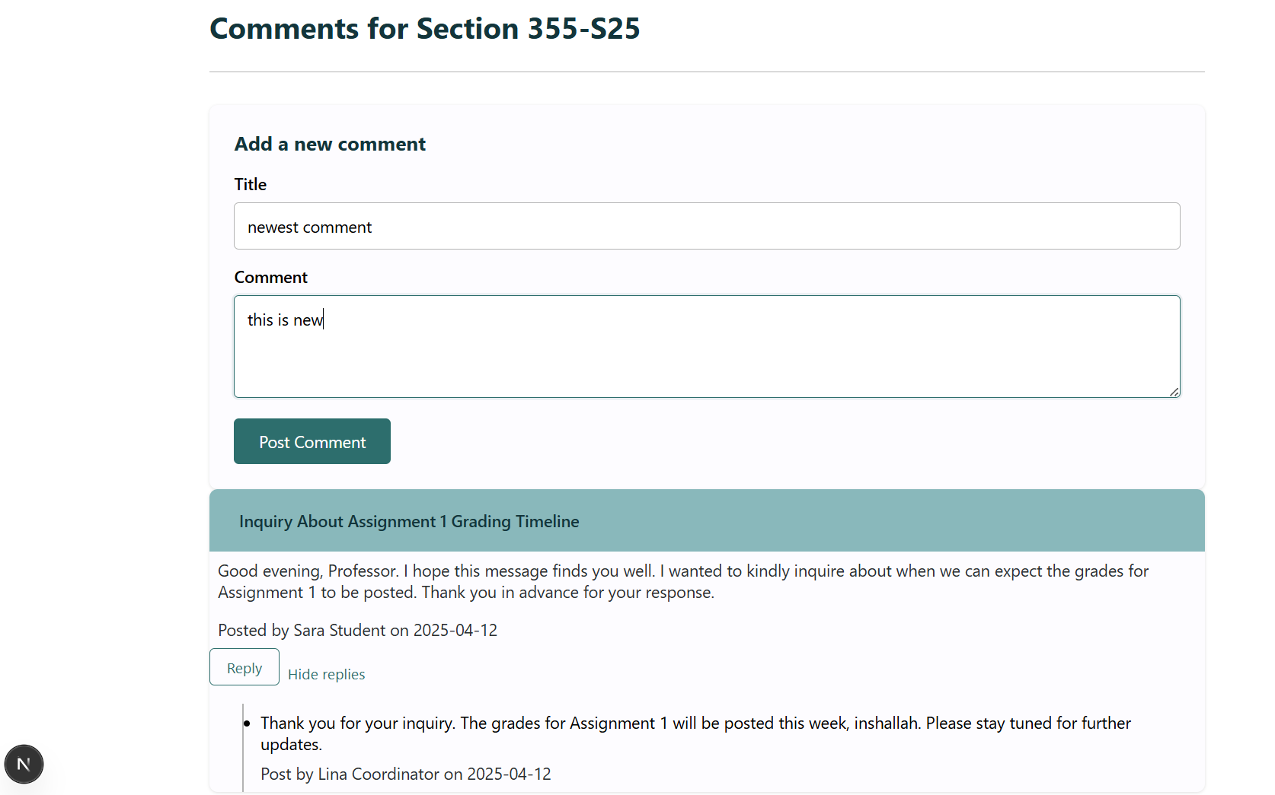

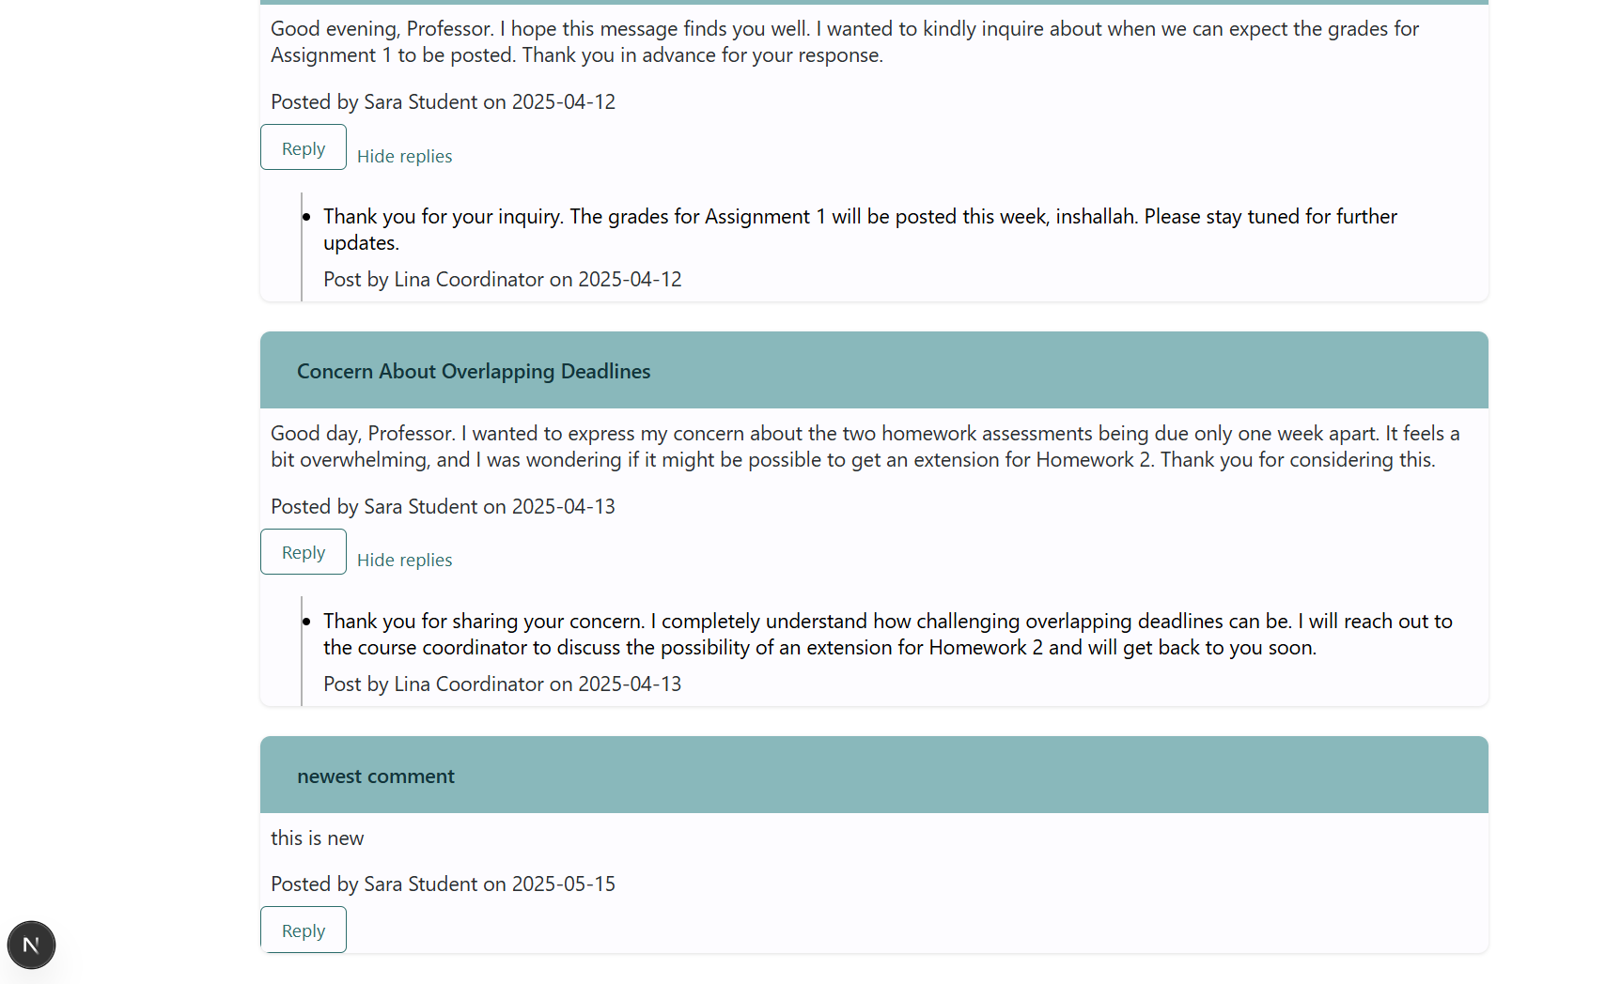
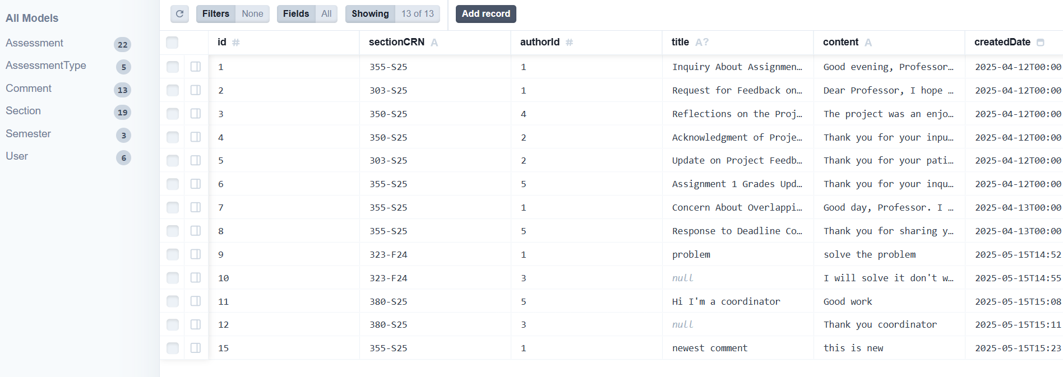

Replay to a comment
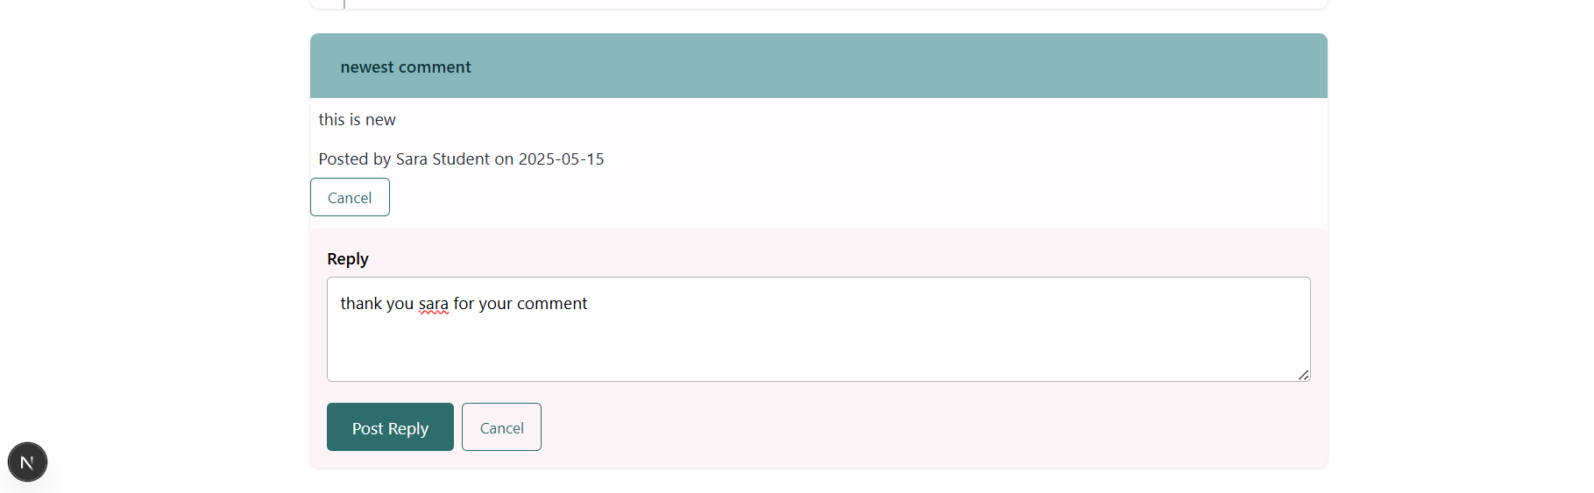
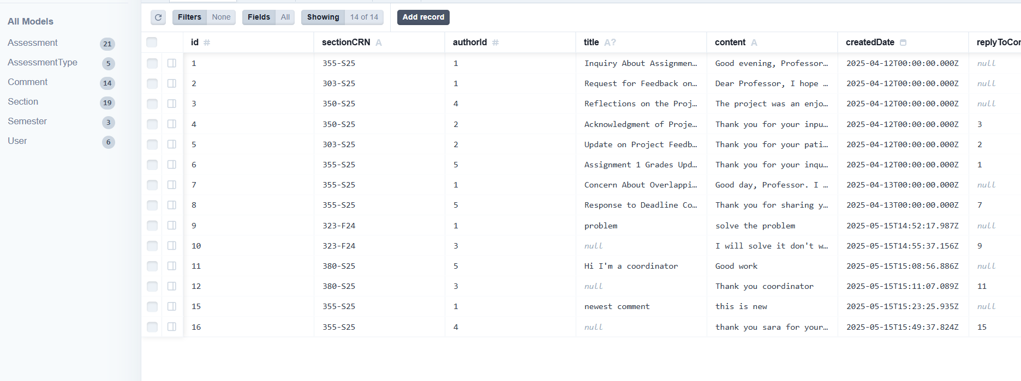

Get Course Comments
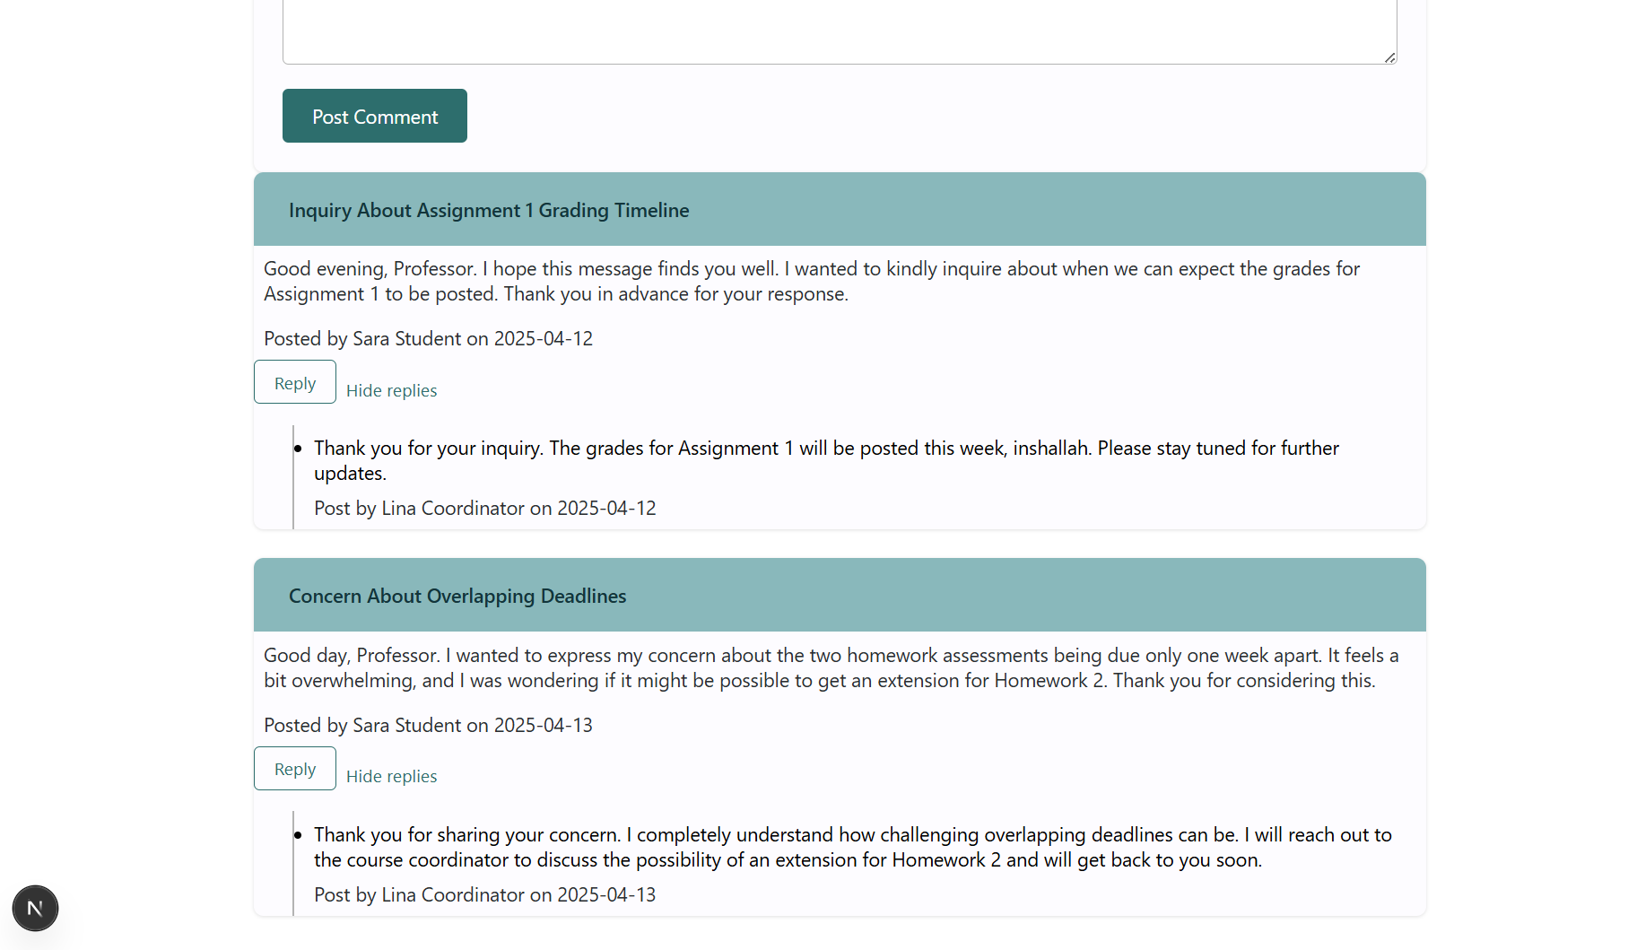
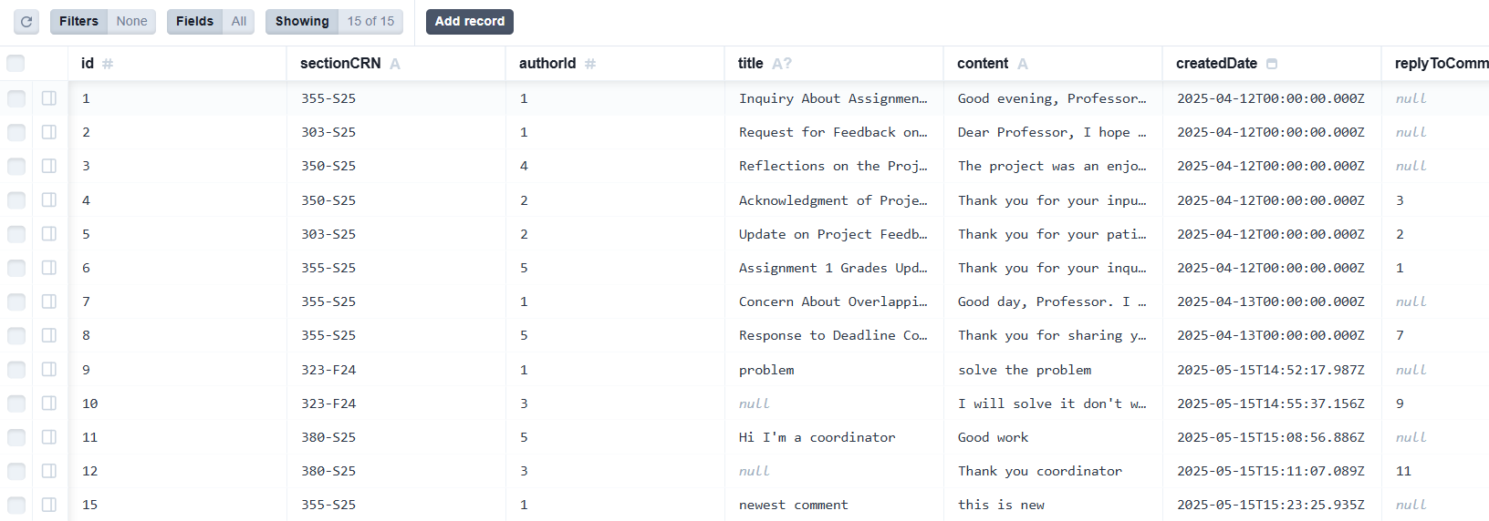

Courses Workload Summary Report
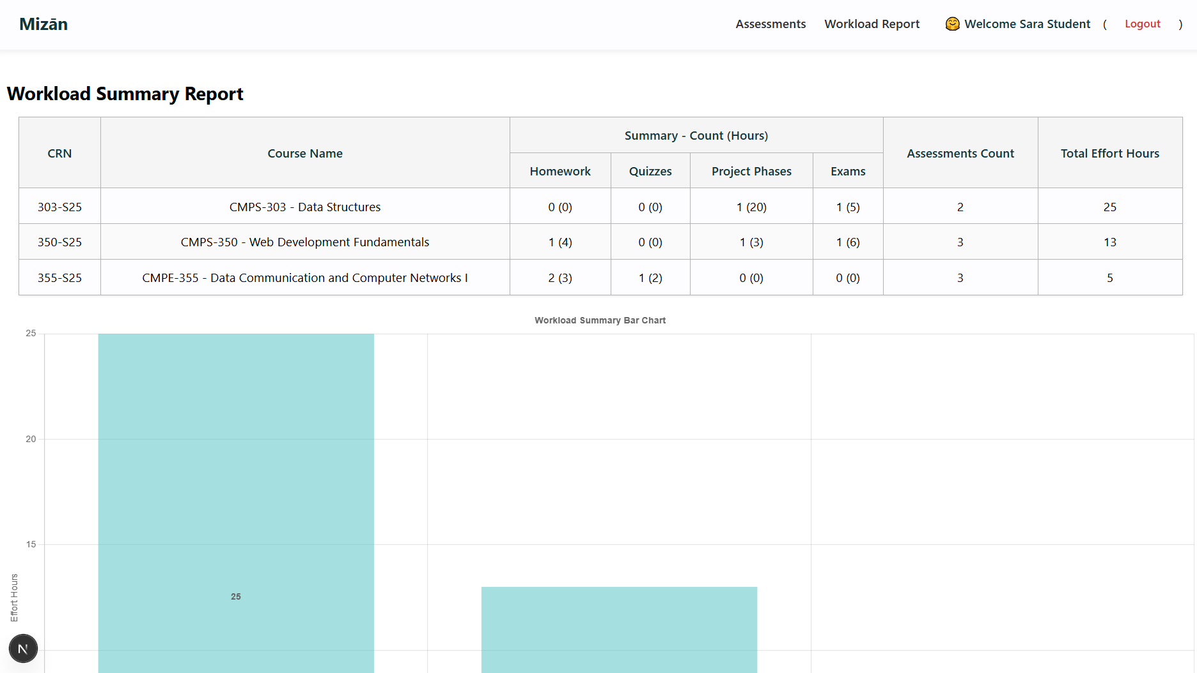
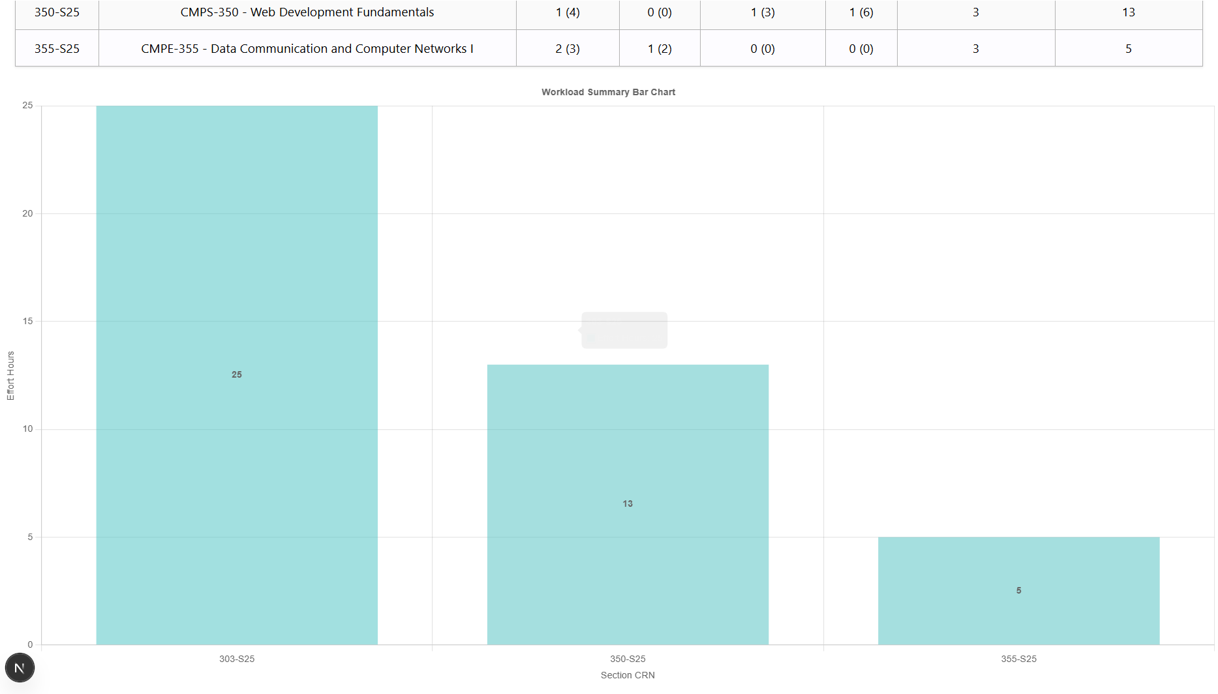

Summary of team member contributions
Member | Completed use cases / tasks
Tamara Bassim | Database Creation – Update Repositories
Fatima Elzahra Mahgoub | Database Creation – Update Repositories
Dina Ayad | Database Creation – Update Repositories
Iman Khabaz | Database Creation – Update Repositories

