Given their rigid and massive construction, a small-sized industrial robot imposes significant hazards on the people that work near it. Hence, robotic manufacturer build robot manipulators that are more compliant and designed to cooperatively without risking their safety [1]⁠⁠. Regardless, a robot manipulator imposes occupational hazard in the workspace during collision with foreign objects or a person [2]⁠. The collision also warrants expensive maintenance and repairs. An industrial robot system implements a certain degree of planning algorithm specifically for the movement of the manipulator.

A robot motion planner can provide a collision-free motion solution for a manipulator if a solution is defined as the collection of waypoints and trajectories that avoid collision between the robot and the obstacle as will be demonstrated by this paper in the following section. A global planner, an offline approach to motion planning, takes in a set of initial and goal positions, 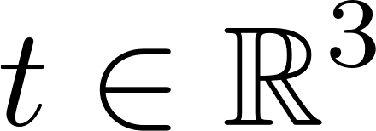, or as set of initial and goal poses, 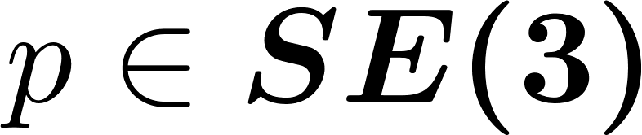, as its input constraint-informed trajectory as intermediate waypoints for the robot to follow \parencite{Deng2016}[3]⁠. However, a global planner is offline, which implies that the trajectories are set before the task commences. The global planner also assumes a static workspace. Any unplanned changes in the workspace over the global planning scheme, such as an unplanned introduction of a stationary object or a moving object into the robot workspace, renders the offline-planned trajectory outdated and, consequently, requires replanning.
Hence, a compliant manipulator or cooperative manipulator must have an efficient online motion planner because of the dynamic aspect of their workspace. However, this requires replanning which is computationally expensive and time-consuming. This is why sampling-based planners are used the pinnacle example of efficient planning \parencite{Elbanhawi2014}[4]⁠. Unfortunately, sampling-based planner trade completeness and optimality with efficiency where the planner may fail to provide a solution \parencite{Kavraki1998}⁠. Also, if a solution exists under its metric space, the waypoints may not be the least cost path to a goal \parencite{LaValle1998}.
Regardless of lack of completeness and optimality, sampling-based planner excel at maintaining reasonable usage of computational resources that pave way to the near-online planning scheme. The sampling-based planners for robot motion are a family of planners that uses probabilistic approach to generate a graph structure encoding the free space and the robot configuration space. The samplings are stochastic, such that resampling will give a unique solution to the previous sampling. Most sampling-based planners are also tractable in higher-dimensional configurations and task space. However, sampling-based planners assume a static workspace.
This paper use a sampling-based motion planning, the rapidly-exploring random tree motion planning, to address operation task in a dynamic environment in Euclidean space, . Our method leverages the efficiency and the computationally reserved sampling-based motion planning without needing to apply a purely reactive motion planning approach so that computational resources can be delegated to other tasks, i.e., motion-tracking, state estimation, mapping, localization, and motion control. In the following sections of this report, we will assume sampling planners to provide solutions in higher dimensional configuration space, which implicates a solution with a set of poses represented by the special Euclidean group, .
- RELATED WORK
The research done in \parencite{Kavraki1998} [5]⁠is the seminal work on the use of probability model for sampling the configuration space for holonomic robot motion such as a manipulator robot. The planner is called the probabilistic roadmap (PRM). The algorithm constructs a graph structure to find a path between an initial pose to a goal pose in a two-dimensional configuration space, . A more general solution for higher dimensional configuration space, , were also proved using the PRM their work. With graph structure, more than one path connects the initial pose to the goal pose. Therefore, PRM is a multi-query type planner.
The work in \parentcite{Kunz2010a}[6]⁠ improved PRM by redefining the distance metric of a robot manipulator so that the robot can move around a moving obstacle in real-time. Their approach performs well in an uncluttered environment. They also redefined the distance function of the PRM to address dynamic objects, such as a walking person, into a two-dimensional map. Although the configuration space of the manipulator is in , the map, constructed from a two-dimensional LiDAR scan, is in, .
In retrospect, the RRT was formulated for non-holonomic motion targeting problems addressed in diffential-constrained motion such as a car on a plane \parencite{LaValle1998}⁠[7]⁠. However, given the model of its metric space and consequently the configuration space, RRT are tractable for higher dimensional problem such as manipulator motion in 3D space . RRT assumes a static environment but investigateion in \parencite{Wei2018}[8]⁠ successfully changed the way RRT samples a robot metric space so that it is fast enough to react to a changing environment. Also, unlike PRM, RRT works well in a cluttered environment because of the randomized sampling on the robot configuration space in the context of the metric space.
Apart from the works in \parencite{Kunz2010a}⁠[6]⁠ and \parencite{Wei2018}⁠[8]⁠, few have applied their planning algorithms on a robot manipulator despite few have applied their planning algorithms on a robot manipulator despite having RRT and PRM algorithms provide mathematical framework for planning for multi-body and multi-frame systems. In this paper, we will use the method demonstrated by \parencite{Kunz} and \parencite{Wei2018} to design a moving obstacle avoidance algorithm with the implementation of the vanilla RRT to solve motion for a robot manipulator in three-dimensional space, . Our method implements the vanilla RRT where we do not represent the obstacle configuration space unlike in \parencite{Wei2018}.
- FORMULATION AND ALGORITHMS
- This paper will use the superscript notation to refer the control space and the subscript as the equivalent representation in the configuration space. For example, , refers to the control space of the end-effector where the controlling pipelines would take in , and the equivalent pose is in the configuration space, . Since, revolute joint topology is the 1-hypersphere, , we will assume that, for the case of 6R robot, it's joints are limited to a certain range which makes, 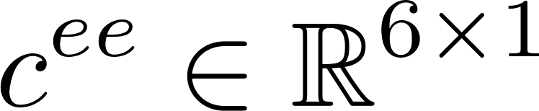.
- The Geometry of a Compliant Robotic Arm, r_mini
We prototype and build a 3D-printed robot called Richard Mini (r_mini, see Fig. 1) based on the conditioned addressed by Pieper \parencite{Pieper1968}[9]⁠, which entails three collated joints sharing the same cross point of their, z-axes, shown in Fig. 2.
r_mini has six revolute axes, 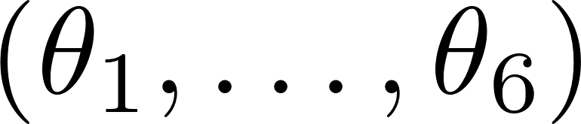. The first three axes move the task space from one point to another representing translation vector, . The last three axes of the manipulator rotate the task space representing the rotation operation about the task space frame, 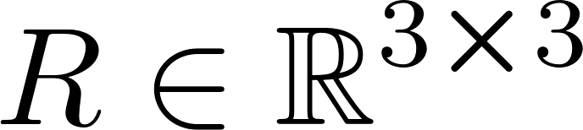. Hence the complete transformation of the task space via the joint movement is represented by the homogenous transformation matrix, 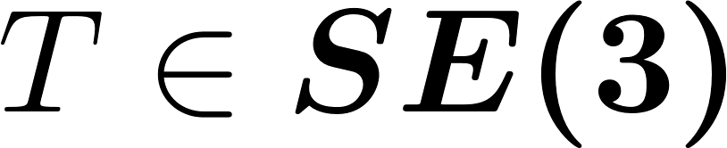, where 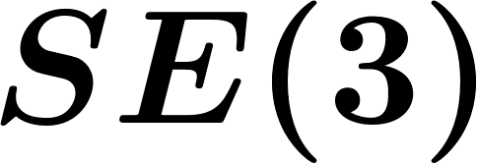 is homomorphic to 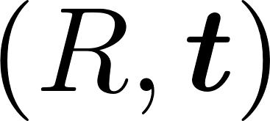; 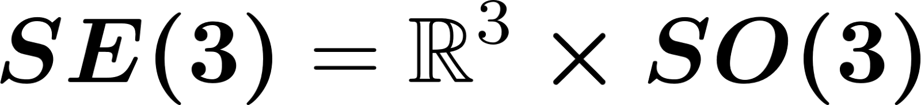. The matrix representation of the homogenous transformation is shown in Eq. (1). (use equation to write these mathematical sample)

 | 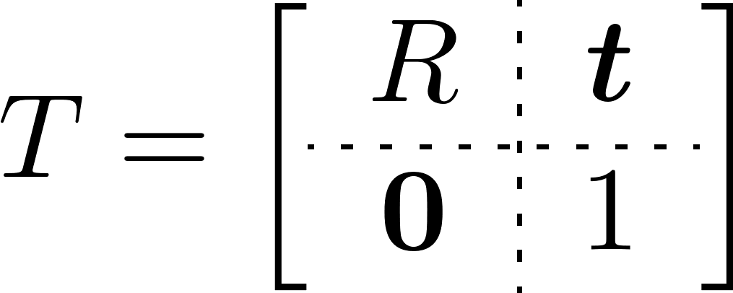 | (1)

The kinematic models of the r_mini follows the Denavit-Hartenberg (DH) formulation [10]⁠.

[1] M. Hägele, K. Nilsson, J. N. Pires, and R. Bischoff, “Industrial robotics,” in Springer Handbook of Robotics, Springer International Publishing, 2016, pp. 1385–1421. doi: 10.1007/978-3-319-32552-1_54.
[2] B. Matthias, S. Kock, H. Jerregard, M. Källman, and I. Lundberg, “Safety of collaborative industrial robots: Certification possibilities for a collaborative assembly robot concept,” in Proceedings - 2011 IEEE International Symposium on Assembly and Manufacturing, ISAM 2011, 2011, no. 230902. doi: 10.1109/ISAM.2011.5942307.
[3] H. Deng, Z. Xia, and J. Xiong, “Robotic manipulation planning using dynamic RRT,” in 2016 IEEE International Conference on Real-Time Computing and Robotics, RCAR 2016, Dec. 2016, pp. 500–504. doi: 10.1109/RCAR.2016.7784080.
[4] M. Elbanhawi and M. Simic, “Sampling-based robot motion planning: A review,” IEEE Access, vol. 2. Institute of Electrical and Electronics Engineers Inc., pp. 56–77, 2014. doi: 10.1109/ACCESS.2014.2302442.
[5] L. E. Kavraki, M. N. Kolountzakis, and J. C. Latombe, “Analysis of probabilistic roadmaps for path planning,” IEEE Trans. Robot. Autom., vol. 14, no. 1, pp. 166–171, 1998, doi: 10.1109/70.660866.
[6] T. Kunz, U. Reiser, M. Stilman, and A. Verl, “Real-time path planning for a robot arm in changing environments,” IEEE/RSJ 2010 Int. Conf. Intell. Robot. Syst. IROS 2010 - Conf. Proc., pp. 5906–5911, 2010, doi: 10.1109/IROS.2010.5653275.
[7] S. M. LaValle, “Rapidly-Exploring Random Trees: A New Tool for Path Planning,” 1998. Accessed: Sep. 25, 2022. [Online]. Available: https://www.cs.csustan.edu/~xliang/Courses/CS4710-21S/Papers/06 RRT.pdf
[8] K. Wei and B. Ren, “A method on dynamic path planning for robotic manipulator autonomous obstacle avoidance based on an improved RRT algorithm,” Sensors (Switzerland), vol. 18, no. 2, 2018, doi: 10.3390/s18020571.
[9] D. L. Pieper, “The Kinematics of Manipulators Under Computer Control,” Stanford University, 1968.
[10] J. Denavit and R. S. Hartenberg, “A Kinematic Notation for Lower-Pair Mechanisms Based on Matrices,” J. Appl. Mech., vol. 22, no. 2, pp. 215–221, 1955, doi: 10.1115/1.4011045.

