[SMART CHILD HUB LOGO PLACEHOLDER]
DESIGN SYSTEM
User Interface and User Experience Guide
Smart Child Daily Activity Tracking System
An Offline Family Dashboard for Monitoring Children’s Daily Habits
Phase 2 – UI/UX Design System (Material 3 · Glassmorphism · Soft UI)
Prepared for the development team
Version 1.0.0
August 2026

TABLE OF CONTENTS
Table of Contents will update when opened in Microsoft Word (right-click → Update Field).

LIST OF FIGURES
Table of Contents will update when opened in Microsoft Word (right-click → Update Field).

CHAPTER ONE

INTRODUCTION

1.1 Purpose of the Design System
The Smart Child Hub design system is the single source of truth for the user interface and user experience of the Smart Child Daily Activity Tracking System. It defines the visual language, design tokens, colour palettes, typography, spacing, motion, components, icons, illustrations and screen layouts that will be used to build the application in Flutter during Phase 3. Every pixel of every screen, every component and every animation shown in this document is specified with exact values so that implementation is deterministic and does not require creative interpretation.
The system deliberately blends three contemporary UI styles: a Material 3 foundation for consistency and accessibility, a glassmorphism treatment (translucent frosted panels over soft gradients) for a modern, layered feel, and soft UI (large rounded shapes, gentle shadows and friendly colours) so that the interface feels warm and approachable for young children. The result is a playful child mode and a professional parent mode that share one underlying token system.

1.2 Scope
This design system covers the complete visual and interaction design of the application. It includes two colour themes (light and dark), a 19-style type scale built from three fonts (Baloo 2, Quicksand and Nunito), a 4–64 px spacing scale, four elevation levels, six motion curves and seven reference durations, eleven component boards, twenty-two full-screen mockups, fifty-two custom SVG icons and five illustrations. The scope is strictly visual and interactional; no Flutter, PHP, MySQL or API implementation code is included in this phase.

1.3 How to Use This Guide
- Designers use the mockups and component boards to validate new screens against the visual language.
- Developers read the design tokens and widget guide to map every token to a Flutter theme before writing widgets.
- Reviewers check screens against the accessibility rules, contrast minimums and touch-target minimums defined in Chapter 3 and Chapter 9.

1.4 Deliverables Overview
1: Phase 2 deliverables at a glance
Deliverable | Location | Count / Format
Design tokens | scripts/tokens.py | 1 source file
UI Style Guide | style-guide/UI_Style_Guide.pdf | 15 pages
Color Palette | style-guide/Color_Palette.pdf | 16 pages
Typography Guide | style-guide/Typography_Guide.pdf | 11 pages
Component Library | style-guide/Component_Library.pdf | 24 pages
Animation Guide | style-guide/Animation_Guide.pdf | 13 pages
Responsive Guide | style-guide/Responsive_Guide.pdf | 11 pages
Widget Guide | style-guide/Widget_Guide.pdf | 13 pages
Component boards | components/ | 11 PNG boards
Screen mockups | mockups/ | 22 PNG screens
Icons | assets/icons/ | 52 SVG files
Illustrations | assets/illustrations/ | 5 SVG files
Screen specifications | design-system/specs/ | docx + markdown
Navigation flow | design-system/specs/ | docx + markdown

1.5 Design Personas and Modes
The interface has two distinct visual voices backed by one token system. Child mode is bright, big and joyful: Baloo 2 display type, the Sunny mascot, candy accents, large cards and confetti. Parent mode is calm and professional: Nunito type, tighter spacing, data-dense charts and tabular numerals. The switch is automatic based on the active profile, never a setting the child can change.
2: Child mode versus parent mode
Characteristic | Child Mode (My Day) | Parent Mode (Family Manager)
Display type | Baloo 2 (700–800) | Nunito (600–800)
Body type | Quicksand (500–700) | Nunito (400–600)
Numerals | Quicksand tabular | Nunito tabular
Layout density | Spacious (16–32 px) | Compact (8–16 px)
Navigation | Bottom bar | Navigation rail + app bar
Accents | Candy, sky, grape | Primary blue, success green
Motifs | Sunny, coins, stars | Charts, tables, approvals

CHAPTER TWO

DESIGN PRINCIPLES AND VISUAL LANGUAGE

2.1 The Four Design Principles
1. Playful – big rounded shapes, the friendly Sunny mascot and warm colours make routines feel like games, never chores. Everything in child mode is scaled, spaced and coloured for delight first.
2. Clear – one primary action per screen, big type and generous spacing mean a four-year-old and a parent both understand the screen instantly. No hidden gestures, no ambiguous icons.
3. Safe – parent-only zones sit behind a PIN. The app runs completely offline with no accounts, no ads and no internet dependency, keeping the family’s data private inside the home.
4. Rewarding – coins, badges and confetti celebrate every win and turn effort into visible, motivating progress. Positive reinforcement is the core emotional loop.

2.2 Visual Language
- Frosted glass (glassmorphism) panels with soft translucent fills over a subtle gradient backdrop create depth without heavy borders.
- Soft UI rounded rectangles (8–32 px radii), low-contrast soft shadows and muted surface tints keep the interface gentle on the eye.
- Gradients reserved for hero areas, the splash, celebrations and the Sunny mascot; content surfaces stay clean and flat.
- Illustration the Sunny mascot and five supporting illustrations carry the personality; they never carry critical information.

2.3 The Mascot: Sunny
Sunny is a smiling sun used across the brand, the splash screen, empty states, celebrations and the child dashboard. Sunny is drawn in flat vector style with the brand colours, an orange glow, rosy cheeks and a friendly closed-mouth smile. The mascot animates with a gentle bobbing motion on idle screens and spins into the splash screen. Sunny is always a supporter, never a judge: on error states Sunny appears helpful and calm.

2.4 Voice and Tone
- Child voice short positive sentences, encouraging words (“Great job!”, “You did it!”), never shame or negative framing for missed tasks.
- Parent voice clear, factual and reassuring (“3 approvals pending”, “Backup completed”).
- Error tone constructive: explain what happened and the one action that fixes it, never blame the child.

CHAPTER THREE

COLOUR SYSTEM AND DESIGN TOKENS

3.1 Token Philosophy
All colours are stored as semantic tokens, not raw hex values. Screens and components reference token names such as primary, surface and success so that theming (light, dark, brand tweaks) is a single point of change. The complete token set is defined in scripts/tokens.py and rendered as reference boards in components/10_colors.png.

3.2 Brand Palette
3: Brand colour tokens (light theme)
Token | Light Value | Purpose
primary | #4F6BF5 | Primary actions, selected states
onPrimary | #FFFFFF | Content on primary
primaryContainer | #DDE5FF | Soft primary backgrounds
onPrimaryContainer | #0E1E5C | Content on primary container
secondary | #FF8A3D | Secondary actions, highlights
secondaryContainer | #FFE0C7 | Soft secondary backgrounds
tertiary | #1FBFA0 | Verified/success accents, brand pop
background | #F7F8FE | Screen background (light)
surface | #FFFFFF | Cards and surfaces
onSurface | #191A24 | Primary text
surfaceVariant | #E9EAF6 | Dividers, subtle fills
onSurfaceVariant | #43434F | Secondary text
outline | #767685 | Borders, icons at rest
outlineVariant | #D5D6E4 | Light borders

3.3 Accent Colours
4: Accent tokens for avatars, categories and delight
Token | Value | Use
sunshine | #FFC93C | Coins, sparkles, celebration
candy | #FF7BA9 | Child avatars, playful accents
sky | #54C3F6 | Child avatars, weather-friendly tints
grape | #A98BFF | Badges, child avatars
mint | #3DDB9E | Success flourishes, fresh tints
peach | #FFB37A | Warm tints, secondary highlights

3.4 Semantic and Status Colours
Status is never communicated by colour alone; each task status pairs its colour with an icon and a text label. This keeps the interface accessible for colour-blind users.
5: The six task status colours
Status | Value | Icon | Meaning
completed | #2FAE66 | check | Task done and verified
pending | #FF9F0A | clock | Waiting for parent approval
rejected | #E5484D | close | Submission rejected by parent
verified | #1FBFA0 | shield | Self-checked and accepted
missed | #8E8E99 | flag | Due date passed without completion
locked | #B9BAC6 | lock | Task not yet available

3.5 Badge Tiers
6: Achievement badge tier colours
Tier | Foreground | Background | Feeling
bronze | #C98A5B | #F5E0D1 | Getting started
silver | #9AA4B5 | #E9EDF3 | Consistent effort
gold | #E8A500 | #FCEFC8 | Outstanding streak
diamond | #3FB9E0 | #D8F3FB | Elite achievement

3.6 Dark Theme
The dark theme keeps the exact same token structure and hue families but shifts luminance. Surfaces become deep indigo-greys, primary becomes a light periwinkle (B7C4FF) so it stays legible on dark surfaces, and error shifts to a lighter red (FFB4AB). The full dark palette is rendered in the Color Palette guide and on the colour board.

3.7 Contrast and Accessibility
- Body text on surfaces must reach WCAG AA (4.5:1); the standard onSurface (#191A24) on surface (#FFFFFF) reaches 16.2:1.
- Large text (18+ px or 14 px bold) must reach 3:1; all display and headline styles exceed this.
- Status chips always pair colour with icon and label, never rely on colour alone.
- Focus states a visible 2 px primary ring with 8 px offset on all interactive elements.

CHAPTER FOUR

TYPOGRAPHY

4.1 The Three-Family System
Three complementary open-source font families create clear hierarchy and instantly distinguish the two modes. Baloo 2 is the rounded, friendly display face for headlines and numbers in child mode. Quicksand is the soft geometric face for child-mode body text and interface numerals. Nunito is the neutral, highly legible face for all parent-mode text and data.
7: The three font families and their roles
Family | Role | Weights used
Baloo 2 | Brand display, child headlines, hero numbers | 400, 500, 600, 700, 800
Quicksand | Child body text, coins and numerals | 400, 500, 600, 700
Nunito | Parent UI, body text, charts, labels | 400, 500, 600, 700, 800

4.2 Type Scale
The scale defines nineteen styles. Every style fixes the family, size, line height and weight. Implementations must use these exact values, not eyeballed approximations.
8: The complete 19-style type scale
Style | Family | Size | Line | Weight | Use
Display Large | Baloo 2 | 57 | 60 | 800 | Hero numbers, splash
Display Medium | Baloo 2 | 45 | 48 | 700 | Screen hero titles (child)
Display Small | Baloo 2 | 36 | 40 | 700 | Welcome, celebration
Headline Large | Baloo 2 | 32 | 36 | 700 | Dashboard main heading
Headline Medium | Baloo 2 | 28 | 32 | 700 | Section titles, headers
Headline Small | Baloo 2 | 24 | 28 | 700 | Card titles, dialogs
Title Large | Nunito | 22 | 26 | 700 | Parent screen titles
Title Medium | Nunito | 16 | 24 | 600 | Card titles (parent)
Title Small | Nunito | 14 | 20 | 600 | List items, nav items
Body Large | Nunito | 16 | 24 | 400 | Primary body text
Body Medium | Nunito | 14 | 20 | 400 | Secondary text
Body Small | Nunito | 12 | 16 | 400 | Captions, meta
Label Large | Nunito | 14 | 20 | 600 | Buttons, tabs
Label Medium | Nunito | 12 | 16 | 600 | Chips, badges, labels
Label Small | Nunito | 11 | 16 | 600 | Overlines, timestamps
Stat Large | Nunito | 48 | 52 | 800 | Coin totals (tabular)
Stat Medium | Nunito | 28 | 32 | 800 | Dashboard statistics
Stat Small | Nunito | 18 | 24 | 700 | Coins on cards
Chart Label | Nunito | 11 | 14 | 600 | Axis labels, legends

4.3 Numerals and Tabular Figures
All numeric totals, statistics and coin values use tabular figures (fixed-width numerals) so that numbers align in tables and count-up animations do not jitter. Quicksand is preferred for child-mode numerals; Nunito for parent-mode data.

4.4 Typography Hygiene
- Never exceed two display words per line in child mode.
- Line height minimums from the scale are binding; do not compress for space.
- Text on glass panels uses the onSurface tokens, not pure white or black.
- Abbreviations and acronyms are spelled out in child mode (“coins” not “coins.”).

CHAPTER FIVE

LAYOUT, GRID AND SPACING

5.1 Breakpoints
9: Responsive breakpoint tiers
Tier | Width | Target
compact | Below 600 dp | Phone portrait – usable but not primary
medium | 600–840 dp | Tablet portrait – the primary target
expanded | Above 840 dp | Tablet landscape and large screens

5.2 The Grid
- Medium (600–840 dp) a 6-column grid with 16 px gutters and 24 px screen padding.
- Expanded (above 840 dp) a 12-column grid, same 16 px gutters and 24 px padding, with a content max width of 880 dp.
- Compact a 4-column grid with 16 px gutters and 16 px padding.

5.3 Spacing Scale
10: The 4–64 px spacing scale
Token | Value | Use
4 | 4 px | Tight gaps between icon and label in small chips
8 | 8 px | Gaps between elements inside cards, icon padding
12 | 12 px | Default internal card padding, small gaps
16 | 16 px | Default screen padding, gaps between cards
20 | 20 px | Gaps between groups of related cards
24 | 24 px | Section spacing, dialog padding
32 | 32 px | Between major screen sections
40 | 40 px | Before/after a screen header or hero
48 | 48 px | Page gutters on large screens
64 | 64 px | Hero spacing, distinct screen zones

5.4 Radii and Elevation
11: Corner radius tokens
Token | Value | Use
xs / sm / md | 8 / 12 / 16 px | Chips, small elements, inputs
lg / xl | 20 / 24 px | Cards, dialogs, buttons
xxl / full | 32 px / 999 | Hero cards, FAB, avatar circles

12: Elevation levels
Level | Shadow | Blur | Alpha | Use
0 | 0 | 0 | 0.00 | Resting flat elements
1 | 2 | 6 | 0.10 | Cards at rest
2 | 4 | 12 | 0.14 | Floating cards, FAB
3 | 8 | 24 | 0.18 | Dialogs, bottom sheets
4 | 12 | 32 | 0.22 | Overlays, snackbars

5.5 Touch Targets
Every interactive element has a minimum touch target of 48 × 48 dp. Visual size may be smaller, but the hit area never is. The bottom navigation bar is 80 dp tall and the app bar 64 dp tall.

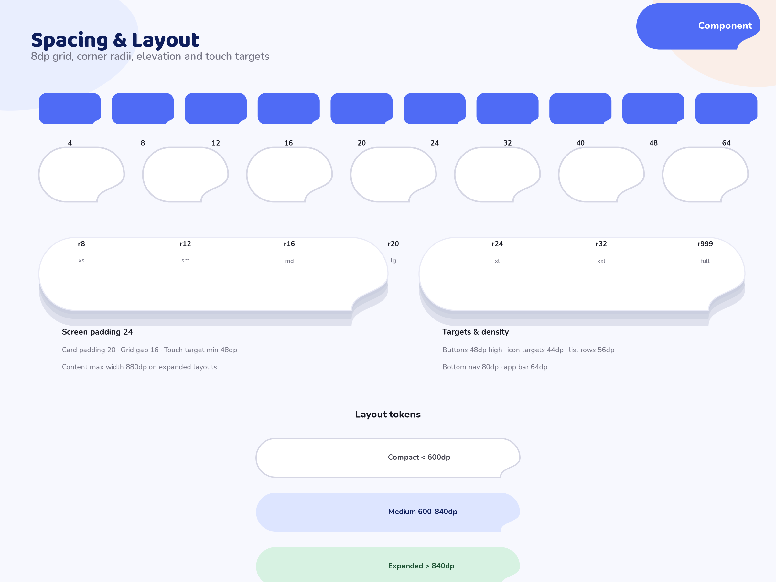
1: Spacing, radius, elevation and grid reference board

CHAPTER SIX

COMPONENT LIBRARY
The component library contains eleven reference boards. Each board is the single visual spec for its component family; the full sizing, state and usage rules live in the Component Library PDF. The boards below are the authoritative visual reference.
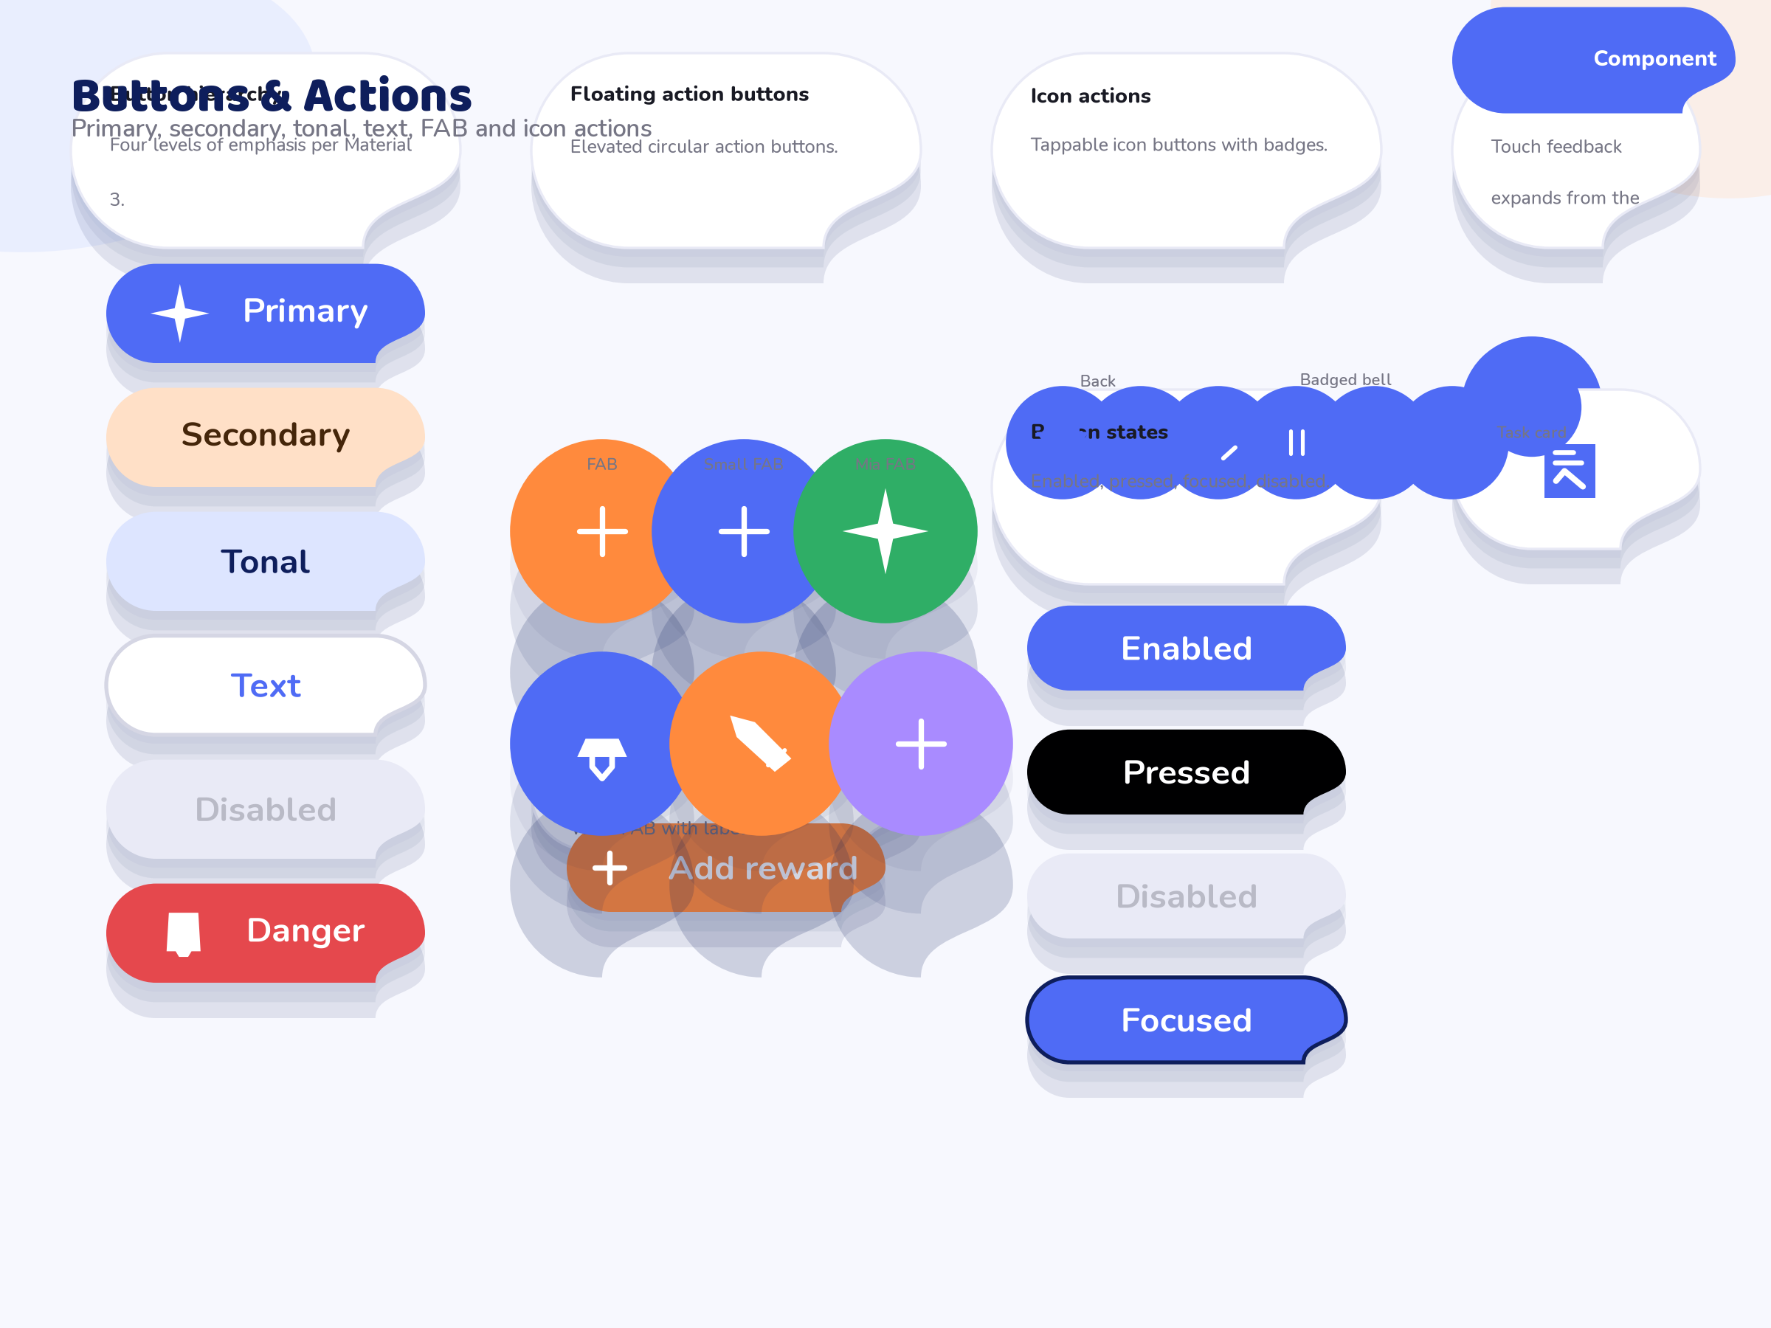
2: Buttons – Filled, tonal, outlined, text and FAB variants in primary, secondary and tertiary colours. Every button respects the 48 px minimum touch target.
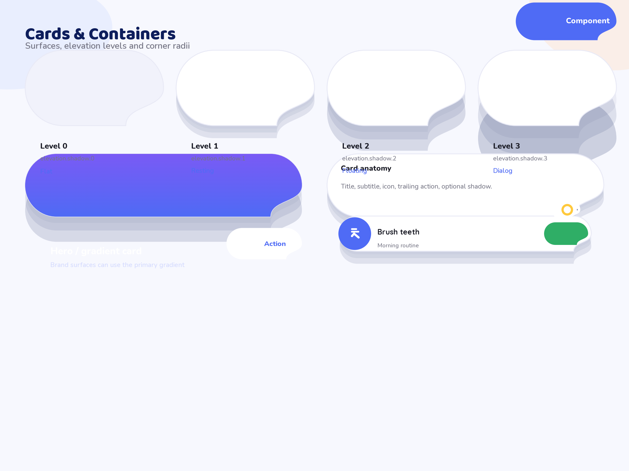
3: Cards – Filled and outlined cards across the four elevation levels, plus the soft shadow style used on child-mode screens.
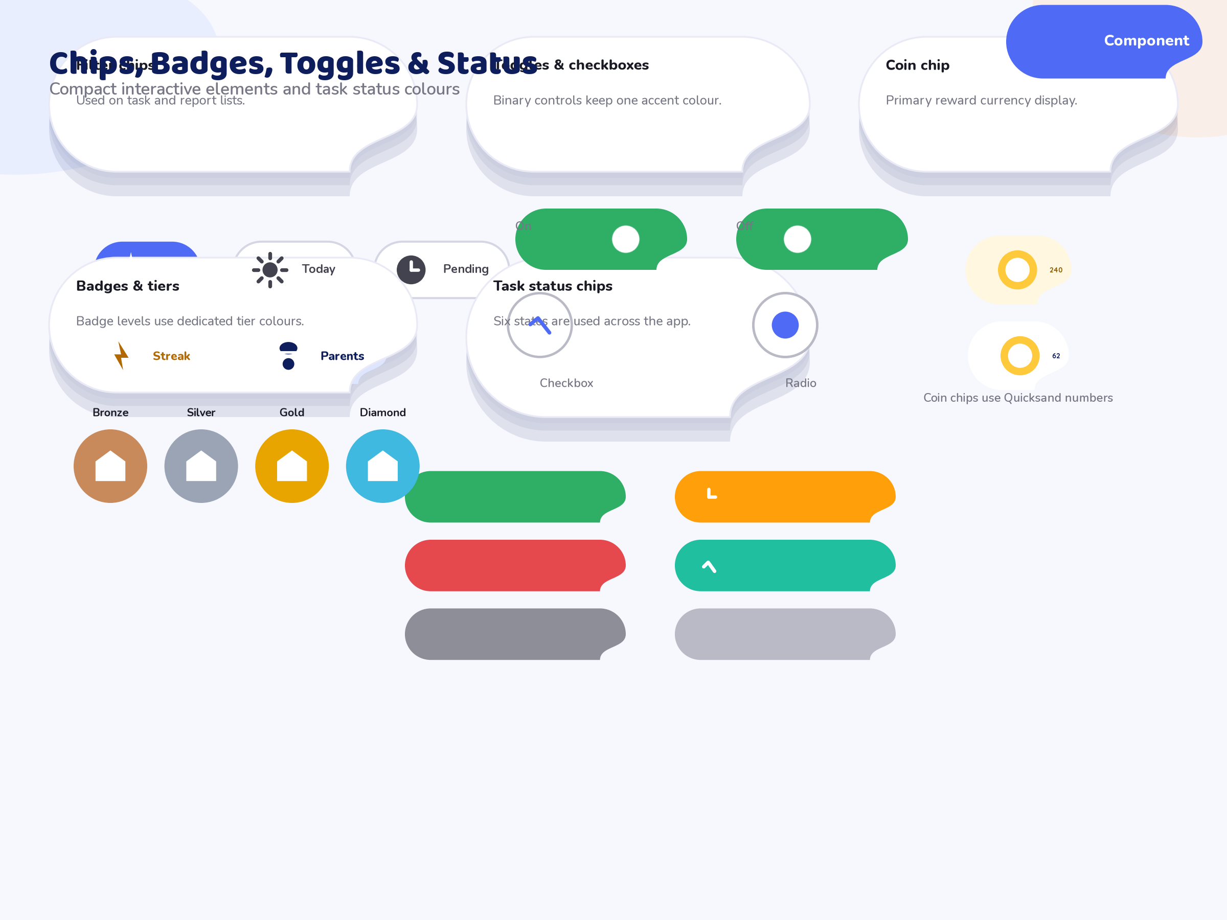
4: Chips – Status chips for the six task states, badge-tier chips, selectable filter chips and coin chips with the flying-coin pattern.
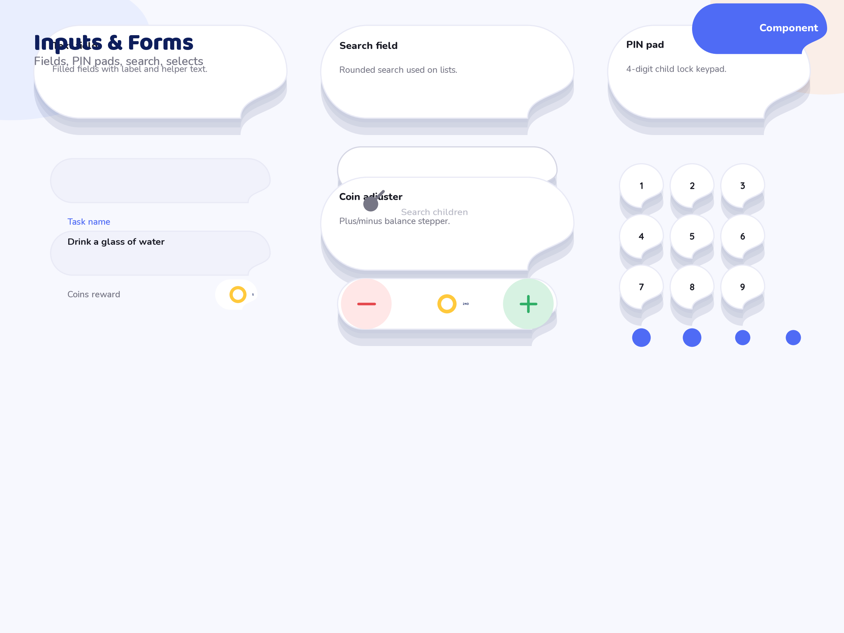
5: Inputs – Text fields, numeric keypads, dropdowns, toggles, radio groups, search bars and a colour/value stepper, all with the soft focus ring.
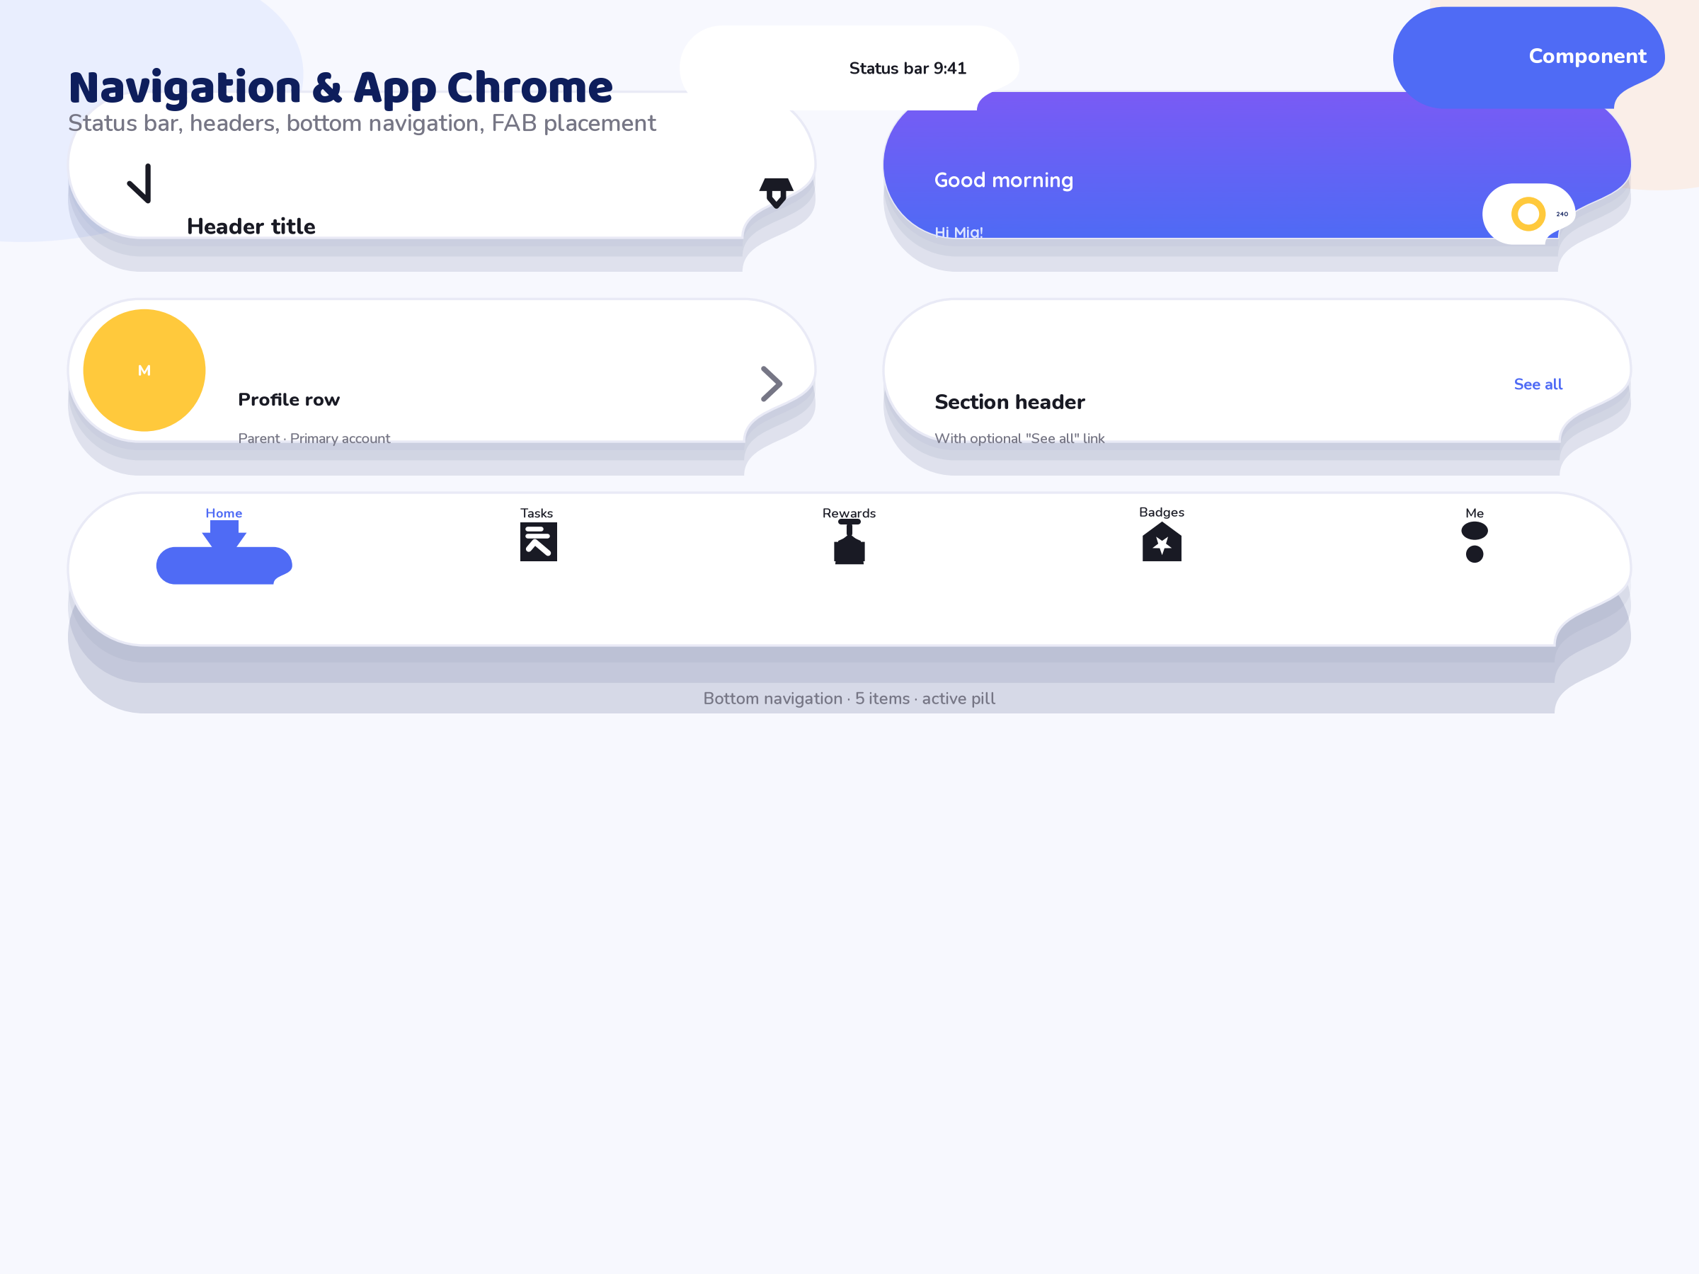
6: Navigation – Bottom navigation bar, navigation rail, app bar, tabs, back affordances and the FAB. Consistent 64 px bars and 48 px targets.
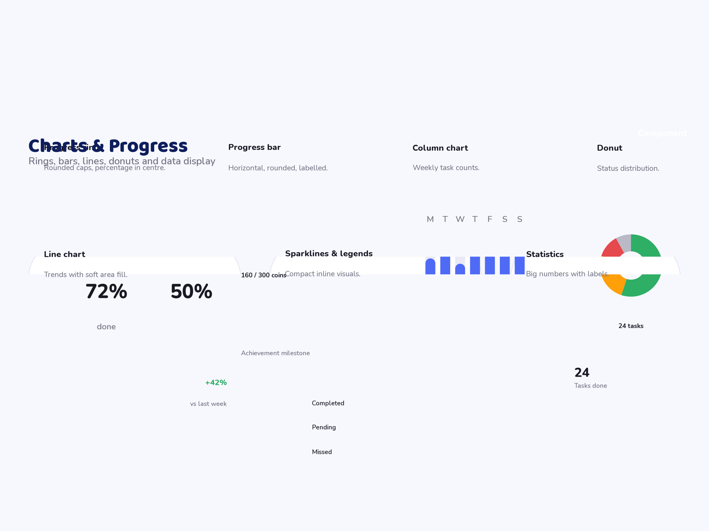
7: Charts – Progress ring, progress bar, line chart, bar chart and donut with rounded caps, soft gridlines and tabular numeral labels.
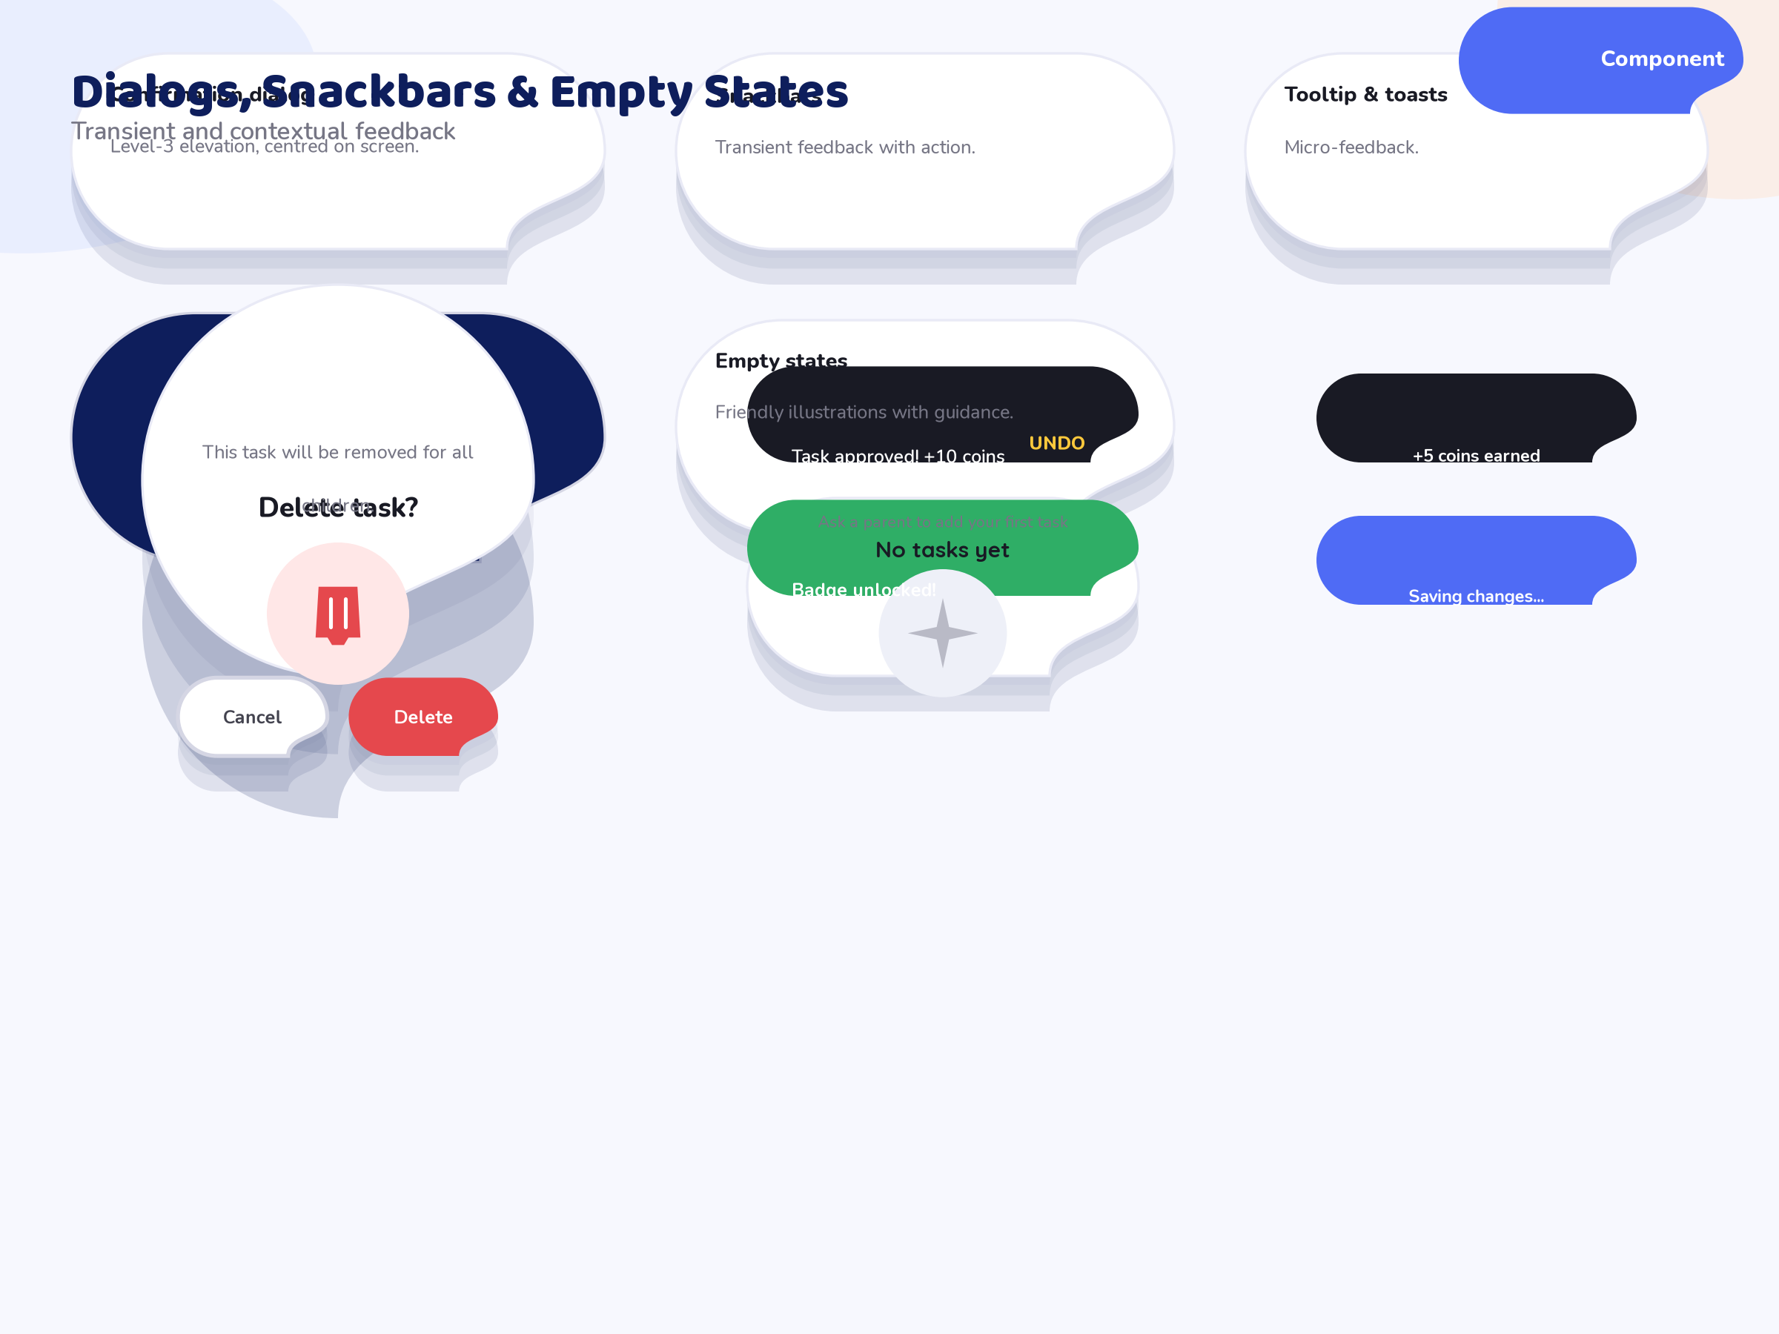
8: Dialogs – Confirmation, success, PIN, date-picker and bottom-sheet dialogs with safe rounded corners and elevation level three shadows.
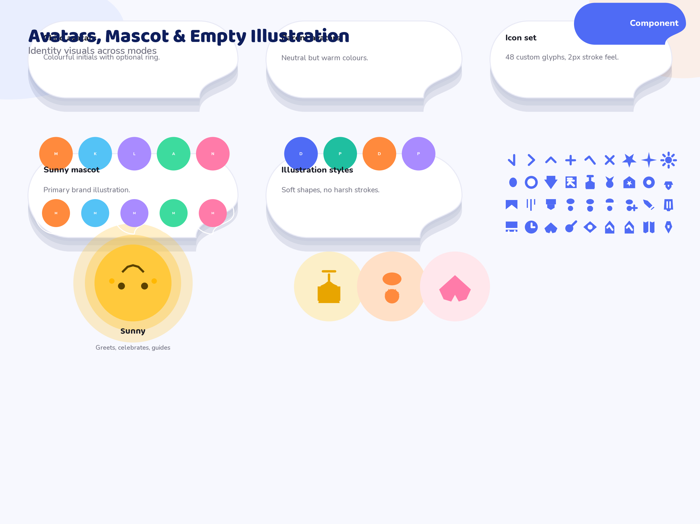
9: Avatars – Profile avatars, Sunny the mascot, initial fallback avatars, status rings and the child/parent header lockups.
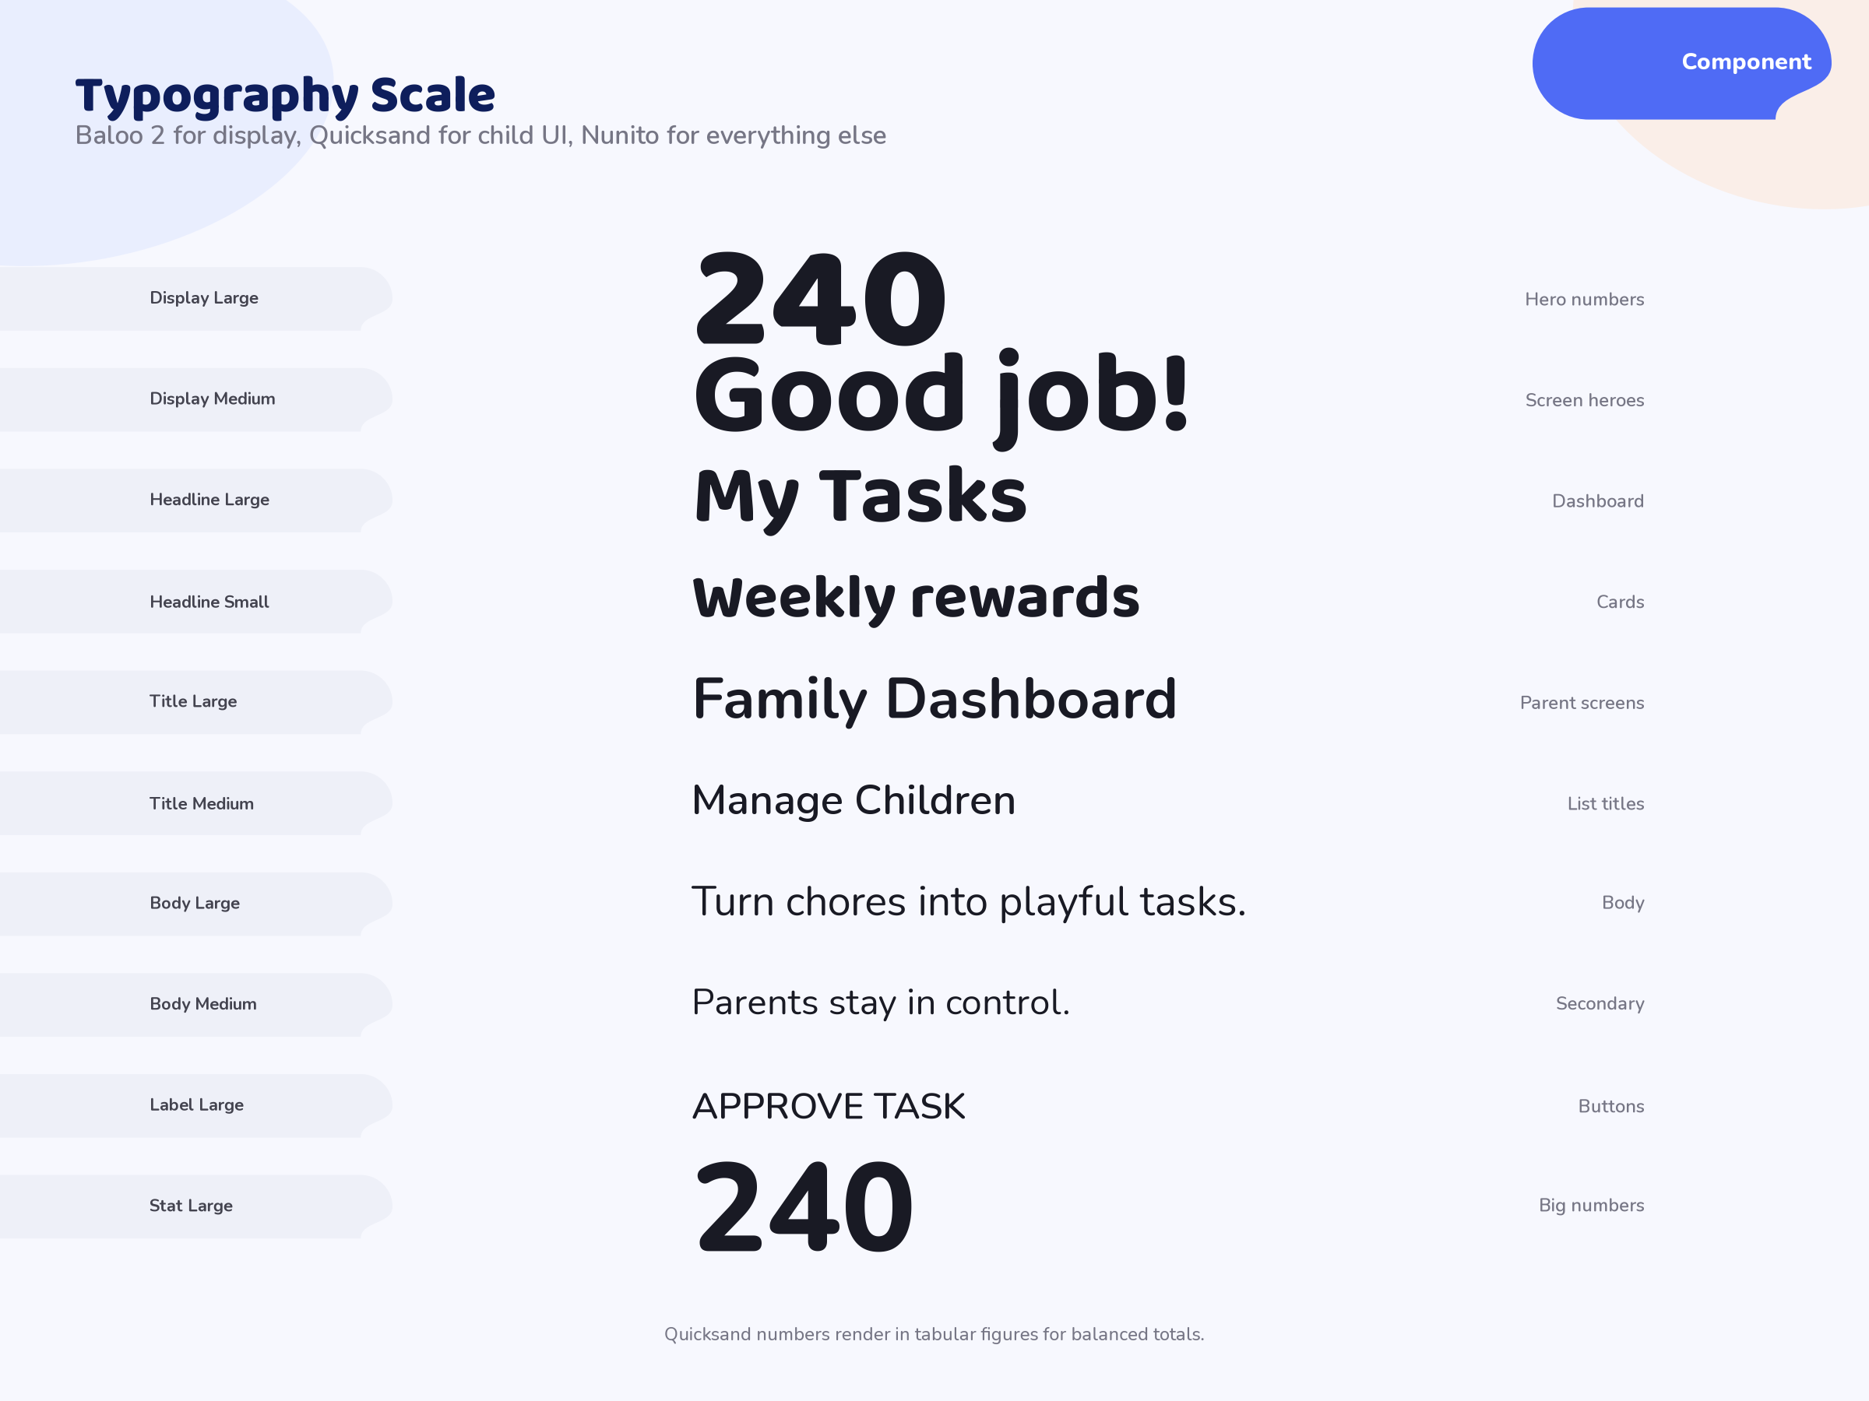
10: Typography – The complete 19-style type scale with family, size, line-height and weight, used exactly as specified in the Typography Guide.
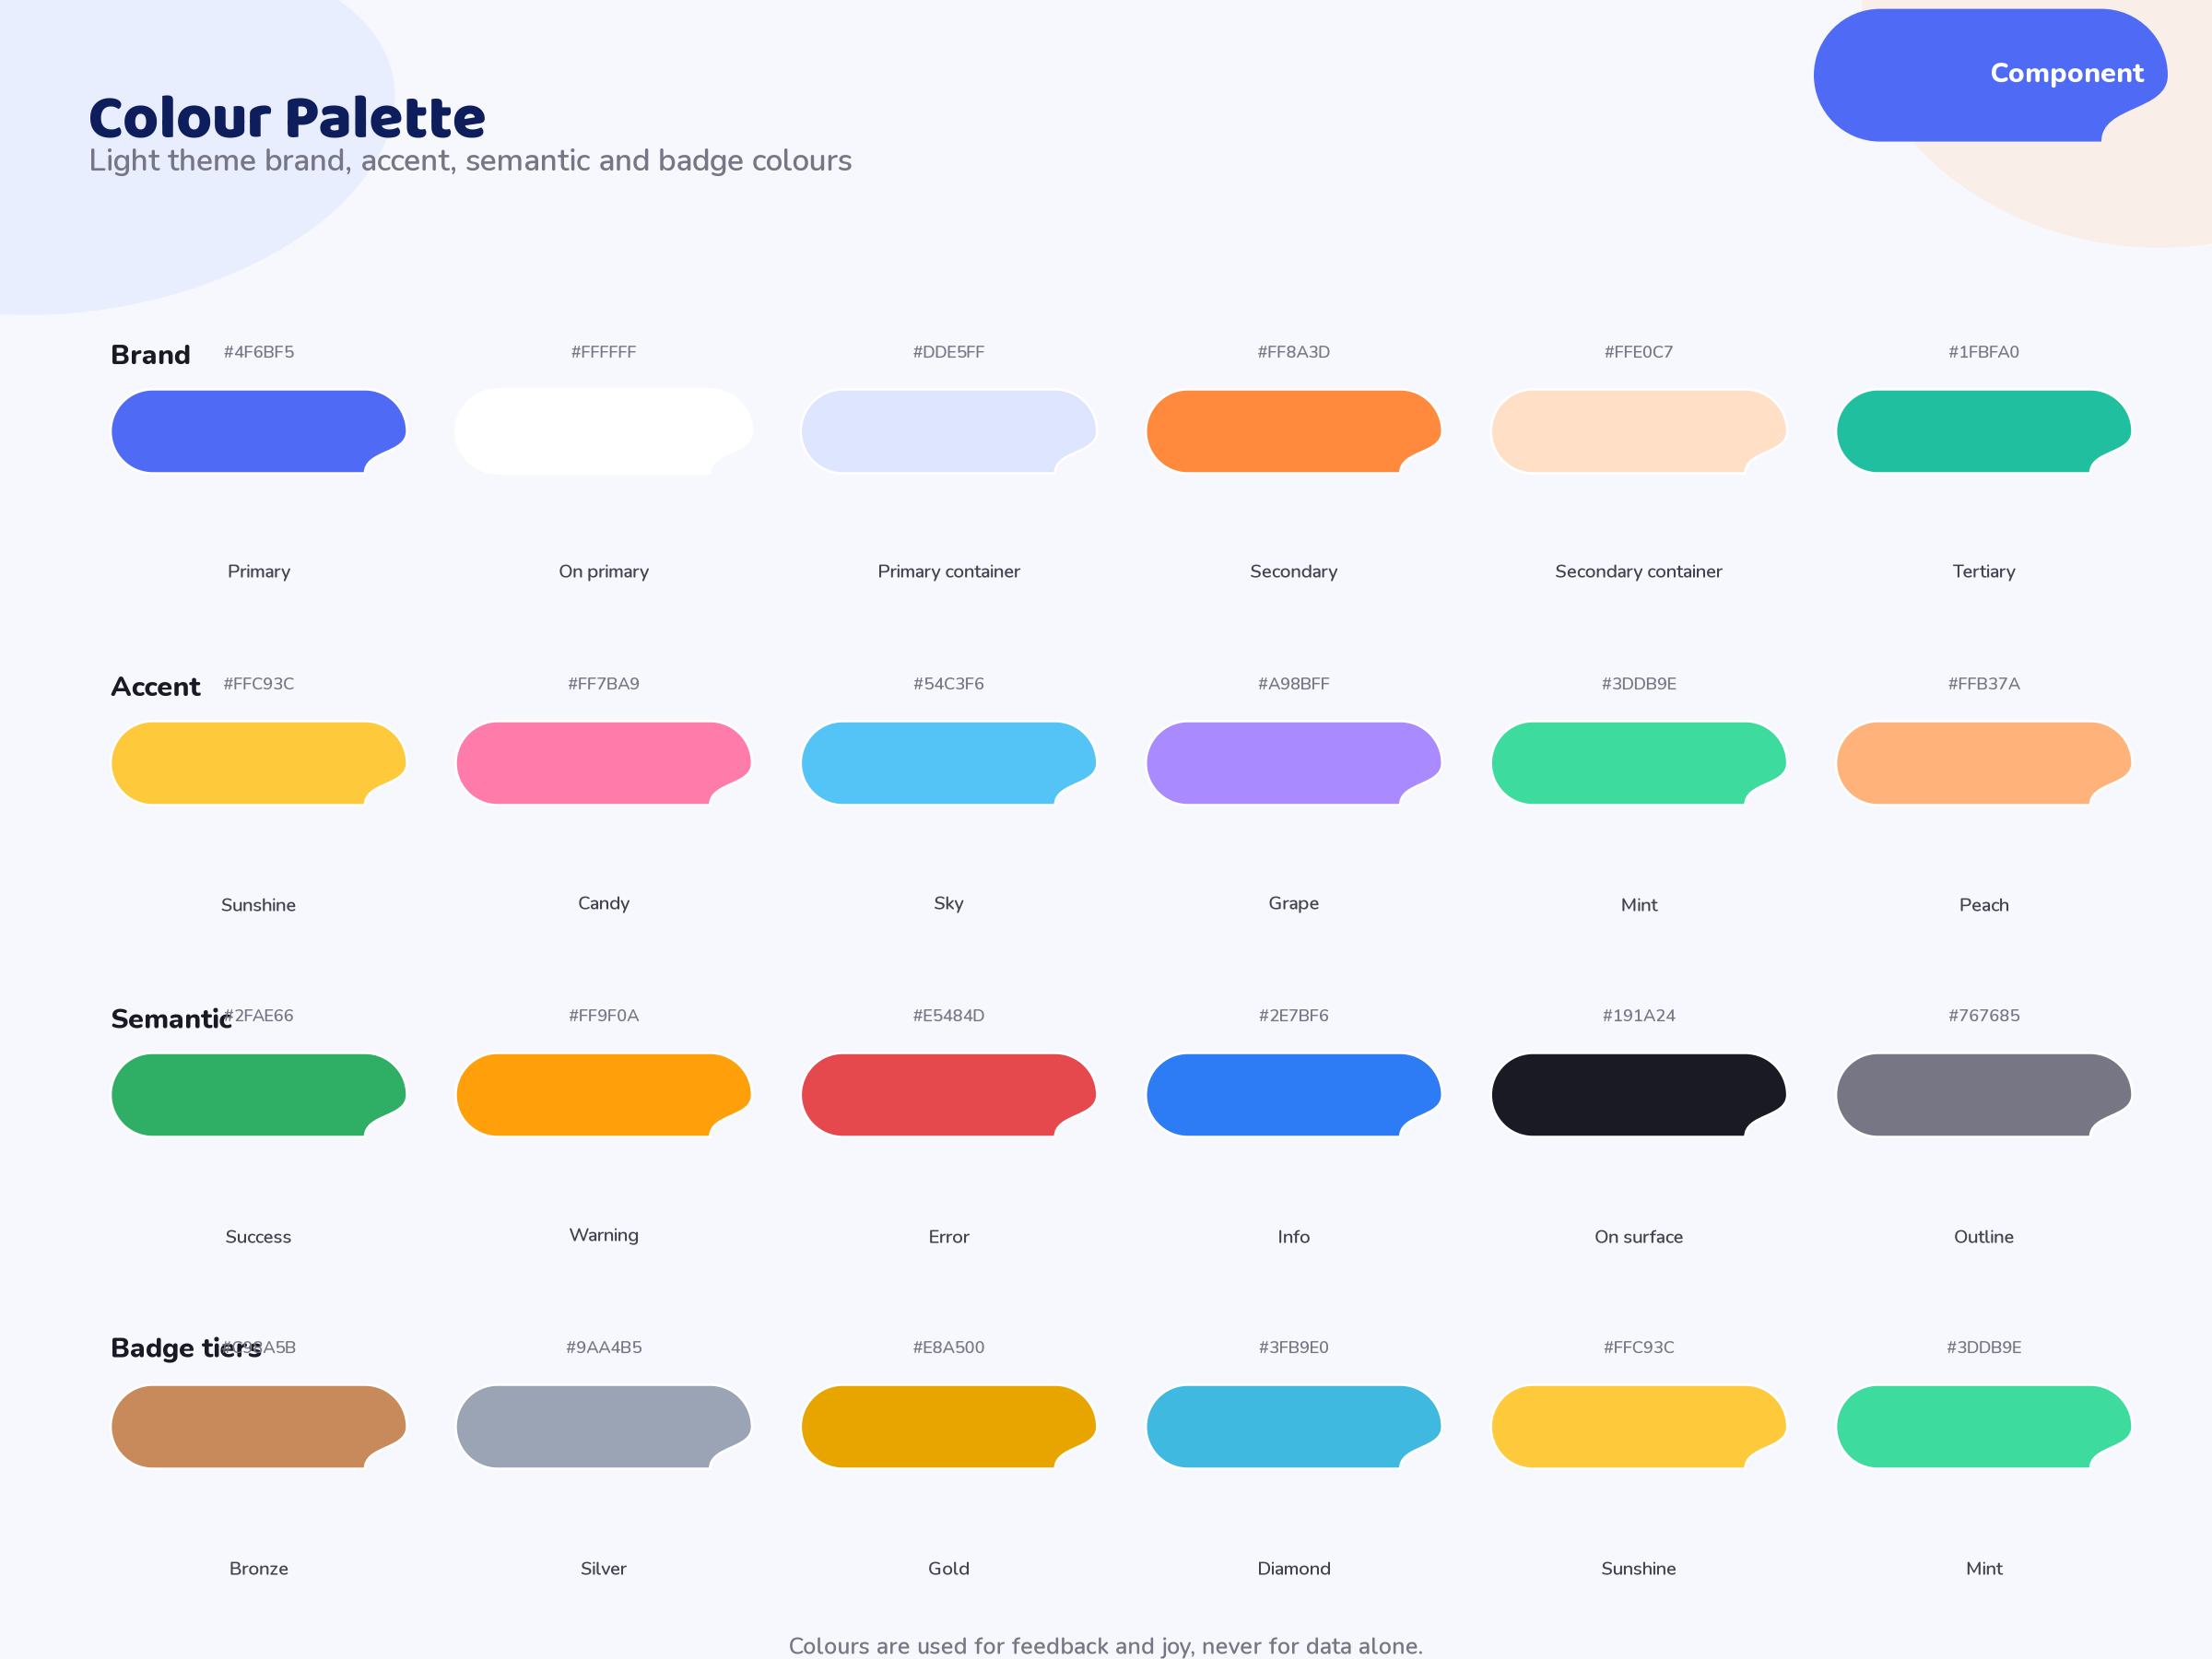
11: Colors – The full light and dark palettes with brand, accent, semantic and status colours and their exact hex values.
12: Spacing – The 4–64 px spacing scale, radii xs–full, elevation levels 0–4 and the 6/12 column grid with 16 px gutters.

CHAPTER SEVEN

ICONS AND ILLUSTRATIONS

7.1 The Icon Set
Fifty-two custom SVG icons cover navigation, tasks, rewards, coins, badges, reports, messages and settings. Icons follow a 24 × 24 viewBox, 2 px stroke weight, rounded caps and joins, and use the onSurfaceVariant colour at rest. Each icon is exported as a single standalone SVG file under assets/icons/ with the sch_icon_ prefix.
13: Icon categories and counts
Category | Icons (naming root) | Count
Navigation | home, grid, list, back, close, search, menu | 7
Tasks | check, clock, flag, lock, sparkle, star, calendar, repeat | 8
Rewards & coins | coin, coins, gift, trophy, tag, cart, redeem | 7
Badges | shield, award, medal, crown, diamond, flame, streak | 7
Reports | chart, chart_line, chart_bar, chart_donut, download, export | 6
People & profiles | person, person_add, child, parents, avatar, pin | 6
Messages | chat, chat_dot, bell, mail, send | 5
Settings & system | settings, tune, lock, theme, wifi, info, help, warning | 8

7.2 Illustrations
Five SVG illustrations carry the personality of the product. Each is drawn in flat vector style with the brand palette and exports as a standalone SVG under assets/illustrations/.
14: Illustration assets
Asset | File | Used on
Sunny mascot | sch_ill_sunny_mascot.svg | Splash, dashboard, about
Empty state | sch_ill_empty_tasks.svg | Empty task lists
Celebration | sch_ill_celebration.svg | Badge unlocks, achievements
Welcome hero | sch_ill_welcome_hero.svg | Welcome screen
Error state | sch_ill_error_state.svg | Offline/error screens

7.3 Asset Conventions
- All assets carry the sch_ asset prefix so the whole family is discoverable.
- Icons ship as stroke SVGs; illustrations as flat-colour SVGs.
- SVGs are optimised, well-formed XML and render without external dependencies.
- Never rasterise SVG assets at design time; Flutter renders them natively.

CHAPTER EIGHT

MOTION AND ANIMATION

8.1 Principles
1. Purposeful – every animation explains a state change; nothing moves for decoration.
2. Fast – durations run 50–900 ms so the interface never feels slow.
3. Joyful – celebrations (coins, confetti, badge glow) reward success; errors animate calmly.

8.2 Durations and Curves
15: Reference durations and easing curves
Token | Duration | Curve
instant | 50 ms | None (hard cut)
fast | 150 ms | standard
normal | 250 ms | standard
gentle | 350 ms | emphasized
slow | 500 ms | emphasized
extra | 750 ms | bounce

16: Easing curves
Curve | Specification
standard | cubic-bezier(0.2, 0.0, 0.0, 1.0)
emphasized | cubic-bezier(0.3, 0.0, 0.1, 1.0)
decelerate | cubic-bezier(0.0, 0.0, 0.2, 1.0)
accelerate | cubic-bezier(0.4, 0.0, 1.0, 1.0)
spring | spring(weight: 0.9, damping: 14)
bounce | cubic-bezier(0.34, 1.56, 0.64, 1.0)

8.3 Signature Moments
17: Signature animations specified for implementation
Animation | Duration | Behaviour
Coin fly | 450 ms | Coin pops at the task card, arcs to the balance chip, total counts up with bounce
Check draw | 500 ms | Check mark draws itself; card pulses green; a coin flies
Confetti | 750 ms | Bursts from the task card; particles fall and rotate
Badge unlock | 600 ms | Badge scales 0 to 1 with a golden glow ring
Reward claim | 500 ms | Reward card lifts, confetti at top, check stamp appears
Screen transition | 300 ms | Fade-through with an 8% horizontal slide

8.4 Loading Patterns
Loading states use three bouncing dots or a gently pulsing spinning coin for 1000 ms loops. Never show a frozen frame; every asynchronous action has an animated placeholder.

CHAPTER NINE

RESPONSIVE BEHAVIOUR AND DARK MODE

9.1 What Changes at Each Tier
18: Responsive playbook across breakpoints
Element | Compact (< 600) | Medium (600–840) | Expanded (> 840)
Navigation | Bottom bar | Bottom bar | Rail + app bar
Grid columns | 4 | 6 | 12
Screen padding | 16 px | 24 px | 24 px + 880 max width
Dashboard cards | 1 column | 2 columns | 3 columns
Charts | Compact labels | Full labels | Full labels + legend

9.2 Phone versus Tablet
Phone is usable but the product is optimised for tablet portrait (medium tier), the typical family-kiosk orientation. On compact screens, multi-column card grids collapse to single columns, charts reduce label density, and dialogs become full-width bottom sheets.

9.3 Dark Mode
The app respects a family-level theme setting (light, dark or follow the shared tablet). Both themes pass the same contrast minimums. Illustrations ship in both palettes or use theme-aware tokens so no asset looks wrong on the dark surfaces.

9.4 Rules to Remember
- Keep it simple at every size; the same content exists on all tiers, only the rhythm changes.
- Never hide an action behind an extra tap on smaller screens; collapse, do not remove.
- Respect the 48 px minimum touch target in every tier.

CHAPTER TEN

SCREEN MOCKUPS
Twenty-two full-screen mockups define the complete application at 1440 × 1920. Each screen below includes its mode, purpose and the key elements that must be implemented. The mockups are the authoritative visual contract for Phase 3 development.
01_splash · Splash · Child mode Brand reveal: Sunny the mascot spins in, the Smart Child Hub logo scales to rest, then the app transitions into the welcome screen. Child mode tone immediately.

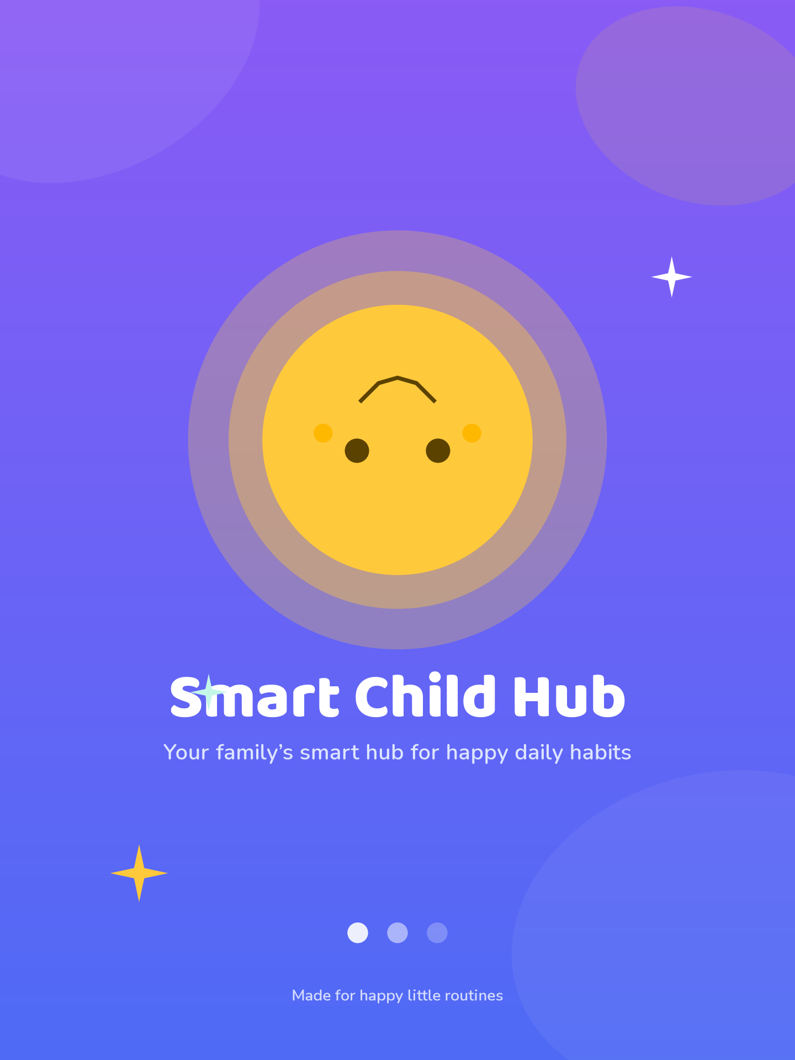
13: Splash – Child mode
02_welcome · Welcome · Shared mode Hero illustration, the product tagline and two clear entry points “I am a parent” and “I am a child”. No login is required for the child path.

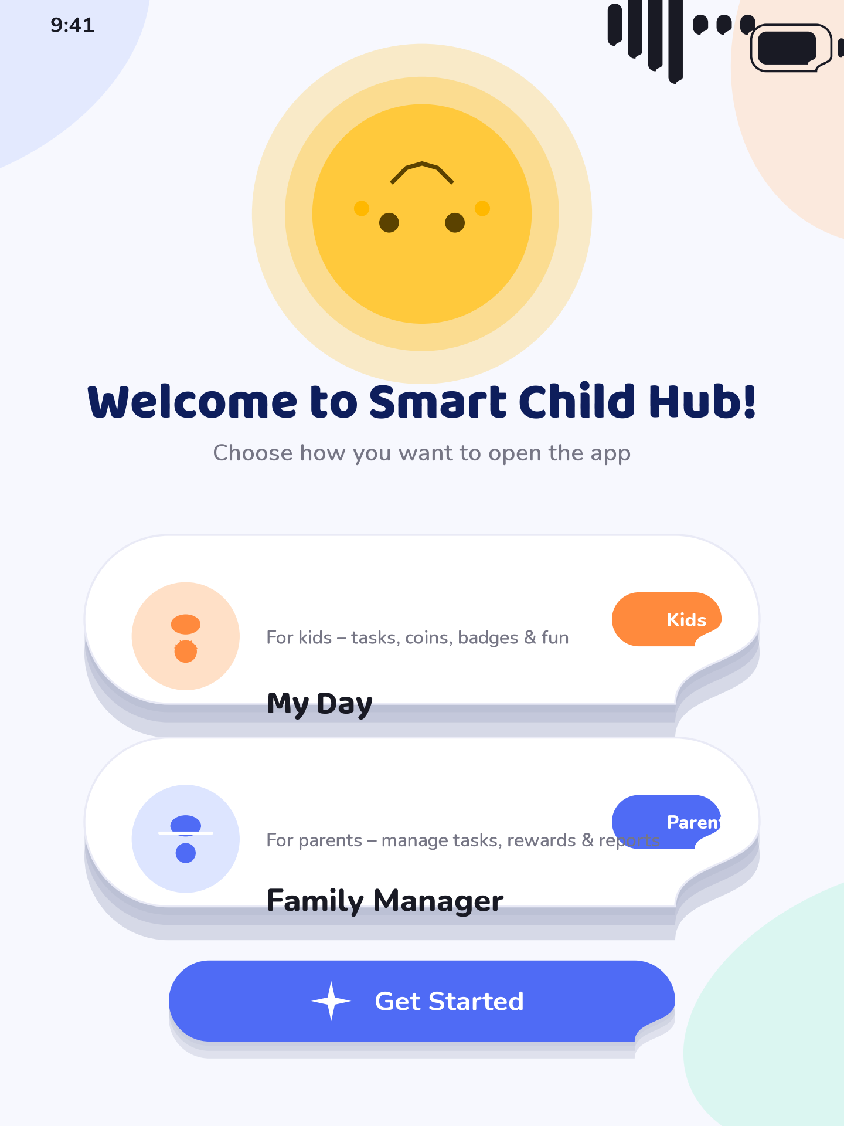
14: Welcome – Shared mode
03_choose_profile · Choose Profile · Child mode Kiosk profile picker: large round avatars with names, an “Add new profile” tile, and a parent-lock affordance. Profiles are touch-first and 96 px tall.

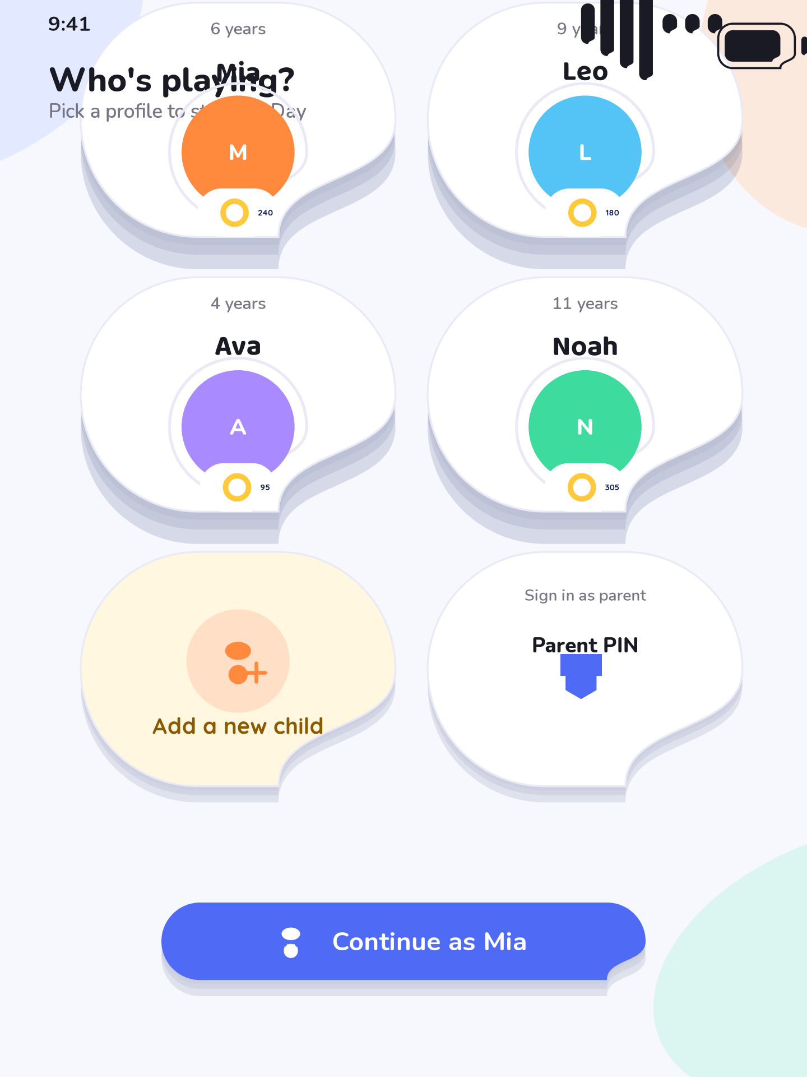
15: Choose Profile – Child mode
04_child_pin · Child PIN · Child mode Optional four-digit PIN gate protecting a specific child profile. Numeric keypad with large keys, gentle shake on error and a back affordance.

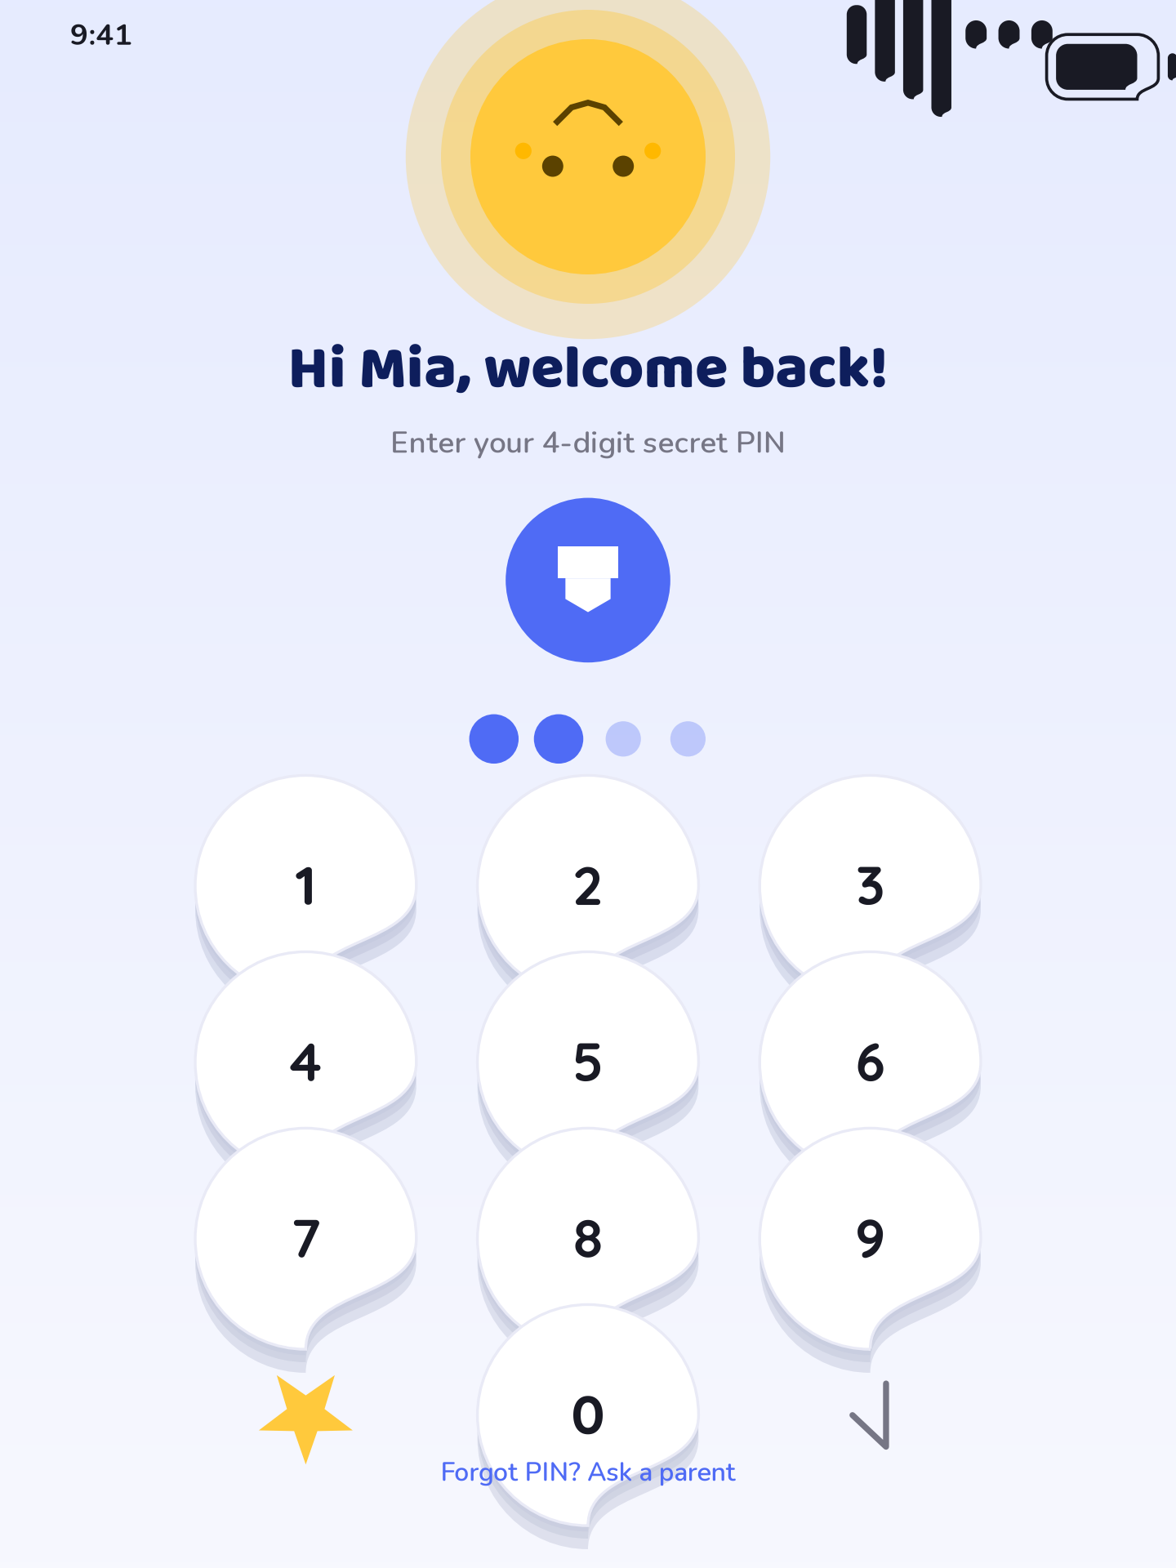
16: Child PIN – Child mode
05_child_dashboard · Child Dashboard · Child mode The daily hub in child mode: greeting with Sunny, today’s progress ring, a task checklist with status pills, a coins balance chip and the bottom navigation bar.

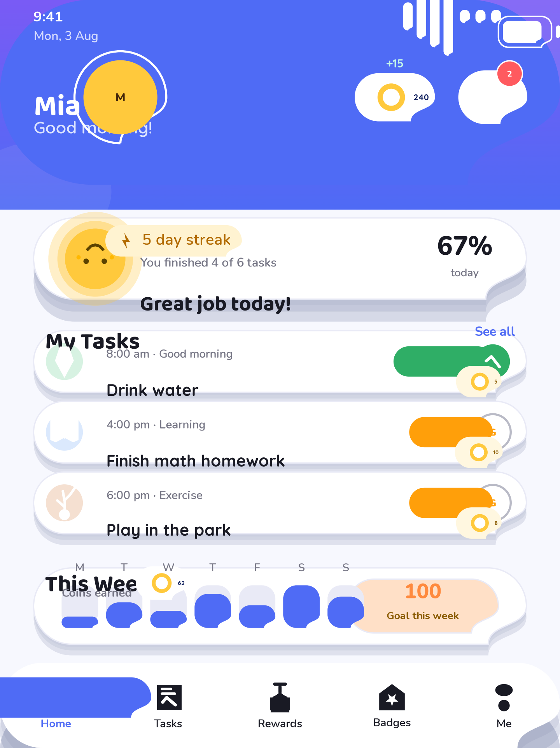
17: Child Dashboard – Child mode
06_task_screen · Task Screen · Child mode Task detail with a bright illustration, step hints, a big completed button and a coin reward badge. Supports self-check and parent-approval variants.

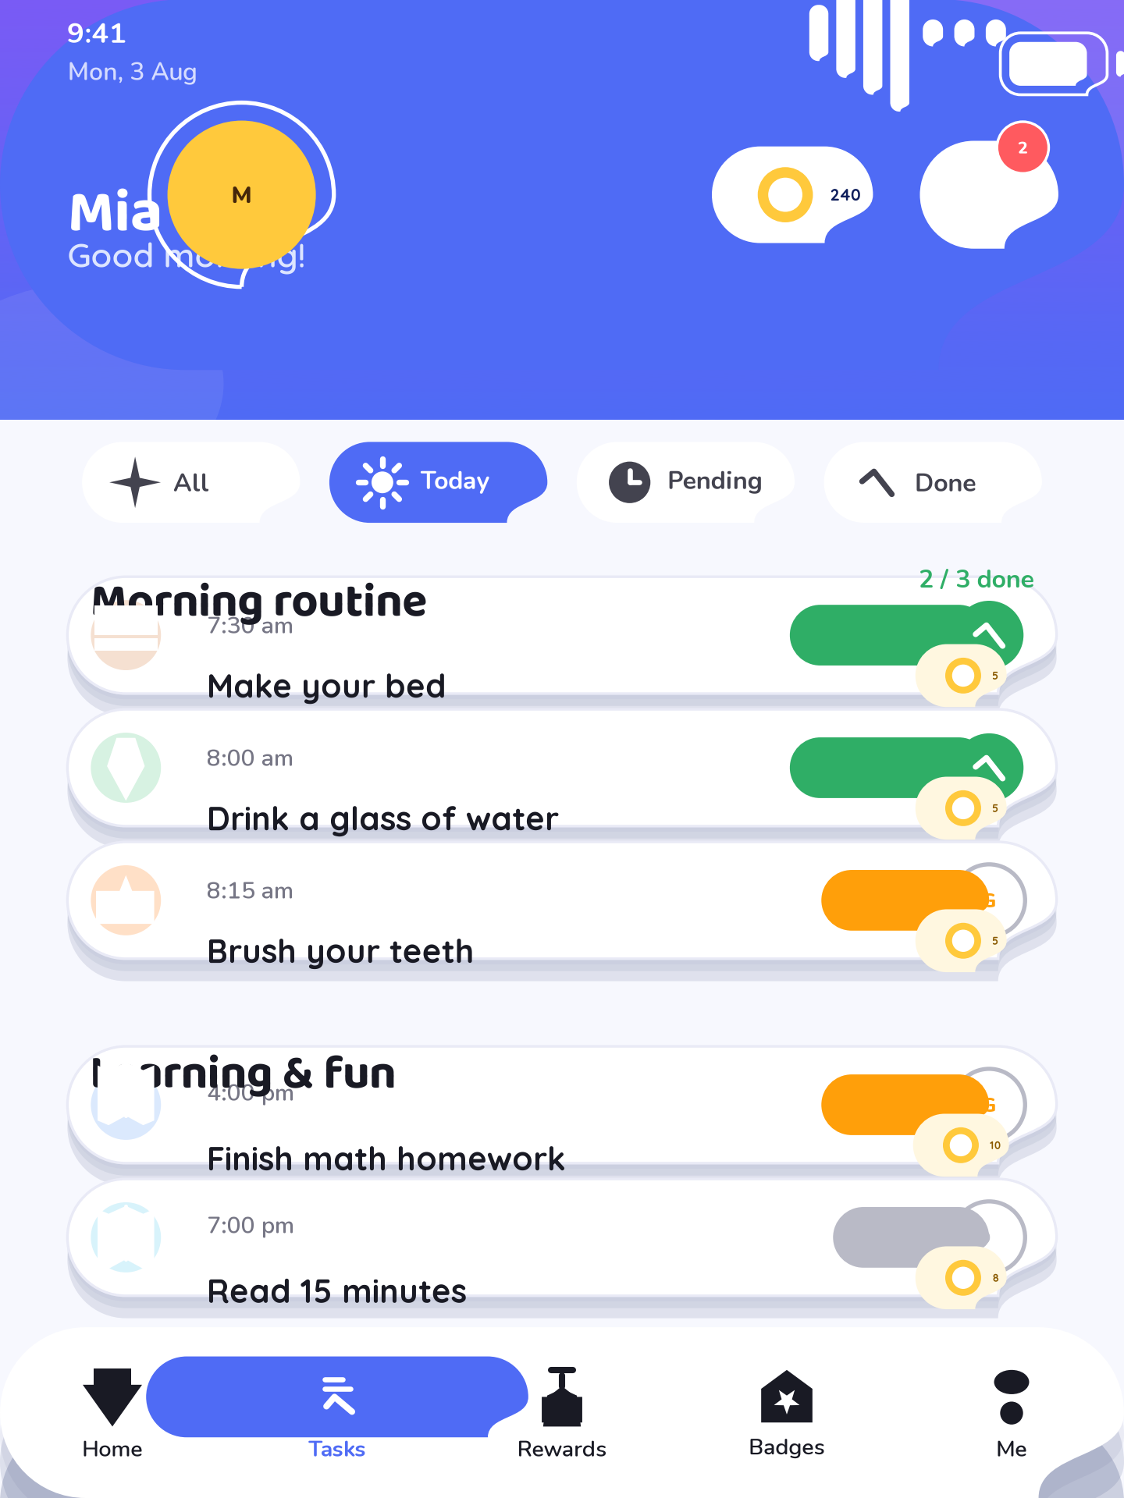
18: Task Screen – Child mode
07_rewards · Rewards · Child mode Rewards shop for the child: reward cards with illustrations, coin prices, available/claimed states and a confirmation dialog before a redemption is submitted.

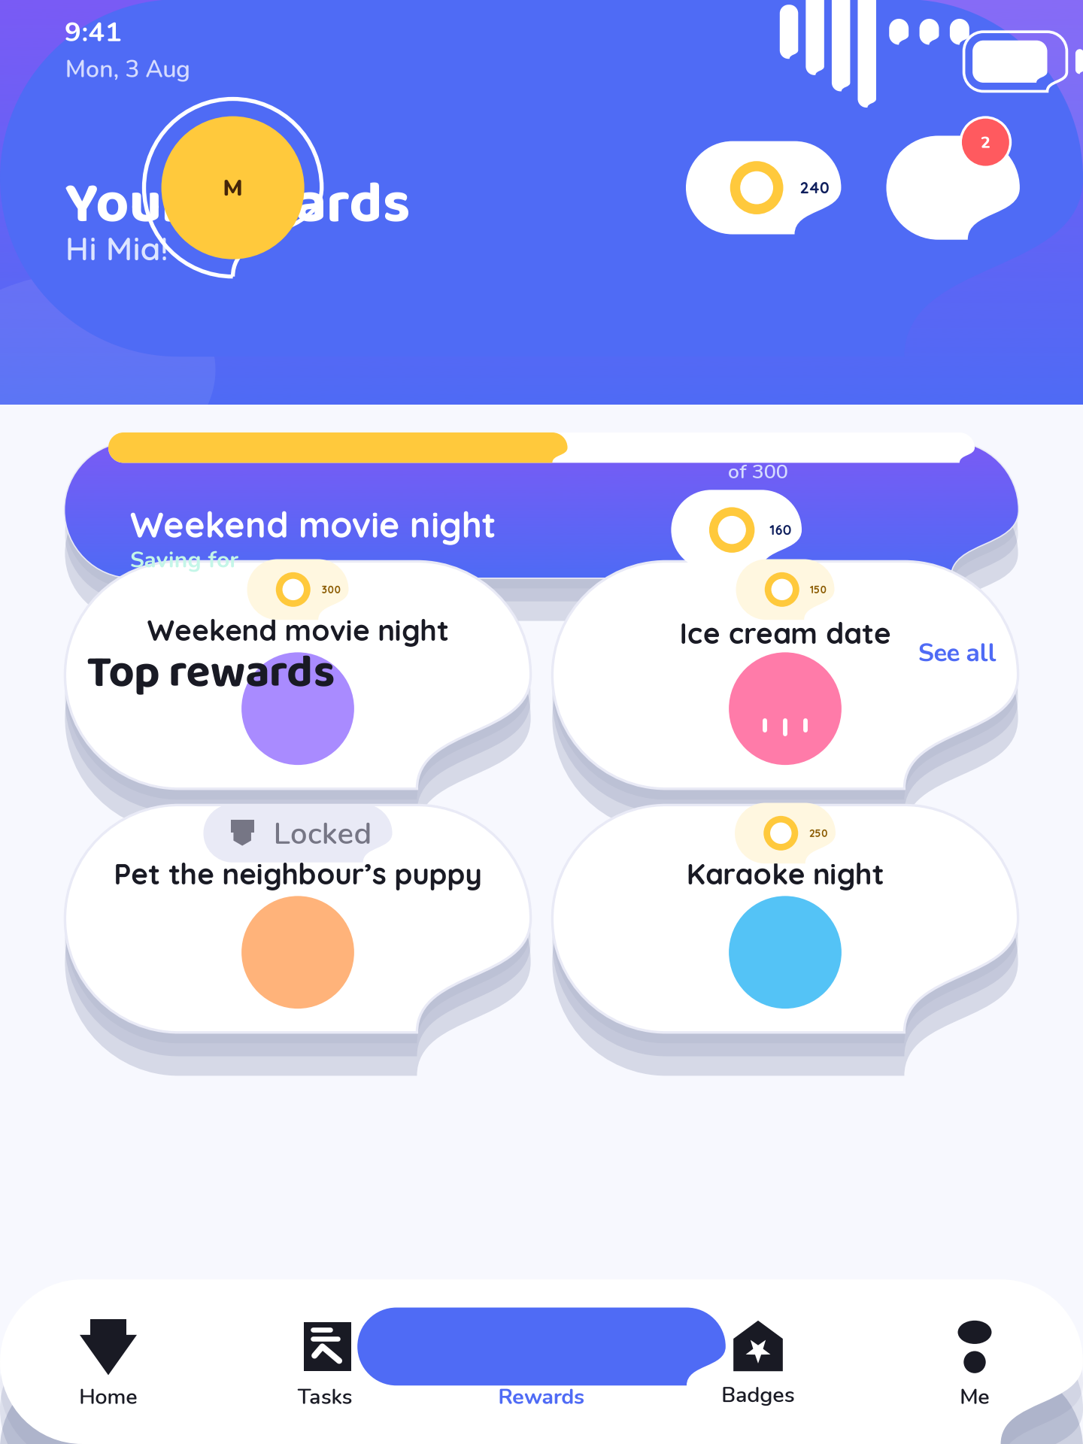
19: Rewards – Child mode
08_coins · Coins · Child mode Coin ledger: current balance card, earn/spend breakdown, a daily history list with icons and the running total in tabular figures.

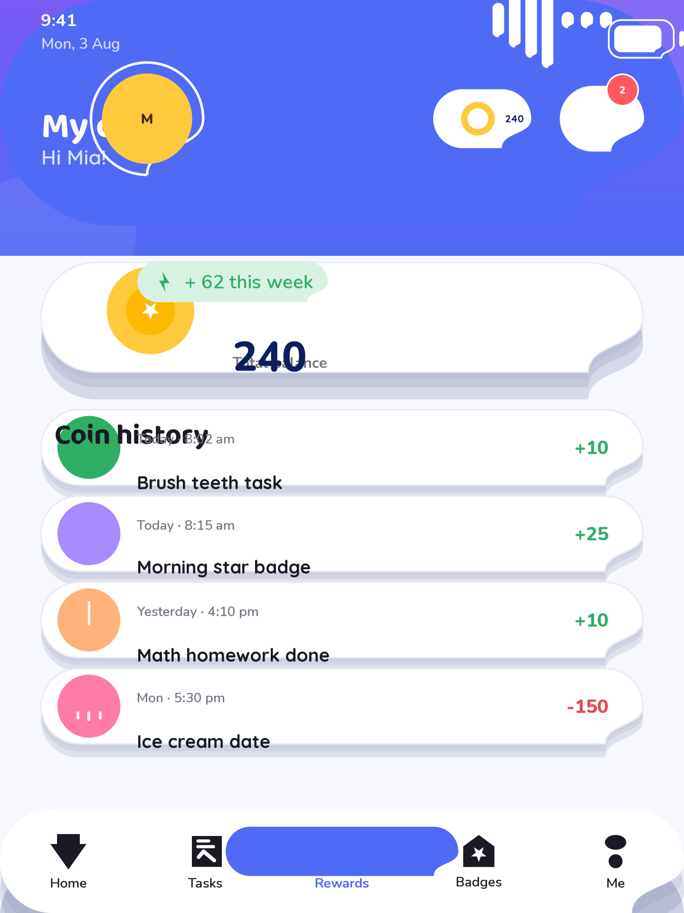
20: Coins – Child mode
09_badges · Badges · Child mode Badge collection in child mode: bronze, silver, gold and diamond tiers with locked and unlocked states and progress hints.

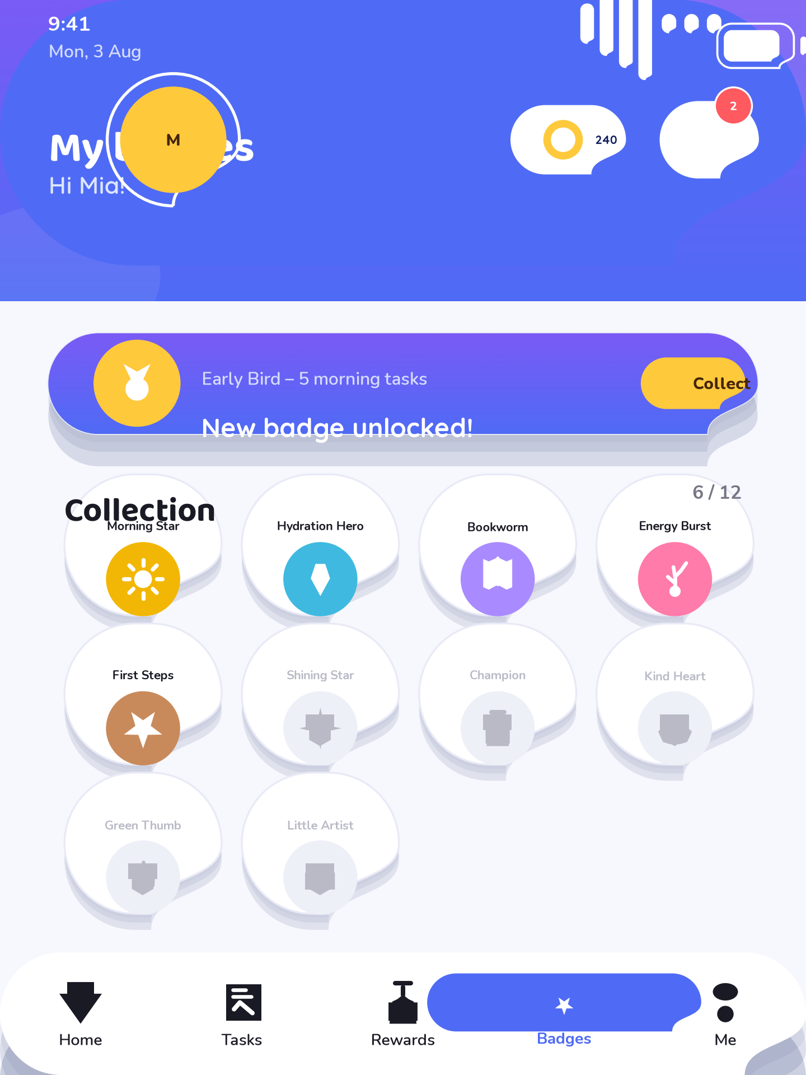
21: Badges – Child mode
10_achievements · Achievements · Child mode Streak and milestone view: week strip with completion days, milestone progress bars, confetti moment when a new tier is reached.

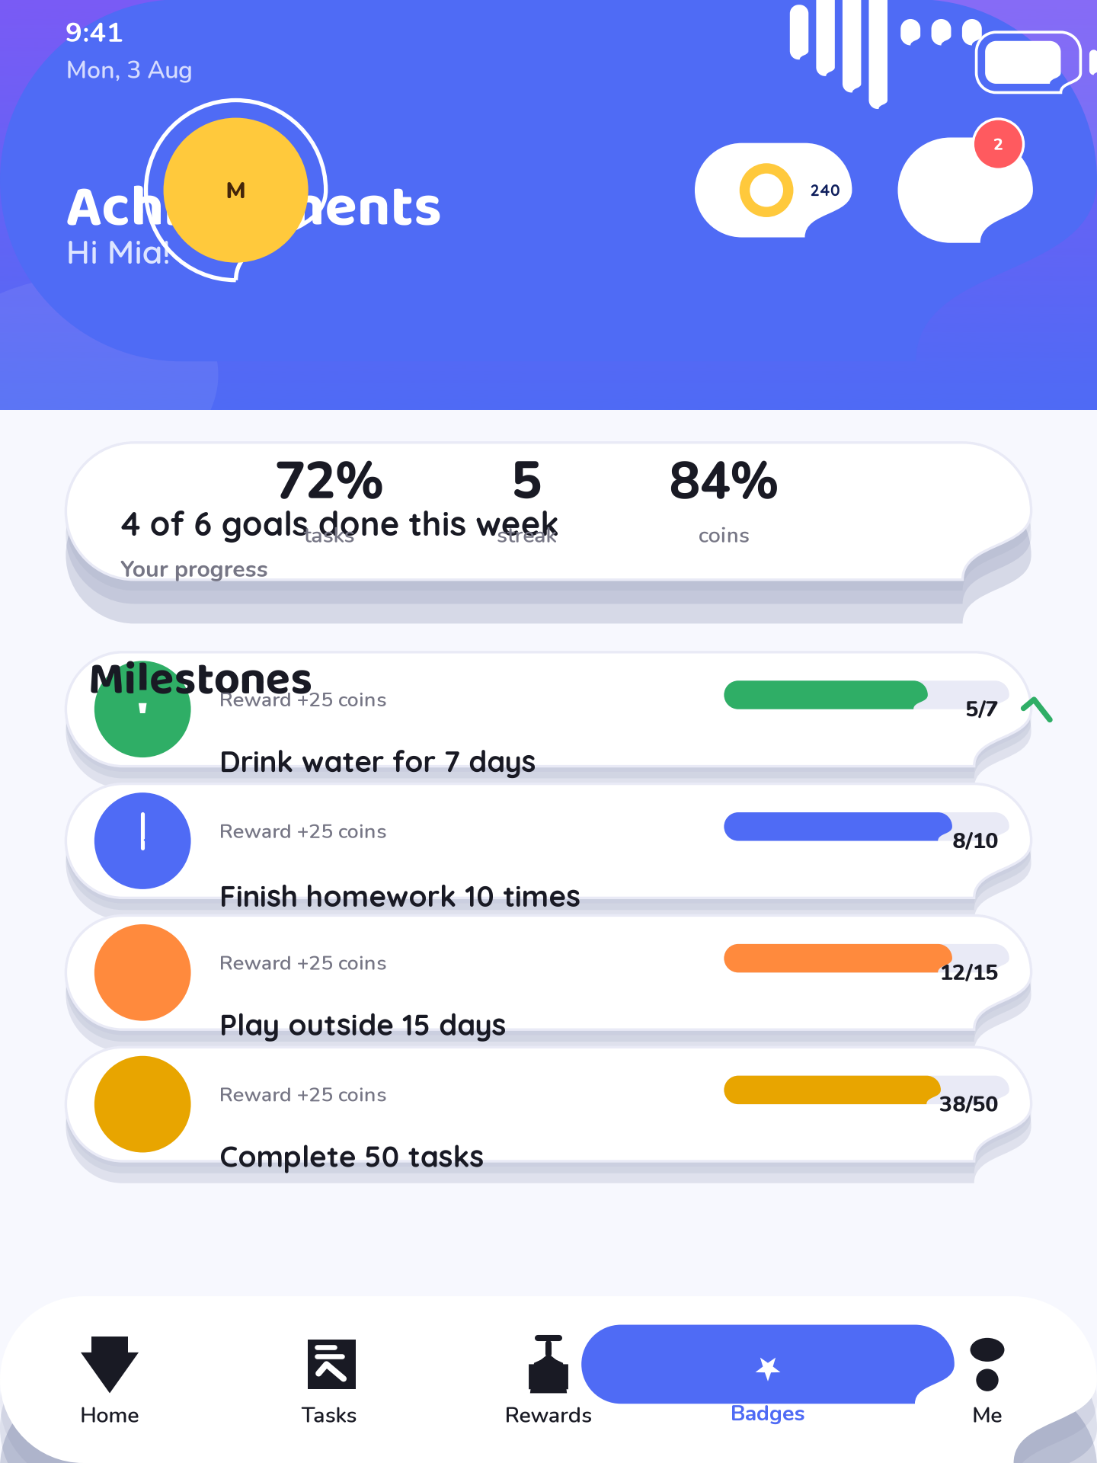
22: Achievements – Child mode
11_messages · Messages · Child mode Parent-child messages: simple positive notes with big icons, read states and a quick-reply composer. Encourages communication without a phone.

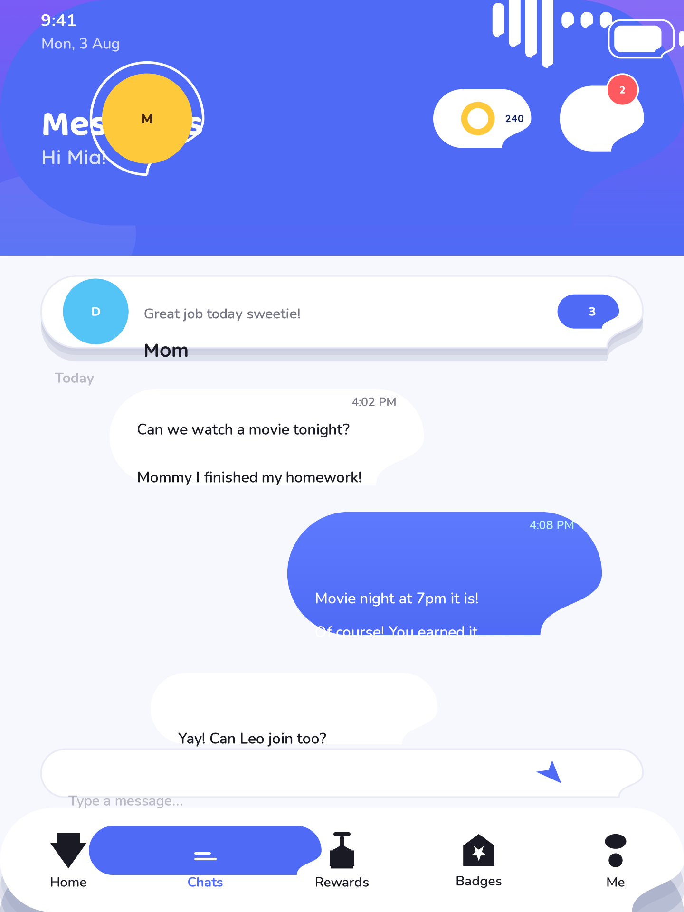
23: Messages – Child mode
12_reports_child · Child Reports · Child mode Child-facing summary: weekly completion percentage, coins earned, badges gained and a simple line chart of the last seven days.

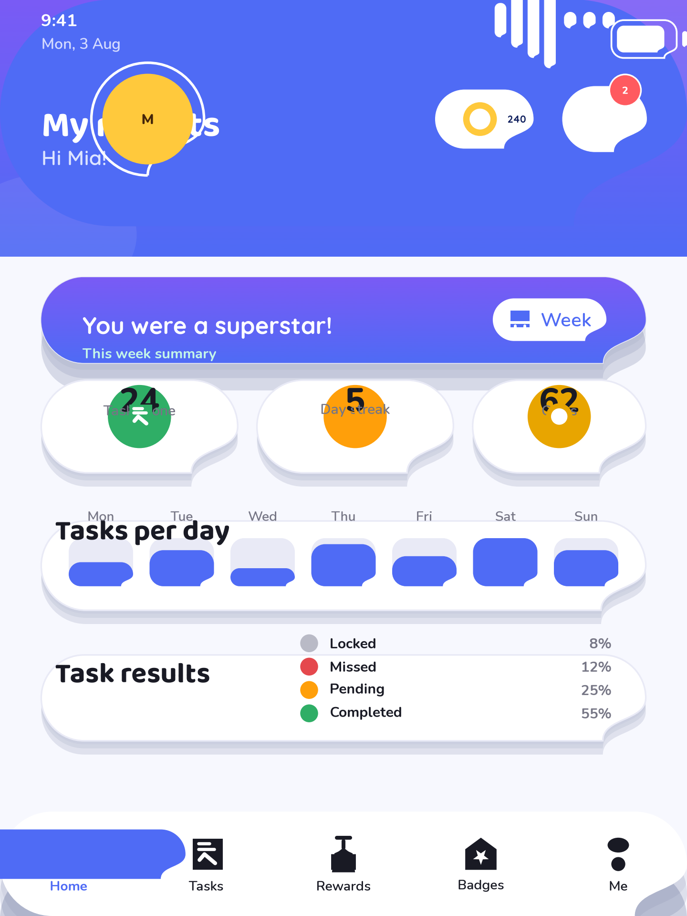
24: Child Reports – Child mode
13_parent_login · Parent Login · Parent mode Parent access gate: PIN pad in the professional parent theme, wrong-PIN lockout messaging and a hint about recovery.

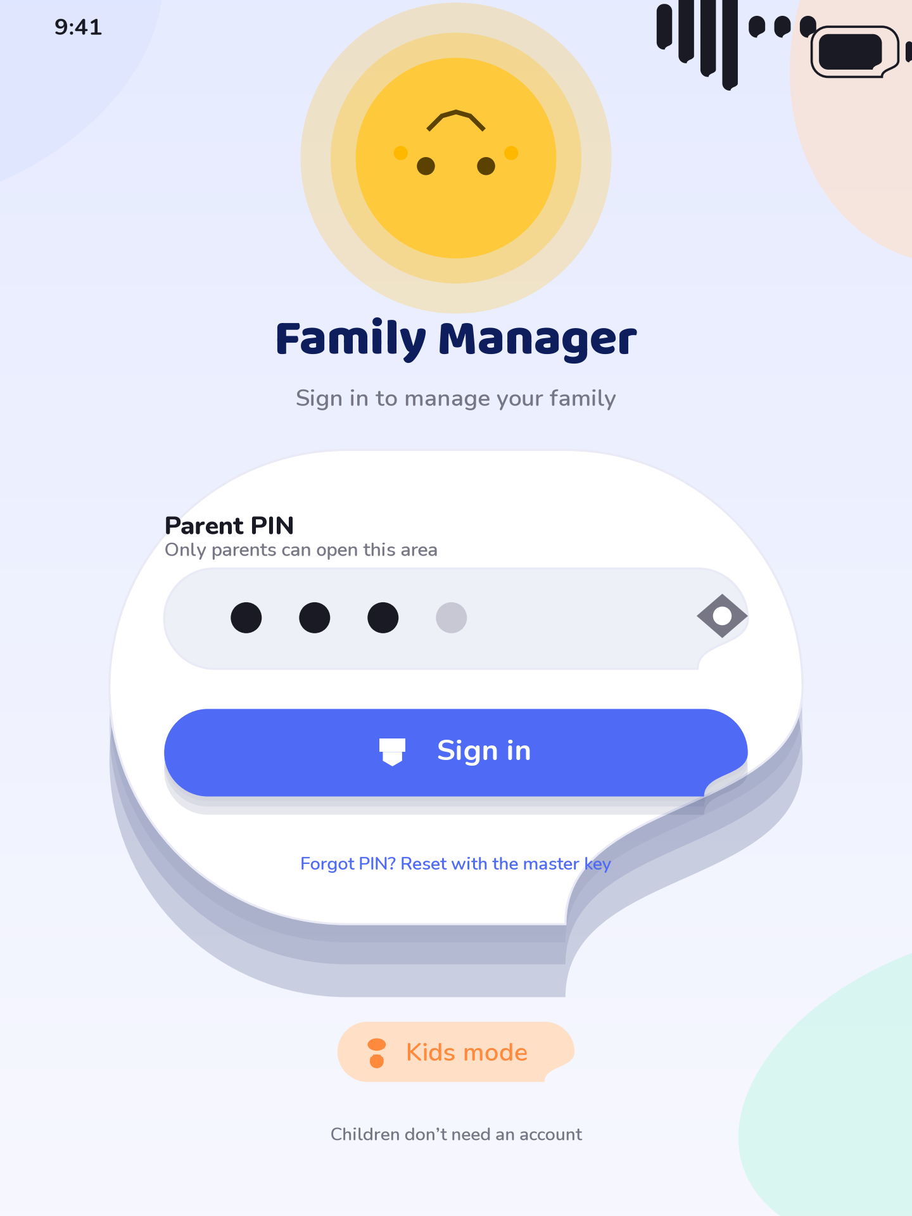
25: Parent Login – Parent mode
14_parent_dashboard · Parent Dashboard · Parent mode Family manager overview: child summary cards with completion rates, pending approvals badge, coin circulation totals and a navigation rail.

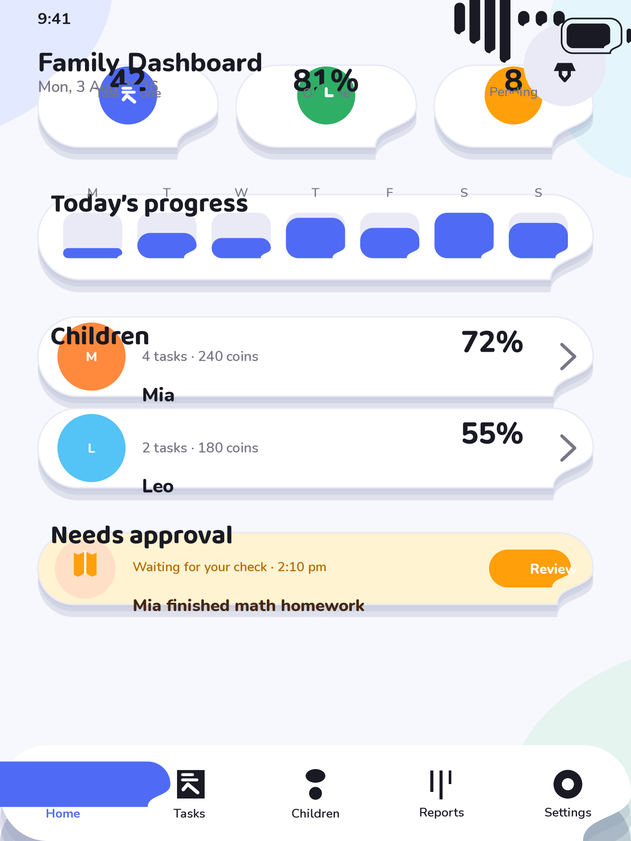
26: Parent Dashboard – Parent mode
15_manage_children · Manage Children · Parent mode Parent administration of profiles: add/edit/remove children, avatars, PINs and active/inactive state. Full-row touch targets in the parent theme.

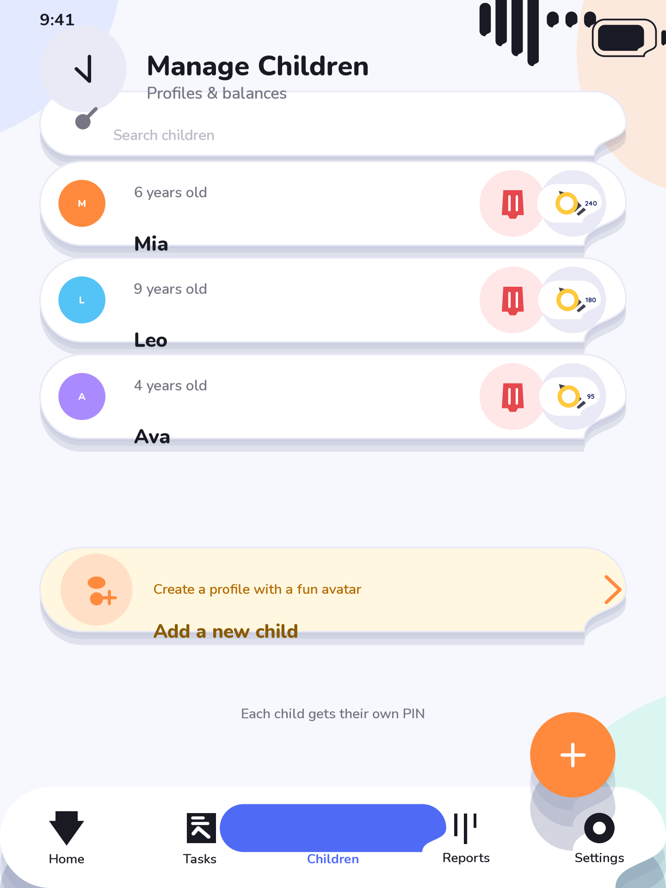
27: Manage Children – Parent mode
16_manage_tasks · Manage Tasks · Parent mode Task management: list of tasks with frequency, coin value, verification type and assignee chips; add, edit, duplicate and archive actions.

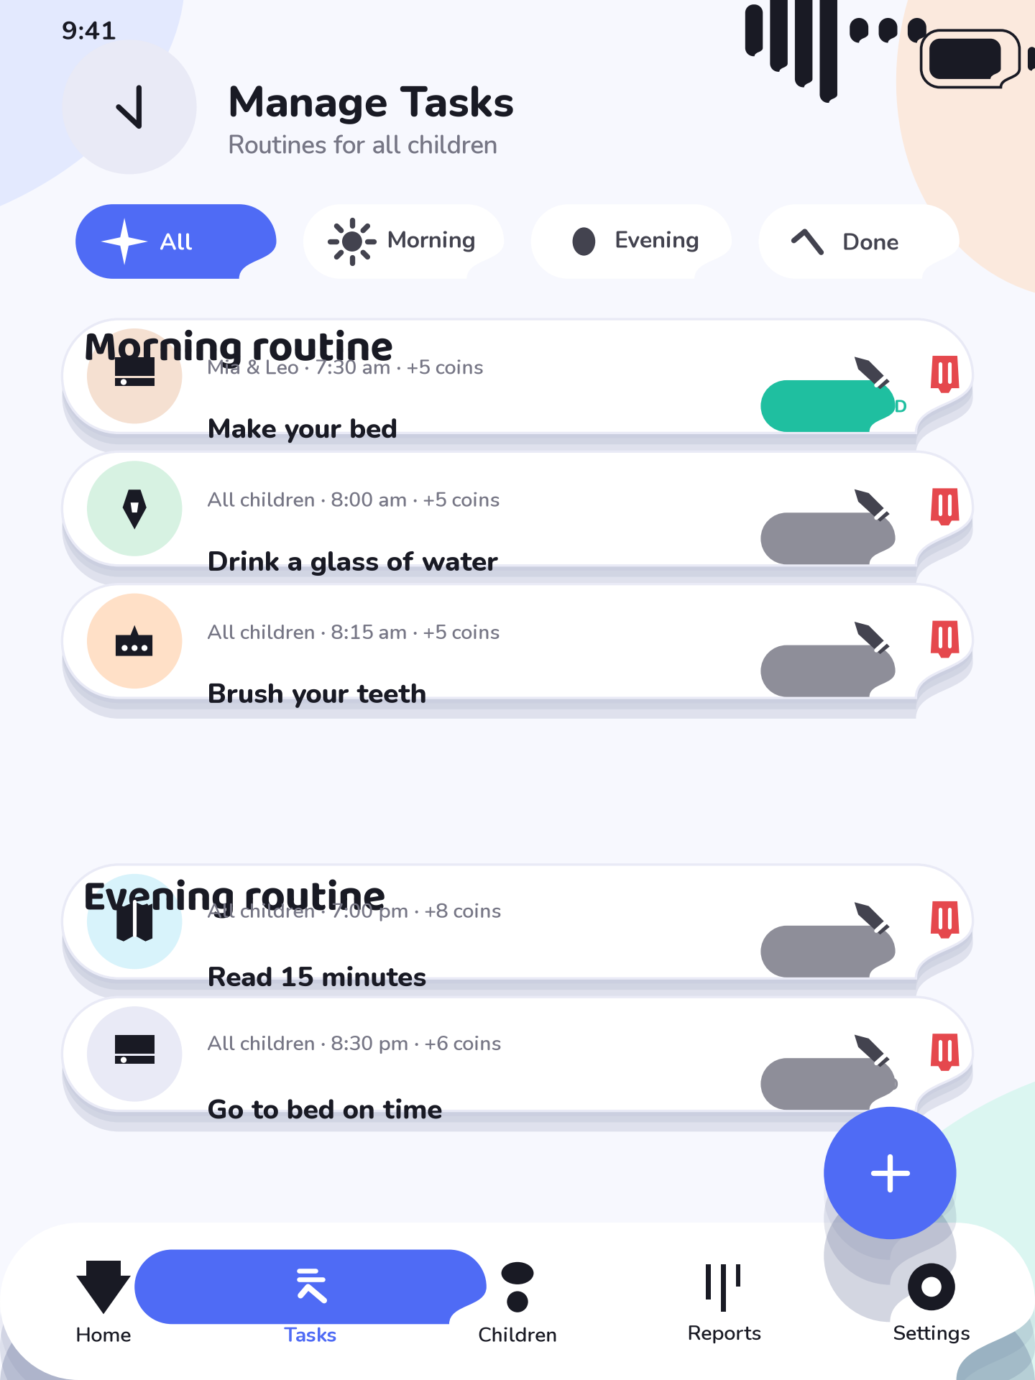
28: Manage Tasks – Parent mode
17_pending_approval · Pending Approval · Parent mode Approval queue: each card shows the child’s submission with proof photo thumbnail, approve and reject buttons and reason input on reject.

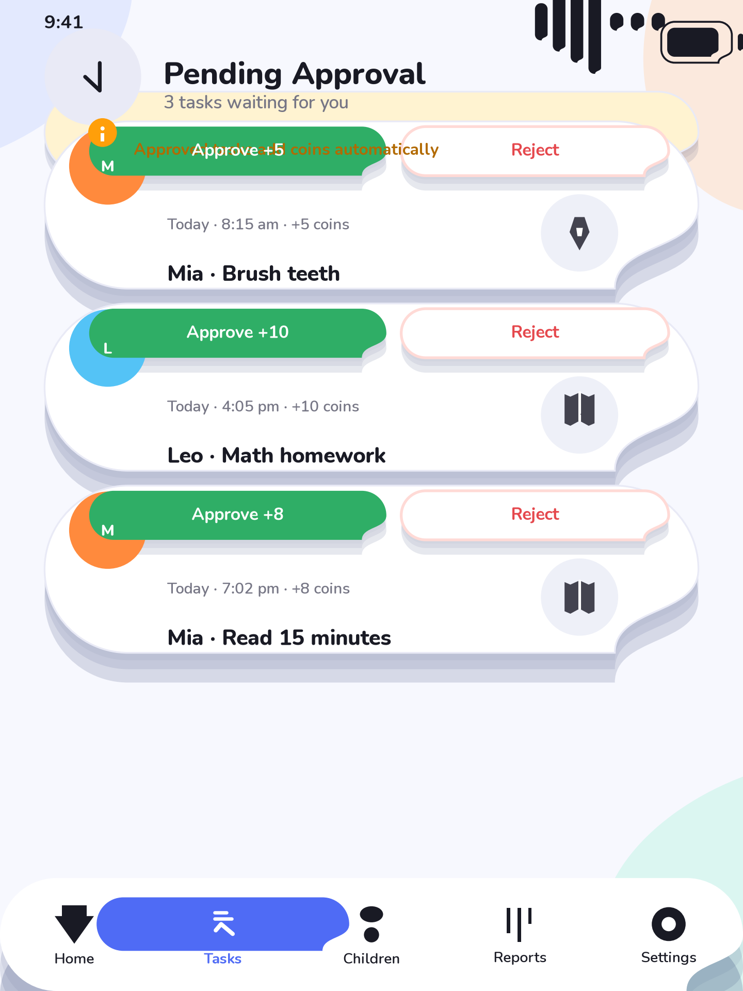
29: Pending Approval – Parent mode
18_rewards_management · Rewards Management · Parent mode Rewards administration: create rewards with illustration, coin price and stock; review redemption requests and approve or decline them.

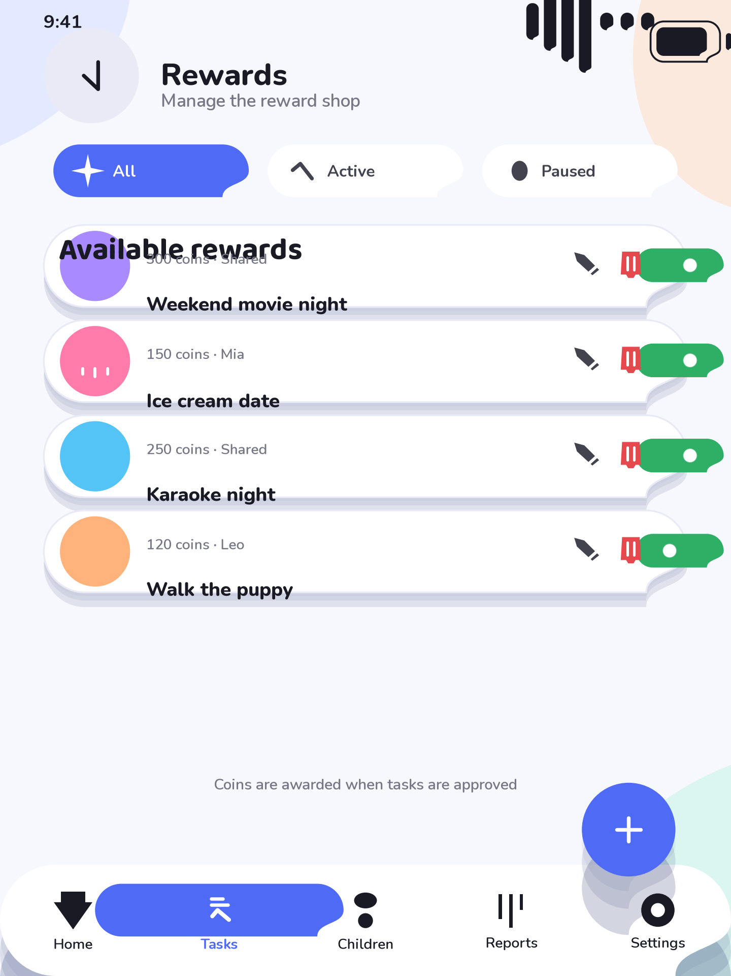
30: Rewards Management – Parent mode
19_coin_management · Coin Management · Parent mode Coin ledger for the parent: per-child balances, manual adjust, transaction history filters and export. Tabular numerals keep totals stable.

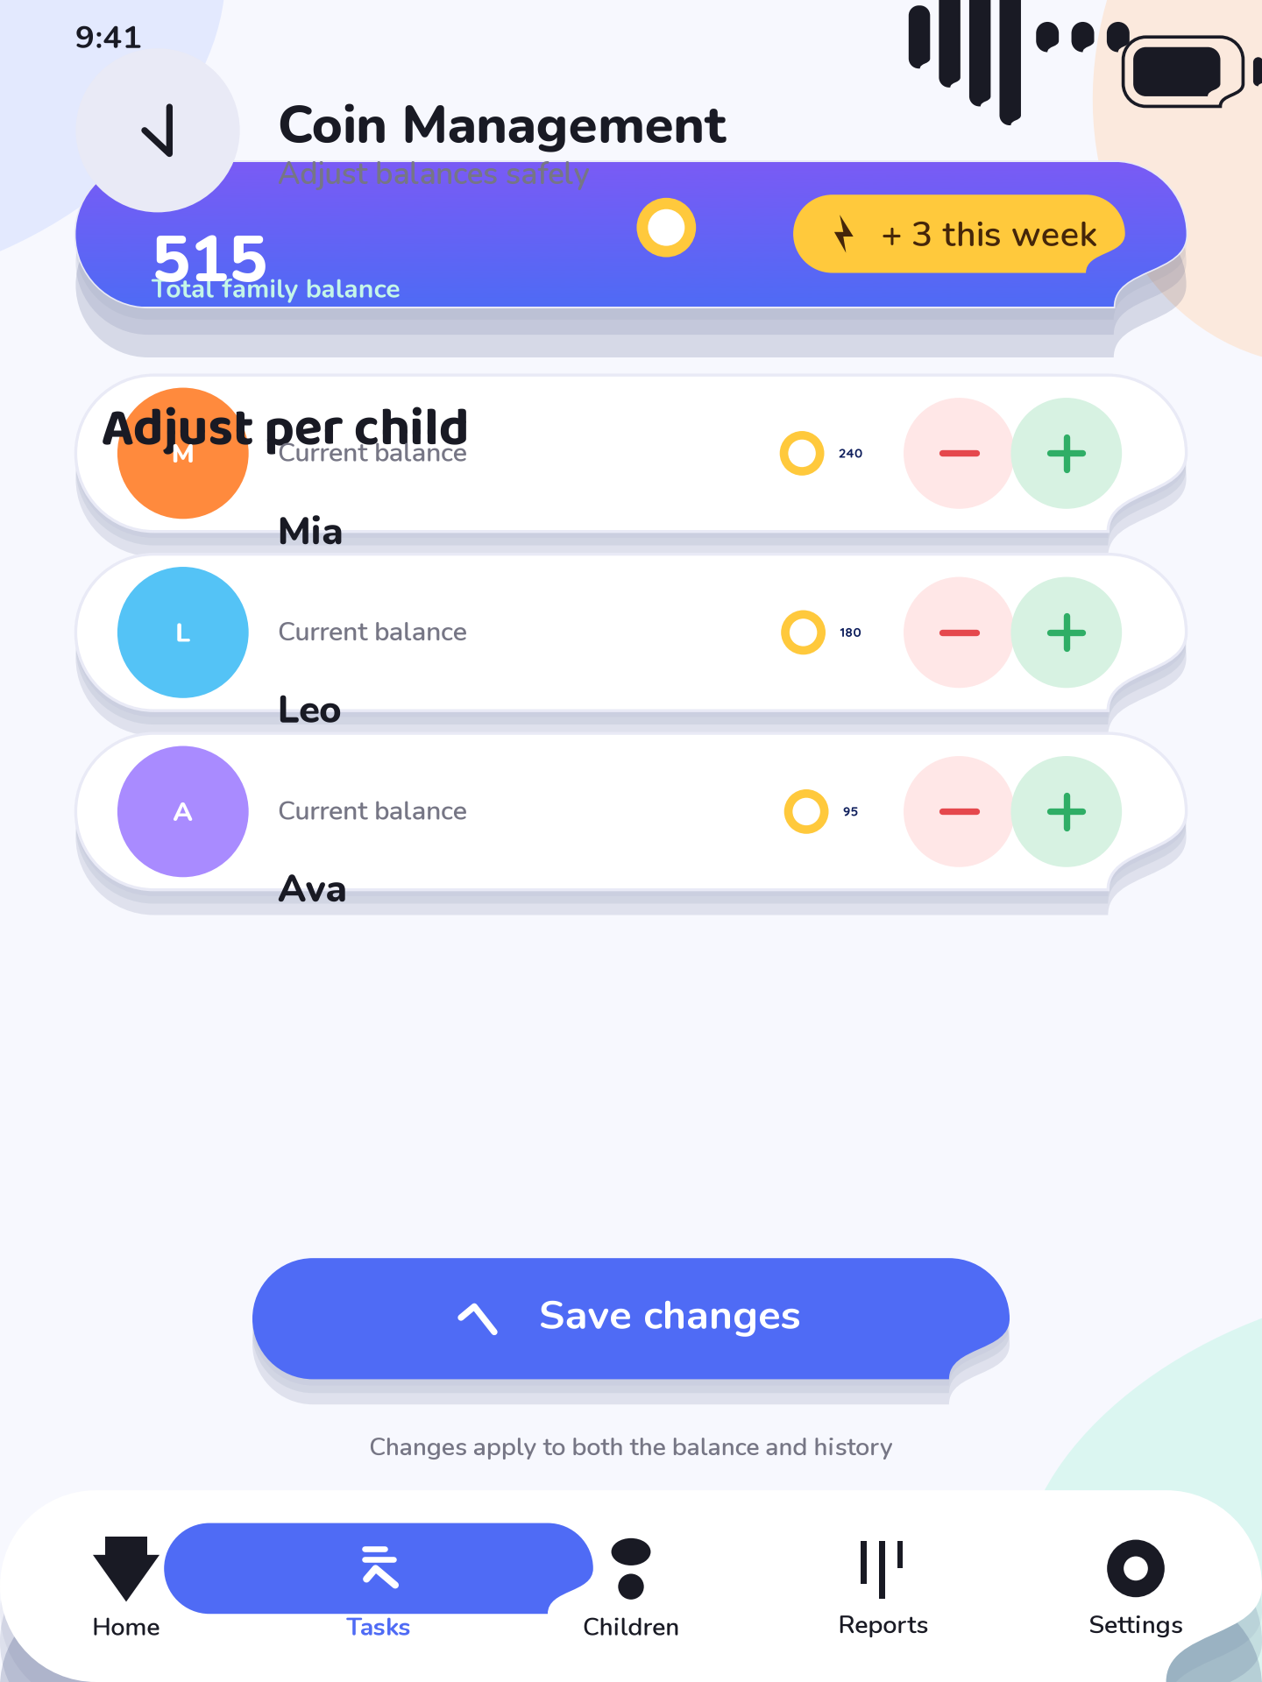
31: Coin Management – Parent mode
20_reports_parent · Parent Reports · Parent mode Period reports: daily, weekly, monthly and yearly tabs with completion rates, missed tasks, top-child ranking and export to PDF.

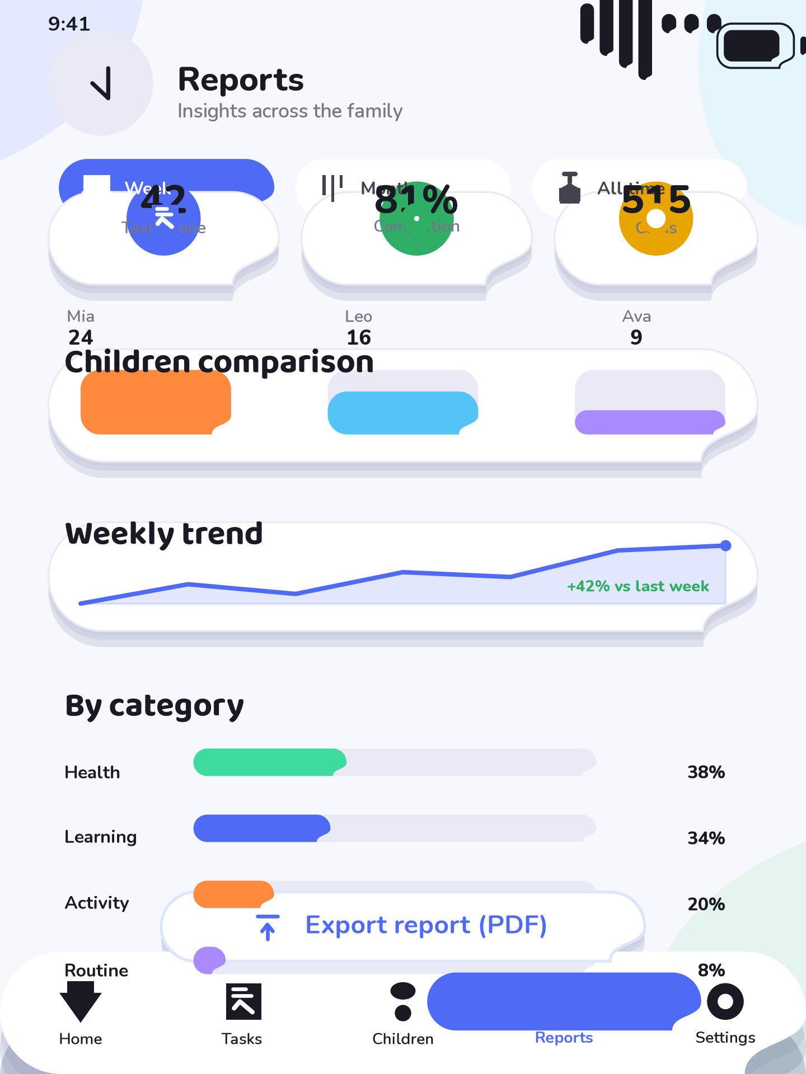
32: Parent Reports – Parent mode
21_settings · Settings · Parent mode Family settings: schedule defaults, verification rules, notification preferences, theme (light/dark) and data backup within the home network.

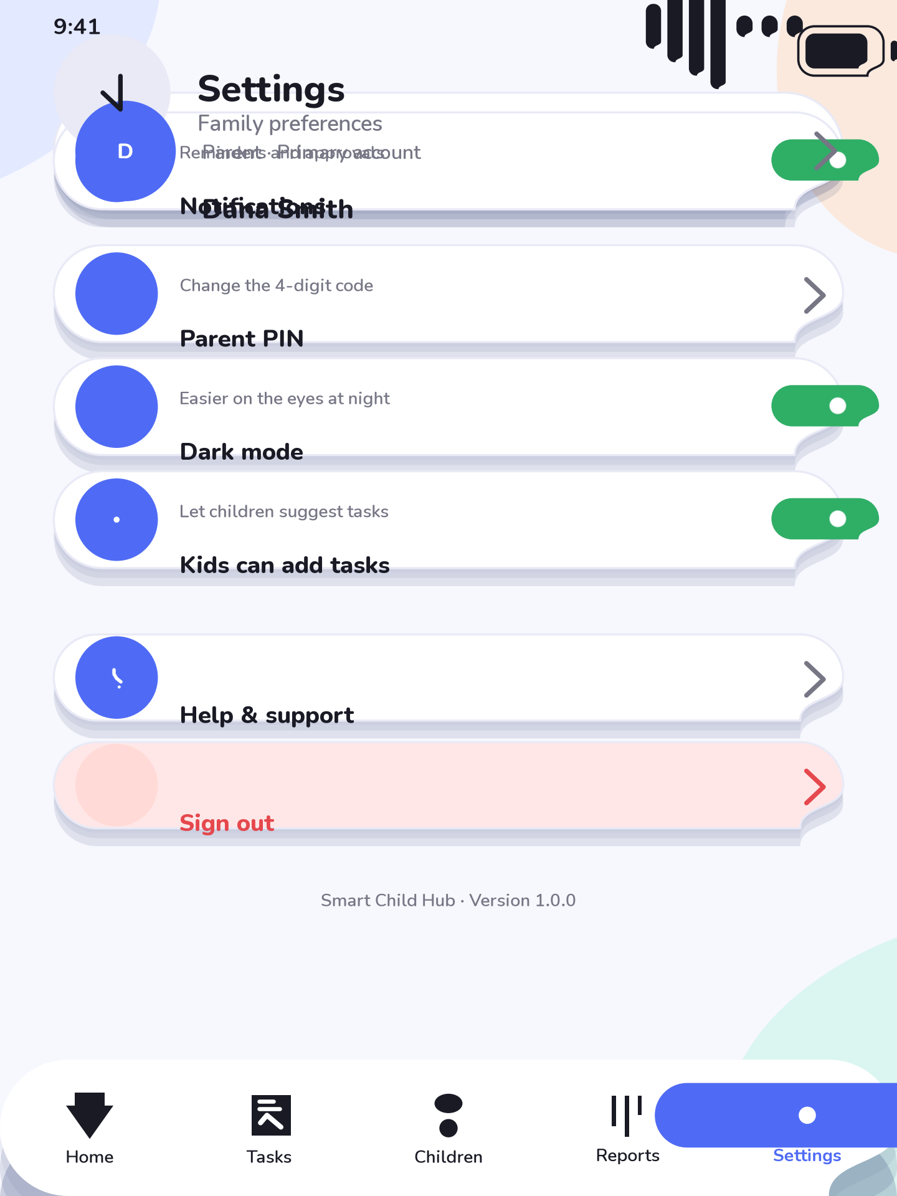
33: Settings – Parent mode
22_about · About · Parent mode About screen: product story, version, credits, the offline/privacy statement and a link to this design system.

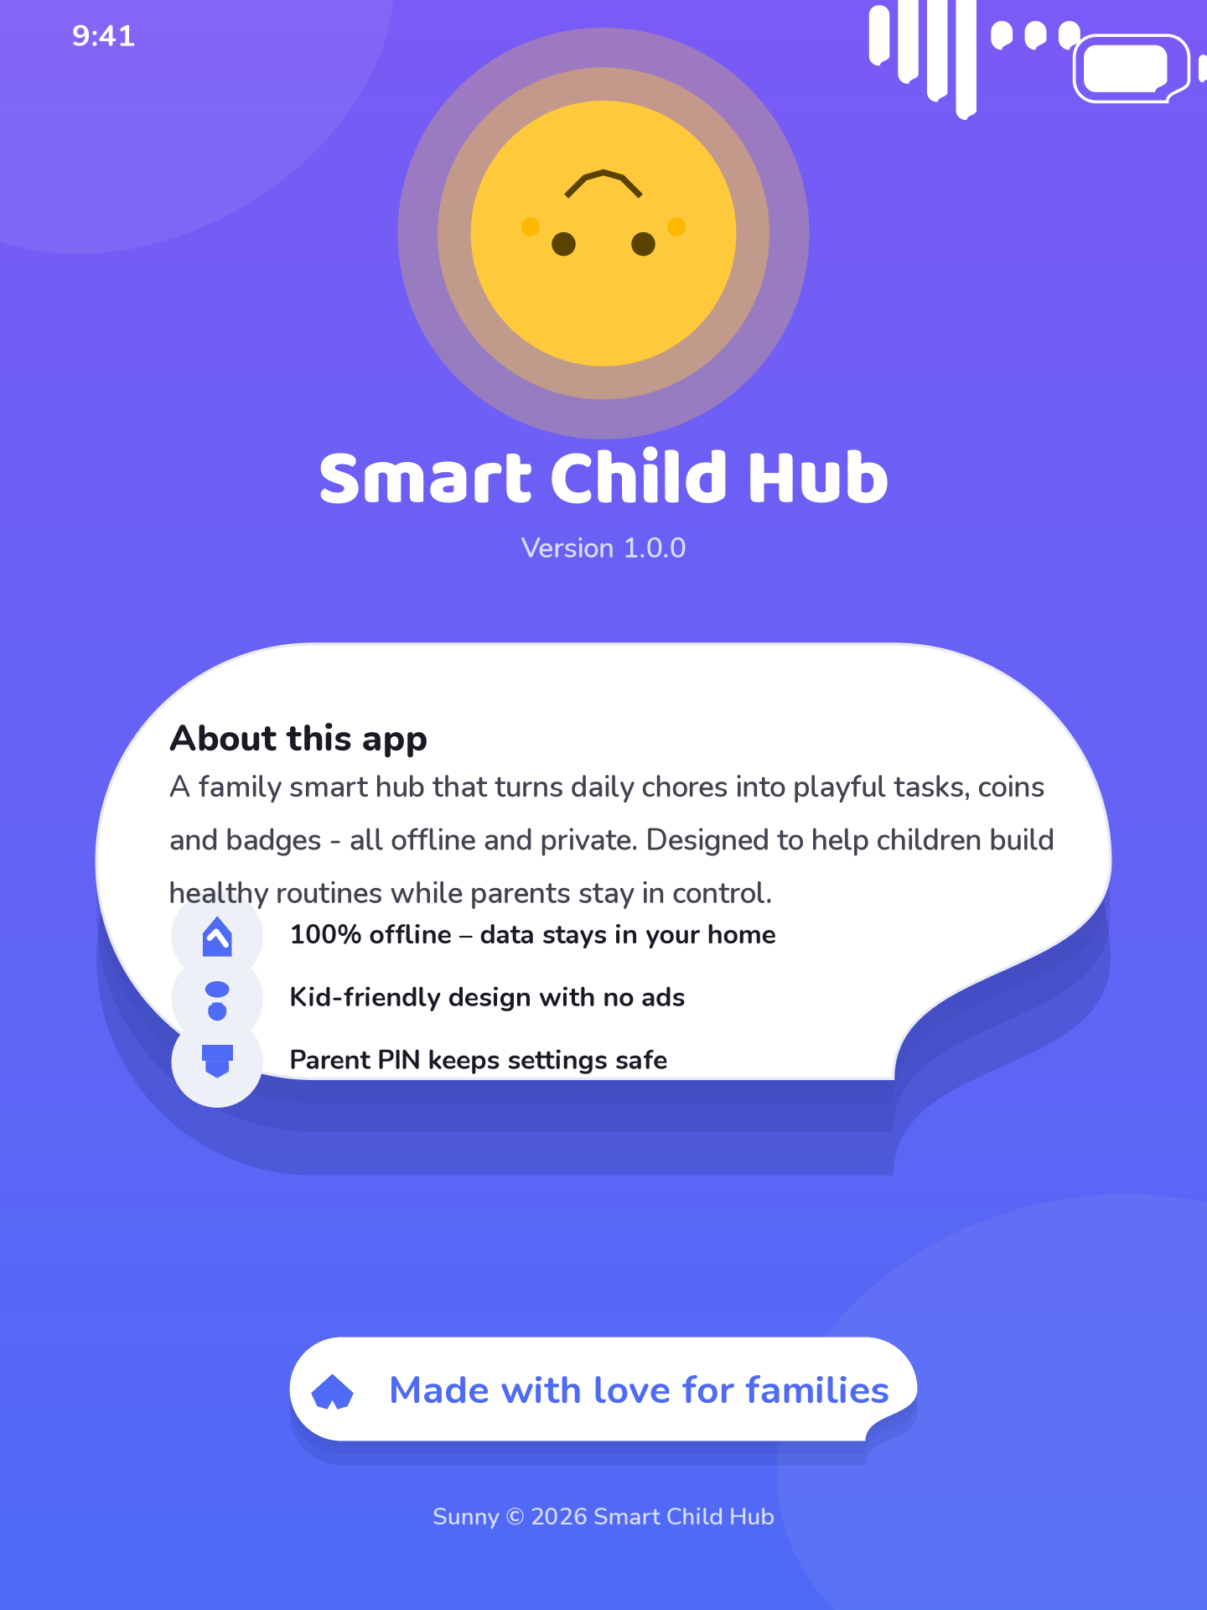
34: About – Parent mode

CHAPTER ELEVEN

NAMING CONVENTIONS AND ASSET STRUCTURE

11.1 Naming Rules
19: Naming conventions
Element | Case | Example
Asset files | snake_case with sch_ prefix | sch_icon_coin.svg
Classes and widgets | UpperCamelCase | RewardsScreen
Constants and tokens | UPPER_SNAKE_CASE | APP_PADDING = 24
Screen files | snake_case with _screen suffix | rewards_screen.dart
Widget files | snake_case with _widget suffix | coin_chip_widget.dart
Colour tokens | snake_case with _color suffix | success_color

11.2 Folder Structure
The design deliverables are organised so that every artefact has one obvious home. The Phase 3 Flutter project should mirror this logic in lib/theme, lib/widgets, lib/screens and lib/assets.
- documentation/design-system – this guide and the screen specifications
- documentation/style-guide – the seven PDF guides
- documentation/mockups – the twenty-two screen mockups
- documentation/components – the eleven component boards
- documentation/assets/icons – the fifty-two SVG icons
- documentation/assets/illustrations – the five SVG illustrations
- documentation/scripts – the token source and all generator scripts

11.3 Token to Flutter Theme Mapping
Design tokens map to a Material 3 ThemeData so implementation needs no design decisions. The primary seed is Color(0xFF4F6BF5); TextTheme maps display styles to Baloo 2 and body styles to Nunito; fontFamily for numerals uses Quicksand with tabular figures. The complete mapping is documented in the Widget Guide PDF.

CHAPTER TWELVE

VALIDATION AND HANDOFF

12.1 Quality Checklist
1. Every screen exists as a mockup and every interactive element as a component board.
2. All tokens are defined once in scripts/tokens.py and used by every renderer.
3. Contrast minimums and 48 px touch targets hold across both themes.
4. All PDFs, SVGs and PNGs open cleanly and are checked for missing glyphs or corrupt pages.
5. Every naming convention in Chapter 11 is applied to the generated assets.

12.2 Handoff to Phase 3
With this design system complete, Phase 3 can begin Flutter development with zero ambiguity. Developers start from scripts/tokens.py to build the ThemeData, then implement the eleven component families against their boards, and finally compose the twenty-two screens from the mockups. The Widget Guide provides the direct component-to-widget translation and the recommended packages for fonts, animation and secure storage.

APPENDIX A

FILE INVENTORY
20: Phase 2 file inventory
Folder | File | Size
mockups | 01_splash.png | 102 KB
mockups | 02_welcome.png | 184 KB
mockups | 03_choose_profile.png | 246 KB
mockups | 04_child_pin.png | 178 KB
mockups | 05_child_dashboard.png | 280 KB
mockups | 06_task_screen.png | 259 KB
mockups | 07_rewards.png | 235 KB
mockups | 08_coins.png | 227 KB
mockups | 09_badges.png | 287 KB
mockups | 10_achievements.png | 252 KB
mockups | 11_messages.png | 180 KB
mockups | 12_reports_child.png | 257 KB
mockups | 13_parent_login.png | 164 KB
mockups | 14_parent_dashboard.png | 244 KB
mockups | 15_manage_children.png | 204 KB
mockups | 16_manage_tasks.png | 253 KB
mockups | 17_pending_approval.png | 241 KB
mockups | 18_rewards_management.png | 214 KB
mockups | 19_coin_management.png | 219 KB
mockups | 20_reports_parent.png | 232 KB
mockups | 21_settings.png | 208 KB
mockups | 22_about.png | 204 KB
components | 01_buttons.png | 334 KB
components | 02_cards.png | 215 KB
components | 03_chips.png | 247 KB
components | 04_inputs.png | 183 KB
components | 05_navigation.png | 180 KB
components | 06_charts.png | 148 KB
components | 07_dialogs.png | 250 KB
components | 08_avatars.png | 244 KB
components | 09_typography.png | 239 KB
components | 10_colors.png | 208 KB
components | 11_spacing.png | 179 KB
assets/icons | sch_icon_add_child.svg | 0 KB
assets/icons | sch_icon_badge.svg | 0 KB
assets/icons | sch_icon_bed.svg | 0 KB
assets/icons | sch_icon_bell.svg | 0 KB
assets/icons | sch_icon_book.svg | 0 KB
assets/icons | sch_icon_calendar.svg | 0 KB
assets/icons | sch_icon_chart.svg | 0 KB
assets/icons | sch_icon_check.svg | 0 KB
assets/icons | sch_icon_chev_down.svg | 0 KB
assets/icons | sch_icon_chev_left.svg | 0 KB
assets/icons | sch_icon_chev_right.svg | 0 KB
assets/icons | sch_icon_child.svg | 0 KB
assets/icons | sch_icon_clock.svg | 0 KB
assets/icons | sch_icon_coin.svg | 0 KB
assets/icons | sch_icon_cross.svg | 0 KB
assets/icons | sch_icon_download.svg | 0 KB
assets/icons | sch_icon_edit.svg | 0 KB
assets/icons | sch_icon_eye.svg | 0 KB
assets/icons | sch_icon_food.svg | 0 KB
assets/icons | sch_icon_gear.svg | 0 KB
assets/icons | sch_icon_heart.svg | 0 KB
assets/icons | sch_icon_help.svg | 0 KB
assets/icons | sch_icon_home.svg | 0 KB
assets/icons | sch_icon_homework.svg | 0 KB
assets/icons | sch_icon_info.svg | 0 KB
assets/icons | sch_icon_lightning.svg | 0 KB
assets/icons | sch_icon_lock.svg | 0 KB
assets/icons | sch_icon_mail.svg | 0 KB
assets/icons | sch_icon_medal.svg | 0 KB
assets/icons | sch_icon_message.svg | 0 KB
assets/icons | sch_icon_minus.svg | 0 KB
assets/icons | sch_icon_moon.svg | 0 KB
assets/icons | sch_icon_music.svg | 0 KB
assets/icons | sch_icon_paint.svg | 0 KB
assets/icons | sch_icon_parent.svg | 0 KB
assets/icons | sch_icon_person.svg | 0 KB
assets/icons | sch_icon_pets.svg | 0 KB
assets/icons | sch_icon_plants.svg | 0 KB
assets/icons | sch_icon_plus.svg | 0 KB
assets/icons | sch_icon_run.svg | 0 KB
assets/icons | sch_icon_search.svg | 0 KB
assets/icons | sch_icon_send.svg | 0 KB
assets/icons | sch_icon_shield.svg | 0 KB
assets/icons | sch_icon_sparkle.svg | 0 KB
assets/icons | sch_icon_star.svg | 0 KB
assets/icons | sch_icon_sun.svg | 0 KB
assets/icons | sch_icon_target.svg | 0 KB
assets/icons | sch_icon_tasks.svg | 0 KB
assets/icons | sch_icon_trash.svg | 0 KB
assets/icons | sch_icon_trophy.svg | 0 KB
assets/icons | sch_icon_verified.svg | 0 KB
assets/icons | sch_icon_water.svg | 0 KB
assets/illustrations | sch_ill_celebration.svg | 0 KB
assets/illustrations | sch_ill_empty_tasks.svg | 0 KB
assets/illustrations | sch_ill_error_state.svg | 0 KB
assets/illustrations | sch_ill_sunny_mascot.svg | 0 KB
assets/illustrations | sch_ill_welcome_hero.svg | 1 KB
style-guide | Animation_Guide.pdf | 149 KB
style-guide | Color_Palette.pdf | 144 KB
style-guide | Component_Library.pdf | 2513 KB
style-guide | Responsive_Guide.pdf | 136 KB
style-guide | Typography_Guide.pdf | 176 KB
style-guide | UI_Style_Guide.pdf | 410 KB
style-guide | Widget_Guide.pdf | 182 KB
design-system | Design_System_Guide.docx | this document

End of Design System Guide. Version 1.0.0 · August 2026

