GLOWNEST SKINCARE
TSG AI Internship — Project 02: AI Image & Content Workflow

Brand Brief

1. Brand Overview
Brand Name: GlowNest Skincare
Brand Type: Fictional skincare brand
Industry: Beauty and Skincare
GlowNest Skincare is a fictional brand focused on simple, clean, and natural-looking skincare products. Its visual identity is designed to feel calm, fresh, modern, and trustworthy.
2. Target Audience
People aged 18–30 who are interested in skincare and prefer a simple, modern, and visually appealing brand.
3. Product Range
- Face Wash: A daily skincare essential.
- Moisturizer: A product for a basic skincare routine.
- Serum: A skincare product presented with minimal, professional packaging.
Note: These are fictional product concepts created for this project.
4. Brand Identity
Element | Description
Brand Personality | Calm, fresh, simple, trustworthy
Brand Style | Clean, minimal, natural, professional
Primary Colors | Sage green, beige, white
Visual Mood | Soft, bright, fresh, elegant
Brand Tone | Friendly, simple, clear
Main Platform | Instagram
5. Visual Guidelines
All product images should follow a consistent visual style:
- Use clean and uncluttered backgrounds.
- Prefer soft, natural lighting.
- Use sage green, beige, and white as the main colors.
- Include subtle botanical elements where suitable.
- Keep product packaging clear and visually prominent.
- Use balanced composition and realistic shadows.
- Avoid excessive decorations and distracting elements.
6. Content Requirements
The project includes:
- Twelve AI-generated product images.
- An image prompt log.
- Prompt iteration evidence for three images.
- Manual editing of at least four images.
- Ten marketing captions, headlines, or descriptions.
- One promotional video of 20–40 seconds.
- A workflow report documenting the process and AI limitations.
7. Project Goal
The goal is to develop a consistent AI-assisted content workflow for GlowNest Skincare. The workflow covers prompt writing, image generation, manual editing, marketing copy creation, video production, and documentation.
8. Brand Message
“Keep Your Skincare Simple.”
This message reflects the brand's clean, minimal, and everyday skincare identity.

GlowNest_Image_Prompt_Log

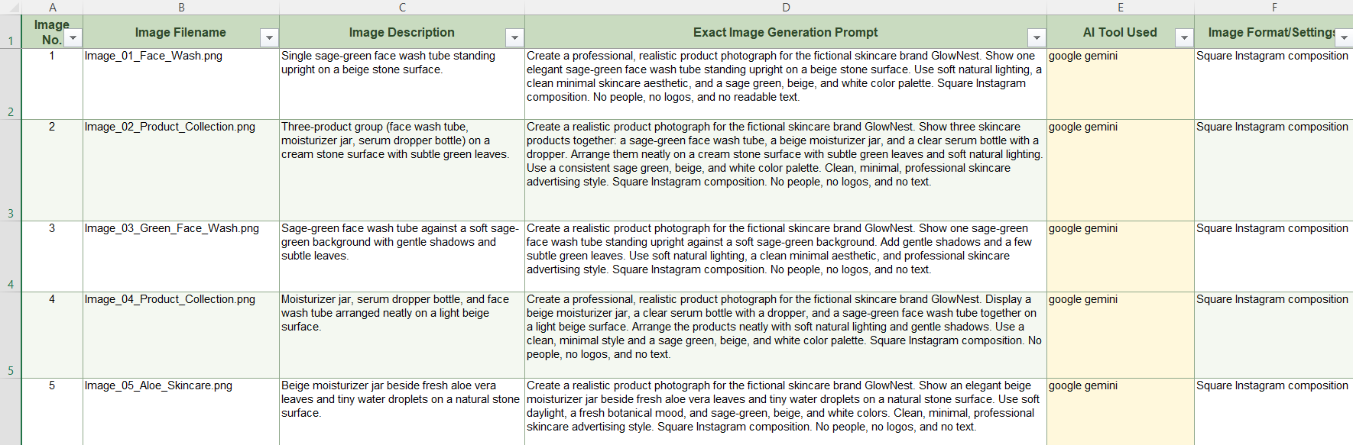
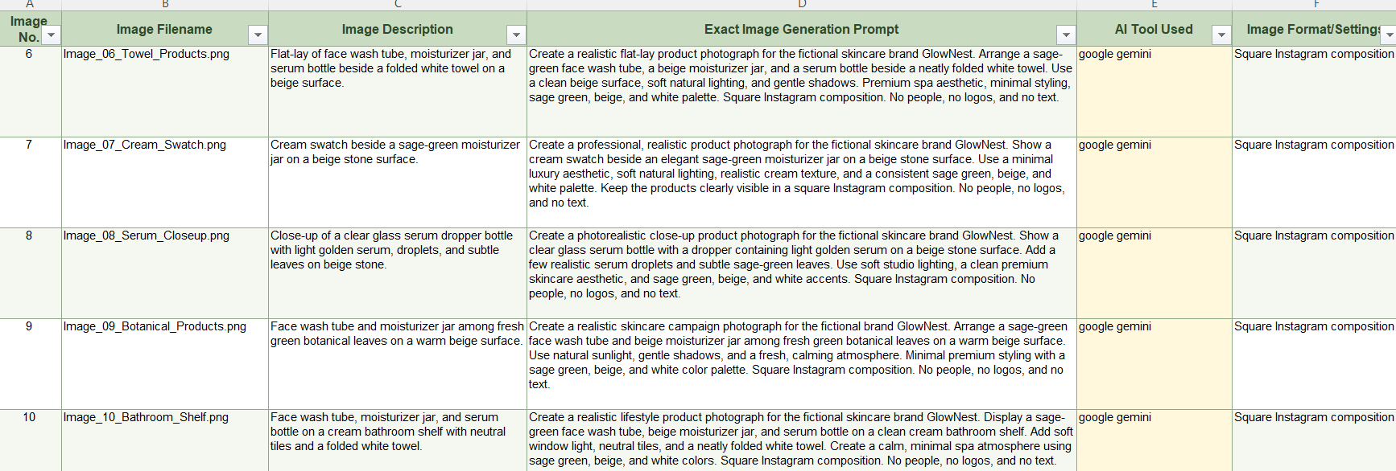

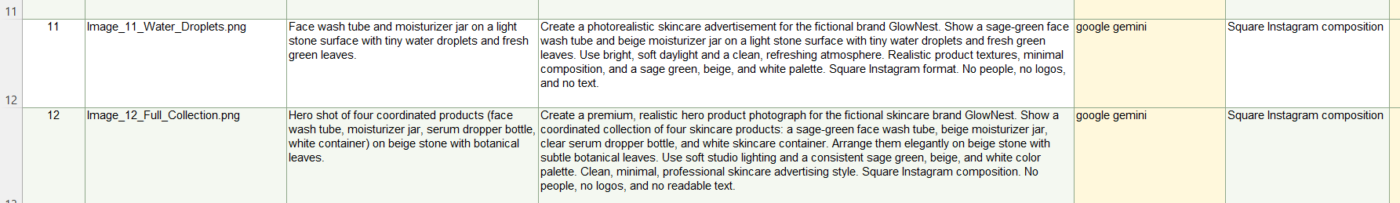

GlowNest_Prompt_Iteration_Evidence

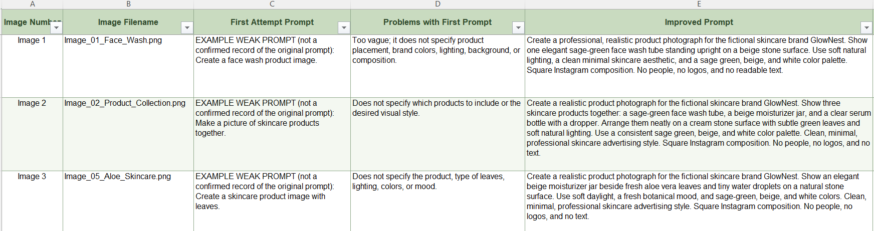
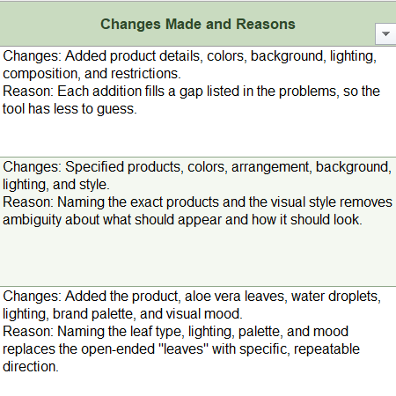

AI IMAGES

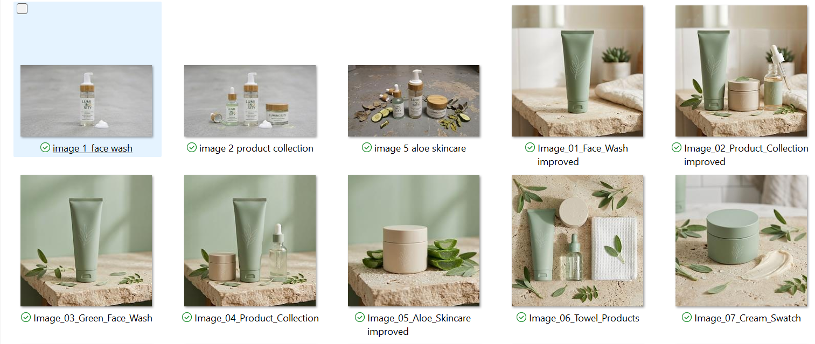
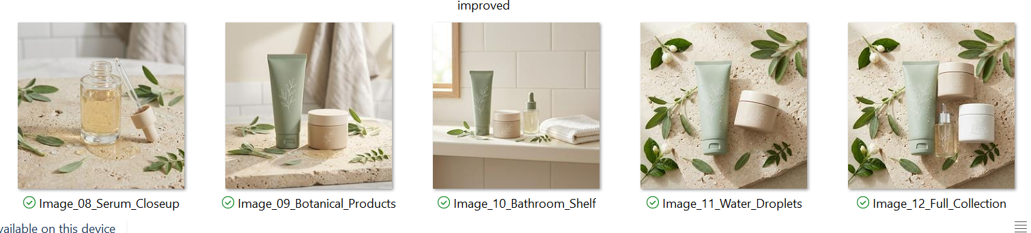

EDITED IMAGES

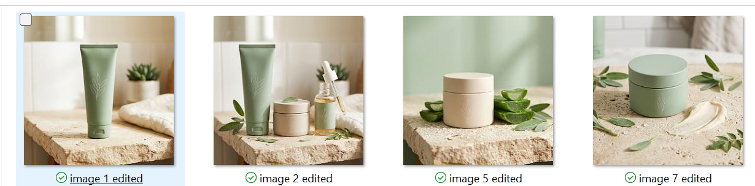

GlowNest Skincare — Marketing Content

1. Face Wash Instagram Caption
AI Draft: Get clean skin with our face wash.
Edited Version: Start your skincare routine with GlowNest Face Wash. Keep your daily routine simple and refreshing.
Reason for Editing: Made the caption more natural and connected it to the brand.
2. Moisturizer Instagram Caption
AI Draft: Buy our moisturizer for beautiful skin.
Edited Version: Add a little care to your day with GlowNest Moisturizer. Simple skincare, made part of your daily routine.
Reason for Editing: Removed pushy wording and used a friendly tone.
3. Serum Instagram Caption
AI Draft: Our serum is the best serum for everyone.
Edited Version: Meet GlowNest Serum, a simple addition to your skincare routine. Find the steps that work best for your skin.
Reason for Editing: Removed an unsupported claim and made the message more trustworthy.
4. Brand Introduction
AI Draft: GlowNest sells skincare products.
Edited Version: Welcome to GlowNest Skincare, where clean design meets simple, everyday skincare.
Reason for Editing: Made the introduction more engaging and professional.
5. Product Collection Caption
AI Draft: We have face wash, moisturizer, and serum.
Edited Version: Your skincare essentials, together. Explore the GlowNest collection: face wash, moisturizer, and serum.
Reason for Editing: Improved flow and made the product list more appealing.
6. Instagram Headline
AI Draft: Good skincare products.
Edited Version: Keep Your Skincare Simple.
Reason for Editing: Made the headline shorter, clearer, and easier to remember.
7. Aloe Vera Product Caption
AI Draft: Our moisturizer looks good with aloe leaves.
Edited Version: A calm, natural look for your skincare routine. Discover the GlowNest Moisturizer.
Reason for Editing: Focused on the product and brand mood rather than only the image.
8. Serum Product Description
AI Draft: This is a serum bottle with liquid inside.
Edited Version: GlowNest Serum features simple, minimal packaging designed to complement your everyday skincare collection.
Reason for Editing: Turned a basic visual description into professional product copy without inventing product benefits.
9. Promotional Headline
AI Draft: Buy skincare products today.
Edited Version: Make Space for Simple Skincare.
Reason for Editing: Replaced a direct sales command with a softer brand message.
10. Instagram Call to Action
AI Draft: Buy now.
Edited Version: Explore the GlowNest collection and find your everyday skincare essentials.
Reason for Editing: Made the call to action friendlier and more suitable for the brand.

PROMO VIDEO

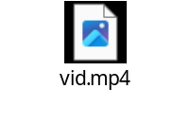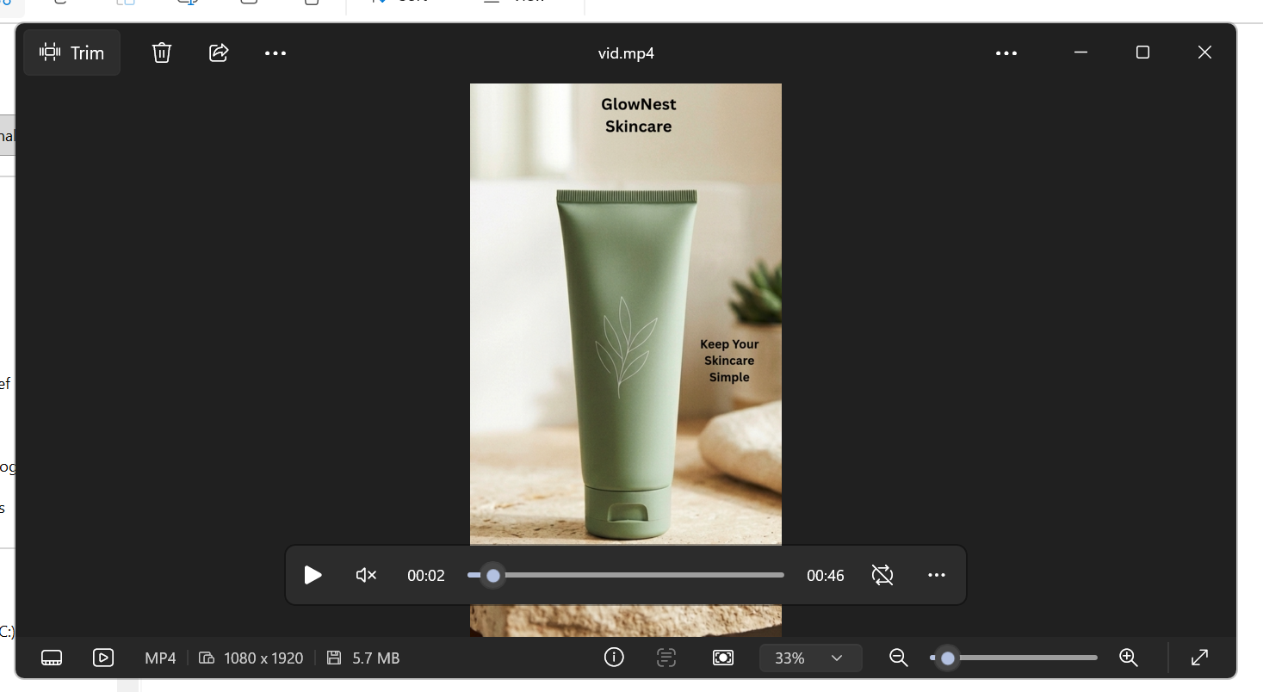

WORKFLOW REPORT
1. Project Overview
GlowNest Skincare is a fictional skincare brand created for this project. The purpose was to use AI tools to create product images, marketing content, and a promotional video.
2. Brand Identity
Element | Details
Brand Name | GlowNest Skincare
Brand Type | Fictional skincare brand
Target Audience | People aged 18–30
Products | Face wash, moisturizer, serum
Brand Style | Clean, minimal, natural, professional
Brand Colors | Sage green, beige, white
Brand Tone | Friendly, simple, calm, trustworthy
Main Platform | Instagram
3. Tools Used
- AI Image Generation: Creating skincare product visuals.
- Canva: Editing images and creating the promotional video.
- Microsoft Word: Preparing marketing content and this report.
- Excel: Recording image prompts and prompt improvements.
4. AI Image Generation
Twelve AI-generated skincare images were created for the brand. They included face wash, serum, moisturizer, aloe vera, product collections, and different product arrangements.
The prompts focused on natural elements, soft lighting, clean backgrounds, and a minimal skincare aesthetic. The images were saved in the 03_AI_Images folder.
5. Image Editing
Four images were manually edited using Canva to improve brightness, contrast, and visual appearance.
The edited versions were saved separately in the 04_Edited_Images folder. Keeping the original and edited images separate helps document the editing process.
6. Prompt Logging and Iteration
A prompt log is intended to record each image prompt and its corresponding output. Prompt iteration evidence compares weak prompts with improved prompts to demonstrate how clearer instructions can improve results.
The improved prompts should specify details such as product placement, background, lighting, colors, and composition.
Important: Example weak prompts must be labelled as examples. Only prompts that were actually tested should be described as tested. Images should only be described as regenerated if they were actually created again.
7. Marketing Content
Ten pieces of marketing content were prepared, including:
- Instagram captions
- Product descriptions
- Brand introduction
- Promotional headlines
- Calls to action
The wording was revised to make it more natural, clear, and consistent with the brand's friendly tone. Unsupported claims about skincare benefits were avoided.
8. Promotional Video
A short promotional video was created using Canva in a vertical Instagram Reel format.
The video contains five slides featuring GlowNest Skincare images and promotional headlines. Background music was added, and the finished video was exported in MP4 format.
9. AI Limitations
AI-generated content has several limitations:
- Product packaging and labels may contain errors.
- Images may look unrealistic or inconsistent.
- Generated captions may be repetitive or generic.
- AI may produce unsupported product claims.
- Generated content may not always match the intended brand style.
For these reasons, all images and written content should be reviewed before publication.
10. Ethical Use and AI Disclosure
GlowNest Skincare is a fictional brand created for educational purposes.
AI-generated images and text should be checked by a human before use. Marketing content should not mislead customers or make unverified skincare claims.
AI Disclosure Statement: AI tools were used to assist with creating visual and written content for this educational project. The content was reviewed and edited as part of the workflow.
11. Conclusion
This project demonstrated how AI tools and Canva can support a basic skincare marketing workflow. It covered image generation, image editing, marketing copy development, and promotional video creation.
The project also highlighted the importance of clear prompts, consistent branding, human review, and responsible use of AI-generated content.

