**Whale Mooder**

**Instructions**

Open the bitmap and the Keyboard and MMIO Simulator. The settings that should be used are 4 X 4 (Unit Width X Unit Height in Pixels), 256 X 256 (Display Width X Display Height in Pixels), and the base address from the display is 0x10010000 (static data). Press run and a default display of the whale will pop up. I have created a system to where when a user types a specific character the mood of the whale will change in the displays case the whale will change colors. The specific characters represent a feeling/mood that the user is presented with through the whale:

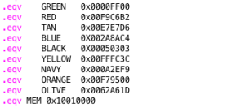

Yellow

• Lowercase (h) represents the feeling of happiness

Navy Blue

• Lowercase (s) represents the feeling of sadness

Bright Orange

• Lowercase (a) represents the feeling of anger

Olive Green

• Lowercase (n) represents the feeling of nervousness

• The (spacebar) will allow the user to exit the program once done however if not pressed the program will continue to run

**Overview**

This project was intended to help kids who have auditory issues and have trouble communicating with others. It gives them a chance to be able to express how they are feeling through this program. In comparison to a mood ring, I was inspired to create a fun and cute way for younger children and their peers to be engaged in an interactive way of expressing their feelings. The basic explanation of this program is that we have whale whom will change colors based on how the user is feeling. The whale will only change colors when the user has typed the specific characters (which are (h) - happy, (s) - sadness, (a) - anger, and (n) - nervous).

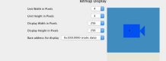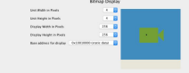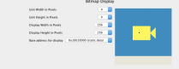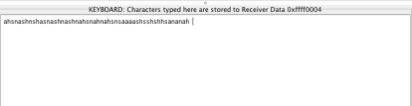

**Flowchart**

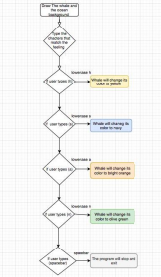

**Helpful Hints**

• In order to achieve the centered whale start at the position 40 on the X and Y axis. • Make sure to set the .eqv width and height to 64 measurements

• Make sure the default whale has a different color than the colors used in for the designated moods