

**LAB 3:**

***DOTNET***

**MOHAMAD IMAN MUHAIMIN BIN HUSIN**

**AI210206**

Masterpages.Master

Style.css

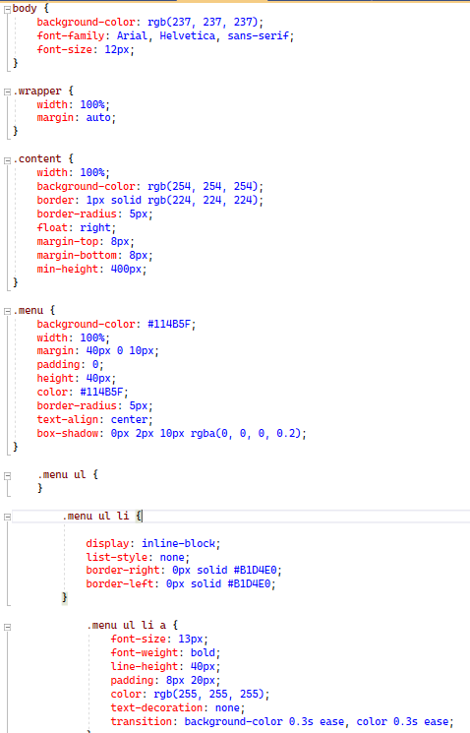

Default.aspx

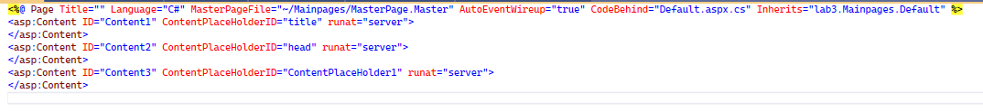

Login.aspx

Login.aspx.cs

ContactUs.aspx

Output

Default

Login

Contact Us

