

Lebanese International University

School of Engineering

CENG375- Introduction to Database Systems

Spring 2025

Database Project

Online Shopping Application

Iman Soleiman 12331027

Dana Ghannam 12332943

Introduction
In this Online Shopping Application, the customer can register, login, view items, make an order, cancel an order, and make payment with the reliance on the admin of this application that adds and manages items and products.
The customer can view the items offered, and if he wants to make an order, he must log in. A customer can register using a username and a password. This application allows the customer to pay for their order using their credit card, they can register the card information within their profile. During purchase a customer can cancel his order and empty his basket.

E/R model
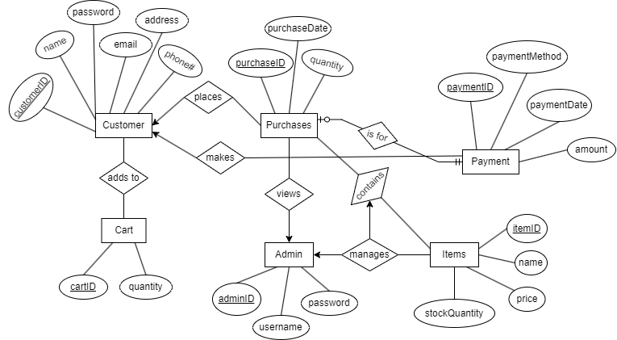
- Customer places Purchases (1:M): A customer can make multiple purchases, but each purchase is associated with only one customer.
- Customer adds Items to Cart (M:M): A customer can add multiple items to their cart, and an item can be in multiple customers' carts.
- Purchase contains Items (M:M): A purchase can contain multiple items, and an item can be part of multiple purchases.
- Customer makes Payments (1:M): A customer can make multiple payments, but each payment belongs to only one customer.
- Payment is for a Purchase (1:1): Each payment corresponds to a single purchase.
- Admin manages Purchase (1:M): An admin can manage multiple items, but each item is managed by only one admin.
- Admin views Purchases (1:M): An admin can view multiple purchases, but a purchase is viewed by only one admin.

Relational Model
Customer (customerID, name, password, email, address, phone#)
Purchase (purchaseID, customerID, adminID, purchaseDate, quantity)
Payment (paymentID, customerID, paymentMethod, paymentDate, amount)
Cart (cartID, quantity)
Admin (adminID, username, password)
Items (itemID, name, price, stockQuantity)
adds to (customerID, cartID)
contains (purchaseID, itemID)

Creating tables and data insertion
This section lists the SQL code used to create and alter the tables of the database, and to insert data into them. Provide the SQL code, and screenshots of outcomes.

Queries to create the tables
The queries show the creation of primary and foreign keys.
Customers table
CREATE TABLE Customer (
customerID INT PRIMARY KEY AUTO_INCREMENT,
name VARCHAR(50) NOT NULL,
password VARCHAR(50) NOT NULL
);

Items table
CREATE TABLE Items (
itemID INT PRIMARY KEY AUTO_INCREMENT,
name VARCHAR(50) NOT NULL,
price DECIMAL(10,2) NOT NULL,
stockQuantity INT NOT NULL
);
Purchase table
CREATE TABLE Purchase (
purchaseID INT PRIMARY KEY AUTO_INCREMENT,
customerID INT NOT NULL,
itemID INT NOT NULL,
itemQuantity INT NOT NULL,
FOREIGN KEY (customerID) REFERENCES Customer(customerID)
ON DELETE CASCADE ON UPDATE CASCADE,
FOREIGN KEY (itemID) REFERENCES Items(itemID)
ON DELETE CASCADE ON UPDATE CASCADE);

Queries to insert data

Insert Customers:
INSERT INTO Customer (name, password) VALUES
('Iman', 'iman123'),
('Dana', 'dana123');

Insert Items
INSERT INTO Items (name, price, stockQuantity) VALUES
('Eggs Dozen', 3.50, 100),
('Milk 1L', 1.20, 80),
('Orange Juice 1L', 2.00, 60),
('Bread Loaf', 1.00, 50),
('Rice 1kg', 2.50, 70),
('Chicken Breast 500g', 5.75, 40),
('Apple 1kg', 3.00, 90),
('Cheese 200g', 4.25, 30);

Insert Purchases
INSERT INTO Purchase (customerID, itemID, itemQuantity) VALUES
(1, 2, 2),
(1, 4, 1);

Querying the database
🔹 Query 1: List all items available in the shop.
SQL: SELECT * FROM items;
Purpose: This query retrieves all items with their name, price, and stock quantity.
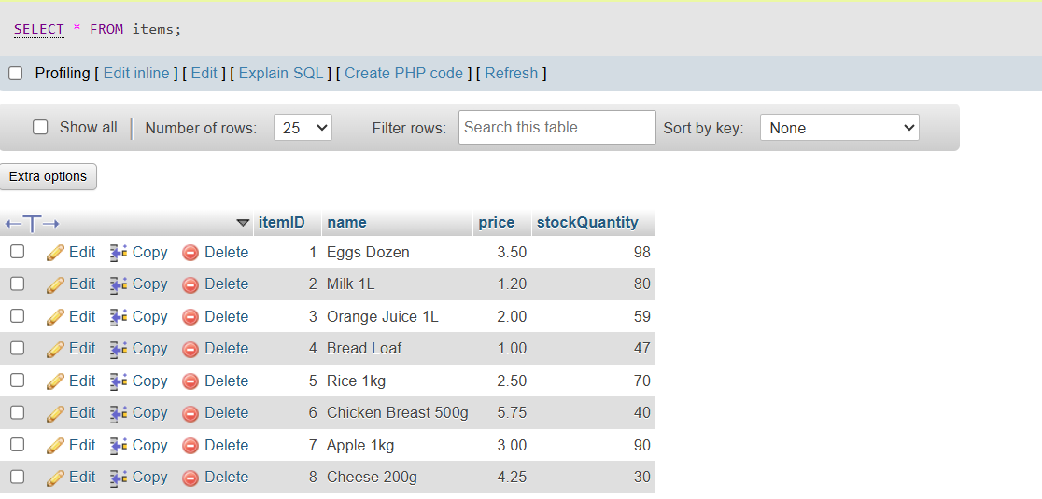

🔹 Query 2: Get the quantity of a specific item by name.
SQL: SELECT stockQuantity FROM items WHERE name = 'Milk 1L';
Purpose: This query retrieves the current stock of Milk 1L.
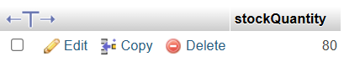

🔹 Query 3: Get the price of a specific item.
SQL: SELECT price FROM items WHERE name = 'Rice 1kg';
Purpose: This query returns the price of Rice (1kg).
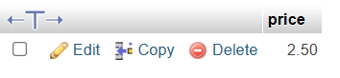

🔹 Query 4: List all customers.
SQL: SELECT * FROM customer;
Purpose: This query displays all customers and their credentials.
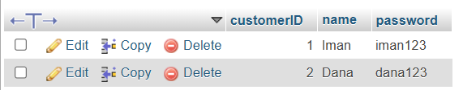

🔹 Query 5: Find the most expensive item in the store
SQL: SELECT name, price FROM Items WHERE price = (SELECT MAX (price) FROM Items);
Purpose: Display the name and price of the item with the highest price.
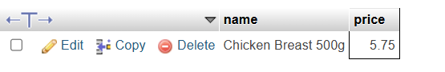

🔹 Query 6: returns the total count of unique items in the inventory.
SQL: SELECT COUNT (*) FROM items;
Purpose: This query returns the total count of unique items in the inventory.
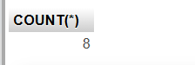

Layout

WelcomeFrame:
This is likely the first screen shown to the user when the application starts. It serves as a welcome screen with options to log in or register.
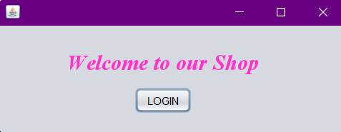

RegLogFrame:

Purpose:

This frame handles both registration and login for two types of users: customers and admins, using a shared interface (same username and password fields).
- Customer Registration:
  - New users can register with a username and password.
  - On registration, the information is sent to the AppControl class via the addCustomer() method.
- Login (for Both Admins and Customers):
  - Users enter their username and password.
  - The system first checks if the credentials match an admin using checkAdmin(username, password).
  - If not an admin, it checks for a valid customer account using checkCustomer(username, password).

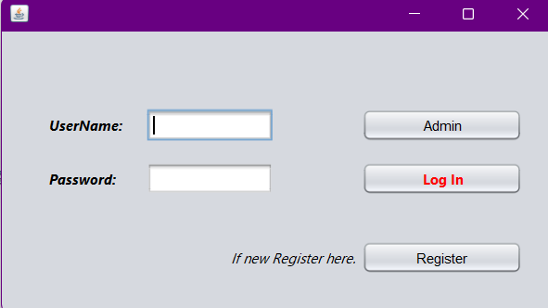

3. AdminFrame:
Purpose:
This is the admin control panel. Admins can:
- Add new items
- View the full list of items and quantities
- Track orders and system data
It likely uses:
- addItem(name, price, quantity)
- getItemList()
- getItemCount()
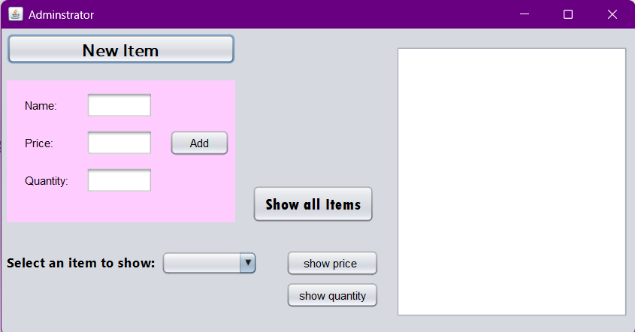

4.OrderFrame:
Purpose:
This frame handles the customer’s cart and finalizes purchases.
It allows users to:
- View items in their cart
- Remove items or confirm the order
It likely calls:
- addPurcahse(cart)
- reduceItemQuantity(cart)

