# Custom Program Plan

Name: Amirul Iman bin Amran

Student ID: 101234444

1. Provide a summary of your program, maybe write up a paragraph or two to describe what does it do? What are some of the key features etc.

Water Reminder is a program that aims to ensure users' daily water consumption is on the right track. Users will have the option to set a daily intake goal and schedule the drinking time based on their preferences. The program then will remind the users to drink whenever it reaches the specified time. The program also can suggest the users for the recommended drinking quantity per intake through calculation. Other than that, users can access the weekly analysis. To summarise, this program's features are setting daily intake goal, scheduling drinking time, and reminding drinking time.

1. Drawing a picture of what you want it to look like, sketch the first few interfaces that will be shown when the program is run.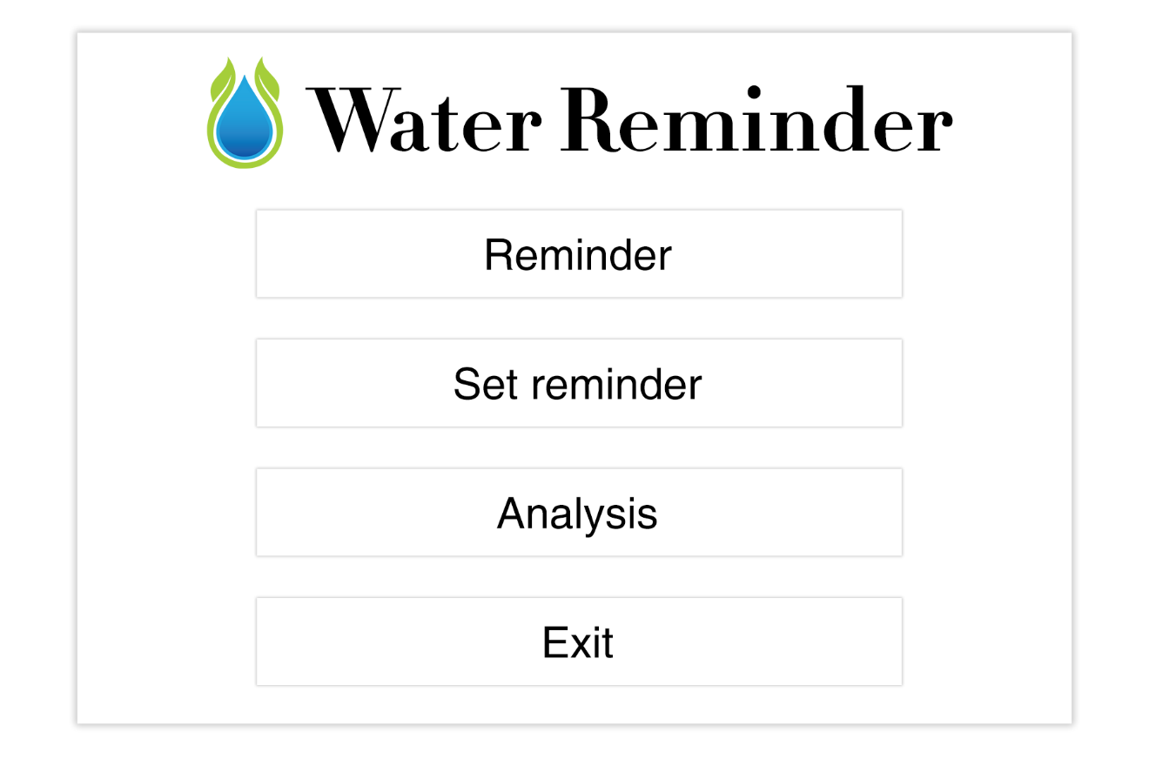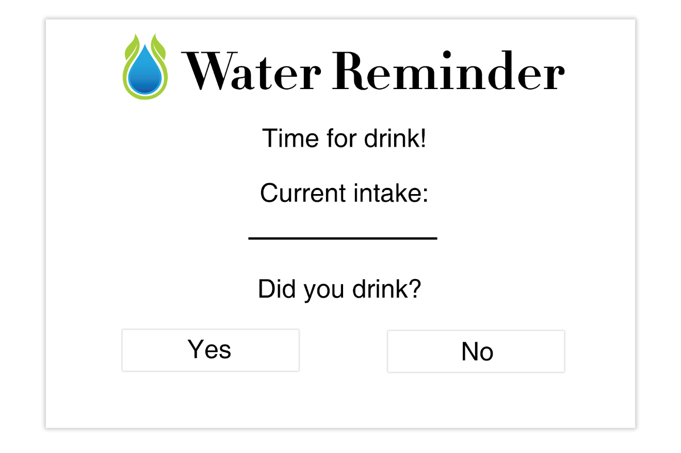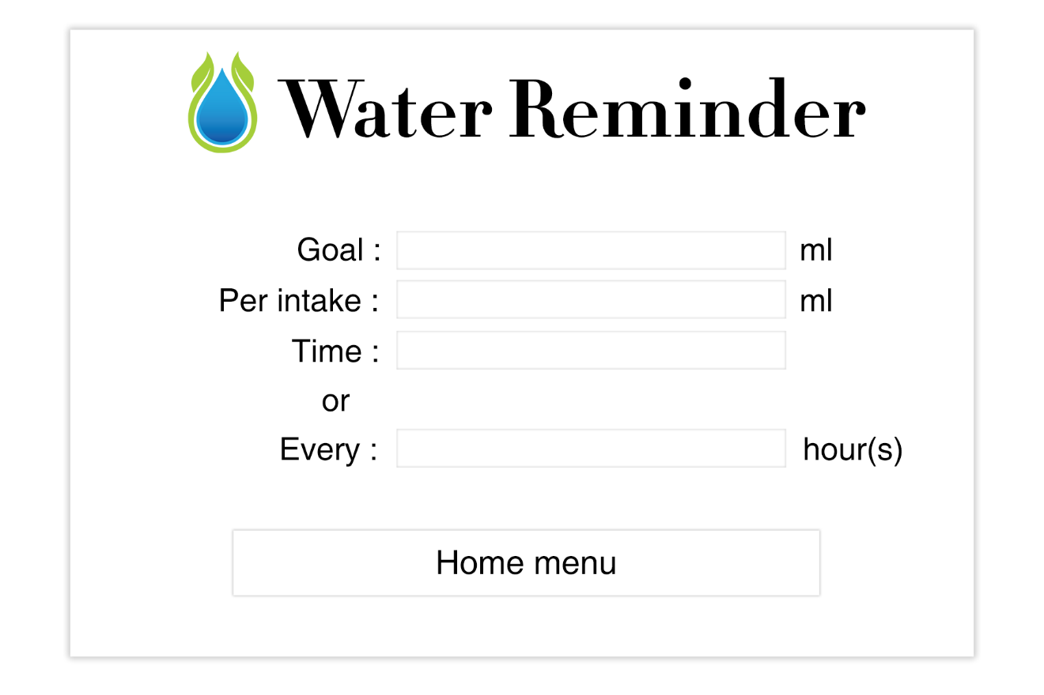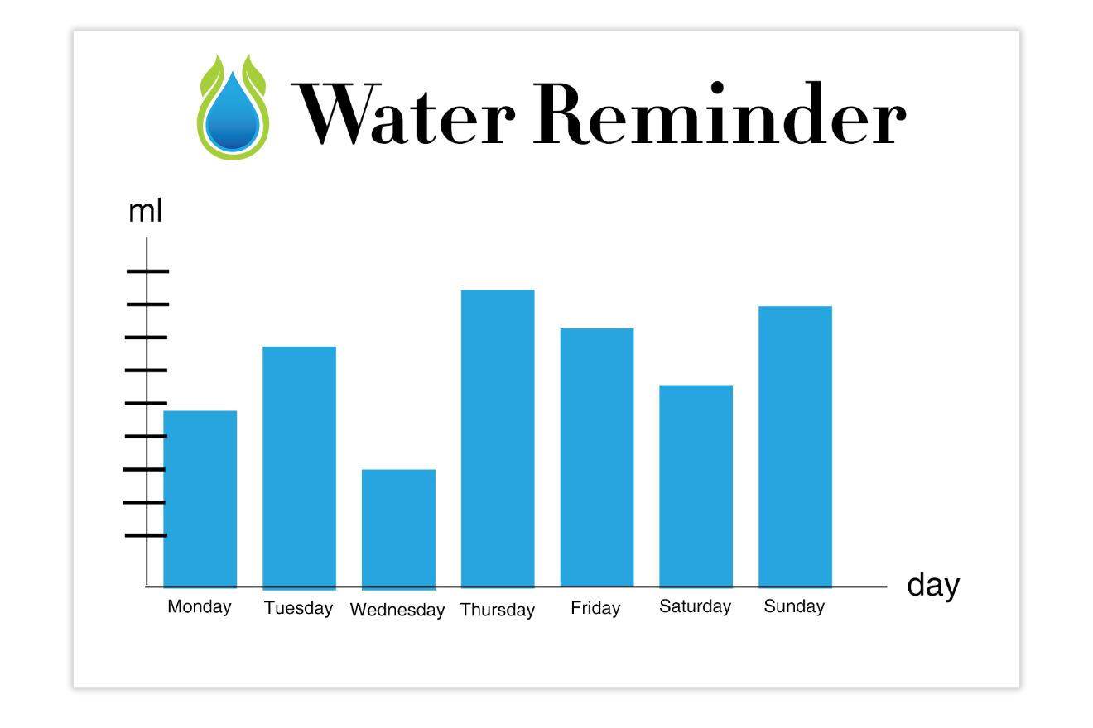
2. List and describe some of the main data types:

|  |  |  |  |
| --- | --- | --- | --- |
| Field Name | Data Type | Description | Example of value |
| reminder | Boolean | True (yes) & False (no) | Yes or No |
| Goal | Float | ml in decimal values | 1000 ml |
| Date | Date/Time | Using syntax of Date & time to calculate weekly consumption | 12/4/2021 – 18/4/2021 |
| If else | Condition | An option between conditions to update the current water | If “yes” then do this,  else if “no” then do this. |
| Current water intake | Float | ml in decimal values to check current water intake | 500ml |

1. Describe the main functions and procedures. Have enough that you can start to see how the program will continue to develop as you progress. (eg: initialize, draw, update etc)

|  |  |
| --- | --- |
| Function /Procedure/Method | Description |
| Menu | Allows users to navigate between options |
| Reminder | Ask users' input (yes & no) & update |
| Inform_reminder | Inform current drinking intake |
| Set_Reminder | Set time reminder |
| Analysis | Analysis throughout the whole week |