ENTERPRISE RAG BOT
Architecture Document
Local-first retrieval-augmented question answering for HR, technical, and compliance knowledge
System | Enterprise RAG Bot
Architecture status | Current implementation
Primary runtime | Streamlit + LangGraph + Chroma + Ollama
Document date | 2026-08-27

Purpose
Define the implemented system boundaries, components, data flows, deployment assumptions, trust controls, and extension points for engineering, operations, and security reviewers.

1. Executive Summary
The Enterprise RAG Bot is a local-first knowledge assistant that answers questions from approved enterprise documents. It separates corpus administration from end-user question answering and exposes source evidence and workflow status for each answer.
- Three knowledge domains: HR, Technical, and Compliance.
- Two provider modes: Ollama for local inference and OpenAI as a supported alternative.
- Persistent semantic retrieval through a Chroma collection with category-aware filtering.
- A LangGraph state machine controls routing, retrieval, evidence grading, answer generation, and safe refusal.
- Streamlit owns presentation and session history; model and retrieval concerns remain behind Python boundaries.

2. Architecture Principles
Principle | Implementation
Ground answers in evidence | The model receives numbered excerpts and is instructed to cite them.
Fail safely | Weak or missing evidence routes to a refusal instead of an unsupported answer.
Keep providers replaceable | Configuration selects Ollama or OpenAI without changing the UI workflow.
Preserve provenance | Source, category, section, page, and stable chunk ID travel with every chunk.
Separate local indexes | Ollama and OpenAI indexes use distinct persistence paths to avoid embedding-dimension conflicts.

3. Logical Architecture
The diagram shows the major runtime components and the two principal flows: document ingestion and question answering.
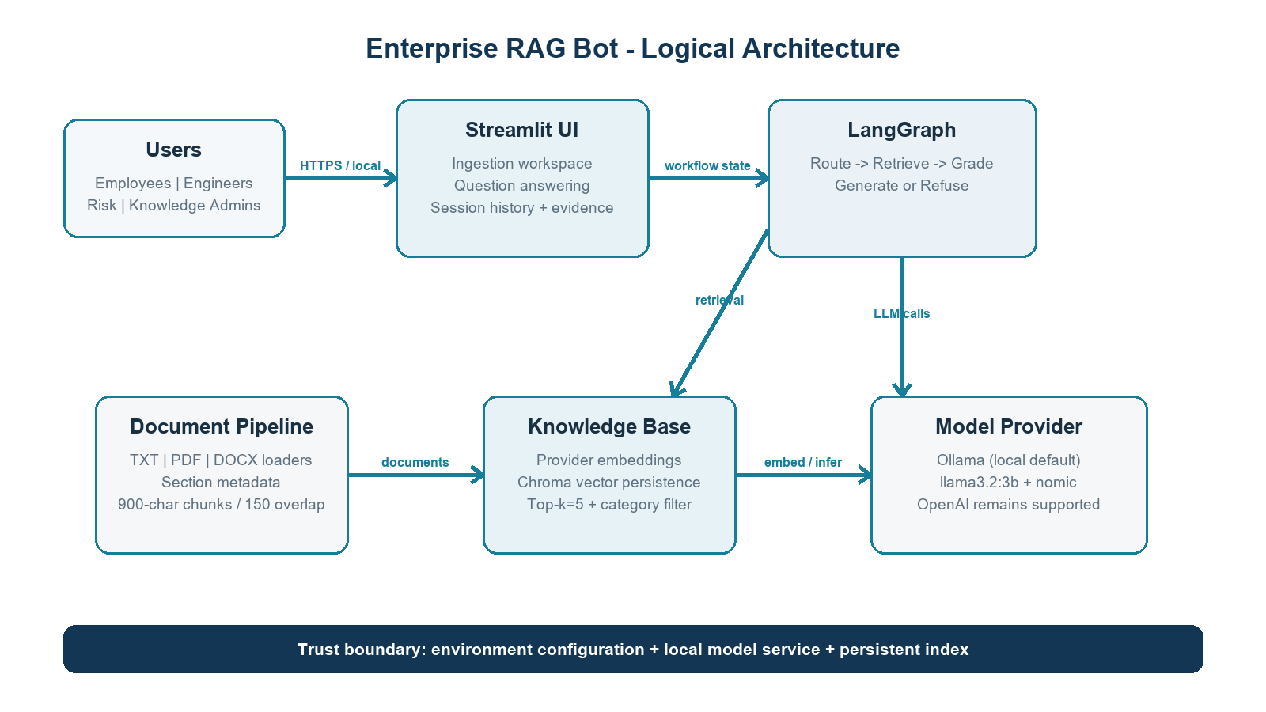
Figure 1. Logical architecture and trust boundary

4. Component Responsibilities
Component | Location | Responsibility
Streamlit UI | app.py | Tabs, uploads, controls, chat history, evidence display, and workflow trace.
Configuration | rag/config.py | Loads environment settings, provider/model selection, index path, chunking, and retrieval values.
Ingestion | rag/ingestion.py | Loads TXT/PDF/DOCX, extracts sections, chunks text, and creates stable metadata-rich documents.
Knowledge base | rag/store.py | Selects embeddings, persists Chroma data, adds/searches chunks, counts records, and resets the index.
Workflow | rag/workflow.py | Implements route, retrieve, grade, generate, and refuse nodes in LangGraph.
Model runtime | Ollama/OpenAI | Creates embeddings and performs evidence grading and grounded answer generation.

5. Runtime Workflows

5.1 Document ingestion
- An administrator selects bundled documents or uploads approved TXT, PDF, or DOCX files.
- The loader extracts text and page information; the category is inferred from the bundled path or selected in the UI.
- The splitter creates 900-character chunks with 150-character overlap.
- Each chunk receives a stable SHA-256-derived ID plus source, category, section, and page metadata.
- The configured embedding provider creates vectors and Chroma persists them in the provider-specific index directory.

5.2 Question answering
- The user submits a question and may select a knowledge domain.
- The route node honors an explicit domain or applies keyword-based category routing.
- The retrieve node performs top-k semantic search (k=5), applying a category filter when present.
- The grade node asks the configured chat model whether the evidence can answer the question.
- Sufficient evidence proceeds to grounded generation with numbered citations; insufficient evidence produces a safe refusal.
- The UI renders the answer, retrieved chunks, provenance, and graph trace, then stores the turn in session state.

6. Data Model and Persistence
Field | Example | Purpose
id | 20-char content digest | Stable update identity
source | hr_policy.txt | Citation provenance
category | hr | Retrieval filtering
section | Annual Leave | Human-readable evidence context
page | 3 or 0 | Page citation where available
page_content | Chunk text | Embedding and grounded context

7. Deployment and Configuration
The reference deployment runs as a local Streamlit process on port 8501 and connects to Ollama on localhost:11434. Ollama is the configured local provider; OpenAI remains available through environment configuration.
Variable | Current/default | Effect
MODEL_PROVIDER | ollama | Selects Ollama or OpenAI adapters
OLLAMA_CHAT_MODEL | llama3.2:3b | Evidence grading and answers
OLLAMA_EMBEDDING_MODEL | nomic-embed-text | Document/query vectors
OLLAMA_BASE_URL | http://localhost:11434 | Local Ollama endpoint
RAG_INDEX_DIR | .rag_index_ollama | Optional persistence override
OPENAI_API_KEY | Required only for OpenAI | Cloud-provider authentication

8. Security and Trust Boundaries
- Retrieved document text is treated as untrusted data, not executable instruction.
- Secrets remain in environment configuration and are not rendered in the UI or document metadata.
- The local Ollama mode keeps inference on the workstation, subject to local endpoint and file-system controls.
- The current reference build does not implement authentication, document-level authorization, tenant isolation, encryption policy, malware scanning, or audit logging.
- Production retrieval filters must enforce user/document access at query time; UI-only controls are insufficient.

9. Reliability, Testing, and Operations
The repository currently includes fast unit coverage for category inference, section extraction, and heuristic routing. Operational readiness should add end-to-end ingestion/query tests, retrieval recall evaluations, faithfulness scoring, model availability checks, structured logging, backups, and index rebuild procedures.

10. Recommended Production Evolution
- Add SSO/RBAC and document-level access metadata enforced by the retrieval layer.
- Move Chroma to an encrypted managed vector service with tenant isolation and backups.
- Add ingestion controls: malware scanning, DLP/PII classification, retention, and approval workflow.
- Introduce tracing, latency/error metrics, prompt/model versioning, rate limits, and user feedback.
- Maintain curated evaluation sets for retrieval recall, answer faithfulness, refusal quality, and security regressions.

Appendix A. Repository Map
Path | Purpose
app.py | Streamlit application
rag/config.py | Environment-backed settings
rag/ingestion.py | Loaders and chunking
rag/store.py | Embedding and Chroma boundary
rag/workflow.py | LangGraph orchestration
docs/ | Bundled enterprise corpus
tests/ | Unit tests
.rag_index_ollama/ | Local Ollama vector index

