**Taak 01 (illustrator)**

***A.1 Explanatory (A.2 Static)***

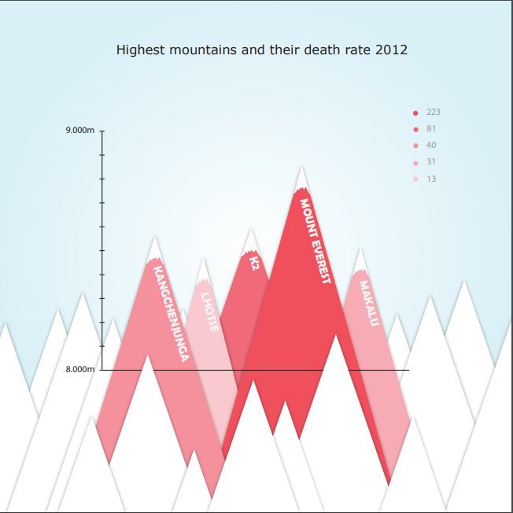

**Bronnen:**

<https://www.statista.com/statistics/259669/ranking-of-the-worlds-highest-mountains-by-death-toll/>

<https://en.wikipedia.org/wiki/List_of_highest_mountains_on_Earth>

**Taak 02 (nodebox)**

***A.x Node-based, A.x Personal Dataset, A.2 Static, A.1 Explanatory***

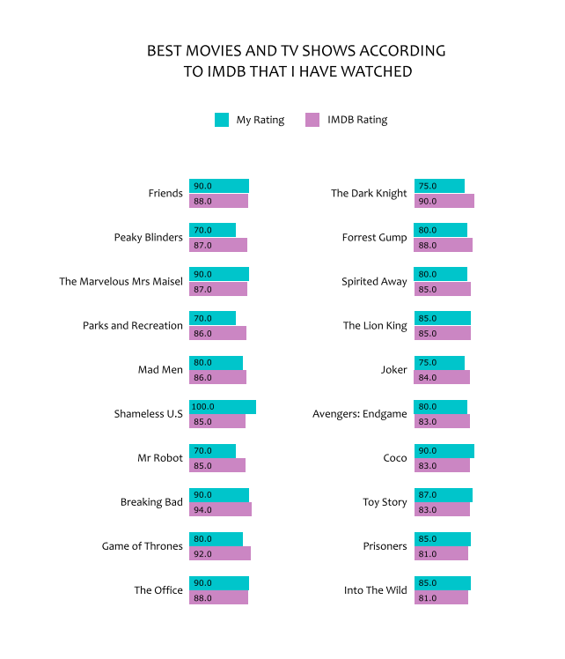

**Bronnen:**

<https://www.nodebox.net/node/documentation/using/data-visualization.html?fbclid=IwAR1Fr6ewVaNIOMZz1o9KY1vEVUf2zm8IRBsi26HNO2MnF63xy3rT1dVa6Tk>

<https://www.imdb.com/chart/top/>

<https://www.imdb.com/chart/toptv/>

**Taak 03 (after effects)**

***A.1 Explanatory (A.2 Linear)***

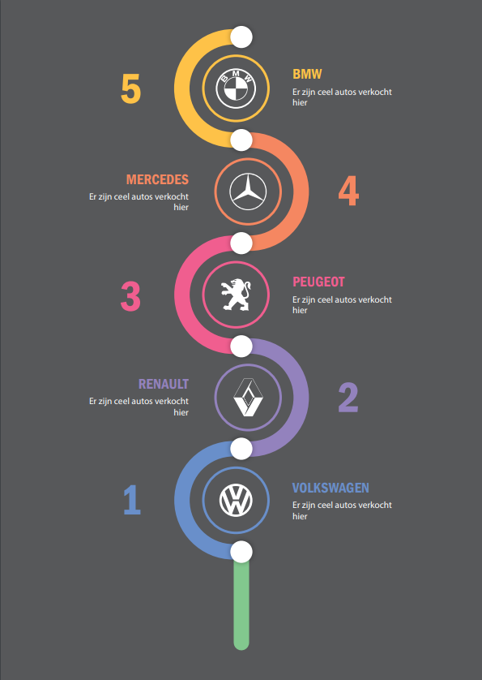

**Bronnen:**

<https://gocar.be/nl/autonieuws/auto-industrie/de-in-belgie-10-meest-verkochte-automerken-in-2019>

<https://logosvector.net/brand-vector-logos/volkswagen>

<https://www.youtube.com/watch?v=tQ5wqg10x_I>

**Taak 04 (visual studio code)**

***A.x D3, A.2 Interactive, A.1 Explanatory***

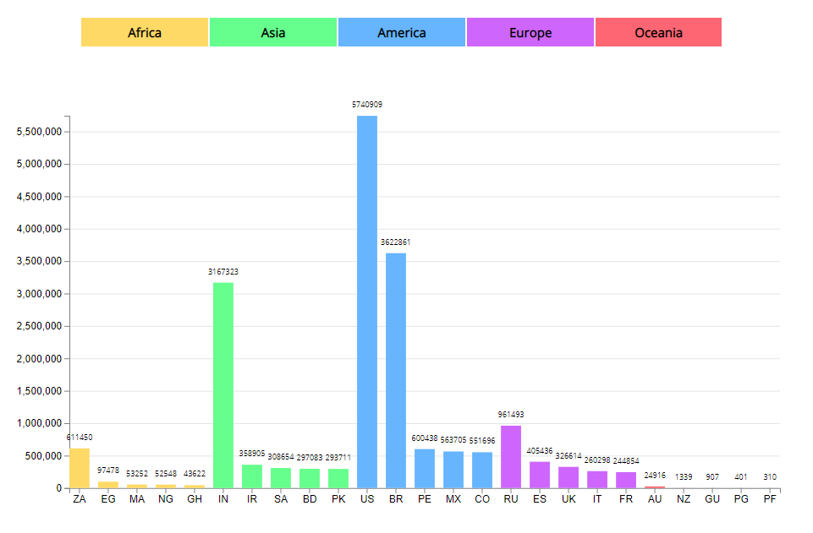

**Bronnen:**

<https://blog.risingstack.com/d3-js-tutorial-bar-charts-with-javascript/>

<https://keithpblog.org/post/upgrading-d3-from-v3-to-v4/>

<https://jsfiddle.net/matehu/w7h81xz2/38/>

<https://stackoverflow.com/questions/50164300/how-to-add-specific-colors-to-data-in-json-with-d3-js>