
COMSATS University Islamabad
SDS and 60% Implementation
(Document 4 — Half Report)
MalTwin: An AI-Based Framework for Malware Variant
Detection in Industrial IoT Using Digital Twins
and Visual Analysis
By
Iman Fatima CIIT/SP23-BCT-021/ISB
Maaz Malik CIIT/SP23-BCT-025/ISB
Supervisor
Ms. Najla Raza
Bachelor of Science in Cyber Security (2023-2027)
The candidate confirms that the work submitted is their own and appropriate
credit has been given where reference has been made to the work of others.

Contents
Revisions Based on Evaluation Feedback 9
Chapter 1: Introduction 11
1.1 Purpose 11
1.2 Problem Statement 11
1.3 Objectives 11
1.4 Scope 12
1.5 System Modules 12
1.6 User Classes and Characteristics 13
1.7 Operating Environment 13
1.8 Design and Implementation Constraints 14
1.9 Document Organisation 14
Chapter 2: Requirements Specification 15
2.1 Requirement Identifying Technique 15
2.1.1 Use Case Diagrams 15
2.1.2 Use Case Descriptions 17
2.1.3 Mapping to SRS v1.0 Use Cases 24
2.2 Functional Requirements 24
FR1 Main Dashboard (Module 6) 24
FR2 Digital Twin (Module 1) 25
FR3 Binary Upload and Visualisation (Modules 2, 6) 25
FR4 Dataset, Training and Evaluation (Modules 3, 4, 5) 26
FR5 Malware Detection, Explanation and Reporting (Modules 5, 7, 8) 27
FR6 Dynamic Behavioural Analysis (Module 9) 27
FR7 Hybrid Static–Dynamic Verdict (Module 10) 28
FR-B Backend Event–Response (All modules) 28
2.3 Non-Functional Requirements 29
2.3.1 Reliability 29
2.3.2 Usability 29
2.3.3 Performance 30
2.3.4 Security 30
2.4 External Interface Requirements 30
2.4.1 User Interfaces 30
2.4.2 Software Interfaces 31
2.4.3 Hardware Interfaces 31
2.4.4 Communication Interfaces 31
Chapter 3: Design and Architecture 32
3.1 System Architecture Overview 32
3.1.1 Purpose 33
3.2 Architecture Diagram 34
3.2.1 Technologies and Services 37
3.3 Key Design Decisions 38
3.4 Design Models 39
3.4.1 Design Models for the Object-Oriented Approach 39
3.4.2 Design Models for the Procedural Approach 58
3.5 Data Design 63
3.5.1 Relational Database Schema 63
3.5.2 JSON Data Structures 65
3.5.3 Model and Evaluation Artefacts 66
3.5.4 Data Retention 66
3.5.5 Module Interaction Summary 67
Chapter 4: Implementation 68
4.1 Project Methodology & Algorithms 68
4.1.1 Project Methodology (Step-by-Step Approach) 68
4.1.2 Algorithms 71
4.2 Training Results & Model Evaluation 73
4.3 Security Techniques 79
4.4 External APIs/SDKs 80
4.5 User Interface 81
4.6 Deployment 85
Chapter 5: Testing and Evaluation 87
5.1 Unit Testing 87
Unit Testing 1: Binary-to-Image Conversion (M2) 87
Unit Testing 2: Dataset Loading and Splitting (M3) 88
Unit Testing 3: Augmentation and Oversampling (M4) 88
Unit Testing 4: CNN Model and Inference (M5) 89
Unit Testing 5: Grad-CAM Explanation (M7) 89
Unit Testing 6: Reporting and MITRE Mapping (M8) 89
Unit Testing 7: Detection Log Database (M6/M8) 90
Unit Testing 8: Dynamic Behavioural Analysis (M9) 91
Unit Testing 9: Hybrid Fusion (M10) 91
Unit Testing 10: Extended Evaluation Metrics 92
Unit Testing 11: Module Health Checks (M6) 92
Unit Testing 12: Training Manager (M5/M6) 92
Unit Testing 13: Benign Class (M3/M5) 93
Unit Testing 14: Balanced Test-Set Evaluation (M5) 93
5.2 Functional Testing 94
Automated UI Tests 95
Functional Testing 1: Binary Upload 95
Functional Testing 2: Malware Detection 96
Functional Testing 3: Dynamic Analysis 96
Functional Testing 4: Hybrid Verdict 97
Functional Testing 5: Navigation and Digital Twin Page 97
5.3 Business Rules Testing 98
Business Rule Test 1: Upload Acceptance 98
Business Rule Test 2: Confidence Colour Coding 98
Business Rule Test 3: Hybrid Fusion Decision 99
5.4 Integration Testing 100
Integration Testing 1: Training Pipeline (M3 + M4 + M5 + evaluation) 100
Integration Testing 2: Static Analysis Path with the Dashboard and Database (M2 + M5 + M6 + SQLite) 100
Integration Testing 3: Dynamic Path and Fusion (M9 + M10 + M8 mapping) 101
5.5 Performance Testing 101
5.6 Defects Found and Fixed 101
5.7 Requirement Traceability Matrix 102
Summary of Testing Results 105
Chapter 6: Conclusion and Future Work 107
6.1 Conclusion 107
6.2 Future Work 108
6.2.1 Digital Twin Implementation (final evaluation) 108
6.2.2 Paired Static–Dynamic Evaluation (final evaluation) 108
6.2.3 A Broader Benign Corpus 108
6.2.4 Richer Dynamic Features 108
6.2.5 Stronger Open-Set Detection 108
6.2.6 Reporting and Deployment 108
Chapter 7: References 109
Chapter 8: Plagiarism Report 111

List of Figures
Figure 2.1 Use case diagram — analysis and reporting subsystem 16
Figure 2.2 Use case diagram — training, evaluation and simulation subsystem 17
Figure 3.1 UML component diagram of MalTwin 33
Figure 3.2 UML package diagram of the layered architecture 36
Figure 3.3 UML class diagram of the core classes 40
Figure 3.4 UML sequence diagram for UC-01 Upload Binary File 41
Figure 3.5 UML sequence diagram for UC-03 Run Malware Detection 42
Figure 3.6 UML sequence diagram for UC-05 View Grad-CAM Explanation 43
Figure 3.7 UML sequence diagram for UC-06 Generate Forensic Report 44
Figure 3.8 UML sequence diagram for UC-07 Analyse Network Capture 45
Figure 3.9 UML sequence diagram for UC-08 View Hybrid Verdict 46
Figure 3.10 UML sequence diagram for UC-09 View Dashboard and Detection History 47
Figure 3.11 UML sequence diagram for UC-11 Train Detection Models 48
Figure 3.12 UML sequence diagram for UC-12 Evaluate Detection Model 48
Figure 3.13 UML sequence diagram for UC-13 Run Digital Twin Simulation (planned) 49
Figure 3.14 UML activity diagram for End-to-end analysis of a sample 50
Figure 3.15 UML activity diagram for UC-01 Upload Binary File 51
Figure 3.16 UML activity diagram for UC-03 Run Malware Detection with UC-05 Grad-CAM 52
Figure 3.17 UML activity diagram for UC-06 Generate Forensic Report 53
Figure 3.18 UML activity diagram for UC-07 Analyse Network Capture 54
Figure 3.19 UML activity diagram for UC-08 Hybrid fusion decision 55
Figure 3.20 UML activity diagram for UC-11 Train Detection Models 56
Figure 3.21 UML activity diagram for UC-12 Evaluate Detection Model on full and balanced test sets 57
Figure 3.22 UML activity diagram for UC-13 Run Digital Twin Simulation (planned) 58
Figure 3.23 Level 0 data flow diagram (context diagram) 59
Figure 3.24 Level 1 data flow diagram 60
Figure 3.25 Level 2 data flow diagram for Process 4.0 61
Figure 3.26 UML state machine diagram for a submitted sample 62
Figure 3.27 Entity relationship diagram (crow's-foot notation) 63
Figure 3.28 Relational schema of the MalTwin database (SQLite) 64
Figure 4.1 Training and validation loss and accuracy (no augmentation, best epoch 29) 77
Figure 4.2 Confusion matrix on the test set, 25 families + Benign 77
Figure 4.3 One-vs-rest ROC curves for all 26 classes 78
Figure 4.4 Prediction confidence on known families and on the five held-out families 78
Figure 4.6 Binary Upload page after validating a PE file 82
Figure 4.7 Dynamic Analysis page (demonstration model trained on synthetic traffic, clearly labelled as such in the interface) 83
Figure 4.8 Hybrid Verdict what-if simulator showing the NOVEL VARIANT case 84
Figure 4.9 Digital Twin page with the planned architecture 85

List of Tables
Table R.1 Committee comments and action taken 9
Table 1.1 Project objectives and their status at 60% 11
Table 1.2 MalTwin modules 12
Table 1.3 User classes 13
Table 1.4 Operating environment 13
Table 2.1 Use case description UC-01: Upload Binary File 17
Table 2.2 Use case description UC-02: View File Analysis 18
Table 2.3 Use case description UC-03: Run Malware Detection 18
Table 2.4 Use case description UC-04: Map to MITRE ATT&CK for ICS 19
Table 2.5 Use case description UC-05: View Grad-CAM Explanation 19
Table 2.6 Use case description UC-06: Generate Forensic Report 19
Table 2.7 Use case description UC-07: Analyse Network Capture 20
Table 2.8 Use case description UC-08: View Hybrid Verdict 20
Table 2.9 Use case description UC-09: View Dashboard and Detection History 21
Table 2.10 Use case description UC-10: Prepare Training Dataset 21
Table 2.11 Use case description UC-11: Train Detection Models 21
Table 2.12 Use case description UC-12: Evaluate Detection Model 22
Table 2.13 Use case description UC-13: Run Digital Twin Simulation 22
Table 2.14 Use case description UC-14: Monitor Digital Twin 23
Table 2.15 Use case description UC-15: Check Twin Prerequisites 23
Table 2.28 Mapping of SRS v1.0 use cases to the revised use cases 24
Table 2.16 Functional requirements — Main Dashboard 24
Table 2.17 Functional requirements — Digital Twin 25
Table 2.18 Functional requirements — Binary Upload and Visualisation 25
Table 2.19 Functional requirements — Dataset, Training and Evaluation 26
Table 2.20 Functional requirements — Malware Detection, Explanation and Reporting 27
Table 2.21 Functional requirements — Dynamic Behavioural Analysis 27
Table 2.22 Functional requirements — Hybrid Static–Dynamic Verdict 28
Table 2.23 Functional requirements — Backend Event–Response 28
Table 2.29 Functional requirements summary 29
Table 2.24 Reliability requirements 29
Table 2.25 Usability requirements 29
Table 2.26 Performance requirements 30
Table 2.27 Security requirements 30
Table 2.30 Software interfaces 31
Table 3.1 Architecture layers 36
Table 3.2 Components, technologies and security measures 37
Table 3.3 Design decisions and rationale 38
Table 3.4 Notation used in the design models 39
Table 3.5 Level 1 processes and data stores 59
Table 3.6 Table detection_events 64
Table 3.7 Table report_events 64
Table 3.8 Schema of mitre_ics_mapping.json and mitre_ics_behaviour_mapping.json 65
Table 3.9 Schema of the JSON forensic report 65
Table 3.10 Schema of balanced_eval.json (results on the balanced test set) 66
Table 3.11 Files produced by training and evaluation 66
Table 3.12 Data retention policy 66
Table 3.13 How modules exchange data 67
Table 4.1 Implementation status by module 68
Table 4.2 Algorithms implemented in MalTwin 72
Table 4.3 Training configuration 73
Table 4.4 Static CNN — Malimg + Benign test set (1,626 images, 26 classes) 74
Table 4.5 Static CNN — balanced test set (equal images per class, 10 draws) 74
Table 4.6 Ablation — training with and without augmentation (same data, seed and schedule) 75
Table 4.7 Unseen-family experiment (5 families held out of training) 76
Table 4.8 Dynamic model — IoT-23 76
Table 4.9 Measured performance against SRS targets 79
Table 4.10 External libraries and SDKs 80
Table 4.11 Dashboard pages and modules covered 81
Table 4.12 System requirements 85
Table 4.13 Configuration through environment variables 86
Table 5.1 Binary-to-Image Conversion (M2) — unit test results 87
Table 5.2 Dataset Loading and Splitting (M3) — unit test results 88
Table 5.3 Augmentation and Oversampling (M4) — unit test results 88
Table 5.4 CNN Model and Inference (M5) — unit test results 89
Table 5.5 Grad-CAM Explanation (M7) — unit test results 89
Table 5.6 Reporting and MITRE Mapping (M8) — unit test results 90
Table 5.7 Detection Log Database (M6/M8) — unit test results 90
Table 5.8 Dynamic Behavioural Analysis (M9) — unit test results 91
Table 5.9 Hybrid Fusion (M10) — unit test results 91
Table 5.10 Extended Evaluation Metrics — unit test results 92
Table 5.11 Module Health Checks (M6) — unit test results 92
Table 5.12 Training Manager (M5/M6) — unit test results 92
Table 5.13 Benign Class (M3/M5) — unit test results 93
Table 5.14 Balanced Test-Set Evaluation (M5) — unit test results 93
Table 5.15 Unit test summary by file 94
Table 5.16 Automated UI tests (Streamlit AppTest) 95
Table 5.17 Binary upload — functional test results 96
Table 5.18 Malware detection — functional test results 96
Table 5.19 Dynamic analysis — functional test results 97
Table 5.20 Hybrid verdict — functional test results 97
Table 5.21 Navigation and Digital Twin — functional test results 97
Table 5.22 Decision table — upload acceptance 98
Table 5.23 Test cases — upload acceptance 98
Table 5.24 Test cases — confidence colour boundaries 99
Table 5.25 Decision table — fusion category and escalation 99
Table 5.26 Test cases — fusion decision (automated in tests/test_fusion.py) 99
Table 5.27 Training pipeline integration results 100
Table 5.28 Static path integration results 100
Table 5.29 Dynamic path and fusion integration results 101
Table 5.30 Defects found during Evaluation 3 testing 101
Table 5.31 Requirement Traceability Matrix (generated from the test run) 103
Table 5.32 Overall testing summary 105

Revisions Based on Evaluation Feedback
The evaluation committee commented on the SRS (Document 2) and on the 30% design document (Document 3). Every comment is listed below, word for word where it was written, with the action taken in this document and where to find it.
Table R.1 Committee comments and action taken
# | Comments (by committee) | Action taken | Where
 | Comments on the SRS (Document 2)
S1 | Revise the use case diagram, as it is not comprehensible in its current format. | Redrawn in standard UML as two diagrams, one per subsystem. Every use case has an ID; actors are stick figures outside the system boundary; the Security Researcher is a specialisation of the Security Analyst, which removes duplicate lines. | Section 2.1.1, Figures 2.1–2.2
S2 | Use case symbols have been joined, which is not a proper way to show use case diagrams. | Use cases are no longer joined by plain lines. The only links between use cases are dashed «include» and «extend» dependencies, used where the UML meaning applies. | Section 2.1.1
S3 | Use case descriptions do not match the use cases presented in the diagram. | A full description (actors, requirements, pre- and postconditions, main and alternative flows) is given for each of the 15 use cases in the diagrams, with the same ID and name. A table maps the old SRS use cases to the revised ones. | Section 2.1.2 (Tables 2.1–2.15), Section 2.1.3
S4 | FRs are too few and should be increased; the FRs are less as compared to a FYP scope. | Functional requirements expanded from 24 to 59, covering every module and screen, each a testable "shall" statement with priority and status. All implemented requirements are traced to automated tests. | Section 2.2; RTM in Section 5.7
S5 | There are formatting errors in the document. For example, the text should be in a justified format. The table of contents (TOC) needs improvement. | All body text and lists are justified. The table of contents, list of figures and list of tables are generated from the heading and caption styles, with three heading levels and page numbers. | Whole document; Contents pages
 | Comments on the 30% evaluation (Document 3)
D1 | Comments given and actions taken are not mentioned in the SDS document. | This table records every comment and the action taken. | This page
D2 | Comment given in SRS evaluation is still not corrected. For example, text is still not in justified format. | Corrected as described in S5. | Whole document
D3 | Document is incomplete. First two chapters are missing. | Chapter 1 (Introduction) and Chapter 2 (Requirements Specification) added. | Chapters 1 and 2
D4 | Use case diagram is not a design diagram, but is included in the design chapter. | Use case diagrams and descriptions moved to the requirements chapter. Chapter 3 contains only design models. | Chapter 2; Chapter 3
D5 | Design diagrams for the complete project should be included in the SDS document. Only one activity diagram and sequence diagram is included in the document. | A sequence diagram and an activity diagram are given for every major use case: 10 sequence diagrams and 9 activity diagrams (including the end-to-end workflow and the planned Digital Twin), in addition to the class, component, package, DFD, state machine and ER diagrams. | Sections 3.4.1.2–3.4.1.3, Figures 3.4–3.22
D6 | Standard icon should be used for representing database in DFD diagram. | Data stores are drawn with the standard Yourdon–DeMarco symbol (open-ended rectangle, numbered D1–D3). The three DFD levels are balanced. | Section 3.4.2.1, Figures 3.23–3.25
D7 | The database schema presented in the document is neither database schema nor ERD diagram. | Two separate models are now given: a crow's-foot ERD (entities, keys, cardinalities, associative entities) and the physical relational schema (tables, column types, PK, FK, NOT NULL, CHECK, indexes). Reviewing the schema exposed that reports were never linked to their detection; this was fixed in the code and the foreign key is now enforced and tested. JSON file structures are documented as schemas. | Section 3.4.2.3 (Figure 3.27); Section 3.5.1 (Figure 3.28, Tables 3.6–3.7); Section 3.5.2
D8 | All tables and figures should be properly captioned. | Every table has a numbered caption above it and every figure a numbered caption below it, using caption styles that feed the lists of tables and figures. | Whole document
D9 | Results should be produced on the balanced dataset. | The model is trained on a balanced dataset (class-aware oversampling: every family drawn equally often). New code evaluates it on a class-balanced test set (equal images per class, 10 random draws) and reports balanced accuracy. Result: 97.6% ± 0.5 accuracy on the balanced test set (98.7% on the natural split). | Section 4.2 (Tables 4.5–4.6); Section 5.1 Unit Testing 14
D10 | Comment given verbally at the 30% evaluation: the diagrams did not follow software engineering notation; the icons were not correct. | Every diagram redrawn in the standard notation of its technique (UML 2.5, Yourdon–DeMarco, crow's foot). A notation key lists every symbol used. | Chapters 2 and 3; Table 3.4

Chapter 1: Introduction
This document is the Software Design Specification of MalTwin, an AI-based framework for detecting malware variants that target Industrial Internet of Things (IIoT) environments. It is submitted as Document 4 for the 60% implementation evaluation. Chapters 1 and 2 restate the project's purpose and its revised requirements; Chapters 3 to 5 describe the design, the implementation and the testing of the system as it stands at this milestone.

1.1 Purpose
The purpose of this document is to describe how MalTwin is designed and built so that the evaluation committee, the supervisor and the development team share one exact picture of the system. It records the requirements the design satisfies (Chapter 2), the architecture and design models (Chapter 3), the algorithms and implementation status of each module (Chapter 4), and the evidence that the implementation works (Chapter 5). Every requirement in Chapter 2 is traced to the automated tests that verify it in the Requirement Traceability Matrix of Chapter 5.

1.2 Problem Statement
Industrial IoT systems such as programmable logic controllers (PLCs), human–machine interfaces and networked sensors are increasingly targeted by malware. Attackers rarely write new malware from scratch; they produce variants of known families by packing, obfuscating or slightly modifying existing code. Signature-based antivirus tools match exact byte patterns and therefore miss these variants and zero-day samples.
Two further problems make IIoT malware hard to study. First, running a suspicious sample on real industrial hardware can stop a production line or damage equipment, so samples cannot simply be executed to see what they do. Second, the detectors that do exist rarely explain their verdict, which makes it hard for an analyst to trust or act on them. MalTwin addresses these problems by combining visual (image-based) analysis of the binary, behavioural analysis of its network traffic, a Digital Twin in which samples can be run safely, and explanations of every verdict.

1.3 Objectives
Table 1.1 lists the objectives from the project proposal and how far each has progressed at the 60% milestone.
Table 1.1 Project objectives and their status at 60%
No. | Objective | Module(s) | Status at 60%
O1 | Develop an IIoT Digital Twin for safe and controlled malware execution | M1 | Designed; scheduled for the final evaluation
O2 | Convert malware binaries into grayscale image representations | M2 | Complete
O3 | Extract behavioural features from network traffic of running samples | M9 | Complete (trained on IoT-23 captures)
O4 | Design learning-based models that combine static and dynamic evidence | M5, M9, M10 | Complete; paired evaluation needs the Digital Twin
O5 | Handle dataset imbalance and generalise to unseen variants | M3, M4, M5 | Complete (oversampling, balanced evaluation, unseen-family test)
O6 | Provide explainable predictions | M7, M9 | Complete (Grad-CAM; feature importance)
O7 | Deliver an interactive, deployable research prototype | M6, M8 | Complete (dashboard, reports); containerised deployment with M1

1.4 Scope
In scope
- Static detection of malware families from Windows PE and Linux ELF binaries using a convolutional neural network trained on the Malimg dataset (25 families) plus a Benign class built from clean system binaries.
- Behavioural detection from network captures in Zeek conn.log format, trained on the IoT-23 dataset.
- Fusion of the static and dynamic evidence into one verdict, with explanations (Grad-CAM heatmaps and feature importance) and MITRE ATT&CK for ICS mapping.
- A local web dashboard, PDF and JSON forensic reports, and a detection log.
- A Docker-based Digital Twin of a small IIoT network for running samples safely (final evaluation).
Out of scope
- Protection of a live production network: MalTwin is an analysis and research platform, not an intrusion prevention system.
- Automatic removal or quarantine of malware on other machines.
- Analysis of document, script or firmware formats other than PE and ELF.

1.5 System Modules
MalTwin is divided into ten modules. Modules 1 to 8 are those of the SRS; Modules 9 and 10 implement proposal objectives O3 and O4 and are added to the SRS in Chapter 2 as an addendum.
Table 1.2 MalTwin modules
Module | Name | Responsibility | Status
M1 | Digital Twin Simulation | Isolated container network (PLC, HMI, sensors, sandbox) that runs samples and records their traffic | Designed (final evaluation)
M2 | Binary-to-Image Conversion | Validate PE/ELF files, compute SHA-256, convert bytes to 128 × 128 grayscale images | Complete
M3 | Dataset Collection and Preprocessing | Load and validate Malimg, build the Benign class, encode labels, stratified split | Complete
M4 | Data Enhancement and Balancing | Augmentation, Gaussian noise, class-aware oversampling | Complete
M5 | Intelligent Malware Detection | MalTwinCNN training, inference and evaluation (incl. balanced and unseen-family evaluation) | Complete
M6 | Dashboard and Visualization | Eight-page Streamlit dashboard | Complete
M7 | Explainable AI and Interpretability | Grad-CAM heatmaps over the binary image | Complete
M8 | Automated Threat Reporting and Intelligence | MITRE ATT&CK for ICS mapping, PDF/JSON reports, SQLite detection log | Complete
M9 | Dynamic Behavioural Analysis (addendum) | Parse Zeek captures, extract flow features, classify behaviour | Complete
M10 | Hybrid Static–Dynamic Fusion (addendum) | Combine both views into one verdict with an agreement category | Complete

1.6 User Classes and Characteristics
Table 1.3 User classes
User class | Description | Main use cases
Security Analyst | Examines suspicious binaries and captures and needs a verdict with reasons. Familiar with malware analysis, not necessarily with machine learning. | UC-01 to UC-03, UC-05 to UC-09
Security Researcher | Specialises the Security Analyst (inherits all of its use cases) and also trains and evaluates the models and runs Digital Twin experiments. | All analyst use cases, UC-11 to UC-14
System Administrator | Installs and maintains the platform and the Docker infrastructure for the Digital Twin. | UC-13, UC-15
Academic Evaluator | Reviews results, reports and evaluation metrics; does not change the system. | UC-06, UC-09, UC-12

1.7 Operating Environment
Table 1.4 Operating environment
Item | Requirement
Operating system | Ubuntu 22.04 LTS (recommended); Windows 10/11 supported for the dashboard
Runtime | Python 3.11, PyTorch 2.6, Streamlit 1.37, scikit-learn 1.5
Hardware | 16 GB RAM, 20 GB free disk; GPU optional (NVIDIA, CUDA 12.x) — all features run on CPU
Browser | Any current Chrome, Firefox or Edge; the dashboard is served on 127.0.0.1
Digital Twin (final evaluation) | Docker Engine with internal bridge networks; Zeek for traffic capture

1.8 Design and Implementation Constraints
- Safety: samples must never be executed on the host. Uploaded binaries are read as bytes in memory and never written to disk or run; execution happens only inside the Digital Twin sandbox.
- Privacy: no file, hash or result leaves the machine; SHA-256 is computed locally and no online service is queried.
- Hardware: the system must run on a student laptop without a GPU, which favours a compact CNN (1.35 M parameters) and a random forest for flows.
- Data: public datasets only (Malimg, IoT-23). Malimg contains no clean files, so a Benign class is built from clean operating-system binaries.
- Interfaces: the Digital Twin must emit the same Zeek conn.log format as IoT-23 so the dynamic model can be trained before the twin exists.

1.9 Document Organisation
Chapter 2 specifies the revised requirements: use case diagrams and descriptions, functional and non-functional requirements and external interfaces. Chapter 3 presents the architecture and the design models (class, sequence, activity, data flow, state machine and entity relationship diagrams) and the data design. Chapter 4 describes the implementation, algorithms and training results. Chapter 5 reports unit, functional, business-rule, integration and performance testing and the Requirement Traceability Matrix. Chapter 6 concludes and lists the remaining work, Chapter 7 gives the references and Chapter 8 the plagiarism report.

Chapter 2: Requirements Specification
This chapter restates the requirements of MalTwin as revised after the SRS and 30% evaluations. Following the committee's comments, the use case diagram has been redrawn, every use case in the diagram now has a matching description, and the functional requirements have been expanded from 24 to 59 so that every module is specified. The requirements are kept in one machine-readable catalogue in the repository (docs/requirements.json); the tables in this chapter and the Requirement Traceability Matrix in Chapter 5 are both generated from it.

2.1 Requirement Identifying Technique
Requirements were identified with use case modelling. For each user class (Section 1.6) we listed the goals the user wants to achieve with MalTwin; each goal became a use case, and each step of a use case's scenarios was turned into one or more functional requirements. Quality expectations stated in the proposal (speed, safety, reliability, usability) became the non-functional requirements.

2.1.1 Use Case Diagrams
The use cases are shown in two UML use case diagrams, one per subsystem, so that each diagram stays readable. Every use case carries the identifier of its description in Section 2.1.2. The diagrams use standard UML notation: stick-figure actors, ellipse use cases inside a rectangular system boundary, plain lines for actor–use case associations and dashed arrows for «include» (the base use case always performs the included one) and «extend» (the extension is optional). Use cases are never chained to each other by plain lines. The Security Researcher is drawn as a specialisation of the Security Analyst (hollow-triangle generalisation), meaning the researcher can perform every analyst use case without repeating the associations.
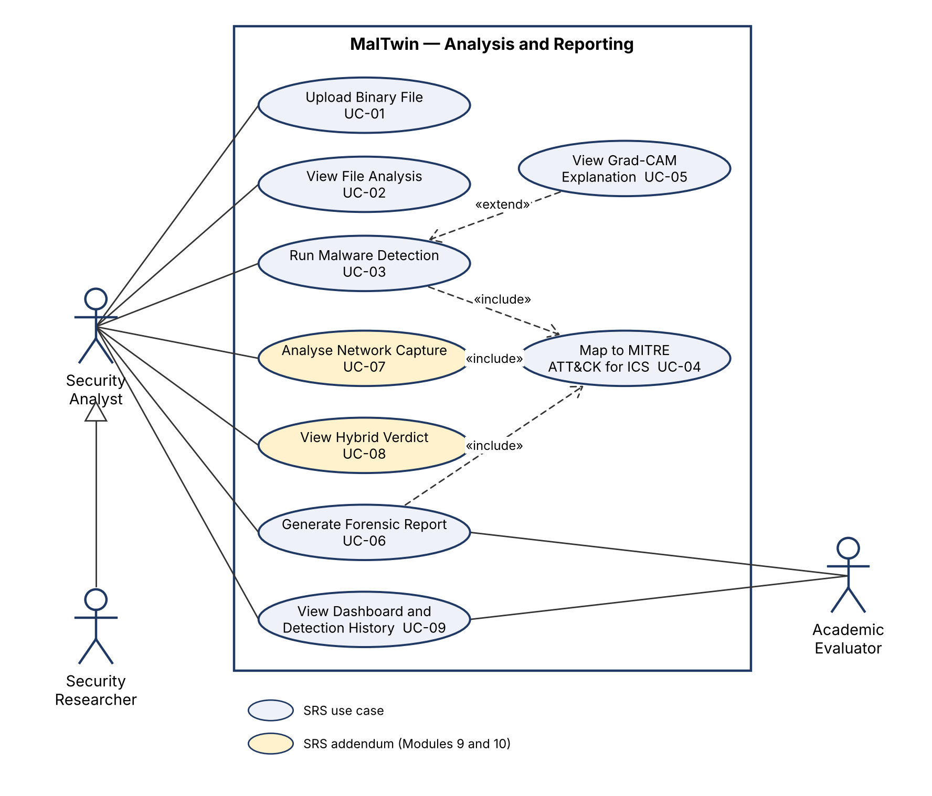
Figure 2.1 Use case diagram — analysis and reporting subsystem
In Figure 2.1, UC-04 Map to MITRE ATT&CK for ICS is an included use case shared by detection, reporting and capture analysis, since all three show the techniques of what was found. UC-05 View Grad-CAM Explanation extends detection because it is optional. UC-07 and UC-08 (shaded) are the SRS addendum for Modules 9 and 10.
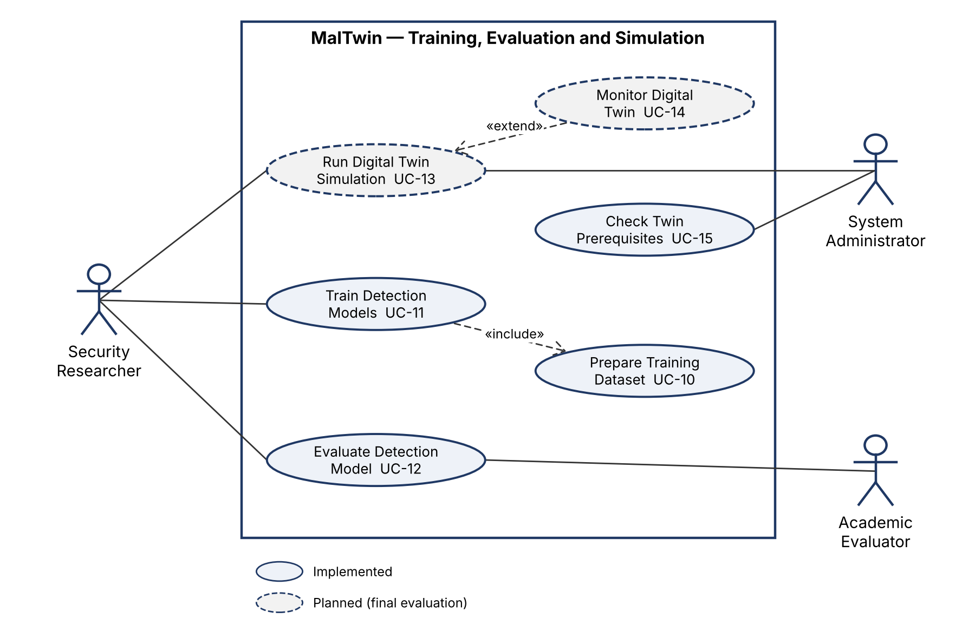
Figure 2.2 Use case diagram — training, evaluation and simulation subsystem
In Figure 2.2, training always prepares the dataset, so UC-11 includes UC-10. Monitoring the twin is optional during a simulation, so UC-14 extends UC-13. UC-13 and UC-14 have dashed outlines because they belong to the Digital Twin, which is scheduled for the final evaluation.

2.1.2 Use Case Descriptions
Tables 2.1 to 2.15 describe every use case that appears in the diagrams, in the same order and with the same identifiers and names. Alternative flows are numbered after the main-scenario step they branch from (for example, 3a branches from step 3).
Table 2.1 Use case description UC-01: Upload Binary File
Field | Description
Use case | UC-01 Upload Binary File
Actors | Security Analyst
Related requirements | FR3.1, FR3.2, FR3.5, FR3.6, FR-B1
Description | The analyst uploads a suspicious PE or ELF binary, which is validated and converted into a grayscale image.
Preconditions | The dashboard is running.
Main success scenario | 1. Analyst opens the Binary Upload screen.  2. Analyst selects a file.  3. System checks the size (≤ 50 MB) and the magic bytes.  4. System computes the SHA-256 hash and converts the bytes to a 128 × 128 image.  5. System displays the image and confirms the upload.
Alternative flows | 3a. File is empty, larger than 50 MB or not PE/ELF: system shows an error stating what, cause and action; the use case ends.
Postconditions | The image and metadata are held in the session for detection.

Table 2.2 Use case description UC-02: View File Analysis
Field | Description
Use case | UC-02 View File Analysis
Actors | Security Analyst
Related requirements | FR3.3, FR3.4
Description | The analyst inspects the uploaded file's metadata, image and byte histogram.
Preconditions | A file has been uploaded (UC-01).
Main success scenario | 1. System displays name, size, format and SHA-256.  2. System displays the grayscale image.  3. System displays the 256-bin pixel histogram.
Alternative flows | 1a. No file uploaded: system asks the analyst to upload one first.
Postconditions | None (read-only).

Table 2.3 Use case description UC-03: Run Malware Detection
Field | Description
Use case | UC-03 Run Malware Detection
Actors | Security Analyst
Related requirements | FR5.1, FR5.2, FR5.3, FR5.8, FR-B2, FR-B3
Description | The analyst runs the CNN on the uploaded binary to obtain its malware family and confidence.
Preconditions | A file has been uploaded (UC-01).
Main success scenario | 1. Analyst opens Malware Detection and clicks Run Detection.  2. System runs the CNN and computes class probabilities.  3. System displays the top-1 family with a colour-coded confidence bar and the probability chart.  4. System logs the detection event to SQLite.  5. System maps the family to MITRE ATT&CK for ICS (UC-04).
Alternative flows | 1a. No file uploaded: system shows guidance to upload one.  2a. No trained model: system explains how to train one; the use case ends.  3a. Predicted class is Benign: system shows the file as benign and no MITRE techniques.
Postconditions | A detection result exists and is recorded in the detection log.
Relationships | «include» UC-04

Table 2.4 Use case description UC-04: Map to MITRE ATT&CK for ICS
Field | Description
Use case | UC-04 Map to MITRE ATT&CK for ICS
Actors | None (included use case, performed by the system)
Related requirements | FR5.5, FR6.6, FR7.2
Description | Included use case: looks up the ICS tactics and techniques of a malware family or an observed behaviour.
Preconditions | A family or behaviour label is available.
Main success scenario | 1. System looks up the label in the local MITRE mapping file.  2. System returns the tactics and the techniques (ID and name).
Alternative flows | 1a. Label not in the mapping: system returns an empty mapping and says so.
Postconditions | Tactics and techniques are displayed by the including use case.
Relationships | included by UC-03, UC-06, UC-07

Table 2.5 Use case description UC-05: View Grad-CAM Explanation
Field | Description
Use case | UC-05 View Grad-CAM Explanation
Actors | Security Analyst
Related requirements | FR5.4, FR5.7, FR-B6
Description | The analyst asks which regions of the binary drove the prediction.
Preconditions | A detection result exists (UC-03).
Main success scenario | 1. Analyst enables the Grad-CAM option.  2. System computes Grad-CAM on the last convolutional layer for the predicted class.  3. System overlays the heatmap on the image and explains the colours.  4. Analyst may download the overlay as PNG.
Alternative flows | 2a. Grad-CAM fails: system shows an error; the detection result is unaffected.
Postconditions | The heatmap is available for the report.
Relationships | «extend» UC-03 (extension point: after result)

Table 2.6 Use case description UC-06: Generate Forensic Report
Field | Description
Use case | UC-06 Generate Forensic Report
Actors | Security Analyst, Academic Evaluator
Related requirements | FR5.6, FR-B4
Description | A PDF or JSON forensic report of the detection is produced for download.
Preconditions | A detection result exists (UC-03).
Main success scenario | 1. Actor chooses PDF or JSON report.  2. System compiles file details, prediction, top-3 classes, MITRE mapping (UC-04) and heatmap if present.  3. System offers the report for download and records a report event.
Alternative flows | 2a. PDF library unavailable or generation fails: system shows an error and still offers JSON.
Postconditions | A report file is downloaded and a report event is logged.
Relationships | «include» UC-04

Table 2.7 Use case description UC-07: Analyse Network Capture
Field | Description
Use case | UC-07 Analyse Network Capture
Actors | Security Analyst
Related requirements | FR6.1, FR6.2, FR6.3, FR6.4, FR6.5, FR6.7
Description | The analyst uploads a Zeek conn.log of a sample's traffic to classify its network behaviour.
Preconditions | A trained behaviour model exists.
Main success scenario | 1. Analyst opens Dynamic Analysis and uploads a conn.log.  2. System parses the flows and extracts 61 IP-free features.  3. System classifies every flow and computes the capture score and verdict.  4. System shows behaviours, the most influential features and MITRE techniques (UC-04).
Alternative flows | 1a. File is not a valid conn.log: system shows an error stating what, cause and action.  1b. No behaviour model: system explains how to train one; the use case ends.
Postconditions | A capture score is available for the hybrid verdict.
Relationships | «include» UC-04

Table 2.8 Use case description UC-08: View Hybrid Verdict
Field | Description
Use case | UC-08 View Hybrid Verdict
Actors | Security Analyst
Related requirements | FR7.1, FR7.2, FR7.3
Description | The analyst sees one verdict that combines static and dynamic evidence, with the reason for it.
Preconditions | A static result (UC-03), a capture score (UC-07), or both, exist.
Main success scenario | 1. Analyst opens Hybrid Verdict.  2. System fuses the two scores with weights 0.5 / 0.5.  3. System assigns MALICIOUS, SUSPICIOUS or BENIGN and the agreement category.  4. System lists the MITRE techniques of both sources, tagged by source.
Alternative flows | 2a. Only one source available: verdict is computed from that source alone.  2b. Neither available: system offers the what-if simulator only.
Postconditions | The hybrid verdict can be downloaded as JSON.

Table 2.9 Use case description UC-09: View Dashboard and Detection History
Field | Description
Use case | UC-09 View Dashboard and Detection History
Actors | Security Analyst, Academic Evaluator
Related requirements | FR1.1, FR1.2, FR1.3, FR1.4, FR1.5, FR1.6, FR1.7
Description | The actor reviews module status, detection statistics and the filterable detection history.
Preconditions | The dashboard is running.
Main success scenario | 1. Actor opens the main dashboard.  2. System shows module status and detection statistics.  3. System lists recent detections.  4. Actor filters the history by family, confidence and date, and may export it to CSV.
Alternative flows | 3a. No detections yet: system says the history is empty.
Postconditions | None (read-only).

Table 2.10 Use case description UC-10: Prepare Training Dataset
Field | Description
Use case | UC-10 Prepare Training Dataset
Actors | None (included use case, performed by the system)
Related requirements | FR4.1, FR4.2, FR4.3, FR4.4, FR4.5, FR4.6, FR4.7
Description | Included use case: loads, validates, splits, augments and balances the Malimg dataset.
Preconditions | The Malimg dataset (and optionally the Benign class) is present on disk.
Main success scenario | 1. System validates dataset integrity and reports class counts.  2. System encodes labels and makes a stratified 70/15/15 split.  3. System builds the training loader with augmentation and class-aware oversampling.
Alternative flows | 1a. Dataset missing or empty: system reports the expected folder; the use case ends.
Postconditions | Balanced training, validation and test loaders are ready.
Relationships | included by UC-11

Table 2.11 Use case description UC-11: Train Detection Models
Field | Description
Use case | UC-11 Train Detection Models
Actors | Security Researcher
Related requirements | FR4.8, FR4.9, FR4.10, FR4.14
Description | The researcher trains the CNN (and, from the command line, the behaviour model).
Preconditions | The dataset is available.
Main success scenario | 1. Researcher sets epochs, learning rate, batch size and oversampling strategy, and starts training.  2. System prepares the dataset (UC-10).  3. System trains the model and shows progress and log output.  4. System saves the best weights and class list and reloads the model.
Alternative flows | 3a. Researcher stops training: system terminates the job and keeps the last best weights.  3b. Training fails: system shows the error output.
Postconditions | A trained model is saved and loaded for detection.
Relationships | «include» UC-10

Table 2.12 Use case description UC-12: Evaluate Detection Model
Field | Description
Use case | UC-12 Evaluate Detection Model
Actors | Security Researcher, Academic Evaluator
Related requirements | FR4.11, FR4.12, FR4.13
Description | The model is evaluated on held-out data, a class-balanced test set, unseen families and clean files.
Preconditions | A trained model exists (UC-11).
Main success scenario | 1. Researcher runs the evaluation.  2. System computes the metrics on the full test split.  3. System computes the metrics on repeated class-balanced draws.  4. System saves metrics and plots; the evaluator views them.
Alternative flows | 1a. No model: system reports that training must be run first.
Postconditions | Metrics files and plots are saved.

Table 2.13 Use case description UC-13: Run Digital Twin Simulation
Field | Description
Use case | UC-13 Run Digital Twin Simulation (planned — final evaluation)
Actors | Security Researcher, System Administrator
Related requirements | FR2.1, FR2.5, FR2.6, FR-B5
Description | A sample is executed inside the isolated IIoT twin and its traffic is captured.
Preconditions | Docker and Zeek are installed (UC-15).
Main success scenario | 1. Actor starts the simulation with a sample.  2. System creates the PLC, HMI, sensor and sandbox containers on an internal network.  3. System runs the sample and records traffic with Zeek.  4. System stops the twin and exports the conn.log.
Alternative flows | 2a. Docker unavailable: system reports the missing prerequisite.
Postconditions | A conn.log of the sample's behaviour is available for UC-07.

Table 2.14 Use case description UC-14: Monitor Digital Twin
Field | Description
Use case | UC-14 Monitor Digital Twin (planned — final evaluation)
Actors | Security Researcher
Related requirements | FR2.2, FR2.3, FR2.4
Description | While a simulation runs, the researcher watches node status and traffic.
Preconditions | A simulation is running (UC-13).
Main success scenario | 1. System shows each node's status.  2. System streams the traffic log.  3. System shows traffic by protocol.
Alternative flows | 1a. A node stops: system marks it as down.
Postconditions | None (read-only).
Relationships | «extend» UC-13

Table 2.15 Use case description UC-15: Check Twin Prerequisites
Field | Description
Use case | UC-15 Check Twin Prerequisites
Actors | System Administrator
Related requirements | FR2.7
Description | The administrator checks whether the machine is ready to host the Digital Twin.
Preconditions | The dashboard is running.
Main success scenario | 1. Administrator opens the Digital Twin screen.  2. System checks Docker, Zeek and the behaviour model.  3. System shows each check as passed or missing with the action to fix it.
Alternative flows | None
Postconditions | None (read-only).

2.1.3 Mapping to SRS v1.0 Use Cases
Because the SRS diagram was redrawn, the use case identifiers changed. Table 2.16 maps the five SRS v1.0 use cases to the revised ones so that earlier documents can still be followed.
Table 2.28 Mapping of SRS v1.0 use cases to the revised use cases
SRS v1.0 use case | Revised use case(s) | Change
UC-01 Upload Binary File and Convert | UC-01, UC-02 | Viewing the analysis separated from uploading
UC-02 Run Malware Detection and View Prediction | UC-03, UC-04, UC-05 | MITRE mapping as an included use case; Grad-CAM as an extension
UC-03 Generate and Download Forensic Report | UC-06 | Unchanged; now includes UC-04
UC-04 Simulate IIoT Environment via Digital Twin | UC-13, UC-14, UC-15 | Monitoring and prerequisite checks separated
UC-05 Train Detection Model | UC-10, UC-11, UC-12 | Dataset preparation included; evaluation separated
— | UC-07, UC-08 | New: SRS addendum for Modules 9 and 10
— | UC-09 | New: dashboard and detection history (FR1.x had no use case)

2.2 Functional Requirements
MalTwin has 59 functional requirements: 33 from SRS v1.0 (some reworded to be testable) and 26 added in this revision to cover every module and the committee's comments. They are grouped by screen or module. 8 requirements belong to the Digital Twin or depend on it and are scheduled for the final evaluation. Each requirement is written as one testable "shall" statement; the status column reflects the code at the 60% milestone.

FR1 Main Dashboard (Module 6)
Table 2.16 Functional requirements — Main Dashboard
ID | Requirement | Priority | Status | Source
FR1.1 | The system shall display the operational status (active or inactive) of all ten modules on the main dashboard. | High | Implemented | SRS v1.0
FR1.2 | The system shall display cumulative detection statistics: total files analysed, malware detected, benign files and model accuracy. | High | Implemented | SRS v1.0
FR1.3 | The system shall provide persistent sidebar navigation to every screen. | High | Implemented | SRS v1.0
FR1.4 | The system shall display a feed of the most recent detection events. | Medium | Implemented | SRS v1.0
FR1.5 | The system shall let the user filter the detection history by malware family, minimum confidence and date range, and sort it by time. | Medium | Implemented | Added in revision
FR1.6 | The system shall let the user export the filtered detection history as a CSV file. | Low | Implemented | Added in revision
FR1.7 | The system shall show in the sidebar whether a model is loaded, whether the dataset is available and which file is currently uploaded. | Medium | Implemented | Added in revision

FR2 Digital Twin (Module 1)
Table 2.17 Functional requirements — Digital Twin
ID | Requirement | Priority | Status | Source
FR2.1 | The system shall let the user start and stop the Digital Twin IIoT simulation from the dashboard. | High | Deferred (final evaluation) | SRS v1.0
FR2.2 | The system shall display a live log of the traffic exchanged between simulated IIoT nodes. | Medium | Deferred (final evaluation) | SRS v1.0
FR2.3 | The system shall display the status of each simulated node (PLC, HMI, sensor, sandbox). | Medium | Deferred (final evaluation) | SRS v1.0
FR2.4 | The system shall display a chart of simulated traffic by protocol (Modbus, MQTT, other). | Low | Deferred (final evaluation) | SRS v1.0
FR2.5 | The system shall execute each sample inside an isolated container network with no route to the host's network. | High | Deferred (final evaluation) | Added in revision
FR2.6 | The system shall capture the network traffic of each simulation run and export it as a Zeek conn.log for dynamic analysis. | High | Deferred (final evaluation) | Added in revision
FR2.7 | The system shall show the planned Digital Twin architecture and live checks of its deployment prerequisites (Docker, Zeek, behaviour model). | Low | Implemented (design only) | Added in revision

FR3 Binary Upload and Visualisation (Modules 2, 6)
Table 2.18 Functional requirements — Binary Upload and Visualisation
ID | Requirement | Priority | Status | Source
FR3.1 | The system shall accept PE and ELF binaries of up to 50 MB, identified by their magic bytes (MZ or 0x7F ELF). | High | Implemented | SRS v1.0
FR3.2 | The system shall convert an accepted binary into a 128 × 128 grayscale image and display it within 3 seconds. | High | Implemented | SRS v1.0
FR3.3 | The system shall display the file's metadata: name, size, format and SHA-256 hash. | High | Implemented | SRS v1.0
FR3.4 | The system shall display a 256-bin pixel intensity histogram of the image. | Low | Implemented | SRS v1.0
FR3.5 | The system shall reject an empty, oversized or non-PE/ELF file with an error message that states what happened, its cause and the action to take. | High | Implemented | Added in revision
FR3.6 | The system shall lay out the bytes using the Malimg (Nataraj) file-size width table before resizing, so that uploaded binaries match the training images. | High | Implemented | Added in revision

FR4 Dataset, Training and Evaluation (Modules 3, 4, 5)
Table 2.19 Functional requirements — Dataset, Training and Evaluation
ID | Requirement | Priority | Status | Source
FR4.1 | The system shall load the Malimg dataset (one folder per family) and validate its integrity, reporting corrupt images, class counts and the imbalance ratio. | High | Implemented | SRS v1.0
FR4.2 | The system shall encode family labels as contiguous integer indices and normalise pixel values before training. | High | Implemented | SRS v1.0
FR4.3 | The system shall split the dataset into stratified training, validation and test sets (70 / 15 / 15) with a fixed random seed. | High | Implemented | SRS v1.0
FR4.4 | The system shall provide optional augmentation of training images with random rotation, flips and brightness changes (disabled by default after the Evaluation 3 ablation showed it lowers accuracy on byte images). | Medium | Implemented | SRS v1.0
FR4.5 | The system shall provide optional Gaussian-noise injection into training images, as part of the augmentation option. | Low | Implemented | SRS v1.0
FR4.6 | The system shall balance the training data with class-aware oversampling so that every family is drawn with equal probability in each epoch. | High | Implemented | SRS v1.0
FR4.7 | The system shall display a dataset gallery with sample images and the number of images per family. | Low | Implemented | Added in revision
FR4.8 | The system shall train the CNN with configurable epochs, learning rate, batch size, oversampling strategy and augmentation on/off, from the dashboard or the command line. | High | Implemented | SRS v1.0
FR4.9 | The system shall display training progress and log output while training runs, and allow the user to stop it. | Medium | Implemented | Added in revision
FR4.10 | The system shall save the best model weights (by validation accuracy) and the class list, and reload them for inference. | High | Implemented | SRS v1.0
FR4.11 | The system shall evaluate the model on the held-out test set and report accuracy, precision, recall, F1, the confusion matrix, ROC-AUC, per-class false positive rate and MCC. | High | Implemented | SRS v1.0
FR4.12 | The system shall report results on a class-balanced test set (equal samples per family, repeated random draws) together with balanced accuracy. | High | Implemented | Added in revision
FR4.13 | The system shall measure detection of families not seen in training with a leave-families-out experiment. | Medium | Implemented | Added in revision
FR4.14 | The system shall include a Benign class built from clean system binaries and measure the false positive rate on clean files. | High | Implemented | Added in revision

FR5 Malware Detection, Explanation and Reporting (Modules 5, 7, 8)
Table 2.20 Functional requirements — Malware Detection, Explanation and Reporting
ID | Requirement | Priority | Status | Source
FR5.1 | The system shall run the detection model on the uploaded binary when the user requests it. | High | Implemented | SRS v1.0
FR5.2 | The system shall display the top-1 family with a confidence bar coloured green (≥ 80%), amber (50–79%) or red (< 50%). | High | Implemented | SRS v1.0
FR5.3 | The system shall display a chart of the probability of every class. | Medium | Implemented | SRS v1.0
FR5.4 | The system shall display a Grad-CAM heatmap over the binary image when the user requests it. | High | Implemented | SRS v1.0
FR5.5 | The system shall display the MITRE ATT&CK for ICS tactics and techniques of the predicted family. | High | Implemented | SRS v1.0
FR5.6 | The system shall generate downloadable PDF and JSON forensic reports. | High | Implemented | SRS v1.0
FR5.7 | The system shall explain the Grad-CAM colours in text and let the user download the heatmap overlay as a PNG image. | Low | Implemented | Added in revision
FR5.8 | The system shall present a file classified as Benign as benign, show no MITRE techniques for it and count it under benign files. | High | Implemented | Added in revision

FR6 Dynamic Behavioural Analysis (Module 9)
Table 2.21 Functional requirements — Dynamic Behavioural Analysis
ID | Requirement | Priority | Status | Source
FR6.1 | The system shall parse Zeek conn.log and IoT-23 conn.log.labeled network captures. | High | Implemented | Added in revision
FR6.2 | The system shall extract behavioural features from each flow without using IP addresses. | High | Implemented | Added in revision
FR6.3 | The system shall classify each flow as Benign, PortScan, C&C, DDoS, Attack, FileDownload or Okiru behaviour. | High | Implemented | Added in revision
FR6.4 | The system shall compute a capture-level score and verdict (MALICIOUS, SUSPICIOUS or BENIGN). | High | Implemented | Added in revision
FR6.5 | The system shall explain the capture verdict with feature importance and each feature's deviation from benign traffic. | Medium | Implemented | Added in revision
FR6.6 | The system shall map observed behaviours to MITRE ATT&CK for ICS techniques. | Medium | Implemented | Added in revision
FR6.7 | The system shall provide a Dynamic Analysis screen to upload a capture and view its results. | High | Implemented | Added in revision

FR7 Hybrid Static–Dynamic Verdict (Module 10)
Table 2.22 Functional requirements — Hybrid Static–Dynamic Verdict
ID | Requirement | Priority | Status | Source
FR7.1 | The system shall fuse the static confidence and the dynamic score into one verdict with an agreement category (confirmed, static only, novel variant, no evidence). | High | Implemented | Added in revision
FR7.2 | The system shall combine the MITRE techniques of both sources, tagged by the source that supports them. | Medium | Implemented | Added in revision
FR7.3 | The system shall provide a Hybrid Verdict screen with a what-if simulator for the fusion rules. | Medium | Implemented | Added in revision
FR7.4 | The system shall evaluate fusion on paired static and dynamic evidence of the same samples. | Medium | Deferred (final evaluation) | Added in revision

FR-B Backend Event–Response (All modules)
Table 2.23 Functional requirements — Backend Event–Response
ID | Requirement | Priority | Status | Source
FR-B1 | When a binary is uploaded, the system shall validate it, read its bytes and build the 2-D image. | High | Implemented | SRS v1.0
FR-B2 | When detection is requested, the system shall load the model, preprocess the image and run a forward pass. | High | Implemented | SRS v1.0
FR-B3 | When a detection result is available, the system shall log the event to SQLite without blocking the result. | High | Implemented | SRS v1.0
FR-B4 | When a report is requested, the system shall compile it with the MITRE data of the predicted family. | High | Implemented | SRS v1.0
FR-B5 | When the Digital Twin is started, the system shall create the containers and the isolated network. | High | Deferred (final evaluation) | SRS v1.0
FR-B6 | When a heatmap is requested, the system shall compute Grad-CAM through hooks on the last convolutional layer. | High | Implemented | SRS v1.0

Table 2.29 Functional requirements summary
Group | Requirements | Implemented | Deferred
FR1 Main Dashboard | 7 | 7 | 0
FR2 Digital Twin | 7 | 1 | 6
FR3 Binary Upload and Visualisation | 6 | 6 | 0
FR4 Dataset, Training and Evaluation | 14 | 14 | 0
FR5 Malware Detection, Explanation and Reporting | 8 | 8 | 0
FR6 Dynamic Behavioural Analysis | 7 | 7 | 0
FR7 Hybrid Static–Dynamic Verdict | 4 | 3 | 1
FR-B Backend Event–Response | 6 | 5 | 1
Total | 59 | 51 | 8

2.3 Non-Functional Requirements
The non-functional requirements are those of SRS v1.0. The "Verified by" column states how each is checked: an automated test (listed in the RTM), a measurement with scripts/benchmark.py (Section 5.5), inspection of the code or configuration, or a user trial.

2.3.1 Reliability
Table 2.24 Reliability requirements
ID | Requirement | Status | Verified by
REL-1 | Identical input shall give identical results (variance < 0.5% over 10 runs). | Implemented | Test
REL-2 | Corrupt or malformed files shall be handled without a crash. | Implemented | Test
REL-3 | The Digital Twin shall run for at least 4 hours between failures. | Deferred (final evaluation) | Deferred
REL-4 | No detection record shall be lost on an unclean shutdown (SQLite WAL). | Implemented | Test
REL-5 | Two concurrent dashboard sessions shall not interfere with each other. | Implemented | Inspection

2.3.2 Usability
Table 2.25 Usability requirements
ID | Requirement | Status | Verified by
USE-1 | A first-time user shall complete upload and detection in under 5 minutes. | Implemented | User trial
USE-2 | Visual indicators shall be interpretable without a machine-learning background. | Implemented | Inspection
USE-3 | Every error message shall state what happened, its cause and the action to take. | Implemented | Test
USE-4 | Technical terms shall have tooltips. | Implemented | Inspection
USE-5 | Reports shall download in under 10 seconds and open in standard viewers. | Implemented | Benchmark

2.3.3 Performance
Table 2.26 Performance requirements
ID | Requirement | Status | Verified by
PER-1 | Conversion shall take < 3 s for files ≤ 10 MB and < 10 s for files ≤ 50 MB. | Implemented | Benchmark
PER-2 | Inference shall take < 5 s on CPU and < 1 s on GPU. | Implemented | Benchmark
PER-3 | The dashboard shall render within 4 s on the local network. | Implemented | User trial
PER-4 | Grad-CAM shall take < 8 s on CPU and < 3 s on GPU. | Implemented | Benchmark
PER-5 | Report generation shall take < 10 s. | Implemented | Benchmark
PER-6 | The database shall hold 100,000 records with queries under 500 ms. | Implemented | Benchmark

2.3.4 Security
Table 2.27 Security requirements
ID | Requirement | Status | Verified by
SEC-1 | Uploaded files shall be processed only inside an isolated container. | Partial | Inspection
SEC-2 | The Digital Twin network shall be isolated from the host network. | Deferred (final evaluation) | Deferred
SEC-3 | The database file shall have permission 600 (owner read/write only). | Implemented | Test
SEC-4 | SHA-256 shall be computed locally, with no external service. | Implemented | Test
SEC-5 | The dashboard shall be bound to localhost by default. | Implemented | Inspection

2.4 External Interface Requirements

2.4.1 User Interfaces
The user interface is a web dashboard with a persistent sidebar and eight screens: Dashboard, Binary Upload, Malware Detection, Dataset Gallery, Dynamic Analysis, Hybrid Verdict, Model Training and Digital Twin. Every error message states what happened, its cause and the action to take (USE-3), and technical terms have tooltips (USE-4). Screenshots are in Section 4.5.

2.4.2 Software Interfaces
Table 2.30 Software interfaces
Interface | Direction | Format | Used by
Malimg dataset | Input | One folder of grayscale PNG images per family | M3, M5 training
IoT-23 / Zeek conn.log | Input | Tab-separated Zeek connection log (labelled or unlabelled) | M9
MITRE ATT&CK for ICS mapping | Input | Local JSON files (families, behaviours) | M8, M9, M10
SQLite database | Input/output | detection_events and report_events tables (Section 3.5) | M6, M8
Model files | Input/output | PyTorch state dict (.pt); joblib (.joblib) | M5, M9
Forensic reports | Output | PDF (FPDF2) and JSON | M8
Docker Engine API | Output (planned) | Container and network commands | M1

2.4.3 Hardware Interfaces
MalTwin has no special hardware interfaces. It runs on a standard PC; an NVIDIA GPU is used automatically when present (CUDA) and the CPU otherwise.

2.4.4 Communication Interfaces
The dashboard is served over HTTP on 127.0.0.1:8501 and is not reachable from other machines by default (SEC-5). MalTwin makes no outbound network connections. In the final evaluation the Digital Twin will use an internal Docker bridge network with no route to the host network; its simulated devices communicate with Modbus TCP (port 502) and MQTT (port 1883).

Chapter 3: Design and Architecture
This chapter describes how MalTwin is put together: which components exist, how a sample moves through them, how data is stored, and the reasoning behind the main design decisions. It reflects the system as implemented for the 60% evaluation, including the two modules added since the SRS: dynamic behavioural analysis (M9) and hybrid static–dynamic fusion (M10). Both were promised as objectives 03 and 04 of the project proposal.

3.1 System Architecture Overview
MalTwin is a research platform for detecting and explaining malware variants that target Industrial IoT environments. It looks at a suspicious sample from two complementary angles. The static view examines the structure of the binary file without running it. The dynamic view examines what the sample does on the network when it runs. A fusion layer combines the two. Everything is operated from a single web dashboard and runs locally on the analyst's machine.
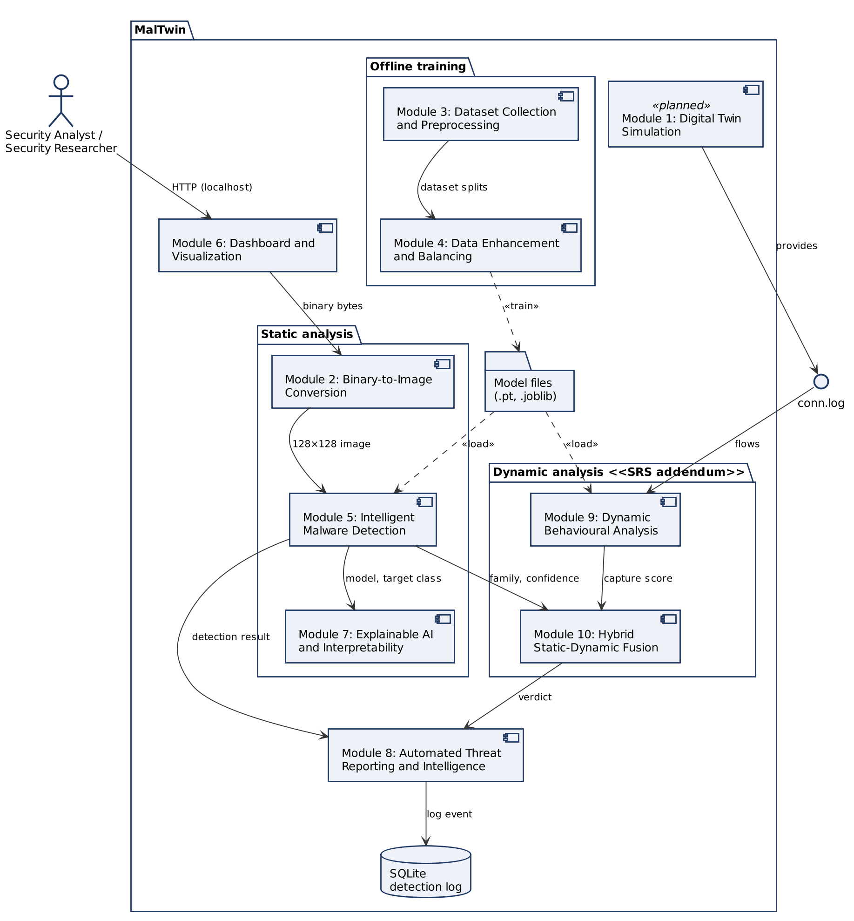
Figure 3.1 UML component diagram of MalTwin

3.1.1 Purpose
What this diagram shows
Figure 3.1 is a UML 2 component diagram. Each rectangle with the component icon is one module of the SRS, named exactly as in the SRS (Module 1 to Module 8), plus the two modules added in the SRS addendum (Module 9 and Module 10, Chapter 2). Packages group the components by role: static analysis, dynamic analysis and offline training. Solid arrows are data passed at run time and are labelled with what is passed. Dashed arrows are dependencies: the training modules produce the model files («train») and the detectors read them at start-up («load»). The lollipop symbol labelled conn.log is the interface between the Digital Twin and dynamic analysis. The analyst only interacts with the dashboard (Module 6).
Walking through the flow
The following sequence is what happens when an analyst submits a sample:
- Upload and validation. The analyst uploads a PE (.exe, .dll) or ELF binary on the Binary Upload page. The file is rejected if it is larger than 50 MB or if its first bytes are not the MZ (PE) or \x7fELF (ELF) signature. The extension is never trusted, because Linux IIoT binaries usually have none.
- Fingerprinting. A SHA-256 digest is computed locally with hashlib. No hash or file ever leaves the machine, so analysing a sample does not alert its authors.
- Binary-to-image conversion (M2). The raw bytes are laid out row by row as an 8-bit grayscale image. The row width follows the Nataraj et al. file-size table used to build Malimg (32 px for files under 10 KB, up to 1,024 px above 1 MB), then the image is resized to 128 × 128. Using the same layout as the training data keeps uploaded binaries in the distribution the network has learned.
- Static classification (M5). MalTwinCNN, a three-block convolutional network, returns a probability for each of 26 classes: the 25 Malimg families plus a Benign class built from clean system binaries. The top-1 class and its probability (confidence) are shown with a green, amber or red bar at the 0.80 and 0.50 thresholds.
- Explanation (M7). On request, Grad-CAM computes which regions of the image, and therefore which byte ranges of the binary, contributed most to the predicted family. The result is overlaid as a heatmap.
- Dynamic analysis (M9). If a network capture of the sample is available as a Zeek conn.log (from IoT-23 today, from the Digital Twin in the final phase), each connection is converted into 61 behavioural features and classified by a random forest into Benign, PortScan, C&C, DDoS, Attack, FileDownload or Okiru behaviour. A capture-level score summarises the most suspicious flows.
- Fusion (M10). The static confidence and the dynamic score are combined into one verdict (MALICIOUS, SUSPICIOUS or BENIGN) together with an agreement category that tells the analyst why: confirmed by both views, static-only, behaviour-only (possible novel variant) or no evidence.
- Threat intelligence and reporting (M8). The predicted family and observed behaviours are mapped to MITRE ATT&CK for ICS tactics and techniques. A PDF or JSON forensic report can be downloaded, and every detection is written to an SQLite log that feeds the dashboard's history and KPI cards.
The Digital Twin (Module 1) carries the «planned» stereotype because it is designed but scheduled for the final evaluation. Its only contract with the rest of the system is the conn.log interface, which is the same format the dynamic model is already trained on. When the twin is built, it plugs into the existing pipeline without changes to Module 9 or Module 10.

3.2 Architecture Diagram
Why a layered architecture
Internally MalTwin follows a layered architecture. Each layer only depends on the one beneath it, and every module sits in exactly one layer. We chose this structure for four reasons:
- Separation of concerns. File validation knows nothing about neural networks, and the CNN knows nothing about Streamlit. This kept the code base testable: 343 unit tests run without a GPU, without the dataset and without a browser.
- Replaceable components. The CNN and the random forest can be retrained or replaced without touching the dashboard, because the layer above only consumes their outputs (a family name and a probability, or a capture score).
- Graceful degradation. If a model file is missing, the detection layer reports itself as inactive and the dashboard still works for every other task. The health panel (FR1.1) shows exactly which layer is unavailable.
- A clear path for the Digital Twin. The twin is a new data source at the input layer. Nothing above that layer needs to change.
Figure 3.2 shows the layers as a UML package diagram. Each package is one layer and contains the components that implement it. The dashed arrows with the «use» stereotype are UML dependencies: a package uses only the package directly below it, which is the rule that makes the architecture strictly layered.
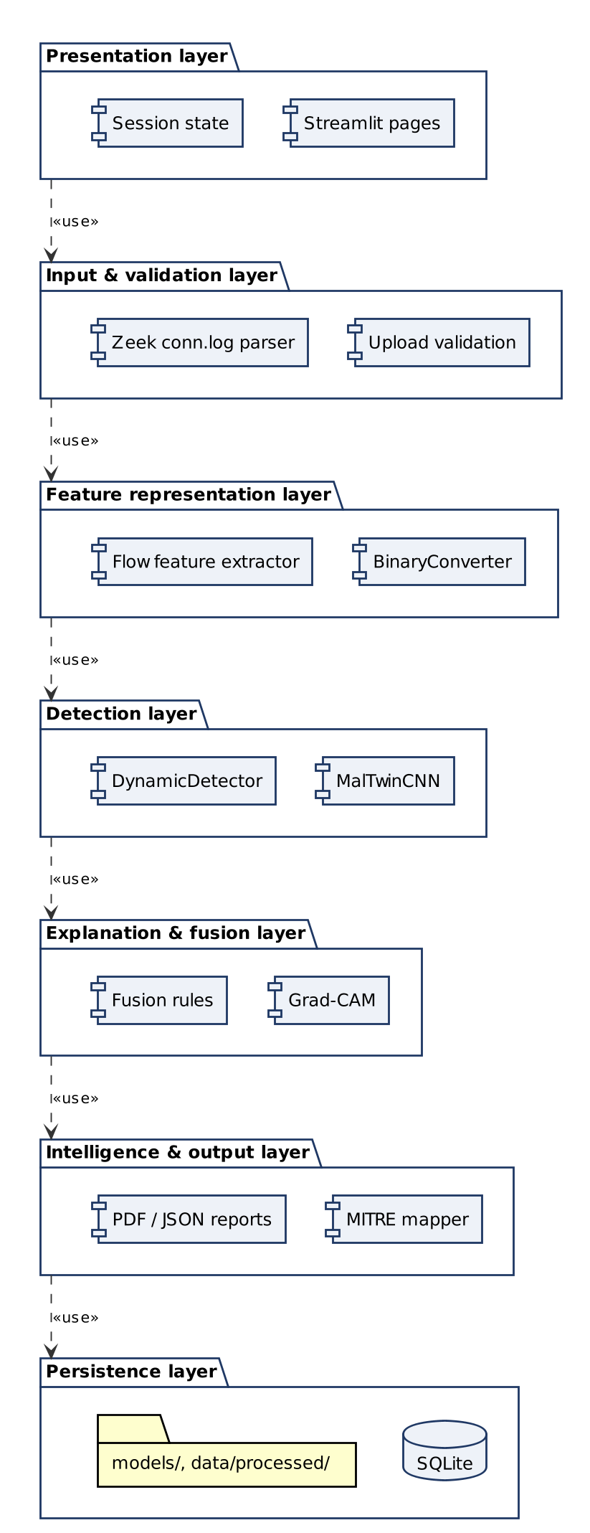
Figure 3.2 UML package diagram of the layered architecture
Table 3.1 Architecture layers
Layer | What is inside | Its job
1. Presentation | Streamlit dashboard, 8 pages, theme | Interaction, visualisation, downloads
2. Input & validation | Upload checks, magic bytes, SHA-256, Zeek parser | Reject bad input early and fingerprint samples
3. Feature representation | Binary-to-image converter; flow feature extractor | Turn raw evidence into model-ready inputs
4. Detection | MalTwinCNN; random-forest behaviour model | Classify family and behaviour
5. Explanation & fusion | Grad-CAM; feature-deviation explanation; fusion rules | Say why, and combine the two views
6. Intelligence & output | MITRE ATT&CK for ICS mapping; PDF/JSON reports | Make results actionable and shareable
7. Persistence | SQLite (WAL), model files, processed metrics | Durable, auditable records

3.2.1 Technologies and Services
Table 3.2 lists the main components, the technology each uses and the security measure applied to it. Versions are pinned in requirements.txt.
Table 3.2 Components, technologies and security measures
Component | What it does | Technology | Security measure
Dashboard (M6) | Eight-page web UI | Streamlit 1.37, Plotly | Bound to 127.0.0.1; 50 MB upload cap; usage statistics disabled
Binary-to-image (M2) | PE/ELF bytes → 128×128 image | NumPy, OpenCV | Magic-byte validation; file is never executed or written to disk
Dataset & enhancement (M3, M4) | Stratified splits, augmentation, oversampling | PyTorch, torchvision | Integrity check flags corrupt images before training
Static detector (M5) | 25-family CNN | PyTorch 2.x | Model loaded only from the project directory; eval mode for deterministic output
Explainability (M7) | Grad-CAM heatmaps | Captum LayerGradCam | Runs locally; no data leaves the host
Reporting (M8) | PDF/JSON reports, MITRE mapping | FPDF2, JSON | Reports identify samples by SHA-256, not file path
Detection log | History and KPIs | SQLite (WAL mode) | File permission 0600; parameterised queries
Dynamic detector (M9) | Behaviour classification of flows | scikit-learn RandomForest, pandas | No IP addresses used as features; model file format and feature list verified on load
Fusion (M10) | Combined verdict | Pure Python | Input range checks; deterministic rules
Digital Twin (M1, planned) | Isolated IIoT network for running samples | Docker (internal network), Zeek | No route to host LAN; no host mounts; CPU/RAM limits; teardown per run

3.3 Key Design Decisions
Several decisions shaped the implementation. Each one is recorded here with its reason, so it can be revisited if the assumptions change.
Table 3.3 Design decisions and rationale
Decision | Alternatives considered | Reason
Lay out bytes with the Malimg width table before resizing | Square layout (width = √size) | The CNN is trained on Malimg images, which were built with this table. Using a different layout at upload time would show the network images unlike anything it was trained on.
Compact 3-block CNN (1.35 M parameters) trained from scratch | ImageNet-pretrained ResNet / VGG | Grayscale 128×128 byte images share little with natural photos. A small network trains on a laptop CPU, runs inference in milliseconds, and keeps Grad-CAM readable.
Add a Benign class built from clean system binaries | Malware-only classifier with a confidence threshold | Malimg contains malware only, so a model trained on it alone assigns every file, including clean software, to some family. Clean PE/ELF files from the operating system, laid out with the same Malimg width table, give the network an explicit "not malware" answer.
Weighted random oversampling | Class-weighted loss only; SMOTE on images | Malimg is 36:1 imbalanced (Allaple.A 2,949 vs Skintrim.N 80). Oversampling makes every family equally frequent in training, so the model is trained on a balanced dataset.
No geometric augmentation (rotation, flips) | Augmentation as planned in the SRS | Each image row is a run of consecutive bytes; flips and rotations reorder them. In the ablation (Table 4.6) accuracy rose from 94.2% to 98.7% without augmentation.
Zeek conn.log as the dynamic input format | Raw PCAP; system-call traces | IoT-23 is published in this format, so a model can be trained now. The Digital Twin can produce the same file by running Zeek on its bridge.
Random forest for flows | Deep sequence models (LSTM) | Tabular, heavy-tailed features with extreme class imbalance; built-in feature importance gives the "why" required for explainability.
No IP addresses as features | Include source/destination IP | Each IoT-23 capture has its own infected host IP. A model that learned IPs would learn identities, not behaviour, and would not transfer to the twin.
Decision-level (late) fusion | Feature-level fusion in one network | Static and dynamic evidence are not yet available for the same samples (that needs the twin). Late fusion works with either source alone and keeps each model independently testable.
Docker networking for the twin, Mininet optional | Mininet only | Mininet requires a native Linux host with root. Docker internal networks give the needed isolation and also run on Windows with WSL2.

3.4 Design Models
Following the committee's comments, every design model is drawn in the standard notation of its technique, and the dynamic models (sequence and activity diagrams) cover every major use case rather than a single example. Use case diagrams are requirement models and are therefore in Chapter 2. Table 3.4 lists the notation used, so each symbol in the figures can be checked.
Table 3.4 Notation used in the design models
Diagram | Standard | Symbols used
Use case (Chapter 2) | UML 2.5 | Stick-figure actors; ellipse use cases; rectangle system boundary; solid association; hollow-triangle generalisation; dashed arrow «include» / «extend»
Component, package | UML 2.5 | Component box with component icon; folder-shaped package; lollipop provided interface; dashed arrow dependency with stereotype («use», «load», «train»)
Class | UML 2.5 | Three-compartment class box; visibility + public, − private; attribute and return types; filled diamond composition; open arrow association; multiplicities; «dataclass» and «utility» stereotypes
Sequence | UML 2.5 (Jacobson stereotypes) | Actor; boundary, control and entity lifelines; database participant; activation bars; solid arrow synchronous call; dashed arrow return; alt, opt and loop combined fragments with guards; numbered messages
Activity | UML 2.5 | Swimlanes per actor; filled circle initial node; rounded actions; diamond decision and merge with [guards]; fork and join bars; bullseye final node
State machine | UML 2.5 | Rounded states; initial and final pseudostates; transitions labelled event [guard] / action
Data flow | Yourdon–DeMarco | Circle process with number; rectangle external entity; open-ended rectangle data store (D1, D2, …); labelled arrow data flow
Entity relationship | Crow's foot (Martin / IE) | Entity box with PK/FK attributes; bar = one, circle = zero, crow's foot = many (e.g. ||—o< one to zero-or-many); associative entities resolve many-to-many relationships
Relational schema | UML data-modelling profile | «table» classes with column types and constraints (PK, FK, NOT NULL, CHECK, DEFAULT) and indexes

3.4.1 Design Models for the Object-Oriented Approach

3.4.1.1 Class Diagram
Purpose: to show the main classes, their attributes and operations with types and visibility, and how they relate. Modules that contain only stateless functions (validation, hashing, MITRE lookup, report generation, balanced evaluation) are shown as «utility» classes.
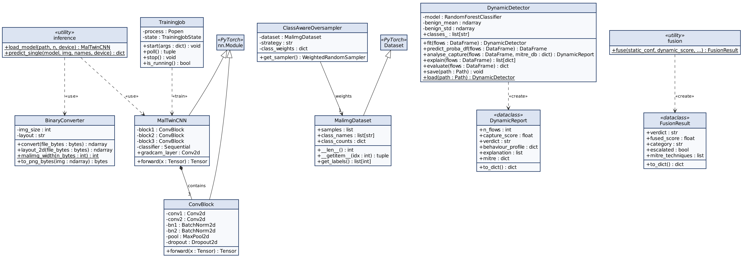
Figure 3.3 UML class diagram of the core classes
MalTwinCNN is composed of three ConvBlock instances (filled diamond, multiplicity 3) and exposes gradcam_layer, the last convolution, which Grad-CAM hooks into. DynamicDetector wraps the random forest and also stores the mean and spread of benign traffic, which it needs to explain a capture. Both detectors feed FusionResult only through plain numbers (a confidence and a capture score). This loose coupling is what allows either detector to be retrained or replaced independently.

3.4.1.2 Sequence Diagrams
One sequence diagram is given for each major use case of Chapter 2. Each shows the objects that take part, in the boundary–control–entity style: the boundary is the dashboard page the actor uses, control objects are the Python modules that carry out the logic, and entities are the trained models, the session state and the stored data. Messages are numbered in order. The alternative flows of each use case description appear as alt fragments labelled with the flow number (for example "UC-03 2a"), optional steps as opt fragments, and repetition as loop fragments.
Sequence diagram for UC-01 Upload Binary File
The page rejects files over 50 MB before hashing them, skips re-processing when the same SHA-256 is uploaded again, and validates the magic bytes before conversion. The converter lays the bytes out with the Malimg width table before resizing, so uploads look like the training images.
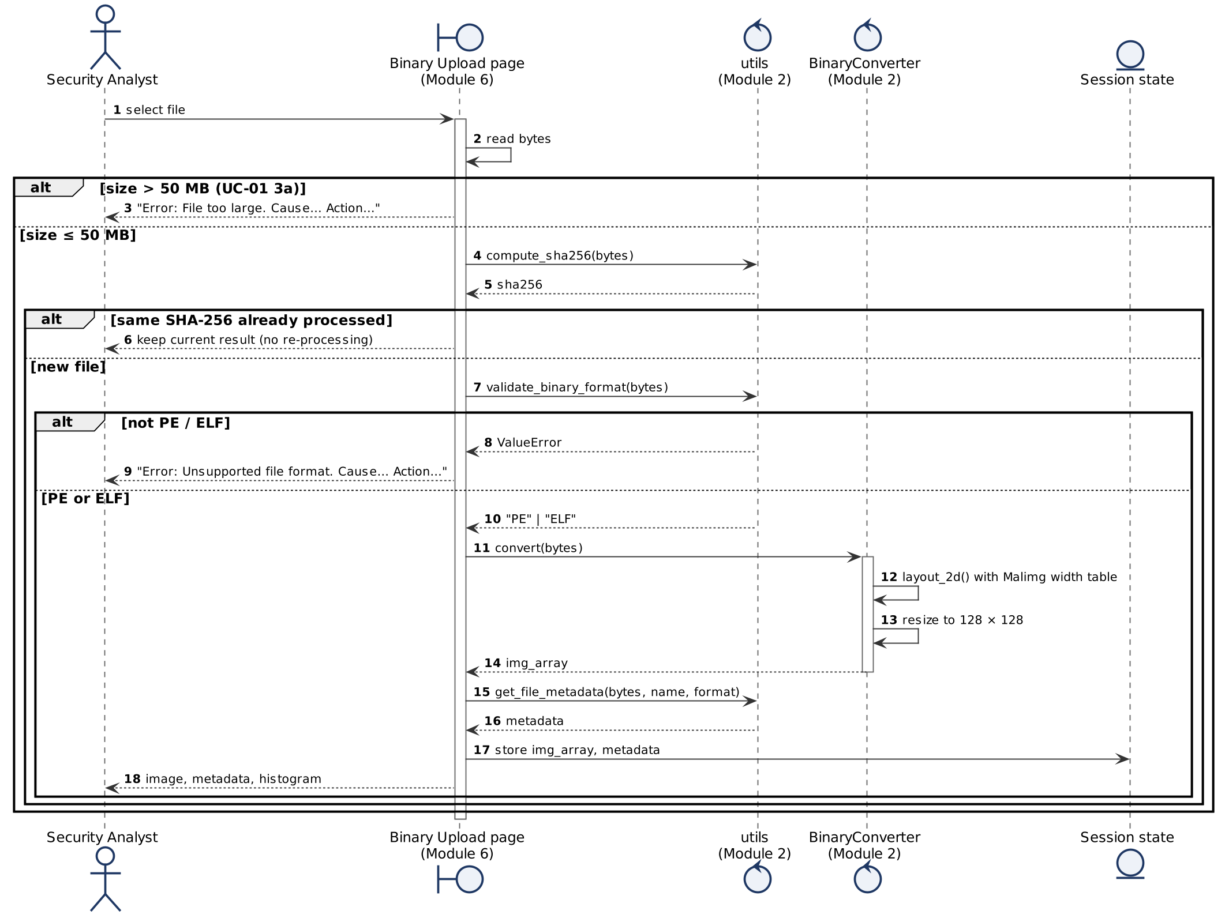
Figure 3.4 UML sequence diagram for UC-01 Upload Binary File
Sequence diagram for UC-03 Run Malware Detection
Inference and logging are separate control objects: the database write is retried once and never raises, so a logging problem cannot hide a detection result. The MITRE lookup is the included use case UC-04 and is skipped when the prediction is Benign.
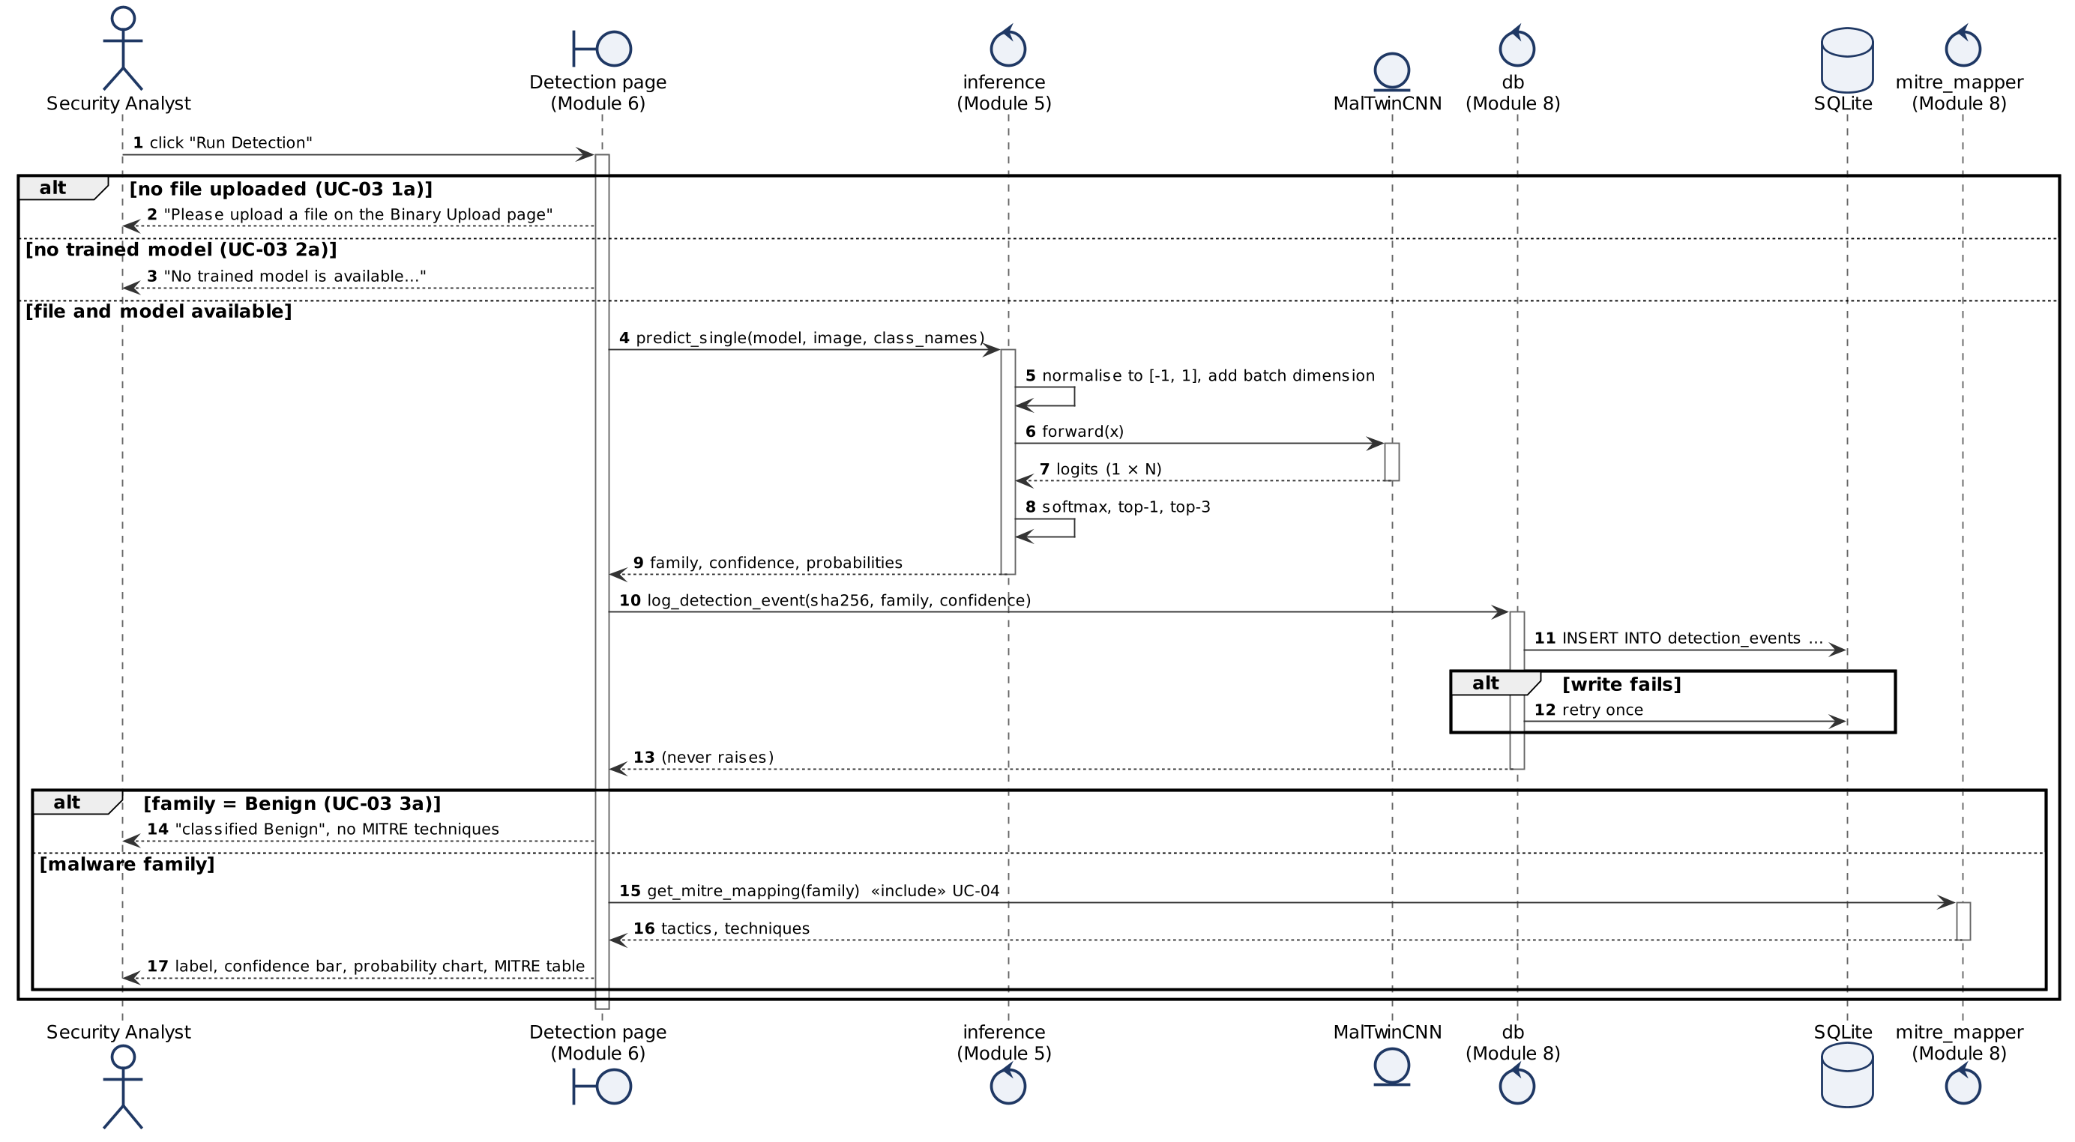
Figure 3.5 UML sequence diagram for UC-03 Run Malware Detection
Sequence diagram for UC-05 View Grad-CAM Explanation
Grad-CAM is computed by Captum through hooks on the CNN's last convolutional layer for the predicted class. Any failure returns None and is reported without affecting the detection result.
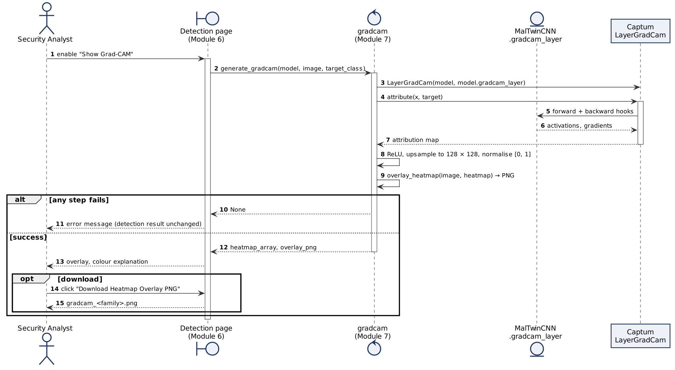
Figure 3.6 UML sequence diagram for UC-05 View Grad-CAM Explanation
Sequence diagram for UC-06 Generate Forensic Report
The report data, including the MITRE mapping (UC-04), is assembled once and rendered as PDF or JSON. Each generated report is recorded in report_events with the id of the detection it documents.
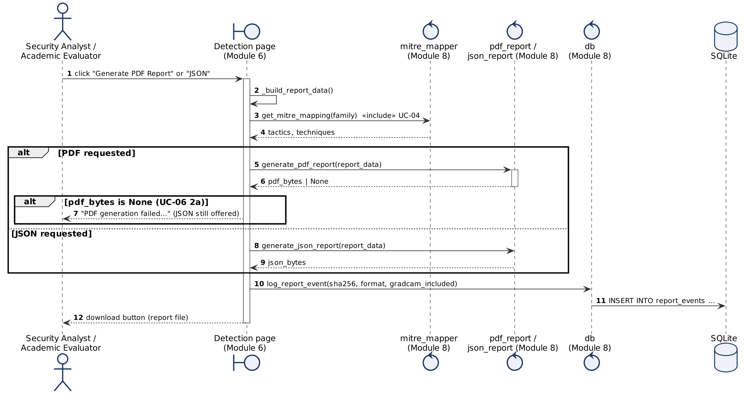
Figure 3.7 UML sequence diagram for UC-06 Generate Forensic Report
Sequence diagram for UC-07 Analyse Network Capture
The parser turns the Zeek log into flows; the detector extracts 61 IP-free features, scores every flow, aggregates the top 5% into a capture score, explains the flagged flows and maps behaviours to MITRE techniques (UC-04).
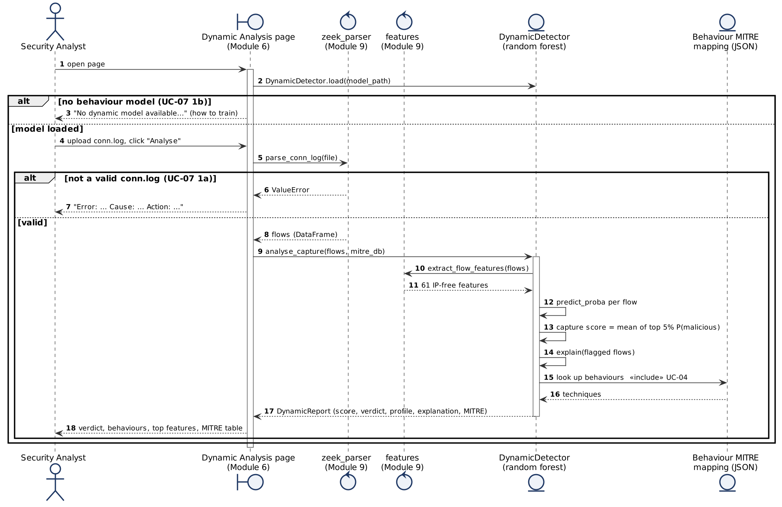
Figure 3.8 UML sequence diagram for UC-07 Analyse Network Capture
Sequence diagram for UC-08 View Hybrid Verdict
The page reads whatever evidence is in the session and calls fuse(), which computes the weighted score, the agreement category and the verdict, and applies the novel-variant escalation rule.
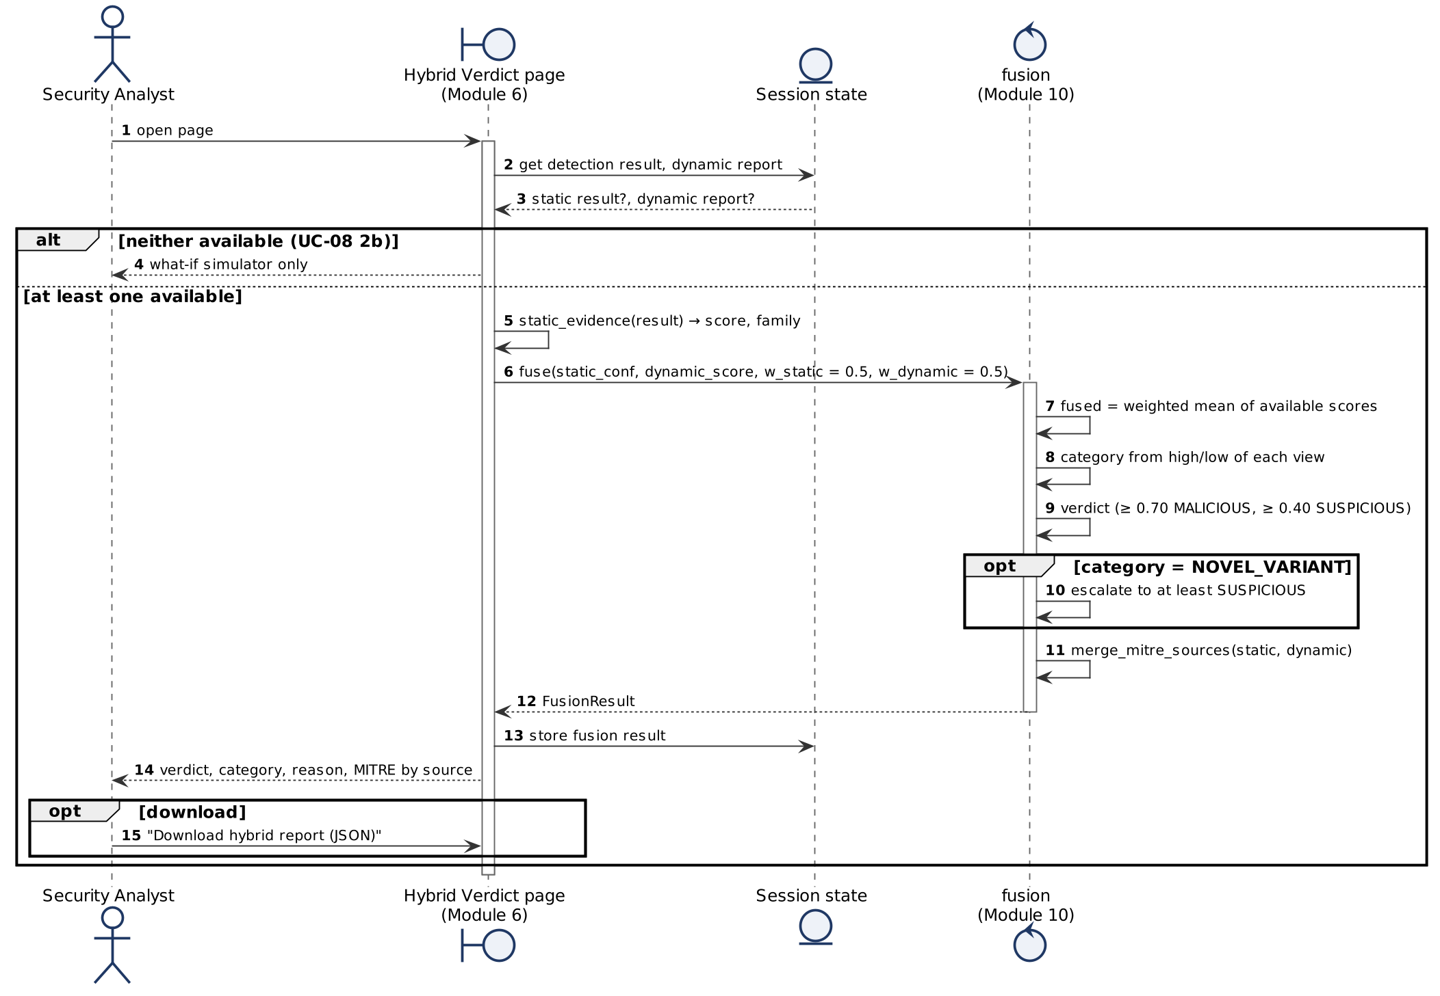
Figure 3.9 UML sequence diagram for UC-08 View Hybrid Verdict
Sequence diagram for UC-09 View Dashboard and Detection History
All database access goes through the db module using parameterised queries. Module status comes from health checks cached for 30 seconds.
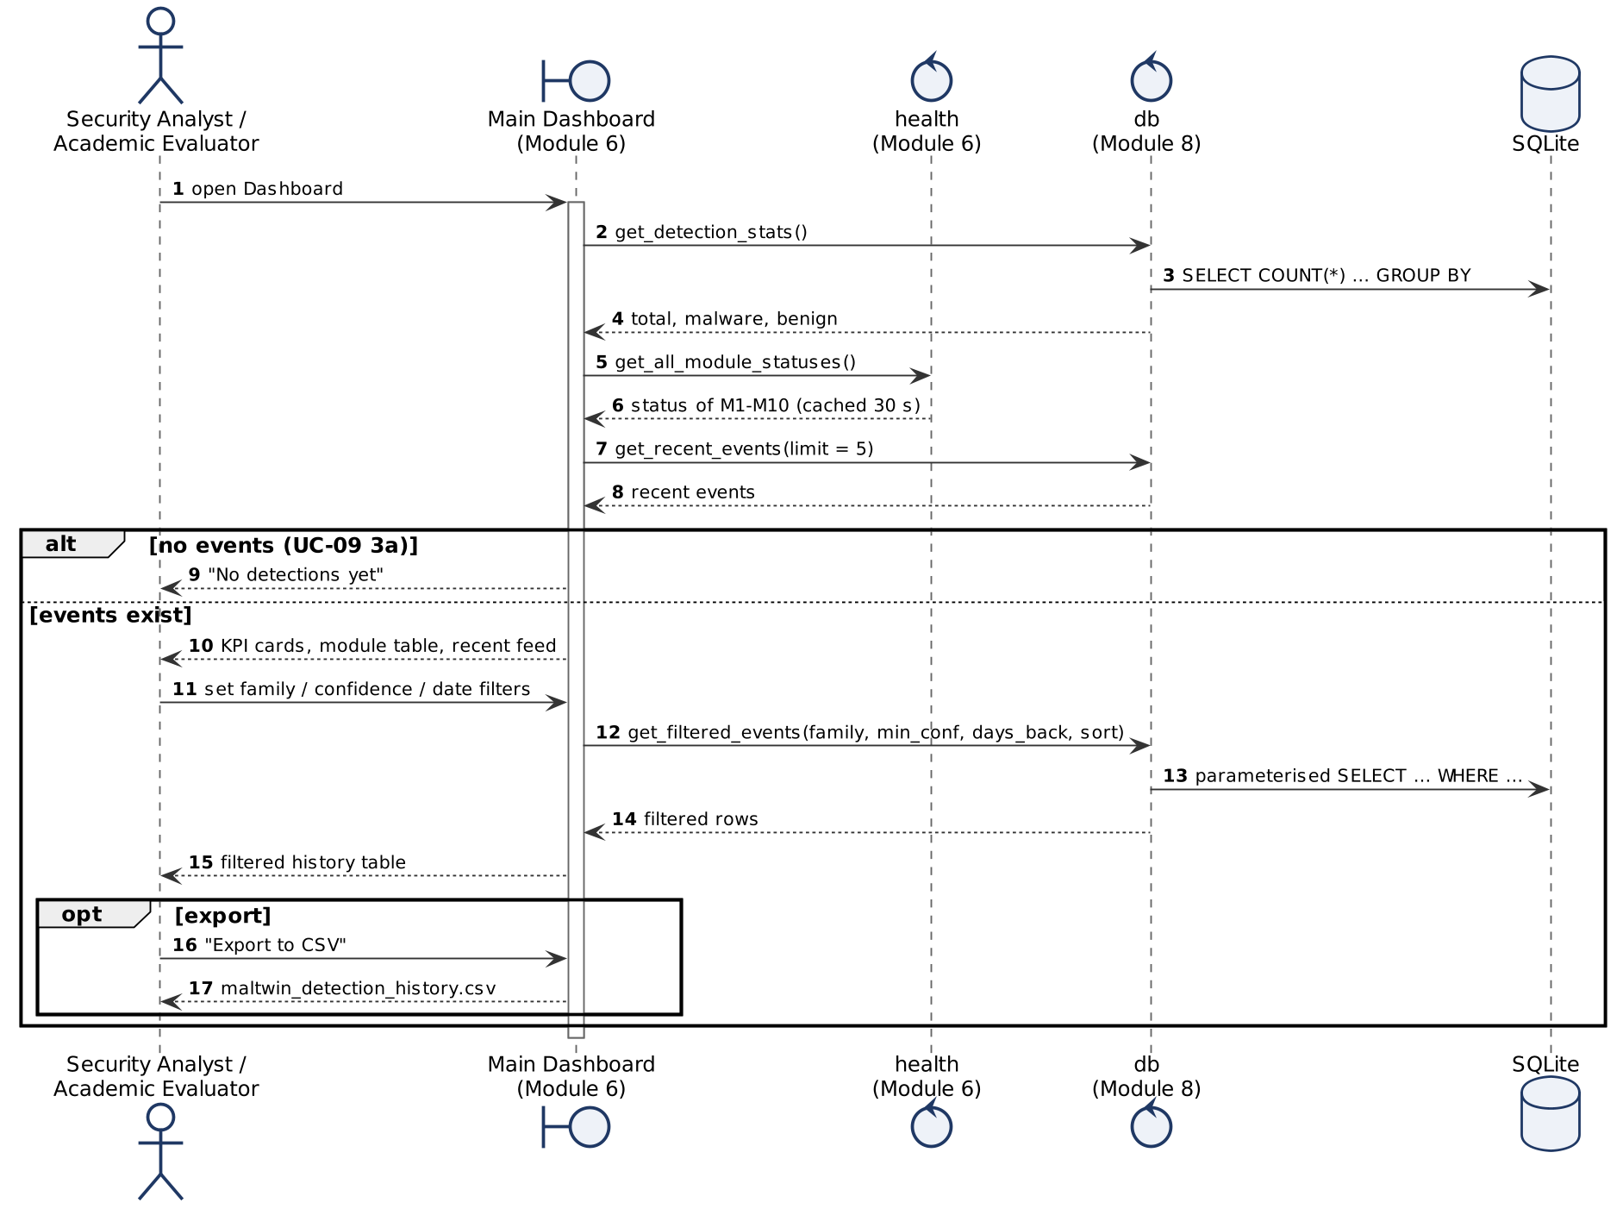
Figure 3.10 UML sequence diagram for UC-09 View Dashboard and Detection History
Sequence diagram for UC-11 Train Detection Models
Training runs as a separate process so that the dashboard stays responsive. The page polls the job for log lines and progress, can stop it, and reloads the model when the process exits successfully. Dataset preparation (UC-10) is included at the start of training.
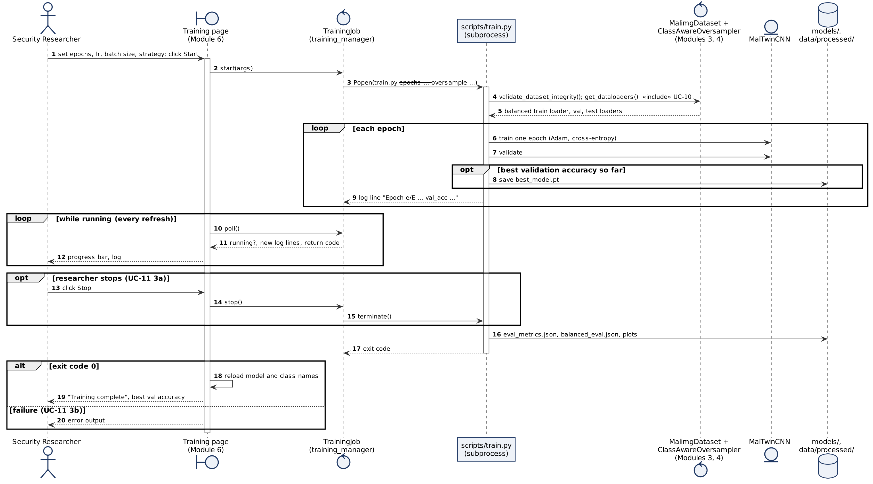
Figure 3.11 UML sequence diagram for UC-11 Train Detection Models
Sequence diagram for UC-12 Evaluate Detection Model
Predictions on the test split are computed once; the balanced evaluation then re-uses them for ten class-balanced draws, so no extra inference is needed.
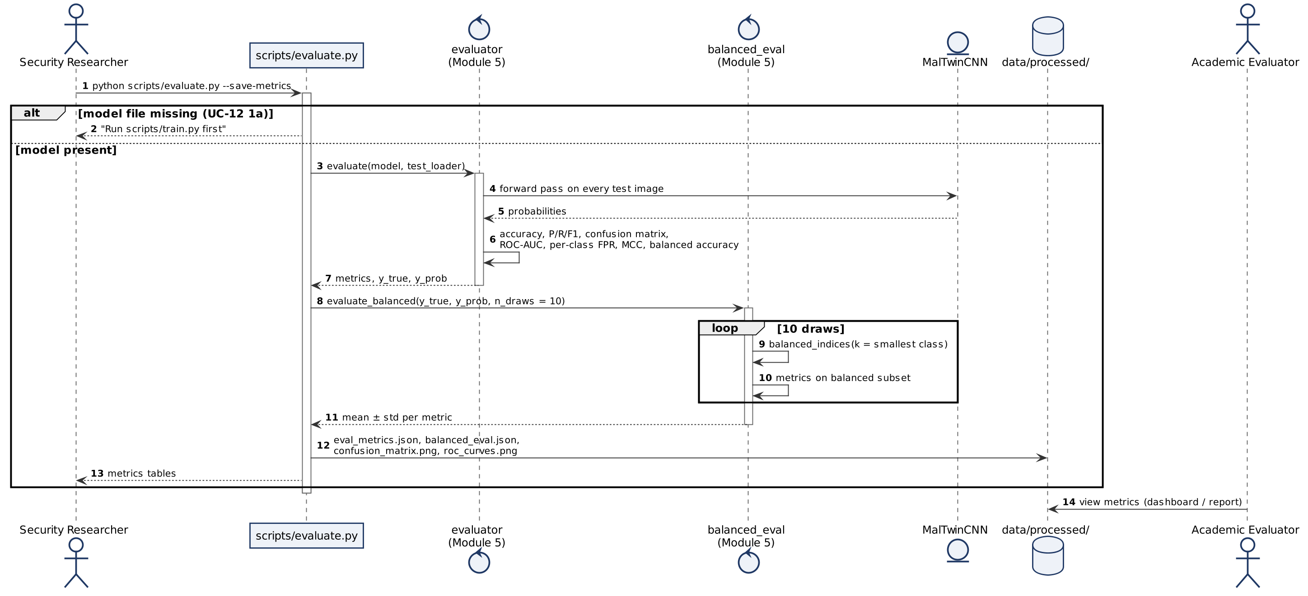
Figure 3.12 UML sequence diagram for UC-12 Evaluate Detection Model
Sequence diagram for UC-13 Run Digital Twin Simulation (planned)
This diagram is the design for the final evaluation. The twin controller creates an internal Docker network with no route to the host, runs the sample, captures its traffic with Zeek and hands the resulting conn.log to Module 9 — the same interface the dynamic model is already trained on.
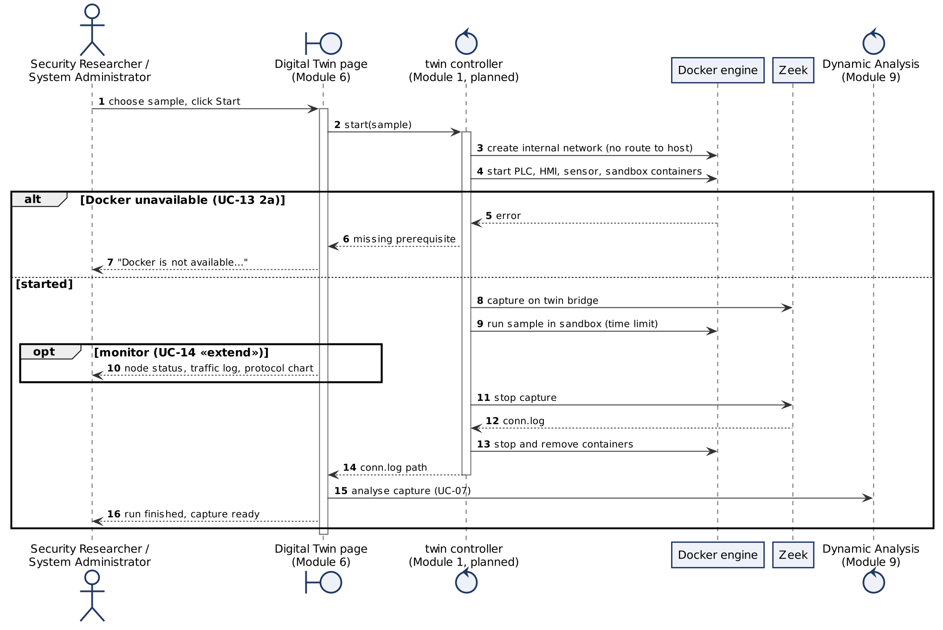
Figure 3.13 UML sequence diagram for UC-13 Run Digital Twin Simulation (planned)

3.4.1.3 Activity Diagrams
Activity diagrams show the control flow of each major process. Swimlanes separate what the actor does from what the system does; every decision has guarded outgoing flows and a matching merge, and parallel work is shown with fork and join bars. Figure 3.14 gives the end-to-end workflow for one sample; the following figures detail each use case.
Activity diagram for End-to-end analysis of a sample
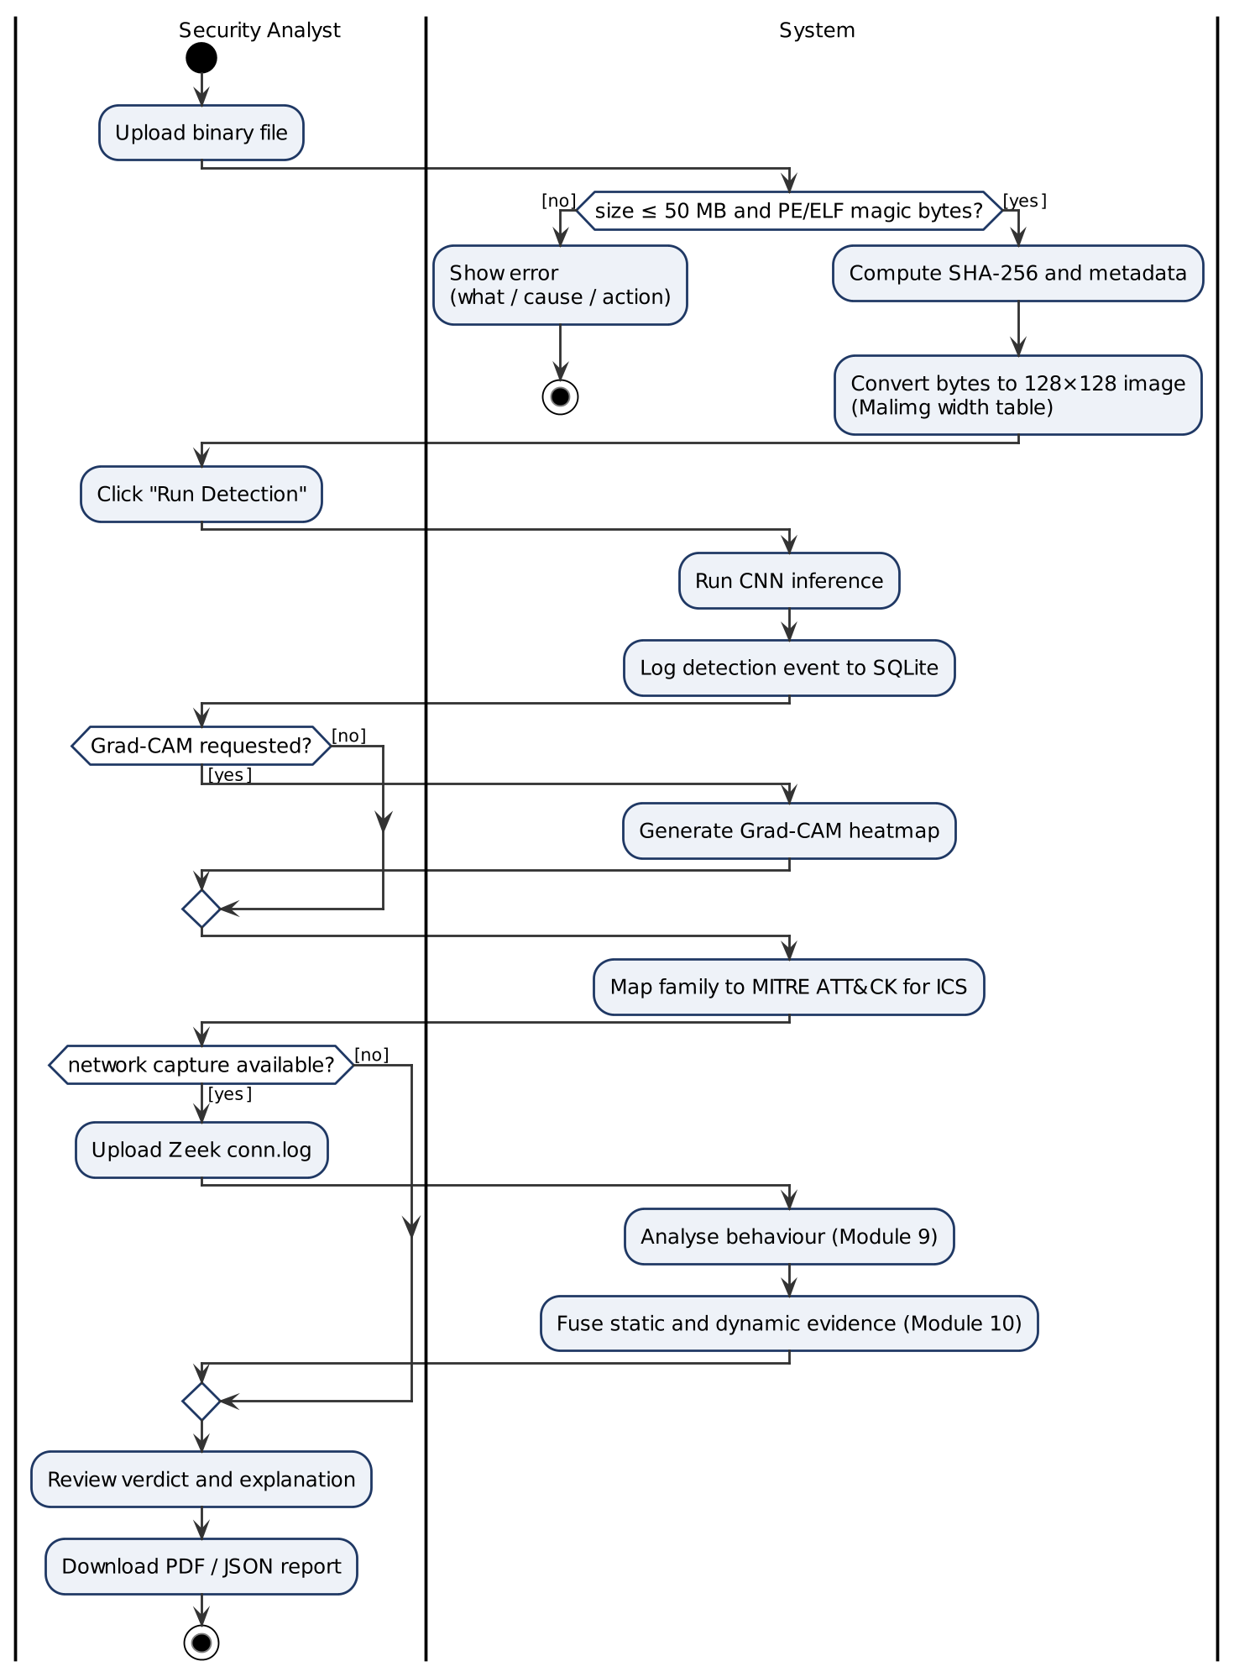
Figure 3.14 UML activity diagram for End-to-end analysis of a sample
Activity diagram for UC-01 Upload Binary File
Each rejection path ends the activity with an error message in the what–cause–action format required by USE-3.
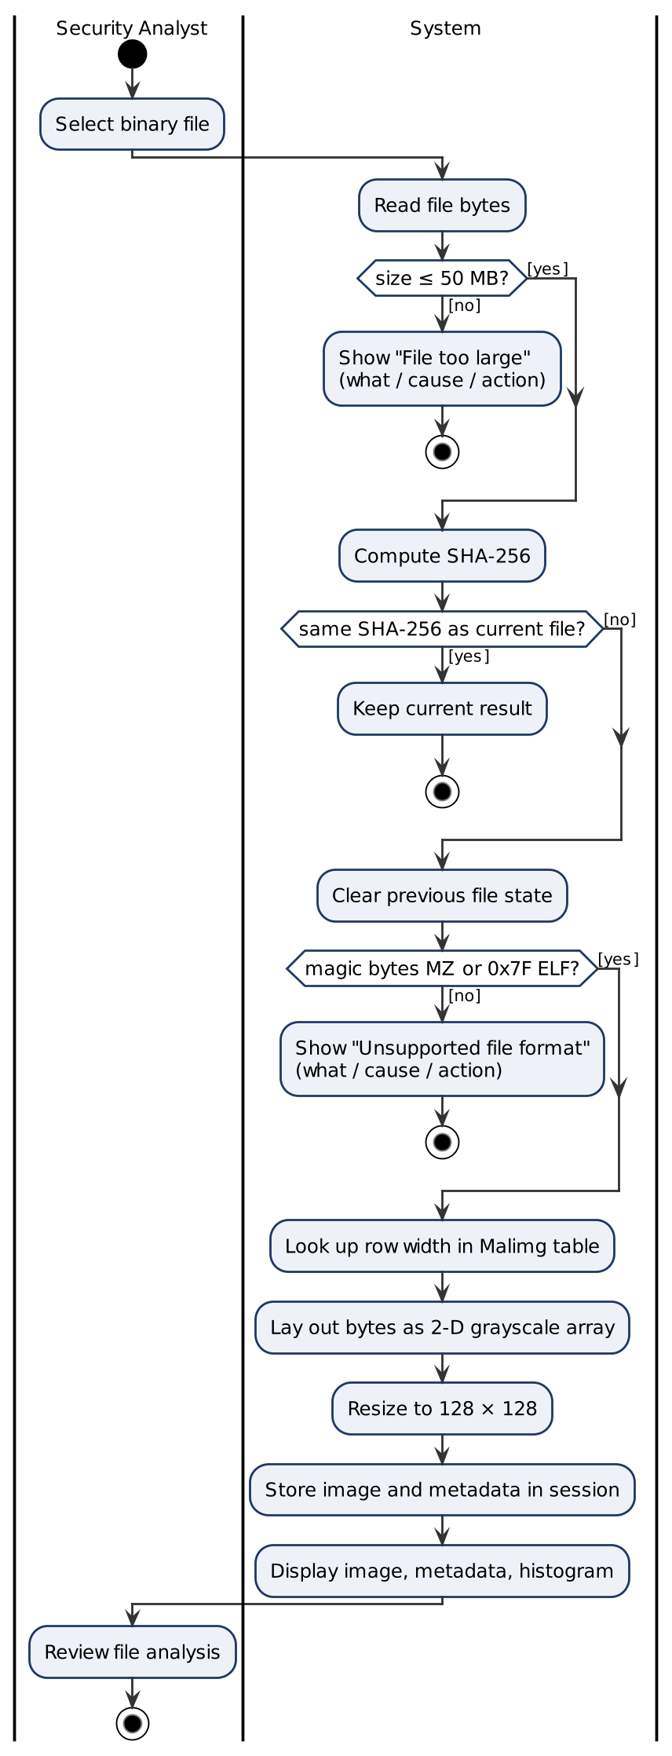
Figure 3.15 UML activity diagram for UC-01 Upload Binary File
Activity diagram for UC-03 Run Malware Detection with UC-05 Grad-CAM
Logging and display happen in parallel (fork/join) because the log write must never delay or block the result.
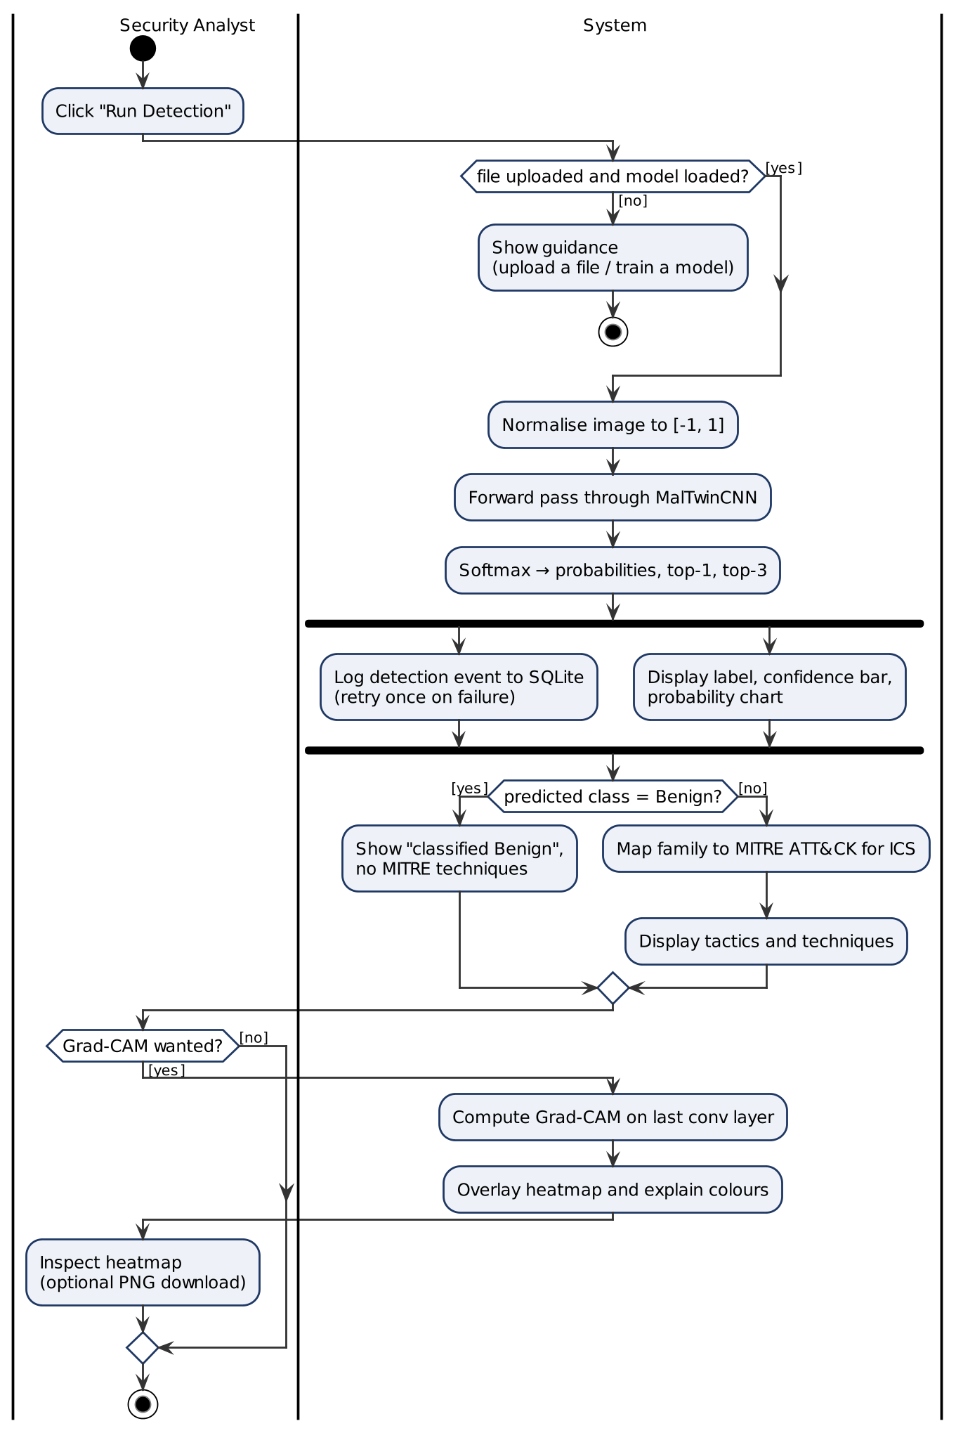
Figure 3.16 UML activity diagram for UC-03 Run Malware Detection with UC-05 Grad-CAM
Activity diagram for UC-06 Generate Forensic Report
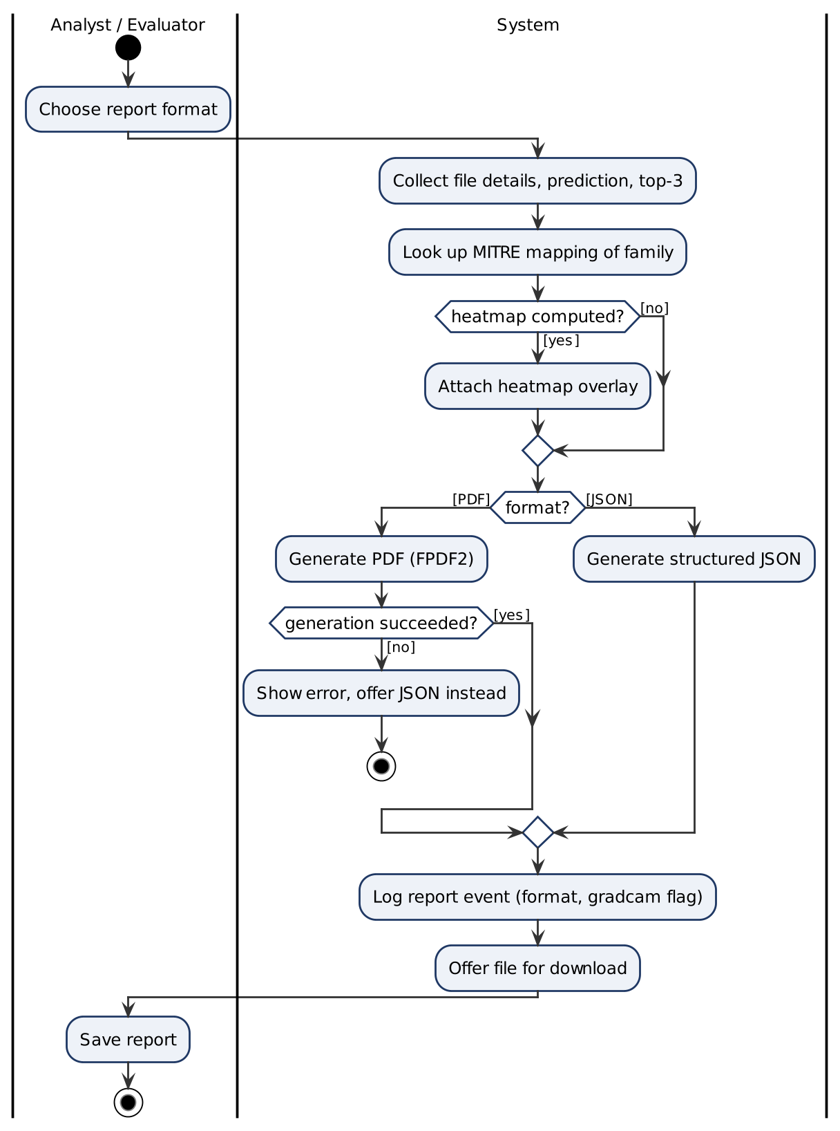
Figure 3.17 UML activity diagram for UC-06 Generate Forensic Report
Activity diagram for UC-07 Analyse Network Capture
The capture verdict thresholds are 0.8 (MALICIOUS) and 0.5 (SUSPICIOUS) on the capture score.
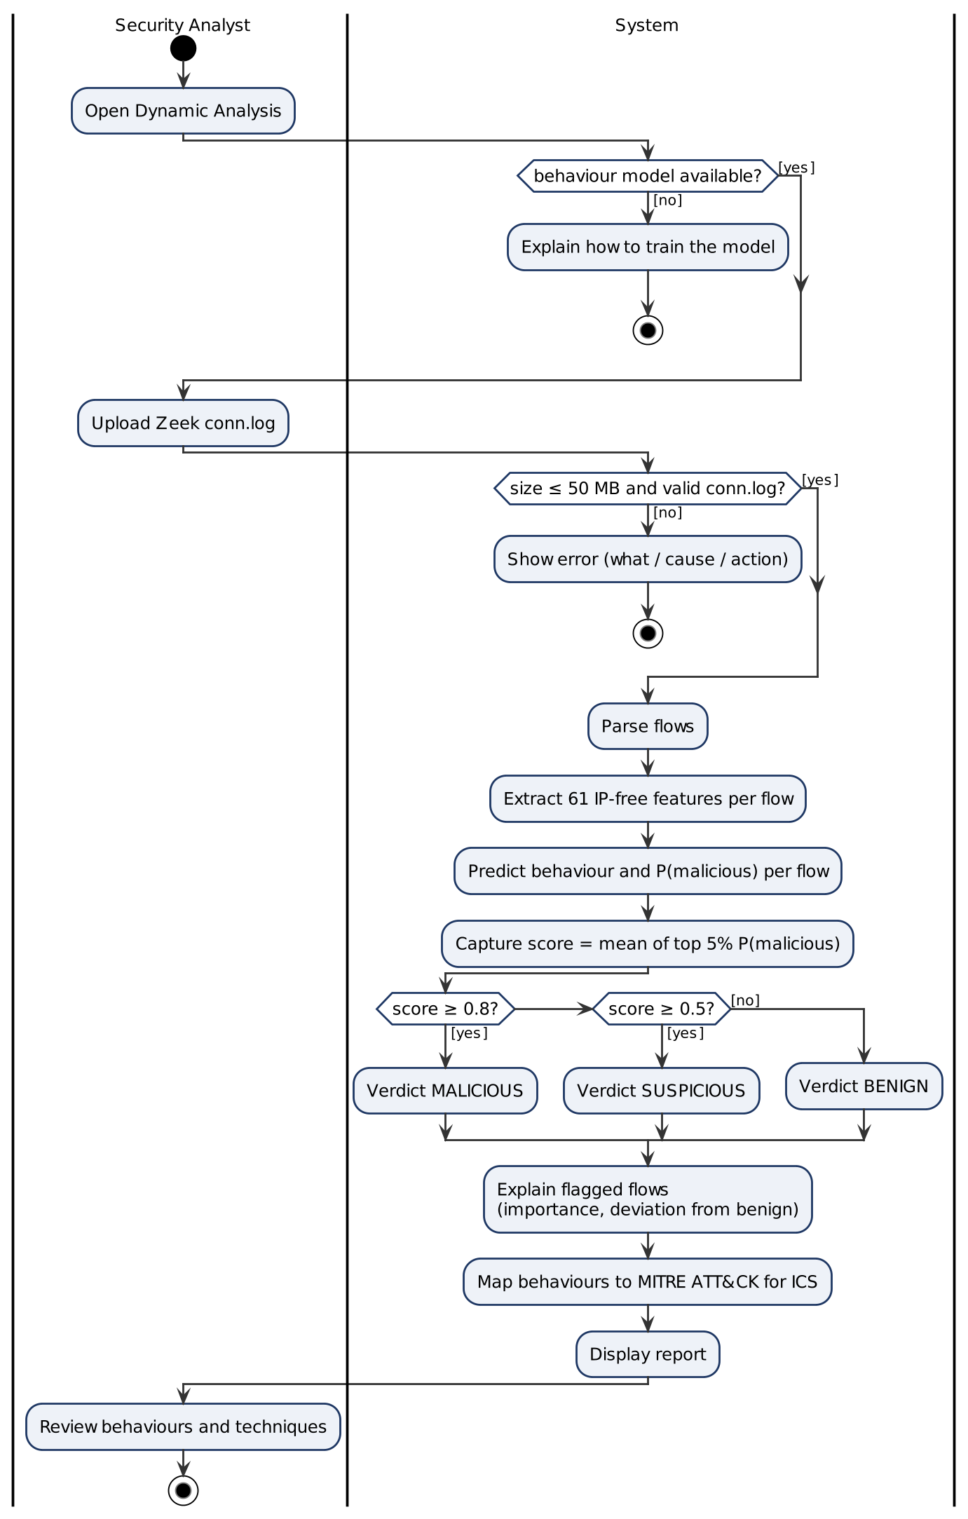
Figure 3.18 UML activity diagram for UC-07 Analyse Network Capture
Activity diagram for UC-08 Hybrid fusion decision
This is the decision logic of Module 10; it is a system process, so it has no actor swimlane. The same rules are tested as a decision table in Section 5.3.
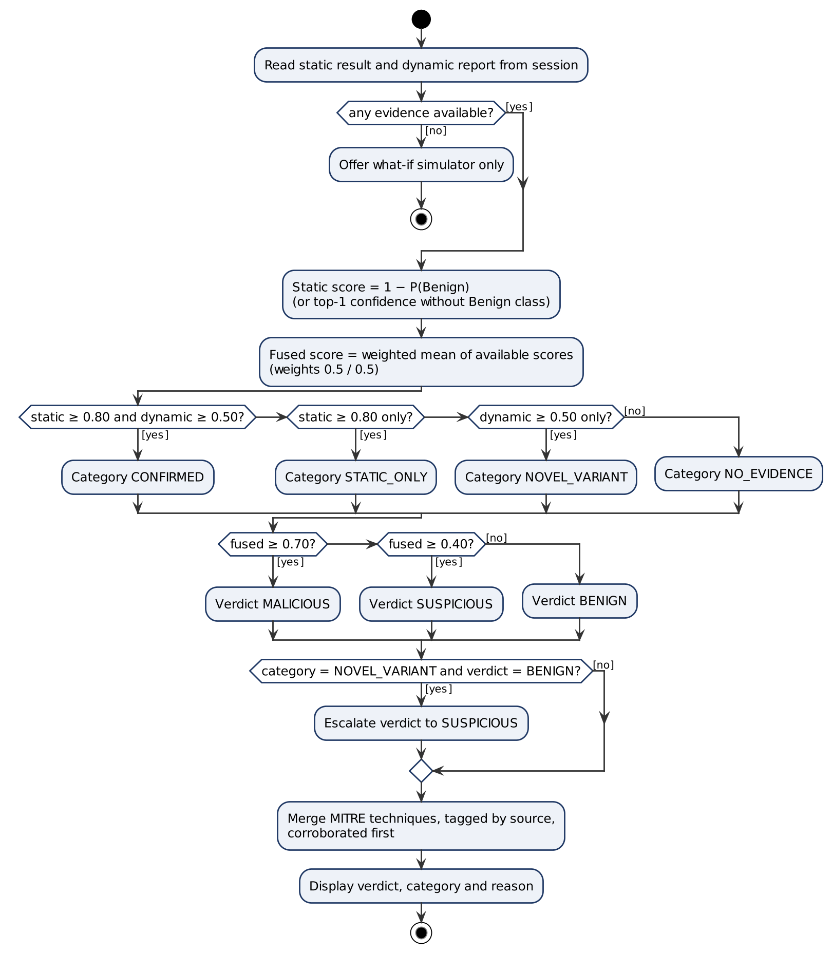
Figure 3.19 UML activity diagram for UC-08 Hybrid fusion decision
Activity diagram for UC-11 Train Detection Models
The loop runs once per epoch; the best weights by validation accuracy are kept, and the balanced evaluation runs automatically at the end.
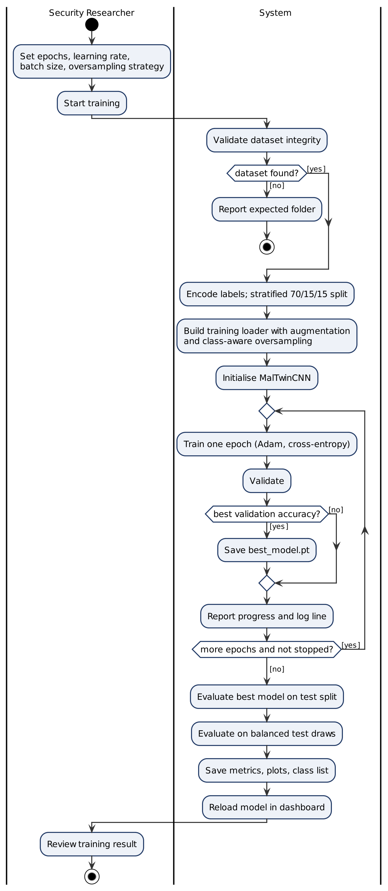
Figure 3.20 UML activity diagram for UC-11 Train Detection Models
Activity diagram for UC-12 Evaluate Detection Model on full and balanced test sets
The full-split metrics and the balanced draws are computed in parallel from the same predictions.
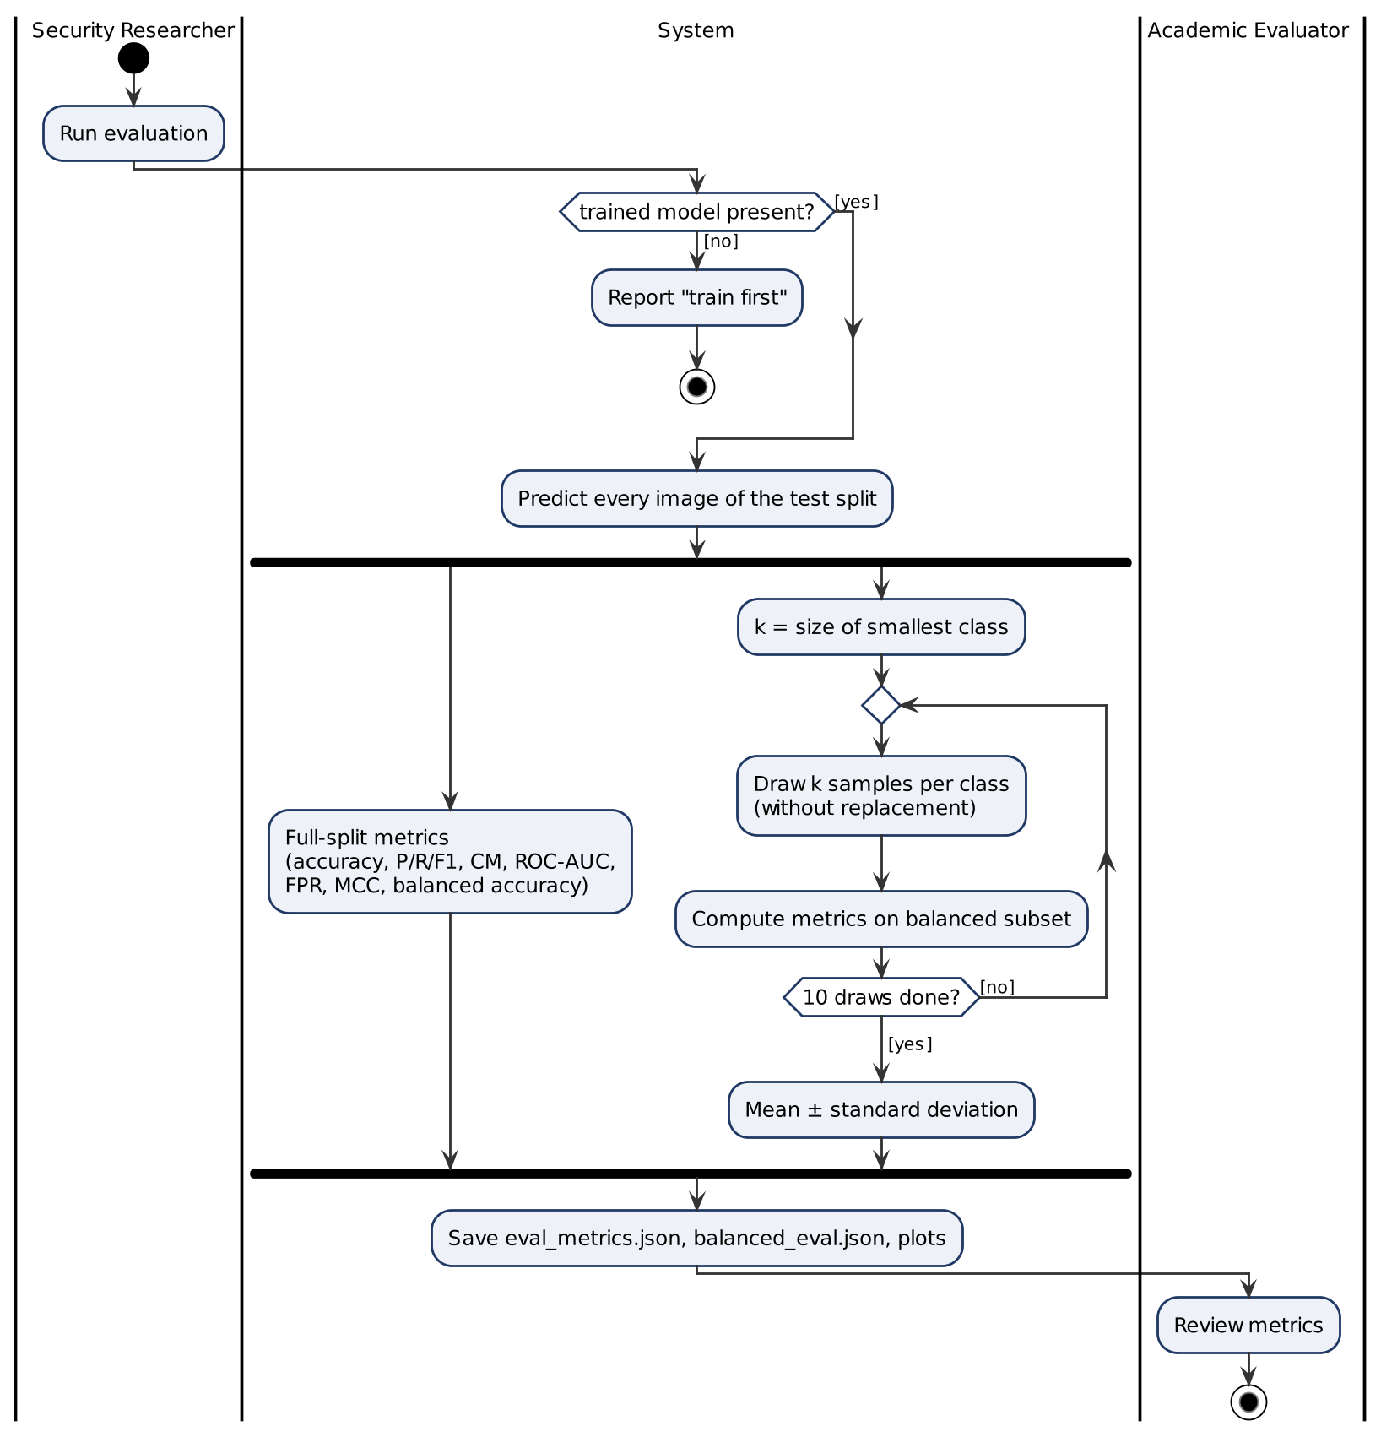
Figure 3.21 UML activity diagram for UC-12 Evaluate Detection Model on full and balanced test sets
Activity diagram for UC-13 Run Digital Twin Simulation (planned)
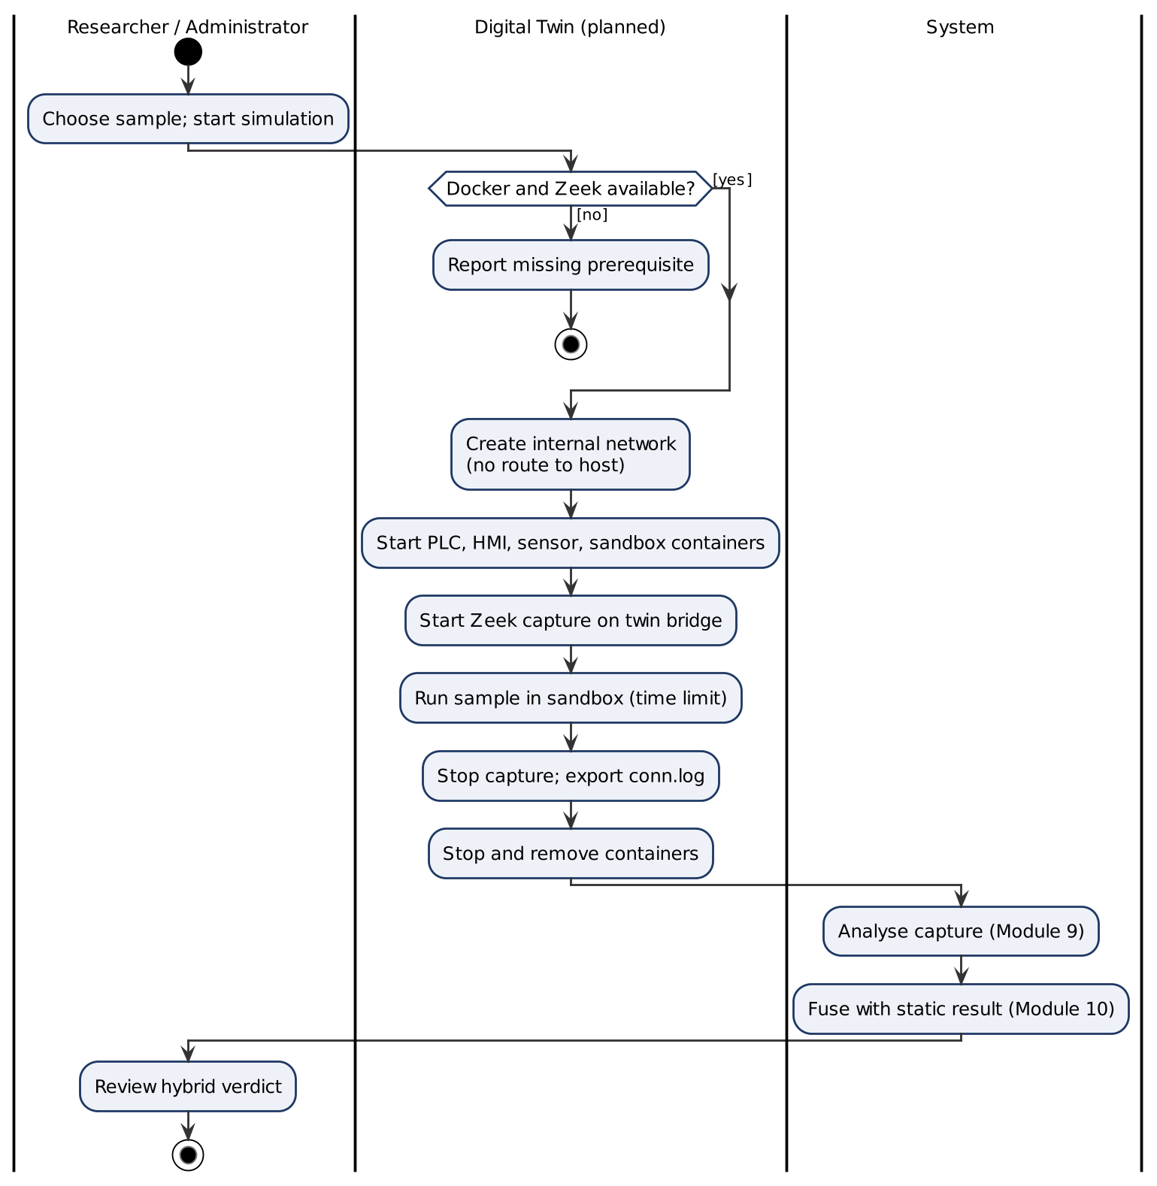
Figure 3.22 UML activity diagram for UC-13 Run Digital Twin Simulation (planned)

3.4.2 Design Models for the Procedural Approach

3.4.2.1 Data Flow Diagrams
Purpose: to show how data moves through the system, from samples and captures to verdicts, reports and stored records. The diagrams use Yourdon–DeMarco notation: circles are processes, rectangles are external entities, open-ended rectangles are data stores (the standard DFD symbol for a database or file, labelled D1, D2, …) and every arrow is a named data flow. The three levels are balanced: every data flow that enters or leaves the system at Level 0 appears at Level 1 with the same name, and the flows into and out of Process 4.0 at Level 1 are the flows on the boundary of its Level 2 expansion.
Level 0: Context diagram
At the highest level MalTwin is a single process (0) exchanging data with five external entities: the Security Analyst, who submits samples and receives verdicts and reports; the Security Researcher, who requests training and receives evaluation metrics; the public datasets used for training (Malimg and IoT-23); the Digital Twin that supplies runtime traffic (final phase); and the MITRE ATT&CK for ICS knowledge base.
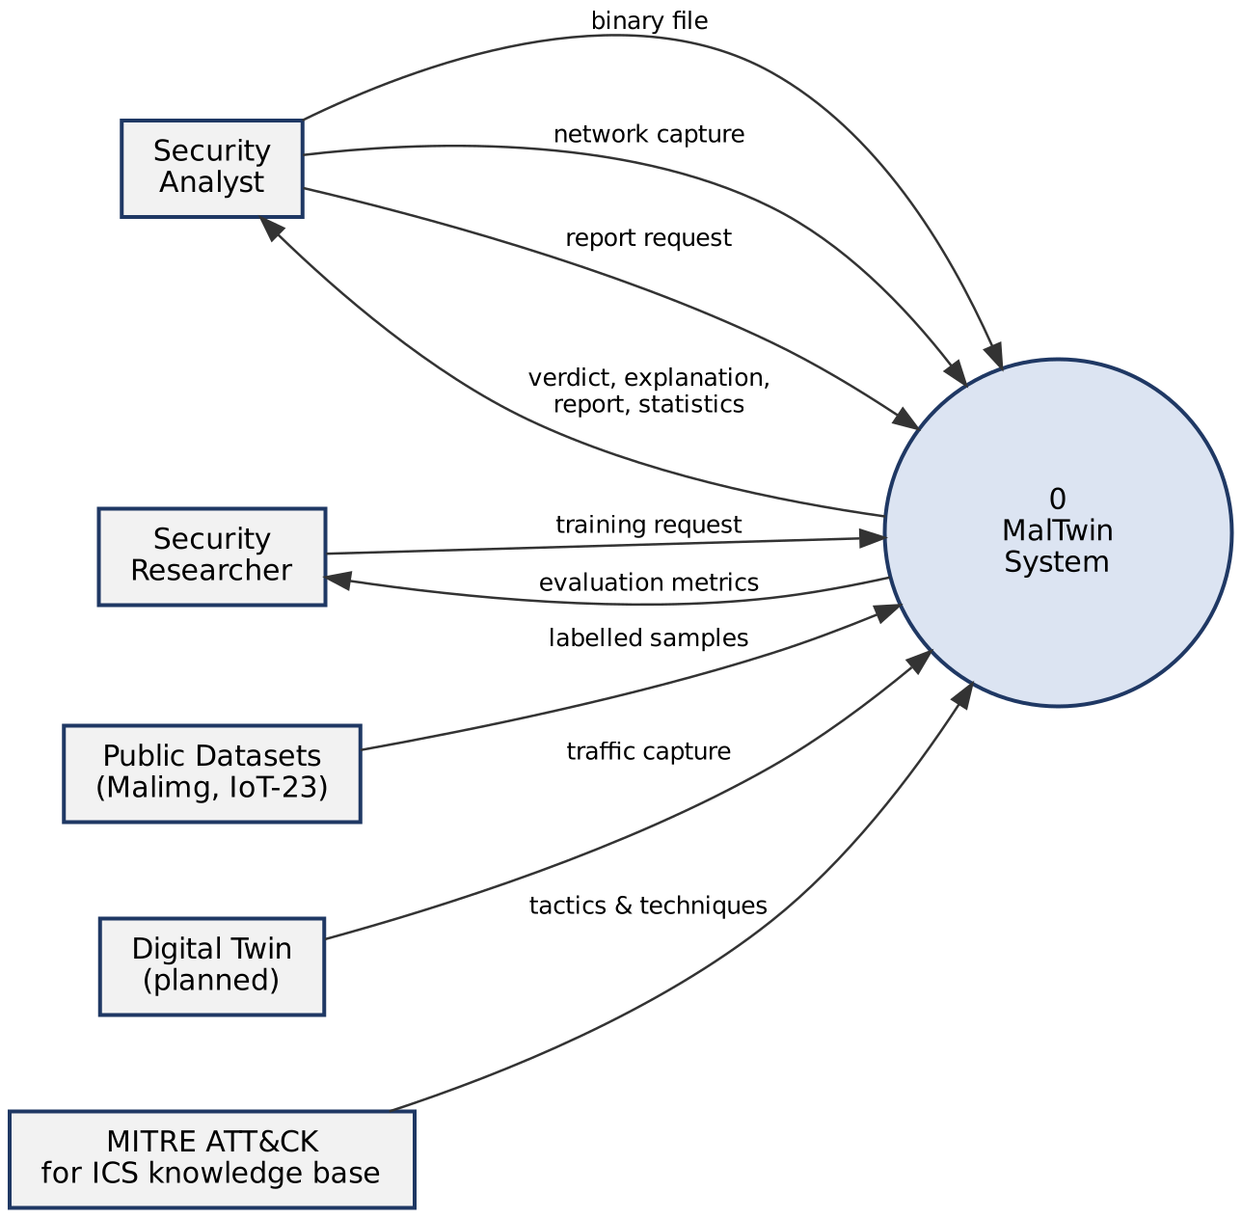
Figure 3.23 Level 0 data flow diagram (context diagram)
Level 1: Main processes
Level 1 breaks the system into six processes and three data stores (Table 3.5).
Table 3.5 Level 1 processes and data stores
ID | Name | What it does
1.0 | Validate & Convert Binary | Checks size and magic bytes, computes SHA-256, builds the 128×128 image
2.0 | Classify Binary | Runs MalTwinCNN, returns family and confidence
3.0 | Analyse Behaviour | Parses conn.log, extracts flow features, scores behaviour
4.0 | Fuse & Explain | Combines both scores, assigns agreement category, merges MITRE techniques
5.0 | Produce Report | Builds PDF/JSON reports and dashboard statistics, records report events
6.0 | Train Models | Offline: trains the CNN and the behaviour model, writes metrics
D1 | Model Files | best_model.pt, dynamic_model.joblib
D2 | Detection Log | SQLite tables detection_events, report_events (Section 3.5)
D3 | Evaluation Metrics | eval_metrics.json, balanced_eval.json, dynamic_metrics.json, plots
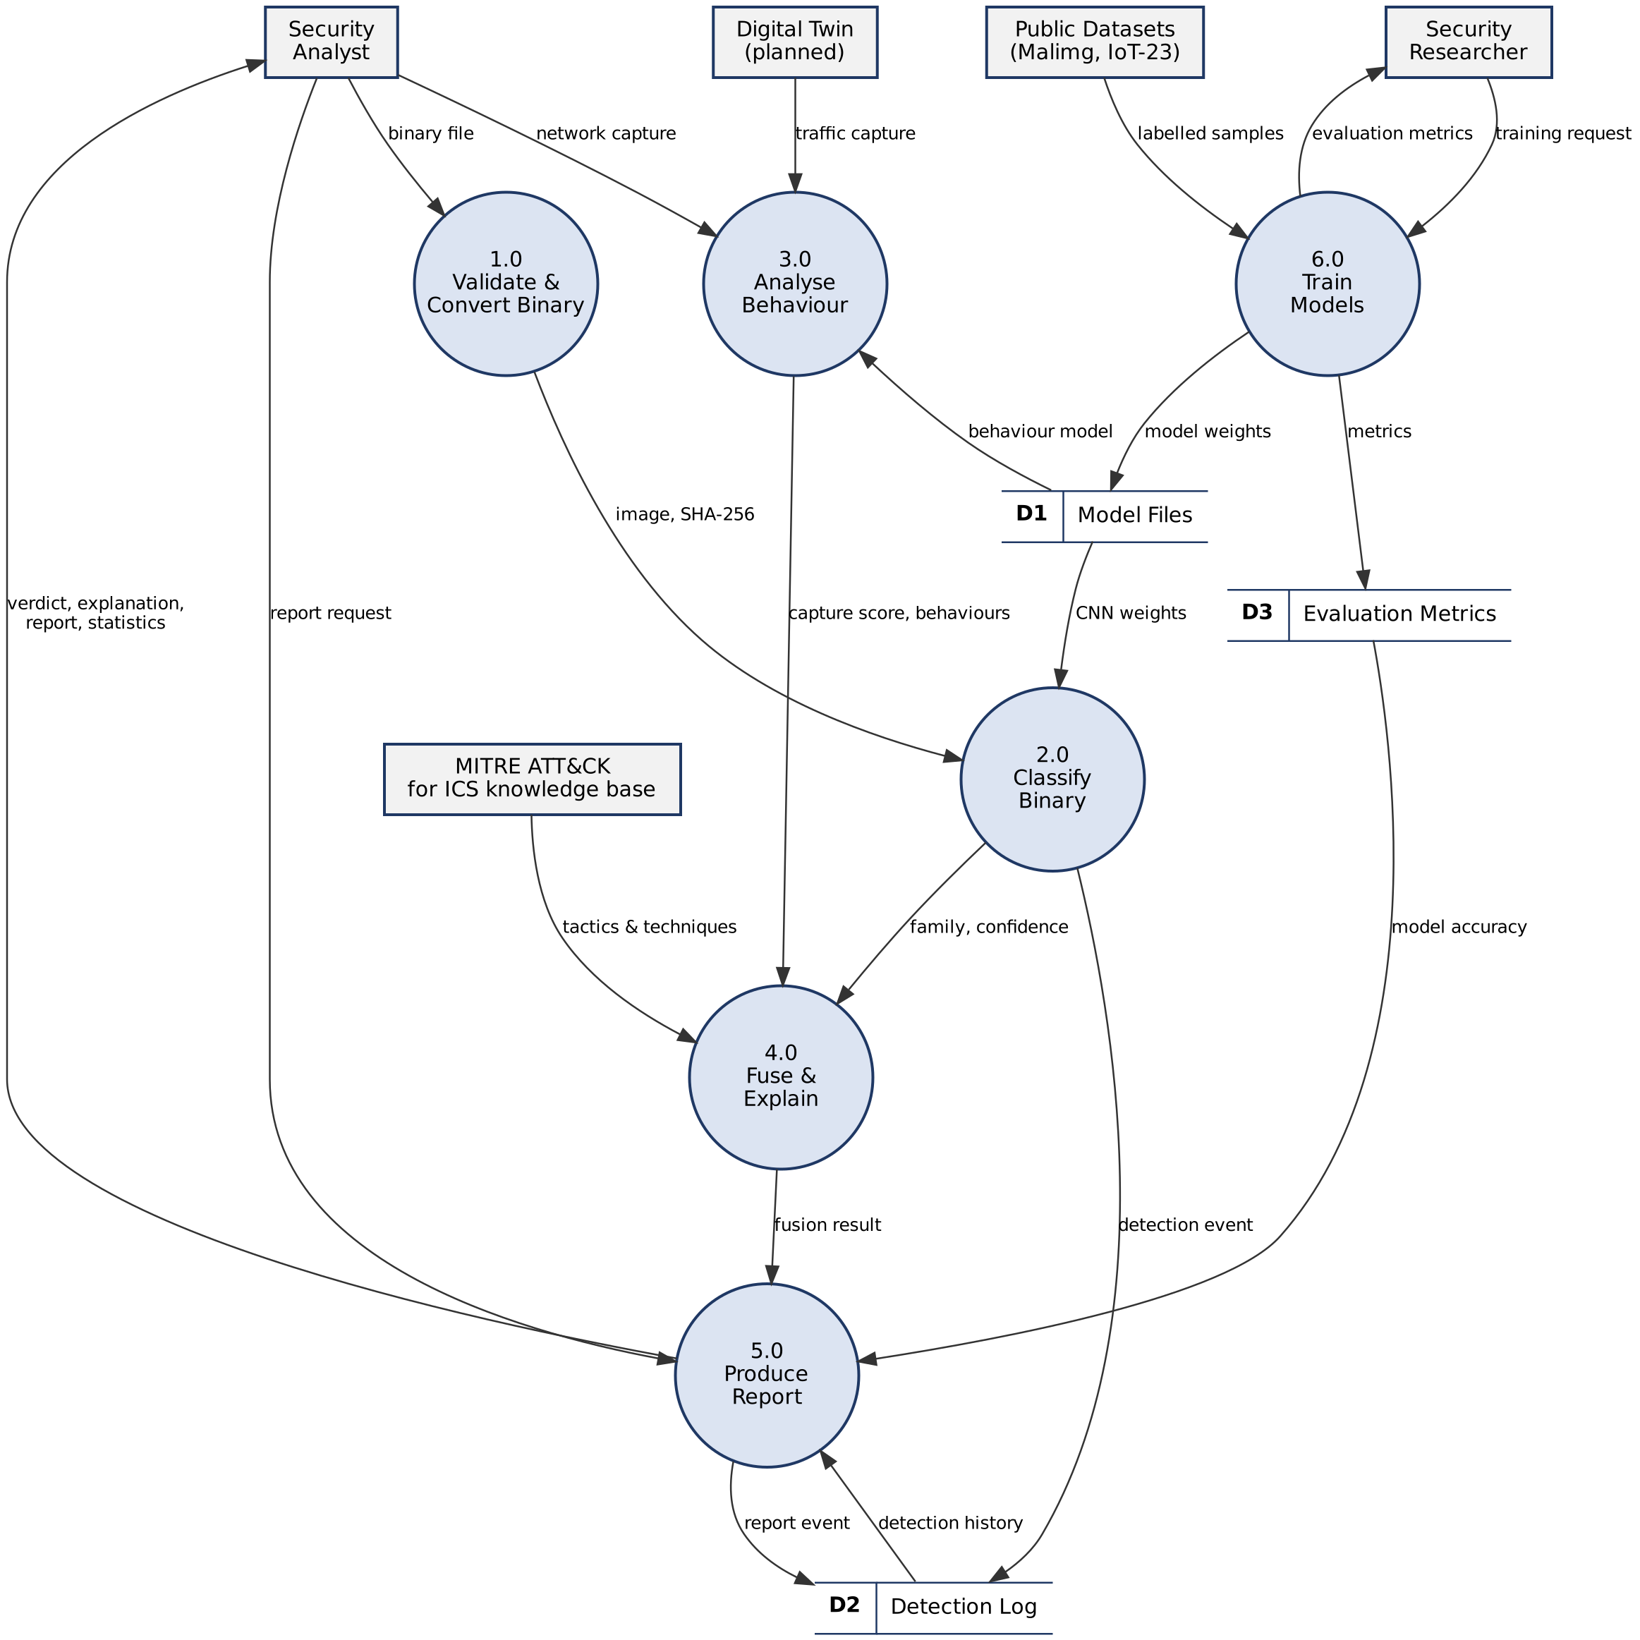
Figure 3.24 Level 1 data flow diagram
Level 2: Process 4.0 — Fuse & Explain
Process 4.0 is the part of MalTwin that is new relative to image-only malware classifiers, so it is expanded here. Sub-process 4.1 computes the weighted score. Sub-process 4.2 independently decides whether each view is "high" (static confidence ≥ 0.80, dynamic score ≥ 0.50) and assigns the agreement category. Sub-process 4.3 turns the score and category into a verdict and applies the novel-variant escalation rule. Sub-process 4.4 merges MITRE techniques from both sources, listing those supported by both first.
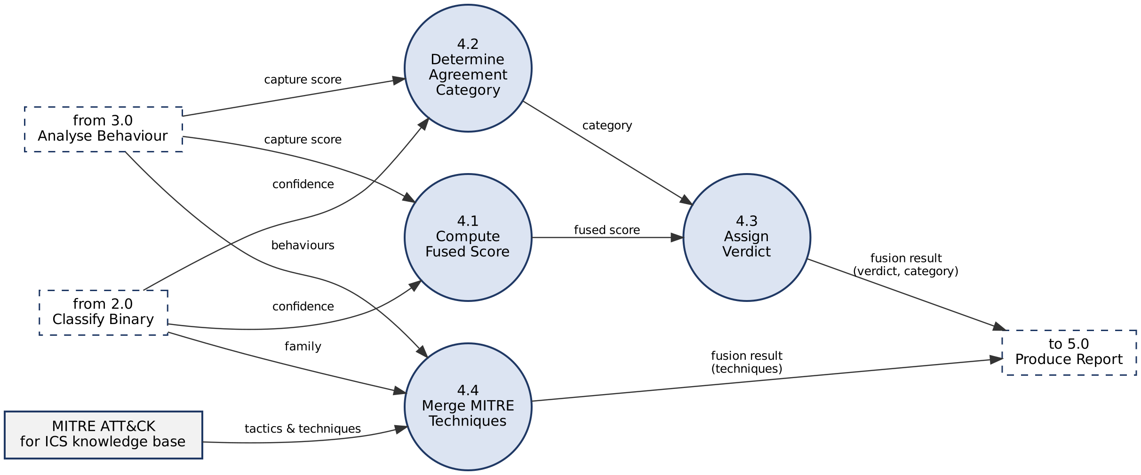
Figure 3.25 Level 2 data flow diagram for Process 4.0

3.4.2.2 State Transition Diagram
Purpose: to show the states a sample passes through during analysis, drawn as a UML state machine. Each transition is labelled event [guard] / action. A sample becomes Rejected if it fails validation. A converted sample returns to Uploaded when a new file is chosen. After Classified, logging happens as the action of the transition, while explanation, fusion and reporting are optional and can be taken in the order the analyst chooses.
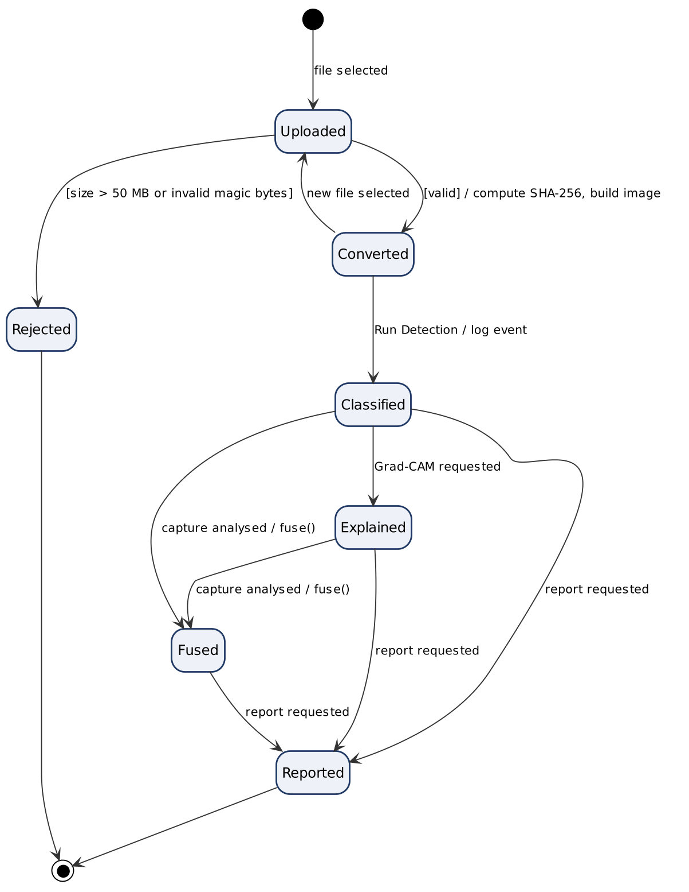
Figure 3.26 UML state machine diagram for a submitted sample

3.4.2.3 Entity Relationship Diagram
Figure 3.27 is the logical data model in crow's-foot notation. Two entities are persisted in SQLite: DETECTION_EVENT, one row per detection run, and REPORT_EVENT, one row per report generated. A detection is documented by zero or more reports, and each report belongs to zero or one detection (zero only if the detection was deleted). Five further entities are reference data held in version-controlled JSON files rather than in the database, because they change only when the models are retrained: MALWARE_FAMILY, BEHAVIOUR, MITRE_TECHNIQUE and MITRE_TACTIC. A family or behaviour maps to many ATT&CK techniques and tactics, and a technique or tactic (for example T0846 Remote System Discovery) can be shared by several families and behaviours. These many-to-many relationships are resolved by the associative entities FAMILY_TECHNIQUE, FAMILY_TACTIC, BEHAVIOUR_TECHNIQUE and BEHAVIOUR_TACTIC. Each detection is predicted as exactly one malware family (or Benign).
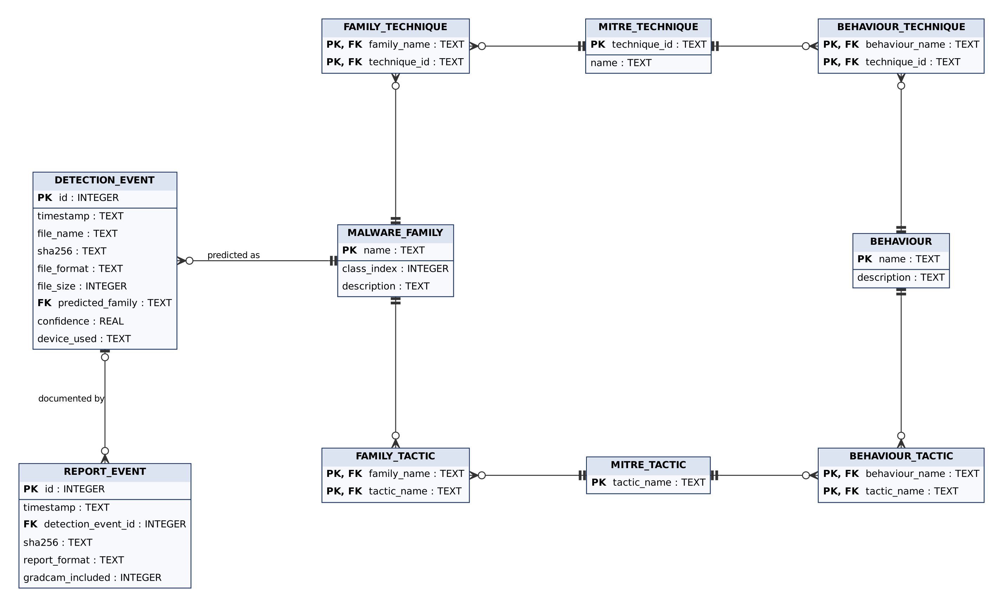
Figure 3.27 Entity relationship diagram (crow's-foot notation)

3.5 Data Design
This section gives the physical design of the stored data: the relational schema of the SQLite database, the structure of the JSON reference and output files, and the files produced by training.

3.5.1 Relational Database Schema
The ERD of Figure 3.27 is implemented in SQLite as two tables. Figure 3.28 is the physical schema, with each column's type and constraints. The foreign key from report_events.detection_event_id to detection_events.id is enforced (PRAGMA foreign_keys = ON is set on every connection), and CHECK constraints reject malformed rows at the database level. Reference entities (families, behaviours, techniques, tactics) are not database tables; they are read from the JSON files described in Section 3.5.2.
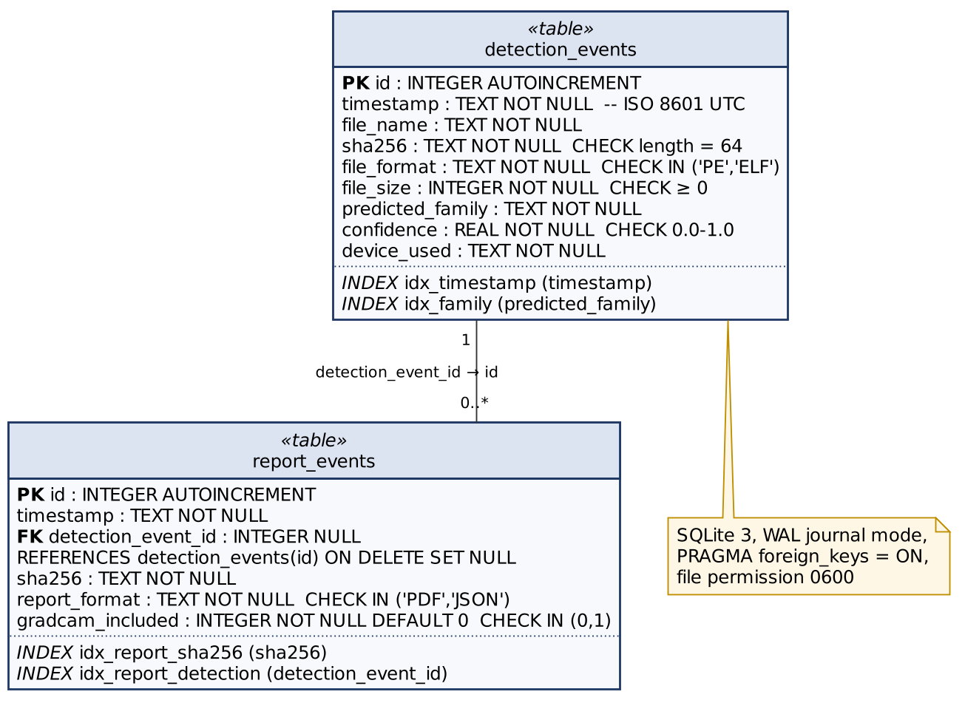
Figure 3.28 Relational schema of the MalTwin database (SQLite)
Table 3.6 Table detection_events
Column | Type | Constraints | What it stores
id | INTEGER | PRIMARY KEY AUTOINCREMENT | Detection identifier
timestamp | TEXT | NOT NULL | UTC time in ISO 8601 format
file_name | TEXT | NOT NULL | Original upload name (display only)
sha256 | TEXT | NOT NULL, CHECK length = 64 | Hex digest; the real identity of the sample
file_format | TEXT | NOT NULL, CHECK IN ('PE','ELF') | Binary format
file_size | INTEGER | NOT NULL, CHECK ≥ 0 | Size in bytes
predicted_family | TEXT | NOT NULL; indexed | Top-1 class (a Malimg family or Benign)
confidence | REAL | NOT NULL, CHECK 0.0–1.0 | Top-1 softmax probability
device_used | TEXT | NOT NULL | "cpu" or "cuda"

Table 3.7 Table report_events
Column | Type | Constraints | What it stores
id | INTEGER | PRIMARY KEY AUTOINCREMENT | Report event identifier
timestamp | TEXT | NOT NULL | When the report was generated
detection_event_id | INTEGER | FOREIGN KEY → detection_events(id) ON DELETE SET NULL; indexed | The detection the report documents
sha256 | TEXT | NOT NULL; indexed | Sample digest
report_format | TEXT | NOT NULL, CHECK IN ('PDF','JSON') | Report type
gradcam_included | INTEGER | NOT NULL DEFAULT 0, CHECK IN (0,1) | 1 if a heatmap was embedded

Indexes on timestamp and predicted_family support the date and family filters of the detection history; with 100,000 rows a filtered aggregate query takes about 0.1 s (Section 5.5). The constraints and the foreign key are verified by automated tests AT-DB-07 and AT-DB-08.

3.5.2 JSON Data Structures
Reference data and machine-readable outputs are stored as JSON. Their structure is given below as a schema: each field, its JSON type and whether it is required.
Table 3.8 Schema of mitre_ics_mapping.json and mitre_ics_behaviour_mapping.json
Path | Type | Required | Description
{ <name> } | object | yes | One entry per malware family (25) or malicious behaviour (6); the key is the class name
<name>.description | string | yes | Short description of the family or behaviour
<name>.tactics | array of string | yes | ATT&CK for ICS tactic names, e.g. "Discovery"
<name>.techniques | array of object | yes | Techniques used by the family or behaviour
<name>.techniques[].id | string | yes | Technique ID, pattern T0xxx (e.g. "T0846")
<name>.techniques[].name | string | yes | Technique name, e.g. "Remote System Discovery"

Table 3.9 Schema of the JSON forensic report
Path | Type | Description
report_metadata | object | generator, report_version, generated_at (ISO 8601), framework
file_information | object | file_name, sha256, file_format, file_size_bytes, upload_time
detection_result | object | predicted_family, confidence (0–1), confidence_pct, top3[] (rank, family, confidence), all_class_probabilities{}
mitre_attack_ics | object | family, mapping_found (bool), description, tactics[], techniques[] (id, name), framework, reference URL
explainability | object | gradcam_generated (bool), target_class, layer, method

Table 3.10 Schema of balanced_eval.json (results on the balanced test set)
Field | Type | Description
per_class_samples, n_classes, n_draws, subset_size | integer | Size of each balanced draw: k samples × number of classes
<metric>_mean, <metric>_std | number | Mean and standard deviation over the draws for accuracy, precision_macro, recall_macro, f1_macro, fpr_macro
balanced_accuracy_full | number | Mean per-class recall on the whole test split
imbalanced_accuracy_full | number | Plain accuracy on the whole test split, for comparison
per_draw | array of object | The metrics of each individual draw

3.5.3 Model and Evaluation Artefacts
Table 3.11 Files produced by training and evaluation
File | Produced by | Content
models/best_model.pt | scripts/train.py | CNN weights with the best validation accuracy
data/processed/eval_metrics.json | scripts/train.py | Test-set accuracy, precision, recall, F1, ROC-AUC, FPR, MCC, balanced accuracy, per-class metrics
data/processed/balanced_eval.json | scripts/train.py, evaluate.py | Results on repeated class-balanced test draws (Table 3.10)
data/processed/*.png | training scripts | Confusion matrices, ROC curves, training curves, importance plots
data/processed/unseen_family_eval.json | scripts/evaluate_unseen.py | Known-vs-unseen family separation metrics
models/dynamic_model.joblib | scripts/train_dynamic.py | Random forest, feature list, benign baseline, metadata
data/processed/dynamic_metrics.json | scripts/train_dynamic.py | Behaviour and malicious-vs-benign metrics
data/processed/performance.json | scripts/benchmark.py | Measured timings for the SRS performance requirements

3.5.4 Data Retention
Table 3.12 Data retention policy
Data | Retention | Reason
Uploaded binaries | Not stored | Held in memory for the session only; avoids keeping live malware on disk
Detection and report events | Until the analyst clears the log | Audit trail; small (one row per run)
Model files and metrics | Versioned per training run | Reproducibility of reported results
Traffic captures | Not stored by the dashboard | Analysed in memory; the analyst keeps the source file

3.5.5 Module Interaction Summary
Table 3.13 How modules exchange data
From | To | Data | How
Upload page | M2 converter | Raw bytes | In-process function call
M2 | M5 CNN | 128×128 uint8 array | Tensor in memory
M5 | M7 Grad-CAM | Model + target class | Captum hook on the last conv layer
M5 | SQLite | Detection event | Parameterised INSERT, one retry on failure; returns the row id
M8 reporting | SQLite | Report event | INSERT with the detection id as foreign key
Dynamic page | M9 detector | Parsed conn.log rows | pandas DataFrame
M5, M9 | M10 fusion | Confidence, capture score, MITRE lists | Session state → fuse()
M10 / M5 | M8 reporting | Result dictionaries | PDF/JSON bytes to download button
Training scripts | Dashboard | Models and metrics | Files in models/ and data/processed/

Chapter 4: Implementation
This chapter documents the implementation of MalTwin at the 60% milestone. It covers the methodology followed for each module, the core algorithms written as pseudocode, the training setup and evaluation method, the security techniques applied, the external libraries used, the user interface and the deployment procedure.
Table 4.1 summarises where each module stands. Eight of the ten modules are implemented and unit-tested. The Digital Twin (M1) is designed and its interface is fixed, but it is not yet built. The fusion module (M10) is complete, but its paired evaluation, scoring the same sample's image and traffic together, depends on the twin. Both are the main work for the final evaluation.
Table 4.1 Implementation status by module
Module | Status | Evidence | Remaining for final evaluation
M1 Digital Twin | Designed | Architecture, node plan, interface contract; dashboard page with live prerequisite checks | Build Docker network (PLC, HMI, sensors, MQTT broker, sandbox, Zeek); start/stop, live log, node status
M2 Binary-to-Image | Complete | 32 unit tests; Malimg-consistent layout | —
M3 Dataset & preprocessing | Complete | 22 unit tests; stratified 70/15/15 split | Optional: add further IIoT sample sources
M4 Enhancement & balancing | Complete | 18 unit tests; 3 oversampling strategies | —
M5 Static detection (CNN) | Complete | 23 + 12 unit tests; Benign class; end-to-end training run verified | Report final metrics; hyperparameter study
M6 Dashboard | Complete | 8 pages; functional tests in Section 5.2 | Twin controls; usability trial (USE-1)
M7 Grad-CAM XAI | Complete | 20 unit tests | —
M8 Reporting & MITRE | Complete | 30 unit tests; 25/25 families mapped | Include dynamic and fused results in PDF
M9 Dynamic analysis | Complete | 31 unit tests; IoT-23 format parser | Train on twin captures; capture-split results
M10 Hybrid fusion | Logic complete | 16 unit tests incl. decision table | Paired evaluation and weight tuning with twin data

4.1 Project Methodology & Algorithms

4.1.1 Project Methodology (Step-by-Step Approach)
Development followed an incremental, test-first approach. Each module was built behind a small interface, covered by unit tests that run on synthetic data (no dataset or GPU required), and only then connected to the dashboard. The steps below follow the order of the data pipeline.

Step 1: Binary-to-Image Conversion (M2)
BinaryConverter reads the uploaded bytes into a NumPy uint8 array without copying, chooses the row width from the file size using the Malimg table, reshapes the bytes into a 2-D array (discarding the incomplete last row), and resizes the result to 128 × 128 with bilinear interpolation. Before conversion, validate_binary_format() checks the magic bytes (MZ for PE, \x7fELF for ELF) and compute_sha256() fingerprints the file. A 256-bin pixel histogram is computed for display (FR3.4).
During this phase we found that the original converter used a square layout (width = √size), whereas the Malimg images used for training were built with Nataraj's width table. The converter now uses the Malimg layout by default. A unit test checks that it reproduces the reference pipeline pixel for pixel. The square layout remains available through MALTWIN_IMAGE_LAYOUT=square.

Step 2: Dataset Loading and Preprocessing (M3)
MalimgDataset scans one folder per family, encodes labels alphabetically, and performs a two-stage stratified split (70% train, 15% validation, 15% test, seed 42), so every family appears in every split in proportion. validate_dataset_integrity() counts samples per family, reports the imbalance ratio and lists unreadable files before training starts. A custom dataset class was used instead of ImageFolder (SRS SI-5) because it supports stratified splits and per-split class counts, which the oversampler needs. An include_families option was added to support the unseen-family experiment (Step 7).

Step 3: Data Enhancement and Balancing (M4)
Malimg is strongly imbalanced: the largest family (Allaple.A, 2,949 images) has about 36 times as many samples as the smallest (Skintrim.N, 80). Two techniques address this:
- Class-aware oversampling (always on): ClassAwareOversampler gives every training sample a weight of 1/count (default), 1/√count or 1, and draws batches with PyTorch's WeightedRandomSampler. Every family, including the Benign class, is therefore drawn with equal probability in each epoch, so the model is trained on a balanced dataset.
- Augmentation (optional, off by default): random rotation up to ±15°, horizontal and vertical flips (p = 0.5), brightness jitter (±20%) and Gaussian noise (σ between 0.01 and 0.05). It was the default in the SRS design, but the ablation in Section 4.2 (Table 4.6) showed that rotations and flips lower accuracy on byte images, because they reorder the bytes of the file. It is now disabled by default and can be enabled with --augment or on the Model Training page.

Step 3b: Benign Class
Early testing showed that clean files were always reported as malware. The cause was the dataset rather than the network. Malimg contains only malware, so a classifier trained on it has no way to answer "clean" and assigns every input to the nearest family. A 26th class, Benign, was therefore added. scripts/build_benign_class.py collects clean PE and ELF binaries from operating-system folders (for example C:\Windows\System32), removes duplicates by SHA-256, and saves each one as a PNG using the same Nataraj width table that produced the Malimg images. Benign and malware images are therefore produced by the same process. A manifest records every file used, so the evaluation can exclude them.
scripts/evaluate_benign.py measures the false positive rate on clean software from a different folder (for example installed applications), skipping any file whose SHA-256 was used in training. It reports how many clean files were called malware and how many of those false alarms were made with confidence above the dashboard's amber and green thresholds. With the Benign class present, the dashboard shows a Benign result in green, counts it in the Benign Files KPI, and fusion uses the probability of malware, 1 − P(Benign), as the static score.

Step 4: Static Detection with MalTwinCNN (M5)
The network has three convolutional blocks (32, 64 and 128 channels). Each block applies two 3×3 convolutions with batch normalisation and ReLU, then 2×2 max-pooling and spatial dropout. Adaptive average pooling reduces the output to 4×4×128, followed by a 512-unit fully connected layer with dropout 0.5 and one output per class (26 with the Benign class). With the Benign class (26 outputs) the model has 1,349,306 trainable parameters (1,348,793 with the 25 Malimg families alone). Training uses Adam with weight decay, cross-entropy loss and a learning-rate schedule that halves the rate when validation accuracy stalls. The checkpoint with the best validation accuracy is kept. Inference applies softmax and returns the top-1 family, its confidence, the top-3 list and all 25 probabilities.
Two defects were fixed during this phase. Training crashed on current PyTorch releases because of a removed scheduler argument (verbose). An unseeded unit test failed intermittently. Both are listed in Table 5.30.

Step 5: Explainable AI with Grad-CAM (M7)
Grad-CAM is computed with Captum's LayerGradCam on the last convolution of block 3 (model.gradcam_layer). The class-specific gradients are averaged over each feature map to weight it, the weighted maps are summed and passed through ReLU, and the result is upsampled to 128×128, normalised to [0, 1] and blended over the grayscale image with a jet colour map. Because rows of the image correspond to consecutive byte ranges, a hot region points the analyst to a specific part of the file, such as the code section or an appended resource.

Step 6: Threat Intelligence and Reporting (M8)
Each of the 25 families is mapped to MITRE ATT&CK for ICS tactics and techniques in mitre_ics_mapping.json (25/25 families covered, verified by verify_mitre.py and unit tests). The PDF report (FPDF2) contains file information, the SHA-256 digest, the detection result with a confidence bar, the top-3 predictions, the MITRE table and, optionally, the Grad-CAM overlay. The JSON report contains the same information in machine-readable form. Every detection is logged to SQLite in WAL mode, so an unclean shutdown cannot corrupt the log (REL-4).

Step 7: Extended Evaluation and Unseen-Variant Experiment
The evaluator was extended beyond accuracy, precision, recall and F1 to cover the metrics listed in the proposal's evaluation plan: one-vs-rest ROC-AUC (macro and weighted), per-class false positive rate, Matthews correlation coefficient, Cohen's kappa and top-3 accuracy, plus ROC-curve and training-curve plots. False positive rate is reported explicitly because a false alarm in an industrial setting can stop a production line.
To measure behaviour on unseen variants, scripts/evaluate_unseen.py runs a leave-families-out experiment. Five families are held out entirely, a fresh model is trained on the remaining twenty, and the model's top-1 confidence is compared on known-family test images and on all images of the held-out families. A closed-set classifier must answer with a known family, so the useful question is whether it does so with low confidence, which the dashboard shows as an amber or red bar. The experiment reports the AUROC for separating known from unseen samples by confidence, the false positive rate at 95% true positive rate, and the share of unseen samples flagged at the 0.50 and 0.80 dashboard thresholds.

Step 8: Dynamic Behavioural Analysis (M9)
The dynamic module reads Zeek connection logs. IoT-23, a labelled dataset of IoT malware and benign traffic from the Stratosphere Laboratory, publishes its data in this format, so the module can be trained now. The parser handles IoT-23's known formatting quirk (the last three columns are separated by spaces rather than tabs) and samples large files with reservoir sampling so that multi-gigabyte captures fit in memory. IoT-23's fine-grained labels are mapped to seven behaviour classes, for example C&C-HeartBeat → C&C and PartOfAHorizontalPortScan → PortScan.
Each connection becomes 61 numeric features: durations, byte and packet counts (raw and log-scaled), direction ratios, indicators for IIoT-relevant destination ports (Modbus 502, MQTT 1883/8883, Telnet 23/2323, IRC 6667), protocol, application service, Zeek connection state, and counts of TCP flags from the connection history. IP addresses are deliberately excluded. A random forest (200 trees, maximum depth 25, balanced class weights) classifies each flow. For a whole capture, the score is the mean malicious probability of the top 5% most suspicious flows, which stays robust to one noisy flow while still reacting when only a minority of traffic is malicious. The explanation lists the features in which the flagged flows deviate most from benign traffic, weighted by their importance to the model.

Step 9: Hybrid Fusion (M10)
Fusion operates on the outputs of the two detectors. It computes a weighted average of the CNN's top-1 confidence and the dynamic capture score (equal weights by default, adjustable on the dashboard). It assigns an agreement category from whether each view is "high". It maps the fused score to a verdict using thresholds of 0.70 (MALICIOUS) and 0.40 (SUSPICIOUS). One safety rule applies: when behaviour is malicious but the binary matches no known family (NOVEL_VARIANT), the verdict is never lower than SUSPICIOUS, because missing a new variant is the costlier error in an IIoT setting. MITRE techniques from both sources are merged and tagged with the evidence that supports them.

Step 10: Dashboard Implementation (M6)
The Streamlit dashboard has eight pages (Table 4.8). Pages share state through a central module (state.py) that defines every session key, so pages never use ad-hoc strings. A health module checks all ten modules and shows their status on the main page and in the sidebar. Four defects in the existing dashboard were found and fixed during functional testing (Section 5.2): a crash after every upload, a navigation click that was discarded after an upload, a duplicate auto-generated page list, and an upload page that wiped the current detection result whenever it was revisited.

4.1.2 Algorithms
Table 4.2 documents the main algorithms in pseudocode.
Table 4.2 Algorithms implemented in MalTwin
Algorithm | Details
Binary-to-image (M2)  Data preparation | Input: bytes B (≥ 64)  Output: 128×128 uint8 image  1. A ← uint8 view of B; n ← |A|  2. w ← MalimgWidth(n) // 32 … 1024 by size  3. w ← min(w, ⌊n/2⌋); r ← ⌊n/w⌋  4. M ← reshape(A[0 : r·w], r × w)  5. return resize(M, 128 × 128, bilinear)
Oversampling weights (M4)  Class balancing | Input: training labels y, strategy s  Output: sampler  1. for each class c: n_c ← count(y = c)  2. w_c ← 1/n_c (minority) | 1/√n_c (sqrt) | 1 (uniform)  3. weight of sample i ← w_{y_i}  4. return WeightedRandomSampler(weights, |y|, replacement)
CNN training (M5)  Supervised learning | Input: loaders, epochs E  Output: best model  1. for e in 1..E:  2. for batch (x, t): loss ← CE(f(x), t); Adam step  3. (v_loss, v_acc) ← validate()  4. scheduler.step(v_acc) // halve LR on plateau  5. if v_acc > best: save weights; best ← v_acc
Grad-CAM (M7)  Explainability | Input: image x, class c  Output: heatmap H  1. A ← activations of last conv layer  2. α_k ← mean over pixels of ∂y_c / ∂A_k  3. H ← ReLU(Σ_k α_k · A_k)  4. H ← upsample to 128×128; normalise to [0, 1]
Unseen-family test  Evaluation | Input: families F, holdout k  Output: separation metrics  1. U ← k families chosen with fixed seed; K ← F \ U  2. train fresh CNN on K only  3. s_K ← max softmax on K test set; s_U ← max softmax on all of U  4. AUROC(known vs unseen by 1 − s); share of s_U below 0.50 / 0.80
Capture scoring (M9)  Behaviour detection | Input: flows F, trained forest  Output: score, profile, explanation  1. X ← features(F); p_i ← 1 − P(Benign | X_i)  2. k ← max(1, ⌈0.05·|F|⌉)  3. score ← mean of the k largest p_i  4. profile ← counts of predicted behaviour where p_i ≥ 0.5  5. explanation ← top features by |z-score vs benign| × importance
Fusion (M10)  Business rule | Input: static s, dynamic d, weights w_s, w_d  Output: verdict, category  1. f ← (w_s·s + w_d·d)/(w_s + w_d)  2. category ← CONFIRMED | STATIC_ONLY | NOVEL_VARIANT | NO_EVIDENCE  from (s ≥ 0.80, d ≥ 0.50)  3. verdict ← MALICIOUS if f ≥ 0.70; SUSPICIOUS if f ≥ 0.40; else BENIGN  4. if category = NOVEL_VARIANT and verdict = BENIGN → SUSPICIOUS

4.2 Training Results & Model Evaluation
This section describes the datasets, the training configuration and the evaluation method for both detectors.
The static model was trained on a Google Colab NVIDIA T4 GPU for 30 epochs (about 10 minutes); the same script runs unchanged on a CPU-only laptop in about 2–3 hours. All result files are kept in the repository under results/eval3/ so every figure below can be checked.
Datasets used
- Malimg (Nataraj et al., 2011): 9,339 grayscale images of Windows malware from 25 families, with a 36:1 imbalance between the largest and smallest family. Split 70/15/15, stratified by family.
- Benign class: up to 1,500 clean PE binaries from the Windows system folders, converted with the Malimg layout and split with the same 70/15/15 ratio. A separate set of clean applications from a different folder is used only for the false-positive test.
- IoT-23 (Garcia et al., Stratosphere Laboratory, 2020): labelled Zeek connection logs from 20 malware captures and 3 benign IoT device captures, covering Mirai, Okiru, Torii, Hide-and-Seek and other IoT botnets. Up to 200,000 flows are sampled per capture. Results are reported for a stratified random split and, as a harder test, a split that holds out entire captures.
Training setup
Table 4.3 Training configuration
Parameter | Static CNN (M5) | Dynamic model (M9)
Framework | PyTorch 2.x | scikit-learn RandomForestClassifier
Input | 1 × 128 × 128 grayscale image | 61 flow features
Output | 25 families + Benign (softmax) | 7 behaviour classes
Optimiser / learner | Adam, lr 0.001, weight decay 1e-4 | 200 trees, max depth 25, min 2 samples per leaf
Schedule | ReduceLROnPlateau (factor 0.5, patience 5, min 1e-6) | —
Epochs / batch | 30 epochs, batch size 32 | —
Imbalance handling | Weighted random oversampling (1/count); no augmentation (Table 4.6) | class_weight = balanced_subsample
Regularisation | Batch norm, spatial dropout, dropout 0.5 | Depth limit, min samples per leaf
Split | 70 / 15 / 15 stratified, seed 42 | 80 / 20 stratified, or held-out captures
Model selection | Best validation accuracy | Fixed hyperparameters

Performance metrics
Table 4.4 Static CNN — Malimg + Benign test set (1,626 images, 26 classes)
Metric | Value
Accuracy | 98.65%
Precision / Recall / F1 (macro) | 96.64% / 97.63% / 97.06%
F1 (weighted) | 98.67%
ROC-AUC (macro / weighted, one-vs-rest) | 0.9997 / 0.9999
False positive rate (macro) | 0.05%
MCC / Cohen's kappa | 0.9845 / 0.9845
Top-3 accuracy | 100%
Weakest families by F1 | Swizzor.gen!E 0.76, Swizzor.gen!I 0.77, C2LOP.gen!g 0.93
Benign class: precision / recall | 1.00 / 0.964 (no malware classified as Benign; 8 of 225 clean files flagged)
Clean applications called malware (500 unseen files from Program Files) | 10.2% (6.4% with confidence ≥ 0.80); 28 of 51 errors labelled VB.AT

The last row is the most realistic test: 500 clean applications from C:\Program Files, none used in training. Before the Benign class existed every one of them would have been reported as malware; now 89.8% are correctly called Benign. Most of the remaining errors are applications compiled with Visual Basic, which the model labels VB.AT (a Visual Basic worm) because they share the Visual Basic runtime layout. The Benign class was built from Windows system binaries only, which contain no Visual Basic programs. Adding a wider range of clean software (Visual Basic, .NET and industrial engineering tools) to the Benign class is the first item of future work (Section 6.2.3).

Results on the balanced dataset
Malimg is 36:1 imbalanced, so plain accuracy on its natural test split is dominated by a few large families (Allaple.A alone is about a third of the data) and can look high even when small families are misclassified. The model is therefore trained on a balanced dataset — class-aware oversampling draws every family with equal probability in each epoch — and its results are also reported on a class-balanced test set. The balanced test set takes the same number of images from every class (k = the size of the smallest class in the test split), drawn without replacement from the held-out test images, and is drawn ten times with different seeds; Table 4.5 reports the mean and standard deviation. Balanced accuracy (the mean of the per-class recalls) on the whole test split is given alongside. These figures are produced automatically by scripts/train.py and scripts/evaluate.py into balanced_eval.json (Section 3.5.2).
Table 4.5 Static CNN — balanced test set (equal images per class, 10 draws)
Metric | Mean ± standard deviation
Images per class × classes | 12 × 26 = 312 images per draw
Accuracy | 97.63% ± 0.51
Precision (macro) | 97.83% ± 0.44
Recall (macro) | 97.63% ± 0.51
F1 (macro) | 97.63% ± 0.52
False positive rate (macro) | 0.09% ± 0.02
Balanced accuracy, whole test split | 97.63%
Plain accuracy, whole test split (for comparison) | 98.65%

On the balanced test set accuracy is one point lower than on the natural split (97.6% against 98.7%), because each small family now counts as much as Allaple.A. The small gap shows that the model is not relying on the large families: oversampling during training has done its job. The lowest scores come from the two Swizzor variants, which are confused with each other (8 of 39 test images) — the near-identical-variant problem that MalTwin targets.
Ablation: effect of augmentation
The SRS design trained with geometric augmentation (rotation and flips). Because the training was unstable — validation accuracy swung between 54% and 94% from one epoch to the next — the model was retrained without augmentation, everything else unchanged. Table 4.6 compares the two runs.
Table 4.6 Ablation — training with and without augmentation (same data, seed and schedule)
Metric | With augmentation | Without augmentation
Test accuracy | 94.16% | 98.65%
Balanced test set accuracy | 91.06% ± 0.44 | 97.63% ± 0.51
F1 (macro) | 88.14% | 97.06%
MCC | 0.934 | 0.985
Best validation accuracy (epoch) | 94.2% (29) | 98.8% (29)
Validation accuracy across epochs 10–30 | unstable (60–94%) | stable (89–99%)

Augmentation hurts because a Malimg image is not a photograph: each row is a consecutive run of bytes. A horizontal flip reverses the byte order inside every row and a rotation moves bytes between rows, producing images that no real binary can generate. Augmentation is therefore off by default; oversampling alone balances the training data.

Table 4.7 Unseen-family experiment (5 families held out of training)
Metric | Value
Held-out families | Adialer.C, Allaple.L, C2LOP.gen!g, Skintrim.N, VB.AT (2,401 images)
Known-family test accuracy (21 classes) | 96.21%
AUROC, known vs unseen by confidence | 0.797
FPR at 95% TPR | 0.961
Mean confidence: known / unseen | 0.934 / 0.938
Unseen samples flagged below 0.50 / 0.80 | 2.8% / 11.5% (known flagged: 0.5% / 14.3%)

This is an honest negative result. Although confidence ranks unseen samples somewhat lower (AUROC 0.80), the model is on average as confident on families it has never seen as on known ones, so a confidence threshold catches very few new variants. This is the known over-confidence of softmax classifiers on out-of-distribution inputs. It is the reason MalTwin does not rely on the static view alone: a new variant that the CNN confidently assigns to a known family can still be exposed by its network behaviour (Module 9), and the fusion rules report exactly this case as NOVEL_VARIANT (Module 10). Better open-set methods are listed as future work (Section 6.2.5).

Table 4.8 Dynamic model — IoT-23
Metric | Random split | Held-out captures
Behaviour accuracy / macro F1 | PENDING (dynamic_metrics.json) | PENDING
Malicious detection rate | PENDING (binary.detection_rate) | PENDING
False positive rate | PENDING (binary.false_positive_rate) | PENDING
ROC-AUC (malicious vs benign) | PENDING (binary.roc_auc) | PENDING

Figures
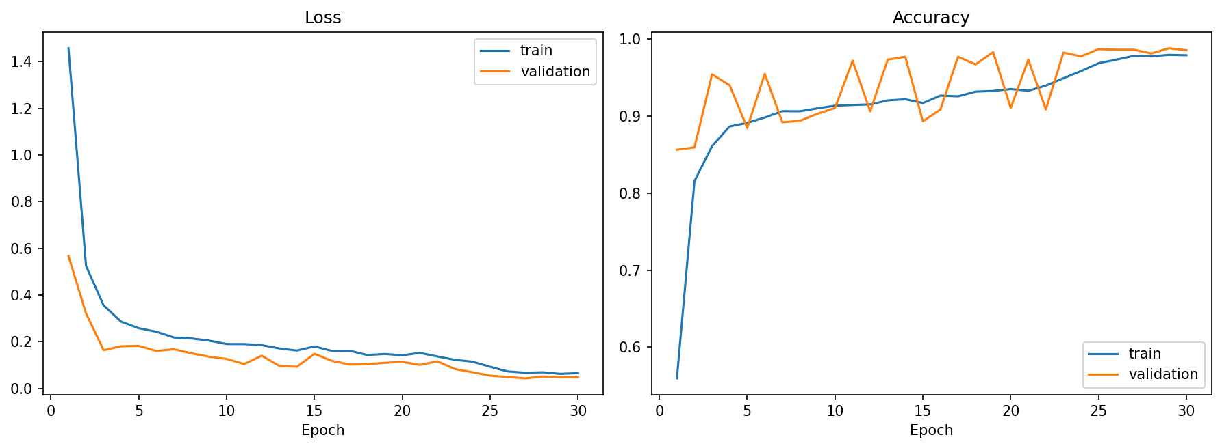
Figure 4.1 Training and validation loss and accuracy (no augmentation, best epoch 29)
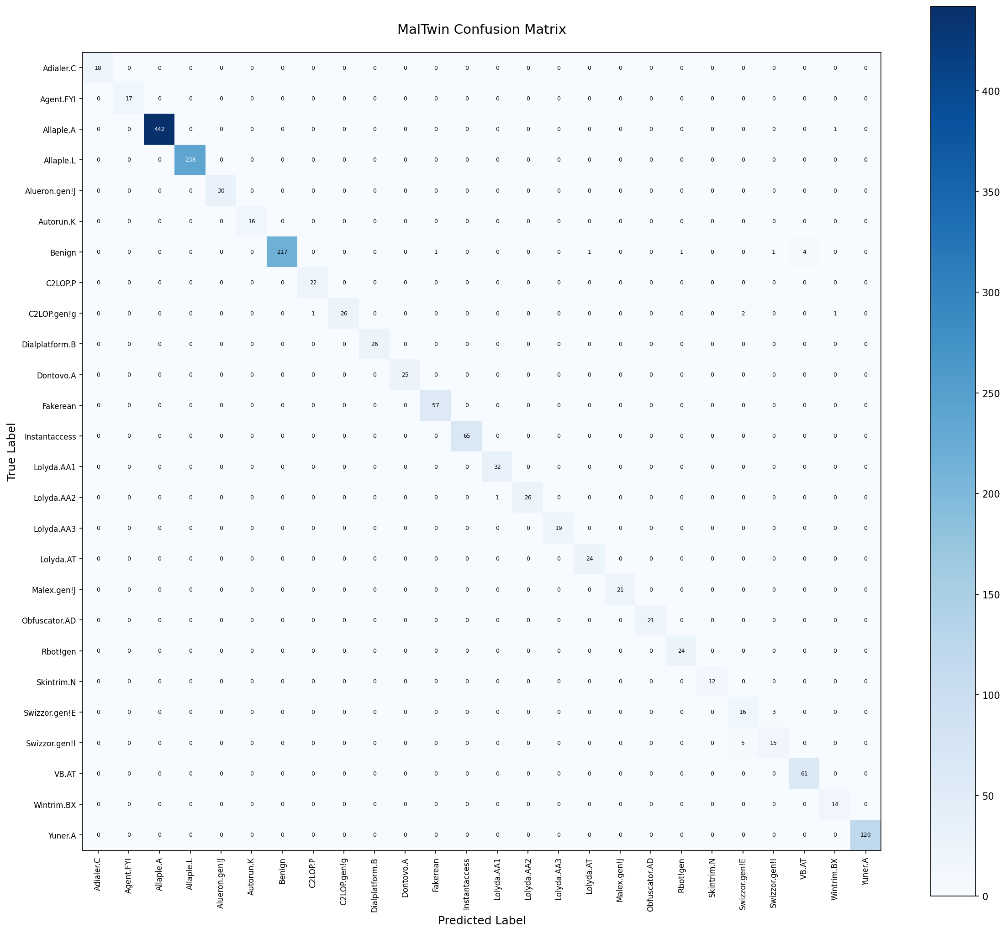
Figure 4.2 Confusion matrix on the test set, 25 families + Benign
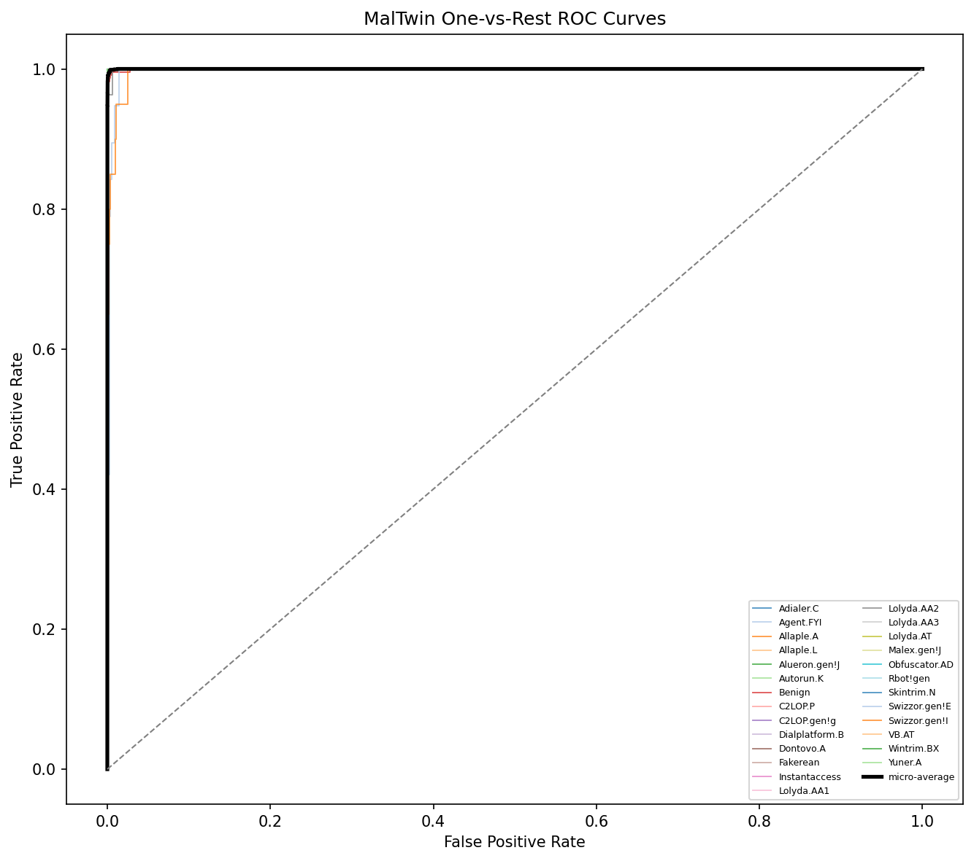
Figure 4.3 One-vs-rest ROC curves for all 26 classes
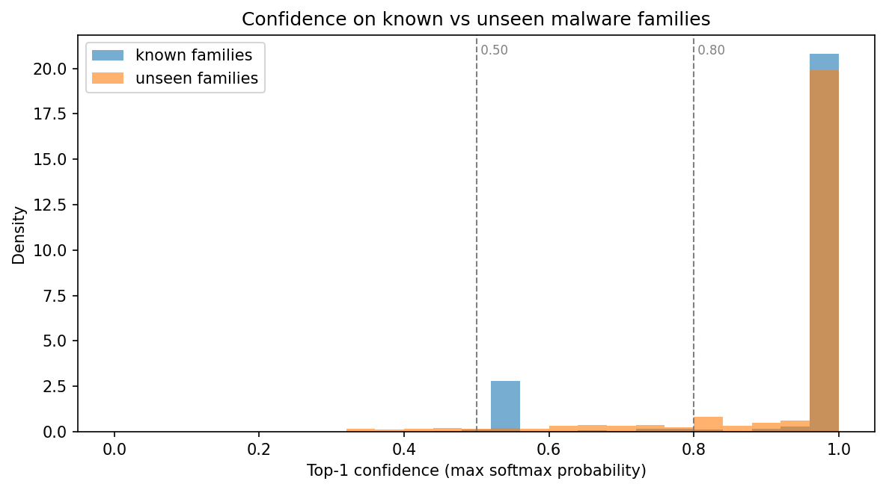
Figure 4.4 Prediction confidence on known families and on the five held-out families
PENDING — Figure 4.5 Dynamic model confusion matrix and feature importance (dynamic_confusion_matrix.png, dynamic_feature_importance.png) — produced by scripts/train_dynamic.py on IoT-23.
Measured performance
The SRS performance requirements were measured with scripts/benchmark.py on a 2-core, CPU-only machine (no GPU). The timings do not depend on trained weights because the computation graph is the same. They will be re-measured on the demonstration laptop.
Table 4.9 Measured performance against SRS targets
Requirement | Target | Measured (mean / max of runs) | Result
PER-1 Conversion, 10 MB | < 3 s | 0.1 ms / 0.2 ms | Pass
PER-1 Conversion, 50 MB | < 10 s | 0.3 ms / 0.4 ms | Pass
PER-2 CNN inference (CPU) | < 5 s | 14 ms / 26 ms | Pass
PER-4 Grad-CAM (CPU) | < 8 s | 0.26 s / 0.49 s | Pass
PER-5 PDF + JSON report | < 10 s | 9 ms / 10 ms | Pass
PER-6 Query over 100,000 rows | < 500 ms | 94 ms / 105 ms | Pass
REL-1 Repeatability over 10 runs | variation < 0.5% | 0.0 | Pass
M9 Analyse a 10,000-flow capture | — | 0.18 s / 0.19 s | —
M10 Fusion decision | — | < 0.1 ms | —
Conversion is fast because the bytes are viewed without copying and only one resize is performed. Grad-CAM is the slowest step because it needs a backward pass, but it is still well within its limit.

4.3 Security Techniques
MalTwin handles live malware, so the implementation applies the following techniques.
Input validation and safe handling of samples
Uploads are capped at 50 MB both in Streamlit's server configuration and in the upload handler, and are accepted only if the magic bytes identify a PE or ELF file. Samples are processed as bytes in memory. They are never executed and never written to disk by the dashboard. Malformed files produce an error that states what failed, why and what to do (USE-3) instead of an exception. Implementation: validate_binary_format(), .streamlit/config.toml.
Local fingerprinting
SHA-256 digests are computed locally with hashlib. No hash or file is submitted to an online service, so analysis does not reveal itself to the malware's authors (SEC-4). Implementation: compute_sha256().
Database protection
The SQLite log is created with file permission 0600 (owner read/write only, SEC-3) and uses write-ahead logging, so an unclean shutdown cannot corrupt committed records (REL-4). All queries use parameter placeholders, never string formatting, which prevents SQL injection through file names. Implementation: db.py (init_db, log_detection_event).
Network exposure
The dashboard binds to 127.0.0.1 by default and shows a warning if it is started on another interface (SEC-5). Streamlit's usage statistics are disabled. Implementation: .streamlit/config.toml, app.py.
Model integrity
Model files are loaded only from the project's own models/ directory. The dynamic model file stores a format version and its feature list, and loading is refused if either differs from the running code. This prevents silently using a model with mismatched inputs. Because the file format relies on Python object serialisation, only files produced by the project's training script should be loaded. Implementation: DynamicDetector.load().
Privacy-preserving features
The behavioural model uses no IP addresses. This avoids learning host identities and keeps captured addresses out of the trained model.
Isolation (planned with the Digital Twin)
Running samples will be confined to an internal Docker network with no route to the host or LAN, no host volume mounts, CPU and memory limits, and teardown after each run (CON-2, SEC-2). Until then, MalTwin performs no execution at all, which is why SEC-1 is marked as partially met in the compliance matrix.

4.4 External APIs/SDKs
The following libraries are used. No external web API is called at run time.
Table 4.10 External libraries and SDKs
Library | Version | Purpose | Used in
Python | 3.11 | Implementation language | All modules
PyTorch / torchvision | 2.6 / 0.21 | CNN, training loop, augmentation transforms | M3, M4, M5
Captum | 0.7 | Grad-CAM attribution | M7 gradcam.py
OpenCV (headless), Pillow | 4.10 / 12.2 | Image resizing, PNG encoding | M2, M3
NumPy, pandas, SciPy | 1.26 / 2.2 / 1.14 | Arrays, flow tables | M2, M9
scikit-learn, imbalanced-learn | 1.5 / 0.12 | Metrics, splits, random forest | M3, M5, M9
joblib | ≥ 1.3 | Model persistence for the dynamic model | M9
Streamlit, Plotly | 1.37 / 5.23 | Dashboard and charts | M6
FPDF2 | 2.7 | PDF forensic reports | M8
Matplotlib | 3.9 | Confusion matrices and curves | Evaluation scripts
psutil | ≥ 5.9 | CPU and RAM statistics | M6 health panel
pytest, pytest-cov | 8.3 / 5.0 | Unit and integration testing | tests/
Zeek (external tool) | — | Produces conn.log from network traffic | M1 (planned), IoT-23 source

4.5 User Interface
The dashboard follows a dark "security operations" theme. Hashes and numeric values use a monospace font, and the confidence and verdict colours carry meaning (green, amber, red). Every page guards against missing prerequisites with an explanatory message rather than an error.
Table 4.11 Dashboard pages and modules covered
Page | Purpose | Modules
Dashboard | KPI cards, 7-day activity, recent detections, history with filters and CSV export, system resources, status of all 10 modules | M6, M8, all (health)
Binary Upload | Upload and validate a PE/ELF file; grayscale image, metadata, SHA-256, pixel histogram | M2
Malware Detection | Family, confidence bar, top-3, 25-class probability chart, Grad-CAM, MITRE table, PDF/JSON export | M5, M7, M8
Dataset Gallery | Sample images per family with MITRE context | M3, M8
Dynamic Analysis | Analyse a Zeek conn.log: verdict, behaviour profile, explanation, MITRE, suspicious flows, JSON export | M9
Hybrid Verdict | Fuse current static and dynamic evidence; what-if simulator with agreement matrix | M10
Model Training | Configure and launch training with live log and progress | M3–M5
Digital Twin | Architecture, planned nodes, interface contract, live prerequisite checks | M1

Screenshots
Screenshots of pages that display model predictions will be taken after the final training run, so they show real results. The pages below do not depend on trained weights.
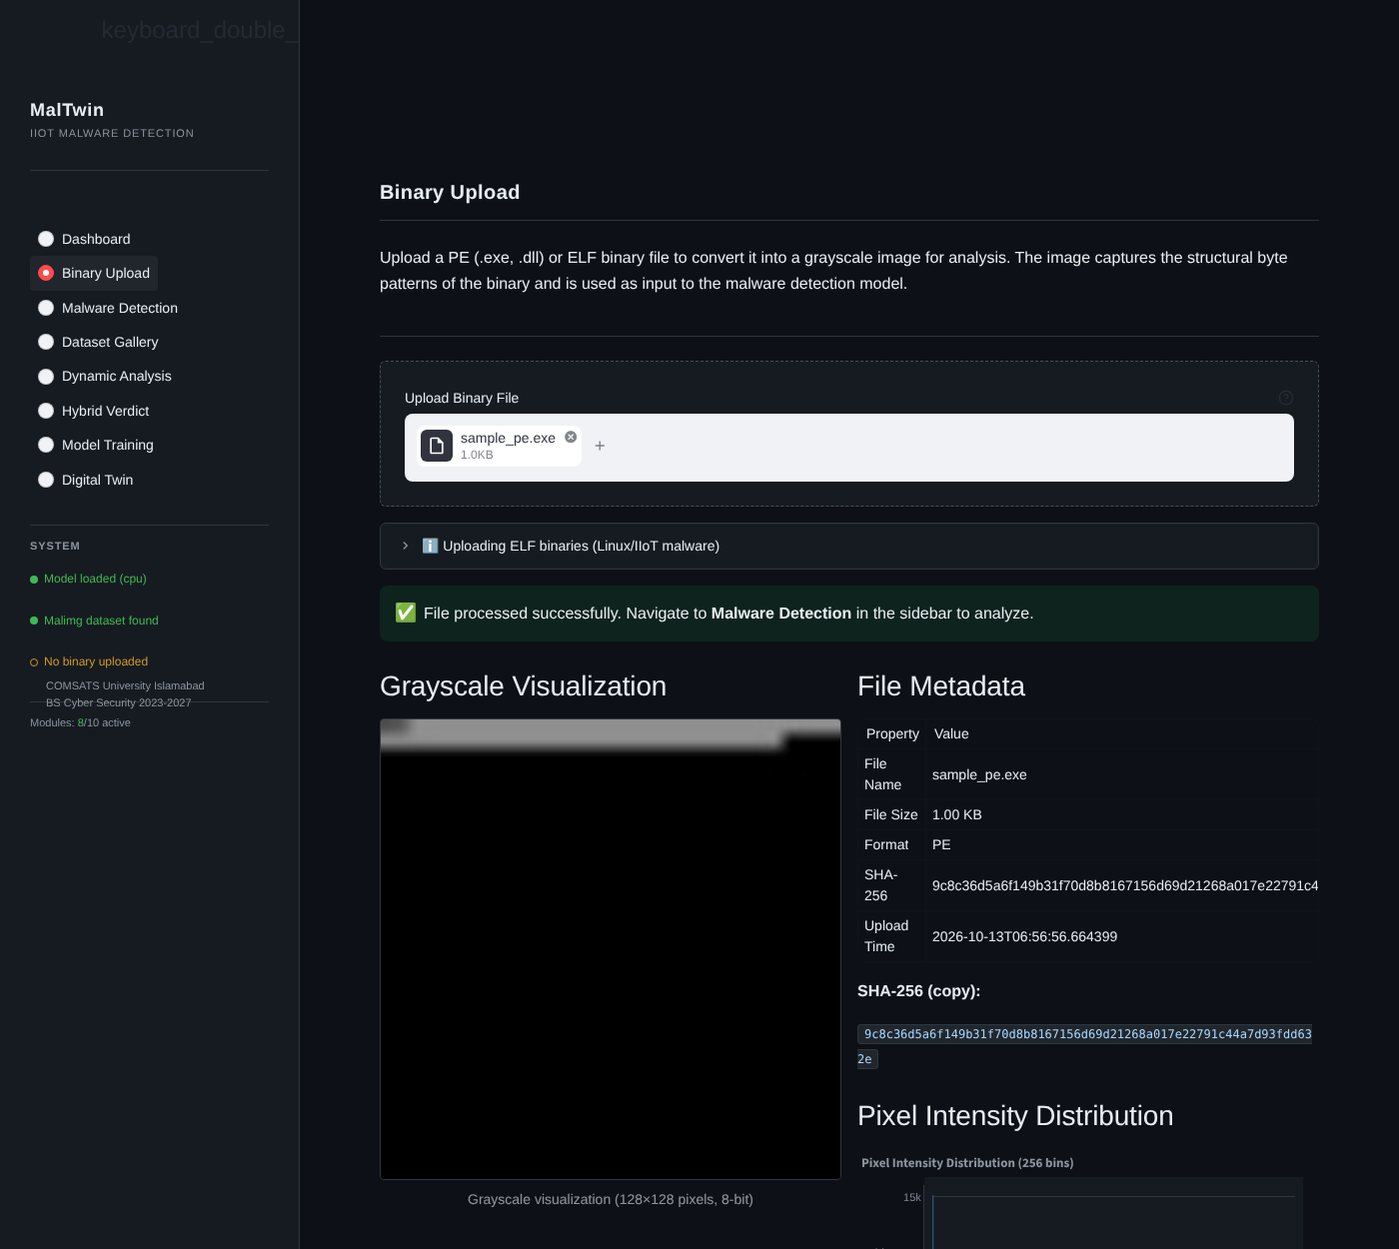
Figure 4.6 Binary Upload page after validating a PE file
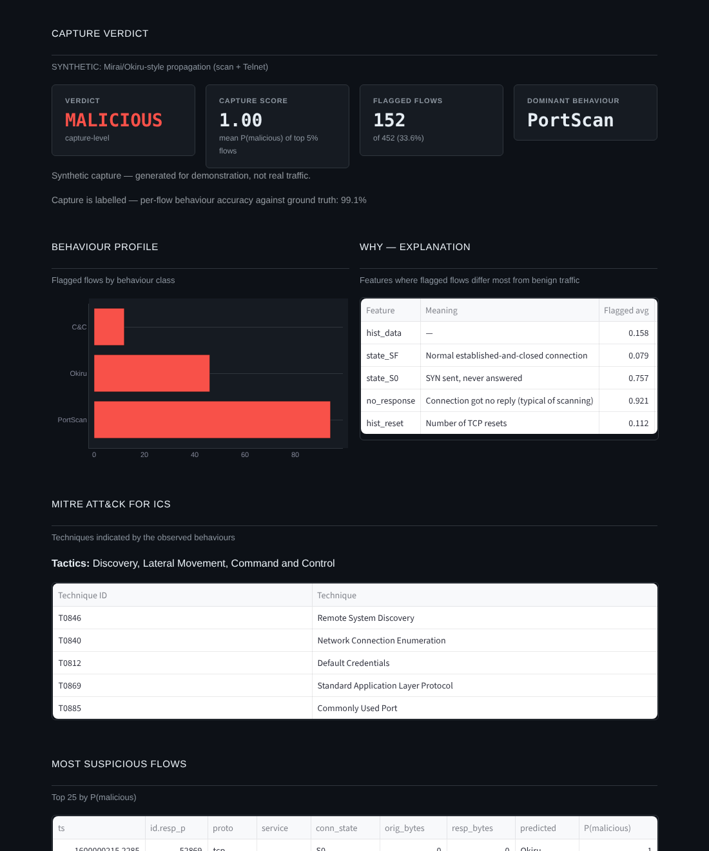
Figure 4.7 Dynamic Analysis page (demonstration model trained on synthetic traffic, clearly labelled as such in the interface)
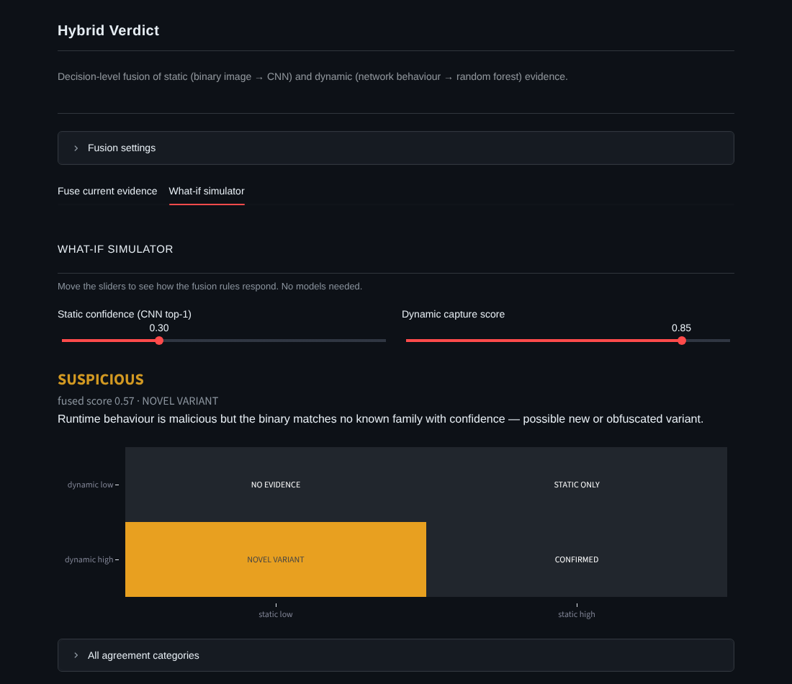
Figure 4.8 Hybrid Verdict what-if simulator showing the NOVEL VARIANT case
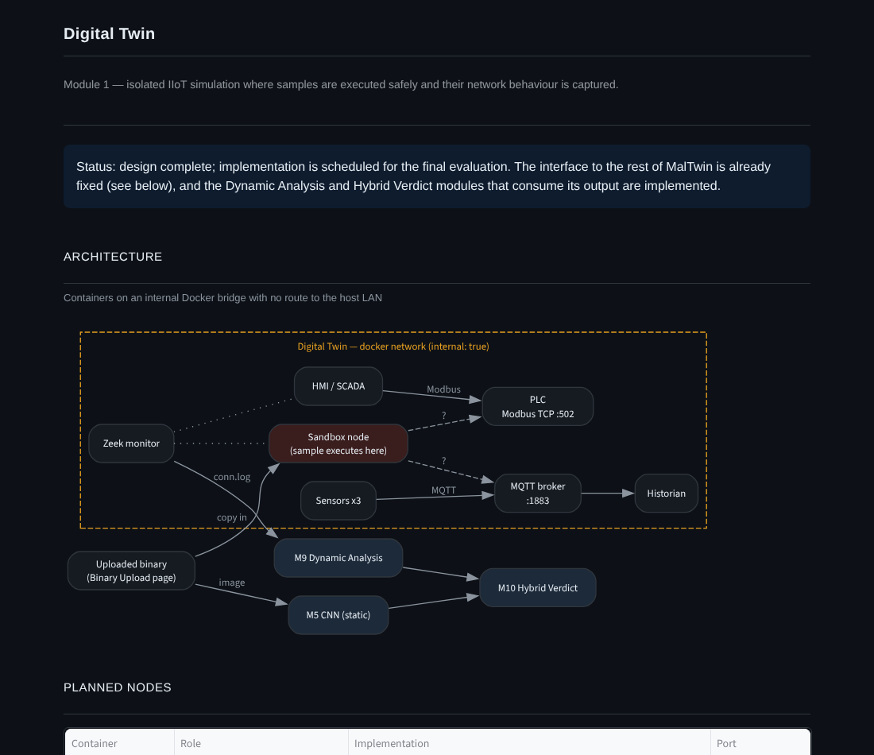
Figure 4.9 Digital Twin page with the planned architecture
PENDING — Figure 4.10 Malware Detection result with Grad-CAM · Figure 4.11 Dashboard KPIs and module status · Figure 4.12 Dynamic Analysis on a real IoT-23 capture · Figure 4.13 Hybrid verdict with both sources (screenshots after training).

4.6 Deployment
MalTwin is deployed as a local Python application. The Digital Twin will add a Docker Compose stack in the final phase.
System requirements
Table 4.12 System requirements
Resource | Minimum | Recommended
Operating system | Ubuntu 22.04 or Windows 10/11 | Ubuntu 22.04 (needed for the full Digital Twin)
Python | 3.11 | 3.11
CPU / RAM | 4 cores, 8 GB | 8 cores, 16 GB or more
GPU | None (CPU works) | NVIDIA, 6 GB VRAM, CUDA 12
Disk | 20 GB free | 100 GB free (with IoT-23)
Container runtime | — | Docker Engine with Compose (for M1)

Main environment variables
Table 4.13 Configuration through environment variables
Variable | Default | Purpose
MALTWIN_DATA_DIR | ./data/malimg | Malimg dataset root
MALTWIN_DYNAMIC_DATA_DIR | ./data/iot23 | IoT-23 conn.log root
MALTWIN_IMAGE_LAYOUT | malimg | Byte layout before resizing
MALTWIN_EPOCHS / _BATCH_SIZE / _LR | 30 / 32 / 0.001 | CNN training
MALTWIN_OVERSAMPLE_STRATEGY | oversample_minority | Balancing strategy
MALTWIN_CONFIDENCE_GREEN / _AMBER | 0.80 / 0.50 | Confidence colour thresholds
MALTWIN_FUSION_STATIC_WEIGHT / _DYNAMIC_WEIGHT | 0.5 / 0.5 | Fusion weights
MALTWIN_FUSION_MALICIOUS / _SUSPICIOUS | 0.70 / 0.40 | Fusion verdict thresholds
MALTWIN_DEVICE | auto | cpu, cuda or auto

Deployment steps
- Install Python 3.11 (Ubuntu 22.04 recommended; Windows 10/11 also works).
- Clone the repository and create a virtual environment: python3.11 -m venv venv then activate it.
- Install dependencies: pip install -r requirements.txt (for a CUDA GPU, install the CUDA build of PyTorch first).
- Copy .env.example to .env; defaults work out of the box.
- Place the Malimg dataset under data/malimg/ (25 family folders) and IoT-23 labelled conn.log files under data/iot23/.
- Train: python scripts/train.py, then python scripts/train_dynamic.py.
- Verify: pytest tests/ -m "not integration" (all tests should pass) and python scripts/benchmark.py.
- Launch: streamlit run modules/dashboard/app.py, then open http://localhost:8501.

Chapter 5: Testing and Evaluation
Testing confirms that MalTwin behaves as specified and exposes defects before evaluation. Five kinds of testing were carried out: unit testing of individual functions and classes, automated UI testing of every dashboard screen, functional testing of the dashboard through a real browser, business-rule testing with decision tables, and integration testing of modules working together. Performance was measured separately (Table 4.9).
Unit tests run with pytest on synthetic data, so they need neither the Malimg dataset nor a GPU and can run on any machine. Eleven further integration tests require the real dataset and a trained model and are marked @pytest.mark.integration. Twelve automated UI tests drive the real dashboard script headlessly with Streamlit's AppTest runner, and the browser-level functional tests were executed with a headless Chromium browser (Playwright) driving the running dashboard. Every automated test that verifies a requirement carries an @pytest.mark.rtm marker with its test ID, from which the Requirement Traceability Matrix in Section 5.7 is generated.
$ pytest tests/ -m "not integration" -q
........................................................................ [ 20%]
........................................................................ [ 40%]
........................................................................ [ 60%]
........................................................................ [ 81%]
................................................................... [100%]
355 passed, 11 deselected in 30.03s

5.1 Unit Testing
Unit testing verifies the smallest testable parts of the software (functions, methods and classes) in isolation. Table 5.15 at the end of this section summarises all 343 unit tests. The tables below show representative cases for each module.

Unit Testing 1: Binary-to-Image Conversion (M2)
Testing objective: to ensure binaries are validated, fingerprinted and converted into 128×128 images exactly as the Malimg training images were built. Test file: tests/test_converter.py.
Table 5.1 Binary-to-Image Conversion (M2) — unit test results
No. | Test case | Input | Expected result | Actual result | Status
1 | PE conversion shape | 1,024-byte PE fixture | 128×128 uint8 array | 128×128 uint8 | Pass
2 | Magic-byte validation | Bytes starting MZ, \x7fELF, ABCD | PE, ELF, rejected | PE, ELF, ValueError | Pass
3 | SHA-256 correctness | Known byte string | Matches hashlib reference digest | Matches | Pass
4 | Malimg width table | Files of 5 KB … 2 MB (8 sizes) | Widths 32, 64, 128, 256, 384, 512, 768, 1024 | All 8 widths correct | Pass
5 | Matches training pipeline | 50 KB random bytes | Pixel-identical to reference Malimg layout + resize | Identical | Pass
6 | Minimum-size file | 64-byte PE | No crash, 128×128 output | 128×128 output | Pass
7 | Pixel histogram | 128×128 image | 256 bins, counts sum to 16,384 | 256 bins, sum 16,384 | Pass

Unit Testing 2: Dataset Loading and Splitting (M3)
Testing objective: to ensure the dataset loader encodes labels consistently and splits data without overlap or loss. Test file: tests/test_dataset.py.
Table 5.2 Dataset Loading and Splitting (M3) — unit test results
No. | Test case | Input | Expected result | Actual result | Status
1 | Label encoding | Family folder names | Contiguous indices 0…N−1, sorted | Contiguous, sorted | Pass
2 | Split sizes | Synthetic dataset | train + val + test = total; train largest | Sums match; train largest | Pass
3 | Item format | dataset[0] | (1×128×128 float tensor, int label) | As expected | Pass
4 | Missing directory | Non-existent path | FileNotFoundError | FileNotFoundError | Pass
5 | Invalid split name | split='foo' | ValueError | ValueError | Pass

Unit Testing 3: Augmentation and Oversampling (M4)
Testing objective: to ensure augmentation keeps tensor shape and type and that the sampler favours minority families. Test file: tests/test_enhancement.py.
Table 5.3 Augmentation and Oversampling (M4) — unit test results
No. | Test case | Input | Expected result | Actual result | Status
1 | Train transform output | PIL grayscale image | 1×128×128 float32 tensor | As expected | Pass
2 | Augmentation varies | Same image twice | Two different tensors | Different | Pass
3 | Validation transform deterministic | Same image twice | Identical tensors | Identical | Pass
4 | Minority weighting | Imbalanced labels | Minority sample weight > majority weight | Greater | Pass
5 | Invalid strategy | strategy='foo' | ValueError | ValueError | Pass

Unit Testing 4: CNN Model and Inference (M5)
Testing objective: to ensure the network has the intended structure, can learn, and that inference returns a well-formed prediction. Test file: tests/test_model.py.
Table 5.4 CNN Model and Inference (M5) — unit test results
No. | Test case | Input | Expected result | Actual result | Status
1 | Forward pass shape | Batch of 2 images | Logits of shape (2, 25) | (2, 25) | Pass
2 | Raw logits | Model output | Rows do not sum to 1 (softmax applied only at inference) | Not normalised | Pass
3 | Can fit one batch | 4 random images, 30 Adam steps (seeded) | Final loss < initial loss | Loss decreased | Pass
4 | Gradients reach all layers | One backward pass | Every parameter has a gradient | All present | Pass
5 | predict_single output | 128×128 image | family in class list, confidence in [0, 1], 3 top-k entries | As expected | Pass
6 | Save and reload | state_dict round-trip | Identical outputs | Identical | Pass

Unit Testing 5: Grad-CAM Explanation (M7)
Testing objective: to ensure Grad-CAM produces a valid, normalised heatmap and overlay for the requested class. Test file: tests/test_gradcam.py.
Table 5.5 Grad-CAM Explanation (M7) — unit test results
No. | Test case | Input | Expected result | Actual result | Status
1 | Heatmap shape and range | Image, target class 0 | 128×128 float32 in [0, 1] | As expected | Pass
2 | Overlay is a valid PNG | Result bytes | Decodable RGB PNG | Decodable | Pass
3 | Class-specific | Target classes 0 and 1 | Different heatmaps | Different | Pass
4 | Bad target class | Class index 999 | Returns None, no crash | None | Pass
5 | Deterministic | Same input twice (eval mode) | Identical heatmaps | Identical | Pass

Unit Testing 6: Reporting and MITRE Mapping (M8)
Testing objective: to ensure every family is mapped to ATT&CK for ICS and that reports contain the required sections. Test file: tests/test_reporting.py.
Table 5.6 Reporting and MITRE Mapping (M8) — unit test results
No. | Test case | Input | Expected result | Actual result | Status
1 | MITRE coverage | mitre_ics_mapping.json | All 25 families with tactics and techniques | 25/25 | Pass
2 | Unknown family | 'NotAFamily' | found = False, empty lists | As expected | Pass
3 | JSON report sections | Detection result | Metadata, file info, detection, top-3, MITRE, explainability | All present | Pass
4 | PDF report | Detection result + heatmap | Bytes starting with %PDF | %PDF… | Pass
5 | Bad input | Empty dictionary | No exception; error JSON / None | Handled | Pass

Unit Testing 7: Detection Log Database (M6/M8)
Testing objective: to ensure detection events are stored correctly and that database failures never crash the dashboard. Test file: tests/test_db.py.
Table 5.7 Detection Log Database (M6/M8) — unit test results
No. | Test case | Input | Expected result | Actual result | Status
1 | WAL mode | init_db() | journal_mode = 'wal' | wal | Pass
2 | Insert and read back | One event | SHA-256, family, confidence stored exactly | Exact | Pass
3 | Idempotent init | init_db() twice | No error, schema unchanged | As expected | Pass
4 | Unicode file name | '恶意软件.exe' | Stored and retrieved | As expected | Pass
5 | Missing database | Query non-existent file | Empty list / zero stats, no exception | As expected | Pass
6 | Report linked to detection | Detection, then report with its id | JOIN returns the detection's family | As expected | Pass
7 | Foreign key enforced | Report for detection id 999 | Row rejected, no exception | Rejected | Pass
8 | CHECK constraints | Confidence 1.5; format "ZIP"; 5-char hash | All three rows rejected | Rejected | Pass
9 | File permission | init_db() | Mode 0600 | 0600 | Pass

Unit Testing 8: Dynamic Behavioural Analysis (M9)
Testing objective: to ensure Zeek logs are parsed correctly, features are well-formed, and the detector classifies and explains behaviour. Test file: tests/test_dynamic.py.
Table 5.8 Dynamic Behavioural Analysis (M9) — unit test results
No. | Test case | Input | Expected result | Actual result | Status
1 | IoT-23 label mapping | 13 label / detailed-label pairs | Correct behaviour class for each | All 13 correct | Pass
2 | IoT-23 format quirk | Row with space-separated last columns | Parsed; behaviour = PortScan; port 23 | As expected | Pass
3 | Feature matrix | Synthetic flows | 61 columns, no NaN, no IP features | As expected | Pass
4 | Port indicators | Ports 502, 1883, 23, 443, 50000 | Modbus, MQTT, Telnet, ephemeral flags set correctly | Correct | Pass
5 | Benign capture | 200 benign flows | Verdict BENIGN, empty profile | BENIGN | Pass
6 | Malicious capture | 200 benign + 40 scan flows | MALICIOUS, PortScan dominant, T0846 mapped, explanation present | As expected | Pass
7 | Save / load | Trained model | Identical probabilities after reload | Identical | Pass

Unit Testing 9: Hybrid Fusion (M10)
Testing objective: to ensure the fusion rules produce the specified verdict and category, validate inputs, and merge MITRE techniques. Test file: tests/test_fusion.py.
Table 5.9 Hybrid Fusion (M10) — unit test results
No. | Test case | Input | Expected result | Actual result | Status
1 | Decision table | 6 cases (Table 5.26) | Category and verdict per rule | All 6 correct | Pass
2 | Single source | Static only (0.9) | STATIC_SOURCE_ONLY, MALICIOUS | As expected | Pass
3 | Out-of-range input | Confidence 1.1 | ValueError | ValueError | Pass
4 | Custom weights | s = 1, d = 0, weights 3 : 1 | Fused score 0.75 | 0.75 | Pass
5 | MITRE merge | Overlapping technique lists | Shared technique first, tagged static + dynamic | As expected | Pass

Unit Testing 10: Extended Evaluation Metrics
Testing objective: to ensure the new evaluation metrics are computed correctly, including edge cases. Test file: tests/test_evaluation_extended.py.
Table 5.10 Extended Evaluation Metrics — unit test results
No. | Test case | Input | Expected result | Actual result | Status
1 | Per-class FPR | Hand-built 3-class confusion matrix | FPR A = 0.25, B = 0.25, C = 0 | As expected | Pass
2 | Perfect predictions | All correct | ROC-AUC = 1, FPR = 0, MCC = 1 | As expected | Pass
3 | Class missing from test set | 3 classes, 1 absent | AUC computed over present classes, no crash | As expected | Pass
4 | Open-set: perfect separation | Known conf. high, unseen low | AUROC = 1, FPR@95 = 0 | As expected | Pass
5 | Open-set: no separation | Identical distributions | AUROC = 0.5 | 0.5 | Pass

Unit Testing 11: Module Health Checks (M6)
Testing objective: to ensure the dashboard can always report the status of every module, even when parts are missing. Test file: tests/test_health.py.
Table 5.11 Module Health Checks (M6) — unit test results
No. | Test case | Input | Expected result | Actual result | Status
1 | All modules listed | get_all_module_statuses() | 10 entries, IDs M1–M10 | 10 entries | Pass
2 | Valid status values | Each entry | 'active', 'inactive' or 'error' | As expected | Pass
3 | Never raises | No model, no dataset | Returns statuses without exception | As expected | Pass

Unit Testing 12: Training Manager (M5/M6)
Testing objective: to ensure training can be started, monitored and stopped from the dashboard as a background process. Test file: tests/test_training_manager.py.
Table 5.12 Training Manager (M5/M6) — unit test results
No. | Test case | Input | Expected result | Actual result | Status
1 | Start job | Small script | Process running, log lines captured | As expected | Pass
2 | Poll | Running job | Returns running flag, new lines, exit code | As expected | Pass
3 | Stop job | Running job | Process terminated | Terminated | Pass

Unit Testing 13: Benign Class (M3/M5)
Testing objective: to ensure clean binaries are converted into Malimg-format training images and that the false-positive evaluation never counts training files. Test file: tests/test_benign.py.
Table 5.13 Benign Class (M3/M5) — unit test results
No. | Test case | Input | Expected result | Actual result | Status
1 | Format detection | PE, ELF, text file, missing file | PE, ELF, None, None | As expected | Pass
2 | Candidate filtering | Folder with binaries, text, tiny file, duplicate | Only PE/ELF within size limits | As expected | Pass
3 | Malimg-format output | 40 KB PE | Full-size 320×128 PNG identical to the Malimg layout | Identical | Pass
4 | Duplicate removal | Two identical files | One image written | One image | Pass
5 | Training files excluded | Manifest hashes passed as exclusions | No images written twice | None written | Pass
6 | No Benign class | Model with malware classes only | False positive rate = 100% | 100% | Pass
7 | Dashboard KPI | 1 malware + 2 Benign events | Malware 1, Benign 2 | As expected | Pass
8 | Fusion static score | P(Benign) = 0.9 | Static score 0.1, no family | As expected | Pass

Unit Testing 14: Balanced Test-Set Evaluation (M5)
Testing objective: to ensure results on the balanced dataset are computed correctly: every class contributes the same number of test images, and the metrics expose a model that only does well on the large families. Test file: tests/test_balanced_eval.py.
Table 5.14 Balanced Test-Set Evaluation (M5) — unit test results
No. | Test case | Input | Expected result | Actual result | Status
1 | Equal class counts | Labels with 50 / 7 / 20 samples | 7 samples of each class, no duplicates, same seed → same draw | As expected | Pass
2 | Invalid sizes | k larger than smallest class; k = 0; empty labels | ValueError | ValueError | Pass
3 | Majority-class bias exposed | 90 correct majority, 10 wrong minority | Plain accuracy 0.90; balanced accuracy 0.50; balanced-draw accuracy 0.50 | As expected | Pass
4 | Perfect model | All predictions correct, 3 classes | All balanced metrics 1.0 with zero spread; FPR 0 | As expected | Pass
5 | Bad input | Shape mismatch; no predictions; 0 draws | ValueError | ValueError | Pass
6 | Balanced accuracy metric | Extended metrics on biased predictions | balanced_accuracy = 0.5 | 0.5 | Pass

Table 5.15 Unit test summary by file
Test file | Module(s) | Tests | Passed
test_converter.py | M2 | 32 | 32
test_dataset.py | M3 | 22 | 22
test_enhancement.py | M4 | 18 | 18
test_model.py | M5 | 23 | 23
test_gradcam.py | M7 | 20 | 20
test_reporting.py | M8 | 30 | 30
test_db.py | M6 / M8 | 33 | 33
test_gallery.py | M6 | 32 | 32
test_health.py | M6 | 31 | 31
test_training_manager.py | M5 / M6 | 23 | 23
test_dynamic.py | M9 | 31 | 31
test_fusion.py | M10 | 16 | 16
test_evaluation_extended.py | M5 (evaluation) | 14 | 14
test_benign.py | M3 / M5 (Benign class) | 12 | 12
test_balanced_eval.py | M5 (balanced evaluation) | 6 | 6
Total |  | 343 | 343
Five histogram tests had been silently skipped because they referred to a function by an old name. They were corrected during this phase and now run and pass.

5.2 Functional Testing
Functional testing checks user-facing features through the interface. The dashboard was started locally and driven by a headless Chromium browser that clicked, uploaded files and captured screenshots. Where a test first failed, the defect was fixed and the test repeated. The "Actual result" column gives the final outcome, and the defects are listed in Table 5.30.

Automated UI Tests
Objective: to verify every dashboard screen automatically, on every run of the test suite. Each test starts the real dashboard script with Streamlit's headless AppTest runner in an isolated temporary environment (its own model, class list and database), clicks buttons and changes pages, and checks what is rendered. Test file: tests/test_ui.py.
Table 5.16 Automated UI tests (Streamlit AppTest)
Test ID | Test case | Expected result | Requirements | Status
AT-UI-01 | Visit every page from the sidebar | All 8 pages render without an exception | FR1.3 | Pass
AT-UI-02 | Open Dashboard | Four KPI cards, accuracy 97.0% from metrics file, module table M1–M10 | FR1.1, FR1.2 | Pass
AT-UI-03 | Open Malware Detection with no upload | Guidance to upload; no Run Detection button | USE-3, FR5.1 | Pass
AT-UI-04 | Upload PE, click Run Detection | Label, probability chart, MITRE section; event logged to SQLite | FR5.1–5.3, FR5.5, FR-B2, FR-B3 | Pass
AT-UI-05 | Click Generate PDF Report | PDF generated; report event linked to the detection id | FR5.6 | Pass
AT-UI-06 | Detect, then open Dashboard | File listed in recent detections | FR1.4, FR1.2 | Pass
AT-UI-07 | Open Dynamic Analysis without a model | "No dynamic model available" with training instructions | FR6.7, USE-3 | Pass
AT-UI-08 | Open Hybrid Verdict (static 0.30, dynamic 0.85) | SUSPICIOUS · NOVEL VARIANT | FR7.3 | Pass
AT-UI-09 | Open Digital Twin | Planned architecture and prerequisite checks | FR2.7 | Pass
AT-UI-10 | Upload a file, inspect sidebar | Model loaded, file name, dataset missing | FR1.7 | Pass
AT-UI-11 | Detect, open Dashboard | Export to CSV button offered for the history | FR1.6, FR1.5 | Pass
AT-UI-12 | Model biased to Benign, run detection | "classified Benign", no MITRE techniques, counted as benign | FR5.8, FR1.2 | Pass

Functional Testing 1: Binary Upload
Objective: to ensure a binary can be uploaded and its image, metadata and histogram are displayed.
Table 5.17 Binary upload — functional test results
No. | Test case | Action | Expected result | Actual result | Status
1 | Upload valid PE | Select tests/fixtures/sample_pe.exe | Success message, image, metadata, SHA-256, histogram | All shown (after fix D1) | Pass
2 | Upload non-binary | Select a non-binary file renamed .exe | Error: what / cause / action | "Error: Unsupported file format. Cause: … magic bytes 41424344. Action: …" | Pass
3 | Sidebar reflects upload | Upload, then view sidebar | File shown as loaded | Shown immediately (after fix D9) | Pass
4 | Navigate after upload | Click "Malware Detection" | Detection page opens | Opens (after fix D2) | Pass

Functional Testing 2: Malware Detection
Objective: to ensure detection runs on the uploaded file and the result, charts, MITRE table and reports are shown.
Table 5.18 Malware detection — functional test results
No. | Test case | Action | Expected result | Actual result | Status
1 | Guard without file | Open page before uploading | Warning asking for an upload | Warning shown | Pass
2 | Run detection | Click "Run Detection" | Family, confidence bar, top-3, probability chart | All shown | Pass
3 | Low-confidence warning | Prediction below 0.50 | Red bar and expert-review message | Shown | Pass
4 | Event logged | Return to Dashboard | Detection appears in Recent Detections and KPIs | Appears; total = 1 | Pass
5 | Result survives revisit | Open Binary Upload, then return | Detection result still shown | Still shown (after fix D9) | Pass

Functional Testing 3: Dynamic Analysis
Objective: to ensure a traffic capture can be analysed and its verdict, explanation and MITRE mapping are displayed.
Table 5.19 Dynamic analysis — functional test results
No. | Test case | Action | Expected result | Actual result | Status
1 | Guard without model | Open page with no dynamic model | Instructions to train | Shown | Pass
2 | Model information | Open page with demo model | Data source, detection rate, FPR, F1; synthetic warning | Shown, labelled SYNTHETIC DEMO | Pass
3 | Analyse demo capture | Choose Mirai/Okiru scenario, click Generate | MALICIOUS verdict, behaviour profile, explanation, MITRE, suspicious flows | All shown; 99.1% flow accuracy against labels | Pass
4 | Benign capture | Choose benign scenario | BENIGN verdict, no techniques | BENIGN | Pass
5 | JSON export | Click download | JSON file with verdict and profile | Downloaded | Pass

Functional Testing 4: Hybrid Verdict
Objective: to ensure static and dynamic evidence can be fused and the what-if simulator follows the fusion rules.
Table 5.20 Hybrid verdict — functional test results
No. | Test case | Action | Expected result | Actual result | Status
1 | Dynamic only | Analyse capture, then Compute | Category DYNAMIC SOURCE ONLY | As expected | Pass
2 | Both sources | Detect binary + analyse capture, then Compute | Fused score, category, pairing note, JSON export | As expected | Pass
3 | What-if: novel variant | Static 0.30, dynamic 0.85 | SUSPICIOUS, NOVEL VARIANT cell highlighted | As expected (Fig. 4.8) | Pass
4 | Zero weights | Set both weights to 0 | Error message; no verdict | Error shown | Pass

Functional Testing 5: Navigation and Digital Twin Page
Objective: to ensure every page is reachable and the Digital Twin page reports its prerequisites.
Table 5.21 Navigation and Digital Twin — functional test results
No. | Test case | Action | Expected result | Actual result | Status
1 | Single navigation list | Load the app | One sidebar menu with 8 pages | One menu (after fix D3) | Pass
2 | All pages render | Visit each page | No exception on any page | No exceptions | Pass
3 | Twin architecture | Open Digital Twin | Diagram, node table, interface contract | Shown | Pass
4 | Prerequisite checks | Open Digital Twin without Docker running | Docker shown as not running; dynamic model status | As expected | Pass

5.3 Business Rules Testing
Decision-table testing was used for the rules that decide outcomes. Each rule column becomes at least one test case.

Business Rule Test 1: Upload Acceptance
Rule: a file is accepted only if it is at most 50 MB and begins with a PE (MZ) or ELF (\x7fELF) signature. The extension is not considered. TC-UP-1, 3 and 4 were executed in the browser; TC-UP-2 through validate_binary_format() because the browser file picker filters by extension.
Table 5.22 Decision table — upload acceptance
Condition / Action | Rule 1 | Rule 2 | Rule 3 | Rule 4
Size ≤ 50 MB? | Yes | Yes | No | No
Valid PE/ELF magic bytes? | Yes | No | Yes | No
Accept and convert | ✓
Reject with format error |  | ✓ |  | ✓
Reject with size error |  |  | ✓

Table 5.23 Test cases — upload acceptance
Test ID | Input | Expected | Actual | Status
TC-UP-1 | 1 KB PE fixture | Accepted | Accepted | Pass
TC-UP-2 | 1 KB ELF fixture without extension | Accepted | Accepted | Pass
TC-UP-3 | Bytes "ABCD…" with .exe extension | Format error | Format error | Pass
TC-UP-4 | 53.5 MB file with MZ header | Size error | "File must be 50.0MB or smaller" | Pass

Business Rule Test 2: Confidence Colour Coding
Rule: the confidence bar is green (HIGH) at ≥ 0.80, amber (MEDIUM) at ≥ 0.50, and red (LOW) below 0.50.
Table 5.24 Test cases — confidence colour boundaries
Test ID | Confidence | Expected | Actual | Status
TC-CONF-1 | 0.95 | HIGH (green) | HIGH | Pass
TC-CONF-2 | 0.80 (boundary) | HIGH (green) | HIGH | Pass
TC-CONF-3 | 0.79 | MEDIUM (amber) | MEDIUM | Pass
TC-CONF-4 | 0.50 (boundary) | MEDIUM (amber) | MEDIUM | Pass
TC-CONF-5 | 0.49 | LOW (red) | LOW | Pass
TC-CONF-6 | 0.00 | LOW (red) | LOW | Pass

Business Rule Test 3: Hybrid Fusion Decision
Rule: fused = (s + d) / 2 with default weights. Verdict is MALICIOUS if fused ≥ 0.70, SUSPICIOUS if fused ≥ 0.40, and otherwise BENIGN. The category follows from s ≥ 0.80 (static high) and d ≥ 0.50 (dynamic high). A NOVEL_VARIANT is never reported as BENIGN.
Table 5.25 Decision table — fusion category and escalation
Condition / Action | Rule 1 | Rule 2 | Rule 3 | Rule 4
Static confidence ≥ 0.80? | Yes | Yes | No | No
Dynamic score ≥ 0.50? | Yes | No | Yes | No
Category | CONFIRMED | STATIC_ONLY | NOVEL_VARIANT | NO_EVIDENCE
Verdict from fused score | ✓ | ✓ | ✓ | ✓
Escalate BENIGN → SUSPICIOUS |  |  | ✓

Table 5.26 Test cases — fusion decision (automated in tests/test_fusion.py)
Test ID | Static | Dynamic | Fused | Expected | Actual | Status
TC-FUS-1 | 0.95 | 0.90 | 0.925 | MALICIOUS · CONFIRMED | MALICIOUS · CONFIRMED | Pass
TC-FUS-2 | 0.92 | 0.10 | 0.51 | SUSPICIOUS · STATIC_ONLY | SUSPICIOUS · STATIC_ONLY | Pass
TC-FUS-3 | 0.30 | 0.95 | 0.625 | SUSPICIOUS · NOVEL_VARIANT | SUSPICIOUS · NOVEL_VARIANT | Pass
TC-FUS-4 | 0.10 | 0.60 | 0.35 | SUSPICIOUS (escalated) · NOVEL_VARIANT | SUSPICIOUS (escalated) | Pass
TC-FUS-5 | 0.20 | 0.05 | 0.125 | BENIGN · NO_EVIDENCE | BENIGN · NO_EVIDENCE | Pass
TC-FUS-6 | 0.85 | 0.55 | 0.70 | MALICIOUS (boundary) · CONFIRMED | MALICIOUS · CONFIRMED | Pass

5.4 Integration Testing
Integration testing verifies that modules developed separately work together through their interfaces.

Integration Testing 1: Training Pipeline (M3 + M4 + M5 + evaluation)
Objective: to ensure the full training script runs end-to-end and writes every artefact the dashboard and this report depend on. A synthetic six-family image set was used so the test is quick and repeatable. The same command is used on Malimg.
Table 5.27 Training pipeline integration results
No. | Test case | Steps | Expected | Actual | Status
1 | Full training run | 1. Validate dataset 2. Build loaders with oversampling 3. Train 8 epochs 4. Evaluate on test split | Completes; all outputs written | Completed; test accuracy 1.00 on separable synthetic data | Pass
2 | Outputs written | Inspect data/processed/ | class_names, eval_metrics, confusion matrix, ROC, training curves, history | All 6 files present | Pass
3 | Unseen-family run | Hold out 2 families, train, compare confidence | JSON + histogram written; main model untouched | As expected | Pass

Integration Testing 2: Static Analysis Path with the Dashboard and Database (M2 + M5 + M6 + SQLite)
Objective: to ensure a sample uploaded in the browser flows through conversion, detection and logging, and appears in the dashboard history.
Table 5.28 Static path integration results
No. | Test case | Steps | Expected | Actual | Status
1 | Upload to detection | 1. Upload PE 2. Open Malware Detection 3. Run Detection | Prediction displayed | Displayed | Pass
2 | Detection to database | 4. Open Dashboard | Total analysed = 1; event in Recent Detections with same file name | As expected | Pass
3 | Module status | 5. Inspect module table | M2, M5 active; M1 inactive (Docker not running) | As expected | Pass

Integration Testing 3: Dynamic Path and Fusion (M9 + M10 + M8 mapping)
Objective: to ensure a dynamic report produced on one page is consumed by the fusion page together with the static result, and that MITRE techniques from both sources are merged.
Table 5.29 Dynamic path and fusion integration results
No. | Test case | Steps | Expected | Actual | Status
1 | Dynamic → fusion | 1. Analyse capture 2. Open Hybrid Verdict | Dynamic evidence card filled from session | Filled | Pass
2 | Static + dynamic | 3. Detect binary 4. Compute verdict | Both sources used; category from both | NO_EVIDENCE for benign capture + low-confidence binary (expected) | Pass
3 | IoT-23 file format | Train dynamic model from two capture folders, one in IoT-23's space-separated format | Both parsed; all 7 classes learned | As expected | Pass

PENDING — Integration tests on the real dataset (pytest tests/ -m integration, 11 tests) run after the Malimg training run; results will be added here.

5.5 Performance Testing
All six measurable SRS performance and reliability targets were met on a 2-core CPU-only machine (Table 4.9). The slowest operation was Grad-CAM at 0.49 s worst case against an 8 s limit. A 100,000-row history query took 0.1 s against a 0.5 s limit.

5.6 Defects Found and Fixed
Testing in this phase found the following defects in previously delivered code. All are fixed and covered by tests or repeated functional checks.
Table 5.30 Defects found during Evaluation 3 testing
ID | Defect | Found by | Impact | Fix
D1 | NameError: mono in upload and detection pages | Functional test FT1 | Upload page crashed after every upload | Module-level import
D2 | Navigation labels changed after upload | Functional test FT1-4 | Click to Malware Detection was discarded | Fixed labels with a stable widget key
D3 | Streamlit auto-generated page list | Functional test FT5-1 | Second menu exposing blank pages | Disabled in .streamlit/config.toml
D4 | Removed verbose argument to LR scheduler | Integration test IT1 | Training crashed on current PyTorch | Argument removed
D5 | Square byte layout at upload | Code review against Malimg method | Uploads differed from training images | Malimg width table
D6 | Unseeded overfit unit test | Repeated unit runs | Intermittent failure | Seed fixed, dropout off for this test
D7 | Histogram tests skipped by name mismatch | Test report review | Feature untested | Tests repointed
D8 | Parameter count documented as 3.2 M | Counting parameters | Incorrect documentation | Corrected to 1.35 M
D9 | Upload re-processed on every rerun; sidebar drawn before upload handled | Functional tests FT1-3, FT1-5 | Detection result lost on revisiting Upload; stale sidebar status | Skip already-processed SHA-256; refresh once after upload
D10 | No benign class in the training data | Testing with clean files | Every clean file was reported as malware | Benign class from clean system binaries; benign false-positive test
D11 | Report events never linked to their detection (detection_event_id always NULL) | Database schema review | Reports could not be traced to detections; ERD relationship not realised | Detection id returned and stored; foreign key enforced
D12 | JSON report event logged on every page refresh | Code review of report flow | Report counts inflated | Logged only when the report is downloaded
D13 | ROC-AUC failed for two-class evaluations | New balanced-evaluation unit test | Evaluation crashed on binary subsets | Two-column one-vs-rest encoding

5.7 Requirement Traceability Matrix
The Requirement Traceability Matrix links every requirement of Chapter 2 to the automated test cases that verify it. It is not written by hand: scripts/generate_rtm.py runs the test suite and reads the @pytest.mark.rtm(test_id, requirement…) marker on each test, so a test that is renamed, removed or failing changes the matrix automatically. The full matrix, with the test function behind each test ID, is in docs/RTM.md; the requirement IDs come from the same catalogue as Chapter 2 (docs/requirements.json).
$ python scripts/generate_rtm.py
pytest tests -m "not integration" -q
355 passed, 11 deselected in 30.03s

- Automated test cases in RTM: 78 (84 executions incl. parameters)
- Passed: 78, failed: 0, skipped: 0
- Requirements verified by test that are covered by at least one automated test: 57 / 57
- Deferred requirements (Digital Twin): FR2.1–FR2.6, FR7.4, FR-B5, REL-3, SEC-2
Wrote docs/RTM.md and docs/rtm.csv

Table 5.31 Requirement Traceability Matrix (generated from the test run)
Requirement | Status | Verified by | Automated test cases | Result
FR1.1 | Implemented | Test | AT-M6-01, AT-M6-02, AT-UI-02 | PASS
FR1.2 | Implemented | Test | AT-DB-04, AT-M5-11, AT-UI-02, AT-UI-06, AT-UI-12 | PASS
FR1.3 | Implemented | Test | AT-UI-01 | PASS
FR1.4 | Implemented | Test | AT-DB-03, AT-UI-06 | PASS
FR1.5 | Implemented | Test | AT-M6-03, AT-M6-04, AT-UI-11 | PASS
FR1.6 | Implemented | Test | AT-UI-11 | PASS
FR1.7 | Implemented | Test | AT-UI-10 | PASS
FR2.1 | Deferred | Deferred | — | —
FR2.2 | Deferred | Deferred | — | —
FR2.3 | Deferred | Deferred | — | —
FR2.4 | Deferred | Deferred | — | —
FR2.5 | Deferred | Deferred | — | —
FR2.6 | Deferred | Deferred | — | —
FR2.7 | Implemented (design only) | Test | AT-UI-09 | PASS
FR3.1 | Implemented | Test | AT-M2-03, AT-M2-04 | PASS
FR3.2 | Implemented | Test | AT-M2-01, AT-M2-02 | PASS
FR3.3 | Implemented | Test | AT-M2-06 | PASS
FR3.4 | Implemented | Test | AT-M2-07 | PASS
FR3.5 | Implemented | Test | AT-M2-04, AT-M2-05 | PASS
FR3.6 | Implemented | Test | AT-M2-08 | PASS
FR4.1 | Implemented | Test | AT-M3-03 | PASS
FR4.2 | Implemented | Test | AT-M3-02 | PASS
FR4.3 | Implemented | Test | AT-M3-01 | PASS
FR4.4 | Implemented | Test | AT-M4-01 | PASS
FR4.5 | Implemented | Test | AT-M4-02 | PASS
FR4.6 | Implemented | Test | AT-M4-03, AT-M4-04 | PASS
FR4.7 | Implemented | Test | AT-M4-05, AT-M4-06 | PASS
FR4.8 | Implemented | Test | AT-M5-04 | PASS
FR4.9 | Implemented | Test | AT-M5-14, AT-M5-15, AT-M5-16 | PASS
FR4.10 | Implemented | Test | AT-M5-05 | PASS
FR4.11 | Implemented | Test | AT-M5-07, AT-M5-13 | PASS
FR4.12 | Implemented | Test | AT-M5-12, AT-M5-13 | PASS
FR4.13 | Implemented | Test | AT-M5-08 | PASS
FR4.14 | Implemented | Test | AT-M5-09, AT-M5-10 | PASS
FR5.1 | Implemented | Test | AT-M5-02, AT-UI-03, AT-UI-04 | PASS
FR5.2 | Implemented | Test | AT-M5-03, AT-UI-04 | PASS
FR5.3 | Implemented | Test | AT-UI-04 | PASS
FR5.4 | Implemented | Test | AT-M7-01 | PASS
FR5.5 | Implemented | Test | AT-M8-01, AT-M8-02, AT-UI-04 | PASS
FR5.6 | Implemented | Test | AT-M8-03, AT-M8-04, AT-M8-05, AT-UI-05 | PASS
FR5.7 | Implemented | Test | AT-M7-04 | PASS
FR5.8 | Implemented | Test | AT-M5-11, AT-UI-12 | PASS
FR6.1 | Implemented | Test | AT-M9-01, AT-M9-02 | PASS
FR6.2 | Implemented | Test | AT-M9-03 | PASS
FR6.3 | Implemented | Test | AT-M9-04, AT-M9-07 | PASS
FR6.4 | Implemented | Test | AT-M9-05, AT-M9-06 | PASS
FR6.5 | Implemented | Test | AT-M9-05 | PASS
FR6.6 | Implemented | Test | AT-M9-05 | PASS
FR6.7 | Implemented | Test | AT-UI-07 | PASS
FR7.1 | Implemented | Test | AT-M10-01, AT-M10-02 | PASS
FR7.2 | Implemented | Test | AT-M10-03 | PASS
FR7.3 | Implemented | Test | AT-UI-08 | PASS
FR7.4 | Deferred | Deferred | — | —
FR-B1 | Implemented | Test | AT-M2-01, AT-M2-02, AT-M2-08 | PASS
FR-B2 | Implemented | Test | AT-M5-01, AT-M5-02, AT-M5-06, AT-UI-04 | PASS
FR-B3 | Implemented | Test | AT-DB-01, AT-DB-05, AT-DB-07, AT-DB-08, AT-UI-04 | PASS
FR-B4 | Implemented | Test | AT-DB-07, AT-M8-03, AT-M8-04 | PASS
FR-B5 | Deferred | Deferred | — | —
FR-B6 | Implemented | Test | AT-M7-01, AT-M7-02, AT-M7-03 | PASS
REL-1 | Implemented | Test | AT-M2-09, AT-M5-05 | PASS
REL-2 | Implemented | Test | AT-DB-08, AT-M2-04, AT-M2-05, AT-M2-10, AT-M7-03 | PASS
REL-3 | Deferred | Deferred | — | —
REL-4 | Implemented | Test | AT-DB-02 | PASS
REL-5 | Implemented | Inspection | — | —
USE-1 | Implemented | User trial | — | —
USE-2 | Implemented | Inspection | — | —
USE-3 | Implemented | Test | AT-UI-03, AT-UI-07 | PASS
USE-4 | Implemented | Inspection | — | —
USE-5 | Implemented | Benchmark | — | —
PER-1 | Implemented | Benchmark | — | —
PER-2 | Implemented | Benchmark | — | —
PER-3 | Implemented | User trial | — | —
PER-4 | Implemented | Benchmark | — | —
PER-5 | Implemented | Benchmark | — | —
PER-6 | Implemented | Benchmark | — | —
SEC-1 | Partial | Inspection | — | —
SEC-2 | Deferred | Deferred | — | —
SEC-3 | Implemented | Test | AT-DB-06 | PASS
SEC-4 | Implemented | Test | AT-M2-06 | PASS
SEC-5 | Implemented | Inspection | — | —

Requirements marked "Benchmark" are verified by the measurements in Section 5.5 and Table 4.9, "Inspection" by review of the code or configuration, and "User trial" by the timed walkthrough planned with first-time users before the final evaluation. Deferred requirements belong to the Digital Twin.

Summary of Testing Results
Table 5.32 Overall testing summary
Test type | Test cases | Passed | Failed | Pass rate
Unit testing (automated) | 343 | 343 | 0 | 100%
Automated UI testing (AppTest) | 12 | 12 | 0 | 100%
Functional testing (browser) | 22 | 22 | 0 | 100%
Business rules testing | 16 | 16 | 0 | 100%
Integration testing | 9 | 9 | 0 | 100%
Performance (SRS targets) | 7 | 7 | 0 | 100%
Total | 409 | 409 | 0 | 100%
The pass rates refer to the final state after the defects in Table 5.30 were fixed. Model-quality results (accuracy, F1, ROC-AUC) are not pass/fail tests. They are reported in Section 4.2.

Chapter 6: Conclusion and Future Work
This chapter summarises what has been achieved at the 60% milestone and sets out the work planned for the final evaluation and beyond.

6.1 Conclusion
MalTwin set out to detect and explain malware variants that target Industrial IoT systems without putting real industrial equipment at risk. At this milestone the static analysis pipeline is complete. Binaries are validated, fingerprinted and converted into images in the same way the Malimg training data was built. A compact convolutional network classifies them into the 25 Malimg families or a Benign class, with 98.7% accuracy on the held-out test set and 97.6% on a class-balanced test set. Grad-CAM shows which byte regions drove the decision, and each result is mapped to MITRE ATT&CK for ICS and exported as a forensic report.
Since the SRS, two modules promised in the proposal have been added. The dynamic analysis module classifies the network behaviour of a sample from Zeek connection logs, using a format shared by the public IoT-23 dataset and by the planned Digital Twin. It explains each verdict in terms of the features that deviate from normal traffic. The fusion module combines the static and dynamic views into a single verdict. It reports how the two views agree, and in particular it raises the case where a binary matches no known family but behaves maliciously, which is how a new variant is most likely to appear.
The evaluation was extended with ROC-AUC, false positive rate, results on a class-balanced test set and an unseen-family experiment that tests whether the model's confidence drops on families it has never seen. An ablation showed that the image augmentation planned in the SRS (rotations and flips) lowers accuracy on byte images from 98.7% to 94.2%, so it is now off by default. Testing covers 343 automated unit tests, 12 automated UI tests, browser-driven functional tests, decision-table tests and integration tests, and every implemented requirement is traced to at least one automated test. All pass, and all measured SRS performance targets are met. Testing also uncovered thirteen defects in earlier work, including a crash on every upload, a mismatch between how uploaded and training images were built, and clean files always being reported as malware because the training data had no benign class. All thirteen have been fixed.
Three limitations remain and are stated plainly. First, the Digital Twin is designed but not yet built, so static and dynamic evidence cannot yet be collected for the same sample; fusion is therefore tested against its decision rules rather than evaluated on paired data. Second, the Benign class is built from operating-system binaries, which are a narrow sample of clean software; installers, games or industrial engineering tools may look different, and on 500 unseen applications from Program Files 10.2% were wrongly flagged, mostly Visual Basic programs mistaken for the VB.AT worm. Third, the static model is as confident on malware families it has never seen as on known ones (mean confidence 0.94 for both), so on its own it cannot flag a new variant; this is why the dynamic view and the fusion rules matter.

6.2 Future Work

6.2.1 Digital Twin Implementation (final evaluation)
Build the Docker-based IIoT network designed in Section 3.1: a Modbus TCP PLC, an HMI that polls it, MQTT sensors, a broker and historian, an isolated sandbox node that executes the sample, and a Zeek monitor. Add start/stop control, a live traffic log, node status and a protocol mix chart to the dashboard (FR2.1–FR2.4), with the isolation controls of CON-2 and SEC-2.

6.2.2 Paired Static–Dynamic Evaluation (final evaluation)
Run IIoT malware samples (for example from the Mirai and Gafgyt families) inside the twin, so each sample has both an image and a traffic capture. Then evaluate fusion against each detector alone, tune the fusion weights and thresholds, and measure the false positive rate on benign IIoT software.

6.2.3 A Broader Benign Corpus
Extend the Benign class beyond operating-system files to include IIoT engineering software, HMI applications and Linux firmware binaries, so the false-positive rate reflects the software actually found in industrial environments.

6.2.4 Richer Dynamic Features
Extend behavioural features beyond connection summaries to industrial protocol content: Modbus function codes and write rates, and MQTT topic patterns. Add host-level signals from the sandbox, such as process creation and file writes.

6.2.5 Stronger Open-Set Detection
Compare maximum-softmax confidence with dedicated unknown-detection methods such as temperature scaling, energy scores and distance in feature space, using the unseen-family experiment as the benchmark. The baseline to beat is AUROC 0.80 with mean confidence 0.94 on unseen families (Table 4.7).

6.2.6 Reporting and Deployment
Include dynamic and fused results in the PDF report, package the whole platform as a Docker Compose stack for reproducibility, and run a timed usability trial with first-time users to validate USE-1.

Chapter 7: References
The following works were consulted during the design and implementation of MalTwin.
Books
[1] K. Wiegers and J. Beatty, Software Requirements, 3rd ed. Redmond, WA, USA: Microsoft Press, 2013.
[2] I. Sommerville, Software Engineering, 10th ed. Boston, MA, USA: Pearson, 2016.
[3] I. Goodfellow, Y. Bengio and A. Courville, Deep Learning. Cambridge, MA, USA: MIT Press, 2016.
Journal articles and conference papers
[4] L. Nataraj, S. Karthikeyan, G. Jacob and B. S. Manjunath, "Malware images: Visualization and automatic classification," in Proc. 8th Int. Symp. Visualization for Cyber Security (VizSec), 2011.
[5] R. R. Selvaraju, M. Cogswell, A. Das, R. Vedantam, D. Parikh and D. Batra, "Grad-CAM: Visual explanations from deep networks via gradient-based localization," in Proc. IEEE Int. Conf. Computer Vision (ICCV), 2017, pp. 618–626.
[6] N. Kokhlikyan et al., "Captum: A unified and generic model interpretability library for PyTorch," arXiv:2009.07896, 2020.
[7] L. Breiman, "Random forests," Machine Learning, vol. 45, no. 1, pp. 5–32, 2001.
[8] D. P. Kingma and J. Ba, "Adam: A method for stochastic optimization," in Proc. Int. Conf. Learning Representations (ICLR), 2015.
[9] S. Ioffe and C. Szegedy, "Batch normalization: Accelerating deep network training by reducing internal covariate shift," in Proc. 32nd Int. Conf. Machine Learning (ICML), 2015, pp. 448–456.
[10] N. Srivastava, G. Hinton, A. Krizhevsky, I. Sutskever and R. Salakhutdinov, "Dropout: A simple way to prevent neural networks from overfitting," J. Machine Learning Research, vol. 15, pp. 1929–1958, 2014.
[11] D. Hendrycks and K. Gimpel, "A baseline for detecting misclassified and out-of-distribution examples in neural networks," in Proc. Int. Conf. Learning Representations (ICLR), 2017.
[12] M. Antonakakis et al., "Understanding the Mirai botnet," in Proc. 26th USENIX Security Symposium, 2017, pp. 1093–1110.
[13] V. Paxson, "Bro: A system for detecting network intruders in real-time," Computer Networks, vol. 31, no. 23–24, pp. 2435–2463, 1999.
[14] A. Paszke et al., "PyTorch: An imperative style, high-performance deep learning library," in Advances in Neural Information Processing Systems 32 (NeurIPS), 2019.
[15] F. Pedregosa et al., "Scikit-learn: Machine learning in Python," J. Machine Learning Research, vol. 12, pp. 2825–2830, 2011.
Datasets
[16] Malimg dataset, Vision Research Lab, University of California, Santa Barbara, released with [4].
[17] S. Garcia, A. Parmisano and M. J. Erquiaga, "IoT-23: A labeled dataset with malicious and benign IoT network traffic," Stratosphere Laboratory, Czech Technical University in Prague, 2020. doi: 10.5281/zenodo.4743746.
Technical documentation and websites
[18] MITRE Corporation, "MITRE ATT&CK for ICS," https://attack.mitre.org/matrices/ics/.
[19] The Zeek Project, "Zeek documentation — conn.log," https://docs.zeek.org/.
[20] Streamlit Inc., "Streamlit documentation," https://docs.streamlit.io/.
[21] Docker Inc., "Docker networking — internal networks," https://docs.docker.com/network/.

Chapter 8: Plagiarism Report
PENDING — Attach the plagiarism (Turnitin) report from the FYP portal here before final submission.

