PROJECT DOCUMENTATION
Parking Slot Reservation & Management System
Project Phase 1 — Proposal, Analysis & Design
Student Name: Imani Nzeyimana David
Student ID: 27896
Institution: Adventist University of Central Africa (AUCA)
Programme: Software Engineering
Date: September 2026

TABLE OF CONTENTS

(Right-click the table above and choose “Update Field” in Word to populate page numbers.)

1. ABSTRACT
The Parking Slot Reservation & Management System is a multi-location, web-based application designed to eliminate the inefficiencies of manual, first-come-first-served parking allocation across institutions such as campuses, office buildings, and shopping malls. The system allows registered users to browse parking facilities across different locations, view available slots in real time, reserve a slot for a specific time window, and pay for their reservation. Facility administrators manage parking slots and pricing for their locations, while on-site attendants monitor occupancy and check reservations for the facility they are assigned to. A central super-admin dashboard oversees all facilities, reservations, and payments system-wide. By digitizing the reservation and payment process across multiple locations, the system reduces congestion at entry points, prevents disputes over slot ownership, and provides accurate, real-time visibility into parking availability and revenue.

2. PROBLEM STATEMENT
Many institutions still rely on manual or unmanaged parking arrangements, where drivers search for available spaces without any prior knowledge of occupancy. This leads to:
- Wasted time and fuel as drivers circle the parking area looking for a free slot.
- Conflicts between drivers over the same physical slot.
- No accountability or record of who parked where and for how long.
- Inefficient use of available parking capacity, especially during peak hours.
- Difficulty for administrators to track slot usage, misuse, or unauthorized parking.
There is a need for a centralized, reliable system that allows users to reserve a slot in advance and allows administrators to manage and monitor the parking facility efficiently.

3. SCOPE OF THE PROJECT

In Scope
- User registration and authentication, with three roles: User (driver), Attendant (on-site staff), and Admin.
- Management of multiple parking facilities / locations, each with its own slots, attendants, and pricing.
- Viewing real-time availability of parking slots, filterable by facility / location.
- Creating, viewing, updating, and cancelling reservations.
- Admin management of facilities and parking slots (create, update, deactivate, delete).
- Attendants viewing and managing reservations for their assigned facility only.
- Recording a payment (amount, method, status) against each reservation.
- Basic reporting of slot occupancy, reservation history, and revenue per facility.
- Input validation and a styled, responsive user interface.

Out of Scope (for this phase)
- Integration with real external payment gateways (e.g., mobile money or card processors) — payments are recorded and simulated within the system.
- Integration with physical hardware (e.g., barrier gates, license-plate cameras).
- Mobile native applications (the system is a responsive web app only).
- Dynamic/surge pricing or discount-code engines.

4. AS-IS MODEL (Current Manual Process)
- A driver arrives at one of several unconnected parking facilities with no prior information on slot availability at that location, and no way to compare it with other locations.
- The driver drives around searching for an empty slot.
- If a slot is found, the driver parks without any formal registration or record, and pays cash on-site with no receipt tracking.
- There is no tracking of which vehicle occupies which slot, for how long, or how much was collected at each location.
- Disputes (e.g., two drivers claiming the same slot) are resolved informally, often by security personnel.
- Each facility keeps its own paper records (if any); head-office administrators have no consolidated, real-time view of occupancy or revenue across locations.
Key weaknesses: time wasted searching, no accountability, no cross-location visibility, no consolidated revenue data, and frequent disputes.

5. TO-BE MODEL (Proposed System)
- A registered user logs into the web system, selects a facility / location, and views a real-time list of available slots at that location.
- The user selects a slot and a time window, then submits a reservation request.
- The system validates the request (slot availability, valid time range, no conflicts) and confirms the reservation.
- The user pays for the reservation (recorded in the system as a Payment linked to the reservation).
- On arrival, the user parks in their reserved slot; the slot status updates to “Occupied.” An on-site attendant can verify the reservation from their assigned-facility dashboard.
- When the reservation period ends, the slot reverts to “Available” (automatically or via attendant/admin).
- Admins manage facilities, slots, and pricing across all locations; attendants manage day-to-day reservations for their own facility; both can monitor occupancy and revenue trends.
Key improvements: no wasted search time, a guaranteed slot on arrival, a full digital and payment record, reduced disputes, multi-location visibility for management, and data-driven capacity planning.

6. BUSINESS REQUIREMENTS
ID | Requirement
BR1 | Users must be able to register and log in securely.
BR2 | Users must be able to view all parking slots and their current status (Available / Reserved / Occupied).
BR3 | Users must be able to create a reservation for an available slot within a valid time range.
BR4 | Users must be able to view, edit, and cancel their own reservations.
BR5 | Administrators must be able to perform full CRUD operations on parking slots.
BR6 | Administrators must be able to view and manage all reservations in the system.
BR7 | The system must prevent double-booking of the same slot for overlapping time periods.
BR8 | The system must validate all user input on both the client side and the server side.
BR9 | The system must present a clean, responsive interface styled with CSS.
BR10 | Admins must be able to create and manage multiple parking facilities (locations), each with its own slots.
BR11 | Users must be able to browse and filter available slots by facility / location.
BR12 | Attendants must be able to view and manage reservations only for the facility they are assigned to.
BR13 | The system must record a payment (amount, method, and status) for each reservation.
BR14 | Admins must be able to view occupancy and revenue reports broken down per facility.

7. SOFTWARE QUALITIES APPLIED
- Usability: Simple, intuitive forms and clear slot-status indicators (e.g., colour-coded availability) so users can complete a reservation with minimal effort.
- Reliability: The system consistently prevents conflicting reservations (no double-booking) and accurately reflects real slot status.
- Security: Authentication and role-based access control across three roles — User, Attendant, and Admin — with attendants restricted to their assigned facility; input validation to prevent invalid or malicious data entry.
- Maintainability: A layered architecture (JSF for presentation, managed beans for logic, Hibernate for persistence) so components can be updated independently.
- Performance: Fast retrieval of slot availability using efficient Hibernate queries.
- Portability: Built as a standard Java web application, deployable on any servlet container supporting JSF.
- Scalability: The data model supports adding more facilities, slots, users, or payment methods without structural changes.

8. INITIAL CLASS DIAGRAM — ENTITIES
The diagram below shows the five core entities — Facility, User, ParkingSlot, Reservation, and Payment — together with their attributes, key operations, and relationships. A Facility has many ParkingSlots; a User makes many Reservations; a ParkingSlot is booked in many Reservations; a Reservation generates a Payment; and a User with the Attendant role is optionally assigned to one Facility.
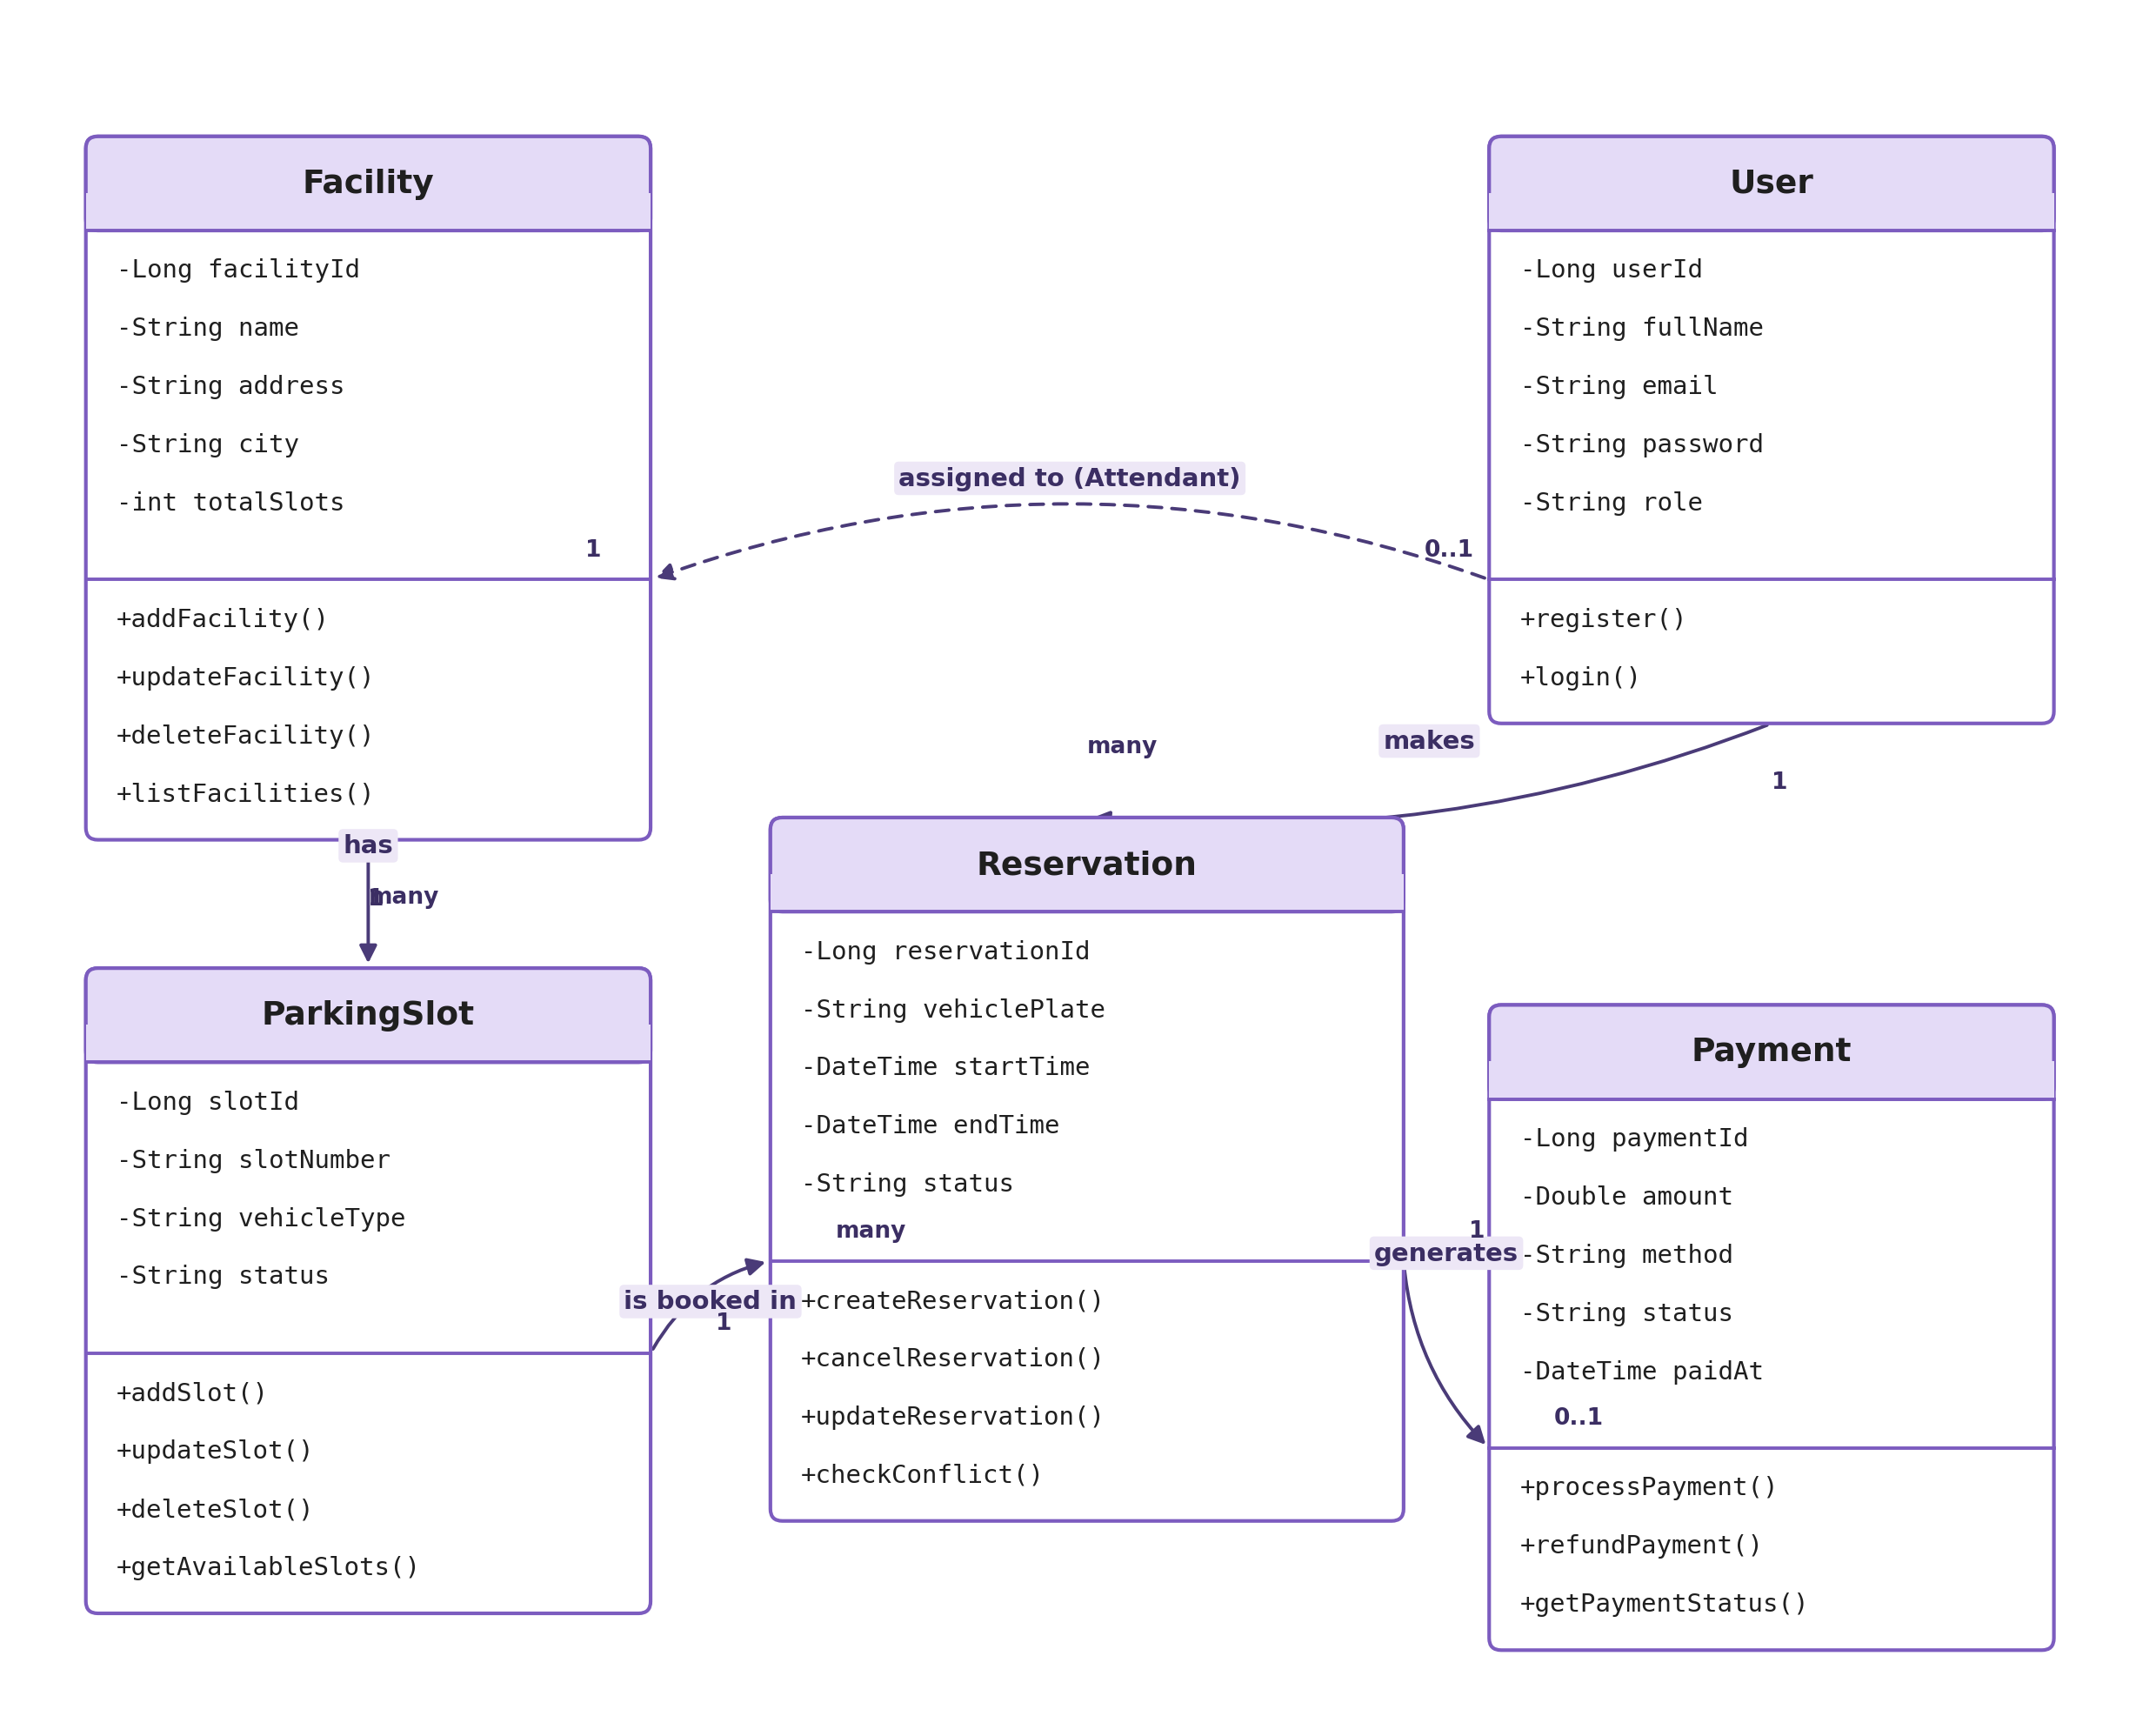

9. ENTITIES SELECTED FOR CRUD IN PHASE 2
The system now has five entities in total: Facility, User, ParkingSlot, Reservation, and Payment. Per the assignment instructions, two of these are selected for full CRUD implementation in this phase: ParkingSlot and Reservation. Both will have complete Create, Read, Update, and Delete functionality implemented using JSF and Hibernate, with client-side, server-side, and database-level validation, and styling applied using internal, external, and inline CSS. Facility, User, and Payment are modelled in the design and class diagram now (and referenced by ParkingSlot / Reservation as foreign keys) so the system reads as a genuine multi-location platform, with their own CRUD screens planned as a straightforward extension in a later phase.

10. PROJECT IMPLEMENTATION DETAILS

10.1 Entities
Facility
facilityId | Long
name | String
address | String
city | String
totalSlots | int

User
userId | Long
fullName | String
email | String
password | String
role | String (USER / ATTENDANT / ADMIN)
assignedFacility | Facility (FK, nullable — Attendant only)

ParkingSlot
slotId | Long
slotNumber | String
vehicleType | String
status | String
facility | Facility (FK)

Reservation
reservationId | Long
slot | ParkingSlot (FK)
user | User (FK)
vehiclePlate | String
startTime | DateTime
endTime | DateTime
status | String

Payment
paymentId | Long
reservation | Reservation (FK)
amount | Double
method | String (Cash / Mobile Money / Card)
status | String (Pending / Paid / Failed)
paidAt | DateTime

10.2 CRUD Operations — ParkingSlot
- Create: Admin can add new parking slots with slot number, location, and vehicle type.
- Read: View all slots and their current status.
- Update: Admin can modify slot details and status.
- Delete: Admin can remove slots from the system.

10.3 CRUD Operations — Reservation
- Create: Users can reserve available slots for specific time windows.
- Read: View reservation details and history.
- Update: Users can modify their reservations, within valid time constraints.
- Delete: Users can cancel their reservations; the slot reverts to “Available” status.

10.4 Validation Types
- Client-side validation: JavaScript validation in manage-slots.xhtml and manage-reservations.xhtml.
- JSF built-in validation: required="true", <f:validateLength>, and <f:convertDateTime>, with <h:message> on each XHTML form field.
- Server-side / database validation: javax.validation annotations (@NotBlank, @NotNull, @Size, @Email, @Future), entity column constraints, and custom controller checks for time ranges and reservation conflicts.

10.5 CSS Implementation
- Internal CSS: <style> blocks defined within individual XHTML pages.
- External CSS: Linked stylesheet files (css/user.css, css/admin.css).
- Inline CSS: style="" attributes applied directly to individual components.

10.6 Robustness / Reliability Fixes (verified during Phase-1 testing)
- Connection pooling: HibernateUtil uses a single, lazily-initialised SessionFactory singleton so one JDBC connection pool is shared across all DAO calls — previously a new SessionFactory was built on every request, exhausting PostgreSQL connections with “too many clients” errors. All DAO Sessions and Transactions are now closed safely in a finally block.
- Vehicle plate constraint: The reservation form now captures the vehicle plate (vehiclePlate), which is NOT NULL in the reservations table, preventing constraint violations when reserving.
- Validation message placement: Each <h:message> is placed as a sibling component after its input (not nested inside it), and every validated input declares an explicit id, so field-level messages attach correctly.
- Login and registration flow: Login failure uses a forward (not a redirect), and the index page renders <h:messages globalOnly="true"> so the “Invalid email or password” message displays correctly. The registration success message is preserved across the redirect via the JSF Flash scope.
- Duplicate email handling: Registration now checks for an existing email and shows a friendly “already registered” message instead of an unhandled server error from the database’s unique constraint.
- Form-wrapped navigation: Command links on the confirmation page (“Back to Dashboard”, Logout) originally rendered outside any <h:form>, so clicks did nothing. The page is now wrapped in an <h:form> and navigation works correctly.
- Logout support: A Logout button on both the user dashboard and the admin page invalidates the HTTP session and redirects to the login page.
- Session / view stability: javax.faces.STATE_SAVING_METHOD=client stores the JSF ViewState in the page itself, preventing ViewExpiredException on rapid refresh or back-button use.

10.7 Reschedule (“Update” CRUD) Fix
- Root cause: The reserve panel, the reservations table, and the reschedule panel originally shared a single <h:form>. Since a browser submits every field of a form, clicking Reschedule / Cancel / Save Changes also submitted the reserve panel’s required (but empty) fields, causing validation to fail and the action to never run.
- Fix: The dashboard now uses separate forms with explicit, stable ids: logoutForm, reserveForm, reservationTableForm, and rescheduleForm (rendered only while an update is in progress). Each action now validates and submits only its own fields.
- Reschedule panel: Provides editable Start/End Time fields (required, format yyyy-MM-dd HH:mm, with per-field messages), a read-only Status field locked to Confirmed, and a Save Changes button.
- DAO hardening: ReservationDao.getReservationById(Long) looks up a reservation directly, and ReservationDao.isSlotAvailable(slot, start, end, excludeReservationId) excludes the reservation being edited so a slot never “conflicts with itself.”
- Update logic: updateReservation() validates that the end time is after the start time, re-checks slot availability, preserves the existing status, shows a success message, and resets the editing bean only on success.
- Display polish: Dates are formatted with f:convertDateTime pattern="yyyy-MM-dd HH:mm"; dashboard messages use severity-aware CSS classes (.msgInfo, .msgWarn, .msgError/.msgFatal).
- Slot visibility: The confirmation page and reservation table show both the slot number and its location (e.g., “SLOT-B1 located at Basement”).
- Verification: End-to-end tested: login → Reschedule → panel shown with prefilled times → valid save succeeds → end-before-start blocked → overlapping range blocked → Cancel removes the reservation.

11. GITHUB REPOSITORY
Repository URL: https://github.com/imanidavid/ParkingSlotReservation
The repository contains the complete source code, including:
- Java entity classes (User.java, ParkingSlot.java, Reservation.java)
- DAO classes for database operations
- JSF managed beans for business logic
- JSF XHTML pages for the user interface
- Configuration files (faces-config.xml, web.xml)
- CSS files (internal, external, and inline styles)
- Hibernate configuration
- Maven build file (pom.xml)

12. VIDEO DEMONSTRATION
Video Link: [To be added once the video has been recorded — Google Vid / Google Drive]
The 5–10 minute video will demonstrate:
- Project proposal explanation
- System workflow and features
- CRUD operations demonstration
- User and admin interface navigation
- Validation mechanisms in action
- CSS styling demonstration
The video will be recorded using Google Vid to capture both screen and camera footage, as required.

13. DELIVERABLES CHECKLIST
✓ | Full documentation (this file) — abstract, problem statement, scope, AS-IS / TO-BE models, business requirements, software qualities, and initial class diagram.
✓ | JSF + Hibernate full CRUD implementation for the ParkingSlot and Reservation entities.
✓ | All three validation types applied: client-side (JavaScript), JSF built-in / bean validation, and server-side / database-level validation.
✓ | CSS applied in all three forms: internal (<style> block), external (linked .css file), and inline (style="" attributes).
✓ | Public GitHub repository link included in this document.
✓ | 5–10 minute video (screen + camera, recorded with Google Vid) explaining the proposal and demonstrating the implementation, with the link included in this document.

14. SUBMISSION REQUIREMENTS
Submission format: 27896_Imani_Nzeyimana_David_assignment_3.zip

Contents
- Project documentation (this file, in PDF or Word format)
- Zipped project implemented with JSF and Hibernate
- GitHub link included in the documentation
- Video link included in the documentation

Zipped Project Structure
src/main/java/com/parking/model/ — Entity classes
src/main/java/com/parking/dao/ — Data Access Objects
src/main/java/com/parking/controller/ — Managed Beans
src/main/webapp/ — JSF pages and resources
src/main/resources/ — Configuration files
src/main/webapp/css/ — External stylesheets

