PROJECT DOCUMENTATION
Karita — Parking Slot Reservation & Management System
Requirements, Domain Analysis and Data Model
Student name: Imani Nzeyimana David
Student ID: 27896
Institution: Adventist University of Central Africa (AUCA)
Programme: Software Engineering
Date: October 2026
https://github.com/imanidavid/ParkingSlotReservation
This document supersedes the Phase 1 documentation, which described an earlier
JSF and Hibernate prototype replaced during implementation.

Table of contents
Table of contents 2
1. Abstract 3
2. Problem statement 3
3. Target users 3
4. Project objectives 4
5. Scope of the project 4
5.1 In scope 4
5.2 Out of scope for this phase 5
6. AS-IS model (the current manual process) 5
7. TO-BE model (the proposed system) 5
8. Business requirements 6
9. Measurable quality attributes 6
10. User stories and acceptance criteria 8
10.1 US-1 — Driver reserves and pays for a bay 8
10.2 US-2 — Attendant verifies a car at the barrier 8
10.3 US-3 — Admin maintains bays and reads the money 9
11. Conceptual domain model 9
11.1 Actors 9
11.2 Processes 10
11.3 Data objects 10
11.4 Relationships 10
12. Entity-relationship diagram — conceptual 11
13. Entity model 13
14. Physical schema — PostgreSQL 16 13
14.1 facilities 13
14.2 users 13
14.3 parking_slots 14
14.4 reservations 14
14.5 payments 14
14.6 Indexes and check constraints 15
14.7 The exclusion constraint 15
15. Entity-relationship diagram — physical schema 16
16. Document schema — MongoDB 7 (database karita_ops) 17
16.1 audit_events 17
16.2 notifications 17
17. Schema notes and known rough edges 18
18. Repository, stack and deliverables 18
18.1 Repository 18
18.2 Demo accounts 18
18.3 Deliverables checklist 18

Right-click the table above and choose "Update Field" to populate the page numbers.

1. Abstract
Karita is a multi-location, web-based parking slot reservation and management system built to replace the turn-up-and-hope arrangement still used at most Kigali campuses, office towers and malls. Registered drivers browse parking facilities across locations, see which bays are free in a given time window, reserve a specific bay and pay for it before they leave the house. On-site attendants verify arrivals by number plate at the barrier and run a live occupancy board for the single facility they are assigned to. Administrators maintain facilities, bays and pricing across every site, and read consolidated occupancy and revenue reports.
The system is a layered Spring Boot 4 monolith. PostgreSQL 16 holds the relational core and carries the integrity rules; MongoDB 7 holds two append-only operational collections whose shape varies per record; RabbitMQ carries notification events to the consumers that render driver emails and SMS. The frontend is plain HTML, CSS and JavaScript with no build step. Payments are simulated in-app, as real gateway integration is out of scope for this phase.
The single hardest requirement in the system — never double-book a bay — is enforced by a PostgreSQL exclusion constraint rather than by application code alone. Two overlapping confirmed reservations on the same bay are not discouraged; they are unrepresentable. That decision shapes the schema, and §14.7 explains it in full.
This document supersedes the Phase 1 documentation, which described an earlier JSF and Hibernate prototype that was replaced during implementation. Where the two disagree, this document is current.

2. Problem statement
Parking at most Kigali campuses, office towers and malls still runs on a simple rule: turn up and hope. Drivers circle. Attendants arbitrate. And nobody, at the end of the month, can say with any confidence how full a given basement actually was or how much cash it took in, because the only record — if one exists at all — is a paper notebook at the barrier.
Concretely, the current arrangement produces:
- Wasted time and fuel, as drivers circle a facility with no prior knowledge of occupancy and no way to compare one location against another.
- Disputes between drivers over the same physical bay, resolved informally by whoever is at the gate.
- No accountability and no record of who parked where, for how long, or what was collected.
- Inefficient use of capacity at peak hours, because availability is invisible until a driver is already inside the facility.
- No consolidated view for management: each site keeps its own paper records, so occupancy and revenue cannot be read across locations.
What is needed is a centralised, reliable system that lets a driver claim a specific bay in advance, lets on-site staff verify that claim in seconds, and gives management accurate real-time visibility of availability and revenue across every facility.

3. Target users
Three groups use Karita, and they want quite different things. The design follows from that difference rather than treating them as one undifferentiated "user".
Drivers want certainty before they leave the house. Which lot has space at 14:00, what it costs, and a guarantee the bay is still theirs when they arrive. They interact with the system mostly from a phone, before and during a journey.
Attendants work at the barrier with a queue behind them. Their need is narrow but sharp — type a plate, get an answer in under a second, wave the car through or turn it away. Anything slower than the gate itself is useless. They are scoped to exactly one facility and never see another site’s data.
Admins sit above the lots. Slots and pricing to maintain, occupancy and revenue to read across every facility at once. They have no facility assignment, because they are above all of them.

4. Project objectives
Each objective is paired with the observable condition that tells us it has been met, so that none of them can be claimed on assertion alone.
# | Objective | How we will know it is met
O1 | Remove the search-for-a-bay problem | A confirmed reservation names an exact level and bay before the driver arrives
O2 | Make double-booking structurally impossible | Enforced in the database, not only in application code
O3 | Give every parking event a record | Every reservation carries a payment row; occupancy is timestamped at check-in and release
O4 | Scope attendants to their own site | An attendant cannot read or write another facility’s data
O5 | Consolidate the view across locations | One revenue and occupancy report spanning all facilities

5. Scope of the project

5.1 In scope
- Registration and authentication across three roles: driver, attendant and administrator, including federated sign-in with Google over OAuth2/OIDC.
- Management of multiple parking facilities, each with its own levels, bays, hourly rate and assigned attendants.
- Real-time availability of bays, filterable and browsable by facility and location.
- Creating, viewing, updating and cancelling reservations.
- Administrator CRUD over facilities and parking bays, including deactivation and deletion with referential safeguards.
- Attendant operations for the assigned facility only: plate verification, check-in, cash recording, release and no-show handling.
- Recording a payment — amount, method and status — against every reservation.
- Occupancy, reservation-history and per-facility revenue reporting.
- Input validation on the client, re-validated on the server and backed by database constraints.
- A styled, responsive user interface usable from 390 px to 1920 px.
- An append-only operations log of staff actions and of every notification sent.

5.2 Out of scope for this phase
- Integration with real external payment gateways. Mobile money and card payments are recorded and simulated within the system.
- Integration with physical hardware such as barrier gates or licence-plate cameras.
- Native mobile applications. The system is a responsive web application only.
- Dynamic or surge pricing and discount-code engines.

6. AS-IS model (the current manual process)
- A driver arrives at one of several unconnected parking facilities with no prior information on availability at that location, and no way to compare it with another.
- The driver circles the facility searching for an empty bay.
- If a bay is found, the driver parks with no formal registration or record, and pays cash on site with no receipt tracking.
- There is no tracking of which vehicle occupies which bay, for how long, or how much was collected at each location.
- Disputes — two drivers claiming the same bay — are resolved informally, usually by security personnel.
- Each facility keeps its own paper records, if any. Head-office administrators have no consolidated, real-time view of occupancy or revenue.
Key weaknesses: time wasted searching, no accountability, no cross-location visibility, no consolidated revenue data, and frequent disputes at the barrier.

7. TO-BE model (the proposed system)
- A registered driver signs in — by password or with Google — browses facilities, and sees real-time availability for a chosen location and time window.
- The driver picks a specific bay and a window, supplies a vehicle plate, and submits the reservation.
- The system validates the request and takes a write lock on the bay before inserting. If the window overlaps an existing confirmed booking, the driver gets a clear conflict message and nothing is written. The database refuses the overlap independently, so the guarantee survives even if the application check is bypassed.
- The driver pays by card or mobile money up front, or leaves the booking pending for cash at the barrier. A payment row is recorded against the reservation either way, and a printable ticket is issued.
- A notification event is published to RabbitMQ on confirmation, payment and cancellation; consumers render the driver’s email or SMS and log what was sent.
- On arrival, the attendant types the plate, sees the bay, window and payment status for their own facility only, and marks the booking occupied. Cash is recorded at this point if the booking is still pending.
- When the driver leaves, the attendant releases the bay. The hold shrinks to the actual departure time and the bay returns to the pool immediately, while the agreed end time is preserved for billing.
- If nobody arrives within fifteen minutes of the start, the booking can be marked a no-show and the bay is freed.
- Administrators maintain facilities, bays and pricing across all sites, and read occupancy and revenue broken down per facility. Every staff action is written to an append-only audit log.
Key improvements: no wasted search time, a guaranteed bay on arrival, a complete digital and payment record, far fewer disputes, multi-location visibility for management, and capacity planning based on numbers rather than on what the attendants report.

8. Business requirements
These are the principal functional and business requirements the system is built against. The user stories in §10 trace back to the identifiers in this table.
ID | Requirement | Where it is implemented
BR1 | Users must be able to register and log in securely. | register.html, login.html; password and Google OAuth2/OIDC
BR2 | Users must be able to view all parking bays and their current status (Available / Reserved / Occupied). | facility.html (the lot map), attendant.html (live board)
BR3 | Users must be able to create a reservation for an available bay within a valid time range. | facility.html → pay.html → ticket.html
BR4 | Users must be able to view, edit and cancel their own reservations. | reservations.html
BR5 | Administrators must be able to perform full CRUD operations on parking bays. | admin.html#slots
BR6 | Administrators must be able to view and manage all reservations in the system. | admin.html#reservations
BR7 | The system must prevent double-booking of the same bay for overlapping time periods. | Service-layer row lock plus the database exclusion constraint (§14.7)
BR8 | The system must validate all user input on both the client side and the server side. | Client checks on every form; server re-validates; database CHECK constraints
BR9 | The system must present a clean, responsive interface styled with CSS. | All pages, 390 px and up
BR10 | Admins must be able to create and manage multiple facilities, each with its own bays. | admin.html#facilities
BR11 | Users must be able to browse and filter available bays by facility and location. | browse.html
BR12 | Attendants must be able to view and manage reservations only for the facility they are assigned to. | attendant.html; per-resource ownership checks server-side
BR13 | The system must record a payment (amount, method and status) for each reservation. | pay.html, the ticket, and the admin reservations list
BR14 | Admins must be able to view occupancy and revenue reports broken down per facility. | admin.html#revenue

9. Measurable quality attributes
The Phase 1 documentation listed these as adjectives — "fast retrieval", "simple forms". That is not much use to anyone, since you cannot fail an adjective. Each attribute below is therefore given a number and a way to check it.
Attribute | Target | How it is measured | Status
Performance — availability map | Facility map for one level renders in under 500 ms at p95, on a dataset of 24 facilities, 1,476 bays and roughly 15,000 bookings | Server timing on GET /api/facilities/{id} against the seeded dataset | Design target; not yet load-tested
Performance — plate lookup | Attendant verification answers in under 300 ms at p95 | GET /api/attendant/verify, backed by the ix_res_facility_start index | Design target; not yet load-tested
Performance — write path | Reservation creation completes in under 1 s including the row lock | POST /api/reservations | Design target
Reliability — no double-booking | Zero overlapping confirmed bookings on one bay, under concurrent load | PostgreSQL EXCLUDE USING gist constraint; a violation is raised at database level even if application code is bypassed | Met — enforced and test-covered
Reliability — durability | Data survives a restart; only sessions are lost | Restart check in the browser test suite | Met
Security — credentials at rest | PBKDF2-HMAC-SHA256, at least 200,000 iterations, per-user random salt | PasswordHasher — currently 210,000 iterations | Met
Security — federated sign-in | OAuth2/OIDC authorisation code flow with state, nonce and PKCE (S256); zero role changes from signing in via a provider | Spring Security oauth2-client; the account is linked by verified email, never replaced | Met — test-covered
Security — brute force | Sign-in throttled to 10 failures per email and IP per 15 minutes, then HTTP 429 | LoginThrottle | Met
Security — tenant isolation | Zero cross-tenant reads: an attendant reaching another facility’s data receives 403 or 404 in 100% of attempts | Role checks plus per-resource ownership checks | Met — test-covered
Usability — booking effort | A signed-in driver reaches a confirmed booking in at most 4 screens and 8 fields | Walkthrough: home → facility → bay → pay | Met
Usability — error clarity | 100% of validation errors render against the specific field, in plain language, with the input preserved | The {fields} error envelope | Met
Responsiveness | No horizontal scroll and no overlap from 390 px to 1920 px on all 10 pages | Manual check at 390, 768, 1280 and 1920 px | Met
Maintainability | Layers stay one-directional: web → service → repository → model | No repository import in web/, no servlet import in service/ | Met
One caveat, stated plainly: the rows marked design target are engineering intent, not measured results. The indexes and the fetch strategy exist in order to hit them, but no load test has been run yet. That gap is labelled here rather than presented as a measurement it is not.

10. User stories and acceptance criteria
Three stories, one per role, each tracing to the business requirements it satisfies and each covered by automated tests.

10.1 US-1 — Driver reserves and pays for a bay
As a driver, I want to pick a specific bay at a specific facility for a specific time window and pay for it up front, so that I can drive straight to a space I know is mine instead of circling the basement.
Covers BR3, BR7, BR13.
 | Given | When | Then
AC-1.1 | I am signed in as a driver and bay B1/A1 at Kigali Heights is free from 08:00 to 12:00 | I reserve it for that window with plate RAD 482 C | The response is 201 and the reservation reads Confirmed, with payment Pending
AC-1.2 | I hold that confirmed reservation | Another driver tries the same bay for any overlapping window | They receive 409 and a message naming the clash; their reservation is never written
AC-1.3 | My reservation is Pending | I pay by mobile money with a valid +2507… number | Payment flips to Paid, paidAt is stamped, and the ticket renders as PAID
AC-1.4 | My reservation is Pending | I pay with card 4000 0000 0000 0002 | I receive 402, the error names the decline, the form keeps what I typed, and the status stays Pending
AC-1.5 | I ask for a bay smaller than my vehicle | I submit the reservation | 400, with the error attached to the vehicle field
Verified by ApiIntegrationTest and the browser checks "reserve with plate, pay by mobile money, see the PAID ticket" and "declined card shows an error and keeps the form".

10.2 US-2 — Attendant verifies a car at the barrier
As an attendant, I want to type a plate and immediately see whether that car has a paid booking at my facility today, so that I can clear the queue at the gate without phoning anyone or guessing.
Covers BR2, BR12.
 | Given | When | Then
AC-2.1 | I am an attendant assigned to Kigali Heights | I search plate RAD 482 C, which holds a paid booking there today | I see the bay, the window, the payment status and a control to mark it occupied
AC-2.2 | The same plate holds a booking at a different facility | I search for it | 404 and the no-match panel — other sites are invisible to me
AC-2.3 | A booking is Paid and the driver has arrived | I mark it occupied | checkedInAt is stamped and the bay shows Occupied on the live board
AC-2.4 | A booking is still Pending because the driver is paying cash | I try to mark it occupied | Blocked until I record the cash payment
AC-2.5 | A booking started more than 15 minutes ago and nobody arrived | I mark it a no-show | The status becomes No-show and the bay returns to the pool
Verified by the browser checks "attendant: verify plate, mark occupied, release the slot", "attendant: unknown plate shows the no-match panel" and "roles: each role is kept to its own pages".

10.3 US-3 — Admin maintains bays and reads the money
As an admin, I want to add, edit and retire bays across any facility, and see occupancy and revenue broken down per site, so that I can plan capacity on numbers rather than on what the attendants tell me.
Covers BR5, BR10, BR14.
 | Given | When | Then
AC-3.1 | I am an admin | I create bay A13 on level B1 at a facility | 201, and the bay appears immediately in the driver-facing map
AC-3.2 | A bay already exists as B1/A13 at that facility | I create it again | 400 — (facility, level, slot_number) is unique
AC-3.3 | A bay carries upcoming confirmed bookings | I delete it | 409 naming the count; nothing is deleted
AC-3.4 | A facility has reservation history | I delete the facility | 409; history is never orphaned
AC-3.5 | Paid reservations exist across several facilities | I open the revenue report | Each facility total equals the sum of its Paid amounts, and the grand total equals the sum of the rows
Verified by the browser checks "admin: facility and slot CRUD with validation", "a facility with history cannot be deleted" and "reservations list filters, revenue table totals".

11. Conceptual domain model
This section describes the domain at an abstract level — the actors, the processes they take part in and the data objects they act on — independent of any implementation choice. Nothing here depends on the system being written in Java, or on the data living in PostgreSQL.

11.1 Actors
Driver — owns a vehicle, holds reservations and pays for them. Sees only their own bookings.
Attendant — staff at exactly one facility. Books nothing; verifies arrivals, records cash and releases bays. Everything they touch is filtered by their assigned site.
Admin — maintains facilities, bays and pricing across every site, and reads consolidated reports. Has no facility assignment, because they are above all of them.

11.2 Processes
Registration turns a visitor into a driver with a plate and a vehicle class. Availability answers which bays are free in a window; it is the one read that has to be fast, and the one every other process depends on. Reservation claims a bay for a window, and is where double-booking is either prevented or not. Payment settles a reservation — by card or mobile money up front, or by cash at the barrier. Check-in and release bracket the physical occupancy. No-show is the timeout branch when nobody turns up. Reporting aggregates the lot.

11.3 Data objects
A Facility is a parking site with an address, a flat hourly rate and named levels. A ParkingSlot is one physical bay on one level, sized for a vehicle class. A User is any account, discriminated by role. A Reservation is the central object — one driver, one bay, one window, one status. A Payment settles exactly one reservation.
One concept deserves a note, because it is not obvious and it drives the schema: the window a bay is held for is not the window the driver booked. A driver books 08:00 to 12:00 and leaves at 09:30. From 09:30 the bay should be bookable again. So the hold tracks the real occupancy and shrinks on release, while the booked end preserves what was agreed and billed. Every conflict check runs against the hold; every receipt runs against the booked end.

11.4 Relationships
- A Facility has many ParkingSlots (1 : N, mandatory on the slot side — a bay cannot exist without a site).
- A Facility has many Reservations (1 : N).
- A User makes many Reservations (1 : N).
- A User who is an attendant is assigned to at most one Facility (0..1; null for drivers and admins).
- A ParkingSlot is booked in many Reservations over time (1 : N), constrained so that their held windows never overlap.
- A Reservation has exactly one Payment (1 : 1).

12. Entity-relationship diagram — conceptual
The diagram below defines the core entities, their attributes and the relationships needed to support the application’s data needs, at the conceptual level described in §11. Keys are marked PK, unique business identifiers UK, and references FK; crow’s-foot notation carries the cardinalities.
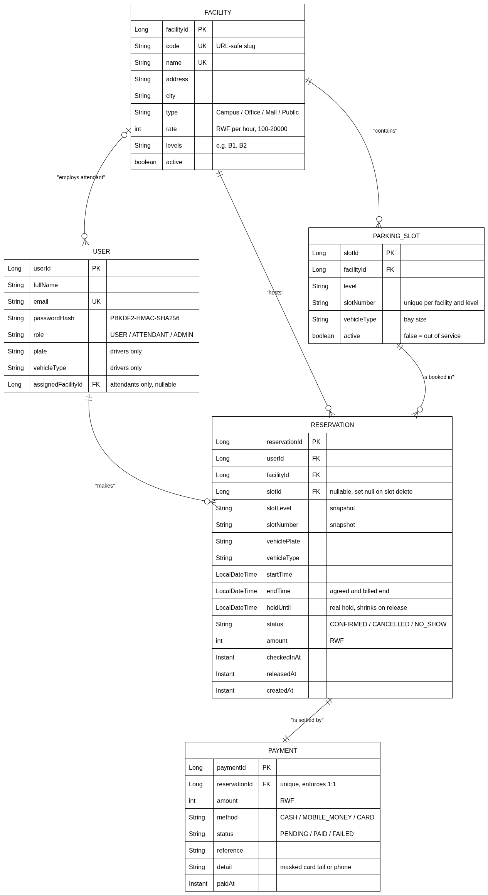
Figure 1 — Conceptual entity-relationship diagram: Facility, User, ParkingSlot, Reservation and Payment.

13. Entity model
The same five entities, stated as an attribute summary before the schema makes them concrete.
Entity | Identity | Key attributes
Facility | facilityId | code, name, address, city, type, rate, levels, active
ParkingSlot | slotId | facility, level, slotNumber, vehicleType, active
User | userId | fullName, email, passwordHash, role, plate, vehicleType, assignedFacility
Reservation | reservationId | user, facility, slot, slotLevel, slotNumber, vehiclePlate, vehicleType, startTime, endTime, holdUntil, status, amount, checkedInAt, releasedAt, createdAt
Payment | paymentId | reservation, amount, method, status, reference, detail, paidAt
Enumerations are stored as strings and constrained in the database rather than left as free text: role (USER / ATTENDANT / ADMIN), vehicle type (MOTORCYCLE / CAR / SUV / TRUCK), reservation status (CONFIRMED / CANCELLED / NO_SHOW), payment status (PENDING / PAID / FAILED) and payment method (CASH / MOBILE_MONEY / CARD).
Reservation.slotLevel and slotNumber duplicate what the bay already knows. That is deliberate denormalisation. An admin can delete a bay, which nulls the reservation’s slot_id through ON DELETE SET NULL, and without the snapshot every historical receipt for that bay would lose the one detail a driver cares about. History stays readable after the thing it points at is gone.

14. Physical schema — PostgreSQL 16
The conceptual model refined into a technology-oriented schema. The tables below are taken from the running database rather than from the entity annotations.

14.1 facilities
Column | Type | Null | Notes
facility_id | bigint | NO | PK, identity
code | varchar(60) | NO | UNIQUE — URL-safe slug
name | varchar(80) | NO | UNIQUE
address | varchar(120) | NO
city | varchar(60) | NO
type | varchar(20) | NO | Campus / Office / Mall / Public
rate | integer | NO | RWF per hour; CHECK between 100 and 20,000
levels | varchar(40) | NO | e.g. "B1, B2"
active | boolean | NO

14.2 users
Column | Type | Null | Notes
user_id | bigint | NO | PK, identity
email | varchar(120) | NO | UNIQUE
full_name | varchar(80) | NO
password_hash | varchar(200) | NO | format pbkdf2$iterations$salt$hash
role | varchar(12) | NO | CHECK in the three roles
plate | varchar(12) | YES | drivers only
vehicle_type | varchar(12) | YES | CHECK; drivers only
assigned_facility_id | bigint | YES | FK → facilities — attendants only

14.3 parking_slots
Column | Type | Null | Notes
slot_id | bigint | NO | PK, identity
facility_id | bigint | NO | FK → facilities
level | varchar(3) | NO
slot_number | varchar(5) | NO
vehicle_type | varchar(12) | NO | CHECK; the bay size
active | boolean | NO | false = out of service
UNIQUE uk_slot_number (facility_id, level, slot_number) — one bay label per level per site.

14.4 reservations
Column | Type | Null | Notes
reservation_id | bigint | NO | PK, sequence, allocation size 50
user_id | bigint | NO | FK → users
facility_id | bigint | NO | FK → facilities
slot_id | bigint | YES | FK → parking_slots, ON DELETE SET NULL
slot_level | varchar(3) | NO | snapshot
slot_number | varchar(5) | NO | snapshot
vehicle_plate | varchar(12) | NO
vehicle_type | varchar(12) | NO | CHECK
start_time | timestamp | NO | local, Africa/Kigali
end_time | timestamp | NO | the agreed and billed end
hold_until | timestamp | NO | the real hold; shrinks on release
status | varchar(12) | NO | CHECK in the three statuses
amount | integer | NO | RWF; CHECK ≥ 0
checked_in_at | timestamptz | YES
released_at | timestamptz | YES
created_at | timestamptz | NO

14.5 payments
Column | Type | Null | Notes
payment_id | bigint | NO | PK
reservation_id | bigint | NO | FK → reservations, UNIQUE — this is what enforces 1 : 1
amount | integer | NO | RWF
method | varchar(16) | YES | CHECK; null until the driver chooses
status | varchar(10) | NO | CHECK
reference | varchar(80) | NO
detail | varchar(40) | NO | masked card tail or phone number
paid_at | timestamptz | YES | set on success

14.6 Indexes and check constraints
Index | Columns | What it serves
ix_res_facility_start | (facility_id, start_time) | The attendant board and the admin reservation list
ix_res_user | (user_id) | "My reservations" for a driver
ix_res_slot | (slot_id) | Conflict checks and bay deletion
Check constraints on reservations:
- reservations_time_order — end_time > start_time AND hold_until BETWEEN start_time AND end_time
- reservations_amount_positive — amount >= 0

14.7 The exclusion constraint
This is the load-bearing wall of the whole system, so it is worth stating plainly what it does.
ALTER TABLE reservations ADD CONSTRAINT reservations_no_overlap
EXCLUDE USING gist (
slot_id WITH =,
tsrange(start_time, hold_until) WITH &&
) WHERE (status = 'CONFIRMED' AND slot_id IS NOT NULL);
It makes two confirmed bookings that overlap on the same bay unrepresentable. Not discouraged — unrepresentable. The service layer also takes a PESSIMISTIC_WRITE lock on the bay row and re-checks before inserting, which gives the driver a clean 409 instead of a stack trace. But if that check were deleted tomorrow, or somebody ran an INSERT by hand in psql, the database would still refuse.
The partial WHERE clause matters too: cancelled and no-show rows fall outside the constraint, so a cancelled booking frees its bay instantly. GiST combined with the btree_gist extension is what lets a single index mix the equality on slot_id with the range overlap on the held window. This is the mechanism behind objective O2 and the reliability target in §9, and it is why the ER diagram alone cannot express the full guarantee — no diagram notation carries a partial exclusion constraint.

15. Entity-relationship diagram — physical schema
The same model expressed against the persistence layers actually in use. Column names, SQL types, primary and foreign keys, uniqueness, check constraints and index membership are all shown. The two MongoDB collections are drawn deliberately detached: they carry no foreign key into the relational core, and §16 explains why.
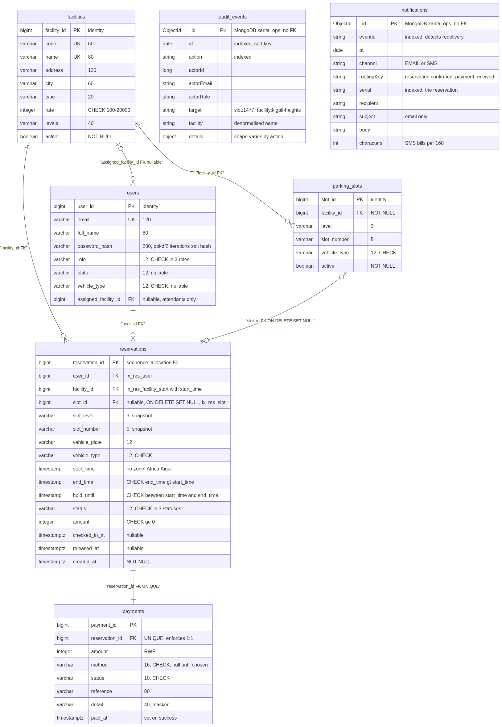
Figure 2 — Physical schema: five PostgreSQL tables with keys, constraints and indexes, plus the two append-only MongoDB collections.

16. Document schema — MongoDB 7 (database karita_ops)
Two append-only collections. Neither is joined to the relational data and neither carries a foreign key, which is why Figure 2 draws them detached. They live in MongoDB rather than PostgreSQL because their payloads have no shared column set: forcing them into a relational table would mean either a wide table of mostly-null columns or a migration every time a new action is logged.

16.1 audit_events
Field | Type | Notes
_id | ObjectId
at | date | indexed; the sort key for every listing
action | string | indexed; SLOT_CREATED, CASH_RECORDED, NO_SHOW, …
actorId / actorEmail / actorRole | long / string / string | who performed the action
target | string | slot:1477, facility:kigali-heights, reservation:00412
facility | string | denormalised name, so a listing needs no lookup
details | sub-document | shape varies by action
A representative document:
{ "at": "2026-10-02T18:23:35.900Z", "action": "SLOT_UPDATED",
"actorEmail": "admin@karita.rw", "actorRole": "ADMIN",
"target": "slot:1477", "facility": "Kigali Heights",
"details": { "level": "B1", "slot": "Z9", "active": false,
"fieldsSubmitted": ["active"] } }
That details object is the whole argument for the collection. A cash payment stores { "amount": 2000 }; a release stores { "plate": …, "freedFrom": … }. No shared columns, no nulls, and no migration when a new action appears.

16.2 notifications
Field | Type | Notes
_id | ObjectId
eventId | string | indexed; the id the event carried, so a redelivery is detectable
at | date
channel | string | EMAIL or SMS
routingKey | string | reservation.confirmed, payment.received, reservation.cancelled
serial | string | indexed; the reservation it concerns
recipient | string
subject | string | email only — absent on SMS
body | string | what was actually sent
characters | int | length; SMS bills per 160
Written by the queue consumers after they render a message. The broker records that an event was published; this collection records that a notification went out — which is exactly what is needed when a driver insists they never received their ticket.

17. Schema notes and known rough edges
Time types split deliberately. Business times — start_time, end_time, hold_until — are timestamp without time zone and are always read as Africa/Kigali, because an 08:00 booking means 08:00 at the gate regardless of server locale. Audit times — created_at, paid_at, checked_in_at, released_at — are timestamptz, because those are instants.
Reservation ids come from a sequence with an allocation size of 50 rather than from an identity column, which lets Hibernate batch inserts; the seeder writes roughly 15,000 rows in about seven seconds. The visible side effect is gaps in the serial numbers. Harmless, but worth knowing before someone files it as a defect.
Two rough edges that would be worth fixing given time:
- facilities carries a duplicate check constraint — facilities_rate_check, generated from the Bean Validation annotations, and facilities_rate_range, added by SchemaInitializer. Both assert the same 100–20,000 range. Redundant, not wrong.
- Foreign keys still use Hibernate’s generated names (fka0t6epq80cb9fwefvastfqsg7 and similar). They are stable but unreadable; explicit names would make production error messages considerably easier to follow.

18. Repository, stack and deliverables

18.1 Repository
https://github.com/imanidavid/ParkingSlotReservation
Directory | Contents
frontend/ | React 19 built by Vite — src/ (pages, components, lib), styles/, and ten HTML entry shells, one per page; npm run build emits dist/, which is what the backend serves
backend/ | Spring Boot 4: PostgreSQL for core data, MongoDB for audit and notification documents, RabbitMQ for events; serves frontend/dist/ and /api
docs/ | This document and the written documentation set
tests/ | End-to-end browser tests, headless Chrome
The five entity classes — Facility, ParkingSlot, User, Reservation and Payment — live in backend/src/main/java/auca/ac/rw/parkinkslotManagement/model.

18.2 Demo accounts
The password for all seeded accounts is karita123.
Role | Email | Lands on
Driver | driver@karita.rw (RAD 482 C, car) | home.html
Driver 2 | driver2@karita.rw (RAC 117 B, SUV) | home.html
Attendant (Kigali Heights) | attendant@karita.rw | attendant.html
Admin | admin@karita.rw | admin.html
New drivers can sign up at register.html. Payments are simulated, as §5.2 puts real gateways out of scope: a cash booking stays pending until the attendant records it, and card 4000 0000 0000 0002 always declines.

18.3 Deliverables checklist
 | Deliverable
✓ | Problem statement, target users, objectives and scope (§2–§5)
✓ | Principal functional and business requirements, BR1–BR14 (§8)
✓ | Measurable quality attributes covering usability, performance, reliability and security (§9)
✓ | Three user stories with acceptance criteria, traced to business requirements and to tests (§10)
✓ | Abstract domain summary: actors, processes and data objects (§11)
✓ | Entity-relationship diagram of the core entities, attributes and relationships (§12)
✓ | Technology-oriented schema with primary keys, foreign keys, constraints and indexes (§14, §15)
✓ | Document schema for the non-relational persistence layer (§16)
✓ | Public repository link (§18.1)

