

MODULE CODE: ITLDM801
MODULE NAME: DATA MINING AND WAREHOUSING.
DEPARTMENT: ICT
OPTION: IT
LEVEL: 8 YEAR 4
CLASS: IT Btech
MULTI-CAMPUS EDUCATION DATA PREPROCESSING PIPELINE
GROUP 10: MEMBERS
NAMES | REG NO | MARKS
IMANIRUMVA Olivier | 25RP19872
NKIZINGABO Philbert | 25RP19724
UWIMANA Diane | 25RP21687

Date: 15 Feb 2026

TABLE OF CONTENTS
- Introduction ............................................................. 1
- Problem Statement ..................................................... 2
- Objectives ................................................................. 3
- Issues Found and Evidence ....................................... 4
4.1 Missing Values .................................................. 4
4.2 Duplicate Records ............................................ 5
4.3 Outliers and Invalid Values ............................. 6
4.4 Inconsistent Formats ....................................... 7
4.5 Noisy Data ....................................................... 8
- Cleaning Justification ................................................. 9
5.1 Handling Missing Values ................................ 9
5.2 Removing Duplicates .................................... 10
5.3 Outliers ............................................................ 11
5.4 Standardization of Formats ............................ 12
- Integration Keys and Conflict Handling ............... 13
6.1 Integration Keys ............................................. 13
6.2 Conflict Handling ............................................ 14
- Feature Engineering .................................................... 15
7.1 Date-Time Features ...................................... 15
7.2 Student Performance Aggregations ............. 16
7.3 Risk Indicators ................................................ 17
- Before vs After Metrics ............................................ 18
- Conclusion ................................................................. 19
Figure 1: Data Preprocessing Pipeline Workflow Diagram ............................. 3
Figure 2: Missing Values Distribution (Before Cleaning) ................................. 4
Figure 3: Mark Distribution Before Outlier Treatment ..................................... 6
Figure 4: Standardization Process Example ..................................................... 12
Figure 5: Final Gold Dataset Structure ............................................................. 14
Figure 6: At-Risk Students by Campus ............................................................... 17

1. Introduction
Modern educational institutions generate large volumes of academic data across multiple campuses. However, this data is often stored in different formats, contains inconsistencies, and suffers from various quality issues. Without proper preprocessing, such data cannot be reliably used for reporting, analytics, or machine learning.
This project focused on building a complete data preprocessing pipeline for a multi-campus education system. Data was collected from three campuses:
- Huye
- Kigali
- Musanze
Each campus exported student, course, and assessment datasets independently, leading to structural differences and data quality problems. The main objective of this project was to transform raw, messy datasets into a clean, standardized, and analytics-ready gold dataset suitable for:
- Institutional reporting
- Student performance analysis
- Risk identification
- Machine learning modeling
The preprocessing pipeline followed structured data warehousing principles including data cleaning, transformation, integration, reduction, and feature engineering.
2. Problem Statement
Rwanda Polytechnic operates across multiple campuses, including Huye, Kigali, and Musanze. Each campus independently generates and exports academic data such as student profiles, course information, and assessment results. However, these datasets are not standardized and contain multiple data quality issues including missing values, duplicates, outliers, inconsistent formats, and noisy entries.
3. Objectives
The main objectives of this project were:
- To integrate academic data from multiple campuses (Huye, Kigali, and Musanze) into a unified dataset despite differences in export formats and data structures.
- To identify and analyze data quality issues present in the raw datasets, including missing values, duplicate records, outliers, inconsistent formats, and noisy entries.
- To apply appropriate data cleaning techniques such as imputation, duplicate removal, outlier correction, and format standardization to improve overall data quality.
- To standardize and normalize key attributes including course codes, dates, program names, and categorical fields to ensure consistency across campuses.
- To integrate cleaned datasets using appropriate keys (Student_ID and Course_Code) while handling conflicts during merging.
- To engineer new analytical features including date-time attributes, student performance aggregations, and risk indicators to enhance the dataset’s analytical value.
- To generate a final gold dataset that is clean, validated, structured, and ready for reporting, visualization, and machine learning applications.
- To evaluate the effectiveness of the preprocessing pipeline by comparing data quality metrics before and after cleaning

4. Issues Found and Evidence
During the data profiling phase, multiple quality issues were identified in the raw datasets.
4.1 Missing Values
The following missing values were detected:
- Gender
- Phone numbers
- Date of Birth (DOB)
- Marks
- Attendance rate
Profiling showed that several student records had missing demographic information, and multiple assessment records had missing marks or attendance values.
Impact:
Missing marks and attendance directly affect calculation of averages, risk flags, and performance summaries. If left untreated, they would result in incorrect analytics.
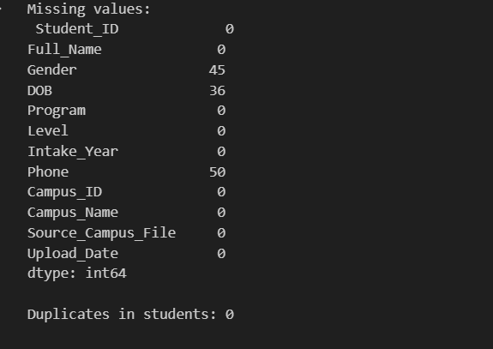
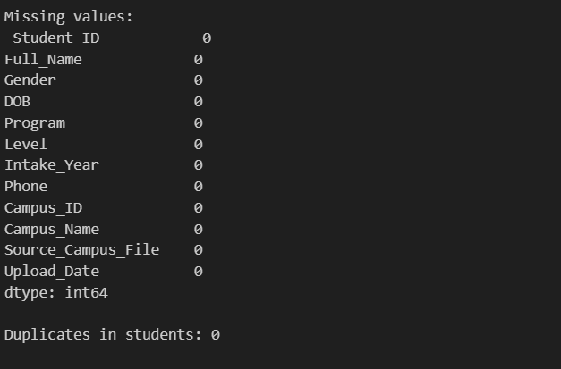
4.2 Duplicate Records
Two major types of duplicates were discovered:
- Duplicate student records sharing the same Student_ID.
- Duplicate assessment records using the composite key:
(Student_ID, Course_Code, Academic_Year, Semester)
These duplicates would artificially inflate course counts and student averages if not removed.
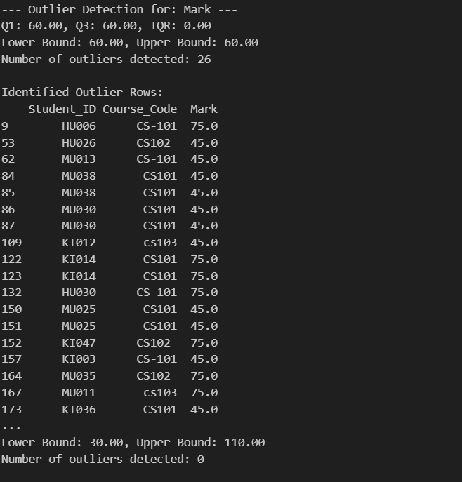

4.3 Outliers and Invalid Values
Several logically invalid values were identified:
- Marks greater than 100 (e.g., 110)
- Negative marks (e.g., -5)
- Attendance rates greater than 100%
- Negative course credits
These values violate academic standards and distort statistical calculations.

4.4 Inconsistent Formats
Significant format inconsistencies were observed:
- Course codes: “CS101”, “CS-101”, “cs101”
- Program names: “ict ”, “ICT”, “ ict”
- Gender: “Male”, “female”
- Semester: “Semester 1”, “Semester1”
- Dates: multiple formats such as “01-02-2023”, “2023/02/01”, “2023-02-01”
Such inconsistencies prevent proper merging and grouping.
4.5 Noisy Data
Noisy entries included:
- Special characters in names (e.g., “bob@”)
- Extra spaces before and after text
- Non-numeric characters in phone numbers
- Typographical inconsistencies
Noisy data reduces reliability and causes integration conflicts.
5. Cleaning Justification
Each cleaning decision was made carefully to preserve data integrity while improving quality.

5.1 Handling Missing Values
Different strategies were applied depending on the type of variable:
Gender → Filled with “Unknown”
Reason: Categorical variable; avoids deleting records.
Phone → Filled with “Not Provided”
Reason: Optional attribute; not critical for analytics.
Marks → Converted to numeric and filled using median value.
Reason: Median is robust to extreme values.
Attendance Rate → Filled using mean value.
Reason: Continuous performance-related variable.
Critical identifiers such as Student_ID and Course_Code were never allowed to remain missing.
5.2 Removing Duplicates
Student duplicates were removed using Student_ID as the primary key.
Assessment duplicates were removed using the composite key:
(Student_ID, Course_Code, Academic_Year, Semester)
This ensured accurate aggregation and prevented double counting.
5.3 Outliers
Marks below 0 or above 100 were set to missing and imputed.
Attendance values above 100 were capped at 100.
Negative credits were replaced with valid positive defaults.
These corrections ensured logical consistency in academic evaluation metrics.
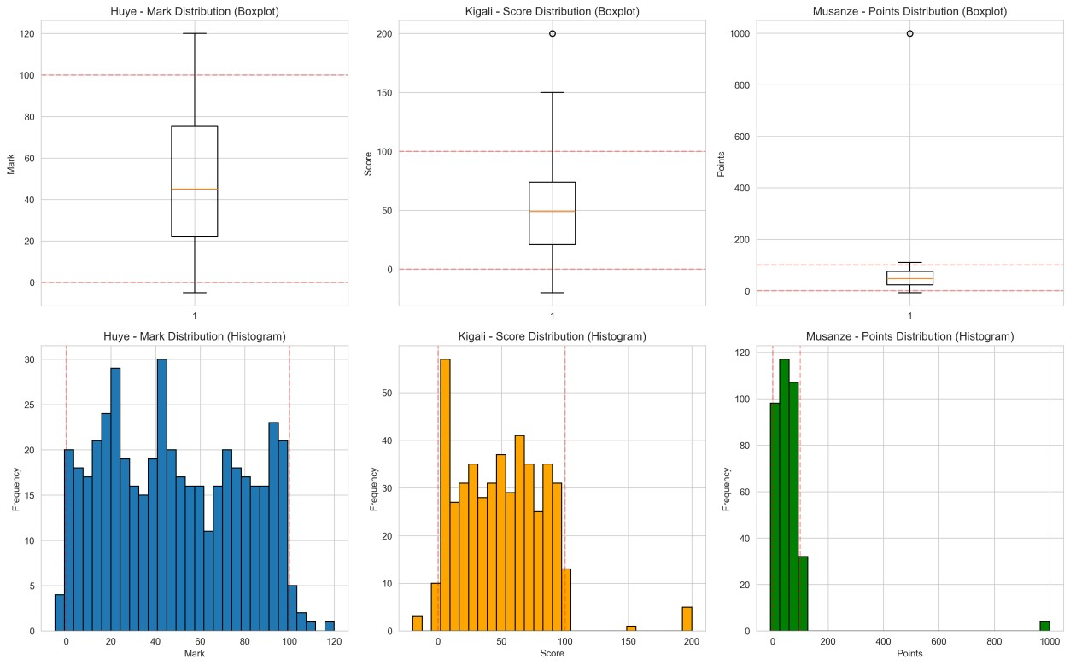
5.4 Standardization of Formats
Text standardization included:
- Removing leading/trailing spaces
- Converting text to uppercase
- Removing special characters using regular expressions
Course codes were normalized by:
- Removing hyphens
- Converting to uppercase
All dates were standardized using datetime conversion.
This ensured successful integration across campuses.
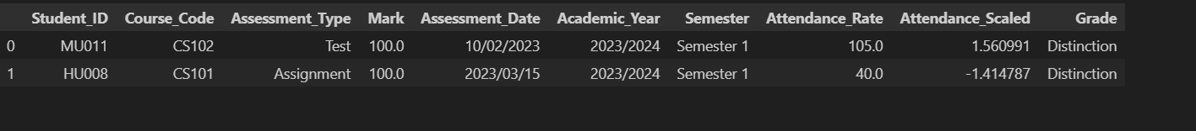
6. Integration Keys and Conflict Handling
After cleaning, datasets were merged to create a unified gold dataset.
6.1 Integration Keys
The following keys were used:
- Student_ID (linking students and assessments)
- Course_Code (linking assessments and courses)
Integration process:
Results
merged with Students on Student_ID
merged with Courses on Course_Code
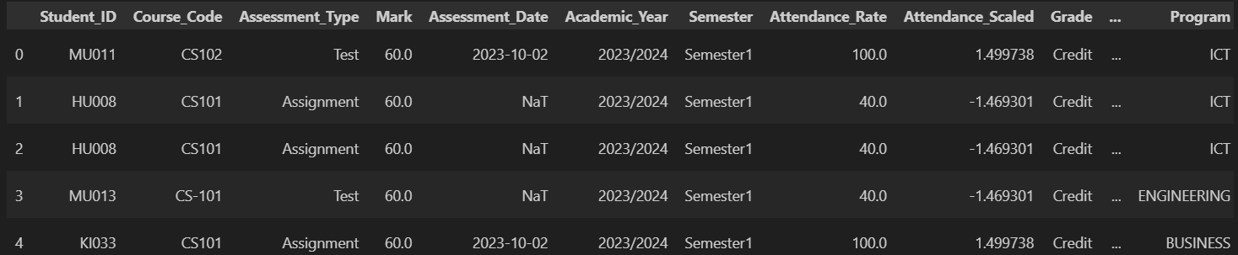
6.2 Conflict Handling
Student Name Conflicts:
When name variations existed for the same Student_ID, the ID was treated as authoritative.
Course Code Conflicts:
Standardization ensured that “CS-101” and “cs101” became “CS101” before merging.
Campus Traceability:
Additional metadata fields were added:
- Campus_ID
- Campus_Name
- Source_Campus_File
- Upload_Date
The final integrated output was saved as:
gold_integrated.csv
7. Feature Engineering
To increase analytical value, new features were created.

7.1 Date-Time Features
- assessment_month
- assessment_weekday
- is_weekend_assessment
These allow time-based analysis of performance trends.
7.2 Student Performance Aggregations
- student_course_count
- student_avg_mark
- student_max_mark
- student_fail_count
- student_total_credits_earned
These provide student-level performance summaries.
7.3 Risk Indicators
- is_at_risk
Defined as:
(student_avg_mark < 50 OR student_fail_count ≥ 2)
- low_attendance_flag
Defined as:
Attendance_Rate < 60
These features are useful for predictive modeling and early intervention systems.
The final engineered dataset was saved as:
gold_features.csv
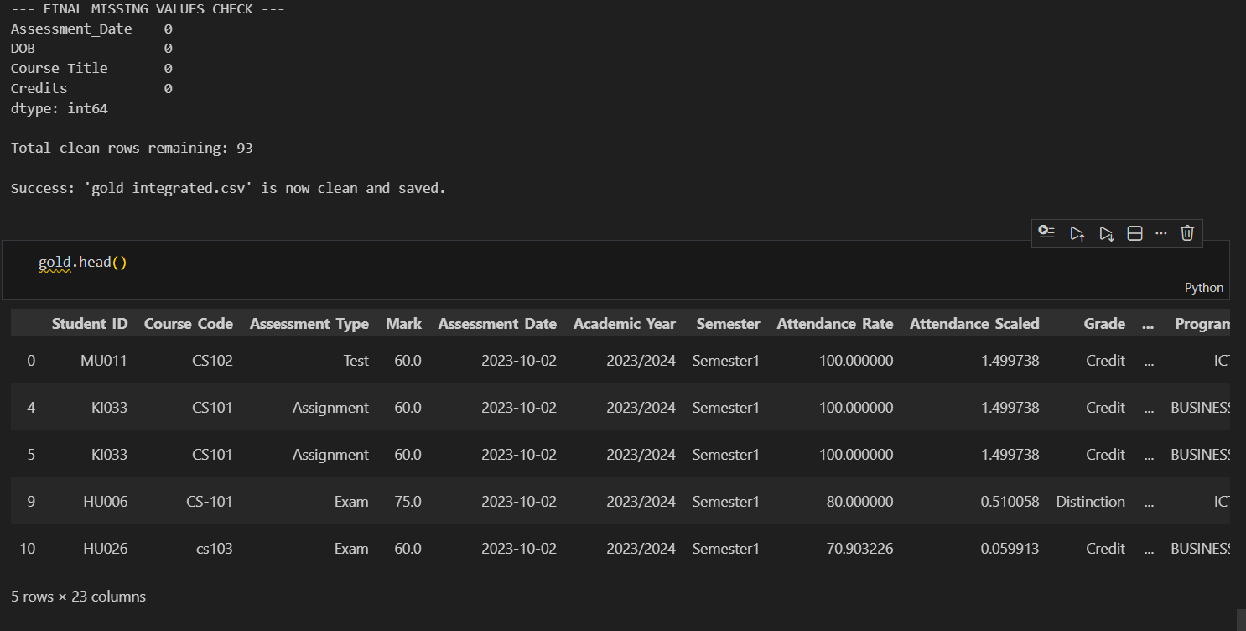

8. Before vs After Metrics
The preprocessing process significantly improved data quality.
Before Cleaning:
- Missing marks present
- Duplicate student records
- Invalid marks (>100 and negative)
- Inconsistent course codes
- Multiple date formats
After Cleaning:
- No missing critical analytical fields
- No duplicate keys
- All marks within 0–100
- Standardized formats
- Clean, consistent integration
The gold dataset is now reliable and analytics-ready.
9. Conclusion
This project successfully implemented a complete multi-campus data preprocessing pipeline. Raw datasets from Huye, Kigali, and Musanze campuses were cleaned, standardized, integrated, and enhanced through feature engineering.
Key achievements include:
- Identification and correction of data quality issues
- Removal of duplicates and outliers
- Standardization of inconsistent formats
- Creation of meaningful engineered features
- Development of a validated gold dataset
The final dataset is:
- Clean
- Consistent
- Structured
- Suitable for reporting and machine learning
This project demonstrates practical application of data mining and data warehousing concepts in a real educational context.
Future improvements may include:
- Building predictive models for student performance
- Developing real-time dashboards
- Automating the pipeline using ETL tools

