1.HOSPITAL MANAGEMENT

ACTIVITY DIAGRAM

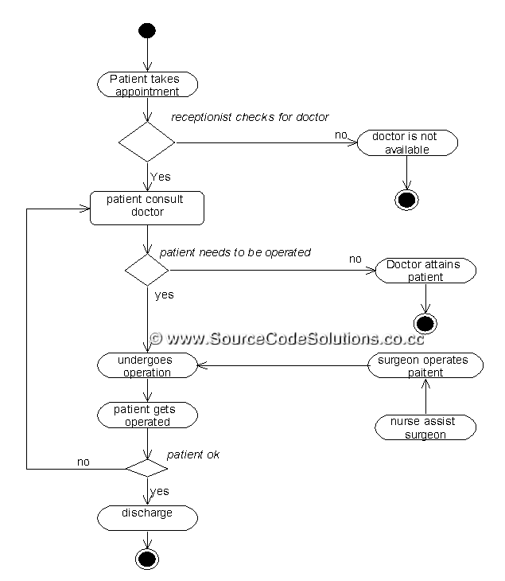

2. HOTEL MANAGEMENT

ACTIVITY DIAGRAM

