Soil Compaction Analysis
Using LiDAR Point Clouds and GPS Wheel-Track Data
Comparing Controlled Traffic Farming and Random Traffic Farming
Flaeche 1 (CTF) | Flaeche 2 (RTF) | Flaeche 3 (CTF)
Fendt 728 Vario (Gross) | Fendt 724 Vario (Klein)

Iman KARAMI

Season 2025
Institut für Landtechnik

Contents
1. Introduction 2
2. Data and Methods 3
2.1 LiDAR Data Collection 3
2.2 GPS Wheel-Track Polygons 3
2.3 Rut Depth Detection Overview 3
2.4 The Local Inter-Row Reference DTM Method 3
2.5 Smoothing Window Selection 4
2.6 Software and Implementation 4
3. Field Descriptions 5
4. Results 6
4.1 Wheel Coverage and Traffic Intensity 6
4.2 Permanent CTF Lanes 6
4.3 Reference Surface Quality 8
4.4 Rut Detection Validation 9
4.5 Rut Depth and Soil Compaction 11
4.6 F2 vs F3 Focused Comparison 15
4.6.1 Wheel-Pass Patterns 15
4.6.2 Rut Depth Maps 15
4.6.3 Depth Distribution 16
4.6.4 Depth Class Breakdown 16
4.6.5 Key Metrics Summary 17
4.7 Depth Class Distribution 18
4.8 Soil Displacement 18
4.9 Field-by-Field Analysis 18
Flaeche 1 (CTF) -- sub-AOI ~1337 m2 18
Flaeche 2 (RTF) -- sub-AOI ~1326 m2 18
Flaeche 3 (CTF) -- sub-AOI ~1310 m2 19
5. Comparison of All Three Fields 20
6. Discussion 22
7. Conclusions and Recommendations for the Farmer 23
8. Limitations 24
8.1 Reference Surface Uncertainty at the F2 Headland 24
8.2 Single Season of Data 24
8.3 Geographic Basis of F2/F3 Comparison 24
References 25

1. Introduction
Every time a tractor wheel passes over agricultural soil it compresses the structure underneath. Soil compaction reduces pore space, restricts root growth, limits water infiltration, and over time leads to yield losses in the affected areas. Under conventional Random Traffic Farming (RTF), wheels can pass over any part of the field during any operation, spreading compaction across the whole growing zone (Hamza and Anderson, 2005; Soane and van Ouwerkerk, 1994).
Controlled Traffic Farming (CTF) addresses this by guiding all machinery passes to the same permanent GPS-guided lanes every season. The crop rows between those lanes are never driven on, preserving soil structure across the majority of the field (Tullberg et al., 2007; Chamen et al., 2015).
This report compares CTF and RTF using two data sources collected during the 2025 season: LiDAR point clouds that measure ground surface elevation at centimetre accuracy, and GPS wheel-track polygon records showing exactly where each tractor wheel travelled during every field operation.
Three fields were studied: Flaeche 1 (F1) and Flaeche 3 (F3) managed under CTF, and Flaeche 2 (F2) managed under RTF. The CTF fields were operated with the Fendt 728 Vario (Gross, rear tyre 70 cm, track gauge 2.00 m) and the Fendt 724 Vario (Klein, rear tyre 60 cm, track gauge 1.80 m). Flaeche 2 and Flaeche 3 are geographically close fields in the same landscape area, making them the primary paired comparison of this study -- any measurable difference between them is most likely attributable to the traffic management system rather than differences in location or farming context.
The report answers five questions:
- How much of each field was trafficked?
- Are the deepest LiDAR points located inside the wheel tracks?
- How deep are the ruts?
- How do F2 (RTF) and F3 (CTF) compare on similar ground?
- Is CTF measurably better at protecting soil than RTF?

2. Data and Methods

2.1 LiDAR Data Collection
Airborne LiDAR scanning was carried out over all three fields on bare soil after the 2025 harvest season. A bare-soil scan is essential -- without any crop present, every laser pulse reflects directly from the soil surface, making it possible to detect depressions of just a few centimetres (Mesas-Carrascosa et al., 2015; Smith et al., 2016). Ground returns were classified as class 2 (bare earth) following standard LAS classification conventions. Each field yielded approximately 17-18 million class-2 ground points, providing a point density sufficient to resolve individual wheel ruts at 10 cm horizontal pixel resolution. All processing was carried out in the projected coordinate system ETRS89 / UTM zone 33N (EPSG:32633).

2.2 GPS Wheel-Track Polygons
The Fendt 728 Vario and Fendt 724 Vario are equipped with RTK-GPS guidance systems, which correct satellite positioning errors using a fixed ground reference station and achieve horizontal accuracy of approximately 2-5 cm (Stombaugh, 2009; Perez-Ruiz and Upadhyaya, 2012). During every field operation the guidance system recorded the tractor position and travel direction. From this trajectory, together with the known tyre width and track gauge of each machine, a polygon was computed representing the area covered by each individual wheel pass. These records were exported as shapefiles, with one polygon per wheel side per operation, attributed with tractor identifier and date.

2.3 Rut Depth Detection Overview
Measuring rut depth requires comparing the actual soil surface inside the wheel track to what the surface would have been if no tractor had driven there. This undisturbed reference surface must be estimated because the soil inside the rut has already been displaced. Two methods were applied:
Method A -- Rut location validation. For each wheel-track polygon, the minimum LiDAR elevation was identified within successive 2-metre sample blocks and plotted as a point on the map. If these deepest points all fall inside the wheel-track polygons, it confirms the LiDAR is detecting real ruts and not random surface noise. Results are shown in Section 4.4.
Method B -- Field-wide Inter-Row Reference DTM. The primary depth measurement method. Described in full in Section 2.4.

2.4 The Local Inter-Row Reference DTM Method
All three fields have natural slopes and rolling terrain. Without correction, low-lying areas would appear as deep ruts and high ground would appear undisturbed, regardless of where the tractor actually drove. The Local Inter-Row Reference DTM Method removes this terrain effect by using the undisturbed soil between the wheel tracks as the local reference (Raper, 2005; Keller et al., 2007):
Step 1. All wheel-track polygons were merged and buffered 0.20 m into a single compacted footprint. Soil outside this footprint was never touched by a wheel and represents undisturbed terrain.

Step 2. The mean LiDAR elevation of undisturbed inter-row pixels was computed at 50 cm resolution, creating a raw reference surface.

Step 3. A weighted spatial average (uniform filter) bridged across the wheel-track gaps by interpolating from inter-row measurements on either side, estimating what the terrain height would have been beneath the wheels.
Step 4. Rut depth = minimum LiDAR elevation inside the rut minus the interpolated reference at the same location. A value of -5 cm means the wheel pressed the soil 5 cm below the adjacent undisturbed surface (Lindner et al., 2016).
$$rut depth = minimum LiDAR elevation in pixel - interpolated reference elevation at same location$$
Reference quality was verified by checking the residual standard deviation at undisturbed inter-row check points. A standard deviation below 3 cm is rated GOOD and means the reference surface reliably represents the undisturbed terrain (Whelan and Taylor, 2013).

2.5 Smoothing Window Selection
A sensitivity analysis was performed for each field to find the best smoothing window width. Multiple window sizes were tested and the one producing the lowest residual standard deviation at inter-row check points was selected. Table 1 shows the results. The 2 m window gave the best results in all three fields, confirming it correctly follows local terrain variation in all cases. Using the same window for all three fields also ensures that differences in measured depth reflect real differences in compaction, not methodological differences.
Tabelle 1. Smoothing window sensitivity analysis. The 2 m window gives the lowest residual standard deviation in all three fields.
Field | Method | Windows tested | Residual std at each window | Window selected | Final residual std
F1 | CTF | 2 / 5 / 10 / 25 m | 1.34 / 1.78 / 2.24 / 3.10 cm | 2 m | 1.34 cm
F2 | RTF | 2 / 5 / 10 / 20 m | 1.23 / 2.03 / 2.84 / 5.01 cm | 2 m | 1.23 cm
F3 | CTF | 2 / 5 / 10 / 25 m | 1.41 / 1.85 / 2.35 / 3.22 cm | 2 m | 1.41 cm

2.6 Software and Implementation
All analysis was implemented in Python 3.13 using laspy for LAS point cloud reading, geopandas and shapely for vector polygon operations, rasterio for raster input/output, scipy.ndimage for spatial filtering, and matplotlib for visualisation. Raster outputs were saved as GeoTIFF files at 10 cm resolution for depth rasters and 50 cm resolution for the reference DTM.

3. Field Descriptions
Tabelle 2. Summary of the three study fields. Sub-AOI areas are equal-sized analysis zones used for cross-field comparison.
Field | Method | Sub-AOI area | Terrain | Tractors
Flaeche 1 (F1) | CTF | ~1337 m2 | Sloped, ~3 m elevation change | Fendt 728 (4 ops) + Fendt 724 (7 ops)
Flaeche 2 (F2) | RTF | ~1326 m2 | Rolling, curved, with hollows | Single tractor (no source separation)
Flaeche 3 (F3) | CTF | ~1310 m2 | Rolling hill across field | Fendt 728 (4 ops) + Fendt 724 (8 ops)

Flaeche 2 and Flaeche 3 are geographically close, both located in the same landscape area. This proximity makes them the primary comparison pair for CTF versus RTF -- they represent similar field conditions managed under contrasting traffic systems. Flaeche 1 serves as a second CTF reference field.
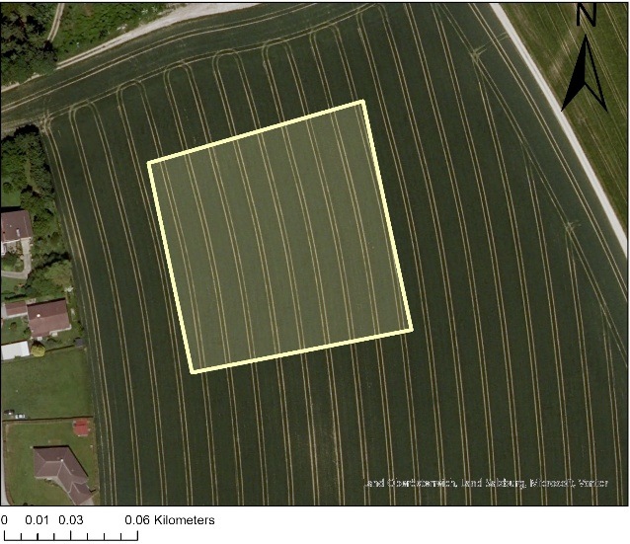
Abbildung 1. .satellite map showing the boundaries and geographic of Flaeche 1

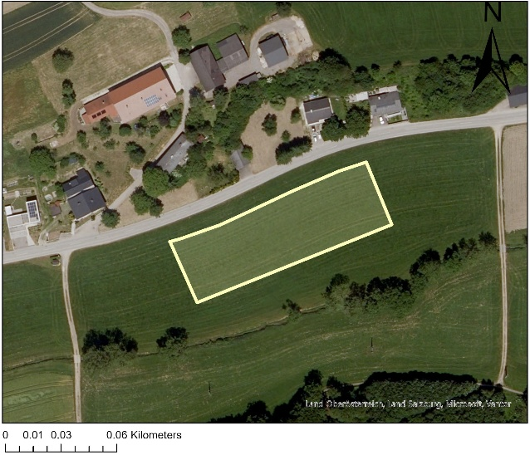
Abbildung 2. satellite map showing the boundaries and geographic of Flaeche 3
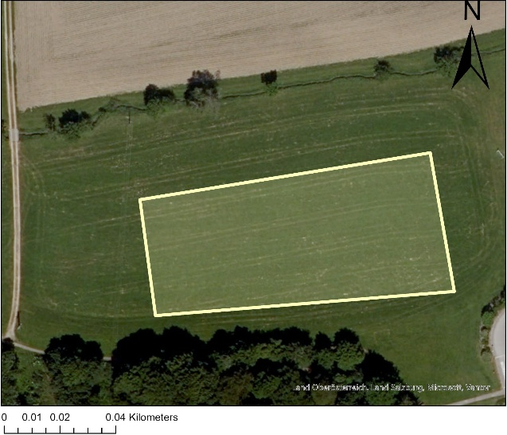
Abbildung 3. satellite map showing the boundaries and geographic of Flaeche 2

4. Results

4.1 Wheel Coverage and Traffic Intensity
Table 3 shows what fraction of each field's area received zero, one to two, three to five, or six or more wheel passes during the 2025 season. This coverage analysis is the most direct measure of the protection CTF provides to soil.

Tabelle 3. Percentage of field area by number of wheel passes during the 2025 season (equal-area sub-AOI, approximately 1330 m2 per field).
Pass count | F1 CTF | F2 RTF | F3 CTF
No wheel contact | 83.6% | 40.9% | 84.7%
1-2 passes | 1.8% | 55.5% | 2.1%
3-5 passes | 3.6% | 3.6% | 1.9%
6+ passes | 11.0% | 0.0% | 11.2%
Total trafficked | 16.4% | 59.1% | 15.3%

The CTF fields (F1 and F3) protected 84-85% of their soil from any wheel contact. The RTF field (F2) protected only 41%. For every 100 m of field, CTF leaves approximately 84 m of topsoil completely undisturbed while RTF leaves only 41 m. This difference of 43-44 percentage points is the most fundamental benefit of CTF (Hamza and Anderson, 2005; Chamen et al., 2015).
The traffic patterns also differ structurally. Under RTF (F2), 56% of the field received only 1-2 passes spread thinly with no spatial organisation. Under CTF, 11% of the field received 6 or more passes -- but all of that concentrated compaction falls within the permanent lanes, leaving the crop rows completely undisturbed throughout the season (Tullberg et al., 2007).

4.2 Permanent CTF Lanes
In a CTF system all tractor and implement passes are guided to the same permanent lanes every season. The pass-count maps (Figures 4, 5, and 6) show the spatial outcome for the 2025 season.
In the CTF fields (F1 and F3), the dark red strips (6+ passes) mark the permanent lane positions -- the exact lines where both tractors' wheel tracks repeatedly coincided across all operations of the season. The wide grey areas between these strips are the crop rows, which received zero wheel contact throughout the year. This spatial separation of compacted lanes from undisturbed crop rows is the defining characteristic of CTF (Antille et al., 2019; Chamen, 2015).

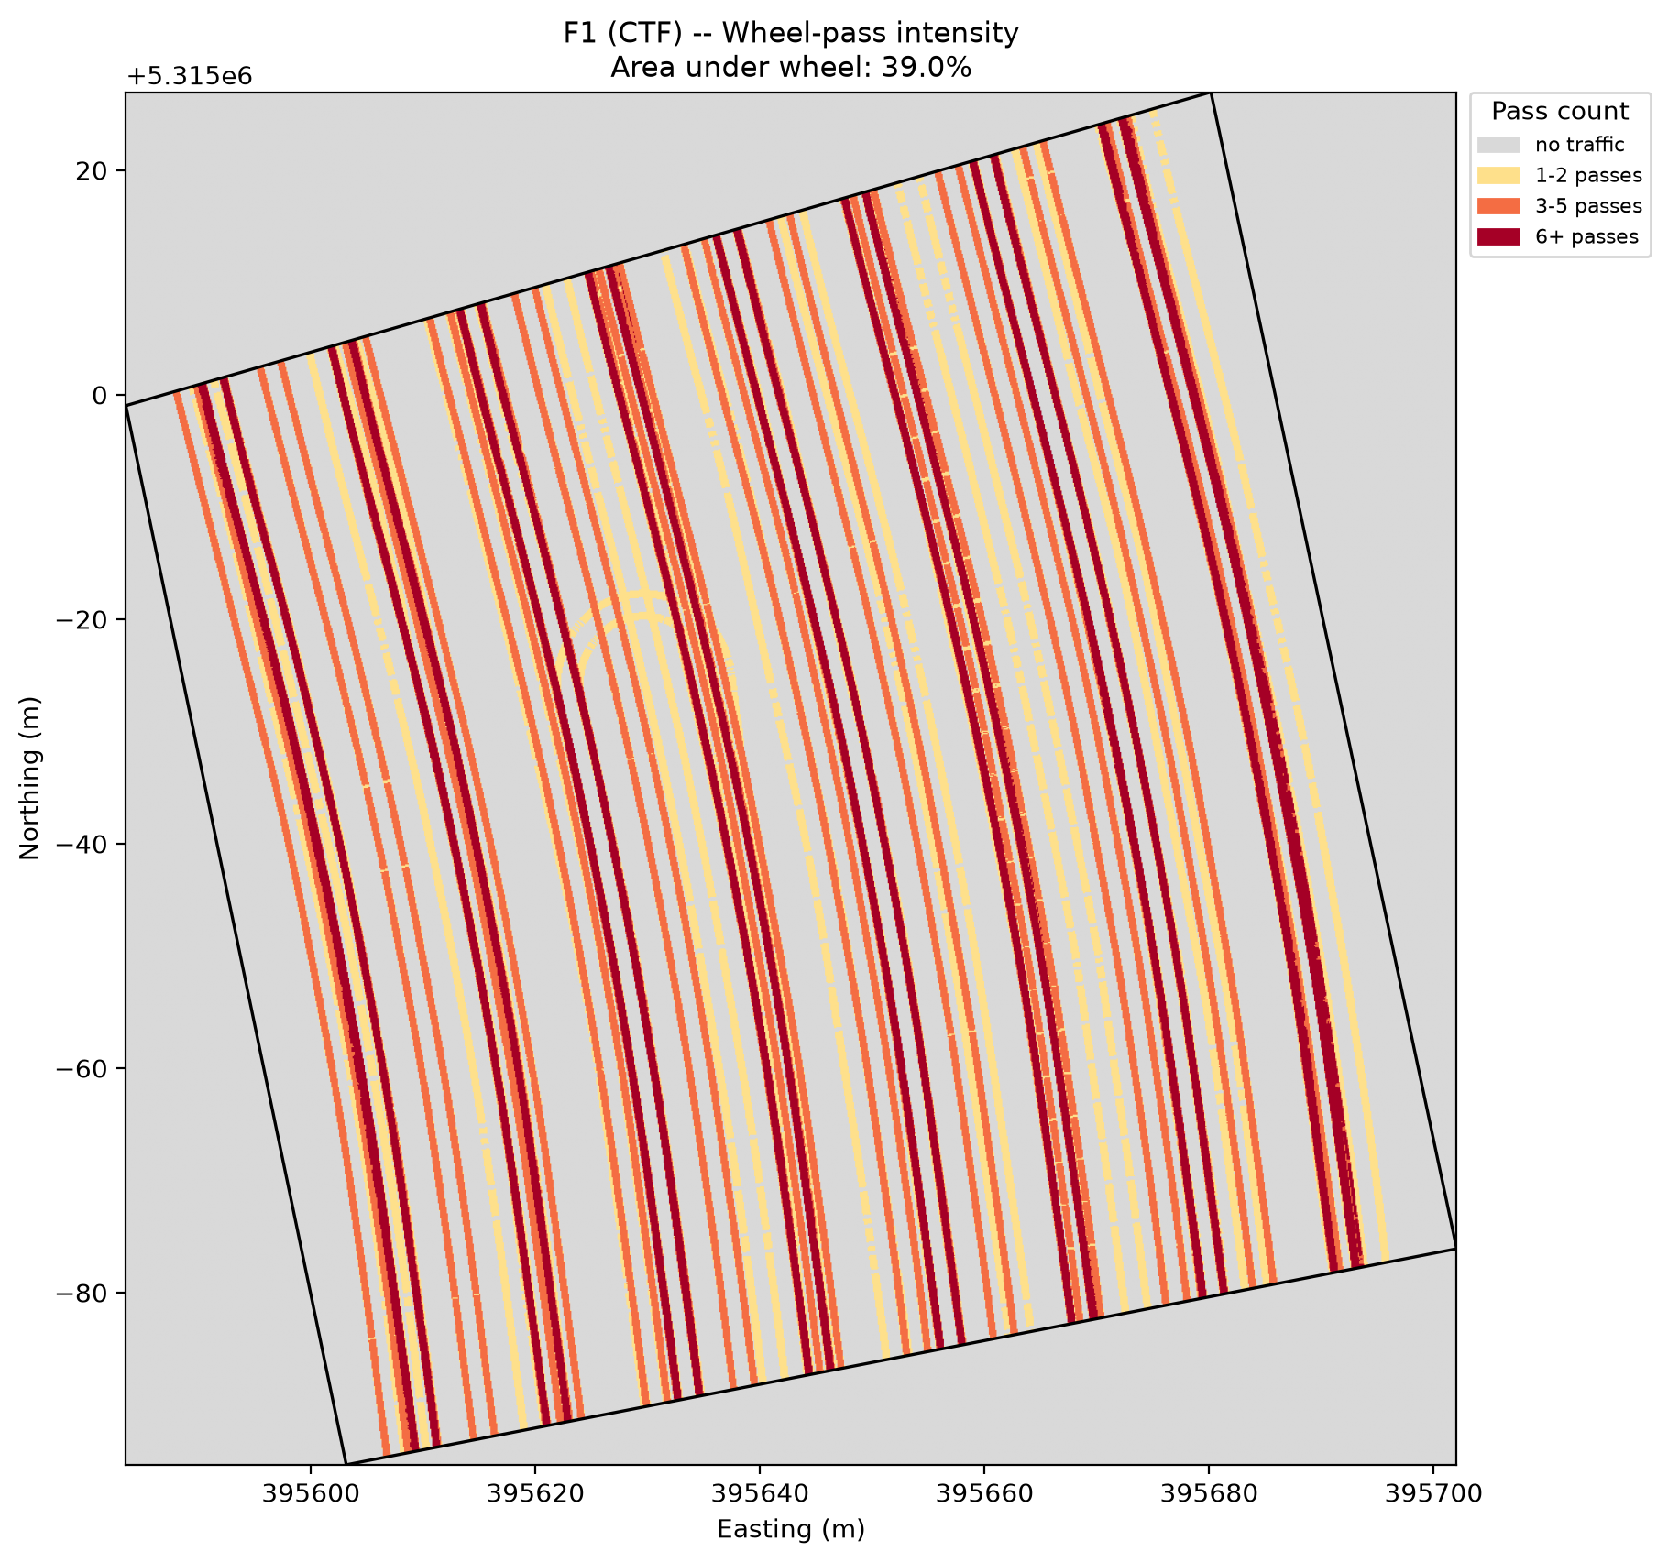
Abbildung 4. Wheel-pass intensity map. Dark red vertical strips = permanent CTF lanes (6+ passes). Grey = never trafficked (83.6% of sub-AOI). The narrow, organised lane structure confirms effective CTF guidance.

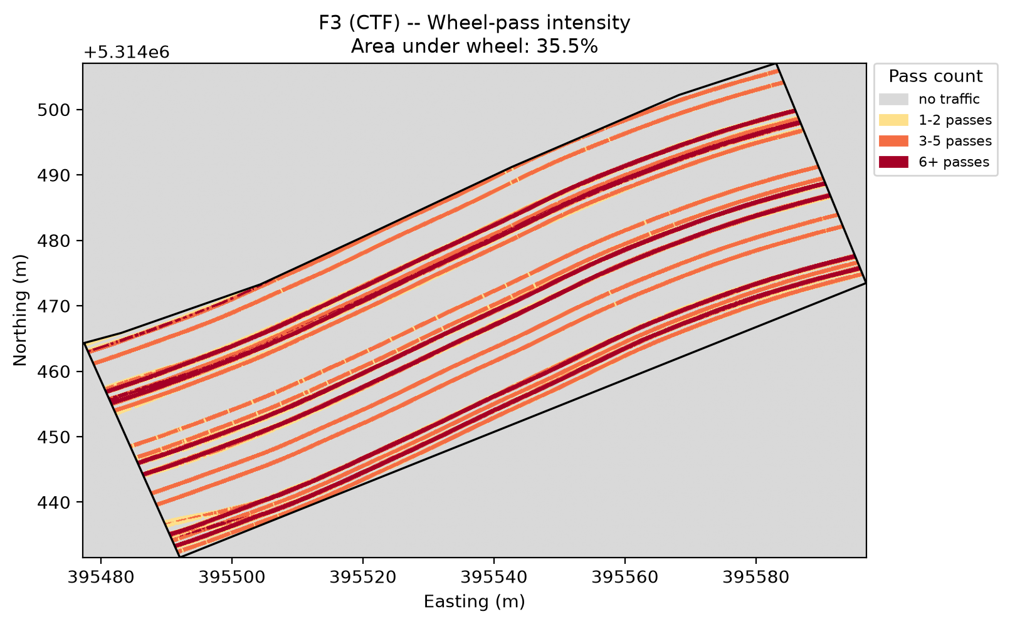
Abbildung 5. Flaeche 3 (CTF) -- Wheel-pass intensity map. The diagonal orientation follows the field shape. Narrow dark red cores with wide grey zones between them confirm effective CTF lane confinement (84.7% protected).

In the RTF field (F2), no organised lane structure is present. The yellow-dominated map shows thinly spread 1-2 pass coverage across most of the field, with no strips that were consistently used in every operation.
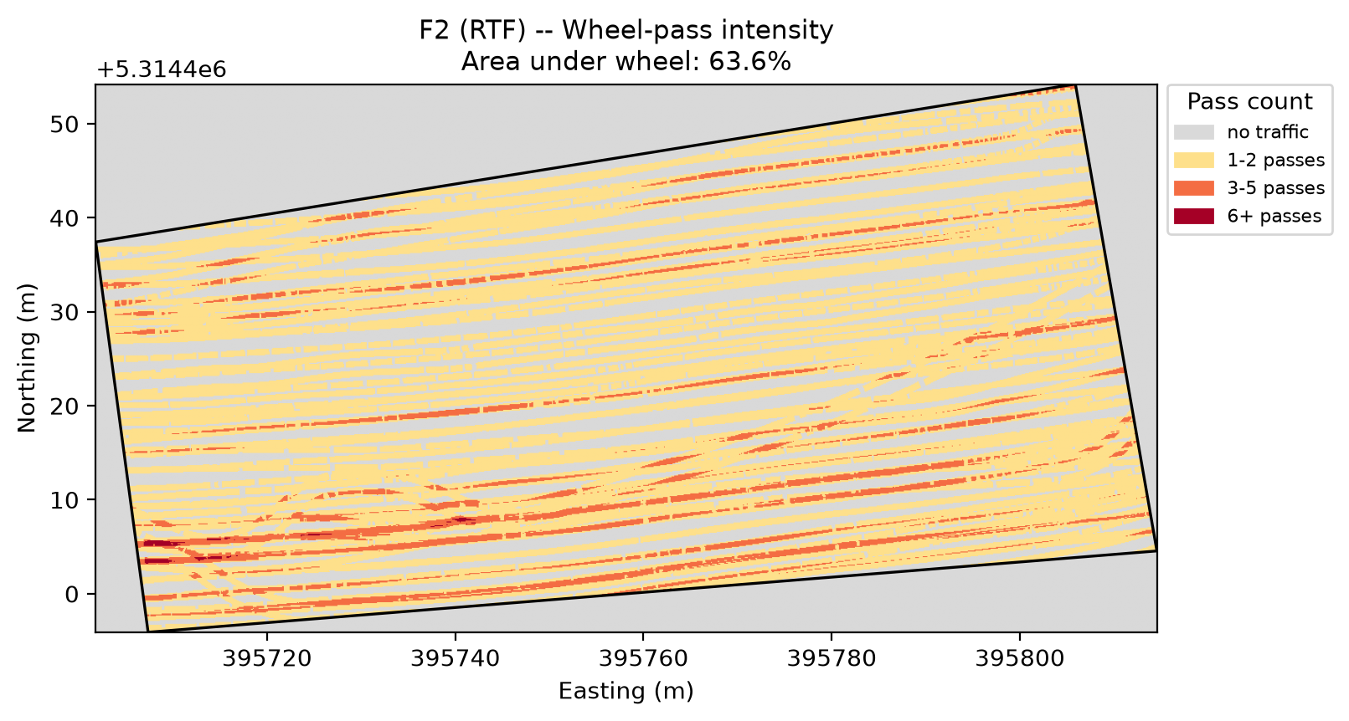
Abbildung 6. Flaeche 2 (RTF) -- Wheel-pass intensity map. The diffuse yellow pattern shows no permanent lane system. 59.1% of the field received at least one wheel pass, spread randomly across the field without spatial organisation.

4.3 Reference Surface Quality
Before interpreting rut depth values, it is necessary to confirm that the terrain correction method worked correctly in each field. The residual histogram shows the difference between actual LiDAR elevation at undisturbed inter-row points and the reference surface at those same locations. A narrow peak centred near zero means the reference correctly represents the undisturbed terrain.

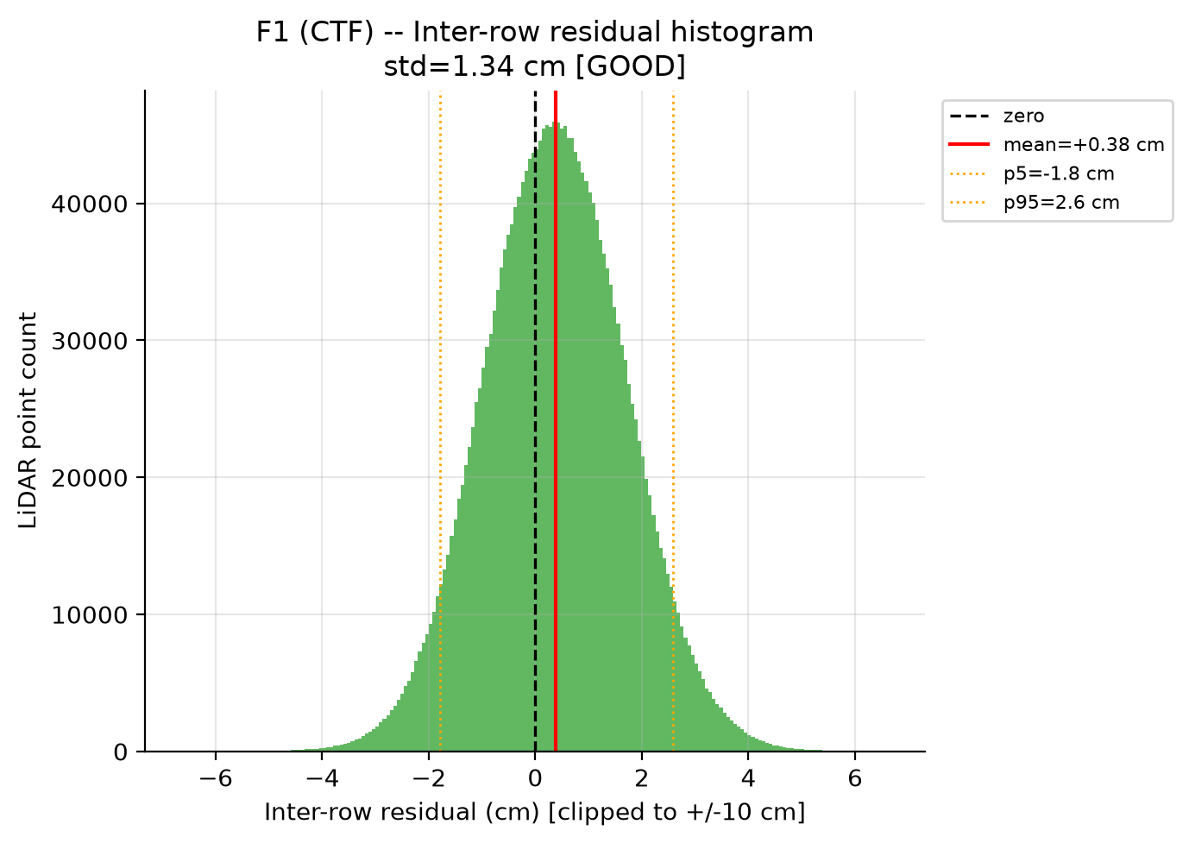
Abbildung 7. Flaeche 1 (CTF) -- Residual std = 1.34 cm [GOOD]. Narrow symmetric peak confirms reliable terrain correction.
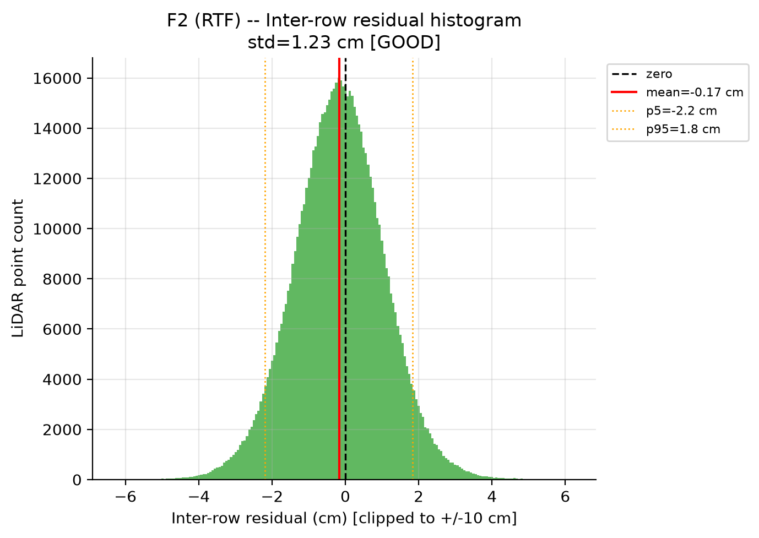
Abbildung 8. Flaeche 2 (RTF) -- Residual std = 1.23 cm [GOOD]. Despite having only 16.6% undisturbed reference soil, the 2 m window correctly captures local terrain variation, giving the best reference quality of all three fields.

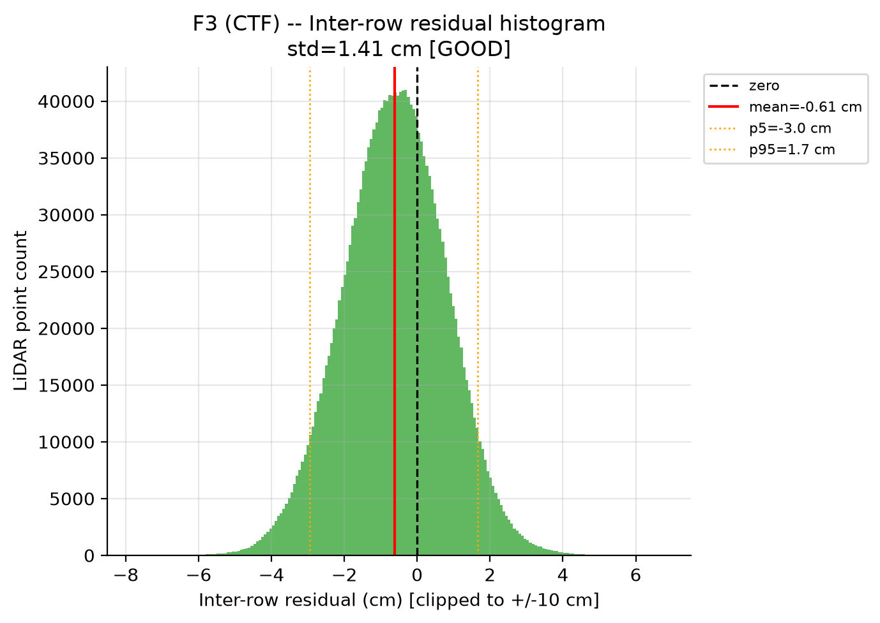
Abbildung 9. Flaeche 3 (CTF) -- Residual std = 1.41 cm [GOOD].
All three fields achieve equivalent GOOD reference quality with the same 2 m smoothing window. Rut depth values are reliable to within approximately 1.2-1.4 cm for all fields, enabling valid cross-field comparison.

4.4 Rut Detection Validation
A key question before interpreting rut depth results is whether the LiDAR scan is actually detecting real ruts or simply measuring random surface variation. If ruts are real, the deepest LiDAR points found within each wheel-track polygon should consistently fall inside the polygon boundaries and form a spatially coherent pattern along the direction of travel. If they were random noise, the deepest points would be scattered randomly across the field with no relationship to the wheel tracks.
For each field, the deepest LiDAR return was identified every 2 metres along the field and plotted as a coloured dot on the map. The orange background shows where the wheel-track polygons are located. If all dots fall inside the orange areas, it confirms the LiDAR is detecting real ruts confined to the wheel tracks.
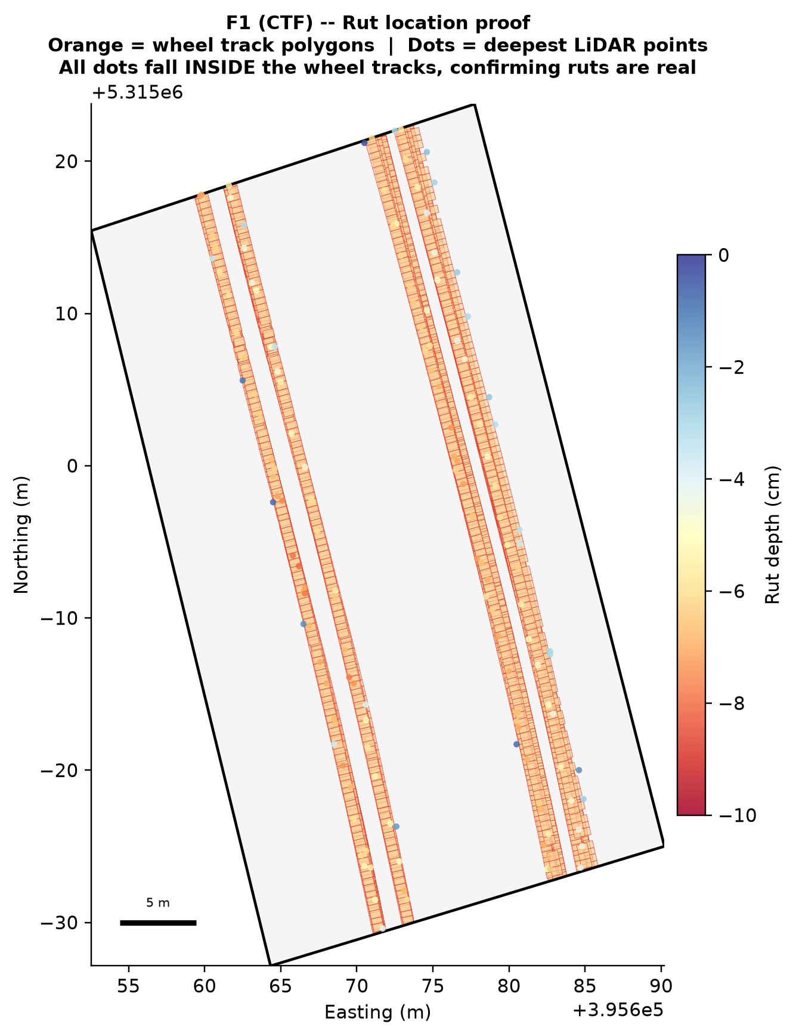
Abbildung 10. Flaeche 1 (CTF) -- Rut location proof. Orange = wheel-track polygons. Coloured dots = deepest LiDAR points (red = deeper, blue = shallower). All dots fall inside the orange wheel tracks. No deep points appear in the grey inter-row zones, confirming the signal is real.

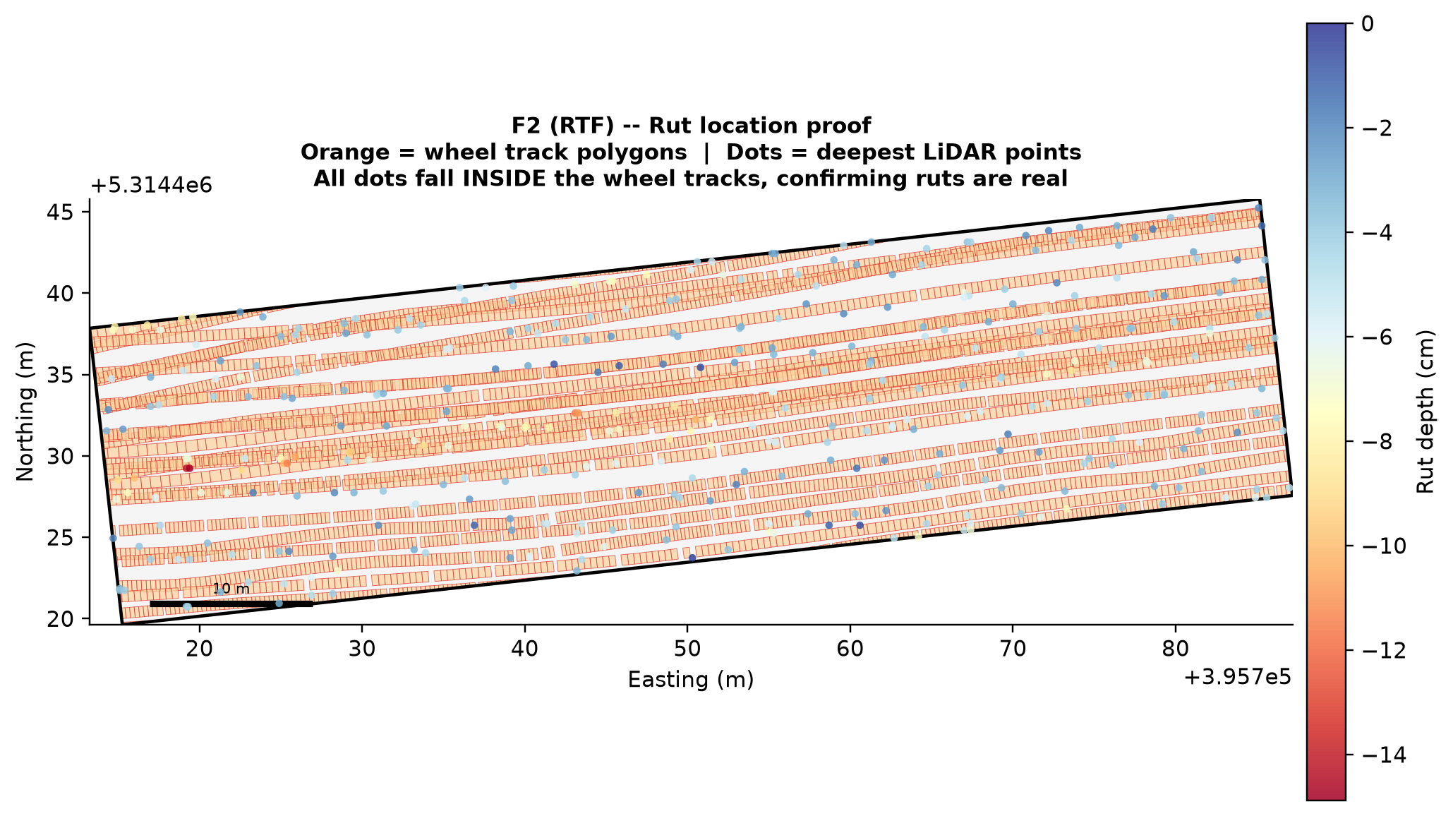
Abbildung 11. Flaeche 2 (RTF) -- Rut location proof. With RTF covering most of the field, the orange polygons are widespread. All deepest LiDAR points fall inside the wheel tracks. One dark red dot near the western edge (deepest = -14.9 cm) corresponds to the headland area with concentrated turning passes.

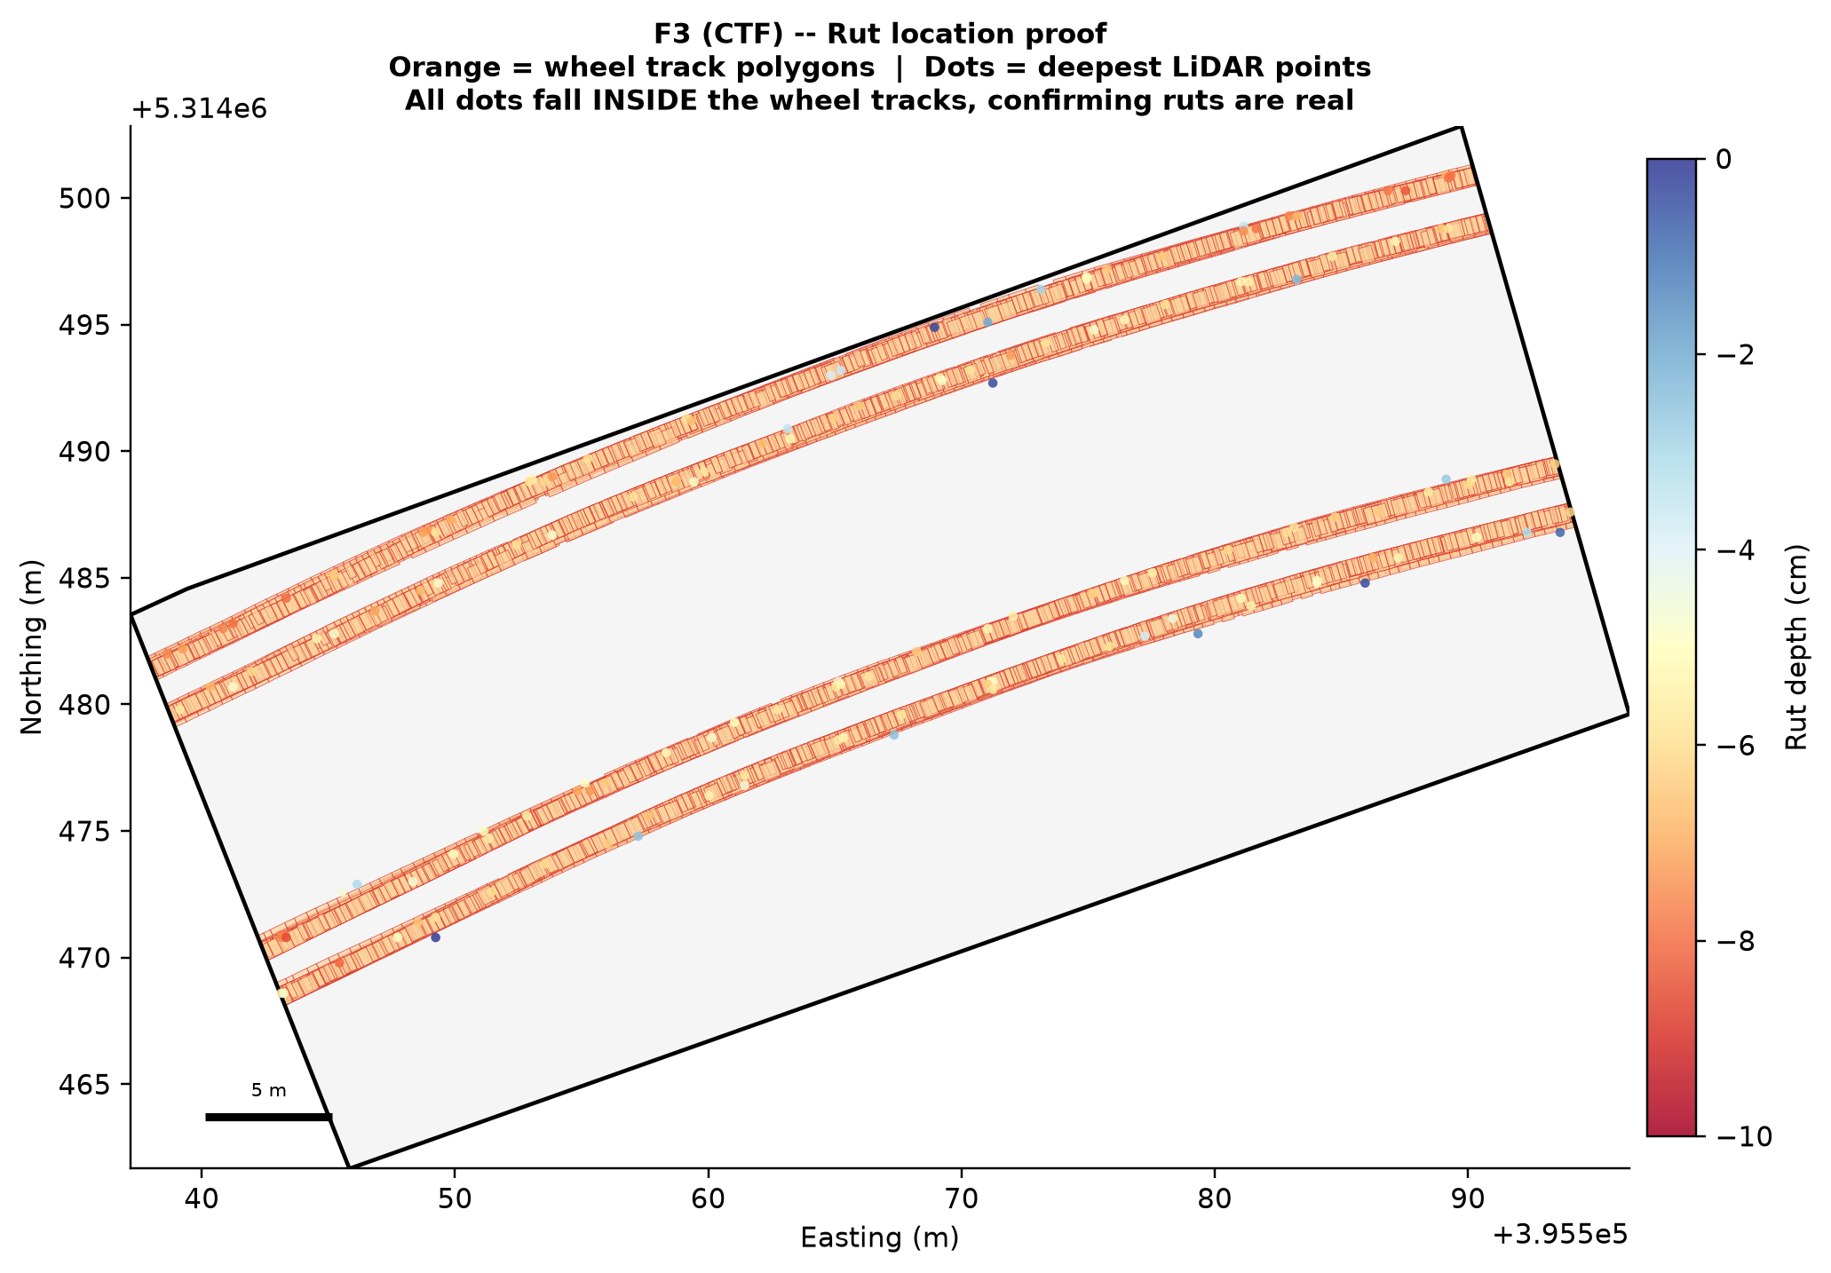
Abbildung 12. Flaeche 3 (CTF) -- Rut location proof. The clear CTF lane structure is visible in the orange polygon pattern. All deepest points fall within the lane polygons, with no deep detections in the undisturbed inter-row zones.

In all three fields, every detected deep point falls inside a wheel-track polygon. No deep LiDAR returns were detected in the undisturbed inter-row zones. This confirms that the depth measurements in the following sections reflect real tractor-induced soil compaction and not terrain noise or measurement artefacts.

4.5 Rut Depth and Soil Compaction
Figure 13.14.15 shows the four-panel diagnostic maps for each field: reference zones, reference DTM, full-field depth map, and depth class map. The depth maps reveal clearly different compaction patterns between CTF and RTF.
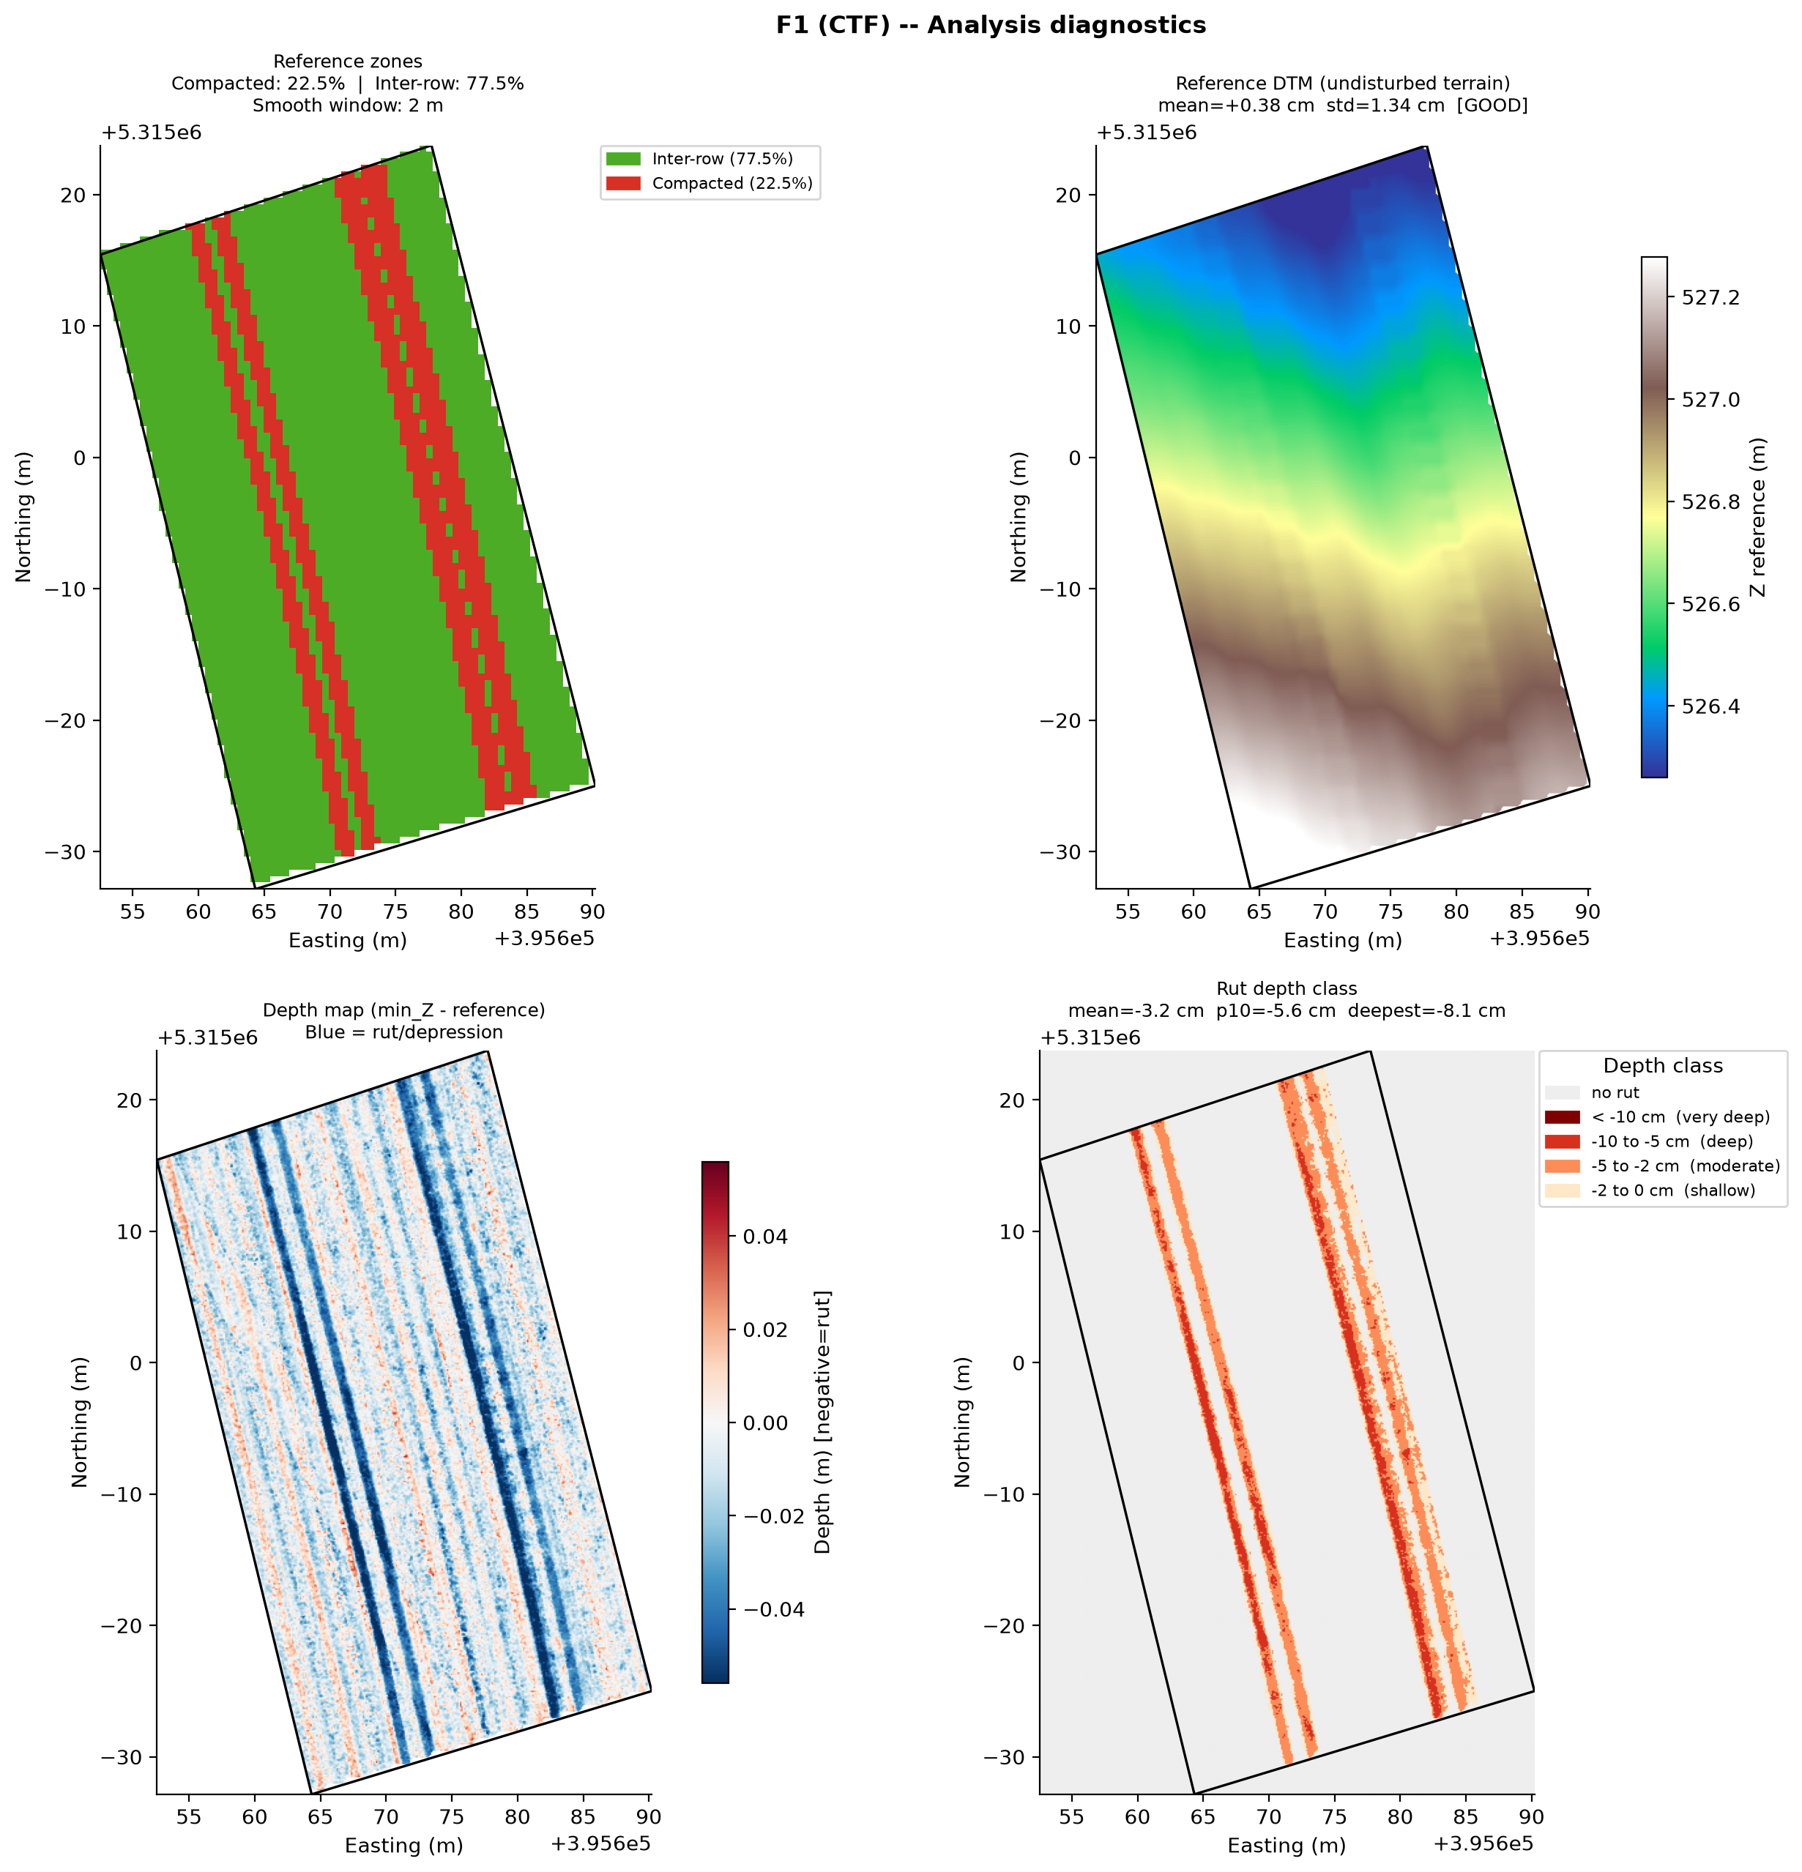
Abbildung 13. Flaeche 1 (CTF) -- Analysis diagnostics. Top-left: reference zones (green = undisturbed inter-row 77.5%, red = compacted 22.5%). Top-right: reference DTM following the terrain slope. Bottom-left: depth map (blue = rut). Bottom-right: depth class map. The narrow parallel blue lines confirm CTF confinement of compaction to permanent lanes.
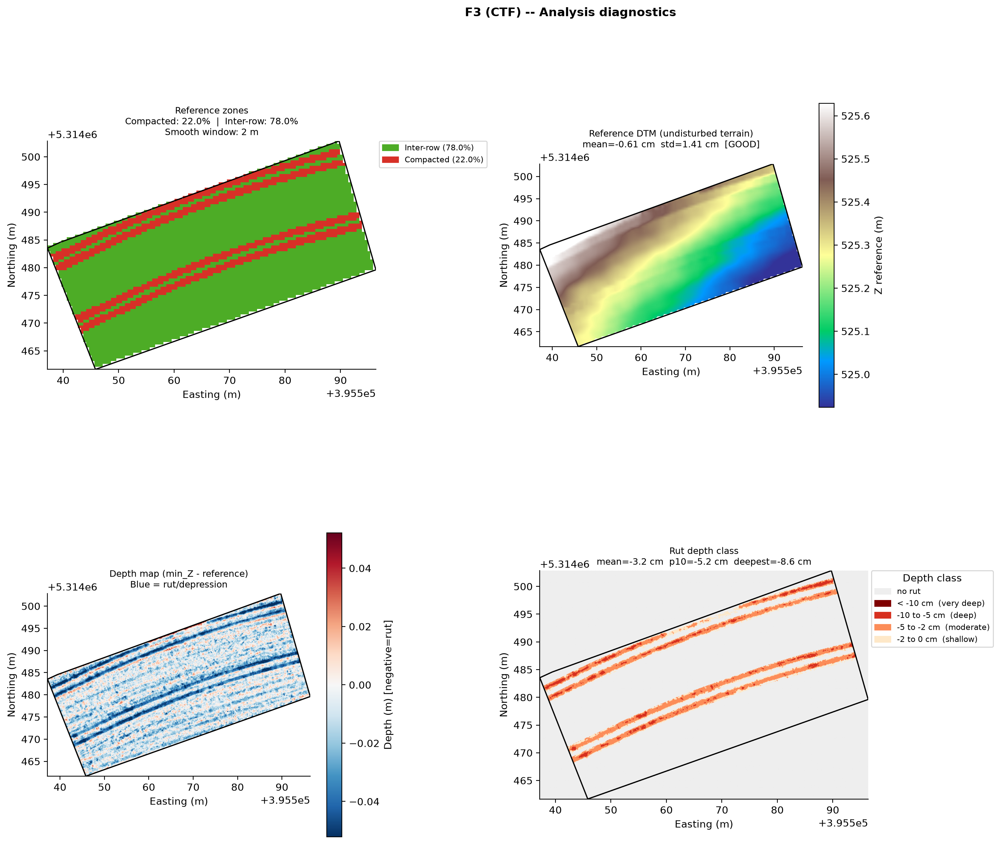
Abbildung 14. Flaeche 3 (CTF) -- Analysis diagnostics. 78% inter-row reference, clear permanent lane structure visible in depth map. Mean depth = -3.2 cm, deepest = -8.6 cm.
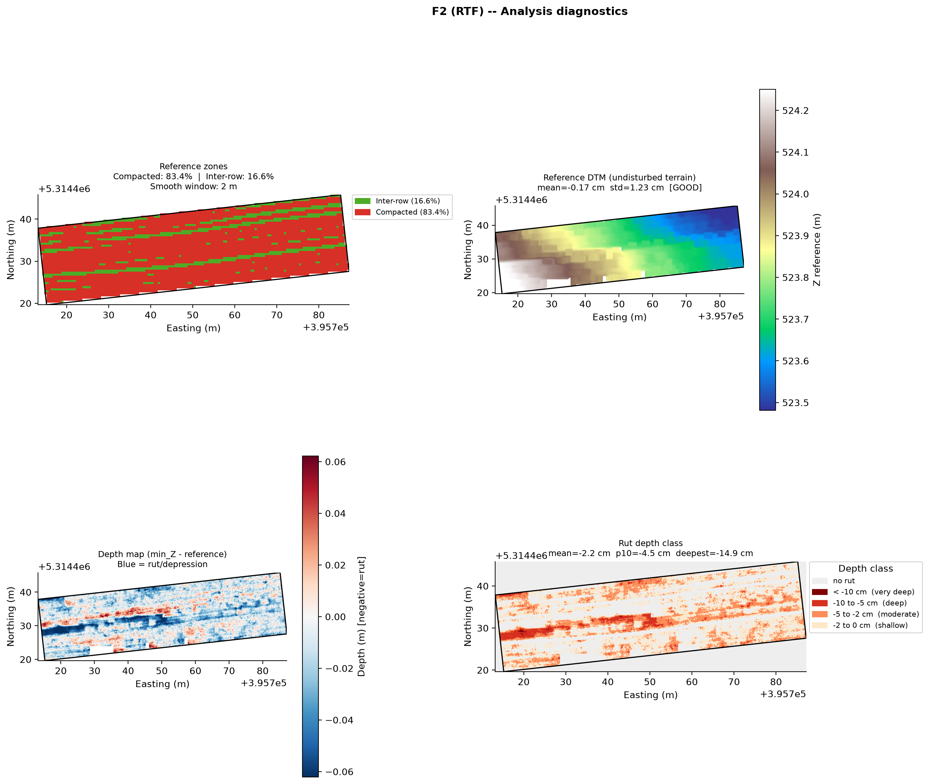
Abbildung 15. Flaeche 2 (RTF) -- Analysis diagnostics. Reference zones (top-left) show 83.4% compacted (red) with only 16.6% undisturbed reference (green dots). The depth map (bottom-left) shows diffuse widespread compaction with no organised structure. Mean depth =-2.2 cm, deepest = -14.9 cm in the headland area.

Tabelle 4. Rut depth statistics per field (equal-area sub-AOI).
Metric | F1 CTF | F2 RTF | F3 CTF
Mean rut depth | -3.2 cm | -2.2 cm | -3.2 cm
p10 depth (10% deeper than) | -5.6 cm | -4.5 cm | -5.2 cm
Deepest point | -8.1 cm | -14.9 cm | -8.6 cm
Reference std | 1.34 cm Good | 1.23 cm Good | 1.41 cm Good

The mean rut depth per wheel pass is similar across all three fields (2.2-3.2 cm). This does not mean compaction is equal -- the critical difference is coverage. RTF traffics 59% of the field versus only 15-16% for CTF. The total compaction impact at field scale must account for how much soil is affected, not just how deep individual ruts are (Hamza and Anderson, 2005; Schjønning et al., 2015). The F2 deepest point of -14.9 cm corresponds to the headland area where repeated turning operations concentrated -- see Section 8.1 for a note on uncertainty at this extreme value.

4.6 F2 vs F3 Focused Comparison

Flaeche 2 and Flaeche 3 are geographically close fields managed under contrasting traffic systems. This section presents their direct comparison as the primary scientific result of this study.

4.6.1 Wheel-Pass Patterns

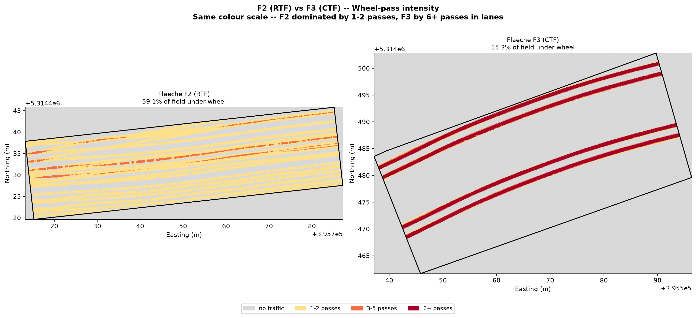
Abbildung 16. F2 (RTF) vs F3 (CTF) -- Wheel-pass intensity at the same colour scale. F2 (left) is dominated by yellow (1-2 passes) spread across 59% of the field. F3 (right) shows narrow dark red permanent lanes (6+ passes) with 85% of the field in grey (no traffic). The structural difference between RTF and CTF is immediately visible.

4.6.2 Rut Depth Maps

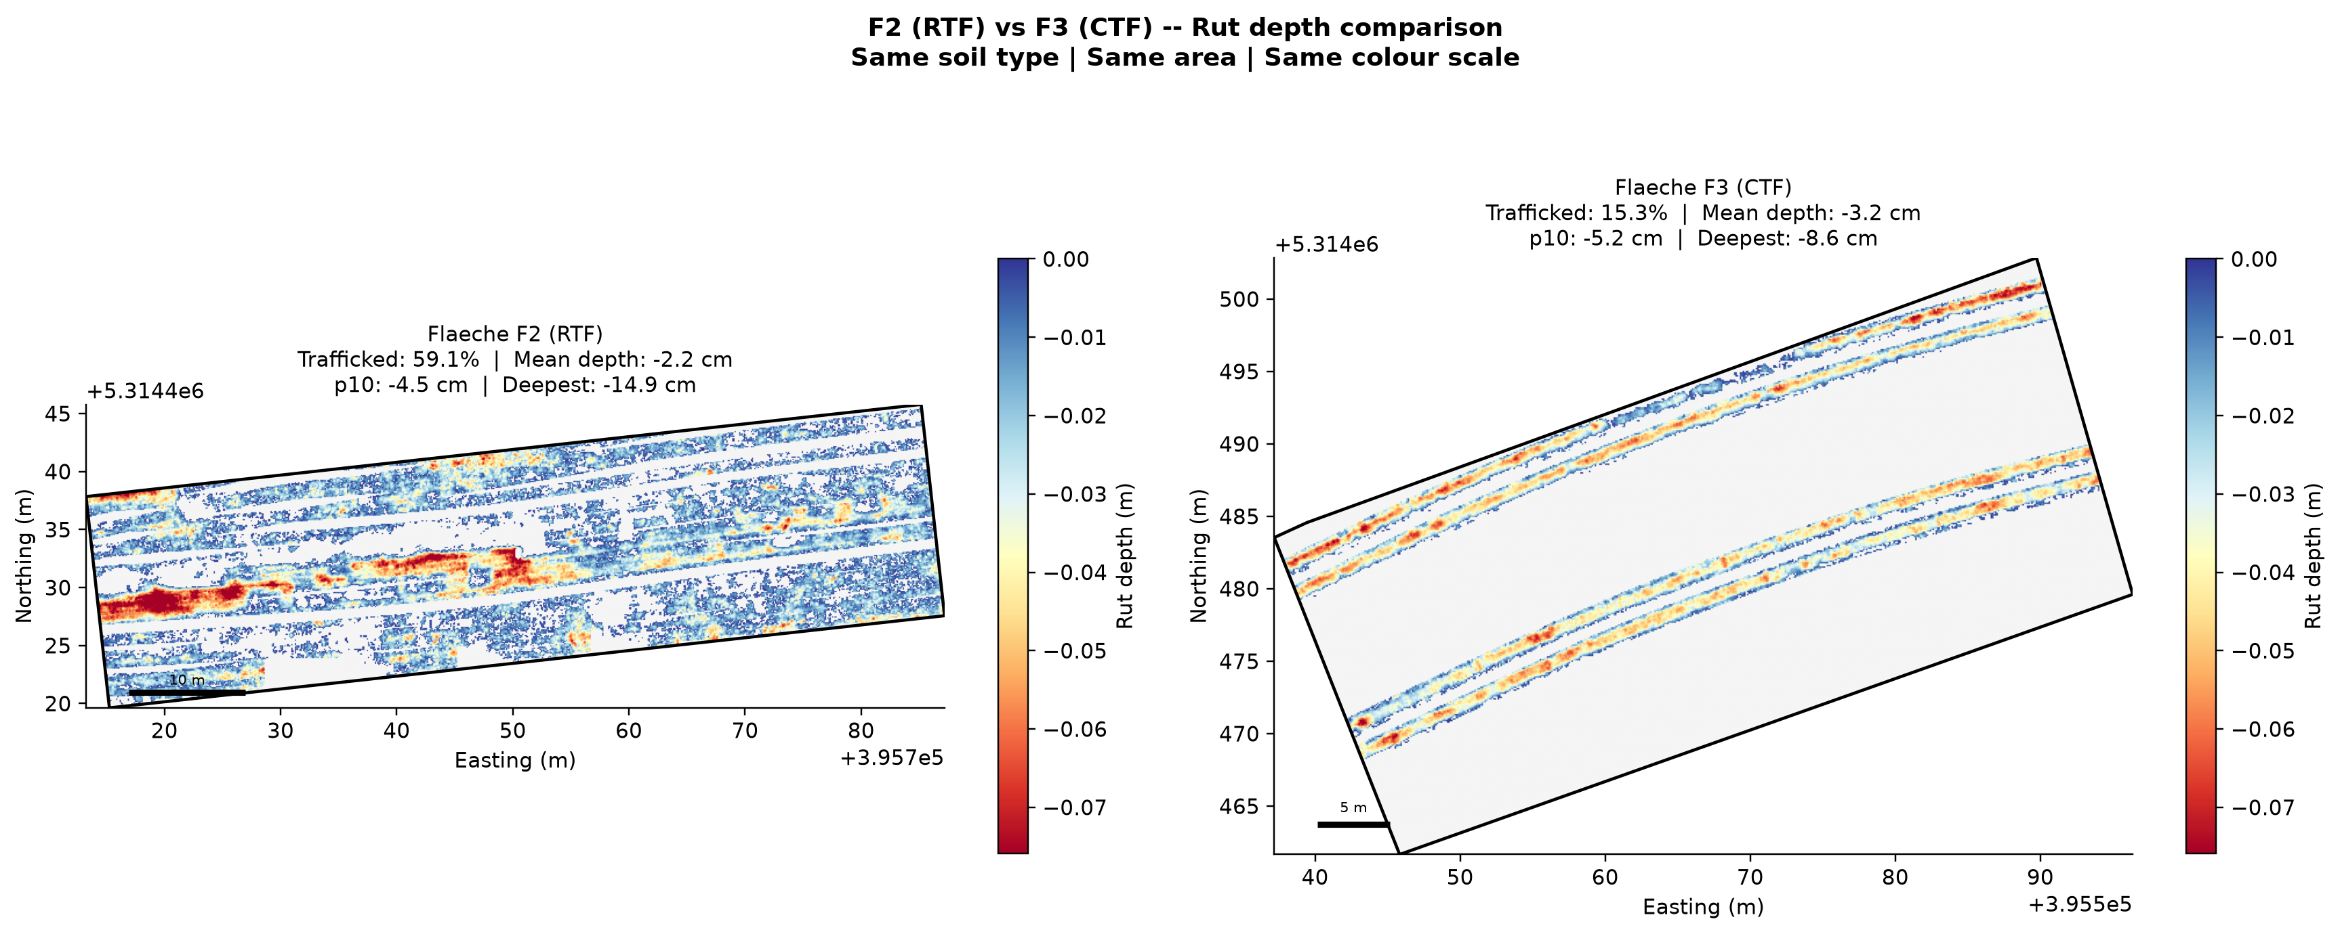
Abbildung 17. F2 (RTF) vs F3 (CTF) -- Rut depth maps at the same colour scale. F2 (left) shows diffuse shallow compaction spread across most of the field. F3 (right) shows narrow concentrated ruts confined to the permanent lanes, with most of the field showing no depth signal. Both fields show mean rut depth of approximately -2.2 to -3.2 cm where the wheel drives, but the spatial distribution is completely different.

4.6.3 Depth Distribution

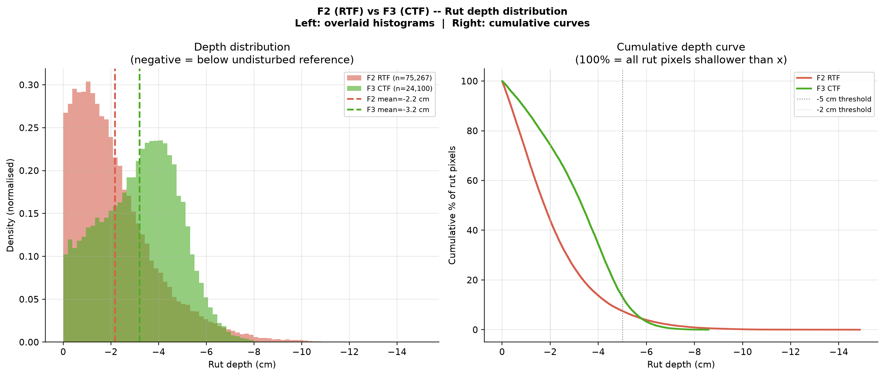
Abbildung 18. F2 (RTF) vs F3 (CTF) -- Rut depth distribution. Left: overlaid histograms (normalised density). F2 (red) peaks at approximately -1 to -2 cm -- mostly shallow. F3 (green) peaks at approximately -3 cm and has a longer tail toward deeper values. Right: cumulative curves showing that at every depth threshold, a higher percentage of F3 rut pixels are deeper. At -5 cm, 15% of F3 rut pixels are deeper versus only 5% for F2.

4.6.4 Depth Class Breakdown

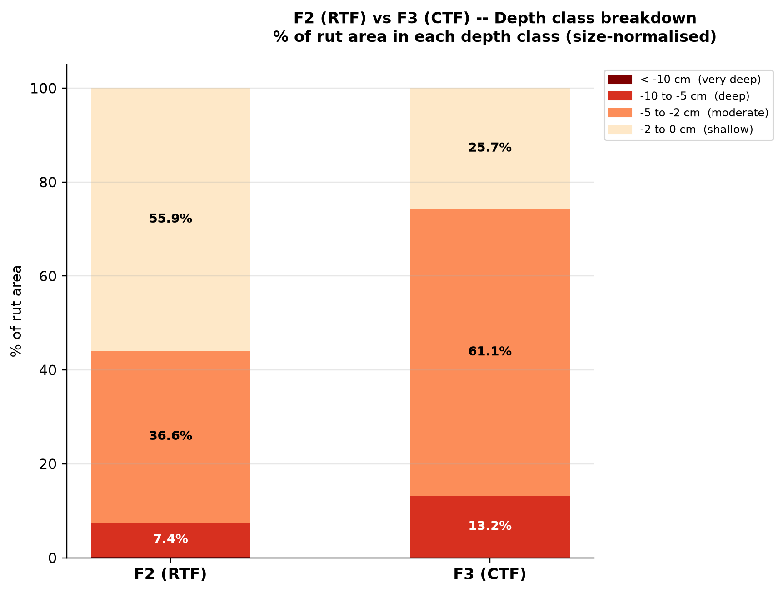

Abbildung 19. F2 (RTF) vs F3 (CTF) -- Depth class breakdown (% of rut area). F2 RTF has 55.9% of rut area in the shallow class (-2 to 0 cm) -- most passes cause only light compaction. F3 CTF has 61.1% in the moderate class (-5 to -2 cm) and 13.2% in the deep class (>5 cm), reflecting the cumulative effect of repeated passes on the same permanent lanes.

4.6.5 Key Metrics Summary
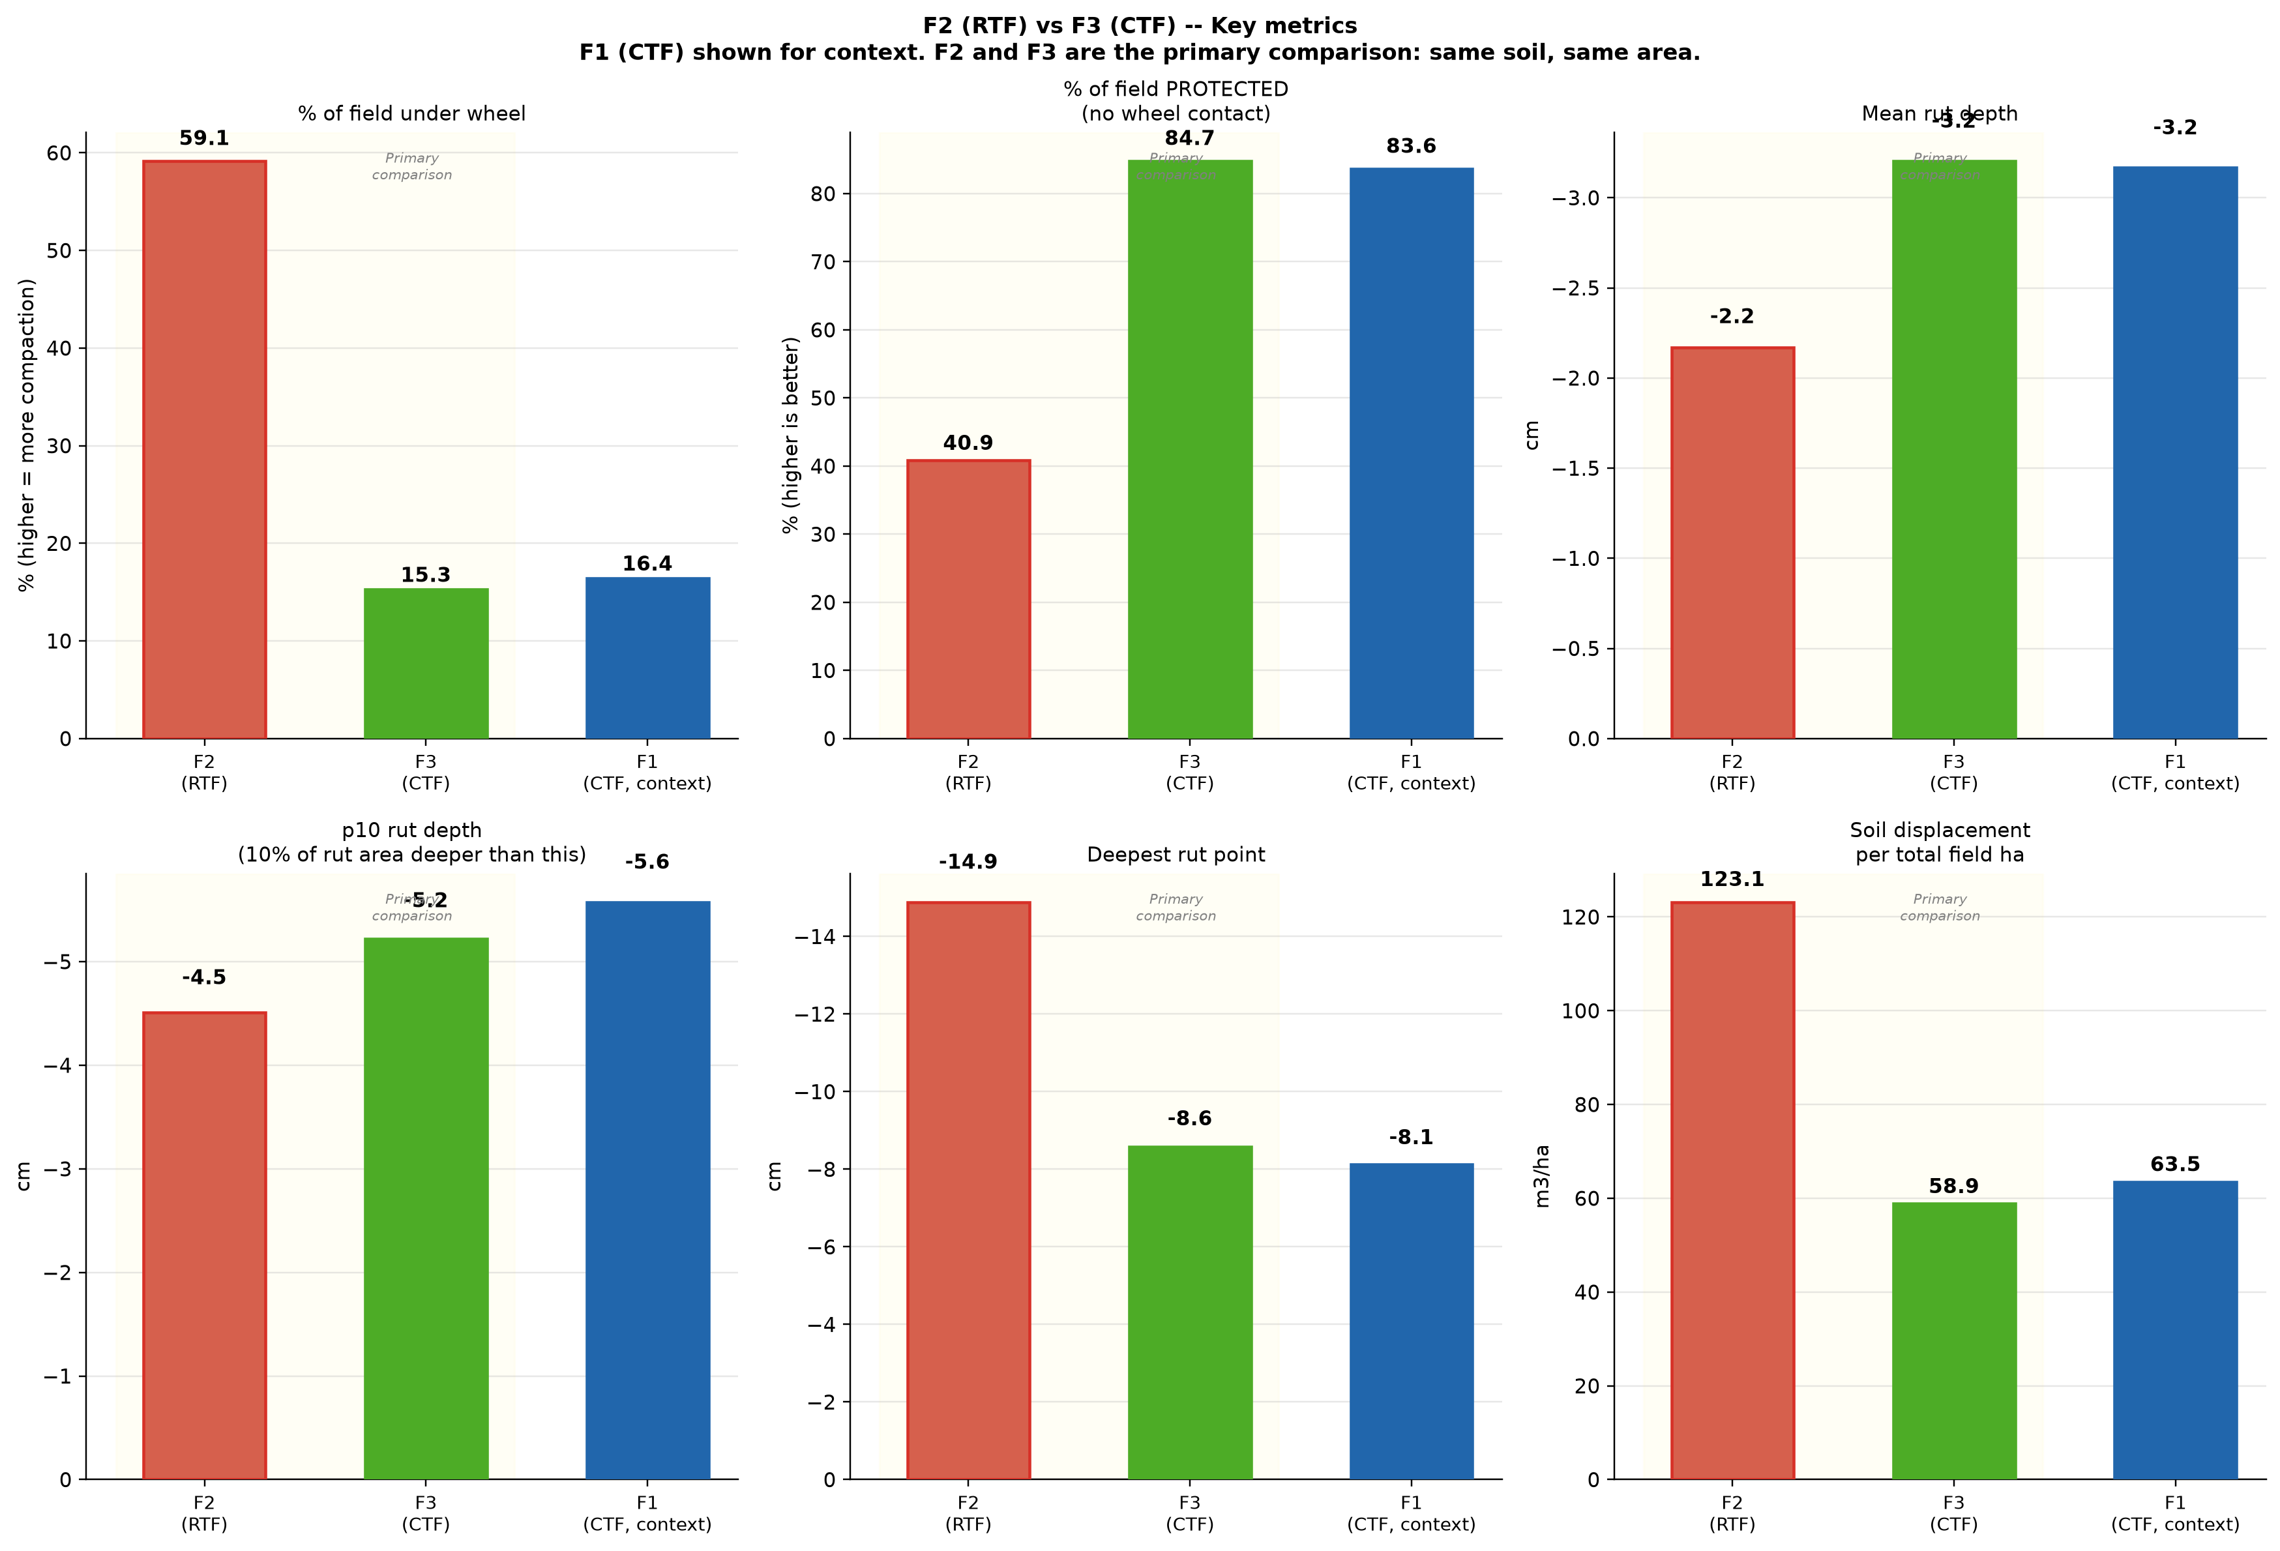
Abbildung 20. F2 (RTF) vs F3 (CTF) -- Key metrics summary (F1 CTF shown for context). Top row: F2 traffics 59% of soil while F3 traffics only 15%; F3 protects 85% of soil versus 41% for F2; individual rut depth is slightly deeper in F3 (-3.2 cm) than F2 (-2.2 cm). Bottom row: soil displacement per total field ha is 123 m3/ha for F2 versus 59 m3/ha for F3 -- RTF causes 2.1 times more total soil displacement despite shallower individual ruts.

Tabelle 5. Direct comparison of F2 (RTF) and F3 (CTF) -- geographically close fields under contrasting traffic management
Metric | F2 RTF | F3 CTF | Difference
% field trafficked | 59.1% | 15.3% | RTF 3.9x more
% field protected (no wheel) | 40.9% | 84.7% | CTF 2.1x more protected
Mean rut depth | -2.2 cm | -3.2 cm | F3 lanes 1 cm deeper
p10 depth | -4.5 cm | -5.2 cm | F3 deeper at p10
Deepest point | -14.9 cm | -8.6 cm | F2 headland deeper
Soil displacement per field ha | 123 m3/ha | 59 m3/ha | RTF causes 2.1x more

4.7 Depth Class Distribution

Tabelle 6. Percentage of rut area in each depth class. Highlighted row = combined deep + very deep (> 5 cm) -- the agronomically most important zone for root penetration restriction.
Depth class | F1 CTF | F2 RTF | F3 CTF
Very deep (< -10 cm) | 0.0% | 0.2% | 0.0%
Deep (-10 to -5 cm) | 18.7% | 7.4% | 13.2%
Deep + Very deep (> 5 cm) | 18.7% | 7.6% | 13.2%
Moderate (-5 to -2 cm) | 50.1% | 36.6% | 61.1%
Shallow (-2 to 0 cm) | 31.3% | 55.9% | 25.7%

The depth class analysis confirms the mechanistic difference between RTF and CTF. F2 RTF has 55.9% of its rut area in the shallow class because most passes cover each spot only once or twice. F3 CTF has only 25.7% in the shallow class but 61.1% in the moderate class because repeated passes on the same permanent lane strips progressively deepen the compaction. Ruts deeper than 5 cm restrict root penetration and require subsoil intervention to correct (Hamza and Anderson, 2005).

4.8 Soil Displacement

Tabelle 7. Soil displacement proxy. Per total field ha is the most meaningful metric for overall soil health impact at field scale.
Metric | F1 CTF | F2 RTF | F3 CTF
Total displaced volume (m3) | 8.5 | 16.3 | 7.7
Per total field ha (m3/ha) | 63.5 | 123.1 | 58.9
Per trafficked ha (m3/ha) | 387.4 | 208.2 | 386.1

Per total field hectare, F2 RTF causes 123 m3/ha of soil displacement -- more than double the CTF fields (59-64 m3/ha). This 2x difference arises entirely from coverage: RTF traffics 59% of the field while CTF traffics only 15-16%. Both systems produce similar displacement intensity per trafficked hectare (208 vs 387 m3/ha), but CTF applies that intensity to a far smaller proportion of the field (Chamen et al., 2015).

4.9 Field-by-Field Analysis

Flaeche 1 (CTF) -- sub-AOI ~1337 m2
F1 shows a clear CTF pattern with three permanent lanes visible in the sub-AOI. 83.6% of the field was never trafficked. The permanent lanes received 6+ passes (dark red), with wide undisturbed green zones between them. Mean rut depth is -3.2 cm and reference quality is GOOD (std 1.34 cm). The rut proof map confirms all deepest LiDAR points fall within the lane polygons.

Flaeche 2 (RTF) -- sub-AOI ~1326 m2
F2 has no permanent lanes. 59.1% of the field received wheel contact, dominated by 1-2 passes spread diffusely (55.5% of the sub-AOI). No location received 6 or more passes within the sub-AOI. Mean rut depth is -2.2 cm -- the shallowest of the three fields -- because each spot was rarely visited more than twice. The deepest point (-14.9 cm) lies in the headland area at the edge of the sub-AOI where turning operations concentrated; this value should be treated with some caution given the terrain and reference conditions discussed in Section 8.1.

Flaeche 3 (CTF) -- sub-AOI ~1310 m2
F3 is a narrow diagonal field with three permanent CTF lanes visible in the sub-AOI. 84.7% of the field was protected from any wheel contact -- the highest of all three fields. The permanent lanes received 6+ passes (11.2% of sub-AOI). Mean rut depth is -3.2 cm, identical to F1 CTF, with 13.2% of rut area in the deep class. The rolling terrain of F3 is clearly visible in the reference DTM panel of Figure 6b, and the 2 m reference window correctly follows this variation (std 1.41 cm, GOOD).

5. Comparison of All Three Fields
Figures 21 to 24 present all key metrics for all three fields side by side. These figures place the F2/F3 comparison in the broader context of the full three-field study.
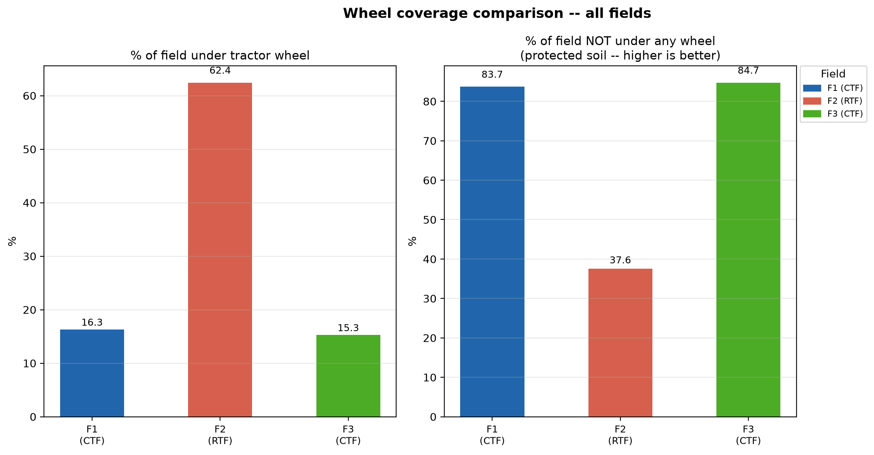
Abbildung 21. Wheel coverage comparison. Left: % under wheel. Right: % NOT under any wheel (higher is better). CTF fields protect 84% of soil; RTF protects only 41%. The difference of 43 percentage points is the most fundamental CTF advantage.

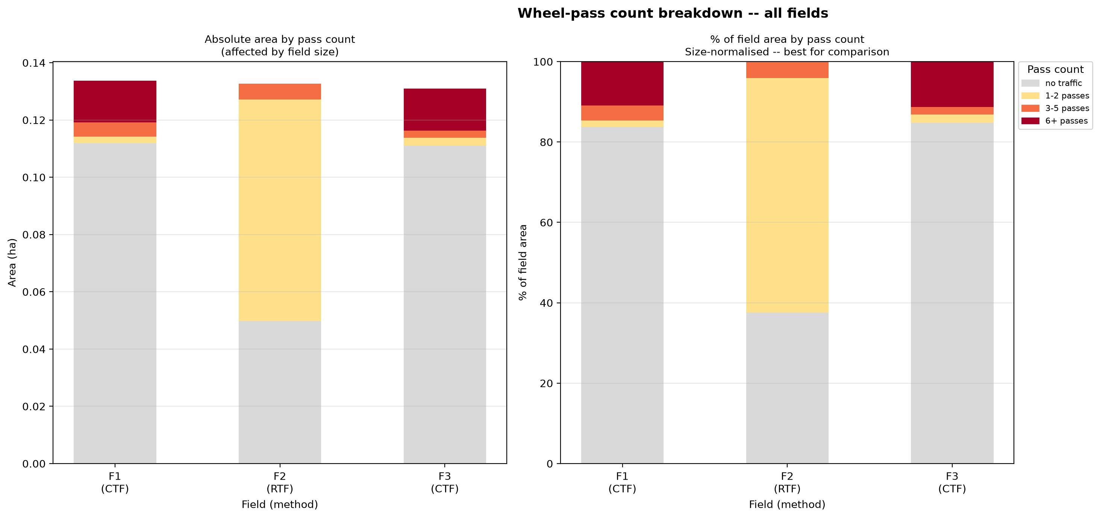
Abbildung 22. Pass-count class breakdown. Right panel (size-normalised): F2 RTF is dominated by yellow (1-2 passes spread thinly). CTF fields concentrate passes into dark red permanent lanes with most of the field area grey (no traffic).

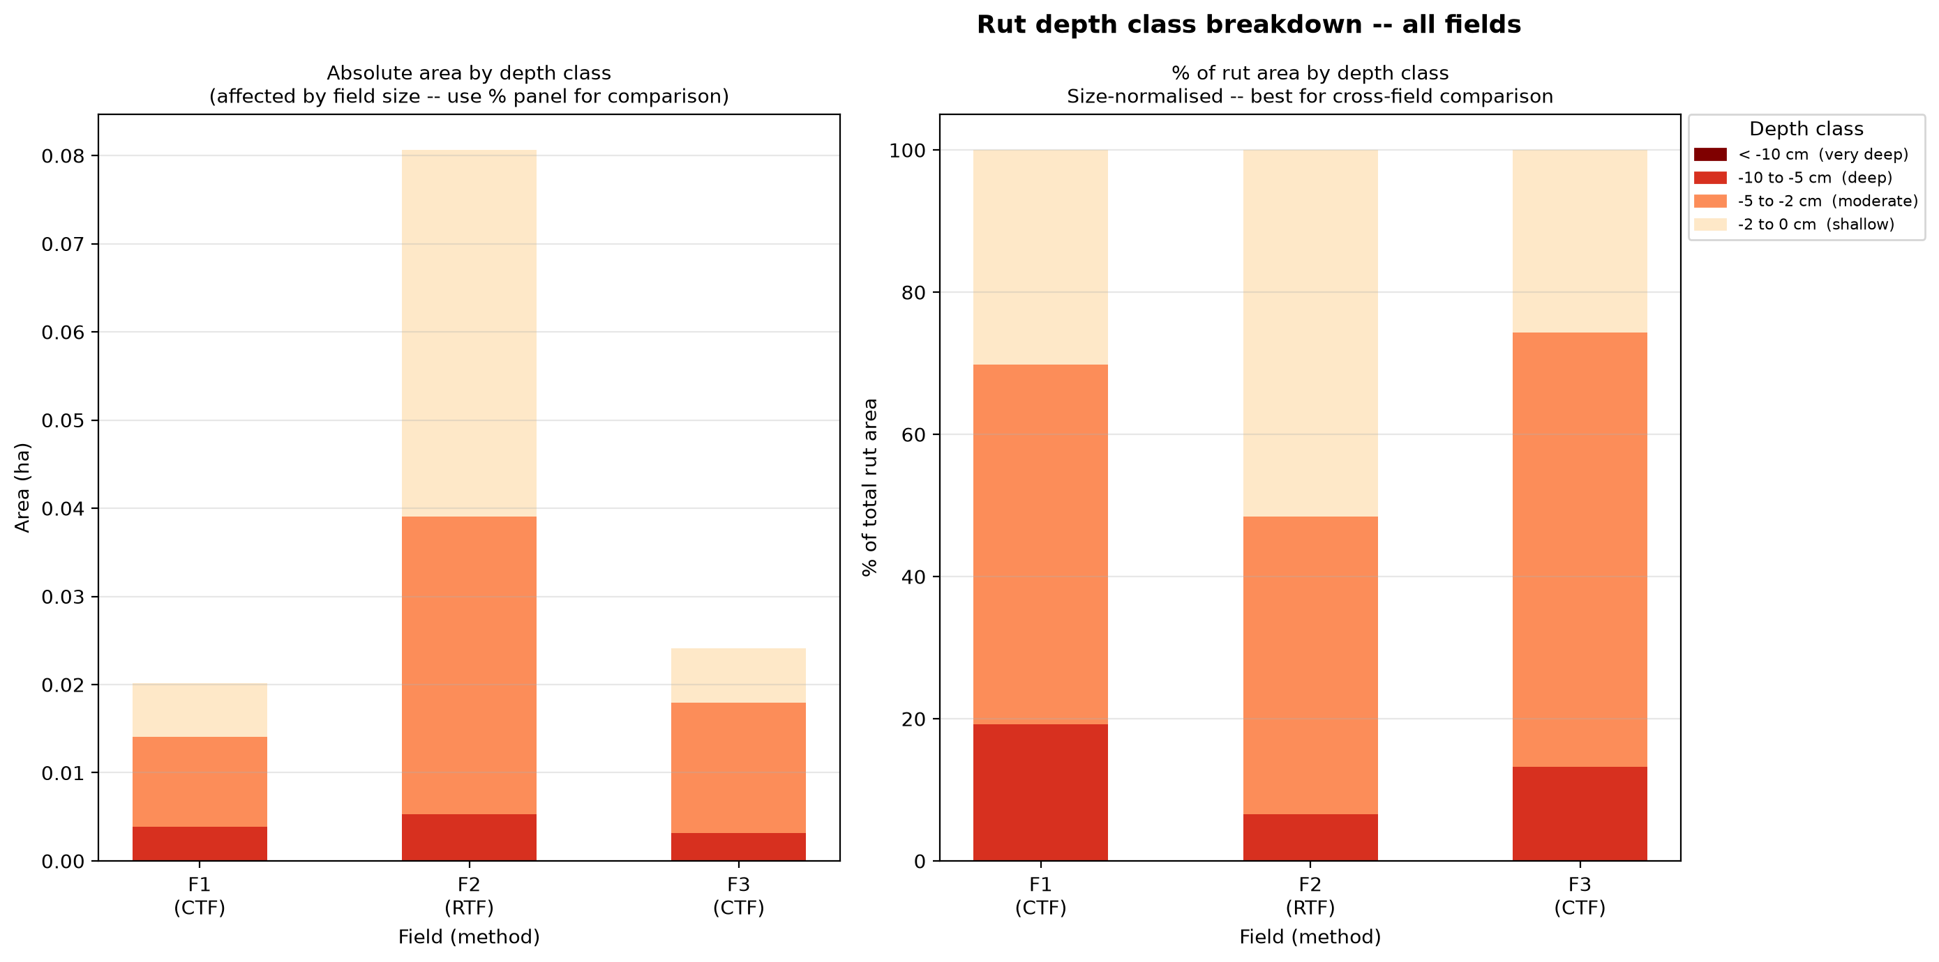
Abbildung 23. Depth class breakdown. Right panel (size-normalised): F2 RTF has a higher proportion of shallow ruts (55.9%) consistent with thin spreading of passes. CTF fields (F1 and F3) have more moderate and deep ruts because permanent lanes receive cumulative compaction from repeated passes.

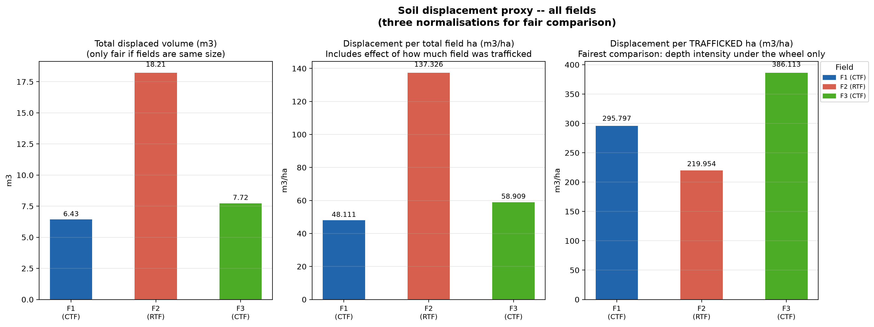
Abbildung 24. Soil displacement in three normalisations. Centre panel (per total field ha): F2 RTF causes 123 m3/ha versus 59-64 m3/ha for CTF fields. RTF causes approximately 2x more total soil displacement per field hectare despite shallower individual ruts.

6. Discussion
Coverage protection is the primary and most consistent benefit of CTF observed in this study. The CTF fields (F1 and F3) left 84-85% of soil untouched by any wheel pass during the 2025 season, compared to only 41% for the RTF field (F2). This 43-percentage-point difference is visible directly in the pass maps and is consistent with the published literature on CTF adoption outcomes (Tullberg et al., 2007; Chamen et al., 2015; Antille et al., 2019).
The F2/F3 comparison is the central finding of this study because these two geographically close fields provide the most direct contrast between traffic management systems. On similar ground, RTF trafficked 3.9 times more of the soil area than CTF while producing shallower individual ruts (-2.2 vs -3.2 cm mean). This confirms the fundamental mechanism: CTF does not reduce compaction depth where the wheel drives -- it reduces how much of the field the wheel drives over. The result is that RTF caused approximately 2.1 times more total soil displacement per field hectare (123 vs 59 m3/ha) despite shallower per-pass depth.
The depth distribution analysis (Figure 18) provides additional insight. RTF shows a distribution dominated by shallow ruts because each spot is rarely visited more than twice per season. CTF shows a distribution shifted toward deeper values in the permanent lanes because the same strips receive 6 or more passes per season, with cumulative compaction building pass by pass (Defossez and Richard, 2002; Horn and Fleige, 2003). The soil in CTF lanes does not reach a compaction ceiling after the first pass -- each additional pass adds measurable depth.
The rut validation proof maps (Section 4.4) confirm that all detected deep LiDAR returns fall within the wheel-track polygon boundaries in all three fields. No deep signal was detected in the undisturbed inter-row zones. This validates the LiDAR method as a genuine detector of wheel-induced soil compaction rather than terrain noise.
The F2 deepest point of -14.9 cm in the headland area illustrates one specific consequence of RTF: uncontrolled accumulation of turning passes at the same location. In a CTF system, headland lanes are planned and permanent, preventing this accumulation. The deeper extreme value under RTF is a direct consequence of the unmanaged traffic pattern, though as discussed in Section 8.1, terrain effects may contribute to this value.
F3 CTF showing slightly deeper lanes than F1 CTF (both -3.2 cm mean, but F3 with a slightly shorter tail) is broadly consistent given both fields use the same tractors under the same CTF system. Small differences in terrain moisture distribution along the F3 slope and the slightly higher number of Fendt 724 operations in F3 (8 vs 7) may explain the minor variation.

7. Conclusions and Recommendations for the Farmer

Tabelle 8. Key findings and practical recommendations.

Finding | Practical recommendation
CTF protects 84-85% of soil from any wheel contact; RTF protects only 41% -- a difference of 43 percentage points. | For every 100 m of field, CTF leaves 84 m of topsoil untouched each season, directly benefiting root development, water infiltration, and long-term soil structure.
RTF (F2) causes 2.1x more soil displacement per field hectare than CTF (F3): 123 vs 59 m3/ha. | The extra damage from RTF comes from coverage -- visiting 59% of the field versus 15%. Switching from RTF to CTF would roughly halve total field-scale soil displacement.
Per wheel pass, individual rut depth is similar between CTF and RTF (-2.2 vs -3.2 cm). CTF lanes are deeper because the same strip receives 6+ passes. | CTF does not reduce per-pass compaction -- it reduces how much soil is compacted. The benefit is spatial confinement, not shallower individual ruts.
The LiDAR rut detection method is validated: all deepest detected points fall inside wheel-track polygons in all three fields. | LiDAR scanning after harvest is a reliable annual monitoring method for tracking compaction trends across seasons.
The RTF headland shows the deepest rut measured (-14.9 cm) from concentration of unmanaged turning passes. | Plan and implement permanent headland lanes as part of a CTF system. Uncontrolled headland turning is the most severe localised compaction point in RTF management.

8. Limitations

8.1 Reference Surface Uncertainty at the F2 Headland
Although the 2 m smoothing window achieves GOOD reference quality for F2 overall (std 1.23 cm), the extreme deepest point of -14.9 cm at the headland area should be treated with some caution. Flaeche 2 has rolling terrain with hollows, and in the headland zone the nearest undisturbed reference points may be on slightly higher ground than the hollow itself. When the reference surface interpolates across this gap it may slightly overestimate the terrain height in the hollow, making the apparent rut depth larger than the true compaction depth. The mean rut depth (-2.2 cm) is considered reliable because errors average out across the whole field; the single deepest point may combine genuine headland compaction with some terrain-interpolation uncertainty.
A pre-season LiDAR scan of F2 taken before any wheel traffic would resolve this completely: rut depth would be calculated as the direct pixel-by-pixel difference between scans, eliminating reference surface uncertainty regardless of how much of the field was trafficked (Lindner et al., 2016).

8.2 Single Season of Data
This study captures one season (2025). Soil compaction is cumulative: the same permanent CTF lanes will deepen further with each additional season of traffic, while undisturbed inter-row soil progressively recovers pore structure and biological activity when wheel contact is permanently excluded (Antille et al., 2019; Horn and Fleige, 2003). The CTF advantage observed in this single season is therefore likely to underestimate the long-term divergence between the two systems. Annual post-harvest LiDAR scans combined with GPS polygon records would allow the cumulative trajectory to be tracked over time.

8.3 Geographic Basis of F2/F3 Comparison
The F2/F3 comparison is based on geographic proximity and similar field conditions rather than on laboratory-confirmed identical soil properties. No soil texture, bulk density, or organic matter measurements were taken to verify that the two fields are pedologically equivalent. While proximity and shared landscape context make F2 and F3 the most appropriate pairing available in this study, soil variability between the fields cannot be fully excluded as a contributing factor to the observed differences. Future work with soil profile sampling would strengthen the causal attribution of observed differences to traffic management.

References
Antille, D.L., Tullberg, J.N., Antille, M., Colley, T.A. (2019). Review of opportunities and constraints for implementing controlled traffic farming in Australian grain production. Soil Research, 57(8), 783-799. https://doi.org/10.1071/SR19162
Chamen, W.C.T. (2015). Controlled traffic farming -- A review of benefits, technology and implementation. Acta Technologica Agriculturae, 18(3), 64-73. https://doi.org/10.1515/ata-2015-0013
Chamen, W.C.T., Moxey, A.P., Towers, W., Balana, B., Hallett, P.D. (2015). Mitigating arable soil compaction: A review and analysis of available cost and benefit data. Soil and Tillage Research, 146, 10-25. https://doi.org/10.1016/j.still.2014.09.011
Defossez, P., Richard, G. (2002). Models of soil compaction due to traffic and their evaluation. Soil and Tillage Research, 67(1-2), 41-64. https://doi.org/10.1016/S0167-1987(02)00045-3
Hamza, M.A., Anderson, W.K. (2005). Soil compaction in cropping systems: A review of the nature, causes and possible solutions. Soil and Tillage Research, 82(2), 121-145. https://doi.org/10.1016/j.still.2004.08.009
Horn, R., Fleige, H. (2003). A method for assessing the impact of load on mechanical stability and on physical properties of soils. Soil and Tillage Research, 73(1-2), 89-99. https://doi.org/10.1016/S0167-1987(03)00102-8
Keller, T., Defossez, P., Weisskopf, P., Arvidsson, J., Richard, G. (2007). SoilFlex: A model for prediction of soil stresses and soil compaction due to agricultural field traffic. Soil and Tillage Research, 93(2), 391-411. https://doi.org/10.1016/j.still.2006.05.012
Lindner, C., Thiel, C., Schindler, A. (2016). Detection of ruts by means of airborne LiDAR. Journal of Applied Remote Sensing, 10(1), 016003. https://doi.org/10.1117/1.JRS.10.016003
McPhee, J.E., Antille, D.L., Tullberg, J.N., Eberhard, J., Cummins, E. (2021). Managing controlled traffic farming: A review of the challenges and opportunities. Soil and Tillage Research, 208, 104880. https://doi.org/10.1016/j.still.2020.104880
Mesas-Carrascosa, F.J., Torres-Sanchez, J., Clavero-Rumbao, I., Garcia-Ferrer, A., Pena, J.M., Borra-Serrano, I., Lopez-Granados, F. (2015). Assessing optimal flight parameters for generating accurate multispectral orthomosaicks by UAV. Remote Sensing, 7(10), 12793-12814. https://doi.org/10.3390/rs71012793
Perez-Ruiz, M., Upadhyaya, S.K. (2012). GNSS in precision agricultural operations. In: New Achievements in Technology Education and Development. InTech, Rijeka, pp. 71-86.
Raper, R.L. (2005). Agricultural traffic impacts on soil. Journal of Terramechanics, 42(3-4), 259-280. https://doi.org/10.1016/j.jterra.2004.10.010
Schjoenning, P., van den Akker, J.J.H., Keller, T., Greve, M.H., Lamande, M., Simojoki, A., Stettler, M., Arvidsson, J., Breuning-Madsen, H. (2015). Driver-pressure-state-impact-response (DPSIR) analysis and risk assessment for soil compaction. Advances in Agronomy, 133, 1-65. https://doi.org/10.1016/bs.agron.2015.06.001
Smith, M.W., Carrivick, J.L., Quincey, D.J. (2016). Structure from motion photogrammetry in physical geography. Progress in Physical Geography, 40(2), 247-275. https://doi.org/10.1177/0309133315615805
Soane, B.D., van Ouwerkerk, C. (Eds.) (1994). Soil Compaction in Crop Production. Elsevier, Amsterdam. ISBN 978-0444882561.
Stombaugh, T. (2009). Agricultural global positioning systems. In: Precision Agriculture Technology for Crop Farming. CRC Press, Boca Raton, pp. 1-26.
Tullberg, J.N., Yule, D.F., McGarry, D. (2007). Controlled traffic farming -- From research to adoption in Australia. Soil and Tillage Research, 97(2), 272-281. https://doi.org/10.1016/j.still.2007.09.007
Whelan, B.M., Taylor, J.A. (2013). Precision Agriculture for Grain Production Systems. CSIRO Publishing, Collingwood, Victoria. ISBN 978-0643107472.

