**INTRODUCTION TO VVM**

Introduction to Computer Architecture – Lab Component

**OBJECTIVE**

Explore Visible Virtual Machine (VVM).

# LAB TASK

1. Take two inputs and Subtract.

**Solution:**

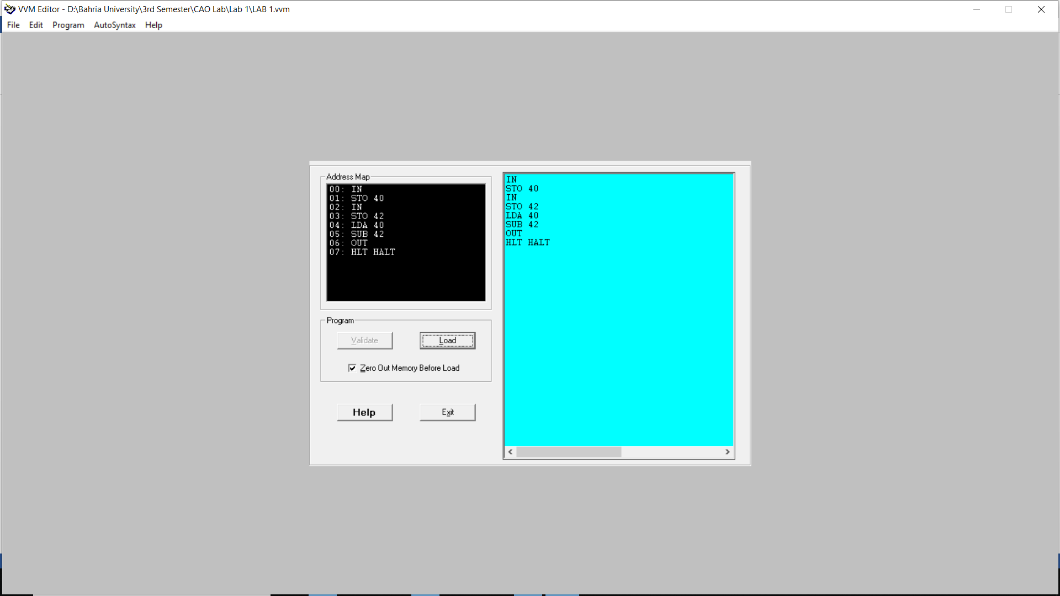

**OUTPUT**

**:**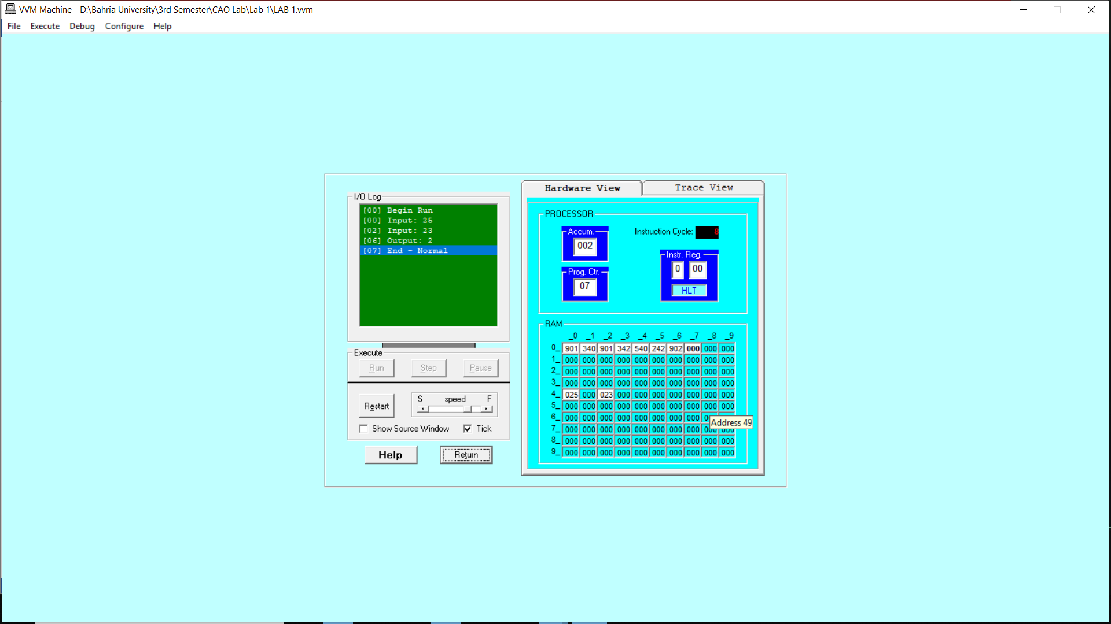

1. Take two hardcoded inputs and add them.

**Solution:**

