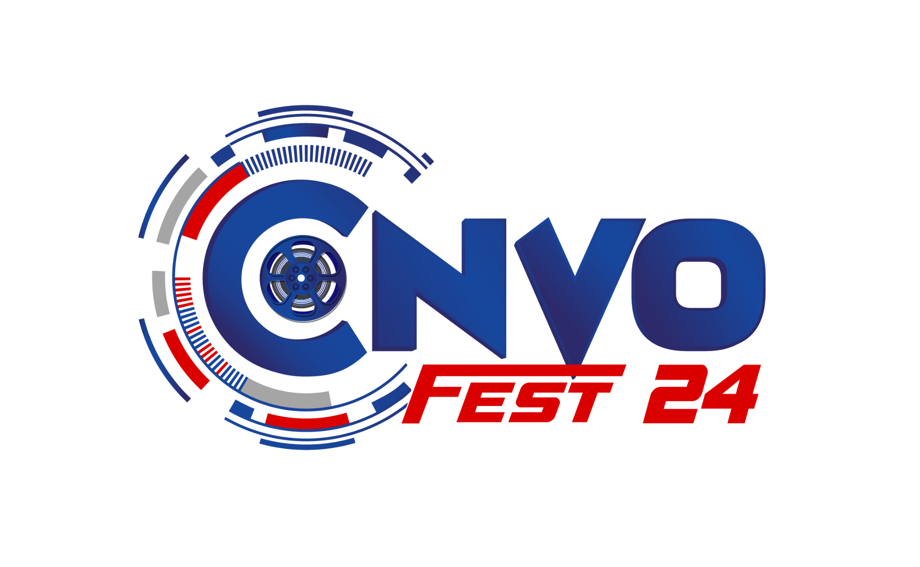

**ConvoFest 2024**

**Multimedia University**

1st Floor, STC Building,

Persiaran Multimedia,

63100 Cyberjaya, Selangor.

[convofest24@gmail.com](mailto:convofest24@gmail.com)

*Reference: cvf2024/sponsor009*

*Date : 11/11/2024*

Bata Malaysia Sdn Bhd,

B-17 Level 17 Menara Bata,

Jalan PJU 8/8A,

Bandar Damansara Perdana,

47820 Petaling Jaya,

Selangor, Malaysia.

Dear Sir/Madam,

**SPONSORSHIP REQUEST FOR THE PROGRAM OF CONVOFEST 2024**

The above matter is kindly referred to.

2. We are pleased to inform you that Multimedia University (MMU), organized by the Student Lifestyle and Experience (STYLE) Department, will be hosting ConvoFest 2024 in conjunction with MMU’s 25th Graduation Ceremony. Themed Nostalgia.com: Where Memories Graduate With You, this event will celebrate both academic achievements and the cherished memories of our graduates. The event details are as follow:

**Theme: Nostalgia.com: Where Memories Graduate With You**

**Date: 30th November – 9th December 2024**

**Venue: MMU Cyberjaya Campus**

**Targeted Attendees: 6,000 to 7,000 participants per day**

3.ConvoFest is an annual celebration organized by the Student Lifestyle and Experience (STyLE) Department to honor the achievements of graduating students and also to enhance the campus vibe throughout the graduation ceremony period. The event brings together graduates, alumni, faculty, and the wider community for a week of festivities, including performances, interactive exhibits, and engaging activities. It provides a unique opportunity to celebrate academic milestones while creating lasting memories for all participants.

4. As such, we are delighted to reach out and would be deeply honored if your company would consider supporting our upcoming ConvoFest 2024 by sponsoring the event. All types of sponsorship are welcomed including monetary, in-kind, vouchers or discounts. Your involvement in this capacity would significantly contribute to the success of the celebration and help create an unforgettable experience for all participants.

6. Your sponsorship would not only contribute to the success of ConvoFest 2024, but it would also provide valuable exposure for your brand among our vibrant student and alumni community. In return for your generosity, we would be happy to offer recognition opportunities during the event, as well as inclusion in our promotional materials. We would be honored to have your esteemed organization as a sponsor for this exciting event, and we look forward to discussing any possibilities for collaboration.

7. Any sponsorship by cheque, money order or postal order shall be made payable to:

**UNIVERSITI TELEKOM SDN BHD**

**Account No: 8004674187 (CIMB)**

**(Please write the program name on the back of the cheque)**

8. For any additional details and clarifications, please feel free to contact the committee member below:

Name : Muhammad Faiz Bin Mohd Shukran

Position : Head of Sponsorship Division

E-mail : mfaizshukran@gmail.com

Telephone Number : +6011 - 65357557

9. We hope that this request will be given due consideration. Your time and kind consideration are much appreciated.

Thank you in advance.

Best Regards, 

_________________________________

**(FARIDAH BINTI ABDUL RASHID TANG)**  
Program Director,  
ConvoFest 2024,

Multimedia University.