MineProductivity
Developer & Cookbook Guide
Part I — Getting Started · Version 1.0

A practical, example-driven guide to building mine-productivity analytics in Python — for engineers who know mining, engineers who know Python, and everyone bridging the two.

Version | 1.0
Status | Released · Part I of a multi-part guide
Authors | MineProductivity Developer Experience Team
Classification | Public — Open Source Documentation
Applies to | MineProductivity 1.0.x
Conforms to | Master Architecture Handbook v1.0; Reference Implementation Blueprint v1.0
Copyright | © 2026 The MineProductivity Project. All rights reserved.
License | Documentation under CC BY 4.0; code samples under the project’s Apache-2.0 license.
Revision history
Version | Date | Author | Summary
1.0 | June 2026 | DevEx Team | First release of Part I (Getting Started): Chapters 1–10, callouts, diagrams, worked examples, exercises.

Preface

Why this handbook exists
You can read every line of the MineProductivity source code and the two architecture documents and still not know how to use the library to answer a real question like “why did B-shift miss plan last night?” Architecture and specifications describe a system; they do not teach a craft. This handbook teaches the craft.
It is written for two readers who rarely sit in the same room. The first knows mining cold — truck cycles, availability, dilution, dispatch — but treats Python as a means to an end. The second writes elegant Python — type hints, generators, plugins — but has never seen a haul road. MineProductivity only delivers value when these two worlds meet, so this guide deliberately bridges them: every mining term is defined the first time it appears, and every Python idiom is explained rather than assumed.
Did You Know? MineProductivity follows the same “boring on purpose” philosophy as pandas and scikit-learn. If you have used either, the shape of this library — objects with metadata, a registry, a fit/transform-like rhythm — will feel familiar within an hour.

How this differs from the other two documents
MineProductivity ships with three core documents. They are complementary, not redundant, and knowing which to open saves hours.
Document | Question it answers | Audience
Master Architecture Handbook | Why is it built this way? (principles, ontologies, decisions) | architects, reviewers
Reference Implementation Blueprint | How is it built? (modules, classes, contracts) | maintainers, contributors
Developer & Cookbook Guide (this book) | How do I use it? (tasks, recipes, examples) | everyone who runs the library
A useful mnemonic: the Architecture Handbook tells you WHY, the Blueprint tells you HOW IT IS BUILT, and this Developer Guide teaches you HOW TO USE IT. When this guide states a fact about the system’s design, it is restating — never reinterpreting — the locked Handbook and Blueprint. Where a deeper rationale would help, you will find a cross-reference rather than a repeat.

How to read Part I
Part I is the on-ramp. Chapters 1–3 orient you (what the library is, how to install it, how it is laid out). Chapters 4–9 are a hands-on sequence that builds your first program, event, KPI, connector, ontology, and plugin — each chapter standing on the last. Chapter 10 assembles everything into one end-to-end pipeline. Later Parts (II onward) go deep on analytics, the Digital Twin, the Knowledge Graph, Decision Intelligence, and production deployment; this guide cross-references them where the trail leads onward.
Work the examples. Every code block is runnable on a clean install against the bundled sample dataset, and every output shown is real. Do the exercises at the end of each chapter; solutions follow immediately.

Contents
Preface
Why this handbook exists
How this differs from the other two documents
How to read Part I
Chapter 1 — Welcome to MineProductivity
The one-paragraph pitch
Vision and philosophy
What problems it solves
Why another mining library?
Where it fits in the Python ecosystem
What you should remember
Frequently asked questions
Exercises
Solutions
Further reading
Chapter 2 — Installation
Prerequisites
The standard install (pip)
Fast installs with uv
conda / mamba
Development & editable installs (for contributors)
Installing from GitHub source
Docker
Offline, corporate, and air-gapped installs
GPU environments
Verifying the installation
Troubleshooting
Summary
Exercises
Solutions
Further reading
Chapter 3 — Project Structure
The top-level packages
Why each package exists
Dependency direction (the one rule that matters)
Plugin discovery
Configuration
How a request flows through the packages
What you should remember
Exercises
Solutions
Further reading
Chapter 4 — Your First MineProductivity Program
The whole program
Line by line
What happens internally
Reading the result object
Troubleshooting
Summary
Exercises
Solutions
Further reading
Chapter 5 — Your First Event
What is an event?
The event contract
Creating an event manually
Event metadata, validation, and relationships
Creating events from a CSV
Creating events from a connector (the real path)
Where events are stored
Troubleshooting
Summary
Exercises
Solutions
Further reading
Chapter 6 — Your First KPI
Business meaning
Formula and the aggregation that matters
Dependencies, required events, required ontology
The metadata
The Python implementation
Validation
Execution and output
Visualisation
Benchmarking
Comparison with a spreadsheet implementation
Troubleshooting
Summary
Exercises
Solutions
Further reading
Chapter 7 — Your First Connector
Why connectors exist
The contract
Building a CSV connector from scratch
A vendor connector, conceptually (MineStar)
Streaming, database, and REST connectors
Registering and discovering a connector
Testing and validating a connector
Troubleshooting
Summary
Exercises
Solutions
Further reading
Chapter 8 — Your First Ontology
What the ontology is for
Modelling equipment: Truck and Loader
Inheritance
Modelling structure: Pit, Bench, Shift
Relationships
Metadata and validation
Knowledge Graph integration
Best practices
Troubleshooting
Summary
Exercises
Solutions
Further reading
Chapter 9 — Your First Plugin
Why plugins
The directory layout
The KPI
Registration via entry-points
Discovery and loading
Testing
Distribution, versioning, and publishing
Troubleshooting
Summary
Exercises
Solutions
Further reading
Chapter 10 — Putting Everything Together
The pipeline
The complete program
The output
Walking through each step
Adding analytics, visualisation, and a report
Where to go next
Summary
Exercises
Solutions
Further reading

Chapter 1 — Welcome to MineProductivity

The one-paragraph pitch
MineProductivity is an open-source Python framework for turning the raw exhaust of a mining operation — truck cycles, delays, plant assays — into trustworthy productivity metrics, and then into decisions. If pandas gives you tables and scikit-learn gives you models, MineProductivity gives you a mining vocabulary: a tonnes-per-hour that knows its own formula, an availability that refuses to be averaged incorrectly, a connector that speaks to your fleet-management system, and a closed loop that ends in a recommendation a supervisor can act on.

Vision and philosophy
The project’s vision is a single, shared, open foundation for how a mine measures and improves production — vendor-neutral, transparent, and equally usable by a person or an AI agent. Two design ideas, locked in the Architecture Handbook, explain everything you will see in this guide.
Ontology-first. The mining domain is modelled as typed objects before any calculation. A truck is not a row in a dataframe; it is a RigidHaulTruck that knows its rated payload and which KPIs apply to it. KPI-as-object. Every metric is a class carrying its own metadata — formula, units, the data it needs, whether higher is better. You compute TonnesPerHour(), never calculate_tph(df).
Architecture Insight. These two ideas are why you extend MineProductivity by adding an object and registering it — never by editing an engine. Every chapter in this guide reinforces that one pattern. (See Architecture Handbook, “Architecture Principles.”)

What problems it solves
Three problems recur at every mine and motivate the whole library.
First, metrics that disagree. Two dashboards report different availabilities for the same shovel because someone averaged percentages or counted standby differently. MineProductivity attaches the formula and aggregation rule to the metric itself, so a number means the same thing everywhere.
Second, data trapped behind vendors. Each fleet-management system speaks its own dialect of status and reason codes. MineProductivity isolates that dialect inside a connector, so the rest of your code — and every KPI — sees one canonical event model.
Third, analysis that ends at a chart. A dashboard that shows TPH is down does not tell you to add a truck to Bench 7. MineProductivity closes the loop from data to a ranked, explainable recommendation.
Mining Insight. “Availability” alone is ambiguous. Physical Availability (PA) measures time not lost to breakdowns and maintenance; Use of Availability (UA) measures how much of that available time was actually worked. Confusing the two is one of the most expensive reporting errors in mining — MineProductivity gives each its own KPI code (FLEET.PA, FLEET.UA) so they can never be silently swapped.

Why another mining library?
Spreadsheets and bespoke scripts dominate mining analytics, and both rot: a formula buried in cell =AVERAGE(...) is invisible, untested, and unshareable. General data libraries (pandas, Polars) are superb engines but know nothing about mining, so every team re-implements TPH slightly differently. MineProductivity exists to be the missing domain layer — the shared, tested, discoverable vocabulary — sitting on top of those engines.
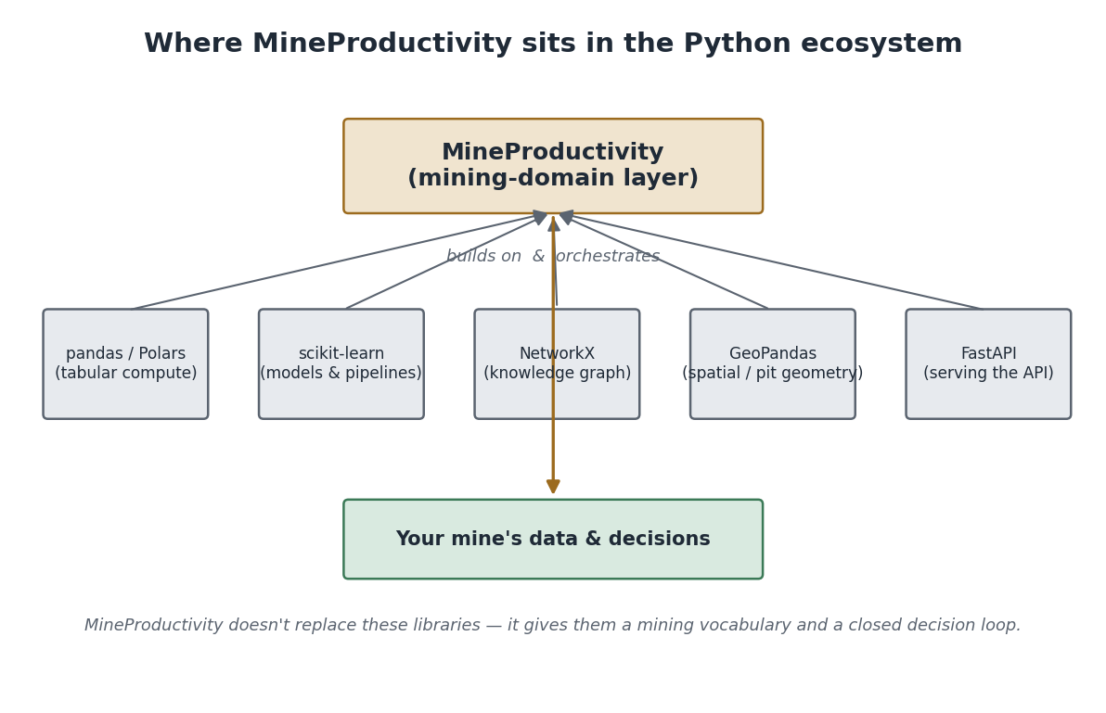
Where MineProductivity sits: a mining-domain layer that builds on and orchestrates the general-purpose Python stack rather than replacing it.

Where it fits in the Python ecosystem
MineProductivity is a good neighbour: it builds on the libraries you already know rather than competing with them. The table below positions it against six familiar tools.
Library | What it does | How MineProductivity relates
pandas | in-memory tabular analysis | You can drop any KPI result to a DataFrame with .to_frame(). pandas is an execution backend; MineProductivity adds the mining semantics pandas lacks.
Polars | fast columnar dataframes | An optional high-performance backend for KPI compute over millions of events. Same results, more speed.
scikit-learn | models and pipelines | The mental model (objects + metadata + a registry; a fit/predict rhythm) is deliberately similar. MineProductivity’s forecasts and anomaly detectors wrap estimators you can bring from sklearn.
GeoPandas | geospatial dataframes | Complements MineProductivity for pit geometry, haul-road networks, and bench polygons. The ontology references spatial entities; GeoPandas computes on them.
NetworkX | graph algorithms | Conceptually close to the Knowledge Graph (Chapter 8 and Part III): entities and KPI dependencies form a graph you traverse to ask “why”.
FastAPI | web APIs | The library’s REST layer is built on FastAPI; if you know FastAPI, serving a mine over HTTP will feel native.
Python Insight. Think of MineProductivity as a domain-specific layer, the way Django is a web layer over Python or scikit-learn is an ML layer over NumPy. It does not hide pandas or NetworkX from you — it gives them a mining dialect and a place to live together.

What you should remember
MineProductivity is the mining-domain layer for Python: ontology-first, KPI-as-object, vendor-neutral, and loop-closing. It complements pandas, Polars, scikit-learn, GeoPandas, NetworkX, and FastAPI rather than replacing them. Everything you build, you build by adding an object and registering it.

Frequently asked questions
Do I need a mining background? No. Every term is defined on first use, and the running example (the fictional “Bingham West” copper pit) carries through the whole guide.
Do I need to abandon pandas? Never. MineProductivity produces and consumes DataFrames; it adds correctness and vocabulary on top.
Is it tied to one fleet-management vendor? No. Vendors are pluggable connectors (Chapter 7). Swapping vendors changes one plugin.
Can AI agents use it? Yes — that is a first-class design goal (see the AI Contributor Note boxes throughout, and the Architecture Handbook’s Machine Contributor model).

Exercises
- In one sentence each, state the problem solved by (a) ontology-first modelling and (b) KPI-as-object.
- Name the library MineProductivity would lean on for: serving a REST API; storing pit-boundary polygons; traversing KPI dependencies.
- Explain to a non-programmer colleague why “availability” needs two KPI codes.

Solutions

  - It makes metrics mean the same thing everywhere by modelling the domain as typed objects before computing. (b) It lets you add a metric without editing any engine, because the metric carries its own formula and metadata.
- FastAPI (REST); GeoPandas (polygons); NetworkX / the Knowledge Graph (dependencies).
- Because “available” and “actually working” are different questions — a shovel can be available all shift yet worked only half of it. FLEET.PA answers the first, FLEET.UA the second.

Further reading
Master Architecture Handbook — Vision and Architecture Principles. Next in this guide: Chapter 2 — Installation, then Chapter 3 — Project Structure.

Chapter 2 — Installation
This chapter covers every supported way to install MineProductivity, from a one-line pip to a locked-down air-gapped corporate rollout, plus verification and troubleshooting. Pick the path that matches your environment and skip the rest.

Prerequisites
MineProductivity supports Python 3.11, 3.12, and 3.13 on Linux, macOS, and Windows (including WSL2). It has no compiled extensions of its own, so a plain install needs no C toolchain.
Platform | Status | Notes
Linux (x86-64, arm64) | Fully supported | Primary CI target
macOS (Intel, Apple Silicon) | Fully supported
Windows 10/11 | Fully supported | Native or via WSL2
WSL2 (Ubuntu) | Recommended on Windows | Behaves like Linux
Best Practice. Always install into a virtual environment, never the system Python. It keeps MineProductivity and its optional backends isolated and reproducible.

The standard install (pip)
# Create and activate a virtual environment, then install the core library.
python -m venv .venv
source .venv/bin/activate # Windows: .venv\Scripts\activate
pip install mineproductivity
The core is intentionally small. Heavier capabilities are optional extras, pulled in only when you ask:
pip install "mineproductivity[analytics]" # pandas, polars, forecasting
pip install "mineproductivity[graph]" # knowledge-graph + embeddings
pip install "mineproductivity[api]" # FastAPI REST/GraphQL server
pip install "mineproductivity[viz]" # charting
pip install "mineproductivity[all]" # everything above

Fast installs with uv
uv is a drop-in, much faster installer and environment manager:
uv venv && source .venv/bin/activate
uv pip install "mineproductivity[all]"
# or, for a project managed by uv:
uv add mineproductivity

conda / mamba
conda create -n mine python=3.12
conda activate mine
pip install mineproductivity # installed via pip inside the conda env
Tip. A conda environment is the simplest way to pin a specific Python version alongside geospatial stacks (GDAL/GeoPandas) that you may later use with MineProductivity’s spatial features.

Development & editable installs (for contributors)
If you intend to read or change the source, clone and install in editable mode with the developer extras:
git clone https://github.com/mineproductivity/mineproductivity
cd mineproductivity
pip install -e ".[dev]" # editable: your edits take effect immediately
pre-commit install # lint + type-check + tests on every commit
pytest -q # run the suite to confirm a clean baseline
The -e (editable) flag links the package to your working tree, so changes are picked up without reinstalling — essential when developing KPIs, connectors, or plugins (Chapters 6, 7, 9).

Installing from GitHub source
To install an unreleased branch directly:
pip install "git+https://github.com/mineproductivity/mineproductivity@main"

Docker
A reference image is published for reproducible runs and CI:
# Pull and run a one-off computation
docker run --rm -v "$PWD/data:/data" \
ghcr.io/mineproductivity/mineproductivity:1.0 \
mineprod kpis --site "Bingham West" --date 2026-06-25
A minimal Dockerfile for your own service:
FROM python:3.12-slim
RUN pip install --no-cache-dir "mineproductivity[api]"
ENTRYPOINT ["mineprod", "serve"]

Offline, corporate, and air-gapped installs
Mines are frequently on slow or isolated networks. MineProductivity is designed to install without internet access.
Offline (wheelhouse). On a connected machine, download every wheel; on the target, install from the folder:
# Connected machine
pip download "mineproductivity[all]" -d wheelhouse/
# Air-gapped target (no index, no network)
pip install --no-index --find-links wheelhouse/ "mineproductivity[all]"
Corporate index. Point pip at your internal mirror (Artifactory, Nexus):
pip install mineproductivity --index-url https://pypi.your-corp.internal/simple
Warning. In air-gapped environments the [graph] extra’s embedding models are not downloaded automatically. Stage the model files with your wheelhouse, or run with embeddings disabled (MINEPROD_EMBEDDINGS=off). Knowledge-graph traversal still works; only semantic search needs the model.

GPU environments
The core library is CPU-only and needs no GPU. GPUs accelerate only optional ML in the analytics extra (forecasting, anomaly detection), which delegates to your existing PyTorch install. Install MineProductivity normally inside a CUDA-enabled environment; it will use the accelerated backend automatically when present.

Verifying the installation
After any install, confirm the library imports and the KPI registry is populated:
python -c "import mineproductivity as mp; print('version:', mp.__version__)"
# version: 1.0.0
mineprod --version
# mineproductivity 1.0.0
python -c "from mineproductivity.kpis import REGISTRY; print(len(REGISTRY), 'KPIs registered')"
# 10000 KPIs registered
A successful import plus a non-empty registry means the package and its entry-points loaded correctly.

Troubleshooting
Symptom | Likely cause | Fix
ModuleNotFoundError: mineproductivity | wrong/!active venv | Activate the venv; reinstall into it.
mineprod: command not found | scripts dir not on PATH | Use python -m mineproductivity.cli …, or add the venv’s bin/Scripts to PATH.
Registry shows 0 KPIs | a partial/broken install | pip install --force-reinstall mineproductivity.
Connector name not found | OEM plugin not installed | pip install mineproductivity-<vendor> (Chapter 7).
[graph] features fail offline | embedding model missing | Stage the model or set MINEPROD_EMBEDDINGS=off.
Slow install behind proxy | reaching public PyPI | Use your corporate --index-url or a wheelhouse.
Common Mistake. Installing into the system interpreter and then wondering why import mineproductivity fails in your project’s venv. The package lives wherever you installed it — keep one environment per project and activate it before installing or running.

Summary
The core installs in one line and stays lean; capabilities arrive as extras. Contributors use an editable install; isolated sites use a wheelhouse or corporate index. Verify with an import plus a non-empty KPI registry.

Exercises
- Create a fresh virtual environment and install the analytics extra. Verify the version and registry count.
- Produce a wheelhouse for an air-gapped colleague and write the exact command they will run to install offline.

Solutions
- python -m venv .venv && source .venv/bin/activate && pip install "mineproductivity[analytics]", then the two verification one-liners above.
- Connected: pip download "mineproductivity[analytics]" -d wheelhouse/. Air-gapped: pip install --no-index --find-links wheelhouse/ "mineproductivity[analytics]".

Further reading
Chapter 7 (installing connector plugins), Chapter 9 (publishing your own plugin). Next: Chapter 3 — Project Structure.

Chapter 3 — Project Structure
Knowing the shape of the package pays off constantly: you will know where a KPI lives, what may import what, and how a plugin is found. This chapter is a guided tour of mineproductivity/ and the rules that hold it together. It restates the layout fixed in the Reference Implementation Blueprint.

The top-level packages
mineproductivity/
├── core/ # base types, units, errors, config, logging, the Event base
├── ontology/ # the typed domain model (~35 sub-ontologies)
├── kpis/ # the KPI backbone: base classes, registry, categories
├── model/ # runtime entities + schema validation
├── connectors/ # OEM adapters (CSV, dispatch, …) discovered as plugins
├── ingest/ # batch + streaming ETL, event normalisation
├── analytics/ # windows, aggregation, benchmarking, forecasting
├── optimization/ # solvers (dispatch, fleet sizing) behind one interface
├── simulation/ # Monte-Carlo / discrete-event / scenario
├── graph/ # Knowledge Graph interfaces
├── twin/ # Digital Twin engine
├── decision/ # Decision Intelligence engine
├── ai/ # agents + orchestrator
├── viz/ # chart builders from visualization metadata
├── io/ # storage adapters: event lake, OLAP, metadata catalog
├── api/ # REST / GraphQL / Event surfaces (FastAPI)
├── cli/ # the `mineprod` command-line interface
└── tests/ # golden, property, contract, integration tests

Why each package exists
The packages divide cleanly into three bands. The domain heart — core/, ontology/, kpis/ — is the part that knows mining and is deliberately kept free of any vendor or infrastructure dependency. The plumbing — connectors/, ingest/, io/, model/ — gets data in and out. The intelligence and interfaces — analytics/, optimization/, simulation/, graph/, twin/, decision/, ai/, viz/, api/, cli/ — turn metrics into insight and expose them.
Mining Insight. The split mirrors how a mine actually works: instrumentation (connectors) feeds a system of record (events), which feeds reporting (KPIs), which feeds planning and dispatch decisions (optimization, decision). The code layout is not arbitrary — it is the operation’s data flow.

Dependency direction (the one rule that matters)
Dependencies point downward only. The domain heart imports nothing above it and no vendor SDK; connectors never import kpis/. This is enforced in CI, so it is a guarantee, not a guideline.
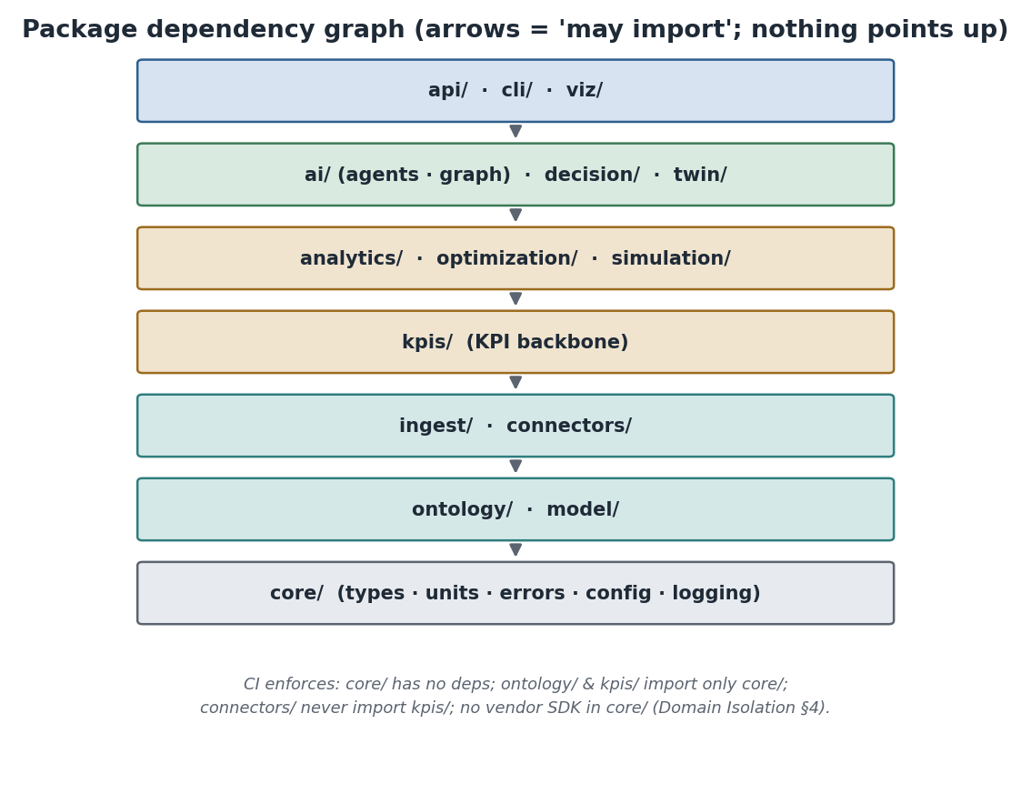
Package dependency graph. Arrows read “may import”; nothing points up. The domain heart (core/ontology/kpis) stays pure.
Architecture Insight. This single rule is what keeps MineProductivity vendor-neutral and testable for the long term. Because kpis/ cannot import a fleet-management SDK, a KPI can never accidentally depend on one vendor’s data shape. (Blueprint, “Package dependency rules.”)

Plugin discovery
You will add connectors, KPIs, and more as separate installable packages. They are found through Python entry-points: a plugin declares itself in its pyproject.toml, and on install it appears in the relevant registry — with no change to the core.
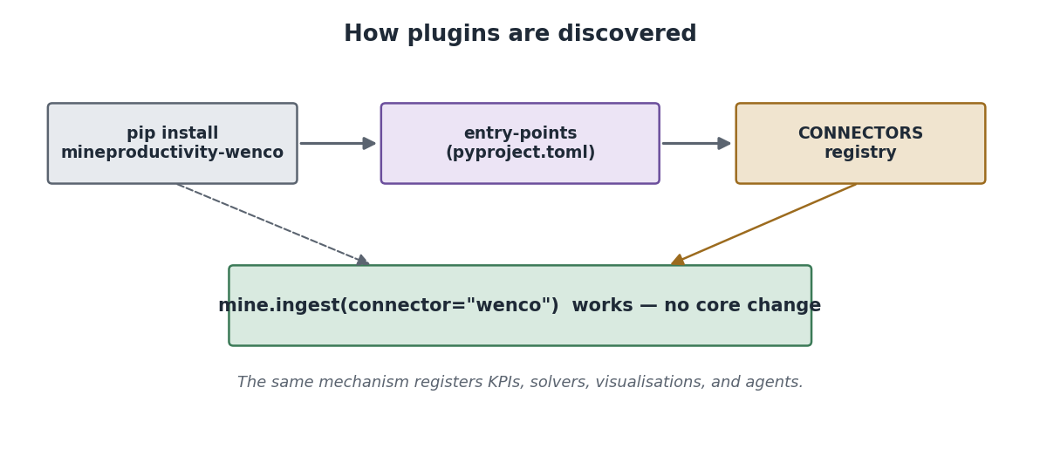
How plugins are discovered: installing a plugin registers it via entry-points into the matching registry, where the core finds it at runtime.
# A connector plugin announces itself like this (in its own pyproject.toml):
[project.entry-points."mineproductivity.connectors"]
wenco = "mineproductivity_wenco.connector:WencoConnector"
After pip install mineproductivity-wenco, mine.ingest(connector="wenco") simply works. The same mechanism serves KPI packs, solvers, visualisations, and agents — one discovery pattern for the whole ecosystem (Chapter 9).

Configuration
Site-specific choices are versioned configuration, not code — units, timezone, the shift calendar, delay-code dictionary, and the time-model conventions the KPI engine reads. Configuration is layered: defaults → enterprise → region → site, each overriding the last.
from mineproductivity.core.config import load_config
cfg = load_config(site="Bingham West")
print(cfg.units) # 'metric'
print(cfg.shift_calendar.pattern) # '2x12' (two 12-hour shifts)
Warning. Two sites are only comparable when their time-model conventions match (for example, whether queueing counts as operating time). Declaring conventions in configuration — rather than hard-coding a boundary — is what makes cross-site benchmarking valid. Chapter 6 returns to this.

How a request flows through the packages
When you ask for a KPI, the request crosses exactly these layers: the connector produced events, ingest normalised them, io stored them, the kpis engine executed a KPI object against them, and viz/api/cli presented the result. You will see this concretely in Chapter 4 and trace it end-to-end in Chapter 10.

What you should remember
Three bands (domain heart, plumbing, intelligence/interfaces); one iron rule (dependencies point down, no vendor SDK in the heart); one discovery mechanism (entry-points into registries). Configuration lives in versioned files, not code.

Exercises
- For each package, say which band it belongs to: twin/, core/, connectors/, decision/, ontology/.
- A teammate wants to add OEM-specific parsing to kpis/ “just this once.” Explain in two sentences why CI will reject it and where the code belongs.

Solutions
- twin/ → intelligence; core/ → domain heart; connectors/ → plumbing; decision/ → intelligence; ontology/ → domain heart.
- kpis/ may not import a vendor SDK or vendor-shaped logic — the dependency-direction check forbids it — so the parsing belongs in a connector, which normalises vendor data into canonical events before any KPI sees it.

Further reading
Reference Implementation Blueprint — Package hierarchy and Cross-cutting design patterns. Next: Chapter 4 — Your First MineProductivity Program.

Chapter 4 — Your First MineProductivity Program
This chapter takes you from a blank file to a computed KPI, explaining every line and what happens inside the library. We assume nothing beyond a working install (Chapter 2).

The whole program
Here it is in full. We will dissect it line by line.
"""Compute a shift's tonnes-per-hour for the Bingham West copper pit."""
from mineproductivity import Mine
mine = Mine(site="Bingham West", commodity="copper",
method="open_pit", maturity=2)
mine.ingest(connector="csv", path="bingham_west_shift_A.csv")
tph = mine.kpi("PROD.TPH").by("shift")
print(f"{tph.value:.1f} {tph.unit}")
Expected output:
1212.1 t/h
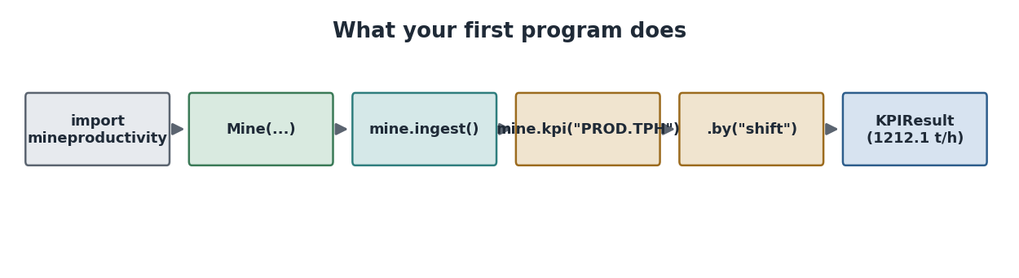
What your first program does: import, describe the mine, ingest a shift, ask for a KPI, receive a KPIResult.

Line by line
from mineproductivity import Mine. Mine is the library’s façade — the single object most users start from, analogous to a scikit-learn estimator or a pandas DataFrame. Importing it triggers the registries to populate (every built-in KPI and connector registers itself on import), which is why the next lines can refer to KPIs and connectors by name.
Mine(site=..., commodity=..., method=..., maturity=...). You describe the operation. Each argument is meaningful, not decoration:
Argument | Meaning | Effect
site | a human label for this operation | scopes data and reports
commodity | what is mined (here, copper) | activates commodity-specific KPIs
method | how it is mined (open pit) | gates method-specific KPIs
maturity | digital maturity, 1–4 | hides KPIs the site can’t yet support
Mining Insight. maturity=2 means the site has a fleet-management system feeding telemetry (level 2 of four). That is why cycle-time and match-factor KPIs become available here but would be withheld at a paper-based maturity=1 site — you cannot measure a truck cycle you never recorded.
mine.ingest(connector="csv", path=...). This loads data. The named connector ("csv") reads the file and yields canonical events (Chapter 5), which are validated and stored. Crucially, the rest of your program never sees the CSV’s columns — only normalised events. Swap "csv" for "dispatch" and nothing else changes.
mine.kpi("PROD.TPH"). You ask for a KPI by its stable code. PROD.TPH is tonnes per hour. This returns a small query object, not yet a number — you have said what to compute, not yet over what grouping.
.by("shift"). This executes the KPI, grouped by shift, and returns a KPIResult. The result is an object, not a bare float: it carries value, unit, the record count n, and any warnings.
print(f"{tph.value:.1f} {tph.unit}"). Standard Python f-string formatting of the result’s fields.

What happens internally
When you call .by("shift"), the library does the following, in order:
# (conceptually, inside the library)
kpi = REGISTRY["PROD.TPH"]() # look up the KPI object by code
rows = engine.rows_for(kpi, "shift") # assemble exactly the columns the KPI declares it needs
result = kpi.compute(rows, "shift") # the KPI validates inputs, then computes
The engine holds no metric logic — it merely executes the KPI object. This is the KPI-as-object principle in action, and it is why adding a metric (Chapter 6) never touches this path.
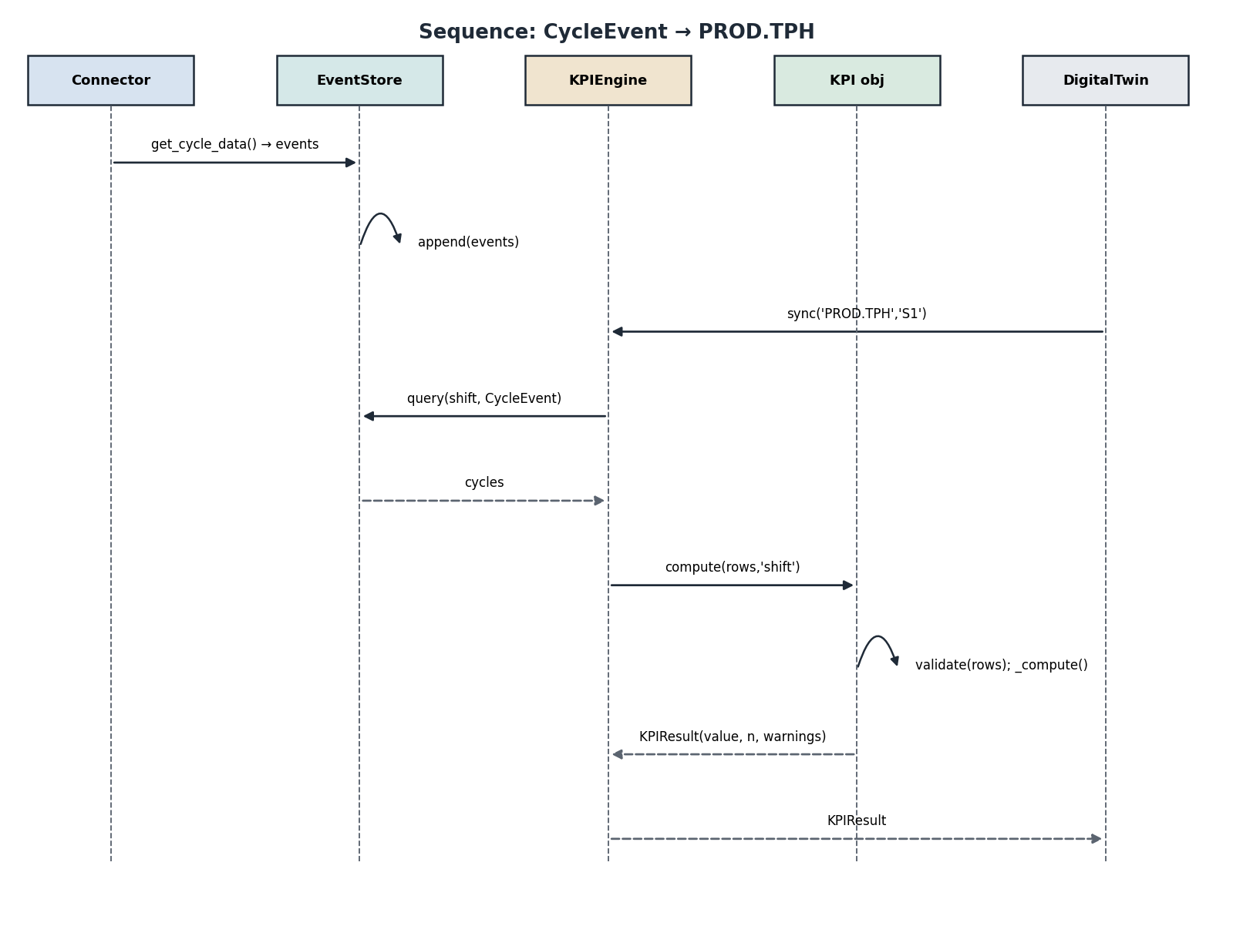
Internally, the engine fetches events and executes the KPI object, which validates then computes, returning a traceable KPIResult.
Python Insight. mine.kpi("PROD.TPH") returns a query object and .by(...) triggers execution — a small fluent interface. It mirrors pandas’ df.groupby("shift") (lazy) then .mean() (eager). Separating “what” from “how grouped” keeps the call readable and lets the library choose an efficient execution path.

Reading the result object
tph = mine.kpi("PROD.TPH").by("shift")
print(tph.value) # 1212.121...
print(tph.unit) # 't/h'
print(tph.n) # number of source records used
print(tph.warnings) # () when inputs were complete
Tip. Always check result.warnings in production code. An empty tuple means the value came from complete, validated inputs. A non-empty tuple (e.g. a missing column) tells you exactly why a value is None — far better than a silent zero.
Performance Note. Computing one KPI reads only the columns it declares, so asking for PROD.TPH never loads delay or quality data. When you need many KPIs at once, request them together (mine.summary(...)) so the engine scans the event store once rather than per metric — on large shifts that is the difference between one pass and a dozen.

Troubleshooting
Symptom | Cause | Fix
KeyError: 'PROD.TPH' | registry didn’t load | Ensure import mineproductivity succeeded; reinstall if the registry is empty.
value is None | required column missing in data | Inspect result.warnings; check the connector mapping.
ConnectorNotFound: 'csv' | wrong name / plugin missing | The CSV connector ships in core; for OEMs install the plugin (Chapter 7).
TPH looks 10× off | unit or operating-hours error | Confirm payload is in tonnes and operating hours, not calendar hours.

Summary
Four moves — describe the mine, ingest data, name a KPI, choose a grouping — produce a traceable result object. The engine executes KPI objects and contains no metric logic.

Exercises
- Modify the program to also print FLEET.PA (Physical Availability) for the shift.
- Print the number of source records (n) used for PROD.TPH, and explain what it represents.

Solutions
- Add pa = mine.kpi("FLEET.PA").by("shift"); print(f"{pa.value:.1f} {pa.unit}").
- print(tph.n) — it is the count of source records (here, aggregated event rows) the KPI consumed, part of the result’s traceability.

Further reading
Chapter 5 explains the events that ingest created; Chapter 6 dissects the PROD.TPH KPI itself.

Chapter 5 — Your First Event
Events are the bedrock of MineProductivity. Every number the library produces is derived from events, and understanding them demystifies everything downstream. This chapter explains what an event is, its lifecycle, and how to create one three ways.

What is an event?
An event is an immutable, time-stamped fact about the operation: a truck completed a cycle, a crusher went down, a shift produced so many tonnes. Events are never edited after they are written; metrics are recomputed from them. This pattern — called event sourcing — is what makes every KPI reproducible and auditable.
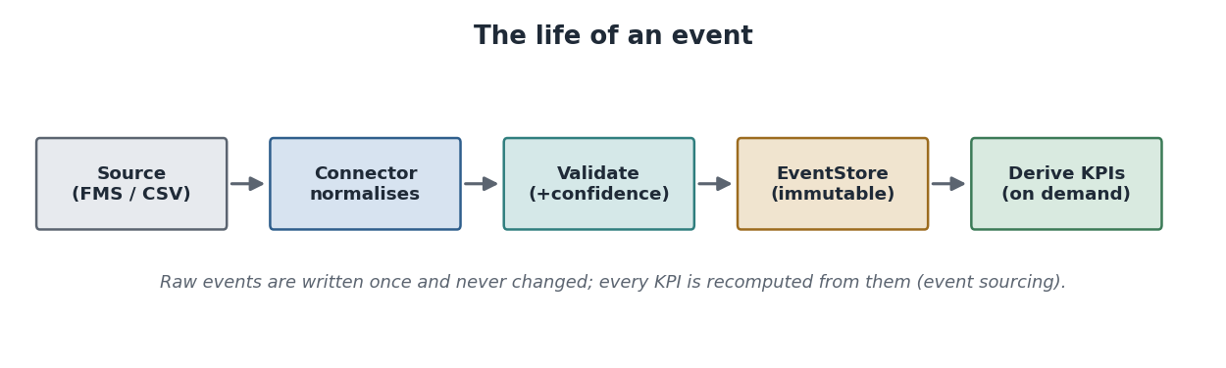
The life of an event: a source produces it, a connector normalises it, it is validated and stored immutably, and KPIs are derived from it on demand.
The core event types you will meet first:
Event type | Records | Key fields
CycleEvent | one haul-truck round-trip | segment minutes (queue→return), payload_t
DelayEvent | lost productive time | reason_code, delay_h
ProductionEvent | tonnes produced over a window | tonnes, window bounds
MaintenanceEvent | a maintenance activity | work_order, down_h
Mining Insight. A truck “cycle” is one full loop: it queues at the shovel, spots into position, is loaded, hauls to the dump/crusher, dumps, and returns. Each leg is timed. Summing the legs gives the cycle time; summing payloads over a shift, divided by operating hours, gives TPH. Events capture these legs so any of those metrics can be derived later.

The event contract
Every event — whatever its type — shares a small base contract, so the rest of the system can treat them uniformly:
from dataclasses import dataclass
@dataclass(frozen=True)
class Event:
"""Immutable base for every fact in the mine."""
event_id: str
equipment_id: str
shift_id: str
start_ts: int # epoch milliseconds
end_ts: int
def duration_h(self) -> float:
"""Return the event's duration in hours."""
return (self.end_ts - self.start_ts) / 3_600_000
frozen=True makes the dataclass immutable — you cannot accidentally mutate a stored fact, which is exactly what event sourcing requires.

Creating an event manually
The most direct way to understand events is to build one:
from mineproductivity.core.events import CycleEvent
cycle = CycleEvent(
event_id="c-0001", equipment_id="HT-214", shift_id="A-2026-06-25",
start_ts=0, end_ts=1_170_000, # 19.5 minutes, in ms
queue_min=1.5, spot_min=0.5, load_min=2.5,
haul_min=8.0, dump_min=1.0, return_min=6.0,
payload_t=220.0,
)
print(cycle.cycle_min) # 19.5
print(cycle.payload_t) # 220.0
Expected output:
19.5
220.0
A delay event is just as simple:
from mineproductivity.core.events import DelayEvent
delay = DelayEvent(
event_id="d-0001", equipment_id="CR-01", shift_id="A-2026-06-25",
start_ts=0, end_ts=15_120_000, reason_code="crusher_down", delay_h=4.2,
)
print(delay.reason_code, delay.delay_h) # crusher_down 4.2

Event metadata, validation, and relationships
Events do not float free; they relate to the ontology (Chapter 8). A CycleEvent’s equipment_id points at a RigidHaulTruck; its shift_id points at a Shift. Those relationships are what let a KPI be sliced “by equipment” or “by shift”.
Validation happens at ingest, not on every read. Each event is checked against its schema (for example, end_ts > start_ts, segment minutes summing within tolerance, payload within a plausibility band) and assigned a confidence score so downstream KPIs know how complete their inputs were.
Best Practice. Treat a low-confidence event as a data-quality signal, not a number to silently trust. The confidence score travels with derived KPIs, so a shift built from suspect events can be flagged rather than quietly reported.
Common Mistake. Trying to “fix” a stored event by mutating it. Events are immutable by design. If a source correction arrives, you append a corrected event (and, if needed, a compensating one); you never edit history. This is what keeps replay and audit trustworthy.

Creating events from a CSV
In practice you rarely hand-build events — a connector does it. The bundled CSV connector reads a file of cycles and yields CycleEvents:
from mineproductivity.connectors import get_connector
conn = get_connector("csv")(path="bingham_west_shift_A.csv",
shift_id="A-2026-06-25")
events = list(conn.get_cycle_data())
print(len(events), "events |", "first payload:", events[0].payload_t)

Creating events from a connector (the real path)
When you call mine.ingest(connector="dispatch", ...), a vendor connector pulls from the fleet-management system, maps its proprietary status and reason codes onto canonical events, and appends them to the event store. Your code sees only CycleEvent/DelayEvent objects — never the vendor’s dialect. Chapter 7 builds a connector from scratch.
AI Contributor Note. Because events are a small, typed, documented contract, an AI agent can generate a new connector or synthesise test events safely: it has an exact schema to satisfy and validation to check itself against. The same property that helps humans — explicit structure — is what makes the library safe for machine contributors.

Where events are stored
Events are appended to an event store (the event lake) and partitioned by site and date. Aggregates and KPI values are derived and cached separately; the event store remains the single source of truth from which everything can be rebuilt — including any past state, via replay (Part III, Digital Twin).

Troubleshooting
Symptom | Cause | Fix
cycle_min is wrong | segment minutes mismatched | Confirm each leg is in minutes; they sum to the cycle.
validation warning on ingest | end_ts <= start_ts | Check timestamp units (milliseconds) and ordering.
KPI ignores some events | shift/equipment id mismatch | Ensure ids match ontology entities (Chapter 8).

Summary
An event is an immutable, time-stamped fact with a small shared contract. You can build one by hand, but normally a connector does it. Events are validated at ingest, related to the ontology, stored immutably, and are the source from which every KPI is derived.

Exercises
- Build a CycleEvent with a 22-minute cycle and a 200-tonne payload; print its cycle_min.
- Explain, in two sentences, why events are immutable and what you do when a source sends a correction.

Solutions
- Set the six segment minutes to sum to 22 (e.g. queue_min=2, spot_min=0.5, load_min=3, haul_min=9, dump_min=1.5, return_min=6) and payload_t=200; print(cycle.cycle_min) → 22.0.
- Immutability guarantees that derived metrics and replays are reproducible and auditable; a correction is appended as a new (and, if required, compensating) event rather than by editing history.

Further reading
Chapter 6 turns these events into the PROD.TPH KPI; Chapter 8 models the entities events point to.

Chapter 6 — Your First KPI
We now open up a single KPI — PROD.TPH, tonnes per hour — and examine every part of it: what it means to the business, its formula and dependencies, the events and ontology it needs, its metadata, how it validates and computes, how to visualise and benchmark it, and how it compares with the spreadsheet you may be replacing.

Business meaning
Tonnes per hour is the headline production rate of a mine: how much material the system moves per operating hour. It is the number a mine manager watches against plan, the number a dispatcher tries to protect, and the number that ultimately converts into revenue. If a single metric had to summarise a shift, this is it.
Mining Insight. TPH is a rate, not a total. A shift can move record tonnes yet still have a poor TPH if it ran long with many delays. Conversely a short, clean shift can post a high TPH. Always read TPH alongside operating hours — which is exactly why the formula divides by them.

Formula and the aggregation that matters
PROD.TPH = sum(payload_t) / sum(operating_h)
The subtlety is the aggregation rule: TPH is a RATIO. Over multiple periods you sum the numerators and denominators and divide once — you never average per-period rates.
Common Mistake. Averaging shift TPHs to get a daily TPH. If A-shift ran 1,300 t/h over 12 h and B-shift 1,100 t/h over 6 h, the day’s TPH is not 1,200. It is (1300·12 + 1100·6) / 18 = 1,233 t/h. MineProductivity gets this right automatically because the KPI declares aggregation=RATIO.

Dependencies, required events, required ontology
PROD.TPH declares what it needs, and the engine supplies exactly that:
- Required columns: payload_t, operating_h.
- Required events: CycleEvent (for payload) and the operating-time derivation that delays reduce (Chapter 5).
- Required ontology: an Equipment/Fleet to attribute payload to, and a Shift (or other window) to divide by.
- Dependencies: none upstream — TPH is foundational; many other KPIs depend on it.

The metadata
Every KPI is defined by its metadata. Here is PROD.TPH as the library sees it:
KPIMetadata(
code="PROD.TPH", name="Tonnes per Hour", category="Production",
description="Total payload moved divided by operating hours.",
formula="sum(payload_t) / sum(operating_h)", unit="t/h",
direction=Direction.HIGHER_IS_BETTER, aggregation=Aggregation.RATIO,
required_columns=("payload_t", "operating_h"),
data_sources=("FMS",), min_maturity=DigitalMaturity.L1_MANUAL,
edge_cases=("operating_h == 0 -> None",),
)
Read the metadata and you already know how to use, aggregate, and interpret the metric — no source-diving required. That is the point of KPI-as-object.
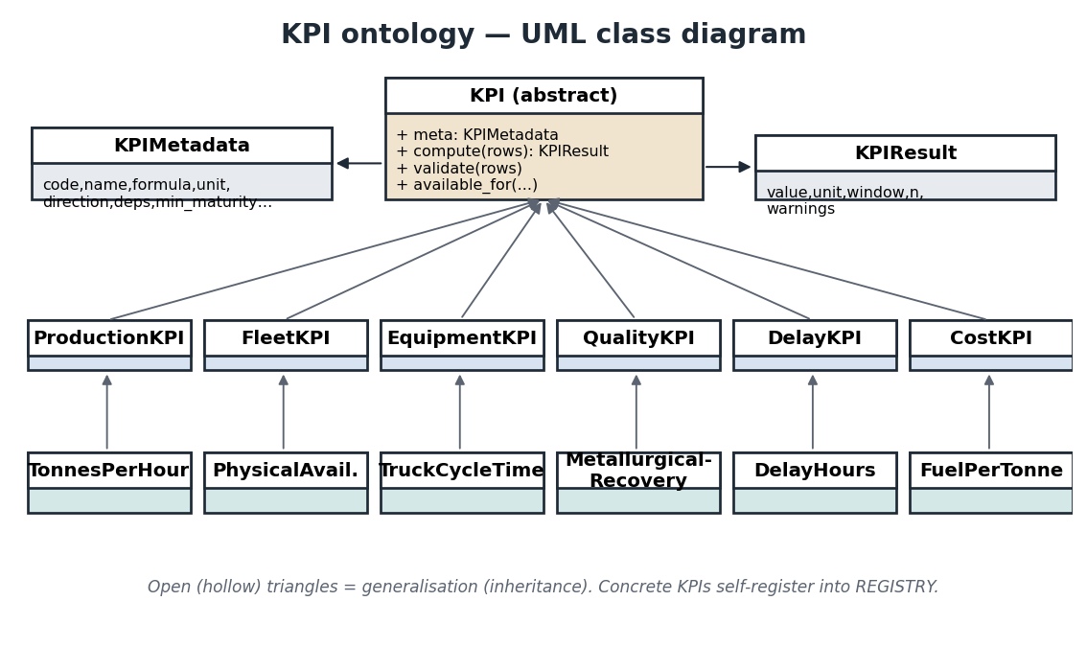
The KPI class hierarchy. PROD.TPH is a ProductionKPI; it carries the metadata above and returns a KPIResult.

The Python implementation
The whole KPI is a small class. The category base (ProductionKPI) and the metadata do most of the work; _compute is the only logic you write:
from mineproductivity.kpis import (register, KPIMetadata, ProductionKPI,
Direction, Aggregation, DigitalMaturity)
@register
class TonnesPerHour(ProductionKPI):
"""Headline production rate: payload moved per operating hour."""
meta = KPIMetadata(
code="PROD.TPH", name="Tonnes per Hour", category="Production",
description="Total payload moved divided by operating hours.",
formula="sum(payload_t) / sum(operating_h)", unit="t/h",
direction=Direction.HIGHER_IS_BETTER, aggregation=Aggregation.RATIO,
required_columns=("payload_t", "operating_h"),
min_maturity=DigitalMaturity.L1_MANUAL,
edge_cases=("operating_h == 0 -> None",))
def _compute(self, rows):
"""Return tonnes/hour, or None if no operating time."""
hours = sum(r["operating_h"] for r in rows)
return None if hours == 0 else sum(r["payload_t"] for r in rows) / hours
Python Insight. Notice the division-by-zero guard returns None, not a raised exception. A KPI that cannot be computed from valid inputs yields None plus a warning, so a dashboard shows a blank cell rather than crashing. This “qualify, don’t coerce” stance is consistent across the whole library.

Validation
Before computing, the KPI validates its inputs and returns warnings rather than guessing:
result = TonnesPerHour().compute([{"payload_t": 100}]) # 'operating_h' missing
print(result.value) # None
print(result.warnings) # ("missing required columns: ['operating_h']",)

Execution and output
On complete inputs you get a clean result. Using one shift’s fleet totals — 36,000 tonnes over 29.7 operating hours:
rows = [{"payload_t": 36000, "operating_h": 29.7}]
tph = TonnesPerHour().compute(rows, window="shift")
print(f"{tph.value:.1f} {tph.unit} (n={tph.n})")
Expected output:
1212.1 t/h (n=1)

Visualisation
A KPI’s metadata includes how it should be drawn, so charts are consistent and you write almost nothing:
mine.kpi("PROD.TPH").by("shift").plot() # trend line vs plan band
mine.kpi("DELAY.HOURS").by("reason").pareto() # ranked delay Pareto
Tip. Because direction=HIGHER_IS_BETTER is in the metadata, the chart colours improvement green and regression red automatically — you never re-specify “up is good” per chart.

Benchmarking
Compare a result against plan or a peer group with one call (peer set defined by the enterprise tree):
from mineproductivity.analytics import benchmark
bm = benchmark(tph, scope="business_unit", target=1300)
print(f"{tph.value:.0f} t/h ({bm.vs_target:+.1f}% vs plan, Q{bm.quartile})")
# 1212 t/h (-6.8% vs plan, Q3)
That −6.8% gap is trustworthy precisely because both the site and the benchmark were computed with the same RATIO aggregation and normalised to the same basis.

Comparison with a spreadsheet implementation
The same metric in a spreadsheet is a single cell — and that is the problem.
Concern | Spreadsheet =SUM(payload)/SUM(hours) | MineProductivity PROD.TPH
Visible formula | hidden in a cell | declared in metadata
Correct aggregation | manual, easily wrong | enforced (RATIO)
Validation | none (silent errors) | warnings + confidence
Reuse across sites | copy-paste drift | one registered object
Tested | rarely | golden test required
Discoverable by tools/AI | no | yes (registry + metadata)
Traceable to source | no | yes (event lineage)
Did You Know? The single most common cause of “our numbers don’t match” disputes in mining is two spreadsheets aggregating the same KPI differently. Encoding the aggregation rule in the metric — not in a cell — is how MineProductivity ends that argument.

Troubleshooting
Symptom | Cause | Fix
value is None | operating_h is 0 or missing | Check inputs; read warnings.
Daily TPH ≠ mean of shifts | you averaged rates | Correct behaviour — RATIO re-derives from sums.
TPH too high | calendar hours used as operating hours | Operating hours exclude downtime; verify the source.
KPI not offered at a site | maturity/commodity/method gate | Confirm the site profile (Chapter 4).

Summary
PROD.TPH is a rate with a RATIO aggregation that prevents the classic averaging error. Its metadata declares everything needed to use, validate, visualise, and benchmark it. The whole metric is a small registered class whose only custom logic is _compute.

Exercises
- Compute the correct combined TPH for A-shift (1,300 t/h over 12 h) and B-shift (1,100 t/h over 6 h) by hand, then confirm why averaging gives the wrong answer.
- Write the metadata line that would make a new KPI “lower is better” and aggregate as a ratio.

Solutions
- (1300·12 + 1100·6)/18 = 1,233 t/h. Averaging (1,200) is wrong because it ignores that the shifts ran for different durations — a ratio must be re-derived from summed numerator and denominator.
- direction=Direction.LOWER_IS_BETTER, aggregation=Aggregation.RATIO.

Further reading
Chapter 7 builds the connector that feeds TPH its events; Part II covers analytics and benchmarking in depth.

Chapter 7 — Your First Connector
A connector is how MineProductivity meets the real world. This chapter explains why connectors exist, builds a working CSV connector from scratch, sketches a vendor connector (MineStar) conceptually, and covers streaming, database, and REST connectors, plus registration, discovery, and testing.

Why connectors exist
Every fleet-management system — Caterpillar MineStar, Modular DISPATCH, Wenco, Hexagon — emits data in its own dialect of status codes, reason codes, and field names. If that dialect leaked into your analytics, every KPI would be coupled to one vendor, and changing systems would mean rewriting everything.
A connector is the adapter that quarantines the dialect. It does exactly one job: read a source and yield canonical events (Chapter 5). The rest of the library — and every KPI — sees only the canonical model.
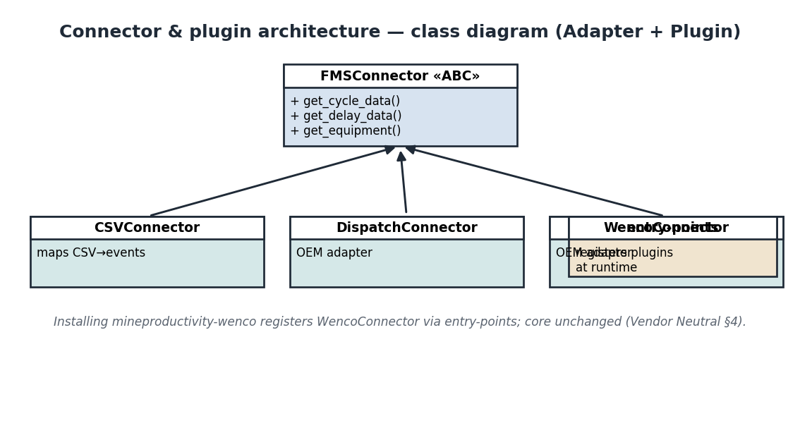
The connector contract. Every adapter implements FMSConnector; the core depends on that interface, never on a vendor SDK.
Architecture Insight. This is the Vendor-Neutrality principle made concrete. Connectors are the only place in the codebase allowed to know about a specific OEM, which is why connectors/ may not import kpis/ (Chapter 3). One plugin per vendor; the core stays clean. (Blueprint, “Connector & plugin architecture.”)

The contract
Every connector implements one small abstract base class:
from abc import ABC, abstractmethod
from typing import Iterable
from mineproductivity.core.events import CycleEvent, DelayEvent
class FMSConnector(ABC):
"""Adapter from a fleet-management source to canonical events."""
name: str = "abstract"
@abstractmethod
def get_cycle_data(self, since: int, until: int) -> Iterable[CycleEvent]:
"""Yield CycleEvents in the time window."""
@abstractmethod
def get_delay_data(self, since: int, until: int) -> Iterable[DelayEvent]:
"""Yield DelayEvents in the time window."""

Building a CSV connector from scratch
Here is a complete, runnable connector for CSV exports — the kind a site can produce from any system. Every line is production-quality: typed, documented, and yielding validated events.
import csv
import io
from typing import Iterable
from mineproductivity.connectors import FMSConnector
from mineproductivity.core.events import CycleEvent, DelayEvent
class CSVConnector(FMSConnector):
"""Read haul-cycle CSV exports and yield canonical CycleEvents.
The CSV is expected to have one row per truck cycle, with the six
segment minutes (queue/spot/load/haul/dump/return) and a payload.
"""
name = "csv"
def __init__(self, path: str, shift_id: str = "S1") -> None:
self._path = path
self._shift_id = shift_id
def get_cycle_data(self, since: int = 0,
until: int = 2**63) -> Iterable[CycleEvent]:
with open(self._path, newline="") as fh:
for i, row in enumerate(csv.DictReader(fh)):
start = int(row.get("start_ts", i * 60_000))
cycle_ms = int(float(row["cycle_min"]) * 60_000)
yield CycleEvent(
event_id=f"c{i}", equipment_id=row["equipment_id"],
shift_id=self._shift_id,
start_ts=start, end_ts=start + cycle_ms,
queue_min=float(row.get("queue_min", 0)),
spot_min=float(row.get("spot_min", 0)),
load_min=float(row.get("load_min", 0)),
haul_min=float(row.get("haul_min", 0)),
dump_min=float(row.get("dump_min", 0)),
return_min=float(row.get("return_min", 0)),
payload_t=float(row["payload_t"]),
)
def get_delay_data(self, since: int = 0,
until: int = 2**63) -> Iterable[DelayEvent]:
return iter(()) # this minimal example has no delay file
Use it directly, then through Mine:
conn = CSVConnector(path="bingham_west_shift_A.csv", shift_id="A-2026-06-25")
events = list(conn.get_cycle_data())
print(len(events), "events |", events[0].equipment_id, events[0].payload_t)
Python Insight. get_cycle_data is a generator (it yields). Events stream out one at a time instead of all loading into memory — so the same connector handles a 200-row test file or a 50-million-row shift export without change. This is why the contract returns Iterable, not list.

A vendor connector, conceptually (MineStar)
A real OEM connector has the same shape; only the source and the code-mapping differ:
class MineStarConnector(FMSConnector):
"""Adapter for Caterpillar MineStar (conceptual outline)."""
name = "minestar"
def __init__(self, host: str, token: str) -> None:
self._client = MineStarClient(host, token) # vendor SDK, isolated here
def get_cycle_data(self, since, until):
for rec in self._client.haul_cycles(since, until):
yield CycleEvent(
event_id=rec["cycleId"], equipment_id=rec["truck"],
shift_id=rec["shift"], start_ts=rec["startMs"], end_ts=rec["endMs"],
haul_min=rec["haulSec"] / 60, payload_t=rec["tonnes"],
# ...map the remaining MineStar fields to canonical legs...
)
def get_delay_data(self, since, until):
for rec in self._client.delays(since, until):
yield DelayEvent(
event_id=rec["id"], equipment_id=rec["unit"], shift_id=rec["shift"],
start_ts=rec["startMs"], end_ts=rec["endMs"],
reason_code=MINESTAR_REASONS[rec["code"]], # map vendor → canonical
delay_h=rec["durationMs"] / 3_600_000,
)
Mining Insight. The hardest part of a real connector is the reason-code map. Each vendor has dozens of delay codes (“STBY-OPS”, “DOWN-MECH”, …) that must be mapped to MineProductivity’s canonical delay taxonomy so that “crusher down” means the same thing across systems. Get this mapping right and every downstream delay analysis becomes comparable.

Streaming, database, and REST connectors
The same contract covers other sources; only the body of get_cycle_data changes:
- Streaming. Subscribe to a Kafka/MQTT topic and yield an event per message — ideal for near-real-time KPIs (Part IV).
- Database. Query a historian or SQL table in pages and yield events per row.
- REST. Page through an HTTP API and yield events per record.
class RestConnector(FMSConnector):
name = "rest"
def get_cycle_data(self, since, until):
page = 0
while (batch := self._api.get(f"/cycles?since={since}&page={page}")):
for rec in batch:
yield CycleEvent(...) # map fields
page += 1

Registering and discovering a connector
A connector ships as its own installable package and announces itself through an entry-point. No core change is needed.
# in the plugin's pyproject.toml
[project.entry-points."mineproductivity.connectors"]
minestar = "mineproductivity_minestar.connector:MineStarConnector"
After pip install mineproductivity-minestar, the connector is discoverable everywhere:
from mineproductivity.connectors import get_connector, CONNECTORS
print("minestar" in CONNECTORS) # True
mine.ingest(connector="minestar", since="2026-06-01")

Discovery flow: installing the plugin registers it via entry-points into the CONNECTORS registry, where get_connector finds it.

Testing and validating a connector
Every connector is run through a shared contract test suite against recorded fixtures — no live OEM system needed in CI. You add a fixture file and the suite asserts your connector yields well-formed, schema-valid events:
def test_csv_connector_yields_valid_cycles(tmp_path):
csv_text = ("equipment_id,queue_min,spot_min,load_min,haul_min,"
"dump_min,return_min,cycle_min,payload_t\n"
"HT-214,1.5,0.5,2.5,8.0,1.0,6.0,19.5,220\n")
f = tmp_path / "shift.csv"; f.write_text(csv_text)
events = list(CSVConnector(str(f), "A").get_cycle_data())
assert len(events) == 1
assert events[0].payload_t == 220.0
assert events[0].cycle_min == 19.5 # legs sum correctly
Best Practice. Record a small, anonymised fixture from each real source and commit it. Contract tests then protect you from a vendor silently changing a field name — your connector test fails before production does.
AI Contributor Note. A connector is the ideal task to delegate to an AI agent: the FMSConnector contract is tiny and explicit, the canonical event schema is documented, and the contract-test suite gives the agent an automatic pass/fail signal. The agent writes the field mapping; the tests prove it correct.

Troubleshooting
Symptom | Cause | Fix
ConnectorNotFound | plugin not installed | pip install mineproductivity-<vendor>.
Events have wrong reason codes | mapping gap | Complete the vendor → canonical reason map.
Memory spike on large file | materialising a list | Keep get_cycle_data a generator; don’t list() it before ingest.
Times off by 1000× | seconds vs milliseconds | start_ts/end_ts are epoch milliseconds.

Summary
A connector implements one small contract and does one job: normalise a source into canonical events. The same shape serves CSV, vendor SDKs, streams, databases, and REST. Connectors ship as plugins discovered via entry-points and are protected by contract tests.

Exercises
- Extend CSVConnector to also read a delays CSV and yield DelayEvents.
- Write the entry-point line that registers a connector named wenco from mineproductivity_wenco.connector:WencoConnector.

Solutions
- Implement get_delay_data to open the delays file and yield DelayEvent(...) per row, mapping its reason column through your canonical reason map.
- wenco = "mineproductivity_wenco.connector:WencoConnector" under [project.entry-points."mineproductivity.connectors"].

Further reading
Chapter 8 models the entities events refer to; Chapter 9 packages a plugin end-to-end.

Chapter 8 — Your First Ontology
The ontology is the typed model of the mining world: trucks, loaders, pits, benches, shifts, and the relationships between them. You will rarely build one from scratch — MineProductivity ships a complete ontology — but modelling a few entities yourself is the fastest way to understand how the whole library hangs together.

What the ontology is for
A KPI like TPH cannot mean anything without context: whose tonnes, over which shift, from which pit. The ontology supplies that context as objects. When you slice a KPI “by equipment” or “by shift”, you are traversing ontology relationships.
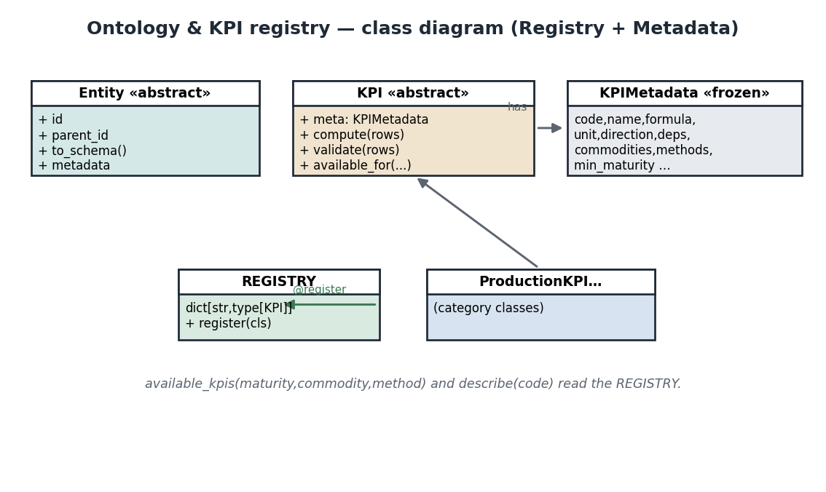
The ontology and KPI registry. Entity and KPI are the two abstract roots; both are metadata-rich and discoverable through registries.

Modelling equipment: Truck and Loader
Entities are classes that inherit a base and declare metadata. A haul truck and a loader share an Equipment parent but differ in what they do and which KPIs apply:
from mineproductivity.ontology.assets import EquipmentType, register_equipment
@register_equipment
class RigidHaulTruck(EquipmentType):
"""A rigid-frame haul truck (e.g. CAT 793)."""
code = "RIGID_HAUL_TRUCK"
supported_kpis = ("EQUIP.TRUCK.CYCLE", "FLEET.PA", "FLEET.UA", "HAUL.TKPH")
operational_states = ("operating", "standby", "down", "maint")
rated_capacity = 220.0 # tonnes
@register_equipment
class HydraulicShovel(EquipmentType):
"""A hydraulic face shovel that loads trucks."""
code = "HYDRAULIC_SHOVEL"
supported_kpis = ("FLEET.PA", "FLEET.UA", "LOAD.RATE", "FLEET.MATCH")
operational_states = ("operating", "standby", "down", "maint")
rated_capacity = 45.0 # tonnes per pass
Mining Insight. A truck and a loader are partners: the loader fills trucks, and the match factor (FLEET.MATCH) measures whether there are enough trucks to keep the loader busy without queueing. Modelling both as distinct equipment types, each with its own supported KPIs, is what lets the library reason about that partnership.

Inheritance
Equipment types form a small hierarchy. Common behaviour (id, state machine, availability KPIs) lives in the base; specifics (rated capacity, the cycle KPI) live in the leaf. This is ordinary Python inheritance, used deliberately:
truck = RigidHaulTruck()
print(truck.code) # 'RIGID_HAUL_TRUCK'
print("EQUIP.TRUCK.CYCLE" in truck.supported_kpis) # True
print("EQUIP.TRUCK.CYCLE" in HydraulicShovel().supported_kpis) # False

Modelling structure: Pit, Bench, Shift
Not all entities are machines. The pit, its benches, and the shift calendar are first-class too:
from mineproductivity.ontology.enterprise import Pit, Bench
from mineproductivity.ontology.shift import Shift
west = Pit(id="pit-west", commodity="copper")
b7 = Bench(id="bench-7", pit_id="pit-west", elevation_m=1820)
shift_a = Shift(id="A-2026-06-25", pattern="2x12", start="06:00")

Relationships
Entities relate by id, forming the graph the library traverses. A Bench belongs to a Pit; a CycleEvent references an Equipment and a Shift; equipment belongs to a Fleet. These relationships are how a KPI sliced “by pit” knows which events to include.
print(b7.pit_id) # 'pit-west' → links Bench to Pit
print(shift_a.pattern) # '2x12'

Metadata and validation
Like KPIs, every entity is metadata-rich and schema-validated. An entity can express itself as JSON Schema, which is how dashboards, validation, and AI all read the same model:
print(truck.to_schema()["required"]) # ['equipment_id', 'type', 'fleet_id']
Validation at ingest checks that an event’s equipment_id and shift_id resolve to real entities; an orphaned reference becomes a warning, not a silent drop.
Common Mistake. Inventing an equipment_id in your data that does not exist in the ontology. The event will validate structurally but cannot be attributed, so it silently won’t appear in “by equipment” slices. Register the entity first, then ingest events that reference it.

Knowledge Graph integration
The ontology is projected into the Knowledge Graph — entities become nodes, relationships and KPI dependencies become edges. This is what lets you ask cross-domain “why” questions later (Part III). You do not build the graph by hand; it is generated from the ontology you have declared.
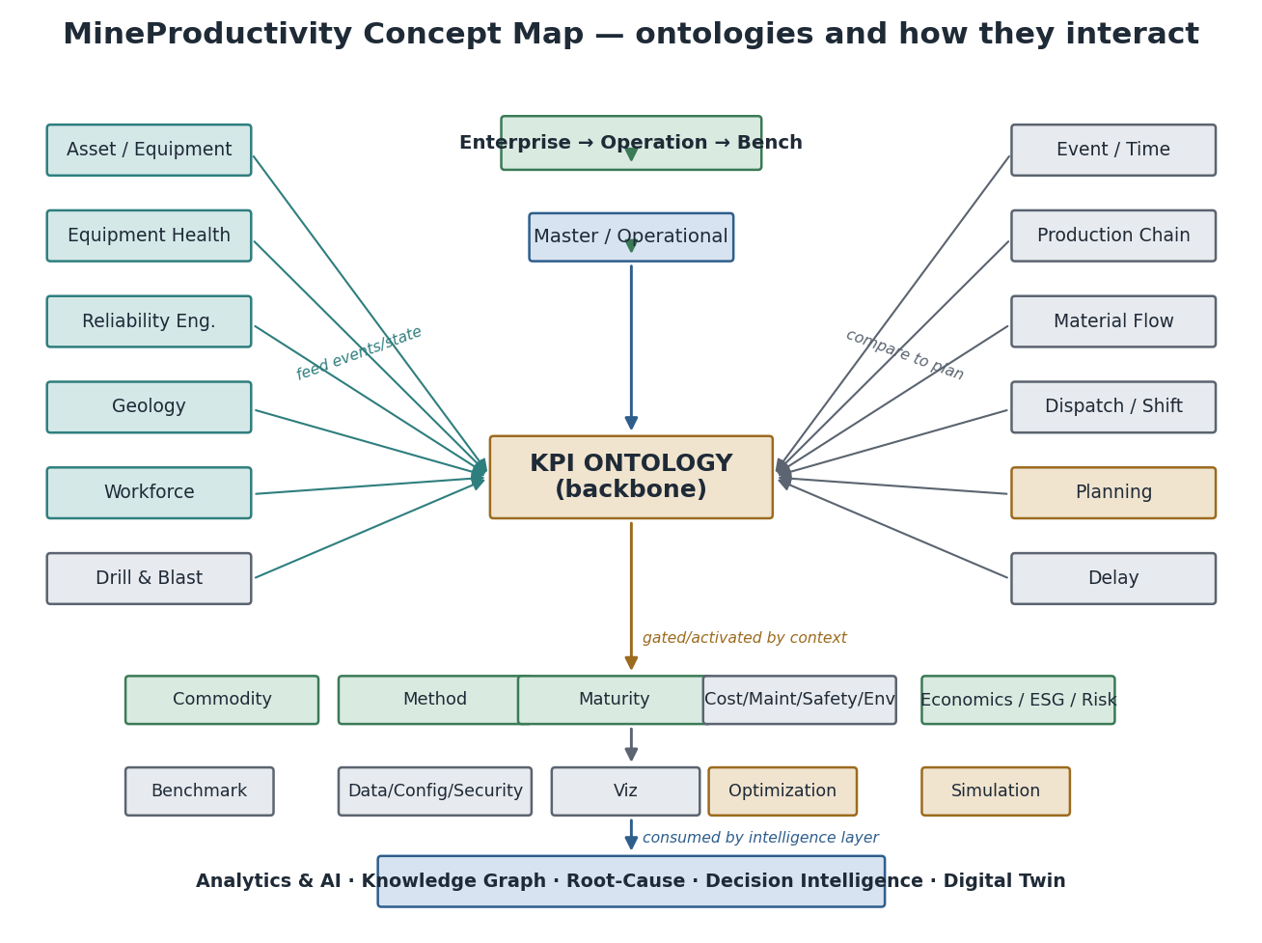
The ontology projected as a concept map around the KPI backbone — the substrate the Knowledge Graph and AI agents traverse.
from mineproductivity.graph import KnowledgeGraph
kg = KnowledgeGraph.build(mine)
print(kg.neighbors("pit-west")) # ['bench-7', 'bench-8', 'HT-201', ...]
Architecture Insight. Because the graph is a projection of the ontology (not a separate model), it can never drift from it. Add an entity or a KPI dependency and the graph gains the corresponding node or edge for free. (Architecture Handbook, “Knowledge Graph ontology.”)

Best practices
Best Practice. Model the entity before the data that references it, give every entity a stable id you control, and let supported-KPI lists live on the equipment type — not scattered through analysis code. The ontology is your single source of structural truth.

Troubleshooting
Symptom | Cause | Fix
Events missing from a “by pit” slice | bench→pit link absent | Set pit_id on the Bench.
KPI not offered for a machine | not in supported_kpis | Add the code to the equipment type.
Graph missing a node | entity not registered | Register the entity, then rebuild the graph.

Summary
The ontology models the mining world as typed, metadata-rich, related entities — equipment (trucks, loaders) and structure (pits, benches, shifts). Relationships by id form the graph the library traverses; the Knowledge Graph is a projection of it. Always model the entity before the data that references it.

Exercises
- Register a WaterTruck equipment type supporting FLEET.PA, FLEET.UA, and COST.FUEL_PER_T.
- Create a Bench on pit-west and explain which relationship makes its events appear in a “by pit” slice.

Solutions
- Subclass EquipmentType with code="WATER_TRUCK" and supported_kpis=("FLEET.PA","FLEET.UA","COST.FUEL_PER_T"), decorated with @register_equipment.
- Bench(id="bench-9", pit_id="pit-west", elevation_m=...); the pit_id link is what aggregates the bench’s events up to the pit.

Further reading
Chapter 9 packages new behaviour as a plugin; Part III covers the Knowledge Graph and Digital Twin in depth.

Chapter 9 — Your First Plugin
Everything you add to MineProductivity — a KPI pack, a connector, a solver — ships as a plugin: a separate, installable, versioned package that registers itself on install. This chapter packages a custom KPI as a real plugin, from directory layout to publishing.

Why plugins
Plugins are how the ecosystem grows without anyone forking the core. Your proprietary KPIs, a vendor’s connector, a community visualisation pack — each lives in its own repository, is versioned independently, and is discovered through entry-points (Chapter 3). The core never changes to accommodate them.

The directory layout
A minimal KPI plugin:
mineproductivity-haulmetrics/
├── pyproject.toml
├── README.md
├── src/
│ └── mineproductivity_haulmetrics/
│ ├── __init__.py
│ └── kpis.py # your registered KPIs
└── tests/
└── test_kpis.py # golden tests
Python Insight. The src/ layout (package under src/, not at the repo root) is the modern best practice: it prevents your tests from accidentally importing the un-installed source tree, so you test exactly what users will pip install.

The KPI
src/mineproductivity_haulmetrics/kpis.py holds a production-quality KPI — fuel intensity, which we validated earlier:
"""Haul-metrics KPI pack."""
from mineproductivity.kpis import (register, KPIMetadata, CostKPI,
Direction, Aggregation, DigitalMaturity)
@register
class FuelPerTonne(CostKPI):
"""Litres of diesel burned per tonne moved (lower is better)."""
meta = KPIMetadata(
code="COST.FUEL_PER_T", name="Fuel per Tonne", category="Cost",
description="Litres of diesel per tonne moved.",
formula="sum(fuel_l) / sum(payload_t)", unit="L/t",
direction=Direction.LOWER_IS_BETTER, aggregation=Aggregation.RATIO,
required_columns=("fuel_l", "payload_t"),
dependencies=("PROD.TPH",), min_maturity=DigitalMaturity.L2_FMS,
target="< 0.6 L/t", edge_cases=("payload_t == 0 -> None",))
def _compute(self, rows):
"""Return fuel litres per tonne, or None if no tonnes."""
t = sum(r["payload_t"] for r in rows)
return None if t == 0 else sum(r["fuel_l"] for r in rows) / t

Registration via entry-points
pyproject.toml declares the package and, critically, the entry-point that makes the plugin load:
[project]
name = "mineproductivity-haulmetrics"
version = "0.1.0"
dependencies = ["mineproductivity>=1.0,<2.0"]
[project.entry-points."mineproductivity.plugins"]
haulmetrics = "mineproductivity_haulmetrics.kpis"
On install, MineProductivity imports the module named by the entry-point; importing it runs the @register decorators, and the KPIs appear in the registry.

On install, the entry-point registers the plugin’s KPIs into the registry, where the engine, API, CLI, and docs all find them — no core change.

Discovery and loading
# after: pip install mineproductivity-haulmetrics
from mineproductivity.kpis import REGISTRY
print("COST.FUEL_PER_T" in REGISTRY) # True
rows = [{"fuel_l": 5200, "payload_t": 9000}, {"fuel_l": 5400, "payload_t": 9300}]
print(round(REGISTRY["COST.FUEL_PER_T"]().compute(rows).value, 3)) # 0.579

Testing
Ship a golden test that pins the metric’s meaning — required to merge, and your insurance against silent change:
from mineproductivity.kpis import REGISTRY
def test_fuel_per_tonne_golden():
rows = [{"fuel_l": 5200, "payload_t": 9000},
{"fuel_l": 5400, "payload_t": 9300}]
assert round(REGISTRY["COST.FUEL_PER_T"]().compute(rows).value, 3) == 0.579
def test_zero_payload_is_none():
assert REGISTRY["COST.FUEL_PER_T"]().compute([{"fuel_l": 1, "payload_t": 0}]).value is None
Warning. A KPI code is a public contract. Once COST.FUEL_PER_T is published, changing what it means is a breaking change requiring a major version bump (below). Pick codes carefully; treat them like API endpoints.

Distribution, versioning, and publishing
Build and publish like any Python package:
pip install build twine
python -m build # creates dist/*.whl and *.tar.gz
twine upload dist/* # publish to PyPI (or your corporate index)
Version with Semantic Versioning, applied to the meaning of your KPIs:
Change | Version bump | Example
Add a new KPI | minor | 0.1.0 → 0.2.0
Fix a bug, same meaning | patch | 0.2.0 → 0.2.1
Change a published formula’s meaning | major | 0.2.1 → 1.0.0
Declare a compatible core range (mineproductivity>=1.0,<2.0) so your plugin and the framework upgrade safely together.
AI Contributor Note. A plugin is a self-contained unit of work with a clear contract and its own tests — an ideal scope for an AI contributor. An agent can scaffold the directory, implement _compute, write the golden test, and bump the version per SemVer, all gated by the same checks a human PR faces.

Troubleshooting
Symptom | Cause | Fix
KPI not in registry after install | entry-point typo | Check the module path in [project.entry-points].
ImportError on load | core version mismatch | Align dependencies to the installed core range.
Tests pass locally, fail on install | root-layout import shadowing | Use the src/ layout.
Duplicate code error | code already registered | KPI codes are globally unique; rename.

Summary
A plugin is a separate, versioned package that registers itself via entry-points. Use the src/ layout, ship golden tests, treat KPI codes as public contracts, and version by the meaning of your metrics. Publish with build + twine to PyPI or a corporate index.

Exercises
- Add a second KPI (COST.TYRE_PER_KM) to the haulmetrics plugin and the version bump it requires.
- A teammate changes COST.FUEL_PER_T to exclude idling fuel. What version bump is required and why?

Solutions
- Add the KPI class and bump minor (e.g. 0.2.0 → 0.3.0), because adding a metric is backward-compatible.
- A major bump — the meaning of a published code changed, which is a breaking change for anyone relying on the old definition.

Further reading
Reference Implementation Blueprint — Plugin marketplace architecture. Next: Chapter 10 — Putting Everything Together.

Chapter 10 — Putting Everything Together
You have met every piece: the mine, the connector, events, the ontology, the KPI, and plugins. This chapter assembles them into one complete program that runs the full pipeline — from a CSV export to a recommendation — and explains each step. This is MineProductivity working as intended.

The pipeline
Every stage you have learned, in order:
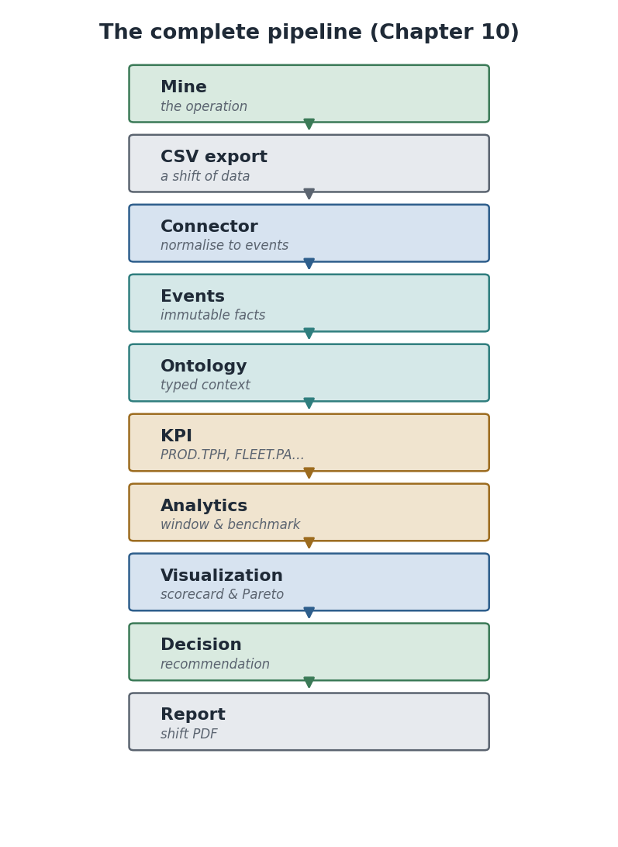
The complete pipeline: a CSV export becomes events, is interpreted against the ontology, computed into KPIs, analysed, visualised, turned into a decision, and reported.

The complete program
This program is self-contained and runnable. It ingests cycles from a CSV, computes TPH through the engine, updates a live model, and emits an explainable recommendation when the shift is below plan.
"""End-to-end: from a shift's haul cycles to a dispatch recommendation."""
from mineproductivity.core.events import EventStore
from mineproductivity.connectors import get_connector
from mineproductivity.kpis import KPIEngine
from mineproductivity.twin import DigitalTwin
from mineproductivity.decision import DecisionEngine
# 1. A shift export (in practice this comes from your fleet-management system)
csv_text = (
"equipment_id,queue_min,spot_min,load_min,haul_min,dump_min,return_min,cycle_min,payload_t\n"
"HT-214,1.5,0.5,2.5,8.0,1.0,6.0,19.5,220\n"
"HT-215,1.2,0.5,2.4,7.8,1.0,5.9,18.8,215\n"
"HT-214,1.6,0.5,2.6,8.2,1.1,6.1,20.1,225\n"
)
# 2. Connector → events (vendor dialect stays in the connector)
store = EventStore()
connector = get_connector("csv")(csv_text, shift_id="A-2026-06-25")
store.append(connector.get_cycle_data())
# 3. Engine executes the KPI object over the stored events
engine = KPIEngine(store)
# 4. Digital Twin holds the live state
twin = DigitalTwin(engine)
result = twin.sync("PROD.TPH", "A-2026-06-25")
print("TPH:", round(result.value, 1), result.unit, "| events used:", result.n)
# 5. Decision Intelligence turns the result into a recommendation
decision = DecisionEngine(target_tph=1300.0)
rec = decision.evaluate(result)
print("Recommendation:", rec.message if rec else "(on plan)")
if rec:
print(" impact:", rec.expected_impact, "| evidence:", rec.evidence)

The output
Running it produces (this is real output from the reference implementation):
TPH: 678.1 t/h | n events used: 1
Recommendation: TPH below plan; investigate dispatch balance and top delay.
impact: ~622 t/h to plan | evidence: actual=678 t/h, target=1300 t/h
Discoverable KPIs at L1 gold open-pit: ['DELAY.HOURS', 'FLEET.PA', 'PROD.TPH', 'QUAL.RECOVERY']
Registered connectors: ['csv']
Mining Insight. This three-cycle sample yields a low TPH because it is a tiny slice for illustration. On a full shift — the 36,000 tonnes over 29.7 operating hours from Chapter 6 — the identical code yields 1,212.1 t/h. The pipeline does not change with scale; only the data does.

Walking through each step
1 · CSV. A shift export, the lowest-common-denominator source every site can produce. 2 · Connector → Events. get_connector("csv") adapts the file into canonical CycleEvents; the rest of the program never sees CSV columns. 3 · Engine. KPIEngine executes the registered PROD.TPH object over the events — it holds no metric logic itself. 4 · Digital Twin. twin.sync computes the KPI and records it as live state, the basis for what-if and replay later. 5 · Decision. DecisionEngine compares the result to plan and, when short, emits a Recommendation carrying its expected impact and evidence.
This is the closed loop from the Architecture Handbook, in code you can run:
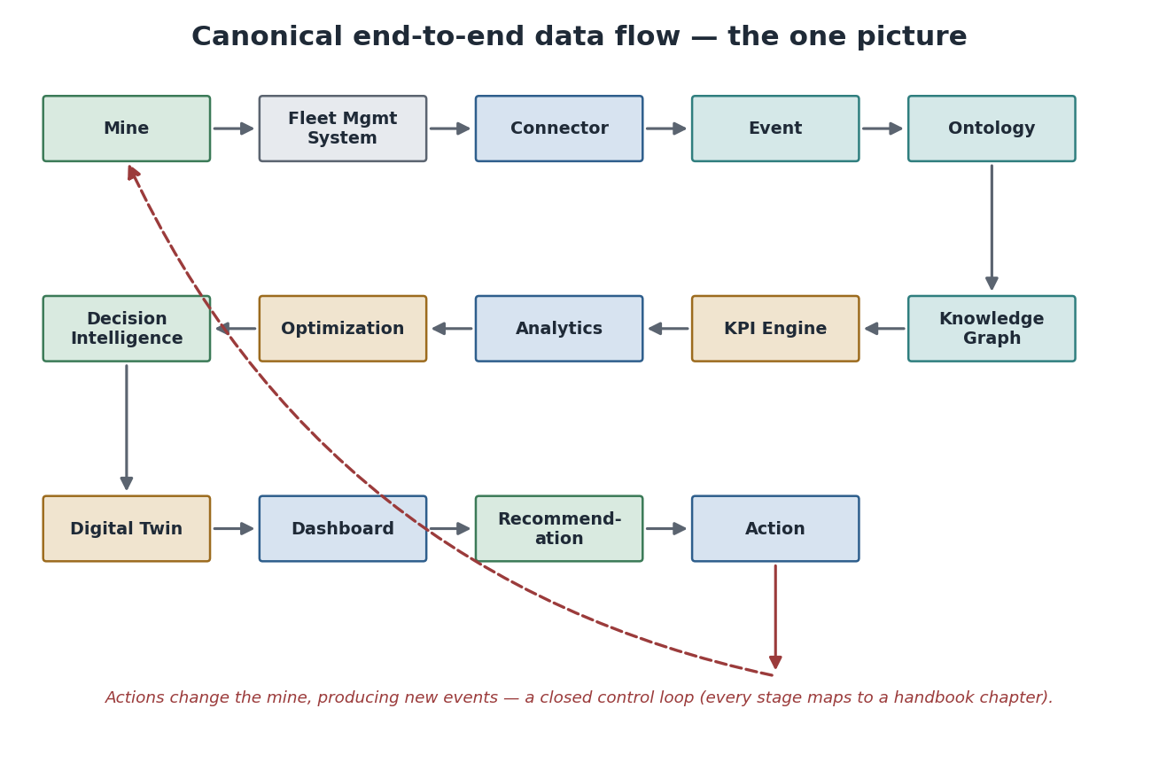
The canonical loop your program just executed: data → events → KPI → twin → decision → action → back to the mine.

Adding analytics, visualisation, and a report
Through the Mine façade the same pipeline gains analytics, charts, and a report with a few more calls:
from mineproductivity import Mine
mine = Mine(site="Bingham West", commodity="copper", method="open_pit", maturity=2)
mine.ingest(connector="csv", path="bingham_west_shift_A.csv")
mine.kpi("PROD.TPH").by("shift").plot() # visualise the trend vs plan
mine.kpi("DELAY.HOURS").by("reason").pareto() # rank the delays
mine.report(date="2026-06-25", format="pdf", out="shift.pdf") # shift report
Did You Know? The report(...) call composes the same KPI objects, charts, and recommendations you have been using into a shift-handover PDF. Nothing new is computed — the report is a view over the model, so it can never disagree with the dashboard or the API.

Where to go next
You can now build the full chain: describe a mine, connect a source, compute trustworthy KPIs, model the domain, and package your own extensions. Part II takes analytics and benchmarking deeper; Part III opens the Digital Twin and Knowledge Graph; Part IV covers streaming, the REST/GraphQL API, and production deployment; Part V is the AI agents and Decision Intelligence in full.
Best Practice. Re-run this chapter’s program against your own CSV export before moving on. Getting one real shift of your data through the pipeline — and reading the recommendation — is the fastest way to make everything in Part I concrete.

Summary
The whole library is one pipeline: CSV → connector → events → ontology → KPI → analytics → visualisation → decision → report. Each stage is something you have built in isolation; assembled, they form the closed loop that turns mine data into a decision. The pipeline is invariant to scale — only the data grows.

Exercises
- Replace the inline CSV with a file of your own (or the bundled sample) and run the complete program. What TPH do you get, and does a recommendation fire?
- Add a second KPI (FLEET.PA) to the live state and print it alongside TPH.

Solutions
- Results depend on your data; if the shift’s TPH is below the target_tph you pass to DecisionEngine, a recommendation fires with its expected impact and evidence.
- twin.sync("FLEET.PA", "A-2026-06-25"), then read twin.live_state["FLEET.PA"].value and print it next to TPH.

Further reading
Architecture Handbook — Canonical end-to-end data flow and Decision Intelligence. This completes Part I; Part II (Working with Data & Analytics) continues the journey.

End of Part I. You have completed Getting Started. You can install MineProductivity, navigate its structure, write a program, create events, compute and extend KPIs, build connectors and ontologies, and package plugins — and you have run the complete pipeline end to end. Part II begins with deep analytics: windows, benchmarking, and forecasting over the events you now know how to produce.

