MineProductivity
Developer & Cookbook Guide
Part II — Mining Fundamentals · Version 1.0

Mining operations explained for software engineers, data scientists, and AI engineers — so you understand the domain before you model it. Every concept maps to MineProductivity’s ontology, events, KPIs, analytics, Digital Twin, and decision intelligence.

Version | 1.0
Status | Released · Part II of a multi-part guide
Authors | MineProductivity Developer Experience Team
Classification | Public — Open Source Documentation
Applies to | MineProductivity 1.0.x
Conforms to | Master Architecture Handbook v1.0; Reference Implementation Blueprint v1.0; Developer & Cookbook Guide Part I v1.0
Builds on | Part I — Getting Started (assumed complete)
Copyright | © 2026 The MineProductivity Project. All rights reserved.
License | Documentation under CC BY 4.0; code samples under the project’s Apache-2.0 license.
Revision history
Version | Date | Author | Summary
1.0 | June 2026 | DevEx Team | First release of Part II (Mining Fundamentals): Chapters 11–20, the shared visual language, diagrams, and the domain-mapping bridge into Part III.

About Part II

Why a chapter on mining in a software guide
You finished Part I able to install MineProductivity, write a program, create an event, compute a KPI, and ship a plugin. You learned the mechanics. What Part I deliberately did not teach is the meaning: why a truck cycle has six legs, why availability and utilisation are different questions, why a crusher caps an entire mine. Without that grounding you can call mine.kpi("PROD.TPH") but you cannot tell whether the answer is good, why it moved, or what to do about it.
Part II fills that gap. It teaches mining operations to people who build software — closely enough that you can model the domain correctly, but always through the lens of MineProductivity. This is not a mining-engineering textbook, an MBA primer, or a geology handbook. Every concept here exists to be turned into an object: an ontology entity, an event, a KPI, a Digital Twin state, an analytic, an optimisation, or a decision.
How to read this part. Each chapter opens with Learning Objectives and Key Concepts, teaches the mining domain with diagrams and a Real Mine Example, and closes by mapping what you learned onto MineProductivity objects. Watch for the Mining Insight, Python Insight, Architecture Insight, Digital Twin Insight, and AI Contributor Note boxes — they are the bridges between the two worlds. Chapter 20 ties everything together.

The cast: five mines used everywhere
To keep examples concrete and consistent, this guide uses the same five fictional operations throughout every part. Meet them once here; you will see them again and again.
Mine | Commodity | Method | Used to illustrate
Pilbara Ridge | iron ore | open pit (strip) | high-volume haulage, rail & port, blending
Bingham West | copper | open pit | truck–shovel cycles, crusher constraint, recovery
Black Diamond | coal | open pit (strip) | dragline/strip logic, wash plant, quality
Aurora Gold | gold | underground | development, stoping, hoisting, dilution
Green Valley | lithium | open pit | new-commodity onboarding, spodumene recovery

One picture, reused everywhere: the visual language
Every diagram in this documentation set speaks one visual language. A Haul Truck is always the same colour; a CycleEvent is always the same shape; the five operational domains always read the same way. Learn the key below once and every later diagram is self-explanatory.
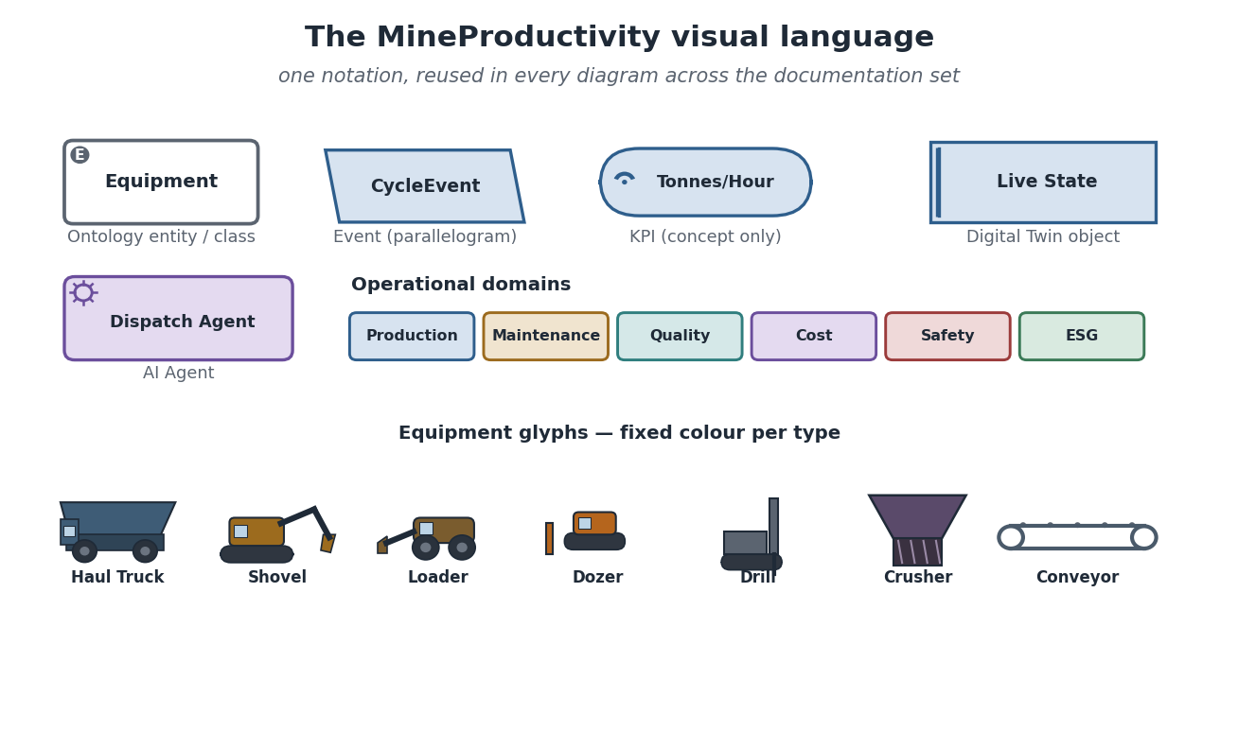
The MineProductivity visual language: the notation for ontology entities, events, KPIs, Digital Twin objects, and AI agents; the five operational-domain colours; and the equipment glyphs — all reused consistently across every part of the guide.
Architecture Insight. The visual language is not decoration — it mirrors the architecture. Entities, events, KPIs, twin objects, and agents are exactly the object kinds the Reference Blueprint defines. When you can read the diagram, you can read the system.

Contents
About Part II
Why a chapter on mining in a software guide
The cast: five mines used everywhere
One picture, reused everywhere: the visual language
Chapter 11 — Introduction to Mining
What mining actually is
The mining value chain
The mine life cycle
Where productivity fits
Common Mistakes
Frequently Asked Questions
Exercises
Solutions
Summary
Further Reading
Chapter 12 — Mining Methods
Why method matters to the model
The major families
Comparing the methods
Every method maps to the same objects
Common Mistakes
Frequently Asked Questions
Exercises
Solutions
Summary
Further Reading
Chapter 13 — Open Pit Mining
The shape of a pit
Haul roads, ramps, and traffic
The production flow
The mine sequence: pushbacks and cutbacks
Typical bottlenecks and opportunities
Common Mistakes
Frequently Asked Questions
Exercises
Solutions
Summary
Further Reading
Chapter 14 — Underground Mining
A different world below the surface
The parts of an underground mine
Development vs production
Ore flow underground
Underground equipment
Common Mistakes
Frequently Asked Questions
Exercises
Solutions
Summary
Further Reading
Chapter 15 — Mining Equipment
Equipment is where events are born
The equipment classes
From sensors to events
Maintenance considerations
Common Mistakes
Frequently Asked Questions
Exercises
Solutions
Summary
Further Reading
Chapter 16 — Fleet Management Systems
What an FMS is
How an FMS works
The events an FMS produces
FMS optimisation vs MineProductivity
Common Mistakes
Frequently Asked Questions
Exercises
Solutions
Summary
Further Reading
Chapter 17 — Mine Operations
The production chain
Where production is lost
How a mine is run, day to day
Common Mistakes
Frequently Asked Questions
Exercises
Solutions
Summary
Further Reading
Chapter 18 — Mine Productivity
Productivity is a family of questions
The time-usage model
Bottlenecks and the Theory of Constraints
Improvement philosophies
Leading vs lagging indicators
Common Mistakes
Frequently Asked Questions
Exercises
Solutions
Summary
Further Reading
Chapter 19 — Mining Data
Mining runs on data
The data types
Data quality, governance, and lineage
Common Mistakes
Frequently Asked Questions
Exercises
Solutions
Summary
Further Reading
Chapter 20 — MineProductivity Domain Mapping
The bridge
Mapping the Part II concepts
The ontology as an entity-relationship model
The knowledge graph agents reason over
Common Mistakes
Frequently Asked Questions
Exercises
Solutions
Summary
Further Reading

Chapter 11 — Introduction to Mining
Learning Objectives. After this chapter you will be able to: explain what mining is and why it is fundamentally a materials-handling problem; describe the mining value chain and the mine life cycle; place “productivity” precisely within that life cycle; and recognise which life-cycle phase MineProductivity instruments and why.

What mining actually is
Strip away the romance and mining is a logistics problem with rock. Valuable material — metal, mineral, coal — sits locked in the ground, mixed with worthless rock at low concentration. A copper orebody might be 0.5% copper by mass, meaning 99.5% of everything you dig, move, and crush is destined to be discarded. Mining is the business of locating that material, separating it from waste, and moving enormous tonnages of both to where they create or stop costing value — safely, at the lowest cost per useful tonne.
That reframing matters for a software engineer. It means the core objects of mining are material, movement, and time: how much material moved, by what, from where to where, and how much time it took versus how much was lost. Those are exactly the quantities MineProductivity models as events and measures as KPIs.
Mining Insight. “Grade” is the concentration of valuable material in the rock (e.g. 0.5% Cu, 1.2 g/t gold). Low grade is not a problem to be fixed — it is the normal condition of modern mining. It is why mines move such staggering tonnages: to recover a little metal you must handle a lot of rock. Every productivity question ultimately traces back to moving more useful rock per unit of time and cost.

The mining value chain
Material flows through a value chain from undiscovered orebody to delivered product. Each link adds cost and, ideally, value; productivity is made or lost at every one.
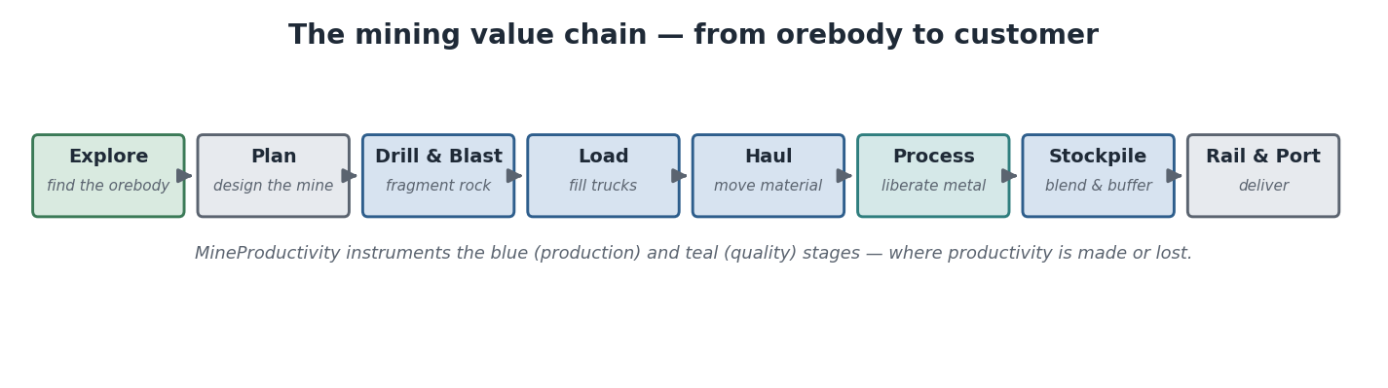
The mining value chain: exploration and planning precede the physical cycle of drill–blast–load–haul–process, then stockpiling and transport to the customer. MineProductivity instruments the production stages where most cost and variability live.
The early links — exploration and planning — are knowledge work: where is the orebody, how big, what grade, and in what sequence should it be mined? The middle links — drill, blast, load, haul, process — are the physical, repetitive, instrument-rich operations that run every shift of every day for decades. The late links — stockpile, rail, port — buffer and deliver. MineProductivity concentrates on the middle: the high-frequency, high-variability production stages that generate millions of events and where a few percentage points of improvement are worth millions.

The mine life cycle
A mine is not built and run in one motion; it passes through distinct phases over decades, each with different questions, data, and stakeholders.
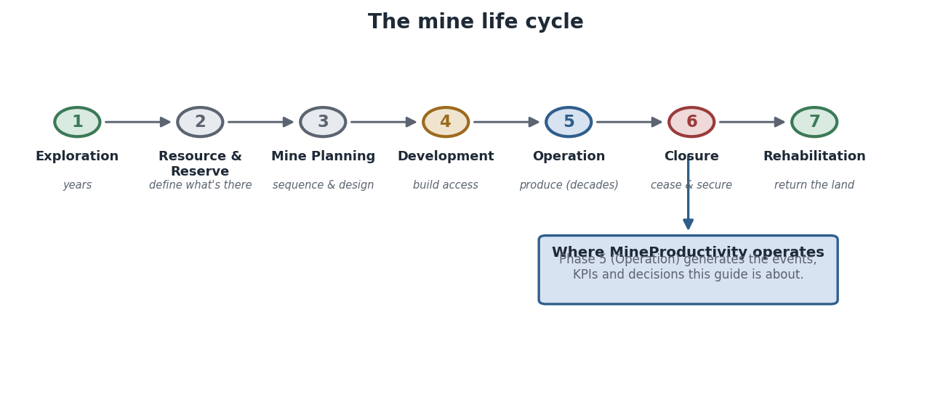
The mine life cycle: exploration, resource and reserve definition, planning, development, operation, closure, and rehabilitation. Operation (Phase 5) is the long, event-generating phase MineProductivity is built for.
Exploration finds and delineates the orebody through geophysics and drilling. Resource and Reserve turn drill data into a quantified, classified estimate — a resource is what is geologically present; a reserve is the economically and legally mineable subset. Mine Planning designs the pit or mine and the sequence in which it will be extracted. Development builds the physical access — stripping waste, sinking shafts, cutting declines, constructing the plant. Operation is the decades-long production phase. Closure safely ceases operations, and Rehabilitation returns the land to a stable, productive state.
Resource vs reserve — a distinction worth keeping straight. A resource is a geological statement (“there is this much metal in the ground”). A reserve is an economic and engineering statement (“this much can be mined at a profit under current conditions”). Reserves shrink when prices fall and grow when technology or prices improve. MineProductivity operates on the reserve and the plan derived from it.

Where productivity fits
Productivity is not a phase — it is a discipline that lives inside the Operation phase and connects strategy to action. Strategy sets the plan and targets; operations execute; measurement captures what actually happened as events and KPIs; improvement turns those measurements into decisions that change the next execution. The loop repeats every shift.
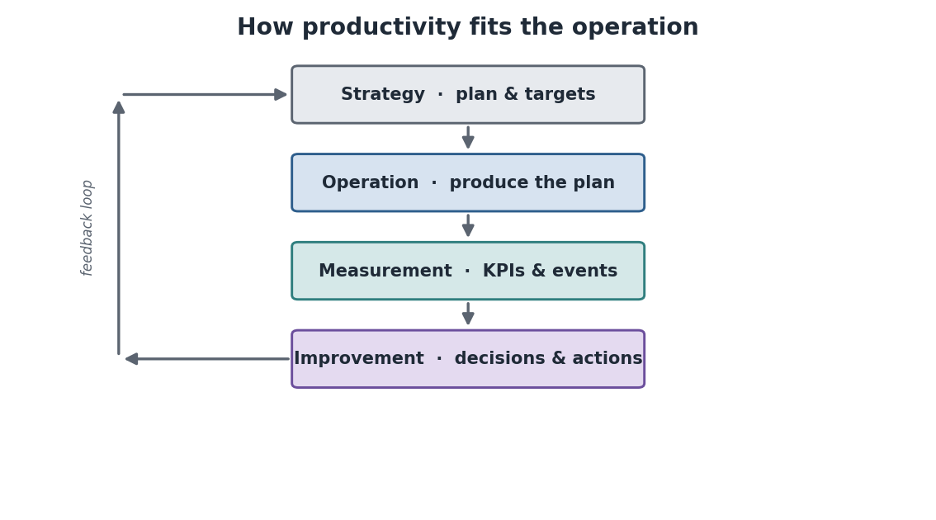
Productivity as a closed loop within Operation: strategy → operation → measurement → improvement → back to strategy. MineProductivity occupies the measurement and improvement steps and feeds them back into operation.
Architecture Insight. This loop is the same closed loop you met in Part I’s canonical data flow (events → KPIs → decision → action → new events). The life-cycle view and the data-flow view are two pictures of one thing: a control loop that runs the operation. MineProductivity is the instrumentation and feedback in that loop.
Real Mine Example — Bingham West, a day in the value chain. At the Bingham West copper pit, the night-shift plan calls for 38,000 tonnes from Bench 7. Shovels load haul trucks; loaded trucks carrying ore drive to the primary crusher while trucks carrying waste drive to the dump. The crusher feeds a conveyor to the concentrator, where copper is liberated and the tailings discarded. Concentrate is railed to port. Across that single shift, the fleet generates tens of thousands of cycle and delay events — the raw material MineProductivity turns into the morning’s productivity report. Every later chapter zooms into one part of this flow.
Digital Twin Insight. The life cycle is also a hint about the Digital Twin’s scope. The twin mirrors the Operation phase: it holds the live state of the producing mine and can replay any past shift. It does not model exploration or closure — those are different problems with different data. Knowing the life cycle tells you where the twin’s boundaries are.

Common Mistakes
Treating mining as one activity. “The mine” is a chain of very different operations — drilling is not hauling, hauling is not processing. Productivity problems are almost always local to one link. Modelling the mine as a single black box hides exactly the information you need.
Confusing resource with reserve, or grade with tonnes. These are different quantities with different uses. A spreadsheet that mixes them produces numbers that look plausible and are wrong. MineProductivity keeps them as distinct, typed concepts for this reason.

Frequently Asked Questions
Do I need to understand geology? Only lightly. You need to know what grade and orebody mean and that they vary in space; you do not need to identify minerals. Chapter 19 covers the geological data you will encounter.
Is MineProductivity used during exploration or planning? Not primarily. Its home is the Operation phase. It consumes the outputs of planning (the plan, the reserve) as reference data and measures execution against them.
Why so much emphasis on moving waste? Because most of what a mine moves is waste, and moving it is pure cost. Stripping ratio (waste to ore) is one of the most important economic facts about an open pit, and it drives haulage — the single largest productivity lever.

Exercises
- In one sentence, restate mining as a logistics problem, naming the three core quantities.
- List the seven life-cycle phases in order and mark the one MineProductivity instruments.
- Explain why a reserve can shrink without any rock being mined.

Solutions
- Mining moves large tonnages of material (rock) between locations over time, separating valuable material from waste; the core quantities are material, movement, and time.
- Exploration → Resource & Reserve → Planning → Development → Operation → Closure → Rehabilitation; Operation is instrumented.
- A reserve is the economically mineable subset of a resource; if the commodity price falls, some material is no longer profitable to mine, so the reserve shrinks even though the rock is untouched.

Summary
Mining is the large-scale separation and movement of valuable material from waste — a logistics problem governed by material, movement, and time. Those flow through a value chain and a multi-decade life cycle. Productivity lives inside the Operation phase as a closed loop of strategy, execution, measurement, and improvement, and that loop is exactly where MineProductivity operates.

Further Reading
Part I, “Architecture Overview” (the canonical data flow). Next: Chapter 12 — Mining Methods, which surveys the ways material is actually extracted.

Chapter 12 — Mining Methods
Learning Objectives. After this chapter you will be able to: name the major families of mining method and what distinguishes them; match each method to its typical equipment, commodities, events, and KPIs; and explain why MineProductivity can stay method-agnostic while still modelling each method faithfully.

Why method matters to the model
The method is how material is physically extracted, and it is the single biggest determinant of what equipment runs, what events are generated, and where the bottleneck sits. A surface mine is haulage-bound; an underground mine is access- and hoisting-bound. If you model an underground mine as if it were a pit, your metrics will measure the wrong things. So before modelling anything, you must know which method you are looking at.
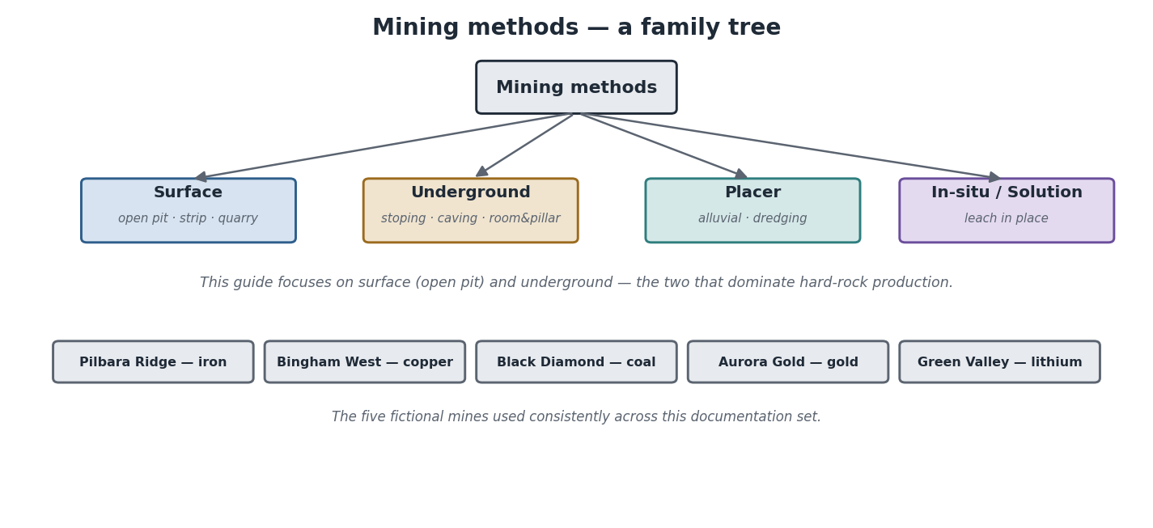
The family of mining methods: surface (open pit, strip, quarry), underground (stoping, caving, room-and-pillar), placer (alluvial, dredging), and in-situ/solution. This guide focuses on surface and underground — the two that dominate hard-rock production.

The major families
Surface mining removes overlying rock (overburden) to expose and extract an orebody from the surface down. It is the default when the orebody is large and reasonably shallow. Its sub-types include open pit (a widening, deepening cone — the focus of Chapter 13), strip mining (long parallel strips, common in coal), and quarrying (dimension stone and aggregates).
Underground mining accesses an orebody too deep or too high-grade-and-narrow to strip economically, via shafts or declines. Its sub-types differ in how the ore is broken and how the void is managed: stoping (excavating ore in defined blocks), caving (inducing the orebody to collapse and drawing it off), and room-and-pillar (leaving pillars of ore to hold the roof). Chapter 14 covers underground in depth.
Placer mining recovers minerals (classically gold, tin) that have weathered out of their source rock and concentrated in sediments — recovered by washing or dredging alluvial deposits. In-situ / solution mining dissolves the valuable mineral in place (e.g. uranium, some copper, potash) and pumps the solution to surface, moving almost no rock at all.
Mining Insight. The choice of method is dictated mostly by geology and depth, then economics. A shallow, large, low-grade orebody → open pit. A deep, narrow, high-grade orebody → underground. A mineral dissolved in groundwater-friendly host rock → in-situ. The method is rarely a free choice; it follows from the deposit.

Comparing the methods
Method | Advantages | Limitations | Typical equipment | Typical commodities
Open pit | high volume, lower unit cost, flexible, safer access | high stripping (waste), large footprint, depth-limited | shovels, haul trucks, drills, dozers | iron, copper, gold, coal, lithium
Underground | reaches deep/high-grade, small footprint, less waste | lower volume, higher unit cost, ventilation & ground-control critical | LHDs, jumbos, UG trucks, hoists | gold, base metals, deep coal
Placer | very low cost, simple, minimal blasting | only for alluvial deposits, water & environmental issues | dredges, pumps, sluices | gold, tin, mineral sands
In-situ / solution | tiny footprint, no rock handling, low cost | only specific minerals/host rocks, groundwater risk | wells, pumps, processing | uranium, some copper, potash
The bottleneck differs by method. In open pit, the binding constraint is usually haulage (or a fixed plant like the crusher). Underground, it is usually access and hoisting — how fast you can develop new ground and lift ore to surface. Placer and in-situ are process-bound. Knowing the typical bottleneck tells you which KPIs matter most for that method.

Every method maps to the same objects
Here is the payoff for the model. However different the methods look on the ground, they all reduce to the same object types: entities (the equipment and structure), events (what happened), KPIs (how well), and an ontology method class that gates which KPIs apply.
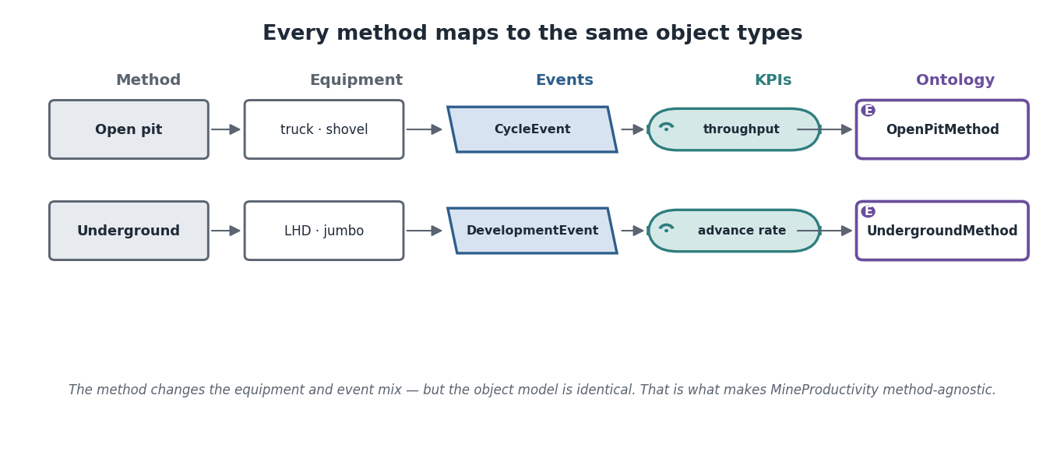
Each method maps to the same object types — only the equipment and event mix changes. Open pit emits CycleEvents from trucks; underground emits DevelopmentEvents and CycleEvents from LHDs. The KPI and ontology structure is identical, which is what makes MineProductivity method-agnostic.
Architecture Insight. Recall from Part I that a MiningMethod is a registered ontology object, and KPIs declare which methods they apply to. That is the mechanism behind this chapter: the method gates the catalogue. A truck-cycle KPI is offered at an open-pit site and correctly withheld underground — not by an if statement, but because the metadata says so.
Python Insight. Method-agnostic does not mean method-blind. In code, you set the method once — Mine(method="open_pit") or Mine(method="block_cave") — and the available KPIs, expected events, and default conventions follow from it. The same library serves Bingham West and Aurora Gold without branching logic in your analysis code.
Digital Twin Insight. Because the object model is shared across methods, one Digital Twin engine serves them all. The twin does not care whether a tonne arrived via a haul truck or an LHD hoisted up a shaft — it tracks the same Production state. Method differences live in the connectors and the ontology, not in the twin.
Real Mine Example — two mines, one model. Pilbara Ridge (iron, open pit) runs 240-tonne trucks against electric rope shovels; its dominant events are cycles and dump-queue delays, and its bottleneck is the rail load-out. Aurora Gold (gold, underground) runs LHDs and jumbos; its dominant events are development advances and stope mucking, and its bottleneck is hoisting. Yet a single MineProductivity deployment models both: same ontology shape, same event store, same KPI engine — different connectors and method metadata.

Common Mistakes
Porting open-pit assumptions underground. Truck cycle time and match factor are surface concepts. Underground, the equivalent questions are development advance and hoisting rate. Applying pit KPIs to an underground mine produces confident nonsense.
Assuming method is a configuration detail. It is foundational. Setting the wrong method changes which KPIs are offered and which conventions apply. Confirm the method before anything else.

Frequently Asked Questions
Can one mine use several methods? Yes — many large operations run an open pit over an underground mine (the pit goes first, then underground reaches deeper ore). MineProductivity models this as one site with multiple method contexts.
Which method does this guide focus on? Surface (open pit) for breadth and underground for contrast — Chapters 13 and 14. Placer and in-situ are introduced for completeness but are less common in instrumented, fleet-heavy operations.
Does in-situ mining even generate the events MineProductivity expects? It generates different events (well flow, solution grade) rather than haulage cycles. The framework can model these as alternative event and KPI types; it simply has fewer of the haulage concepts that dominate surface mining.

Exercises
- For each of open pit, underground, and in-situ, name the typical bottleneck.
- Explain why a truck-cycle KPI is offered at Bingham West but withheld at Aurora Gold.
- Give one geological reason a deposit would be mined underground rather than by open pit.

Solutions
- Open pit → haulage (or fixed plant); underground → access and hoisting; in-situ → process (solution flow/recovery).
- The KPI declares it applies to surface methods; Aurora Gold’s method is underground, so the metadata gates it out of the catalogue.
- The orebody is deep and/or narrow and high-grade, so stripping the overburden to reach it would move far too much waste to be economic.

Summary
Mining methods fall into surface, underground, placer, and in-situ families, chosen mainly by geology and depth. Method determines equipment, events, and the binding bottleneck. Crucially, every method reduces to the same MineProductivity objects — entities, events, KPIs gated by a method class — which is what lets one library and one Digital Twin serve every kind of mine.

Further Reading
Part I, “Creating Mining Methods”. Next: Chapter 13 — Open Pit Mining, a complete tour of the most common surface operation.

Chapter 13 — Open Pit Mining
Learning Objectives. After this chapter you will be able to: read an open-pit layout and name its parts; trace material from a loading face to the crusher or waste dump; describe the haul-truck cycle and the mine sequence (pushbacks); and identify where bottlenecks and optimisation opportunities arise — and which MineProductivity events and KPIs capture them.

The shape of a pit
An open pit is an inverted, terraced cone widening and deepening over years. It is cut as a stack of horizontal levels called benches, each a working floor with a vertical face above and below. Benches give the pit its staircase profile, provide safe working levels, and let multiple shovels operate at once. A spiralling ramp (haul road) connects the benches so trucks can drive from the pit bottom to the surface.
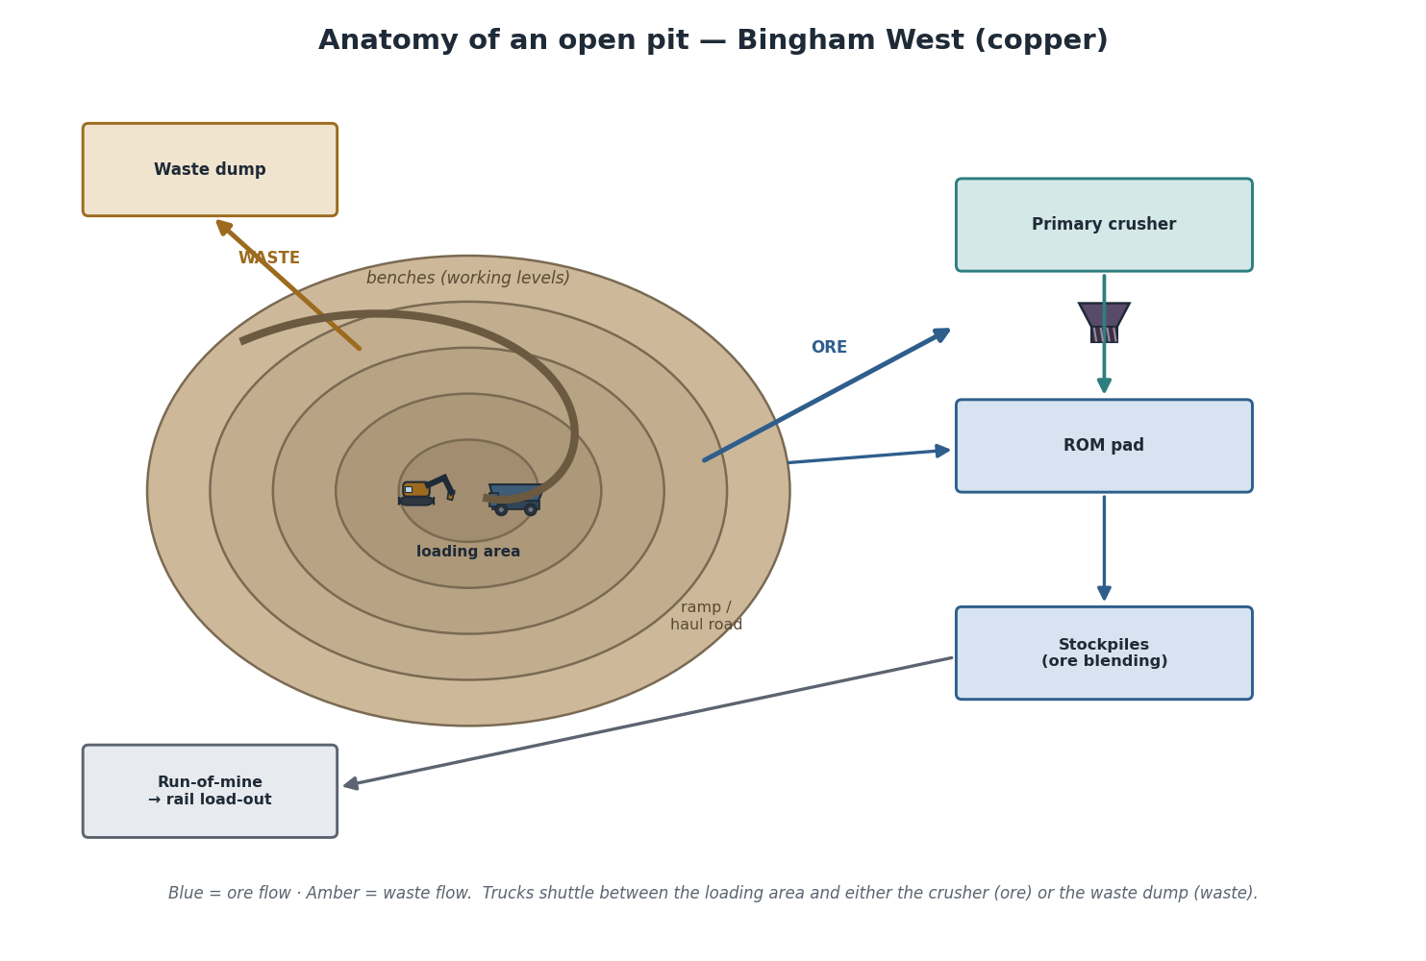
Anatomy of an open pit (Bingham West, copper): nested benches form the pit, a ramp spirals out, shovels load trucks at the working face, and material flows out as ore (to the crusher and ROM pad) or waste (to the dump). Blue arrows are ore; amber arrows are waste.
The parts you must know:
Part | What it is | Why it matters
Bench | a horizontal working level | where loading happens; the unit of the working face
Face | the vertical rock wall of a bench | what the shovel digs into
Ramp / haul road | graded road linking benches | the artery of the pit; its condition governs cycle time
Loading area | where a shovel fills trucks | the source of production
ROM pad | run-of-mine stockpile near the crusher | buffers ore before crushing
Crusher | reduces ore size for processing | a common fixed bottleneck
Waste dump | where barren rock is tipped | destination for most tonnes moved
Stockpiles | graded ore stored for blending | smooths grade variability to the plant
Mining Insight. Bench height (often 10–15 m) is an engineering compromise: taller benches mean fewer levels and more efficient loading, but worse selectivity (you cannot separate thin ore from waste) and bigger safety consequences if a face fails. The bench is therefore both a geometry choice and a grade-control choice — and it appears in the ontology as a first-class entity.

Haul roads, ramps, and traffic
The haul road network is the pit’s circulatory system. Grade (steepness), width, surface condition, and rolling resistance directly determine truck speed, fuel burn, tyre life, and cycle time. A poorly maintained road quietly taxes every cycle of every truck for the whole shift — which is why graders and water trucks (dust suppression) are not optional extras but productivity equipment. Traffic flows in a loaded direction (face → dump/crusher) and an empty return, with intersections, passing bays, and queue points where delays accumulate.

The production flow
Material has exactly two destinations: ore goes to value (crusher → plant), waste goes to cost (dump). At the face, a shovel digs the bench and loads a haul truck in a few passes. The loaded truck climbs the ramp and either tips ore at the crusher/ROM pad or dumps waste at the waste dump, then returns empty for the next load. Multiply this by dozens of trucks and shovels running continuously and you have an open-pit operation.

The haul-truck cycle
The single most important repeating unit in a pit is the truck cycle — and it is the heartbeat MineProductivity listens to.
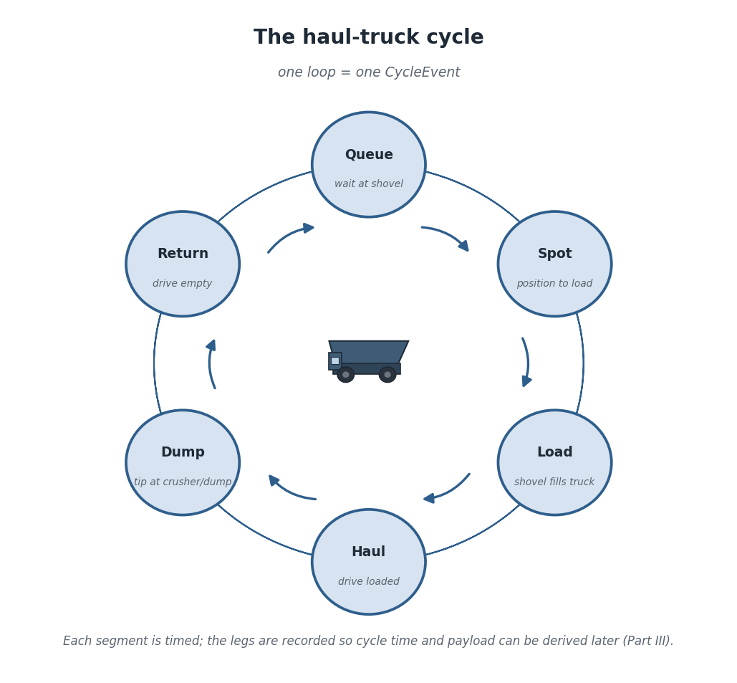
The haul-truck cycle: queue, spot, load, haul, dump, return. One loop is one CycleEvent; each leg is timed so cycle time and payload can be derived later (Part III).
The six legs are: queue (waiting for the shovel), spot (manoeuvring into loading position), load (the shovel filling the tray), haul (driving loaded), dump (tipping at the destination), and return (driving back empty). Each leg is timed by the fleet-management system. Summed, they give the cycle time; the payload carried is recorded too.
Architecture Insight. This is the CycleEvent you met in Part I, Chapter 5 — its six segment-minute fields are exactly these legs, and payload_t is the load. Everything in this section is the real-world referent of that event type. The pit’s physical heartbeat and the event store’s primary record are the same thing seen from two sides.
Digital Twin Insight. Because each cycle is an immutable event, the Digital Twin can reconstruct the pit’s production for any past shift exactly, and project the next hour from the current cycle rate. The truck cycle is the granularity at which the twin “ticks”.

The mine sequence: pushbacks and cutbacks
A pit is not dug all at once. It is extracted in planned stages called pushbacks (or cutbacks) — nested pit shells that progressively widen and deepen the pit while keeping wall angles safe and exposing the next slice of ore on schedule.
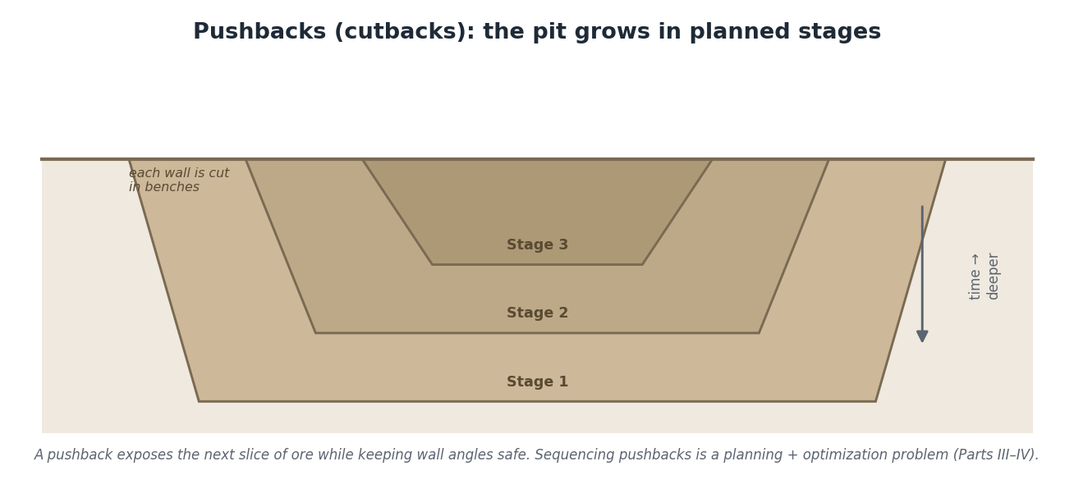
Pushbacks: the pit is mined in nested stages over time, each exposing the next slice of ore while maintaining safe wall angles. Sequencing pushbacks is a planning and optimisation problem addressed in later parts.
The sequence balances competing pressures: expose enough ore to feed the plant, strip enough waste in advance so ore is always available, keep haul distances short, and never over-steepen a wall. Getting this wrong shows up months later as ore shortfalls or unsafe slopes.
Mining Insight. Stripping ratio — tonnes of waste moved per tonne of ore — is the economic signature of a pit. A high stripping ratio means most of your haulage capacity is spent moving cost, not value. Pushback design is largely about managing stripping ratio over time so the mine is neither starved of ore nor drowning in waste.

Typical bottlenecks and opportunities
Bottleneck | Symptom | Opportunity (later parts)
Crusher / fixed plant | trucks queue to dump; ROM pad fills | feed control, surge buffering
Haulage capacity | shovels wait for trucks (low match) | fleet sizing, dispatch optimisation
Loading | trucks queue at the shovel | shovel placement, double-siding
Haul road condition | rising cycle times, fuel, tyre wear | road maintenance scheduling
Blast fragmentation | slow digging, crusher chokes | drill-and-blast tuning
Python Insight. Each row above becomes observable in code without new concepts: queue and delay legs surface as parts of CycleEvent and DelayEvent; “shovels waiting for trucks” is the match-factor question; “rising cycle times” is a trend over cycle events. You already have the API from Part I — Part III supplies the specific KPIs.
Real Mine Example — Bingham West, Bench 7 night shift. Two shovels load 220-tonne trucks on Bench 7. Ore trucks haul 3.2 km up the ramp to the primary crusher; waste trucks haul 1.8 km to the south dump. Mid-shift the crusher trips for 42 minutes; ore trucks back up, the ROM pad fills, and shovels go to standby because there is nowhere to send ore. The shift ends below plan — not because anything dug slowly, but because the fixed-plant constraint stopped the chain. Every minute of that story is captured as cycle and delay events; Chapter 18’s Theory of Constraints explains why the crusher, not the shovels, set the night’s tonnes.

Common Mistakes
Optimising the shovels when the crusher is the constraint. Speeding up loading just makes trucks queue earlier at a crusher that cannot keep up. Always find the binding constraint first (Chapter 18).
Ignoring haul-road condition. It is invisible in a summary number but taxes every cycle. Rising average cycle time with stable distances is the tell.

Frequently Asked Questions
How many trucks per shovel? Enough that the shovel rarely waits and trucks rarely queue — the “match factor” question. It depends on haul distance and cycle time, which is why dispatch systems re-balance it continuously.
Why keep stockpiles if the goal is to move ore to the plant? To blend. Orebodies vary in grade; stockpiles let the mine feed the plant a consistent grade by mixing high and low material, which stabilises recovery.
Is the ramp ever a bottleneck itself? Yes — single-lane sections, sharp switchbacks, and congestion at intersections all add queue and haul time. Traffic management is a real productivity lever.

Exercises
- Name the six legs of the haul-truck cycle in order.
- A shift loses tonnes after a crusher trip even though shovels were available. Explain why, in one sentence.
- What does a rising stripping ratio imply for haulage demand?

Solutions
- Queue, spot, load, haul, dump, return.
- The crusher is the binding constraint, so when it stops, ore has nowhere to go and the whole production chain stalls regardless of shovel availability.
- More waste must be moved per tonne of ore, so haulage capacity is increasingly consumed by waste, reducing effective ore-moving capacity unless the fleet grows.

Summary
An open pit is a terraced cone mined in benches, served by a ramp network, and extracted in planned pushbacks. Material flows from loading faces to either the crusher (ore) or the dump (waste), one truck cycle at a time — and that cycle is the CycleEvent at the heart of MineProductivity. Bottlenecks cluster at fixed plant, haulage, loading, and road condition, each observable through the events and KPIs the later parts build on.

Further Reading
Part I, “Your First Event” and “Your First KPI”. Next: Chapter 14 — Underground Mining, the contrasting world below the surface.

Chapter 14 — Underground Mining
Learning Objectives. After this chapter you will be able to: name the parts of an underground mine and how ore moves through it; describe the development cycle and how it differs from a surface truck cycle; identify the equipment unique to underground; and map underground concepts onto MineProductivity events, KPIs, and the Digital Twin.

A different world below the surface
When an orebody is too deep or too narrow-and-rich to strip economically, the mine goes underground. The economics invert: instead of moving vast quantities of waste to reach ore, you build precise access tunnels straight to it and move comparatively little rock. The constraint shifts from haulage to access and hoisting — how fast you can develop new ground and lift ore to surface. That single difference reshapes every metric.
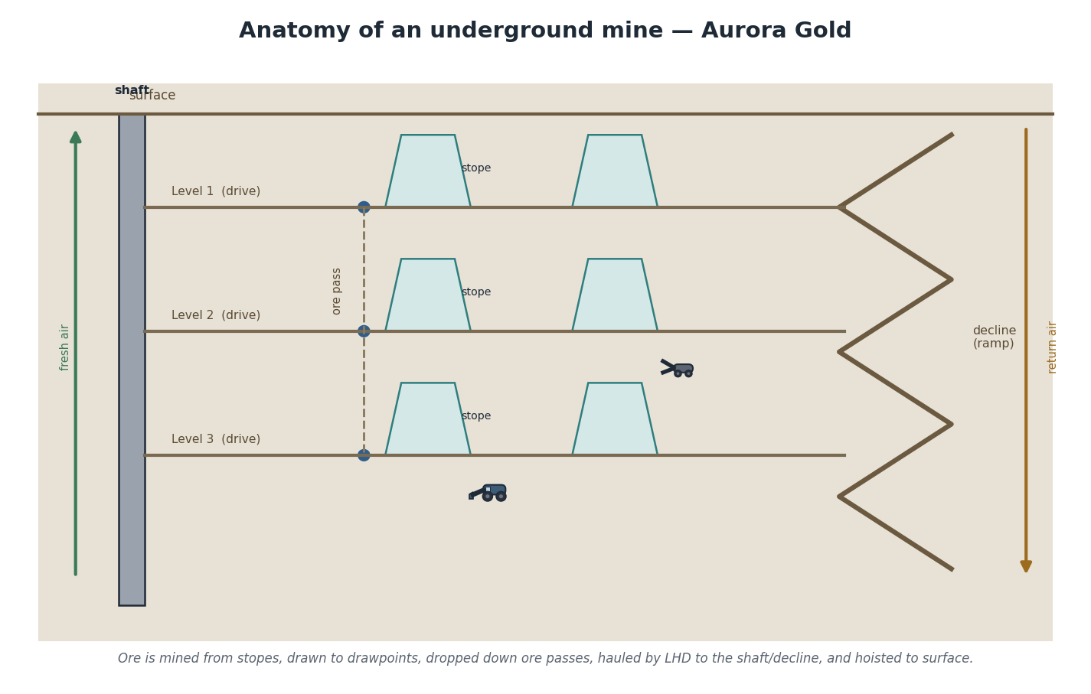
Anatomy of an underground mine (Aurora Gold): a shaft and a decline provide access; horizontal levels and drives reach the orebody; stopes are mined and ore is drawn to drawpoints, dropped down ore passes, hauled by LHD, and hoisted to surface. Ventilation pushes fresh air in and returns exhaust air out.

The parts of an underground mine
Term | What it is
Shaft | a vertical excavation for hoisting ore, people, and materials
Decline | a spiral or ramp tunnel allowing rubber-tyred vehicles to drive underground
Level | a horizontal working horizon at a given depth
Drive | a horizontal tunnel running along the orebody on a level
Crosscut | a horizontal tunnel cutting across, connecting drives or reaching the orebody
Stope | the excavation from which ore is actually produced
Drawpoint | where broken ore is collected from a stope
Ore pass | a vertical/steep passage that drops ore between levels by gravity
Ventilation | the airflow circuit supplying fresh air and removing exhaust, dust, and heat
Ground support | bolts, mesh, and shotcrete that keep excavations stable
Mining Insight. Two systems have no surface equivalent and can each stop the mine outright: ventilation and ground support. Without adequate airflow, no one can work (diesel fumes, heat, dust); without competent ground support, excavations fail. In an underground productivity model these are not background details — they are hard constraints that gate whether production can occur at all.

Development vs production
Underground work splits cleanly into two activities. Development builds the access — driving declines, drives, and crosscuts to reach and prepare the ore. Production (also called stoping) extracts ore from the prepared stopes. Development is investment; production is return. A mine that under-develops runs out of available stopes and stalls months later — the underground equivalent of an open pit that under-strips and starves of ore.

The development cycle
Development advances one blast “round” at a time through a fixed, repeating cycle — the underground analogue of the haul-truck cycle.
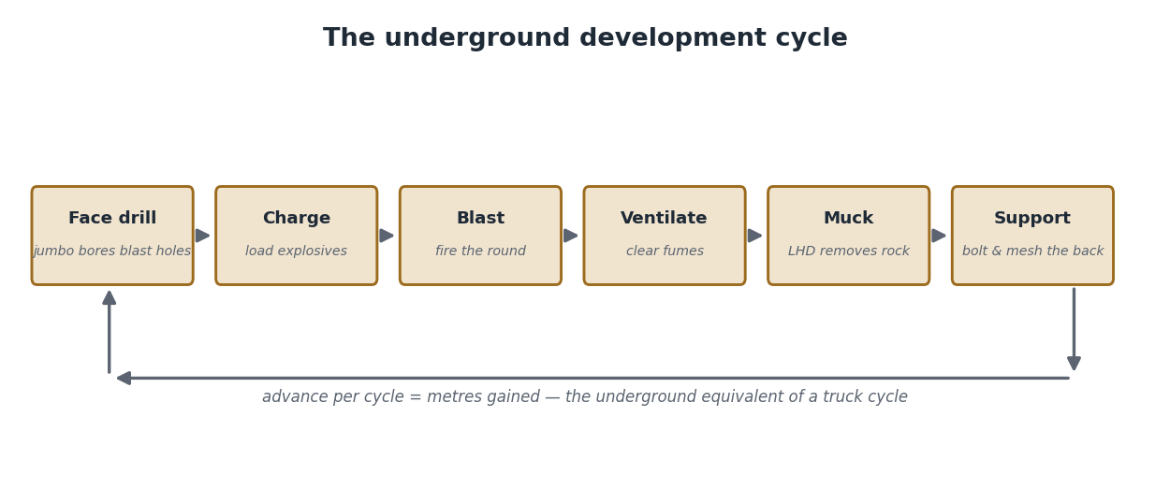
The underground development cycle: face drill, charge, blast, ventilate, muck, support — then repeat. Advance per cycle (metres gained) is the underground equivalent of a completed truck cycle.
A jumbo drills a pattern of holes into the face; the holes are charged with explosives; the round is blasted; the heading is ventilated to clear fumes; an LHD mucks out the broken rock; and the new ground is supported with bolts and mesh before the cycle repeats. The metres advanced per cycle, and the cycles per day, set the development rate — and development rate sets how fast the mine can open new production.
Architecture Insight. This cycle is captured as a DevelopmentEvent — the underground sibling of CycleEvent. Both are immutable records of one completed cycle of work; they differ in their fields (advance metres and round data versus haul legs and payload), not in their nature. The event store treats them uniformly, which is why one engine measures both surface and underground mines.

Ore flow underground
Ore takes a gravity-assisted journey to surface. It is blasted in a stope, drawn through drawpoints, dropped down ore passes to a haulage level, loaded by LHD (or trucked) to the shaft or decline, and finally hoisted (via shaft) or trucked (via decline) to surface, where it joins the same crusher-and-plant chain as a surface mine. From the crusher onward, surface and underground operations look identical — which is exactly why the model converges there.
Digital Twin Insight. The Digital Twin of an underground mine tracks two coupled flows: the development front (how far each heading has advanced) and the production draw (how much each stope has yielded). Because both arrive as events, the twin can answer “are we developing fast enough to keep stopes available?” — the question that most often predicts an underground mine’s future, weeks before tonnes fall short.

Underground equipment
Equipment | Role
LHD (load-haul-dump) | low-profile loader that mucks and trams ore from drawpoints
Jumbo | twin-boom drill rig that bores the development face
Underground truck | low-profile haul truck for tramming ore via decline
Raise borer | machine that bores vertical/steep raises (ore passes, ventilation)
Production drill | drills the long blast holes that break stope ore
Bolter / shotcrete rig | installs ground support
Python Insight. In code, underground equipment registers under the same ontology base as surface equipment — an LHD and a RigidHaulTruck are both Equipment subclasses. Your analysis code iterates mine.equipment without caring which is which; the method context and equipment class carry the differences. The same for eq in mine.fleet loop works at Bingham West and Aurora Gold.
Real Mine Example — Aurora Gold, the development squeeze. Aurora Gold hoists from 1,100 m via shaft and trams ore by LHD on three active levels. For two months, jumbo availability slipped and development advance fell short of plan. Production held up at first — there were still prepared stopes to mine. Then the stopes ran out, and tonnes dropped sharply with no equipment failure to blame. The leading signal had been visible for weeks in the development-advance trend; the lagging signal (tonnes) only appeared once it was too late to prevent. Chapter 18 returns to this leading-versus-lagging distinction.
AI Contributor Note. When you contribute an underground KPI or analytic, declare its method applicability as underground and reference DevelopmentEvent where appropriate — do not reuse surface haulage assumptions. A good contribution states the constraint it speaks to (access, hoisting, ventilation, or ground) so reviewers and agents can reason about where it applies.

Common Mistakes
Measuring only production tonnes underground. Tonnes are a lagging outcome. If development advance is not measured and watched, you will be surprised by a production cliff that was forecastable weeks earlier.
Forgetting ventilation and ground support as constraints. They do not move tonnes, so they are easy to omit from a model — until they stop the mine. Represent them explicitly.

Frequently Asked Questions
Shaft or decline — which is better? Shafts hoist large tonnages from great depth efficiently but are expensive and slow to build; declines are flexible and quick to start but limited by truck haulage over distance. Many mines use both.
Is the LHD just an underground loader? It loads, hauls a short distance, and dumps — hence “load-haul-dump”. Over longer distances it feeds an underground truck or an ore pass rather than tramming all the way itself.
Why does ore flow downward before going up? Gravity is free. Ore passes drop ore to a central haulage or hoisting level, minimising the powered handling needed before the single lift to surface.

Exercises
- Put the development-cycle steps in order: blast, charge, support, face drill, muck, ventilate.
- Explain why under-development causes a delayed production drop.
- Name two underground systems that can halt production despite healthy equipment.

Solutions
- Face drill → charge → blast → ventilate → muck → support.
- Development opens new stopes; if it lags, existing stopes are still mined for a while, then run out, causing a sudden tonnes drop weeks after the development shortfall began.
- Ventilation and ground support.

Summary
Underground mining trades haulage for access: shafts and declines reach the orebody, levels and drives prepare it, stopes produce it, and ore flows by gravity and LHD to a single lift to surface. Development (building access) and production (extracting ore) are distinct, and development rate predicts future production. MineProductivity models this with DevelopmentEvent alongside CycleEvent, the same ontology and engine, and a twin that watches both the development front and the production draw.

Further Reading
Chapter 13 (the surface contrast); Part I, “Your First Event”. Next: Chapter 15 — Mining Equipment, the machines that generate the events.

Chapter 15 — Mining Equipment
Learning Objectives. After this chapter you will be able to: identify the major equipment classes and their roles; describe what each senses and what events it generates; and explain how raw telematics become typed events that MineProductivity reasons over — without inventing new concepts beyond Part I’s connector.

Equipment is where events are born
Every event in MineProductivity ultimately originates at a machine. A truck completes a cycle; a shovel loads; a crusher trips. So understanding equipment is understanding your data source. This chapter surveys the classes you will meet, organised by what they do, and shows how their sensors become your events. (Telematics is rich, but remember the constraint: we name what is sensed and what events result — never the KPI formulas, which belong to Part III.)
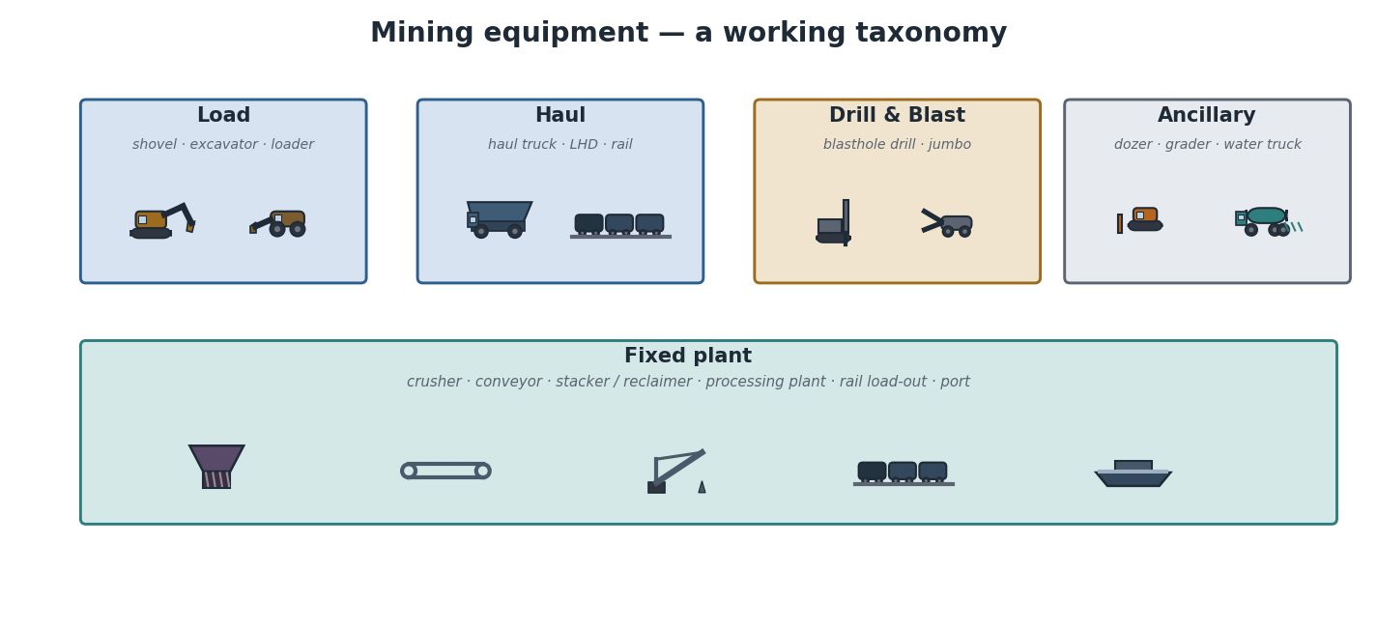
A working taxonomy of mining equipment: load, haul, drill-and-blast, ancillary, and fixed plant. The same glyphs and colours are used wherever these machines appear in the documentation set.

The equipment classes

Load: shovels, excavators, loaders
Hydraulic shovels and excavators dig the face and load trucks, using hydraulic boom-and-bucket motion; electric rope shovels are larger, electrically powered machines for the highest-volume operations; wheel loaders are mobile, flexible loaders for stockpiles and smaller faces. They sense bucket position, payload per pass, cycle counts, and engine/hydraulic health.

Haul: trucks, LHDs, rail
Rigid haul trucks are the workhorses of the pit, carrying 100–400 tonnes per load; LHDs and underground trucks do the equivalent below ground; rail moves bulk product over long distances to port. They sense GPS position, payload (via strut pressure), speed, fuel, gear, and tyre temperature/pressure.

Drill and blast: blasthole drills, jumbos
Blasthole drills bore the pattern of holes that are charged and blasted to fragment rock for digging; jumbos drill development faces underground. They sense hole depth, penetration rate, position, and rig health.

Ancillary: dozers, graders, water trucks
Often overlooked, these keep the operation running: dozers push and clean up; graders maintain haul-road surface; water trucks suppress dust and stabilise roads. Their condition quietly governs everyone else’s cycle times.

Fixed plant: crushers, conveyors, stackers, processing, rail, port
Crushers reduce ore size; conveyors move it continuously; stackers and reclaimers build and recover stockpiles; the processing plant liberates the valuable mineral; rail and port deliver product. Unlike mobile fleet, fixed plant is instrumented through process historians (SCADA) rather than vehicle telematics, but it generates the same kind of running/stopped/throughput signals.
Mining Insight. OEMs you will hear named include Caterpillar, Komatsu, and Hitachi (trucks and shovels), Liebherr (excavators), Epiroc and Sandvik (drills and underground), and a range of plant vendors. From the model’s point of view, the OEM matters only because it determines the telematics format your connector must read — the concepts (cycle, payload, delay) are vendor-independent.

From sensors to events
Raw telematics is a firehose of signals at sub-second resolution. MineProductivity does not consume that firehose directly. A connector (Part I, Chapter 7) normalises it into a small number of typed events — the only thing the rest of the system ever sees.
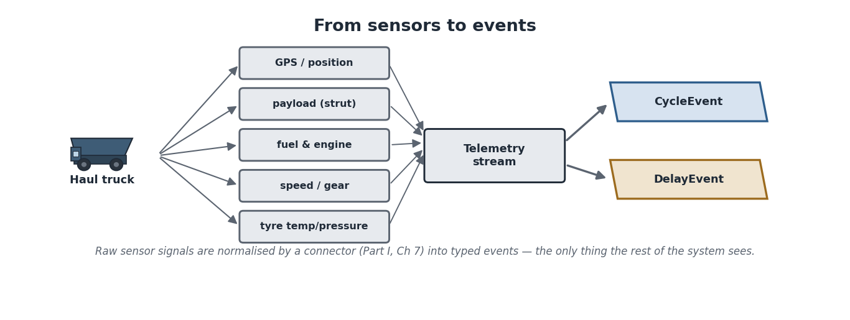
From sensors to events: a haul truck’s GPS, payload, fuel, speed, and tyre sensors feed a telemetry stream, which a connector normalises into typed CycleEvents and DelayEvents. The rest of the system reasons over events, never raw signals.
Architecture Insight. This is the anti-corruption boundary from the Architecture Handbook in concrete form. Vendor telematics is messy, proprietary, and ever-changing; events are clean, typed, and stable. The connector absorbs the mess so the ontology, KPI engine, twin, and agents never depend on a vendor’s data model. Swapping an OEM changes a connector, nothing else.
Python Insight. You already wrote one of these in Part I: a connector that yields events. Every equipment class in this chapter is “supported” the moment a connector exists that maps its telematics to CycleEvent, DelayEvent, or DevelopmentEvent. Adding a new machine type is a connector problem, not a core-model problem.
Digital Twin Insight. Each physical machine has a counterpart in the twin — an Equipment entity whose live state (running, loading, queued, down) is updated by its event stream. The twin is, in effect, a synchronised mirror of the whole fleet, assembled entirely from the typed events these machines emit.
Real Mine Example — Green Valley onboards a new fleet. Green Valley Lithium commissions a fleet of trucks from a vendor MineProductivity has never seen. No core code changes. A new connector is written to read the vendor’s telematics and emit the standard cycle and delay events; the ontology gains the new truck model as an Equipment entry; and within a day the new fleet’s cycles flow into the same KPIs and twin as everything else. The equipment was new; the concepts were not.
AI Contributor Note. When documenting an equipment class for the project, record three things an agent needs: what it senses, what events it emits, and which ontology class it maps to. That triple is what lets an automated reasoner connect a machine to the metrics and decisions that concern it.

Maintenance considerations
Every machine alternates between running and being maintained, and maintenance is where much availability is won or lost. Equipment emits health signals (engine hours, fault codes, component temperatures) that drive maintenance — planned (scheduled services) and unplanned (breakdowns). For the model, the key point is that “down for maintenance” is a DelayEvent with a reason code; the equipment’s pattern of such events is the raw material for reliability analysis in later parts.

Common Mistakes
Consuming raw telematics in analysis code. It couples your logic to a vendor format and drowns you in sub-second noise. Always go through the connector → event boundary.
Ignoring ancillary equipment. Graders and water trucks generate few headline tonnes but strongly influence everyone else’s cycle times. Leaving them out of the model hides a real lever.

Frequently Asked Questions
Do I need a different event type per machine? No. A few event types (cycle, delay, development) cover most machines; the equipment class on the event tells you which machine produced it.
How is fixed plant different from mobile fleet here? Mostly in the data source — SCADA/historian rather than vehicle telematics — but it still reduces to running/stopped/throughput signals and the same delay concept.
Where do OEM differences live? In connectors only. The core model is OEM-agnostic by design.

Exercises
- Name the five equipment groups in the taxonomy.
- Explain, in one sentence, why analysis code should never read raw telematics directly.
- What three facts should documentation record about an equipment class for an AI agent’s benefit?

Solutions
- Load; haul; drill and blast; ancillary; fixed plant.
- Because it couples the code to a proprietary, unstable vendor format and to high-frequency noise — the connector→event boundary keeps the rest of the system clean and stable.
- What it senses; what events it emits; which ontology class it maps to.

Summary
Equipment is the origin of every event. Machines fall into load, haul, drill-and-blast, ancillary, and fixed-plant classes, each sensing different signals but all funnelled through connectors into a few typed events. That boundary keeps the ontology, KPIs, twin, and agents independent of any OEM, and makes onboarding new equipment a connector task rather than a core change.

Further Reading
Part I, “Your First Connector”. Next: Chapter 16 — Fleet Management Systems, the systems that already track much of this and that MineProductivity reads from.

Chapter 16 — Fleet Management Systems
Learning Objectives. After this chapter you will be able to: explain what a Fleet Management System (FMS) does and how it works; list the events an FMS produces; distinguish the FMS’s job (running the fleet in real time) from MineProductivity’s job (measuring and improving it); and describe how MineProductivity consumes FMS data through a connector.

What an FMS is
A Fleet Management System is the real-time control system that runs a mine’s mobile fleet. It knows where every truck and shovel is, assigns trucks to shovels and dumps, tracks each cycle, records payloads, captures delay reasons, and continuously optimises assignments to keep shovels fed and trucks moving. If MineProductivity is the mine’s memory and judgement, the FMS is its nervous system — fast, operational, and always on.
The major commercial systems you will encounter include Caterpillar MineStar, Modular Mining DISPATCH, Wenco, and Hexagon (formerly including MineFleet), each paired with — or interoperating with — OEM fleets from Caterpillar, Komatsu, Hitachi, Epiroc, and Sandvik. They differ in detail but share a common job and a common set of outputs.
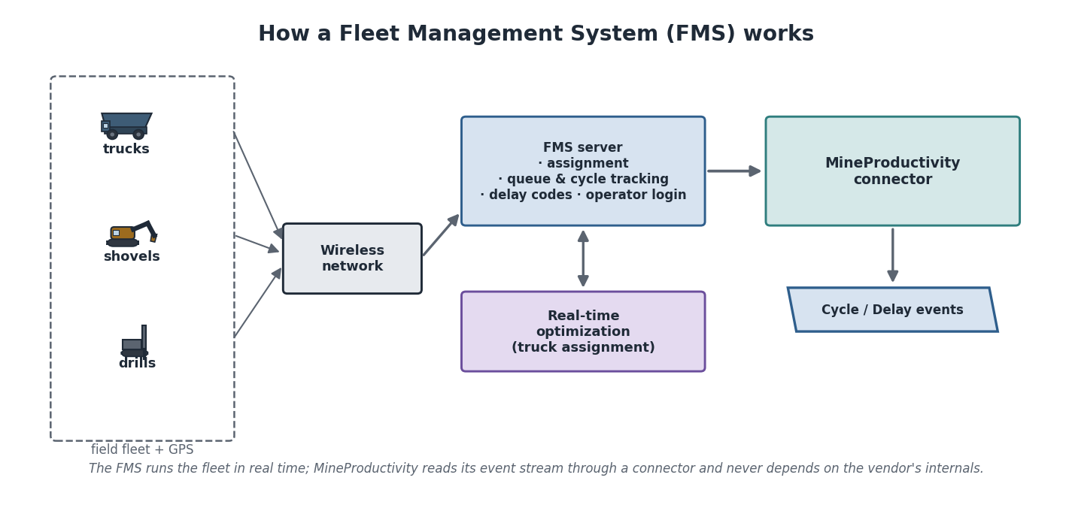
How a Fleet Management System works: field fleet with GPS report over a wireless network to the FMS server, which handles assignment, queue and cycle tracking, delay codes, and operator login, and runs real-time truck-assignment optimisation. MineProductivity reads the FMS’s event stream through a connector — never its internals.

How an FMS works
Every machine carries a GPS unit and an in-cab display, connected over a mine-wide wireless network to a central FMS server. Operators log in (so performance can be attributed and shifts tracked). As trucks move, the system detects state changes — empty at the dump, queued at a shovel, loading, hauling — and records them. When a truck empties, the FMS decides which shovel it should go to next, balancing queues and haul distances across the whole fleet in real time.

Dispatch logic
The central decision is assignment: when a truck becomes free, which shovel (or dump) should it serve? A good assignment keeps shovels from waiting and trucks from queueing, minimising lost time across the fleet. This is a live optimisation, recomputed continuously as conditions change.
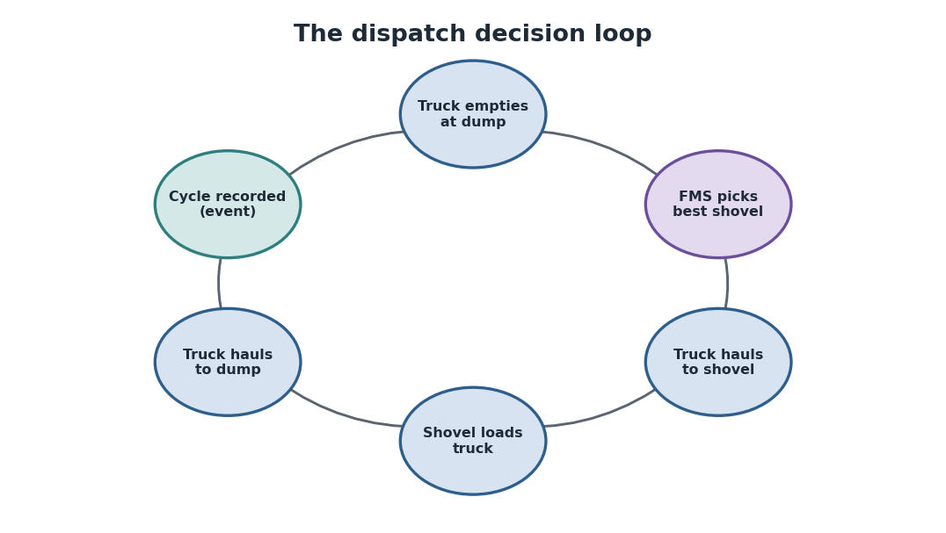
The dispatch decision loop: a truck empties at the dump, the FMS picks the best shovel, the truck hauls to it, the shovel loads, the truck hauls back to the dump, and the completed cycle is recorded as an event — then the loop repeats.
Mining Insight. Dispatch optimisation is one of mining’s highest-value software problems: small improvements in assignment ripple across an entire fleet for every shift, every day. But the FMS optimises the next few minutes. It does not ask whether the fleet is the right size, whether the crusher is the true constraint, or whether last month’s pattern is repeating. Those longer-horizon questions are MineProductivity’s domain.

The events an FMS produces
FMS output | Becomes | Carries
Completed haul cycle | CycleEvent | per-leg times, payload, equipment, location
Lost-time event with reason | DelayEvent | duration, reason code, equipment, shift
Operator login/logout | shift attribution | operator, machine, shift
Position / state stream | telemetry context | GPS, speed, state transitions
Payload measurement | field on the cycle | tonnes carried
These are precisely the events you met in Part I. The FMS is, for most mines, the single richest source of them.
Architecture Insight. MineProductivity consumes the FMS through a connector and depends on nothing inside it. This matters for three reasons: mines change FMS vendors; one corporation often runs several FMS systems across sites; and FMS schemas evolve. By reading the FMS’s event stream behind a connector boundary, MineProductivity stays portable across all of them — exactly the anti-corruption principle from the Handbook.
Python Insight. A real FMS connector is the production cousin of the CSV connector you wrote in Part I. It authenticates to the FMS, pulls completed cycles and delays for a time window, maps the vendor’s fields to the standard event schema, and yields events. Your downstream analysis is identical whether the events came from a CSV fixture or a live DISPATCH feed.
Digital Twin Insight. Because the FMS streams cycle and delay events continuously, it is the primary heartbeat that keeps the Digital Twin live. As each cycle closes in the field, the corresponding event updates the twin’s fleet state within seconds — the twin is a near-real-time mirror precisely because the FMS feeds it.

FMS optimisation vs MineProductivity
It is worth stating the division of labour plainly, because confusing the two is a common architectural error.
Question | Answered by
Which shovel should this truck go to now? | FMS (real-time)
Is the fleet the right size for this haul profile? | MineProductivity (tactical)
What is today’s availability and where did time go? | MineProductivity (measurement)
Why is this week below plan, and what should change? | MineProductivity + Decision Intelligence
What will the next hour look like at the current rate? | MineProductivity Digital Twin
Real Mine Example — Pilbara Ridge, two systems, one truth. Pilbara Ridge runs a commercial FMS dispatching 60 trucks across the pit. The FMS keeps the fleet humming minute to minute. Overnight, MineProductivity ingests the shift’s cycle and delay events through the FMS connector and produces the morning report: availability, where time was lost, plan attainment, and a flagged trend in dump-queue delays that the FMS — focused on the next assignment — never surfaced. The FMS ran the fleet; MineProductivity explained it.
AI Contributor Note. When building or documenting an FMS connector, treat the vendor mapping as the contract: list each vendor field and the standard event field it maps to, and note any reason-code translation. Agents and reviewers rely on that mapping to trust that a DelayEvent from one mine means the same thing as one from another.

Common Mistakes
Treating the FMS as the system of record for analytics. It is optimised for real-time control, not historical analysis or cross-site consistency. Read its events into MineProductivity; do not build long-horizon analytics inside it.
Hard-coding one vendor’s schema. FMS vendors and versions change. Always map through a connector so a vendor switch touches one component.

Frequently Asked Questions
Does MineProductivity replace the FMS? No. They are complementary: the FMS runs the fleet in real time; MineProductivity measures, explains, and improves it over longer horizons.
What if a site has no FMS? Then events come from another source — manual logs, weighbridge data, SCADA — via a different connector. The FMS is the richest source, not the only one.
Can MineProductivity feed recommendations back to the FMS? That is the direction Decision Intelligence points (Part V): turning MineProductivity’s longer-horizon insight into actions the FMS or operators can take. Part II only establishes the data relationship.

Exercises
- State the FMS’s core real-time decision in one phrase.
- Map three FMS outputs to the MineProductivity events they become.
- Give one reason MineProductivity reads the FMS through a connector rather than directly.

Solutions
- Truck-to-shovel (and truck-to-dump) assignment.
- Completed cycle → CycleEvent; lost-time-with-reason → DelayEvent; operator login → shift attribution.
- Portability — mines change FMS vendors and run multiple systems; the connector boundary isolates those differences to one component.

Summary
A Fleet Management System is the real-time nervous system of a mine’s fleet: it tracks positions, assigns trucks, records cycles and delays, and optimises the next few minutes. It is the richest source of the cycle and delay events MineProductivity consumes — through a connector that keeps the core model independent of any vendor. The FMS runs the fleet; MineProductivity measures, explains, and improves it.

Further Reading
Part I, “Your First Connector”; Architecture Handbook, “Anti-corruption boundaries”. Next: Chapter 17 — Mine Operations, the daily rhythm these systems support.

Chapter 17 — Mine Operations
Learning Objectives. After this chapter you will be able to: trace the full production chain from loading to shipping; explain where and how production is lost; and describe how a mine is run day to day — the meetings, the dispatch room, and the control room — and where MineProductivity fits into that rhythm.

The production chain
A mine’s output is the result of a chain of operations, each feeding the next. Material is loaded, hauled, dumped, crushed, processed, stockpiled, and finally railed and shipped. Value accrues along the chain; so does the risk of loss, because a stoppage anywhere caps everything downstream.
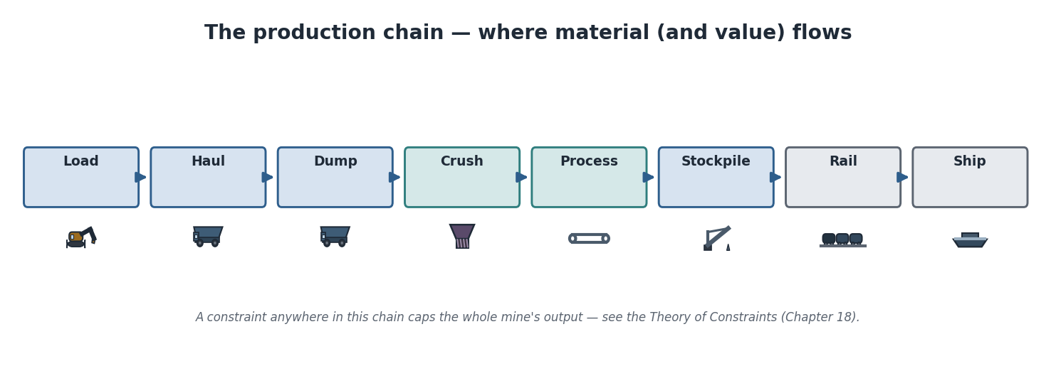
The production chain end-to-end: load, haul, dump, crush, process, stockpile, rail, ship. Material — and value — flows left to right; a constraint anywhere caps the whole mine’s output.
Loading fills trucks at the face. Hauling moves material along the haul-road network. Dumping delivers it — ore to the crusher or ROM pad, waste to the dump. Crushing reduces ore size; processing liberates the valuable mineral and rejects tailings. Stockpiling buffers and blends ore to feed the plant a steady grade. Rail carries product to the coast, and shipping delivers it to the customer. Each link has its own equipment, its own delays, and its own capacity.
Mining Insight. The chain has slack in some places (stockpiles are deliberate buffers) and none in others (a crusher with no surge capacity stops the trucks behind it). Where the buffers are — and are not — determines how a local stoppage propagates. Reading a mine well means knowing which links are rigidly coupled and which are cushioned.

Where production is lost
Production is rarely lost in one dramatic event; it leaks away in many small ones. Every leak has a reason, and every reason becomes a coded delay.
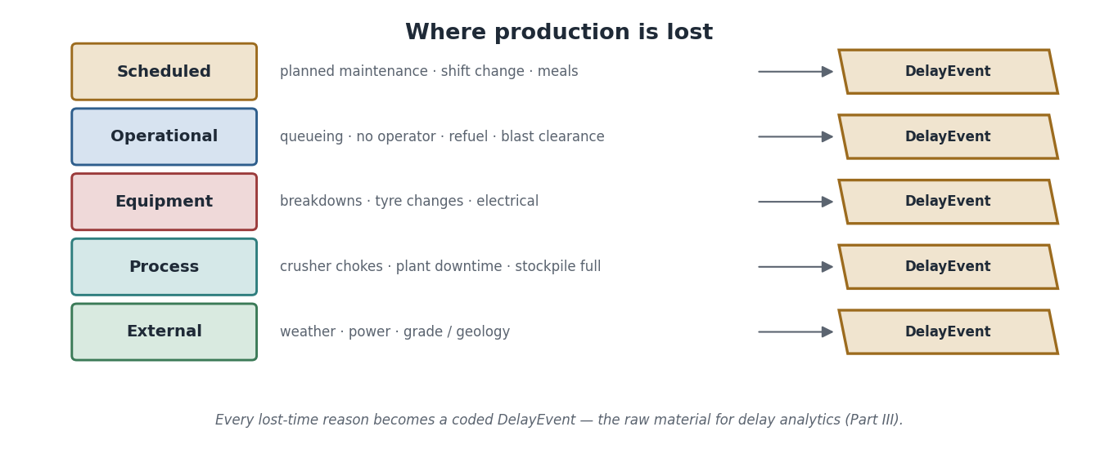
Where production is lost: scheduled, operational, equipment, process, and external delay categories — each captured as a coded DelayEvent, the raw material for delay analytics in Part III.
Category | Examples
Scheduled | planned maintenance, shift change, meal breaks
Operational | queueing, waiting for an operator, refuelling, blast clearance
Equipment | breakdowns, tyre changes, electrical faults
Process | crusher chokes, plant downtime, stockpile full
External | weather, power outage, grade/geology surprises
Architecture Insight. Each category maps to a reason code on a DelayEvent. The category taxonomy is reference data in the ontology, which is why two mines can be compared fairly: a “scheduled” delay means the same thing at Pilbara Ridge as at Black Diamond. Consistent reason codes are what make cross-site delay analytics possible at all.

How a mine is run, day to day
A producing mine runs on a daily rhythm built around shifts. Understanding this rhythm tells you when MineProductivity’s outputs are actually used — and by whom.
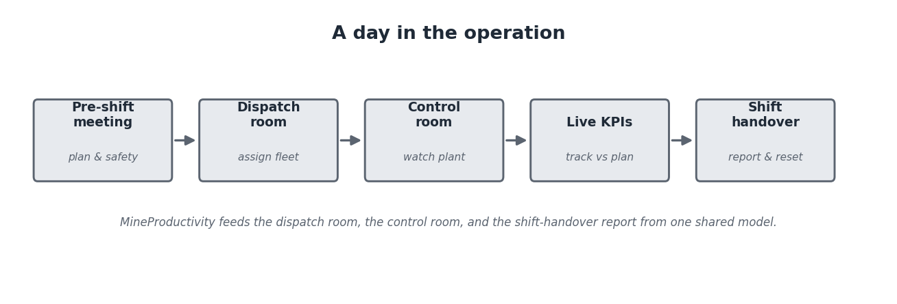
A day in the operation: pre-shift meeting, dispatch room, control room, live KPI tracking, and shift handover. MineProductivity feeds the dispatch room, the control room, and the handover report from one shared model.
The pre-shift (or morning) meeting sets the plan and safety focus for the coming shift and reviews the last one. The dispatch room assigns and monitors the fleet in real time (often via the FMS). The control room watches the fixed plant — crusher, conveyors, processing — through SCADA. Throughout the shift, live KPIs track progress against plan. At shift handover, the outgoing crew reports what happened and resets for the incoming crew. MineProductivity supplies a shared, consistent picture to the dispatch room, the control room, and especially the handover and morning meeting, so everyone argues from the same numbers.
Python Insight. The morning report is a natural MineProductivity job: ingest the shift’s events, compute the day’s KPIs, summarise where time went, and flag trends — exactly the end-to-end flow you assembled in Part I, Chapter 10, now run on a schedule. Operations does not see Python; it sees a report that is the same every day and traceable to events.
Digital Twin Insight. During the shift, the Digital Twin is what the dispatch and control rooms watch: a live mirror of fleet and plant state, updated as events arrive. At handover it becomes a record that can be replayed, so the next crew can see not just the ending numbers but how the shift unfolded.
Real Mine Example — Black Diamond, the 6 a.m. meeting. At Black Diamond, the night shift ran below plan. In the morning meeting, the superintendent opens the MineProductivity report: tonnes were short, availability was normal, but a cluster of “stockpile full” delays shows the wash plant fell behind and backed the chain up. The conversation moves immediately from “who was slow?” to “why did the plant back up?” — the right question — because everyone is looking at the same delay breakdown rather than competing anecdotes. The report did not run the shift; it focused the decision after it.
AI Contributor Note. The daily rhythm is where decision-support agents will eventually plug in: a morning-briefing agent that drafts the shift narrative, or a watchdog agent that flags an emerging delay pattern mid-shift. When contributing, design outputs that fit these moments — concise, traceable to events, and timed to the meeting or the shift, not to a dashboard nobody is watching.

Common Mistakes
Blaming people for chain effects. A crew “running slow” is often a downstream symptom of an upstream stoppage. The delay breakdown usually relocates the cause; start there before attributing fault.
Reporting only the headline tonnes. Tonnes tell you whether you missed, not why. The categorised delays tell you why — and only the why is actionable.

Frequently Asked Questions
Dispatch room vs control room — what’s the difference? The dispatch room runs the mobile fleet; the control room runs the fixed plant. Both consume MineProductivity, from different angles.
How often do KPIs update during a shift? As often as events arrive — typically near-real-time for fleet, and at process-historian cadence for plant. The shift report consolidates them.
Why do mines still hold morning meetings if everything is on a screen? Because decisions are social. The meeting turns shared numbers into agreed actions and owners. MineProductivity’s job is to make sure the numbers are not in dispute.

Exercises
- List the production chain in order from face to customer.
- Give the five delay categories and one example of each.
- Explain why “blaming the slow crew” is often the wrong conclusion.

Solutions
- Load → haul → dump → crush → process → stockpile → rail → ship.
- Scheduled (shift change), operational (queueing), equipment (breakdown), process (crusher choke), external (weather).
- Because a chain stoppage upstream (e.g. crusher down, stockpile full) propagates downstream and makes a crew appear slow when the real cause is elsewhere; the delay breakdown reveals the true origin.

Summary
A mine’s output flows along a coupled chain from loading to shipping, losing production to many small, categorised delays along the way. The operation runs on a daily rhythm of meetings, a dispatch room, and a control room. MineProductivity supplies all of them with one consistent, event-traceable picture — turning arguments into decisions and headline misses into specific, actionable causes.

Further Reading
Chapter 16 (dispatch and the FMS); Part I, “Putting Everything Together”. Next: Chapter 18 — Mine Productivity, where these ideas become precise concepts and the bridge into Part III.

Chapter 18 — Mine Productivity
Learning Objectives. After this chapter you will be able to: define productivity, availability, utilisation, reliability, performance, efficiency, and throughput as distinct concepts; explain bottlenecks and the Theory of Constraints; describe the improvement philosophies (Lean, Six Sigma, OEE, operational excellence); and distinguish leading from lagging indicators. This chapter is conceptual — formulas live in Part III.
A note on scope. This is the chapter where it is most tempting to write equations. Resist it. Here we build precise mental models of each concept and how they relate; Part III, the KPI Cookbook, turns each into a defined, implemented metric. If you finish this chapter able to say exactly what question each term answers, it has done its job.

Productivity is a family of questions
“Productivity” is not one number — it is a family of related questions about how well a mine converts time, equipment, and effort into useful output. The terms below are often used loosely in conversation, but a good model keeps them sharply separate, because they have different causes and different fixes.

The time-usage model
The cleanest way to separate the concepts is to follow how a machine’s time is actually spent, from the whole calendar down to genuinely productive work. Each step down the ladder loses some time to a different cause — and each concept names one step.
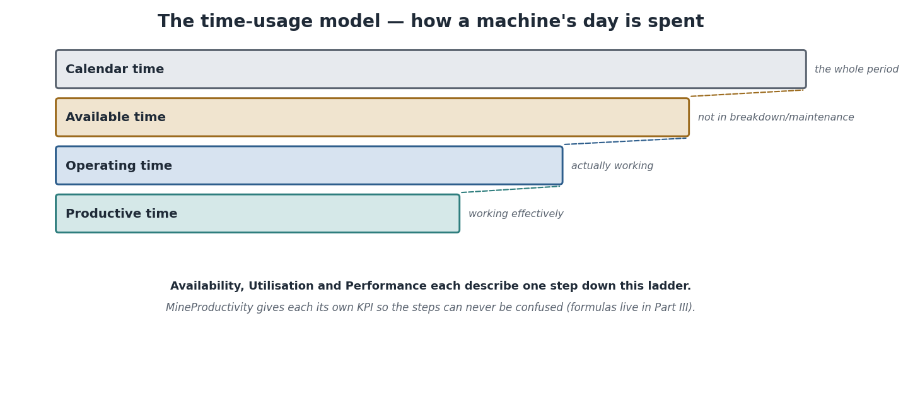
The time-usage model: calendar time contains available time (lost to maintenance and breakdowns), which contains operating time (lost to standby and idle), which contains productive time (lost to speed and quality). Availability, utilisation, and performance each describe one step down this ladder.
Concept | The question it answers
Availability | Of the calendar time, how much was the equipment able to work (not broken or in maintenance)?
Utilisation | Of the available time, how much was it actually working (not idle or on standby)?
Performance | When working, how close to its capable rate did it run?
Reliability | How consistently does it avoid failure over time (long, predictable runs)?
Efficiency | How little waste (time, fuel, rework) accompanied the output?
Throughput | The rate of useful output actually achieved (e.g. tonnes per hour).
Productivity | The overall conversion of input (time, equipment, people) into useful output.
Mining Insight. The classic confusion is availability versus utilisation. A truck can be 95% available (rarely broken) yet poorly utilised (often parked waiting for a shovel or an operator). Telling these apart changes the fix entirely: low availability points at maintenance; low utilisation points at operations and dispatch. Collapsing them into one “uptime” number hides which lever to pull.
Architecture Insight. This is exactly why MineProductivity gives each concept its own KPI rather than a single blended score. The ontology and KPI engine keep availability, utilisation, and performance as separate, comparable metrics so that a result always points at a cause. The separation in the model mirrors the separation in this ladder.

Bottlenecks and the Theory of Constraints
A mine is a chain, and a chain’s output is set by its weakest link. The Theory of Constraints makes this precise: in any production chain there is one binding constraint — the bottleneck — and the system’s output equals the bottleneck’s capacity, no matter how fast everything else can run.
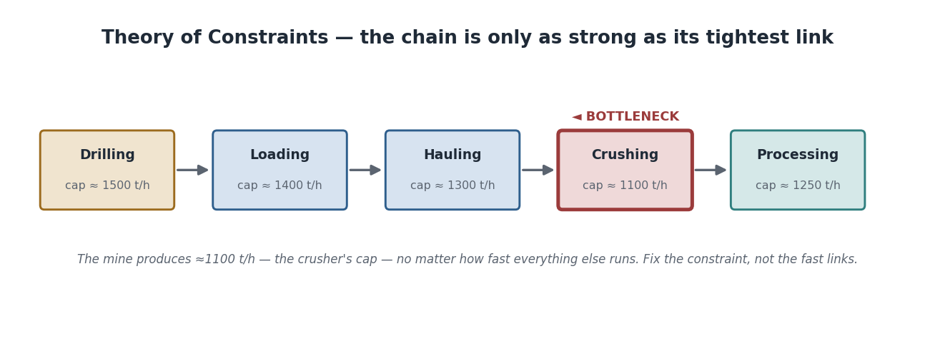
Theory of Constraints: each stage has a capacity; the mine’s output is set by the tightest link (here, crushing at ~1,100 t/h), not the fastest. Improving non-bottleneck stages adds nothing; only relieving the constraint raises output.
The practical discipline follows directly: find the constraint, get the most from it, subordinate everything else to it, then elevate (expand) it — and when it moves, repeat. The counter-intuitive lesson is that improving a non-bottleneck is worthless or harmful: faster shovels feeding a capped crusher just create queues. Most wasted improvement effort in mining comes from optimising fast links while the real constraint sits untouched.
Digital Twin Insight. A Digital Twin is the natural home for constraint analysis because it holds the whole chain’s live state at once. It can show, right now, which link is binding — and, by replaying or simulating, predict where the constraint will move if you relieve the current one. Constraint-hunting is one of the twin’s highest-value uses.

Improvement philosophies
Several management philosophies recur in mining; you do not need to practise them, but you should recognise them, because they shape what stakeholders ask of the data.
Philosophy | Core idea | What it asks of the data
Lean | eliminate waste; maximise flow | where is time/material wasted along the chain?
Six Sigma | reduce variation | how variable is cycle time, payload, grade?
Continuous Improvement (Kaizen) | many small, ongoing gains | is this week better than last, and why?
Operational Excellence | sustained, disciplined execution | are we consistently attaining plan?
OEE (Overall Equipment Effectiveness) | one combined view of availability × performance × quality | how is each loss category trending?
OEE, conceptually. Overall Equipment Effectiveness is a single lens that combines three of the ladder’s losses — availability, performance, and quality — into one view of how effectively equipment is used. The point for now is not how it is computed but what it expresses: a deliberately combined score that you decompose back into its three causes when it moves. Part III defines it precisely.

Leading vs lagging indicators
Finally, the distinction that makes productivity actionable. Lagging indicators report outcomes after the fact — tonnes, availability, cost per tonne, plan attainment. They tell you whether you won. Leading indicators move before the outcome — queue length, match factor, payload variance, maintenance backlog, development advance. They let you act while the shift can still be saved.
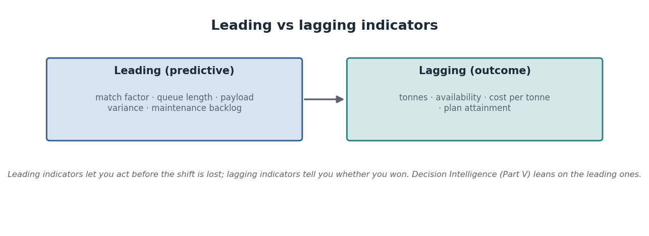
Leading vs lagging indicators: leading indicators (match factor, queue length, payload variance, maintenance backlog) are predictive and let you act early; lagging indicators (tonnes, availability, cost per tonne, plan attainment) report the outcome. Decision Intelligence leans on the leading ones.
Mining Insight. Aurora Gold’s development squeeze (Chapter 14) is the canonical lesson: development advance is a leading indicator of future tonnes. Watching only the lagging tonnes meant the cliff arrived unannounced. Mature operations are defined by how well they watch their leading indicators — which is precisely where Decision Intelligence (Part V) aims.
Python Insight. Nothing here needs new API beyond Part I — these are interpretations of the events and KPIs you already have. A leading indicator is just a KPI chosen because it moves early; a constraint analysis is a comparison of stage throughputs. Part III gives them names and definitions; the data and access patterns are already in your hands.
Real Mine Example — Bingham West, chasing the wrong link. For a quarter, Bingham West invested in faster loading — bigger buckets, tighter spotting. Loading improved; tonnes did not. The constraint was the crusher all along, so faster loading only lengthened the dump queue. Once attention moved to crusher availability and feed control, tonnes finally rose. The lesson is pure Theory of Constraints, and the data showed it the whole time in the dump-queue delays — a leading indicator nobody was watching.
AI Contributor Note. When you contribute a KPI in Part III, tag whether it is leading or lagging and which time-usage step or constraint it speaks to. That metadata is what lets a decision-support agent assemble an early-warning view automatically, rather than a wall of after-the-fact numbers.

Common Mistakes
Blending availability, utilisation, and performance into one number. The blend hides the cause. Keep them separate; combine deliberately (as in OEE) only when you will decompose again.
Improving non-bottlenecks. It feels productive and changes nothing. Always identify the binding constraint first.
Managing by lagging indicators alone. By the time tonnes are short, the shift is lost. Watch the leading indicators that move first.

Frequently Asked Questions
Is “productivity” the same as “throughput”? No. Throughput is the achieved output rate; productivity is the broader conversion of inputs to output. High throughput with high cost and waste is not high productivity.
Why not just track OEE and be done? Because a single score cannot tell you which loss moved. OEE is useful precisely when paired with its decomposition into availability, performance, and quality.
Where are the formulas? In Part III, deliberately. This chapter builds the concepts so the formulas have meaning when you meet them.

Exercises
- State the question each of availability, utilisation, and performance answers.
- Why does speeding up a non-bottleneck stage fail to raise output?
- Classify as leading or lagging: tonnes, queue length, cost per tonne, development advance.

Solutions
- Availability: was it able to work? Utilisation: was it actually working? Performance: when working, how close to capable rate?
- Output is capped by the bottleneck’s capacity; a faster non-bottleneck just produces queues or idle time upstream/downstream without raising the constrained throughput.
- Lagging: tonnes, cost per tonne. Leading: queue length, development advance.

Summary
Mine productivity is a family of distinct questions — availability, utilisation, performance, reliability, efficiency, throughput — best separated by the time-usage ladder. Output is governed by the binding constraint (Theory of Constraints), improvement philosophies shape what stakeholders ask, and leading indicators let you act before lagging outcomes are sealed. MineProductivity keeps these concepts separate and comparable so every result points at a cause — and Part III turns each into a defined metric.

Further Reading
Chapters 13–17 (the operations these concepts measure); Part III — The KPI Cookbook (formulas and implementations). Next: Chapter 19 — Mining Data, the raw material of every metric here.

Chapter 19 — Mining Data
Learning Objectives. After this chapter you will be able to: categorise the data a mine produces; explain data quality, governance, lineage, metadata, cataloguing, and master-data management in mining terms; and describe how MineProductivity gives each data type a home in its architecture.

Mining runs on data
A modern mine is one of the most heavily instrumented industrial environments on earth: thousands of sensors, a continuous fleet feed, surveys, lab assays, and plans, all generated around the clock. Turning that flood into trustworthy metrics is as much a data problem as a mining one. This chapter maps the data landscape and shows where each piece lives in MineProductivity.
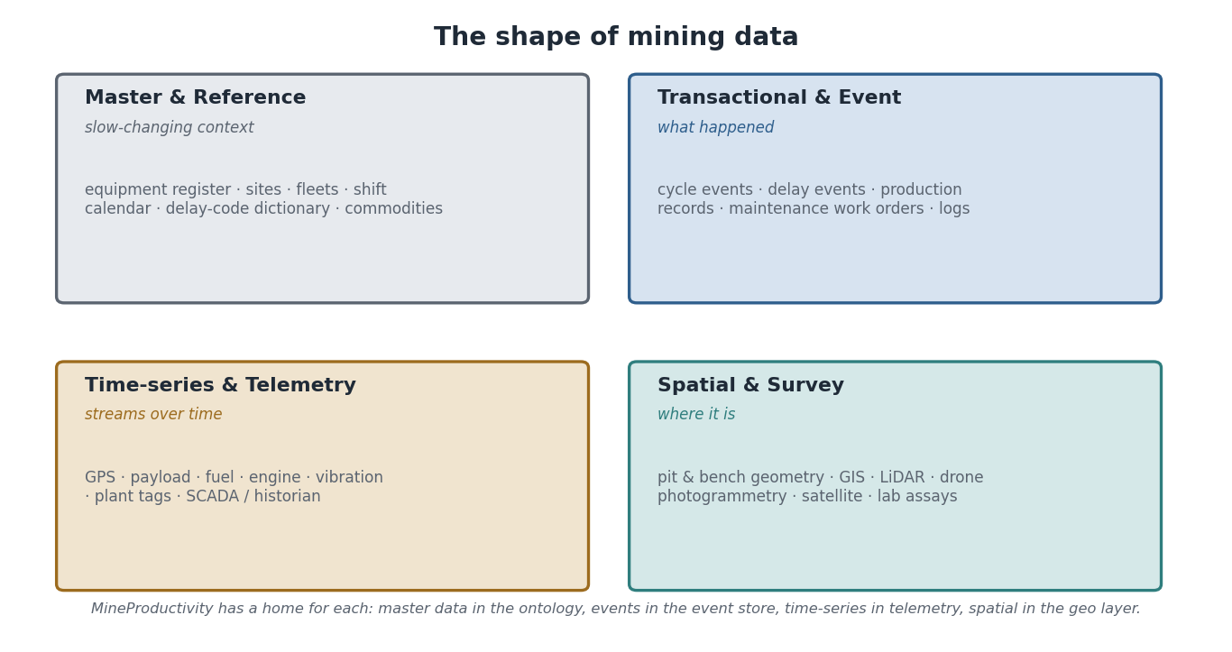
The shape of mining data: master and reference data (slow-changing context), transactional and event data (what happened), time-series and telemetry (streams over time), and spatial and survey data (where things are). MineProductivity provides a home for each.

The data types
Master data is the slow-changing context that everything else references: the equipment register, sites, fleets, the shift calendar, commodities. Reference data is the controlled vocabularies — delay-code dictionaries, status codes, units. Transactional data records discrete business events — production records, maintenance work orders. Events are the typed records at the heart of MineProductivity — cycles, delays, development. Logs are semi-structured operational records. Time-series and telemetry are the high-frequency streams from machines and plant — GPS, payload, fuel, vibration, SCADA tags. Production, maintenance, survey, and laboratory data capture tonnes, work orders, pit/level geometry, and assay grades respectively. Planning data is the mine plan and schedule. Spatial data — GIS, LiDAR, drone photogrammetry, satellite imagery — locates everything in three dimensions and time.
Family | Examples | Cadence
Master & reference | equipment register, sites, delay codes, commodities | slow / curated
Transactional & event | cycles, delays, work orders, production records | per-event
Time-series & telemetry | GPS, payload, fuel, engine, SCADA tags | sub-second to minutes
Spatial & survey | pit geometry, GIS, LiDAR, drone, satellite, assays | periodic
Mining Insight. Spatial data is the dimension software engineers most often under-estimate. A mine is a moving three-dimensional object: the pit changes shape daily, equipment occupies real coordinates, and grade varies through the rock. LiDAR and drone surveys keep the geometry current; satellite imagery tracks the surface over time. Much of mining’s hardest analytics is where, not just what.

Data quality, governance, and lineage
Raw mining data is dirty: sensors drop out, operators mis-key reason codes, timestamps drift, payloads spike. A metric is only as trustworthy as the data beneath it, so quality and governance are first-class concerns, not afterthoughts.
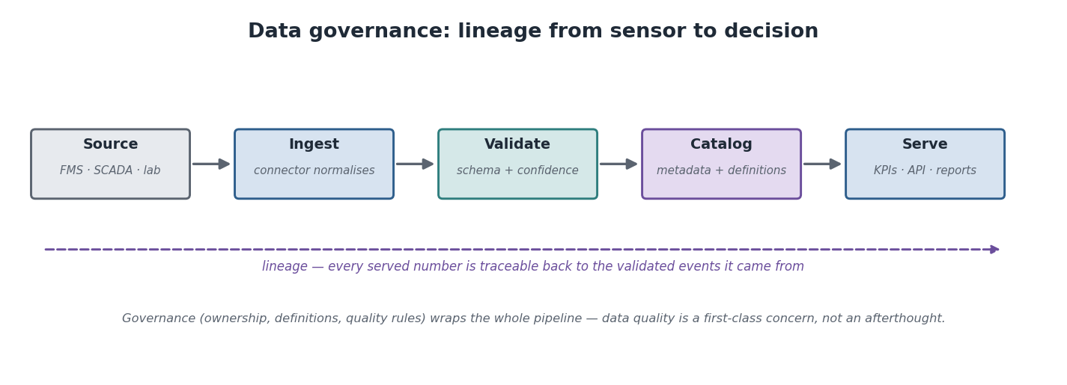
Data governance: source, ingest, validate, catalogue, serve — with lineage threading through so every served number traces back to the validated events it came from. Governance (ownership, definitions, quality rules) wraps the whole pipeline.
- Data quality — is the data complete, accurate, timely, and consistent? Validation at ingest catches the worst problems and attaches a confidence to questionable records.
- Data governance — who owns each dataset, what its definitions are, and what rules it must satisfy.
- Data lineage — the traceable path from a served number back through the events and signals it came from. If a KPI looks wrong, lineage lets you walk back to the raw cause.
- Metadata — data about the data: definitions, units, owners, update times.
- Data catalogue — a searchable inventory of available datasets and their metadata.
- Master Data Management (MDM) — keeping the master data (equipment, sites, codes) consistent and authoritative across systems.
Architecture Insight. MineProductivity’s design gives each data type a natural home: master and reference data become the ontology; events become the event store; time-series and telemetry are normalised by connectors into events (or kept as supporting context); spatial data sits in a geo layer the ontology references. Lineage is preserved because every KPI is computed from immutable events, which themselves reference the master data — so any number can be traced back to its sources by construction.
Python Insight. This is why Part I insisted on typed events and a connector boundary. Typed events give you validation and lineage for free: a malformed cycle is rejected (or flagged) at the connector, and a valid one carries references to the equipment and shift it belongs to. Your analysis code inherits clean, traceable data without writing bespoke cleaning logic everywhere.
Digital Twin Insight. The Digital Twin is only as good as its data feed. Because it is assembled from validated events that reference master data, the twin’s state is inherently traceable: every value it shows can be explained by the events that produced it. A twin built on unvalidated, lineage-less data would be a confident fiction — the governance pipeline is what makes it trustworthy.
Real Mine Example — Green Valley, the mis-keyed reason code. At Green Valley, a week of “other” delays mysteriously spiked. Lineage made the diagnosis quick: the delays traced to one crew on one shift, whose in-cab device had a mislabelled button mapping a common stoppage to “other”. Because every delay event referenced its equipment, operator, and shift, the bad mapping was isolated in minutes and the reason codes corrected — without discarding the shift’s good data. Governance turned a data-quality scare into a five-minute fix.
AI Contributor Note. Agents reason over the catalogue and the lineage graph, not over raw files. When you add a dataset or KPI, register its metadata — definition, units, owner, source events — so an agent can discover it, trust it, and trace it. Undocumented data is, to an automated reasoner, invisible.

Common Mistakes
Trusting a metric without checking lineage. A clean-looking number can rest on dirty data. Build on a pipeline where every number is traceable to validated events.
Neglecting master data. Inconsistent equipment IDs or delay codes across sites quietly break every cross-site comparison. MDM is unglamorous and essential.

Frequently Asked Questions
Is telemetry the same as events? No. Telemetry is the raw, high-frequency stream; events are the typed, validated records a connector distils from it. The system reasons over events.
Where does spatial data fit if MineProductivity is event-driven? Events reference entities, and entities have spatial attributes (a bench, a level, a dump). The geo layer holds geometry the ontology points to.
Do I need a data catalogue for a small deployment? Even a small one benefits from recorded definitions and lineage. The discipline scales down; skipping it does not.

Exercises
- Place each in the right family: GPS stream, equipment register, delay-code dictionary, LiDAR survey, completed cycle.
- Define data lineage in one sentence and say why it matters.
- Name the MineProductivity home for master data and for events.

Solutions
- GPS stream → time-series/telemetry; equipment register → master; delay-code dictionary → reference; LiDAR survey → spatial/survey; completed cycle → event.
- Lineage is the traceable path from a served number back to the validated events and signals it came from; it matters because it lets you trust and debug every metric.
- Master data lives in the ontology; events live in the event store.

Summary
Mining generates master, reference, transactional, event, time-series, telemetry, production, maintenance, survey, laboratory, planning, and spatial data — at wildly different cadences. Quality, governance, lineage, metadata, cataloguing, and master-data management turn that flood into trustworthy metrics. MineProductivity gives each type a home — ontology, event store, connectors, geo layer — and preserves lineage by computing every KPI from immutable, reference-bearing events.

Further Reading
Part I, “Your First Ontology” and “Your First Connector”; Architecture Handbook, data-architecture sections. Next: Chapter 20 — MineProductivity Domain Mapping, the bridge that connects everything in Part II to the parts ahead.

Chapter 20 — MineProductivity Domain Mapping
Learning Objectives. After this chapter you will be able to: take any mining concept from Part II and trace it through the full MineProductivity stack — ontology, events, KPIs, analytics, optimisation, decision intelligence, Digital Twin, and AI agents; read the ontology as an entity-relationship model; and understand the knowledge graph that automated reasoning will use. This chapter is the bridge into Part III.

The bridge
Everything in Part II has been preparing for one idea: that each mining concept becomes a precise MineProductivity object, and those objects flow through a single pipeline from raw fact to autonomous decision. This is the hinge of the whole guide.
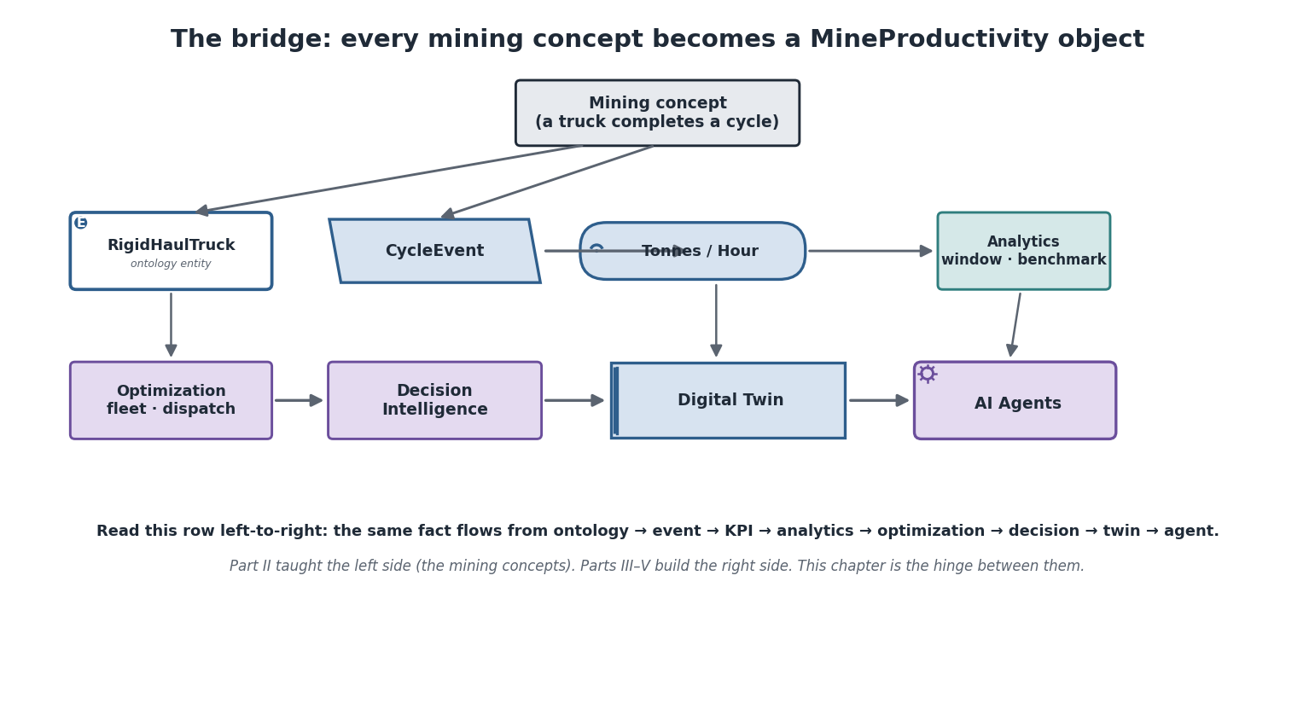
The bridge: a mining concept (a truck completes a cycle) becomes an ontology entity, then a CycleEvent, then a KPI (Tonnes/Hour), then analytics, then feeds optimisation, decision intelligence, the Digital Twin, and AI agents. Part II taught the left side; Parts III–V build the right side.
Read the flow left to right. A mining concept — a truck completing a cycle — is represented by an ontology entity (RigidHaulTruck). Its real-world action is recorded as an event (CycleEvent). A KPI (tonnes per hour) reads those events to measure performance. Analytics windows and benchmarks the KPIs. Optimisation uses the analytics to improve decisions (fleet sizing, dispatch). Decision Intelligence turns insight into recommended action. The Digital Twin holds the live state the whole way through. And AI agents reason over all of it to answer questions and propose actions. Every layer consumes the one before; nothing skips the chain.
The single most important sentence in Part II. The same fact flows from ontology → event → KPI → analytics → optimisation → decision → twin → agent. If you remember nothing else, remember that a truck cycle and an agent’s recommendation are the same fact at different stages of refinement. That is what makes the system coherent rather than a pile of disconnected tools.

Mapping the Part II concepts
The table below is the explicit bridge: every major concept you met in Part II, and the MineProductivity object it becomes. This is the index Part III will assume you know.
Mining concept (Part II) | Ontology entity | Event(s) | Measured by (concept)
Haul truck (Ch 13, 15) | RigidHaulTruck | CycleEvent, DelayEvent | throughput, availability, utilisation
Shovel / excavator (Ch 15) | Shovel / Excavator | CycleEvent (load legs), DelayEvent | loading rate, availability
Truck cycle (Ch 13) | — (process) | CycleEvent | cycle time, payload
Development round (Ch 14) | heading / Drive | DevelopmentEvent | advance rate
Stope (Ch 14) | Stope | production draw events | tonnes, dilution
Delay / lost time (Ch 17) | reason code (reference) | DelayEvent | delay by category
Crusher / plant (Ch 13, 15) | Crusher / Plant | run/stop, throughput | plant availability, constraint
Bench / level (Ch 13, 14) | Bench / Level | (location context) | grade control, sequence
Fleet (Ch 16) | Fleet | aggregated cycles | match factor, fleet utilisation
Shift (Ch 17) | Shift | groups events | plan attainment
Notice that the concept column is pure Part II and the measured by column is deliberately conceptual — the formulas arrive in Part III. The bridge connects the two without crossing into calculation.

The ontology as an entity-relationship model
Underneath the bridge sits a structured ontology. Seen as an entity-relationship sketch, it is a hierarchy of place and equipment, with events referencing entities and KPIs reading events.
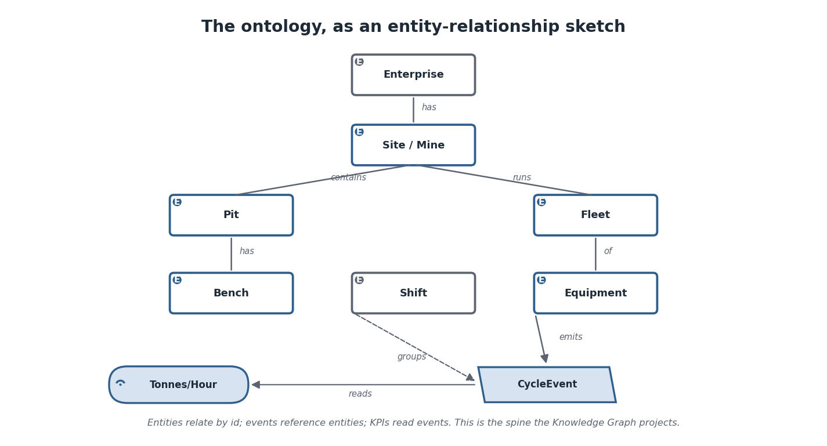
The ontology as an ER sketch: Enterprise contains Sites; a Site contains Pits (with Benches) and runs Fleets (of Equipment); Shifts group events; Equipment emits CycleEvents; KPIs read events. Entities relate by id, events reference entities, KPIs read events.
The structure is deliberately simple and stable: an enterprise owns sites; a site contains the physical mine (pits, benches, or levels and drives underground) and runs fleets of equipment; shifts organise time; equipment emits events; KPIs read events. Everything relates by stable identifiers, which is what lets the system join a cycle event to the truck that produced it, the bench it occurred on, and the shift it belonged to — and therefore slice any KPI by any of them.
Architecture Insight. This ER sketch is a view of the ontology you built in Part I, Chapter 8 — not a new structure. The Handbook’s layered architecture, the Blueprint’s reference classes, and Part I’s hands-on ontology are three views of this same spine. Part II’s contribution is to populate it with mining meaning: now you know what a Bench, a Stope, or a DelayEvent means in the world.

The knowledge graph agents reason over
Project the ontology, events, and KPIs into a connected graph and you get the structure that automated reasoning traverses. An agent asked “why is throughput low?” does not run a fixed report — it walks the graph from the KPI through the events and entities to the root cause.
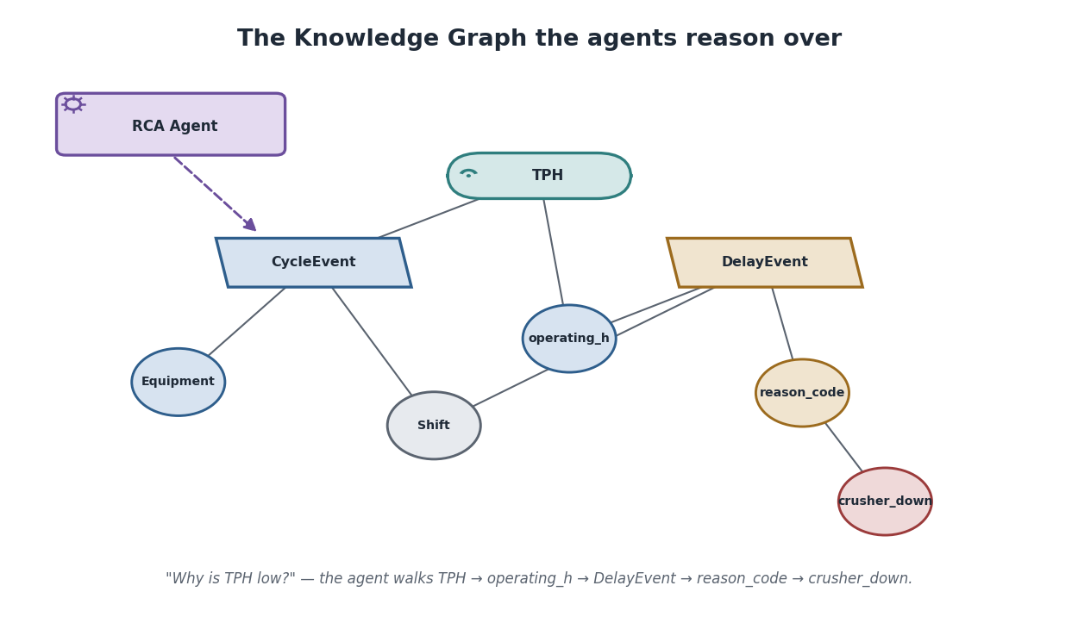
The knowledge graph agents reason over: KPIs connect to the events they read, events connect to the equipment, shifts, and reason codes they reference, and an RCA (root-cause-analysis) agent walks the graph — from Tonnes/Hour through operating hours to a DelayEvent’s reason code to “crusher down”.
Digital Twin Insight. The knowledge graph is the static structure (what connects to what); the Digital Twin is the live state laid over it (what is true right now). Together they are what an agent needs: the graph tells it where it can walk, the twin tells it what it finds when it gets there. An RCA agent uses both — graph to navigate from symptom to candidate causes, twin to check which cause is currently real.
Python Insight. You can already see the seams of all of this in the Part I API: entities, events, and KPIs are objects with references between them. Parts III–V do not replace that API; they build on it — analytics over KPIs, optimisation over analytics, agents over the graph. The mental model you finish Part II with is the model the rest of the code assumes.
AI Contributor Note. This chapter is your contributor’s map. Whatever you add — a KPI, a connector, an analytic, an agent skill — find it on the bridge and declare its neighbours: which events it reads, which entities it references, which downstream layer consumes it. Contributions that state their place in the graph compose automatically; contributions that float disconnect the reasoning the whole system depends on.
Real Mine Example — one fact, all the way across. Tie the whole guide together with a single cycle at Bingham West. A 220-tonne truck finishes hauling ore from Bench 7 to the crusher. The FMS records the cycle; a connector turns it into a CycleEvent referencing the truck, the bench, and the night shift. The throughput KPI reads it; analytics notes throughput is trending below the weekly benchmark; optimisation flags the dump queue as the likely cause; decision intelligence recommends prioritising crusher feed; the Digital Twin shows the queue forming in real time; and an RCA agent, asked “why are we behind?”, walks the knowledge graph from throughput to operating hours to a cluster of “crusher down” delay events and answers in one sentence. One truck cycle, refined step by step into a decision. That is MineProductivity — and that is what Part III begins to build.

Common Mistakes
Skipping layers. Computing a “decision” straight from raw telematics, bypassing typed events and KPIs, throws away lineage and method-awareness. The pipeline’s order is its integrity — respect it.
Adding a concept without placing it on the bridge. A KPI that does not declare its events, or an entity with no relationships, cannot be reasoned over. Always connect a new concept to its neighbours.

Frequently Asked Questions
Is this chapter Part III? No — it is the bridge to Part III. It maps concepts to objects without giving formulas. Part III, the KPI Cookbook, defines and implements the metrics named here.
Why model a knowledge graph at all? Because it lets reasoning be general: an agent that can walk the graph can answer questions no one pre-programmed, by following references from symptom to cause.
Do I need agents to use MineProductivity? No. The lower layers (ontology, events, KPIs, analytics) stand on their own. Agents are the top of the stack, not a prerequisite for the rest.

Exercises
- Trace a haul-truck cycle through all eight stages of the bridge, naming the object at each.
- In the ER model, explain how a single KPI can be sliced by both equipment and shift.
- Describe the path an RCA agent walks to explain low throughput in the knowledge-graph figure.

Solutions
- Concept (truck completes cycle) → entity (RigidHaulTruck) → event (CycleEvent) → KPI (tonnes/hour) → analytics (trend vs benchmark) → optimisation (fleet/dispatch) → decision intelligence (recommended action) → Digital Twin / AI agent (live state and reasoning).
- The event references both the equipment id and the shift id, so KPIs reading those events can group by either dimension.
- Throughput (Tonnes/Hour) → operating hours → DelayEvent → reason code → “crusher down”.

Summary
Every mining concept in Part II becomes a MineProductivity object, and those objects flow through one pipeline: ontology → events → KPIs → analytics → optimisation → decision intelligence → Digital Twin → AI agents. The ontology is a stable ER spine; the knowledge graph projects it for reasoning; the twin lays live state over it. Part II taught the mining meaning of every node on that bridge. Part III crosses it — turning the concepts you now understand into defined, implemented KPIs.

Further Reading
The entire Part II (every concept mapped here); Master Architecture Handbook and Reference Implementation Blueprint (the structures this chapter views); Part I (the hands-on API). Next: Part III — The KPI Cookbook, where the metrics named throughout Part II are finally defined and built.

End of Part II. You now understand the mining domain through the lens of MineProductivity: what a mine is, how it is mined, what equipment and systems run it, how production is lost and measured, what data it produces, and how every concept maps onto the object model. You are ready for Part III — The KPI Cookbook.

