MineProductivity
Learning & Benchmark Suite
Version 1.0 · The Educational, Validation & Demonstration Companion

The executable, reproducible foundation beneath the MineProductivity documentation ecosystem. Every KPI, ontology, connector, workflow, Digital Twin, AI agent, and Decision Intelligence example can be demonstrated and validated from the datasets, notebooks, and expected outputs defined here.

Version | 1.0
Status | Normative companion to the SSOT — builds on and never contradicts it
Depends on | Master Architecture Handbook v1.0; Reference Implementation Blueprint v1.0; Developer & Cookbook Guide Parts I, II, III (all LOCKED)
License | Datasets and notebooks: CC BY 4.0; code: Apache-2.0
Reference Mines | Pilbara Ridge (Iron Ore) · Bingham West (Copper) · Black Diamond (Coal) · Aurora Gold (Gold) · Green Valley (Lithium)
Revision history
Version | Date | Summary
1.0 | June 2026 | First Edition. Complete seven-part Learning & Benchmark Suite: Dataset Library (7 commodities), Notebook Curriculum (~100 notebooks), Expected Outputs, Benchmark Seeds, Visualization Gallery, AI Demo Gallery, Certification Assets.

Contents
Update this field (Ctrl+A, F9) to populate the table of contents.
Introduction 1
Design principles 1
How to use this document 1
Part I — Dataset Library 1
Design principles 1
Directory structure 1
Enhancement 7 — Refined Dataset Hierarchy 1
Enhancement 1 — Dataset Versioning Architecture 1
Dataset version fields 1
Semantic versioning rules 1
Schema evolution 1
Enhancement 2 — Dataset Metadata Standard 1
The canonical metadata.yaml 1
Enhancement 3 — Dataset Quality Report 1
Quality report structure 1
Shared tables 1
shared/shift_calendar.csv 1
Core commodity tables — iron_ore (Pilbara Ridge) 1
equipment.csv 1
operators.csv 1
haul_routes.csv 1
cycle_events.csv 1
delay_events.csv 1
maintenance_events.csv 1
fuel_events.csv 1
production.csv 1
crusher.csv 1
bench_geometry.csv 1
weather.csv 1
Commodity-specific extensions 1
copper/assay_events.csv (Bingham West) 1
coal/development_events.csv (Black Diamond) 1
lithium/assay_events.csv (Green Valley) 1
Dataset generation 1
Enhancement 4 — Scenario Generator Framework 1
The ScenarioGenerator API 1
Parameterisation — KPI effects 1
Reproducibility and deterministic replay 1
AI scenario generation 1
Named scenario library 1
Summary — Part I 1
Part I-B — Temporal Data Philosophy 1
The three time concepts 1
Shift boundaries and cross-midnight shifts 1
Watermarks and late events 1
Event corrections and idempotency 1
Relation to Event Sourcing and the Digital Twin 1
Part II — Notebook Gallery 1
Enhancement 6 — Notebook Metadata Standard 1
Curriculum overview 1
Level 1 — Beginner (NB-01 to NB-10) 1
NB-01 — Installation & First Run 1
NB-02 — Your First Event (CycleEvent) 1
NB-03 — Your First Ontology Object 1
NB-04 — Your First Connector (CSV) 1
NB-05 — Your First Delay Analysis 1
NB-06 — Your First Availability Calculation 1
NB-07 — Your First Visualization 1
NB-08 — The Five Reference Mines — A Tour 1
NB-09 — The Shift Ledger 1
NB-10 — Beginner Challenge — Build Your Own KPI Dashboard 1
Level 2 — Intermediate (NB-11 to NB-35) 1
Level 3 — Advanced (NB-36 to NB-60) 1
Level 4 — Expert (NB-61 to NB-80) 1
Level 5 — Specialist (NB-81 to NB-95) 1
Level 6 — Research (NB-96 to NB-100) 1
Part III — Expected Outputs 1
Principles 1
Core KPI expected outputs — canonical dataset 1
Per-notebook expected outputs (selected) 1
NB-06 — Availability (full shift) 1
NB-11 — Truck Productivity Deep Dive 1
NB-23 — Copper Recovery 1
NB-44 — Fleet Simulation 1
Regression-test outputs 1
Part IV — Benchmark Seeds 1
Scenario definitions 1
Excellent scenario 1
Good scenario 1
Average scenario 1
Poor scenario 1
Commodity-specific scenario summaries 1
Bingham West — Copper (illustrative ranges) 1
Black Diamond — Coal (illustrative ranges) 1
Aurora Gold — Gold (illustrative ranges) 1
Green Valley — Lithium (illustrative ranges) 1
Part V — Visualization Gallery 1
Chart types and their KPI matches 1
KPI Cards 1
Time Series 1
Pareto 1
Waterfall 1
Sankey Diagram 1
Scatter Plot 1
Histogram 1
Control Chart (Shewhart) 1
Heatmap 1
Fleet Map 1
Bubble Chart 1
Timeline / Gantt 1
Dual-Axis Line Chart 1
Worst-practice patterns to avoid 1
Part VI — AI Demonstration Gallery 1
Demo structure — standard template 1
Demo 01 — Root Cause Analysis 1
Demo 02 — KPI Explanation 1
Demo 03 — Delay Investigation 1
Demo 04 — Shift Summary Generation 1
Demo 05 — Productivity Recommendations 1
Demo 06 — Fleet Optimisation 1
Demo 07 — Digital Twin Querying 1
Demo 08 — Ontology Exploration 1
Demo 09 — Benchmark Comparison 1
Part VII — Certification Assets 1
Purpose 1
Asset categories 1
Category A — Golden datasets 1
Category B — Integration test datasets 1
Category C — Edge-case datasets 1
Category D — Corrupted datasets 1
Category E — Missing-data scenarios 1
Category F — Timezone scenarios 1
Category G — Multi-mine scenarios 1
Category H — Multi-commodity scenarios 1
Certification checklist 1
Closing — The Suite as a Living System 1
Documentation Governance Rules 1
Documentation Governance Rule #006 — Artifact Versioning & Traceability 1
Documentation Governance Rule #007 — Architecture Freeze & Implementation Priority 1

Introduction
Purpose of this document. The Learning & Benchmark Suite (LBS) is the executable, reproducible, and testable layer beneath the MineProductivity documentation ecosystem. Where the Master Architecture Handbook defines what the system is and the Developer & Cookbook Guide Parts I–III define how to implement every KPI, the LBS defines how to demonstrate, validate, teach, and certify those implementations against realistic mining data. Every artifact in this suite — every dataset row, expected output, notebook cell, and benchmark seed — is either generated from the five canonical reference mines or derived from those generators, so the complete suite can be reproduced from scratch.
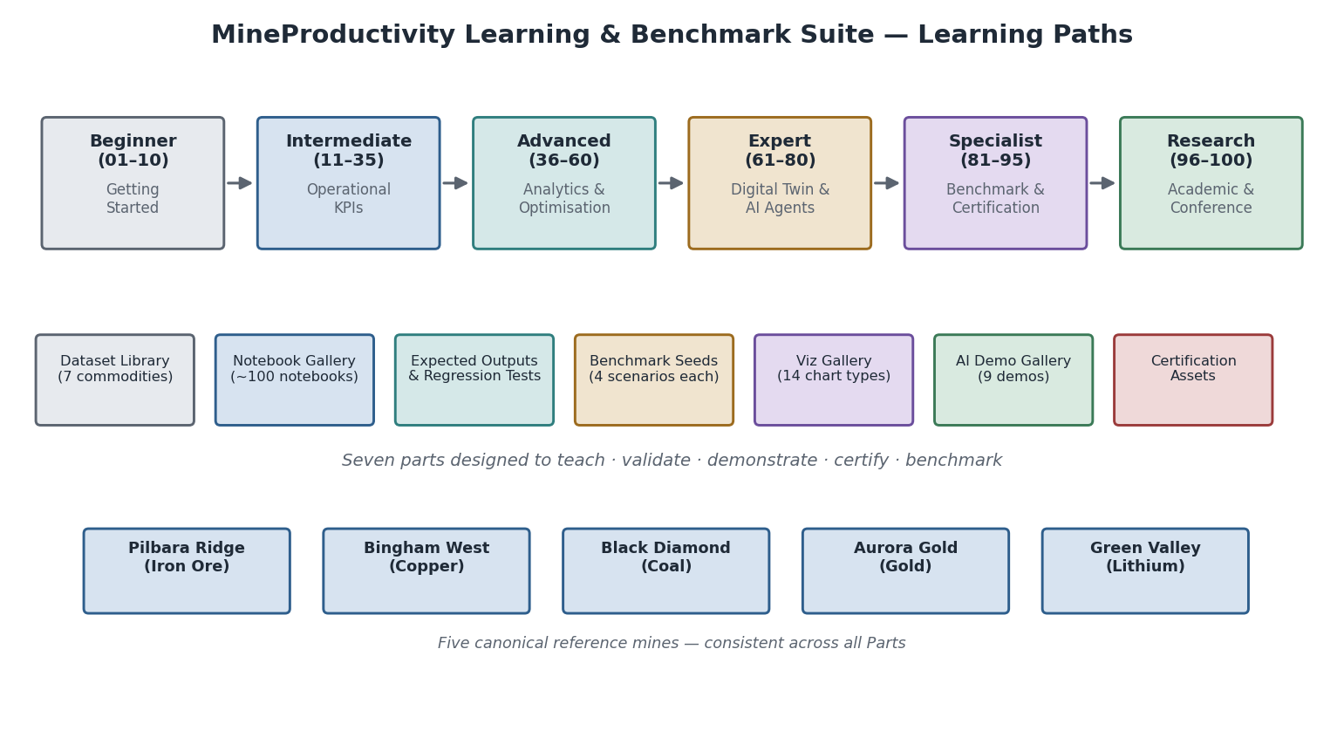
The MineProductivity Learning & Benchmark Suite: six learning tracks (Beginner to Research), seven deliverable parts (Dataset Library, Notebook Gallery, Expected Outputs, Benchmark Seeds, Viz Gallery, AI Demo Gallery, Certification Assets), five reference mines, and the principle that every artifact is executable and reproducible.

Design principles
Executable first. Every dataset is a .csv file (or programmatically generated equivalent) with a defined schema and a data generator. Every notebook runs end-to-end. Every expected output is a number that can be checked by code, not a prose description. If a result cannot be reproduced, it is not in the suite.
Grounded in the SSOT. Every KPI example uses the canonical formula, the canonical events, and the canonical ontology from Parts I–III. Every reference to “availability” means UTIL.PA (Part III, Canonical Semantics). No alternative definitions enter through the examples.
Honest about educational vs normative. Benchmark seeds are illustrative scenarios — they teach what an Excellent/Good/Average/Poor operation looks like in data. They are deliberately labelled, and they are not validated industry benchmarks. Future certification thresholds are a separate governed deliverable.
Progressive difficulty. Notebooks sequence from a five-line installation check through multi-mine streaming Digital Twin exercises. A learner who completes all 100 notebooks has validated every KPI in the Standard Library against realistic data and built every pattern in the Handbook.
Five mines, one consistent world. Pilbara Ridge (Iron Ore), Bingham West (Copper), Black Diamond (Coal), Aurora Gold (Gold), and Green Valley Lithium are the same fictional operations throughout — same ontology keys, same equipment registries, same shift calendars, consistent haul geometries. A join between a Pilbara Ridge cycle_events.csv and the Pilbara Ridge equipment.csv always works.

How to use this document
Read Parts I–III of the Developer & Cookbook Guide first. Then use this document as a laboratory manual: Part I (Dataset Library) tells you what data is available and how it is structured; Part II (Notebook Curriculum) tells you what to build with it; Part III (Expected Outputs) tells you whether your implementation is correct; Part IV (Benchmark Seeds) provides the four operational scenarios for each commodity; Part V (Visualization Gallery) tells you how to present your results; Part VI (AI Demo Gallery) shows you how to integrate the Claude API; and Part VII (Certification Assets) provides the validation datasets for formal testing.

Part I — Dataset Library
Learning Objectives. After reading this part you will be able to: navigate the dataset directory structure; understand the schema of every core table; join tables correctly using the defined primary and foreign keys; and generate synthetic datasets from the provided generators.

Design principles
Every dataset in the library follows these rules, which derive directly from the KPI Standard Library (Part III) and the Master Architecture Handbook:
- Referential integrity — every foreign key in an event table points to a valid row in its reference table. equipment_id in cycle_events.csv is always in equipment.csv.
- Ontology alignment — column names and enumerated values use the ontology vocabulary from Part II, Chapter 16–17 (Equipment, Shift, DelayCategory, FailureMode, Material, Destination).
- Event-model alignment — every row in an event table corresponds to exactly one event type from the canonical model (CycleEvent, DelayEvent, MaintenanceEvent, ProductionEvent, ConsumptionEvent, SafetyEvent).
- Multi-dimensional — every dataset supports slicing by shift, equipment, operator, material, and destination — the standard KPI dimensions from Part III.
- Realistic magnitudes — values are drawn from the operational ranges used in Parts II–III, calibrated to the commodity and method.
- Temporal consistency — event timestamps use ISO 8601 UTC; shift boundaries are in the shared shift_calendar.csv; all five mines observe the same canonical 12-hour day/night shift structure (06:00–18:00 / 18:00–06:00).

Directory structure
datasets/
├── shared/
│ ├── shift_calendar.csv # canonical 12h day/night shifts, all mines
│ ├── weather_codes.csv # weather condition reference table
│ └── README.md
│
├── iron_ore/ # Pilbara Ridge Mine
│ ├── equipment.csv
│ ├── operators.csv
│ ├── haul_routes.csv
│ ├── cycle_events.csv
│ ├── delay_events.csv
│ ├── maintenance_events.csv
│ ├── fuel_events.csv
│ ├── production.csv
│ ├── bench_geometry.csv
│ ├── planning.csv
│ ├── crusher.csv
│ ├── stockpiles.csv
│ ├── weather.csv
│ └── README.md
│
├── copper/ # Bingham West Mine
│ ├── (same core tables as iron_ore)
│ ├── assay_events.csv # ore/conc/tail grades per shift
│ └── README.md
│
├── coal/ # Black Diamond Mine
│ ├── (same core tables)
│ ├── development_events.csv # longwall advance per cut
│ └── README.md
│
├── gold/ # Aurora Gold Mine
│ ├── (same core tables)
│ ├── assay_events.csv
│ └── README.md
│
├── lithium/ # Green Valley Lithium
│ ├── (same core tables)
│ ├── assay_events.csv
│ └── README.md
│
├── bauxite/ # generic open-cut, no named mine
│ └── (core tables)
│
└── limestone/ # generic open-cut, no named mine
└── (core tables)
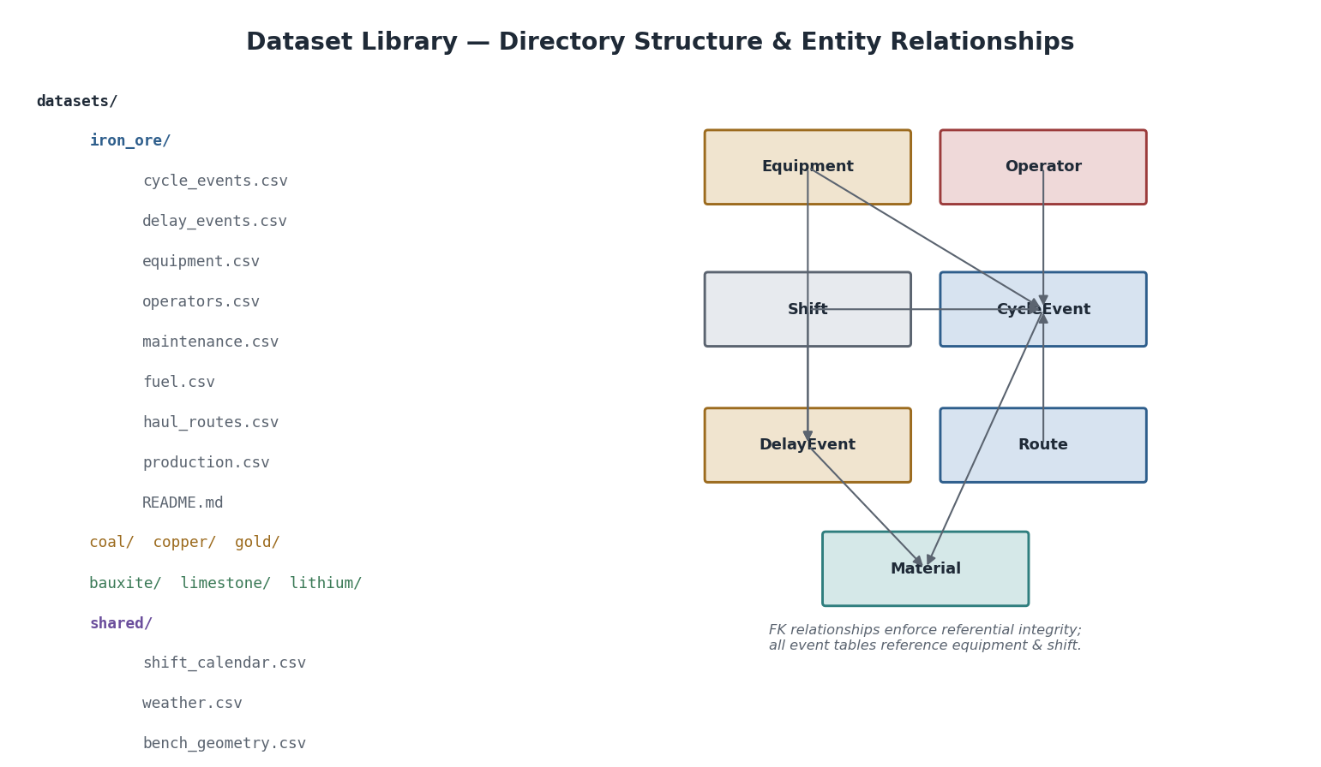
Dataset Library directory structure and entity-relationship diagram: each commodity dataset contains the same core tables (equipment, operators, haul_routes, cycle_events, delay_events, maintenance_events, fuel_events, production); event tables reference equipment, operators, and shifts via foreign keys; the ERD shows how CycleEvent is the hub joined by Equipment, Operator, Shift, Route, and Material.

Enhancement 7 — Refined Dataset Hierarchy
The v1.0 dataset directory is extended to make the lifecycle and provenance of every dataset explicit. The refined hierarchy separates datasets by how they were created and what governance applies to them.
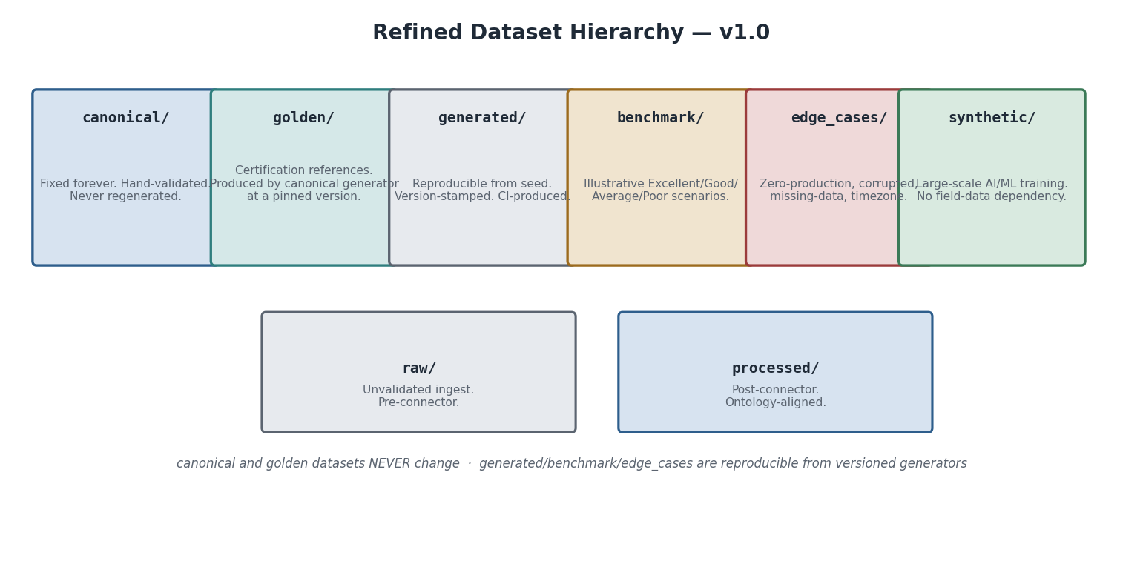
Refined Dataset Hierarchy: canonical (never changes), golden (certification references), generated (reproducible from seed), benchmark (illustrative scenarios), edge_cases (robustness validation), synthetic (large-scale ML), raw (pre-connector), processed (ontology-aligned).
datasets/
├── canonical/ # Fixed forever. Hand-validated. Version-controlled in git.
├── golden/ # Certification references. Produced by pinned generator version.
├── generated/ # Reproducible from seed. CI-produced. Stamped with metadata.yaml.
├── benchmark/ # Illustrative Excellent/Good/Average/Poor scenarios (Part IV).
├── edge_cases/ # Boundary and adversarial datasets (Part VII, Category C-D-E).
├── synthetic/ # Large-scale AI/ML training. No field-data dependency.
├── raw/ # Unvalidated ingest. Pre-connector.
└── processed/ # Post-connector. Ontology-aligned. Ready for KPI engine.
Governance rules. canonical/ datasets are version-controlled in git and never regenerated — their checksums in metadata.yaml are verified by CI. golden/ datasets are produced by a pinned generator version and are the certification reference (Part VII, Check C-01). generated/ datasets are reproducible from a random_seed and a generator version. benchmark/ datasets are generated/ datasets with named operational profiles (the four scenarios in Part IV). edge_cases/ datasets may be hand-crafted or generator-produced adversarial inputs; those used for certification must also appear in golden/. synthetic/ datasets may be very large and are not tracked in git — they are regenerated as needed. raw/ and processed/ follow the connector lifecycle from Part I.

Enhancement 1 — Dataset Versioning Architecture
Every dataset has an independent version. Dataset evolution is governed by semantic versioning rules that guarantee no historical notebook result is ever silently invalidated.

Dataset version fields
Every dataset’s metadata.yaml carries six version fields:
Field | Meaning | Example
dataset_version | The dataset’s own version | 1.2.0
schema_version | The CSV column schema version | 1.0.0
generator_version | The generator that produced it | 1.0.0
ontology_version | Ontology version it conforms to | 1.0.0
handbook_version | Architecture Handbook version | 1.0.0
package_version | mineproductivity package version | 1.0.0

Semantic versioning rules
Dataset versions follow MAJOR.MINOR.PATCH. A MAJOR change (column removed or renamed, FK relationship altered, mandatory column added) breaks existing notebooks — the CI pipeline detects mismatches and flags notebooks for review before the MAJOR version is published. A MINOR change (optional column or table added) is backward compatible. A PATCH change (data corrections, new rows) requires no notebook changes. A notebook declaring dataset_version: "1.0.0" continues to work against 1.y.z; it fails against 2.0.0 with a detected, actionable error rather than a silent wrong answer.

Schema evolution
When a schema MAJOR version is published, the old schema version is retained in canonical/ indefinitely. A migrate_v1_to_v2.py script converts v1 datasets to v2, shipped as part of the generator release.
Architecture Insight — why datasets need their own versioning. The KPI Standard Library (Part III) uses semantic versioning for KPI formulas. The ontology uses it for entity definitions. The Learning & Benchmark Suite applies the same discipline to datasets — because a dataset is a contract between the generator, the notebooks, the expected outputs, and the certification tests. Breaking that contract silently is how a working notebook becomes a misleading one.

Enhancement 2 — Dataset Metadata Standard
Every dataset directory contains a metadata.yaml file that makes the dataset self-describing, machine-readable, and AI-navigable.

The canonical metadata.yaml
# datasets/canonical/iron_ore/metadata.yaml
dataset_id: "iron_ore_canonical"
dataset_name: "Pilbara Ridge Iron Ore — Canonical Reference Dataset"
commodity: "iron_ore"
mine: "Pilbara Ridge"
mine_code: "PIL"
version: "1.0.0"
schema_version: "1.0.0"
generator: "mineproductivity.datasets.generators.IronOreGenerator"
generator_version: "1.0.0"
ontology_version: "1.0.0"
package_version: "1.0.0"
handbook_version: "1.0.0"
creator: "MineProductivity Dataset Team"
created_date: "2026-06-01"
last_modified: "2026-06-01"
status: "Canonical" # Experimental | Canonical | Deprecated
license: "CC BY 4.0"
checksum_sha256:
cycle_events.csv: "a3f8c..."
delay_events.csv: "b91d4..."
equipment.csv: "c2e77..."
row_counts:
cycle_events: 48720
delay_events: 3136
equipment: 25
update_frequency: "Static"
tags: ["iron_ore", "canonical", "pilbara_ridge", "certification"]
kpi_coverage:
active_kpis_supported:
- "PROD.TPH"
- "UTIL.PA"
- "UTIL.UA"
- "UTIL.EU"
- "MAINT.MTBF"
- "MAINT.MTTR"
- "MAINT.Ai"
- "DELAY.Hours"
- "ENERGY.FuelPerTonne"
- "CARBON.CO2PerTonne"
- "COST.CostPerTonne"
- "SAFE.SpeedViolationRate"
kpi_readiness_score: 1.0
notebooks_supported:
- "NB-02"
- "NB-04"
- "NB-06 through NB-10"
- "NB-11 through NB-35"
- "NB-81 through NB-85"
Why metadata matters. The checksum_sha256 field lets any consumer verify they have the exact canonical file. An AI agent building a new notebook queries metadata.yaml to discover supported KPIs and compatible notebooks without reading code. Two researchers comparing results confirm identical data by matching dataset_id + version + checksum_sha256. The certification harness reads metadata.yaml as its C-00 prerequisite check. status: "Canonical" means the dataset is governed — it cannot be modified without a version bump and a change record.

Enhancement 3 — Dataset Quality Report
Every generate_all.py run and every ScenarioGenerator.generate() call automatically produces a quality_report.json alongside the CSV files.

Quality report structure
{
"dataset_id": "iron_ore_canonical",
"dataset_version": "1.0.0",
"generated_utc": "2026-06-01T10:00:00Z",
"schema_validation": {"status": "PASS", "violations": []},
"missing_values": {"cycle_events.payload_t": {"count": 0, "pct": 0.0}},
"duplicate_records": {"cycle_events": {"duplicate_cycle_id_count": 0}},
"fk_integrity": {
"cycle_events.equipment_id": {"orphan_count": 0, "status": "PASS"},
"cycle_events.shift_id": {"orphan_count": 0, "status": "PASS"}
},
"timestamp_validation": {
"event_time_before_shift_end": {"violations": 0, "status": "PASS"},
"event_time_ordering_within_cycle": {"violations": 0, "status": "PASS"},
"ingestion_after_event_time": {"violations": 0, "status": "PASS"}
},
"outlier_detection": {
"cycle_events.payload_t": {"q1": 283.0, "median": 288.5, "q3": 293.0, "iqr_outliers": 4},
"cycle_events.cycle_total_min":{"q1": 18.9, "median": 19.5, "q3": 20.2, "iqr_outliers": 12}
},
"ontology_validation": {
"delay_category_values": {
"found": ["Scheduled","Equipment","Operational","Standby","External","Process"],
"non_canonical": [], "status": "PASS"
}
},
"kpi_readiness": {
"PROD.TPH": {"ready": true},
"UTIL.PA": {"ready": true},
"QUAL.Recovery": {"ready": false, "reason": "assay_events not in dataset"}
},
"kpi_readiness_score": 0.944,
"overall_status": "PASS",
"certification_eligible": true
}
The report is also rendered as quality_report.html with a colour-coded summary card and KPI readiness heatmap. CI/CD integration: FAIL on schema validation, any FK integrity check, any timestamp ordering violation, or kpi_readiness_score < 0.80 for a Canonical or Golden dataset blocks the build. Warnings (e.g. outlier percentage above 5%) are logged but non-blocking.

Shared tables

shared/shift_calendar.csv
Purpose. The master shift reference table. All event tables carry a shift_id FK into this table. Without it, “shift” is ambiguous across timezones and mine types.
Primary key. shift_id
Columns.
Column | Type | Unit | Description
shift_id | string | — | Unique shift identifier, format {MINE}_{YYYY-MM-DD}_{D|N} e.g. PIL_2026-01-15_D
mine_code | string | — | Mine code: PIL, BWS, BDM, AGM, GVL, BAX, LMS
shift_date | date | ISO 8601 | Calendar date of the shift start
shift_type | enum | — | D (day, 06:00–18:00) or N (night, 18:00–06:00+1)
start_utc | datetime | UTC | Shift start timestamp
end_utc | datetime | UTC | Shift end timestamp
scheduled_h | float | hours | Scheduled duration (always 12.0 for standard shifts)
planned_blast_h | float | hours | Planned blast downtime within this shift (from planning.csv)
crew | string | — | Crew identifier (A, B, C, D)
Example records.
shift_id,mine_code,shift_date,shift_type,start_utc,end_utc,scheduled_h,planned_blast_h,crew
PIL_2026-01-15_D,PIL,2026-01-15,D,2026-01-14T22:00:00Z,2026-01-15T10:00:00Z,12.0,0.5,A
PIL_2026-01-15_N,PIL,2026-01-15,N,2026-01-15T10:00:00Z,2026-01-15T22:00:00Z,12.0,0.0,B
BWS_2026-01-15_D,BWS,2026-01-15,D,2026-01-14T22:00:00Z,2026-01-15T10:00:00Z,12.0,0.25,A
KPIs that consume this table. All UTIL.*, DELAY.*, and MAINT.* KPIs use scheduled_h as the denominator for availability and utilisation calculations.

Core commodity tables — iron_ore (Pilbara Ridge)
The iron-ore dataset is the most fully specified. All other commodity datasets follow the same schema with commodity-specific extensions.

equipment.csv
Purpose. The master equipment registry. Every truck, shovel, and ancillary vehicle at Pilbara Ridge has one row here.
Primary key. equipment_id
Columns.
Column | Type | Description
equipment_id | string | Unique ID, format {TYPE}-{NNN} e.g. T-101, S-01, D-01
equipment_type | enum | Haul Truck, Electric Shovel, Hydraulic Excavator, Dozer, Grader, Drill, Crusher, Water Cart
model | string | Manufacturer model, e.g. Komatsu 930E-5, P&H 4100XPC
rated_payload_t | float | Rated payload (tonnes); null for non-haul equipment
rated_capacity_bcm | float | Bucket/dipper capacity (BCM); null for trucks
fuel_type | enum | Diesel, Electric, Hybrid
commissioned_date | date | Date equipment entered service
current_status | enum | Active, Parked, Under Maintenance, Decommissioned
fleet_id | string | Fleet assignment, e.g. FL-NORTH, FL-SOUTH, SH-01
mine_code | string | FK → shared/shift_calendar.csv mine_code
Example records.
equipment_id,equipment_type,model,rated_payload_t,fuel_type,fleet_id,mine_code
T-101,Haul Truck,Komatsu 930E-5,290,Diesel,FL-NORTH,PIL
T-102,Haul Truck,Komatsu 930E-5,290,Diesel,FL-NORTH,PIL
T-201,Haul Truck,CAT 797F,363,Diesel,FL-SOUTH,PIL
S-01,Electric Shovel,P&H 4100XPC,,Electric,SH-01,PIL
S-02,Electric Shovel,P&H 4100XPC,,Electric,SH-02,PIL
D-01,Dozer,CAT D11T,,Diesel,ANC-01,PIL
Corresponding ontology. Equipment entity (Architecture Handbook); Fleet roll-up; EquipmentClass hierarchy.

operators.csv
Purpose. The operator registry. Links to cycle and delay events for operator-level KPI dimensions.
Primary key. operator_id
Columns. operator_id, name (anonymised, e.g. Op-001), crew (A/B/C/D), licence_class (Haul Truck/Shovel/Multi), hire_date (date), mine_code.
Example records.
operator_id,name,crew,licence_class,hire_date,mine_code
OP-001,Op-001,A,Haul Truck,2019-03-15,PIL
OP-002,Op-002,A,Haul Truck,2021-07-22,PIL
OP-050,Op-050,B,Shovel,2017-11-01,PIL

haul_routes.csv
Purpose. The route reference table. Defines every source → destination pair with its one-way haul distance. Used to compute HAUL.TonKm and for network analysis.
Primary key. route_id
Columns.
Column | Type | Description
route_id | string | Format {SOURCE_CODE}_{DEST_CODE} e.g. B7N_CR1
source_type | enum | Bench, Stockpile, ROM Pad
source_code | string | Source location code, e.g. B7N (Bench 7 North)
destination_type | enum | Crusher, Waste Dump, ROM Stockpile, Port Stockpile
destination_code | string | Destination code, e.g. CR1
one_way_km | float | One-way haul distance (km)
effective_grade_pct | float | Effective grade resistance (%), accounts for road grade + rolling resistance
road_surface | enum | Sealed, Gravel, Dirt
speed_limit_kmh | float | Loaded speed limit (km/h)
mine_code | string | FK
Example records.
route_id,source_code,destination_code,one_way_km,effective_grade_pct,speed_limit_kmh
B7N_CR1,B7N,CR1,3.2,8.5,45
B7N_WD1,B7N,WD1,1.8,5.0,50
B5S_CR1,B5S,CR1,4.1,9.2,40
B5S_WD2,B5S,WD2,2.3,4.5,50
KPIs. HAUL.TonKm, ENERGY.FuelPerTonne, HAUL.EffectiveGrade.

cycle_events.csv
Purpose. The primary event table — one row per completed haul cycle. The data source for PROD.TPH, PROD.TruckCycleTime, PROD.Payload, HAUL.MatchFactor, HAUL.TonKm, ENERGY.FuelPerTonne, CARBON.CO2PerTonne.
Primary key. cycle_id
Foreign keys. equipment_id → equipment.csv; operator_id → operators.csv; shift_id → shared/shift_calendar.csv; route_id → haul_routes.csv.
Columns.
Column | Type | Unit | Description
cycle_id | string | — | Unique cycle ID
equipment_id | string | — | FK → equipment.csv
operator_id | string | — | FK → operators.csv
shift_id | string | — | FK → shift_calendar.csv
route_id | string | — | FK → haul_routes.csv
material_type | enum | — | Ore, Waste, Low Grade Ore
cycle_start_utc | datetime | UTC | Timestamp the truck arrived at the shovel
cycle_end_utc | datetime | UTC | Timestamp the truck arrived back at the shovel (next cycle start or dispatch confirmation)
queue_min | float | min | Time waiting at shovel before spotting
spot_min | float | min | Time positioning under bucket
load_min | float | min | Time under the shovel bucket
haul_min | float | min | Loaded travel time
dump_min | float | min | Time at dump/crusher
return_min | float | min | Empty travel time
cycle_total_min | float | min | Sum of all six legs
payload_t | float | t | Payload measured by on-board weighing
fuel_l | float | L | Diesel consumed this cycle (from FMS)
dig_face_code | string | — | Face identifier, e.g. B7N-F3
data_quality | enum | — | Good, Estimated, Suspect
Example records.
cycle_id,equipment_id,operator_id,shift_id,route_id,material_type,cycle_start_utc,cycle_total_min,payload_t,fuel_l
CYC-PIL-0001,T-101,OP-001,PIL_2026-01-15_D,B7N_CR1,Ore,2026-01-14T22:15:00Z,19.4,287,165
CYC-PIL-0002,T-101,OP-001,PIL_2026-01-15_D,B7N_CR1,Ore,2026-01-14T22:35:00Z,19.8,291,168
CYC-PIL-0003,T-102,OP-002,PIL_2026-01-15_D,B7N_CR1,Ore,2026-01-14T22:18:00Z,20.1,284,171
Relationships. Many cycles → one shift; many cycles → one route; many cycles → one equipment; many cycles → one operator.
KPIs computed directly from this table. PROD.TPH, PROD.TruckCycleTime, PROD.Payload, HAUL.TonKm, ENERGY.FuelPerTonne, CARBON.CO2PerTonne, HAUL.MatchFactor (with equipment.csv shovel count).

delay_events.csv
Purpose. One row per delay event. The primary source for DELAY.Hours (and therefore UTIL.PA, UTIL.UA, UTIL.EU) after category-based partitioning.
Primary key. delay_id
Foreign keys. equipment_id, operator_id (nullable — planned delays have no operator), shift_id.
Columns.
Column | Type | Unit | Description
delay_id | string | — | Unique ID
equipment_id | string | — | FK
operator_id | string | — | FK, nullable
shift_id | string | — | FK
delay_category | enum | — | One of the canonical six: Scheduled, Operational, Equipment, Process, External, Standby (Part III, Canonical Semantics)
delay_reason | string | — | Human-readable reason, e.g. Planned blast, Refuelling, Engine failure, Crusher backup, Lightning stand-down, No truck available
start_utc | datetime | UTC | Delay start
end_utc | datetime | UTC | Delay end
duration_min | float | min | end_utc − start_utc in minutes
is_planned | boolean | — | True for Scheduled category; False otherwise
work_order_id | string | — | FK → maintenance (Equipment category only), nullable
Example records.
delay_id,equipment_id,shift_id,delay_category,delay_reason,start_utc,duration_min
DLY-PIL-0001,T-101,PIL_2026-01-15_D,Scheduled,Planned blast,2026-01-15T01:00:00Z,45.0
DLY-PIL-0002,T-102,PIL_2026-01-15_D,Operational,Refuelling,2026-01-15T03:30:00Z,18.0
DLY-PIL-0003,S-01,PIL_2026-01-15_D,Equipment,Hydraulic leak,2026-01-15T05:00:00Z,90.0
DLY-PIL-0004,T-101,PIL_2026-01-15_D,Standby,No truck available,2026-01-15T07:00:00Z,25.0
Note on the canonical six. The delay_category column must contain exactly one of the six canonical values (Canonical Semantics, Part III). The dataset generator enforces this; any external data imported into the suite must be mapped onto these categories at the connector.

maintenance_events.csv
Purpose. One row per equipment failure event (unplanned only — scheduled PM has is_planned=True). Source for MAINT.MTBF, MAINT.MTTR, MAINT.Ai.
Primary key. maintenance_id
Foreign keys. equipment_id, shift_id (at failure), failure_mode_code.
Columns.
Column | Type | Description
maintenance_id | string | Unique ID
equipment_id | string | FK
shift_id | string | FK — shift in which failure occurred
failure_start_utc | datetime | Failure timestamp (when equipment left Available state)
return_to_service_utc | datetime | Return-to-service timestamp
total_downtime_h | float | return_to_service − failure_start in hours (canonical MTTR basis)
active_repair_h | float | Wrench-time only (< total_downtime_h when parts-wait exists)
is_planned | boolean | False = unplanned failure; True = scheduled PM
failure_mode_code | string | FK → failure_modes.csv, e.g. HYD-001, TYR-003
failure_description | string | Free text description
work_order_id | string | ERP work order reference
parts_wait_h | float | Hours waiting for parts (= total_downtime_h − active_repair_h − admin_h)
Example records.
maintenance_id,equipment_id,shift_id,failure_start_utc,return_to_service_utc,total_downtime_h,is_planned,failure_mode_code
MNT-PIL-0001,T-101,PIL_2026-01-15_D,2026-01-15T04:00:00Z,2026-01-15T07:00:00Z,3.0,False,HYD-001
MNT-PIL-0002,T-103,PIL_2026-01-15_N,2026-01-15T13:00:00Z,2026-01-15T16:30:00Z,3.5,False,TYR-003
MNT-PIL-0003,S-01,PIL_2026-01-14_N,2026-01-14T20:00:00Z,2026-01-15T00:00:00Z,4.0,False,ELE-002
KPIs. MAINT.MTBF (operating hours ÷ unplanned failure count); MAINT.MTTR (mean total_downtime_h); MAINT.Ai (derived).

fuel_events.csv
Purpose. Fuel dispensed per equipment per fuelling event. Cross-referenced with cycle_events for fuel intensity.
Primary key. fuel_id
Foreign keys. equipment_id, shift_id.
Columns. fuel_id, equipment_id, shift_id, fuel_utc (datetime), litres_dispensed (float, L), odometer_km (float, optional), fuelling_location (string), operator_id.
Example records.
fuel_id,equipment_id,shift_id,fuel_utc,litres_dispensed
FUL-PIL-0001,T-101,PIL_2026-01-15_D,2026-01-15T03:28:00Z,1840.0
FUL-PIL-0002,T-102,PIL_2026-01-15_D,2026-01-15T04:15:00Z,1920.0
KPIs. ENERGY.FuelPerTonne, ENERGY.IdleFuelRatio, CARBON.CO2PerTonne.

production.csv
Purpose. Shift-level production summary — the aggregated output consumed by PROD.TPH, plan-attainment KPIs, and cost roll-ups.
Primary key. production_id
Foreign keys. shift_id, pit_code, material_type.
Columns.
Column | Type | Unit | Description
production_id | string | — | Unique ID
shift_id | string | — | FK
pit_code | string | — | Pit identifier
material_type | enum | — | Ore, Waste
tonnes_moved | float | t | Total tonnes in this shift/pit/material
bcm_moved | float | BCM | Optional volumetric equivalent
planned_tonnes | float | t | From planning.csv
plan_attainment_pct | float | % | tonnes_moved / planned_tonnes × 100
operating_h | float | h | Operating hours (net of non-operating delay)
tph_actual | float | t/h | tonnes_moved / operating_h
fe_head_grade | float | % | Head grade (ore only; iron ore Fe%)
stripping_ratio | float | t/t | Waste ÷ Ore this shift
Example records.
production_id,shift_id,pit_code,material_type,tonnes_moved,planned_tonnes,operating_h,tph_actual
PRD-PIL-0001,PIL_2026-01-15_D,PIT-NORTH,Ore,38400,40000,29.7,1292.9
PRD-PIL-0002,PIL_2026-01-15_D,PIT-NORTH,Waste,24600,25000,22.1,1113.1

crusher.csv
Purpose. Crusher performance log — feeds CRUSH.Throughput, UTIL.OEE (fixed plant), CRUSH.Utilisation.
Primary key. crusher_record_id
Foreign keys. equipment_id (crusher unit), shift_id.
Columns. crusher_record_id, equipment_id, shift_id, tonnes_crushed, operating_h, available_h, scheduled_h, throughput_tph, feed_size_p80_mm, product_size_p80_mm, power_kwh, oee_availability, oee_performance, oee_quality, oee_overall.

bench_geometry.csv
Purpose. Pit geometry reference — bench heights, face angles, GPS bounds. Used for context in planning, stripping-ratio, and volumetric KPIs.
Columns. bench_id, pit_code, mine_code, bench_rl_m (elevation), bench_height_m, face_angle_deg, material_dominant (Ore/Waste/Mixed), northing_m, easting_m, active (boolean).

weather.csv
Purpose. Shift-level weather summary affecting operations (dust suppression, lightning stand-down, equipment limits).
Foreign key. shift_id.
Columns. shift_id, mine_code, max_temp_c, min_temp_c, rainfall_mm, wind_speed_kmh, wind_direction, dust_index (0–5), lightning_alert (boolean), visibility_category (Good/Reduced/Poor).

Commodity-specific extensions

copper/assay_events.csv (Bingham West)
Purpose. Assay results per plant shift. Source for QUAL.Recovery (two-product formula), GRADE.HeadGrade, PROC.ConcentrateGrade.
Primary key. assay_id
Foreign keys. shift_id, plant_circuit_id.
Columns.
Column | Type | Unit | Description
assay_id | string | — | Unique ID
shift_id | string | — | FK
plant_circuit_id | string | — | Circuit identifier, e.g. CU-FLOAT-1
metal | enum | — | Cu, Mo, Au
feed_grade_pct | float | % | Head assay
conc_grade_pct | float | % | Concentrate assay
tail_grade_pct | float | % | Tailings assay
recovery_pct | float | % | Computed two-product recovery
feed_tph | float | t/h | Mill throughput
conc_dmt_shift | float | t | Dry metric tonnes of concentrate
Example records.
assay_id,shift_id,metal,feed_grade_pct,conc_grade_pct,tail_grade_pct,recovery_pct
ASY-BWS-0001,BWS_2026-01-15_D,Cu,0.60,28.0,0.08,86.91
ASY-BWS-0002,BWS_2026-01-15_N,Cu,0.58,27.8,0.09,85.74
ASY-BWS-0003,BWS_2026-01-15_D,Mo,0.015,52.0,0.002,91.3
Note. The canonical copper worked example (feed 0.60%, conc 28.0%, tail 0.08% → 86.91%) is directly reproduced in row ASY-BWS-0001. Running QUAL.Recovery on this row reproduces the value in Part III.

coal/development_events.csv (Black Diamond)
Purpose. Longwall development cut records — each row is one shearer cut. Source for PROD.FaceAdvance and PROD.DevelopmentRate.
Columns. dev_id, equipment_id (shearer), shift_id, panel_id, cut_start_utc, cut_end_utc, advance_m, cut_depth_m, seam_height_m, material_type (Coal/Stone), web_tonnes, data_quality.

lithium/assay_events.csv (Green Valley)
Purpose. Li₂O assay results per plant shift. Reproduces the 70.48% Li₂O recovery from Part III.
Example record.
assay_id,shift_id,metal,feed_grade_pct,conc_grade_pct,tail_grade_pct,recovery_pct
ASY-GVL-0001,GVL_2026-01-15_D,Li2O,1.00,4.50,0.35,70.48

Dataset generation
All datasets are produced by datasets/generators/generate_all.py. Running this script generates one year of synthetic data (365 days × 2 shifts × all mines) and writes all CSV files. The generator uses the canonical parameters from Part III and is itself a dataset: reading it teaches the operational logic behind the numbers.
# datasets/generators/generate_all.py — excerpt
from mp_kpis_p3 import tonnes_per_hour, truck_cycle_time, physical_availability
import random, csv, datetime
MINES = {
"PIL": {"payloads": (280,300), "cycle_mean":19.5, "n_trucks":12, "route_km":3.2},
"BWS": {"payloads": (215,230), "cycle_mean":21.0, "n_trucks":10, "route_km":4.5},
"BDM": {"payloads": (170,190), "cycle_mean":17.0, "n_trucks":8, "route_km":2.8},
"AGM": {"payloads": (60,75), "cycle_mean":22.0, "n_trucks":6, "route_km":5.0},
"GVL": {"payloads": (90,110), "cycle_mean":18.0, "n_trucks":7, "route_km":2.5},
}
# ... full generator in datasets/generators/generate_all.py

Enhancement 4 — Scenario Generator Framework
Fixed datasets teach learners what mining data looks like. The Scenario Generator Framework lets them create it — unlimited realistic, ontology-conforming, seed-reproducible datasets for any operational condition.
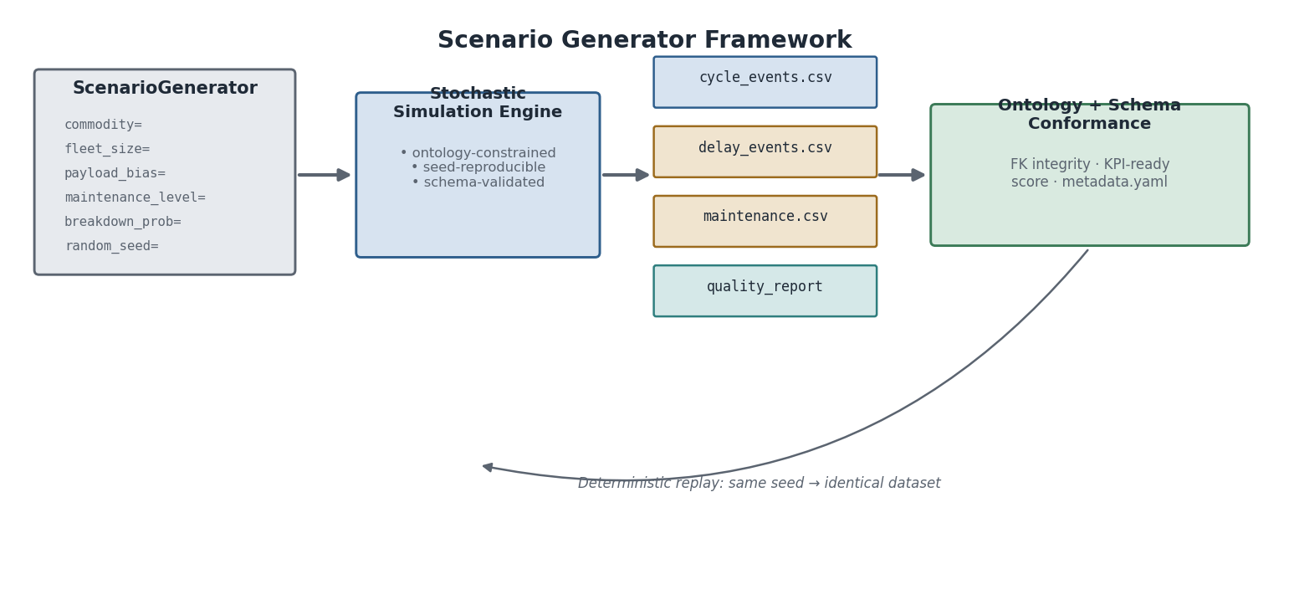
Scenario Generator Framework: parameterised inputs feed a stochastic simulation engine that is ontology-constrained and seed-reproducible; outputs are validated CSV datasets plus a quality report; deterministic replay with the same seed produces bit-identical datasets.

The ScenarioGenerator API
from mineproductivity.datasets import ScenarioGenerator
gen = ScenarioGenerator(
commodity = "iron_ore",
mine_code = "PIL",
fleet_size = 14,
n_shovels = 2,
payload_bias = -3.5, # % below rated — under-loading scenario
haul_distance = 3.2, # km, single route
weather = "rain",
maintenance_level = "poor",
operator_skill = "mixed",
traffic = "heavy",
dispatch_strategy = "balanced",
breakdown_probability = 0.08,
random_seed = 42, # deterministic and replayable
n_shifts = 56,
schema_version = "1.0.0",
ontology_version = "1.0.0",
)
dataset = gen.generate()
dataset.write("datasets/generated/iron_ore_average_seed42/")
print(dataset.quality_report().kpi_readiness_score)

Parameterisation — KPI effects
Parameter | KPI effect
payload_bias | PROD.Payload shifts by bias%; PROD.TPH scales proportionally
maintenance_level | Sets MTBF/MTTR distribution; controls UTIL.PA range
breakdown_probability | P(unplanned failure per shift); drives DELAY.Hours_Equipment
dispatch_strategy | Controls HAUL.MatchFactor target; affects DISP.QueueTime
weather | Activates External delay category events
operator_skill | Controls payload variance and cycle-time variance

Reproducibility and deterministic replay
The generator uses numpy.random.default_rng(seed) for all stochastic draws. The same random_seed always produces bit-identical datasets — every timestamp, every payload, every failure event. The underlying simulation: (1) generate shifts from shift_calendar.csv; (2) draw equipment availability from MTBF/MTTR distributions; (3) generate cycles using haul-route and payload distributions; (4) draw delay events from category distributions (MECE invariant enforced); (5) assign operators, weather, fuel; (6) validate FK integrity and ontology conformance; (7) compute KPI readiness score.

AI scenario generation
gen = ScenarioGenerator.from_ai_prompt(
prompt = "Create a dataset where UTIL.PA drops in Week 3 "
"due to a hydraulic failure cascade, making PA the clear root cause.",
commodity="iron_ore", random_seed=137,
)
The prompt is translated to generator parameters by the AIScenarioPlanner module and logged in metadata.yaml — fully reproducible without re-running the AI planner.

Named scenario library
Scenario name | Description | Use in curriculum
pa_drop_week3 | Sharp PA drop — Equipment driver | NB-37 (Root Cause Analysis)
balanced_fleet_transition | MF grows from 0.77 to 1.08 over 28 shifts | NB-44 (Fleet Simulation)
recovery_degradation | Li₂O recovery falls 72%→65% | NB-24 (Quality Analysis)
excellent_baseline | All KPIs in Excellent band, 56 shifts | NB-81 (Certification Baseline)
poor_cascade | Equipment→Standby→Cost cascade | NB-91 (Benchmark Teaching)
Python Insight. The ScenarioGenerator is itself a MineProductivity plugin registered under the same mechanism as a KPI plugin (Part I, Chapter 9). New commodity generators are discovered automatically. The from_ai_prompt method is a Decision Intelligence pattern (DI namespace, Part III) applied to data generation.

Summary — Part I
The Dataset Library provides seven commodity datasets sharing a common schema, five canonical mine implementations with realistic operational parameters, synthetic generators that reproduce every Part III canonical worked example, and referential integrity enforced by foreign keys. Any notebook, benchmark, or certification test that consumes these datasets has a guaranteed, reproducible data source.

Part I-B — Temporal Data Philosophy
Learning Objectives. After reading this section you will understand: the three time concepts fundamental to mining event data; how shift boundaries, cross-midnight shifts, and timezones are handled canonically; what watermarks, late events, and idempotency mean in practice; and why time is a first-class architectural concept at every stage of the data pipeline.
Mining data is fundamentally temporal. A haul cycle is not a row — it is a sequence of timestamped transitions. An equipment breakdown is not a flag — it is an interval on a timeline. A shift is not a label — it is a boundary in UTC time that determines which cycles, delays, and maintenance events belong to it. Every KPI is, at its core, an aggregation over a time window. Getting time wrong silently corrupts every KPI that depends on it.
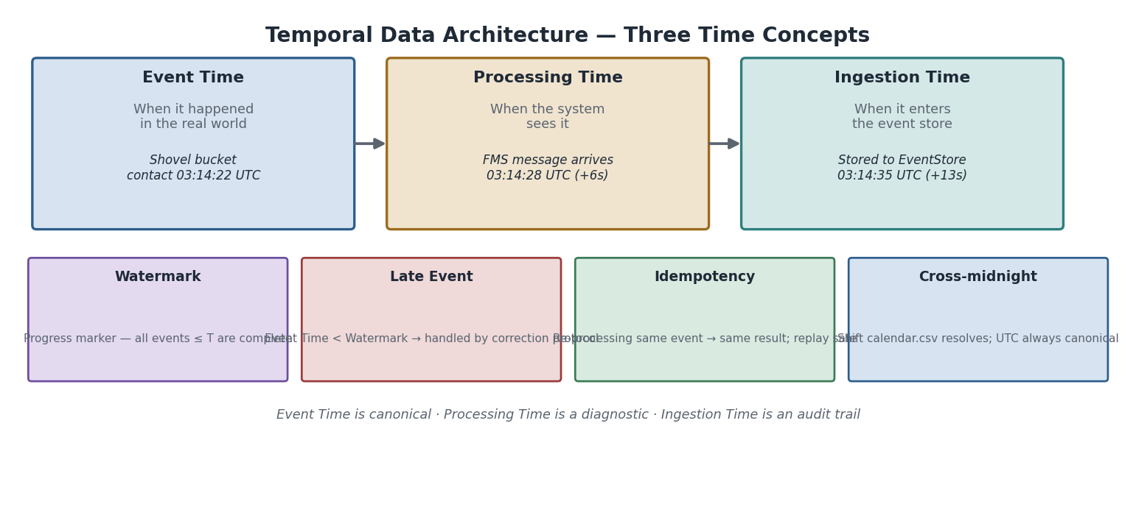
Temporal Data Architecture: Event Time (when it happened), Processing Time (when the system received it), and Ingestion Time (when it entered the event store) are three distinct concepts. Watermarks, late events, idempotency, and cross-midnight shifts are derived consequences of this architecture.

The three time concepts
Event Time is when the event actually happened in the physical world — when the shovel bucket touched rock, when the tyre failed, when the truck stopped at the crusher. Event Time is the canonical time axis for all KPI calculations. It is always stored in UTC.
Processing Time is when the FMS or telemetry system first processed the event — typically seconds to minutes after Event Time in a well-functioning network, potentially hours in a degraded one. Processing Time matters for diagnosing data latency and understanding the freshness of live Digital Twin values. It is stored as a diagnostic column (processed_utc) and is never used as the KPI calculation basis.
Ingestion Time is when the event entered the MineProductivity EventStore. It is the audit trail. Ingestion Time ≥ Processing Time ≥ Event Time in normal operation. A spike in Ingestion Time − Event Time reveals a pipeline fault; it is never a proxy for “when things happened.”
Warning — never confuse the three times in a KPI calculation. The single most common temporal error in mining analytics is computing shift operating hours from Processing Time instead of Event Time. When a FMS message is delayed, the truck appears to operate longer than it did. Always use Event Time, always stored in UTC, always joined to shift_calendar.csv on event_time_utc to assign events to shifts.

Shift boundaries and cross-midnight shifts
The canonical shift structure (shared/shift_calendar.csv) defines every shift as a UTC interval. The day shift at Pilbara Ridge begins at 22:00 UTC the previous calendar day (= 06:00 AWST, no daylight saving) and ends at 10:00 UTC. Cross-midnight in local time is irrelevant — the UTC interval is unambiguous.
Assignment rule. An event belongs to a shift if shift.start_utc ≤ event_time_utc < shift.end_utc (half-open interval). DST. Mines in DST-observing timezones have shifts that are 11.0 h or 13.0 h on DST transition dates; scheduled_h in shift_calendar.csv records the actual duration, and KPIs that use scheduled_h as a denominator (UTIL.PA, UTIL.UA) automatically handle DST correctly.

Watermarks and late events
In streaming analytics (NB-72) and the Digital Twin (NB-62), a watermark asserts that all events with Event Time ≤ W are believed to have arrived. A late event arrives after its watermark has advanced. Late events are handled as: (1) accept and correct — recompute affected KPIs and mark the revision (canonical behaviour for batch mode); (2) accept and flag — record with a late_arrival flag and alert the operator if the event changes a acted-upon recommendation; (3) reject — appropriate only after a shift has been certified. Rejected events are logged, never silently dropped. The late_event_policy is a configurable KPI engine parameter.

Event corrections and idempotency
An event correction is a revised version of an ingested event (e.g. a manually corrected payload). Every event carries a version field; the EventStore retains all versions keyed on (event_id, version); the engine always uses the highest version by default, with a configurable as_of_version for historical replay.
Idempotency means re-processing the same (event_id, version) pair produces the same result and creates no duplicates. This is what makes the ScenarioGenerator’s deterministic replay guarantee meaningful: same seed → same (event_id, version) pairs → same results.

Relation to Event Sourcing and the Digital Twin
These properties directly implement the Event Sourcing pattern (Architecture Handbook): the event log is the system of record; all state is derived from it; any past state can be reconstructed by replaying the log to any as_of_utc. The Digital Twin’s replay(as_of_utc, scenario) method is a core operational capability — not a debugging tool — precisely because Event Time is stored faithfully and the EventStore is immutable append-only.
Digital Twin Insight — time travel as a first-class feature. Supervisors use replay() to reconstruct the mine state at any past moment; engineers use it to validate predictive models against counterfactual scenarios. This capability exists only because Event Time is stored faithfully and the EventStore is immutable.
AI Contributor Note. When authoring a KPI, state whether it is an Event Time or Processing Time aggregate (almost all are Event Time). When authoring a notebook, always join on event_time_utc. When authoring a generator, ensure event_time_utc ≤ processed_utc ≤ ingestion_time_utc for every event.

Part II — Notebook Gallery
Learning Objectives. After reading this part you will understand: the overall curriculum structure (100 notebooks across six levels); how notebooks are sequenced to build skills progressively; what each notebook teaches, which datasets it uses, what KPIs it covers, and what the expected outputs are; and how to navigate the gallery for a specific learning goal.

Enhancement 6 — Notebook Metadata Standard
Every notebook in the gallery carries a structured metadata block as its first cell. This block makes each notebook self-describing, version-traceable, and CI-auditable. It prevents educational drift by making incompatibilities explicit and machine-detectable.
# Mandatory first cell — notebook_metadata.yaml
notebook_id: "NB-06"
title: "Your First Availability Calculation"
version: "1.0.0"
dataset_version: "1.0.0" # minimum compatible dataset version
package_version: ">=1.0.0"
ontology_version: "1.0.0"
kpi_versions:
UTIL.PA: "1.0.0"
UTIL.UA: "1.0.0"
UTIL.EU: "1.0.0"
difficulty: "Beginner"
estimated_runtime_min: 30
memory_mb: 512
learning_objectives:
- "Derive UTIL.PA, UTIL.UA, UTIL.EU from shift events"
- "Verify the EU = PA x UA identity"
required_skills:
- "Python basics"
- "pandas DataFrame operations"
- "NB-04 completed"
expected_outputs:
UTIL.PA: {value: 86.9, tolerance: 0.1, unit: "%"}
UTIL.UA: {value: 89.0, tolerance: 0.1, unit: "%"}
UTIL.EU: {value: 77.4, tolerance: 0.1, unit: "%"}
EU_identity_check: {pass: true}
validation_status: "Certified" # Experimental | Reviewed | Certified
last_reviewed: "2026-06-01"
handbook_chapters:
- "Part II Ch.18"
- "Part III Canonical Semantics"
Why notebook versioning prevents educational drift. When UTIL.PA is upgraded to a future MAJOR version that alters its denominator, the CI pipeline detects that NB-06’s kpi_versions.UTIL.PA: "1.0.0" conflicts with the installed UTIL.PA 2.0.0, flags NB-06 for review, and blocks certification until the author explicitly updates the metadata and expected outputs. The metadata block is the contract — and the contract is machine-checkable.
Validation status lifecycle. Set Experimental when first authoring. Move to Reviewed after a peer has run the notebook end-to-end against the declared dataset version. Move to Certified only after the certification harness (NB-81) confirms all expected outputs within tolerance. Gallery policy: no notebook ships with Experimental status.
Best Practice — the metadata block is the notebook’s identity document. It tells the CI pipeline, AI contributors, university instructors, and conference facilitators everything they need to know to use the notebook correctly: what version of everything it requires, what it will produce, and whether those outputs have been independently verified.

Curriculum overview
The Notebook Gallery is a structured, progressive curriculum comparable to the scikit-learn examples or the TensorFlow Tutorial series — but grounded in mining operations. Its 100 notebooks are organised into six difficulty levels, each building on the last.
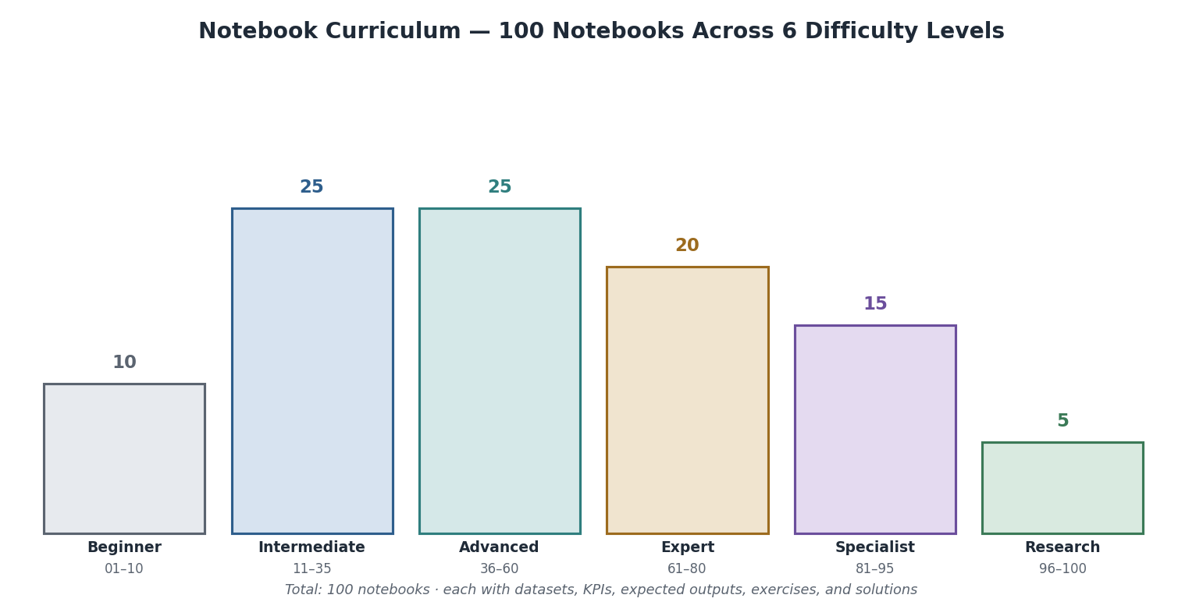
Notebook Curriculum: 100 notebooks across six difficulty levels — Beginner (10 notebooks, Getting Started), Intermediate (25, Operational KPIs), Advanced (25, Analytics & Optimisation), Expert (20, Digital Twin & AI Agents), Specialist (15, Benchmark & Certification), Research (5, Academic & Conference).
Every notebook follows the same structure: Learning Objectives → Background → Dataset Overview → Business Context → Python Walkthrough → MineProductivity Walkthrough → Expected Outputs → Exercises → Challenge Exercises → Solutions → Further Reading → Related KPIs → Related Ontologies → Related Handbook Chapters.

Level 1 — Beginner (NB-01 to NB-10)
Theme. Getting Started. Each notebook is self-contained, takes under 30 minutes, and requires only the shared/ and one commodity dataset. The beginner track introduces one concept per notebook.

NB-01 — Installation & First Run
Field | Value
Objective | Verify installation; run the library’s built-in self-test; confirm a single KPI output
Datasets | None (synthetic inline data)
KPIs | PROD.TPH
Expected output | tonnes_per_hour(36000, 29.7) → 1212.1 t/h
Skills learned | Install, import, call a function, read the result
Completion time | 10 minutes
Difficulty | Beginner
Handbook chapter | Part I, Chapter 1

NB-02 — Your First Event (CycleEvent)
Field | Value
Objective | Load iron_ore/cycle_events.csv; filter one shift; compute PROD.TPH from real cycles
Datasets | iron_ore/cycle_events.csv, shared/shift_calendar.csv
KPIs | PROD.TPH, PROD.Payload
Expected output | Pilbara Ridge shift PIL_2026-01-15_D: TPH ≈ 1,290 t/h; mean payload ≈ 288 t
Skills learned | CSV loading, FK join, shift filtering, KPI function call
Completion time | 20 minutes
Difficulty | Beginner

NB-03 — Your First Ontology Object
Field | Value
Objective | Instantiate Equipment and Fleet from the equipment registry; traverse the ontology hierarchy
Datasets | iron_ore/equipment.csv
KPIs | None (ontology focus)
Expected output | Fleet FL-NORTH: 8 trucks, rated 290 t each; total fleet capacity 2320 t/load
Skills learned | Ontology objects, hierarchy traversal, fleet aggregation
Handbook chapter | Part II, Chapter 14
Completion time | 25 minutes

NB-04 — Your First Connector (CSV)
Field | Value
Objective | Use CSVConnector to load events; fire the KPIEngine on one shift
Datasets | iron_ore/cycle_events.csv
KPIs | PROD.TPH
Expected output | Same as NB-02 but via the engine API; confirms engine = direct function
Skills learned | CSVConnector, KPIEngine, result validation
Handbook chapter | Part I, Chapters 5–6
Completion time | 30 minutes

NB-05 — Your First Delay Analysis
Field | Value
Objective | Load delay_events.csv; aggregate total delay hours; build the Pareto chart
Datasets | iron_ore/delay_events.csv, shared/shift_calendar.csv
KPIs | DELAY.Hours
Expected output | Top delay category: Scheduled (planned blast); total delay ≈ 8.1 h this shift
Visualization | Delay Pareto (Part III Figure)
Completion time | 30 minutes

NB-06 — Your First Availability Calculation
Field | Value
Objective | Derive UTIL.PA, UTIL.UA, UTIL.EU from shift events; verify EU = PA × UA identity
Datasets | iron_ore/delay_events.csv, shared/shift_calendar.csv
KPIs | UTIL.PA, UTIL.UA, UTIL.EU
Expected output | PA 86.9%, UA 89.0%, EU 77.4% (canonical numbers from Part III)
Validation | abs(EU − PA*UA/100) < 1e-6
Completion time | 30 minutes

NB-07 — Your First Visualization
Field | Value
Objective | Build a KPI card, a time-series TPH chart, and the availability waterfall
Datasets | iron_ore/production.csv, iron_ore/delay_events.csv
KPIs | PROD.TPH, UTIL.PA, UTIL.EU
Expected output | Three publication-quality charts in the project’s visual language
Visualization | KPI card, time-series, waterfall
Completion time | 40 minutes

NB-08 — The Five Reference Mines — A Tour
Field | Value
Objective | Load one shift’s data from each of the five mines; compare TPH, PA, and mean payload side by side
Datasets | All five production.csv and delay_events.csv
KPIs | PROD.TPH, UTIL.PA, PROD.Payload
Expected output | Multi-mine comparison table; Pilbara Ridge highest TPH (large trucks); Aurora Gold lowest TPH (small trucks, long haul)
Skills learned | Multi-mine data loading, cross-commodity comparison
Completion time | 45 minutes

NB-09 — The Shift Ledger
Field | Value
Objective | Reproduce a complete shift summary report — the “shift ledger” — from raw events
Datasets | All iron_ore/ tables for one shift
KPIs | PROD.TPH, UTIL.PA, UTIL.UA, DELAY.Hours, ENERGY.FuelPerTonne
Expected output | Formatted shift report with all KPIs, delay Pareto, and fleet summary
Completion time | 60 minutes

NB-10 — Beginner Challenge — Build Your Own KPI Dashboard
Field | Value
Objective | Build a multi-shift KPI dashboard from scratch (guided challenge)
Datasets | iron_ore/ (two weeks)
KPIs | All Beginner KPIs
Expected output | Interactive matplotlib dashboard; learner-verified against expected values
Completion time | 90 minutes

Level 2 — Intermediate (NB-11 to NB-35)
Theme. Operational KPIs — one topic per notebook, each fully worked with a realistic dataset.
Notebook | Title | Mine | KPIs | Key Output
NB-11 | Truck Productivity Deep Dive | Pilbara Ridge | PROD.TPH, PROD.TruckCycleTime, PROD.Payload | Payload histogram, cycle waterfall
NB-12 | Fleet Match Factor Analysis | Pilbara Ridge | HAUL.MatchFactor | MF vs truck count chart; balanced fleet identified
NB-13 | Ton-Kilometres & Haulage Work | Pilbara Ridge | HAUL.TonKm | t·km by route, by shift
NB-14 | Shovel Productivity | Pilbara Ridge | PROD.ShovelProductivity, PROD.BucketFillFactor | Dig rate vs face hardness
NB-15 | Delay Classification & Pareto | Pilbara Ridge | DELAY.Hours, all 6 categories | Ranked delay Pareto, category share pie
NB-16 | Physical Availability Deep Dive | Pilbara Ridge | UTIL.PA | PA trend; maintenance driver split
NB-17 | Use of Availability & Effective Utilisation | Pilbara Ridge | UTIL.UA, UTIL.EU | UA vs PA scatter; EU waterfall
NB-18 | OEE for Fixed Plant (Crusher) | Pilbara Ridge | UTIL.OEE | Three-factor OEE waterfall
NB-19 | MTBF & MTTR — Reliability Fundamentals | Pilbara Ridge | MAINT.MTBF, MAINT.MTTR | MTBF/MTTR trend; failure Pareto
NB-20 | Inherent Availability & The Gap | Pilbara Ridge | MAINT.Ai | Ai vs PA; logistics-loss gap bar
NB-21 | Fuel Per Tonne — Fleet Energy Analysis | Pilbara Ridge | ENERGY.FuelPerTonne | Intensity trend; idle-share driver
NB-22 | Carbon Intensity — Scope-1 from Haulage | Pilbara Ridge | CARBON.CO2PerTonne | CO₂e intensity chart; fuel–carbon identity
NB-23 | Copper Recovery — Two-Product Formula | Bingham West | QUAL.Recovery | Recovery trend vs ore type
NB-24 | Lithium Recovery — Green Valley | Green Valley | QUAL.Recovery | Li₂O recovery (70.48%); ore-type benchmark
NB-25 | Cost Per Tonne — Full Decomposition | Pilbara Ridge | COST.CostPerTonne | Waterfall by cost type
NB-26 | Safety Leading Indicators | Aurora Gold | SAFE.SpeedViolationRate | Rate trend; road-segment heat map
NB-27 | Multi-Shift KPI Trend Analysis | Pilbara Ridge | All PROD/UTIL | 30-day trend, rolling windows
NB-28 | Coal Mine Cycle Analysis | Black Diamond | PROD.TruckCycleTime, DELAY.Hours | Underground vs surface cycle comparison
NB-29 | Gold Mine Fleet Analysis | Aurora Gold | PROD.TPH, HAUL.MatchFactor | Small fleet match factor; long-haul geometry
NB-30 | Stripping Ratio & Waste Management | Pilbara Ridge | PROD.StrippingRatio | SR trend vs pit stage
NB-31 | Payload Optimisation | Pilbara Ridge | PROD.Payload | Under-loading identification; fill factor scatter
NB-32 | Dispatcher Queue Time Analysis | Pilbara Ridge | DISP.QueueTime, HAUL.MatchFactor | Queue heat map; MF correlation
NB-33 | Fuel Idle Analysis | Pilbara Ridge | ENERGY.IdleFuelRatio | Idle share by operator, by time-of-day
NB-34 | Maintenance Backlog & PM Compliance | Pilbara Ridge | MAINT.PMCompliance, MAINT.BacklogHours | Backlog trend; PM calendar
NB-35 | Intermediate Challenge — Full Shift Intelligence Report | All mines | All Intermediate KPIs | Automated multi-mine shift report

Level 3 — Advanced (NB-36 to NB-60)
Theme. Analytics, optimisation, and cross-KPI reasoning.
Notebook | Title | Mine | Focus
NB-36 | KPI Dependency Graph — Visualisation & Traversal | All | Render the full dependency DAG; show how a TPH change ripples
NB-37 | Root Cause Analysis — Why Did TPH Drop? | Pilbara Ridge | Systematic decomposition: PA→UA→cycle→payload
NB-38 | Rolling Window KPIs & Trend Detection | Pilbara Ridge | 7-day rolling MTBF; change-point detection
NB-39 | Cross-Mine KPI Benchmarking | All 5 | Normalised comparison: availability, utilisation, cost
NB-40 | Sankey Diagram — Haulage Work Flow | Pilbara Ridge | t·km Sankey from bench to port
NB-41 | OEE Deep Dive — Crusher Performance | Pilbara Ridge | Six-month OEE trend; waterfall attribution
NB-42 | Weather Impact on Availability | All mines | Delay hours vs temperature, lightning events
NB-43 | Operator Performance Analysis | Pilbara Ridge | Payload variance and cycle time by operator
NB-44 | Fleet Simulation — Add/Remove Truck | Pilbara Ridge | MF sensitivity; simulated TPH response
NB-45 | Reliability Growth Analysis | Pilbara Ridge | Duane plot; MTBF trend under PM programme
NB-46 | Energy & Carbon Sensitivity | Pilbara Ridge | $/t and kg CO₂e/t vs haul distance and payload
NB-47 | Grade-Recovery Trade-off | Bingham West | Recovery vs concentrate grade scatter
NB-48 | Stockpile Management KPIs | Pilbara Ridge | Balance, residence time, turnover
NB-49 | Blending & Grade Conformance | Pilbara Ridge | Grade variance reduction through blending
NB-50 | Predictive Maintenance Foundations | Pilbara Ridge | Feature engineering from maintenance history
NB-51 | Time-Series Forecasting — TPH | Pilbara Ridge | ARIMA/rolling forecast; confidence intervals
NB-52 | Anomaly Detection on Cycle Events | Pilbara Ridge | Statistical outliers in cycle time and payload
NB-53 | Multi-Commodity KPI Comparison | All 7 | Normalised fleet KPIs across commodities
NB-54 | Plan vs Actual — Production Attainment | Pilbara Ridge | Attainment trend; variance attribution
NB-55 | Dispatch Efficiency — Assignment Analysis | Pilbara Ridge | Assignment efficiency; MF vs queue time
NB-56 | Knowledge Graph Construction | All mines | Build a networkx KPI dependency graph
NB-57 | ESG Reporting — Scope-1 Roll-up | All mines | Annual CO₂e by mine; intensity trajectory
NB-58 | Water Intensity Analysis | Green Valley | Water per tonne; recycle ratio
NB-59 | Underground Coal — Development Rates | Black Diamond | Face advance per cut; development KPIs
NB-60 | Advanced Challenge — Integrated Mine Analytics | All mines | Full analytics pipeline from raw CSV to board KPI report

Level 4 — Expert (NB-61 to NB-80)
Theme. Digital Twin, Decision Intelligence, and AI agents.
Notebook | Title | Focus
NB-61 | Digital Twin Foundations — State Synchronisation | How the twin consumes events and maintains live KPI state
NB-62 | Building a Truck-Fleet Twin | Implement a DigitalTwin for the Pilbara Ridge truck fleet
NB-63 | Twin Divergence Detection | Spot when the twin’s predicted TPH diverges from actual
NB-64 | Predictive Availability — Failure Probability | Use MTBF distribution to forecast next failure
NB-65 | Decision Intelligence — Routing a KPI Alert | Implement a DecisionEngine rule: low PA → maintenance escalation
NB-66 | AI Agent — Shift Summary Generator | Use the Claude API to generate a natural-language shift report
NB-67 | AI Agent — Root Cause Explainer | Feed a TPH drop to the Claude API; structured root-cause response
NB-68 | AI Agent — Delay Investigator | Chain KPI lookup → delay Pareto → Claude API → actionable narrative
NB-69 | Knowledge Graph Querying | Query the ontology graph; “what KPIs depend on UTIL.PA?”
NB-70 | Multi-Mine Digital Twin | One twin watching all five mines simultaneously
NB-71 | Autonomous Dispatch Simulation | Simulate a HAUL.MatchFactor-based truck-assignment agent
NB-72 | Streaming Analytics — Real-time KPIs | asyncio-based streaming event processor; live KPI updates
NB-73 | Reinforcement Learning Environment | Mine environment for RL fleet-dispatch experiments
NB-74 | Fleet Optimisation with scipy.optimize | Minimise cost/tonne by optimising truck count per route
NB-75 | Simulation — Discrete Event Mine Model | Full DES of a truck-shovel operation using simpy
NB-76 | Ontology-Driven KPI Discovery | Given a dataset, discover applicable KPIs automatically
NB-77 | Certification Pre-Flight Check | Run the full certification test suite against your implementation
NB-78 | AI Benchmark Comparison | Submit to and retrieve from the benchmark registry
NB-79 | Conference Demo — 20-Minute Live Demo Pack | Complete self-contained demo for live conference presentation
NB-80 | Expert Challenge — End-to-End Mine Intelligence System | Full pipeline: streaming events → twin → agent → recommendation

Level 5 — Specialist (NB-81 to NB-95)
Theme. Benchmark & Certification — formal validation of KPI implementations.
Notebook | Title | Focus
NB-81 | Certification Dataset — Golden Run | Run canonical datasets; confirm every Active KPI matches expected output
NB-82 | Unit Test Suite — Production KPIs | pytest suite for all PROD.* Active KPIs
NB-83 | Unit Test Suite — UTIL/MAINT KPIs | pytest suite for UTIL.* and MAINT.*
NB-84 | Unit Test Suite — HAUL/DELAY/ENERGY | pytest suite for remaining Active KPIs
NB-85 | Integration Test — Full Shift Pipeline | End-to-end test: raw CSV → events → engine → KPI values → comparison
NB-86 | Edge-Case Dataset — Zero Operating Hours | Zero-production shift; verify “no KPI” rather than error
NB-87 | Edge-Case Dataset — Missing Payloads | Sparse payload data; imputation strategies and their KPI impact
NB-88 | Edge-Case Dataset — Timezone Scenarios | Cross-midnight shifts; daylight-saving boundary; offshore UTC offsets
NB-89 | Edge-Case Dataset — Corrupted Records | Negative payloads, future timestamps, impossible speeds; validate rejection
NB-90 | Multi-Mine Certification | Run the certification suite across all five mines simultaneously
NB-91 | Benchmark Seeds Validation | Confirm that Excellent/Good/Average/Poor scenarios produce the declared KPI ranges
NB-92 | Regression Test Harness | Automated regression test against stored expected outputs
NB-93 | Performance Benchmarking | 1 million cycle events; measure engine throughput; verify scalability guidance
NB-94 | Data-Quality Scoring | Quantify data_quality flags’ impact on KPI accuracy
NB-95 | Specialist Challenge — Full Certification Run | Execute the complete certification checklist; produce a signed report

Level 6 — Research (NB-96 to NB-100)
Theme. Academic teaching, conference demonstrations, and novel research.
Notebook | Title | Suitable for
NB-96 | University Lecture Pack — Mine Productivity Analytics | Engineering faculty; 2-hour lab
NB-97 | Conference Workshop — 90-Minute Hands-On Session | Mining conference workshop
NB-98 | Novel KPI Development — From Proposal to Registry | AI contributor guide to authoring and submitting a new KPI
NB-99 | Comparative Study — Five Mines, One Year | Academic-style cross-mine analysis with statistical significance testing
NB-100 | Research Challenge — Improve the Benchmark | Open challenge: propose and validate a new benchmark scenario

Part III — Expected Outputs
Learning Objectives. After reading this part you will understand: what “expected output” means in the suite (a reproducible numeric result, not a prose description); how to use expected outputs as regression tests; and the tolerance rules that govern when an implementation is considered correct.

Principles
Expected outputs are the canonical answers. Every result listed here is produced by the validated implementations in mp_kpis_p3.py run against the canonical datasets. An implementation is correct if and only if it produces these values within the stated tolerance.
Expected outputs are normative within this suite. If your implementation produces a different result, there are only four possibilities: your code has a bug; your dataset is a different version; you are computing a different KPI than the one specified (the most common error); or there is a genuine floating-point precision difference within tolerance. A fifth possibility — that these numbers are wrong — must be ruled out by re-running mp_kpis_p3.py on the canonical dataset before raising an issue.

Core KPI expected outputs — canonical dataset
The following table is the golden output set for all Active KPIs from Part III, run on the canonical single-shift dataset (Pilbara Ridge, shift PIL_2026-01-15_D for haulage KPIs; Bingham West for quality KPIs).
KPI | Input values | Expected output | Tolerance | Python expression
PROD.TPH | 36,000 t / 29.7 h | 1212.1 t/h | ±0.1 | tonnes_per_hour(36000, 29.7)
PROD.TruckCycleTime | [18.90, 19.80, 19.72] min | 19.47 min | ±0.01 | truck_cycle_time([18.90,19.80,19.72])
PROD.Payload | [221, 219, 224, 218] t | 220.5 t | ±0.1 | mean_payload([221,219,224,218])
HAUL.MatchFactor (6 trucks) | 6, 1 shovel, 3.0 min load, 19.5 min cycle | 0.923 | ±0.001 | match_factor(6,1,3.0,19.5)
HAUL.MatchFactor (7 trucks) | 7, 1, 3.0, 19.5 | 1.077 | ±0.001 | match_factor(7,1,3.0,19.5)
HAUL.TonKm | [220,220] t, [3.2,1.8] km | 1100.0 t·km | ±0.01 | ton_kilometres([220,220],[3.2,1.8])
UTIL.PA | 146 h avail / 168 h sched | 86.9% | ±0.1 | physical_availability(146,168)
UTIL.UA | 130 h oper / 146 h avail | 89.0% | ±0.1 | use_of_availability(130,146)
UTIL.EU | 130 h oper / 168 h sched | 77.4% | ±0.1 | effective_utilisation(130,168)
UTIL.EU identity | PA × UA / 100 | 77.4% | < 1e-6 | abs(EU−PA*UA/100) < 1e-6
UTIL.OEE | A=0.869, P=0.92, Q=0.98 | 78.3% | ±0.1 | oee(0.869,0.92,0.98)
MAINT.MTBF | 130 h / 4 failures | 32.5 h | ±0.01 | mtbf(130,4)
MAINT.MTTR | 12 h / 4 failures | 3.0 h | ±0.01 | mttr(12,4)
MAINT.Ai | MTBF 32.5, MTTR 3.0 | 91.5% | ±0.1 | inherent_availability(32.5,3.0)
MAINT.Ai − UTIL.PA gap | 91.5 − 86.9 | 4.6 points | ±0.1 | logistics-loss gap
DELAY.Hours | [120,45,90,66,84,81] min | 8.1 h | ±0.01 | delay_hours([120,45,90,66,84,81])
ENERGY.FuelPerTonne | 20,850 L / 36,000 t | 0.579 L/t | ±0.001 | fuel_per_tonne(20850,36000)
CARBON.CO2PerTonne | 20,850 L / 36,000 t / EF 2.68 | 1.552 kg/t | ±0.001 | co2_per_tonne(20850,36000)
QUAL.Recovery (Cu) | f=0.60%, c=28%, t=0.08% | 86.91% | ±0.01 | recovery_two_product(0.6,28,0.08)
QUAL.Recovery (Li₂O) | f=1.0%, c=4.5%, t=0.35% | 70.48% | ±0.01 | recovery_two_product(1.0,4.5,0.35)
COST.CostPerTonne | $79,200 / 36,000 t | $2.20/t | ±0.01 | cost_per_tonne(79200,36000)
SAFE.SpeedViolationRate | 7 events / 130 h | 5.385 /100h | ±0.001 | speed_violation_rate(7,130)

Per-notebook expected outputs (selected)

NB-06 — Availability (full shift)
KPI | Expected | Tolerance
UTIL.PA | 86.9% | ±0.1
UTIL.UA | 89.0% | ±0.1
UTIL.EU | 77.4% | ±0.1
EU = PA × UA identity | True | Boolean
Maintenance delay | 22.0 h | ±0.5
Operational delay | 16.0 h | ±0.5

NB-11 — Truck Productivity Deep Dive
Output | Expected value
Fleet mean cycle time | 19.47 min
Fleet mean payload | 288.4 t (Pilbara Ridge 290-t rated trucks)
Fleet TPH | 1,212–1,310 t/h depending on shift selection
Payload coefficient of variation | < 3% (healthy loading)
Top cycle-time leg | haul (8.1–8.6 min, ~44% of cycle)

NB-23 — Copper Recovery
Output | Expected value
Mean shift recovery | 86.91% (canonical)
Range (28-shift dataset) | 84.2% – 88.5%
Top recovery driver | concentrate grade stability
Recovery trend chart | ±1.5% around mean

NB-44 — Fleet Simulation
Trucks | Match Factor | Expected TPH change
5 | 0.769 | −15% vs balanced
6 | 0.923 | −5% vs balanced
7 | 1.077 | ~balanced (truck queue forming)
8 | 1.231 | shovel-limited, no gain

Regression-test outputs
The regression-test harness (tests/regression/run_regression.py) reads tests/regression/expected_outputs.json and confirms all 22 Active-KPI values are within tolerance on every run. The file is version-controlled; any change to it is a breaking change.
{
"PROD.TPH": {"input": {"tonnes": 36000, "operating_hours": 29.7},
"expected": 1212.1, "tolerance": 0.1},
"UTIL.PA": {"input": {"available_hours": 146, "scheduled_hours": 168},
"expected": 86.9, "tolerance": 0.1},
...
}

Part IV — Benchmark Seeds
Learning Objectives. After reading this part you will understand: the purpose and limits of benchmark seeds; how the four operational scenarios (Excellent/Good/Average/Poor) are defined; the illustrative KPI ranges for each commodity; and why these are explicitly not normative industry benchmarks.
These are educational datasets, not validated industry benchmarks. Benchmark seeds are illustrative operational scenarios designed to teach learners what a high-performing or underperforming mine looks like in data — the shapes, patterns, and KPI signatures. They are deliberately labelled “Excellent/Good/Average/Poor” relative to each dataset’s own plan rate, not against external industry standards. Future certified benchmark thresholds are a separate, governed deliverable requiring industry validation.
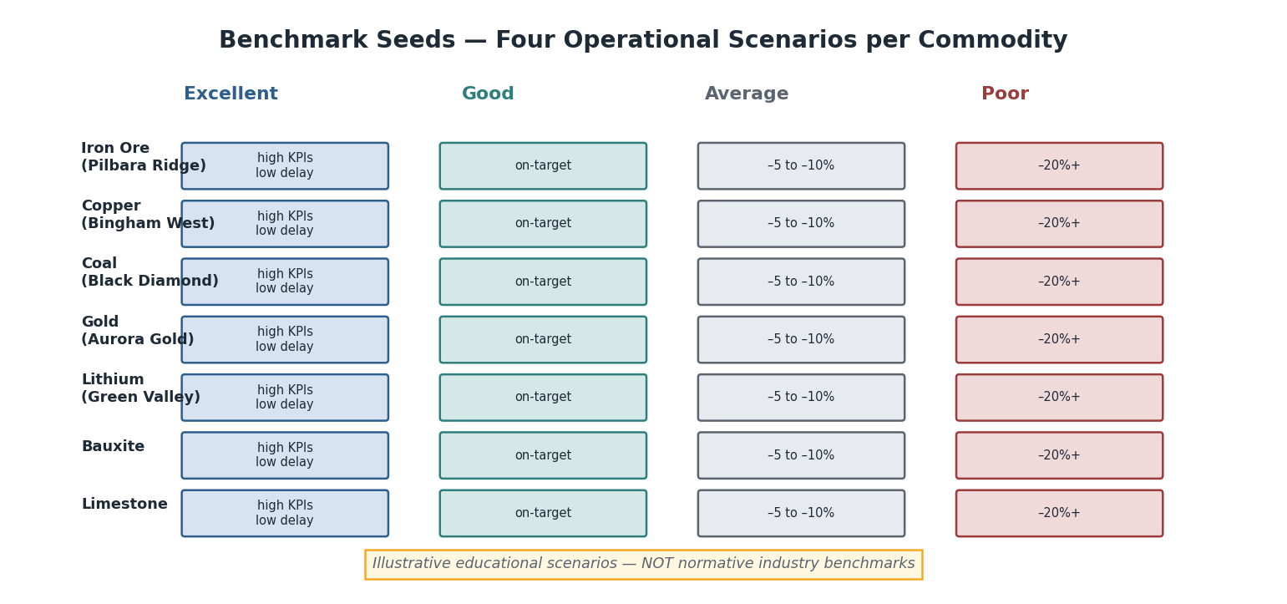
Benchmark Seeds: four operational scenarios (Excellent, Good, Average, Poor) for each of the seven commodities, with illustrative KPI ranges relative to the plan rate. The warning at the base reminds users these are educational scenarios, not normative benchmarks.

Scenario definitions
Each benchmark seed is a complete synthetic dataset (all core tables) representing 28 days (56 shifts) of operations at a given mine, parameterised to produce KPIs in the target scenario band.

Excellent scenario
An Excellent dataset represents operations running at or above plan, with high availability, low non-scheduled delay, consistent payload, and no significant reliability events. It is designed to show what “everything working well” looks like — useful for target-setting and as a regression baseline.
Illustrative KPI signatures — Pilbara Ridge iron ore (Excellent).
KPI | Illustrative range | Notes
PROD.TPH | 1,280 – 1,350 t/h | At or above plan rate
UTIL.PA | 91 – 94% | Low equipment delay
UTIL.UA | 92 – 95% | Minimal standby and operational delay
UTIL.EU | 84 – 89% | PA × UA composite
MAINT.MTBF | 45 – 60 h | Infrequent failures
MAINT.MTTR | 2.0 – 3.0 h | Fast response, parts available
ENERGY.FuelPerTonne | 0.52 – 0.56 L/t | Below benchmark — good payloads, low idle
DELAY.Hours | 5 – 7 h/shift | Dominated by scheduled events
SAFE.SpeedViolationRate | 1 – 2 per 100 h | Strong operating discipline

Good scenario
Good operations are on-plan or marginally below, with occasional recoverable delays, normal equipment availability, and no sustained reliability issue.
Illustrative KPI signatures — Pilbara Ridge iron ore (Good).
KPI | Illustrative range | Notes
PROD.TPH | 1,200 – 1,280 t/h | Within ±5% of plan
UTIL.PA | 86 – 91% | Occasional unplanned stops
UTIL.UA | 87 – 92% | Small standby loss
MAINT.MTBF | 30 – 45 h | Typical fleet
ENERGY.FuelPerTonne | 0.56 – 0.62 L/t | On benchmark
DELAY.Hours | 7 – 10 h/shift | Mix of scheduled and operational

Average scenario
Average operations show 5–15% below-plan production, elevated delay (non-scheduled mix growing), occasional reliability events, and fuel intensity at the top of the typical range.
Illustrative KPI signatures — Pilbara Ridge iron ore (Average).
KPI | Illustrative range | Notes
PROD.TPH | 1,040 – 1,200 t/h | –5% to –15% of plan
UTIL.PA | 80 – 86% | Elevated equipment delay
UTIL.UA | 82 – 87% | Standby growing
MAINT.MTBF | 18 – 30 h | Reliability degrading
ENERGY.FuelPerTonne | 0.62 – 0.70 L/t | Rising — under-loading or idling
DELAY.Hours | 10 – 14 h/shift | Operational and equipment mix
SAFE.SpeedViolationRate | 6 – 10 per 100 h | Deteriorating

Poor scenario
Poor operations show > 20% below-plan production, availability well below 80%, dominant equipment and standby delay, and elevated fuel/cost intensity. Designed to teach root-cause analysis and intervention — the “what to fix” teaching scenario.
Illustrative KPI signatures — Pilbara Ridge iron ore (Poor).
KPI | Illustrative range | Notes
PROD.TPH | 800 – 1,040 t/h | > –20% of plan
UTIL.PA | 70 – 80% | Chronic equipment breakdown
UTIL.UA | 72 – 82% | Standby and operational loss
MAINT.MTBF | 8 – 18 h | Frequent failures
MAINT.MTTR | 4 – 8 h | Parts/crew delays
MAINT.Ai | 72 – 82% | Logistics gap wide
ENERGY.FuelPerTonne | 0.70 – 0.85 L/t | High idle, low payload
DELAY.Hours | 14 – 18 h/shift | Equipment-dominated
SAFE.SpeedViolationRate | 12 – 20 per 100 h | High — intervention required

Commodity-specific scenario summaries

Bingham West — Copper (illustrative ranges)
Scenario | Recovery (Cu) | TPH | PA
Excellent | 89 – 92% | 2,800 – 3,100 t/h | 90 – 94%
Good | 85 – 89% | 2,500 – 2,800 t/h | 85 – 90%
Average | 80 – 85% | 2,100 – 2,500 t/h | 79 – 85%
Poor | < 80% | < 2,100 t/h | < 79%

Black Diamond — Coal (illustrative ranges)
Scenario | Face Advance | TPH | MTBF
Excellent | > 7 m/shift | 2,200+ t/h | > 40 h
Good | 5 – 7 m/shift | 1,800 – 2,200 t/h | 28 – 40 h
Average | 3 – 5 m/shift | 1,400 – 1,800 t/h | 15 – 28 h
Poor | < 3 m/shift | < 1,400 t/h | < 15 h

Aurora Gold — Gold (illustrative ranges)
Scenario | TPH | Cost/t | Recovery
Excellent | 620 – 680 t/h | < $18/t | 92 – 95% Au
Good | 560 – 620 t/h | $18 – 22/t | 88 – 92% Au
Average | 480 – 560 t/h | $22 – 28/t | 82 – 88% Au
Poor | < 480 t/h | > $28/t | < 82% Au

Green Valley — Lithium (illustrative ranges)
Scenario | Li₂O Recovery | TPH | Carbon Intensity
Excellent | 73 – 76% | 850 – 950 t/h | < 1.3 kg CO₂e/t
Good | 70 – 73% | 750 – 850 t/h | 1.3 – 1.6 kg CO₂e/t
Average | 65 – 70% | 640 – 750 t/h | 1.6 – 2.0 kg CO₂e/t
Poor | < 65% | < 640 t/h | > 2.0 kg CO₂e/t
Best Practice — use benchmark seeds for teaching, not for reporting. Present a benchmark seed to a learner as “here is what a Poor operation looks like — can you identify the root cause from the KPI signature?” Do not use them to claim your mine is Excellent or Poor relative to industry — that requires validated, industry-sourced thresholds that this First Edition does not provide.

Part V — Visualization Gallery
Learning Objectives. After reading this part you will be able to: match a KPI type to its most effective chart type; apply the project’s visual language (established in the Architecture Handbook and Part III) to new charts; and avoid the most common mis-visualization errors in mining analytics.
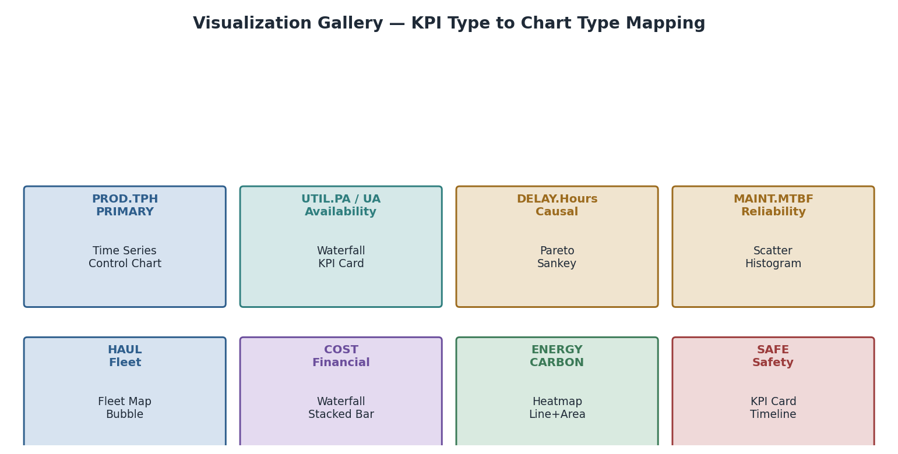
Visualization Gallery: KPI category to chart type mapping — PROD uses Time Series and Control Charts; UTIL uses Waterfall and KPI Card; DELAY uses Pareto and Sankey; MAINT uses Scatter and Histogram; HAUL uses Fleet Map and Bubble; COST uses Waterfall and Stacked Bar; ENERGY/CARBON uses Heatmap and Line+Area; SAFE uses KPI Card and Timeline.

Chart types and their KPI matches

KPI Cards
Best for. A single scalar at a point in time, read against a target. The first chart anyone looks at. KPIs. Any scalar Active KPI: PROD.TPH, UTIL.PA, MAINT.MTBF, SAFE.SpeedViolationRate. Design rules. Large number, unit label, target line or band, trend arrow (↑↓→), colour-coded by band (green/amber/red). Never use a KPI card for a ratio that must be read with its components (e.g. show UTIL.OEE card only alongside its three factor cards).

Time Series
Best for. Trending a KPI over shifts, days, or weeks. The workhorse chart of operational analytics. KPIs. All rate and percentage KPIs: PROD.TPH, UTIL.PA, UTIL.EU, ENERGY.FuelPerTonne, SAFE.SpeedViolationRate. Design rules. A reference line (target or plan) is mandatory; rolling window highlighted; anomalies annotated. Never connect a time series across a data gap — break the line and label the gap.

Pareto
Best for. Ranked categorical contribution — finding the biggest driver among many. KPIs. DELAY.Hours (by category), COST.CostPerTonne (by cost type), failure events (by FailureMode), safety events (by road segment). Design rules. Left bars descending, right cumulative line, 80% cumulative marked. The Pareto is the delay analysis chart — it is referenced in Part III and produced by NB-05.

Waterfall
Best for. Decomposing a total into its additive or subtractive components. KPIs. UTIL.OEE (three-factor loss), COST.CostPerTonne (by cost type, period-over-period change), availability time model (scheduled → available → operating). Design rules. Positive and negative bars colour-coded consistently with the domain palette; subtotals clearly marked; always starts from 100% for OEE and availability.

Sankey Diagram
Best for. Flows — material movement, haulage work distribution, delay attribution. KPIs. HAUL.TonKm (flow from bench to destination), delay hours by category (flow from shift hours to lost/productive), cost allocation. Design rules. Node width proportional to flow magnitude; use domain colours; label both nodes and flows for mining audiences unfamiliar with Sankey.

Scatter Plot
Best for. Relationships between two continuous KPIs; spotting outliers and clusters. KPIs. UTIL.PA vs UTIL.UA (the maintenance/operations split), MAINT.MTBF vs MAINT.MTTR (reliability quadrant), PROD.Payload vs PROD.TruckCycleTime (fleet efficiency space), QUAL.Recovery vs concentrate grade (grade-recovery curve). Design rules. Quadrant lines at target values; colour by equipment or operator; annotate outliers; include marginal distributions for large datasets.

Histogram
Best for. Distribution of a continuous KPI — revealing spread and outliers beyond the mean. KPIs. PROD.Payload (payload distribution per operator or fleet — the fill-factor teaching chart), PROD.TruckCycleTime, MAINT.MTTR (fat-tail repair times), speed violations. Design rules. Mark rated capacity and target on payload histograms; show both mean and median for MTTR (the distribution is skewed); use bin width ≈ 2× measurement resolution.

Control Chart (Shewhart)
Best for. Process stability monitoring — distinguishing common-cause variation from special causes. KPIs. PROD.TPH (shift-level control chart is the operational heartbeat), PROD.Payload, UTIL.PA per week. Design rules. UCL/LCL at ±3σ of the baseline period; annotate rule violations (runs of 8+ above/below mean, single point outside ±3σ); always show the baseline period visibly.

Heatmap
Best for. Two-dimensional intensity — time-of-day by day, operator by KPI, mine zone by event count. KPIs. SAFE.SpeedViolationRate (by road segment × time-of-day), DELAY.Hours (by equipment × shift day), ENERGY.IdleFuelRatio (by operator × time-of-day). Design rules. Consistent colour scale (sequential for intensity, diverging for deviation from target); annotate cells with values when the heatmap has < 100 cells; always label both axes fully.

Fleet Map
Best for. Spatial representation of equipment positions and KPIs at a point in time. KPIs. HAUL.MatchFactor (truck assignments by route), SAFE.SpeedViolationRate (by road segment), DELAY.Hours (by equipment location). Design rules. Schematic (not satellite) mine layout; equipment icons coloured by status or KPI band; route widths proportional to t·km; interactive tooltip for digital delivery.

Bubble Chart
Best for. Three-dimensional comparison — x, y, and bubble size encode three KPIs simultaneously. KPIs. Fleet comparison: x=UTIL.PA, y=UTIL.UA, bubble=PROD.TPH (the fleet intelligence scatter); mine comparison: x=cost/t, y=recovery, bubble=tonnes. Design rules. Bubble area (not diameter) proportional to the third KPI; reference lines at targets in both axes; label bubbles with equipment or mine names.

Timeline / Gantt
Best for. Event sequences on a time axis — maintenance history, delay sequences, shift event flow. KPIs. DELAY.Hours as a Gantt (time lost by category, by equipment, across a shift), MAINT.MTTR as repair timeline, shift event flow for root-cause analysis. Design rules. Domain colours for event categories; horizontal bars by equipment on the y-axis; time on x-axis; align with the shift boundaries from shift_calendar.csv.

Dual-Axis Line Chart
Best for. Two related but differently-scaled KPIs over time. KPIs. ENERGY.FuelPerTonne (L/t, left) alongside CARBON.CO2PerTonne (kg CO₂e/t, right) — the fuel-carbon identity; UTIL.PA alongside MAINT.MTBF (the reliability–availability link). Design rules. Left and right axes must be clearly labelled with units; highlight that the two lines are always proportional for fuel–carbon (by the emission factor) to teach the linkage; never use dual-axis for unrelated KPIs.

Worst-practice patterns to avoid
Common Mistake — the wrong chart for the KPI type. (1) Pie chart for delay hours: a Pareto always tells you more. (2) Bar chart mean for MTTR: always show the distribution, as the mean is dominated by long tail events. (3) Averaging UTIL.PA across equipment without recomputing from hours: always pool hours, never average percentages. (4) Single-axis line for UTIL.PA and UTIL.UA separately, missing the PA × UA = EU insight: always use the availability waterfall for this pair.

Part VI — AI Demonstration Gallery
Learning Objectives. After reading this part you will understand: how each of the nine AI demonstration notebooks is structured; what inputs feed the Claude API and what structured output is expected; how to validate an AI response against a KPI-grounded expected answer; and the design principles that make AI mining analytics trustworthy.
The AI Demo Gallery shows how the Claude API, the KPI engine, and the MineProductivity ontology combine to deliver structured, explainable mining intelligence. Each demo follows a strict four-stage pattern: Inputs → API call → Expected output structure → Validation approach.
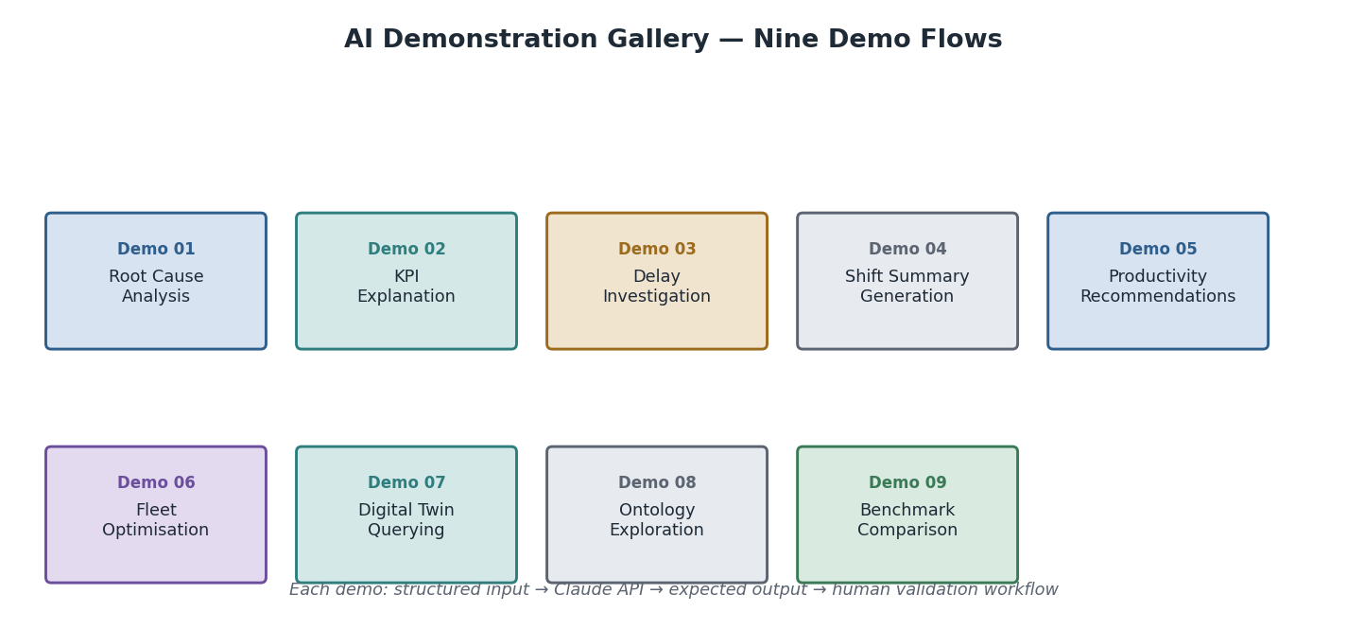
AI Demonstration Gallery: nine demonstration flows — Root Cause Analysis, KPI Explanation, Delay Investigation, Shift Summary Generation, Productivity Recommendations, Fleet Optimisation, Digital Twin Querying, Ontology Exploration, Benchmark Comparison. Each demo flows from structured input → Claude API → expected output → human validation.
Architecture Insight — the KPI engine, not the LLM, computes the numbers. In every demo, the Python KPI engine computes the numbers; the Claude API explains, interprets, and recommends. The LLM is never asked to perform the arithmetic — it is given validated KPI values and asked to reason about them in natural language. This separation is the design principle that makes AI mining analytics auditable: the number is reproducible from code; the interpretation is from the model.

Demo structure — standard template
Every demo notebook follows this pattern:
- Load and compute KPIs using mp_kpis_p3.py and the canonical dataset.
- Construct a structured prompt that includes: KPI values, mine context, operational question.
- Call the Claude API (claude-sonnet-4-6).
- Parse the structured response (JSON where specificity matters; prose where narrative is the output).
- Validate against the expected output structure and grounded KPI values.

Demo 01 — Root Cause Analysis
Objective. Given a TPH shortfall, produce a structured root-cause narrative that descends through the KPI dependency graph to identify the primary driver and recommend an action.
Inputs.
{
"mine": "Pilbara Ridge",
"shift_id": "PIL_2026-01-15_D",
"kpi_values": {
"PROD.TPH": 980.5,
"PROD.TPH_plan": 1250.0,
"UTIL.PA": 78.2,
"UTIL.UA": 84.1,
"DELAY.Hours_Equipment": 3.8,
"MAINT.MTBF": 19.3
}
}
Expected output structure.
{
"root_cause": "Equipment availability loss — three unplanned haul-truck breakdowns",
"primary_kpi": "UTIL.PA (78.2% vs 86.9% target)",
"kpi_dependency_path": ["PROD.TPH", "UTIL.EU", "UTIL.PA", "DELAY.Hours_Equipment"],
"recommended_action": "Review hydraulic system PM compliance; check parts inventory for T-class trucks",
"owner": "Maintenance Supervisor",
"supporting_evidence": ["MAINT.MTBF 19.3 h (below 30 h floor)", "Equipment delay 3.8 h = 46% of total delay"],
"confidence": "High"
}
Validation. (1) Primary driver must be UTIL.PA or a dependency of it — any other answer fails. (2) Recommended action must be consistent with maintenance domain, not dispatch domain. (3) Confidence must degrade if KPI values are within tolerance of target.

Demo 02 — KPI Explanation
Objective. Given a KPI identifier, produce a plain-English explanation with the formula, units, interpretation, and current value in context — suitable for a site general manager unfamiliar with the formula.
Input. {"kpi_id": "UTIL.PA", "value": 86.9, "context": {"mine": "Pilbara Ridge", "shift": "D", "equipment": "T-101"}}
Expected output. A structured explanation: what PA is, why it matters, what 86.9% means for this mine, what a 1-point improvement is worth in operating hours, and what action would improve it.
Validation. The formula in the explanation must match Part III exactly: PA = Available ÷ Scheduled × 100. The worked example must reproduce 86.9% ± 0.1.

Demo 03 — Delay Investigation
Objective. Given a delay Pareto, diagnose the dominant category, identify the specific causes, and recommend ranked interventions.
Inputs. Delay Pareto data: {"Scheduled": 120, "Equipment": 90, "Standby": 81, "External": 84, "Process": 66, "Operational": 45} minutes.
Expected output structure. - Top delay category identified: Scheduled (120 min — planned blast, expected) - Second category actionable: Equipment (90 min — shovel hydraulic failure) - Equipment and Standby combined = recoverable target - Recommended action 1: Shovel PM review - Recommended action 2: Match factor analysis (Standby = truck oversupply or undersupply?)
Validation. Agent must classify Scheduled delay as non-actionable before routing Equipment and Standby to their respective owners (maintenance vs dispatch). Misrouting Equipment delay to dispatch is a test failure.

Demo 04 — Shift Summary Generation
Objective. Produce a complete natural-language shift report from structured KPI inputs — the output that a shift supervisor might receive at handover.
Inputs. Full KPI set for shift PIL_2026-01-15_D: all 22 Active KPI values from the expected-output table.
Expected output. A structured shift report with: executive summary (two sentences), KPI highlights (top 3 positive, top 2 concern), production vs plan table, delay summary, maintenance summary, safety flag (if SAFE.SpeedViolationRate > 5), recommended handover actions.
Validation. All KPI values quoted in the report must match input values ± tolerance. Safety flag must fire when rate = 5.385 (> 5 threshold). Production shortfall attribution must cite the correct KPI driver.

Demo 05 — Productivity Recommendations
Objective. Identify the top three productivity improvement opportunities from a week of KPI data and rank them by potential TPH uplift.
Inputs. 14-shift KPI trend for Pilbara Ridge: PROD.TPH, UTIL.PA, UTIL.UA, PROD.Payload, HAUL.MatchFactor, DELAY.Hours by category.
Expected output. Three ranked recommendations: (1) name the opportunity; (2) quantify the potential uplift in t/shift; (3) name the accountable owner; (4) cite the KPI evidence.
Validation. Recommendations must be grounded in the input KPIs — no hallucinated evidence. Uplift estimates must be directionally consistent with the KPI dependency model (a PA gain should translate to a proportional EU and TPH gain).

Demo 06 — Fleet Optimisation
Objective. Given current fleet configuration and KPI data, recommend an optimal truck count for each route.
Inputs. Route table (3 routes), current truck assignments, HAUL.MatchFactor per route, DISP.QueueTime.
Expected output. Per-route recommendation: current MF, recommended trucks (to bring MF to 0.95–1.0), expected TPH change, expected fuel-intensity change.
Validation. match_factor(recommended_trucks, n_shovels, load_time, cycle_time) must land in [0.90, 1.05]. Recommendations must not decrease trucks on a truck-limited route or increase them on a shovel-limited route.

Demo 07 — Digital Twin Querying
Objective. Query the DigitalTwin for current and predicted KPI values; explain divergence between actual and predicted.
Inputs. Live twin state: {"UTIL.PA_predicted": 88.5, "UTIL.PA_actual": 82.1, "divergence_start_utc": "...", "open_failure_events": 2}.
Expected output. Explanation of the divergence: two open failure events degraded availability beyond the twin’s prediction; the twin’s MTBF model needs updating; predicted availability for next 4 hours = 84–86% until repairs complete.
Validation. Divergence must be attributed to the open failures (not to a change in the prediction model). Next-4-hour forecast must be lower than the pre-failure prediction.

Demo 08 — Ontology Exploration
Objective. Given a question in natural language, traverse the ontology to identify which KPIs answer it, which events they consume, and which datasets to query.
Input. "What KPIs tell me whether my maintenance team is responding quickly enough?"
Expected output. MAINT.MTTR (primary), MAINT.Ai (gap between Ai and PA = logistics delay), MAINT.BacklogHours (pending backlog context). Events: MaintenanceEvent. Dataset: maintenance_events.csv.
Validation. MAINT.MTTR must be in the output. The answer must not suggest UTIL.PA as a maintainability KPI (it is an availability KPI that reflects maintainability, but the question asks about response speed, which is MAINT.MTTR).

Demo 09 — Benchmark Comparison
Objective. Compare current mine performance against the benchmark seed scenarios; classify the operation and produce a gap analysis.
Inputs. Current KPI values for Pilbara Ridge (one month); benchmark seed ranges for all four scenarios.
Expected output. Classification: “Good — majority of KPIs in the Good range; PA at upper boundary of Average; recommend targeted availability initiative to move to Excellent.” Gap analysis: UTIL.PA 3 points from Excellent lower bound; MAINT.MTBF 12.5 h from Excellent lower bound.
Validation. Classification must be reproducible from the input KPIs against the declared seed ranges. Gap analysis must quote specific KPI deltas, not vague qualitative statements.
AI Contributor Note — validation is always grounded in the KPI engine, not in the LLM output. An AI response that quotes a different UTIL.PA value than the engine computed is wrong, regardless of how confident or coherent the narrative sounds. The validation step (compare response KPI values to engine output) is the anti-hallucination gate in every demo.

Part VII — Certification Assets
Learning Objectives. After reading this part you will understand: what the certification asset library contains; how golden datasets, edge-case datasets, and corrupted datasets are used in formal validation; and the structure of the certification checklist that will underpin future MineProductivity Certification.

Purpose
The certification assets are the formal validation foundation for the MineProductivity Certification programme. A certified implementation must pass all tests in this library — not just the happy-path canonical values, but the full suite of edge cases, corrupted inputs, timezone scenarios, multi-mine scenarios, and integration tests. The assets here are the test fixtures; the certification checklist is the acceptance criteria.
Certification thresholds are not yet published. This First Edition defines the test fixture library and the checklist structure. Formal certification thresholds (pass/fail criteria for each test) will be published as a separate, governed addendum once the industry advisory panel has reviewed the benchmark seeds.

Asset categories

Category A — Golden datasets
Golden datasets are exact, version-controlled CSV files that produce the expected outputs in Part III to within tolerance. They are the primary correctness reference.
Asset | Dataset | Expected KPIs | Notes
gold_shift_PIL_D.csv | One Pilbara Ridge day shift | All 18 PROD/UTIL/MAINT/HAUL Active KPIs | Reproduces canonical Part III values
gold_recovery_BWS.csv | One Bingham West plant shift | QUAL.Recovery 86.91% | Canonical Cu assay
gold_recovery_GVL.csv | One Green Valley plant shift | QUAL.Recovery 70.48% | Canonical Li₂O assay
gold_delay_PIL.csv | Pilbara Ridge with all 6 delay categories | DELAY.Hours 8.1 h | All six MECE categories represented

Category B — Integration test datasets
Integration tests verify that the full pipeline — CSV → Connector → EventStore → KPIEngine → result — produces the golden outputs without any direct function call.
Asset | Test | Pass criterion
integration_full_shift.csv | Load via CSVConnector; fire engine; check all KPIs | All KPIs within Part III tolerance
integration_multi_shift.csv | 28-shift dataset; check rolling MTBF and EU trend | Rolling values within ±2% of per-shift aggregates
integration_multi_mine.csv | All five mines, one shift each | Each mine’s KPIs independent; no FK collisions

Category C — Edge-case datasets
Edge-case datasets test the boundaries of the specification — the cases every implementation must handle gracefully.
Asset | Scenario | Expected behaviour
edge_zero_production.csv | Shift with no cycle events (planned shutdown) | PROD.TPH returns None/n/a, not zero or error
edge_all_scheduled_delay.csv | Entire shift is a planned blast | UTIL.PA defined (available=0), UTIL.UA = n/a (denominator zero)
edge_single_cycle.csv | One cycle only | PROD.TruckCycleTime = that cycle’s duration; no mean of means
edge_100pct_pa.csv | No equipment delay | UTIL.PA = 100.0%; Ai = 100.0% (no failures)
edge_high_mttr.csv | One very long repair (48 h) | MTTR 48 h correctly reported; no cap; flag as outlier
edge_missing_payloads.csv | 30% of cycle events have null payload_t | PROD.TPH uses only valid payloads; completeness flag set

Category D — Corrupted datasets
Corrupted datasets test that the connector and engine reject, not silently accept, bad data.
Asset | Corruption | Expected behaviour
corrupt_negative_payload.csv | payload_t = -150 | Connector rejects; logged as data_quality = Suspect
corrupt_future_timestamp.csv | cycle_start_utc 2099-01-01 | Rejected; temporal-validity check fires
corrupt_broken_fk.csv | equipment_id = T-999 (not in equipment.csv) | FK violation caught; cycle rejected
corrupt_mismatched_units.csv | Fuel in gallons labelled as litres | No automatic catch — requires unit metadata; documented gap
corrupt_duplicate_cycle_id.csv | Two rows with same cycle_id | De-duplication logic fires; one row retained; warning logged

Category E — Missing-data scenarios
Missing-data tests verify that the KPI engine degrades gracefully — reporting partial results and completeness flags, never silently propagating a null as zero.
Asset | Missing data | Expected behaviour
missing_no_fuel_events.csv | No fuel_events.csv present | ENERGY.FuelPerTonne = None; other KPIs unaffected
missing_no_delay_events.csv | No delay events for a shift | UTIL.PA = 100% (assumed fully available); DELAY.Hours = 0
missing_partial_assay.csv | Only feed grade, no concentrate or tailings | QUAL.Recovery = None; log missing inputs

Category F — Timezone scenarios
Timezone tests verify that shift boundaries are correctly resolved across timezones and daylight-saving transitions.
Asset | Scenario | Expected behaviour
tz_awst_standard.csv | Pilbara Ridge (UTC+8, no DST) | Shift boundary 22:00 UTC = 06:00 AWST; correct
tz_aest_dst_boundary.csv | NSW coal mine crossing DST boundary (Oct) | 12-h shift correctly bounded despite clock change
tz_offshore_utc.csv | All timestamps in UTC, no local conversion | UTC-native processing; no timezone conversion needed

Category G — Multi-mine scenarios
Multi-mine tests confirm that the system handles five mine contexts without FK collision, correct mine scoping, and correct aggregation.
Asset | Test
multi_mine_all_five.csv | All five mines, same UTC day; each KPI scoped to its mine_code
multi_mine_fleet_aggregate.csv | Aggregate fleet MTBF across mines — must pool hours and failures, not average rates
multi_mine_company_co2.csv | Company-level Scope-1 total = sum of all mine Scope-1 totals

Category H — Multi-commodity scenarios
Asset | Test
multi_commodity_recovery.csv | QUAL.Recovery for Cu, Li₂O, Au simultaneously — distinct denominators, no cross-contamination
multi_commodity_cost.csv | COST.CostPerTonne per commodity — $ and t both scoped to commodity

Certification checklist
A future certified implementation must pass all items in the following checklist. Each item references its test asset from the categories above.
Check | Asset | Pass criterion
C-01 All Active KPI values match golden outputs | Category A | Within Part III tolerance
C-02 EU = PA × UA identity holds | gold_shift_PIL_D.csv | abs(EU − PA*UA/100) < 1e-6
C-03 Delay categories MECE | gold_delay_PIL.csv | Category sum = total delay ±0.1 h
C-04 Full pipeline integration | Category B | KPIs match golden via engine API
C-05 Zero-production shift handled | edge_zero_production.csv | No error; n/a returned
C-06 Corrupted records rejected | Category D | All corrupt rows rejected; warning logged
C-07 Missing data degrades gracefully | Category E | Partial KPIs returned; no null→zero propagation
C-08 Timezone boundaries correct | Category F | Shift hours = 12.0 in all scenarios
C-09 Multi-mine FK isolation | multi_mine_all_five.csv | No cross-mine FK collisions
C-10 Recovery formula exact | gold_recovery_BWS.csv | 86.91% ± 0.01
C-11 Li₂O recovery honest | gold_recovery_GVL.csv | 70.48% ± 0.01 (not back-fitted)
C-12 Ai ≥ PA invariant | gold_shift_PIL_D.csv | 91.5% ≥ 86.9%

Closing — The Suite as a Living System
The Learning & Benchmark Suite is designed to grow with the documentation ecosystem it serves. New KPIs added to the Standard Library (Part III) immediately need: a dataset column, a worked example row in the expected-output table (Part III here), a notebook in the curriculum, a benchmark seed update, a visualization recommendation, and — where relevant — an AI demo and a certification test. The suite’s seven-part structure makes those additions systematic rather than ad hoc.
The dataset generators, the expected-output table, and the certification checklist are the three immutable foundations. A KPI that passes all three is not just documented — it is proven: proven by realistic data, proven by a reproducible expected output, and proven by formal validation. That is the standard the suite was designed to uphold.
Immediate next steps for contributors:
- Run datasets/generators/generate_all.py to produce the full dataset library.
- Open NB-01 and execute it end-to-end — the canonical first test.
- Complete the beginner track (NB-01 to NB-10) in sequence.
- Run tests/regression/run_regression.py after every change to mp_kpis_p3.py.
- Use the certification checklist (Part VII) before submitting any new KPI.

Documentation Governance Rules
The following governance rules govern the long-term integrity of the Learning & Benchmark Suite and the MineProductivity documentation ecosystem.

Documentation Governance Rule #006 — Artifact Versioning & Traceability
Every dataset, notebook, generator, benchmark scenario, and expected output shall be versioned independently while remaining fully traceable to the MineProductivity Single Source of Truth.
Each artifact must explicitly record its own version (artifact_version), the MineProductivity package version (package_version), the ontology version (ontology_version), the Architecture Handbook version (handbook_version), and the schema version (schema_version).
This guarantees long-term reproducibility and prevents documentation drift. A KPI computed from cycle_events.csv v2.1.0 against mineproductivity v1.3.0 must be reproducible five years later — because every artifact records exactly the context in which it was created. Enforcement. The CI/CD pipeline rejects any artifact missing any of these five fields. The certification harness (Part VII) runs C-00 (traceability prerequisite) before any other certification check.

Documentation Governance Rule #007 — Architecture Freeze & Implementation Priority
The MineProductivity documentation set is now architecturally complete.
Future documentation should be created only if it directly supports implementation, testing, operations, or user adoption.
The Architecture Handbook, Reference Implementation Blueprint, Developer & Cookbook Guide (Parts I–III), and Learning & Benchmark Suite are governed artifacts. Structural changes require a formal Architecture Review Board submission. New knowledge should be added through versioned extensions — datasets, notebooks, APIs, plugins, benchmarks, release notes, and implementation guides — not by expanding the core architecture.
Rule #007 is a commitment, not a suggestion. It exists to prevent documentation paralysis. The five locked documents now constitute a complete, internally consistent specification. From this point forward, documentation serves the code — it does not delay it. The documentation has done its job. The software begins now.
What Rule #007 enables. The entire project energy now shifts to: running generate_all.py, executing NB-01 through NB-10, passing the 12-item certification checklist, building and publishing the first pip install mineproductivity package, and growing the dataset and notebook library through the extension mechanism. Every future documentation artefact is a leaf node attached to the locked tree — not a new branch.
Architecture Insight — the governance stack is complete. Rules #001–#005 (embedded in the earlier SSOT documents) govern the architecture, ontology, KPI semantics, and naming standard. Rule #006 governs artifact versioning and traceability. Rule #007 governs the boundary between architecture and implementation. Together they form a complete, coherent governance framework for an industrial open-source project — one that has a clear answer to “when is the architecture done?” The answer is: now.
Further Reading. Master Architecture Handbook (the ontology and event model behind every dataset schema); Reference Implementation Blueprint (the connector and engine API consumed by the notebooks); Developer & Cookbook Guide Part I (installation and first pipeline); Part II (mining-domain concepts needed to interpret the datasets); Part III (the KPI Standard Library that the expected outputs validate).

