**PISA TEST PRACTICE DOCUMENTATION**

**By Imanol González – January 24th 2023**

**Note: The project is made in Spanish**

The PISA test practice was a project part of the subject TC1028 Computational Thinking for Engineering and it was made by the following people:

* Imanol Armando González Solís (me)
* José Miguel Guerrero Jiménez
* Gustavo Adrián Alanis Elizondo
* Emilio Castillo De la Garza

We developed a program that works as a practice resource for the [PISA](https://www.oecd.org/pisa/test/) test. To achieve that goal we used the Tkinter and pillow libraries from python to make a graphic interface in which the user can practice taking multiple-choice exams where their performance in various subjects is graded.

Below are some screenshots of the program:

Main menu / Selection menu of the topic to practice

Questions in the “Comprensión Lectora” Section

Score window

**CODE EXPLANATION**

Creation of the window using Tkinter Library

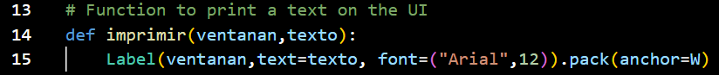

Function that we use to print in the interface easily

Window that appears when selecting one of the 3 main options, for this particular case the “Lectura” one. Then for adding the Scrollbar we created a canvas where all the elements of the window are displayed

Questions for each section



Code found in each section that evaluates the score obtained, displays it in a popup window, and closes the respective section window

Find the complete project at

<https://github.com/imanolgzz/Project-Portfolio/tree/main/Python/pisaTestPractice>

Note: you need to install the Tkinter and Pillow libraries to run the program