Week # 01
Day # 02

Code

<!DOCTYPE html>
<html lang="en">
<head>
<meta charset="UTF-8">
<meta name="viewport" content="width=device-width, initial-scale=1.0">
<title>Iman's Page</title>
</head>
<body>
<header>
<h1>
Iman Sagheer
</h1>
</header>
<nav>
<a href="#">About</a>
<a href="#">Home</a>
<a href="#">Contact</a>
</nav>
<main>
<section>
<h2>About me</h2>
<p>Hii, I am Iman Sagheer. I am currently in 7th semester of BS Computer Science at Superior University. I am from Lahore and enjoy working on new technologies. I am excited to learn new practical skills. </p>
</section>
</main>

<img src="https://images.unsplash.com/vector-1749532960847-0321e8e5c2c7?w=600&auto=format&fit=crop&q=60&ixlib=rb-4.1.0&ixid=M3wxMjA3fDB8MHxzZWFyY2h8M3x8Z2lybHxlbnwwfHwwfHx8MA%3D%3D" alt="My image" width="300" height="300">
<footer>
<p>
Iman Sagheer | GrowthLift intern 2026
</p>
</footer>
</body>
</html>

Live Server

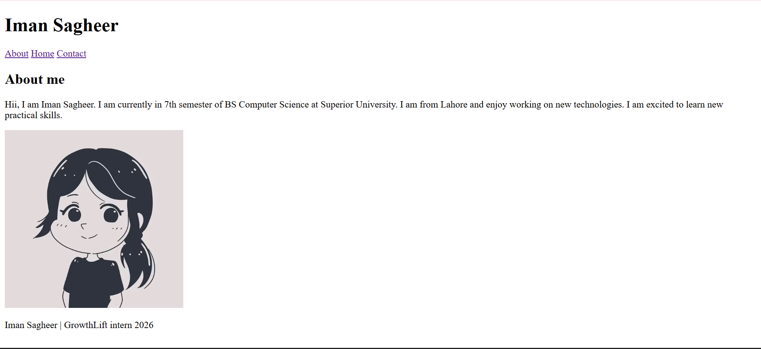

Git add.
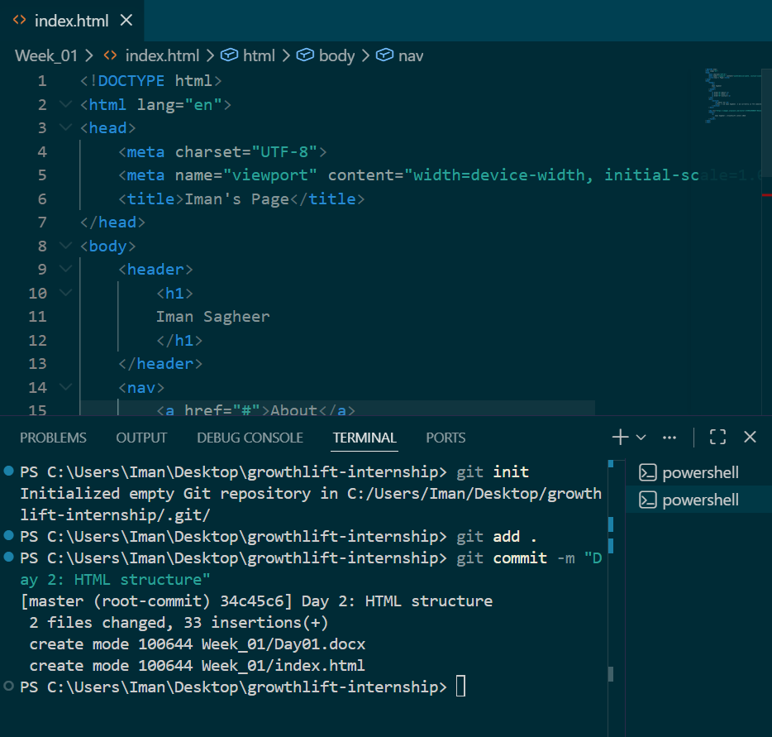

W3C HTML Validator

