Week # 01
Day # 01
VS Code Installation
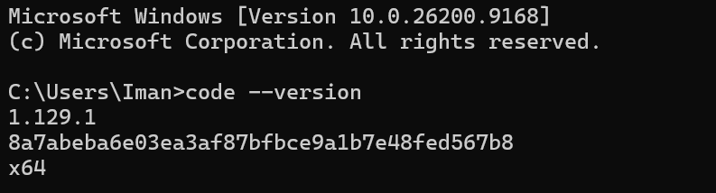

VS Code Extensions
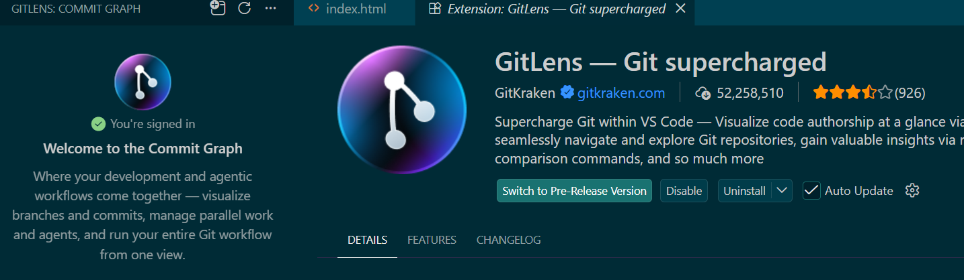

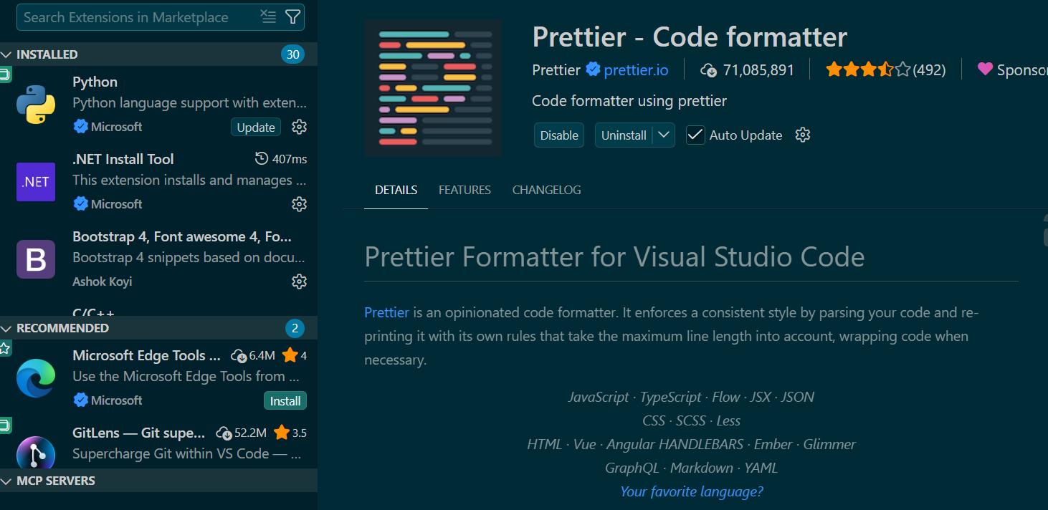

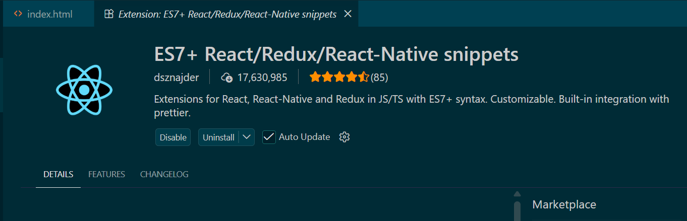

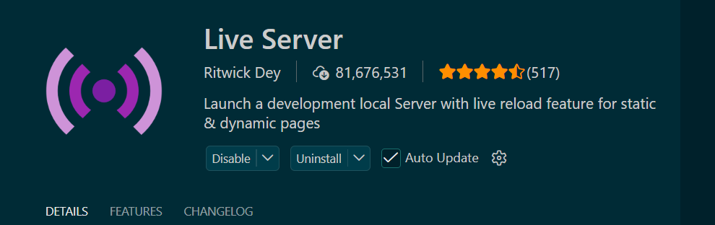

Git Installation
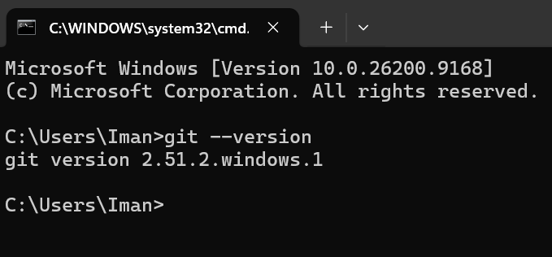

GitHub Account Setup
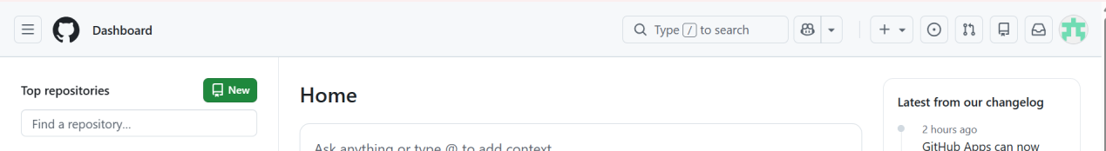

Cursor AI Installation
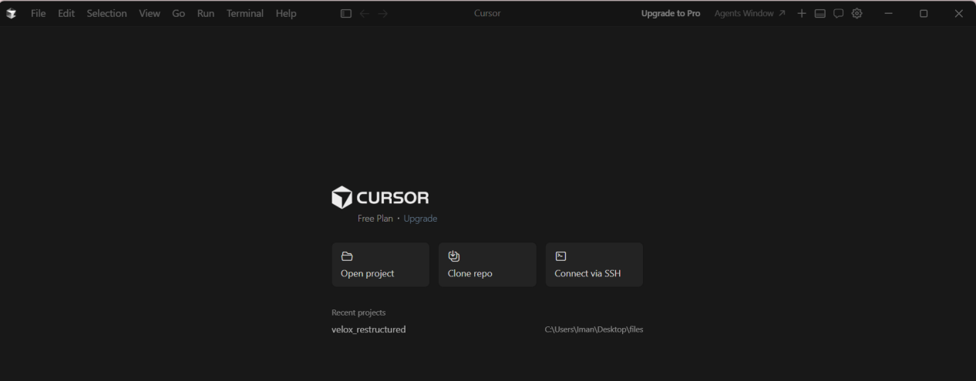

Node.js LTS Installation
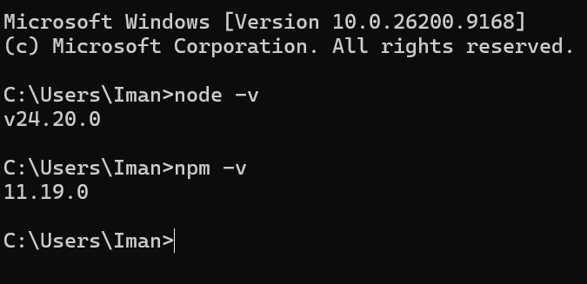

Project Folder & index.html
