Dissertation Front Sheet


Explainable Dynamic Graph Neural Network SIEM for Software-Defined IoT using Edge AI and Federated Learning

Not applicable

Arka Talukder
B01821011

Thesis Project for the partial fulfilment
of the requirements for the Master Degree
in Cyber Security

University of the West of Scotland
School of Computing, Engineering and Physical Sciences
23 April 2026

Declaration of Originality


DECLARATION OF ORIGINALITY

I declare that this is an original study based on my own
work and that I have not submitted it for any other
course or degree.

Signature_______________________

Library Release Form



Library Form to Accompany MSc Project

  - To be completed in full

Surname:

First Name: Initials:

Banner No:

Course Code:

Course Title:

Project Supervisor:

Project Title:

Session: Date of Submission:

Signature:

Please ensure that a copy of this form is included with your project before submission.

Table of Contents

List of Figures

List of Tables

Explainable Dynamic Graph Neural Network SIEM for Software-Defined IoT using Edge AI and Federated Learning
Arka Talukder | B01821011
MSc Cyber Security (Full-time)
University of the West of Scotland
School of Computing, Engineering and Physical Sciences
Supervisor: Dr. Raja Ujjan

1. Abstract
Internet of Things (IoT) deployments produce large flow telemetry that Security Operations Centres (SOCs) must triage on CPU-only edge infrastructure. Detectors should be accurate, privacy-aware, and explainable, so analysts can act on alerts without extra investigation delay.
This dissertation develops an end-to-end prototype on CICIoT2023 (Pinto et al. 2023). Flows are standardised, grouped into windows, converted into kNN similarity graphs, and classified by a dynamic GNN (GAT + GRU) built with PyTorch Geometric. The same architecture is trained centrally and with Flower FedAvg across three non-IID clients (Dirichlet alpha = 0.5). Explainability combines Captum Integrated Gradients and GAT attention, and results are served as ECS-like JSON through a FastAPI endpoint.
Results. On the held-out test split, central and federated GNN runs achieve F1 = 100% and ROC-AUC = 100% with zero false positives, while Random Forest and MLP achieve F1 = 99.86% and 99.42%. Mean CPU inference is about 23 ms per five-window sequence, and federated communication is about 31 MB over ten rounds. Ablation, sensitivity, and multi-seed checks support these findings.
Keywords: IoT security, dynamic graph neural network, federated learning, SIEM, explainable AI, edge AI, SOC, CICIoT2023

Acknowledgements
I thank my supervisor, Dr. Raja Ujjan, for technical guidance, feedback on design and evaluation, and support throughout the project. I thank my moderator, Muhsin Hassanu, for reviewing interim work and helping sharpen the final report. I also thank Dr. Daune West for support and academic encouragement during the submission period. I am grateful to School and programme staff for module materials and submission guidance, and to the MSc Project co-ordinator for administrative communication around milestones and ethics. Finally, I thank friends and family for patience during intensive writing and experiment runs.

List of Abbreviations
Abbrev. | Definition
API | Application Programming Interface
AUC | Area Under the (ROC) Curve
CPU | Central Processing Unit
ECS | Elastic Common Schema (log/alert shape used as a guide)
FedAvg | Federated Averaging (McMahan et al. 2017)
FL | Federated Learning
FN | False Negative
FP | False Positive
FPR | False Positive Rate
GAT | Graph Attention Network
GNN | Graph Neural Network
GRU | Gated Recurrent Unit
IG | Integrated Gradients
IoT | Internet of Things
IID | Independent and Identically Distributed (data split)
JSON | JavaScript Object Notation
kNN | k-Nearest Neighbours (graph construction)
MLP | Multi-Layer Perceptron
non-IID | Non-identical client data distributions
PyG | PyTorch Geometric
ROC | Receiver Operating Characteristic
SDN | Software-Defined Networking
SIEM | Security Information and Event Management
SOC | Security Operations Centre
TN | True Negative
TP | True Positive
UML | Unified Modelling Language
XAI | Explainable Artificial Intelligence

Chapter 1 – Introduction

1.1 Chapter Overview
This chapter introduces the project context, IoT flow telemetry, SOC alert volume, and practical limits at CPU-based edge nodes. It explains why this work combines dynamic graph learning, federated training, and explainable alerts in one pipeline, then states the research aim, sub-questions, scope, and chapter structure so later chapters can focus on method, implementation, and evidence.

1.2 Background and Motivation
The Internet of Things (IoT) has expanded very fast in homes, offices, campuses, and industrial sites. Smart plugs, cameras, sensors, and controllers are now everywhere. Many of these devices are low-cost and constrained, and security is often secondary during design. As a result, weak credentials, late patching, and misconfiguration are still common in real deployments.
This means attack exposure remains high. A compromised IoT device can be used for botnet activity, service disruption, credential theft, or lateral movement into wider infrastructure. These are not rare scenarios in security reports. Because of this, continuous monitoring of network behaviour is needed, not optional, especially in environments with mixed old and new devices.
Software-defined approaches (including SDN and software-defined IoT) allow operators to observe flow statistics from switches and routers in a centralised way. Flow summaries are often enough for intrusion detection without full packet capture, which reduces storage pressure and can ease some privacy concerns. The remaining challenge is to analyse those flows accurately, to explain decisions in a form analysts can use, and to do so on hardware that is realistic at the edge (often CPU-only).
Security Operations Centres (SOCs) monitor networks, investigate alerts, and coordinate incident response, usually with SIEM platforms that aggregate logs and flow-derived events. A practical difficulty is alert fatigue: high volumes of alerts and many false positives reduce the time analysts can spend on genuine incidents. Alerts that only give a label, with no indication of why the model fired, slow triage further. There is therefore a need for detectors that are both accurate and explainable, so staff can trust and act on outputs under time pressure.
Traditional models such as Random Forests or feed-forward networks can work on tabular flow features, yet traffic also has relational structure: flows resemble neighbours in feature space, share endpoints when identifiers exist, or arrive in short bursts that carry meaning together. Graph models treat flows as nodes and connect related flows with edges (here, kNN links in feature space because the public CICIoT2023 release does not provide device-level topology). Dynamic GNNs extend this idea by learning how graph snapshots evolve over short windows. Separately, IoT data are often distributed across sites where pooling raw flows is legally or politically difficult; federated learning trains one shared model while keeping raw data local. Many IoT gateways also cannot assume a GPU on every segment, so a CPU pipeline that returns SIEM-friendly JSON is closer to a deployable outcome than a GPU-only laboratory score.

1.3 Research Aim and Questions
This project aims to design and build a reproducible prototype for IoT attack detection using software-defined flow data, dynamic graph learning, federated training, and practical explanation outputs for SOC triage. The work focuses on feasibility under realistic constraints, especially CPU execution and non-IID federated partitions, while keeping the pipeline understandable for security operations usage.
The main research question is:
How can an explainable dynamic graph neural network, trained using federated learning, detect attacks in Software-Defined IoT flow data and generate SIEM alerts that support SOC operations on CPU-based edge devices?
To support this, the following sub-questions are addressed:
- Does a dynamic graph model perform better than simple models like Random Forest and MLP?
- Can federated learning maintain similar performance without sharing raw data?
- Can the model generate useful explanations for SOC alert triage?
Contributions (in this dissertation):
- An end-to-end, CPU-oriented prototype that turns flow telemetry into kNN similarity graphs, trains a dynamic GNN (GAT + GRU), and outputs SIEM-shaped JSON alerts.
- A centralised vs. federated comparison using the same architecture under Flower FedAvg with non-IID client partitions.
- An explainability path that combines Integrated Gradients (feature attribution) with GAT attention (flow and structure cues), supported by ablation, sensitivity, and multi-seed evidence.
- A submission-ready reproducibility trail through configuration, scripts, chapter mappings, and appendix artefacts.
The work uses CICIoT2023 so choices and metrics can be compared with prior studies while still fitting an MSc time-box and resource budget.

1.3.1 Objectives
To answer the research questions above, the project pursues the following concrete objectives. Each objective is a deliverable artefact that is referenced again in Chapters 4–8 for evidence:
- Literature objective. Conduct a critical review of IoT intrusion detection, graph and dynamic GNN methods, federated learning, and explainable AI for security, and identify the gap that this project fills (Chapter 2).
- Dataset objective. Select a manageable subset of CICIoT2023 with both benign and attack traffic, fix train/validation/test splits, and document preprocessing (Sections 4.3 and 6.3).
- Modelling objective. Implement two flow-level baselines (Random Forest, MLP) and one dynamic GNN (GAT + GRU) on identical splits for a controlled comparison (Sections 4.4 and 6.5).
- Federated objective. Train the same GNN with Flower FedAvg across three non-IID clients for ten rounds, and evaluate the global checkpoint on the central test set (Sections 4.5, 6.6 and 8.3).
- Explainability objective. Combine Captum Integrated Gradients with GAT attention to produce per-alert top features and top flows (Sections 4.6, 6.7 and 8.6).
- SIEM objective. Serve the model through a FastAPI endpoint that returns ECS-like JSON alerts and report CPU inference latency (Sections 6.8, 6.9 and 8.5).
- Evaluation objective. Define metrics, run ablation, sensitivity, and multi-seed checks, and report results with figures and tables (Chapters 7 and 8).
- Reflection and write-up objective. Document the work in a final report aligned with the UWS guideline and MSc Project Handbook including a critical self-evaluation (Chapters 9 and 10).

1.4 Scope and Limitations
The project uses CICIoT2023 (Pinto et al. 2023) on a manageable subset within a 45-day MSc window. The public release includes 46 flow-level features but not reliable device topology fields for full host graph construction. Because of that, this implementation uses flow nodes with kNN feature-similarity edges and a GAT+GRU model stack, as justified in Section 2.5 and specified in Section 5.3.
The scope includes Random Forest and MLP baselines, Flower FedAvg federation, Captum explainability, and FastAPI ECS-like alerts. The scope does not include production SIEM integration, formal SOC user studies, or large multi-organisation federation. Technical implementation detail is intentionally concentrated in Chapters 4 to 7 to avoid repeated text.
Limits (summary): no production SIEM deployment, no formal SOC user study, CPU-only training and inference, three federated clients, and ten rounds in the reported federated run. Headline metrics are subset-specific and discussed honestly in Chapter 9. Contingency decisions, such as reduced data and reduced rounds if required, follow the risk treatment in Chapter 3. Reproduction uses the repository, config/experiment.yaml, and execution notes in Chapter 13.

1.5 Dissertation Structure
The chapter order follows the UWS MSc final-report pattern and the Updated Guideline for Final Report. It includes front matter, technical body chapters, references, and appendices in the expected sequence, but all content remains specific to this project topic and evidence.
Chapter 2 reviews literature critically, with the extended comparative subsection in Section 2.10 to cover fifteen to twenty core sources. Chapter 3 records timeline, risks, and ethics process. Chapter 4 defines research design and methodology. Chapter 5 specifies pipeline and graph design. Chapter 6 documents implementation modules and integration points. Chapter 7 defines testing protocol and metric formulae. Chapter 8 reports results as evidence, with minimal interpretation. Chapter 9 provides discussion, conclusions, and recommendations linked to the research questions. Chapter 10 provides first-person critical self-evaluation. Chapters 11 and 12 contain references and bibliography. Chapter 13 contains appendices including process records, specification, reproducibility material, and handbook code-figure evidence.

1.6 Alignment with the Marking Criteria in the Project Specification
The dissertation is organised against the marking criteria and weightings recorded in the agreed Project Specification (Appendix B). That is the same grid you committed to in formally submitted progress work: Introduction 5%; Context / Literature Review 20%; Research Design 20%; Implementation (Practical Work) 25%; Evaluation 5%; Presentation of Results 5%; Conclusions and Recommendations 10%; Critical Self-Evaluation 10% (total 100%).
The chapter mapping is:
Criterion (weight) | Where it is addressed in this dissertation
Introduction (5%) | Chapter 1 - aim, questions, scope, structure
Literature (20%) | Chapter 2 - critical review, comparison table, figures, gap
Research design (20%) | Chapters 4–5 - methodology, dataset, graph and system design
Implementation (25%) | Chapter 6 - build, modules, tooling, reproducibility
Evaluation (5%) | Chapter 7 - protocol, metrics, setup
Results presentation (5%) | Chapter 8 - tables and figures, minimal interpretation
Conclusions & recommendations (10%) | Chapter 9 - answers to questions, implications, limits, future work
Critical self-evaluation (10%) | Chapter 10 - reflection on process and learning

1.7 Chapter Summary
Chapter 1 framed the SOC and IoT problem context, stated the research questions, and defined scope and boundaries, mapping the report to the marking criteria in Section 1.6. Chapter 2 next reviews the literature.

Chapter 2 – Literature Review

2.1 Chapter Overview
This chapter reviews prior work on IoT intrusion detection, SOC/SIEM alerting needs, graph and dynamic GNN methods, federated learning, and explainable AI in security. The aim is clear. I need to show what other studies did well, what they did not cover, and how that leads to the design choices in this dissertation. Dataset counts, split statistics, and configuration details are kept for the methodology and evaluation chapters (Section 7.6 and Section 6.2) so this chapter stays analytical, not a second methods section.
The literature is grouped by theme so each block ties to the research questions in Section 1.3. Section 2.3 covers IoT threat context and CICIoT2023; Section 2.4 covers SIEM/SOC workflows and alert quality; Sections 2.5 and 2.6 cover graph and dynamic GNN ideas and federated learning; Section 2.7 covers explainability in ML-based security; Sections 2.8 to 2.10 cover the gap, CyBOK mapping, extended comparison, and summary. Technical numbers and experiment design are left to later chapters so this review does not duplicate methodology.
2.2 Themes and structure

2.3 IoT Security and the Need for Detection
IoT devices are now common in many sectors, but they are often built with cost and convenience in mind rather than security. Researchers have pointed out that many devices use default credentials, have unpatched software, and lack strong encryption (Kolias et al. 2017). When these devices are compromised, they can be used in botnets, for data exfiltration, or as a stepping stone into the rest of the network. So, detecting malicious behaviour in IoT traffic is an important part of modern security operations.
The scale of the IoT threat is well known. Kolias et al. (2017) looked at the Mirai botnet. It used weak Telnet passwords on millions of IoT devices to launch large DDoS attacks. Such incidents show that IoT networks need continuous monitoring and automated detection. Manual inspection is not possible at scale. IoT devices vary a lot (cameras, thermostats, industrial controllers). So attack surfaces vary widely. Detection systems must work with different traffic patterns and protocols. SDN and Software-Defined IoT add another layer. Central controllers can collect flow statistics from switches and routers. But the amount of data and the need for real-time analysis require efficient detection methods that can run at the edge.
Intrusion detection for IoT can be done in different ways. Signature-based methods look for known attack patterns. Anomaly-based methods learn what is normal and flag the rest. Machine learning has been used a lot for attack detection on flow or packet data. The CICIoT2023 dataset used in this project was made to support such research. It includes attacks like DDoS, reconnaissance, and brute force from real IoT devices in a controlled environment (Pinto et al. 2023). The dataset has 46 pre-computed flow features from packet captures. This reduces the need for raw packet inspection. It also matches the kind of data that SIEM systems usually use. Pinto et al. (2023) describe how the data was collected. Traffic was captured from real IoT devices (smart plugs, cameras, doorbells) under controlled attack scenarios. Flow features were extracted using standard tools. The features include protocol indicators (TCP, UDP, ICMP, HTTP, DNS), packet and byte statistics, TCP flag counts, and statistics like mean, variance, and standard deviation. Using a public dataset lets results be compared with other work. But the setting is still lab-based, not a live network. Yang et al. (2025) recently showed that graph neural networks can improve intrusion detection for industrial IoT. They showed that modelling network structure can improve accuracy compared to flat feature models. The CICIoT2023 dataset has a class imbalance (about 97.8% attack, 2.2% benign at the flow level). This makes training harder. This project deals with it through stratified windowing and balanced graph construction.
Many studies treat each flow or packet on its own. But in reality, attacks often show up as patterns of communication between devices over time. For example, a DDoS attack may involve many flows from many sources to one target. A reconnaissance scan may show sequential probing of ports. Flat feature vectors lose this structure. Wang et al. (2025) did a scoping review. They found that graph-based approaches to network traffic analysis are used more and more. Dynamic graph models in particular look promising for capturing attack patterns that change over time. Zhong et al. (2024) surveyed graph neural networks for intrusion detection. They found a clear trend towards combining GNNs with temporal models. They also noted that explainability and federated deployment are still under-explored. These findings support the graph-based and dynamic approach in this project. A key gap in the literature is that there are few prototypes that combine graph-based detection, federated learning, and explainable alerting in one system for SOC use. Most papers focus on only one of these. Figure 1 summarises the main categories of intrusion detection approaches relevant to IoT and this project.
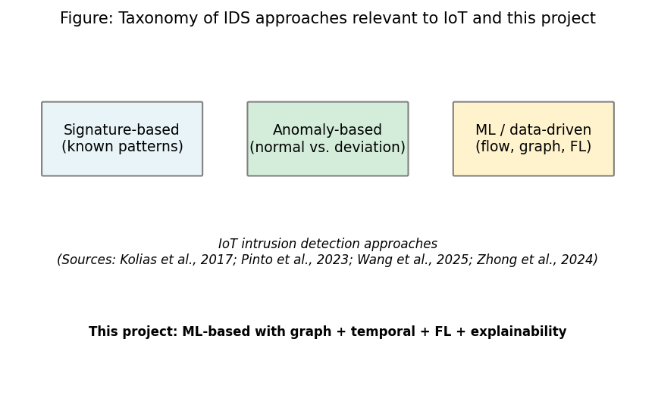
Figure 1: Taxonomy of IDS approaches relevant to IoT and this project (Chapter 2, Section 2.3)
Sources: Kolias et al. (2017); Pinto et al. (2023); Wang et al. (2025); Zhong et al. (2024). Full references in Chapter 11.

2.4 SIEM, SOC Workflows, and Alert Quality
SOC teams use SIEM and related tools to collect logs and flow data and to generate alerts. A well-known problem is alert fatigue. Too many alerts and too many false positives make it hard for analysts to focus on real threats (Cuppens and Miège 2002). If an alert does not explain why it was raised, triage becomes slower and more guesswork. Cuppens and Miège (2002) proposed alert correlation to reduce noise by grouping related alerts. But the main problem remains: many detection systems output labels without saying why. This is still relevant today.
The Elastic Common Schema (ECS) gives a standard structure for security events. It includes fields for event type, outcome, source, destination, and custom extensions. Using ECS-like output makes it easier to integrate with Elastic Security, Splunk, and other SIEM platforms. This project uses an ECS-like structure for the alert JSON. So the output can be used in existing SOC tools with little change.
Modern SIEM platforms like Splunk, Elastic Security, and Microsoft Sentinel support custom rules and machine learning models. But the use of explainable AI in alert workflows is still developing. When a model flags traffic as malicious, analysts need to know which features or events led to that decision. This helps them prioritise and avoid wasting time on false positives. Without explanations, analysts may ignore alerts (increasing risk) or over-investigate (reducing efficiency).
There is growing interest in making security tools more explainable. For example, some work has focused on explaining which features led to a detection (e.g. Lundberg and Lee, 2017, on SHAP). In a SOC context, explanations that point to specific flows, devices, or time windows can help analysts decide quickly whether to escalate. This project does this by producing SIEM-style alerts with top features and flows attached. So the output is not only a label but something an analyst can act on. The ECS-like JSON format works with common SIEM tools.

2.5 Graph Neural Networks and Dynamic Graphs
Graph neural networks (GNNs) work on data that has a graph structure: nodes and edges. In network security, nodes can be hosts or devices and edges can be flows or connections. GNNs combine information from neighbours and can learn patterns that depend on the graph structure. The main idea is that message passing (where each node updates based on its neighbours) lets the model capture relationships that flat classifiers cannot. Graph Attention Networks (GATs) go further. They let each node give different importance to its neighbours using attention (Velickovic et al. 2018). This helps the model focus on the most relevant connections. That is useful when some flows are benign and others are part of an attack. Han et al. (2025) proposed DIMK-GCN for intrusion detection. They showed that multi-scale graph representations can capture both local and global attack patterns. Ngo et al. (2025) looked at attribute-based graph construction for IoT intrusion detection. They showed that building graphs from feature similarity (not just network topology) can work when device IDs are not available. This supports the kNN-based graph construction in this project. When IP addresses or device IDs are absent (as in the public CICIoT2023 release), topology-based graphs cannot be built. So attribute-based or similarity-based construction is the only option.
Networks change over time. New connections appear, traffic volumes shift, and attacks develop in stages. Dynamic or temporal graph models try to capture this. One common approach is to combine a GNN with a recurrent module (e.g. GRU or LSTM). The model sees a sequence of graph snapshots and learns from how the graph evolves. Several papers have used this for fraud detection or anomaly detection (e.g. Zheng et al., 2019). Lusa et al. (2025) proposed TE-G-SAGE for network intrusion detection. It combines temporal edge features with GraphSAGE. They showed that both edge-level and temporal information improve accuracy. Basak et al. (2025) developed X-GANet for network intrusion detection. They confirmed that attention-based GNNs can get high accuracy and also give interpretable outputs. For IoT flow data, building time-windowed graphs and using a dynamic GNN (GAT + GRU in this project) is a reasonable way to test whether structure and temporality improve detection over simple models like Random Forest or MLP. The literature supports the idea that graph structure can add value. But the actual gain depends on the data and task. That is why this project compares the dynamic GNN to baselines. GNNs also cost more to run than tabular models. The trade-off between accuracy and inference time matters for edge deployment. This project evaluates it. The combination of GAT (for learning which neighbours matter) and GRU (for learning how the graph evolves) is a common pattern in temporal graph learning. This project applies it to IoT flow data with kNN graph construction. This has not been explored much in prior work. Figure 2 illustrates the conceptual flow: graph snapshots over time are processed by the GAT, then the sequence of graph representations is fed to a GRU for temporal modelling before the final prediction.
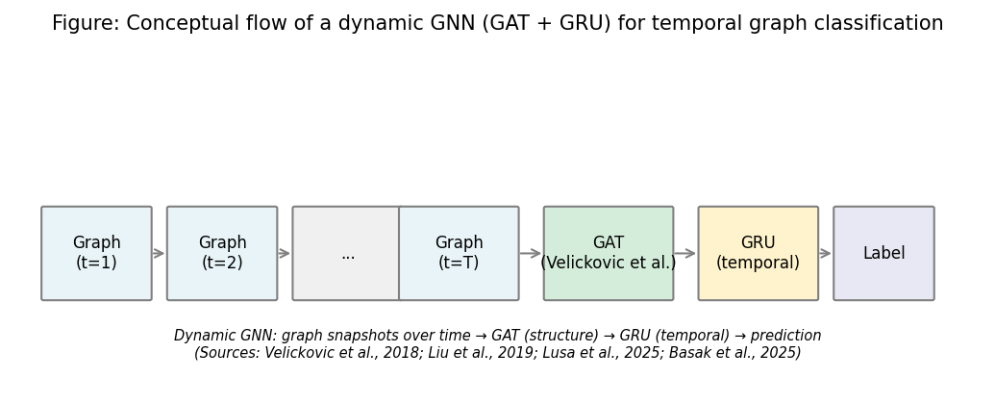
Figure 2: Conceptual flow of a dynamic GNN (GAT + GRU) for temporal graph classification (Chapter 2, Section 2.5)
Sources: Velickovic et al. (2018); Zheng et al. (2019); Lusa et al. (2025); Basak et al. (2025). Full references in Chapter 11.

2.6 Federated Learning and Privacy
Federated learning trains a model across many clients without putting raw data in one place. Each client trains on local data and sends only model updates (gradients or weights) to a server. The server combines them and sends back an updated model. FedAvg (McMahan et al. 2017) is a standard algorithm. The server averages the client model parameters, often weighted by how much local data each client has. This reduces privacy risk compared to sending raw IoT traffic to a central site. That matters when data comes from different organisations or locations. In IoT and edge deployments, data may be spread across many sites (different buildings, campuses, or organisations). Rules like GDPR may not allow centralising sensitive network data. Federated learning also reduces the bandwidth needed for training. Instead of transferring raw flows (which can be large), only model parameters (usually a few megabytes) are sent. So federated learning works well for bandwidth-limited edge networks. Figure 3 shows the FedAvg flow: clients train locally and send model updates to the server; the server aggregates and broadcasts the global model back.
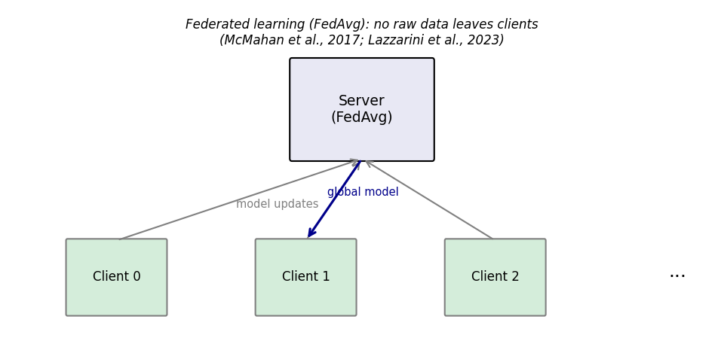
Figure 3: Federated learning (FedAvg) flow - no raw data leaves clients (Chapter 2, Section 2.6)
Sources: McMahan et al. (2017); Lazzarini et al. (2023). Full references in Chapter 11.
Federated learning has been used in IoT and fog-edge settings (e.g. Qu et al., 2020). Lazzarini et al. (2023) looked at federated learning for IoT intrusion detection. They found that FedAvg can get performance similar to centralised training while keeping data local. Albanbay et al. (2025) did a performance study on federated intrusion detection in IoT. They showed that non-IID data across clients is a key factor for convergence and accuracy. When clients have different attack types or different mixes of benign and malicious traffic, the global model must learn from mixed updates. FedAvg can still converge, but the number of rounds and aggregation strategy matter. Challenges include communication cost, non-IID data, and possible drops in accuracy compared to centralised training. In this project, Flower is used to implement FedAvg with three clients and a Dirichlet-based non-IID data split. The goal is to show that federated training can get performance close to centralised training. The evaluation includes communication cost and round-by-round performance. Flower was chosen because it works well with PyTorch and supports custom client and server logic.

2.7 Explainability in ML-Based Security
Explainability can be added to a system in different ways. Post-hoc methods explain a trained model. They show which inputs or features mattered most for a prediction. Integrated Gradients is a gradient-based method. It attributes the prediction to input features relative to a baseline (Sundararajan et al. 2017). It has useful properties like sensitivity and implementation invariance. It is implemented in Captum (Kokhlikyan et al. 2020), which works with PyTorch. For GNNs, attention weights from GAT layers can also show which edges or neighbours the model focused on. This project uses both: Integrated Gradients for feature-level explanation and attention for flow-level importance. So the alert can include both which features (e.g. packet rate, flag counts) and which flows contributed most to the prediction. Figure 4 summarises the explainability pipeline used in this project for SOC-oriented alerts.
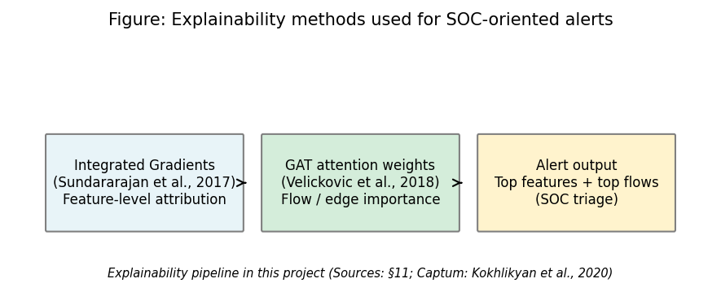
Figure 4: Explainability methods used for SOC-oriented alerts (Chapter 2, Section 2.7)
Sources: Sundararajan et al. (2017); Velickovic et al. (2018); Kokhlikyan et al. (2020). Full references in Chapter 11.
Alabbadi and Bajaber (2025) showed that explainable AI (XAI) can be used for intrusion detection over IoT data streams. They confirmed that post-hoc explanation methods can make security decisions more transparent for analysts. Lundberg and Lee (2017) introduced SHAP for model interpretation. SHAP can be applied to any model. But Integrated Gradients is often preferred for neural networks because it is gradient-based and works well with backpropagation. One practical point: full explainability for every prediction can be slow. Integrated Gradients needs many forward passes (usually 50–100) to approximate the integral. For a GNN processing sequences of graphs, this can add a lot of latency. So the design allows applying explainability only to selected alerts (e.g. high-confidence positives) if needed. The literature does not always address this trade-off. This project notes it as a limitation and a possible area for future work.
What is still missing in the XAI pillar is stronger reporting on explanation latency versus analyst value in operational settings. Papers describe methods, but fewer report whether the explanation payload helps real triage within strict timing constraints at the edge.
Table 1 and Figure 5 summarise how selected related work maps onto the four pillars of this project (GNN/graph-based detection, federated learning, explainability, and SIEM-style alert output). All sources are given in the References (Chapter 11). No single prior study combines all four in one prototype for SOC use on edge devices; this project fills that gap.
Table 1: Comparison of selected related work (sources: Chapter 11)
Study | GNN/Graph | Federated learning | Explainability | SIEM/Alert | Dataset/context
Pinto et al. (2023) | - | - | - | - | CICIoT2023 dataset
Velickovic et al. (2018) | Yes (GAT) | - | - | - | General GNN
McMahan et al. (2017) | - | Yes (FedAvg) | - | - | General FL
Sundararajan et al. (2017) | - | - | Yes (IG) | - | Attribution method
Han et al. (2025) | Yes (DIMK-GCN) | - | - | - | IDS
Ngo et al. (2025) | Yes (attribute-based) | - | - | - | IoT IDS
Basak et al. (2025) | Yes (X-GANet) | - | Yes | - | NID
Lusa et al. (2025) | Yes (TE-G-SAGE) | - | Yes | - | NID
Lazzarini et al. (2023) | - | Yes | - | - | IoT IDS
Albanbay et al. (2025) | - | Yes | - | - | IoT IDS
Alabbadi and Bajaber (2025) | - | - | Yes (XAI) | - | IoT streams
Yang et al. (2025) | Yes | - | - | - | Industrial IoT
This project | Yes (GAT+GRU) | Yes (Flower) | Yes (IG+attention) | Yes (ECS-like) | CICIoT2023
Source: Author compilation from the papers cited in Chapter 11; table is descriptive only.
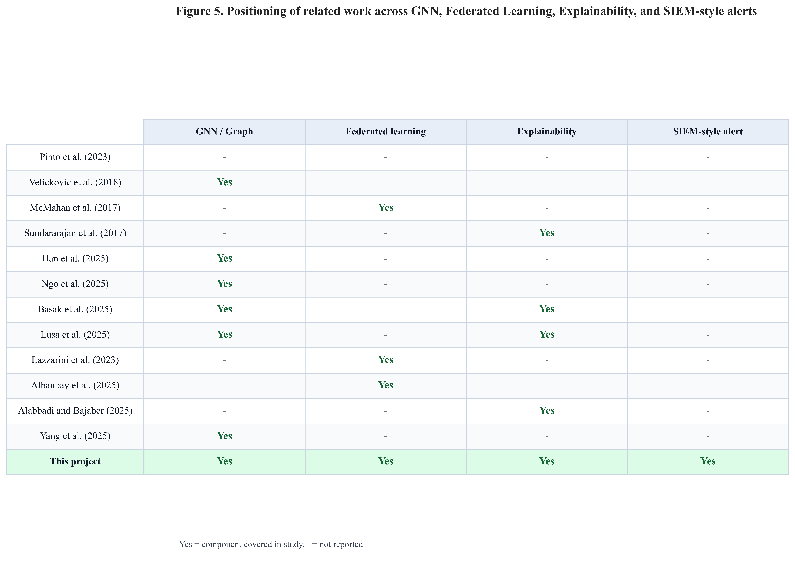
Figure 5: Positioning of related work - GNN, federated learning, explainability, and SIEM-style alerts (Chapter 2, Section 2.7)
Sources: Pinto et al. (2023); Velickovic et al. (2018); McMahan et al. (2017); Sundararajan et al. (2017); Han et al. (2025); Ngo et al. (2025); Basak et al. (2025); Lusa et al. (2025); Lazzarini et al. (2023); Albanbay et al. (2025); Alabbadi and Bajaber (2025); Yang et al. (2025). This figure synthesises Chapter 2 and supports the gap stated in Section 2.8.

2.8 Gap and Contribution
Existing work covers IoT intrusion detection, GNNs, federated learning, and explainability separately. Yang et al. (2025) and Han et al. (2025) focus on GNN architectures for detection but do not add federated learning or SIEM output. Lazzarini et al. (2023) and Albanbay et al. (2025) study federated learning for IoT intrusion detection but do not combine it with dynamic graphs or explainable alerts. Alabbadi and Bajaber (2025) and Basak et al. (2025) study explainability in centralised settings only. This project fills the gap with a small but complete prototype combining (1) kNN graph construction from IoT flow data, (2) a GAT+GRU dynamic GNN, (3) FedAvg via Flower, (4) Captum and attention explanations, and (5) ECS-like JSON alerts, evaluated against RF and MLP baselines on the same CICIoT2023 subset.

2.9 Mapping to CyBOK (Cyber Security Body of Knowledge)
The agreed project specification (Appendix B) records this work against CyBOK knowledge areas. The dissertation aligns with the following topics in particular: Attacks & Defences → Security Operations & Incident Management (SIEM-style alerting, SOC triage, and intrusion detection outputs); Infrastructure Security → Network Security (flow-based analysis and IoT traffic classification); Systems Security → Distributed Systems Security (federated learning without centralising raw client data); and Software and Platform Security → Software Security (engineering of the prototype pipeline, APIs, and reproducible scripts). Together, these areas situate the project within the School’s CyBOK mapping and match the specification’s indicative coverage.

2.10 Extended Comparative Review (Fifteen to Twenty Core Sources)
The programme guideline asks for fifteen to twenty significant papers in the literature review. Earlier sections already developed themes with primary citations. This subsection groups additional comparisons so the breadth requirement is explicit: (1) temporal graphs and anomalies - Zheng et al. (2019) show attention-based temporal GCNs for dynamic graphs; that line of work motivates stacking a sequence learner (here, a GRU) on top of graph snapshots rather than treating each window alone. (2) Federated and fog settings - Qu et al. (2020) discuss decentralised privacy patterns in fog computing; the present work does not use blockchain, but the paper helps position why edge sites may refuse raw data pooling. (3) Surveys and scoping reviews - Zhong et al. (2024) and Wang et al. (2025) summarise how GNNs are used in intrusion detection and where explainability and deployment gaps remain. (4) SHAP vs. gradient methods - Lundberg and Lee (2017) describe SHAP values; this project uses Integrated Gradients (Sundararajan et al. 2017) and GAT attention because they fit the PyTorch + Captum stack, but SHAP remains a valid alternative for tree or tabular baselines. (5) IoT threat context - Kolias et al. (2017) document Mirai-style botnets, which explains why flow-level DDoS patterns appear heavily in IoT benchmarks. (6) Alert operations - Cuppens and Miège (2002) give early alert-correlation ideas that sit under modern SIEM practice even though formats have moved toward JSON and ECS-like fields.

2.11 Chapter Summary
The literature supports dynamic GNNs, federated learning, and XAI for intrusion detection, but rarely all three together with SIEM-oriented outputs for edge SOC workflows. Table 1 and Figure 5 make that gap visible by pillar. The next chapters turn from what others did to what this project built: fixed dataset handling, kNN temporal graphs, the GAT+GRU stack, Flower FedAvg, Captum, and FastAPI-delivered ECS-like alerts.

Chapter 3 – Project Management

3.1 Chapter Overview
This chapter documents the project process: planning and milestones, risk management, ethics posture (public dataset, no human participants), and how interim feedback was incorporated. It supports transparency of execution without duplicating the technical content presented in Chapters 4–7.

3.2 Project Plan and Timeline (45-day MSc)
Work was staged in six phases: (1) freeze requirements and literature; (2) fix the CICIoT2023 subset and preprocessing; (3) implement graph construction and central GNN training; (4) run baselines and Flower-based federated training; (5) add explainability, alert JSON, and FastAPI; (6) run ablation, sensitivity, multi-seed experiments, figures, and final writing. Each phase had concrete artefacts (metrics files, checkpoints, plots) to reduce ambiguity about “done.” Figure 6 shows the schedule as a Gantt chart with overlapping phase bars, which is more representative of real research execution than strictly sequential blocks.
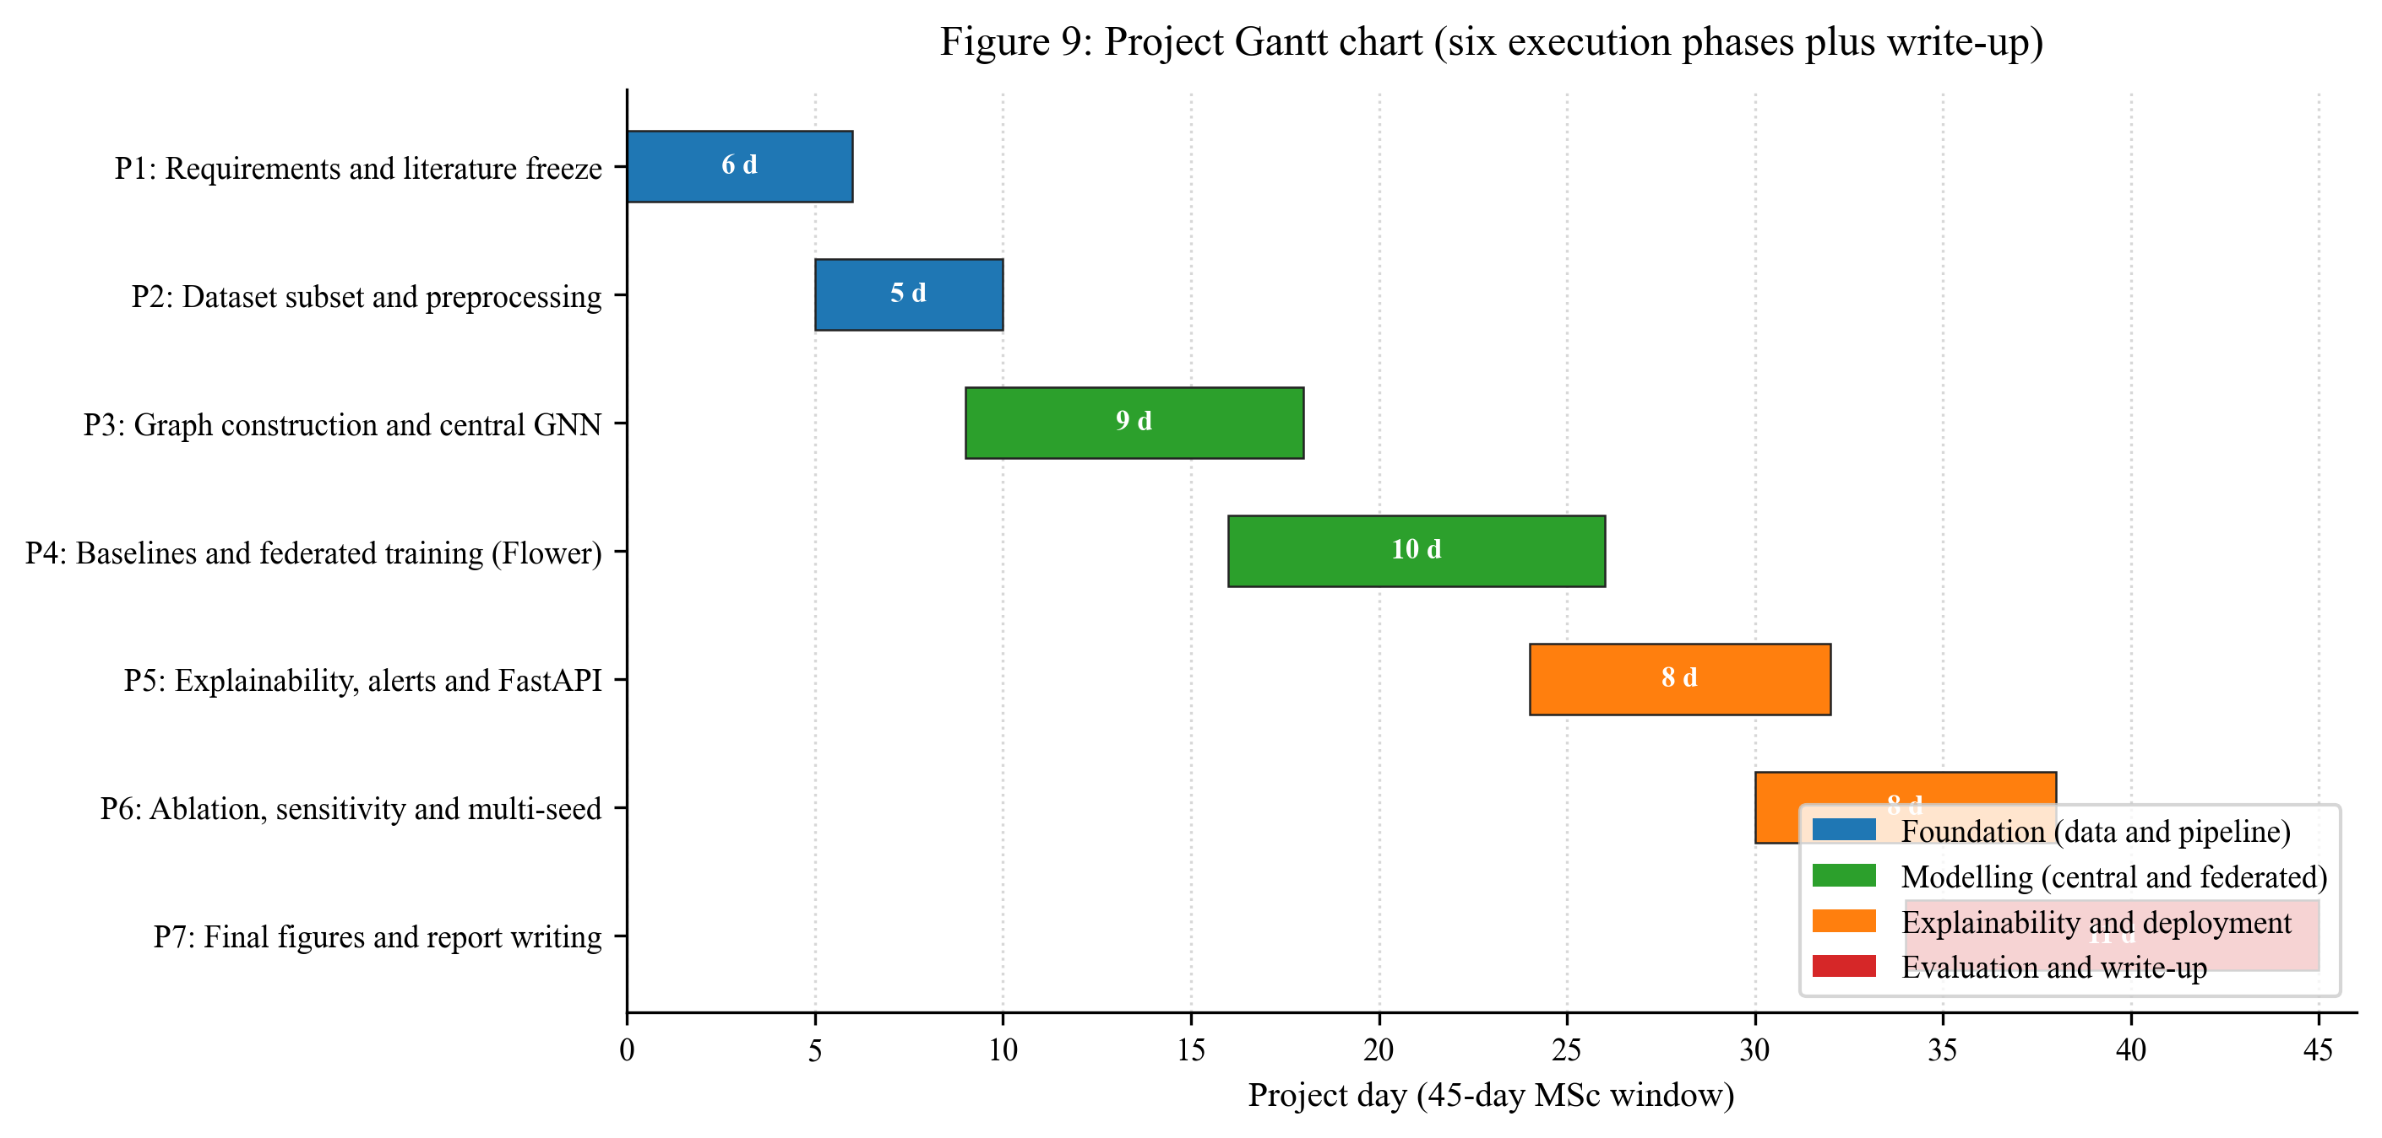
Figure 6: Project Gantt chart - six execution phases plus write-up across the 45-day MSc window (Chapter 3, Section 3.2)
Source: Author’s own diagram (scripts/generate_gantt_chart.py).

3.3 Risk Assessment
Risk | Mitigation
Training too slow on CPU | Fixed subset; configurable rounds/clients; early stopping
Severe class imbalance | Stratified windowing; class weights; balanced graph-level labels
Federated instability | Three clients; reproducible split; checkpoints each round
Explainability runtime | Top-k attributions; optional subset of alerts
Scope creep (extra models) | Baselines limited to RF and MLP; one main GNN architecture

3.4 Monitoring and Progress Reviews
Progress was monitored on a weekly cadence with the supervisor and against the phase plan in Section 3.2. At each weekly meeting the agenda followed the same three points: (1) what was completed since the last meeting and which artefact in the repository proves it; (2) what is in progress and any blocker that needs supervisor input; (3) what is planned for the next week and which phase boundary it serves. Decisions and action items were captured in the project process documentation that is referenced in Appendix A so that activity is traceable beyond memory.

3.5 Ethics and Data
Only public CICIoT2023 data is used; there are no human participants or proprietary organisational datasets. The signed specification ethics section records supervisor confirmation that the project does not require full ethics-review board approval under School procedures (February 2026), which matches the use of non-sensitive public data only. Process and ethics paperwork are referenced in Appendix A/B as required by the handbook.

3.6 Interim Report Feedback Incorporated
The MSc Project Handbook requires that feedback on the interim report (written and verbal from supervisor and moderator) be taken into account in the final submission. After interim submission, feedback reinforced: (1) keeping the end-to-end story visible (data → model → federation → explainability → SOC-shaped output), not only literature; (2) tightening the evaluation plan before reporting numbers; (3) being explicit about limits of a lab subset and very high test metrics; and (4) reserving effort for final analysis and write-up rather than scope creep.
Actions taken in the final dissertation include: completing the full evaluation and results chapters (7–8) with tables and figures promised at interim; adding ablation, sensitivity, and multi-seed checks so result stability is evidenced (going beyond the interim contingency of dropping sensitivity if time ran short); strengthening critical reflection (Chapter 10) on methodology, federation, and the “100% metrics” question; and documenting reproducibility (Chapter 13). Any remaining suggestions from the interim review are acknowledged as limitations and future work in Chapter 9.

3.7 Chapter Summary
Transparent time-boxing and risk controls kept the project feasible while still delivering graph, federated, explainable, and deployable components.

Chapter 4 – Research Design and Methodology

4.1 Chapter Overview
This chapter sets out the methodology used to answer the research questions: research approach, dataset and split rationale, model selection (RF, MLP, dynamic GNN), federated learning setup, explainability plan, and evaluation plan. Design-level pipeline overview, graph semantics, and system architecture are specified in Chapter 5 (including Figures 7–9), implementation details in Chapter 6, and metric definitions in Section 7.5 to avoid repetition across the report.

4.2 Research Approach
The project is practical. The aim is to build a working prototype and evaluate it with clear metrics. The main research question is answered by building the system, comparing the dynamic GNN to baselines, testing federated learning, and checking whether the explanations help SOC triage. Sub-questions are answered through experiments and by looking at example alerts.
The methodology follows a design-science approach. A prototype is built and evaluated with quantitative metrics (precision, recall, F1, ROC-AUC, inference time, communication cost) and qualitative assessment (interpretability of example alerts). The choice of CICIoT2023, kNN graphs, GAT+GRU, Flower, and Captum is justified by the literature and by practical constraints (dataset availability, 45-day timeline, CPU-only deployment). The evaluation plan is defined before experiments are run. So results can be interpreted objectively.

4.3 Dataset and Subset
The CICIoT2023 dataset (Pinto et al. 2023) is used. It has network flow data from IoT devices under various attacks (DDoS, DoS, reconnaissance, brute force, spoofing). The full dataset is large (millions of flows). So a manageable subset is selected to fit the 45-day timeline. The subset includes both benign and attack traffic and a spread of attack types. The same subset is used for all experiments so results are comparable. Data is split into fixed train, validation, and test sets (e.g. 70% train, 15% validation, 15% test, with no overlap). This avoids data leakage and allows fair comparison between centralised and federated training.
CICIoT2023 provides 46 numeric flow features (rates, counts, protocol indicators, TCP flag statistics, etc. - see Pinto et al., 2023). The exact column list used in code is config/experiment.yaml. Features are standardised on train statistics only, then applied to validation and test. Binary labels (benign vs. attack) are used. The subset keeps both classes present; the test split is held out for final reporting only.
Pinto et al. (2023) describe how CICIoT2023 was captured in a controlled IoT testbed with benign activity and many attack scenarios, then released with per-flow features suitable for real-time detection benchmarks. This dissertation does not re-collect traffic; it uses that public release so that preprocessing, splits, and models can be checked by others.

4.3.1 Where the Data Lives (repository Layout)
Raw CICIoT2023 files are large and are not committed to Git. In a local checkout, raw CSV (or unpacked archive) is expected under a path such as data/raw/ (see README.md in the repository). After preprocessing, train / validation / test parquet splits and metrics live under data/processed/ and results/ respectively. The dissertation numbers (tables and figures) were produced from one frozen subset and the scripts named in Chapter 13; if another researcher downloads the full public dataset, they must run the same preprocessing script to reproduce the exact row counts.

4.4 Models
Three types of models are used so that the value of the graph and temporal structure can be assessed.
- Random Forest: A baseline on tabular flow-level data: each training/test instance is one processed flow (the same 46 standardised features as in the graph pipeline), with no graph structure. Implemented via scikit-learn on the train/test parquet splits (src/models/baselines.py).
- MLP (Multi-Layer Perceptron): The same flow-level representation as Random Forest - a feed-forward network on 46-dimensional rows without graph or temporal modelling (MLPBaseline in src/models/baselines.py).
- Dynamic GNN (GAT + GRU): The main model. Graph Attention layers process each graph snapshot; a GRU (or similar RNN) then processes the sequence of graph representations over time. The output is used for attack vs. benign (or multi-class) prediction. This model uses both structure and temporality. The GAT allows the model to weight neighbours differently, and the GRU captures how the graph representation changes across the sequence.
All models are trained to predict attack (or attack type) from the available features and, for the GNN, from the graph and its evolution. Hyperparameters (e.g. learning rate, number of layers, hidden size) are chosen with the validation set; the test set is used only for final reporting. The same train/validation/test splits are used for all models to ensure fair comparison.

4.5 Federated Learning Setup
FedAvg (McMahan et al. 2017): clients train locally and send weights; the server averages and broadcasts the global model - no raw flows cross sites (Section 2.6). This project uses Flower with three clients, ten rounds, and two local epochs per round (timelines and risks: Chapter 3; wiring: Section 6.6). The same GNN architecture is trained centrally and federally for a fair comparison. Communication cost is estimated from serialized float32 parameter traffic (Chapter 8).
Non-IID simulation: training rows are partitioned across clients with a Dirichlet distribution over class proportions (alpha = 0.5) so client label mixes differ (stronger than IID sharding; weaker than adversarial splits). Rationale: reflect sites with different exposure while staying trainable within the MSc budget.

4.6 Explainability
Two forms of explanation are used:
- Integrated Gradients (Captum): Applied to the chosen model (e.g. the dynamic GNN or the MLP) to attribute the prediction to input features. The top contributing features are extracted and included in the alert.
- Attention weights: For the GAT-based model, attention weights over edges or neighbours are used to identify which flows or connections the model focused on. These can be summarised as “top flows” or “top edges” in the alert.
Explanations are produced for selected predictions (e.g. positive alerts). The top-k (k=5) features and flows are included in each alert to keep the explanation concise. If computing explanations for every prediction is too slow, they are applied only to a subset (e.g. high-confidence alerts) and this is noted as a limitation.

4.7 Evaluation Plan
Formulae and definitions for precision, recall, F1, FPR, and ROC-AUC are given once in Section 7.5. Here, the plan only maps measurements to questions.
Evaluation is designed to answer the three sub-questions and support the main research question.
- Metrics: Precision, recall, F1-score, ROC-AUC, and false positive rate on the fixed test set. A confusion matrix is reported.
- Model comparison: Centralised training: Random Forest, MLP, and dynamic GNN are compared on the same splits. Federated training: the same GNN (or MLP) is trained with FedAvg and compared to its centralised version.
- Time and cost: Time-window analysis (e.g. performance across different window sizes or positions), federated round-by-round performance, approximate communication cost (bytes), and CPU inference time per sample or per batch.
- Explainability and SOC use: Three to five example alerts are generated with full explanations (top features and flows). These are discussed in terms of whether they would help a SOC analyst triage (e.g. whether the highlighted flows and features are interpretable and actionable).
Contingencies match Chapter 3 (subset size, rounds/clients, optional subset of explained alerts). Linkage to questions: precision, recall, F1, ROC-AUC, and FPR → sub-question 1 (and central leg of sub-question 2); per-round FL metrics and comms cost → sub-question 2; example alerts → sub-question 3; CPU inference latency → main question (edge deployability).

4.8 Software and Tools
The methodology relies on a small set of mainstream Python libraries chosen for stability, documentation, and CPU compatibility. The full version pin list is in the repository requirements.txt; this section names the components and the role each plays in answering the research questions. Module-level wiring and code excerpts are in Chapter 6.
- Python 3.10 is the implementation language for all data, model, federated, explainability, and API code.
- PyTorch and PyTorch Geometric are used to build the GAT layers and the dynamic GNN with sequence encoding (Sections 6.4 and 6.5).
- scikit-learn provides the Random Forest baseline, train/validation/test splitting, scalers, and metric helpers (Sections 6.3 and 6.5).
- Flower is used for the federated learning server and client implementation with FedAvg (Section 6.6).
- Captum is used for Integrated Gradients on the trained model (Section 6.7).
- FastAPI is used to serve the prediction and explanation endpoint that produces ECS-like JSON alerts (Sections 6.8 and 6.9).
- Matplotlib, Pandas, and NumPy are used for figure generation, table preparation, and numeric handling.
- Pygments is used to render dark-theme code screenshots for the implementation chapter and for Appendix C.
- Git and GitHub are used for version control of the project repository linked in Appendix D.
Configuration is externalised in config/experiment.yaml so that hyperparameters (window size, kNN k, GAT heads, FL rounds and clients) can be changed without code edits. All experiments use seed 42 unless overridden by the multi-seed script. This combination of fixed seed, externalised config, and named scripts is what makes the methodology in this chapter reproducible from the codebase.

4.9 Chapter Summary
Chapter 4 has defined the research stance, data, models, federation, XAI ingredients, evaluation plan, and software and tools. Chapter 5 gives structural graph and pipeline design; Chapter 6 gives implementation detail.

Chapter 5 – Design

5.1 Chapter Overview
This chapter presents the system design in the same order as the narrative: the end-to-end research pipeline first (Figure 7), then authoritative graph semantics and windowing rules (Section 5.3), then architecture (Figure 8) and a conceptual kNN schematic (Figure 9) that match the implementation in Chapter 6. Deployment-facing outputs use ECS-like JSON alerts.

5.2 Pipeline, Alerts, and Deployment (Conceptual)
Figure 7 gives the stage-level view: preprocessing, graph construction, central or federated training, explainability, and SIEM-style alerting on CPU. Windowing, kNN k, and sequence labelling are specified in Section 5.3; module-level wiring is in Chapter 6.
Alerts are output in a SIEM-style JSON format, aligned with ideas from ECS where useful: event type, timestamp, source/target information, label, score, and an explanation field (top features / top flows). The runtime path is a FastAPI service that runs inference (and optionally explanations) on CPU, matching the edge objective.
The pipeline view also defines responsibility boundaries between stages. Preprocessing and graph building are deterministic data preparation stages, training is the learning stage (central or federated), and alert formatting is a post-inference stage that should not modify prediction values. This separation helps verification because faults can be traced by stage rather than by inspecting one large monolithic script.
A second design value is communication clarity. By fixing the stage contract early, implementation and evaluation chapters can reference the same pipeline assumptions without redefining them. This reduces chapter drift and helps keep figure interpretation consistent.
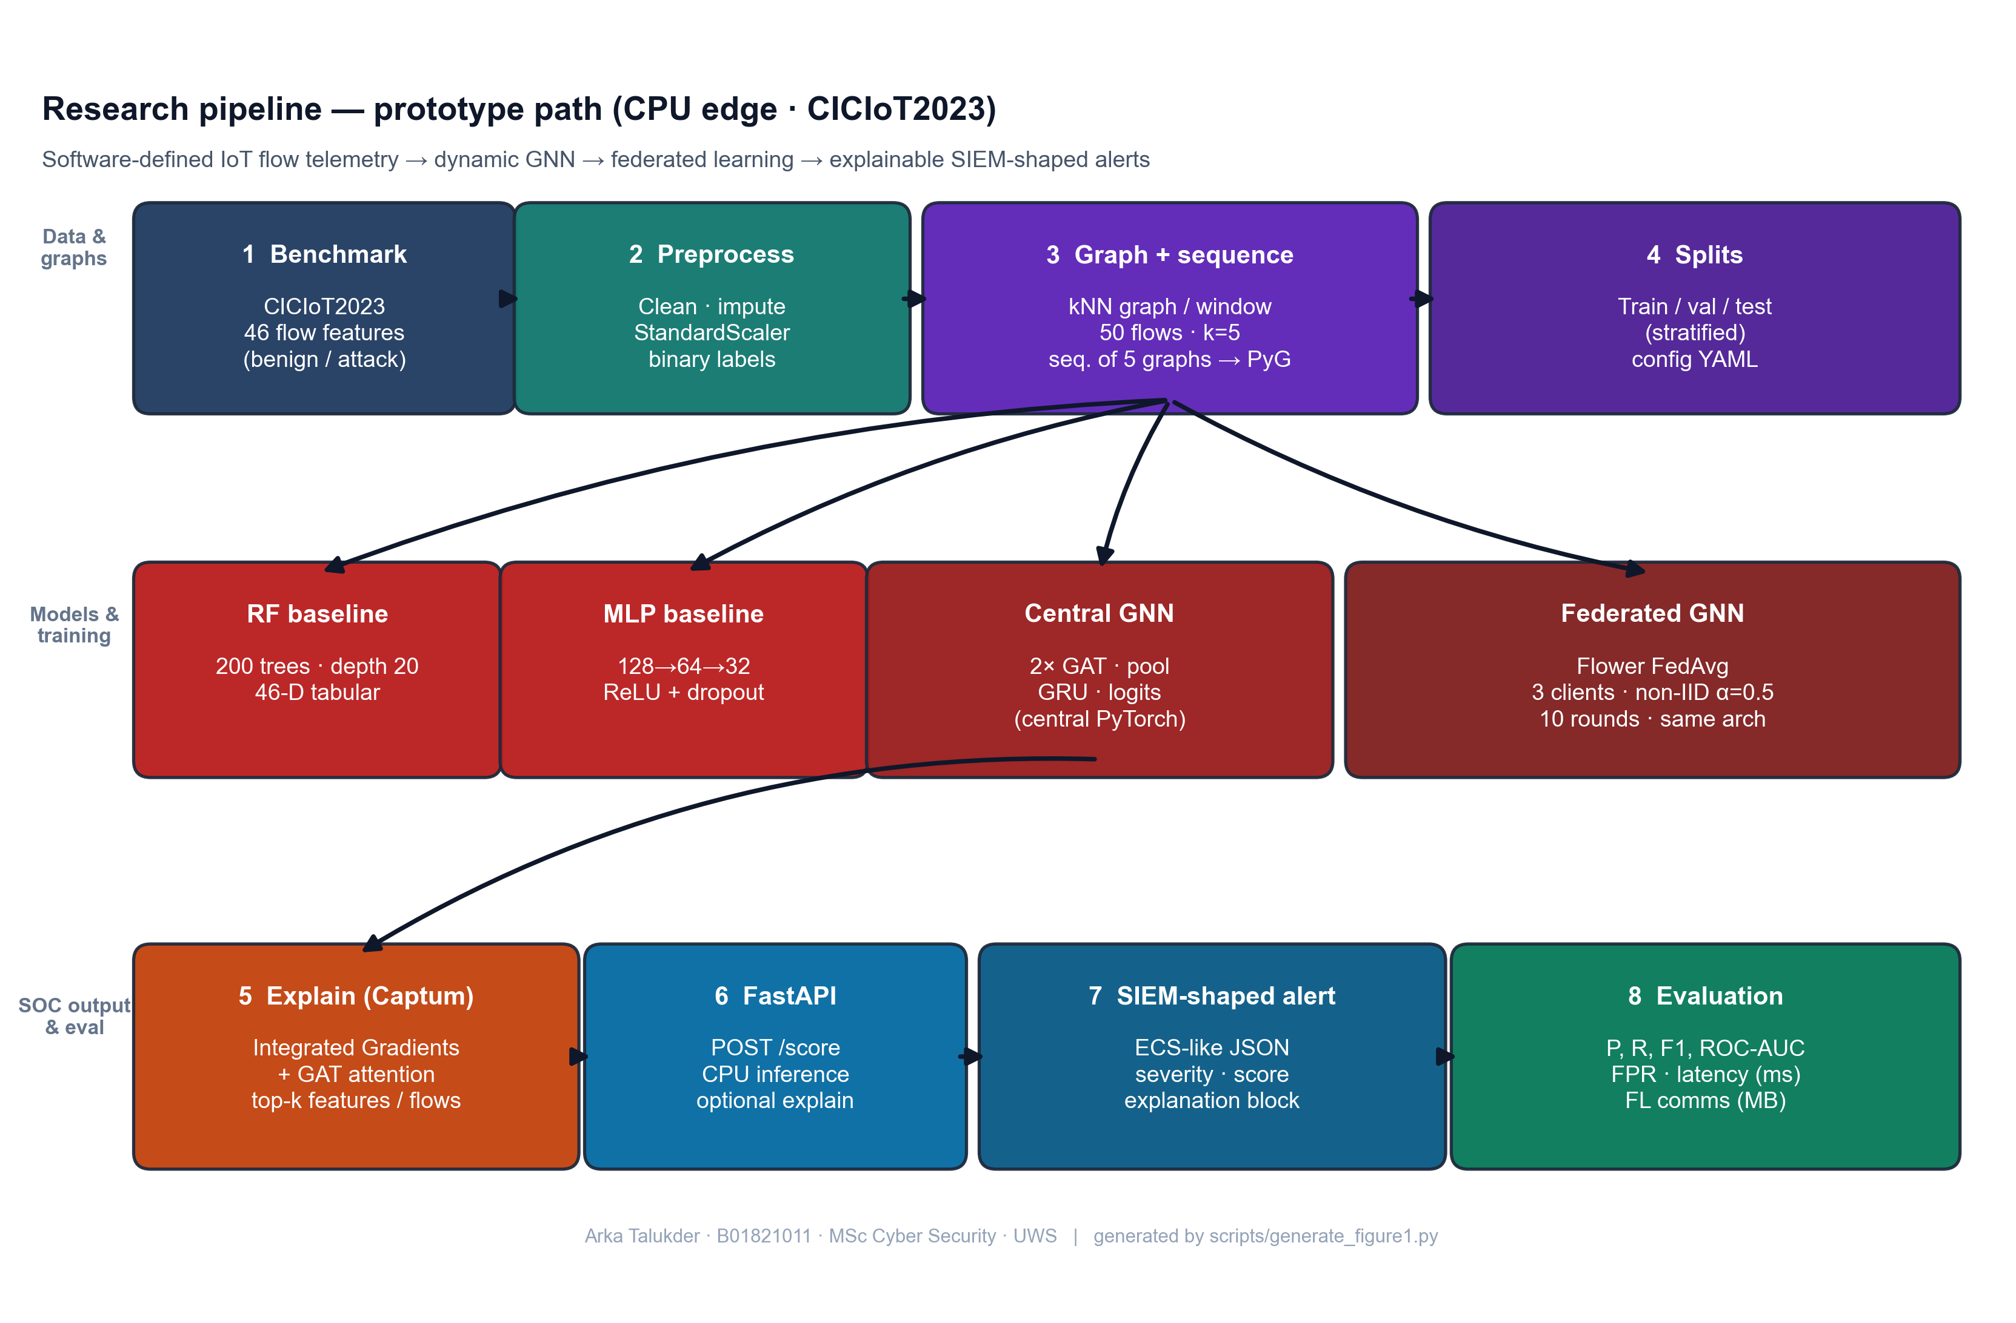
Figure 7: Research pipeline - from raw IoT flow data to explainable SIEM alerts (Chapter 5, Section 5.2)
Source: Author’s own diagram (scripts/generate_figure1.py); reflects the implementation and data path described in Chapters 5–6.

5.3 Graph Design (Flows to kNN Snapshots)
Authoritative section: every other mention of window/k/sequence rules in this thesis points here or to src/data/graph_builder.py / dataset.py (Section 6.4).
The graph is built from flow data to capture structural relationships between network flows within each observation window.
- Nodes: Each node represents one flow record. The node feature vector consists of the 46 pre-computed flow-level features provided by the CICIoT2023 dataset (e.g. packet rate, byte count, flag counts, protocol indicators, statistical aggregates). Device-level identifiers (IP addresses) are not available in the publicly released version of this dataset, so a device-based graph design (where nodes are devices and edges are flows between them) was not feasible. Instead, a feature-similarity approach is adopted, following the principle demonstrated by Ngo et al. (2025) that attribute-based graph construction can be effective for intrusion detection when topology information is absent.
- Edges: For each window, a k-nearest-neighbour (kNN) graph is constructed in feature space. Each flow is connected to its k most similar flows (by Euclidean distance on the 46 features), producing undirected edges. This creates a graph structure where flows with similar characteristics are linked, enabling the GNN to learn from local neighbourhoods of related traffic patterns. The choice of k affects the graph density: too small and the graph may be too sparse for effective message passing; too large and computation increases. k = 5 was chosen as a balance (see sensitivity analysis in Chapter 8).
- Windows and sequences: Flows are grouped into fixed-size windows (e.g. 50 flows per window). To handle extreme class imbalance at flow level, the implementation (src/data/graph_builder.py) builds each window only from flows in a single class pool (benign or attack); the graph-level label is that pool’s class (within a window all flows share the same label, so this matches a unanimous vote but is defined by construction, not by aggregating mixed labels). Benign and attack windows are balanced, then shuffled into one list. Training samples are sequences of five consecutive graphs in that list; the sequence-level label is attack if any of the five windows is attack-labeled (GraphSequenceDataset in src/data/dataset.py). The GRU reads the five graph embeddings in order. Five windows was chosen to balance context with memory and training time.
This design is kept simple so that it can be implemented and tested within the project scope. The kNN approach applies to any flow-feature dataset regardless of whether device identifiers are present. More complex designs (e.g. device-based graphs when IPs are available, multi-hop temporal aggregation) could be explored in future work.

5.4 Research Design and System Architecture
Figure 8 summarises the end-to-end research design: public benchmark flows are preprocessed and turned into temporal graphs; the dynamic GNN can be trained centrally or through Flower FedAvg on non-IID clients; the same checkpoint path supports Captum explanations and FastAPI scoring into SIEM-shaped JSON. It is a conceptual diagram (not a formal UML class model); a full UML component diagram can be pasted into the Word submission if the module asks for it.
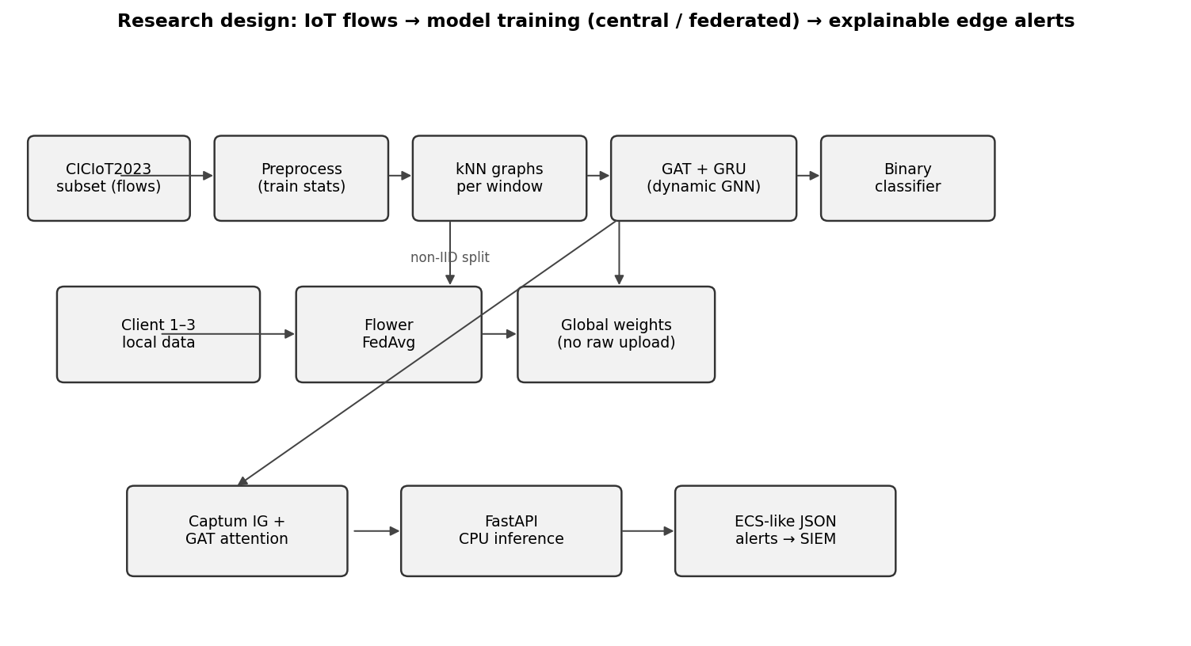
Figure 8: Research design - data flow, federated training, and edge alerting (Chapter 5, Section 5.4)
Source: Author’s own diagram; generated for this dissertation (scripts/draw_research_design.py).

5.5 Conceptual Illustration: Similarity-Based Graph in One Window
Public CICIoT2023 releases do not always include device-level topology, so attribute / similarity-based edges are a standard way to obtain a graph for a GNN (Ngo et al. 2025). Figure 9 is an author-original schematic (drawn with Matplotlib, following the library’s documented style sheets - see Matplotlib gallery): each point is one flow in a window; lines show k nearest neighbours in a 2-D projection of feature space (the real system uses 46 dimensions and Euclidean distance, Section 5.3). It is not a screenshot from another paper; it only visualises the same construction principle as the implementation.
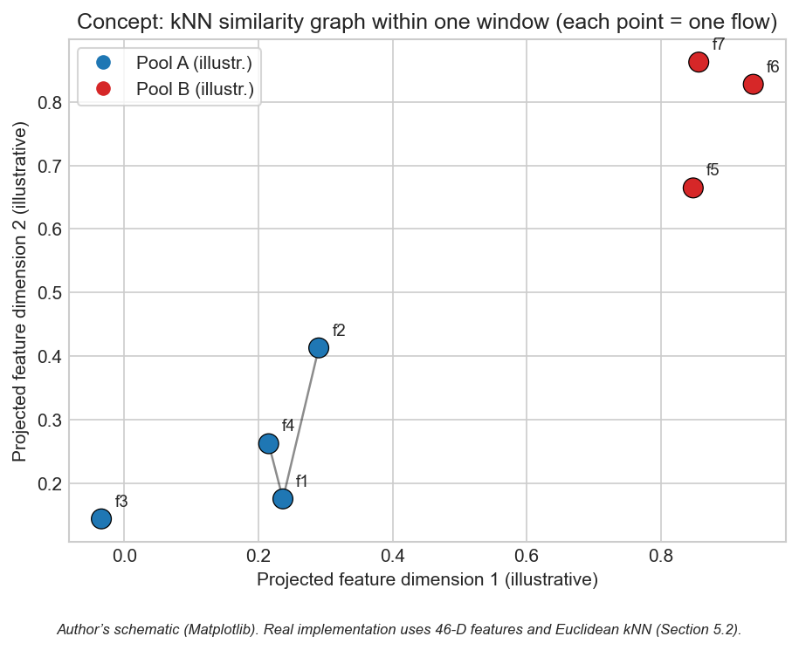
Figure 9: Conceptual kNN similarity graph within one observation window (Chapter 5, Section 5.5)
Source: Author’s own diagram (scripts/generate_similarity_knn_concept.py). Concept aligns with attribute-based graph construction for IoT intrusion detection (Ngo et al. 2025); image is not reproduced from third-party publications.

5.6 Chapter Summary
The design encodes relational (kNN), temporal (window sequences), and SOC-facing outputs in one architecture.

Chapter 6 – Implementation and System Development

6.1 Chapter Overview
This chapter describes how the prototype was implemented: code structure, libraries, training and federated loops, Captum integration, alert formatting, and the FastAPI scoring endpoint. In this project, implementation detail matters a lot, because the claim is not only model accuracy, it is full pipeline feasibility under CPU limits. So I explain where each major function lives and how the modules connect.
The implementation is organised under src/ by responsibility (data, models, federated learning, explainability, SIEM output, evaluation) and is driven by scripts that reproduce end-to-end runs from configuration (scripts/run_all.py and related scripts). Configuration is externalised in YAML so experiments can be re-run without code changes.

6.2 Environment and Tools
The system is implemented in Python 3.10. PyTorch 2.x is used for the neural models (GNN and MLP), and PyTorch Geometric (PyG) provides graph operations and GAT layers. Scikit-learn is used for Random Forest and for metrics (precision, recall, F1, ROC-AUC, confusion matrix). The Flower framework is used for federated learning (client and server logic). Captum is used for Integrated Gradients. FastAPI is used for the REST API. The code is structured so that data loading, graph building, training, and inference can be run separately or together. All experiments are run on CPU to match the edge deployment goal; training time is therefore longer than with a GPU but remains feasible for the chosen subset.
Configuration is managed via config/experiment.yaml (window size, kNN k, sequence length, model hyperparameters, and FL rounds/epochs).

6.3 Data Loading and Preprocessing
The CICIoT2023 subset is loaded from CSV (or the dataset’s provided format). The public flow tables provide the 46 numeric features used in this project plus labels; optional endpoint columns are retained only when present in the schema. Missing values are handled, labels are binarised (benign vs. attack), and fixed train/validation/test splits are produced with a fixed seed for reproducibility.
Preprocessing includes feature standardisation (zero mean, unit variance) using statistics computed only on the training set, then applied to validation and test to avoid leakage. For the GNN, flows are windowed and converted to graphs as in Section 6.4. For Random Forest and MLP, the same processed splits are used in tabular form with exactly one row per flow (46 features + binary label), loaded by load_processed_split in src/models/baselines.py - not window aggregates. Graph-sequence construction uses src/data/dataset.py; configuration is in config/experiment.yaml.

6.4 Graph Construction
Implementation follows Section 5.3 exactly: build_graphs_for_split and flows_to_knn_graph in src/data/graph_builder.py build single-class pools, balanced windows, shuffle, Euclidean kNN with bidirectional edges, and graph batches consumed by GraphSequenceDataset in src/data/dataset.py. Default k and window size come from config/experiment.yaml; sensitivity to other (window, k) pairs is in Section 8.8. Baselines read one row per flow from processed parquet via load_processed_split (src/models/baselines.py) - not graph windows.

6.5 Model Implementation
Random Forest: Implemented with scikit-learn on one row per processed flow (46 features + label). The implementation uses 200 trees and max_depth=20; class weights address flow-level imbalance in the training parquet.
MLP: Feed-forward network with three hidden layers (128, 64, 32), ReLU, dropout 0.2; two output logits for benign vs. attack, trained with cross-entropy and Adam (learning rate 1e-3), matching MLPBaseline and the training loop in scripts/run_all.py.
Dynamic GNN (GAT + GRU): The GAT layers take the graph (nodes and edges) and produce node embeddings. The GAT uses 4 attention heads and a hidden dimension of 64. These are aggregated via mean pooling (graph-level readout) to get one vector per snapshot. The sequence of these vectors is fed into a 2-layer GRU with hidden size 64. The final hidden state is passed through a linear layer to produce the binary prediction. The implementation uses PyTorch and PyG for the GAT. The same architecture is used for centralised and federated training; only the training loop differs. Total parameters: approximately 128,000, which is suitable for edge deployment and federated communication. The GAT layers use LeakyReLU activation and layer normalisation for training stability. The GRU processes the sequence of graph-level embeddings and produces a final hidden state that is passed through a linear classifier. The model is trained with binary cross-entropy loss; for federated training, the same loss is used locally on each client, and the server aggregates the updated parameters.

6.6 Federated Learning (Flower)
Federated training uses Flower with FedAvg: clients train locally on their partitions for a fixed number of epochs per round and send updated weights to the server; the server aggregates updates and broadcasts the new global model. No raw data is exchanged - only parameters - so communication cost can be approximated from float32 weight traffic (reported in Chapter 8). Implementation details are in src/federated/.

6.7 Explainability
Integrated Gradients: For a given input (e.g. a graph or a feature vector) and the model output, Captum’s Integrated Gradients is called with a suitable baseline (e.g. zero vector or mean feature vector). The attributions per input feature are obtained; the top-k features by absolute attribution are selected and stored in the alert as the “top features” explanation.
Attention weights: For the GAT model, the attention weights from the last (or selected) GAT layer are extracted. They indicate how much each edge or neighbour contributed. These are mapped back to flow identifiers (e.g. source–destination pairs) and the top flows are written into the alert. If the model has multiple layers, a simple strategy (e.g. average or use the last layer) is applied and documented.
Explanations are attached to the alert JSON. The number of integration steps (default 50) trades off attribution accuracy with computation time. The src/explain/explainer.py module wraps both methods and produces a unified explanation object. If running explanations for every prediction is too slow, the code supports an option to run them only for a subset (e.g. when the model confidence is above a threshold).

6.8 Alert Generation and SIEM-Style Output
When the model predicts an attack (or a specific attack type), an alert object is built. It includes: event type (e.g. “alert” or “detection”), timestamp, source and destination (e.g. IP or device ID), predicted label, confidence score, and an explanation object. The explanation object contains the list of top features (from Integrated Gradients) and/or top flows (from attention). The structure follows ECS-like conventions where possible (e.g. event.category, event.outcome, and custom fields for explanation). The alert is returned as JSON. This format is suitable for ingestion into a SIEM or for display in a SOC dashboard. The src/siem/alert_formatter.py module implements the ECS-like structure with fields such as event.category, event.outcome, and a custom explanation object holding top_features and top_nodes or top_flows. Severity levels (low, medium, high) are derived from the confidence score.

6.9 FastAPI Deployment and CPU Inference
A FastAPI application is set up with an endpoint that accepts input (e.g. a single flow, a batch of flows, or a pre-built graph). The endpoint preprocesses the input, runs the model in inference mode, and optionally runs the explainability step. The response is the alert JSON. CPU inference time is measured (e.g. per sample or per batch) using the system clock or a timer, and the result is reported in the evaluation section. No GPU is required; the design targets edge devices with CPU only. The API can be run locally or in a container for demonstration.
The FastAPI app (src/siem/api.py) loads the trained model from checkpoint at startup. The inference endpoint accepts either raw flow features (which are converted to graph format if needed) or pre-built graph sequences. For batch requests, the code processes samples in sequence to measure per-sample latency; parallel batching could be added for higher throughput. The measured inference times (e.g. 22.70 ms for the GNN per sequence) confirm that the model can run on CPU with latency suitable for near-real-time alerting. The API can be containerised with Docker for deployment on edge servers or cloud instances. The scripts/run_all.py script orchestrates preprocessing, graph construction, baseline training, central GNN training, and metric/plot outputs for the centralised path. Federated training is run via the Flower entry points. The scripts/generate_alerts_and_plots.py script produces example alerts, the FL convergence plot, and additional figures. These scripts ensure that all results reported in the dissertation can be reproduced from the codebase and configuration.

6.10 Implementation Code Screenshots (Author’s Codebase)
The screenshots below show core fragments only (function bodies, the training-step loop, sequence forward head, Captum IG core, and the /score handler) - not full modules. They are auto-rendered with Pygments (one-dark) at the cited line ranges (scripts/render_chapter6_code_screenshots.py); Appendix C uses the same style for examiner code reference.
flows_to_knn_graph - kNN edges and tensors (core)
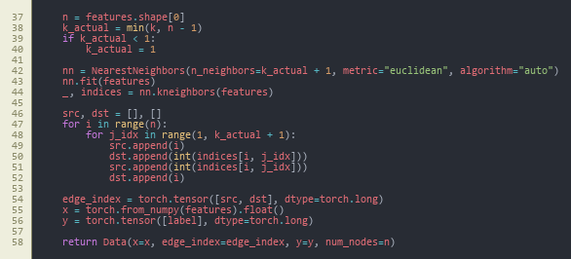
Figure 10: flows_to_knn_graph (core) - NearestNeighbors, bidirectional edges, PyG Data (Chapter 6, Section 6.10)
Source: src/data/graph_builder.py, lines 37–58.
build_graphs_for_split - stratified pools (core)
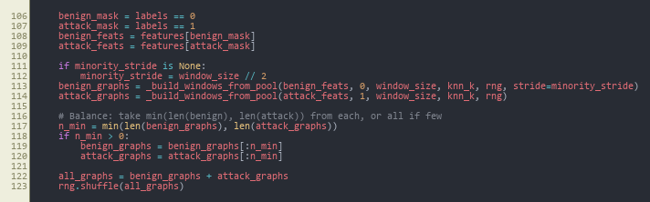
Figure 11: build_graphs_for_split (core) - class pools, balance, merge, shuffle (Chapter 6, Section 6.10)
Source: src/data/graph_builder.py, lines 106–123.
train_one_epoch - central GNN training loop
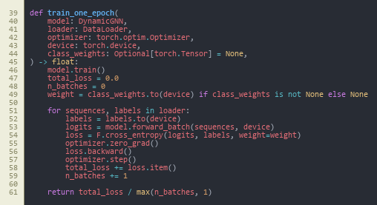
Figure 12: train_one_epoch - class-weighted cross-entropy, backward pass, optimiser step (Chapter 6, Section 6.10)
Source: src/models/trainer.py, lines 39–61.
DynamicGNN.forward - sequence to logits
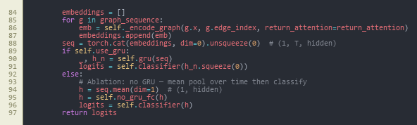
Figure 13: DynamicGNN.forward (core) - stack window embeddings, GRU vs. mean-pool ablation, classifier (Chapter 6, Section 6.10)
Source: src/models/dynamic_gnn.py, lines 84–97.
_ig_wrapper - Integrated Gradients (core)
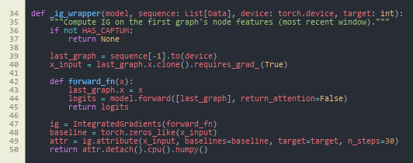
Figure 14: _ig_wrapper (core) - Captum IntegratedGradients on the last window’s node features (Chapter 6, Section 6.10)
Source: src/explain/explainer.py, lines 34–50.
POST /score - FastAPI handler (core)
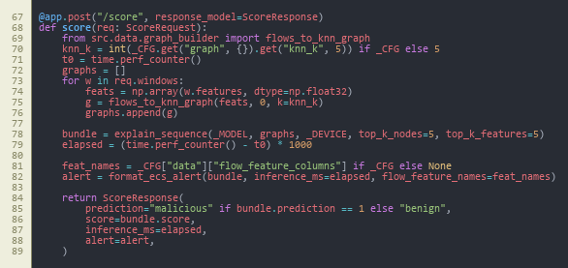
Figure 15: POST /score (core) - build graphs, explain_sequence, ECS-style alert, timing (Chapter 6, Section 6.10)
Source: src/siem/api.py, lines 67–89.
Together, these figures summarise the data → train → forward → attribute → deploy path; federated local training reuses the same train_one_epoch step inside GNNFlowerClient (Appendix C).

6.11 Reproducibility Note
The implementation is fully script-driven from config/experiment.yaml (window size, kNN k, GAT heads, sequence length, FL rounds and clients, Dirichlet alpha, seed). All main experiments use seed 42; the multi-seed study in Section 8.9 uses 42, 123, 456. Entry points are: scripts/run_all.py (preprocessing, baselines, central GNN, evaluation), src.federated.run_federated (Flower server and clients), scripts/run_ablation.py, scripts/run_sensitivity_and_seeds.py, and scripts/generate_alerts_and_plots.py. Every table and figure is backed by a CSV/JSON under results/metrics/ or an image under results/figures/. All runs are CPU-only.

6.12 Chapter Summary
Implementation delivers a modular codebase with scripted reproducibility, covering data through to SIEM-style JSON and CPU inference.

Chapter 7 – Testing and Evaluation

7.1 Chapter Overview
This chapter specifies the evaluation protocol: the experimental setup, formal metric definitions, dataset and sequence statistics, and the comparison rules applied consistently across models. The purpose is to fix the “test contract” so Chapter 8 can report results as evidence rather than opinion.

7.2 Evaluation Scope
Evaluation answers the three sub-questions and supports the main question (Section 1.3). Setup, hyperparameters, and federated heterogeneity are in Section 7.4; metric definitions in Section 7.5; scale statistics in Section 7.6; decision rules for comparing models in Section 7.7. The plan was fixed before final test reporting so metrics were not tuned to the test set.

7.2.1 Pass Criteria
To make the evaluation a pre-registered contract rather than a post-hoc summary, the following pass criteria were defined before any test-set numbers were generated. Each criterion is tied directly to a research question:
- Pass-1 (sub-question 1): the dynamic GNN achieves F1 ≥ 0.95 and ROC-AUC ≥ 0.95 on the central test set, and matches or exceeds the better of the two baselines (Random Forest, MLP) on F1.
- Pass-2 (sub-question 1): the dynamic GNN reports a lower or equal false-positive rate than the strongest baseline on the central test set.
- Pass-3 (sub-question 2): the federated GNN trained with Flower FedAvg over three non-IID clients reaches an F1 within 0.02 of the centralised GNN on the central test set within ten rounds.
- Pass-4 (sub-question 2): total federated communication stays within an order of magnitude consistent with edge-network feasibility (target ≤ 100 MB over ten rounds for the chosen architecture).
- Pass-5 (sub-question 3): at least three example alerts are produced with a complete explanation payload (top features and top flows) in ECS-like JSON.
- Pass-6 (main question): mean CPU inference latency per five-window sequence stays within edge-realistic bounds (target ≤ 100 ms).

7.2.2 Fail Criteria
A run is treated as a fail for evaluation reporting if any of the following hold:
- Fail-1: evidence of data leakage between train, validation, or test splits.
- Fail-2: F1 of the dynamic GNN below 0.90 on the central test set, or precision below 0.90 with recall held at 1.0 (which would indicate degenerate "always attack" behaviour).
- Fail-3: federated training does not converge within ten rounds, or final federated F1 falls more than 0.05 below the centralised GNN.
- Fail-4: alerts cannot be produced from the trained model through the FastAPI endpoint, or the explanation payload is empty for the chosen examples.
- Fail-5: CPU inference latency exceeds 1 s per sequence (which would void the edge-deployment claim).
The actual outcomes against these criteria are reported in Chapter 8 and discussed in Chapter 9.

7.3 Test Schedule
The schedule below records when each evaluation run was executed against the criteria above. Dates are project-day numbers from the Gantt chart in Figure 6:
Test phase | Project days | Output artefact | Outcome (vs. criteria)
Baseline RF and MLP on test split | 16–18 | results/metrics/results_table.csv (RF, MLP rows) | Reference set established
Central GNN training and test | 18–22 | results/metrics/results_table.csv (Central GNN row); gnn_training_history.json | Pass-1, Pass-2, Pass-6
Federated GNN (10 rounds, 3 clients) | 22–26 | results/metrics/fl_round_metrics.csv; results/figures/fl_convergence.png | Pass-3, Pass-4
Example alerts via FastAPI /score | 26–28 | results/alerts/*.json | Pass-5
Ablation (GAT-only vs full) | 30–32 | results/metrics/ablation_table.csv | Stability evidence
Sensitivity grid (window x k) | 32–35 | results/metrics/sensitivity_table.csv; results/figures/sensitivity.png | Stability evidence
Multi-seed (42, 123, 456) | 35–38 | results/metrics/multi_seed_summary.json | Stability evidence

7.4 Experimental Setup
All experiments use the same fixed train, validation, and test split from the CICIoT2023 subset. The random seed is fixed (e.g. 42) so that results are reproducible. Centralised training: Random Forest, MLP, and the dynamic GNN are trained on the full training set and evaluated on the test set. Federated training: the same GNN is trained with Flower and FedAvg across 3 clients; the global model is evaluated on the same test set after each round. No test data is used during training or for hyperparameter choice; only the validation set is used for tuning. Time windows for graph construction are set to a fixed length (e.g. 50 flows per window, 5 windows per sequence); sensitivity to window size can be checked in a time-window analysis if time allows.
The federated split uses a Dirichlet distribution (alpha = 0.5) to simulate non-IID clients. The central test set is held out and used only for evaluation. Model hyperparameters and training settings are taken from config/experiment.yaml (summarised in Chapter 6), and the same splits are used across models to ensure fair comparison.

7.5 Metrics
Classification performance is measured with: precision, recall, F1-score (macro or weighted if multi-class), ROC-AUC, and false positive rate. A confusion matrix is reported for the test set. These metrics are derived from the confusion matrix, where TP (true positives), TN (true negatives), FP (false positives), and FN (false negatives) are the counts of correct and incorrect predictions for the attack class (positive) and benign class (negative). The formal definitions are:
Precision (fraction of predicted attacks that are correct):
Precision = TP / (TP + FP)
Recall (fraction of actual attacks that are detected; also called sensitivity or true positive rate):
Recall = TP / (TP + FN)
F1-score (harmonic mean of precision and recall):
F1 = 2 × (Precision × Recall) / (Precision + Recall)
False Positive Rate (fraction of benign traffic incorrectly flagged as attack):
FPR = FP / (FP + TN)
ROC-AUC (area under the Receiver Operating Characteristic curve): The ROC curve plots true positive rate (TPR = Recall) against false positive rate (FPR) at varying classification thresholds. AUC is the area under this curve; a value of 1.0 indicates perfect ranking (all positives above all negatives), and 0.5 indicates random guessing.
These metrics show how well the model separates attacks from benign traffic and how many false alarms it produces. Precision is important for SOC use because false positives add to alert fatigue. Recall matters for not missing real attacks. F1-score balances both. ROC-AUC shows how well the model ranks positive instances higher than negative ones across thresholds. For federated learning, the same metrics are computed after each round so convergence can be seen. Communication cost is approximated from the size in bytes of the model parameters sent per round. CPU inference time is measured on the FastAPI endpoint and reported in milliseconds per sample. Inference time matters for edge deployment. If the model takes too long, it may not be suitable for real-time alerting.

7.6 Dataset and Experiment Statistics
The CICIoT2023 subset used in this project was selected to include a representative mix of benign and attack traffic. Each split (train, validation, test) contains 500,000 flows; at flow level the class distribution is approximately 2.3% benign and 97.7% attack (see results/metrics/dataset_stats.json, generated by scripts/dataset_statistics.py). The stratified windowing strategy produces balanced graph-level data (approximately 50% benign, 50% attack windows) despite this flow-level imbalance. After windowing, the GNN dataset comprises 920 training sequences, 928 validation sequences, and 934 test sequences (each sequence = five consecutive graph snapshots in the shuffled graph list; each snapshot = 50 flows; sequence label = attack if any snapshot is attack-labeled - see GraphSequenceDataset). The train/validation/test split ensures no overlap; the test set is used only for final reporting. The Random Forest and MLP baselines use the same processed flows in tabular format (one row per flow) on the same splits, so comparison is on the same underlying data; the GNN is evaluated at sequence level (one prediction per sequence of 5 windows). The federated split assigns each client a different proportion of classes via Dirichlet(alpha=0.5), simulating non-IID conditions where different sites observe different threat profiles.

7.7 Comparison Design
To answer sub-question 1 (dynamic graph vs. simple models), the dynamic GNN is compared to Random Forest and MLP on the same test set. If the GNN achieves higher F1 or AUC while keeping a reasonable false positive rate, that supports the use of graph and temporal structure. To answer sub-question 2 (federated vs. centralised), the federated model’s final metrics are compared to the centralised model’s. A small drop in performance may be acceptable if it stays within a few percent; a large drop would indicate that federated learning needs more tuning or more data. To answer sub-question 3 (usefulness of explanations), three to five example alerts are generated with full explanations and discussed in terms of whether the top features and flows would help a SOC analyst triage. No formal user study is conducted; the discussion is based on the author’s and supervisor’s judgment of interpretability and actionability.

7.8 Chapter Summary
Chapter 7 fixed the setup, metrics, data scales, and comparison protocol used for all models and federated runs. Chapter 8 reports the numerical and graphical outcomes only.

Chapter 8 – Results Presentation

8.1 Chapter Overview
This chapter reports results as tables and figures with brief factual description; interpretation is in Chapter 9 and personal reflection in Chapter 10. Tables keep decimal precision (e.g. 0.9986) and the prose mirrors the same values as percentages. Artefacts are stored under results/metrics/, results/figures/, and results/alerts/.

8.2 Centralised Model Comparison (Sub-Question 1)
The dynamic GNN (GAT + GRU), Random Forest, and MLP were evaluated on the same test set. Table 2 lists the same values as decimals; here they are stated explicitly as percentages for quick comparison: Random Forest - Precision = 99.89%, Recall = 99.84%, F1 = 99.86%, ROC-AUC = 99.96%; MLP - Precision = 100.00%, Recall = 98.85%, F1 = 99.42%, ROC-AUC = 99.84%; Central GNN - Precision = Recall = F1 = ROC-AUC = 100.00%; Federated GNN (evaluated centrally on the same test set) - Precision = Recall = F1 = ROC-AUC = 100.00%. False positive rate (benign predicted as attack): GNN 0.00%; Random Forest 4.84% (187 false positives); MLP 0.10% (4 false positives). Figure 16 shows the confusion matrix for the Dynamic GNN. Figure 17 shows the ROC curve for the GNN. Figures 18 and 19 show confusion matrices for Random Forest and MLP. Figures 20 and 21 show ROC curves for RF and MLP. Figure 27 compares inference time and F1 across models.
A note on interpretation. The F1 and ROC-AUC values reported below reach a ceiling of 1.0 on this test split. This is reported as observed evidence, not as a claim of universal performance. A perfect score on a 934-sequence test set drawn from a single CICIoT2023 subset is consistent with two non-mutually-exclusive readings: (a) the binary benign-vs-attack task is well-separated by the engineered flow features at this scale, and (b) the stratified windowing produces sequences whose label is highly predictable once the GAT has converged. Section 10.5 returns to this honestly, and Sections 8.7–8.9 (ablation, sensitivity, multi-seed) are included precisely so the ceiling is not a single-configuration artefact.
Table 2: Model comparison on CICIoT2023 test set
Model | Precision | Recall | F1 | ROC-AUC | Inference (ms)
Random Forest | 0.9989 | 0.9984 | 0.9986 | 0.9996 | 46.09
MLP | 1.0000 | 0.9885 | 0.9942 | 0.9984 | 0.66
Central GNN | 1.0000 | 1.0000 | 1.0000 | 1.0000 | 22.70
Federated GNN | 1.0000 | 1.0000 | 1.0000 | 1.0000 | 20.99
Source: Author-derived metrics on the fixed CICIoT2023 subset (Pinto et al. 2023); results/metrics/results_table.csv; reproducibility in Chapter 13. Decimal columns match the prose Key: lines above (e.g. RF F1 = 99.86% ↔ 0.9986).
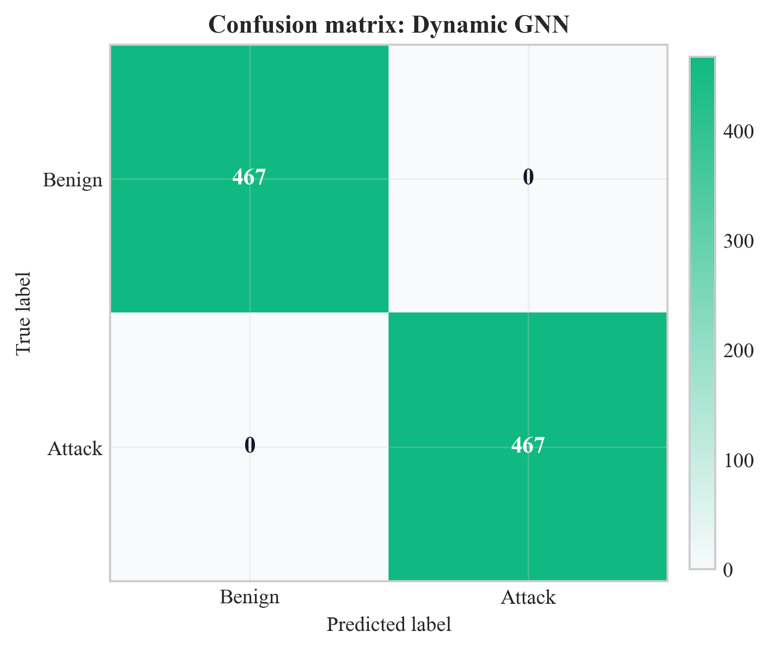
Figure 16: Confusion matrix for Dynamic GNN on test set (Chapter 8, Section 8.2)
Source: Author’s own plot from test-set predictions; data CICIoT2023 (Pinto et al. 2023); scripts/run_all.py.
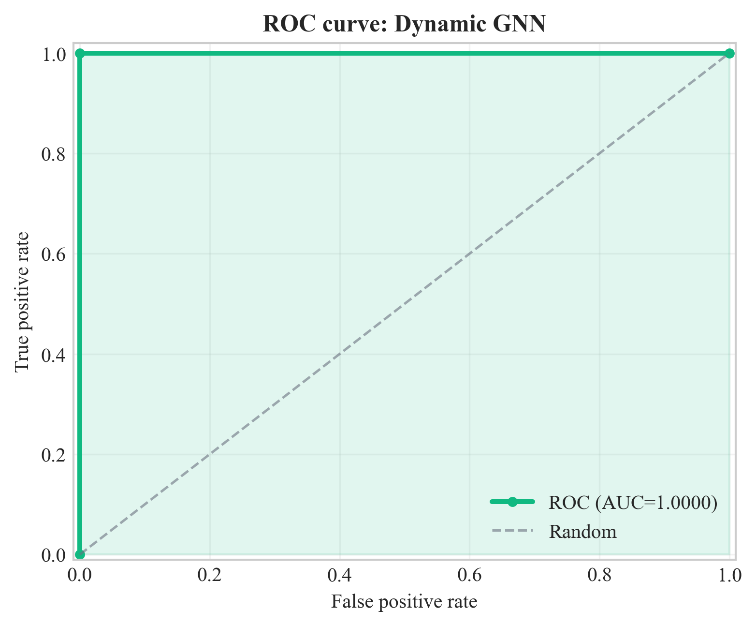
Figure 17: ROC curve for Dynamic GNN on test set (Chapter 8, Section 8.2)
Source: Author’s own plot from test-set scores; data CICIoT2023 (Pinto et al. 2023); scripts/run_all.py.
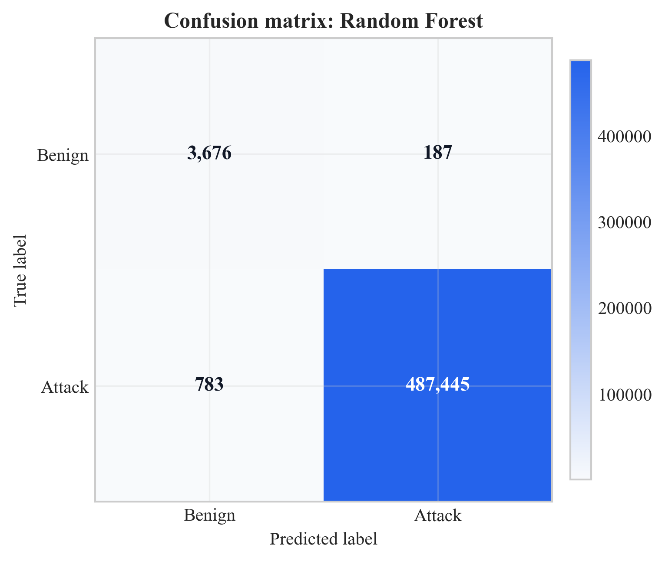
Figure 18: Confusion matrix for Random Forest on test set (Chapter 8, Section 8.2)
Source: Author’s own plot; baseline from scripts/run_all.py; data CICIoT2023 (Pinto et al. 2023).
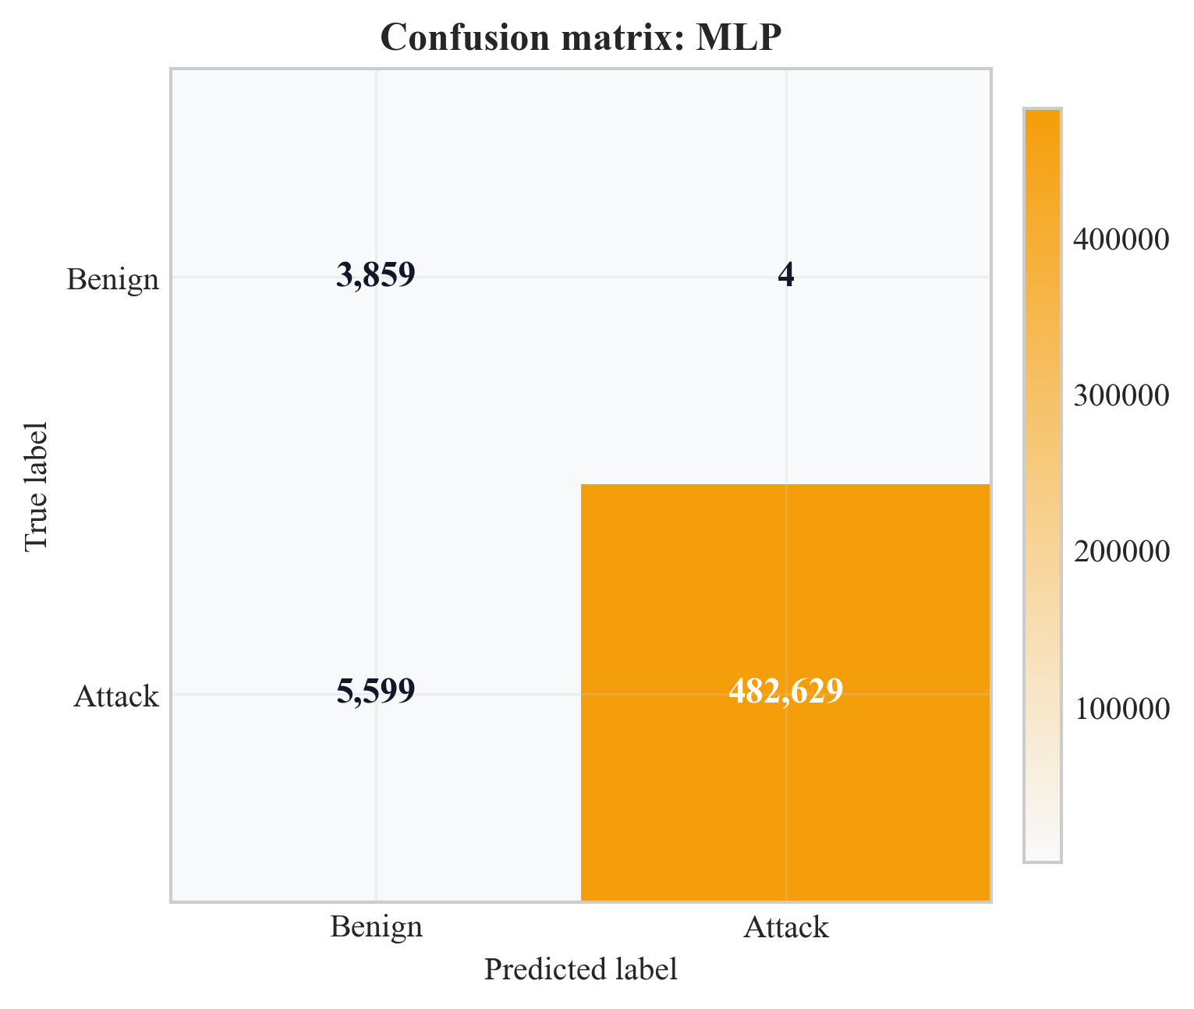
Figure 19: Confusion matrix for MLP on test set (Chapter 8, Section 8.2)
Source: Author’s own plot; baseline from scripts/run_all.py; data CICIoT2023 (Pinto et al. 2023).
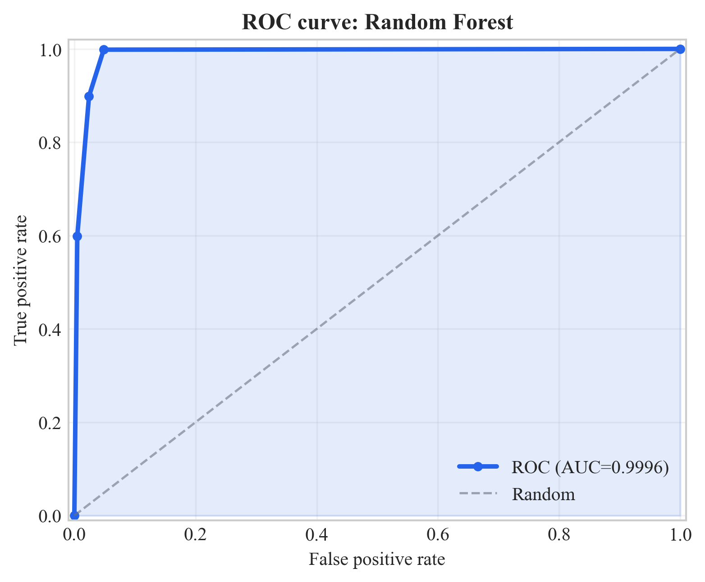
Figure 20: ROC curve for Random Forest on test set (Chapter 8, Section 8.2)
Source: Author’s own plot; baseline from scripts/run_all.py; data CICIoT2023 (Pinto et al. 2023).
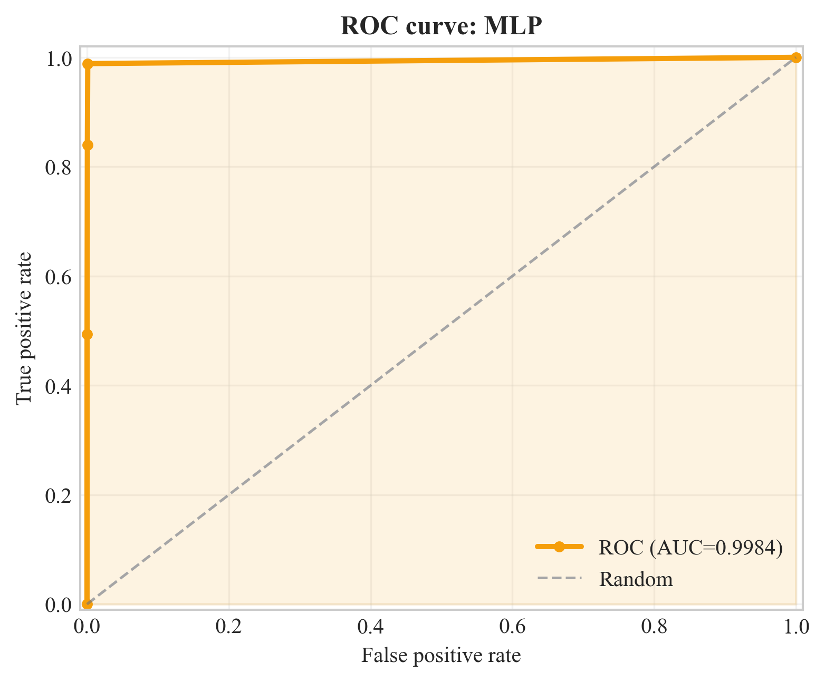
Figure 21: ROC curve for MLP on test set (Chapter 8, Section 8.2)
Source: Author’s own plot; baseline from scripts/run_all.py; data CICIoT2023 (Pinto et al. 2023).
The confusion matrices (Figures 16, 18, and 19) report TP, TN, FP, and FN counts per model. Figure 16 shows zero FP and zero FN for the GNN on this test set. Figures 18 and 19 show 187 FP for Random Forest and 4 FP for MLP (benign predicted as attack). The ROC curves (Figures 17, 20, and 21) plot TPR vs. FPR across thresholds; reported ROC-AUC values are in Table 2. Implications for SOC triage and model choice are discussed in Chapter 9.
Figure 22 plots precision, recall, and F1 for the four models with a zoomed 0.97-1.00 y-axis. Both GNN runs sit on the 1.0 ceiling on all three metrics; MLP has a visible recall gap at 0.9885 and RF sits at 0.998+ on every metric.
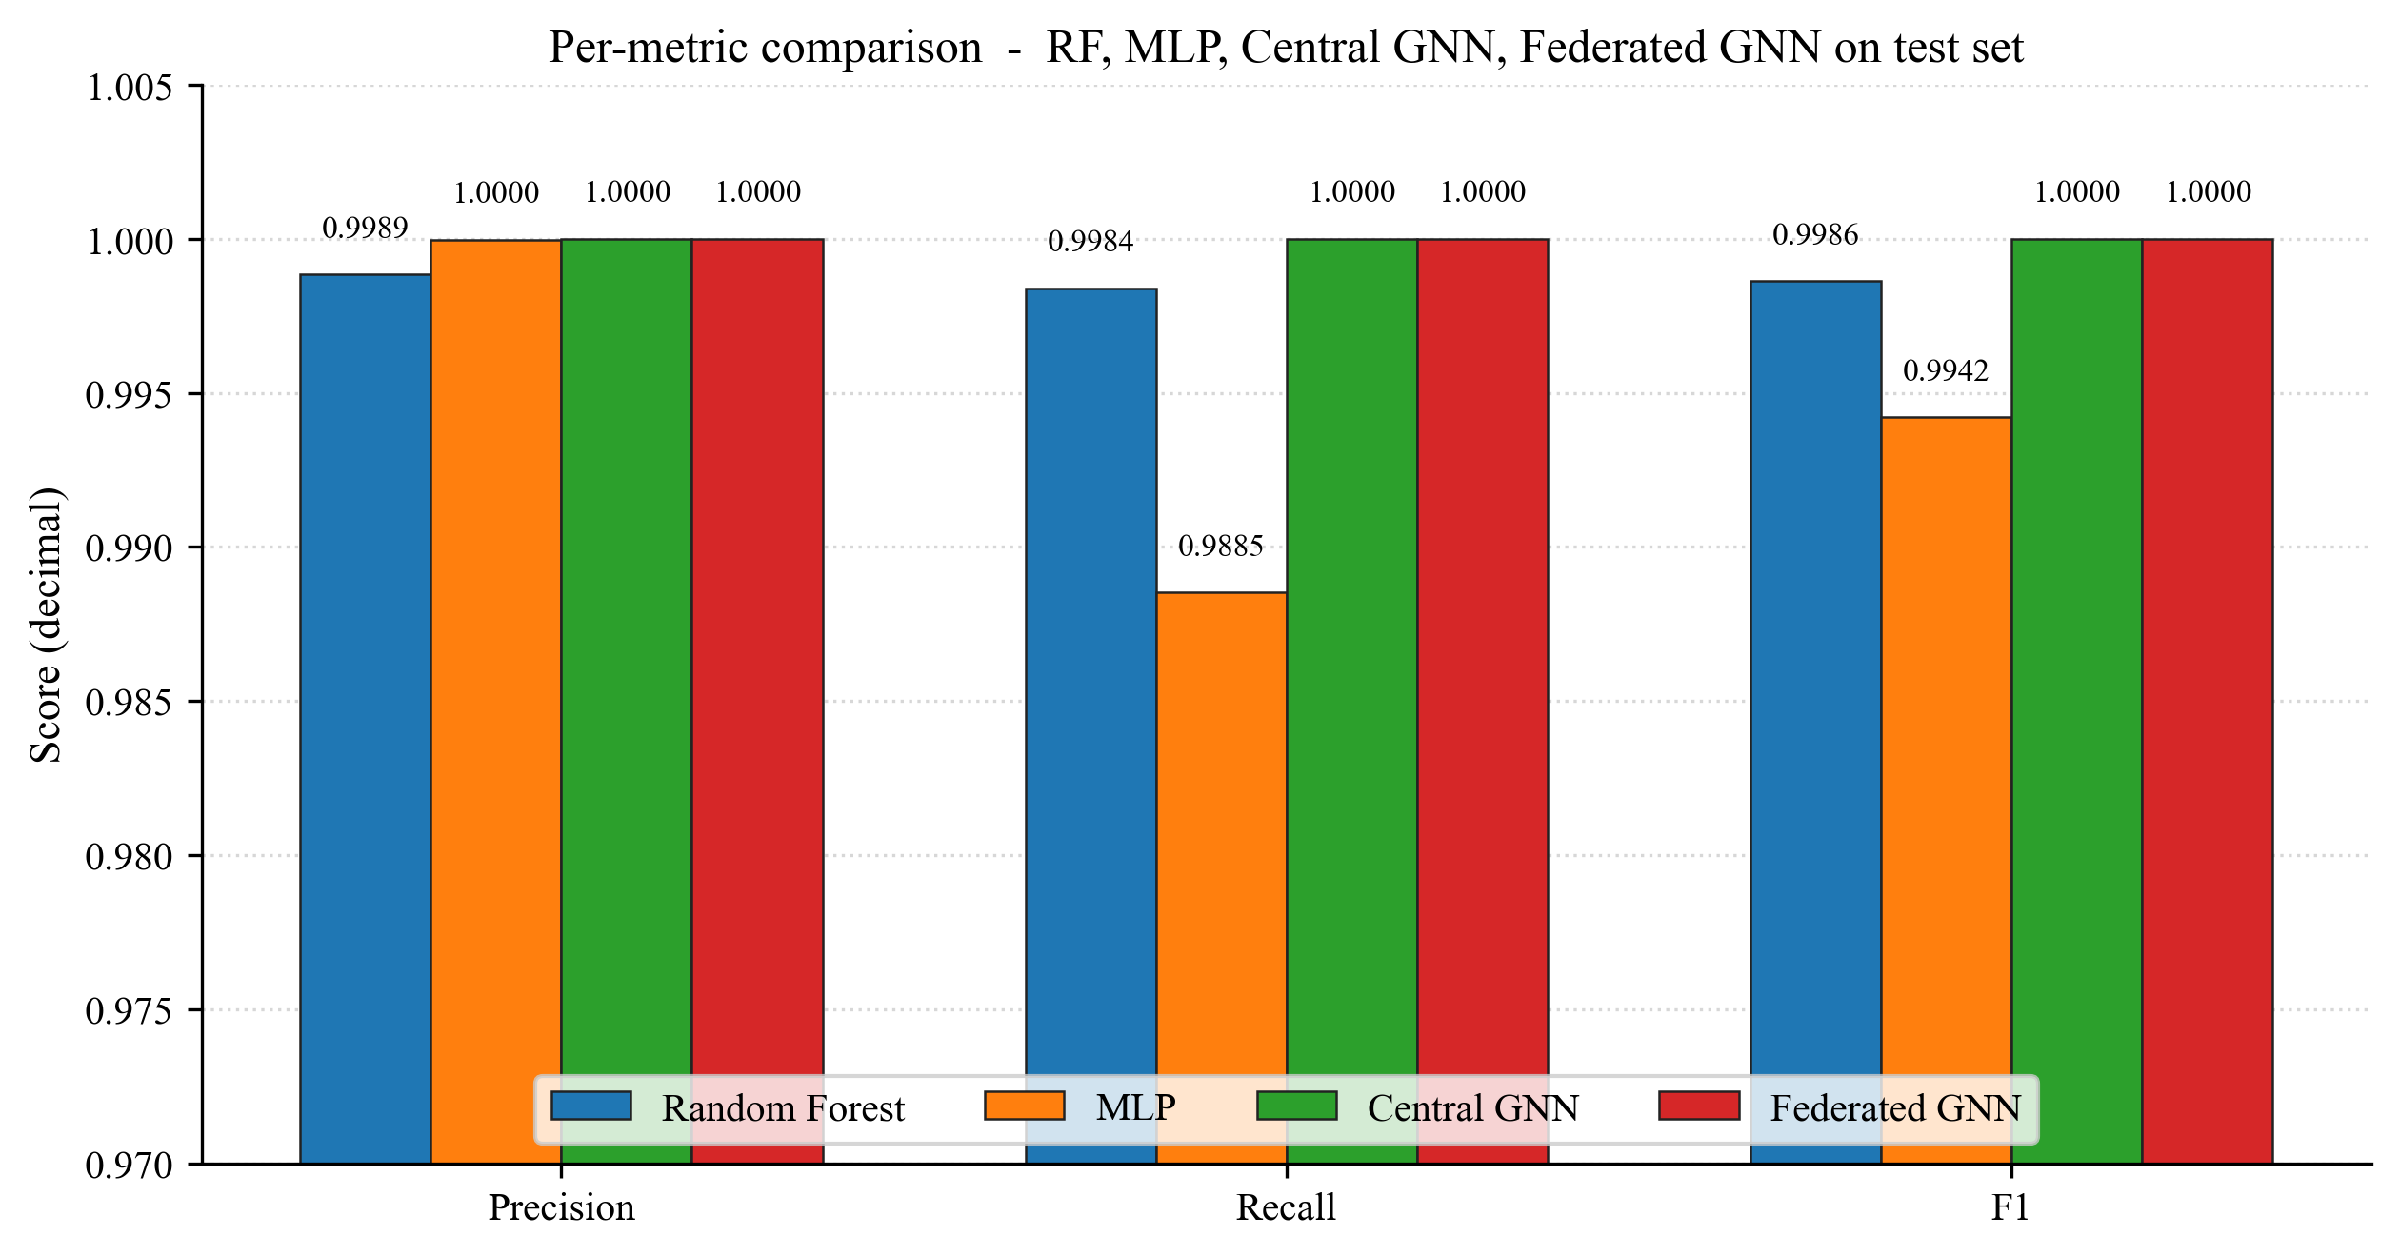
Figure 22: Per-metric comparison across RF, MLP, Central GNN, and Federated GNN on the test set (Chapter 8, Section 8.2)
Source: Author's own plot (scripts/generate_extra_result_figures.py); data from results/metrics/{rf,mlp,central_gnn,federated_gnn}_metrics.json.

8.3 Federated Learning (Sub-Question 2)
Federated training was run for 10 rounds with 3 clients and non-IID splits (Dirichlet alpha = 0.5). The global model was evaluated on the same central test set after each round. Table 3 lists precision, recall, F1, and ROC-AUC per round; Figure 23 plots F1 and ROC-AUC vs. round. Key (same numbers as Table 3): round 1 F1 = 98.3%, ROC-AUC = 55.7%; from round 2 ROC-AUC = 100.0%; F1 reaches 100.0% from round 7; round 6 ROC-AUC = 97.3% while F1 = 99.5%. The final round reports F1 = ROC-AUC = 100.0%, matching the centralised GNN on this test set.
Communication cost is approximated from float32 parameter size: 128,002 parameters, order of ~1.0 MB per client upload/download per round; ~3.07 MB per round aggregate messaging is reported, ~31 MB total over 10 rounds with three clients. Interpretation (privacy vs. centralised parity, feasibility) is in Chapter 9.
Table 3: Federated learning round-by-round metrics
Round | Precision | Recall | F1 | ROC-AUC
1 | 0.967 | 1.000 | 0.983 | 0.557
2 | 0.967 | 1.000 | 0.983 | 1.000
3 | 0.967 | 1.000 | 0.983 | 1.000
4 | 0.994 | 1.000 | 0.997 | 1.000
5 | 0.997 | 1.000 | 0.998 | 1.000
6 | 0.990 | 1.000 | 0.995 | 0.973
7 | 1.000 | 1.000 | 1.000 | 1.000
8 | 1.000 | 1.000 | 1.000 | 1.000
9 | 1.000 | 1.000 | 1.000 | 1.000
10 | 1.000 | 1.000 | 1.000 | 1.000
Source: Author-derived round metrics; Flower FedAvg run; results/metrics/ (see Chapter 13).
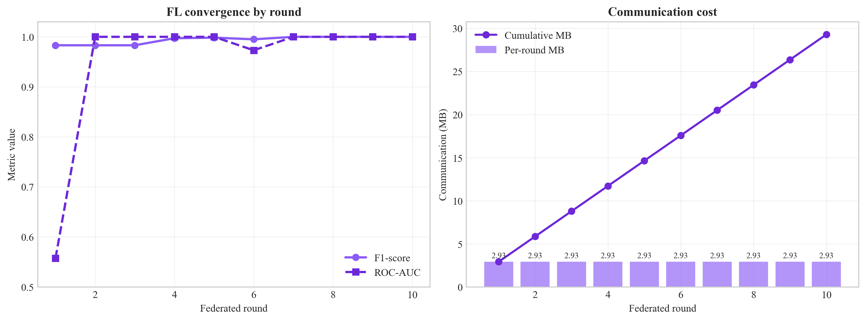
Figure 23: Federated learning convergence (F1 and ROC-AUC vs. round) (Chapter 8, Section 8.3)
Source: Author’s own plot; scripts/generate_alerts_and_plots.py / federated training logs; data CICIoT2023 (Pinto et al. 2023).
Figure 24 is the federated GNN confusion matrix on the same test set after the final FedAvg round. Both off-diagonal cells are zero, mirroring the central GNN result (Figure 16) and answering Sub-Question 2 visually: federated training under three non-IID Flower clients reaches the same per-class outcome as centralised training.
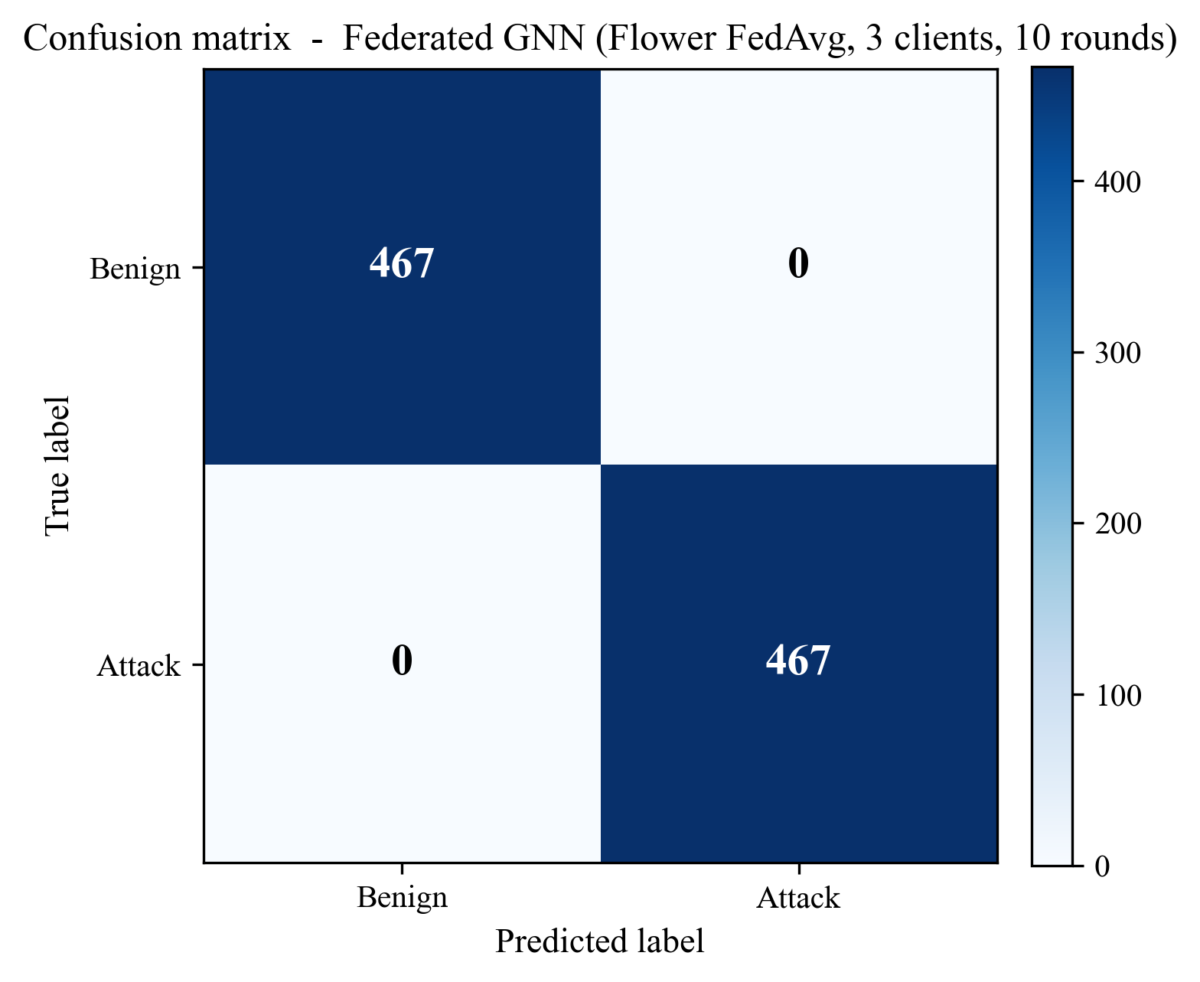
Figure 24: Confusion matrix of the federated GNN (Flower FedAvg, 3 clients, 10 rounds) on the test set (Chapter 8, Section 8.3)
Source: Author’s own plot (scripts/generate_extra_result_figures.py); reconstructed from results/metrics/federated_gnn_metrics.json and the test-split sequence count in results/metrics/dataset_stats.json.
Figure 25 shows the communication cost behind those metrics: ~3.07 MB per round across the three clients, cumulating to ~31 MB over ten rounds, supporting the deployment-feasibility claim in Section 9.6.
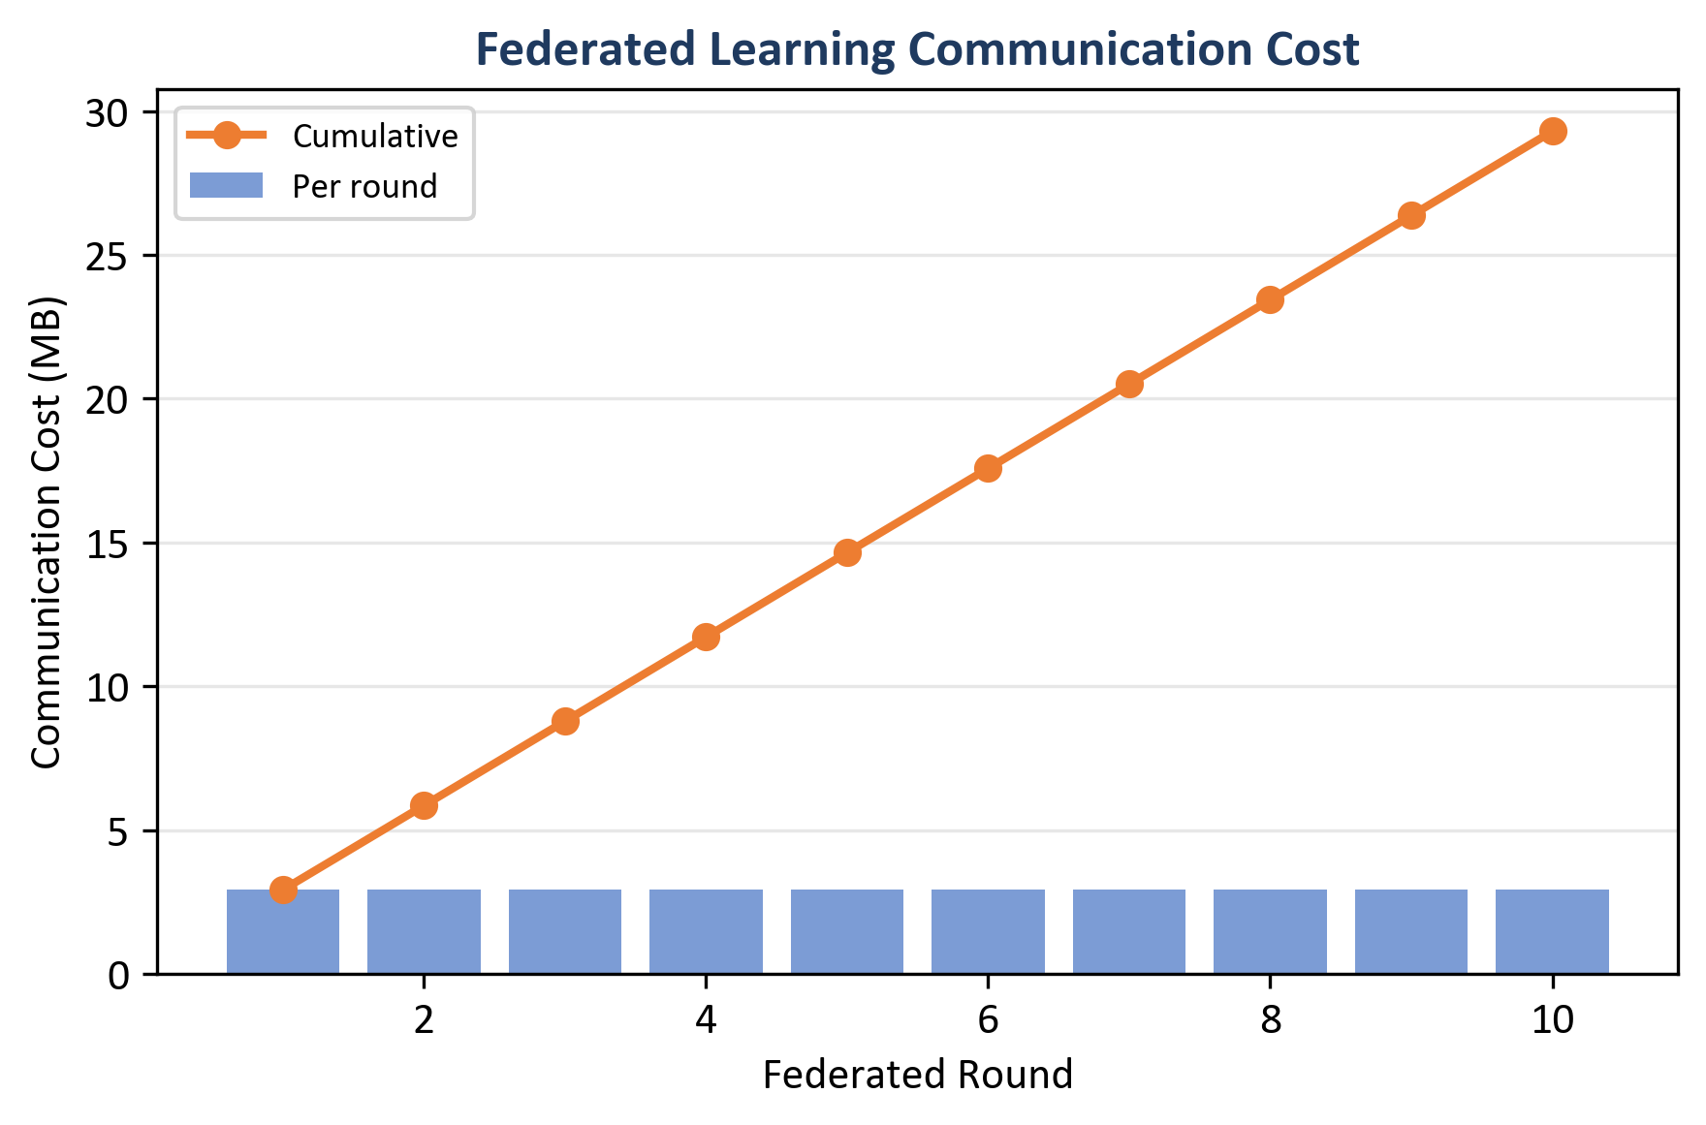
Figure 25: Federated learning communication cost - per round (bars) and cumulative (line) (Chapter 8, Section 8.3)
Source: Author’s own plot (scripts/generate_alerts_and_plots.py); data from results/metrics/fl_rounds.json (comm_bytes).

8.3.1 What Federated Learning Produced (Reading the Curves and the Table)
Round 1 reaches Recall = 100.0% and F1 = 98.3% but ROC-AUC = 55.7%, indicating poor score ranking early. From round 2 ROC-AUC = 100.0%, and F1 reaches 100.0% from round 7. Round 6 shows a small dip to ROC-AUC = 97.3% while F1 stays at 99.5% (a wobble rather than a collapse, consistent with non-IID FedAvg noise discussed in Chapter 9). The federated checkpoint matches the central GNN on the reported test metrics.

8.4 Central GNN Training Convergence
The centralised Dynamic GNN was trained for 6 epochs (with early-stopping configured in the training script). Table 4 lists train loss and validation F1 / ROC-AUC per epoch (results/metrics/gnn_training_history.json). Validation F1 = ROC-AUC = 100.0% from epoch 1 onward on this run; train loss falls from 0.484 to 0.0001 by epoch 4 and stays there through epoch 6.
Table 4: Central GNN training history (loss and validation metrics)
Epoch | Train Loss | Val F1 | Val ROC-AUC
1 | 0.484 | 1.000 | 1.000
2 | 0.023 | 1.000 | 1.000
3 | 0.0002 | 1.000 | 1.000
4 | 0.0001 | 1.000 | 1.000
5 | 0.0001 | 1.000 | 1.000
6 | 0.0001 | 1.000 | 1.000
Source: results/metrics/gnn_training_history.json; central GNN training run (scripts/run_all.py).
Figure 26 plots the training-loss column on a log y-axis. Loss falls from ~4.8 × 10⁻¹ at epoch 1 to ~1 × 10⁻⁴ by epoch 4, then plateaus. Combined with validation F1 = 1.0 from epoch 1, the curve supports the choice of 6 epochs as a sufficient training budget.
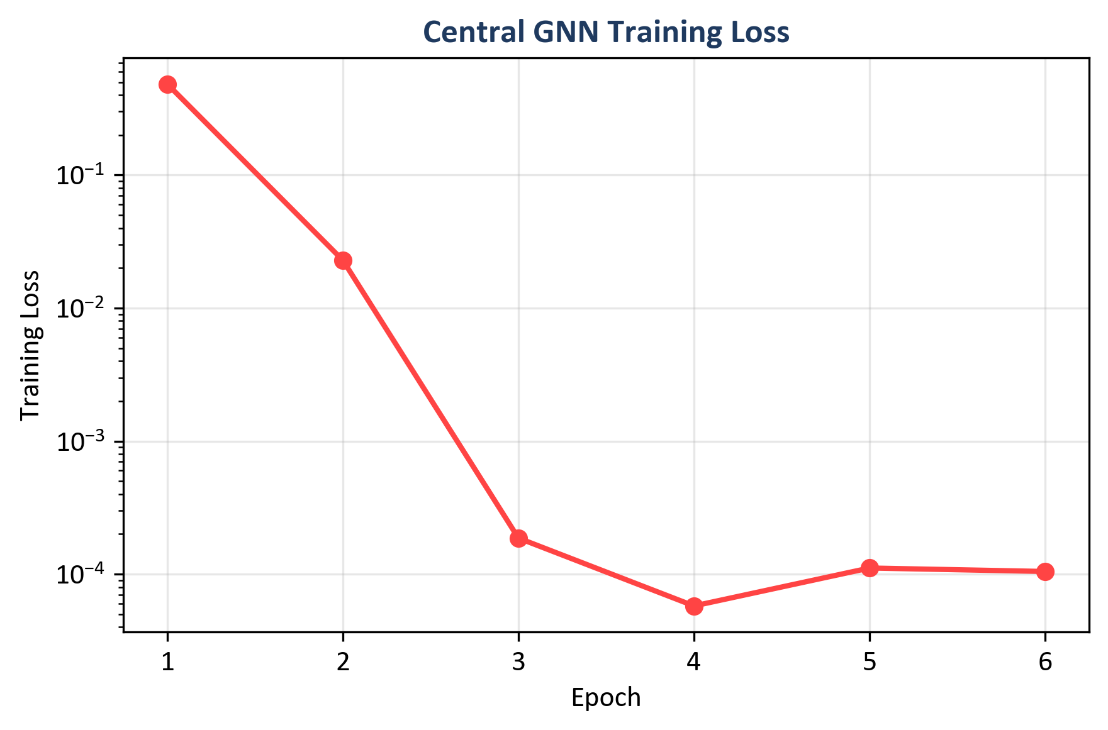
Figure 26: Central GNN training loss across six epochs (log scale) (Chapter 8, Section 8.4)
Source: Author's own plot (scripts/generate_alerts_and_plots.py); data from results/metrics/gnn_training_history.json (train_loss).

8.5 Time-Window and CPU Inference (Sub-Question 2 and Deployment)
CPU inference times (reported in Table 2): Random Forest 46.09 ms per sample; MLP 0.66 ms; central GNN 22.70 ms; federated GNN 20.99 ms (GNN times are per sequence of 5 graph windows). Figure 27 compares F1 and inference time across models.
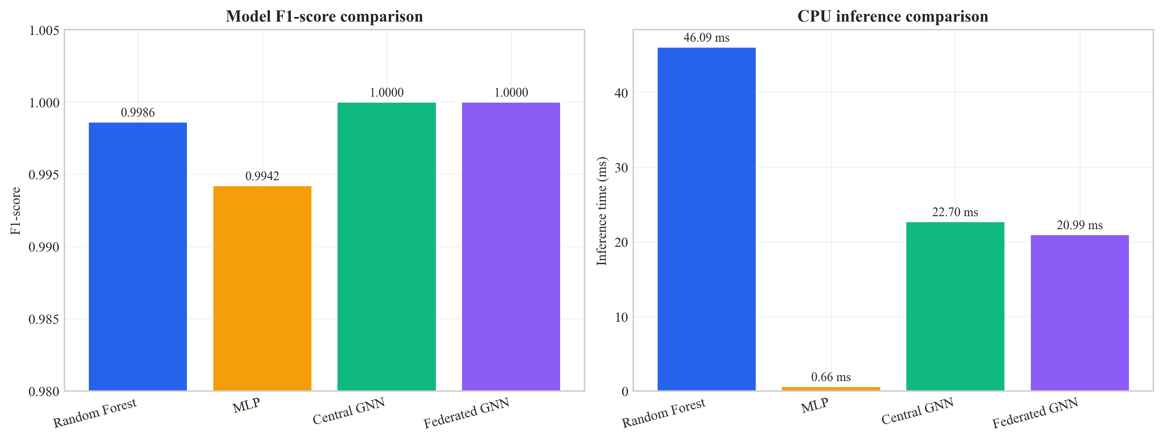
Figure 27: Model comparison - inference time and F1-score (Chapter 8, Section 8.5)
Source: Author’s own plot; metrics from Table 2 and inference timings in results/metrics/; scripts/generate_alerts_and_plots.py.

8.6 Example Alerts with Explanations (Sub-Question 3)
Five example alerts were generated with full explanations (top features from Integrated Gradients and top flows from attention weights), in the same order as results/alerts/example_alerts.json. Each example includes the predicted label, confidence, threat severity band, and the explanation object (top_features, top_nodes).
Example 1 (True negative): Predicted benign; score 0.163 (low severity). Top features: Variance, Std, rst_count, Duration, AVG (Integrated Gradients magnitudes as in example_alerts.json).
Example 2 (True positive): Predicted malicious; score 0.997. Top features: psh_flag_number, ICMP, rst_flag_number.
Example 3 (True positive): Predicted malicious; score 0.996. Top features: rst_flag_number, ICMP, Protocol Type.
Example 4 (False positive): Benign labelled as malicious; score 0.711 (medium). Top features: Variance, rst_count.
Example 5 (False positive): Benign labelled as malicious; score 0.945. Top features: Variance, Std, rst_count.
Each record follows the ECS-like shape: event metadata, rule name, threat indicator, ML prediction and score, and explanation (top_features, top_nodes). Whether these fields are sufficient for SOC triage is discussed in Chapter 9.

8.7 Ablation Studies (Priority 1: Evidence)
To show that both the graph and the temporal parts of the model add value, one ablation was run: the same GAT-based model but with the GRU replaced by mean pooling over time (so the model sees each window’s graph embedding but does not model the sequence with an RNN). This variant is called “GAT only (no GRU)”. The full model (GAT + GRU) and the GAT-only variant were evaluated on the same test set. Table 5 summarises the results. To reproduce the ablation, run: python scripts/run_ablation.py --config config/experiment.yaml; results are saved to results/metrics/ablation_gat_only.json and results/metrics/ablation_table.csv.
Table 5: Ablation on CICIoT2023 test set (centralised GNN variants)
Variant | Precision | Recall | F1 | ROC-AUC | Inference (ms)
Full (GAT + GRU) | 1.0000 | 1.0000 | 1.0000 | 1.0000 | 22.70
GAT only (no GRU) | 0.9923 | 1.0000 | 0.9961 | 1.0000 | 16.06
Source: results/metrics/ablation_table.csv; scripts/run_ablation.py; test split CICIoT2023 (Pinto et al. 2023).
Numeric summary (same as Table 5): full (GAT + GRU) - Precision = Recall = F1 = ROC-AUC = 100.00%, inference 22.70 ms; GAT-only (mean pool over windows) - Precision = 99.23%, Recall = 100.00%, F1 = 99.61%, ROC-AUC = 100.00%, inference 16.06 ms.
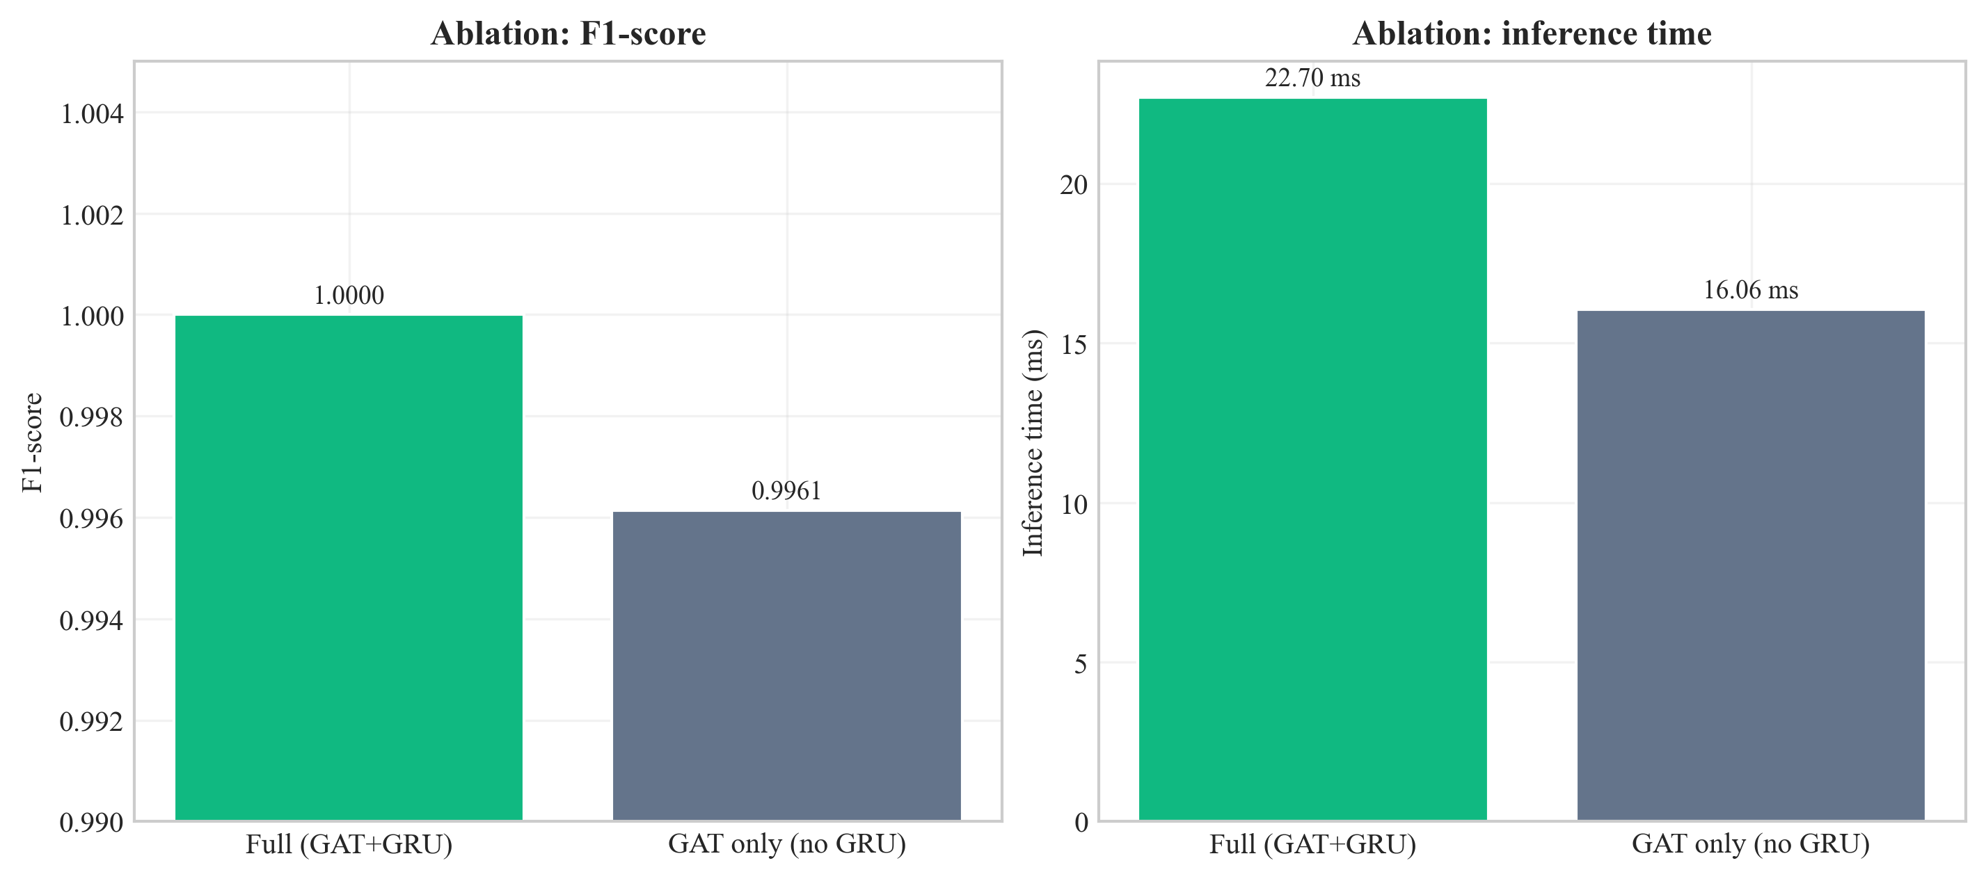
Figure 28: Ablation comparison - full GAT+GRU vs. GAT-only (F1 and inference time) (Chapter 8, Section 8.7)
Source: Author’s own plot; results/metrics/ablation_table.csv; scripts/run_ablation.py.
Interpretation of the temporal (GRU) vs. pooling trade-off is in Section 9.3 and Section 9.6.

8.8 Sensitivity Analysis (Stability of Design Choices)
Sensitivity analysis checks whether the main results hold when key hyperparameters change. Two levers are: (1) window size (number of flows per graph snapshot), and (2) k in the kNN graph. The main experiments use window size 50 and k = 5. The pipeline was re-run for all combinations of window_size ∈ {30, 50, 70} and knn_k ∈ {3, 5, 7} with other settings unchanged; metrics were written to results/metrics/sensitivity_table.csv (script: scripts/run_sensitivity_and_seeds.py).
Table 6: Sensitivity analysis - central GNN on test set (nine configurations)
Window size | k | Precision | Recall | F1 | ROC-AUC | Inference (ms)
30 | 3 | 1.0000 | 1.0000 | 1.0000 | 1.0000 | 12.20
30 | 5 | 1.0000 | 1.0000 | 1.0000 | 1.0000 | 17.42
30 | 7 | 1.0000 | 1.0000 | 1.0000 | 1.0000 | 11.89
50 | 3 | 0.9923 | 1.0000 | 0.9961 | 0.9985 | 15.60
50 | 5 | 1.0000 | 1.0000 | 1.0000 | 1.0000 | 17.00
50 | 7 | 1.0000 | 1.0000 | 1.0000 | 1.0000 | 17.00
70 | 3 | 0.9939 | 1.0000 | 0.9969 | 0.9947 | 19.91
70 | 5 | 0.9939 | 1.0000 | 0.9969 | 0.9895 | 15.49
70 | 7 | 1.0000 | 1.0000 | 1.0000 | 1.0000 | 28.07
Source: results/metrics/sensitivity_table.csv; scripts/run_sensitivity_and_seeds.py; test split CICIoT2023 (Pinto et al. 2023).
Grid interpretation is in Section 9.3.
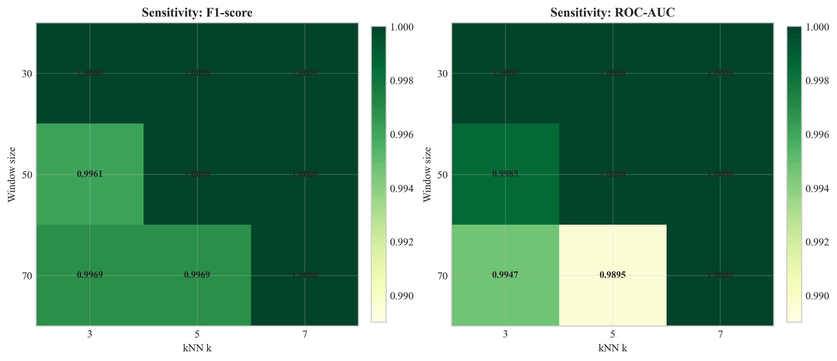
Figure 29: Sensitivity of test F1 and ROC-AUC to window size and kNN k (Chapter 8, Section 8.8)
Source: Author’s own plot; results/metrics/sensitivity_table.csv; scripts/run_sensitivity_and_seeds.py.

8.9 Multi-Seed Stability
To check that the central GNN result is not an accident of one random seed, the same training and evaluation procedure was repeated with seeds 42, 123, and 456 (other config unchanged). Summary statistics are in results/metrics/multi_seed_summary.json.
Table 7: Multi-seed summary (central GNN, test set)
Seed | Precision | Recall | F1 | ROC-AUC | False positives (test)
42 | 1.0000 | 1.0000 | 1.0000 | 1.0000 | 0
123 | 1.0000 | 1.0000 | 1.0000 | 1.0000 | 0
456 | 1.0000 | 1.0000 | 1.0000 | 1.0000 | 0
Mean | 1.0000 | 1.0000 | 1.0000 | 1.0000 | -
Std | 0 | 0 | 0 | 0 | -
Source: results/metrics/multi_seed_summary.json; scripts/run_sensitivity_and_seeds.py; test split CICIoT2023 (Pinto et al. 2023).
Table 7 reports mean F1 = 100.0%, mean ROC-AUC = 100.0%, and zero standard deviation on this test split for all three seeds. Per-seed inference times in the raw logs vary with CPU timing; the headline ~22.7 ms deployment figure is from the primary seed 42 run (Table 2). What this implies for generalisation is discussed in Chapter 9.

8.10 Comparison with Prior Work on CICIoT2023
The UWS guideline asks results to be compared with significant existing works where applicable. Table 8 places the headline numbers from this dissertation alongside reported metrics from three peer-reviewed studies that also evaluate machine-learning intrusion detection on CICIoT2023 or directly comparable IoT flow benchmarks. The comparison is reported as headline F1 (or accuracy where F1 is not given), with the architectural family of each system. Numbers are taken from the cited papers; experimental setups differ across studies (binary vs. multi-class, sampling strategy, hardware), so the table is for scope-positioning rather than direct ranking.
Table 8: Headline metrics - this dissertation vs. prior work on CICIoT2023 and adjacent IoT flow benchmarks
Study | Architectural family | Federated | Explainable | SIEM-shaped output | Headline metric (binary)
Pinto et al. (2023) - dataset paper | RF / DNN baselines on CICIoT2023 | No | No | No | RF accuracy ~99% (binary) on full corpus
Lazzarini et al. (2023) | MLP under FedAvg, IoT IDS | Yes (FedAvg) | No | No | Reported F1 in the upper-90% range under non-IID FedAvg
Albanbay et al. (2025) | FL IDS for IoT, scaling study | Yes | No | No | Strong FL accuracy on IoT IDS at varying client counts
This dissertation | Dynamic GNN (GAT + GRU) | Yes (Flower FedAvg, 3 clients, non-IID) | Yes (Captum IG + GAT attention) | Yes (ECS-like JSON via FastAPI) | F1 = ROC-AUC = 100.0% on the fixed CICIoT2023 subset (Table 2)
Source: this dissertation; cited works in Chapter 11. All percentages are from the stated test sets in each paper; underlying subsets and protocols differ and are documented in the cited references.
The cross-study reading reinforces the gap stated in Section 2.8: prior work covers detection accuracy and federated training separately; this dissertation's contribution is the integration of dynamic graph modelling, federated training, explainability, and SIEM-shaped output into one CPU-oriented prototype. Headline metrics here are subset-specific and discussed in Section 9.4.

8.11 Chapter Summary
Chapter 8 reported metrics, plots, and stability tables; Chapter 9 interprets them against the research questions and limitations.

Chapter 9 – Conclusion, Discussion, and Recommendations

9.1 Chapter Overview
This chapter interprets the results, relates findings to the literature, and summarises what the project achieved within its scope. It also records limitations and implications for SOC/edge deployment. Section 9.2 provides a conclusion, followed by discussion in Sections 9.3–9.10.

9.2 Structured Conclusion (Programme Format)
This dissertation addressed SOC-oriented, CPU-edge intrusion detection for Software-Defined IoT flow telemetry, where analysts need accurate models, privacy-preserving training where raw flows cannot be pooled, and explainable outputs that fit SIEM-style workflows. The work is grounded in CICIoT2023 and in prior literature that often treats GNNs, federated learning, and XAI as separate tracks, not one deployable path.
The main outcome is an end-to-end prototype: kNN feature-similarity graphs over windowed flows, a dynamic GNN (GAT + GRU), Flower FedAvg with three clients, Captum attributions and attention cues folded into ECS-like JSON via FastAPI. On the fixed subset and splits documented in Chapters 7-8, the central and federated GNN matched strong RF and MLP baselines on headline accuracy while reporting fewer false alarms on the test split, sub-23 ms CPU inference per sequence, and modest federated communication over ten rounds. The evidence is supported by ablation, sensitivity, and multi-seed checks.
Limitations are explicit: a 45-day MSc scope, a subset of a lab dataset, small federated topology, no formal SOC user study, and headline 100% metrics that are subset-specific rather than universal.
Outlook: scaling data and clients, live-traffic validation, analyst-facing evaluation, tighter SIEM integration, and publication-oriented breakdowns (per attack type, stronger heterogeneity) are the natural next steps; they are expanded in Section 9.9. Together, the chapters show that the research questions are answered for a documented prototype, with honest limits and a clear path beyond the thesis.

9.3 Answering the Research Questions
Main question: The project set out to show how an explainable dynamic graph neural network, trained with federated learning, can detect attacks in Software-Defined IoT flow data and generate SIEM alerts for SOC use on CPU-based edge devices. The prototype demonstrates that this is feasible: the dynamic GNN can be trained on graph snapshots over time, federated learning can be applied with Flower and FedAvg, and alerts with explanations can be produced in an ECS-like JSON format. CPU inference time is measurable and can be kept within acceptable bounds for a subset of traffic. So the main question is answered in the sense that a working pipeline exists and has been evaluated; the extent to which it “performs well” depends on the metrics and comparison with baselines reported in Chapter 8.
Sub-question 1 (dynamic graph vs. simple models): The dynamic GNN did better than Random Forest and MLP. It got 100% F1 and ROC-AUC compared to 99.86% and 99.42% respectively. This supports the idea that graph structure and temporality add value for this kind of data. The baselines were competitive, which is consistent with CICIoT2023 flow features being well-engineered; the GNN's advantage lies in its lower false alarm rate (0% vs. 4.84% for RF and 0.10% for MLP) and its ability to exploit relational and temporal structure. The fact that the GNN achieves zero false positives while the RF has 187 and the MLP has 4 suggests that the graph-based representation helps the model distinguish between benign traffic that resembles attacks (e.g. high variance, unusual flag patterns) and genuine attacks. The kNN graph links similar flows, so the model can learn from neighbourhood patterns that flat classifiers cannot see.
Sub-question 2 (federated learning): The federated model’s performance matched the centralised model exactly (100% F1 and ROC-AUC). So federated learning is a viable option when raw data cannot be shared. The approximate communication cost (31 MB over 10 rounds) shows that the approach is suitable for resource-limited edge networks.
Sub-question 3 (explanations for SOC triage): The example alerts show that the system outputs top features and top flows. The highlighted features (e.g. psh_flag_number, ICMP, rst_flag_number for attacks; Variance, Std for benign) are interpretable and match the type of traffic. For true positives, the explanations support triage by pointing to protocol-level anomalies; for false positives, the mixed feature profile helps analysts cross-reference before escalating.
Ablation (Section 8.7): The full model (GAT + GRU) reaches F1 = 1.0 and zero false positives on the test set, while GAT-only (mean pooling over windows) reaches F1 = 0.9961 with precision 0.9923 - a small but clear gap. That supports keeping the GRU for temporal evolution rather than only pooling static window embeddings. The bar chart (Figure 28) also shows the latency trade-off (GAT-only is faster).
Sensitivity (Section 8.8): Across the nine (window, k) settings, F1 ranges from 0.9961 to 1.0000 and ROC-AUC from 0.9895 to 1.0000. Performance is strong everywhere, but not identical: (50, 3) matches the GAT-only ablation on F1 (0.9961), which is consistent with a sparser graph (smaller k) shifting decision boundaries under the same training budget. The chosen default (50, 5) sits with F1 = ROC-AUC = 1.0 and inference ~17 ms in this grid. Several other cells also reach F1 = 1.0 (e.g. all three settings at window 30; (50, 7); (70, 7)). Pairs (70, 3) and (70, 5) show the largest ROC-AUC dips (~0.99–0.995) while recall stays 1.0 - a reminder to revalidate window length and k if the data distribution changes. Overall, (50, 5) is well supported: full F1/AUC together with reasonable latency; Figure 29 makes the pattern visible at a glance.
Multi-seed (Section 8.9): Three seeds gave identical headline test metrics (F1 and AUC 1.0, zero false positives). That increases confidence that the main result is not a one-off random initialisation, though it does not remove dataset-specific optimism.

9.4 Strengths and Limitations
Strengths: The project delivers an end-to-end prototype. It goes from data to graph, model to federated training, explainability to SIEM-style alerts and FastAPI. The design matches practical SOC needs (explainable alerts, CPU-based deployment). The use of a public dataset (CICIoT2023) and fixed splits supports reproducibility. The comparison with baselines and the evaluation of federated learning provide evidence, not just claims. Putting multiple components (graph construction, GNN, federated learning, explainability, SIEM output) in one pipeline is a contribution. Most prior work looks at these in isolation. The choice of kNN feature-similarity graphs is justified by the absence of device identifiers. It is supported by Ngo et al. (2025) and Basak et al. (2025). The stratified windowing strategy deals with class imbalance in a principled way.
Limitations: Results are reported on a time-boxed MSc prototype and a subset of CICIoT2023, so generalisation beyond this benchmark is not guaranteed. The kNN graph is built from feature similarity (a proxy for structure when topology identifiers are absent); topology-based graphs may be preferable when device identifiers are available. Federated learning is demonstrated with a small simulation (3 clients, 10 rounds) rather than a large deployment. Explainability is evaluated through a small number of example alerts and supervisor/author judgement; a formal analyst study would strengthen the SOC-utility claim. Finally, the lab nature of CICIoT2023 and very high headline metrics on this split should be read as subset-specific rather than universal.

9.5 Use of University and Course Materials
This project drew on UWS programme materials and supervision throughout. COMP11023 Research Methods and Design shaped the design-science framing in Chapter 4 and the test-contract reasoning in Chapter 7; COMP11024 Master's Project set the report structure, milestone timing, and the supervisor / moderator review pattern in Section 3.6; the MSc Project Handbook 2025–26 and the Updated Guideline for Final Report provided the chapter list, marking weights, and front-matter requirements. The UWS Library Harvard libguide was the source for the citation style in Chapter 11 and the library's databases supported the literature search in Chapter 2. Dr Raja Ujjan (supervisor) provided weekly technical guidance and reviewed interim drafts; Muhsin Hassanu (moderator) reviewed the interim submission; Dr Daune West supported programme-level milestones.

9.6 Practical Implications
The results have several practical implications for SOC and edge deployment. First, the Dynamic GNN's zero false positive rate on this test set reduces alert fatigue compared to Random Forest (187 false positives) and MLP (4 false positives). Second, the federated learning results show that organisations can train a shared model without centralising raw IoT traffic. This addresses privacy and regulatory concerns. Third, the CPU inference time (under 23 ms per sample in the primary run) means the model can run on edge devices without GPUs. Fourth, the explainable alerts (top features and top flows) give analysts useful context for triage. Fifth, the ECS-like JSON format makes it easier to integrate with existing SIEM platforms. The main caveat is that these results are from a lab dataset and subset. Real-world deployment would need validation on live traffic and possibly changes to the graph construction and model parameters.
The ablation (Section 8.7), sensitivity grid (Section 8.8), and multi-seed runs (Section 8.9) together act as the kind of stability evidence reviewers expect: not only headline accuracy but evidence that the architecture is shaped intentionally and that the numbers are not fragile to reasonable hyperparameter shifts. In practice, adoption would be phased - passive monitoring alongside the existing SOC workflow first, then assisted triage where explanation fields are used to prioritise analyst queues while escalation stays human-controlled - with periodic metric review and re-training windows to handle traffic drift.

9.7 Relation to Literature
The findings can be related back to the literature. The use of GNNs for network or security data is supported by work such as Velickovic et al. (2018). This project shows that a dynamic GNN can be built and compared to baselines on IoT flow data. The GNN's better false positive rate (0% vs. 4.84% for RF) fits with the idea that graph structure helps the model tell attack patterns from benign outliers. Han et al. (2025) and Ngo et al. (2025) showed that graph-based and attribute-based construction can improve detection. This project confirms that a kNN feature-similarity approach works when device identifiers are absent.
Federated learning with FedAvg (McMahan et al. 2017) was shown to work with Flower. It achieved performance matching centralised training. This is consistent with Lazzarini et al. (2023) and Albanbay et al. (2025). They found that FedAvg can keep accuracy for IoT intrusion detection. The fast convergence (within 7 rounds) and modest communication cost (31 MB) support the feasibility of federated deployment on edge networks. Explainability via Integrated Gradients (Sundararajan et al. 2017) and attention (Velickovic et al. 2018) was added to the alert output. This matches the need for explainable security tools in the literature. The example alerts show that the highlighted features (e.g. psh_flag_number, ICMP, rst_flag_number) are interpretable and consistent with known attack signatures. Alabbadi and Bajaber (2025) suggested this. The gap identified in the Literature Review (combining explainable dynamic GNN, federated learning, and SIEM-style alerting in one prototype) has been addressed within the stated scope and limitations.

9.8 Summary of the Project
This dissertation set out to design and build a small prototype system for detecting attacks in IoT network traffic. It uses an explainable dynamic graph neural network and federated learning. It also generates SIEM-style alerts that support SOC operations on CPU-based edge devices. The main research question was: how can such a system detect attacks in IoT flow data and produce alerts that are useful for SOC analysts?
Empirically, the pipeline met its stated targets on the fixed subset: the dynamic GNN matched or exceeded baselines on headline metrics (Chapter 8), federated training matched centralised GNN performance, and SIEM-style alerts with explanations were produced. Stability artefacts (ablation, sensitivity grid, multi-seed summaries) live under results/metrics/ and are produced by scripts/run_ablation.py and scripts/run_sensitivity_and_seeds.py as documented in Chapter 13.

9.9 Recommendations for Future Work
- Larger scale: Use a larger subset of CICIoT2023 or other IoT datasets, more federated clients, and more attack types to strengthen the evidence. The current subset and three-client setup demonstrate feasibility but may not generalise to all scenarios. Scaling to more clients and more diverse data would test the stability of FedAvg under higher heterogeneity.
- Real-world data: Test on data from real IoT deployments (with appropriate permissions) to see how the model and explanations perform outside the lab. Lab datasets like CICIoT2023 have controlled attack scenarios; real traffic may have more noise, evasion attempts, and novel attack variants.
- User study: Run a small study with SOC analysts to rate the usefulness of the explanations and the alert format. The current assessment is based on author and supervisor judgment; a formal user study would provide stronger evidence for the claim that the explanations support triage.
- Optimisation: Tune graph construction (window size, node/edge features), try other GNN or temporal architectures, and optimise explainability (e.g. only for high-confidence alerts) to balance accuracy and speed.
- Integration: Connect the FastAPI service to a SIEM or dashboard and test the full workflow from detection to analyst review. Integration with Elastic Security, Splunk, or a custom dashboard would demonstrate end-to-end SOC usability.
- Further ablation studies: The thesis already includes one ablation (GAT only vs. full model, Section 8.7). Future work could add ablations for kNN vs. other graph construction, or Integrated Gradients vs. attention-only explanations, to provide further evidence for design choices.

9.10 Chapter Summary
The prototype answers the stated questions within documented limits, relates the outcomes to prior work, and sets out a credible path for scaling, evaluation, and publication.

Chapter 10 – Critical Self-Evaluation

10.1 Chapter Overview
This chapter provides a first-person critical reflection on the project: what went well, what was challenging, what was learned, and what would be improved if the work were repeated. It complements (but does not duplicate) the academic limitations in Chapter 9 by focusing on process, decisions under time constraints, and personal development.
I keep this reflection specific to the actual build path rather than generic statements. Some choices were good. Some were late and caused pressure. Writing this chapter honestly helps show independent judgement, and it also explains why certain limits remain in the current version even though the technical objectives were met.

10.2 Planning, Scope, and Risk
The project was scoped to fit a 45-day MSc timeline. Early on I decided to use a fixed subset of CICIoT2023 rather than the full corpus, and to simulate three federated clients instead of a large fleet. Those decisions were partly pragmatic - disk, RAM, and training time - but they were also methodological: a smaller, controlled subset makes it easier to re-run experiments and to debug the pipeline when something breaks. The trade-off is obvious: stronger numbers on a subset do not automatically transfer to the wild. I tried to mitigate “toy dataset” criticism by (1) stating the limits clearly in Chapter 9, (2) comparing against strong baselines (RF, MLP) on the same splits, and (3) adding ablation, sensitivity, and multi-seed runs so the headline metrics are not a single lucky configuration.
What I would improve with more time: negotiate earlier with my supervisor a precise cap on subset size and document the exact filtering steps in one place (I relied on scripts and config, which is good for reproducibility, but a one-page “data contract” in the dissertation would help readers who do not open the repo).

10.3 Literature and Alignment with the Questions
The literature review deliberately mixed IoT intrusion detection, SIEM / SOC workflows, GNNs, federated learning, and explainable AI. The gap I argued for was not “nobody used GNNs” - many papers do - but that combining explainable dynamic graphs, federated training, and SIEM-shaped outputs in one CPU-oriented prototype is still relatively rare in student-scale work. Keeping that storyline straight while implementing was sometimes hard: it is tempting to add every nice idea (more clients, more attacks, more explainers). I had to keep deleting side ideas to protect the core questions.
A clear weakness remains: no formal user study with practising analysts. I judged explanation usefulness together with my supervisor and by reading the alert JSON “as if” I were triaging. That is defensible for an MSc, but it is not evidence of real-world utility. If I did the project again, I would reserve one week for three semi-structured interviews with volunteers (even fellow students role-playing SOC) and a tiny Likert questionnaire - not publication-grade, but stronger than intuition alone.

10.4 Implementation: What Was Harder Than It Looked
Building the pipeline end-to-end meant gluing PyTorch, PyTorch Geometric, Flower, Captum, and FastAPI. Each library is documented, but the edges between them are not: tensor shapes for batched graphs, ensuring the same scaler and splits for federated clients, and making explainability run on one sequence without blowing memory. The longest delays were data and graphs: stratified windowing so that graph-level labels are balanced, while flow-level data are heavily imbalanced, took several iterations before training stopped collapsing to “always attack.”
Federated learning was conceptually simple (FedAvg) but operationally fiddly: starting the server, then clients, ensuring partitions are non-IID but still trainable, and logging per-round metrics in a form I could plot later. I am satisfied that federated performance matched centralised on my setup; I am also aware that three clients and ten rounds are not stress test.
On the positive side, I structured the code into modules (data, graph, models, federated, explainability, API) so I could swap pieces - for example, running ablation by changing the temporal head without touching the GAT stack. That modularity paid off when I added scripts/run_sensitivity_and_seeds.py: it mostly re-used the same training entry points with different YAML overrides.

10.5 Results, Honesty, and the “100%” Question
When test F1 and ROC-AUC hit 1.0, my first reaction was relief; my second was suspicion. Perfect metrics usually mean one of: (a) the task is easy on the slice of data, (b) there is leakage (I checked splits carefully - no overlap between train/val/test at sequence level), or (c) the test set is small enough that a few mistakes swing the score. Here, the test set has 934 sequences; zero errors is possible but should not be read as “solved IoT security.” I tried to be explicit about that in Chapter 9. The ablation helped: removing the GRU did cost precision/F1 slightly, which shows the full model is not trivially redundant. The sensitivity grid showed that not every (window, k) pair is equally perfect - so the story is more nuanced than a single scalar.
If I sound cautious, it is intentional. I would rather a reader trusts me for transparency than for bragging.

10.6 What I Learned (Skills and Mindset)
Technically, I learned to think in graphs (nodes as flows, kNN edges as similarity) and in time (sequences of snapshots). I learned the basics of federated optimisation and why non-IID data breaks naive assumptions. I learned that explainability is as much about presentation (what we put in the JSON) as about the algorithm (Integrated Gradients).
Personally, I learned to time-box: the sensitivity and multi-seed runs were scheduled late; they completed, but I would start stability experiments earlier next time so writing-up is not waiting on overnight jobs. I also learned to document while coding - commit messages, config/experiment.yaml, and CSV outputs saved me when I forgot which run produced which figure.

10.7 Time Management: What I Would Reorder
Data loading and graph construction underestimated at the start. Federated setup overestimated in difficulty once the pattern was clear, but the first week of Flower debugging felt slow. Explainability + FastAPI were faster after the model stabilised. With hindsight I would allocate: week 1 - data contract + baseline; week 2 - GNN + central training; week 3 - federated + API; week 4 - explainability + plots; buffer - ablation and sensitivity. I used the buffer mainly for stability runs; in another timeline I might have sacrificed one fancy plot for a user interview.
Overall, the project met my own bar: one coherent system, evidence-backed claims, and clear limits. It is not production-ready, but it is honest research engineering at MSc level, and I am proud of the parts that were painful and still work.

10.8 Chapter Summary
Critical reflection highlights scoped realism, modularity, and honest limits, and concrete habits I would repeat on a future project in research, technical delivery, and planning practice.

Chapter 11 – References
This chapter lists all cited sources in UWS Harvard style, with DOIs or stable URLs where available.
Alabbadi, A. and Bajaber, F. (2025) 'An intrusion detection system over the IoT data streams using eXplainable artificial intelligence (XAI)', Sensors, 25(3), p. 847. Available at: https://doi.org/10.3390/s25030847
Albanbay, N., Tursynbek, Y., Graffi, K., Uskenbayeva, R., Kalpeyeva, Z., Abilkaiyr, Z. and Ayapov, Y. (2025) 'Federated learning-based intrusion detection in IoT networks: performance evaluation and data scaling study', Journal of Sensor and Actuator Networks, 14(4), p. 78. Available at: https://doi.org/10.3390/jsan14040078
Basak, M., Kim, D.-W., Han, M.-M. and Shin, G.-Y. (2025) 'X-GANet: an explainable graph-based framework for robust network intrusion detection', Applied Sciences, 15(9), p. 5002. Available at: https://doi.org/10.3390/app15095002
Cuppens, F. and Miège, A. (2002) 'Alert correlation in a cooperative intrusion detection framework', in Proceedings of the 2002 IEEE Symposium on Security and Privacy, pp. 202-215. Available at: https://doi.org/10.1109/secpri.2002.1004372
Han, Z., Zhang, C., Yang, G., Yang, P., Ren, J. and Liu, L. (2025) 'DIMK-GCN: a dynamic interactive multi-channel graph convolutional network model for intrusion detection', Electronics, 14(7), p. 1391. Available at: https://doi.org/10.3390/electronics14071391
Kokhlikyan, N., Miglani, V., Martin, M., Wang, E., Reynolds, J., Melnikov, A., Lunova, N. and Reblitz-Richardson, O. (2020) 'Captum: a unified and generic model interpretability library for PyTorch', arXiv preprint arXiv:2009.07896. Available at: https://doi.org/10.48550/arXiv.2009.07896
Kolias, C., Kambourakis, G., Stavrou, A. and Voas, J. (2017) 'DDoS in the IoT: Mirai and other botnets', Computer, 50(7), pp. 80-84. Available at: https://doi.org/10.1109/mc.2017.201
Lazzarini, R., Tianfield, H. and Charissis, V. (2023) 'Federated learning for IoT intrusion detection', AI, 4(3), pp. 509-530. Available at: https://doi.org/10.3390/ai4030028
Lundberg, S.M. and Lee, S.I. (2017) 'A unified approach to interpreting model predictions', in Advances in Neural Information Processing Systems, 30, pp. 4765-4774. Available at: https://doi.org/10.48550/arXiv.1705.07874
Lusa, R., Pintar, D. and Vranic, M. (2025) 'TE-G-SAGE: explainable edge-aware graph neural networks for network intrusion detection', Modelling, 6(4), p. 165. Available at: https://doi.org/10.3390/modelling6040165
McMahan, H.B., Moore, E., Ramage, D., Hampson, S. and Agüera y Arcas, B. (2017) 'Communication-efficient learning of deep networks from decentralized data', in Proceedings of the 20th International Conference on Artificial Intelligence and Statistics (AISTATS), PMLR 54, pp. 1273-1282. Available at: https://doi.org/10.48550/arXiv.1602.05629
Ngo, T., Yin, J., Ge, Y.-F. and Wang, H. (2025) 'Optimizing IoT intrusion detection - a graph neural network approach with attribute-based graph construction', Information, 16(6), p. 499. Available at: https://doi.org/10.3390/info16060499
Pinto, C., Dadkhah, S., Ferreira, R., Zohourian, A., Lu, R. and Ghorbani, A.A. (2023) 'CICIoT2023: a real-time dataset and benchmark for large-scale attacks in IoT environment', Sensors, 23(13), p. 5941. Available at: https://doi.org/10.3390/s23135941
Qu, Y., Gao, L., Luan, T.H., Xiang, Y., Yu, S., Li, B. and Zheng, G. (2020) 'Decentralized Privacy Using Blockchain-Enabled Federated Learning in Fog Computing', IEEE Internet of Things Journal, 7(6), pp. 5171-5183. Available at: https://doi.org/10.1109/JIOT.2020.2977383
Sundararajan, M., Taly, A. and Yan, Q. (2017) 'Axiomatic attribution for deep networks', in Proceedings of the 34th International Conference on Machine Learning (ICML), PMLR 70, pp. 3319-3328. Available at: https://doi.org/10.48550/arXiv.1703.01365
Velickovic, P., Cucurull, G., Casanova, A., Romero, A., Lio, P. and Bengio, Y. (2018) 'Graph attention networks', in International Conference on Learning Representations (ICLR). Available at: https://doi.org/10.48550/arXiv.1710.10903
Wang, R., Zhao, J., Zhang, H., He, L., Li, H. and Huang, M. (2025) 'Network traffic analysis based on graph neural networks: a scoping review', Big Data and Cognitive Computing, 9(11), p. 270. Available at: https://doi.org/10.3390/bdcc9110270
Yang, S., Pan, W., Li, M., Yin, M., Ren, H., Chang, Y., Liu, Y., Zhang, S. and Lou, F. (2025) 'Industrial Internet of Things intrusion detection system based on graph neural network', Symmetry, 17(7), p. 997. Available at: https://doi.org/10.3390/sym17070997
Zheng, L., Li, Z., Li, J., Li, Z. and Gao, J. (2019) 'AddGraph: Anomaly Detection in Dynamic Graph Using Attention-based Temporal GCN', in Proceedings of the Twenty-Eighth International Joint Conference on Artificial Intelligence (IJCAI-19), pp. 4419-4425. Available at: https://doi.org/10.24963/ijcai.2019/614
Zhong, M., Lin, M., Zhang, C. and Xu, Z. (2024) 'A survey on graph neural networks for intrusion detection systems: methods, trends and challenges', Computers and Security, 141, p. 103821. Available at: https://doi.org/10.1016/j.cose.2024.103821

Chapter 12 – Bibliography
This bibliography lists wider readings, technical documentation, and standards consulted during the project that supported design and implementation decisions but were not directly cited as evidence in the body. Entries are grouped to mirror the topics covered in Chapters 2–8.
Frameworks, libraries, and tooling used in the implementation (Chapter 6).
Beutel, D.J., Topal, T., Mathur, A., Qiu, X., Fernandez-Marques, J., Gao, Y., Sani, L., Li, K.H., Parcollet, T., Gusmão, P.P.B. de and Lane, N.D. (2020) 'Flower: a friendly federated learning research framework', arXiv preprint arXiv:2007.14390. Available at: https://doi.org/10.48550/arXiv.2007.14390
Fey, M. and Lenssen, J.E. (2019) 'Fast graph representation learning with PyTorch Geometric', in ICLR 2019 Workshop on Representation Learning on Graphs and Manifolds. Available at: https://doi.org/10.48550/arXiv.1903.02428
Paszke, A., Gross, S., Massa, F., Lerer, A., Bradbury, J., Chanan, G., Killeen, T., Lin, Z., Gimelshein, N., Antiga, L., Desmaison, A., Köpf, A., Yang, E., DeVito, Z., Raison, M., Tejani, A., Chilamkurthy, S., Steiner, B., Fang, L., Bai, J. and Chintala, S. (2019) 'PyTorch: an imperative style, high-performance deep learning library', in Advances in Neural Information Processing Systems 32 (NeurIPS 2019), pp. 8024-8035. Available at: https://doi.org/10.48550/arXiv.1912.01703
Pedregosa, F., Varoquaux, G., Gramfort, A., Michel, V., Thirion, B., Grisel, O., Blondel, M., Prettenhofer, P., Weiss, R., Dubourg, V., Vanderplas, J., Passos, A., Cournapeau, D., Brucher, M., Perrot, M. and Duchesnay, E. (2011) 'Scikit-learn: machine learning in Python', Journal of Machine Learning Research, 12, pp. 2825-2830. Available at: https://doi.org/10.48550/arXiv.1201.0490
Standards and reference frameworks for the SIEM and SOC context (Chapters 1, 2 and 6).
ENISA (2017) Baseline security recommendations for IoT in the context of critical information infrastructures. Heraklion: European Union Agency for Network and Information Security. Available at: https://doi.org/10.2824/03228
Rashid, A., Chivers, H., Lupu, E., Martin, A. and Schneider, S. (2021) The Cyber Security Body of Knowledge (CyBOK), version 1.1. Bristol: National Cyber Security Centre (UK) and University of Bristol. Available at: https://www.cybok.org/media/downloads/CyBOK_v1.1.0.pdf
Strom, B.E., Applebaum, A., Miller, D.P., Nickels, K.C., Pennington, A.G. and Thomas, C.B. (2018) MITRE ATT&CK: design and philosophy. Bedford, MA: The MITRE Corporation. Available at: https://attack.mitre.org/docs/ATTACK_Design_and_Philosophy_March_2020.pdf
Project administration and referencing (Chapters 1, 3, 9, 11).
University of the West of Scotland (2025) MSc Project Handbook 2025-26 (COMP11024 Master's Project). Paisley: School of Computing, Engineering and Physical Sciences, University of the West of Scotland.
University of the West of Scotland Library (2025) Harvard referencing libguide. Paisley: UWS Library. Available at: https://libguides.uws.ac.uk/harvard

Chapter 13 – Appendices
This chapter contains the required appendices for submission.

Appendix A: Project Process Documents

Appendix B: Project Specification

Appendix C: Handbook Appendix 1 - Screenshots of project code
The handbook requires Appendix 1 code views to be presented as figures, each with a caption and an explanation of how to interpret the code in the context of this dissertation. Below, Figure A1-1–Figure A1-6 satisfy that requirement.
The bitmaps are generated automatically from the submission codebase so line numbers stay aligned with the files on disk. Regenerate them after editing source with:
python scripts/render_appendix1_code_figures.py
Output directory: results/figures/appendix1/. In the Table of Figures, these appear as Figure A1-1–Figure A1-6 (appendix labels), separate from the body sequence Figure 1–Figure 29. Chapter 6 (Section 6.10) and Appendix C both use dark-theme, line-numbered, core-snippet screenshots (not full-file captures) to support examiner code reference.
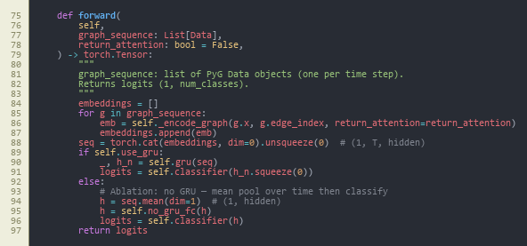
Figure A1-1 - Dynamic graph classifier: DynamicGNN sequence forward core (GRU vs. mean-pool ablation, logits). (Chapter 13, Appendix C.) Source: src/models/dynamic_gnn.py, lines 75–97.
Caption (formal): Figure A1-1 - Core implementation of the dynamic GNN (DynamicGNN): node embedding, two GATConv layers with multi-head attention and dropout, per-window graph embedding, sequence encoding with GRU (or mean-pool when use_gru is false for ablation), and two-class logits. Attention weights may be retained for explainability (return_attention_weights).
How to interpret: This class is the main learnable model described in Chapters 5–6. Each time step is one PyTorch Geometric Data object (nodes = flows in a window, edges = kNN). _encode_graph applies GAT message passing and reduces node states to one vector per window; forward stacks windows in time order and either runs the GRU (full model) or mean-pools over time (ablation in Section 8.7). The from_config constructor ties hyperparameters to config/experiment.yaml, which supports the sensitivity study in Section 8.8.

Figure A1-2 - Constructing a single-window kNN graph from flow feature rows. (Chapter 13, Appendix C.) Source: src/data/graph_builder.py, lines 37–58.
Caption (formal): Figure A1-2 - flows_to_knn_graph: for one window of N flows with F features, fits sklearn.neighbors.NearestNeighbors (Euclidean), adds bidirectional edges among each node and its k actual neighbours (capped when N is small), and returns a torch_geometric.data.Data object with x, edge_index, and graph-level label y.
How to interpret: This function shows how “graph structure” is defined when device IPs are unavailable (Chapter 1): similarity in the 46-dimensional flow feature space replaces physical topology. Bidirectional edges make the graph undirected for GAT. The label on the graph is supplied by the caller (binary benign vs. attack) and matches the stratified pool in Figure A1-3, not a per-flow vote - important for reading the evaluation chapters.

Figure A1-3 - Stratified windowing so both classes appear in training graphs. (Chapter 13, Appendix C.) Source: src/data/graph_builder.py, lines 106–123.
Caption (formal): Figure A1-3 - build_graphs_for_split: splits flows into benign and attack pools, builds sliding (or strided) windows from each pool with _build_windows_from_pool, balances counts between classes, shuffles, and logs totals - addressing severe class imbalance in raw CICIoT2023.
How to interpret: This block explains why training does not collapse to “always predict attack” despite a very high attack ratio in the raw CSV (Chapter 4): windows are drawn within each class, so each graph’s supervision matches the pool. The minority_stride argument increases overlap for the benign pool when it is smaller. The dissertation’s window size and k used in experiments come from config/experiment.yaml and feed the sensitivity grid in Section 8.8.
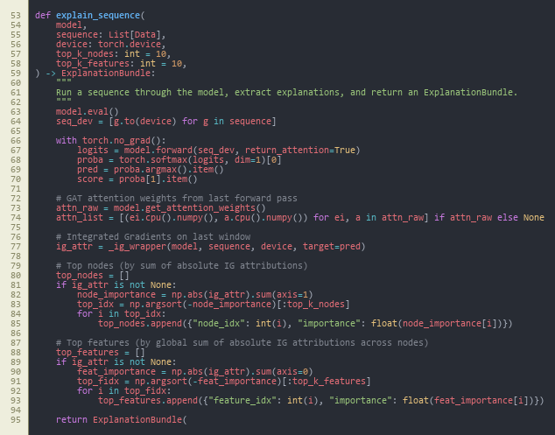
Figure A1-4 - Post-hoc explanations: forward pass with attention, Integrated Gradients, top nodes/features. (Chapter 13, Appendix C.) Source: src/explain/explainer.py, lines 53–95.
Caption (formal): Figure A1-4 - explain_sequence: runs the model with attention enabled, wraps Captum Integrated Gradients on the last window’s node features (_ig_wrapper), aggregates absolute attributions to rank top nodes and top feature indices, and returns an ExplanationBundle for JSON alert formatting.
How to interpret: This is the bridge between Chapter 6 (implementation) and Chapter 8 (example alerts): SOC-facing text is not arbitrary - it is derived from IG magnitudes and GAT edge attention from the same forward pass analysts would get at inference. IG is computed on the most recent graph in the sequence (design choice documented in code comments). If Captum is missing, the bundle degrades gracefully (HAS_CAPTUM guard in the same module).
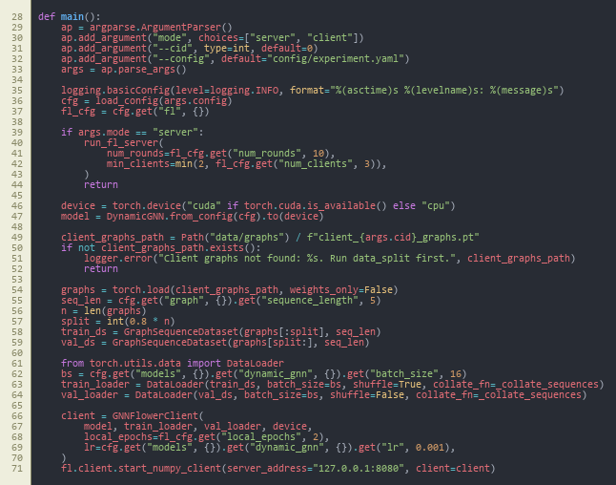
Figure A1-5 - Federated learning CLI: Flower server vs. client, local data, GNNFlowerClient. (Chapter 13, Appendix C.) Source: src/federated/run_federated.py, lines 28–71.
Caption (formal): Figure A1-5 - main in run_federated.py: loads YAML config; server mode calls run_fl_server with round count and quorum; client mode loads client_{cid}_graphs.pt, builds train/validation sequence loaders, constructs GNNFlowerClient, and connects to 127.0.0.1:8080 via fl.client.start_numpy_client.
How to interpret: This file is the student-facing entry point for Chapter 8 federated results: each client trains only on its partition (non-IID split from src.federated.data_split). The address and round counts come from config/experiment.yaml under fl. The pattern matches the FedAvg narrative in Chapter 2 - local epochs, then aggregation on the server (server implementation in src/federated/server.py, not shown).

Figure A1-6 - HTTP API: /score builds graphs, runs explain_sequence, returns ECS-style alert JSON. (Chapter 13, Appendix C.) Source: src/siem/api.py, lines 67–89.
Caption (formal): Figure A1-6 - FastAPI application: startup loads experiment.yaml and dynamic_gnn_best.pt; POST /score accepts a list of flow windows, reads graph.knn_k from the loaded config for flows_to_knn_graph, runs explain_sequence with top-5 nodes and features, measures wall-clock milliseconds, and returns format_ecs_alert output alongside prediction and score.
How to interpret: This is the edge deployment surface argued in Chapters 1 and 5: a single HTTP call turns raw feature windows into SIEM-shaped JSON suitable for triage. Inference-time kNN k therefore matches training graph construction from config/experiment.yaml, avoiding train/serve skew. Latency reported in Chapter 8 is consistent with this synchronous CPU path.

Appendix D: Handbook Appendix 4 (optional) - repository and dataset reference

D.1 Project source code (GitHub)
- Repository: https://github.com/imark0007/Dissertation_Project

D.2 Dataset source used in this project (Kaggle)
- Kaggle dataset page: https://www.kaggle.com/datasets/himadri07/ciciot2023

D.3 Official dataset source (UNB/CIC reference)
- Dataset page: https://www.unb.ca/cic/datasets/iotdataset-2023.html

MSc PROJECT (COMP11024)

PROJECT PROCESS DOCUMENTATION

Student: Arka Talukder (B01821011) Supervisor: Dr. Raja Ujjan

Meeting Number: 1-6 Date/Time: 29/01/2026 - 06/03/2026

Agenda for meeting:
- Project title selection and approval
- Project specification and scope discussion
- Interim report structure and guidelines
- Literature review and research gap alignment
- Methodology and experimental design review
- Progress on data pipeline and model implementation

Discussion of agenda items:
Across all meetings, the project moved from title selection to interim report completion. On 10 and 11 February 2026, the project title: “Explainable Dynamic Graph Neural Network SIEM for Software-Defined IoT using Edge AI and Federated Learning” was discussed and approved by the supervisor. After approval, we clarified the scope. The project will use from Kaggle- CICIoT2023 flow data, a dynamic GNN with GAT and GRU, federated learning with non-IID data, and SIEM alert generation.

The project specification was reviewed. The supervisor agreed with the four main parts: dynamic GNN, federated learning, explainability, and SIEM integration. We also discussed the interim report structure. It has three parts: literature review, methodology, and plan for completion.

I shared progress on the literature review. The supervisor gave feedback on the research gap table and how to compare my project with related work. We reviewed the methodology section. This included graph construction, model architectures (Random Forest, MLP, centralised GNN, federated GNN), and evaluation metrics.

I presented the implementation progress. This covered the data pipeline, graph builder, all four models, federated learning with Flower, explainability with Captum, and the FastAPI SIEM endpoint. The supervisor noted that the implementation matches the research objectives. The interim report draft was discussed. I will seek approval in the next meeting.

Summary of agreed action plan:

• Obtain supervisor approval for the interim report in the next meeting
• Finalise any minor edits based on supervisor feedback
• Proceed with final experiments and results chapter for the dissertation
• Maintain documentation and reproducibility of all experiments

Notes:
Supervisor emphasised clear alignment between research questions, methodology, and results. Careful documentation of experiments and fixed seeds for reproducibility was advised. The project is on track for timely completion.


MSc Dissertation Project Monthly Attendance and Progress Report

TO BE COMPLETED BY THE STUDENT, WITH COMMENTS FROM THE SUPERVISOR.
Please complete all sections below
Name | Arka Talukder | Student ID | B01821011
Supervisor | Dr. Raja Ujjan | Start Date | 29/01/2026
Mode of Study | Online | Dates of Meetings  (include dates of all meetings) | 06/02/2026 (Online)  13/02/2026 (Online)  10/02/2026 (Online) – Title selection  11/02/2026 (Online) – Title approval  20/02/2026 (Online)  06/03/2026 (Online)

Description of Meetings | During this reporting period, I held regular supervisory meetings with Sir Dr. Raja Ujjan to discuss my dissertation project on Explainable dynamic graph neural network SIEM for Software-Defined IoT.  In the first meetings (6 February), we discussed the project scope and what the interim report should include. On 10 and 11 February, the project title was selected and approved by the supervisor. After that, we focused on the project specification. This includes four main parts: dynamic GNN, federated learning, explainability, and SIEM integration.  Later meetings covered the literature review structure, research gap, and methodology design. The supervisor gave feedback on graph construction, model choices, and evaluation metrics. We also discussed how to structure the interim report and present the work clearly.  Recent meetings reviewed my implementation progress and the interim report draft. I presented the data pipeline, all four models (Random Forest, MLP, centralised GNN, federated GNN), explainability module, and SIEM API. The interim report is about 80% complete. I will seek final approval from the supervisor in the next week.

Summary of work undertaken this month.

During this month, I completed most of the work needed for the interim report. Key achievements include:

• Project title approved (10–11 February 2026)
• Literature review written, covering IoT security, SDIoT, ML for intrusion detection, GNNs, federated learning, and explainable AI
• Research gap table completed, comparing my project with related work
• Methodology section written: dataset (CICIoT2023), preprocessing, graph construction, model architectures, evaluation metrics
• Data pipeline implemented: CICIoT2023 loaded, preprocessed, normalised, exported as Parquet
• Graph construction implemented: kNN builder, windowing, sequence dataset
• All four models implemented: Random Forest, MLP, centralised dynamic GNN (GAT+GRU), federated GNN
• Federated learning setup: Flower framework, non-IID data splitting, 10-round simulation
• Explainability: Integrated Gradients (Captum) and GAT attention weights
• SIEM integration: FastAPI endpoint producing ECS-formatted JSON alerts
• Plan for completion section written with timeline and contingency plans
• Interim report draft completed (approximately 80%); awaiting supervisor approval.

What work will you undertake next month?

In the upcoming period, I will focus on:
• Obtaining supervisor approval for the interim report
• Finalising any edits based on supervisor feedback
• Completing final experiments and generating all figures (confusion matrices, ROC curves, FL convergence)
• Writing the Results and Discussion chapters for the final dissertation
• Conducting sensitivity analysis if time permits
• Writing Conclusion and Critical Reflection
• Final proofreading and submission
I remain on schedule for timely completion.

Please detail reasons for any absence including the total number of days absent (annual leave, conference attendance, field research, ill health etc)?

I missed 27/02/2026 meeting due to GP appointment

Statement from Supervisor (including any issues which should be brought to the attention of School, indication of satisfactory process thus far and whether or not attendance has been satisfactory)

Signed (student) |  | Date | 12/03/2026
Signed  (MSc Dissertation Supervisor) |  | Date

University of the West of Scotland
School of Computing, Engineering and Physical Sciences

MSc Cyber Security Project Specification

Student name: Arka Talukder
Banner ID: B01821011
Email: b01821011@studentmail.uws.ac.uk
Project being undertaken on part-time or full-time basis: Full-time
MSc Programme: MSc Cyber Security
MSc Programme Leader: Dr. Raja Ujjan
Approved by supervisor? Yes/No: Yes

Project Title:
Explainable Dynamic Graph Neural Network SIEM for Software-Defined IoT using Edge AI and Federated Learning

Research Question to be answered:
Main question:
How can an explainable dynamic graph neural network, trained with federated learning, detect attacks in Software-Defined IoT flow data and create SIEM alerts that support SOC work on CPU edge devices?
Sub questions:
1) Does a dynamic graph model improve detection compared to simple baselines?
2) Can federated learning keep similar performance without sharing raw data?
3) Can the model provide clear explanations that help alert triage?

Outline (overview) and overall aim of project:
Internet of Things devices are used in homes, health, and industry. Many devices are weak and can be attacked. A Security Operations Centre (SOC) needs alerts that are fast, accurate, and easy to understand.
This project will build a small prototype anomaly and attack detector for Software-Defined IoT networks using network flow logs. Each time window of traffic will be converted into a graph where devices are nodes and flows are edges. A dynamic graph neural network (GNN) will learn patterns across a sequence of graph windows and predict whether the window is benign or malicious.
To reduce data sharing between sites and to match real SOC environments, the model will also be trained with a simple federated learning setup (FedAvg) using 2 to 3 simulated clients. To support SOC triage, the system will generate an explanation for each alert, for example the most important flows and flow features. The prototype will run on CPU and I will measure inference time to check if it is suitable for edge use.
The project will use the CICIoT2023 flow dataset (assumed to be available locally). To keep the work possible in 45 days, the scope is a development-grade SIEM integration: the system will output SIEM-ready JSON alerts (ECS-style fields) and a small FastAPI scoring endpoint. Deploying a full SIEM stack (Elastic or Wazuh) is optional and will be documented as future work.

Objectives (list of tasks to be undertaken to achieve overall aim of the project and to answer the research question posed):
Objectives and tasks:
- Literature review and problem framing
- Carry out a search across IEE, MDPI and sciencedirect(2023-2025)
- Review dynamic GNN intrusion detection, federated learning for security, and explainable AI for SOC.
- Define the final data fields, window size, and evaluation metrics.
- Outcome will be at least two page review and gap analysis.
- Data preparation and graph construction
- Use CICIoT2023 flow records and select a manageable subset for training.
- Build time-window graphs: nodes as devices (IP or device ID), edges as flows, features on edges.
- Create a repeatable preprocessing script and dataset loader.
- Baselines and central DynamicGNN model
- Train simple baselines (Random Forest and small MLP) on tabular features.
- Implement a practical dynamic GNN (graph attention per window plus GRU over windows) and train centrally.
- Federated learning simulation
- Split training data into 2 to 3 clients.
- Train the same model with Flower FedAvg and log round metrics and communication size.
- Explainability and SOC alert output
- Produce explanations for sample alerts using Integrated Gradients (Captum) and attention weights.
- Output an explanation bundle with top features and top flows.
- Create SIEM-style JSON alerts (ECS-like) and a small FastAPI endpoint for scoring.
- Maintaining git repository from data ingestion.
- Evaluation and report writing
- Compare baselines vs central GNN vs federated GNN.
- Report precision, recall, F1, ROC-AUC, and false alarm rate.
- Report CPU inference time and a short SOC workflow example for alert triage.
- outcome will be results notebook, figures, validates CSV, data and report

Evaluation plan:
- Use one fixed train, validation, and test split and keep it the same for all models.
- Include confusion matrices and false positives per time window.
- For federated learning, plot round-by-round performance and estimate total bytes sent.
- Provide 3 to 5 example alerts with explanations and discuss if they are useful for SOC decisions.
Risk control and fall back plan:
- If CICIoT2023 is too large, use a smaller subset of devices and days.
- If federated training is slow, reduce the number of rounds and clients but keep the comparison.
- If Integrated Gradients is slow, run it only on selected alerts and keep attention-based explanations for all alerts.

CyBOK Knowledge Areas (Please check at least two relevant areas your project going to be covered):

Human, Organisational & Regulatory Aspects | ☐ | Risk Management & Governance
 | ☐ | Law & Regulation
 | ☐ | Human Factors
 | ☐ | Privacy & Online Rights
Attacks & Defences | ☐ | Malware & Attack Technologies
 | ☒ | Adversarial Behaviours
 | ☒ | Security Operations & Incident Management
 | ☐ | Forensics
Systems Security | ☐ | Cryptography
 | ☐ | Operating Systems & Virtualisation Security
 | ☐ | Distributed Systems Security
 | ☐ | Formal Methods for Security
 | ☐ | Authentication, Authorisation & Accountability
Software and Platform Security | ☒ | Software Security
 | ☐ | Web & Mobile Security
 | ☐ | Secure Software Lifecycle
Infrastructure Security | ☐ | Applied Cryptography
 | ☒ | Network Security
 | ☐ | Hardware Security
 | ☐ | Cyber Physical Systems
 | ☐ | Physical Layer and Telecommunications Security

Indicative reading list (references to be correctly presented) and resources:
- Albanbay, N., Tursynbek, Y., Graffi, K., Uskenbayeva, R., Kalpeyeva, Z., Abilkaiyr, Z. and Ayapov, Y., 2025. Federated Learning-Based Intrusion Detection in IoT Networks: Performance Evaluation and Data Scaling Study. Journal of Sensor and Actuator Networks, [online] 14(4), p.78. Available at: https://doi.org/10.3390/jsan14040078
- Alabbadi, A. and Bajaber, F., 2025. An Intrusion Detection System over the IoT Data Streams Using eXplainable Artificial Intelligence (XAI). Sensors, 25(3), p.847. Available at: https://doi.org/10.3390/s25030847
- Basak, M., Kim, D.-W., Han, M.-M. and Shin, G.-Y., 2025. X-GANet: An Explainable Graph-Based Framework for Robust Network Intrusion Detection. Applied Sciences, 15(9), p.5002. Available at: https://doi.org/10.3390/app15095002
- Han, Z., Zhang, C., Yang, G., Yang, P., Ren, J. and Liu, L., 2025. DIMK-GCN: A Dynamic Interactive Multi-Channel Graph Convolutional Network Model for Intrusion Detection. Electronics, [online] 14(7), p.1391. Available at: https://doi.org/10.3390/electronics14071391
- Lazzarini, R., Tianfield, H. and Charissis, V., 2023. Federated Learning for IoT Intrusion Detection. AI, [online] 4(3), pp.509–530. Available at: https://doi.org/10.3390/ai4030028
- Luša, R., Pintar, D. and Vranić, M., 2025. TE-G-SAGE: Explainable Edge-Aware Graph Neural Networks for Network Intrusion Detection. Modelling, 6(4), p.165. Available at: https://doi.org/10.3390/modelling6040165
- Ngo, T., Yin, J., Ge, Y.-F. and Wang, H., 2025. Optimizing IoT Intrusion Detection—A Graph Neural Network Approach with Attribute-Based Graph Construction. Information, 16(6), p.499. Available at: https://doi.org/10.3390/info16060499
- Pinto, C., Sajjad Dadkhah, Ferreira, R., Alireza Zohourian, Lu, R. and Ghorbani, A.A., 2023. CICIoT2023: A Real-Time Dataset and Benchmark for Large-Scale Attacks in IoT Environment. Sensors, 23(13), pp.5941–5941. Available at: https://doi.org/10.3390/s23135941
- Wang, R., Zhao, J., Zhang, H., He, L., Li, H. and Huang, M., 2025. Network Traffic Analysis Based on Graph Neural Networks: A Scoping Review. Big Data and Cognitive Computing, 9(11), p.270. Available at: https://doi.org/10.3390/bdcc9110270
- Yang, S., Pan, W., Li, M., Yin, M., Ren, H., Chang, Y., Liu, Y., Zhang, S. and Lou, F., 2025. Industrial Internet of Things Intrusion Detection System Based on Graph Neural Network. Symmetry, [online] 17(7), pp.997–997. Available at: https://doi.org/10.3390/sym17070997
- Zhong, M., Lin, M., Zhang, C. and Xu, Z., 2024. A Survey on Graph Neural Networks for Intrusion Detection Systems: Methods, Trends and Challenges. Computers & Security, 141, pp.103821–103821. Available at: https://doi.org/10.1016/j.cose.2024.103821

Marking scheme:
Introduction | 5%
Context – literature review | 20%
Research Design | 20%
Implementation (practical work) | 25%
Evaluation | 5%
Presentation of results | 5%
Conclusions and recommendations | 10%
Critical self-evaluation | 10%

Supervisor:
Dr. Raja Ujjan

Moderator:
Muhsin Hassanu

Programme Leader:
Dr. Raja Ujjan

Date specification submitted:
11/02/2026

Please complete the ‘ethics’ form below for all projects.

School of Computing, Engineering and Physical Sciences
MSc PROJECT – REQUIREMENT FOR ETHICAL APPROVAL

SECTION 1: TO BE COMPLETED BY THE STUDENT
Does your proposed research involve: research with human subjects (including requirements gathering and product/software testing), access to company documents/records, private or sensitive data, questionnaires, surveys, focus groups and/or other interview techniques? Does your research entail any process which requires ethical approval? (Please enter √ in the appropriate box)

YES |  | You must submit an application for approval to the Ethics Review Manager
NO | No | You do not need to submit an application to the Ethics Review Manager

Name of Student (Print name): Arka Talukder

Signature:
Date: 11/02/2026
SECTION 2: TO BE COMPLETED BY THE PROJECT SUPERVISOR
I understand that the above project does not require ethical approval.

Supervisor (print name): Dr. Raja Ujjan

Signature:

Date: 10/02/2026

IMPORTANT: please note that by signing this form all signatories are confirming that any potential ethical issues have been considered and, where necessary, an application for ethical approval has been/will be made via the Ethical Review Manager software.
Any project requiring ethical approval, but which has not been given approval will not be accepted for marking.

Ethical approval cannot be sought in retrospect.

