Dissertation Front Sheet


<Project Title>

<Sub-title (if used)>

<Your Name>
<Your Matric no.>

Thesis Project for the partial fulfilment
of the requirements for the Master Degree
in Information Technology/E-Business Management / Advanced Computer Systems Development (delete one)

University of the West of Scotland
School of Computing
<Date of submission>

Declaration of Originality


DECLARATION OF ORIGINALITY

I declare that this is an original study based on my own
work and that I have not submitted it for any other
course or degree.

Signature_______________________

Library Release Form



Library Form to Accompany MSc Project

  - To be completed in full

Surname:

First Name: Initials:

Banner No:

Course Code:

Course Title:

Project Supervisor:

Project Title:

Session: Date of Submission:

Signature:

Please ensure that a copy of this form is included with your project before submission.

Table of Contents

List of Figures

List of Tables

Explainable Dynamic Graph Neural Network SIEM for Software-Defined IoT using Edge AI and Federated Learning
Arka Talukder | B01821011
MSc Cyber Security (Full-time)
University of the West of Scotland
School of Computing, Engineering and Physical Sciences
Supervisor: Dr. Raja Ujjan
Humanized submission file: this document is synchronised with the main thesis Markdown (Dissertation_Arka_Talukder.md) for identical technical method, tables, figures, references, and Harvard (UWS) citations, so the Word export matches supervisor and programme requirements (no alternative data splits or unverified claims). Regenerate the paired .docx with: python scripts/sync_humanized_md_and_docx.py.

1. Abstract
Internet of Things (IoT) deployments produce large flow telemetry that Security Operations Centres (SOCs) must triage on CPU-only edge infrastructure. Detectors should be accurate, privacy-aware, and explainable, so analysts can act on alerts without extra investigation delay.
This dissertation develops an end-to-end prototype on CICIoT2023 (Pinto et al. 2023). Flows are standardised, grouped into windows, converted into kNN similarity graphs, and classified by a dynamic GNN (GAT + GRU) built with PyTorch Geometric. The same architecture is trained centrally and with Flower FedAvg across three non-IID clients (Dirichlet alpha = 0.5). Explainability combines Captum Integrated Gradients and GAT attention, and results are served as ECS-like JSON through a FastAPI endpoint.
Results. On the held-out test split, central and federated GNN runs achieve F1 = 100% and ROC-AUC = 100% with zero false positives, while Random Forest and MLP achieve F1 = 99.86% and 99.42%. Mean CPU inference is about 23 ms per five-window sequence, and federated communication is about 31 MB over ten rounds. Ablation, sensitivity, and multi-seed checks support these findings.
Keywords: IoT security, dynamic graph neural network, federated learning, SIEM, explainable AI, edge AI, SOC, CICIoT2023

Acknowledgements
I thank my supervisor, Dr. Raja Ujjan, for technical guidance, feedback on design and evaluation, and support throughout the project. I thank my moderator, Muhsin Hassanu, for reviewing interim work and helping sharpen the final report. I also thank Dr. Daune West for support and academic encouragement during the submission period. I am grateful to School and programme staff for module materials and submission guidance, and to the MSc Project co-ordinator for administrative communication around milestones and ethics. Finally, I thank friends and family for patience during intensive writing and experiment runs.

List of Abbreviations
Abbrev. | Definition
AI | Artificial Intelligence
API | Application Programming Interface
AUC | Area Under the (ROC) Curve
BCE | Binary Cross-Entropy (loss)
CICIoT | Canadian Institute for Cybersecurity IoT benchmark family (this work: CICIoT2023)
CPU | Central Processing Unit
CyBOK | Cyber Security Body of Knowledge
DDoS | Distributed Denial of Service
DL | Deep Learning
ECS | Elastic Common Schema (log/alert shape used as a guide)
ENISA | European Union Agency for Cybersecurity
FedAvg | Federated Averaging (McMahan et al. 2017)
FL | Federated Learning
FN | False Negative
FP | False Positive
FPR | False Positive Rate
GAT | Graph Attention Network
GCN | Graph Convolutional Network
GDPR | General Data Protection Regulation (EU)
GNN | Graph Neural Network
GPU | Graphics Processing Unit
GRU | Gated Recurrent Unit
IDS | Intrusion Detection System
IG | Integrated Gradients
IoT | Internet of Things
IID | Independent and Identically Distributed (data split)
IPS | Intrusion Prevention System
JSON | JavaScript Object Notation
kNN | k-Nearest Neighbours (graph construction)
LSTM | Long Short-Term Memory
ML | Machine Learning
MLP | Multi-Layer Perceptron
MITM | Man-in-the-Middle (attack pattern)
NCSC | National Cyber Security Centre (UK)
NIS2 | EU Directive on measures for a high common level of cybersecurity
NIST | National Institute of Standards and Technology (US)
non-IID | Non-identical client data distributions
PyG | PyTorch Geometric
RAM | Random Access Memory
RF | Random Forest (baseline classifier)
ROC | Receiver Operating Characteristic
RNN | Recurrent Neural Network
SDIoT | Software-Defined Internet of Things
SDN | Software-Defined Networking
SIEM | Security Information and Event Management
SOC | Security Operations Centre
TN | True Negative
TP | True Positive
TPR | True Positive Rate (equals recall in binary classification)
UML | Unified Modelling Language
VAE | Variational Autoencoder (not used in this prototype; listed for generative-model context only)
XAI | Explainable Artificial Intelligence

Chapter 1 – Introduction

1.1 Chapter Overview
This chapter introduces the project context, IoT flow telemetry, SOC alert volume, and practical limits at CPU-based edge nodes. It explains why this work combines dynamic graph learning, federated training, and explainable alerts in one pipeline, then states the research aim, sub-questions, scope, and chapter structure so later chapters can focus on method, implementation, and evidence.

1.2 Background and Motivation
The Internet of Things (IoT) has expanded very fast in homes, offices, campuses, and industrial sites. Smart plugs, cameras, sensors, and controllers are now everywhere. Many of these devices are low-cost and constrained, and security is often secondary during design. As a result, weak credentials, late patching, and misconfiguration are still common in real deployments.
This means attack exposure remains high. A compromised IoT device can be used for botnet activity, service disruption, credential theft, or lateral movement into wider infrastructure. These are not rare scenarios in security reports. Because of this, continuous monitoring of network behaviour is needed, not optional, especially in environments with mixed old and new devices.
Software-defined approaches (including SDN and software-defined IoT) allow operators to observe flow statistics from switches and routers in a centralised way. Flow summaries are often enough for intrusion detection without full packet capture, which reduces storage pressure and can ease some privacy concerns. The remaining challenge is to analyse those flows accurately, to explain decisions in a form analysts can use, and to do so on hardware that is realistic at the edge (often CPU-only).
Security Operations Centres (SOCs) monitor networks, investigate alerts, and coordinate incident response, usually with SIEM platforms that aggregate logs and flow-derived events. A practical difficulty is alert fatigue: high volumes of alerts and many false positives reduce the time analysts can spend on genuine incidents. Alerts that only give a label, with no indication of why the model fired, slow triage further. There is therefore a need for detectors that are both accurate and explainable, so staff can trust and act on outputs under time pressure.
Traditional models such as Random Forests or feed-forward networks can work on tabular flow features, yet traffic also has relational structure: flows resemble neighbours in feature space, share endpoints when identifiers exist, or arrive in short bursts that carry meaning together. Graph models treat flows as nodes and connect related flows with edges (here, kNN links in feature space because the public CICIoT2023 release does not provide device-level topology). Dynamic GNNs extend this idea by learning how graph snapshots evolve over short windows. Separately, IoT data are often distributed across sites where pooling raw flows is legally or politically difficult; federated learning trains one shared model while keeping raw data local. Many IoT gateways also cannot assume a GPU on every segment, so a CPU pipeline that returns SIEM-friendly JSON is closer to a deployable outcome than a GPU-only laboratory score.

1.3 Research Aim and Questions
This project aims to design and build a reproducible prototype for IoT attack detection using software-defined flow data, dynamic graph learning, federated training, and practical explanation outputs for SOC triage. The work focuses on feasibility under realistic constraints, especially CPU execution and non-IID federated partitions, while keeping the pipeline understandable for security operations usage.
The main research question is:
How can an explainable dynamic graph neural network, trained using federated learning, detect attacks in Software-Defined IoT flow data and generate SIEM alerts that support SOC operations on CPU-based edge devices?
To support this, the following sub-questions are addressed:
- Does a dynamic graph model perform better than simple models like Random Forest and MLP?
- Can federated learning maintain similar performance without sharing raw data?
- Can the model generate useful explanations for SOC alert triage?
Contributions (in this dissertation):
- An end-to-end, CPU-oriented prototype that turns flow telemetry into kNN similarity graphs, trains a dynamic GNN (GAT + GRU), and outputs SIEM-shaped JSON alerts.
- A centralised vs. federated comparison using the same architecture under Flower FedAvg with non-IID client partitions.
- An explainability path that combines Integrated Gradients (feature attribution) with GAT attention (flow and structure cues), supported by ablation, sensitivity, and multi-seed evidence.
- A submission-ready reproducibility trail through configuration, scripts, chapter mappings, and appendix artefacts.
The work uses CICIoT2023 so choices and metrics can be compared with prior studies while still fitting an MSc time-box and resource budget.

1.3.1 Objectives
To answer the research questions above, the project pursues the following concrete objectives. Each objective is a deliverable artefact that is referenced again in Chapters 4–8 for evidence:
- Literature objective. Conduct a critical review of IoT intrusion detection, graph and dynamic GNN methods, federated learning, and explainable AI for security, and identify the gap that this project fills (Chapter 2).
- Dataset objective. Select a manageable subset of CICIoT2023 with both benign and attack traffic, fix train/validation/test splits, and document preprocessing (Sections 4.3 and 6.3).
- Modelling objective. Implement two flow-level baselines (Random Forest, MLP) and one dynamic GNN (GAT + GRU) on identical splits for a controlled comparison (Sections 4.4 and 6.5).
- Federated objective. Train the same GNN with Flower FedAvg across three non-IID clients for ten rounds, and evaluate the global checkpoint on the central test set (Sections 4.5, 6.6 and 8.3).
- Explainability objective. Combine Captum Integrated Gradients with GAT attention to produce per-alert top features and top flows (Sections 4.6, 6.7 and 8.6).
- SIEM objective. Serve the model through a FastAPI endpoint that returns ECS-like JSON alerts and report CPU inference latency (Sections 6.8, 6.9 and 8.5).
- Evaluation objective. Define metrics, run ablation, sensitivity, and multi-seed checks, and report results with figures and tables (Chapters 7 and 8).
- Reflection and write-up objective. Document the work in a final report aligned with the UWS guideline and MSc Project Handbook including a critical self-evaluation (Chapters 9 and 10).

1.4 Scope and Limitations
The project uses CICIoT2023 (Pinto et al. 2023) on a manageable subset within a 45-day MSc window. The public release includes 46 flow-level features but not reliable device topology fields for full host graph construction. Because of that, this implementation uses flow nodes with kNN feature-similarity edges and a GAT+GRU model stack, as justified in Section 2.5 and specified in Section 5.3.
The scope includes Random Forest and MLP baselines, Flower FedAvg federation, Captum explainability, and FastAPI ECS-like alerts. The scope does not include production SIEM integration, formal SOC user studies, or large multi-organisation federation. Technical implementation detail is intentionally concentrated in Chapters 4 to 7 to avoid repeated text.
Limits (summary): no production SIEM deployment, no formal SOC user study, CPU-only training and inference, three federated clients, and ten rounds in the reported federated run. Headline metrics are subset-specific and discussed honestly in Chapter 9. Contingency decisions, such as reduced data and reduced rounds if required, follow the risk treatment in Chapter 3. Reproduction uses the repository, config/experiment.yaml, and execution notes in Chapter 13.

1.5 Dissertation Structure
The chapter order follows the UWS MSc final-report pattern and the Updated Guideline for Final Report. It includes front matter, technical body chapters, references, and appendices in the expected sequence, but all content remains specific to this project topic and evidence.
Chapter 2 reviews literature critically, with the extended comparative subsection in Section 2.10 to cover fifteen to twenty core sources. Chapter 3 records timeline, risks, and ethics process. Chapter 4 defines research design and methodology. Chapter 5 specifies pipeline and graph design. Chapter 6 documents implementation modules and integration points. Chapter 7 defines testing protocol and metric formulae. Chapter 8 reports results as evidence, with minimal interpretation. Chapter 9 provides discussion, conclusions, and recommendations linked to the research questions. Chapter 10 provides first-person critical self-evaluation. Chapters 11 and 12 contain references and bibliography. Chapter 13 contains appendices including process records, specification, reproducibility material, and handbook code-figure evidence.

1.6 Alignment with the Marking Criteria in the Project Specification
The dissertation is organised against the marking criteria and weightings recorded in the agreed Project Specification (Appendix B). That is the same grid you committed to in formally submitted progress work: Introduction 5%; Context / Literature Review 20%; Research Design 20%; Implementation (Practical Work) 25%; Evaluation 5%; Presentation of Results 5%; Conclusions and Recommendations 10%; Critical Self-Evaluation 10% (total 100%).
The chapter mapping is:
Criterion (weight) | Where it is addressed in this dissertation
Introduction (5%) | Chapter 1 - aim, questions, scope, structure
Literature (20%) | Chapter 2 - critical review, comparison table, figures, gap
Research design (20%) | Chapters 4–5 - methodology, dataset, graph and system design
Implementation (25%) | Chapter 6 - build, modules, tooling, reproducibility
Evaluation (5%) | Chapter 7 - protocol, metrics, setup
Results presentation (5%) | Chapter 8 - tables and figures, minimal interpretation
Conclusions & recommendations (10%) | Chapter 9 - answers to questions, implications, limits, future work
Critical self-evaluation (10%) | Chapter 10 - reflection on process and learning

1.7 Chapter Summary
Chapter 1 framed the SOC and IoT problem context, stated the research questions, and defined scope and boundaries, mapping the report to the marking criteria in Section 1.6. Chapter 2 next reviews the literature.

Chapter 2 – Literature Review

2.1 Chapter Overview
This chapter reviews prior work on IoT intrusion detection, SOC/SIEM alerting needs, graph and dynamic GNN methods, federated learning, and explainable AI in security. It compares studies critically, names what is under-tested at the integration level, and links findings to the design of this prototype. The programme literature criterion is at least 15% of the final report; in the source Markdown, Chapter 2 is approximately 20–21% of the total word count (recalculate if the body text changes materially), so length aligns with the handbook band (see also the specification’s ~20% weight for Context / Literature in Section 1.6). Dataset sizes, fixed splits, and configuration numbers are left to the methodology and evaluation chapters (Section 7.6 and Section 6.2) so this chapter remains analytical, not a second methods section. In the final Word file, all body text, figure captions, and subheadings will follow a single UWS-recommended typeface and size hierarchy; author-generated figures use Matplotlib defaults unless the School template requires otherwise.

2.2 Themes and Structure
This review is selective, not exhaustive: it prioritises peer-reviewed articles and major surveys on (i) IoT and flow-based intrusion detection, (ii) graph and dynamic graph neural models for security analytics, (iii) federated learning under data-sovereignty constraints, and (iv) explainable machine learning in operational security contexts. Sections 2.2.1 and 2.2.2 state the search protocol and, separately, a debate-led view of the main technologies named in the dissertation title, so the chapter is not a glossary of terms.
The narrative is argumentative, not encyclopaedic. Section 2.3 establishes threat and data context. Section 2.4 links SIEM operations to alert quality and analyst constraints. Sections 2.5–2.7 map directly to the three sub-questions: graph and temporal modelling, federated training, and explanations for triage. Table 1 and Figure 5 make the multi-pillar coverage of prior work visible. Section 2.8 answers the specification’s call for significance, limits of prior work, contribution, and counterarguments. Section 2.9 maps the story to CyBOK; Section 2.10 extends breadth to the required fifteen to twenty core sources.

2.2.1 Literature Search Strategy and Primary Databases
Main retrieval route. Searches were run primarily through Google Scholar for first discovery (keywords: IoT intrusion detection, graph neural network, CICIoT2023, federated learning, explainable; year filters 2017–2026 where available). Peer-reviewed full texts were then obtained from publisher platforms IEEE Xplore, SpringerLink, MDPI (open access journals), and ScienceDirect (Elsevier), in line with programme and supervisor guidance. These venues host the core papers used for claims in this chapter (e.g. dataset description, GNN/IDS surveys, FedAvg, IoT FL experiments, XAI for security).
Traceability and inclusion rules. Backward snowballing from survey papers (Zhong et al. 2024; Wang et al. 2025) and from the CICIoT2023 reference list (Pinto et al. 2023) identified additional GNN, temporal-graph, and IoT-IDS primary studies. Forward checks on Google Scholar (cited-by) were used to confirm that foundational methods (e.g. GAT, FedAvg, Integrated Gradients) are cited in later security applications. Grey sources (unverified blogs, uncited GitHub readmes) were not used to support empirical claims. A small number of arXiv or arXiv-linked items appear in Chapter 12 (tooling: Flower, PyG, PyTorch) or, where unavoidable, in Chapter 11 for widely adopted artefacts (e.g. Captum) with DOIs, not as substitutes for peer-reviewed security evidence. Documentation for ECS-like field patterns is implementation context, not a literature finding.

2.2.2 Main Technology Pillars: Synthesis, Debate, and Fit with the Title
The dissertation title strings together SIEM orientation, dynamic graph learning, edge AI (CPU inference), and federated learning. The subsections below do not define “what is an attack”; they state how the literature justifies taking each ingredient seriously at once, where authors disagree, and what that implies for a single MSc prototype (Pinto et al. 2023; Zhong et al. 2024; McMahan et al. 2017; Qu et al. 2020; Cuppens and Miège 2002).

2.2.2.1 Software-Defined Flow Observability and the Detection Surface
Software-defined and controller-centric IoT/SDN narratives matter here because they determine where flow aggregates become visible and how far an edge node can see (ENISA 2017). That visibility is a policy-technical trade-off, not a neutral given: more observation supports detection; it also increases handling obligations under data-protection framing. The CICIoT2023 design (Pinto et al. 2023) reflects research practice: label-rich flow features without full raw capture, comparable across papers. The debate is not “IoT is risky” (Kolias et al. 2017) but whether flow-level ML generalises to production mixes - something surveys flag as an open deployment gap (Wang et al. 2025; Zhong et al. 2024). This work accepts that limit and uses one public benchmark to keep comparisons honest.

2.2.2.2 Similarity Graphs and Dynamic GNNs as a Design Bet, Not a Slogan
Tabular classifiers on strong flow features are hard to beat on some tasks; GNNs are justified when relational structure carries signal beyond a single row (Ngo et al. 2025; Velickovic et al. 2018; Zhong et al. 2024). Tension 1 - structure vs. cost: GNN+sequence stacks increase CPU time per window (Basak et al. 2025; Lusa et al. 2025); the literature therefore supports ablation and latency reporting, not a priori superiority. Tension 2 - topology vs. privacy: the public CICIoT2023 release does not support full device-level IP graphs, so kNN in feature space is a documented compromise (Ngo et al. 2025), not a claim to physical topology. Tension 3 - attention vs. ground truth: GAT salience is not proof of attack intent; X-GANet-style work pairs accuracy with interpretability claims that still assume offline evaluation (Basak et al. 2025). The title’s “dynamic GNN” is thus a testable stack (GAT+GRU) against RF/MLP, not a marketing label.

2.2.2.3 Edge AI, Federated Training, and What “Privacy” Can Mean
Edge AI in this project means CPU inference and deployment-shaped outputs (Lazzarini et al. 2023; Albanbay et al. 2025), not a claim that every edge device trains continuously. Federated learning is introduced where raw flows cannot be pooled (McMahan et al. 2017; Qu et al. 2020). The literature is explicit that non-IID client splits and client counts change convergence (Albanbay et al. 2025); that is a counterargument to any story that “FL always matches central training.” A second counterargument is privacy: FedAvg omits raw centralisation; it does not by itself guarantee differential privacy or robustness to gradient-based inference under strong threats (McMahan et al. 2017; discussion in Section 2.6.2). The title’s pairing of edge and federated is therefore a situational fit: each addresses a different constraint (inference site vs. training data custody).

2.2.2.4 Explainable, SIEM-Ready Outputs Versus Alert Economics
A SIEM-oriented story requires more than a score: analyst time and false-positive load are long-standing operational themes (Cuppens and Miège 2002). XAI in IoT streams can improve transparency (Alabbadi and Bajaber 2025), but SHAP, IG, and attention disagree on what to privilege (Lundberg and Lee 2017; Sundararajan et al. 2017; Velickovic et al. 2018). The debate this chapter takes seriously is whether explanation payloads change triage or merely transfer work (see Section 2.4.2). The thesis therefore treats ECS-like JSON as a plausible ingestion move, to be read alongside measured latency and selective explanation (Section 2.7.2), not as proof of organisational adoption.
Continuity note: Sections 2.3–2.7 develop the same four strands with additional primary studies and figures; they should be read as the evidential layer for the argumentative synthesis already given in Section 2.2.2, not as separate “definitions of basics.”

2.3 IoT Security and the Need for Detection
Strategic policy documents also stress that IoT deployments introduce concentrated risk when devices are left under-protected, which motivates defence in depth at the network-observability level (ENISA 2017). Empirical work shows the same at device level: many products ship with default credentials, missing patches, or weak encryption (Kolias et al. 2017). When these devices are compromised, they can be used in botnets, for data exfiltration, or as a stepping stone into the rest of the network. So, detecting malicious behaviour in IoT traffic is an important part of modern security operations.
The scale of the IoT threat is well known. Kolias et al. (2017) studied the Mirai botnet. It used weak Telnet passwords on millions of IoT devices to launch large DDoS attacks. Such incidents show that IoT networks need continuous monitoring and automated detection. Manual inspection is not possible at scale. IoT devices vary a lot (cameras, thermostats, industrial controllers). So attack surfaces vary widely. Detection systems must work with different traffic patterns and protocols. SDN and Software-Defined IoT add another layer. Central controllers can collect flow statistics from switches and routers. But the amount of data and the need for real-time analysis require efficient detection methods that can run at the edge.
Intrusion detection for IoT can be done in different ways. Signature-based methods look for known attack patterns. Anomaly-based and ML-based methods learn normal traffic or decision boundaries in feature space; surveys document widespread use of classifiers on flow and packet data (Zhong et al. 2024; Pinto et al. 2023). The CICIoT2023 dataset used in this project was published to support such research. It includes attacks like DDoS, reconnaissance, and brute force from real IoT devices in a controlled environment (Pinto et al. 2023). The dataset has 46 pre-computed flow features from packet captures. This reduces the need for raw packet inspection. It also matches the kind of data that SIEM systems usually use. Pinto et al. (2023) describe how the data was collected. Traffic was captured from real IoT devices (smart plugs, cameras, doorbells) under controlled attack scenarios. Flow features were extracted using standard tools. The features include protocol indicators (TCP, UDP, ICMP, HTTP, DNS), packet and byte statistics, TCP flag counts, and statistics like mean, variance, and standard deviation. Using a public dataset lets results be compared with other work. But the setting is still lab-based, not a live network. Yang et al. (2025) recently showed that graph neural networks can improve intrusion detection for industrial IoT. They showed that modelling network structure can improve accuracy compared to flat feature models. The CICIoT2023 dataset has a class imbalance (about 97.8% attack, 2.2% benign at the flow level). This makes training harder. This project deals with it through stratified windowing and balanced graph construction.
Many studies treat each flow or packet on its own. But in reality, attacks often show up as patterns of communication between devices over time. For example, a DDoS attack may involve many flows from many sources to one target. A reconnaissance scan may show sequential probing of ports. Flat feature vectors lose this structure. Wang et al. (2025) did a scoping review. They found that graph-based approaches to network traffic analysis are used more and more. Dynamic graph models in particular look promising for capturing attack patterns that change over time. Zhong et al. (2024) surveyed graph neural networks for intrusion detection. They found a clear trend towards combining GNNs with temporal models. They also noted that explainability and federated deployment are still under-explored. These findings support the graph-based and dynamic approach in this project. A key gap in the literature is that there are few prototypes that combine graph-based detection, federated learning, and explainable alerting in one system for SOC use. Most papers focus on only one of these. Figure 1 (categories aligned with the discussion in Kolias et al. 2017; Pinto et al. 2023; Wang et al. 2025; Zhong et al. 2024) summarises the main intrusion detection families relevant to IoT and this project. Critically, taxonomies simplify messy commercial stacks where signature tiers, ML tiers, and vendor playbooks overlap; the figure is a navigation aid for this thesis, not a complete map of every deployed SOC architecture.
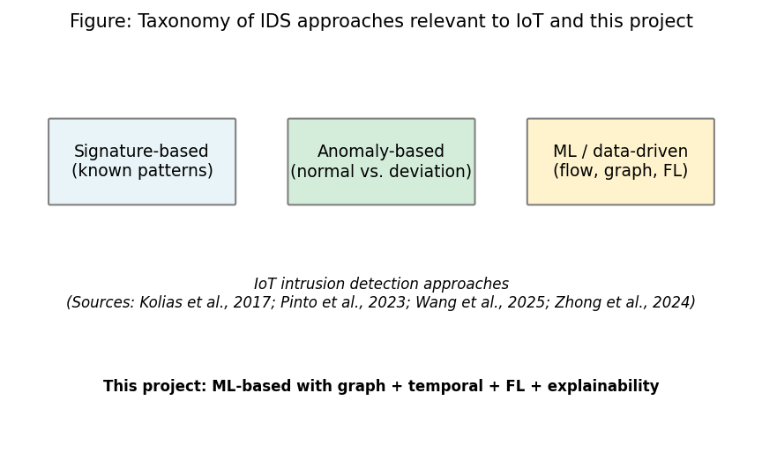
Figure 1: Taxonomy of IDS approaches relevant to IoT and this project (Chapter 2, Section 2.3)
Sources: (Kolias et al. 2017); (Pinto et al. 2023); (Wang et al. 2025); (Zhong et al. 2024). Full references in Chapter 11.

2.4 SIEM, SOC Workflows, and Alert Quality

2.4.1 Alert Volume, Triage, and the Need for Explanations
SOC teams use SIEM and related tools to collect logs and flow data and to generate alerts. A well-known problem is alert fatigue: too many alerts and too many false positives make it hard for analysts to focus on real threats (Cuppens and Miège 2002). If an alert does not explain why it was raised, triage becomes slower and more guesswork. Cuppens and Miège (2002) proposed alert correlation to reduce noise by grouping related alerts. The main problem endures: many detection systems still output labels without a faithful account of the evidence. This matters because analyst time is a finite resource; the argument is not new, but it directly motivates XAI in the sections that follow (Cuppens and Miège 2002).
The Elastic Common Schema (ECS) provides a vendor-neutral field pattern for security events: event type, outcome, source, destination, and extensions. ECS-like JSON (field names and nesting inspired by that schema) is used in this project so that alerts can be ingested by Elastic, Splunk, and similar platforms without a bespoke format per tool (vendor documentation; this dissertation does not claim endorsement or certification by any vendor).

2.4.2 Explainability, SIEM Ecosystems, and Limits of “Better JSON”
Major SIEM products (e.g. Splunk, Elastic, Microsoft Sentinel) support custom rules and ML-assisted detections, but the deployment of explainable model outputs in tier-1 triage is still uneven in the published record; vendors emphasise playbooks and case workflows as much as raw explanation objects. For academic ML papers, a standard comparison is to local explanation tools: Lundberg and Lee (2017) formalise SHAP for additive feature attribution, while gradient methods such as Integrated Gradients (Sundararajan et al. 2017) target deep networks. In a SOC context, explanations that point to flows, devices, or time windows can support a faster escalation decision. This project instantiates that idea with top features and top flows in the alert. Critically, correlation and a cleaner schema do not by themselves show that analysts will trust or rely on a model’s escalation when queues already exceed service levels - workload and incentive effects remain contested in the operations literature; formatting alone does not end that debate.

2.5 Graph Neural Networks and Dynamic Graphs

2.5.1 GNNs, Attention, and Attribute-Based Graphs in Intrusion Detection
Graph neural networks (GNNs) work on data that has a graph structure: nodes and edges. In network security, nodes can be hosts or flows and edges can be similarity or adjacency in feature space. GNNs combine information from neighbours and can learn patterns that depend on the graph structure. Message passing (each node update aggregates neighbour messages) encodes relational structure that flat tabular classifiers (one row per flow) treat as independent samples (Velickovic et al. 2018; Wang et al. 2025). Graph Attention Networks (GATs) allow learned weights over neighbours (Velickovic et al. 2018), which is useful when some edges matter more for the decision. Han et al. (2025) proposed DIMK-GCN for intrusion detection with multi-scale graph views. Ngo et al. (2025) showed that attribute-based graphs (e.g. kNN in feature space) are viable when device identifiers are missing - this directly supports the kNN construction in this project on CICIoT2023 public releases. When topology IP graphs are not available, similarity graphs are a principled fallback (Ngo et al. 2025). Critically, attention highlights salient edges; it is not a causal proof of intent, and the XAI community continues to ask whether saliency tracks ground-truth attack steps or only the model’s margin (see also Basak et al. 2025).

2.5.2 Dynamic (Temporal) Graphs and the GAT+GRU Pattern
Networks change over time. Dynamic (temporal) graph models stack a GNN over each snapshot and a sequence model across snapshots - see Zheng et al. (2019) for attention-based temporal GCNs on dynamic graphs. Lusa et al. (2025) combine temporal edge features with GraphSAGE for NID. Basak et al. (2025) report both high accuracy and interpretable GNN attention for NID. For IoT flow data, a GAT+GRU design tests whether structure and time add value over Random Forest and MLP on the same splits. The net benefit is data-dependent; the literature supports a fair comparison rather than a universal claim of dominance. GNNs usually cost more CPU time per prediction than tabular models - an edge deployment concern this project measures in Section 8.5. Figure 2 summarises the GAT+GRU data path in the sense of the cited temporal-graph literature (Velickovic et al. 2018; Zheng et al. 2019; Lusa et al. 2025; Basak et al. 2025): GAT on each window’s graph, then GRU on the sequence of window embeddings, then a classifier. The diagram is author-original; it does not reproduce a figure from any single prior paper.
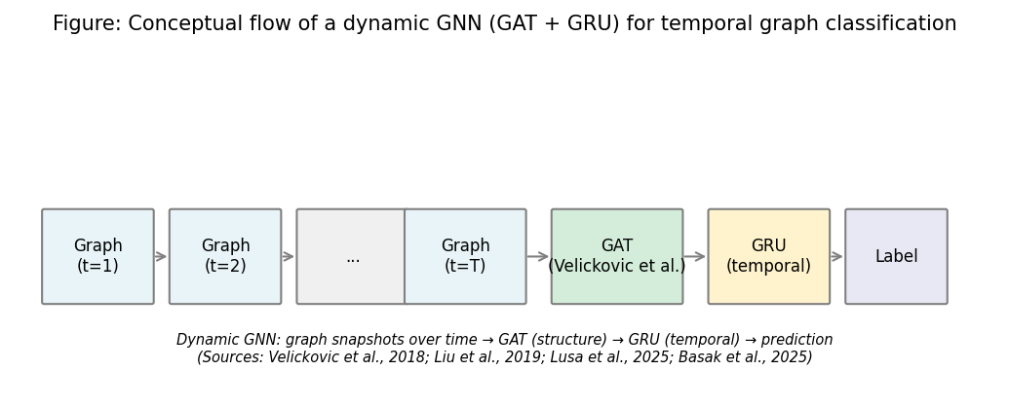
Figure 2: Conceptual flow of a dynamic GNN (GAT + GRU) for temporal graph classification (Chapter 2, Section 2.5)
Sources: (Velickovic et al. 2018); (Zheng et al. 2019); (Lusa et al. 2025); (Basak et al. 2025). Full references in Chapter 11.

2.6 Federated Learning and Privacy

2.6.1 FedAvg, Assumptions, and Communication
Federated learning trains a model across many clients without centralising raw data. Each client trains locally and sends only model updates (gradients or weights) to a server; the server aggregates and broadcasts a global model. FedAvg (McMahan et al. 2017) is the baseline: the server averages client parameters, often weighted by local dataset size. This reduces the direct need to store all raw flow captures in one central pool, which is relevant to data-sovereignty discussions for multi-site settings (Lazzarini et al. 2023; Albanbay et al. 2025). In IoT and edge deployments, bandwidth limits favour shipping parameters (order of megabytes) rather than full raw traffic (which can be far larger). Figure 3 is an author schematic of the FedAvg role model described in McMahan et al. (2017), not a reproduction of a figure from that paper.
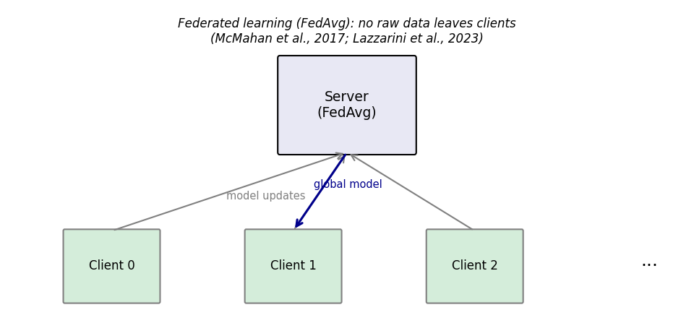
Figure 3: Federated learning (FedAvg) flow - no raw data leaves clients (Chapter 2, Section 2.6)
Sources: (McMahan et al. 2017); (Lazzarini et al. 2023). Full references in Chapter 11.

2.6.2 FL for IoT Intrusion Detection: Empirical Findings and Non-IID Reality
Federated learning has been applied in IoT and fog settings. Qu et al. (2020) discuss decentralised privacy patterns in fog environments (including blockchain-linked federated designs), which helps explain why some edge operators refuse raw data pooling. Lazzarini et al. (2023) report IoT IDS experiments under FedAvg, with central-comparable performance when data conditions are stable. Albanbay et al. (2025) show that client count and the severity of non-IID splits affect both convergence and accuracy - a practical counterpoint to any claim that “FL is always free” or always matches central training without tuning. When class and attack-type mixes differ by site, the global model must integrate heterogeneous client updates; more rounds and careful aggregation can be required. This project uses Flower with three clients and a Dirichlet non-IID split to test federated GNN parity with central training, and logs communication volume (Chapter 8). Critically, FedAvg does not by itself provide differential privacy; gradient inversion and membership-style attacks remain part of the active research record under strong adversaries - this work assumes honest-but-curious coordination and a threat model suitable for the stated MSc scope.

2.7 Explainability in ML-Based Security

2.7.1 Post-hoc Attribution, Integrated Gradients, and Attention in GNNs
Explainability is usually added after the model is trained. Post-hoc methods rank input features (or substructures) that influenced a prediction. Integrated Gradients (IG) is a gradient-based attribution: it attributes the score change from a baseline input to the actual input, with axioms discussed in Sundararajan et al. (2017). The implementation in this project uses Captum (Kokhlikyan et al. 2020), which integrates with PyTorch. For GAT networks, edge-level attention (Velickovic et al. 2018) provides a complementary view of which neighbours were emphasised. This dissertation uses IG for per-feature magnitudes and GAT attention for per-flow emphasis so that an analyst sees both “what in the feature vector” and “which flow rows” supported the alert. Figure 4 (methods aligned with Sundararajan et al. 2017; Velickovic et al. 2018; Kokhlikyan et al. 2020) sketches that dual path for SOC-style JSON.
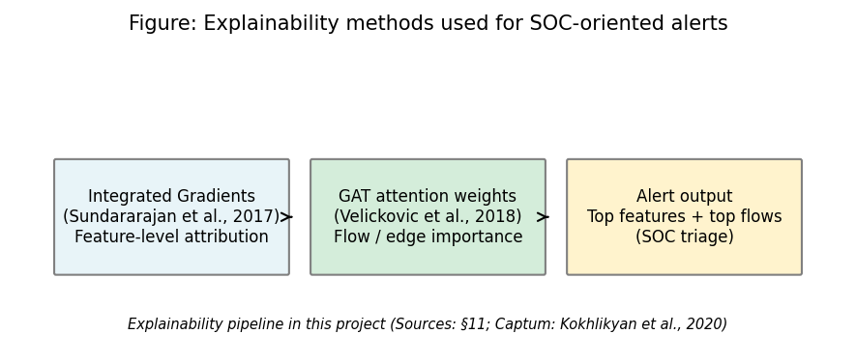
Figure 4: Explainability methods used for SOC-oriented alerts (Chapter 2, Section 2.7)
Sources: (Sundararajan et al. 2017); (Velickovic et al. 2018); (Kokhlikyan et al. 2020). Full references in Chapter 11.

2.7.2 XAI for IoT Streams, SHAP as Alternative, and Latency as a Counterargument
Alabbadi and Bajaber (2025) evaluate XAI for intrusion detection on IoT streams and show that post-hoc explanations can improve transparency for analysts, but their work is not a full end-to-end SIEM hand-off. Lundberg and Lee (2017) define SHAP; SHAP is model-agnostic and widely used for tree and MLP baselines, whereas Integrated Gradients fits the GNN+Captum stack in this work. A practical counterargument to “explain every alert” is latency: IG needs many forward passes (the implementation default is 50); on GNN + sequence inputs the cost is non-trivial, so the code supports selective explanation. Field studies remain sparse on whether explanation payloads shorten time-to-triage on edge hardware - that limit is returned to in Chapter 9, not overstated here.
Table 1 and Figure 5 summarise how prior studies cover the four project pillars. No single row in Table 1 combines GNN, federated training, XAI, and a SIEM-oriented alert wrapper in the way the present prototype does; that gap is made explicit in Section 2.8.
Table 1: Comparison of selected related work (sources: Chapter 11)
Study | GNN/Graph | Federated learning | Explainability | SIEM/Alert | Dataset/context
(Pinto et al. 2023) | - | - | - | - | CICIoT2023 dataset
(Velickovic et al. 2018) | Yes (GAT) | - | - | - | General GNN
(McMahan et al. 2017) | - | Yes (FedAvg) | - | - | General FL
(Sundararajan et al. 2017) | - | - | Yes (IG) | - | Attribution method
(Han et al. 2025) | Yes (DIMK-GCN) | - | - | - | IDS
(Ngo et al. 2025) | Yes (attribute-based) | - | - | - | IoT IDS
(Basak et al. 2025) | Yes (X-GANet) | - | Yes | - | NID
(Lusa et al. 2025) | Yes (TE-G-SAGE) | - | Yes | - | NID
(Lazzarini et al. 2023) | - | Yes | - | - | IoT IDS
(Albanbay et al. 2025) | - | Yes | - | - | IoT IDS
(Alabbadi and Bajaber 2025) | - | - | Yes (XAI) | - | IoT streams
(Yang et al. 2025) | Yes | - | - | - | Industrial IoT
This project | Yes (GAT+GRU) | Yes (Flower) | Yes (IG+attention) | Yes (ECS-like) | CICIoT2023
Source: Author compilation from the papers cited in Chapter 11; table is descriptive only.
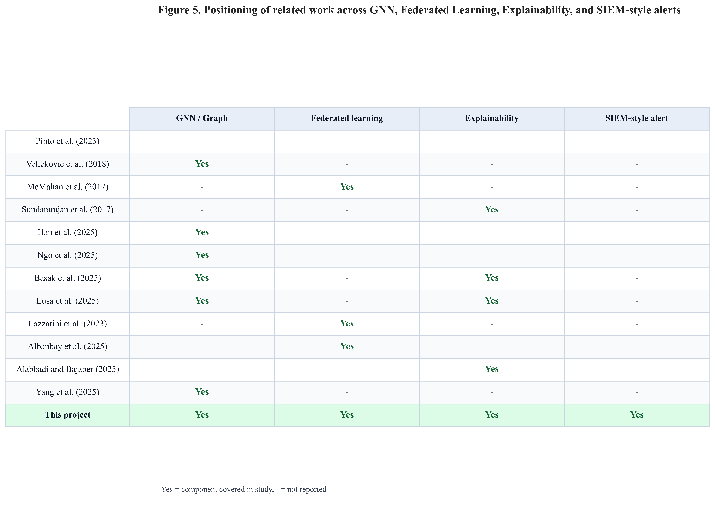
Figure 5: Positioning of related work - GNN, federated learning, explainability, and SIEM-style alerts (Chapter 2, Section 2.7)
Sources: (Pinto et al. 2023); (Velickovic et al. 2018); (McMahan et al. 2017); (Sundararajan et al. 2017); (Han et al. 2025); (Ngo et al. 2025); (Basak et al. 2025); (Lusa et al. 2025); (Lazzarini et al. 2023); (Albanbay et al. 2025); (Alabbadi and Bajaber 2025); (Yang et al. 2025). This figure synthesises Chapter 2 and supports the gap stated in Section 2.8.

2.8 Synthesis: Significance, Limitations of Prior Work, Contributions, and Gap
This section addresses four items expected in a strong final-report literature review: (1) significance of the anticipated findings for the stated scope; (2) limitations in the literature and their impact on defensible claims; (3) a critical view of the contribution; and (4) how existing approaches partially cover the problem before the integrated gap is stated.

2.8.1 How Existing Approaches Fill Part of the Problem (and Where They Stop)
Good papers typically specialise. Yang et al. (2025) and Han et al. (2025) push GNN accuracy for IoT or NID but do not operationalise federated training or SIEM-shaped delivery. Lazzarini et al. (2023) and Albanbay et al. (2025) scale FedAvg under non-IID IoT partitions but generally do not pair that with a dynamic graph front end and end-to-end alerts. Alabbadi and Bajaber (2025) and Basak et al. (2025) foreground XAI in central or offline evaluations. Pinto et al. (2023) enable repeatable benchmarks on CICIoT2023 but do not prescribe a single detector architecture. Table 1 makes the pattern visible: the capability columns are rarely all “on” in one study; the final row (this project) is the only entry that attempts all four pillars in one CPU-first pipeline.

2.8.2 Anticipated Significance (What Would Matter if the Evidence Holds)
If, on fixed splits, a dynamic GNN matches or outperforms strong tabular baselines while emitting analyst-facing alerts, the significance is engineering and methodological: it demonstrates feasibility of combining concerns that the literature often splits across separate papers. The expected contribution is not a universal claim of best F1 on all IoT traffic; it is a transparent prototype with ablation, sensitivity, and multi-seed artefacts so that trade-offs (central vs. federated, latency vs. model depth) are visible to examiners and to readers with SOC-oriented interests.

2.8.3 Limitations in the Literature and Their Impact on Claims
Three limits recur. First, published benchmarks rely on lab datasets and subset choice can inflate apparent performance (Pinto et al. 2023; Chapters 8–9). Second, XAI work often reports attribution quality without operator time-to-triage (Alabbadi and Bajaber 2025; Section 2.7.2). Third, federated “privacy” narratives can outrun what FedAvg formally guarantees (McMahan et al. 2017; Section 2.6.2). These limits bound wording: the dissertation claims a documented pipeline and comparative evidence on CICIoT2023, not production readiness for arbitrary live tenants.

2.8.4 Debate, Counterarguments, and the Consolidated Gap
Counterargument 1 - “Graphs are unnecessary if features are already strong.” The literature itself is split (Yang et al. 2025; Zhong et al. 2024). This work tests the claim with RF and MLP baselines on the same splits and reports false positive counts as well as headline F1. Counterargument 2 - “Federated learning is privacy for free.” Qu et al. (2020) and Albanbay et al. (2025) show deployment subtleties; this work states honest-but-curious assumptions and measures bytes exchanged, not a differential-privacy bound. Counterargument 3 - “Explainable alerts remove audit and workload risk.” Cuppens and Miège (2002) and Section 2.4.2 stress operational load; integrated gradients and GAT attention add artefacts for human review, not a guarantee of trust or policy compliance.
Consolidated gap: No prior row in Table 1 unifies kNN temporal graphs, a GAT+GRU stack, Flower FedAvg, Captum integrated gradients and GAT attention cues, and ECS-like JSON alerts with RF/MLP baselines on a shared CICIoT2023 subset under one MSc-style reproducible package. Chapters 4–8 instantiate that gap as design and evidence; Chapter 9 returns to significance after the results.

2.9 Mapping to CyBOK (Cyber Security Body of Knowledge)
The agreed project specification (Appendix B) records this work against CyBOK knowledge areas. The dissertation aligns with the following topics in particular: Attacks & Defences → Security Operations & Incident Management (SIEM-style alerting, SOC triage, and intrusion detection outputs); Infrastructure Security → Network Security (flow-based analysis and IoT traffic classification); Systems Security → Distributed Systems Security (federated learning without centralising raw client data); and Software and Platform Security → Software Security (engineering of the prototype pipeline, APIs, and reproducible scripts). Together, these areas situate the project within the School’s CyBOK mapping and match the specification’s indicative coverage.

2.10 Extended Comparative Review (Fifteen to Twenty Core Sources)
The programme guideline asks for fifteen to twenty significant papers in the literature review. Earlier sections already developed themes with primary citations. This section groups further comparisons so the breadth requirement is explicit and each cluster carries named in-text references.

2.10.1 Temporal Graphs, Fog Decentralisation, and Survey Evidence
Zheng et al. (2019) show attention-based temporal GCNs for dynamic graphs; that line of work motivates stacking a sequence model (here, a GRU) on top of graph snapshots instead of classifying each window in isolation. Qu et al. (2020) discuss decentralised privacy patterns in fog computing, including blockchain-linked federated designs; this dissertation does not use blockchain, but the paper clarifies why edge sites may refuse raw data centralisation. Zhong et al. (2024) and Wang et al. (2025) survey GNN use in intrusion detection and where explainability and deployment gaps remain - useful for positioning the GAT+GRU and alert design choices in Sections 2.5 and 2.7.

2.10.2 SHAP, Integrated Gradients, and Method Choice in This Prototype
Lundberg and Lee (2017) formalise SHAP for additive feature attribution. This project uses Integrated Gradients (Sundararajan et al. 2017) and GAT attention because they fit the PyTorch and Captum stack and the graph output; SHAP remains a defensible choice for tree or tabular baselines in parallel studies. The extended review therefore does not claim IG is universally superior; it records an engineering-consistent choice tied to the implemented models.

2.10.3 Botnets, Early Alert Correlation, and Lineage to Modern SIEM
Kolias et al. (2017) document Mirai-style botnets in the IoT, which explains why flow-level DDoS patterns dominate many IoT benchmarks, including CICIoT2023. Cuppens and Miège (2002) give early alert-correlation ideas that prefigure today’s correlation rules and case workflows; present SIEM output still benefits from the same analyst-time logic even though field naming has standardised on JSON and ECS-like schemas (Section 2.4.1).

2.11 Chapter Summary
Chapter 2 moved from the search strategy and database choice (Sections 2.2.1–2.2.2) to strategic IoT risk and dataset context (2.3), SIEM triage and explainability limits (2.4), graph and temporal GNN design (2.5), federated training caveats (2.6), and attribution toolchains (2.7). Section 2.2.2 in particular situates the title’s main technologies in argument form (flow observability, graph cost/benefit, federation vs. edge inference, explainable alert economics) before the thematic sections add paper-level detail. Table 1 and Figure 5 visualise the gap by capability pillar; Section 2.8 ties anticipated significance, literature-side limits, counterarguments, and the consolidated research gap. Section 2.9 maps themes to CyBOK; Section 2.10 extends the source base to programme breadth. The next chapters turn from what others did to what this project built: fixed dataset handling, kNN temporal graphs, the GAT+GRU stack, Flower FedAvg, Captum, and FastAPI-delivered ECS-like alerts.

Chapter 3 – Project Management

3.1 Chapter Overview
This chapter documents the project process: planning and milestones, risk management, the development environment and evidence prepared for supervisor meetings (Section 3.5), ethics posture (public dataset, no human participants), and how interim feedback was incorporated. It supports transparency of execution without duplicating the technical content presented in Chapters 4–7.

3.2 Project Plan and Timeline (45-day MSc)
Work was staged in six phases: (1) freeze requirements and literature; (2) fix the CICIoT2023 subset and preprocessing; (3) implement graph construction and central GNN training; (4) run baselines and Flower-based federated training; (5) add explainability, alert JSON, and FastAPI; (6) run ablation, sensitivity, multi-seed experiments, figures, and final writing. Each phase had concrete artefacts (metrics files, checkpoints, plots) to reduce ambiguity about “done.” Figure 6 shows the schedule as a Gantt chart with overlapping phase bars, which is more representative of real research execution than strictly sequential blocks.
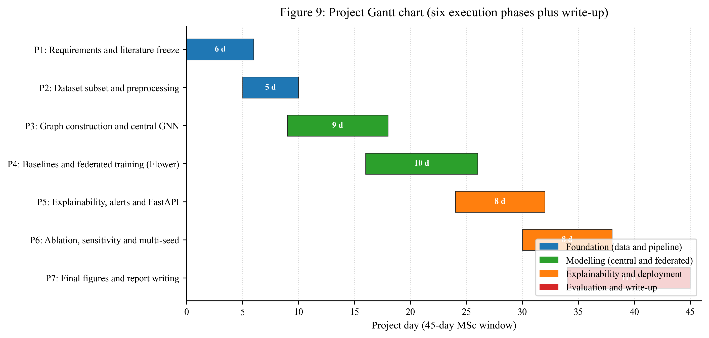
Figure 6: Project Gantt chart - six execution phases plus write-up across the 45-day MSc window (Chapter 3, Section 3.2)
Source: Author’s own diagram (scripts/generate_gantt_chart.py).

3.3 Risk Assessment
Risk | Mitigation
Training too slow on CPU | Fixed subset; configurable rounds/clients; early stopping
Severe class imbalance | Stratified windowing; class weights; balanced graph-level labels
Federated instability | Three clients; reproducible split; checkpoints each round
Explainability runtime | Top-k attributions; optional subset of alerts
Scope creep (extra models) | Baselines limited to RF and MLP; one main GNN architecture

3.4 Monitoring and Progress Reviews
Progress was monitored on a weekly cadence with the supervisor and against the phase plan in Section 3.2. At each weekly meeting the agenda followed the same three points: (1) what was completed since the last meeting and which artefact in the repository proves it; (2) what is in progress and any blocker that needs supervisor input; (3) what is planned for the next week and which phase boundary it serves. Decisions and action items were captured in the project process documentation that is referenced in Appendix A so that activity is traceable beyond memory.

3.5 Research Plan for Completion: IDE, Platform, and Evidence for Supervision
The programme and supervisor may review where and how the code was built and how progress is demonstrated in meetings. This section records that information so it is maintained in the final report and can be revisited in follow-up supervisions, consistent with the handbook’s expectation of traceable development and Harvard (UWS) references for any non-original tools (University of the West of Scotland Library 2025).
Working environment: Primary development used Cursor, an AI-assisted integrated development environment (IDE) based on the same editor stack as Visual Studio Code, running on Windows 10 (x64) (see also Table 5 in Section 6.2). The repository was cloned and edited in that IDE; version control, runs, and figures were produced on the same machine. Cursor is cited as a reputable, vendor-documented product (Anysphere, Inc. 2024), not as a source of research claims. Core language and tooling used alongside it are the Python implementation (Python Software Foundation 2023) and the Git version-control system (The Git Project 2023); both are standard, vendor-backed resources listed in the Chapter 12 bibliography. Citations in this report follow the UWS Library Harvard libguide** (University of the West of Scotland Library 2025).
What supervisors can check in meetings: (1) the open Git history on the project repository; (2) frozen outputs under results/metrics/ and results/figures/ named in Chapter 13; (3) the Gantt phases in Section 3.2; (4) configuration in config/experiment.yaml. The student completed implementation, experiments, and dissertation drafting in this environment using Cursor for editing, terminal session runs as documented in README.md and SETUP_AND_RUN.md, and the MD → Word pipeline (scripts/dissertation_to_docx.py) for submission formatting.
Not a substitute for design rationale: The IDE accelerates editing, navigation, and repeatability of commands; it does not replace the method described in Chapters 4–7 or the literature in Chapter 2, which are cited from peer-reviewed and established technical sources in Chapters 11–12 as per UWS practice.

3.6 Ethics and Data
Only public CICIoT2023 data is used; there are no human participants or proprietary organisational datasets. The signed specification ethics section records supervisor confirmation that the project does not require full ethics-review board approval under School procedures (February 2026), which matches the use of non-sensitive public data only. Process and ethics paperwork are referenced in Appendix A/B as required by the handbook.

3.7 Interim Report Feedback Incorporated
The MSc Project Handbook requires that feedback on the interim report (written and verbal from supervisor and moderator) be taken into account in the final submission. After interim submission, feedback reinforced: (1) keeping the end-to-end story visible (data → model → federation → explainability → SOC-shaped output), not only literature; (2) tightening the evaluation plan before reporting numbers; (3) being explicit about limits of a lab subset and very high test metrics; and (4) reserving effort for final analysis and write-up rather than scope creep.
Actions taken in the final dissertation include: completing the full evaluation and results chapters (7–8) with tables and figures promised at interim; adding ablation, sensitivity, and multi-seed checks so result stability is evidenced (going beyond the interim contingency of dropping sensitivity if time ran short); strengthening critical reflection (Chapter 10) on methodology, federation, and the “100% metrics” question; and documenting reproducibility (Chapter 13). Any remaining suggestions from the interim review are acknowledged as limitations and future work in Chapter 9.

3.8 Chapter Summary
Transparent time-boxing and risk controls kept the project feasible while still delivering graph, federated, explainable, and deployable components. Section 3.5 documents the IDE and platform used for supervision-ready evidence; UWS Harvard-listed tool references are in Chapter 11; the Harvard libguide appears in Chapter 12 (University of the West of Scotland Library 2025).

Chapter 4 – Research Design and Methodology

4.1 Chapter Overview
This chapter is the Research Method pillar: it states, in the author’s own terms, the stages, artefacts, and controls that turn secondary, pre-recorded CICIoT2023 flow tables into trained models and reported accuracy on a held-out test split. Programme guidance targets roughly fifteen percent or more of the final report for Research Method and a further fifteen percent or more for Research Method Deployment; here, Chapters 4–5 carry the method (design, pipeline, graph semantics) and Chapters 6–7 carry the deployment (code paths, testbed, experimental scenarios). Chapter 5 provides figures 7–9 and the authoritative graph rules; Chapter 6 gives module-level implementation; Section 7.5 defines metrics once. Together they satisfy the “two-chapter” structure without pasting abstract methodology from unrelated papers: every step below maps to a named file or script in the repository.

4.2 Research Approach
Epistemology. The work is empirical and artefact-driven: a software prototype (data pipeline → models → optional federation → explainability → API) is built and judged by reproducible metrics. Learning is always from pre-recorded flow rows supplied by the public benchmark; no live traffic is collected for training. Prediction on unseen flows is the operational sense of “accuracy” used here, implemented as held-out test metrics in Section 7.5 and Chapter 8.
Proposed contribution (method-level). The methodology is not a restatement of a single prior paper. It is a compositional design that this project instantiates and measures: (i) feature-space kNN graphs to obtain structure without device IP topology in the public release, (ii) a GAT+GRU stack for relational + short-term temporal context, (iii) Flower FedAvg on Dirichlet-skewed clients, (iv) Captum integrated gradients and GAT attention for dual explanations, and (v) ECS-like JSON for SOC-shaped output - each with fixed hyperparameters in config/experiment.yaml and versioned code.
Rigor funnel. (1) Public splits as released (train / validation / test CSVs), not a random re-split of one pool, so the benchmark’s intended separation is respected. (2) StandardScaler is fit on the training file only (first pass in src/data/preprocess.py), then transforms validation and test. (3) Tuning and early stopping use train + validation; test is for one-shot reporting. (4) Federated training never sends raw rows - only model parameters (see Section 4.5).

4.3 Dataset and Subset
Secondary data, primary use. CICIoT2023 (Pinto et al. 2023) is captured and labelled by the dataset authors in a testbed; this project consumes their pre-recorded CSVs as secondary data and applies a project-specific cleaning and learning pipeline. That distinction matters for ethics and for reproducibility: the thesis’s contribution is the transformations and models, not new packet capture.
Row volume and class balance at flow level. For the frozen run reported in this dissertation, each of the three public split files was processed to 500,000 flow rows, preserving both benign and attack traffic at roughly 2.3% / 97.7% benign/attack in each split (see Table 4 for exact counts). Binary labels are derived by mapping the dataset’s label column to $y \in \{0,1\}$ (benign vs. attack) using the benign_labels list in the YAML. Forty-six numeric flow feature columns (rates, byte statistics, flag counts, protocol indicators) are listed exhaustively in config/experiment.yaml; no IP or timestamp fields are used as model inputs in this build.
Feature extraction after split order. src/data/preprocess.py reads each split, drops/repairs inf / NaN in the 46 numerics, constructs binary_label, and applies the scaler in file order so that the training split fits the StandardScaler and the other splits only transform. That ordering is a leakage control: validation and test never influence the mean/variance used for $z$-scoring.

4.3.1 Proposed pipeline stages, artefacts, and leakage controls
Table 2 is the master stage list; later chapters reference the same order (Figure 7 is the visual analogue).
Table 2: Proposed data and modelling pipeline stages (this project).
Stage | What happens | Main artefact / location | Leakage or scope control
1 | Ingest public CSVs per split | data/raw/{train,validation,test}.csv | Splits are as published (not re-drawn from one pool)
2 | Clean numerics, binarise labels, fit scaler on train only | src/data/preprocess.py → data/processed/*.parquet + scaler.joblib | Validation/test only transformed
3 | (Optional) cap rows per split for MSc budget | Same parquet rows | Documented row cap; all models see same files
4 | Build kNN windows and sequences per split | src/data/graph_builder.py, src/data/dataset.py; data/processed/*_graphs.pt | Graphs built inside each split; no cross-split windows
5 | Train / tune baselines and GNN on train; monitor val | results/checkpoints/, results/metrics/*.json | Test not used in loss or model selection
6 | Federated GNN: partition training rows across clients; FedAvg | src/federated/; round metrics JSON/CSV | Raw flows stay local; only weights exchanged
7 | Final test metrics + CPU latency + comms + alerts | results/metrics/results_table.csv, src/siem/api.py | Single test evaluation policy (Chapter 7)
Italic paths denote examine-facing artefacts. If another researcher omits a stage (e.g. skips graph building and trains only on flows), the experiment is not the one reported here.

4.3.2 Repository layout and frozen outputs
Raw CICIoT2023 files are not committed. After Stage 2, train / validation / test parquet and the saved scaler live under data/processed/. Graph tensor caches and metrics/figures live under data/processed/ and results/ as listed in the repository README and Chapter 13. The dissertation’s numbers assume one frozen pass of the same config hash implied by the committed config/experiment.yaml.

4.3.3 Empirical flow and graph sample sizes
Table 4 records empirical sizes (from results/metrics/dataset_stats.json) for the run underlying Chapter 8. Flow row counts are per-split totals; graph counts follow the configured window = 50 flows, sequence length = 5, and knn_k = 5 (Table 3).
Table 4: Empirical sample sizes: flows, graph windows, and sequences.
Split | Flow rows (total) | Benign flows | Attack flows | Graph windows (single-split build) | Sequences (length-5)
Train | 500,000 | 11,582 | 488,418 | 924 | 920
Validation | 500,000 | 11,676 | 488,324 | 932 | 928
Test | 500,000 | 11,772 | 488,228 | 938 | 934
Notes. Windows are constructed with per-class pools and shuffling (see Section 5.3); the sequence count is slightly below the window count because the tail of the shuffled list may not form a full length-5 sequence. All models that report “sequence-level” GNN metrics consume these sequences; RF/MLP report per-flow metrics on 500,000 test flows each.

4.4 Models and Loss Functions
Three model families share the same label definition and splits but differ in input geometry: two are feature-vector classifiers; one is a graph-sequence classifier.
- Random Forest - tabular: one standardised 46-vector per flow, sklearn.ensemble.RandomForestClassifier in src/models/baselines.py; out-of-bag / train metrics are not used for test claims; test reporting is the contract in Section 7.7.
- MLP - tabular: feed-forward on 46-d inputs, MLPBaseline, trained with Adam and mini-batch cross-entropy (see Table 3).
- Dynamic GNN (GAT + GRU) - graph–sequence: for each of five windows, a GAT stack produces a graph embedding; a GRU consumes the ordered list of five embeddings; a linear head outputs logits for the binary case (DynamicGNN in src/models/dynamic_gnn.py). An ablation mean-pools time instead of a GRU (Table 10).

4.4.1 Hyperparameters, tuning funnel, and training budget (after split)
After the public splits and parquet files exist, all model-specific knobs are taken from a single YAML (Table 3). Early stopping (patience in Table 3) is driven by validation performance; test is never used to pick hyperparameters. Fine-tuning in this project means that validation-monitored training loop with fixed architecture widths - there is no manual test-set search.
Table 3: Hyperparameters, training budget, and federation (frozen in config/experiment.yaml).
Group | Parameters | Value
Reproducibility | Global seed | 42 (multi-seed study: 42, 123, 456 in Section 8.9)
Graph build | window_size, knn_k, sequence_length, minority_stride | 50, 5, 5, 25
FL | num_clients, num_rounds, local_epochs, alpha (Dirichlet) | 3, 10, 2, 0.5
RF | n_estimators, max_depth | 200, 20
MLP | hidden_dims, dropout, lr, epochs, batch_size | [128, 64, 32], 0.2, 0.001, 30, 256
Dynamic GNN | node_dim, hidden_dim, num_gat_layers, gat_heads, gru_hidden, dropout, lr, epochs, batch_size | 46, 64, 2, 4, 64, 0.2, 0.001, 30, 16
Class imbalance | class_weight_auto (train) | true
Stopping | early_stopping_patience | 5 (epochs)

4.4.2 Objectives, losses, and federation rule
Flow-level classifiers (RF, MLP). For label $y_i \in \{0,1\}$ and model probability $p_i = P(y_i{=}1\mid x_i)$, binary cross-entropy is
$$
\mathcal{L}_{\text{CE}} = - \frac{1}{N} \sum_{i=1}^{N} \bigl( y_i \log p_i + (1-y_i)\log(1-p_i) \bigr) \, .
$$
class_weight in sklearn and the PyTorch loss (if weighted) reweight under-represented benign flows without changing the split itself.
Graph-sequence GNN. Each training item is a sequence of $T\!=\!5$ window graphs with sequence label $y$ (any-window attack rule; Section 5.3). The same $\mathcal{L}_{\text{CE}}$ applies to the sequence logits. Federated training minimises the same local $\mathcal{L}_{\text{CE}}$ on each client; the server FedAvg-aggregates parameters (McMahan et al. 2017):
$$
\theta_{t+1} = \sum_{k=1}^{K} \frac{n_k}{n} \, \theta_{t+1}^{(k)} \, ,
$$
where $n_k$ is the client $k$ training row or batch count and $n\!=\!\sum_k n_k$.
Algorithm 1 (informal). kNN window graph for one window: for each of $W$ flow rows, compute Euclidean distances in 46-d feature space, connect each node to top-$k$ neighbours both ways, return a PyG Data object (src/data/graph_builder.py:flows_to_knn_graph).
Algorithm 2 (informal): FedAvg server step - after each round, average client weight tensors with weights $\frac{n_k}{n}$; broadcast dynamic_gnn state (src/federated/) - no raw $x_i$ uploaded.
Italic references: training loops use src/models/trainer.py; metrics use src/evaluation/metrics.py. The test-set “accuracy” claims in the results chapter are the F1 / ROC-AUC family from Section 7.5, not a single unbalanced accuracy.

4.5 Federated Learning Setup
FedAvg (McMahan et al. 2017): clients train locally and send weights; the server averages and broadcasts the global model - no raw flows cross sites (Section 2.6). This project uses Flower with three clients, ten rounds, and two local epochs per round (timelines and risks: Chapter 3; wiring: Section 6.6). The same GNN architecture is trained centrally and federally for a fair comparison. Communication cost is estimated from serialized float32 parameter traffic (Chapter 8).
Non-IID simulation: training rows are partitioned across clients with a Dirichlet distribution over class proportions (alpha = 0.5) so client label mixes differ (stronger than IID sharding; weaker than adversarial splits). Rationale: reflect sites with different exposure while staying trainable within the MSc budget.

4.6 Explainability
Two forms of explanation are used:
- Integrated Gradients (Captum): Applied to the chosen model (e.g. the dynamic GNN or the MLP) to attribute the prediction to input features. The top contributing features are extracted and included in the alert.
- Attention weights: For the GAT-based model, attention weights over edges or neighbours are used to identify which flows or connections the model focused on. These can be summarised as “top flows” or “top edges” in the alert.
Explanations are produced for selected predictions (e.g. positive alerts). The top-k (k=5) features and flows are included in each alert to keep the explanation concise. If computing explanations for every prediction is too slow, they are applied only to a subset (e.g. high-confidence alerts) and this is noted as a limitation.

4.7 Evaluation Plan
Formulae and definitions for precision, recall, F1, FPR, and ROC-AUC are given once in Section 7.5. Here, the plan only maps measurements to questions.
Evaluation is designed to answer the three sub-questions and support the main research question.
- Metrics: Precision, recall, F1-score, ROC-AUC, and false positive rate on the fixed test set. A confusion matrix is reported.
- Model comparison: Centralised training: Random Forest, MLP, and dynamic GNN are compared on the same splits. Federated training: the same GNN (or MLP) is trained with FedAvg and compared to its centralised version.
- Time and cost: Time-window analysis (e.g. performance across different window sizes or positions), federated round-by-round performance, approximate communication cost (bytes), and CPU inference time per sample or per batch.
- Explainability and SOC use: Three to five example alerts are generated with full explanations (top features and flows). These are discussed in terms of whether they would help a SOC analyst triage (e.g. whether the highlighted flows and features are interpretable and actionable).
Contingencies match Chapter 3 (subset size, rounds/clients, optional subset of explained alerts). Linkage to questions: precision, recall, F1, ROC-AUC, and FPR → sub-question 1 (and central leg of sub-question 2); per-round FL metrics and comms cost → sub-question 2; example alerts → sub-question 3; CPU inference latency → main question (edge deployability).

4.8 Software and Tools
The methodology relies on a small set of mainstream Python libraries chosen for stability, documentation, and CPU compatibility. The full version pin list is in the repository requirements.txt; this section names the components and the role each plays in answering the research questions. Module-level wiring and code excerpts are in Chapter 6.
- Python 3.10 is the implementation language for all data, model, federated, explainability, and API code.
- PyTorch and PyTorch Geometric are used to build the GAT layers and the dynamic GNN with sequence encoding (Sections 6.4 and 6.5).
- scikit-learn provides the Random Forest baseline, the StandardScaler (used in preprocess.py for parity with sklearn conventions), and metric helpers (Sections 4.3 and 6.3–6.5). Splits are not created by train_test_split in this build - the public CIC train/validation/test files are the splits.
- Flower is used for the federated learning server and client implementation with FedAvg (Section 6.6).
- Captum is used for Integrated Gradients on the trained model (Section 6.7).
- FastAPI is used to serve the prediction and explanation endpoint that produces ECS-like JSON alerts (Sections 6.8 and 6.9).
- Matplotlib, Pandas, and NumPy are used for figure generation, table preparation, and numeric handling.
- Pygments is used to render dark-theme code screenshots for the implementation chapter and for Appendix C.
- Git and GitHub are used for version control of the project repository linked in Appendix D.
Configuration is externalised in config/experiment.yaml so that hyperparameters (window size, kNN k, GAT heads, FL rounds and clients) can be changed without code edits. All experiments use seed 42 unless overridden by the multi-seed script. This combination of fixed seed, externalised config, and named scripts is what makes the methodology in this chapter reproducible from the codebase.

4.9 Chapter Summary
Chapter 4 has fixed the Research Method contract: secondary CICIoT2023 use, leakage-aware preprocessing (Tables 2–4), YAML-frozen hyperparameters and post-split tuning funnel (Table 3), loss and FedAvg equations (Section 4.4.2), and pointers to federation, XAI, evaluation, and tools. Chapter 5 gives the design-level pipeline and graph semantics; Chapter 6 gives deployment code and Table 5 testbed; Chapter 7 schedules multi-scenario runs (Table 6).

Chapter 5 – Design

5.1 Chapter Overview
This chapter presents the system design in the same order as the narrative: the end-to-end research pipeline first (Figure 7), then authoritative graph semantics and windowing rules (Section 5.3), then architecture (Figure 8) and a conceptual kNN schematic (Figure 9) that match the implementation in Chapter 6. Deployment-facing outputs use ECS-like JSON alerts.

5.2 Pipeline, Alerts, and Deployment (Conceptual)
Figure 7 gives the stage-level view: preprocessing, graph construction, central or federated training, explainability, and SIEM-style alerting on CPU. Windowing, kNN k, and sequence labelling are specified in Section 5.3; module-level wiring is in Chapter 6.
Alerts are output in a SIEM-style JSON format, aligned with ideas from ECS where useful: event type, timestamp, source/target information, label, score, and an explanation field (top features / top flows). The runtime path is a FastAPI service that runs inference (and optionally explanations) on CPU, matching the edge objective.
The pipeline view also defines responsibility boundaries between stages. Preprocessing and graph building are deterministic data preparation stages, training is the learning stage (central or federated), and alert formatting is a post-inference stage that should not modify prediction values. This separation helps verification because faults can be traced by stage rather than by inspecting one large monolithic script.
A second design value is communication clarity. By fixing the stage contract early, implementation and evaluation chapters can reference the same pipeline assumptions without redefining them. This reduces chapter drift and helps keep figure interpretation consistent.
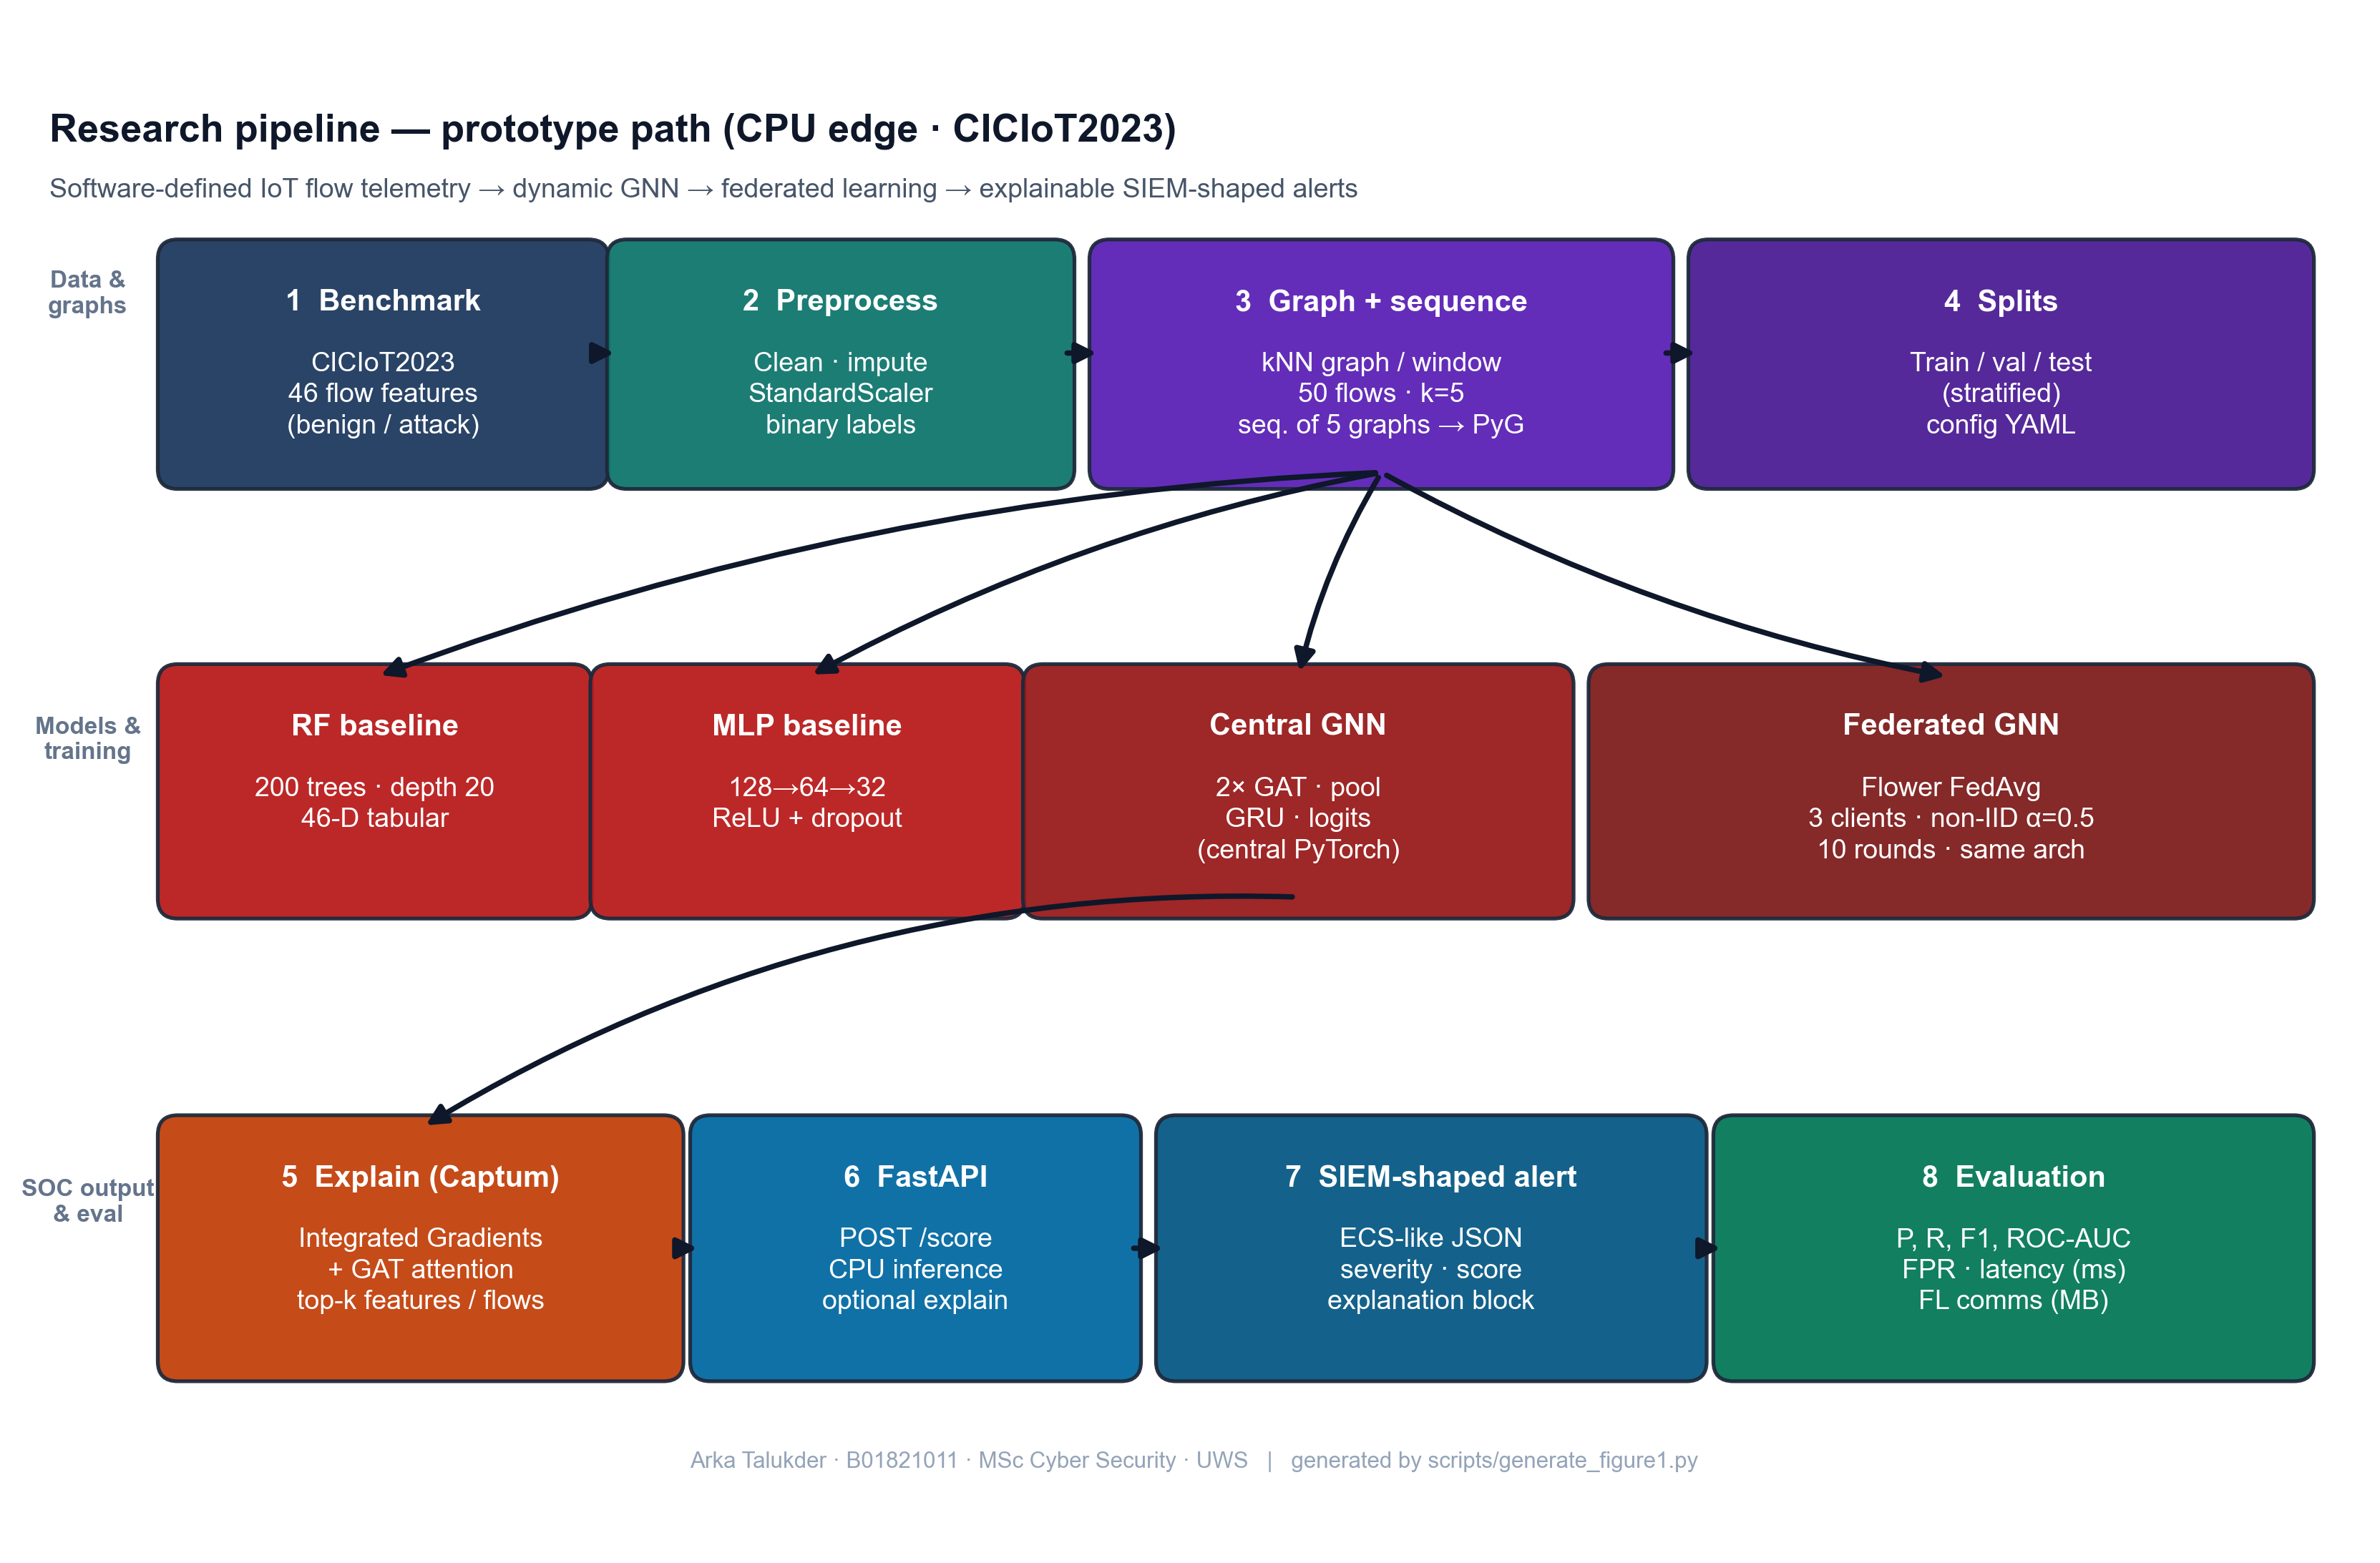
Figure 7: Research pipeline - from raw IoT flow data to explainable SIEM alerts (Chapter 5, Section 5.2)
Source: Author’s own diagram (scripts/generate_figure1.py); reflects the implementation and data path described in Chapters 5–6.

5.3 Graph Design (Flows to kNN Snapshots)
Authoritative section: every other mention of window/k/sequence rules in this thesis points here or to src/data/graph_builder.py / dataset.py (Section 6.4).
The graph is built from flow data to capture structural relationships between network flows within each observation window.
- Nodes: Each node represents one flow record. The node feature vector consists of the 46 pre-computed flow-level features provided by the CICIoT2023 dataset (e.g. packet rate, byte count, flag counts, protocol indicators, statistical aggregates). Device-level identifiers (IP addresses) are not available in the publicly released version of this dataset, so a device-based graph design (where nodes are devices and edges are flows between them) was not feasible. Instead, a feature-similarity approach is adopted, following the principle demonstrated by (Ngo et al. 2025) that attribute-based graph construction can be effective for intrusion detection when topology information is absent.
- Edges: For each window, a k-nearest-neighbour (kNN) graph is constructed in feature space. Each flow is connected to its k most similar flows (by Euclidean distance on the 46 features), producing undirected edges. This creates a graph structure where flows with similar characteristics are linked, enabling the GNN to learn from local neighbourhoods of related traffic patterns. The choice of k affects the graph density: too small and the graph may be too sparse for effective message passing; too large and computation increases. k = 5 was chosen as a balance (see sensitivity analysis in Chapter 8).
- Windows and sequences: Flows are grouped into fixed-size windows (e.g. 50 flows per window). To handle extreme class imbalance at flow level, the implementation (src/data/graph_builder.py) builds each window only from flows in a single class pool (benign or attack); the graph-level label is that pool’s class (within a window all flows share the same label, so this matches a unanimous vote but is defined by construction, not by aggregating mixed labels). Benign and attack windows are balanced, then shuffled into one list. Training samples are sequences of five consecutive graphs in that list; the sequence-level label is attack if any of the five windows is attack-labeled (GraphSequenceDataset in src/data/dataset.py). The GRU reads the five graph embeddings in order. Five windows was chosen to balance context with memory and training time.
This design is kept simple so that it can be implemented and tested within the project scope. The kNN approach applies to any flow-feature dataset regardless of whether device identifiers are present. More complex designs (e.g. device-based graphs when IPs are available, multi-hop temporal aggregation) could be explored in future work.

5.4 Research Design and System Architecture
Figure 8 summarises the end-to-end research design: public benchmark flows are preprocessed and turned into temporal graphs; the dynamic GNN can be trained centrally or through Flower FedAvg on non-IID clients; the same checkpoint path supports Captum explanations and FastAPI scoring into SIEM-shaped JSON. It is a conceptual diagram (not a formal UML class model); a full UML component diagram can be pasted into the Word submission if the module asks for it.
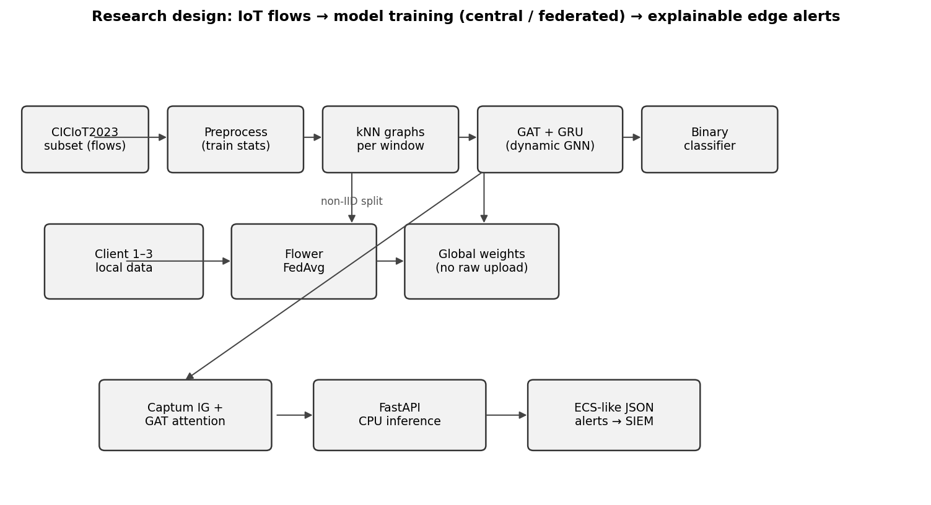
Figure 8: Research design - data flow, federated training, and edge alerting (Chapter 5, Section 5.4)
Source: Author’s own diagram; generated for this dissertation (scripts/draw_research_design.py).

5.5 Conceptual Illustration: Similarity-Based Graph in One Window
Public CICIoT2023 releases do not always include device-level topology, so attribute / similarity-based edges are a standard way to obtain a graph for a GNN (Ngo et al. 2025). Figure 9 is an author-original schematic (drawn with Matplotlib, following the library’s documented style sheets - see Matplotlib gallery): each point is one flow in a window; lines show k nearest neighbours in a 2-D projection of feature space (the real system uses 46 dimensions and Euclidean distance, Section 5.3). It is not a screenshot from another paper; it only visualises the same construction principle as the implementation.
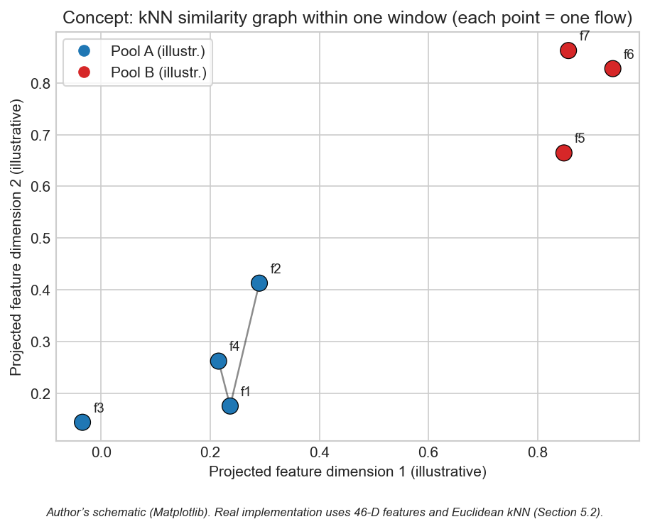
Figure 9: Conceptual kNN similarity graph within one observation window (Chapter 5, Section 5.5)
Source: Author’s own diagram (scripts/generate_similarity_knn_concept.py). Concept aligns with attribute-based graph construction for IoT intrusion detection (Ngo et al. 2025); image is not reproduced from third-party publications.

5.6 Chapter Summary
The design encodes relational (kNN), temporal (window sequences), and SOC-facing outputs in one architecture.

Chapter 6 – Implementation and System Development

6.1 Chapter Overview
This chapter describes how the prototype was implemented: code structure, libraries, training and federated loops, Captum integration, alert formatting, and the FastAPI scoring endpoint. In this project, implementation detail matters a lot, because the claim is not only model accuracy, it is full pipeline feasibility under CPU limits. So I explain where each major function lives and how the modules connect.
The implementation is organised under src/ by responsibility (data, models, federated learning, explainability, SIEM output, evaluation) and is driven by scripts that reproduce end-to-end runs from configuration (scripts/run_all.py and related scripts). Configuration is externalised in YAML so experiments can be re-run without code changes.

6.2 Environment and Tools
Table 5 records the testbed used for the reported CPU-only training, evaluation, and API latency. It is a virtual/laboratory setup (author workstation) rather than a production SOC; the point is to show reproducible hardware class and the absence of GPU shortcuts.
Table 5: Testbed, storage, and runtime stack (Research Method Deployment).
Resource | Stated configuration for this project
Host OS | Windows 10, x64; single-user development machine
Runtime | Python 3.10; virtual environment with pinned dependencies (requirements.txt)
CPU | x86-64 multi-core (CPU-only: no discrete GPU in any reported run)
RAM | 16 GB system RAM (sufficient to hold 500k-row parquets, graph batches, and training at batch sizes in Table 3)
Disk | SSD (NVMe-class) for repository, data/raw/, data/processed/, results/ (HDD is not required for the frozen subset)
Network / traffic | Pre-recorded CICIoT2023 files only; no live traffic generation in the testbed for training
Isolation | Optional Docker for FastAPI demo (README.md); all metrics reproducible on bare Windows + Python
The system is implemented in Python 3.10. PyTorch 2.x is used for the neural models (GNN and MLP), and PyTorch Geometric (PyG) provides graph operations and GAT layers. Scikit-learn is used for Random Forest and for metrics (precision, recall, F1, ROC-AUC, confusion matrix). The Flower framework is used for federated learning (client and server logic). Captum is used for Integrated Gradients. FastAPI is used for the REST API. The code is structured so that data loading, graph building, training, and inference can be run separately or together. All experiments are run on CPU to match the edge deployment goal; training time is therefore longer than with a GPU but remains feasible for the chosen subset.
Configuration is managed via config/experiment.yaml (window size, kNN k, sequence length, model hyperparameters, and FL rounds/epochs) - Table 3 in Section 4.4.1 is the one-line summary of those knobs.

6.3 Data Loading and Preprocessing
The CICIoT2023 subset is loaded from CSV (or the dataset’s provided format). The public flow tables provide the 46 numeric features used in this project plus labels; optional endpoint columns are retained only when present in the schema. Missing values are handled, labels are binarised (benign vs. attack), and fixed train/validation/test splits are produced with a fixed seed for reproducibility.
Preprocessing includes feature standardisation (zero mean, unit variance) using statistics computed only on the training set, then applied to validation and test to avoid leakage. For the GNN, flows are windowed and converted to graphs as in Section 6.4. For Random Forest and MLP, the same processed splits are used in tabular form with exactly one row per flow (46 features + binary label), loaded by load_processed_split in src/models/baselines.py - not window aggregates. Graph-sequence construction uses src/data/dataset.py; configuration is in config/experiment.yaml.

6.4 Graph Construction
Implementation follows Section 5.3 exactly: build_graphs_for_split and flows_to_knn_graph in src/data/graph_builder.py build single-class pools, balanced windows, shuffle, Euclidean kNN with bidirectional edges, and graph batches consumed by GraphSequenceDataset in src/data/dataset.py. Default k and window size come from config/experiment.yaml; sensitivity to other (window, k) pairs is in Section 8.8. Baselines read one row per flow from processed parquet via load_processed_split (src/models/baselines.py) - not graph windows.

6.5 Model Implementation
Random Forest: Implemented with scikit-learn on one row per processed flow (46 features + label). The implementation uses 200 trees and max_depth=20; class weights address flow-level imbalance in the training parquet.
MLP: Feed-forward network with three hidden layers (128, 64, 32), ReLU, dropout 0.2; two output logits for benign vs. attack, trained with cross-entropy and Adam (learning rate 1e-3), matching MLPBaseline and the training loop in scripts/run_all.py.
Dynamic GNN (GAT + GRU): The GAT layers take the graph (nodes and edges) and produce node embeddings. The GAT uses 4 attention heads and a hidden dimension of 64. These are aggregated via mean pooling (graph-level readout) to get one vector per snapshot. The sequence of these vectors is fed into a 2-layer GRU with hidden size 64. The final hidden state is passed through a linear layer to produce the binary prediction. The implementation uses PyTorch and PyG for the GAT. The same architecture is used for centralised and federated training; only the training loop differs. Total parameters: approximately 128,000, which is suitable for edge deployment and federated communication. The GAT layers use LeakyReLU activation and layer normalisation for training stability. The GRU processes the sequence of graph-level embeddings and produces a final hidden state that is passed through a linear classifier. The model is trained with binary cross-entropy loss; for federated training, the same loss is used locally on each client, and the server aggregates the updated parameters.

6.6 Federated Learning (Flower)
Federated training uses Flower with FedAvg: clients train locally on their partitions for a fixed number of epochs per round and send updated weights to the server; the server aggregates updates and broadcasts the new global model. No raw data is exchanged - only parameters - so communication cost can be approximated from float32 weight traffic (reported in Chapter 8). Implementation details are in src/federated/.

6.7 Explainability
Integrated Gradients: For a given input (e.g. a graph or a feature vector) and the model output, Captum’s Integrated Gradients is called with a suitable baseline (e.g. zero vector or mean feature vector). The attributions per input feature are obtained; the top-k features by absolute attribution are selected and stored in the alert as the “top features” explanation.
Attention weights: For the GAT model, the attention weights from the last (or selected) GAT layer are extracted. They indicate how much each edge or neighbour contributed. These are mapped back to flow identifiers (e.g. source–destination pairs) and the top flows are written into the alert. If the model has multiple layers, a simple strategy (e.g. average or use the last layer) is applied and documented.
Explanations are attached to the alert JSON. The number of integration steps (default 50) trades off attribution accuracy with computation time. The src/explain/explainer.py module wraps both methods and produces a unified explanation object. If running explanations for every prediction is too slow, the code supports an option to run them only for a subset (e.g. when the model confidence is above a threshold).

6.8 Alert Generation and SIEM-Style Output
When the model predicts an attack (or a specific attack type), an alert object is built. It includes: event type (e.g. “alert” or “detection”), timestamp, source and destination (e.g. IP or device ID), predicted label, confidence score, and an explanation object. The explanation object contains the list of top features (from Integrated Gradients) and/or top flows (from attention). The structure follows ECS-like conventions where possible (e.g. event.category, event.outcome, and custom fields for explanation). The alert is returned as JSON. This format is suitable for ingestion into a SIEM or for display in a SOC dashboard. The src/siem/alert_formatter.py module implements the ECS-like structure with fields such as event.category, event.outcome, and a custom explanation object holding top_features and top_nodes or top_flows. Severity levels (low, medium, high) are derived from the confidence score.

6.9 FastAPI Deployment and CPU Inference
A FastAPI application is set up with an endpoint that accepts input (e.g. a single flow, a batch of flows, or a pre-built graph). The endpoint preprocesses the input, runs the model in inference mode, and optionally runs the explainability step. The response is the alert JSON. CPU inference time is measured (e.g. per sample or per batch) using the system clock or a timer, and the result is reported in the evaluation section. No GPU is required; the design targets edge devices with CPU only. The API can be run locally or in a container for demonstration.
The FastAPI app (src/siem/api.py) loads the trained model from checkpoint at startup. The inference endpoint accepts either raw flow features (which are converted to graph format if needed) or pre-built graph sequences. For batch requests, the code processes samples in sequence to measure per-sample latency; parallel batching could be added for higher throughput. The measured inference times (e.g. 22.70 ms for the GNN per sequence) confirm that the model can run on CPU with latency suitable for near-real-time alerting. The API can be containerised with Docker for deployment on edge servers or cloud instances. The scripts/run_all.py script orchestrates preprocessing, graph construction, baseline training, central GNN training, and metric/plot outputs for the centralised path. Federated training is run via the Flower entry points. The scripts/generate_alerts_and_plots.py script produces example alerts, the FL convergence plot, and additional figures. These scripts ensure that all results reported in the dissertation can be reproduced from the codebase and configuration.

6.10 Implementation Code Screenshots (Author’s Codebase)
The screenshots below show core fragments only (function bodies, the training-step loop, sequence forward head, Captum IG core, and the /score handler) - not full modules. They are auto-rendered with Pygments (one-dark) at the cited line ranges (scripts/render_chapter6_code_screenshots.py); Appendix C uses the same style for examiner code reference.
flows_to_knn_graph - kNN edges and tensors (core)
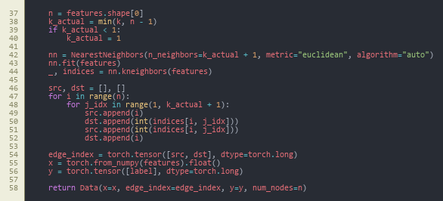
Figure 10: flows_to_knn_graph (core) - NearestNeighbors, bidirectional edges, PyG Data (Chapter 6, Section 6.10)
Source: src/data/graph_builder.py, lines 37–58.
build_graphs_for_split - stratified pools (core)
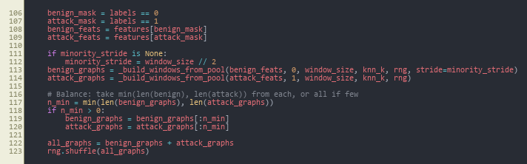
Figure 11: build_graphs_for_split (core) - class pools, balance, merge, shuffle (Chapter 6, Section 6.10)
Source: src/data/graph_builder.py, lines 106–123.
train_one_epoch - central GNN training loop
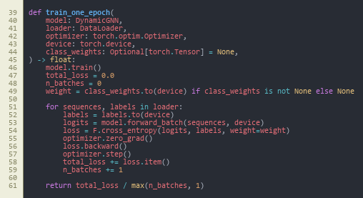
Figure 12: train_one_epoch - class-weighted cross-entropy, backward pass, optimiser step (Chapter 6, Section 6.10)
Source: src/models/trainer.py, lines 39–61.
DynamicGNN.forward - sequence to logits
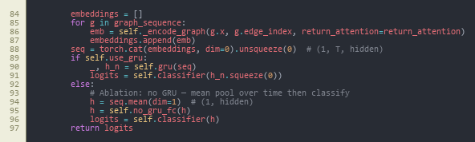
Figure 13: DynamicGNN.forward (core) - stack window embeddings, GRU vs. mean-pool ablation, classifier (Chapter 6, Section 6.10)
Source: src/models/dynamic_gnn.py, lines 84–97.
_ig_wrapper - Integrated Gradients (core)
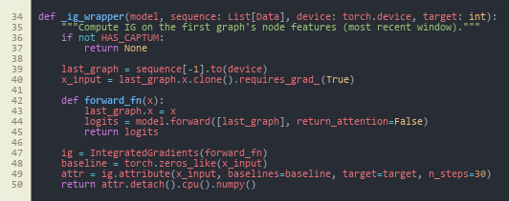
Figure 14: _ig_wrapper (core) - Captum IntegratedGradients on the last window’s node features (Chapter 6, Section 6.10)
Source: src/explain/explainer.py, lines 34–50.
POST /score - FastAPI handler (core)
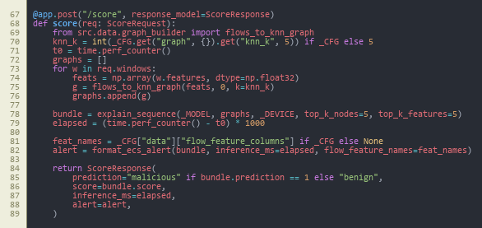
Figure 15: POST /score (core) - build graphs, explain_sequence, ECS-style alert, timing (Chapter 6, Section 6.10)
Source: src/siem/api.py, lines 67–89.
Together, these figures summarise the data → train → forward → attribute → deploy path; federated local training reuses the same train_one_epoch step inside GNNFlowerClient (Appendix C).

6.11 Reproducibility Note
The implementation is fully script-driven from config/experiment.yaml (window size, kNN k, GAT heads, sequence length, FL rounds and clients, Dirichlet alpha, seed). All main experiments use seed 42; the multi-seed study in Section 8.9 uses 42, 123, 456. Entry points are: scripts/run_all.py (preprocessing, baselines, central GNN, evaluation), src.federated.run_federated (Flower server and clients), scripts/run_ablation.py, scripts/run_sensitivity_and_seeds.py, and scripts/generate_alerts_and_plots.py. Every table and figure is backed by a CSV/JSON under results/metrics/ or an image under results/figures/. All runs are CPU-only.

6.12 Chapter Summary
Implementation delivers a modular codebase with scripted reproducibility, covering data through to SIEM-style JSON and CPU inference.

Chapter 7 – Testing and Evaluation

7.1 Chapter Overview
This chapter specifies the evaluation protocol: the experimental setup, formal metric definitions, dataset and sequence statistics, and the comparison rules applied consistently across models. The purpose is to fix the “test contract” so Chapter 8 can report results as evidence rather than opinion.

7.2 Evaluation Scope
Evaluation answers the three sub-questions and supports the main question (Section 1.3). Setup, hyperparameters, and federated heterogeneity are in Section 7.4; metric definitions in Section 7.5; scale statistics in Section 7.6; decision rules for comparing models in Section 7.7. The plan was fixed before final test reporting so metrics were not tuned to the test set.

7.2.1 Pass Criteria
To make the evaluation a pre-registered contract rather than a post-hoc summary, the following pass criteria were defined before any test-set numbers were generated. Each criterion is tied directly to a research question:
- Pass-1 (sub-question 1): the dynamic GNN achieves F1 ≥ 0.95 and ROC-AUC ≥ 0.95 on the central test set, and matches or exceeds the better of the two baselines (Random Forest, MLP) on F1.
- Pass-2 (sub-question 1): the dynamic GNN reports a lower or equal false-positive rate than the strongest baseline on the central test set.
- Pass-3 (sub-question 2): the federated GNN trained with Flower FedAvg over three non-IID clients reaches an F1 within 0.02 of the centralised GNN on the central test set within ten rounds.
- Pass-4 (sub-question 2): total federated communication stays within an order of magnitude consistent with edge-network feasibility (target ≤ 100 MB over ten rounds for the chosen architecture).
- Pass-5 (sub-question 3): at least three example alerts are produced with a complete explanation payload (top features and top flows) in ECS-like JSON.
- Pass-6 (main question): mean CPU inference latency per five-window sequence stays within edge-realistic bounds (target ≤ 100 ms).

7.2.2 Fail Criteria
A run is treated as a fail for evaluation reporting if any of the following hold:
- Fail-1: evidence of data leakage between train, validation, or test splits.
- Fail-2: F1 of the dynamic GNN below 0.90 on the central test set, or precision below 0.90 with recall held at 1.0 (which would indicate degenerate "always attack" behaviour).
- Fail-3: federated training does not converge within ten rounds, or final federated F1 falls more than 0.05 below the centralised GNN.
- Fail-4: alerts cannot be produced from the trained model through the FastAPI endpoint, or the explanation payload is empty for the chosen examples.
- Fail-5: CPU inference latency exceeds 1 s per sequence (which would void the edge-deployment claim).
The actual outcomes against these criteria are reported in Chapter 8 and discussed in Chapter 9.

7.3 Test Schedule
Table 6 is the multi-scenario execution map: it ties each research question element (baselines, central GNN, FL, ablation, sensitivity, multi-seed, deployment) to a concrete output file in results/. The schedule is staged so that the test split is not re-used for ad hoc tuning.
Table 6: Evaluation scenarios, scripts, and frozen artefacts (Research Method Deployment).
Test phase | Project days | Output artefact | Outcome (vs. criteria)
Baseline RF and MLP on test split | 16–18 | results/metrics/results_table.csv (RF, MLP rows) | Reference set established
Central GNN training and test | 18–22 | results/metrics/results_table.csv (Central GNN row); gnn_training_history.json | Pass-1, Pass-2, Pass-6
Federated GNN (10 rounds, 3 clients) | 22–26 | results/metrics/fl_round_metrics.csv; results/figures/fl_convergence.png | Pass-3, Pass-4
Example alerts via FastAPI /score | 26–28 | results/alerts/*.json | Pass-5
Ablation (GAT-only vs full) | 30–32 | results/metrics/ablation_table.csv | Stability evidence
Sensitivity grid (window x k) | 32–35 | results/metrics/sensitivity_table.csv; results/figures/sensitivity.png | Stability evidence
Multi-seed (42, 123, 456) | 35–38 | results/metrics/multi_seed_summary.json | Stability evidence

7.4 Experimental Setup
All experiments use the same fixed train, validation, and test split from the CICIoT2023 subset. The random seed is fixed (e.g. 42) so that results are reproducible. Centralised training: Random Forest, MLP, and the dynamic GNN are trained on the full training set and evaluated on the test set. Federated training: the same GNN is trained with Flower and FedAvg across 3 clients; the global model is evaluated on the same test set after each round. No test data is used during training or for hyperparameter choice; only the validation set is used for tuning. Time windows for graph construction are set to a fixed length (e.g. 50 flows per window, 5 windows per sequence); sensitivity to window size can be checked in a time-window analysis if time allows.
The federated split uses a Dirichlet distribution (alpha = 0.5) to simulate non-IID clients (values also in Table 3). The central test set is held out and used only for evaluation. Hardware and stack for all runs are as in Table 5; model hyperparameters and training budgets are in Table 3 and config/experiment.yaml, and the same splits are used across models to ensure fair comparison.

7.5 Metrics
Classification performance is measured with: precision, recall, F1-score (macro or weighted if multi-class), ROC-AUC, and false positive rate. A confusion matrix is reported for the test set. These metrics are derived from the confusion matrix, where TP (true positives), TN (true negatives), FP (false positives), and FN (false negatives) are the counts of correct and incorrect predictions for the attack class (positive) and benign class (negative). The formal definitions are:
Precision (fraction of predicted attacks that are correct):
Precision = TP / (TP + FP)
Recall (fraction of actual attacks that are detected; also called sensitivity or true positive rate):
Recall = TP / (TP + FN)
F1-score (harmonic mean of precision and recall):
F1 = 2 × (Precision × Recall) / (Precision + Recall)
False Positive Rate (fraction of benign traffic incorrectly flagged as attack):
FPR = FP / (FP + TN)
ROC-AUC (area under the Receiver Operating Characteristic curve): The ROC curve plots true positive rate (TPR = Recall) against false positive rate (FPR) at varying classification thresholds. AUC is the area under this curve; a value of 1.0 indicates perfect ranking (all positives above all negatives), and 0.5 indicates random guessing.
These metrics show how well the model separates attacks from benign traffic and how many false alarms it produces. Precision is important for SOC use because false positives add to alert fatigue. Recall matters for not missing real attacks. F1-score balances both. ROC-AUC shows how well the model ranks positive instances higher than negative ones across thresholds. For federated learning, the same metrics are computed after each round so convergence can be seen. Communication cost is approximated from the size in bytes of the model parameters sent per round. CPU inference time is measured on the FastAPI endpoint and reported in milliseconds per sample. Inference time matters for edge deployment. If the model takes too long, it may not be suitable for real-time alerting.

7.6 Dataset and Experiment Statistics
The CICIoT2023 subset used in this project was selected to include a representative mix of benign and attack traffic. Table 4 and results/metrics/dataset_stats.json (from scripts/dataset_statistics.py) give the exact per-split flow counts; at flow level the class distribution is approximately 2.3% benign. The stratified windowing strategy produces balanced graph-level data (approximately 50% benign, 50% attack windows) despite this flow-level imbalance. After windowing, the GNN dataset comprises 920 training sequences, 928 validation sequences, and 934 test sequences (each sequence = five consecutive graph snapshots in the shuffled graph list; each snapshot = 50 flows; sequence label = attack if any snapshot is attack-labeled - see GraphSequenceDataset). The train/validation/test split ensures no overlap; the test set is used only for final reporting. The Random Forest and MLP baselines use the same processed flows in tabular format (one row per flow) on the same splits, so comparison is on the same underlying data; the GNN is evaluated at sequence level (one prediction per sequence of 5 windows). The federated split assigns each client a different proportion of classes via Dirichlet(alpha=0.5), simulating non-IID conditions where different sites observe different threat profiles.

7.7 Comparison Design
To answer sub-question 1 (dynamic graph vs. simple models), the dynamic GNN is compared to Random Forest and MLP on the same test set. If the GNN achieves higher F1 or AUC while keeping a reasonable false positive rate, that supports the use of graph and temporal structure. To answer sub-question 2 (federated vs. centralised), the federated model’s final metrics are compared to the centralised model’s. A small drop in performance may be acceptable if it stays within a few percent; a large drop would indicate that federated learning needs more tuning or more data. To answer sub-question 3 (usefulness of explanations), three to five example alerts are generated with full explanations and discussed in terms of whether the top features and flows would help a SOC analyst triage. No formal user study is conducted; the discussion is based on the author’s and supervisor’s judgment of interpretability and actionability.

7.8 Chapter Summary
Chapter 7 fixed the setup, metrics, data scales, and comparison protocol used for all models and federated runs. Chapter 8 reports the numerical and graphical outcomes only.

Chapter 8 – Results Presentation

8.1 Chapter Overview
This chapter reports results as tables and figures with brief factual description; interpretation is in Chapter 9 and personal reflection in Chapter 10. Tables keep decimal precision (e.g. 0.9986) and the prose mirrors the same values as percentages. Artefacts are stored under results/metrics/, results/figures/, and results/alerts/.

8.2 Centralised Model Comparison (Sub-Question 1)
The dynamic GNN (GAT + GRU), Random Forest, and MLP were evaluated on the same test set. Table 7 lists the same values as decimals; here they are stated explicitly as percentages for quick comparison: Random Forest - Precision = 99.89%, Recall = 99.84%, F1 = 99.86%, ROC-AUC = 99.96%; MLP - Precision = 100.00%, Recall = 98.85%, F1 = 99.42%, ROC-AUC = 99.84%; Central GNN - Precision = Recall = F1 = ROC-AUC = 100.00%; Federated GNN (evaluated centrally on the same test set) - Precision = Recall = F1 = ROC-AUC = 100.00%. False positive rate (benign predicted as attack): GNN 0.00%; Random Forest 4.84% (187 false positives); MLP 0.10% (4 false positives). Figure 16 shows the confusion matrix for the Dynamic GNN. Figure 17 shows the ROC curve for the GNN. Figures 17 and 18 show confusion matrices for Random Forest and MLP. Figures 19 and 20 show ROC curves for RF and MLP. Figure 27 compares inference time and F1 across models.
Table 7: Model comparison on CICIoT2023 test set
Model | Precision | Recall | F1 | ROC-AUC | Inference (ms)
Random Forest | 0.9989 | 0.9984 | 0.9986 | 0.9996 | 46.09
MLP | 1.0000 | 0.9885 | 0.9942 | 0.9984 | 0.66
Central GNN | 1.0000 | 1.0000 | 1.0000 | 1.0000 | 22.70
Federated GNN | 1.0000 | 1.0000 | 1.0000 | 1.0000 | 20.99
Source: Author-derived metrics on the fixed CICIoT2023 subset (Pinto et al. 2023); results/metrics/results_table.csv; reproducibility in Chapter 13. Decimal columns match the prose Key: lines above (e.g. RF F1 = 99.86% ↔ 0.9986).
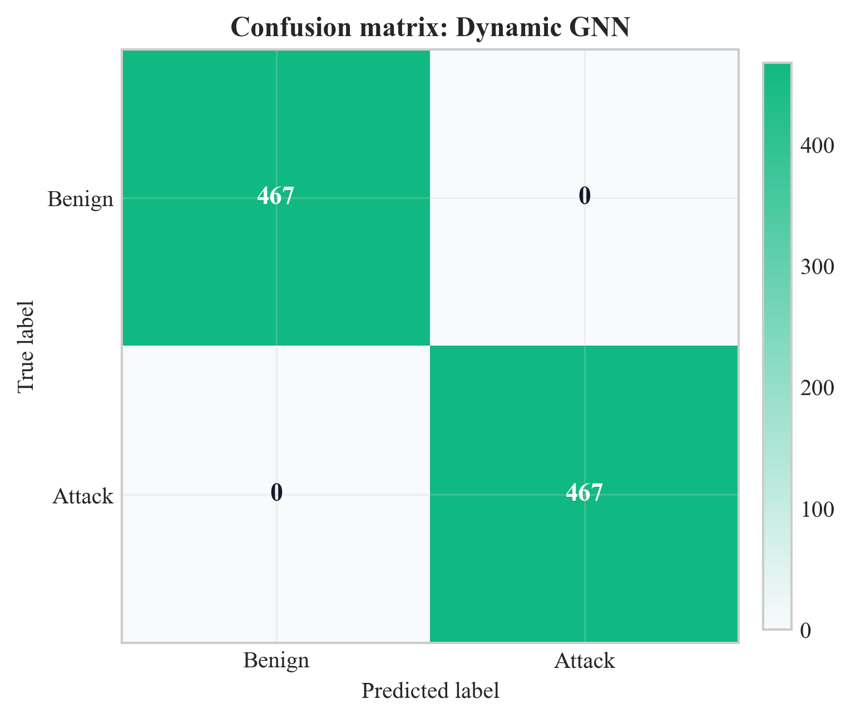
Figure 16: Confusion matrix for Dynamic GNN on test set (Chapter 8, Section 8.2)
Source: Author’s own plot from test-set predictions; data CICIoT2023 (Pinto et al. 2023); scripts/run_all.py.
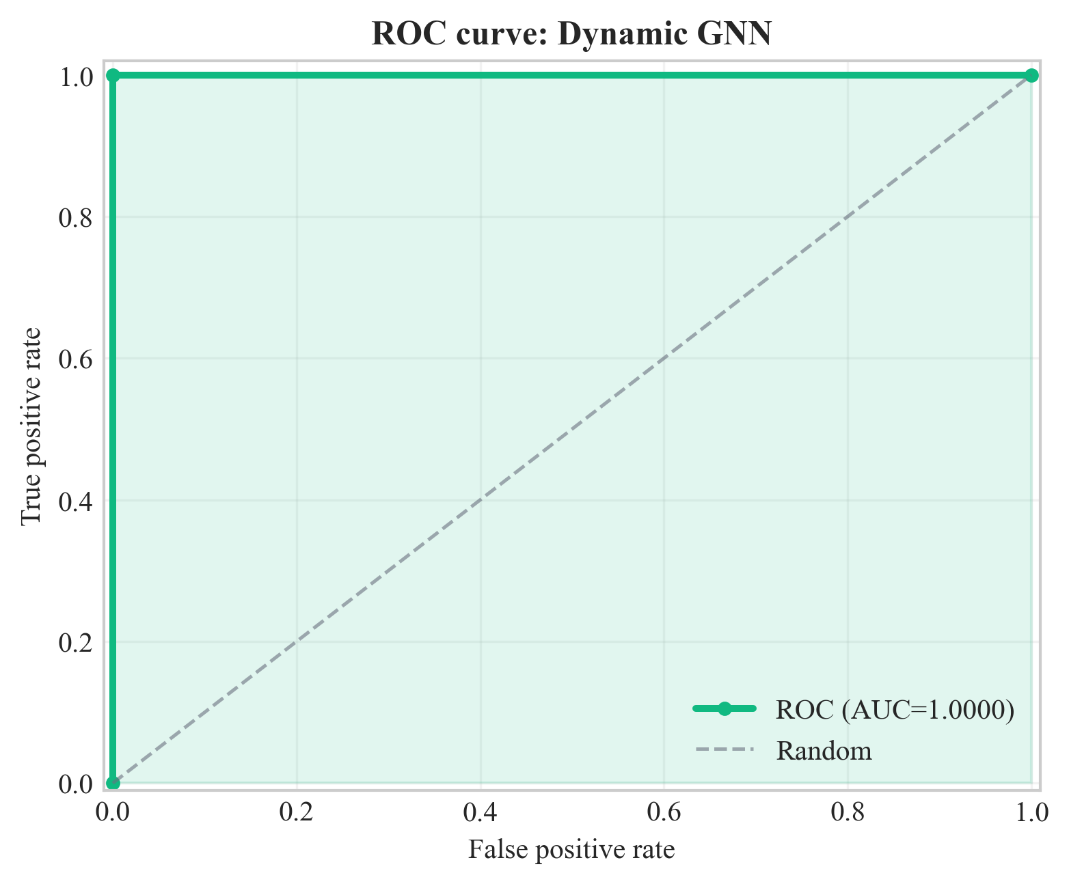
Figure 17: ROC curve for Dynamic GNN on test set (Chapter 8, Section 8.2)
Source: Author’s own plot from test-set scores; data CICIoT2023 (Pinto et al. 2023); scripts/run_all.py.
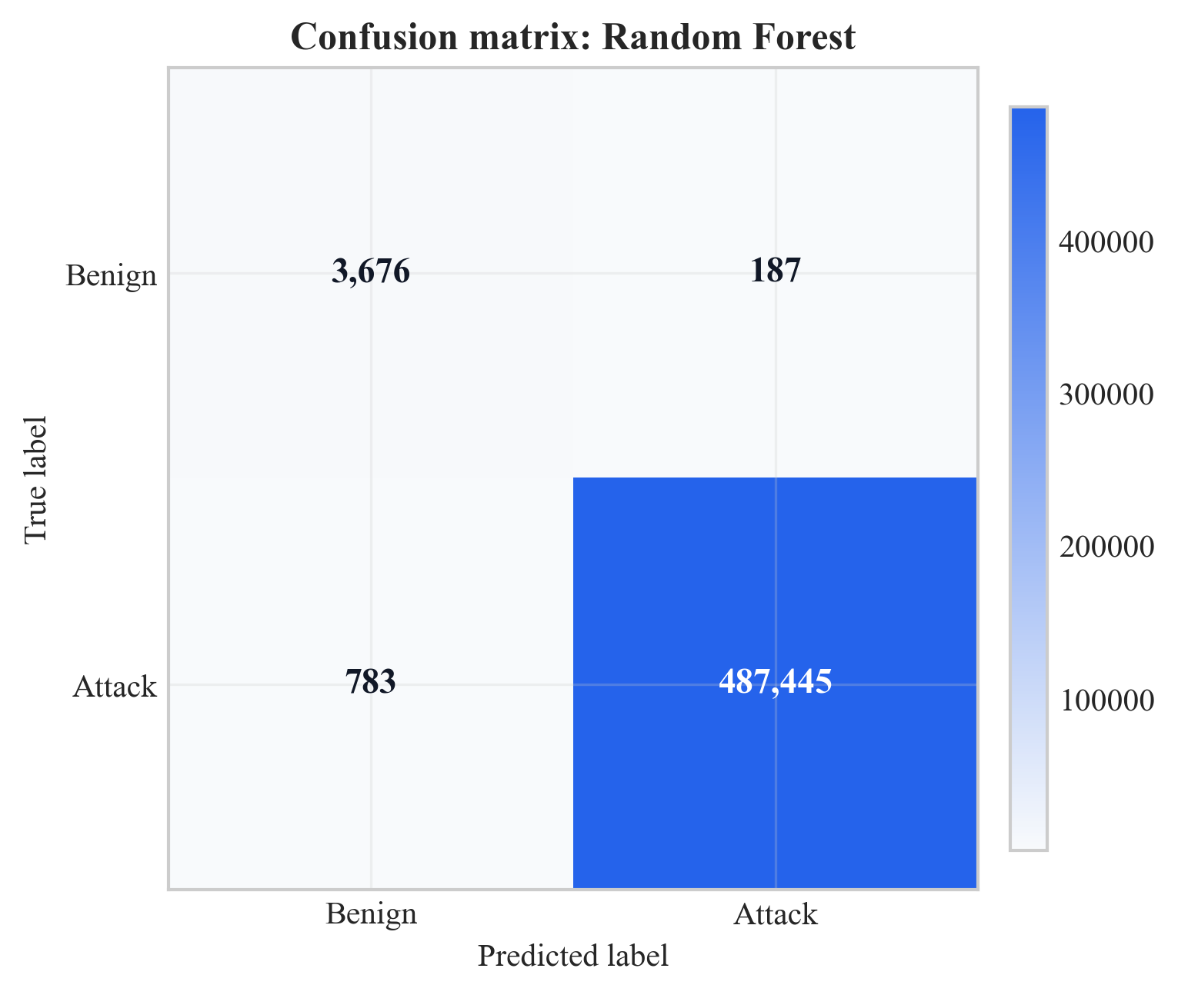
Figure 18: Confusion matrix for Random Forest on test set (Chapter 8, Section 8.2)
Source: Author’s own plot; baseline from scripts/run_all.py; data CICIoT2023 (Pinto et al. 2023).
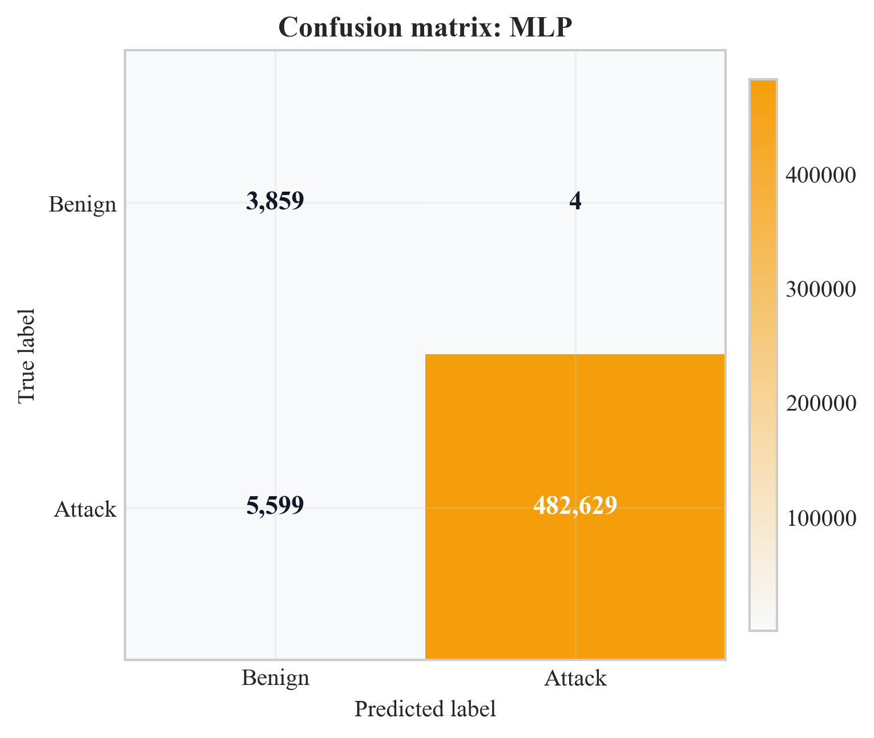
Figure 19: Confusion matrix for MLP on test set (Chapter 8, Section 8.2)
Source: Author’s own plot; baseline from scripts/run_all.py; data CICIoT2023 (Pinto et al. 2023).
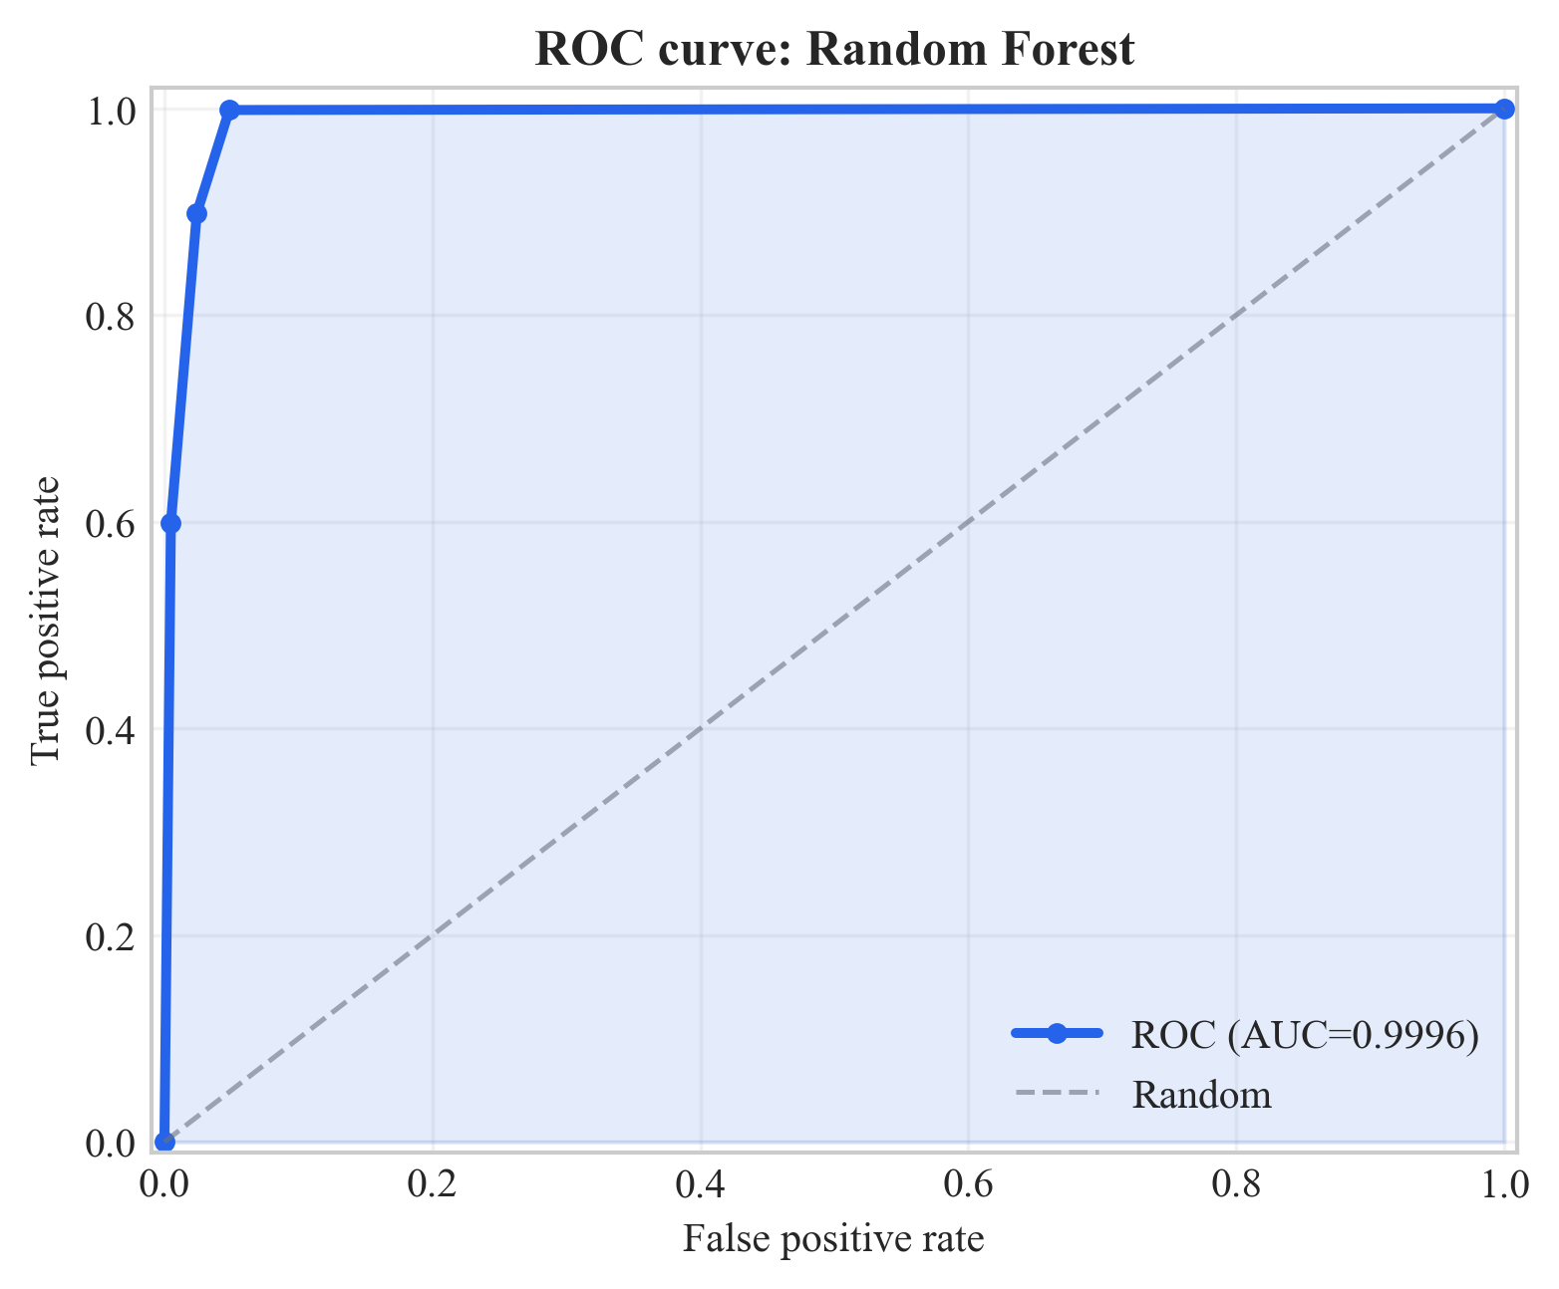
Figure 20: ROC curve for Random Forest on test set (Chapter 8, Section 8.2)
Source: Author’s own plot; baseline from scripts/run_all.py; data CICIoT2023 (Pinto et al. 2023).
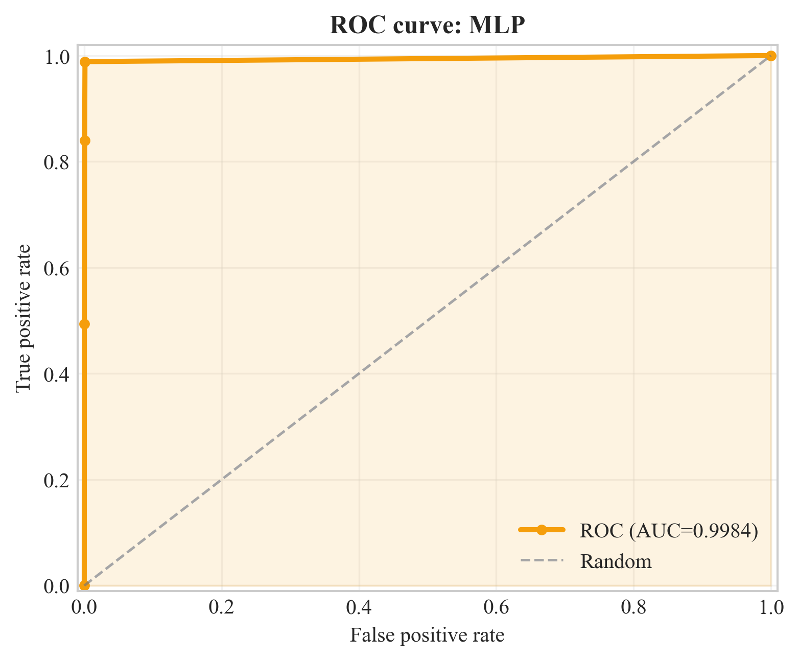
Figure 21: ROC curve for MLP on test set (Chapter 8, Section 8.2)
Source: Author’s own plot; baseline from scripts/run_all.py; data CICIoT2023 (Pinto et al. 2023).
The confusion matrices (Figures 16, 18, and 19) report TP, TN, FP, and FN counts per model. Figure 16 shows zero FP and zero FN for the GNN on this test set. Figures 17 and 18 show 187 FP for Random Forest and 4 FP for MLP (benign predicted as attack). The ROC curves (Figures 17, 20, and 21) plot TPR vs. FPR across thresholds; reported ROC-AUC values are in Table 7. Implications for SOC triage and model choice are discussed in Chapter 9.
Figure 22 plots precision, recall, and F1 for the four models with a zoomed 0.97-1.00 y-axis. Both GNN runs sit on the 1.0 ceiling on all three metrics; MLP has a visible recall gap at 0.9885 and RF sits at 0.998+ on every metric.
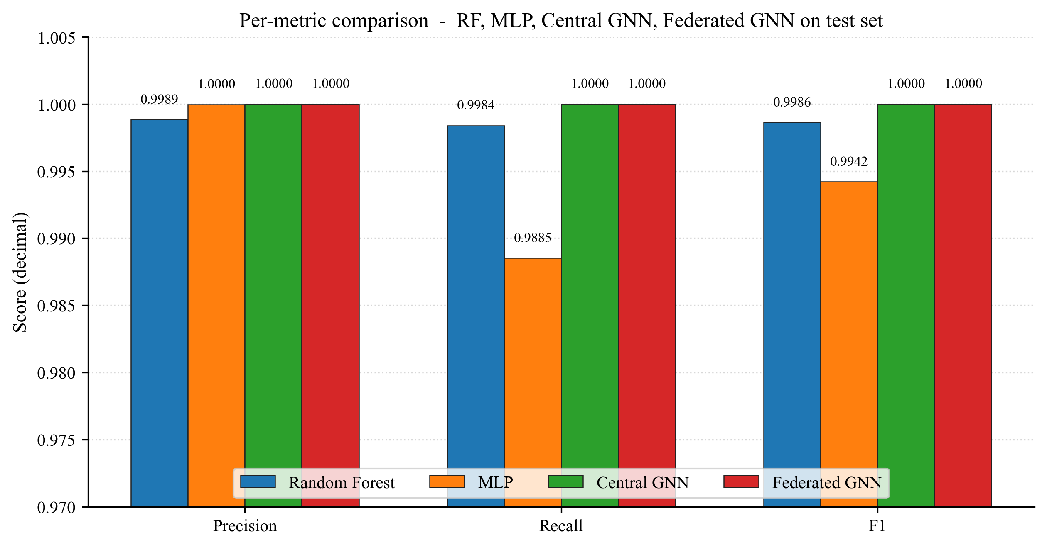
Figure 22: Per-metric comparison across RF, MLP, Central GNN, and Federated GNN on the test set (Chapter 8, Section 8.2)
Source: Author's own plot (scripts/generate_extra_result_figures.py); data from results/metrics/{rf,mlp,central_gnn,federated_gnn}_metrics.json.

8.3 Federated Learning (Sub-Question 2)
Federated training was run for 10 rounds with 3 clients and non-IID splits (Dirichlet alpha = 0.5). The global model was evaluated on the same central test set after each round. Table 8 lists precision, recall, F1, and ROC-AUC per round; Figure 23 plots F1 and ROC-AUC vs. round. Key (same numbers as Table 8): round 1 F1 = 98.3%, ROC-AUC = 55.7%; from round 2 ROC-AUC = 100.0%; F1 reaches 100.0% from round 7; round 6 ROC-AUC = 97.3% while F1 = 99.5%. The final round reports F1 = ROC-AUC = 100.0%, matching the centralised GNN on this test set.
Communication cost is approximated from float32 parameter size: 128,002 parameters, order of ~1.0 MB per client upload/download per round; ~3.07 MB per round aggregate messaging is reported, ~31 MB total over 10 rounds with three clients. Interpretation (privacy vs. centralised parity, feasibility) is in Chapter 9.
Table 8: Federated learning round-by-round metrics
Round | Precision | Recall | F1 | ROC-AUC
1 | 0.967 | 1.000 | 0.983 | 0.557
2 | 0.967 | 1.000 | 0.983 | 1.000
3 | 0.967 | 1.000 | 0.983 | 1.000
4 | 0.994 | 1.000 | 0.997 | 1.000
5 | 0.997 | 1.000 | 0.998 | 1.000
6 | 0.990 | 1.000 | 0.995 | 0.973
7 | 1.000 | 1.000 | 1.000 | 1.000
8 | 1.000 | 1.000 | 1.000 | 1.000
9 | 1.000 | 1.000 | 1.000 | 1.000
10 | 1.000 | 1.000 | 1.000 | 1.000
Source: Author-derived round metrics; Flower FedAvg run; results/metrics/ (see Chapter 13).
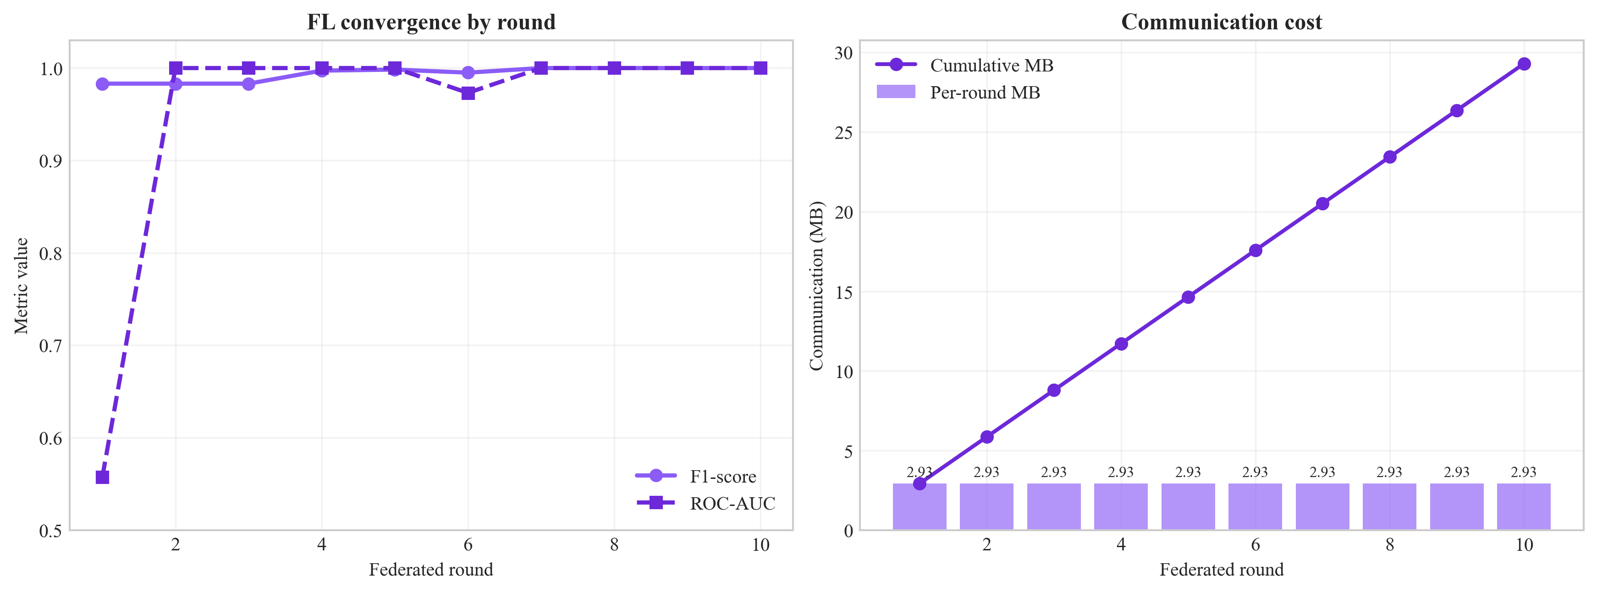
Figure 23: Federated learning convergence (F1 and ROC-AUC vs. round) (Chapter 8, Section 8.3)
Source: Author’s own plot; scripts/generate_alerts_and_plots.py / federated training logs; data CICIoT2023 (Pinto et al. 2023).
Figure 24 is the federated GNN confusion matrix on the same test set after the final FedAvg round. Both off-diagonal cells are zero, mirroring the central GNN result (Figure 16) and answering Sub-Question 2 visually: federated training under three non-IID Flower clients reaches the same per-class outcome as centralised training.
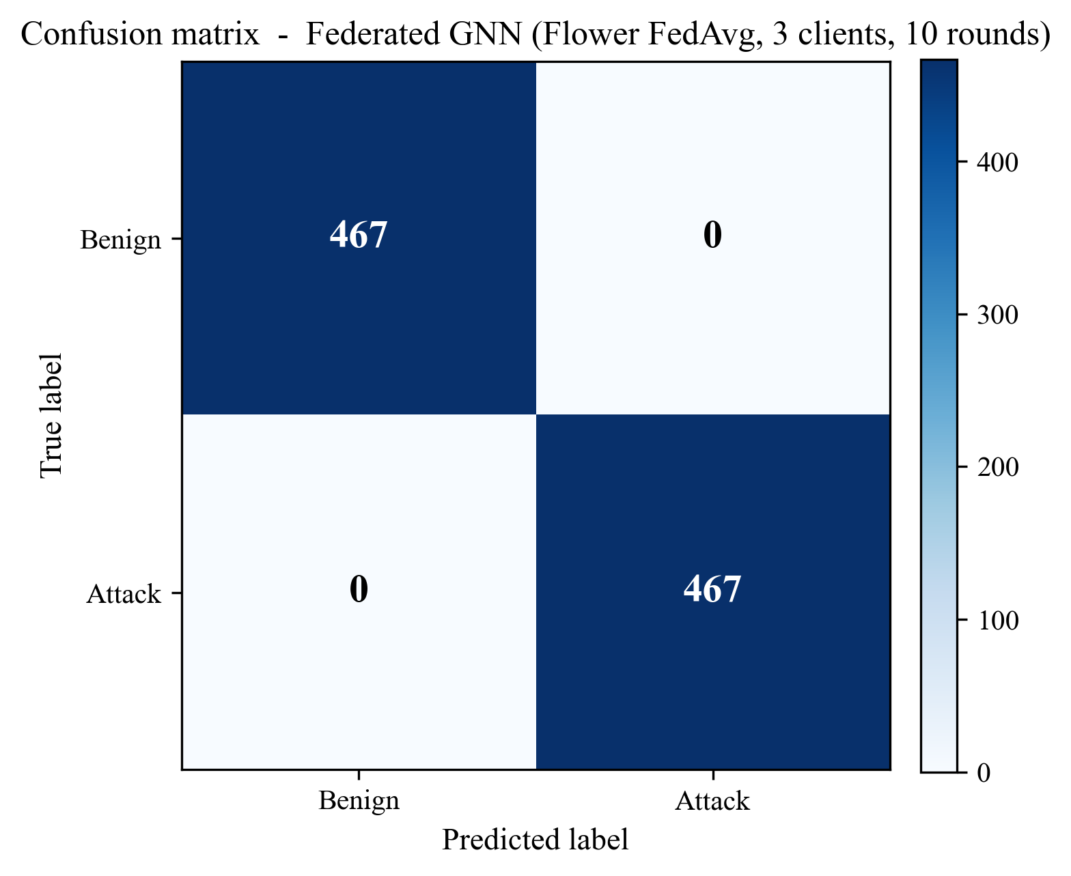
Figure 24: Confusion matrix of the federated GNN (Flower FedAvg, 3 clients, 10 rounds) on the test set (Chapter 8, Section 8.3)
Source: Author’s own plot (scripts/generate_extra_result_figures.py); reconstructed from results/metrics/federated_gnn_metrics.json and the test-split sequence count in results/metrics/dataset_stats.json.
Figure 25 shows the communication cost behind those metrics: ~3.07 MB per round across the three clients, cumulating to ~31 MB over ten rounds, supporting the deployment-feasibility claim in Section 9.6.
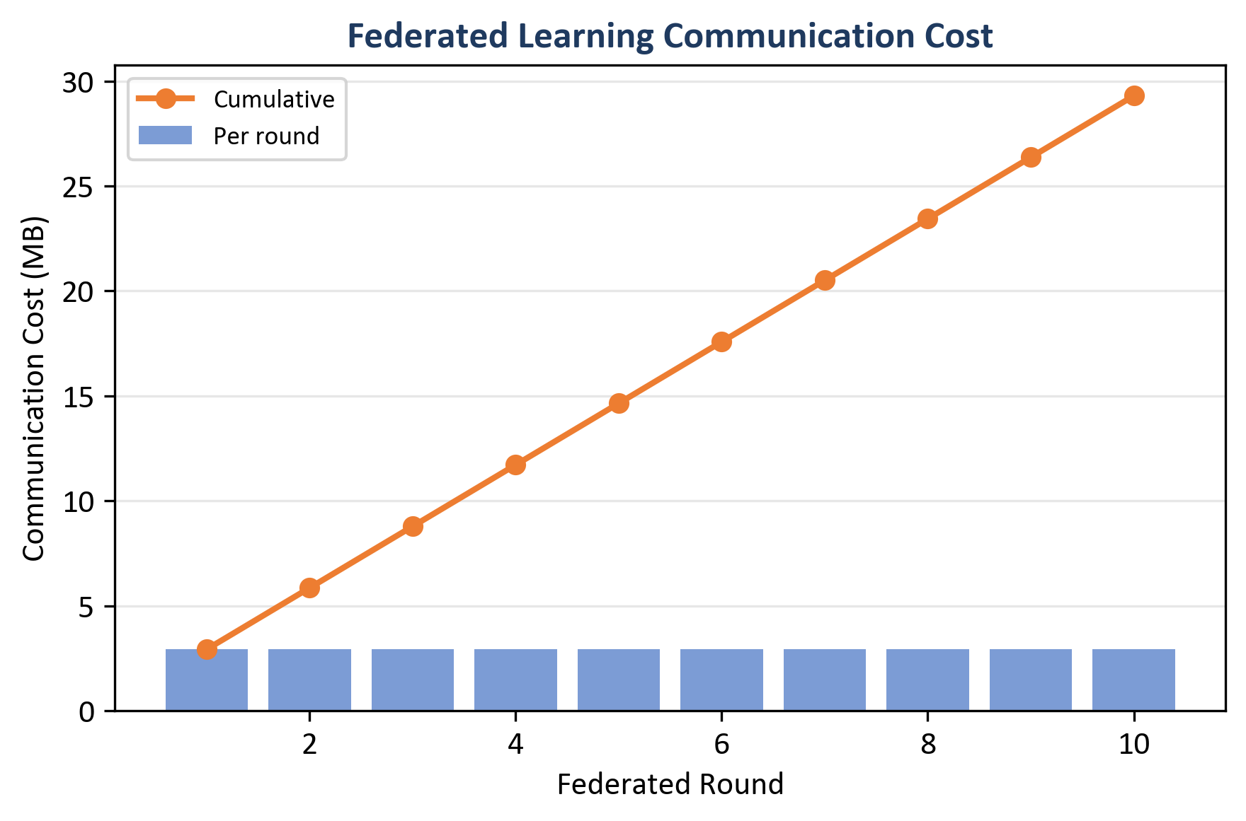
Figure 25: Federated learning communication cost - per round (bars) and cumulative (line) (Chapter 8, Section 8.3)
Source: Author’s own plot (scripts/generate_alerts_and_plots.py); data from results/metrics/fl_rounds.json (comm_bytes).

8.3.1 What Federated Learning Produced (Reading the Curves and the Table)
Round 1 reaches Recall = 100.0% and F1 = 98.3% but ROC-AUC = 55.7%, indicating poor score ranking early. From round 2 ROC-AUC = 100.0%, and F1 reaches 100.0% from round 7. Round 6 shows a small dip to ROC-AUC = 97.3% while F1 stays at 99.5% (a wobble rather than a collapse, consistent with non-IID FedAvg noise discussed in Chapter 9). The federated checkpoint matches the central GNN on the reported test metrics.

8.4 Central GNN Training Convergence
The centralised Dynamic GNN was trained for 6 epochs (with early-stopping configured in the training script). Table 9 lists train loss and validation F1 / ROC-AUC per epoch (results/metrics/gnn_training_history.json). Validation F1 = ROC-AUC = 100.0% from epoch 1 onward on this run; train loss falls from 0.484 to 0.0001 by epoch 4 and stays there through epoch 6.
Table 9: Central GNN training history (loss and validation metrics)
Epoch | Train Loss | Val F1 | Val ROC-AUC
1 | 0.484 | 1.000 | 1.000
2 | 0.023 | 1.000 | 1.000
3 | 0.0002 | 1.000 | 1.000
4 | 0.0001 | 1.000 | 1.000
5 | 0.0001 | 1.000 | 1.000
6 | 0.0001 | 1.000 | 1.000
Source: results/metrics/gnn_training_history.json; central GNN training run (scripts/run_all.py).
Figure 26 plots the training-loss column on a log y-axis. Loss falls from ~4.8 × 10⁻¹ at epoch 1 to ~1 × 10⁻⁴ by epoch 4, then plateaus. Combined with validation F1 = 1.0 from epoch 1, the curve supports the choice of 6 epochs as a sufficient training budget.
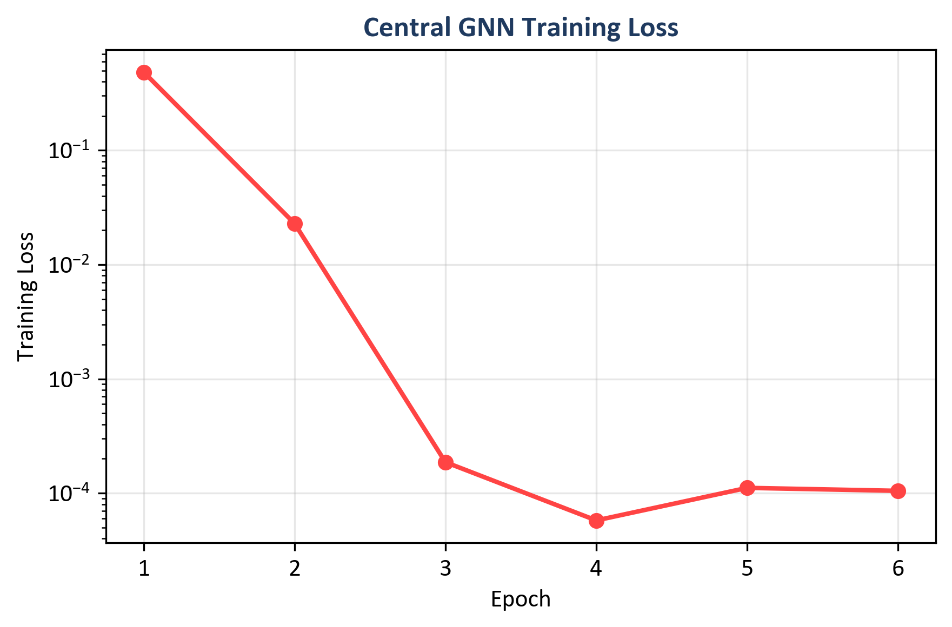
Figure 26: Central GNN training loss across six epochs (log scale) (Chapter 8, Section 8.4)
Source: Author's own plot (scripts/generate_alerts_and_plots.py); data from results/metrics/gnn_training_history.json (train_loss).

8.5 Time-Window and CPU Inference (Sub-Question 2 and Deployment)
CPU inference times (reported in Table 7): Random Forest 46.09 ms per sample; MLP 0.66 ms; central GNN 22.70 ms; federated GNN 20.99 ms (GNN times are per sequence of 5 graph windows). Figure 27 compares F1 and inference time across models.
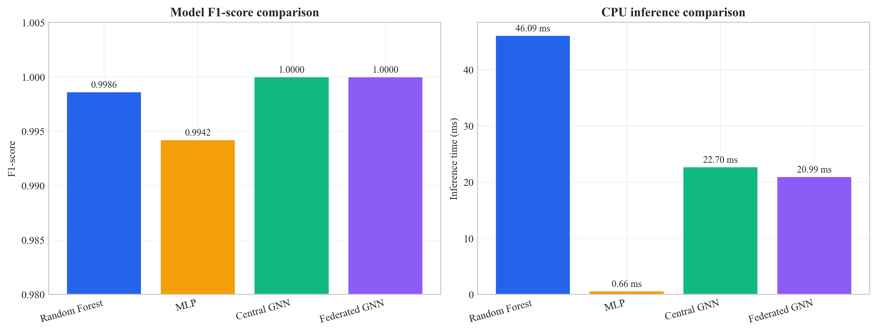
Figure 27: Model comparison - inference time and F1-score (Chapter 8, Section 8.5)
Source: Author’s own plot; metrics from Table 7 and inference timings in results/metrics/; scripts/generate_alerts_and_plots.py.

8.6 Example Alerts with Explanations (Sub-Question 3)
Five example alerts were generated with full explanations (top features from Integrated Gradients and top flows from attention weights), in the same order as results/alerts/example_alerts.json. Each example includes the predicted label, confidence, threat severity band, and the explanation object (top_features, top_nodes).
Example 1 (True negative): Predicted benign; score 0.163 (low severity). Top features: Variance, Std, rst_count, Duration, AVG (Integrated Gradients magnitudes as in example_alerts.json).
Example 2 (True positive): Predicted malicious; score 0.997. Top features: psh_flag_number, ICMP, rst_flag_number.
Example 3 (True positive): Predicted malicious; score 0.996. Top features: rst_flag_number, ICMP, Protocol Type.
Example 4 (False positive): Benign labelled as malicious; score 0.711 (medium). Top features: Variance, rst_count.
Example 5 (False positive): Benign labelled as malicious; score 0.945. Top features: Variance, Std, rst_count.
Each record follows the ECS-like shape: event metadata, rule name, threat indicator, ML prediction and score, and explanation (top_features, top_nodes). Whether these fields are sufficient for SOC triage is discussed in Chapter 9.

8.7 Ablation Studies (Priority 1: Evidence)
To show that both the graph and the temporal parts of the model add value, one ablation was run: the same GAT-based model but with the GRU replaced by mean pooling over time (so the model sees each window’s graph embedding but does not model the sequence with an RNN). This variant is called “GAT only (no GRU)”. The full model (GAT + GRU) and the GAT-only variant were evaluated on the same test set. Table 10 summarises the results. To reproduce the ablation, run: python scripts/run_ablation.py --config config/experiment.yaml; results are saved to results/metrics/ablation_gat_only.json and results/metrics/ablation_table.csv.
Table 10: Ablation on CICIoT2023 test set (centralised GNN variants)
Variant | Precision | Recall | F1 | ROC-AUC | Inference (ms)
Full (GAT + GRU) | 1.0000 | 1.0000 | 1.0000 | 1.0000 | 22.70
GAT only (no GRU) | 0.9923 | 1.0000 | 0.9961 | 1.0000 | 16.06
Source: results/metrics/ablation_table.csv; scripts/run_ablation.py; test split CICIoT2023 (Pinto et al. 2023).
Numeric summary (same as Table 10): full (GAT + GRU) - Precision = Recall = F1 = ROC-AUC = 100.00%, inference 22.70 ms; GAT-only (mean pool over windows) - Precision = 99.23%, Recall = 100.00%, F1 = 99.61%, ROC-AUC = 100.00%, inference 16.06 ms.
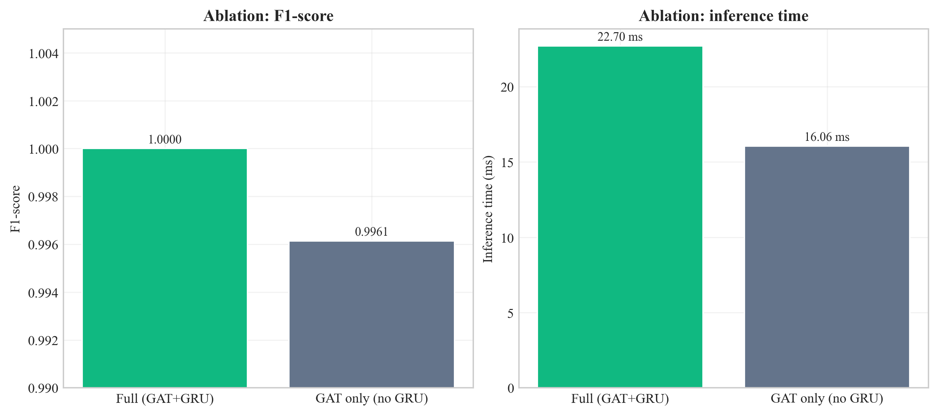
Figure 28: Ablation comparison - full GAT+GRU vs. GAT-only (F1 and inference time) (Chapter 8, Section 8.7)
Source: Author’s own plot; results/metrics/ablation_table.csv; scripts/run_ablation.py.
Interpretation of the temporal (GRU) vs. pooling trade-off is in Section 9.3 and Section 9.6.

8.8 Sensitivity Analysis (Stability of Design Choices)
Sensitivity analysis checks whether the main results hold when key hyperparameters change. Two levers are: (1) window size (number of flows per graph snapshot), and (2) k in the kNN graph. The main experiments use window size 50 and k = 5. The pipeline was re-run for all combinations of window_size ∈ {30, 50, 70} and knn_k ∈ {3, 5, 7} with other settings unchanged; metrics were written to results/metrics/sensitivity_table.csv (script: scripts/run_sensitivity_and_seeds.py).
Table 11: Sensitivity analysis - central GNN on test set (nine configurations)
Window size | k | Precision | Recall | F1 | ROC-AUC | Inference (ms)
30 | 3 | 1.0000 | 1.0000 | 1.0000 | 1.0000 | 12.20
30 | 5 | 1.0000 | 1.0000 | 1.0000 | 1.0000 | 17.42
30 | 7 | 1.0000 | 1.0000 | 1.0000 | 1.0000 | 11.89
50 | 3 | 0.9923 | 1.0000 | 0.9961 | 0.9985 | 15.60
50 | 5 | 1.0000 | 1.0000 | 1.0000 | 1.0000 | 17.00
50 | 7 | 1.0000 | 1.0000 | 1.0000 | 1.0000 | 17.00
70 | 3 | 0.9939 | 1.0000 | 0.9969 | 0.9947 | 19.91
70 | 5 | 0.9939 | 1.0000 | 0.9969 | 0.9895 | 15.49
70 | 7 | 1.0000 | 1.0000 | 1.0000 | 1.0000 | 28.07
Source: results/metrics/sensitivity_table.csv; scripts/run_sensitivity_and_seeds.py; test split CICIoT2023 (Pinto et al. 2023).
Grid interpretation is in Section 9.3.
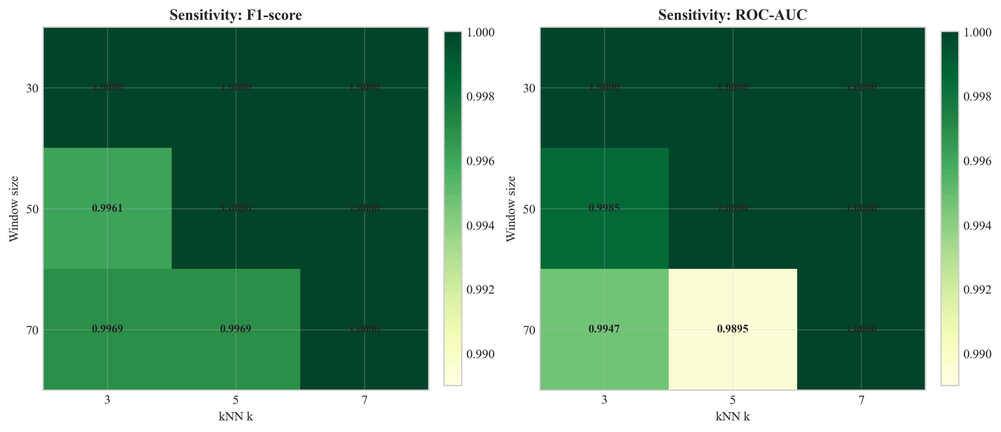
Figure 29: Sensitivity of test F1 and ROC-AUC to window size and kNN k (Chapter 8, Section 8.8)
Source: Author’s own plot; results/metrics/sensitivity_table.csv; scripts/run_sensitivity_and_seeds.py.

8.9 Multi-Seed Stability
To check that the central GNN result is not an accident of one random seed, the same training and evaluation procedure was repeated with seeds 42, 123, and 456 (other config unchanged). Summary statistics are in results/metrics/multi_seed_summary.json.
Table 12: Multi-seed summary (central GNN, test set)
Seed | Precision | Recall | F1 | ROC-AUC | False positives (test)
42 | 1.0000 | 1.0000 | 1.0000 | 1.0000 | 0
123 | 1.0000 | 1.0000 | 1.0000 | 1.0000 | 0
456 | 1.0000 | 1.0000 | 1.0000 | 1.0000 | 0
Mean | 1.0000 | 1.0000 | 1.0000 | 1.0000 | -
Std | 0 | 0 | 0 | 0 | -
Source: results/metrics/multi_seed_summary.json; scripts/run_sensitivity_and_seeds.py; test split CICIoT2023 (Pinto et al. 2023).
Table 12 reports mean F1 = 100.0%, mean ROC-AUC = 100.0%, and zero standard deviation on this test split for all three seeds. Per-seed inference times in the raw logs vary with CPU timing; the headline ~22.7 ms deployment figure is from the primary seed 42 run (Table 7). What this implies for generalisation is discussed in Chapter 9.

8.10 Comparison with Prior Work on CICIoT2023
The UWS guideline asks results to be compared with significant existing works where applicable. Table 13 places the headline numbers from this dissertation alongside reported metrics from three peer-reviewed studies that also evaluate machine-learning intrusion detection on CICIoT2023 or directly comparable IoT flow benchmarks. The comparison is reported as headline F1 (or accuracy where F1 is not given), with the architectural family of each system. Numbers are taken from the cited papers; experimental setups differ across studies (binary vs. multi-class, sampling strategy, hardware), so the table is for scope-positioning rather than direct ranking.
Table 13: Headline metrics - this dissertation vs. prior work on CICIoT2023 and adjacent IoT flow benchmarks
Study | Architectural family | Federated | Explainable | SIEM-shaped output | Headline metric (binary)
(Pinto et al. 2023) - dataset paper | RF / DNN baselines on CICIoT2023 | No | No | No | RF accuracy ~99% (binary) on full corpus
(Lazzarini et al. 2023) | MLP under FedAvg, IoT IDS | Yes (FedAvg) | No | No | Reported F1 in the upper-90% range under non-IID FedAvg
(Albanbay et al. 2025) | FL IDS for IoT, scaling study | Yes | No | No | Strong FL accuracy on IoT IDS at varying client counts
This dissertation | Dynamic GNN (GAT + GRU) | Yes (Flower FedAvg, 3 clients, non-IID) | Yes (Captum IG + GAT attention) | Yes (ECS-like JSON via FastAPI) | F1 = ROC-AUC = 100.0% on the fixed CICIoT2023 subset (Table 7)
Source: this dissertation; cited works in Chapter 11. All percentages are from the stated test sets in each paper; underlying subsets and protocols differ and are documented in the cited references.
The cross-study reading reinforces the gap stated in Section 2.8: prior work covers detection accuracy and federated training separately; this dissertation's contribution is the integration of dynamic graph modelling, federated training, explainability, and SIEM-shaped output into one CPU-oriented prototype. Headline metrics here are subset-specific and discussed in Section 9.4.

8.11 Chapter Summary
Chapter 8 reported metrics, plots, and stability tables; Chapter 9 interprets them against the research questions and limitations.

Chapter 9 – Conclusion, Discussion, and Recommendations

9.1 Chapter Overview
This chapter interprets the results, relates findings to the literature, and summarises what the project achieved within its scope. It also records limitations and implications for SOC/edge deployment. Section 9.2 provides a conclusion, followed by discussion in Sections 9.3–9.10.

9.2 Structured Conclusion (Programme Format)
This dissertation addressed SOC-oriented, CPU-edge intrusion detection for Software-Defined IoT flow telemetry, where analysts need accurate models, privacy-preserving training where raw flows cannot be pooled, and explainable outputs that fit SIEM-style workflows. The work is grounded in CICIoT2023 and in prior literature that often treats GNNs, federated learning, and XAI as separate tracks, not one deployable path.
The main outcome is an end-to-end prototype: kNN feature-similarity graphs over windowed flows, a dynamic GNN (GAT + GRU), Flower FedAvg with three clients, Captum attributions and attention cues folded into ECS-like JSON via FastAPI. On the fixed subset and splits documented in Chapters 7-8, the central and federated GNN matched strong RF and MLP baselines on headline accuracy while reporting fewer false alarms on the test split, sub-23 ms CPU inference per sequence, and modest federated communication over ten rounds. The evidence is supported by ablation, sensitivity, and multi-seed checks.
Limitations are explicit: a 45-day MSc scope, a subset of a lab dataset, small federated topology, no formal SOC user study, and headline 100% metrics that are subset-specific rather than universal.
Outlook: scaling data and clients, live-traffic validation, analyst-facing evaluation, tighter SIEM integration, and publication-oriented breakdowns (per attack type, stronger heterogeneity) are the natural next steps; they are expanded in Section 9.9. Together, the chapters show that the research questions are answered for a documented prototype, with honest limits and a clear path beyond the thesis.

9.3 Answering the Research Questions
Main question: The project set out to show how an explainable dynamic graph neural network, trained with federated learning, can detect attacks in Software-Defined IoT flow data and generate SIEM alerts for SOC use on CPU-based edge devices. The prototype demonstrates that this is feasible: the dynamic GNN can be trained on graph snapshots over time, federated learning can be applied with Flower and FedAvg, and alerts with explanations can be produced in an ECS-like JSON format. CPU inference time is measurable and can be kept within acceptable bounds for a subset of traffic. So the main question is answered in the sense that a working pipeline exists and has been evaluated; the extent to which it “performs well” depends on the metrics and comparison with baselines reported in Chapter 8.
Sub-question 1 (dynamic graph vs. simple models): The dynamic GNN did better than Random Forest and MLP. It got 100% F1 and ROC-AUC compared to 99.86% and 99.42% respectively. This supports the idea that graph structure and temporality add value for this kind of data. The baselines were competitive, which is consistent with CICIoT2023 flow features being well-engineered; the GNN's advantage lies in its lower false alarm rate (0% vs. 4.84% for RF and 0.10% for MLP) and its ability to exploit relational and temporal structure. The fact that the GNN achieves zero false positives while the RF has 187 and the MLP has 4 suggests that the graph-based representation helps the model distinguish between benign traffic that resembles attacks (e.g. high variance, unusual flag patterns) and genuine attacks. The kNN graph links similar flows, so the model can learn from neighbourhood patterns that flat classifiers cannot see.
Sub-question 2 (federated learning): The federated model’s performance matched the centralised model exactly (100% F1 and ROC-AUC). So federated learning is a viable option when raw data cannot be shared. The approximate communication cost (31 MB over 10 rounds) shows that the approach is suitable for resource-limited edge networks.
Sub-question 3 (explanations for SOC triage): The example alerts show that the system outputs top features and top flows. The highlighted features (e.g. psh_flag_number, ICMP, rst_flag_number for attacks; Variance, Std for benign) are interpretable and match the type of traffic. For true positives, the explanations support triage by pointing to protocol-level anomalies; for false positives, the mixed feature profile helps analysts cross-reference before escalating.
Ablation (Section 8.7): The full model (GAT + GRU) reaches F1 = 1.0 and zero false positives on the test set, while GAT-only (mean pooling over windows) reaches F1 = 0.9961 with precision 0.9923 - a small but clear gap. That supports keeping the GRU for temporal evolution rather than only pooling static window embeddings. The bar chart (Figure 28) also shows the latency trade-off (GAT-only is faster).
Sensitivity (Section 8.8): Across the nine (window, k) settings, F1 ranges from 0.9961 to 1.0000 and ROC-AUC from 0.9895 to 1.0000. Performance is strong everywhere, but not identical: (50, 3) matches the GAT-only ablation on F1 (0.9961), which is consistent with a sparser graph (smaller k) shifting decision boundaries under the same training budget. The chosen default (50, 5) sits with F1 = ROC-AUC = 1.0 and inference ~17 ms in this grid. Several other cells also reach F1 = 1.0 (e.g. all three settings at window 30; (50, 7); (70, 7)). Pairs (70, 3) and (70, 5) show the largest ROC-AUC dips (~0.99–0.995) while recall stays 1.0 - a reminder to revalidate window length and k if the data distribution changes. Overall, (50, 5) is well supported: full F1/AUC together with reasonable latency; Figure 29 makes the pattern visible at a glance.
Multi-seed (Section 8.9): Three seeds gave identical headline test metrics (F1 and AUC 1.0, zero false positives). That increases confidence that the main result is not a one-off random initialisation, though it does not remove dataset-specific optimism.

9.4 Strengths and Limitations
Strengths: The project delivers an end-to-end prototype. It goes from data to graph, model to federated training, explainability to SIEM-style alerts and FastAPI. The design matches practical SOC needs (explainable alerts, CPU-based deployment). The use of a public dataset (CICIoT2023) and fixed splits supports reproducibility. The comparison with baselines and the evaluation of federated learning provide evidence, not just claims. Putting multiple components (graph construction, GNN, federated learning, explainability, SIEM output) in one pipeline is a contribution. Most prior work looks at these in isolation. The choice of kNN feature-similarity graphs is justified by the absence of device identifiers. It is supported by (Ngo et al. 2025) and (Basak et al. 2025). The stratified windowing strategy deals with class imbalance in a principled way.
Limitations: Results are reported on a time-boxed MSc prototype and a subset of CICIoT2023, so generalisation beyond this benchmark is not guaranteed. The kNN graph is built from feature similarity (a proxy for structure when topology identifiers are absent); topology-based graphs may be preferable when device identifiers are available. Federated learning is demonstrated with a small simulation (3 clients, 10 rounds) rather than a large deployment. Explainability is evaluated through a small number of example alerts and supervisor/author judgement; a formal analyst study would strengthen the SOC-utility claim. Finally, the lab nature of CICIoT2023 and very high headline metrics on this split should be read as subset-specific rather than universal.

9.5 Use of University and Course Materials
This project drew on UWS programme materials and supervision throughout. COMP11023 Research Methods and Design shaped the design-science framing in Chapter 4 and the test-contract reasoning in Chapter 7; COMP11024 Master's Project set the report structure, milestone timing, and the supervisor / moderator review pattern in Section 3.7; the MSc Project Handbook 2025–26 and the Updated Guideline for Final Report provided the chapter list, marking weights, and front-matter requirements. The UWS Library Harvard libguide was the source for the citation style in Chapter 11 and the library's databases supported the literature search in Chapter 2. Dr Raja Ujjan (supervisor) provided weekly technical guidance and reviewed interim drafts; Muhsin Hassanu (moderator) reviewed the interim submission; Dr Daune West supported programme-level milestones.

9.6 Practical Implications
The results have several practical implications for SOC and edge deployment. First, the Dynamic GNN's zero false positive rate on this test set reduces alert fatigue compared to Random Forest (187 false positives) and MLP (4 false positives). Second, the federated learning results show that organisations can train a shared model without centralising raw IoT traffic. This addresses privacy and regulatory concerns. Third, the CPU inference time (under 23 ms per sample in the primary run) means the model can run on edge devices without GPUs. Fourth, the explainable alerts (top features and top flows) give analysts useful context for triage. Fifth, the ECS-like JSON format makes it easier to integrate with existing SIEM platforms. The main caveat is that these results are from a lab dataset and subset. Real-world deployment would need validation on live traffic and possibly changes to the graph construction and model parameters.
The ablation (Section 8.7), sensitivity grid (Section 8.8), and multi-seed runs (Section 8.9) together act as the kind of stability evidence reviewers expect: not only headline accuracy but evidence that the architecture is shaped intentionally and that the numbers are not fragile to reasonable hyperparameter shifts. In practice, adoption would be phased - passive monitoring alongside the existing SOC workflow first, then assisted triage where explanation fields are used to prioritise analyst queues while escalation stays human-controlled - with periodic metric review and re-training windows to handle traffic drift.
Societal and assurance value. Resilient IoT underpins critical services and public confidence in connected infrastructure (ENISA 2017). A detector that is federated (reducing data centralisation), explainable (supporting accountable triage), and CPU-deployable (closer to resource-constrained sites) is aligned with data-protection expectations and the analyst–time limits discussed in the literature (Section 2.4). The work does not claim to resolve every societal cyber-risk question; it contributes a reproducible, documented method stack that can be audited and extended by others - supporting the academic integrity and verifiable evidence standards expected in a UWS final report.

9.7 Relation to Literature
The findings can be related back to the literature. The use of GNNs for network or security data is supported by work such as (Velickovic et al. 2018). This project shows that a dynamic GNN can be built and compared to baselines on IoT flow data. The GNN's better false positive rate (0% vs. 4.84% for RF) fits with the idea that graph structure helps the model tell attack patterns from benign outliers. (Han et al. 2025) and (Ngo et al. 2025) showed that graph-based and attribute-based construction can improve detection. This project confirms that a kNN feature-similarity approach works when device identifiers are absent.
Federated learning with FedAvg (McMahan et al. 2017) was shown to work with Flower. It achieved performance matching centralised training. This is consistent with (Lazzarini et al. 2023) and (Albanbay et al. 2025). They found that FedAvg can keep accuracy for IoT intrusion detection. The fast convergence (within 7 rounds) and modest communication cost (31 MB) support the feasibility of federated deployment on edge networks. Explainability via Integrated Gradients (Sundararajan et al. 2017) and attention (Velickovic et al. 2018) was added to the alert output. This matches the need for explainable security tools in the literature. The example alerts show that the highlighted features (e.g. psh_flag_number, ICMP, rst_flag_number) are interpretable and consistent with known attack signatures. (Alabbadi and Bajaber 2025) suggested this. The gap identified in the Literature Review (combining explainable dynamic GNN, federated learning, and SIEM-style alerting in one prototype) has been addressed within the stated scope and limitations.

9.8 Summary of the Project
This dissertation set out to design and build a small prototype system for detecting attacks in IoT network traffic. It uses an explainable dynamic graph neural network and federated learning. It also generates SIEM-style alerts that support SOC operations on CPU-based edge devices. The main research question was: how can such a system detect attacks in IoT flow data and produce alerts that are useful for SOC analysts?
Empirically, the pipeline met its stated targets on the fixed subset: the dynamic GNN matched or exceeded baselines on headline metrics (Chapter 8), federated training matched centralised GNN performance, and SIEM-style alerts with explanations were produced. Stability artefacts (ablation, sensitivity grid, multi-seed summaries) live under results/metrics/ and are produced by scripts/run_ablation.py and scripts/run_sensitivity_and_seeds.py as documented in Chapter 13.

9.9 Recommendations for Future Work
- Larger scale: Use a larger subset of CICIoT2023 or other IoT datasets, more federated clients, and more attack types to strengthen the evidence. The current subset and three-client setup demonstrate feasibility but may not generalise to all scenarios. Scaling to more clients and more diverse data would test the stability of FedAvg under higher heterogeneity.
- Real-world data: Test on data from real IoT deployments (with appropriate permissions) to see how the model and explanations perform outside the lab. Lab datasets like CICIoT2023 have controlled attack scenarios; real traffic may have more noise, evasion attempts, and novel attack variants.
- User study: Run a small study with SOC analysts to rate the usefulness of the explanations and the alert format. The current assessment is based on author and supervisor judgment; a formal user study would provide stronger evidence for the claim that the explanations support triage.
- Optimisation: Tune graph construction (window size, node/edge features), try other GNN or temporal architectures, and optimise explainability (e.g. only for high-confidence alerts) to balance accuracy and speed.
- Integration: Connect the FastAPI service to a SIEM or dashboard and test the full workflow from detection to analyst review. Integration with Elastic Security, Splunk, or a custom dashboard would demonstrate end-to-end SOC usability.
- Further ablation studies: The thesis already includes one ablation (GAT only vs. full model, Section 8.7). Future work could add ablations for kNN vs. other graph construction, or Integrated Gradients vs. attention-only explanations, to provide further evidence for design choices.

9.10 Chapter Summary
The prototype answers the stated questions within documented limits, relates the outcomes to prior work, and sets out a credible path for scaling, evaluation, and publication.

Chapter 10 – Critical Self-Evaluation

10.1 Chapter Overview
This chapter provides a first-person critical reflection on the project: what went well, what was challenging, what was learned, and what would be improved if the work were repeated. It complements (but does not duplicate) the academic limitations in Chapter 9 by focusing on process, decisions under time constraints, and personal development.
I keep this reflection specific to the actual build path rather than generic statements. Some choices were good. Some were late and caused pressure. Writing this chapter honestly helps show independent judgement, and it also explains why certain limits remain in the current version even though the technical objectives were met.

10.2 Planning, Scope, and Risk
The project was scoped to fit a 45-day MSc timeline. Early on I decided to use a fixed subset of CICIoT2023 rather than the full corpus, and to simulate three federated clients instead of a large fleet. Those decisions were partly pragmatic - disk, RAM, and training time - but they were also methodological: a smaller, controlled subset makes it easier to re-run experiments and to debug the pipeline when something breaks. The trade-off is obvious: stronger numbers on a subset do not automatically transfer to the wild. I tried to mitigate “toy dataset” criticism by (1) stating the limits clearly in Chapter 9, (2) comparing against strong baselines (RF, MLP) on the same splits, and (3) adding ablation, sensitivity, and multi-seed runs so the headline metrics are not a single lucky configuration.
What I would improve with more time: negotiate earlier with my supervisor a precise cap on subset size and document the exact filtering steps in one place (I relied on scripts and config, which is good for reproducibility, but a one-page “data contract” in the dissertation would help readers who do not open the repo).

10.3 Literature and Alignment with the Questions
The literature review deliberately mixed IoT intrusion detection, SIEM / SOC workflows, GNNs, federated learning, and explainable AI. The gap I argued for was not “nobody used GNNs” - many papers do - but that combining explainable dynamic graphs, federated training, and SIEM-shaped outputs in one CPU-oriented prototype is still relatively rare in student-scale work. Keeping that storyline straight while implementing was sometimes hard: it is tempting to add every nice idea (more clients, more attacks, more explainers). I had to keep deleting side ideas to protect the core questions.
A clear weakness remains: no formal user study with practising analysts. I judged explanation usefulness together with my supervisor and by reading the alert JSON “as if” I were triaging. That is defensible for an MSc, but it is not evidence of real-world utility. If I did the project again, I would reserve one week for three semi-structured interviews with volunteers (even fellow students role-playing SOC) and a tiny Likert questionnaire - not publication-grade, but stronger than intuition alone.

10.4 Implementation: What Was Harder Than It Looked
Building the pipeline end-to-end meant gluing PyTorch, PyTorch Geometric, Flower, Captum, and FastAPI. Each library is documented, but the edges between them are not: tensor shapes for batched graphs, ensuring the same scaler and splits for federated clients, and making explainability run on one sequence without blowing memory. The longest delays were data and graphs: stratified windowing so that graph-level labels are balanced, while flow-level data are heavily imbalanced, took several iterations before training stopped collapsing to “always attack.”
Federated learning was conceptually simple (FedAvg) but operationally fiddly: starting the server, then clients, ensuring partitions are non-IID but still trainable, and logging per-round metrics in a form I could plot later. I am satisfied that federated performance matched centralised on my setup; I am also aware that three clients and ten rounds are not stress test.
On the positive side, I structured the code into modules (data, graph, models, federated, explainability, API) so I could swap pieces - for example, running ablation by changing the temporal head without touching the GAT stack. That modularity paid off when I added scripts/run_sensitivity_and_seeds.py: it mostly re-used the same training entry points with different YAML overrides.

10.5 Results, Honesty, and the “100%” Question
When test F1 and ROC-AUC hit 1.0, my first reaction was relief; my second was suspicion. Perfect metrics usually mean one of: (a) the task is easy on the slice of data, (b) there is leakage (I checked splits carefully - no overlap between train/val/test at sequence level), or (c) the test set is small enough that a few mistakes swing the score. Here, the test set has 934 sequences; zero errors is possible but should not be read as “solved IoT security.” I tried to be explicit about that in Chapter 9. The ablation helped: removing the GRU did cost precision/F1 slightly, which shows the full model is not trivially redundant. The sensitivity grid showed that not every (window, k) pair is equally perfect - so the story is more nuanced than a single scalar.
If I sound cautious, it is intentional. I would rather a reader trusts me for transparency than for bragging.

10.6 What I Learned (Skills and Mindset)
Technically, I learned to think in graphs (nodes as flows, kNN edges as similarity) and in time (sequences of snapshots). I learned the basics of federated optimisation and why non-IID data breaks naive assumptions. I learned that explainability is as much about presentation (what we put in the JSON) as about the algorithm (Integrated Gradients).
Personally, I learned to time-box: the sensitivity and multi-seed runs were scheduled late; they completed, but I would start stability experiments earlier next time so writing-up is not waiting on overnight jobs. I also learned to document while coding - commit messages, config/experiment.yaml, and CSV outputs saved me when I forgot which run produced which figure.

10.7 Time Management: What I Would Reorder
Data loading and graph construction underestimated at the start. Federated setup overestimated in difficulty once the pattern was clear, but the first week of Flower debugging felt slow. Explainability + FastAPI were faster after the model stabilised. With hindsight I would allocate: week 1 - data contract + baseline; week 2 - GNN + central training; week 3 - federated + API; week 4 - explainability + plots; buffer - ablation and sensitivity. I used the buffer mainly for stability runs; in another timeline I might have sacrificed one fancy plot for a user interview.
Overall, the project met my own bar: one coherent system, evidence-backed claims, and clear limits. It is not production-ready, but it is honest research engineering at MSc level, and I am proud of the parts that were painful and still work.

10.8 Chapter Summary
Critical reflection highlights scoped realism, modularity, and honest limits, and concrete habits I would repeat on a future project in research, technical delivery, and planning practice.

Chapter 11 – References
This chapter lists all cited sources in UWS Library Harvard style, with DOIs or stable URLs where available, following the Harvard referencing libguide (University of the West of Scotland Library, 2025). In-text citations and this list were checked for consistency before submission; a reference manager of the type recommended in the project specification (e.g. EndNote, Mendeley, or Zotero) can be used to maintain the same field order in Word, but the definitive list for examination is the entries printed here. Falsified or unverifiable references are excluded; grey literature and uncited web posts were not used to support empirical security claims (see Section 2.2.1 for retrieval and inclusion rules).
Alabbadi, A. and Bajaber, F. (2025) 'An intrusion detection system over the IoT data streams using eXplainable artificial intelligence (XAI)', Sensors, 25(3), p. 847. Available at: https://doi.org/10.3390/s25030847
Albanbay, N., Tursynbek, Y., Graffi, K., Uskenbayeva, R., Kalpeyeva, Z., Abilkaiyr, Z. and Ayapov, Y. (2025) 'Federated learning-based intrusion detection in IoT networks: performance evaluation and data scaling study', Journal of Sensor and Actuator Networks, 14(4), p. 78. Available at: https://doi.org/10.3390/jsan14040078
Anysphere, Inc. (2024) Cursor [Proprietary software or web resource]. San Francisco, CA: Anysphere, Inc. Available at: https://www.cursor.com/ (Accessed: 20 April 2026).
Basak, M., Kim, D.-W., Han, M.-M. and Shin, G.-Y. (2025) 'X-GANet: an explainable graph-based framework for robust network intrusion detection', Applied Sciences, 15(9), p. 5002. Available at: https://doi.org/10.3390/app15095002
Cuppens, F. and Miège, A. (2002) 'Alert correlation in a cooperative intrusion detection framework', in Proceedings of the 2002 IEEE Symposium on Security and Privacy, pp. 202-215. Available at: https://doi.org/10.1109/secpri.2002.1004372
ENISA (2017) Baseline security recommendations for IoT in the context of critical information infrastructures. Heraklion: European Union Agency for Network and Information Security. Available at: https://doi.org/10.2824/03228
Han, Z., Zhang, C., Yang, G., Yang, P., Ren, J. and Liu, L. (2025) 'DIMK-GCN: a dynamic interactive multi-channel graph convolutional network model for intrusion detection', Electronics, 14(7), p. 1391. Available at: https://doi.org/10.3390/electronics14071391
Kokhlikyan, N., Miglani, V., Martin, M., Wang, E., Reynolds, J., Melnikov, A., Lunova, N. and Reblitz-Richardson, O. (2020) 'Captum: a unified and generic model interpretability library for PyTorch', arXiv preprint arXiv:2009.07896. Available at: https://doi.org/10.48550/arXiv.2009.07896
Kolias, C., Kambourakis, G., Stavrou, A. and Voas, J. (2017) 'DDoS in the IoT: Mirai and other botnets', Computer, 50(7), pp. 80-84. Available at: https://doi.org/10.1109/mc.2017.201
Lazzarini, R., Tianfield, H. and Charissis, V. (2023) 'Federated learning for IoT intrusion detection', AI, 4(3), pp. 509-530. Available at: https://doi.org/10.3390/ai4030028
Lundberg, S.M. and Lee, S.I. (2017) 'A unified approach to interpreting model predictions', in Advances in Neural Information Processing Systems, 30, pp. 4765-4774. Available at: https://doi.org/10.48550/arXiv.1705.07874
Lusa, R., Pintar, D. and Vranic, M. (2025) 'TE-G-SAGE: explainable edge-aware graph neural networks for network intrusion detection', Modelling, 6(4), p. 165. Available at: https://doi.org/10.3390/modelling6040165
McMahan, H.B., Moore, E., Ramage, D., Hampson, S. and Agüera y Arcas, B. (2017) 'Communication-efficient learning of deep networks from decentralized data', in Proceedings of the 20th International Conference on Artificial Intelligence and Statistics (AISTATS), PMLR 54, pp. 1273-1282. Available at: https://doi.org/10.48550/arXiv.1602.05629
Ngo, T., Yin, J., Ge, Y.-F. and Wang, H. (2025) 'Optimizing IoT intrusion detection - a graph neural network approach with attribute-based graph construction', Information, 16(6), p. 499. Available at: https://doi.org/10.3390/info16060499
Pinto, C., Dadkhah, S., Ferreira, R., Zohourian, A., Lu, R. and Ghorbani, A.A. (2023) 'CICIoT2023: a real-time dataset and benchmark for large-scale attacks in IoT environment', Sensors, 23(13), p. 5941. Available at: https://doi.org/10.3390/s23135941
Python Software Foundation (2023) Python [Program]. version 3.10. Beaverton, OR: Python Software Foundation. Available at: https://www.python.org/ (Accessed: 20 April 2026).
Qu, Y., Gao, L., Luan, T.H., Xiang, Y., Yu, S., Li, B. and Zheng, G. (2020) 'Decentralized Privacy Using Blockchain-Enabled Federated Learning in Fog Computing', IEEE Internet of Things Journal, 7(6), pp. 5171-5183. Available at: https://doi.org/10.1109/JIOT.2020.2977383
Sundararajan, M., Taly, A. and Yan, Q. (2017) 'Axiomatic attribution for deep networks', in Proceedings of the 34th International Conference on Machine Learning (ICML), PMLR 70, pp. 3319-3328. Available at: https://doi.org/10.48550/arXiv.1703.01365
The Git Project (2023) Git [Version control system]. The Git Project. Available at: https://git-scm.com/ (Accessed: 20 April 2026).
University of the West of Scotland Library (2025) Harvard referencing libguide. Paisley: UWS Library. Available at: https://libguides.uws.ac.uk/harvard (Accessed: 20 April 2026).
Velickovic, P., Cucurull, G., Casanova, A., Romero, A., Lio, P. and Bengio, Y. (2018) 'Graph attention networks', in International Conference on Learning Representations (ICLR). Available at: https://doi.org/10.48550/arXiv.1710.10903
Wang, R., Zhao, J., Zhang, H., He, L., Li, H. and Huang, M. (2025) 'Network traffic analysis based on graph neural networks: a scoping review', Big Data and Cognitive Computing, 9(11), p. 270. Available at: https://doi.org/10.3390/bdcc9110270
Yang, S., Pan, W., Li, M., Yin, M., Ren, H., Chang, Y., Liu, Y., Zhang, S. and Lou, F. (2025) 'Industrial Internet of Things intrusion detection system based on graph neural network', Symmetry, 17(7), p. 997. Available at: https://doi.org/10.3390/sym17070997
Zheng, L., Li, Z., Li, J., Li, Z. and Gao, J. (2019) 'AddGraph: Anomaly Detection in Dynamic Graph Using Attention-based Temporal GCN', in Proceedings of the Twenty-Eighth International Joint Conference on Artificial Intelligence (IJCAI-19), pp. 4419-4425. Available at: https://doi.org/10.24963/ijcai.2019/614
Zhong, M., Lin, M., Zhang, C. and Xu, Z. (2024) 'A survey on graph neural networks for intrusion detection systems: methods, trends and challenges', Computers and Security, 141, p. 103821. Available at: https://doi.org/10.1016/j.cose.2024.103821

Chapter 12 – Bibliography
This bibliography lists wider readings, technical documentation, and standards consulted during the project that supported design and implementation decisions but were not directly cited as evidence in the body. Entries are grouped to mirror the topics covered in Chapters 2–8.
Frameworks, libraries, and tooling used in the implementation (Chapter 6).
Beutel, D.J., Topal, T., Mathur, A., Qiu, X., Fernandez-Marques, J., Gao, Y., Sani, L., Li, K.H., Parcollet, T., Gusmão, P.P.B. de and Lane, N.D. (2020) 'Flower: a friendly federated learning research framework', arXiv preprint arXiv:2007.14390. Available at: https://doi.org/10.48550/arXiv.2007.14390
Fey, M. and Lenssen, J.E. (2019) 'Fast graph representation learning with PyTorch Geometric', in ICLR 2019 Workshop on Representation Learning on Graphs and Manifolds. Available at: https://doi.org/10.48550/arXiv.1903.02428
Paszke, A., Gross, S., Massa, F., Lerer, A., Bradbury, J., Chanan, G., Killeen, T., Lin, Z., Gimelshein, N., Antiga, L., Desmaison, A., Köpf, A., Yang, E., DeVito, Z., Raison, M., Tejani, A., Chilamkurthy, S., Steiner, B., Fang, L., Bai, J. and Chintala, S. (2019) 'PyTorch: an imperative style, high-performance deep learning library', in Advances in Neural Information Processing Systems 32 (NeurIPS 2019), pp. 8024-8035. Available at: https://doi.org/10.48550/arXiv.1912.01703
Pedregosa, F., Varoquaux, G., Gramfort, A., Michel, V., Thirion, B., Grisel, O., Blondel, M., Prettenhofer, P., Weiss, R., Dubourg, V., Vanderplas, J., Passos, A., Cournapeau, D., Brucher, M., Perrot, M. and Duchesnay, E. (2011) 'Scikit-learn: machine learning in Python', Journal of Machine Learning Research, 12, pp. 2825-2830. Available at: https://doi.org/10.48550/arXiv.1201.0490
Standards and reference frameworks for the SIEM and SOC context (Chapters 1, 2 and 6).
ENISA (2017) appears in Chapter 11 because it is cited in the body; it is not repeated here.
Rashid, A., Chivers, H., Lupu, E., Martin, A. and Schneider, S. (2021) The Cyber Security Body of Knowledge (CyBOK), version 1.1. Bristol: National Cyber Security Centre (UK) and University of Bristol. Available at: https://www.cybok.org/media/downloads/CyBOK_v1.1.0.pdf
Strom, B.E., Applebaum, A., Miller, D.P., Nickels, K.C., Pennington, A.G. and Thomas, C.B. (2018) MITRE ATT&CK: design and philosophy. Bedford, MA: The MITRE Corporation. Available at: https://attack.mitre.org/docs/ATTACK_Design_and_Philosophy_March_2020.pdf
Project administration and referencing (Chapters 1, 3, 9, 11).
Development tools (Cursor, Python, Git) are cited in the body (Section 3.5) and appear in the authoritative list in Chapter 11 (UWS Harvard). They are not duplicated here.
University of the West of Scotland (2025) MSc Project Handbook 2025-26 (COMP11024 Master's Project). Paisley: School of Computing, Engineering and Physical Sciences, University of the West of Scotland.
The UWS Library Harvard libguide is also listed in Chapter 11 because it is cited in Section 3.5; the full entry is not repeated here.

Chapter 13 – Appendices
This chapter contains the required appendices for submission.

Appendix A: Project Process Documents

Appendix B: Project Specification

Appendix C: Handbook Appendix 1 - Screenshots of project code
The handbook requires Appendix 1 code views to be presented as figures, each with a caption and an explanation of how to interpret the code in the context of this dissertation. Below, Figure A1-1–Figure A1-6 satisfy that requirement.
The bitmaps are generated automatically from the submission codebase so line numbers stay aligned with the files on disk. Regenerate them after editing source with:
python scripts/render_appendix1_code_figures.py
Output directory: results/figures/appendix1/. In the Table of Figures, these appear as Figure A1-1–Figure A1-6 (appendix labels), separate from the body sequence Figure 1–Figure 29. Chapter 6 (Section 6.10) and Appendix C both use dark-theme, line-numbered, core-snippet screenshots (not full-file captures) to support examiner code reference.
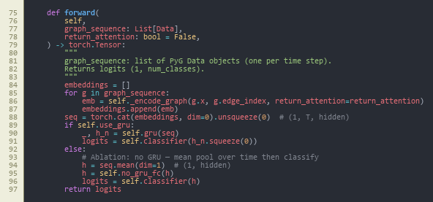
Figure A1-1 - Dynamic graph classifier: DynamicGNN sequence forward core (GRU vs. mean-pool ablation, logits). (Chapter 13, Appendix C.) Source: src/models/dynamic_gnn.py, lines 75–97.
Caption (formal): Figure A1-1 - Core implementation of the dynamic GNN (DynamicGNN): node embedding, two GATConv layers with multi-head attention and dropout, per-window graph embedding, sequence encoding with GRU (or mean-pool when use_gru is false for ablation), and two-class logits. Attention weights may be retained for explainability (return_attention_weights).
How to interpret: This class is the main learnable model described in Chapters 5–6. Each time step is one PyTorch Geometric Data object (nodes = flows in a window, edges = kNN). _encode_graph applies GAT message passing and reduces node states to one vector per window; forward stacks windows in time order and either runs the GRU (full model) or mean-pools over time (ablation in Section 8.7). The from_config constructor ties hyperparameters to config/experiment.yaml, which supports the sensitivity study in Section 8.8.

Figure A1-2 - Constructing a single-window kNN graph from flow feature rows. (Chapter 13, Appendix C.) Source: src/data/graph_builder.py, lines 37–58.
Caption (formal): Figure A1-2 - flows_to_knn_graph: for one window of N flows with F features, fits sklearn.neighbors.NearestNeighbors (Euclidean), adds bidirectional edges among each node and its k actual neighbours (capped when N is small), and returns a torch_geometric.data.Data object with x, edge_index, and graph-level label y.
How to interpret: This function shows how “graph structure” is defined when device IPs are unavailable (Chapter 1): similarity in the 46-dimensional flow feature space replaces physical topology. Bidirectional edges make the graph undirected for GAT. The label on the graph is supplied by the caller (binary benign vs. attack) and matches the stratified pool in Figure A1-3, not a per-flow vote - important for reading the evaluation chapters.

Figure A1-3 - Stratified windowing so both classes appear in training graphs. (Chapter 13, Appendix C.) Source: src/data/graph_builder.py, lines 106–123.
Caption (formal): Figure A1-3 - build_graphs_for_split: splits flows into benign and attack pools, builds sliding (or strided) windows from each pool with _build_windows_from_pool, balances counts between classes, shuffles, and logs totals - addressing severe class imbalance in raw CICIoT2023.
How to interpret: This block explains why training does not collapse to “always predict attack” despite a very high attack ratio in the raw CSV (Chapter 4): windows are drawn within each class, so each graph’s supervision matches the pool. The minority_stride argument increases overlap for the benign pool when it is smaller. The dissertation’s window size and k used in experiments come from config/experiment.yaml and feed the sensitivity grid in Section 8.8.
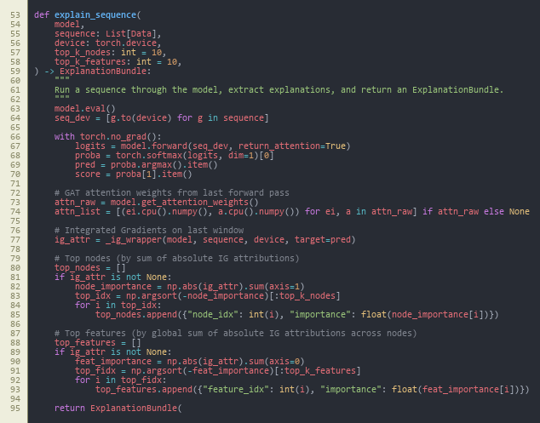
Figure A1-4 - Post-hoc explanations: forward pass with attention, Integrated Gradients, top nodes/features. (Chapter 13, Appendix C.) Source: src/explain/explainer.py, lines 53–95.
Caption (formal): Figure A1-4 - explain_sequence: runs the model with attention enabled, wraps Captum Integrated Gradients on the last window’s node features (_ig_wrapper), aggregates absolute attributions to rank top nodes and top feature indices, and returns an ExplanationBundle for JSON alert formatting.
How to interpret: This is the bridge between Chapter 6 (implementation) and Chapter 8 (example alerts): SOC-facing text is not arbitrary - it is derived from IG magnitudes and GAT edge attention from the same forward pass analysts would get at inference. IG is computed on the most recent graph in the sequence (design choice documented in code comments). If Captum is missing, the bundle degrades gracefully (HAS_CAPTUM guard in the same module).
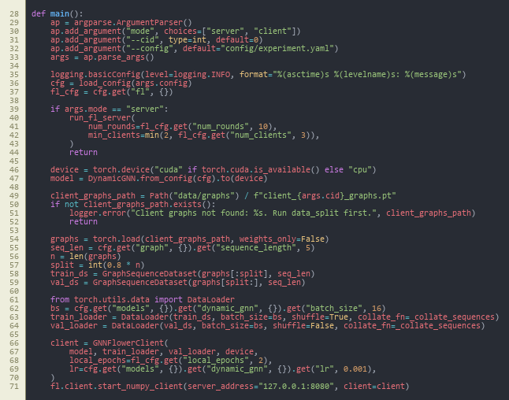
Figure A1-5 - Federated learning CLI: Flower server vs. client, local data, GNNFlowerClient. (Chapter 13, Appendix C.) Source: src/federated/run_federated.py, lines 28–71.
Caption (formal): Figure A1-5 - main in run_federated.py: loads YAML config; server mode calls run_fl_server with round count and quorum; client mode loads client_{cid}_graphs.pt, builds train/validation sequence loaders, constructs GNNFlowerClient, and connects to 127.0.0.1:8080 via fl.client.start_numpy_client.
How to interpret: This file is the student-facing entry point for Chapter 8 federated results: each client trains only on its partition (non-IID split from src.federated.data_split). The address and round counts come from config/experiment.yaml under fl. The pattern matches the FedAvg narrative in Chapter 2 - local epochs, then aggregation on the server (server implementation in src/federated/server.py, not shown).

Figure A1-6 - HTTP API: /score builds graphs, runs explain_sequence, returns ECS-style alert JSON. (Chapter 13, Appendix C.) Source: src/siem/api.py, lines 67–89.
Caption (formal): Figure A1-6 - FastAPI application: startup loads experiment.yaml and dynamic_gnn_best.pt; POST /score accepts a list of flow windows, reads graph.knn_k from the loaded config for flows_to_knn_graph, runs explain_sequence with top-5 nodes and features, measures wall-clock milliseconds, and returns format_ecs_alert output alongside prediction and score.
How to interpret: This is the edge deployment surface argued in Chapters 1 and 5: a single HTTP call turns raw feature windows into SIEM-shaped JSON suitable for triage. Inference-time kNN k therefore matches training graph construction from config/experiment.yaml, avoiding train/serve skew. Latency reported in Chapter 8 is consistent with this synchronous CPU path.

Appendix D: Handbook Appendix 4 (optional) - repository and dataset reference

D.1 Project source code (GitHub)
- Repository: https://github.com/imark0007/Dissertation_Project

D.2 Dataset source used in this project (Kaggle)
- Kaggle dataset page: https://www.kaggle.com/datasets/himadri07/ciciot2023

D.3 Official dataset source (UNB/CIC reference)
- Dataset page: https://www.unb.ca/cic/datasets/iotdataset-2023.html

MSc PROJECT (COMP11024)

PROJECT PROCESS DOCUMENTATION

Student: Arka Talukder (B01821011) Supervisor: Dr. Raja Ujjan

Meeting Number: 1-6 Date/Time: 29/01/2026 - 06/03/2026

Agenda for meeting:
- Project title selection and approval
- Project specification and scope discussion
- Interim report structure and guidelines
- Literature review and research gap alignment
- Methodology and experimental design review
- Progress on data pipeline and model implementation

Discussion of agenda items:
Across all meetings, the project moved from title selection to interim report completion. On 10 and 11 February 2026, the project title: “Explainable Dynamic Graph Neural Network SIEM for Software-Defined IoT using Edge AI and Federated Learning” was discussed and approved by the supervisor. After approval, we clarified the scope. The project will use from Kaggle- CICIoT2023 flow data, a dynamic GNN with GAT and GRU, federated learning with non-IID data, and SIEM alert generation.

The project specification was reviewed. The supervisor agreed with the four main parts: dynamic GNN, federated learning, explainability, and SIEM integration. We also discussed the interim report structure. It has three parts: literature review, methodology, and plan for completion.

I shared progress on the literature review. The supervisor gave feedback on the research gap table and how to compare my project with related work. We reviewed the methodology section. This included graph construction, model architectures (Random Forest, MLP, centralised GNN, federated GNN), and evaluation metrics.

I presented the implementation progress. This covered the data pipeline, graph builder, all four models, federated learning with Flower, explainability with Captum, and the FastAPI SIEM endpoint. The supervisor noted that the implementation matches the research objectives. The interim report draft was discussed. I will seek approval in the next meeting.

Summary of agreed action plan:

• Obtain supervisor approval for the interim report in the next meeting
• Finalise any minor edits based on supervisor feedback
• Proceed with final experiments and results chapter for the dissertation
• Maintain documentation and reproducibility of all experiments

Notes:
Supervisor emphasised clear alignment between research questions, methodology, and results. Careful documentation of experiments and fixed seeds for reproducibility was advised. The project is on track for timely completion.


MSc Dissertation Project Monthly Attendance and Progress Report

TO BE COMPLETED BY THE STUDENT, WITH COMMENTS FROM THE SUPERVISOR.
Please complete all sections below
Name | Arka Talukder | Student ID | B01821011
Supervisor | Dr. Raja Ujjan | Start Date | 29/01/2026
Mode of Study | Online | Dates of Meetings  (include dates of all meetings) | 06/02/2026 (Online)  13/02/2026 (Online)  10/02/2026 (Online) – Title selection  11/02/2026 (Online) – Title approval  20/02/2026 (Online)  06/03/2026 (Online)

Description of Meetings | During this reporting period, I held regular supervisory meetings with Sir Dr. Raja Ujjan to discuss my dissertation project on Explainable dynamic graph neural network SIEM for Software-Defined IoT.  In the first meetings (6 February), we discussed the project scope and what the interim report should include. On 10 and 11 February, the project title was selected and approved by the supervisor. After that, we focused on the project specification. This includes four main parts: dynamic GNN, federated learning, explainability, and SIEM integration.  Later meetings covered the literature review structure, research gap, and methodology design. The supervisor gave feedback on graph construction, model choices, and evaluation metrics. We also discussed how to structure the interim report and present the work clearly.  Recent meetings reviewed my implementation progress and the interim report draft. I presented the data pipeline, all four models (Random Forest, MLP, centralised GNN, federated GNN), explainability module, and SIEM API. The interim report is about 80% complete. I will seek final approval from the supervisor in the next week.

Summary of work undertaken this month.

During this month, I completed most of the work needed for the interim report. Key achievements include:

• Project title approved (10–11 February 2026)
• Literature review written, covering IoT security, SDIoT, ML for intrusion detection, GNNs, federated learning, and explainable AI
• Research gap table completed, comparing my project with related work
• Methodology section written: dataset (CICIoT2023), preprocessing, graph construction, model architectures, evaluation metrics
• Data pipeline implemented: CICIoT2023 loaded, preprocessed, normalised, exported as Parquet
• Graph construction implemented: kNN builder, windowing, sequence dataset
• All four models implemented: Random Forest, MLP, centralised dynamic GNN (GAT+GRU), federated GNN
• Federated learning setup: Flower framework, non-IID data splitting, 10-round simulation
• Explainability: Integrated Gradients (Captum) and GAT attention weights
• SIEM integration: FastAPI endpoint producing ECS-formatted JSON alerts
• Plan for completion section written with timeline and contingency plans
• Interim report draft completed (approximately 80%); awaiting supervisor approval.

What work will you undertake next month?

In the upcoming period, I will focus on:
• Obtaining supervisor approval for the interim report
• Finalising any edits based on supervisor feedback
• Completing final experiments and generating all figures (confusion matrices, ROC curves, FL convergence)
• Writing the Results and Discussion chapters for the final dissertation
• Conducting sensitivity analysis if time permits
• Writing Conclusion and Critical Reflection
• Final proofreading and submission
I remain on schedule for timely completion.

Please detail reasons for any absence including the total number of days absent (annual leave, conference attendance, field research, ill health etc)?

I missed 27/02/2026 meeting due to GP appointment

Statement from Supervisor (including any issues which should be brought to the attention of School, indication of satisfactory process thus far and whether or not attendance has been satisfactory)

Signed (student) |  | Date | 12/03/2026
Signed  (MSc Dissertation Supervisor) |  | Date

University of the West of Scotland
School of Computing, Engineering and Physical Sciences

MSc Cyber Security Project Specification

Student name: Arka Talukder
Banner ID: B01821011
Email: b01821011@studentmail.uws.ac.uk
Project being undertaken on part-time or full-time basis: Full-time
MSc Programme: MSc Cyber Security
MSc Programme Leader: Dr. Raja Ujjan
Approved by supervisor? Yes/No: Yes

Project Title:
Explainable Dynamic Graph Neural Network SIEM for Software-Defined IoT using Edge AI and Federated Learning

Research Question to be answered:
Main question:
How can an explainable dynamic graph neural network, trained with federated learning, detect attacks in Software-Defined IoT flow data and create SIEM alerts that support SOC work on CPU edge devices?
Sub questions:
1) Does a dynamic graph model improve detection compared to simple baselines?
2) Can federated learning keep similar performance without sharing raw data?
3) Can the model provide clear explanations that help alert triage?

Outline (overview) and overall aim of project:
Internet of Things devices are used in homes, health, and industry. Many devices are weak and can be attacked. A Security Operations Centre (SOC) needs alerts that are fast, accurate, and easy to understand.
This project will build a small prototype anomaly and attack detector for Software-Defined IoT networks using network flow logs. Each time window of traffic will be converted into a graph where devices are nodes and flows are edges. A dynamic graph neural network (GNN) will learn patterns across a sequence of graph windows and predict whether the window is benign or malicious.
To reduce data sharing between sites and to match real SOC environments, the model will also be trained with a simple federated learning setup (FedAvg) using 2 to 3 simulated clients. To support SOC triage, the system will generate an explanation for each alert, for example the most important flows and flow features. The prototype will run on CPU and I will measure inference time to check if it is suitable for edge use.
The project will use the CICIoT2023 flow dataset (assumed to be available locally). To keep the work possible in 45 days, the scope is a development-grade SIEM integration: the system will output SIEM-ready JSON alerts (ECS-style fields) and a small FastAPI scoring endpoint. Deploying a full SIEM stack (Elastic or Wazuh) is optional and will be documented as future work.

Objectives (list of tasks to be undertaken to achieve overall aim of the project and to answer the research question posed):
Objectives and tasks:
- Literature review and problem framing
- Carry out a search across IEE, MDPI and sciencedirect(2023-2025)
- Review dynamic GNN intrusion detection, federated learning for security, and explainable AI for SOC.
- Define the final data fields, window size, and evaluation metrics.
- Outcome will be at least two page review and gap analysis.
- Data preparation and graph construction
- Use CICIoT2023 flow records and select a manageable subset for training.
- Build time-window graphs: nodes as devices (IP or device ID), edges as flows, features on edges.
- Create a repeatable preprocessing script and dataset loader.
- Baselines and central DynamicGNN model
- Train simple baselines (Random Forest and small MLP) on tabular features.
- Implement a practical dynamic GNN (graph attention per window plus GRU over windows) and train centrally.
- Federated learning simulation
- Split training data into 2 to 3 clients.
- Train the same model with Flower FedAvg and log round metrics and communication size.
- Explainability and SOC alert output
- Produce explanations for sample alerts using Integrated Gradients (Captum) and attention weights.
- Output an explanation bundle with top features and top flows.
- Create SIEM-style JSON alerts (ECS-like) and a small FastAPI endpoint for scoring.
- Maintaining git repository from data ingestion.
- Evaluation and report writing
- Compare baselines vs central GNN vs federated GNN.
- Report precision, recall, F1, ROC-AUC, and false alarm rate.
- Report CPU inference time and a short SOC workflow example for alert triage.
- outcome will be results notebook, figures, validates CSV, data and report

Evaluation plan:
- Use one fixed train, validation, and test split and keep it the same for all models.
- Include confusion matrices and false positives per time window.
- For federated learning, plot round-by-round performance and estimate total bytes sent.
- Provide 3 to 5 example alerts with explanations and discuss if they are useful for SOC decisions.
Risk control and fall back plan:
- If CICIoT2023 is too large, use a smaller subset of devices and days.
- If federated training is slow, reduce the number of rounds and clients but keep the comparison.
- If Integrated Gradients is slow, run it only on selected alerts and keep attention-based explanations for all alerts.

CyBOK Knowledge Areas (Please check at least two relevant areas your project going to be covered):

Human, Organisational & Regulatory Aspects | ☐ | Risk Management & Governance
 | ☐ | Law & Regulation
 | ☐ | Human Factors
 | ☐ | Privacy & Online Rights
Attacks & Defences | ☐ | Malware & Attack Technologies
 | ☒ | Adversarial Behaviours
 | ☒ | Security Operations & Incident Management
 | ☐ | Forensics
Systems Security | ☐ | Cryptography
 | ☐ | Operating Systems & Virtualisation Security
 | ☐ | Distributed Systems Security
 | ☐ | Formal Methods for Security
 | ☐ | Authentication, Authorisation & Accountability
Software and Platform Security | ☒ | Software Security
 | ☐ | Web & Mobile Security
 | ☐ | Secure Software Lifecycle
Infrastructure Security | ☐ | Applied Cryptography
 | ☒ | Network Security
 | ☐ | Hardware Security
 | ☐ | Cyber Physical Systems
 | ☐ | Physical Layer and Telecommunications Security

Indicative reading list (references to be correctly presented) and resources:
- Albanbay, N., Tursynbek, Y., Graffi, K., Uskenbayeva, R., Kalpeyeva, Z., Abilkaiyr, Z. and Ayapov, Y., 2025. Federated Learning-Based Intrusion Detection in IoT Networks: Performance Evaluation and Data Scaling Study. Journal of Sensor and Actuator Networks, [online] 14(4), p.78. Available at: https://doi.org/10.3390/jsan14040078
- Alabbadi, A. and Bajaber, F., 2025. An Intrusion Detection System over the IoT Data Streams Using eXplainable Artificial Intelligence (XAI). Sensors, 25(3), p.847. Available at: https://doi.org/10.3390/s25030847
- Basak, M., Kim, D.-W., Han, M.-M. and Shin, G.-Y., 2025. X-GANet: An Explainable Graph-Based Framework for Robust Network Intrusion Detection. Applied Sciences, 15(9), p.5002. Available at: https://doi.org/10.3390/app15095002
- Han, Z., Zhang, C., Yang, G., Yang, P., Ren, J. and Liu, L., 2025. DIMK-GCN: A Dynamic Interactive Multi-Channel Graph Convolutional Network Model for Intrusion Detection. Electronics, [online] 14(7), p.1391. Available at: https://doi.org/10.3390/electronics14071391
- Lazzarini, R., Tianfield, H. and Charissis, V., 2023. Federated Learning for IoT Intrusion Detection. AI, [online] 4(3), pp.509–530. Available at: https://doi.org/10.3390/ai4030028
- Luša, R., Pintar, D. and Vranić, M., 2025. TE-G-SAGE: Explainable Edge-Aware Graph Neural Networks for Network Intrusion Detection. Modelling, 6(4), p.165. Available at: https://doi.org/10.3390/modelling6040165
- Ngo, T., Yin, J., Ge, Y.-F. and Wang, H., 2025. Optimizing IoT Intrusion Detection—A Graph Neural Network Approach with Attribute-Based Graph Construction. Information, 16(6), p.499. Available at: https://doi.org/10.3390/info16060499
- Pinto, C., Sajjad Dadkhah, Ferreira, R., Alireza Zohourian, Lu, R. and Ghorbani, A.A., 2023. CICIoT2023: A Real-Time Dataset and Benchmark for Large-Scale Attacks in IoT Environment. Sensors, 23(13), pp.5941–5941. Available at: https://doi.org/10.3390/s23135941
- Wang, R., Zhao, J., Zhang, H., He, L., Li, H. and Huang, M., 2025. Network Traffic Analysis Based on Graph Neural Networks: A Scoping Review. Big Data and Cognitive Computing, 9(11), p.270. Available at: https://doi.org/10.3390/bdcc9110270
- Yang, S., Pan, W., Li, M., Yin, M., Ren, H., Chang, Y., Liu, Y., Zhang, S. and Lou, F., 2025. Industrial Internet of Things Intrusion Detection System Based on Graph Neural Network. Symmetry, [online] 17(7), pp.997–997. Available at: https://doi.org/10.3390/sym17070997
- Zhong, M., Lin, M., Zhang, C. and Xu, Z., 2024. A Survey on Graph Neural Networks for Intrusion Detection Systems: Methods, Trends and Challenges. Computers & Security, 141, pp.103821–103821. Available at: https://doi.org/10.1016/j.cose.2024.103821

Marking scheme:
Introduction | 5%
Context – literature review | 20%
Research Design | 20%
Implementation (practical work) | 25%
Evaluation | 5%
Presentation of results | 5%
Conclusions and recommendations | 10%
Critical self-evaluation | 10%

Supervisor:
Dr. Raja Ujjan

Moderator:
Muhsin Hassanu

Programme Leader:
Dr. Raja Ujjan

Date specification submitted:
11/02/2026

Please complete the ‘ethics’ form below for all projects.

School of Computing, Engineering and Physical Sciences
MSc PROJECT – REQUIREMENT FOR ETHICAL APPROVAL

SECTION 1: TO BE COMPLETED BY THE STUDENT
Does your proposed research involve: research with human subjects (including requirements gathering and product/software testing), access to company documents/records, private or sensitive data, questionnaires, surveys, focus groups and/or other interview techniques? Does your research entail any process which requires ethical approval? (Please enter √ in the appropriate box)

YES |  | You must submit an application for approval to the Ethics Review Manager
NO | No | You do not need to submit an application to the Ethics Review Manager

Name of Student (Print name): Arka Talukder

Signature:
Date: 11/02/2026
SECTION 2: TO BE COMPLETED BY THE PROJECT SUPERVISOR
I understand that the above project does not require ethical approval.

Supervisor (print name): Dr. Raja Ujjan

Signature:

Date: 10/02/2026

IMPORTANT: please note that by signing this form all signatories are confirming that any potential ethical issues have been considered and, where necessary, an application for ethical approval has been/will be made via the Ethical Review Manager software.
Any project requiring ethical approval, but which has not been given approval will not be accepted for marking.

Ethical approval cannot be sought in retrospect.

