

Explainable Dynamic Graph Neural Network SIEM for Software-Defined IoT using Edge AI and Federated Learning

Arka Talukder

B01821011

Thesis Project for the partial fulfilment
of the requirements for the Master Degree
in Cyber Security

University of the West of Scotland
School of Computing
23 April 2026



DECLARATION OF ORIGINALITY

I declare that this is an original study based on my own
work and that I have not submitted it for any other
course or degree.

Signature_______________________



Library Form to Accompany MSc Project
  - To be completed in full
Surname: Talukder
First Name: Arka Initials: Mr.
Banner No: B01821011
Course Code: COMP11024
Course Title: Masters Project 2025/26 T2
Project Supervisor: Dr. Raja Ujjan
Project Title: Explainable Dynamic Graph Neural Network SIEM for Software-Defined IoT using Edge AI and Federated Learning
Session: 2025-26 Date of Submission: 23 April 2026
Signature: 

Please ensure that a copy of this form is included with your project before submission.

Acknowledgements
I thank my supervisor, Dr Raja Ujjan, for technical guidance and support throughout the project. I thank my moderator, Muhsin Hassanu, for review of interim reports.
I also thank Dr Daune West for academic support during the submission period. I am grateful to School and programme staff for module materials and to the MSc project co-ordinator for programme and ethics communication.
Finally, I thank friends and family for their patience during intensive writing and experiment runs.

Abstract
The deployments of Internet of Things (IoT) generate flow telemetry that needs to be triaged by Security Operations Centres (SOCs) on CPU-only edge infrastructure. Detectors ought to be precise, privacy conscious, and understandable by the analysts to take action on alerts without wasting too much time.
Research question (answer to the headline). The paper poses the question of how it is possible to execute an explainable GAT+GRU on kNN flow graphs, using Flower FedAvg and SIEM-shaped output, on a CPU. The contribution includes a reproducible, integrated prototype on CICIoT2023 (Pinto et al. 2023): public splits, leakage-conscious preprocessing, Captum IG + GAT attention, FastAPI JSON delivery, and a single config/experiment.yaml. Chapter 2, 4-6 deals with justifying, building; Chapter 7-8 tests, Chapter 9 answers the sub-questions using Table 7-12.
Outcomes (sub set, fixed split). Here, central and federated GNN achieves report F1 = 100% and ROC-AUC = 100% with none of these false positives; Random Forest and MLP report F1 = 99.86% and 99.42% respectively. The mean CPU inference of five-window GNN sequence is approximately 23 ms; the federated weight traffic is approximately 31 MB per ten rounds. Ablation, (window, k) sensitivity, multi-seed runs are used to deal with reliability of the headline configuration, but no full claims of external validity to live sites.
Keywords: IoT security, dynamic graph neural network, federated learning, SIEM, explainable AI, edge AI, SOC, CICIoT2023.

Table of Contents
Acknowledgements 4
Abstract 5
Table of Contents 6
List of Figures 12
List of Tables 14
List of Abbreviations 1
Chapter 1 - Introduction 2
1.1 Chapter Overview 2
1.2 Background and Motivation 2
1.3 Research Aim and Questions 2
1.3.1 Objectives 3
1.3.2 Where the research questions are answered (evidence map) 4
1.4 Scope and Limitations 5
1.5 Dissertation Structure 5
1.6 Conformity with the Marking Criteria in the Project Specification. 7
1.6.1 where every technical matter is mentioned only once (clarity and no repetition) 7
1.7 Chapter Summary 7
Chapter 2 - Literature Review 8
2.1 Chapter Overview 8
2.2 Themes and Structure 8
2.2.1 Literature Search Strategy and Primary Databases 8
2.2.2 Key Technology Pillars: Synthesis, Debate and Fit with the Title. 9
2.2.2.1 Flow Observability and Detection Surface in software defined. 9
2.2.2.2 Graphs of similarities and Dynamic GNNs as a design bet, not a Slogan. 9
2.2.2.3 Edge AI, Federated Training, and What “Privacy” Can Mean 9
2.2.2.4 Explainable, SIEM-Ready Outputs Versus Alert Economics 10
2.2.2.5 Title-Technology coupling Trade-offs, Counterarguments, What the Build Should Evidence. 10
2.3 IoT security and why it requires detection. 10
2.4 SIEM, SOC Workflows, and Alert Quality 11
2.4.1 Alert Volume, Triage, and the Need for Explanations 11
2.4.2 SIEM Ecosystems, Explainability, and limits of better JSON. 12
2.5 Dynamic Graphs and Graph Neural Networks. 12
2.5.1 GNNs, Attention and Attribute based Graphs in intrusion detection. 12
2.5.2 Dynamic (Temporal) Graphs and GAT +GRU Pattern. 12
2.6 Federated Learning and Privacy 13
2.6.1 FedAvg, Assumptions, and Communication 13
2.6.2 FL for IoT Intrusion Detection: Empirical Findings and Non-IID Reality 13
2.7 justifiable ML-Based Security. 13
2.7.1 GNNs Post-hoc Attribution, Integrated Gradients, and Attention. 13
2.7.2 XAI for IoT Streams, SHAP as Alternative, and Latency as a Counterargument 14
2.8 Synthesis: Significance, Limitations of Prior Work, Contributions, and Gap 15
2.8.1 How Existing Approaches Fill Part of the Problem (and Where They Stop) 15
2.8.2 Expected Significance (What Would Matter were the Evidence to be true) 16
2.8.3 Literature and its Limitations and their effects on Claims. 16
2.8.4 Discussion, refutations, and the Gap-Synthesized. 16
2.9 Mapping to CyBOK (Cyber security body of knowledge) 16
2.10 Extended Comparative Review (Fifteen to Twenty Core Sources) 17
2.11 Chapter Summary 17
Chapter 3 - Project Management 18
3.1 Chapter Overview 18
3.2 Project Plan and Schedule (45-day MSc) 18
3.3 Monitoring and Progress Reviews 19
3.4 Research Plan for Completion: IDE, Platform, and Evidence for Supervision 19
3.5 Ethics and Data 20
3.6 Supervision and Progress Alignment 20
3.7 Chapter Summary 20
Chapter 4 - Research Design and Methodology 21
4.1 Chapter Overview 21
4.2 Research Approach 21
4.3 Dataset and Subset 21
4.3.1 Proposed pipeline stages, artefacts, and leakage controls 22
4.3.2 Repository layout and frozen outputs 22
4.3.3 Empirical flow and graph sample sizes 23
4.4 Models and Loss Functions 23
4.4.1 Hyperparameters, tuning funnel, and training budget (after split) 23
4.4.2 Objectives, losses, and federation rule 24
4.5 Federated Learning Setup 25
4.6 Explainability 25
4.7 Evaluation Plan 25
4.8 Software and Tools 26
4.9 Chapter Summary 27
Chapter 5 - Design 28
5.1 Chapter Overview 28
5.2 Pipeline, Alerts and Deployment (Conceptual) 28
5.3 Graph Design (Flows to kNN Snapshots) 29
5.4 Research Design and System Architecture 30
5.5 Conceptual Illustration: Similarity-Based Graph in One Window 31
5.6 Chapter Summary 31
Chapter 6 - Implementation and System Development 32
6.1 Chapter Overview 32
6.2 Environment and Tools 32
6.3 Data Loading and Preprocessing 33
6.4 Graph Construction 33
6.5 Model Implementation 34
6.6 Federated Learning (Flower) 34
6.7 Explainability 34
6.8 Alert Generation and SIEM-Style Output 35
6.9 FastAPI Deployment and CPU Inference 35
6.10 Implementation Code Screenshots (Author’s Codebase) 35
6.11 Reproducibility Note 39
6.12 Chapter Summary 39
Chapter 7 - Testing and Evaluation 40
7.1 Chapter Overview 40
7.2 Evaluation Scope 40
7.2.1 Pass Criteria 40
7.2.2 Fail Criteria 41
7.3 Test Schedule 41
7.4 Experimental Setup 42
7.4.1 Data validity, reliability, and limits on generalisation 42
7.4.2 Hardware, software, and run configuration 42
7.5 Metrics 43
7.6 Dataset and Experiment Statistics 44
7.7 Comparison Design 44
7.8 Chapter Summary 44
Chapter 8 - Results Presentation 45
8.1 Chapter Overview 45
8.2 Centralised Model Comparison (Sub-Question 1) 45
8.3 Federated Learning (Sub-Question 2) 52
8.4 Central GNN Training Convergence 55
8.5 Time-Window and CPU Inference (Sub-Question 2 and Deployment) 56
8.6 Example Alerts with Explanations (Sub-Question 3) 57
8.7 Ablation Studies (Priority 1: Evidence) 58
8.8 Sensitivity Analysis (Stability of Design Choices) 59
8.9 Multi-Seed Stability 60
8.10 Correlation with the Previous Research on CICIoT2023. 61
8.11 Chapter Summary 62
Chapter 9 - Conclusion, Discussion, and Recommendations 63
9.1 Chapter Overview 63
9.2 Structured Conclusion 63
9.3 Responding to the Research Questions. 63
9.4 Strengths and Limitations 64
9.5 University/ Course Materials. 64
9.6 Practical Implications 65
9.7 Relation to Literature 65
9.8 Summary of the Project 66
9.9 Recommendations for Future Work 66
9.10 Chapter Summary 67
Chapter 10 - Critical Self-Evaluation 68
10.1 Chapter Overview 68
10.2 Planning, Scope, and Risk. 68
10.3 Literature and Alignment with the Questions 68
10.4 Implementation: What Was Harder Than It Looked 69
10.5 Results, Honesty, and the “100%” Question 69
10.6 What I Learned (Skills and Mindset) 70
10.7 Time Management: What I Would Reorder 70
10.8 Chapter Summary 71
References 72
Bibliography 75
Appendices 77
Appendix A: Project code 77
Appendix B: Project Process Documents 84
Appendix C: Project Specification Form 94
Appendix D: Handbook Appendix 4 (optional) - repository and dataset reference 103
D.1 Project source code (GitHub) 103
D.2 Dataset source used in this project (Kaggle) 103
D.3 Official dataset source (UNB/CIC reference) 103

List of Figures
Figure 1: Taxonomy of IDS approaches relevant to IoT and this project (Chapter 2, Section 2.3) 11
Figure 2: Conceptual flow of a dynamic GNN (GAT + GRU) for temporal graph classification (Chapter 2, Section 2.5) 12
Figure 3: Federated learning (FedAvg) flow - no raw data leaves clients (Chapter 2, Section 2.6) 13
Figure 4: Explainability methods used for SOC-oriented alerts (Chapter 2, Section 2.7) 14
Figure 5: Positioning of related work - GNN, federated learning, explainability, and SIEM-style alerts (Chapter 2, Section 2.7) 15
Figure 6: Project Gantt chart - six execution phases plus write-up across the 45-day MSc window (Chapter 3, Section 3.2) 18
Figure 7: Research pipeline - from raw IoT flow data to explainable SIEM alerts (Chapter 5, Section 5.2) 29
Figure 8: Research design - data flow, federated training, and edge alerting (Chapter 5, Section 5.4) 30
Figure 9: Conceptual kNN similarity graph within one observation window (Chapter 5, Section 5.5) 31
Figure 10: flows_to_knn_graph (core) - NearestNeighbors, bidirectional edges, PyG Data (Chapter 6, Section 6.10) 36
Figure 11: build_graphs_for_split (core) - class pools, balance, merge, shuffle (Chapter 6, Section 6.10) 36
Figure 12: train_one_epoch - class-weighted cross-entropy, backward pass, optimiser step (Chapter 6, Section 6.10) 37
Figure 13: : DynamicGNN.forward (core) - stack window embeddings, GRU vs. mean-pool ablation, classifier (Chapter 6, Section 6.10) 37
Figure 14: _ig_wrapper (core) - Captum IntegratedGradients on the last window’s node features (Chapter 6, Section 6.10) 38
Figure 15: : POST /score (core) - build graphs, explain_sequence, ECS-style alert, timing (Chapter 6, Section 6.10) 38
Figure 16: : Confusion matrix for Dynamic GNN on test set (Chapter 8, Section 8.2) 46
Figure 17: ROC curve for Dynamic GNN on test set (Chapter 8, Section 8.2) 47
Figure 18: Confusion matrix for Random Forest on test set (Chapter 8, Section 8.2) 48
Figure 19: Confusion matrix for MLP on test set (Chapter 8, Section 8.2) 49
Figure 20: ROC curve for Random Forest on test set (Chapter 8, Section 8.2) 50
Figure 21: ROC curve for MLP on test set (Chapter 8, Section 8.2) 51
Figure 22: Per-metric comparison across RF, MLP, Central GNN, and Federated GNN on the test set (Chapter 8, Section 8.2) 52
Figure 23: Federated: learning convergence (F1 and ROC-AUC vs. round) (Chapter 8, Section 8.3) 53
Figure 24: Confusion matrix of the federated GNN (Flower FedAvg, 3 clients, 10 rounds) on the test set (Chapter 8, Section 8.3) 54
Figure 25: Federated learning communication cost - per round (bars) and cumulative (line) (Chapter 8, Section 8.3) 55
Figure 26: Central GNN training loss across six epochs (log scale) (Chapter 8, Section 8.4) 56
Figure 27: Model comparison - inference time and F1-score (Chapter 8, Section 8.5) 57
Figure 28: Ablation comparison - full GAT+GRU vs. GAT-only (F1 and inference time) (Chapter 8, Section 8.7) 59
Figure 29: : Sensitivity of test F1 and ROC-AUC to window size and kNN k (Chapter 8, Section 8.8) 60

List of Tables
Table 1: Research questions are answered (evidence map) 5
Table 2 : Cross-tabulated signed specification form 7
Table 3: Dissertation Structure 7
Table 4: Comparison of related work of choice (sources: Chapter 11) 16
Table 5: Monitoring and Progress Reviews 20
Table 6: is the master stage list; later chapters reference the same order (Figure 7 is the visual analogue). 23
Table 7: Empirical sample sizes: flows, graph windows, and sequences. 24
Table 8: Hyperparameters, training budget, and federation (frozen in config/experiment.yaml). 25
Table 9: Testbed, storage and runtime stack (Research Method Deployment). 33
Table 10: Evaluation scenarios, scripts, and frozen artefacts (Research Method Deployment). 42
Table 11: Definitions of the reported metrics (attack = positive). 44
Table 12: Model comparison on CICIoT2023 test set 46
Table 13: Federated learning round-by-round metrics 54
Table 14: Training history (loss and validation) of the central GNN. 57
Table 15: Ablation on CICIoT2023 test set (centralised GNN variants) 59
Table 16: Sensitivity analysis - central GNN on the test set (There are nine configurations) 60
Table 17: Multi-seed summary (central GNN, test set) 61
Table 18: Headline metrics - this dissertation vs. prior work on CICIoT2023 and adjacent IoT flow benchmarks 62

List of Abbreviations
Abbrev. | Definition
API | Application Programming Interface
AUC | Area Under the (ROC) Curve
CPU | Central Processing Unit
ECS | Elastic Common Schema (log/alert shape used as a guide)
FedAvg | Federated Averaging (McMahan et al. 2017)
FL | Federated Learning
FN | False Negative
FP | False Positive
FPR | False Positive Rate
GAT | Graph Attention Network
GNN | Graph Neural Network
GRU | Gated Recurrent Unit
IG | Integrated Gradients
IoT | Internet of Things
IID | Independent and Identically Distributed (data split)
JSON | JavaScript Object Notation
kNN | k-Nearest Neighbours (graph construction)
MLP | Multi-Layer Perceptron
non-IID | Non-identical client data distributions
PyG | PyTorch Geometric
ROC | Receiver Operating Characteristic
SDN | Software-Defined Networking
SIEM | Security Information and Event Management
SOC | Security Operations Centre
TN | True Negative
TP | True Positive
UML | Unified Modelling Language
XAI | Explainable Artificial Intelligence
AI | Artificial Intelligence (general discipline; not a model name)
ML | Machine learning (umbrella for supervised and neural methods in Chapters 4-8)
IDS | Intrusion Detection System
NIDS | Network-based Intrusion Detection System
DNN | Deep Neural Network
VAE | Variational Autoencoder (cited in wider ML literature only; not a model used in this project)
Adam | Adaptive moment optimiser (used for MLP/GNN; see PyTorch documentation, Chapter 12)
IDE | Integrated Development Environment

Chapter 1 - Introduction

1.1 Chapter Overview
This chapter presents the project background, IoT flow telemetry, SOC alert volume and the practical limitation at the edge node of a CPU. It describes the rationale behind the inclusion of dynamic graph learning, federated training, and explainable alerts in the same pipeline, followed by the research aim, sub-questions, scope, and structure of the chapters to ensure that subsequent chapters in the work are focused on method, implementation, and evidence.

1.2 Background and Motivation
The Internet of Things has become widespread, although the practice of protection against many devices is low, which opens the possibility of botnets, service abuse, and lateral movement (Kolias et al. 2017). Constant observation of the network is thus necessary in cases where there are old and new devices. Software-defined solutions may provide flow-level statistics with no packet captures stored, simplifying storage and some privacy concerns, but the more challenging task is to analyse such flows correctly, to justify decisions to an analyst, and to perform it on edge hardware that is often CPU-only.
Security Operations Centres triage SIEM-fed alerts, but alert fatigue and opaque model scores delay response (Cuppens and Miège 2002). Random Forest and MLP baselines on tabular features are strong competitors; this work also models flows as nodes in a similarity graph and sequences of window graphs, because attacks often unfold as structured patterns, not independent rows. The public CICIoT2023 release does not support a full device-device IP topology, so kNN feature-space edges are used. A GAT+GRU stack encodes local neighbour structure and short-term temporal change; Flower FedAvg trains without centralising raw flows; a FastAPI path emits ECS-like JSON and reports CPU time - aligned with the main research question.

1.3 Research Aim and Questions
This project will develop and implement a software-defined flow data-based, dynamically trained, federated training, and practical explanation output-based reproducible prototype to detect IoT attacks and provide triage of SOC. It works on realistically constrained feasibility, particularly CPU execution and non-IID federated partitions and ensures that the pipeline is easy to understand when used by security operations.
The primary research question is:
How can an explainable dynamic graph neural network, trained using federated learning, detect attacks in Software-Defined IoT flow data and generate SIEM alerts that support SOC operations on CPU-based edge devices?
The sub-questions (each mapped to Chapters 7-8 and Section 9.3) are:
- Sub-Q1: Does a dynamic graph model outperform simple tabular models (Random Forest, MLP) on the same test protocol?
- Sub-Q2: Can federated learning (Flower FedAvg) match centralised training without exchanging raw flow rows?
- Sub-Q3: Can the system produce analyst-useful explanation fields (Integrated Gradients + attention) in SIEM-shaped JSON for triage?
Contributions (in this dissertation):
A flow telemetry-to-kNN similarity-graphs prototype that is end-to-end, CPU-based and trains a dynamic GNN (GAT + GRU), and results in SIEM-shaped JSON alerts.
Comparison between a centralised and federated architecture with the same architecture under Flower FedAvg with non-IID client partitions.
An explainability route that integrates Integrated Gradients (feature attribution) with GAT attention (flow and structure cues) with ablation, sensitivity, and multi-seed support.
A reproducibility trail in submission ready format as configuration, scripts, chapter mappings and artefacts in the form of appendices.
CICIoT2023 is used in the work to compare choices and metrics with outcomes of previous studies and yet fit within a budget of an MSc time-box and resources.

1.3.1 Objectives
The project has the following specific objectives to provide answers to the above research questions. All of these objectives are artefacts deliverable which are revisited in Chapters 4-8 as evidence:
Literature objective. Critically review IoT intrusion detection, graph and dynamic GNN techniques, federated learning and explainable AI to security, and determine the gap that this project addresses (Chapter 2).
Dataset objective. Use a manageable CICIoT2023 subset with public train / validation / test files, full preprocessing, and no test-data leakage (Sections 4.3 and 6.3).
Modelling objective. A controlled comparison (Sections 4.4 and 6.5) of two flow-level baselines (Random Forest, MLP) and one dynamic GNN (GAT + GRU).
Federated objective. Train on three non-IID clients (ten rounds) with Flower FedAvg, and test the global checkpoint on the central test set (Sections 4.5, 6.6 and 8.3).
Explainability objective. Add Captum Integrated Gradients to GAT attention to obtain per-alert top features and top flows ( Sections 4.6, 6.7 and 8.6).
SIEM objective. Serve the model through a FastAPI endpoint that returns ECS-like JSON alerts and report CPU inference latency (Sections 6.8, 6.9 and 8.5).
Evaluation objective. Establish metrics, ablation, sensitivity and multi-seed tests and present results in figures and tables (Chapters 7 and 8).
Reflect and write-up goal. Produce a full written report with critical self-evaluation (Chapters 9 and 10).

1.3.2 Where the research questions are answered (evidence map)
Question | What “answered” means in this project | Main evidence (body)
Main RQ (edge, CPU, explainable, federated, SIEM-shaped) | A working pipeline: data → model(s) → optional FL → FastAPI alerts with latency and JSON shape | Chapters 6-8; Table 5 (testbed), Table 7, 8.5-8.6
Sub-Q1 (GNN vs baselines) | Held-out test F1 / ROC-AUC / FPR for GNN vs RF/MLP on the same splits | Section 8.2; Table 7; Figures 16-22
Sub-Q2 (federated vs central) | FedAvg global model vs central GNN on the shared test set; communication | Section 8.3; Table 7; Figures 23-25
Sub-Q3 (explanations for triage) | Example alerts with top_features / top_nodes and plausibility discussion | Section 8.6; 9.6 (limits: no formal user study)
Robustness (not a separate RQ) | Ablation (GRU), sensitivity (window, k), multi-seed | Sections 8.7-8.9; Tables 10-12
Table 1: Research questions are answered (evidence map)

Similar work exists on parts of this stack (GNN IDS, FL on IoT, XAI, SIEM). This dissertation’s defensible claim is integration under one configuration: the same benchmark subset, same splits, one experiment.yaml, and comparable baselines - feasibility and artefact contribution - rather than a claim to beat every prior accuracy figure (Section 2.8, Table 13).

1.4 Scope and Limitations
The project implements CICIoT2023 (Pinto et al. 2023) in a manageable subset in 45 days MSc. Flow level features are publicly exposed but unreliable device topology fields are not, to construct the complete host graph. Due to this, this implementation has flow nodes equipped with kNN feature-similarity edges and using a GAT+GRU model stack as explained in Section 2.5 and defined in Section 5.3.
It covers the baselines of Random Forest and MLP, Flower FedAvg federation, Captum explainability, and ECS-like alerts of FastAPI. Production SIEM integration, formal SOC user studies and large multi-organisation federation are outside of the scope. Details of technical implementation are specifically focused in Chapters 4 to 7 to eliminate repetitive text.
Limitations (overview): no production SIEM deployment, no formal study of SOC users, CPU-only training and inference, three federated clients and ten rounds in reported federated run. The headline measures are subset measures and are candidly talked about in Chapter 9. Following the risk treatment in Chapter 3 are contingency decisions, like reduced data and reduced rounds should it be necessary. The repository, config/experiment.yaml and execution notes are used to reproduce Chapter 13 content.
Continuity of scope. Everybody chapter is tied to the same problem: CPU-realistic, explainable, optionally federated detection of binary attack vs benign traffic on CICIoT2023 flow features, with SIEM-oriented output. The literature (Chapter 2) defines the gap; Chapters 4-6 implement one artefact; Chapters 7-8 test one pre-declared plan; Chapters 9-10 interpret and reflect without moving the goal to new datasets or live capture.

1.5 Dissertation Structure
The report is structured in the following way: Chapter 2 (literature, including the extended comparative review in Section 2.10 with fifteen to twenty core sources), Chapter 3 (ethics, time, and project management), Chapters 4-5 (research design and system design), Chapter 6 (implementation), Chapter 7 (evaluation contract), Chapter 8 (results, minimal interpretation), Chapter 9 (discussion and conclusions), Chapter Mapping to signed project specification (Appendix C). The weight grid that is agreed upon is as follows. Introduction 5-Context / Literature 20-Research Design 20-Implementation 25-Evaluation 5-Presentation of Results 5-Conclusions 10-Critical Self-Evalation 10 (100). The authoritative percentages are those on the signed specification form; they are cross-tabulated in the table below to this dissertation.
Criterion (specification) | Where it is addressed
Introduction | Chapter 1 - aim, RQs, Section 1.3.2 evidence map, scope
Context / literature | Chapter 2 - search, Table 1, Section 2.8 gap
Research design | Chapters 4-5 - method, Tables 2-4, design figures
Implementation | Chapter 6 - code, testbed Table 5, screenshots Section 6.10
Evaluation | Chapter 7 - pass/fail, Table 6, Section 7.4.1 validity, Section 7.5 metrics
Presentation of results | Chapter 8 - Tables 7-13, figures
Conclusions | Chapter 9 - Section 9.3 RQ answers, limitations, future work
Critical self-evaluation | Chapter 10
Table 2 : Cross-tabulated signed specification form
Dramatic chapter bands (indicative). It is also possible to read the body in thematic bands which reflect a typical technical dissertation: Chapters 4 and 5 = research design and system design; Chapter 6 = implementation and deployment (with Appendix A code evidence); Chapters 7-8 = evaluation and results; Chapters 7-9 = evaluation and discussion; Chapter 10 = critical reflection; Sections 9.2, 9.8, 9.9 = conclusion and References and tables of figures and tables are supported by Front matter, List of Abbreviations, and Chapters 11-12 in the list mentioned at the beginning of this paper.
Indicative band (typical report shape) | Chapters in this report
Abstract | 1. Abstract (front)
Introduction (~10% of body) | Chapter 1
Literature review (~15-20%) | Chapter 2
Research design & methods (~15-20%) | Chapters 4 and 5
Research design - deployment & implementation (~15-20%) | Chapter 6 (with Appendix A code evidence)
Results - visualization / analysis (~15-20%) | Chapter 8 (and metrics in Chapter 7)
Model / results evaluation & discussion (~15-20%) | Chapters 7, 8 (interpretation light), 9
Critical reflection (~10%) | Chapter 10
Conclusion & future direction (~10%) | Chapter 9 (esp. 9.2, 9.8-9.9)
Overall format: contents, references, own diagrams / plots (~10%) | Front matter; 11-12; figures and tables
Table 3: Dissertation Structure
Distribution and practice. Chapters 4 and 5 establish the data contract, models, loss, federation design, and graph semantics, Tables 2-4 and Figures 7-9. The implementation and deployment is documented in Chapter 6: testbed Table 5, modules, code paths, Section 6.10, FastAPI, and code figure Appendix A. The chapters 4-6 as a block are to be considered as a balanced design-and-build block compared to the weight split in the Appendix C (Research Design 20% + Implementation 25% comprises of the design chapters and the implementation chapter).

1.6 Conformity with the Marking Criteria in the Project Specification.
This dissertation is connected with the signed Project Specification (Appendix C) in Section 1.5. The indicative bands in the second table are an aid to narrative reading; official marking is by means of the specification percentages at which the project was approved.

1.6.1 where every technical matter is mentioned only once (clarity and no repetition)
To ensure continuity without contradiction, the dissertation treats a single home to each of the major technical claims: graph construction and windowing - Section 5.3 and Chapter 4 (pipeline); loss and FedAvg - Section 4.4.2; metrics - Section 7.5; test evidence - Chapter 8; interpretation - Chapter 9. Subsequent chapters refer to the past rather than redefine.

1.7 Chapter Summary
Chapter 1 presented the context of SOC and IoT problem, articulated the main and sub research questions, presented an evidence map (Section 1.3.2) and scope, continuity, and boundaries. Chapter mappings to the signed project specification (Appendix C) and an approximate thematic layout are made in section 1.5. Chapter 2 discusses the literature.

Chapter 2 - Literature Review

2.1 Chapter Overview
This chapter provides a review of the IoT intrusion detection, SOC/SIEM needs, graph and dynamic GNNs, federated learning, and explainable ML of security, associating each strand with this prototype. It is a large section of dissertation body with the design and results sections (Section 1.5). The splits of datasets, as well as hyperparameters, are not repeated in Chapters 4, 6-7. This chapter is analytical, that is, it does not repeat the Research Method.

2.2 Themes and Structure
This review is not exhaustive, but selective: the priority is given to peer-reviewed articles, major surveys on (i) IoT and flow-based intrusion detection, (ii) graph and dynamic graph neural models to security analytics, (iii) federated learning within the conditions of data-sovereignty and (iv) explainable machine learning in the context of operational security. The search protocol and, individually, a debate-based perspective of the key technologies mentioned in the title of the dissertation appear in section 2.2.1 and 2.2.2, thus making the chapter not a glossary of terms.
It is an argumentative narrative, as opposed to an encyclopaedic narrative. Section 2.2.2.5 (following 2.2.2.1-2.2.2.4) specifically describes how the technology mix in the title is a contestable design claim, and not a buzzword list. Section 2.3 sets context of threats and data. Section 2.4 correlates SIEM activities with quality of alerts and constraints of the analysts. The sections 2.5-2.7 are directly connected to the three sub-questions namely graph and temporal modelling, federated training and explanations of triage. The multi-pillar coverage of the work carried out previously can be seen in Table 1 and Figure 5. Section 2.8 expresses importance, scope of the previous research, contribution and refutations. Section 2.9 maps the story to CyBOK; Section 2.10 goes out to the breadth necessary of fifteen to twenty core sources required.

2.2.1 Literature Search Strategy and Primary Databases
Discovery and venues. The first pass was done using Google Scholar; IEEE Xplore, SpringerLink, MDPI and ScienceDirect were searched to get full texts. The pool was broadened with backward snowballing of Zhong et al. (2024), Wang et al. (2025) and Pinto et al. (2023). Empirical security claims were not supported with unverified blog posts and informal READMEs, implementation tools (Flower, PyG, Captum) are mentioned in Chapters 1112.

2.2.2 Key Technology Pillars: Synthesis, Debate and Fit with the Title.
The title of the dissertation is a combination of SIEM orientation, dynamic graph learning, edge AI (CPU inference) and federated learning. Subsections following do not specify what it means to be an attack, but it is clear that the literature reasons why each ingredient should be considered seriously, and where there is disagreement on this point, and what it would mean to the single MSc prototype (Pinto et al. 2023; Zhong et al. 2024; McMahan et al. 2017; Qu et al. 202

2.2.2.1 Flow Observability and Detection Surface in software defined.
Software-defined and controller-centric IoT/SDN narratives are important to consider here since it dictates where the aggregation of flows can be observed and how far an edge node can observe (ENISA 2017). The fact that visibility is a trade-off between policy and technology, rather than a given: more visibility results in more detection; it also means additional handling requirements due to framing of data-protection. The research practice is captured in the CICIoT2023 design (Pinto et al. 2023): the features of flow are labelled, and the records are not captured in all their raw form, similar to the papers. It is not a debate about whether or not IoT is risky (Kolias et al. 2017) but whether flow-level ML can generalise to production mixes - a gap in surveys reported as an open deployment gap (Wang et al. 2025; Zhong et al. 2024). This work acknowledges that limit and it employs a single benchmark in the society to make comparisons truthful.

2.2.2.2 Graphs of similarities and Dynamic GNNs as a design bet, not a Slogan.
Strong flow features feature tabular classifiers are very difficult to outperform on certain tasks; GNNs ought to be used when the signal is embedded in multiple rows (Ngo et al. 2025; Velickovic et al. 2018; Zhong et al. 2024). Tension 1 - structure vs. cost: GNN+sequence stacks add CPU time per window (Basak et al. 2025; Lusa et al. 2025), the literature is thus in favor of ablation and latency reporting, rather than of a priori superiority.y. Tension 2 - topology vs. privacy: published CICIoT2023 does not claim to be able to run kNN in feature space, and indeed is a documented trade-off (Ngo et al. 2025), not a statement regarding physical topology.y. Tension 3 - attention vs. ground truth: GAT salience is not an indication of attack intent; X-GANet-type work does not claim accuracy and interpretability even in the offline evaluation (Basak et al. 2025).). The name of the title dynamic GNN is a stack (GAT+GRU) that can be tested against RF/MLP, not a marketing designation.

2.2.2.3 Edge AI, Federated Training, and What “Privacy” Can Mean
In this project, edge AI implies inference on the CPU and the deployment-like results (Lazzarini et al. 2023; Albanbay et al. 2025), and it is not a statement that all edge devices are continuously trained. The concept of federated learning is presented in which raw flows cannot be aggregated (McMahan et al. 2017; Qu et al. 2020). The literature makes it clear that client splits and client counts converge to non-IID (Albanbay et al. 2025); an objection to any narrative that “FL always matches central training.” A second counterargument is privacy: FedAvg omits raw centralisation; it does not by itself guarantee differential privacy or robustness to gradient-based inference under strong threats (McMahan et al. 2017; discussion in Section 2.6.2). The title’s pairing of edge and federated is therefore a situational fit: each addresses a different constraint (inference site vs. training data custody).

2.2.2.4 Explainable, SIEM-Ready Outputs Versus Alert Economics
The score of a SIEM-related tale demands more than a score: analyst time and load of false-positives are old-time topics of operation (Cuppens and Miège 2002). The XAI of IoT streams has the potential to enhance transparency (Alabbadi and Bajaber 2025), whereas SHAP, IG, and attention do not agree on which aspect to prioritize (Lundberg and Lee 2017; Sundarararajan et al. 2017; Velickovic et al. 2018). One debate that is taken seriously in this chapter is whether or not the payloads of explanation alter triage, or simply transfers work (see Section 2.4.2). Then the thesis considers the ECS-like JSON as a plausible ingestion move that should be read together with measured latency and selective explanation (Section 2.7.2) and not as evidence of organisational adoption.

2.2.2.5 Title-Technology coupling Trade-offs, Counterarguments, What the Build Should Evidence.
Each title ingredient is justified in subsections 2.2.2.12.2.2.4; in this subsection, it is indicated how they relate. The work is a contestable integrated design, not a keyword stack (Zhong et al. 2024; Wang et al. 2025): (i) software-defined here means operational flow visibility on public splits (Pinto et al. 2023), not vendor lock-in; (ii) GAT+GRU is tested against RF/MLP with FPR and latency (Cuppens and Miège 2002; Basak et al. 2025); (iii) FedAvg supports data custody but is not a complete privacy story; non-IID clients matter (McMahan et al. 2017; Albanbay et al. 2025); (iv) explainable JSON is triage-shaped output, not proof of trust (Lundberg and Lee 2017; Section 2.4.2). The justifiable argument is the end-to-end integration on CICIoT2023 with the scope of deployment (Wang et al. 2025). Section 2.3- 2.7 enrich evidence; Chapter 4-8 put into practice and test.
Continuity note: 2.32.7 follow 2.2.2 they are not a second methods chapter.

2.3 IoT security and why it requires detection.
The focused risk in IoT implementations and poor default postures are recorded in policy and surveys (ENISA 2017; Kolias et al. 2017 on Mirai-scale abuse). Monitoring flows at scale requires automated monitoring, which can be provided by software-defined and controller-centric exports, which in turn provide flow statistics, and detectors must be efficient enough to process edges.
The approaches of signature/anomaly/ML are both of them prevalent in surveys (Zhong et al. 2024; Pinto et al. 2023). The benchmark, here CICIoT2023 (Pinto et al. 2023), consists of 46 pre-computed flow features, lab attack scenario control, and imbalance in the class at the level of the windowing flow (~97.8% attack), which was processed in this work using stratified windowing. The gains of the graph models on industrial IoT are provided by Yang et al. (2025); Wang et al. (2025) and Zhong et al. (2024) reveal the increased usage of GNNs and mention that the temporal modelling, explainability, and federated deployment are unfinished in most previous studies. This thesis IDS families (Figure 1) are categorized to provide a roadmap and not a map of all commercial SOC stacks (Kolias et al. 2017; Pinto et al. 2023; Wang et al. 2025; Zhong et al. 2024).
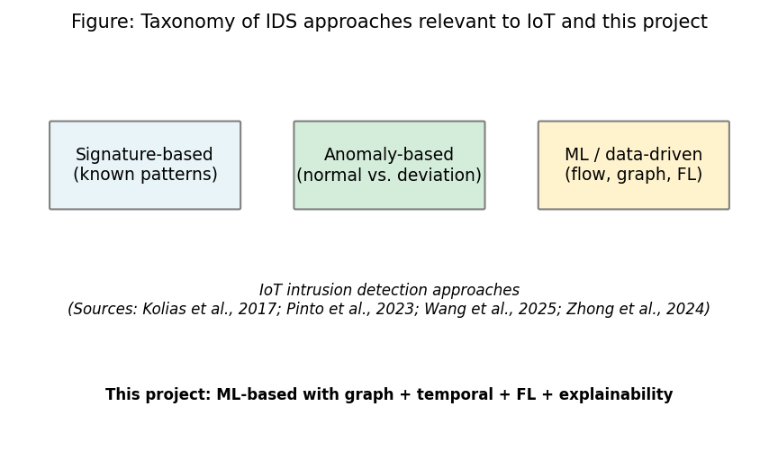
Figure 1: Taxonomy of IDS approaches relevant to IoT and this project (Chapter 2, Section 2.3)

2.4 SIEM, SOC Workflows, and Alert Quality

2.4.1 Alert Volume, Triage, and the Need for Explanations
SIEM-fed events are triaged by SOC teams, opaque model scores and alert fatigue consume the time of analysts (Cuppens and Miège 2002). Elastic Common Schema (ECS) provides a vendor-neutral schema of event fields ( Elastic N.V. 2023); the project uses ECS-like JSON to get events ingested interoperably, but not certified by vendors.

2.4.2 SIEM Ecosystems, Explainability, and limits of better JSON.
ML detections are still matched with playbooks and cases; explainable model output in tier-1 triage are disproportionate in the record. Academic comparators are commonplace SHAP and IG (Lundberg and Lee 2017; Sundarararajan et al. 2017). The alert contains best features and best flows in this work. Workload economics are not eliminated in Cleaner JSON (Cuppens and Mioge 2002; Section 1.2).

2.5 Dynamic Graphs and Graph Neural Networks.

2.5.1 GNNs, Attention and Attribute based Graphs in intrusion detection.
GNNs combine information about the neighbourhood of graph-structured data; GATs learn edge-based attention (Velickovic et al. 2018). The reason Ngo et al. (2025) use kNN feature-space graphs is due to the non-availability of device IPs (such as in the CICIoT2023 public release). Attention points out the salient structure but this is not a causal attack evidence (Basak et al. 2025).

2.5.2 Dynamic (Temporal) Graphs and GAT +GRU Pattern.
Dynamic graph models use GNN models to run on each window, and sequence models (GRU in this case) to run across windows (Zheng et al. 2019; Lusa et al. 2025; Basak et al. 2025). This work compares GAT+GRU with RF/MLP using the same splits and provides CPU time (Section 8.5). Figure 2 (author) is a sketch of GAT-then-GRU; this figure is not reproduced in one of the previous papers.
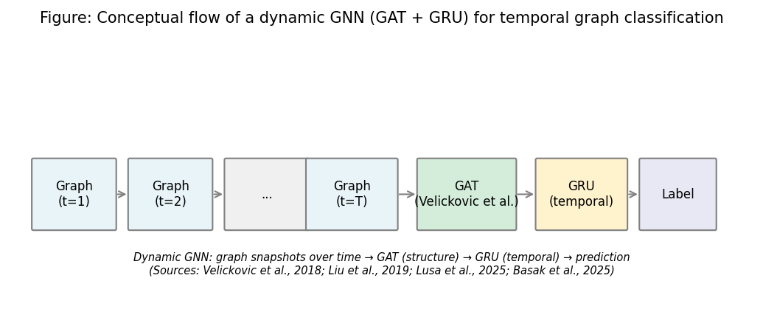
Figure 2: Conceptual flow of a dynamic GNN (GAT + GRU) for temporal graph classification (Chapter 2, Section 2.5)

2.6 Federated Learning and Privacy

2.6.1 FedAvg, Assumptions, and Communication
FedAvg (McMahan et al. 2017) averages parameter sizes of clients with size weights, trading updates rather than raw rows (Lazzarini et al. 2023; Albanbay et al. 2025). Figure 3 is a schematic by the author, not a copy of McMahan et al. (2017).
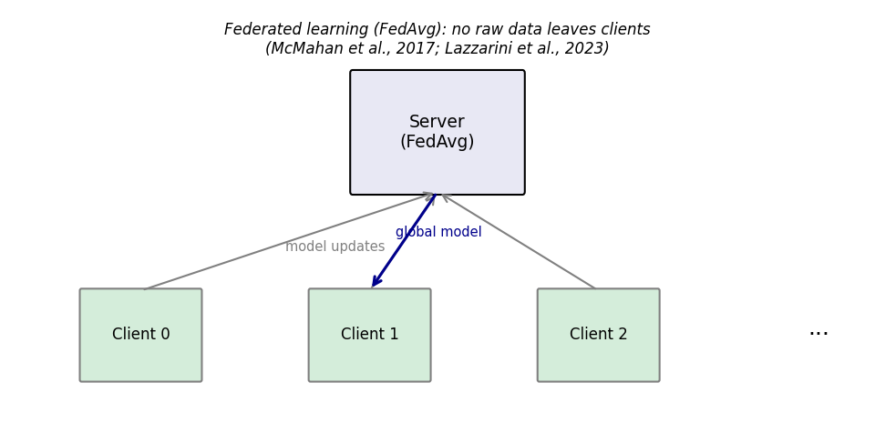
Figure 3: Federated learning (FedAvg) flow - no raw data leaves clients (Chapter 2, Section 2.6)

2.6.2 FL for IoT Intrusion Detection: Empirical Findings and Non-IID Reality
Qu and colleagues (2020) encourage decentralised training in the case of the prohibition of raw pooling. Lazzarini et al. (2023) and Albanbay et al. (2025) demonstrate non-IID client mixes and client counts convergence. The work adopts Flower with three clients, Dirichlet non-IID split and communication is reported in Chapter 8. FedAvg is not differential privacy: the MSc scope is based on an honest-but-curious threat model.

2.7 justifiable ML-Based Security.

2.7.1 GNNs Post-hoc Attribution, Integrated Gradients, and Attention.
Post-hoc Integrated Gradients is implemented on top of PyTorch with Captum (Kokhlikyan et al. 2020) to attribute input features (Sundararajan et al. 2017). GAT edge attention emphasises neighbour flows (Velickovic et al. 2018). In Chapter 8, example alerts (Figure 4) are a combination of both cues.
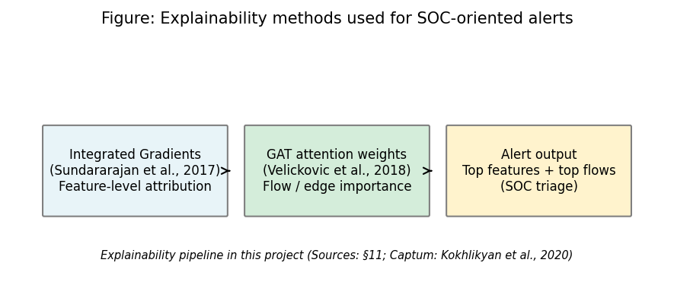
Figure 4: Explainability methods used for SOC-oriented alerts (Chapter 2, Section 2.7)

2.7.2 XAI for IoT Streams, SHAP as Alternative, and Latency as a Counterargument
Alabbadi and Bajaber (2025) analyze XAI on IoT streams; the work implements the Integrated Gradients on the GNN+Captum stack with SHAP being a natural fit to tree baselines (Lundberg and Lee 2017). Gradients Integrated gradients is a latency-intensive (50 steps default) algorithm, and thus can be used selectively (to explain); triage-time claims are conservative (Chapter 9).
The four project pillars are summarised in Table 1 and Figure 5 on how they are covered in previous studies. None of the rows in Table 1 contains a combination of GNN, federated training, XAI, and a SIEM-oriented alert wrapper as the current prototype does; this difference is indicated in Section 2.8.
Study | GNN/Graph | Federated learning | Explainability | SIEM/Alert | Dataset/context
(Pinto et al. 2023) | - | - | - | - | CICIoT2023 dataset
(Velickovic et al. 2018) | Yes (GAT) | - | - | - | General GNN
(McMahan et al. 2017) | - | Yes (FedAvg) | - | - | General FL
(Sundararajan et al. 2017) | - | - | Yes (IG) | - | Attribution method
(Han et al. 2025) | Yes (DIMK-GCN) | - | - | - | IDS
(Ngo et al. 2025) | Yes (attribute-based) | - | - | - | IoT IDS
(Basak et al. 2025) | Yes (X-GANet) | - | Yes | - | NID
(Lusa et al. 2025) | Yes (TE-G-SAGE) | - | Yes | - | NID
(Lazzarini et al. 2023) | - | Yes | - | - | IoT IDS
(Albanbay et al. 2025) | - | Yes | - | - | IoT IDS
(Alabbadi and Bajaber 2025) | - | - | Yes (XAI) | - | IoT streams
(Yang et al. 2025) | Yes | - | - | - | Industrial IoT
This project | Yes (GAT+GRU) | Yes (Flower) | Yes (IG+attention) | Yes (ECS-like) | CICIoT2023
Table 4: Comparison of related work of choice (sources: Chapter 11)

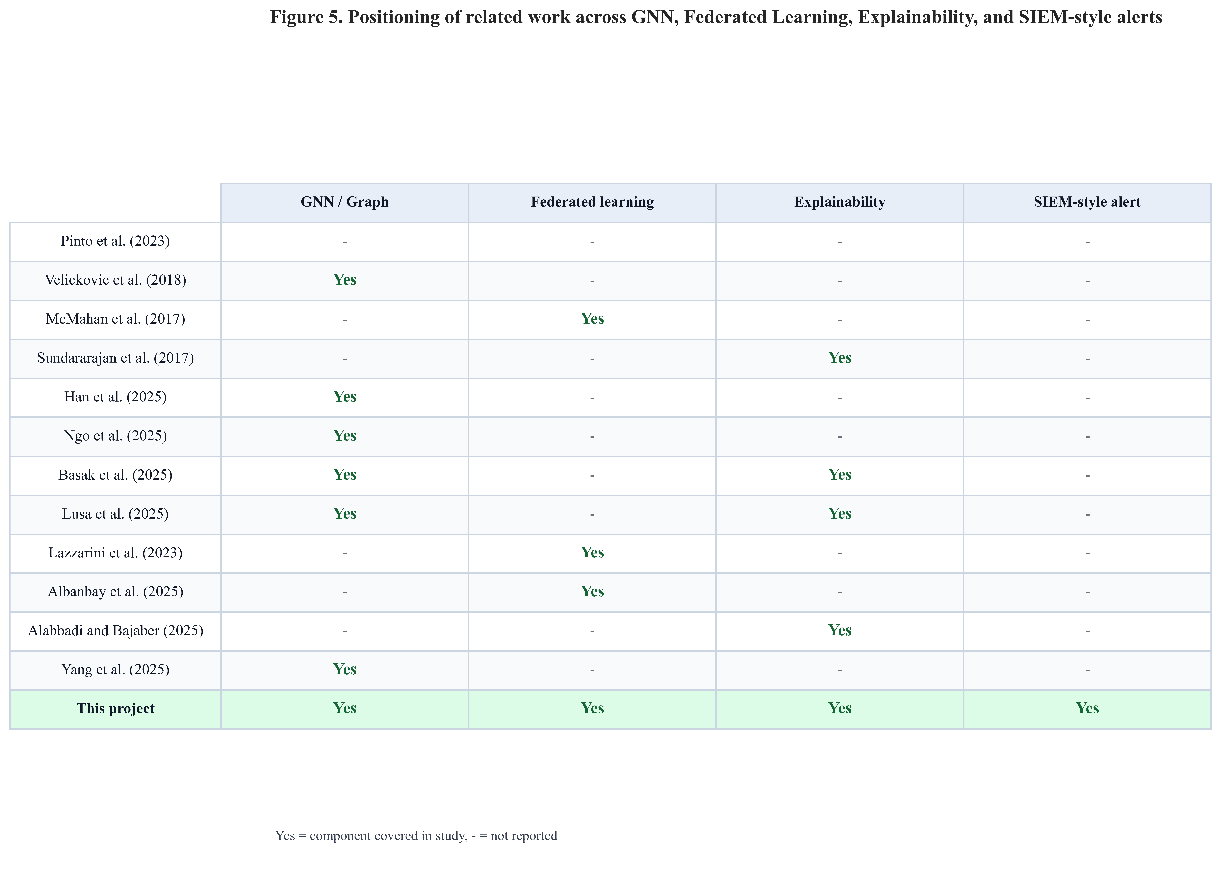
Figure 5: Positioning of related work - GNN, federated learning, explainability, and SIEM-style alerts (Chapter 2, Section 2.7)

2.8 Synthesis: Significance, Limitations of Prior Work, Contributions, and Gap

2.8.1 How Existing Approaches Fill Part of the Problem (and Where They Stop)
The majority of the related papers focus on one of the pillars: GNN results (Yang et al. 2025; Han et al. 2025), FedAvg in IoT (Lazzarini et al. 2023; Albanbay et al. 2025), XAI offline (Alabbadi and Bajaber 2025; Basak et al. Table 1 indicates that it can run only few rows with all four columns; the only row to run the entire stack on a single CPU-first pipeline using RF/MLP on a common CICIoT2023 subset is this project.

2.8.2 Expected Significance (What Would Matter were the Evidence to be true)
Achieving a reproducible end-to-end integration - SIEM-shaped alerts, GAT+GRU, FedAvg, ablation, sensitivity, multi-seed - is the targeted contribution, is not a claim to best F1 on all IoT traffic (Pinto et al. 2023).

2.8.3 Literature and its Limitations and their effects on Claims.
Lab-only models, XAI, and triage time studies (Alabbadi and Bajaber 2025), and the FL models of privacy that can surpass the assumptions of FedAvg (McMahan et al. 2017) all narrow the terms of Chapter 8 and Chapter 9 in this project.

2.8.4 Discussion, refutations, and the Gap-Synthesized.
Counterargument 1 - “Strong features mean that we do not need graphs..” There is even a division in the literature itself (Yang et al. 2025; Zhong et al. 2024). This work validates this assertion with RF and MLP baselines on the identical splits and displays the numbers of false positives and headline F1. Counterargument 2 - “Federated learning is privacy free..” Qu et al. (2020) and Albanbay et al. (2025) present details of deployment; in this paper, truthful-but-curious assumptions and count the number of exchanged bytes, rather than a differential-privacy guarantee. Counterargument 3 - “Elucidable alerts eliminate audit and workload danger..” Section 2.4.2 and Cuppens and Miège (2002) emphasize the operational load, integrated gradients and GAT attention introduce artefacts to be reviewed by humans, rather than a statement of trust and adherence to policy.
It is united with a previous row in Table 1 by kNN temporal graphs and a GAT+GRU stack and Flower FedAvg and Captum integrated gradients and GAT attention cues and ECS-like JSON alerts, all on a unified CICIoT2023 subset and under a single MSc-style reproducible package. The gap as design, evidence, is instantiated in Chapters 4 to 8; Chapter 9 comes back to significance at the end of the results.

2.9 Mapping to CyBOK (Cyber security body of knowledge)
This work is captured in the agreed project specification (Appendix C) mapped against knowledge areas in CyBOK. Specifically, the dissertation is aligned with the following topics: Attacks & Defences: Security Operations and Incident Management (flow-based analysis, IoT traffic classification), Systems Security: Distributed Systems Security (federated learning without centralising raw client data), Software and Platform Security: Software Security (engineering of the prototype pipeline, APIs, and reproducible scripts). These areas, combined with each other, place the project in the context of the CyBOK mapping that is found in the School and aligns with the indicative coverage of the specification.

2.10 Extended Comparative Review (Fifteen to Twenty Core Sources)
Section 2.10 has an extension of fifteen to twenty core-source breadth; the next paragraph lists more auditable touch-stones in addition to Sections 2.3 2.7: Zheng et al. (2019) on temporal graph stacks; Qu et al. (2020) on decentralised training

2.11 Chapter Summary
The fixed CICIoT2023 build will be established later in the chapters using search strategy, title-level synthesis (Section 2.2.2), threads 2.3-2.7, Table 1 / Figure 5, gap (Section 2.8), CyBOK (2.9), and the extended source list (2.10).

Chapter 3 - Project Management

3.1 Chapter Overview
The process of the project is recorded in this chapter: planning and milestones, risk management, the IDE and platform to be used to provide evidence of verifiable development (Section 3.5), and ethics posture (public dataset, no human subjects). It aids in transparency of performance without repeating technical data in Chapters 4-7.

3.2 Project Plan and Schedule (45-day MSc)
The project was divided into six stages: (1) freeze requirements and literature; (2) fix the CICIoT2023 subset and preprocessing, (3) implement graph construction and central GNN training, (4) run baselines and Flower-based federated training, (5) add explainability, alert JSON, and FastAPI, (6) run ablation, sensitivity, multi-seed experiments, figures, and final writing. To eliminate ambiguity on the definition of done, each phase had tangible artefacts (metrics files, checkpoints, plots). The schedule is presented in figure 6 in the form of a Gantt chart with overlapping phase bars, more realistic to the implementation of the research in reality rather than in sequential blocks.
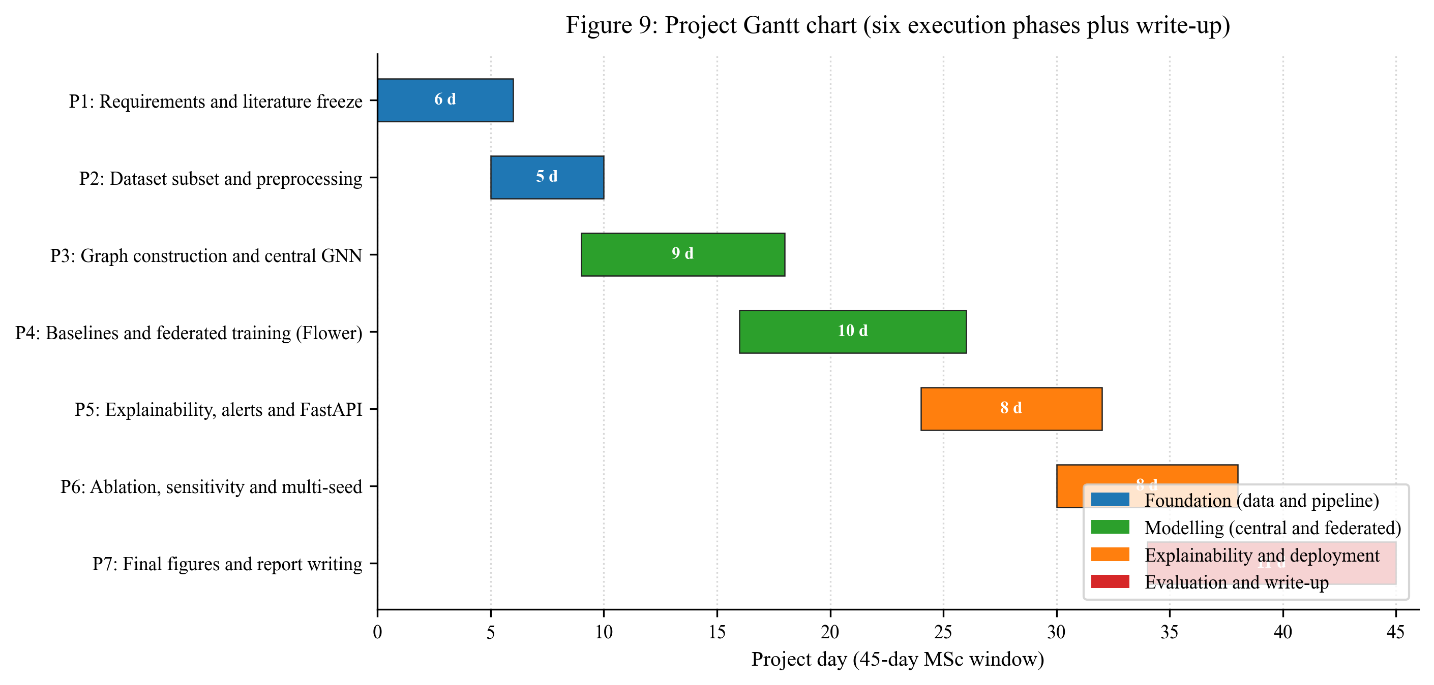
Figure 6: Project Gantt chart - six execution phases plus write-up across the 45-day MSc window (Chapter 3, Section 3.2)

3.3 Monitoring and Progress Reviews
Risk | Mitigation
Training too slow on CPU | Fixed subset; configurable rounds/clients; early stopping
Severe class imbalance | Stratified windowing; class weights; balanced graph-level labels
Federated instability | Three clients; reproducible split; checkpoints each round
Explainability runtime | Top-k attributions; optional subset of alerts
Scope creep (extra models) | Baselines limited to RF and MLP; one main GNN architecture
Table 5: Monitoring and Progress Reviews
The progress was tracked on a weekly rhythm with the supervisor and in relation to the phase scheme in Section 3.2. The agenda of every meeting (once a week) was based on the same three points: (1) what has been done since the previous meeting and which artefact in the repository demonstrates it; (2) what was being done and what blocker required supervisor input; (3) what was going to be done next week and what phase boundary was it. The project process documentation referenced in Appendix B captured decisions and action items so that activity can be traced after the fact.

3.4 Research Plan for Completion: IDE, Platform, and Evidence for Supervision
This section records where and how the code was built and which artefacts show progress, so the development story can be read alongside Chapters 4-6. Non-article tools (IDE, language, Git) are cited in Chapters 11-12 in author-year (Harvard) form (University of the West of Scotland Library 2025).
Working environment: Primary development used Cursor, an development environment (IDE) based on the same editor stack as Visual Studio Code, running on Windows 10 (x64) (see also Table 5 in Section 6.2). That IDE was cloned and edited in the same IDE; version control, and figures were generated on the same machine. Cursor is not mentioned as a source of research claims, but as a reputable vendor-documented product (Anysphere, Inc. 2024). Core language and tooling used alongside it are the Python implementation (Python Software Foundation 2023) and the Git version-control system (The Git Project 2023); both are standard, vendor-backed resources listed in the Chapter 12 bibliography.
Other IDEs. The project is a standard Python tree (src/, scripts/, requirements.txt) and can run in PyCharm, VS Code, or notebooks; this submission’s reproducibility is documented for local Windows runs (README.md, SETUP_AND_RUN.md, Table 5), not a hosted Colab kernel.
Reproducibility checks: Git history; frozen results/metrics/ and results/figures/ (Chapter 13); Gantt (Section 3.2); config/experiment.yaml. Development used Cursor and documented terminal runs. The IDE is infrastructure only - method and evidence are Chapters 2 and 4-7 with 11-12 references.

3.5 Ethics and Data
Only public CICIoT2023 data is used; there are no human participants or proprietary organisational datasets. The signed specification ethics section records that the project does not require full ethics-review board approval under School procedures (February 2026) for this use of non-sensitive public data. Process and ethics paperwork are nicely referenced in Appendix B (and the signed project specification in Appendix C where relevant).

3.6 Supervision and Progress Alignment
Frequent meetings with the supervisor and moderator followed scope, risks and alignment between the implementation and research questions. The MSc Interim Report - Student record and action plan (15 April 2026, Dr R. M. Ujjan) is sent to the Appendix B; the technical build is described in Chapters 4-8.
Supervision kept the work grounded to: (1) an end-to-end narrative (data → model → optional federation → explainability → SOC-shaped output); (2) a well-defined evaluation plan with a definite test contract before results; (3) explicit boundaries of a lab subset and very high test metrics; (4) analysis and write-up in Chapters 7-10 without scope drift.

3.7 Chapter Summary
The project was viable through clear time-boxing and risk management that resulted in the creation of graph, federated, explainable, and deployable components. The IDE, platform and key artefacts are documented in Section 3.5, with tools and the Harvard (author-year) style of authority listed in Chapters 11-12 (University of the West of Scotland Library 2025).

Chapter 4 - Research Design and Methodology

4.1 Chapter Overview
The approach in this chapter is in the words of the author: it describes how the public CICIoT2023 files are trained models and one-shot test metrics with leakage controls. Section 1.5 maps research design / deployment to Chapters 4-6 and evaluation / metrics to Chapters 7-8; and then defines the metrics once in Section 7.5. Chapters 4-5 establish stages and graph semantics (Figures 7-9); each stage is represented by a path in the repository with a name.

4.2 Research Approach
Epistemology and design. It is an empirical work: a prototype pipeline (data → baselines and GNN → optional Flower → explainability → FastAPI) is evaluated using reproducible metrics of pre-recorded CIC rows - no live capture. Accuracy in this case refers to held-out test scores (Section 7.5, Chapter 8). The approach is compositional: kNN graphs, GAT+GRU, FedAvg (Dirichlet clients), Captum IG and GAT attention, ECS-like JSON - frozen in config/experiment.yaml.
Rigor funnel. (1) Public splits are released (train / validation / test CSVs), and not a random re-split of one pool, therefore the desired separation of the benchmark is honored. (2) Only training file (first pass in src/data/preprocess.py) is transformed using StandardScaler, which is then used to transform validation and test. (3) Train + validation Tuning and early stopping; test: one-shot reporting. (4) Federated training does not transmit raw rows - just model parameters (see Section 4.5).

4.3 Dataset and Subset
Use of secondary data, primary. The dataset authors capture and label CICIoT2023 in a testbed and use their pre-recorded CSVs as secondary data and run a project-specific learning pipeline and cleaning.
Row volume and flow level class balance. In the frozen run described in this dissertation, the three public split files were run to 500,000 flow rows, maintaining both the benign and attack traffic at approximately 2.3% / 97.7% benign/attack in each split (see Table 4 of the actual counts). The binary labels are obtained by mapping the label column of the dataset to y = 0 or 1 (benign vs. attack) with the help of benign_labels list in the YAML. The exhaustive list of numeric flow feature columns (rates, counts of flags, counts of protocol indicators) is present in config/experiment.yaml; in this build, there are no IP or timestamp entries present as model inputs.
Feature extraction after split order. src/data/preprocess.py reads each split, drops/repairs inf / NaN in the 46 numerics, constructs binary_label, and applies the scaler in file order so that the training split fits the StandardScaler and the other splits only transform. That ordering is a leakage control: validation and test never influence the mean/variance used for $z$-scoring.

4.3.1 Proposed pipeline stages, artefacts, and leakage controls
Stage | What happens | Main artefact / location | Leakage or scope control
1 | Ingest public CSVs per split | data/raw/{train,validation,test}.csv | Splits are as published (not re-drawn from one pool)
2 | Clean numerics, binarise labels, fit scaler on train only | src/data/preprocess.py → data/processed/*.parquet + scaler.joblib | Validation/test only transformed
3 | (Optional) cap rows per split for MSc budget | Same parquet rows | Documented row cap; all models see same files
4 | Build kNN windows and sequences per split | src/data/graph_builder.py, src/data/dataset.py; data/processed/*_graphs.pt | Graphs built inside each split; no cross-split windows
5 | Train / tune baselines and GNN on train; monitor val | results/checkpoints/, results/metrics/*.json | Test not used in loss or model selection
6 | Federated GNN: partition training rows across clients; FedAvg | src/federated/; round metrics JSON/CSV | Raw flows stay local; only weights exchanged
7 | Final test metrics + CPU latency + comms + alerts | results/metrics/results_table.csv, src/siem/api.py | Single test evaluation policy (Chapter 7)
Table 6: is the master stage list; later chapters reference the same order (Figure 7 is the visual analogue).
Italic paths denote examine-facing artefacts. If another researcher omits a stage (e.g. skips graph building and trains only on flows), the experiment is not the one reported here.

4.3.2 Repository layout and frozen outputs
Raw CICIoT2023 files are not committed. After Stage 2, train / validation / test parquet and the saved scaler live under data/processed/. Graph tensor caches and metrics/figures live under data/processed/ and results/ as listed in the repository README and Chapter 13. The dissertation’s numbers assume one frozen pass of the same config hash implied by the committed config/experiment.yaml.

4.3.3 Empirical flow and graph sample sizes
Table 4 records empirical sizes (from results/metrics/dataset_stats.json) for the run underlying Chapter 8. Flow row counts are per-split totals; graph counts follow the configured window = 50 flows, sequence length = 5, and knn_k = 5 (Table 7).
Split | Flow rows (total) | Benign flows | Attack flows | Graph windows (single-split build) | Sequences (length-5)
Train | 500,000 | 11,582 | 488,418 | 924 | 920
Validation | 500,000 | 11,676 | 488,324 | 932 | 928
Test | 500,000 | 11,772 | 488,228 | 938 | 934
Table 7: Empirical sample sizes: flows, graph windows, and sequences.
Notes. Windows are constructed with per-class pools and shuffling (see Section 5.3); the sequence count is slightly below the window count because the tail of the shuffled list may not form a full length-5 sequence. All models that report “sequence-level” GNN metrics consume these sequences; RF/MLP report per-flow metrics on 500,000 test flows each.

4.4 Models and Loss Functions
Three model families share the same label definition and splits but differ in input geometry: two are feature-vector classifiers; one is a graph-sequence classifier.
- Random Forest - tabular: one standardised 46-vector per flow, sklearn.ensemble.RandomForestClassifier in src/models/baselines.py; out-of-bag / train metrics are not used for test claims; test reporting is the contract in Section 7.7.
- MLP - tabular: feed-forward on 46-d inputs, MLPBaseline, trained with Adam and mini-batch cross-entropy (see Table 7).
- Dynamic GNN (GAT + GRU) - graph-sequence: for each of five windows, a GAT stack produces a graph embedding; a GRU consumes the ordered list of five embeddings; a linear head outputs logits for the binary case (DynamicGNN in src/models/dynamic_gnn.py). An ablation mean-pools time instead of a GRU (Table 10).

4.4.1 Hyperparameters, tuning funnel, and training budget (after split)
After the public splits and parquet files exist, all model-specific knobs are taken from a single YAML (Table 7). Early stopping (patience in Table 7) is driven by validation performance; test is never used to pick hyperparameters. Fine-tuning in this project means that validation-monitored training loop with fixed architecture widths - there is no manual test-set search.
Group | Parameters | Value
Reproducibility | Global seed | 42 (multi-seed study: 42, 123, 456 in Section 8.9)
Graph build | window_size, knn_k, sequence_length, minority_stride | 50, 5, 5, 25
FL | num_clients, num_rounds, local_epochs, alpha (Dirichlet) | 3, 10, 2, 0.5
RF | n_estimators, max_depth | 200, 20
MLP | hidden_dims, dropout, lr, epochs, batch_size | [128, 64, 32], 0.2, 0.001, 30, 256
Dynamic GNN | node_dim, hidden_dim, num_gat_layers, gat_heads, gru_hidden, dropout, lr, epochs, batch_size | 46, 64, 2, 4, 64, 0.2, 0.001, 30, 16
Class imbalance | class_weight_auto (train) | true
Stopping | early_stopping_patience | 5 (epochs)
Table 8: Hyperparameters, training budget, and federation (frozen in config/experiment.yaml).

4.4.2 Objectives, losses, and federation rule
Binary cross-entropy (all trainable models). Labels are binary (benign = 0, attack = 1). For N training items, with yᵢ ∈ {0,1} and modelled probability pᵢ = P(yᵢ = 1 | input i), the training objective is binary cross-entropy: minimise the mean of −(yᵢ log pᵢ + (1−yᵢ) log(1−pᵢ)) over i = 1,…,N.
What counts as one training item differs by model. Random Forest and MLP use one flow per i; the dynamic GNN uses one window sequence of T = 5 window graphs with a single sequence label (any-window attack rule; Section 5.3), and the same mean cross-entropy is applied to the sequence logits. Class weighting in scikit-learn (class_weight) and the PyTorch loss, where used, reweights the minority benign class without changing the splits (Section 4.3).
Federation (FedAvg). In Flower, each client minimises the same local cross-entropy on its data partition. After each round, the server sets the global network parameters to a sample-size-weighted average of the client models (McMahan et al., 2017): each client k contributes with weight nₖ / n, where nₖ is that client’s training count (rows or batch-equivalent) and n = Σₖ nₖ over all clients k. This is a weighted mean of the client parameter vectors after the round; it is not a raw feature upload - raw flow feature vectors never leave the client machine (Section 2.6; wiring Section 6.6).
Implementation mirrors the equations: kNN graph build and FedAvg server steps live in src/data/graph_builder.py and src/federated/; training in src/models/trainer.py. Test claims use Section 7.5 metrics via src/evaluation/metrics.py and results/metrics/.

4.5 Federated Learning Setup
FedAvg (McMahan et al. 2017): clients train locally and send weights; the server averages and broadcasts the global model - no raw flows cross sites (Section 2.6). This project involves Flower and three clients, ten rounds and two local epochs per round (timelines and risks: Chapter 3; wiring: Section 6.6). The identical GNN architecture is trained both centrally and federally to provide a fair comparison. Estimate of communication cost is based on the traffic of float32 parameters that are serialized (Chapter 8).
Non-IID simulation: Each training row is allocated to a client, distributed using a Dirichlet distribution over the proportions of classes (alpha = 0.5) such that the client label mixes are different (even stronger than IID sharding; even weaker than adversarial splits). Rationale: reflect sites with different exposure while staying trainable within the MSc budget.

4.6 Explainability
Two forms of explanation are used:
- Integrated Gradients (Captum): Applied to the chosen model (e.g. the dynamic GNN or the MLP) to attribute the prediction to input features. The top contributing features are extracted and included in the alert.
- Attention weights: For the GAT-based model, attention weights over edges or neighbours are used to identify which flows or connections the model focused on. These can be summarised as “top flows” or “top edges” in the alert.
Explanations are produced for selected predictions (e.g. positive alerts). The top-k (k=5) features and flows are included in each alert to keep the explanation concise. If computing explanations for every prediction is too slow, they are applied only to a subset (e.g. high-confidence alerts) and this is noted as a limitation.

4.7 Evaluation Plan
Formulae and definitions for precision, recall, F1, FPR, and ROC-AUC are given once in Section 7.5. Here, the plan only maps measurements to questions.
Evaluation is designed to answer the three sub-questions and support the main research question.
- Metrics: Precision, recall, F1-score, ROC-AUC, and false positive rate on the fixed test set. A confusion matrix is reported.
- Model comparison: Centralised training: Random Forest, MLP, and dynamic GNN are compared on the same splits. Federated training: the same GNN (or MLP) is trained with FedAvg and compared to its centralised version.
- Time and cost: Time-window analysis (e.g. performance across different window sizes or positions), federated round-by-round performance, approximate communication cost (bytes), and CPU inference time per sample or per batch.
- Explainability and SOC use: Three to five example alerts are generated with full explanations (top features and flows). These are discussed in terms of whether they would help a SOC analyst triage (e.g. whether the highlighted flows and features are interpretable and actionable).
Contingencies match Chapter 3 (subset size, rounds/clients, optional subset of explained alerts). Linkage to questions: precision, recall, F1, ROC-AUC, and FPR → sub-question 1 (and central leg of sub-question 2); per-round FL metrics and comms cost → sub-question 2; example alerts → sub-question 3; CPU inference latency → main question (edge deployability).

4.8 Software and Tools
The methodology relies on a small set of mainstream Python libraries chosen for stability, documentation, and CPU compatibility. The full version pin list is in the repository requirements.txt; this section names the components and the role each plays in answering the research questions. Module-level wiring and code excerpts are in Chapter 6.
- Python 3.10 is the implementation language for all data, model, federated, explainability, and API code.
- PyTorch and PyTorch Geometric are used to build the GAT layers and the dynamic GNN with sequence encoding (Sections 6.4 and 6.5).
- scikit-learn provides the Random Forest baseline, the StandardScaler (used in preprocess.py for parity with sklearn conventions), and metric helpers (Sections 4.3 and 6.3-6.5). Splits are not created by train_test_split in this build - the public CIC train/validation/test files are the splits.
- Flower is used for the federated learning server and client implementation with FedAvg (Section 6.6).
- Captum is used for Integrated Gradients on the trained model (Section 6.7).
- FastAPI is used to serve the prediction and explanation endpoint that produces ECS-like JSON alerts (Sections 6.8 and 6.9).
- Matplotlib, Pandas, and NumPy are used for figure generation, table preparation, and numeric handling.
- Pygments is used to render dark-theme code screenshots for the implementation chapter and for Appendix A (code figures).
- Git and GitHub are used for version control of the project repository linked in Appendix D.
Configuration is externalised in config/experiment.yaml so that hyperparameters (window size, kNN k, GAT heads, FL rounds and clients) can be changed without code edits. All experiments have seed 42 unless specified otherwise by the multi-seed script. It is this fixed seed, externalised config and named scripts that makes the methodology in this chapter reproducible based on the codebase.

4.9 Chapter Summary
The Research Method contract: secondary CICIoT2023 use, leakage-aware preprocessing (Tables 2-4), YAML-frozen hyperparameters and post-split tuning funnel (Table 7), loss and FedAvg equations (Section 4.4.2), and federation, XAI, evaluation, and tools pointers are fixed in chapter 4. Chapter 5 provides the design-level pipeline and graph semantics, Chapter 6 provides deployment code and Table 5 testbed, Chapter 7 schedules multi-scenario runs (Table 6).

Chapter 5 - Design

5.1 Chapter Overview
This chapter describes the system design sequentially as the narrative: the end-to-end research pipeline (first, Figure 7), the semantics of authoritative graphs and windowing rules (Section 5.3), the architecture (Figure 8) and a conceptual kNN schematic (Figure 9) which is consistent with the implementation in Chapter 6. Outputs that face deployment refer to ECS-like JSON alerts.

5.2 Pipeline, Alerts and Deployment (Conceptual)
The stage-level view is provided in Figure 7: preprocessing, graph construction, central training, explainability and SIEM-like alerting on CPU. Section 5.3 specifies windowing, kNN k, sequence labelling; Chapter 6 specifies wiring at the module level.
Alerts are formatted in a SIEM-like JSON format, which is consistent with the concepts of ECS with useful: type of event, date/time, source/target data, label, score, and an explanation field (top features / top flows). The runtime path is a FastAI service which executes inference (and explanations) on CPU, which corresponds to the edge objective.
The limits of stages (prep-learn-score-alert) are set in stone in order that Chapters 6-8 should not redefine contracts; fault tracing can be done by stage.
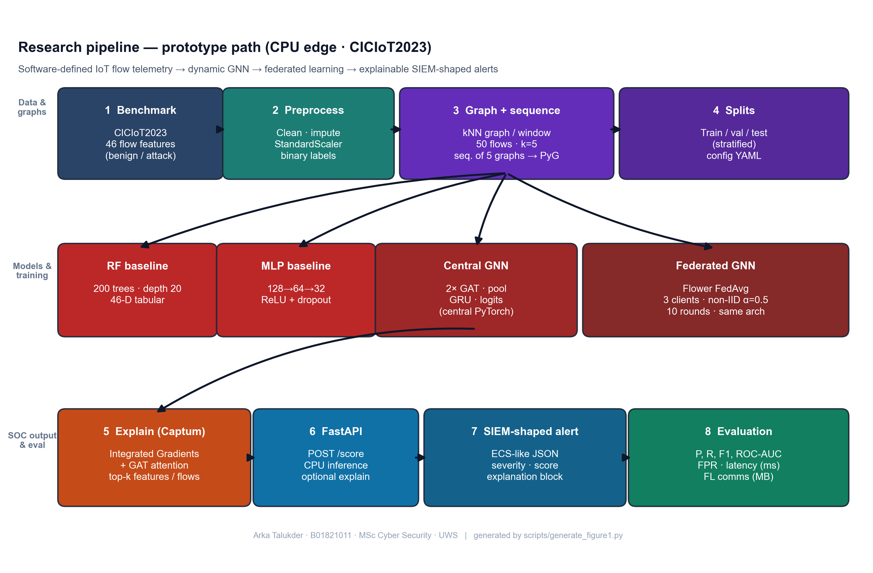
Figure 7: Research pipeline - from raw IoT flow data to explainable SIEM alerts (Chapter 5, Section 5.2)

5.3 Graph Design (Flows to kNN Snapshots)
Authoritative section: every other mention of window/k/sequence rules in this thesis points here or to src/data/graph_builder.py / dataset.py (Section 6.4).
The graph is built from flow data to capture structural relationships between network flows within each observation window.
- Nodes: One node per flow; 46 CIC feature columns (Ngo et al. 2025: attribute graphs when IPs are not used publicly).
- Edges: Per window, kNN in Euclidean 46-D space (bidirectional); default k = 5 (Chapter 8 sensitivity).
- Windows and sequences: Flows are grouped into fixed-size windows (e.g. 50 flows per window). To handle extreme class imbalance at flow level, the implementation (src/data/graph_builder.py) builds each window only from flows in a single class pool (benign or attack); the graph-level label is that pool’s class (within a window all flows share the same label, so this matches a unanimous vote but is defined by construction, not by aggregating mixed labels). Benign and attack windows are balanced, then shuffled into one list. Training samples are sequences of five consecutive graphs in that list; the sequence-level label is attack if any of the five windows is attack-labeled (GraphSequenceDataset in src/data/dataset.py). The GRU reads the five graph embeddings in order. Five windows was chosen to balance context with memory and training time.
This design is kept simple so that it can be implemented and tested within the project scope. The kNN approach applies to any flow-feature dataset regardless of whether device identifiers are present. More complex designs (e.g. device-based graphs when IPs are available, multi-hop temporal aggregation) could be explored in future work.

5.4 Research Design and System Architecture
Figure 8 summarises the end-to-end research design: public benchmark flows are preprocessed and turned into temporal graphs; the dynamic GNN can be trained centrally or through Flower FedAvg on non-IID clients; the same checkpoint path supports Captum explanations and FastAPI scoring into SIEM-shaped JSON. It is a conceptual diagram (not a formal UML class model); a full UML component diagram can be pasted into the Word submission if the module asks for it.
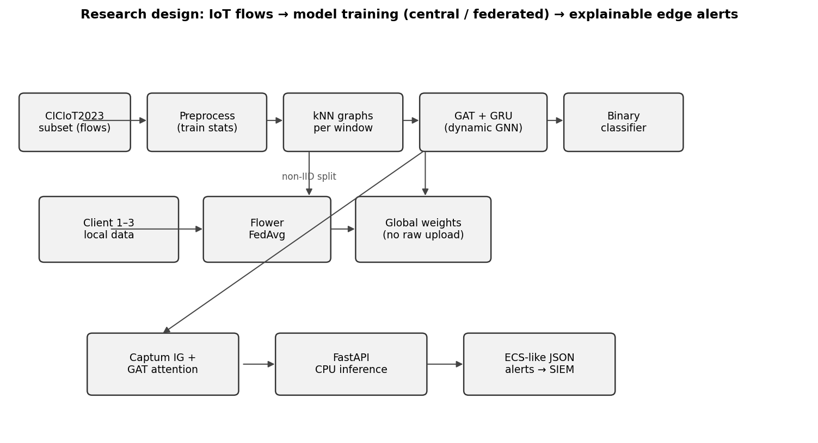
Figure 8: Research design - data flow, federated training, and edge alerting (Chapter 5, Section 5.4)

Source: Author’s own diagram; generated for this dissertation (scripts/draw_research_design.py).

5.5 Conceptual Illustration: Similarity-Based Graph in One Window
Public CICIoT2023 releases do not always include device-level topology, so attribute / similarity-based edges are a standard way to obtain a graph for a GNN (Ngo et al. 2025). Figure 9 is an author-original schematic (drawn with Matplotlib, following the library’s documented style sheets - see Matplotlib gallery): each point is one flow in a window; lines show k nearest neighbours in a 2-D projection of feature space (the real system uses 46 dimensions and Euclidean distance, Section 5.3). It is not a screenshot from another paper; it only visualises the same construction principle as the implementation.
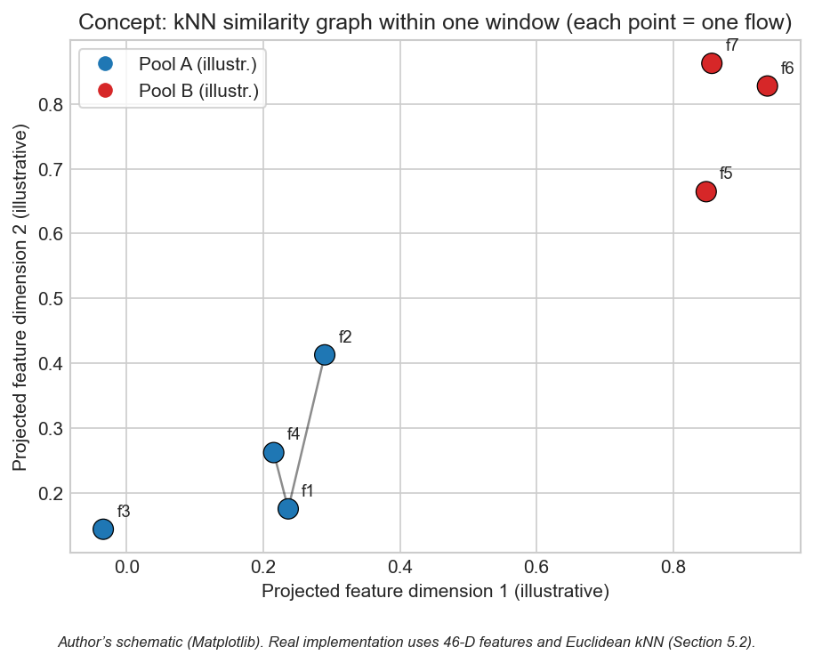
Figure 9: Conceptual kNN similarity graph within one observation window (Chapter 5, Section 5.5)

5.6 Chapter Summary
The design encodes relational (kNN), temporal (window sequences), and SOC-facing outputs in one architecture.

Chapter 6 - Implementation and System Development

6.1 Chapter Overview
The chapter outlines the implementation of the prototype: code structure, libraries, training and federated loops, Captum integration, alert formatting, and the FastAPI scoring endpoint. The implementation detail is important in this project, as the claim is not merely the model accuracy, but the entire pipeline implementation within the CPU constraints. And so I tell where all the great functions reside, and how the modules are interrelated.
It is implemented in a directory structure (src/), by responsibility (data, models, federated learning, explainability, SIEM output, evaluation) with scripts reproducing end-to-end runs based on configuration (scripts/run_all.py and scripts to it). The YAML configuration is externalised such that experiments can be re-run without making code modifications.

6.2 Environment and Tools
The testbed that was applied in the reported CPU-only training, evaluation, and API latency is reported in Table 5. It is not a production SOC but a virtual/laboratory (author workstation) so that one can demonstrate reproducible hardware class and that there are no GPU shortcuts.
Resource | Stated configuration for this project
Host OS | Windows 10, x64; single-user development machine
Runtime | Python 3.10; virtual environment with pinned dependencies (requirements.txt)
CPU | x86-64 multi-core (CPU-only: no discrete GPU in any reported run)
RAM | 16 GB system RAM (sufficient to hold 500k-row parquets, graph batches, and training at batch sizes in Table 7)
Disk | SSD (NVMe-class) for repository, data/raw/, data/processed/, results/ (HDD is not required for the frozen subset)
Network / traffic | Pre-recorded CICIoT2023 files only; no live traffic generation in the testbed for training
Isolation | Optional Docker for FastAPI demo (README.md); all metrics reproducible on bare Windows + Python
Table 9: Testbed, storage and runtime stack (Research Method Deployment).
This system is run in Python 3.10. The neural models (GNN and MLP) are trained with PyTorch 2.x and graph operations and GAT layers are offered by PyTorch Geometric (PyG). Random Forest is applied with scikit-learn, as well as metrics (precision, recall, F1, ROC-AUC, confusion matrix). Federated learning (client and server logic) is based on the Flower framework. Integrated Gradients are done with captum. The REST API is based on FastAPI. The code is designed to allow the data loading, graph building, training, and inference to be executed individually or in combination. All the experiments are run on CPU to align with the edge deployment objective; training time is thus more than with a GPU but achievable with the selected subset.
It can be configured through config/experiment.yaml (window size, kNN k, sequence length, model hyperparameters and FL rounds/epochs) - Table 7 in Section 4.4.1 is the one-line description of those knobs.

6.3 Data Loading and Preprocessing
The CICIoT2023 subset is loaded from the public train / validation / test CSVs (or equivalent files) as released with the benchmark - not by re-splitting a single pool in this build. The public flow tables provide the 46 numeric features used in this project plus labels; optional endpoint columns are retained only when present in the schema. Missing values are handled and labels are binarised (benign vs. attack) as in src/data/preprocess.py; a global random seed (Table 7) governs shuffling in graph building and model initialisation, not the boundary between splits.
Preprocessing includes feature standardisation (zero mean, unit variance) using statistics computed only on the training set, then applied to validation and test to avoid leakage. For the GNN, flows are windowed and converted to graphs as in Section 6.4. For Random Forest and MLP, the same processed splits are used in tabular form with exactly one row per flow (46 features + binary label), loaded by load_processed_split in src/models/baselines.py - not window aggregates. Graph-sequence construction uses src/data/dataset.py; configuration is in config/experiment.yaml.

6.4 Graph Construction
Implementation follows Section 5.3 exactly: build_graphs_for_split and flows_to_knn_graph in src/data/graph_builder.py build single-class pools, balanced windows, shuffle, Euclidean kNN with bidirectional edges, and graph batches consumed by GraphSequenceDataset in src/data/dataset.py. Default k and window size come from config/experiment.yaml; sensitivity to other (window, k) pairs is in Section 8.8. Baselines read one row per flow from processed parquet via load_processed_split (src/models/baselines.py) - not graph windows.

6.5 Model Implementation
Random Forest: Implemented with scikit-learn on one row per processed flow (46 features + label). The implementation uses 200 trees and max_depth=20; class weights address flow-level imbalance in the training parquet.
MLP: Feed-forward network with three hidden layers (128, 64, 32), ReLU, dropout 0.2; two output logits for benign vs. attack, trained with cross-entropy and Adam (learning rate 1e-3), matching MLPBaseline and the training loop in scripts/run_all.py.
Dynamic GNN (GAT + GRU): Two GAT layers (4 heads, hidden 64) read out each window graph; a two-layer GRU (hidden 64) runs on the five-step embedding sequence; a linear head outputs logits (~128k parameters). The same module is trained centrally or under FedAvg (binary CE; server averages client weights).

6.6 Federated Learning (Flower)
Federated training uses Flower with FedAvg: clients train locally on their partitions for a fixed number of epochs per round and send updated weights to the server; the server aggregates updates and broadcasts the new global model. No raw data is exchanged - only parameters - so communication cost can be approximated from float32 weight traffic (reported in Chapter 8). Implementation details are in src/federated/.

6.7 Explainability
Integrated Gradients: For a given input (e.g. a graph or a feature vector) and the model output, Captum’s Integrated Gradients is called with a suitable baseline (e.g. zero vector or mean feature vector). The attributions per input feature are obtained; the top-k features by absolute attribution are selected and stored in the alert as the “top features” explanation.
Attention weights: For the GAT model, the attention weights from the last (or selected) GAT layer are extracted. They indicate how much each edge or neighbour contributed. These are mapped back to flow identifiers (e.g. source-destination pairs) and the top flows are written into the alert. If the model has multiple layers, a simple strategy (e.g. average or use the last layer) is applied and documented.
Explanations are attached to the alert JSON. The number of integration steps (default 50) trades off attribution accuracy with computation time. The src/explain/explainer.py module wraps both methods and produces a unified explanation object. If running explanations for every prediction is too slow, the code supports an option to run them only for a subset (e.g. when the model confidence is above a threshold).

6.8 Alert Generation and SIEM-Style Output
When the model predicts an attack (or a specific attack type), an alert object is built. It includes: event type (e.g. “alert” or “detection”), timestamp, source and destination (e.g. IP or device ID), predicted label, confidence score, and an explanation object. The explanation object contains the list of top features (from Integrated Gradients) and/or top flows (from attention). The structure follows ECS-like conventions where possible (e.g. event.category, event.outcome, and custom fields for explanation). The alert is returned as JSON. This format is suitable for ingestion into a SIEM or for display in a SOC dashboard. The src/siem/alert_formatter.py module implements the ECS-like structure with fields such as event.category, event.outcome, and a custom explanation object holding top_features and top_nodes or top_flows. Severity levels (low, medium, high) are derived from the confidence score.

6.9 FastAPI Deployment and CPU Inference
A FastAPI application is set up with an endpoint that accepts input (e.g. a single flow, a batch of flows, or a pre-built graph). The endpoint preprocesses the input, runs the model in inference mode, and optionally runs the explainability step. The response is the alert JSON. CPU inference time is measured (e.g. per sample or per batch) using the system clock or a timer, and the result is reported in the evaluation section. No GPU is required; the design targets edge devices with CPU only. The API can be run locally or in a container for demonstration.
The src/siem/api.py service loads a checkpoint, scores sequences on CPU, and returns alerts; latency matches the figures in Chapter 8 (scripts/run_all.py and generate_alerts_and_plots.py reproduce the frozen artefacts in results/).

6.10 Implementation Code Screenshots (Author’s Codebase)
The screenshots below show core fragments only (function bodies, the training-step loop, sequence forward head, Captum IG core, and the /score handler) - not full modules. They are auto-rendered with Pygments (one-dark) at the cited line ranges (scripts/render_chapter6_code_screenshots.py); Appendix A uses the same style for code reference.
flows_to_knn_graph - kNN edges and tensors (core)
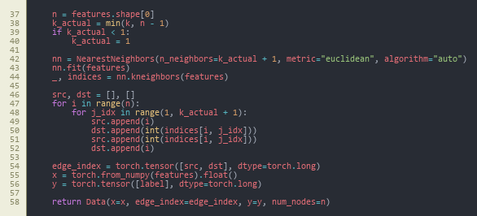
Figure 10: flows_to_knn_graph (core) - NearestNeighbors, bidirectional edges, PyG Data (Chapter 6, Section 6.10)

Source: src/data/graph_builder.py, lines 37-58.
build_graphs_for_split - stratified pools (core)
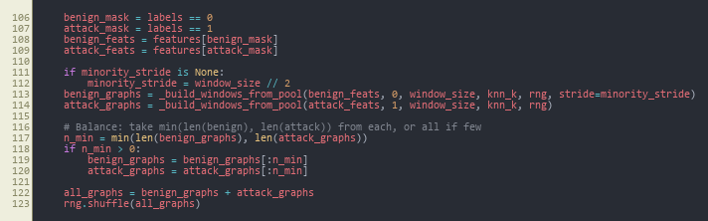
Figure 11: build_graphs_for_split (core) - class pools, balance, merge, shuffle (Chapter 6, Section 6.10)

Source: src/data/graph_builder.py, lines 106-123.
train_one_epoch - central GNN training loop
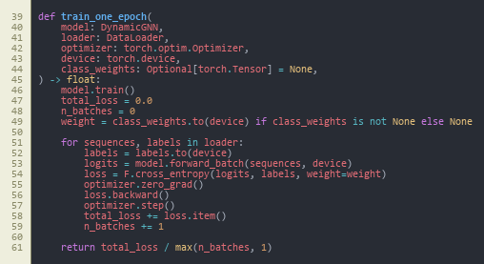
Figure 12: train_one_epoch - class-weighted cross-entropy, backward pass, optimiser step (Chapter 6, Section 6.10)

Source: src/models/trainer.py, lines 39-61.
DynamicGNN.forward - sequence to logits
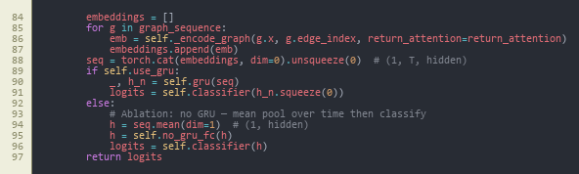
Figure 13: : DynamicGNN.forward (core) - stack window embeddings, GRU vs. mean-pool ablation, classifier (Chapter 6, Section 6.10)

Source: src/models/dynamic_gnn.py, lines 84-97.
_ig_wrapper - Integrated Gradients (core)
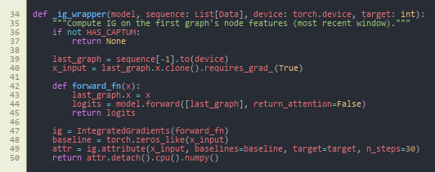
Figure 14: _ig_wrapper (core) - Captum IntegratedGradients on the last window’s node features (Chapter 6, Section 6.10)

Source: src/explain/explainer.py, lines 34-50.
POST /score - FastAPI handler (core)
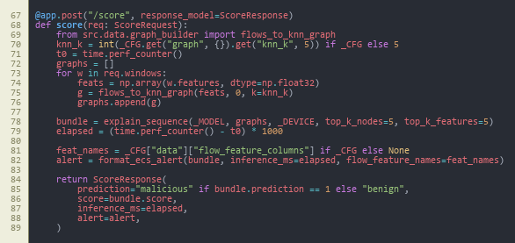
Figure 15: : POST /score (core) - build graphs, explain_sequence, ECS-style alert, timing (Chapter 6, Section 6.10)

Source: src/siem/api.py, lines 67-89.
Together, these figures summarise the data → train → forward → attribute → deploy path; federated local training reuses the same train_one_epoch step inside GNNFlowerClient (Appendix A).

6.11 Reproducibility Note
The implementation is fully script-driven from config/experiment.yaml (window size, kNN k, GAT heads, sequence length, FL rounds and clients, Dirichlet alpha, seed). All main experiments use seed 42; the multi-seed study in Section 8.9 uses 42, 123, 456. Entry points are: scripts/run_all.py (preprocessing, baselines, central GNN, evaluation), src.federated.run_federated (Flower server and clients), scripts/run_ablation.py, scripts/run_sensitivity_and_seeds.py, and scripts/generate_alerts_and_plots.py. Every table and figure is backed by a CSV/JSON under results/metrics/ or an image under results/figures/. All runs are CPU-only.

6.12 Chapter Summary
Implementation delivers a modular codebase with scripted reproducibility, covering data through to SIEM-style JSON and CPU inference.

Chapter 7 - Testing and Evaluation

7.1 Chapter Overview
The evaluation protocol is specified in this chapter: data validity and reliability (Section 7.4.1), experimental setup (Section 7.4.2), formal metric definition (Section 7.5), statistics of the data set (Section 7.6), and comparison rules (Section 7.7). This is in order to correct the so-called test contract to enable Chapter 8 to claim findings and not opinions.

7.2 Evaluation Scope
The evaluation provides the answer to the three sub-questions and answers the main question (Section 1.3). Hyperparameters, setup, and federated heterogeneity is in Section 7.4; metrics definitions in Section 7.5; scale statistics in Section 7.6; decision rules to compare models in Section 7.7. Before final test reporting the plan was fixed, which means that metrics were not tuned to the test set.

7.2.1 Pass Criteria
To have the evaluation as a pre-registered contract and not a post-hoc summary, the following pass criteria were established prior to any test-set numbers being produced. Each criterion is tied directly to a research question:
- Pass-1 (sub-question 1): the dynamic GNN achieves F1 ≥ 0.95 and ROC-AUC ≥ 0.95 on the central test set, and matches or exceeds the better of the two baselines (Random Forest, MLP) on F1.
- Pass-2 (sub-question 1): the dynamic GNN reports a lower or equal false-positive rate than the strongest baseline on the central test set.
- Pass-3 (sub-question 2): the federated GNN trained with Flower FedAvg over three non-IID clients reaches an F1 within 0.02 of the centralised GNN on the central test set within ten rounds.
- Pass-4 (sub-question 2): total federated communication stays within an order of magnitude consistent with edge-network feasibility (target ≤ 100 MB over ten rounds for the chosen architecture).
- Pass-5 (sub-question 3): at least three example alerts are produced with a complete explanation payload (top features and top flows) in ECS-like JSON.
- Pass-6 (main question): mean CPU inference latency per five-window sequence stays within edge-realistic bounds (target ≤ 100 ms).

7.2.2 Fail Criteria
A run is treated as a fail for evaluation reporting if any of the following hold:
- Fail-1: evidence of data leakage between train, validation, or test splits.
- Fail-2: F1 of the dynamic GNN below 0.90 on the central test set, or precision below 0.90 with recall held at 1.0 (which would indicate degenerate "always attack" behaviour).
- Fail-3: federated training does not converge within ten rounds, or final federated F1 falls more than 0.05 below the centralised GNN.
- Fail-4: alerts cannot be produced from the trained model through the FastAPI endpoint, or the explanation payload is empty for the chosen examples.
- Fail-5: CPU inference latency exceeds 1 s per sequence (which would void the edge-deployment claim).
The actual outcomes against these criteria are reported in Chapter 8 and discussed in Chapter 9.

7.3 Test Schedule
Table 6 is the multi-scenario execution map: it ties each research question element (baselines, central GNN, FL, ablation, sensitivity, multi-seed, deployment) to a concrete output file in results/. The schedule is staged so that the test split is not re-used for ad hoc tuning.
Test phase | Project days | Output artefact | Outcome (vs. criteria)
Baseline RF and MLP on test split | 16-18 | results/metrics/results_table.csv (RF, MLP rows) | Reference set established
Central GNN training and test | 18-22 | results/metrics/results_table.csv (Central GNN row); gnn_training_history.json | Pass-1, Pass-2, Pass-6
Federated GNN (10 rounds, 3 clients) | 22-26 | results/metrics/fl_round_metrics.csv; results/figures/fl_convergence.png | Pass-3, Pass-4
Example alerts via FastAPI /score | 26-28 | results/alerts/*.json | Pass-5
Ablation (GAT-only vs full) | 30-32 | results/metrics/ablation_table.csv | Stability evidence
Sensitivity grid (window x k) | 32-35 | results/metrics/sensitivity_table.csv; results/figures/sensitivity.png | Stability evidence
Multi-seed (42, 123, 456) | 35-38 | results/metrics/multi_seed_summary.json | Stability evidence
Table 10: Evaluation scenarios, scripts, and frozen artefacts (Research Method Deployment).

7.4 Experimental Setup

7.4.1 Data validity, reliability, and limits on generalisation
Internal validity (whether the test measures what we claim). (i) Label and task definition - the benchmark’s flow-level labels are mapped to a single binary target in config/experiment.yaml so every model optimises the same target. (ii) Split integrity - train / validation / test come from separate CICIoT2023 files; no rows from validation or test fit the StandardScaler (Section 4.3). (iii) Test-set discipline - test is used for one-shot reporting; early stopping and federated monitoring use train + validation or per-round dev metrics, not test (Sections 4.2, 4.4.1). (iv) Metric validity - precision, recall, F1, FPR, and ROC-AUC are defined in Section 7.5 and implement P/R/FPR for the attack-positive class, which is the SOC-relevant failure mode for benign traffic.
Reliability (repeatability and stability). Hyperparameters are frozen in config/experiment.yaml. Seeds (42 primary; 42, 123, 456 in the multi-seed run) control shuffling and initialisation so runs can be re-executed from the repository. Ablation (Table 10), (window, k) sensitivity (Table 11), and multi-seed results (Table 12) are stability checks: they do not convert a lab dataset into a field guarantee, but they show the headline result is not tied to a single ad hoc choice.
External validity (what is not guaranteed). Results are on a CICIoT2023 subset with artificial attack mix; live IoT traffic, concept drift, and adversarial evasion are out of scope (Section 1.4). Societal benefit is therefore argued as plausible impact on analyst workload and data minimisation under federation (Section 9.6), not as a proven national-scale deployment.

7.4.2 Hardware, software, and run configuration
All experiments use the same public train / validation / test split from the CICIoT2023 subset processed for this build. A global random seed (e.g. 42) supports reproducible shuffling and initialisation. Centralised training: Random Forest, MLP, and the dynamic GNN are trained on the training split and evaluated on the test split. Federated training: the same GNN is trained with Flower and FedAvg across 3 clients; the global model is evaluated on the same central test set after each round. No test data is used during training or for choosing hyperparameters; the validation split supports early stopping and monitoring. Graph windows use 50 flows per window and 5 windows per sequence by default; (window, k) alternatives appear in the sensitivity study (Section 8.8).
The federated labelling of clients uses a Dirichlet distribution (alpha = 0.5) over class proportions (Table 7). Table 5 records CPU / RAM / SSD; config/experiment.yaml and Table 7 give the full training budget for fair comparison across models.

7.5 Metrics
Positive class and confusion matrix. All models are evaluated as binary classifiers with attack as the positive class. From the test-set confusion matrix, TP (true positive), TN (true negative), FP (false positive), and FN (false negative) are counted at the same decision rule used in code (e.g. 0.5 threshold on the predicted attack probability, unless a script states otherwise). The headline “how well does the detector do?” in this thesis is not a single unweighted accuracy under a highly imbalanced attack-heavy flow mix (~98% attack at flow level, Table 4), but the F1 and ROC-AUC pair (and FPR where relevant) defined below.
Metric | Definition and interpretation
Precision | TP / (TP + FP). Share of predicted attacks that are true attacks.
Recall (true positive rate, TPR) | TP / (TP + FN). Share of true attacks that are detected.
False positive rate (FPR) | FP / (FP + TN). Share of true benign items incorrectly flagged as attack (SOC-relevant where benign volume is high).
F1 | Harmonic mean of precision and recall: 2·TP / (2·TP + FP + FN), i.e. 2·Precision·Recall / (Precision + Recall).
ROC-AUC | Area under the receiver operating characteristic curve: TPR plotted against FPR as the classification threshold on predicted attack probability is varied from 0 to 1. A value of 1.0 is perfect rank separation; 0.5 is chance performance.
Table 11: Definitions of the reported metrics (attack = positive).
Where these are applied. src/evaluation/metrics.py and the JSON/CSV under results/metrics/ use these definitions consistently for central and federated runs. For federated training, the same test-set metrics are computed from the global model (unless a note in Chapter 8 states a per-round view). Communication cost is approximated from float32 parameter payload size; CPU inference time comes from the FastAPI path in src/siem/api.py, in milliseconds per flow or per window sequence, as tabulated in Chapter 8.

7.6 Dataset and Experiment Statistics
Table 4 and results/metrics/dataset_stats.json record per-split flow counts; about 2.3% benign at flow level. Stratified windowing gives roughly balanced graph-level classes. The GNN dataset has 920 / 928 / 934 train/validation/test sequences (each sequence: five 50-flow windows; sequence label = attack if any window is attack, per GraphSequenceDataset). RF/MLP consume one row per flow on the same splits; the GNN emits one label per five-window sequence. Federated training uses a Dirichlet(α=0.5) split over class proportions (Section 4.5).

7.7 Comparison Design
Sub-Q1 compares the dynamic GNN to RF/MLP on the same test protocol (F1, ROC-AUC, FPR). Sub-Q2 compares the final federated global GNN to the central GNN. Sub-Q3 uses worked example alerts with explanation payloads; there is no formal user study, only structured author/supervisor judgement of plausibility.

7.8 Chapter Summary
Chapter 7 fixed the setup, metrics, data scales, and comparison protocol used for all models and federated runs. Chapter 8 reports the numerical and graphical outcomes only.

Chapter 8 - Results Presentation

8.1 Chapter Overview
This chapter reports results as tables and figures with brief factual description; interpretation is in Chapter 9 and personal reflection in Chapter 10. Tables keep decimal precision (e.g. 0.9986) and the prose mirrors the same values as percentages. Artefacts are stored under results/metrics/, results/figures/, and results/alerts/.

8.2 Centralised Model Comparison (Sub-Question 1)
The dynamic GNN (GAT + GRU), Random Forest, and MLP were evaluated on the same test set; the federated GNN (final global model) is evaluated on that test set for parity. The official record (decimals; divide by 100 to get percentages in the headline) is in Table 7. Summarily, F1 and ROC-AUC of central and federated GNNs are 1.0 on this run; RF and MLP are slightly lower on F1. False-positive rate (benign as attack): GNN 0%; RF 4.84% (187 FP); MLP 0.10% (4 FP). Confusion matrices, ROC curves, and a bar view per-metric view are presented in Figures 16-22, and inference time and F1 are reported in Figure 27 (Section 8.5).
Model | Precision | Recall | F1 | ROC-AUC | Inference (ms)
Random Forest | 0.9989 | 0.9984 | 0.9986 | 0.9996 | 46.09
MLP | 1.0000 | 0.9885 | 0.9942 | 0.9984 | 0.66
Central GNN | 1.0000 | 1.0000 | 1.0000 | 1.0000 | 22.70
Federated GNN | 1.0000 | 1.0000 | 1.0000 | 1.0000 | 20.99
Table 12: Model comparison on CICIoT2023 test set
Source: Author-derived metrics on the fixed CICIoT2023 subset (Pinto et al. 2023); results/metrics/results_table.csv; reproducibility in Chapter 13.
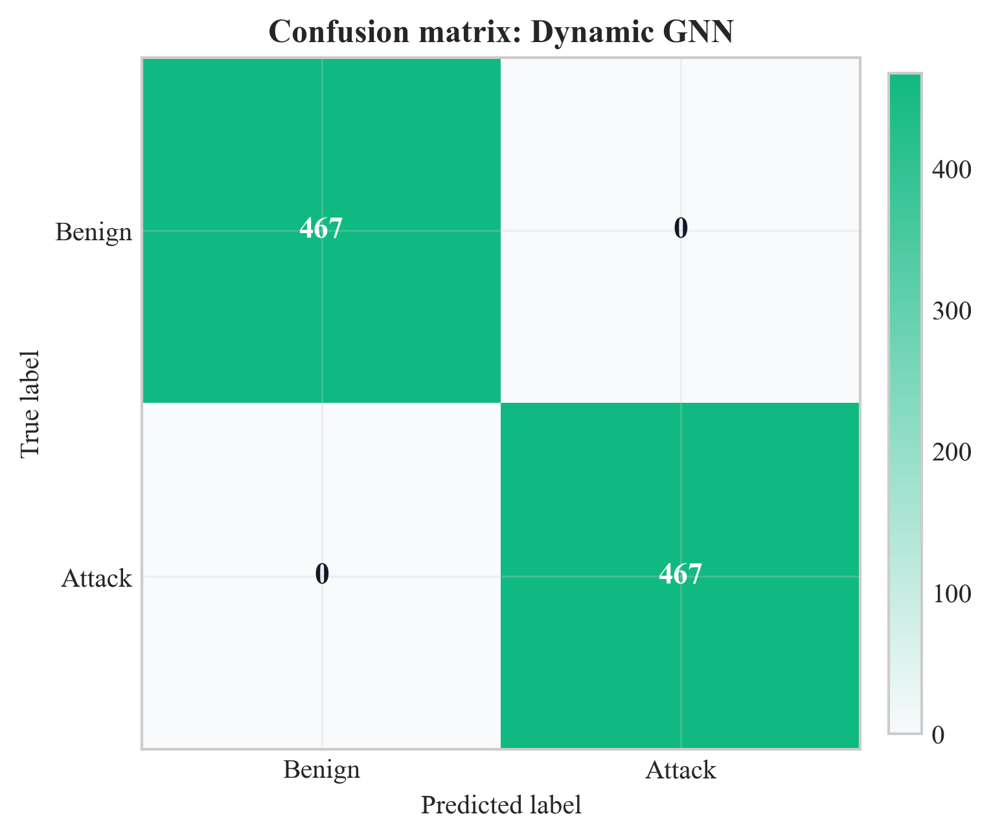
Figure 16: : Confusion matrix for Dynamic GNN on test set (Chapter 8, Section 8.2)

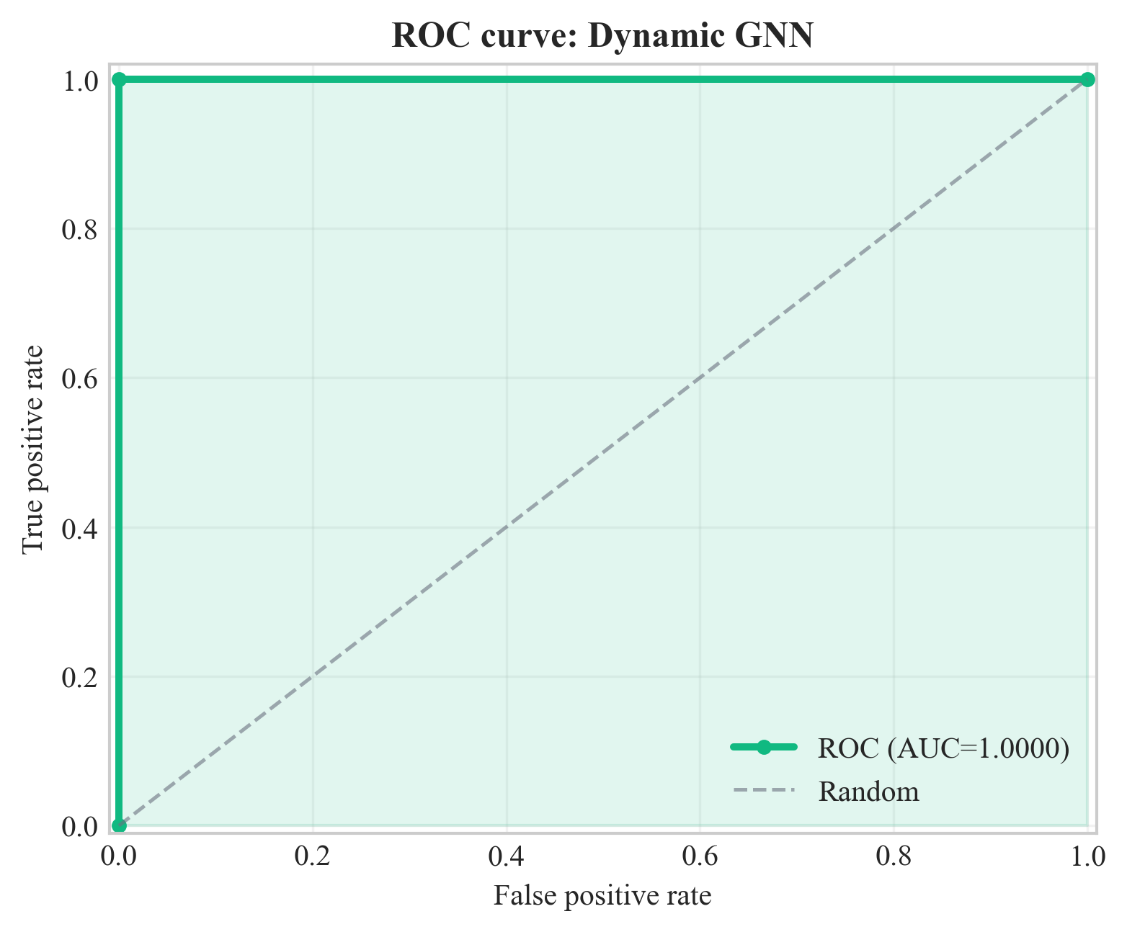
Figure 17: ROC curve for Dynamic GNN on test set (Chapter 8, Section 8.2)

Source: Author’s own plot from test-set scores; data CICIoT2023 (Pinto et al. 2023); scripts/run_all.py.
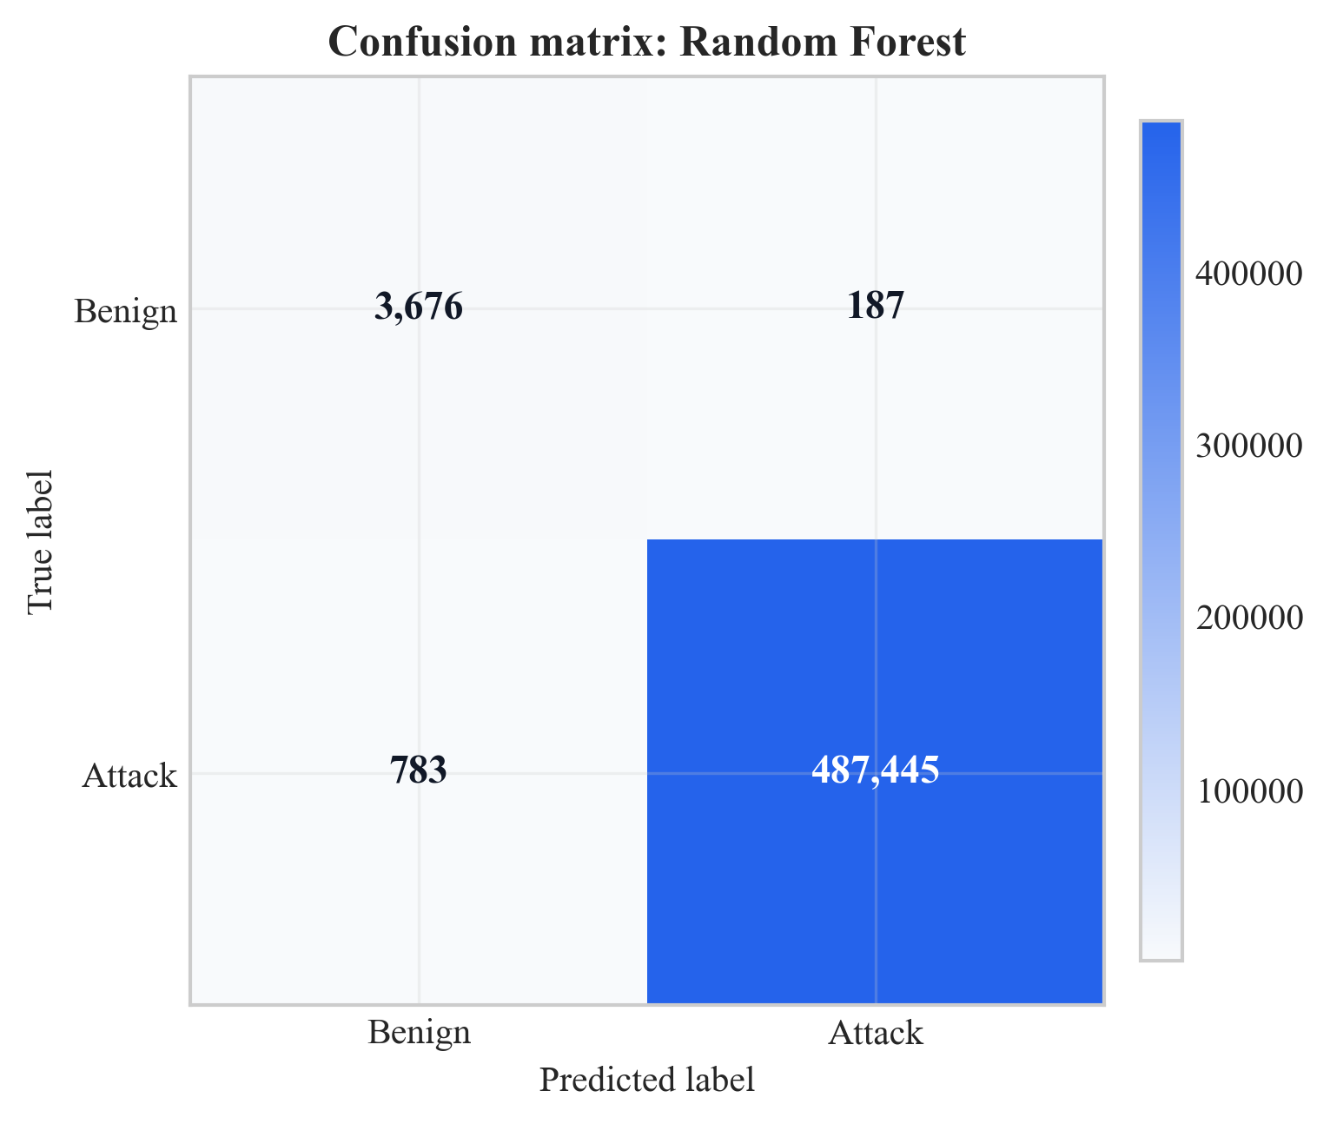
Figure 18: Confusion matrix for Random Forest on test set (Chapter 8, Section 8.2)

Source: Author’s own plot; baseline from scripts/run_all.py; data CICIoT2023 (Pinto et al. 2023).
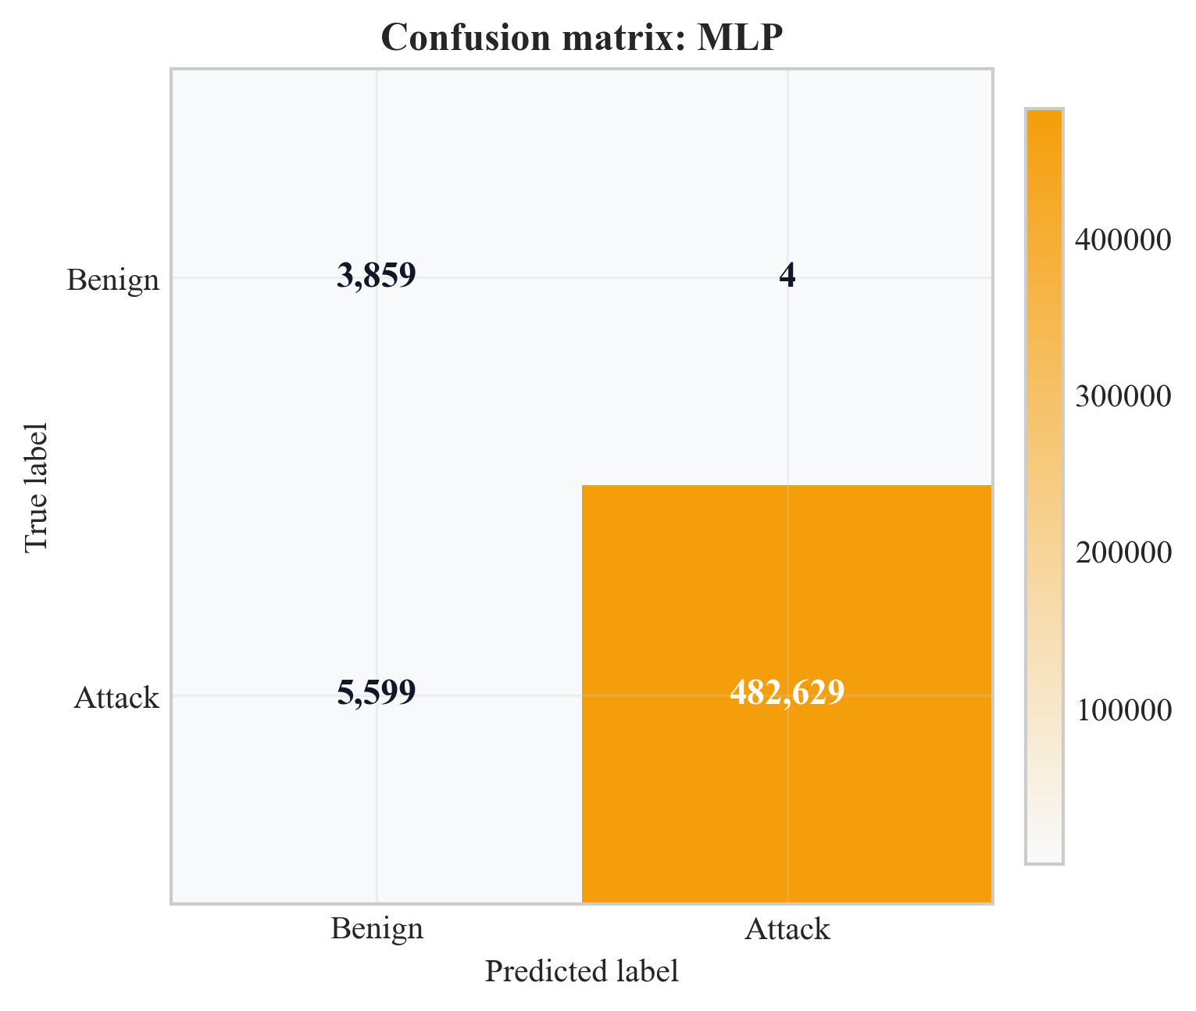
Figure 19: Confusion matrix for MLP on test set (Chapter 8, Section 8.2)

Source: Author’s own plot; baseline from scripts/run_all.py; data CICIoT2023 (Pinto et al. 2023).
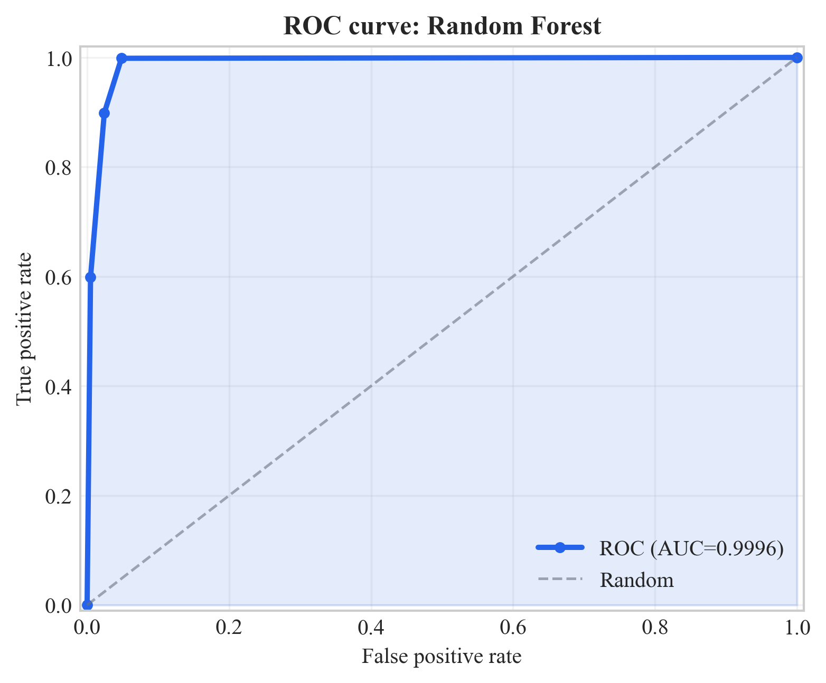
Figure 20: ROC curve for Random Forest on test set (Chapter 8, Section 8.2)

Source: Author’s own plot; baseline from scripts/run_all.py; data CICIoT2023 (Pinto et al. 2023).
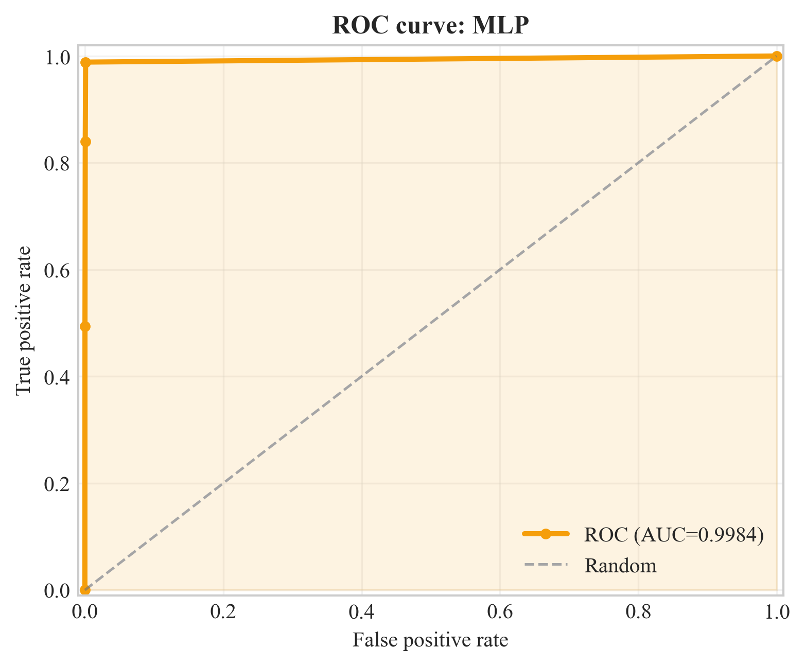
Figure 21: ROC curve for MLP on test set (Chapter 8, Section 8.2)

Source: Author’s own plot; baseline from scripts/run_all.py; data CICIoT2023 (Pinto et al. 2023).
Figures 16, 18, 19: GNN: 0 FP / 0 FN; RF: 187 FP; MLP: 4 FP. ROC curves (17, 20, 21); AUCs in Table 7 (Chapter 9 for triage).
Figure 22: per-metric bars (y-axis 0.97-1.00); GNNs at 1.0; MLP recall 0.9885; RF high but below GNN on F1.
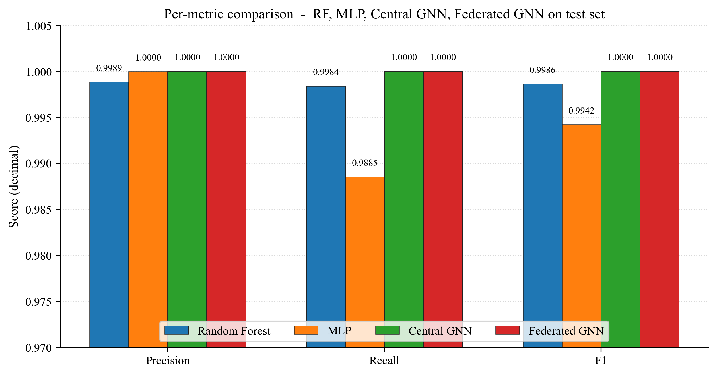
Figure 22: Per-metric comparison across RF, MLP, Central GNN, and Federated GNN on the test set (Chapter 8, Section 8.2)

Source: Author's own plot (scripts/generate_extra_result_figures.py); data from results/metrics/{rf,mlp,central_gnn,federated_gnn}_metrics.json.

8.3 Federated Learning (Sub-Question 2)
10 rounds, 3 clients, non-IID (alpha = 0.5), same test set; Table 7 + Figure 23. Early rounds are weaker (e.g. round 1: F1 98.3%, AUC 55.7%); from round 7, F1 100%; final round F1 = AUC = 100%, matching the central GNN.
Communication cost is approximated from float32 parameter size: 128,002 parameters, order of ~1.0 MB per client upload/download per round; ~3.07 MB per round aggregate messaging is reported, ~31 MB total over 10 rounds with three clients. Interpretation (privacy vs. centralised parity, feasibility) is in Chapter 9
Round | Precision | Recall | F1 | ROC-AUC
1 | 0.967 | 1.000 | 0.983 | 0.557
2 | 0.967 | 1.000 | 0.983 | 1.000
3 | 0.967 | 1.000 | 0.983 | 1.000
4 | 0.994 | 1.000 | 0.997 | 1.000
5 | 0.997 | 1.000 | 0.998 | 1.000
6 | 0.990 | 1.000 | 0.995 | 0.973
7 | 1.000 | 1.000 | 1.000 | 1.000
8 | 1.000 | 1.000 | 1.000 | 1.000
9 | 1.000 | 1.000 | 1.000 | 1.000
10 | 1.000 | 1.000 | 1.000 | 1.000
Table 13: Federated learning round-by-round metrics
Source: Author-derived round metrics; Flower FedAvg run; results/metrics/ (see Chapter 13).
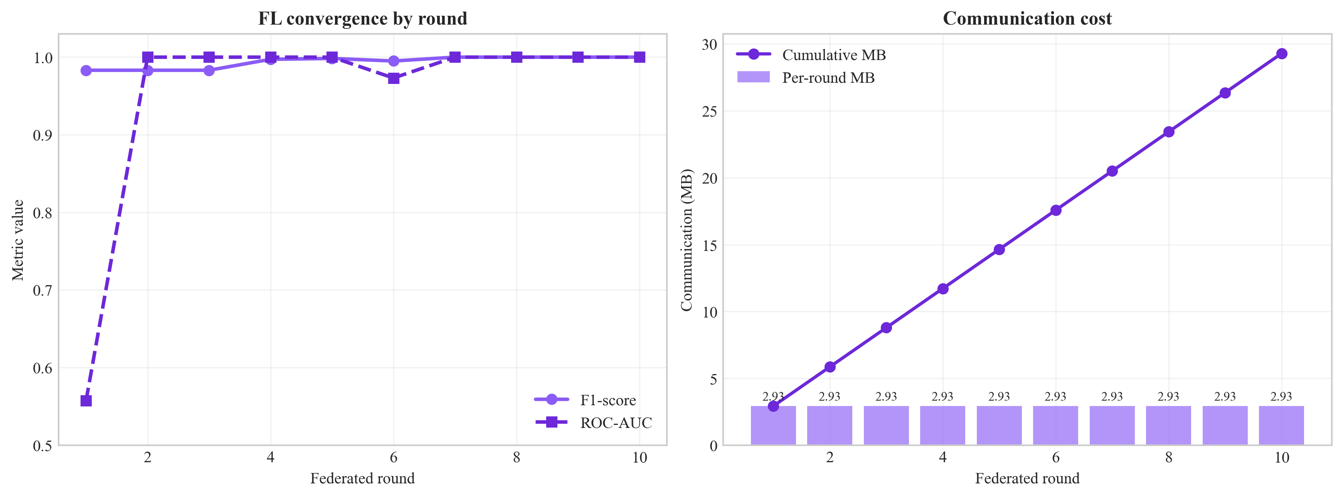
Figure 23: Federated: learning convergence (F1 and ROC-AUC vs. round) (Chapter 8, Section 8.3)

Source: Author’s own plot; scripts/generate_alerts_and_plots.py / federated training logs; data CICIoT2023 (Pinto et al. 2023).
Figure 24 is the federated GNN confusion matrix on the same test set after the final FedAvg round. Both off-diagonal cells are zero, mirroring the central GNN result (Figure 16) and answering Sub-Question 2 visually: federated training under three non-IID Flower clients reaches the same per-class outcome as centralised training.
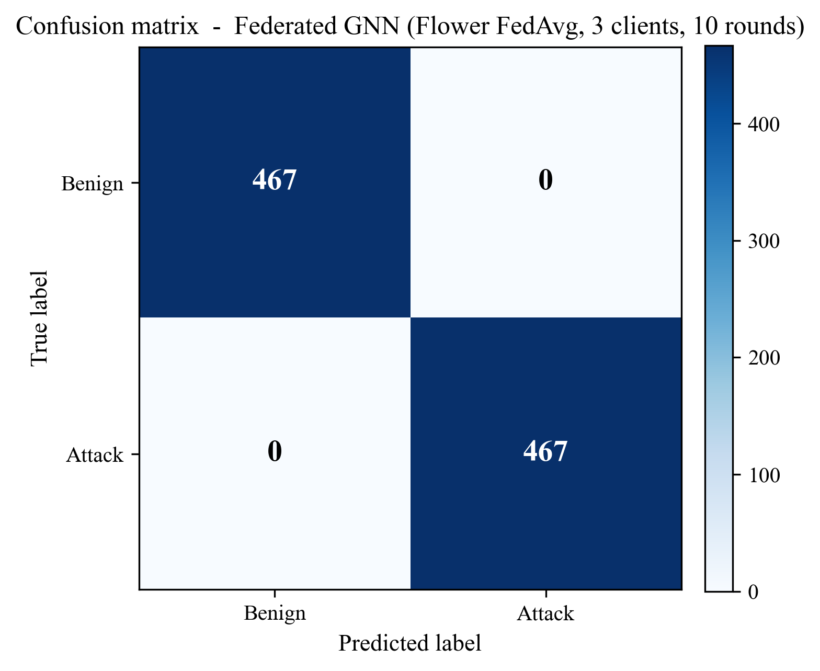
Figure 24: Confusion matrix of the federated GNN (Flower FedAvg, 3 clients, 10 rounds) on the test set (Chapter 8, Section 8.3)

Source: Author’s own plot (scripts/generate_extra_result_figures.py); reconstructed from results/metrics/federated_gnn_metrics.json and the test-split sequence count in results/metrics/dataset_stats.json.
Figure 25 shows the communication cost behind those metrics: ~3.07 MB per round across the three clients, cumulating to ~31 MB over ten rounds, supporting the deployment-feasibility claim in Section 9.6.
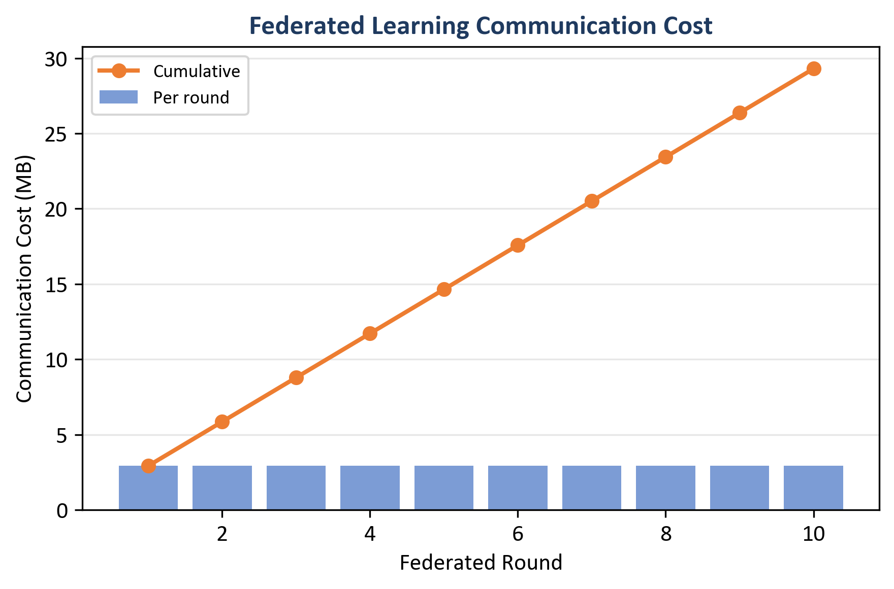
Figure 25: Federated learning communication cost - per round (bars) and cumulative (line) (Chapter 8, Section 8.3)

Source: Author’s own plot (scripts/generate_alerts_and_plots.py); data from results/metrics/fl_rounds.json (comm_bytes).
(Round 1 is weak on ROC-AUC; metrics stabilise from round 2; round 6 shows a small ROC wobble; see Table 7 and Chapter 9 for interpretation.)

8.4 Central GNN Training Convergence
The centralised Dynamic GNN was trained using 6 epochs (early-stopping set in the training script). Table 9 shows train loss and validation F1 / ROC-AUC per epoch (results/metrics/gnn_training_history.json). ROC-AUC = 100.0% in epoch 1 and F1 = 100.0% in epoch 1 and beyond on this run; train loss drops from 0.484 to 0.0001 in epoch 4 and remains there until epoch 6.
Epoch | Train Loss | Val F1 | Val ROC-AUC
1 | 0.484 | 1.000 | 1.000
2 | 0.023 | 1.000 | 1.000
3 | 0.0002 | 1.000 | 1.000
4 | 0.0001 | 1.000 | 1.000
5 | 0.0001 | 1.000 | 1.000
6 | 0.0001 | 1.000 | 1.000
Table 14: Training history (loss and validation) of the central GNN.
Source: results/metrics/gnn_training_history.json; central GNN training run (scripts/run_all.py).
Figure 26 is a plot of the column with training-loss on a log y-axis. Loss falls from ~4.8 × 10⁻¹ at epoch 1 to ~1 × 10⁻⁴ by epoch 4, then plateaus. Together with validation F1 = 1.0 at epoch 1, the curve justifies the selection of 6 epochs as an adequate training budget.
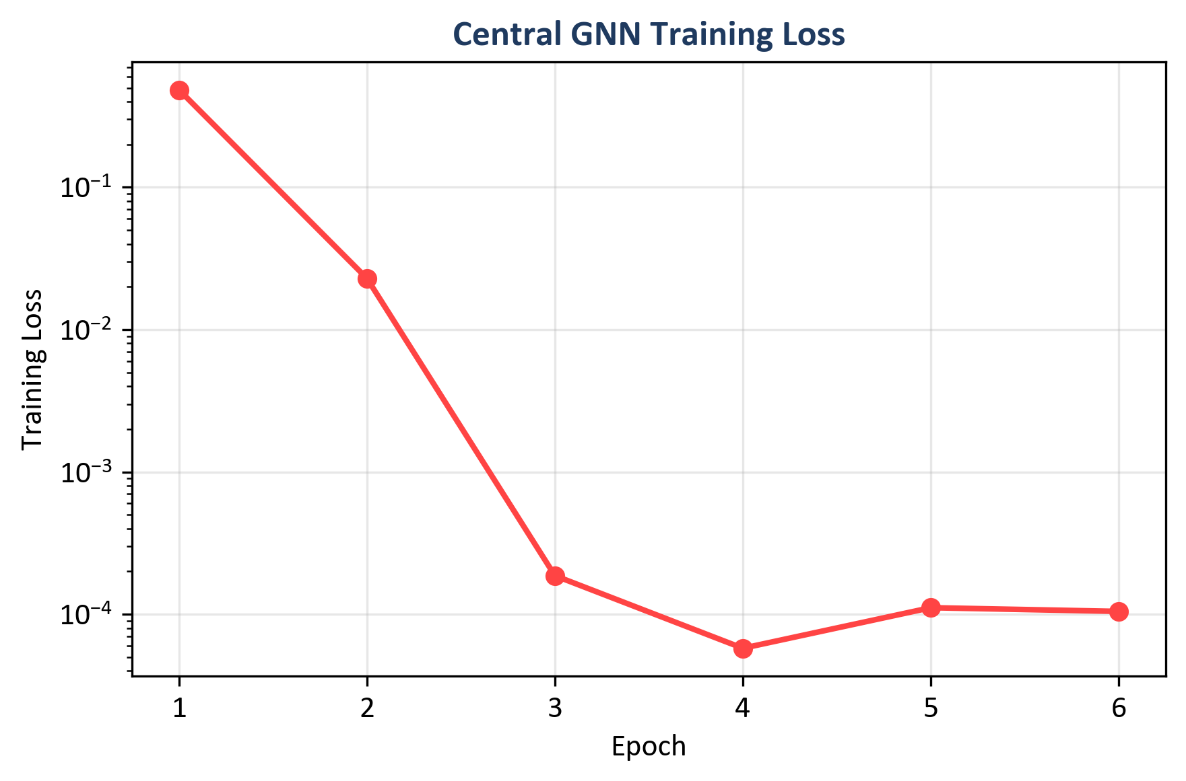
Figure 26: Central GNN training loss across six epochs (log scale) (Chapter 8, Section 8.4)

Source: Author's own plot (scripts/generate_alerts_and_plots.py); data from results/metrics/gnn_training_history.json (train_loss).

8.5 Time-Window and CPU Inference (Sub-Question 2 and Deployment)
CPU inference times (see Table 7): Random Forest 46.09 ms per sample; MLP 0.66 ms; central GNN 22.70 ms; federated GNN 20.99 ms (GNN times are in ms per 5 graph window sequence). Figure 27 shows the comparison of F1 and inference time between models.
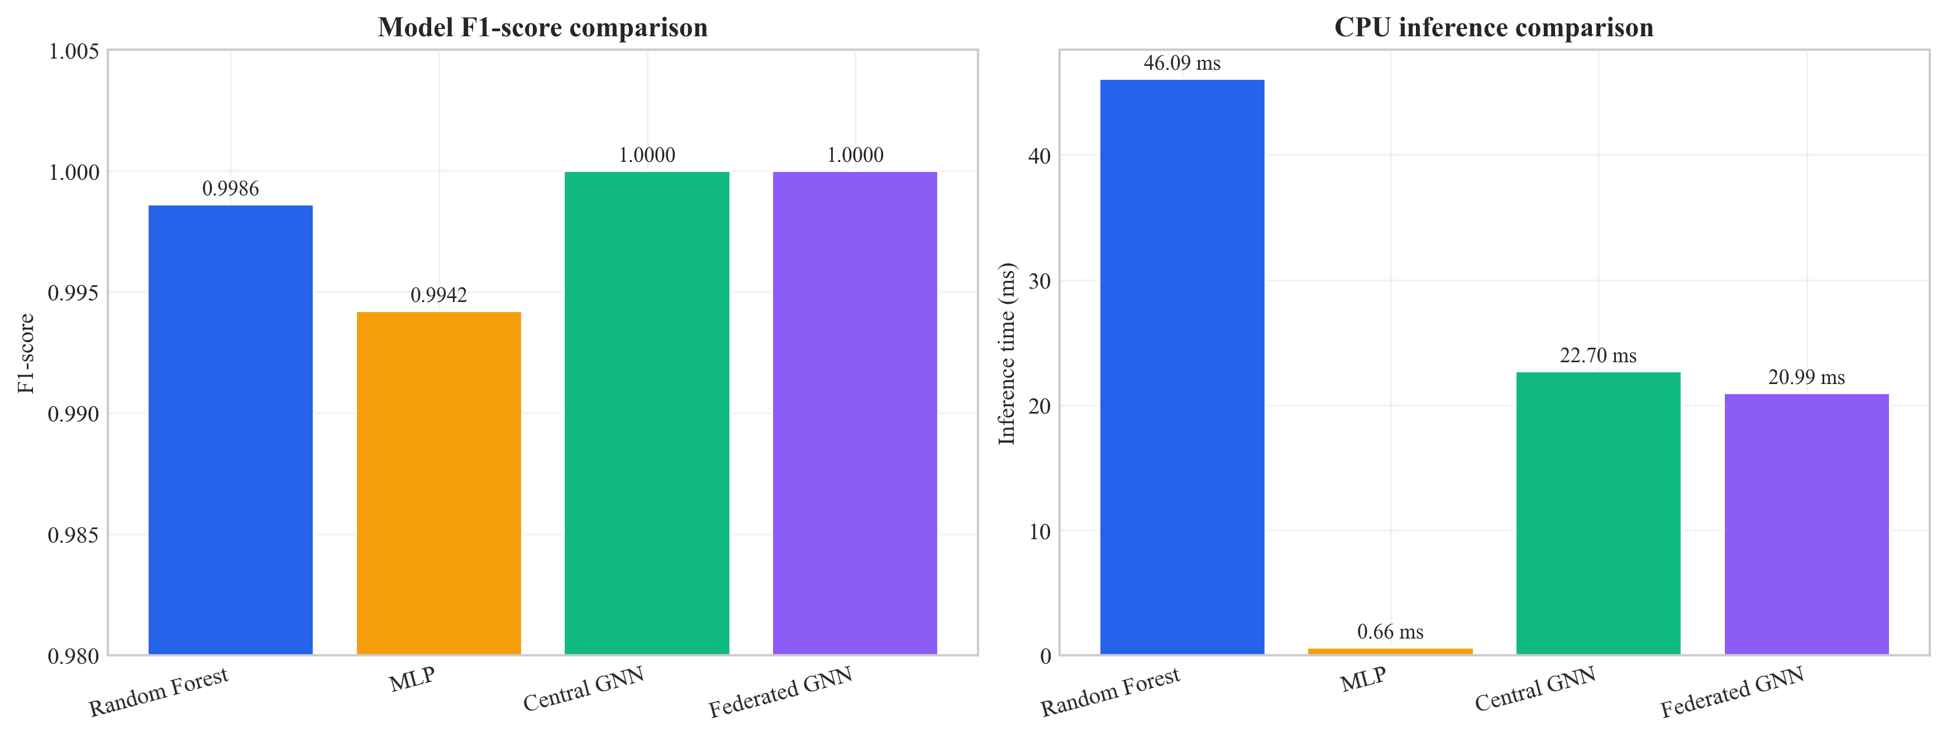
Figure 27: Model comparison - inference time and F1-score (Chapter 8, Section 8.5)

Source: Author’s own plot; metrics from Table 7 and inference timings in results/metrics/; scripts/generate_alerts_and_plots.py.

8.6 Example Alerts with Explanations (Sub-Question 3)
Five example alerts were created with complete descriptions (best features using Integrated Gradients and best flows using attention weights) in the same order as results/alerts/example alerts.json. The predicted label, confidence, severity band of threats and the explanation object (top_features, top_nodes) are included in each example.
- Example 1 (True negative): Predicted benign; score 0.163 (low severity). The best features: Variance, Std, rst_count, Duration, AVG (Integrated Gradients magnitudes as in example_alerts.json).
- Example 2 (True positive): Predicted malicious; 0.997 score. Best characteristics: psh flag number, ICMP, rst flag number.
- Example 3 (True positive): Predicted malicious; score=0.996. Best features: rst_flag_number, ICMP, Protocol Type.
- Example 4 (False positive): Benign or malicious; score 0.711 (medium). Best attributes: Variance, rst count.
- Example 5 (False positive): Benign was labelled malicious; the score was 0.945. Best features: rst_count, Std, Variance.
Each record follows the ECS-like shape: event metadata, rule name, threat indicator, ML prediction and score, and explanation (top_features, top_nodes). Whether these fields are sufficient for SOC triage is discussed in Chapter 9.

8.7 Ablation Studies (Priority 1: Evidence)
To show that both the graph and the temporal parts of the model add value, one ablation was run: the same GAT-based model but with the GRU replaced by mean pooling over time (so the model sees each window’s graph embedding but does not model the sequence with an RNN). This variant is called “GAT only (no GRU)”. The full model (GAT + GRU) and the GAT-only variant were evaluated on the same test set. Table 10 summarises the results. To reproduce the ablation, run: python scripts/run_ablation.py --config config/experiment.yaml; results are saved to results/metrics/ablation_gat_only.json and results/metrics/ablation_table.csv.
Variant | Precision | Recall | F1 | ROC-AUC | Inference (ms)
Full (GAT + GRU) | 1.0000 | 1.0000 | 1.0000 | 1.0000 | 22.70
GAT only (no GRU) | 0.9923 | 1.0000 | 0.9961 | 1.0000 | 16.06
Table 15: Ablation on CICIoT2023 test set (centralised GNN variants)

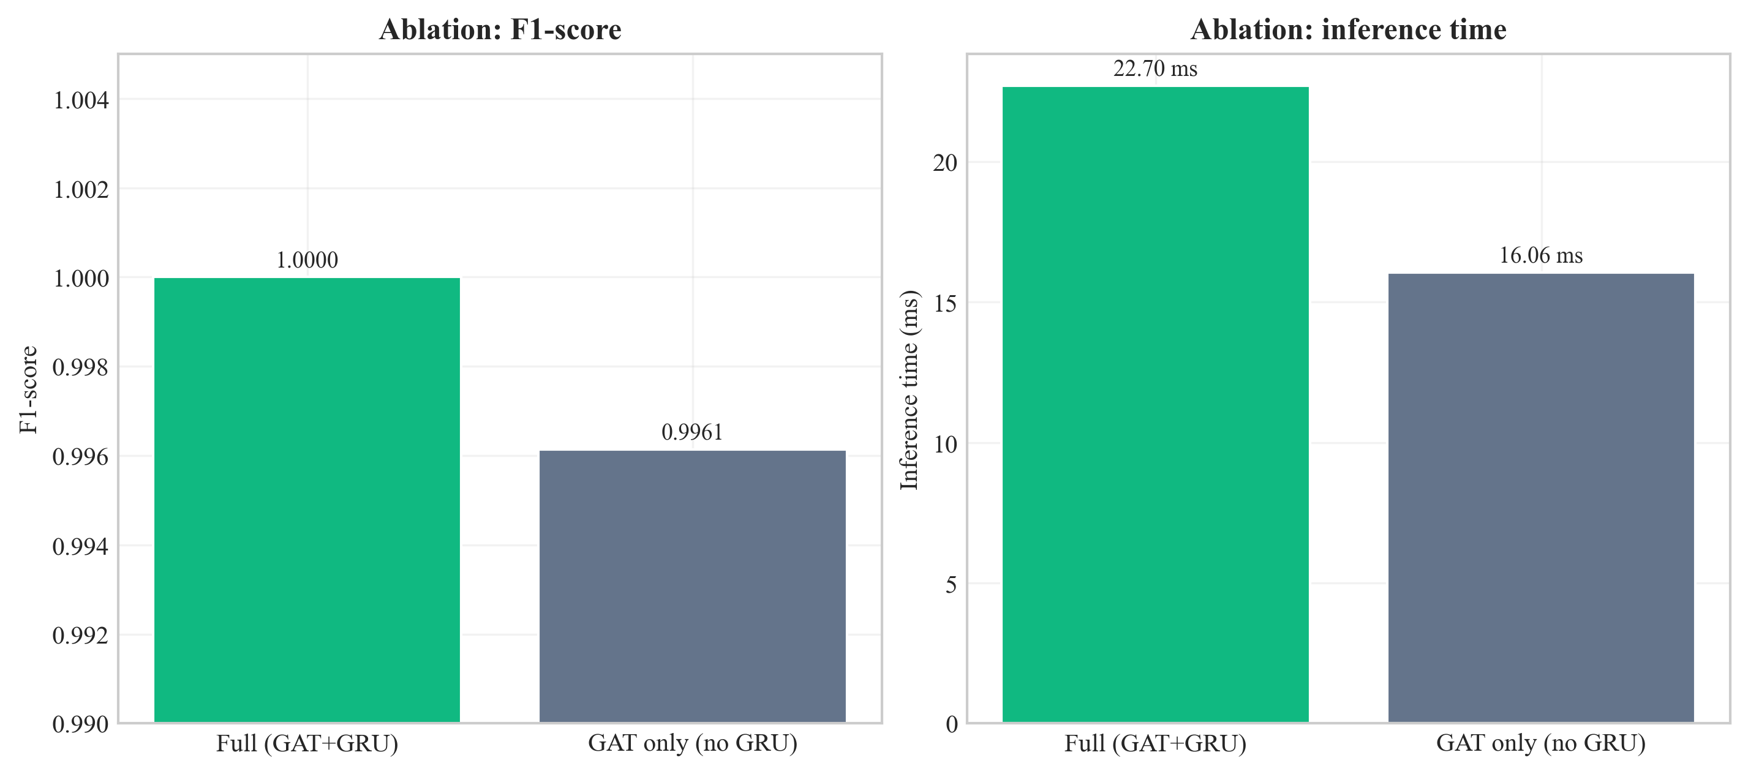
Figure 28: Ablation comparison - full GAT+GRU vs. GAT-only (F1 and inference time) (Chapter 8, Section 8.7)

Source: Author’s own plot; results/metrics/ablation_table.csv; scripts/run_ablation.py.
Interpretation of the temporal (GRU) vs. pooling trade-off is in Section 9.3 and Section 9.6.

8.8 Sensitivity Analysis (Stability of Design Choices)
Sensitivity analysis tests the main results of variations in key hyperparameters. Two levers are: (1) window size (number of flows per snapshot of the graph), and (2) k in the kNN graph. The window size is 50 and k = 5 in the main experiments. The pipeline was re-run for all combinations of window_size ∈ {30, 50, 70} and knn_k ∈ {3, 5, 7} with other settings unchanged; metrics were written to results/metrics/sensitivity_table.csv (script: scripts/run_sensitivity_and_seeds.py).
Window size | k | Precision | Recall | F1 | ROC-AUC | Inference (ms)
30 | 3 | 1.0000 | 1.0000 | 1.0000 | 1.0000 | 12.20
30 | 5 | 1.0000 | 1.0000 | 1.0000 | 1.0000 | 17.42
30 | 7 | 1.0000 | 1.0000 | 1.0000 | 1.0000 | 11.89
50 | 3 | 0.9923 | 1.0000 | 0.9961 | 0.9985 | 15.60
50 | 5 | 1.0000 | 1.0000 | 1.0000 | 1.0000 | 17.00
50 | 7 | 1.0000 | 1.0000 | 1.0000 | 1.0000 | 17.00
70 | 3 | 0.9939 | 1.0000 | 0.9969 | 0.9947 | 19.91
70 | 5 | 0.9939 | 1.0000 | 0.9969 | 0.9895 | 15.49
70 | 7 | 1.0000 | 1.0000 | 1.0000 | 1.0000 | 28.07
Table 16: Sensitivity analysis - central GNN on the test set (There are nine configurations)

Grid interpretation is in Section 9.3.
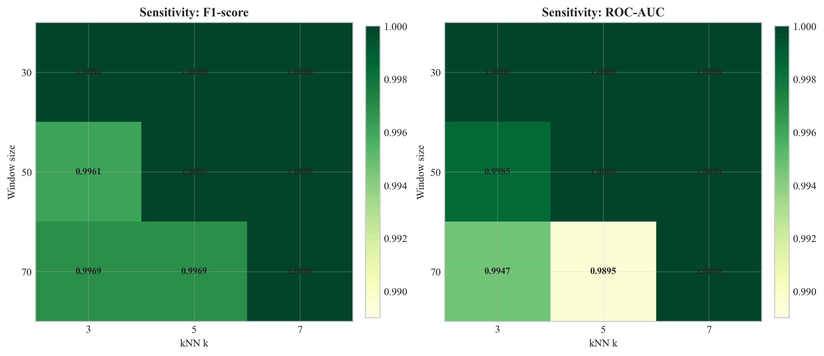
Figure 29: : Sensitivity of test F1 and ROC-AUC to window size and kNN k (Chapter 8, Section 8.8)

Source: Author’s own plot; results/metrics/sensitivity_table.csv; scripts/run_sensitivity_and_seeds.py.

8.9 Multi-Seed Stability
The result of the central GNN was checked with seeds 42, 123, and 456 (remaining config unchanged) to ensure it was not an accident of a single random seed. Results/metrics/multi_seed_summary.json has summary statistics.
Seed | Precision | Recall | F1 | ROC-AUC | False positives (test)
42 | 1.0000 | 1.0000 | 1.0000 | 1.0000 | 0
123 | 1.0000 | 1.0000 | 1.0000 | 1.0000 | 0
456 | 1.0000 | 1.0000 | 1.0000 | 1.0000 | 0
Mean | 1.0000 | 1.0000 | 1.0000 | 1.0000 | -
Std | 0 | 0 | 0 | 0 | -
Table 17: Multi-seed summary (central GNN, test set)
Source: results/metrics/multi_seed_summary.json; scripts/run_sensitivity_and_seeds.py; test split CICIoT2023 (Pinto et al. 2023).
Table 12 of mean F1 = 100.0, mean ROC-AUC = 100.0 and zero standard deviation on this test split indicates the same on this test split across all three seeds. The CPU timing of per-seed inference in raw logs differs depending on the CPU timing; the headline 22.7 ms deployment time is the top of the primary seed 42 run(Table 7). Chapter 9 discusses what this means as far as generalisation is concerned.

8.10 Correlation with the Previous Research on CICIoT2023.
Table 13 places this work and peer-reviewed CICIoT2023 / IoT-IDS works: headline F1 (where F1 is not present) and architectural family. Configurations are vary (binary or multi-class, sampling, hardware); the ranking is placing, not a rigid leaedrboard.
Study | Architectural family | Federated | Explainable | SIEM-shaped output | Headline metric (binary)
(Pinto et al. 2023) - dataset paper | RF / DNN baselines on CICIoT2023 | No | No | No | RF accuracy ~99% (binary) on full corpus
(Lazzarini et al. 2023) | MLP under FedAvg, IoT IDS | Yes (FedAvg) | No | No | Reported F1 in the upper-90% range under non-IID FedAvg
(Albanbay et al. 2025) | FL IDS for IoT, scaling study | Yes | No | No | Strong FL accuracy on IoT IDS at varying client counts
This dissertation | Dynamic GNN (GAT + GRU) | Yes (Flower FedAvg, 3 clients, non-IID) | Yes (Captum IG + GAT attention) | Yes (ECS-like JSON via FastAPI) | F1 = ROC-AUC = 100.0% on the fixed CICIoT2023 subset (Table 7)
Table 18: Headline metrics - this dissertation vs. prior work on CICIoT2023 and adjacent IoT flow benchmarks
Source: this dissertation; cited works in Chapter 11. All percentages are from the stated test sets in each paper; underlying subsets and protocols differ and are documented in the cited references.
As in Section 2.8, prior work often treats accuracy, FL, and XAI separately; this prototype combines them with SIEM-oriented output (subset metrics - Section 9.4).

8.11 Chapter Summary
Chapter 8 reported metrics, plots, and stability tables; Chapter 9 interprets them against the research questions and limitations.

Chapter 9 - Conclusion, Discussion, and Recommendations

9.1 Chapter Overview
The chapter gives the interpretation of the results, makes correlations with the literature and summarises what the project has been able to accomplish within the scope of the project. It also documents restrictions and constraints to SOC/edge implementation. A conclusion is given in Section 9.2, and in Sections 9.3-9.10, discussed.

9.2 Structured Conclusion
The dissertation addresses SOC-oriented, CPU-edge detection on Software-Defined IoT flow telemetry, with optional federated training when raw flows are not pooled, and explainable SIEM-style output. CICIoT2023 and the literature in Chapter 2 often treat GNNs, FL, and XAI as separate threads; this work integrates them in one pipeline.
The main artefact is end-to-end: kNN graphs over windowed flows, GAT+GRU, Flower FedAvg (three non-IID clients), Captum plus attention, ECS-like JSON via FastAPI. On the fixed subset (Chapters 7-8), central and federated GNNs match strong RF/MLP headlines with low FPR, about 23 ms GNN sequence inference, and modest federated traffic; ablation, sensitivity, and multi-seed runs support the default configuration. Scope: 45-day MSc, subset of labs, small FL topology, no formal SOC user study, and 100% metrics, not general. In Section 9.9 there are extensions (data scale, live traffic, analyst evaluation, SIEM hardening). The research questions will be responded to as a paper prototype with clear boundaries.

9.3 Responding to the Research Questions.
Primary research question (single paragraph). The main question was whether an explainable GAT+GRU on kNN graphs of IoT flows, that were trained using federated learning, could identify attacks and produce SIEM-like CPU-timed alerts. It is proven in the dissertation that this can be done within an MSc scope as a written pipeline: Method, code, configuration is in Chapters 4-6, test metrics, ablation, sensitivity, multi-seed, and example alerts are in Chapters 7-8, and limits of 100% lab metrics are stated in Chapter 10. The answer is “yes, under the stated benchmark and resource assumptions”, not “solved for all real-world IoT.”
At a glance: the primary RQ is met by the end-to-end pipeline in Chapters 4-8 (Tables 7-9; example alerts; ~23 ms GNN sequence inference). Novelty is integration + evaluation of graph, FL, and SIEM-shaped outputs on one benchmark, not a new GNN operator alone (Section 2.8; Table 13).
Sub-Q1 (GNN vs. baselines). The central GNN reports higher F1/ROC-AUC on this split than RF/MLP and lower false-positive load on the held-out set (Table 7), consistent with relational-temporal modelling on top of strong flow features (Pinto et al. 2023).
Sub-Q2 (Federation). The federated global model matches the central GNN on the test metrics (Table 7; Figures 23-25), with on the order of 31 MB cumulative parameter traffic over ten rounds (Chapter 8) - feasible at MSc scale, not a large-fleet production proof.
Sub-Q3 (Triage). Worked example alerts in Section 8.6 pair Integrated Gradients feature ranks with GAT node cues; plausibility is argued in Section 9.6, not via a user study.
Stability (Sections 8.7-8.9). Ablation shows a small F1 margin for keeping the GRU (Table 10; Figure 28). Sensitivity: default (50,5) is within a wide good region, with some (70,·) settings dipping on ROC-AUC (Table 11; Figure 29). Multi-seed tables repeat the headline test outcome for three seeds (Table 12), which reduces one-off init luck but does not prove field validity (see Section 7.4.1).

9.4 Strengths and Limitations
Strengths: The dissertation provides a single reproducible path of CICIoT2023 using kNN graphs, GAT+GRU, optional Flower FedAvg, and SIEM-shaped, CPU-timed FastAPI output, and baselines, FL, and stability runs on the same protocol. kNN edges are based on the argument of Ngo et al. (2025) in the case of absence of device IPs; stratified windowing controls the skew of classes on flow level. Integration (not an isolated graph operator) is the main contribution, not a novel graph operator.
Limitations: an MSc time-box and a part of a lab dataset - no field generalisation assertion. kNN is a proxy of the features but is not a topology graph. Not a large deployment, federated learning is three clients and ten rounds. The explanations are based on a few example alerts and qualitative review of plausibility, as opposed to a user study. Split-specific perfect headline measures are discussed in Section 7.4.1 and Chapter 10.

9.5 University/ Course Materials.
The material in the UWS modules and the research databases at the library were utilized in this project. Chapter 4 used the design-science framing of COMP11023 Research Methods and Design, and Chapter 7 used the test-contract view of the same; Chapter 8 used milestones and reporting framed in COMP11024 Master’s Project. Dr Raja Ujjan and Muhsin Hassanu (moderator) managed project reviews; Dr Daune West assisted with milestones programme-level. Chapter 11 cites in Harvard (author-year) as defined by the University of the West of Scotland Library (2025).

9.6 Practical Implications
The importance of this work (societal and organisational). Lack of consumer and industrial IoT device security, and overloaded queues in SOCs: Missed intrusions present both safety and continuity risks, and false alarms are a waste of limited time spent by the analysts (Section 1.2; ENISA 2017, Chapter 11). It is not in the scope of this project to assert to have solved that problem on the national scale; it is just engineering evidence that a CPU-first, explained, and possibly federated detector can be constructed and end-to-end measured. The GNN did not have benign-as-attack false positives on the reported test split, but Random Forest and MLP non-zero FPR (Table 7) - a behavior that, assuming this holds in production, would minimize noise in the analysis. Federated training exchanges only supports data-minimising collaboration by weighting only, when the raw flows cannot be pooled, but does not replace legal or contractual review.
Practical implications (assuming validation of pilots). (1) Edge deployment: CPU-based sub-23 ms/GNN sequence (Section 8.5; Table 7) is comparable to near real time scoring on a type of gateway (Table 5). (2) Analyst use: ECS like JSON and explanation fields are a reasonable handover to SIEM pipelines; a formal usability study is not in scope (Section 1.4). (3) Limit: the CICIoT2023 lab run is inferred to benefit, live traffic, drift and adversarial evasion requires additional work (Section 9.9).
Pace and gradual implementation. The headline configuration has the following key reliability arguments: ablation (Section 8.7), sensitivity grid (Section 8.8), and multi-seed runs (Section 8.9). Passive monitoring followed by assisted triage with the help of explanation fields would be a sensible way to go in the production to manage the drift, and human retraining should be periodic.

9.7 Relation to Literature
The literature (e.g. Velickovic et al. 2018) supports GNNs for network or security data. Through this project, we show that a dynamic GNN can be trained and compared against baselines on IoT flow data. Han et al. (2025) and Ngo et al. (2025) report that graph-based and attribute-based construction can improve detection. This work validates that a kNN feature-similarity graph remains usable when device identifiers are unavailable.
Federated learning using FedAvg (McMahan et al. 2017) is shown to work with Flower, with performance similar to centralised training. Lazzarini et al. (2023) and Albanbay et al. (2025) also report that FedAvg can sustain accuracy in their IoT intrusion-detection settings. Measured Flower runs converged in 7 global rounds, with ≈ 31 MB of cumulative weight traffic over 10 rounds (Chapter 8), which supports a feasibility argument for federated deployment at student scale. Alert output is augmented with explainability through Integrated Gradients (Sundararajan et al. 2017) and GAT attention (Velickovic et al. 2018), in line with calls for more interpretable security ML. Example alerts show highlighted features (e.g. psh_flag_number, ICMP, rst_flag_number) that are consistent with the attack context described by Alabbadi and Bajaber (2025). Within the stated scope, the dissertation instantiates the integration gap identified in Section 2.8 - combining dynamic graphs, Flower FedAvg, XAI, and SIEM-shaped outputs on one benchmark and codebase.

9.8 Summary of the Project
In brief: a CICIoT2023-driven, CPU-feasible pipeline (kNN graphs, GAT+GRU, Flower when needed, Integrated Gradients plus attention, FastAPI) answers the main research question and sub-questions on the documented test contract in Chapter 8. Federated and central GNNs align; alerts carry explanation fields. Stability artefacts are under results/metrics/.

9.9 Recommendations for Future Work
- Scale: CICIoT2023 slices or other IoT data; more federated clients and per-attack-type measures to stress FedAvg to more non-IID splits.
- Field validation: allowed live traffic, drift and evasion tests outside of CICIoT2023 lab assumptions.
- Human factors: short SOC user study on usefulness of explanation (author and supervisor review limits the claims that can be made nowadays).
- Methods: alternative graph construction (not necessarily kNN), other temporal architectures, selective Integrated Gradients (latency versus coverage), other explainers versus attention-only.
- Integration: integrate FastAPI with a production SIEM (e.g. Elastic, Splunk) and end-to-end triage.
- Ablations: expand on Section 8.7 with clear kNN vs. alternatives and Integrated Gradients vs. attention only to solidify design decisions.

9.10 Chapter Summary
This chapter answers the main questions within the documentation limits, relates findings to prior work, and points to scaling, evaluation, and publication routes with a credible path forward.

Chapter 10 - Critical Self-Evaluation

10.1 Chapter Overview
This chapter is a critical reflection on the project, which discusses the aspects of the project that went well, which were difficult, what was learned, and what would be done differently in the event the work is repeated. It is a complement (as opposed to a duplicate) of the academic constraints in Chapter 9 as it is process-oriented, time-constrained decisions, and individual development.
I maintain this reflection to the actual build path as opposed to abstract statements. There were good decisions to make. Others were tardy and put pressure. Honest writing of this chapter assists in demonstrating independent judgement and the reasons given as to why there are still limits in the existing version despite the achievement of the technical objectives.

10.2 Planning, Scope, and Risk.
The project was planned to be within a 45-day MSc time frame. I had early chosen to work with an unchangeable subset of CICIoT2023, and to model three federated clients, as opposed to a large fleet. Part of those choices were practical disk, RAM, and training time, but they were also technical: a smaller, controlled sub-set allows one to more easily rerun experiments and to debug the pipeline when things fail. The trade-off becomes clear: higher scores on a subsample may not necessarily translate to the wild. I attempted to address criticism of the toy datasets by (1) clearly indicating the limits in Chapter 9, (2) comparing to strong baselines (RF, MLP) in the same splits, and (3) including ablation, sensitivity and multi-seed runs to ensure that the headline metrics do not represent a fortuitous configuration.
What I would do better with more time: discuss with my supervisor an accurate boundary on the size of a subset and a one-page data contract in the dissertation to ease the process of reading the repo (I can reproduce it, but I would include a one-page data contract to indicate to the reader that the information is in the dissertation).

10.3 Literature and Alignment with the Questions
The literature review was purposely combined with IoT intrusion detection, SIEM / SOC workflows, GNNs, federated learning, and explainable AI. The difference I defended was not that no one used GNNs - many papers do - but that it is still fairly uncommon to have explainable dynamic graphs, federated training, and outputs in the form of SIEM-like alerts in a single CPU-based prototype, even in student-scale work. Staying on track of that storyline during implementation was occasionally not easy: it is so easy to put in all the good ideas (more clients, more attacks, and more explainers). I needed to keep eliminating peripheral ideas, to guard the main questions.
One obvious weakness is still: no official user study involving practising analysts. I assessed usefulness of explanation along with my supervisor and by reading the alert JSON as if I was triaging. That is justifiable of an MSc, but not indicative of practical use. Given a repeat of the project, I would set the three semi-structured interviews with volunteers aside a week (including fellow students performing the role of SOC) and a small Likert questionnaire - not publication-quality, but not necessarily dependent solely on intuition.

10.4 Implementation: What Was Harder Than It Looked
The construction of the pipeline end-to-end consisted of gluing together PyTorch, PyTorch Geometric, Flower, Captum and FastAPI. Libraries are recorded, but not between: batched graph tensor shapes, the same scaler and splits between federated clients, and explainability that can be run on a single sequence without scaling out of memory. The slowest delays were data and graphs: stratified windowing to ensure that the labels on the graphs are balanced, but the data in the flows are highly unbalanced, required multiple iterations to learn to stop collapsing to always attack.
The concept of federated learning was simple (FedAvg) but the operationally fiddly: the server needed to be started first, followed by clients, non-IID partitions need to be trained, and per-round metrics should be logged in a form that I could later plot. I am content that on my federated performance was equal to centralised; I know also that three clients and ten rounds are not a stress test.
On the good side, I organized the code into modules (data, graph, models, federated, explainability, API) to allow me to replace parts - for example, to run ablation by replacing the temporal head without altering the GAT stack. That modularity worked in my favor after I added scripts/run_sensitivity_and_seeds.py: on the whole it re-used the same training entry points with various YAML overrides.

10.5 Results, Honesty, and the “100%” Question
At the point when test F1 and ROC-AUC reached 1.0, I felt relief and secondly I felt suspicious. Perfect metrics typically imply one of: (a) the task on this slice of data is easy, (b) there is leakage (I checked splits carefully: no overlap between train/val/test at sequence level), or (c) the test set is small enough that a small number of mistakes can shift the score. In this case, the test set consists of 934 sequences; there can be 0 errors but that cannot be interpreted as “solved” IoT security. I attempted to make it quite clear in Chapter 9. The ablation was informative: removing the GRU did not increase precision/F1 error much, so the model is not entirely redundant. The sensitivity grid showed that not all (window, k) pairs are equally good - there is more to the story than a single scalar headline.
In case I sound warnings, it is not accidental. I would prefer that a reader has trust in me in terms of transparency than to bragging.

10.6 What I Learned (Skills and Mindset)
Technically, I got to think in graphs (nodes are flows, kNN edges are similarity), in time (sequences of snapshots). I got to know the fundamentals of federated optimisation and that naive assumptions are violated by non-IID data. I came to know the extent of explainability is presentation (what we put in the JSON) as much as it is the algorithm (Integrated Gradients).
Personally, I got to know time-boxing: The sensitivity and multi-seed run was planned late, they ran, but I would start stability experiments earlier next time to avoid that writing-up waits on jobs running at night. Another thing that I learned was to document when coding - save of commit messages, config/experiment.yaml, and CSV output came to my rescue when I had forgotten what run generated what figure.

10.7 Time Management: What I Would Reorder
At the beginning, data loading and graph constructions were underestimated. Federated setup overestimated when the trend was obvious, but the initial week of Flower debugging was a slog. Explainability + FastAPI was faster after stabilising. Reflectively I would assign: week 1 - data contract + baseline; week 2 - GNN + central training; week 3 - federated + API; week 4 - explainability + plots; buffer - ablation and sensitivity. My main use of the buffer was during stability runs; another timeline I would have ditched one of the fancy plots and done a user interview.
Overall, the project met my personal criteria, which included an integrated system, evidence-based arguments, and limitations. It is not even production ready, but it is good MSc level research engineering that was painful and yet worked.

10.8 Chapter Summary
The scoped realism, modularity and honest limits are critical reflection that I would repeat on a subsequent project in research, technical delivery, and planning practice.

References
Alabbadi, A. and Bajaber, F. (2025) 'An intrusion detection system over the IoT data streams using eXplainable artificial intelligence (XAI)', Sensors, 25(3), p. 847. Available at: https://doi.org/10.3390/s25030847
Albanbay, N., Tursynbek, Y., Graffi, K., Uskenbayeva, R., Kalpeyeva, Z., Abilkaiyr, Z. and Ayapov, Y. (2025) 'Federated learning-based intrusion detection in IoT networks: performance evaluation and data scaling study', Journal of Sensor and Actuator Networks, 14(4), p. 78. Available at: https://doi.org/10.3390/jsan14040078
Basak, M., Kim, D.-W., Han, M.-M. and Shin, G.-Y. (2025) 'X-GANet: an explainable graph-based framework for robust network intrusion detection', Applied Sciences, 15(9), p. 5002. Available at: https://doi.org/10.3390/app15095002
Cuppens, F. and Miège, A. (2002) 'Alert correlation in a cooperative intrusion detection framework', in Proceedings of the 2002 IEEE Symposium on Security and Privacy, pp. 202-215. Available at: https://doi.org/10.1109/secpri.2002.1004372
Elastic N.V. (2023) Elastic Common Schema (ECS) Reference [Online]. Santa Clara, CA: Elastic. Available at: https://www.elastic.co/guide/en/ecs/current/ (Accessed: 20 April 2026).
ENISA (2017) Baseline security recommendations for IoT in the context of critical information infrastructures. Heraklion: European Union Agency for Network and Information Security. Available at: https://doi.org/10.2824/03228
Han, Z., Zhang, C., Yang, G., Yang, P., Ren, J. and Liu, L. (2025) 'DIMK-GCN: a dynamic interactive multi-channel graph convolutional network model for intrusion detection', Electronics, 14(7), p. 1391. Available at: https://doi.org/10.3390/electronics14071391
Kokhlikyan, N., Miglani, V., Martin, M., Wang, E., Reynolds, J., Melnikov, A., Lunova, N. and Reblitz-Richardson, O. (2020) 'Captum: a unified and generic model interpretability library for PyTorch', arXiv preprint arXiv:2009.07896. Available at: https://doi.org/10.48550/arXiv.2009.07896
Kolias, C., Kambourakis, G., Stavrou, A. and Voas, J. (2017) 'DDoS in the IoT: Mirai and other botnets', Computer, 50(7), pp. 80-84. Available at: https://doi.org/10.1109/mc.2017.201
Lazzarini, R., Tianfield, H. and Charissis, V. (2023) 'Federated learning for IoT intrusion detection', AI, 4(3), pp. 509-530. Available at: https://doi.org/10.3390/ai4030028
Lundberg, S.M. and Lee, S.I. (2017) 'A unified approach to interpreting model predictions', in Advances in Neural Information Processing Systems, 30, pp. 4765-4774. Available at: https://doi.org/10.48550/arXiv.1705.07874
Lusa, R., Pintar, D. and Vranic, M. (2025) 'TE-G-SAGE: explainable edge-aware graph neural networks for network intrusion detection', Modelling, 6(4), p. 165. Available at: https://doi.org/10.3390/modelling6040165
McMahan, H.B., Moore, E., Ramage, D., Hampson, S. and Agüera y Arcas, B. (2017) 'Communication-efficient learning of deep networks from decentralized data', in Proceedings of the 20th International Conference on Artificial Intelligence and Statistics (AISTATS), PMLR 54, pp. 1273-1282. Available at: https://doi.org/10.48550/arXiv.1602.05629
Ngo, T., Yin, J., Ge, Y.-F. and Wang, H. (2025) 'Optimizing IoT intrusion detection - a graph neural network approach with attribute-based graph construction', Information, 16(6), p. 499. Available at: https://doi.org/10.3390/info16060499
Pinto, C., Dadkhah, S., Ferreira, R., Zohourian, A., Lu, R. and Ghorbani, A.A. (2023) 'CICIoT2023: a real-time dataset and benchmark for large-scale attacks in IoT environment', Sensors, 23(13), p. 5941. Available at: https://doi.org/10.3390/s23135941
Qu, Y., Gao, L., Luan, T.H., Xiang, Y., Yu, S., Li, B. and Zheng, G. (2020) 'Decentralized Privacy Using Blockchain-Enabled Federated Learning in Fog Computing', IEEE Internet of Things Journal, 7(6), pp. 5171-5183. Available at: https://doi.org/10.1109/JIOT.2020.2977383
Sundararajan, M., Taly, A. and Yan, Q. (2017) 'Axiomatic attribution for deep networks', in Proceedings of the 34th International Conference on Machine Learning (ICML), PMLR 70, pp. 3319-3328. Available at: https://doi.org/10.48550/arXiv.1703.01365
Velickovic, P., Cucurull, G., Casanova, A., Romero, A., Lio, P. and Bengio, Y. (2018) 'Graph attention networks', in International Conference on Learning Representations (ICLR). Available at: https://doi.org/10.48550/arXiv.1710.10903
Wang, R., Zhao, J., Zhang, H., He, L., Li, H. and Huang, M. (2025) 'Network traffic analysis based on graph neural networks: a scoping review', Big Data and Cognitive Computing, 9(11), p. 270. Available at: https://doi.org/10.3390/bdcc9110270
Yang, S., Pan, W., Li, M., Yin, M., Ren, H., Chang, Y., Liu, Y., Zhang, S. and Lou, F. (2025) 'Industrial Internet of Things intrusion detection system based on graph neural network', Symmetry, 17(7), p. 997. Available at: https://doi.org/10.3390/sym17070997
Zheng, L., Li, Z., Li, J., Li, Z. and Gao, J. (2019) 'AddGraph: Anomaly Detection in Dynamic Graph Using Attention-based Temporal GCN', in Proceedings of the Twenty-Eighth International Joint Conference on Artificial Intelligence (IJCAI-19), pp. 4419-4425. Available at: https://doi.org/10.24963/ijcai.2019/614
Zhong, M., Lin, M., Zhang, C. and Xu, Z. (2024) 'A survey on graph neural networks for intrusion detection systems: methods, trends and challenges', Computers and Security, 141, p. 103821. Available at: https://doi.org/10.1016/j.cose.2024.103821

Bibliography
This bibliography lists wider readings, technical documentation, and standards consulted during the project that supported design and implementation decisions but were not directly cited as evidence in the body. Entries are grouped to mirror the topics covered in Chapters 2-8.
Frameworks, libraries, and tooling used in the implementation (Chapter 6).
Beutel, D.J., Topal, T., Mathur, A., Qiu, X., Fernandez-Marques, J., Gao, Y., Sani, L., Li, K.H., Parcollet, T., Gusmão, P.P.B. de and Lane, N.D. (2020) 'Flower: a friendly federated learning research framework', arXiv preprint arXiv:2007.14390. Available at: https://doi.org/10.48550/arXiv.2007.14390
Fey, M. and Lenssen, J.E. (2019) 'Fast graph representation learning with PyTorch Geometric', in ICLR 2019 Workshop on Representation Learning on Graphs and Manifolds. Available at: https://doi.org/10.48550/arXiv.1903.02428
Paszke, A., Gross, S., Massa, F., Lerer, A., Bradbury, J., Chanan, G., Killeen, T., Lin, Z., Gimelshein, N., Antiga, L., Desmaison, A., Köpf, A., Yang, E., DeVito, Z., Raison, M., Tejani, A., Chilamkurthy, S., Steiner, B., Fang, L., Bai, J. and Chintala, S. (2019) 'PyTorch: an imperative style, high-performance deep learning library', in Advances in Neural Information Processing Systems 32 (NeurIPS 2019), pp. 8024-8035. Available at: https://doi.org/10.48550/arXiv.1912.01703
Pedregosa, F., Varoquaux, G., Gramfort, A., Michel, V., Thirion, B., Grisel, O., Blondel, M., Prettenhofer, P., Weiss, R., Dubourg, V., Vanderplas, J., Passos, A., Cournapeau, D., Brucher, M., Perrot, M. and Duchesnay, E. (2011) 'Scikit-learn: machine learning in Python', Journal of Machine Learning Research, 12, pp. 2825-2830. Available at: https://doi.org/10.48550/arXiv.1201.0490
Standards and reference frameworks for the SIEM and SOC context (Chapters 1, 2 and 6).
ENISA (2017) and Elastic N.V. (2023) appear in Chapter 11 because they are cited in the body; they are not repeated here.
Rashid, A., Chivers, H., Lupu, E., Martin, A. and Schneider, S. (2021) The Cyber Security Body of Knowledge (CyBOK), version 1.1. Bristol: National Cyber Security Centre (UK) and University of Bristol. Available at: https://www.cybok.org/media/downloads/CyBOK_v1.1.0.pdf
Strom, B.E., Applebaum, A., Miller, D.P., Nickels, K.C., Pennington, A.G. and Thomas, C.B. (2018) MITRE ATT&CK: design and philosophy. Bedford, MA: The MITRE Corporation. Available at: https://attack.mitre.org/docs/ATTACK_Design_and_Philosophy_March_2020.pdf
Project administration and referencing (Chapters 1, 3, 9, 11).
University of the West of Scotland (2025) Master’s Project (module COMP11024: project administration, assessment, and reporting - 2025/26). Paisley: School of Computing, Engineering and Physical Sciences, University of the West of Scotland.
University of the West of Scotland Library (2025) Harvard (author-year) style guide [Online]. Paisley: UWS Library. Available at: https://libguides.uws.ac.uk/harvard

Appendices
This chapter contains the required appendices for submission.

Appendix A: Project code
config/experiment.yaml
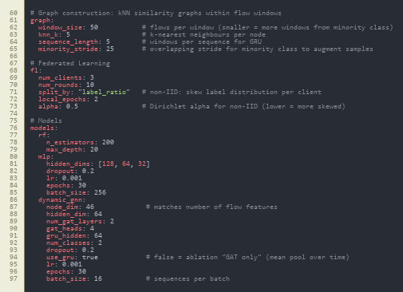
src/data/preprocess.py
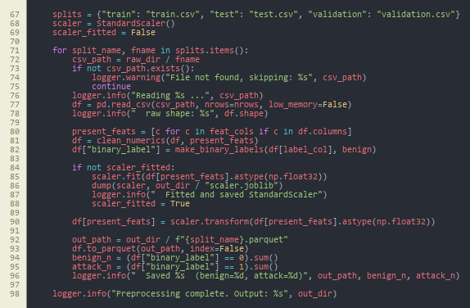
src/data/graph_builder.py - flows_to_knn_graph

src/data/graph_builder.py - build_graphs_for_split

src/data/dataset.py - GraphSequenceDataset
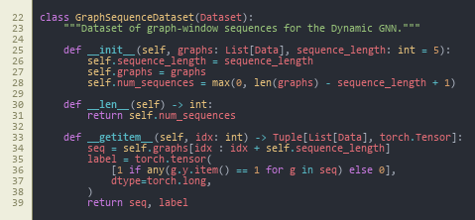
src/data/dataset.py - get_dataloaders
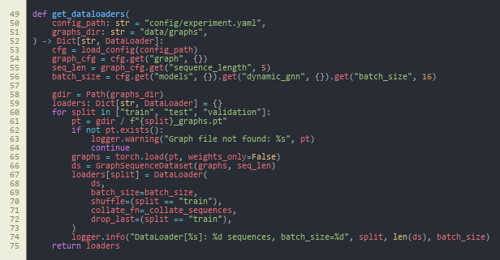
src/models/baselines.py
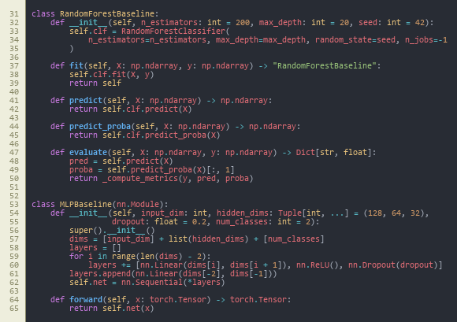
src/models/dynamic_gnn.py - DynamicGNN.forward
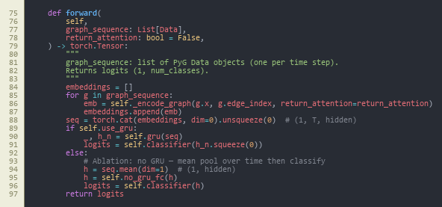
src/models/trainer.py - train_one_epoch

src/explain/explainer.py - explain_sequence
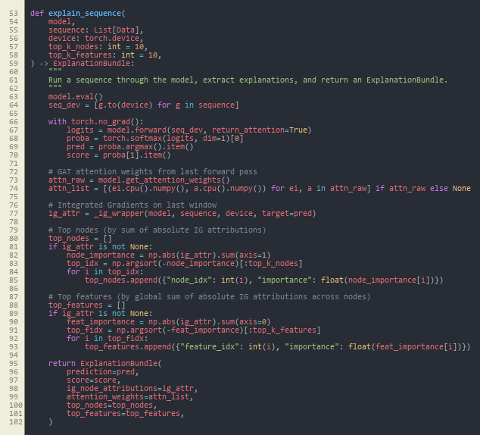
src/federated/run_federated.py
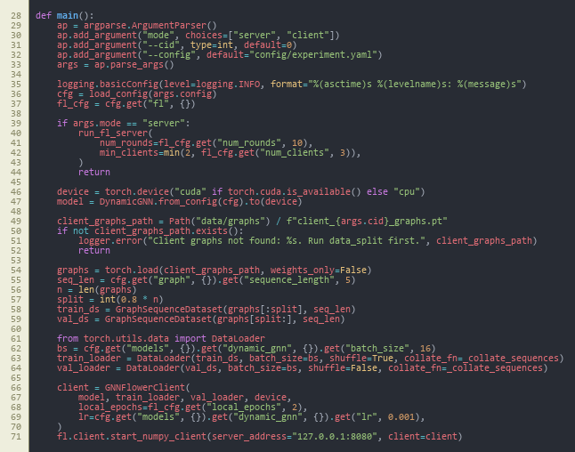
src/federated/client.py - GNNFlowerClient
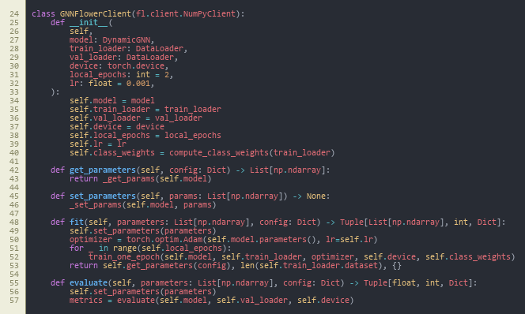
src/federated/server.py - run_fl_server
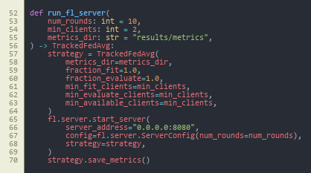
src/siem/api.py - POST /score


Appendix B: Project Process Documents
MSc PROJECT (COMP11024)
PROJECT PROCESS DOCUMENTATION-01
Student: Arka Talukder (B01821011) Supervisor: Dr. Raja Ujjan
Meeting Number: 1-6 Date/Time: 29/01/2026 - 06/03/2026
Agenda for meeting:
- Project title selection and approval
- Project specification and scope discussion
- Interim report structure and guidelines
- Literature review and research gap alignment
- Methodology and experimental design review
- Progress on data pipeline and model implementation
Discussion of agenda items:
Across all meetings, the project moved from title selection to interim report completion. On 10 and 11 February 2026, the project title: “Explainable Dynamic Graph Neural Network SIEM for Software-Defined IoT using Edge AI and Federated Learning” was discussed and approved by the supervisor. After approval, we clarified the scope. The project will use from Kaggle- CICIoT2023 flow data, a dynamic GNN with GAT and GRU, federated learning with non-IID data, and SIEM alert generation.
The project specification was reviewed. The supervisor agreed with the four main parts: dynamic GNN, federated learning, explainability, and SIEM integration. We also discussed the interim report structure. It has three parts: literature review, methodology, and plan for completion.
I shared progress on the literature review. The supervisor gave feedback on the research gap table and how to compare my project with related work. We reviewed the methodology section. This included graph construction, model architectures (Random Forest, MLP, centralised GNN, federated GNN), and evaluation metrics.
I presented the implementation progress. This covered the data pipeline, graph builder, all four models, federated learning with Flower, explainability with Captum, and the FastAPI SIEM endpoint. The supervisor noted that the implementation matches the research objectives. The interim report draft was discussed. I will seek approval in the next meeting.
Summary of agreed action plan:
- Obtain supervisor approval for the interim report in the next meeting
- Finalise any minor edits based on supervisor feedback
- Proceed with final experiments and results chapter for the dissertation
- Maintain documentation and reproducibility of all experiments
Notes:
Supervisor emphasized clear alignment between research questions, methodology, and results. Careful documentation of experiments and fixed seeds for reproducibility was advised. The project is on track for timely completion.

MSc PROJECT (COMP11024)
PROJECT PROCESS DOCUMENTATION-02

Student: Arka Talukder (B01821011) Supervisor: Dr. Raja Ujjan
Meeting Number: 7-14 Date/Time: 07/03/2026 - 22/04/2026
Agenda for meeting:
- Weekly Friday updates: Coding environment, experimental outcomes, references and implementation.
- Get ready to conduct complete on-campus project analysis with supervisor.
- On-campus supervision: integrated dissertation discussion and demonstration (14 April 2026).
- Write corrections to emails (15 April 2026)
- Last dissertation polishing: structure, evidence and reproducibility.
- Check cross-chapters to ensure objectives, methodology, results and discussion are in line.
Discussion of agenda items:
Through this set of meetings, supervision changed to interim reporting to final dissertation presentation. To ensure that the coding environment was reproducible, to consolidate Experimental results, to tighten references, and to close implementation gaps in the dynamic GNN, federated learning, explainability, and SIEM integration tracks, standing Friday sessions were employed.
The meeting in the campus on 14 April 2026 gave the supervisor the opportunity to look at the entire project in context: end-to-end pipeline, model behaviour, evaluation outputs and the way they would be presented in the dissertation. Clear presentation, traceability between goals and evidence, and limitations presentation were discussed.
On 15 April 2026 I was sent elaborate feedback and a formatted list of corrections via email. This included narrative edits, labelling of figures/tables and citation consistency and specific notes on methodology and interpretation of results where congruence had to be higher.
I have enacted all corrections suggested. The draft of the dissertation now indicates the advice of the

Summary of agreed action plan:
• Set up of Freeze main experiment and document environment in a reproducible manner.
• Keep a record of corrections made (edits made / version used to submit)
• Check full final proofread and reference audit prior to submission.
• Sign off by any last supervisor as necessary by School process.
Notes:
The campus review as well as the email of the 15 April gave a clear, actionable checklist as supervisor feedback. Everything has been covered. The project is still on-track towards its final submission with documentation and scripts in line with the results reported.


MSc Dissertation Project Monthly Attendance and Progress Report-01

TO BE COMPLETED BY THE STUDENT, WITH COMMENTS FROM THE SUPERVISOR.
Please complete all sections below
Name | Arka Talukder | Student ID | B01821011
Supervisor | Dr. Raja Ujjan | Start Date | 29/01/2026
Mode of Study | Online | Dates of Meetings  (include dates of all meetings) | 06/02/2026 (Online)  13/02/2026 (Online)  10/02/2026 (Online) – Title selection  11/02/2026 (Online) – Title approval  20/02/2026 (Online)  06/03/2026 (Online)  13/03/2026(online)

Description of Meetings | During this reporting period, I held regular supervisory meetings with Sir Dr. Raja Ujjan to discuss my dissertation project on Explainable dynamic graph neural network SIEM for Software-Defined IoT.  In the first meetings (6 February), we discussed the project scope and what the interim report should include. On 10 and 11 February, the project title was selected and approved by the supervisor. After that, we focused on the project specification. This includes four main parts: dynamic GNN, federated learning, explainability, and SIEM integration.  Later meetings covered the literature review structure, research gap, and methodology design. The supervisor gave feedback on graph construction, model choices, and evaluation metrics. We also discussed how to structure the interim report and present the work clearly.  Recent meetings reviewed my implementation progress and the interim report draft. I presented the data pipeline, all four models (Random Forest, MLP, centralised GNN, federated GNN), explainability module, and SIEM API. The interim report is about 80% complete. I will seek final approval from the supervisor in the next week.

Summary of work undertaken this month.

During this month, I completed most of the work needed for the interim report. Key achievements include:

- Project title approved (10–11 February 2026)
- Literature review written, covering IoT security, SDIoT, ML for intrusion detection, GNNs, federated learning, and explainable AI
- Research gap table completed, comparing my project with related work
- Methodology section written: dataset (CICIoT2023), preprocessing, graph construction, model architectures, evaluation metrics
- Data pipeline implemented: CICIoT2023 loaded, preprocessed, normalised, exported as Parquet
- Graph construction implemented: kNN builder, windowing, sequence dataset
- All four models implemented: Random Forest, MLP, centralised dynamic GNN (GAT+GRU), federated GNN
- Federated learning setup: Flower framework, non-IID data splitting, 10-round simulation
- Explainability: Integrated Gradients (Captum) and GAT attention weights
- SIEM integration: FastAPI endpoint producing ECS-formatted JSON alerts
- Plan for completion section written with timeline and contingency plans
- Interim report draft completed (approximately 80%); awaiting supervisor approval.

What work will you undertake next month?

In the upcoming period, I will focus on:
- Obtaining supervisor approval for the interim report
- Finalising any edits based on supervisor feedback
- Completing final experiments and generating all figures (confusion matrices, ROC curves, FL convergence)
- Writing the Results and Discussion chapters for the final dissertation
- Conducting sensitivity analysis if time permits
- Writing Conclusion and Critical Reflection
- Final proofreading and submission
I remain on schedule for timely completion.

Please detail reasons for any absence including the total number of days absent (annual leave, conference attendance, field research, ill health etc)?

I missed 27/02/2026 meeting due to GP appointment

Statement from Supervisor (including any issues which should be brought to the attention of School, indication of satisfactory process thus far and whether or not attendance has been satisfactory)

Signed (student) |  | Date | 12/03/2026
Signed  (MSc Dissertation Supervisor) |  | Date


MSc Dissertation Project Monthly Attendance and Progress Report-02

TO BE COMPLETED BY THE STUDENT, WITH COMMENTS FROM THE SUPERVISOR.
Please complete all sections below
Name | Arka Talukder | Student ID | B01821011
Supervisor | Dr. Raja Ujjan | Start Date | 29/01/2026
Mode of Study | Hybrid | Dates of Meetings  (include dates of all meetings) | 07/03/2026 (Online) - future work: coding environment, results, references, implementation  14/03/2026 (Online) - same standing agenda (environment, results, references,implementation)  27/03/2026 (Online)  03/04/2026 (Online)  10/04/2026 (Online)  14/04/2026 (On campus) - full project review with supervisor  15/04/2026 - detailed written feedback and correction points received by email (following campus meeting); all items subsequently addressed

Description of Meetings | In this reporting period, I maintained a regular weekly supervision in line with dissertation completion. During every Friday meeting (online), I was reporting on the progress of my coding environment, my running and documentation of experiments, compilation of results, reference management, and details of how I was implementing the Explainable dynamic GNN SIEM pipeline. I scheduled a full walkthrough of the project with Dr. Raja Ujjan on campus on 14 April 2026 to ensure that he would look at the integrated system, dissertation structure and evidence base in a single session. On 15 April 2026 I was provided with a detailed feedback and a list of correction points via e-mail. I have then gone through that list in order and sorted out the comments of the supervisor.

Summary of work undertaken this month.

In this month, I worked on transforming the implementation into a dissertation package that can be submitted. Key points include:
Friday online weekly meetings discussing reproducible environment setup, experimental outcomes, bibliography and citation hygiene, and refinements to implementation.
- On-campus monitoring on 14 April 2026 and full project presentation and discussion of the complete dissertation draft.
- Detailed email feedback received on 15 April 2026; all corrections requested made (text, structure, figures/tables and implementation notes as requested).
- • Increased consistency between research questions, methodology, results and discussion in the last chapters.

What work will you undertake next month?

During the next period, I will concentrate on:
- Ultimate internal consistency and proofreading are complete over all chapters.
- Final proofreading of figures, tables and Harvard-style references.
- Final submission and handover of supervisor preparation materials.
- Any follow-up to the supervisor in case of any final sign-off meeting.
I am still on track towards completing on time.

Please detail reasons for any absence including the total number of days absent (annual leave, conference attendance, field research, ill health etc)?

No absence to report for scheduled supervision during this period.

Statement from Supervisor (including any issues which should be brought to the attention of School, indication of satisfactory process thus far and whether or not attendance has been satisfactory)

Signed (student) |  | Date | 22/04/2026
Signed  (MSc Dissertation Supervisor) |  | Date

Appendix C: Project Specification Form
University of the West of Scotland
School of Computing, Engineering and Physical Sciences

MSc Cyber Security Project Specification

Student name: Arka Talukder
Banner ID: B01821011
Email: b01821011@studentmail.uws.ac.uk
Project being undertaken on part-time or full-time basis: Full-time
MSc Programme: MSc Cyber Security
MSc Programme Leader: Dr. Raja Ujjan
Approved by supervisor? Yes/No: Yes
Project Title:
Explainable Dynamic Graph Neural Network SIEM for Software-Defined IoT using Edge AI and Federated Learning

Research Question to be answered:
Main question:
How can an explainable dynamic graph neural network, trained with federated learning, detect attacks in Software-Defined IoT flow data and create SIEM alerts that support SOC work on CPU edge devices?
Sub questions:
1) Does a dynamic graph model improve detection compared to simple baselines?
2) Can federated learning keep similar performance without sharing raw data?
3) Can the model provide clear explanations that help alert triage?

Outline (overview) and overall aim of project:
Internet of Things devices are used in homes, health, and industry. Many devices are weak and can be attacked. A Security Operations Centre (SOC) needs alerts that are fast, accurate, and easy to understand.
This project will build a small prototype anomaly and attack detector for Software-Defined IoT networks using network flow logs. Each time window of traffic will be converted into a graph where devices are nodes and flows are edges. A dynamic graph neural network (GNN) will learn patterns across a sequence of graph windows and predict whether the window is benign or malicious.
To reduce data sharing between sites and to match real SOC environments, the model will also be trained with a simple federated learning setup (FedAvg) using 2 to 3 simulated clients. To support SOC triage, the system will generate an explanation for each alert, for example the most important flows and flow features. The prototype will run on CPU and I will measure inference time to check if it is suitable for edge use.
The project will use the CICIoT2023 flow dataset (assumed to be available locally). To keep the work possible in 45 days, the scope is a development-grade SIEM integration: the system will output SIEM-ready JSON alerts (ECS-style fields) and a small FastAPI scoring endpoint. Deploying a full SIEM stack (Elastic or Wazuh) is optional and will be documented as future work.

Objectives (list of tasks to be undertaken to achieve overall aim of the project and to answer the research question posed):
Objectives and tasks:
- Literature review and problem framing
- Carry out a search across IEE, MDPI and sciencedirect(2023-2025)
- Review dynamic GNN intrusion detection, federated learning for security, and explainable AI for SOC.
- Define the final data fields, window size, and evaluation metrics.
- Outcome will be at least two page review and gap analysis.
- Data preparation and graph construction
- Use CICIoT2023 flow records and select a manageable subset for training.
- Build time-window graphs: nodes as devices (IP or device ID), edges as flows, features on edges.
- Create a repeatable preprocessing script and dataset loader.
- Baselines and central DynamicGNN model
- Train simple baselines (Random Forest and small MLP) on tabular features.
- Implement a practical dynamic GNN (graph attention per window plus GRU over windows) and train centrally.
- Federated learning simulation
- Split training data into 2 to 3 clients.
- Train the same model with Flower FedAvg and log round metrics and communication size.
- Explainability and SOC alert output
- Produce explanations for sample alerts using Integrated Gradients (Captum) and attention weights.
- Output an explanation bundle with top features and top flows.
- Create SIEM-style JSON alerts (ECS-like) and a small FastAPI endpoint for scoring.
- Maintaining git repository from data ingestion.
- Evaluation and report writing
- Compare baselines vs central GNN vs federated GNN.
- Report precision, recall, F1, ROC-AUC, and false alarm rate.
- Report CPU inference time and a short SOC workflow example for alert triage.
- outcome will be results notebook, figures, validates CSV, data and report

Evaluation plan:
- Use one fixed train, validation, and test split and keep it the same for all models.
- Include confusion matrices and false positives per time window.
- For federated learning, plot round-by-round performance and estimate total bytes sent.
- Provide 3 to 5 example alerts with explanations and discuss if they are useful for SOC decisions.
Risk control and fall back plan:
- If CICIoT2023 is too large, use a smaller subset of devices and days.
- If federated training is slow, reduce the number of rounds and clients but keep the comparison.
- If Integrated Gradients is slow, run it only on selected alerts and keep attention-based explanations for all alerts.

CyBOK Knowledge Areas (Please check at least two relevant areas your project going to be covered):

Human, Organisational & Regulatory Aspects | ☐ | Risk Management & Governance
 | ☐ | Law & Regulation
 | ☐ | Human Factors
 | ☐ | Privacy & Online Rights
Attacks & Defences | ☐ | Malware & Attack Technologies
 | ☒ | Adversarial Behaviours
 | ☒ | Security Operations & Incident Management
 | ☐ | Forensics
Systems Security | ☐ | Cryptography
 | ☐ | Operating Systems & Virtualisation Security
 | ☐ | Distributed Systems Security
 | ☐ | Formal Methods for Security
 | ☒ | Authentication, Authorisation & Accountability
Software and Platform Security | ☒ | Software Security
 | ☐ | Web & Mobile Security
 | ☐ | Secure Software Lifecycle
Infrastructure Security | ☐ | Applied Cryptography
 | ☒ | Network Security
 | ☐ | Hardware Security
 | ☐ | Cyber Physical Systems
 | ☐ | Physical Layer and Telecommunications Security

Indicative reading list (references to be correctly presented) and resources:
- Albanbay, N., Tursynbek, Y., Graffi, K., Uskenbayeva, R., Kalpeyeva, Z., Abilkaiyr, Z. and Ayapov, Y., 2025. Federated Learning-Based Intrusion Detection in IoT Networks: Performance Evaluation and Data Scaling Study. Journal of Sensor and Actuator Networks, [online] 14(4), p.78. Available at: https://doi.org/10.3390/jsan14040078
- Alabbadi, A. and Bajaber, F., 2025. An Intrusion Detection System over the IoT Data Streams Using eXplainable Artificial Intelligence (XAI). Sensors, 25(3), p.847. Available at: https://doi.org/10.3390/s25030847
- Basak, M., Kim, D.-W., Han, M.-M. and Shin, G.-Y., 2025. X-GANet: An Explainable Graph-Based Framework for Robust Network Intrusion Detection. Applied Sciences, 15(9), p.5002. Available at: https://doi.org/10.3390/app15095002
- Han, Z., Zhang, C., Yang, G., Yang, P., Ren, J. and Liu, L., 2025. DIMK-GCN: A Dynamic Interactive Multi-Channel Graph Convolutional Network Model for Intrusion Detection. Electronics, [online] 14(7), p.1391. Available at: https://doi.org/10.3390/electronics14071391
- Lazzarini, R., Tianfield, H. and Charissis, V., 2023. Federated Learning for IoT Intrusion Detection. AI, [online] 4(3), pp.509–530. Available at: https://doi.org/10.3390/ai4030028
- Luša, R., Pintar, D. and Vranić, M., 2025. TE-G-SAGE: Explainable Edge-Aware Graph Neural Networks for Network Intrusion Detection. Modelling, 6(4), p.165. Available at: https://doi.org/10.3390/modelling6040165
- Ngo, T., Yin, J., Ge, Y.-F. and Wang, H., 2025. Optimizing IoT Intrusion Detection—A Graph Neural Network Approach with Attribute-Based Graph Construction. Information, 16(6), p.499. Available at: https://doi.org/10.3390/info16060499
- Pinto, C., Sajjad Dadkhah, Ferreira, R., Alireza Zohourian, Lu, R. and Ghorbani, A.A., 2023. CICIoT2023: A Real-Time Dataset and Benchmark for Large-Scale Attacks in IoT Environment. Sensors, 23(13), pp.5941–5941. Available at: https://doi.org/10.3390/s23135941
- Wang, R., Zhao, J., Zhang, H., He, L., Li, H. and Huang, M., 2025. Network Traffic Analysis Based on Graph Neural Networks: A Scoping Review. Big Data and Cognitive Computing, 9(11), p.270. Available at: https://doi.org/10.3390/bdcc9110270
- Yang, S., Pan, W., Li, M., Yin, M., Ren, H., Chang, Y., Liu, Y., Zhang, S. and Lou, F., 2025. Industrial Internet of Things Intrusion Detection System Based on Graph Neural Network. Symmetry, [online] 17(7), pp.997–997. Available at: https://doi.org/10.3390/sym17070997
- Zhong, M., Lin, M., Zhang, C. and Xu, Z., 2024. A Survey on Graph Neural Networks for Intrusion Detection Systems: Methods, Trends and Challenges. Computers & Security, 141, pp.103821–103821. Available at: https://doi.org/10.1016/j.cose.2024.103821

Marking scheme:
Introduction | 5%
Context – literature review | 20%
Research Design | 20%
Implementation (practical work) | 25%
Evaluation | 5%
Presentation of results | 5%
Conclusions and recommendations | 10%
Critical self-evaluation | 10%

Supervisor:
Dr. Raja Ujjan

Moderator:
Muhsin Hassanu

Programme Leader:
Dr. Raja Ujjan

Date specification submitted:
11/02/2026

Please complete the ‘ethics’ form below for all projects.

School of Computing, Engineering and Physical Sciences
MSc PROJECT – REQUIREMENT FOR ETHICAL APPROVAL

SECTION 1: TO BE COMPLETED BY THE STUDENT
Does your proposed research involve: research with human subjects (including requirements gathering and product/software testing), access to company documents/records, private or sensitive data, questionnaires, surveys, focus groups and/or other interview techniques? Does your research entail any process which requires ethical approval? (Please enter √ in the appropriate box)

YES |  | You must submit an application for approval to the Ethics Review Manager
NO | No | You do not need to submit an application to the Ethics Review Manager

Name of Student (Print name): Arka Talukder

Signature:
Date: 11/02/2026
SECTION 2: TO BE COMPLETED BY THE PROJECT SUPERVISOR
I understand that the above project does not require ethical approval.

Supervisor (print name): Dr. Raja Ujjan

Signature:

Date: 10/02/2026

IMPORTANT: please note that by signing this form all signatories are confirming that any potential ethical issues have been considered and, where necessary, an application for ethical approval has been/will be made via the Ethical Review Manager software.
Any project requiring ethical approval, but which has not been given approval will not be accepted for marking.

Ethical approval cannot be sought in retrospect.

Appendix D: Handbook Appendix 4 (optional) - repository and dataset reference

D.1 Project source code (GitHub)
- Repository: https://github.com/imark0007/Dissertation_Project

D.2 Dataset source used in this project (Kaggle)
- Kaggle dataset page: https://www.kaggle.com/datasets/himadri07/ciciot2023

D.3 Official dataset source (UNB/CIC reference)
- Dataset page: https://www.unb.ca/cic/datasets/iotdataset-2023.html

