Dissertation Front Sheet


<Project Title>

<Sub-title (if used)>

<Your Name>
<Your Matric no.>

Thesis Project for the partial fulfilment
of the requirements for the Master Degree
in Information Technology/E-Business Management / Advanced Computer Systems Development (delete one)

University of the West of Scotland
School of Computing
<Date of submission>

Declaration of Originality


DECLARATION OF ORIGINALITY

I declare that this is an original study based on my own
work and that I have not submitted it for any other
course or degree.

Signature_______________________

Library Release Form



Library Form to Accompany MSc Project

  - To be completed in full

Surname:

First Name: Initials:

Banner No:

Course Code:

Course Title:

Project Supervisor:

Project Title:

Session: Date of Submission:

Signature:

Please ensure that a copy of this form is included with your project before submission.

Table of Contents

List of Figures

List of Tables

Explainable Dynamic Graph Neural Network SIEM for Software-Defined IoT using Edge AI and Federated Learning
Arka Talukder | B01821011
MSc Cyber Security (Full-time)
University of the West of Scotland
School of Computing, Engineering and Physical Sciences
Supervisor: Dr. Raja Ujjan

1. Abstract
Internet of Things (IoT) deployments produce flow telemetry that Security Operations Centres (SOCs) must triage on CPU-only edge infrastructure. Detectors should be accurate, privacy-aware, and explainable so analysts can act on alerts without undue delay.
Research question (headline answer). The work asks how an explainable GAT+GRU on kNN flow graphs, with Flower FedAvg and SIEM-shaped output, can run on CPU. The contribution is a reproducible, integrated prototype on CICIoT2023 (Pinto et al. 2023): public splits, leakage-aware preprocessing, Captum IG + GAT attention, FastAPI JSON delivery, and one config/experiment.yaml. Chapters 2, 4–6 justify and build; 7–8 test; 9 answers the sub-questions with Tables 7–12.
Outcomes (subset, fixed split). Central and federated GNN runs report F1 = 100% and ROC-AUC = 100% with zero false positives here; Random Forest and MLP reach F1 = 99.86% and 99.42% under the same protocol. Mean CPU inference is about 23 ms per five-window GNN sequence; federated weight traffic is about 31 MB over ten rounds. Ablation, (window, k) sensitivity, and multi-seed runs address reliability of the headline configuration; full external validity to live sites is not claimed.
Keywords: IoT security, dynamic graph neural network, federated learning, SIEM, explainable AI, edge AI, SOC, CICIoT2023

Acknowledgements
I thank my supervisor, Dr Raja Ujjan, for technical guidance and support throughout the project. I thank my moderator, Muhsin Hassanu, for review of interim reports. I also thank Dr Daune West for academic support during the submission period. I am grateful to School and programme staff for module materials and to the MSc project co-ordinator for programme and ethics communication.
Finally, I thank friends and family for their patience during intensive writing and experiment runs.

List of Abbreviations
Abbrev. | Definition
API | Application Programming Interface
AUC | Area Under the (ROC) Curve
CPU | Central Processing Unit
ECS | Elastic Common Schema (log/alert shape used as a guide)
FedAvg | Federated Averaging (McMahan et al. 2017)
FL | Federated Learning
FN | False Negative
FP | False Positive
FPR | False Positive Rate
GAT | Graph Attention Network
GNN | Graph Neural Network
GRU | Gated Recurrent Unit
IG | Integrated Gradients
IoT | Internet of Things
IID | Independent and Identically Distributed (data split)
JSON | JavaScript Object Notation
kNN | k-Nearest Neighbours (graph construction)
MLP | Multi-Layer Perceptron
non-IID | Non-identical client data distributions
PyG | PyTorch Geometric
ROC | Receiver Operating Characteristic
SDN | Software-Defined Networking
SIEM | Security Information and Event Management
SOC | Security Operations Centre
TN | True Negative
TP | True Positive
UML | Unified Modelling Language
XAI | Explainable Artificial Intelligence
AI | Artificial Intelligence (general discipline; not a model name)
ML | Machine learning (umbrella for supervised and neural methods in Chapters 4–8)
IDS | Intrusion Detection System
NIDS | Network-based Intrusion Detection System
DNN | Deep Neural Network
VAE | Variational Autoencoder (cited in wider ML literature only; not a model used in this project)
Adam | Adaptive moment optimiser (used for MLP/GNN; see PyTorch documentation, Chapter 12)
IDE | Integrated Development Environment
The front matter includes a Table of Contents, List of Figures, List of Tables, and this List of Abbreviations, as required for a complete technical report.

Chapter 1 – Introduction

1.1 Chapter Overview
This chapter presents the project background, IoT flow telemetry, SOC alert volume and the practical limitation at the edge node of a CPU. It describes the rationale behind the inclusion of dynamic graph learning, federated training, and explainable alerts in the same pipeline, followed by the research aim, sub-questions, scope, and structure of the chapters to ensure that subsequent chapters in the work are focused on method, implementation, and evidence.

1.2 Background and Motivation
The Internet of Things is now pervasive, yet many devices remain weakly protected in practice, creating exposure to botnet use, service abuse, and lateral movement (Kolias et al. 2017). Continuous network monitoring is therefore essential where legacy and new devices coexist. Software-defined approaches can expose flow-level statistics without storing full packet captures, easing storage and some privacy concerns; the harder problem is to analyse those flows accurately, to explain decisions to analysts, and to do so on edge hardware that is often CPU-only.
Security Operations Centres triage SIEM-fed alerts, but alert fatigue and opaque model scores delay response (Cuppens and Miège 2002). Random Forest and MLP baselines on tabular features are strong competitors; this work also models flows as nodes in a similarity graph and sequences of window graphs, because attacks often unfold as structured patterns, not independent rows. The public CICIoT2023 release does not support a full device–device IP topology, so kNN feature-space edges are used. A GAT+GRU stack encodes local neighbour structure and short-term temporal change; Flower FedAvg trains without centralising raw flows; a FastAPI path emits ECS-like JSON and reports CPU time - aligned with the main research question.

1.3 Research Aim and Questions
This project will develop and implement a software-defined flow data-based, dynamically trained, federated training, and practical explanation output-based reproducible prototype to detect IoT attacks and provide triage of SOC. It works on realistically constrained feasibility, particularly CPU execution and non-IID federated partitions and ensures that the pipeline is easy to understand when used by security operations.
The primary research question is:
How can an explainable dynamic graph neural network, trained using federated learning, detect attacks in Software-Defined IoT flow data and generate SIEM alerts that support SOC operations on CPU-based edge devices?
The sub-questions (each mapped to Chapters 7–8 and Section 9.3) are:
- Sub-Q1: Does a dynamic graph model outperform simple tabular models (Random Forest, MLP) on the same test protocol?
- Sub-Q2: Can federated learning (Flower FedAvg) match centralised training without exchanging raw flow rows?
- Sub-Q3: Can the system produce analyst-useful explanation fields (Integrated Gradients + attention) in SIEM-shaped JSON for triage?
Contributions (in this dissertation):
A flow telemetry-to-kNN similarity-graphs prototype that is end-to-end, CPU-based and trains a dynamic GNN (GAT + GRU), and results in SIEM-shaped JSON alerts.
Comparison between a centralised and federated architecture with the same architecture under Flower FedAvg with non-IID client partitions.
An explainability route that integrates Integrated Gradients (feature attribution) with GAT attention (flow and structure cues) with ablation, sensitivity, and multi-seed support.
A reproducibility trail in submission ready format as configuration, scripts, chapter mappings and artefacts in the form of appendices.
CICIoT2023 is used in the work to compare choices and metrics with outcomes of previous studies and yet fit within a budget of an MSc time-box and resources.

1.3.1 Objectives
The project has the following specific objectives to provide answers to the above research questions. All of these objectives are artefacts deliverable which are revisited in Chapters 4-8 as evidence:
Literature objective. Critically review IoT intrusion detection, graph and dynamic GNN techniques, federated learning and explainable AI to security, and determine the gap that this project addresses (Chapter 2).
Dataset objective. Use a manageable CICIoT2023 subset with public train / validation / test files, full preprocessing, and no test-data leakage (Sections 4.3 and 6.3).
Modelling objective. A controlled comparison (Sections 4.4 and 6.5) of two flow-level baselines (Random Forest, MLP) and one dynamic GNN (GAT + GRU).
Federated objective. Train on three non-IID clients (ten rounds) with Flower FedAvg, and test the global checkpoint on the central test set (Sections 4.5, 6.6 and 8.3).
Explainability objective. Add Captum Integrated Gradients to GAT attention to obtain per-alert top features and top flows ( Sections 4.6, 6.7 and 8.6).
SIEM objective. Serve the model through a FastAPI endpoint that returns ECS-like JSON alerts and report CPU inference latency (Sections 6.8, 6.9 and 8.5).
Evaluation objective. Establish metrics, ablation, sensitivity and multi-seed tests and present results in figures and tables (Chapters 7 and 8).
Reflect and write-up goal. Produce a full written report with critical self-evaluation (Chapters 9 and 10).

1.3.2 Where the research questions are answered (evidence map)
Question | What “answered” means in this project | Main evidence (body)
Main RQ (edge, CPU, explainable, federated, SIEM-shaped) | A working pipeline: data → model(s) → optional FL → FastAPI alerts with latency and JSON shape | Chapters 6–8; Table 5 (testbed), Table 7, 8.5–8.6
Sub-Q1 (GNN vs baselines) | Held-out test F1 / ROC-AUC / FPR for GNN vs RF/MLP on the same splits | Section 8.2; Table 7; Figures 16–22
Sub-Q2 (federated vs central) | FedAvg global model vs central GNN on the shared test set; communication | Section 8.3; Table 8; Figures 23–25
Sub-Q3 (explanations for triage) | Example alerts with top_features / top_nodes and plausibility discussion | Section 8.6; 9.6 (limits: no formal user study)
Robustness (not a separate RQ) | Ablation (GRU), sensitivity (window, k), multi-seed | Sections 8.7–8.9; Tables 10–12
Similar work exists on parts of this stack (GNN IDS, FL on IoT, XAI, SIEM). This dissertation’s defensible claim is integration under one configuration: the same benchmark subset, same splits, one experiment.yaml, and comparable baselines - feasibility and artefact contribution - rather than a claim to beat every prior accuracy figure (Section 2.8, Table 13).

1.4 Scope and Limitations
The project implements CICIoT2023 (Pinto et al. 2023) in a manageable subset in 45 days MSc. Flow level features are publicly exposed but unreliable device topology fields are not, to construct the complete host graph. Due to this, this implementation has flow nodes equipped with kNN feature-similarity edges and using a GAT+GRU model stack as explained in Section 2.5 and defined in Section 5.3.
It covers the baselines of Random Forest and MLP, Flower FedAvg federation, Captum explainability, and ECS-like alerts of FastAPI. Production SIEM integration, formal SOC user studies and large multi-organisation federation are outside of the scope. Details of technical implementation are specifically focused in Chapters 4 to 7 to eliminate repetitive text.
Limitations (overview): no production SIEM deployment, no formal study of SOC users, CPU-only training and inference, three federated clients and ten rounds in reported federated run. The headline measures are subset measures and are candidly talked about in Chapter 9. Following the risk treatment in Chapter 3 are contingency decisions, like reduced data and reduced rounds should it be necessary. The repository, config/experiment.yaml and execution notes are used to reproduce Chapter 13 content.
Continuity of scope. Every body chapter is tied to the same problem: CPU-realistic, explainable, optionally federated detection of binary attack vs benign traffic on CICIoT2023 flow features, with SIEM-oriented output. The literature (Chapter 2) defines the gap; Chapters 4–6 implement one artefact; Chapters 7–8 test one pre-declared plan; Chapters 9–10 interpret and reflect without moving the goal to new datasets or live capture.

1.5 Dissertation Structure
The report is organised as follows: Chapter 2 (literature, including the extended comparative review in Section 2.10 with fifteen to twenty core sources), Chapter 3 (ethics, time, and project management), Chapters 4–5 (research design and system design), Chapter 6 (implementation), Chapter 7 (evaluation contract), Chapter 8 (results, minimal interpretation), Chapter 9 (discussion and conclusions), Chapter 10 (critical self-evaluation), Chapters 11–12 (references), and Chapter 13 (appendices and reproducibility material).
Mapping to the signed project specification (Appendix C). The agreed weight grid is: Introduction 5%; Context / Literature 20%; Research Design 20%; Implementation 25%; Evaluation 5%; Presentation of Results 5%; Conclusions 10%; Critical Self-Evaluation 10% (100%). Authoritative percentages are those on the signed specification form; the table below maps each criterion to this dissertation.
Criterion (specification) | Where it is addressed
Introduction | Chapter 1 - aim, RQs, Section 1.3.2 evidence map, scope
Context / literature | Chapter 2 - search, Table 1, Section 2.8 gap
Research design | Chapters 4–5 - method, Tables 2–4, design figures
Implementation | Chapter 6 - code, testbed Table 5, screenshots Section 6.10
Evaluation | Chapter 7 - pass/fail, Table 6, Section 7.4.1 validity, Section 7.5 metrics
Presentation of results | Chapter 8 - Tables 7–13, figures
Conclusions | Chapter 9 - Section 9.3 RQ answers, limitations, future work
Critical self-evaluation | Chapter 10
Narrative chapter bands (indicative). The body can also be read in thematic bands that mirror a typical technical dissertation: Chapters 4 and 5 = research design and system design; Chapter 6 = implementation and deployment (with Appendix A code evidence); Chapters 7–8 = evaluation and results; Chapters 7–9 = evaluation and discussion; Chapter 10 = critical reflection; Sections 9.2, 9.8, 9.9 = conclusion and future work. Front matter, List of Abbreviations, and Chapters 11–12 support referencing and tables of figures and tables as listed at the start of this document.
Indicative band (typical report shape) | Chapters in this report
Abstract | 1. Abstract (front)
Introduction (~10% of body) | Chapter 1
Literature review (~15–20%) | Chapter 2
Research design & methods (~15–20%) | Chapters 4 and 5
Research design – deployment & implementation (~15–20%) | Chapter 6 (with Appendix A code evidence)
Results – visualisation / analysis (~15–20%) | Chapter 8 (and metrics in Chapter 7)
Model / results evaluation & discussion (~15–20%) | Chapters 7, 8 (interpretation light), 9
Critical reflection (~10%) | Chapter 10
Conclusion & future direction (~10%) | Chapter 9 (esp. 9.2, 9.8–9.9)
Overall format: contents, references, own diagrams / plots (~10%) | Front matter; 11–12; figures and tables
Method and deployment spread. Chapters 4 and 5 set out the data contract, models, loss, federation design, graph semantics, Tables 2–4, and Figures 7–9. Chapter 6 records implementation and deployment: testbed Table 5, modules, code paths, Section 6.10, FastAPI, and Appendix A code figures. Chapters 4–6 together should read as a balanced design-and-build block relative to the Appendix C weight split (Research Design 20% + Implementation 25% includes both design chapters and the implementation chapter).

1.6 Alignment with the Marking Criteria in the Project Specification
Section 1.5 links this dissertation to the signed Project Specification (Appendix C). The indicative bands in the second table are a narrative reading aid; official marking uses the specification percentages agreed at project approval.

1.6.1 Where each technical topic is stated once (clarity and non-repetition)
To keep continuity without contradiction, the dissertation uses a single home for each major technical claim: graph construction and windowing - Section 5.3 and Chapter 4 (pipeline); loss and FedAvg - Section 4.4.2; metrics - Section 7.5; test evidence - Chapter 8; interpretation - Chapter 9. Later chapters point back instead of redefining.

1.7 Chapter Summary
Chapter 1 framed the SOC and IoT problem context, stated the primary and sub research questions, provided an evidence map (Section 1.3.2), and defined scope, continuity, and boundaries. Section 1.5 maps chapters to the signed project specification (Appendix C) and to an indicative thematic layout. Chapter 2 reviews the literature.

Chapter 2 – Literature Review

2.1 Chapter Overview
This chapter reviews IoT intrusion detection, SOC/SIEM needs, graph and dynamic GNNs, federated learning, and explainable ML for security, linking each strand to this prototype. It is a major part of the dissertation body alongside the design and results chapters (Section 1.5). Dataset splits and hyperparameters are fixed in Chapters 4, 6–7, not repeated here. This chapter is analytical only: it does not duplicate the Research Method.

2.2 Themes and Structure
This review is selective, not exhaustive: it prioritises peer-reviewed articles and major surveys on (i) IoT and flow-based intrusion detection, (ii) graph and dynamic graph neural models for security analytics, (iii) federated learning under data-sovereignty constraints, and (iv) explainable machine learning in operational security contexts. Sections 2.2.1 and 2.2.2 state the search protocol and, separately, a debate-led view of the main technologies named in the dissertation title, so the chapter is not a glossary of terms.
The narrative is argumentative, not encyclopaedic. Section 2.2.2.5 (after 2.2.2.1–2.2.2.4) states explicitly how the title’s technology mix functions as a contestable design claim, not a list of buzzwords. Section 2.3 establishes threat and data context. Section 2.4 links SIEM operations to alert quality and analyst constraints. Sections 2.5–2.7 map directly to the three sub-questions: graph and temporal modelling, federated training, and explanations for triage. Table 1 and Figure 5 make the multi-pillar coverage of prior work visible. Section 2.8 states significance, limits of prior work, contribution, and counterarguments. Section 2.9 maps the story to CyBOK; Section 2.10 extends breadth to the required fifteen to twenty core sources.

2.2.1 Literature Search Strategy and Primary Databases
Discovery and venues. Google Scholar was used for the first pass; full texts were taken from IEEE Xplore, SpringerLink, MDPI, and ScienceDirect. Backward snowballing from Zhong et al. (2024), Wang et al. (2025), and Pinto et al. (2023) expanded the pool. Unverified blog posts and informal READMEs were not used to support empirical security claims; implementation tools (Flower, PyG, Captum) are referenced in Chapters 11–12.

2.2.2 Main Technology Pillars: Synthesis, Debate, and Fit with the Title
The dissertation title strings together SIEM orientation, dynamic graph learning, edge AI (CPU inference), and federated learning. The subsections below do not define “what is an attack”; they state how the literature justifies taking each ingredient seriously at once, where authors disagree, and what that implies for a single MSc prototype (Pinto et al. 2023; Zhong et al. 2024; McMahan et al. 2017; Qu et al. 2020; Cuppens and Miège 2002).

2.2.2.1 Software-Defined Flow Observability and the Detection Surface
Software-defined and controller-centric IoT/SDN narratives matter here because they determine where flow aggregates become visible and how far an edge node can see (ENISA 2017). That visibility is a policy-technical trade-off, not a neutral given: more observation supports detection; it also increases handling obligations under data-protection framing. The CICIoT2023 design (Pinto et al. 2023) reflects research practice: label-rich flow features without full raw capture, comparable across papers. The debate is not “IoT is risky” (Kolias et al. 2017) but whether flow-level ML generalises to production mixes - something surveys flag as an open deployment gap (Wang et al. 2025; Zhong et al. 2024). This work accepts that limit and uses one public benchmark to keep comparisons honest.

2.2.2.2 Similarity Graphs and Dynamic GNNs as a Design Bet, Not a Slogan
Tabular classifiers on strong flow features are hard to beat on some tasks; GNNs are justified when relational structure carries signal beyond a single row (Ngo et al. 2025; Velickovic et al. 2018; Zhong et al. 2024). Tension 1 - structure vs. cost: GNN+sequence stacks increase CPU time per window (Basak et al. 2025; Lusa et al. 2025); the literature therefore supports ablation and latency reporting, not a priori superiority. Tension 2 - topology vs. privacy: the public CICIoT2023 release does not support full device-level IP graphs, so kNN in feature space is a documented compromise (Ngo et al. 2025), not a claim to physical topology. Tension 3 - attention vs. ground truth: GAT salience is not proof of attack intent; X-GANet-style work pairs accuracy with interpretability claims that still assume offline evaluation (Basak et al. 2025). The title’s “dynamic GNN” is thus a testable stack (GAT+GRU) against RF/MLP, not a marketing label.

2.2.2.3 Edge AI, Federated Training, and What “Privacy” Can Mean
Edge AI in this project means CPU inference and deployment-shaped outputs (Lazzarini et al. 2023; Albanbay et al. 2025), not a claim that every edge device trains continuously. Federated learning is introduced where raw flows cannot be pooled (McMahan et al. 2017; Qu et al. 2020). The literature is explicit that non-IID client splits and client counts change convergence (Albanbay et al. 2025); that is a counterargument to any story that “FL always matches central training.” A second counterargument is privacy: FedAvg omits raw centralisation; it does not by itself guarantee differential privacy or robustness to gradient-based inference under strong threats (McMahan et al. 2017; discussion in Section 2.6.2). The title’s pairing of edge and federated is therefore a situational fit: each addresses a different constraint (inference site vs. training data custody).

2.2.2.4 Explainable, SIEM-Ready Outputs Versus Alert Economics
A SIEM-oriented story requires more than a score: analyst time and false-positive load are long-standing operational themes (Cuppens and Miège 2002). XAI in IoT streams can improve transparency (Alabbadi and Bajaber 2025), but SHAP, IG, and attention disagree on what to privilege (Lundberg and Lee 2017; Sundararajan et al. 2017; Velickovic et al. 2018). The debate this chapter takes seriously is whether explanation payloads change triage or merely transfer work (see Section 2.4.2). The thesis therefore treats ECS-like JSON as a plausible ingestion move, to be read alongside measured latency and selective explanation (Section 2.7.2), not as proof of organisational adoption.

2.2.2.5 Title–Technology Coupling: Trade-Offs, Counterarguments, and What the Build Must Evidence
Subsections 2.2.2.1–2.2.2.4 justify each title ingredient; this subsection states how they connect. The work is a contestable integrated design, not a keyword stack (Zhong et al. 2024; Wang et al. 2025): (i) software-defined here means operational flow visibility on public splits (Pinto et al. 2023), not vendor lock-in; (ii) GAT+GRU is tested against RF/MLP with FPR and latency (Cuppens and Miège 2002; Basak et al. 2025); (iii) FedAvg supports data custody but is not a complete privacy story; non-IID clients matter (McMahan et al. 2017; Albanbay et al. 2025); (iv) explainable JSON is triage-shaped output, not proof of trust (Lundberg and Lee 2017; Section 2.4.2). The defensible claim is end-to-end integration on CICIoT2023 with deployment limits (Wang et al. 2025). Sections 2.3–2.7 deepen evidence; Chapters 4–8 implement and measure.
Continuity note: 2.3–2.7 support 2.2.2; they are not a second methods chapter.

2.3 IoT Security and the Need for Detection
Policy and surveys document concentrated risk in IoT deployments and weak default postures (ENISA 2017; Kolias et al. 2017 on Mirai-scale abuse). Automated monitoring of flows is required at scale; software-defined and controller-centric exports can supply flow statistics, so detectors should be efficient enough for edge processing.
Signature, anomaly/ML approaches are both common in surveys (Zhong et al. 2024; Pinto et al. 2023). CICIoT2023 (Pinto et al. 2023) is the benchmark used here: 46 pre-computed flow features, controlled lab attack scenarios, and class imbalance at flow level (~97.8% attack) handled in this work by stratified windowing. Yang et al. (2025) report gains from graph models on industrial IoT; Wang et al. (2025) and Zhong et al. (2024) show growing use of GNNs and note temporal modelling, explainability, and federated deployment as incomplete in many prior studies. Figure 1 classes IDS families for this thesis (Kolias et al. 2017; Pinto et al. 2023; Wang et al. 2025; Zhong et al. 2024) as a navigation aid, not a map of every commercial SOC stack.
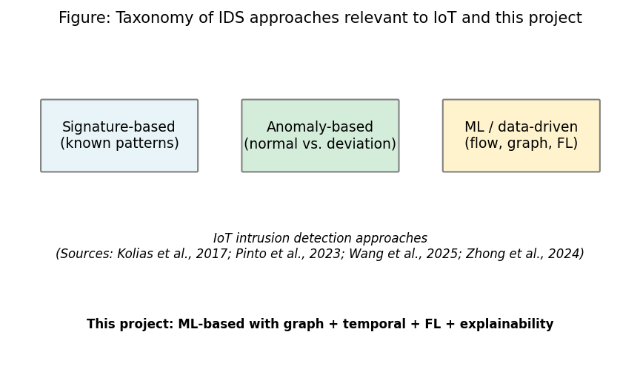
Figure 1: Taxonomy of IDS approaches relevant to IoT and this project (Chapter 2, Section 2.3)
Sources: (Kolias et al. 2017); (Pinto et al. 2023); (Wang et al. 2025); (Zhong et al. 2024). Full references in Chapter 11.

2.4 SIEM, SOC Workflows, and Alert Quality

2.4.1 Alert Volume, Triage, and the Need for Explanations
SOC teams triage SIEM-fed events; alert fatigue and opaque model scores waste analyst time (Cuppens and Miège 2002). The Elastic Common Schema (ECS) gives a vendor-neutral field pattern for events (Elastic N.V. 2023); this project uses ECS-like JSON for interoperable ingestion only, not vendor certification.

2.4.2 Explainability, SIEM Ecosystems, and Limits of “Better JSON”
Vendors still pair ML detections with playbooks and cases; “explainable” model outputs in tier-1 triage remain uneven in the record. SHAP and IG (Lundberg and Lee 2017; Sundararajan et al. 2017) are standard academic comparators. This work puts top features and top flows in the alert. Cleaner JSON does not remove workload economics (Cuppens and Miège 2002; Section 1.2).

2.5 Graph Neural Networks and Dynamic Graphs

2.5.1 GNNs, Attention, and Attribute-Based Graphs in Intrusion Detection
GNNs aggregate neighbour information on graph-structured data; GATs learn attention over edges (Velickovic et al. 2018). Ngo et al. (2025) justify kNN feature-space graphs when device IPs are unavailable, as in the CICIoT2023 public release. Attention highlights salient structure but is not a causal attack proof (Basak et al. 2025).

2.5.2 Dynamic (Temporal) Graphs and the GAT+GRU Pattern
Dynamic graph models run a GNN on each window and a sequence model (here GRU) over windows (Zheng et al. 2019; Lusa et al. 2025; Basak et al. 2025). This work tests GAT+GRU against RF/MLP on the same splits and reports CPU time (Section 8.5). Figure 2 (author) sketches GAT-then-GRU; it is not copied from a single prior paper.
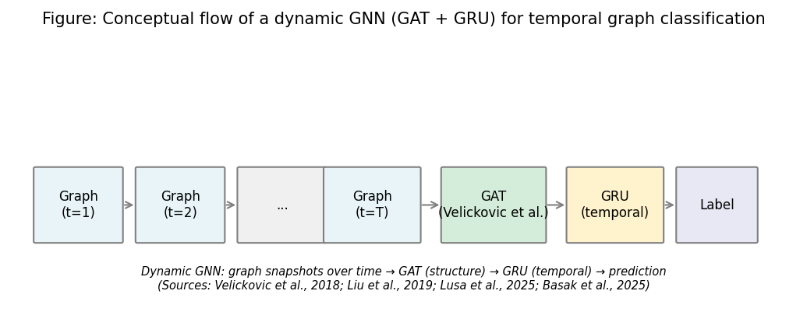
Figure 2: Conceptual flow of a dynamic GNN (GAT + GRU) for temporal graph classification (Chapter 2, Section 2.5)
Sources: (Velickovic et al. 2018); (Zheng et al. 2019); (Lusa et al. 2025); (Basak et al. 2025). Full references in Chapter 11.

2.6 Federated Learning and Privacy

2.6.1 FedAvg, Assumptions, and Communication
FedAvg (McMahan et al. 2017) averages client parameters with size weights, exchanging updates instead of raw rows (Lazzarini et al. 2023; Albanbay et al. 2025). Figure 3 is an author schematic, not a reproduction from McMahan et al. (2017).
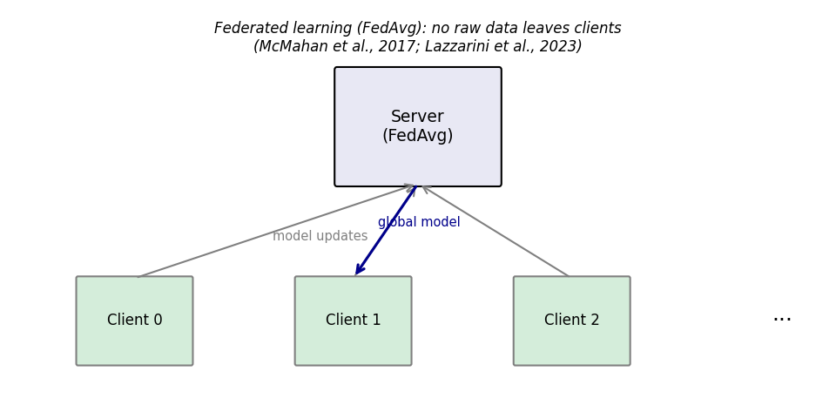
Figure 3: Federated learning (FedAvg) flow - no raw data leaves clients (Chapter 2, Section 2.6)
Sources: (McMahan et al. 2017); (Lazzarini et al. 2023). Full references in Chapter 11.

2.6.2 FL for IoT Intrusion Detection: Empirical Findings and Non-IID Reality
Qu et al. (2020) motivate decentralised training when raw pooling is disallowed. Lazzarini et al. (2023) and Albanbay et al. (2025) show non-IID client mixes and client counts change convergence. This work uses Flower with three clients, a Dirichlet non-IID split, and reports communication in Chapter 8. FedAvg is not differential privacy; the MSc scope assumes an honest-but-curious threat model.

2.7 Explainability in ML-Based Security

2.7.1 Post-hoc Attribution, Integrated Gradients, and Attention in GNNs
Post-hoc Integrated Gradients attributes input features (Sundararajan et al. 2017) via Captum (Kokhlikyan et al. 2020) on top of PyTorch. GAT edge attention highlights neighbour flows (Velickovic et al. 2018). Example alerts in Chapter 8 combine both cues (Figure 4).
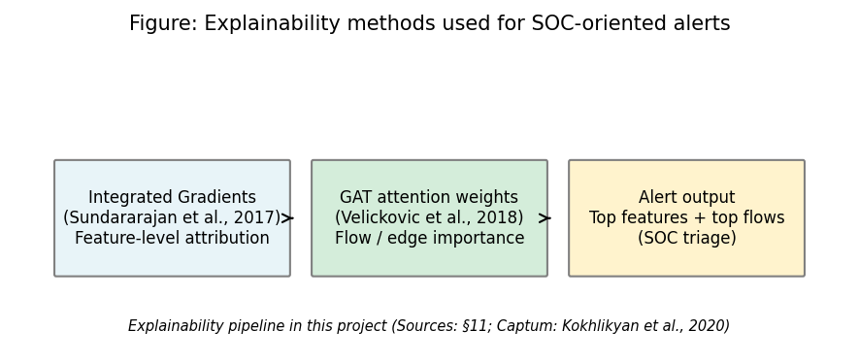
Figure 4: Explainability methods used for SOC-oriented alerts (Chapter 2, Section 2.7)
Sources: (Sundararajan et al. 2017); (Velickovic et al. 2018); (Kokhlikyan et al. 2020). Full references in Chapter 11.

2.7.2 XAI for IoT Streams, SHAP as Alternative, and Latency as a Counterargument
Alabbadi and Bajaber (2025) study XAI on IoT streams; this work uses Integrated Gradients on the GNN+Captum stack where SHAP is a natural match for tree baselines (Lundberg and Lee 2017). Integrated Gradients is latency-heavy (50 steps by default), so the implementation supports selective explanation; triage-time claims are conservative (Chapter 9).
Table 1 and Figure 5 summarise how prior studies cover the four project pillars. No single row in Table 1 combines GNN, federated training, XAI, and a SIEM-oriented alert wrapper in the way the present prototype does; that gap is made explicit in Section 2.8.
Table 1: Comparison of selected related work (sources: Chapter 11)
Study | GNN/Graph | Federated learning | Explainability | SIEM/Alert | Dataset/context
(Pinto et al. 2023) | - | - | - | - | CICIoT2023 dataset
(Velickovic et al. 2018) | Yes (GAT) | - | - | - | General GNN
(McMahan et al. 2017) | - | Yes (FedAvg) | - | - | General FL
(Sundararajan et al. 2017) | - | - | Yes (IG) | - | Attribution method
(Han et al. 2025) | Yes (DIMK-GCN) | - | - | - | IDS
(Ngo et al. 2025) | Yes (attribute-based) | - | - | - | IoT IDS
(Basak et al. 2025) | Yes (X-GANet) | - | Yes | - | NID
(Lusa et al. 2025) | Yes (TE-G-SAGE) | - | Yes | - | NID
(Lazzarini et al. 2023) | - | Yes | - | - | IoT IDS
(Albanbay et al. 2025) | - | Yes | - | - | IoT IDS
(Alabbadi and Bajaber 2025) | - | - | Yes (XAI) | - | IoT streams
(Yang et al. 2025) | Yes | - | - | - | Industrial IoT
This project | Yes (GAT+GRU) | Yes (Flower) | Yes (IG+attention) | Yes (ECS-like) | CICIoT2023
Source: Author compilation from the papers cited in Chapter 11; table is descriptive only.
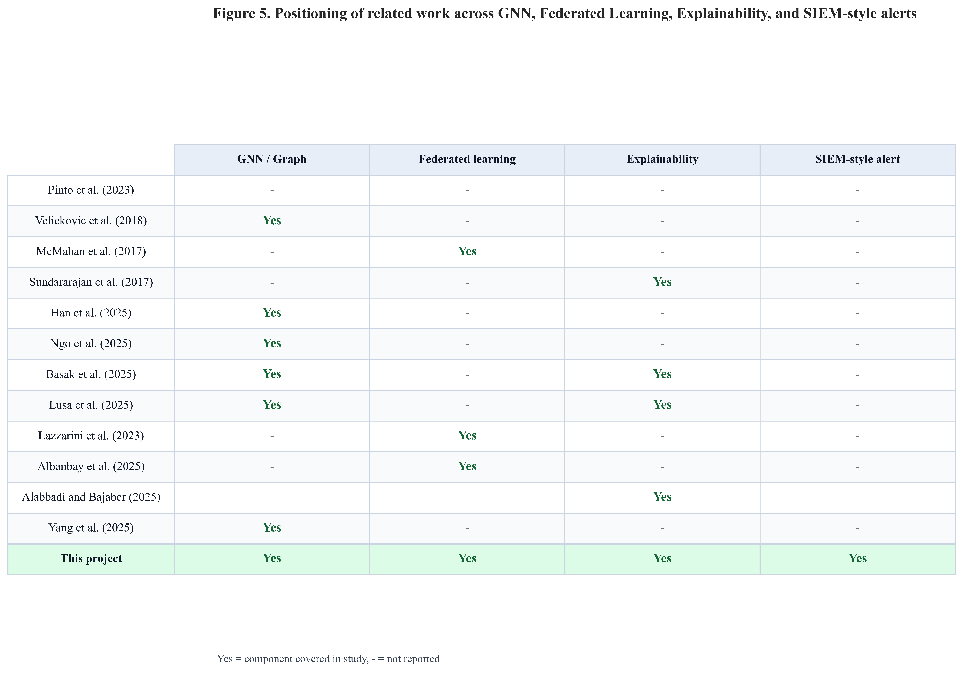
Figure 5: Positioning of related work - GNN, federated learning, explainability, and SIEM-style alerts (Chapter 2, Section 2.7)
Sources: (Pinto et al. 2023); (Velickovic et al. 2018); (McMahan et al. 2017); (Sundararajan et al. 2017); (Han et al. 2025); (Ngo et al. 2025); (Basak et al. 2025); (Lusa et al. 2025); (Lazzarini et al. 2023); (Albanbay et al. 2025); (Alabbadi and Bajaber 2025); (Yang et al. 2025). This figure synthesises Chapter 2 and supports the gap stated in Section 2.8.

2.8 Synthesis: Significance, Limitations of Prior Work, Contributions, and Gap

2.8.1 How Existing Approaches Fill Part of the Problem (and Where They Stop)
Most related papers emphasise one pillar: GNN results (Yang et al. 2025; Han et al. 2025), FedAvg in IoT (Lazzarini et al. 2023; Albanbay et al. 2025), XAI offline (Alabbadi and Bajaber 2025; Basak et al. 2025), or a benchmark (Pinto et al. 2023). Table 1 shows few rows enable all four columns; this project is the only row that attempts the full stack on one CPU-first pipeline with RF/MLP on a shared CICIoT2023 subset.

2.8.2 Anticipated Significance (What Would Matter if the Evidence Holds)
The targeted contribution is a reproducible end-to-end integration - SIEM-shaped alerts, GAT+GRU, FedAvg, ablation, sensitivity, multi-seed - not a claim to best F1 on all IoT traffic (Pinto et al. 2023).

2.8.3 Limitations in the Literature and Their Impact on Claims
Lab-only benchmarks, XAI without triage time studies (Alabbadi and Bajaber 2025), and FL “privacy” narratives that can exceed what FedAvg assumes (McMahan et al. 2017) all tighten the wording in Chapters 8–9 for this project.

2.8.4 Debate, Counterarguments, and the Consolidated Gap
Counterargument 1 - “Graphs are unnecessary if features are already strong.” The literature itself is split (Yang et al. 2025; Zhong et al. 2024). This work tests the claim with RF and MLP baselines on the same splits and reports false positive counts as well as headline F1. Counterargument 2 - “Federated learning is privacy for free.” Qu et al. (2020) and Albanbay et al. (2025) show deployment subtleties; this work states honest-but-curious assumptions and measures bytes exchanged, not a differential-privacy bound. Counterargument 3 - “Explainable alerts remove audit and workload risk.” Cuppens and Miège (2002) and Section 2.4.2 stress operational load; integrated gradients and GAT attention add artefacts for human review, not a guarantee of trust or policy compliance.
Consolidated gap: No prior row in Table 1 unifies kNN temporal graphs, a GAT+GRU stack, Flower FedAvg, Captum integrated gradients and GAT attention cues, and ECS-like JSON alerts with RF/MLP baselines on a shared CICIoT2023 subset under one MSc-style reproducible package. Chapters 4–8 instantiate that gap as design and evidence; Chapter 9 returns to significance after the results.

2.9 Mapping to CyBOK (Cyber Security Body of Knowledge)
The agreed project specification (Appendix C) records this work against CyBOK knowledge areas. The dissertation aligns with the following topics in particular: Attacks & Defences → Security Operations & Incident Management (SIEM-style alerting, SOC triage, and intrusion detection outputs); Infrastructure Security → Network Security (flow-based analysis and IoT traffic classification); Systems Security → Distributed Systems Security (federated learning without centralising raw client data); and Software and Platform Security → Software Security (engineering of the prototype pipeline, APIs, and reproducible scripts). Together, these areas situate the project within the School’s CyBOK mapping and match the specification’s indicative coverage.

2.10 Extended Comparative Review (Fifteen to Twenty Core Sources)
Section 2.10 extends the fifteen to twenty core-source breadth; the paragraph below names additional auditable touchstones alongside Sections 2.3–2.7: Zheng et al. (2019) on temporal graph stacks; Qu et al. (2020) on decentralised training; Zhong (2024) and Wang (2025) on GNN IDS surveys; Lundberg and Lee (2017) and Sundararajan et al. (2017) for SHAP/IG; Kolias et al. (2017) and Cuppens and Miège (2002) for threat and alert-noise context (Section 2.4.1).

2.11 Chapter Summary
Search strategy, title-level synthesis (Section 2.2.2), threads 2.3–2.7, Table 1 / Figure 5, gap (Section 2.8), CyBOK (2.9), and the extended source list (2.10) set up the fixed CICIoT2023 build in later chapters.

Chapter 3 – Project Management

3.1 Chapter Overview
This chapter documents the project process: planning and milestones, risk management, the IDE and platform used for verifiable development evidence (Section 3.5), and ethics posture (public dataset, no human participants). It supports transparency of execution without replicating technical information in Chapters 4–7.

3.2 Project Plan and Timeline (45-day MSc)
The work was broken down into six phases: (1) freeze requirements and literature; (2) fix the CICIoT2023 subset and preprocessing; (3) implement graph construction and central GNN training; (4) run baselines and Flower-based federated training; (5) add explainability, alert JSON, and FastAPI; (6) run ablation, sensitivity, multi-seed experiments, figures, and final writing. To eliminate ambiguity on the definition of done, each phase had tangible artefacts (metrics files, checkpoints, plots). The schedule is presented in figure 6 in the form of a Gantt chart with overlapping phase bars, more realistic to the implementation of the research in reality rather than in sequential blocks.
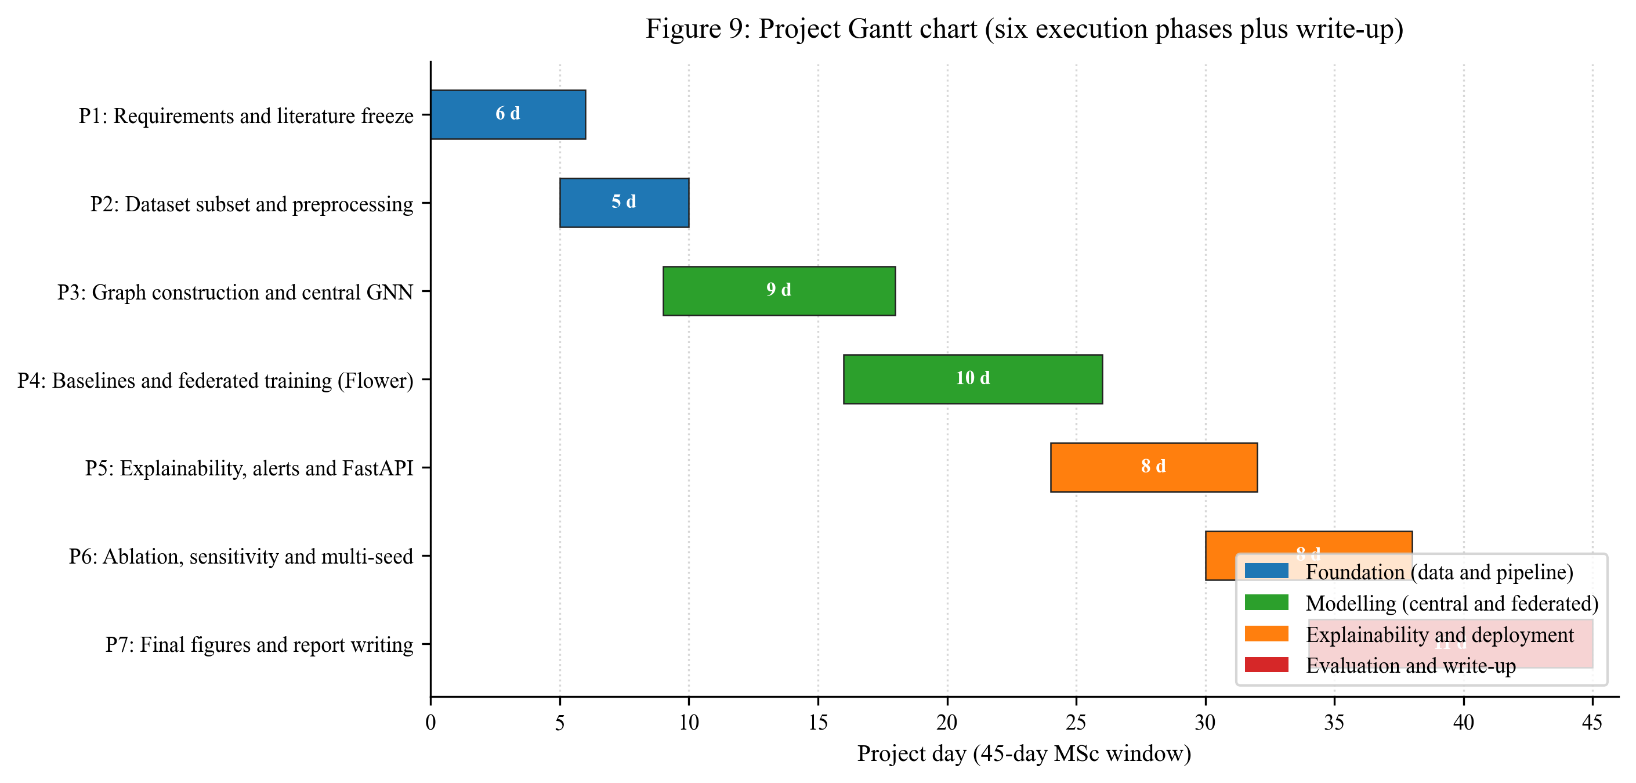
Figure 6: Project Gantt chart - six execution phases plus write-up across the 45-day MSc window (Chapter 3, Section 3.2)
Source: Author’s own diagram (scripts/generate_gantt_chart.py).

3.3 Risk Assessment

3.4 Monitoring and Progress Reviews
Risk | Mitigation
Training too slow on CPU | Fixed subset; configurable rounds/clients; early stopping
Severe class imbalance | Stratified windowing; class weights; balanced graph-level labels
Federated instability | Three clients; reproducible split; checkpoints each round
Explainability runtime | Top-k attributions; optional subset of alerts
Scope creep (extra models) | Baselines limited to RF and MLP; one main GNN architecture
The progress was tracked on a weekly rhythm with the supervisor and in relation to the phase scheme in Section 3.2. The agenda of every meeting (once a week) was based on the same three points: (1) what has been done since the previous meeting and which artefact in the repository demonstrates it; (2) what was being done and what blocker required supervisor input; (3) what was going to be done next week and what phase boundary was it. The project process documentation referenced in Appendix B captured decisions and action items so that activity can be traced after the fact.

3.5 Research Plan for Completion: IDE, Platform, and Evidence for Supervision
This section records where and how the code was built and which artefacts show progress, so the development story can be read alongside Chapters 4–6. Non-article tools (IDE, language, Git) are cited in Chapters 11–12 in author–year (Harvard) form (University of the West of Scotland Library 2025).
Working environment: Primary development used Cursor, an AI-assisted integrated development environment (IDE) based on the same editor stack as Visual Studio Code, running on Windows 10 (x64) (see also Table 5 in Section 6.2). The repository was cloned and edited in that IDE; version control, runs, and figures were produced on the same machine. Cursor is cited as a reputable, vendor-documented product (Anysphere, Inc. 2024), not as a source of research claims. Core language and tooling used alongside it are the Python implementation (Python Software Foundation 2023) and the Git version-control system (The Git Project 2023); both are standard, vendor-backed resources listed in the Chapter 12 bibliography.
Other IDEs. The project is a standard Python tree (src/, scripts/, requirements.txt) and can run in PyCharm, VS Code, or notebooks; this submission’s reproducibility is documented for local Windows runs (README.md, SETUP_AND_RUN.md, Table 5), not a hosted Colab kernel.
Reproducibility checks: Git history; frozen results/metrics/ and results/figures/ (Chapter 13); Gantt (Section 3.2); config/experiment.yaml. Development used Cursor and documented terminal runs. The IDE is infrastructure only - method and evidence are Chapters 2 and 4–7 with 11–12 references.

3.6 Ethics and Data
Only public CICIoT2023 data is used; there are no human participants or proprietary organisational datasets. The signed specification ethics section records that the project does not require full ethics-review board approval under School procedures (February 2026) for this use of non-sensitive public data. Process and ethics paperwork are referenced in Appendix B (and the signed project specification in Appendix C where relevant).

3.7 Supervision and Progress Alignment
Regular meetings with the supervisor and moderator tracked scope, risks, and alignment between the implementation and the research questions. The MSc Interim Report – Student record and action plan (15 April 2026, Dr R. M. Ujjan) are filed in Appendix B; the technical build is reported in Chapters 4–8.
Through supervision, the work stayed anchored to: (1) an end-to-end story (data → model → optional federation → explainability → SOC-shaped output); (2) a clear evaluation plan with a fixed test “contract” before results; (3) explicit limits of a lab subset and very high test metrics; (4) analysis and write-up in Chapters 7–10 without scope drift.

3.8 Chapter Summary
Clear time-boxing and risk management made the project viable and produced graph, federated, explainable, and deployable components. Section 3.5 documents the IDE, platform, and key artefacts; Chapters 11–12 list tools and the Harvard (author–year) style authority (University of the West of Scotland Library 2025).

Chapter 4 – Research Design and Methodology

4.1 Chapter Overview
This chapter gives the method in the author’s own terms: it explains how public CICIoT2023 files become trained models and one-shot test metrics with explicit leakage controls. Section 1.5 maps “research design / deployment” to Chapters 4–6 and “evaluation / metrics” to Chapters 7–8; Section 7.5 defines the metrics once. Chapters 4–5 set stages and graph semantics (Figures 7–9); every step below maps to a named path in the repository.

4.2 Research Approach
Epistemology and design. The work is empirical: a prototype pipeline (data → baselines and GNN → optional Flower → explainability → FastAPI) is judged on reproducible metrics from pre-recorded CIC rows - no live capture. Accuracy here means held-out test scores (Section 7.5, Chapter 8). The method is compositional: kNN graphs, GAT+GRU, FedAvg (Dirichlet clients), Captum IG plus GAT attention, ECS-like JSON - frozen in config/experiment.yaml.
Rigor funnel. (1) Public splits as released (train / validation / test CSVs), not a random re-split of one pool, so the benchmark’s intended separation is respected. (2) StandardScaler is fit on the training file only (first pass in src/data/preprocess.py), then transforms validation and test. (3) Tuning and early stopping use train + validation; test is for one-shot reporting. (4) Federated training never sends raw rows - only model parameters (see Section 4.5).

4.3 Dataset and Subset
Secondary data, primary use. CICIoT2023 (Pinto et al. 2023) is captured and labelled by the dataset authors in a testbed; this project consumes their pre-recorded CSVs as secondary data and applies a project-specific cleaning and learning pipeline. That distinction matters for ethics and for reproducibility: the thesis’s contribution is the transformations and models, not new packet capture.
Row volume and class balance at flow level. For the frozen run reported in this dissertation, each of the three public split files was processed to 500,000 flow rows, preserving both benign and attack traffic at roughly 2.3% / 97.7% benign/attack in each split (see Table 4 for exact counts). Binary labels are derived by mapping the dataset’s label column to $y \in \{0,1\}$ (benign vs. attack) using the benign_labels list in the YAML. Forty-six numeric flow feature columns (rates, byte statistics, flag counts, protocol indicators) are listed exhaustively in config/experiment.yaml; no IP or timestamp fields are used as model inputs in this build.
Feature extraction after split order. src/data/preprocess.py reads each split, drops/repairs inf / NaN in the 46 numerics, constructs binary_label, and applies the scaler in file order so that the training split fits the StandardScaler and the other splits only transform. That ordering is a leakage control: validation and test never influence the mean/variance used for $z$-scoring.

4.3.1 Proposed pipeline stages, artefacts, and leakage controls
Table 2 is the master stage list; later chapters reference the same order (Figure 7 is the visual analogue).
Table 2: Proposed data and modelling pipeline stages (this project).
Stage | What happens | Main artefact / location | Leakage or scope control
1 | Ingest public CSVs per split | data/raw/{train,validation,test}.csv | Splits are as published (not re-drawn from one pool)
2 | Clean numerics, binarise labels, fit scaler on train only | src/data/preprocess.py → data/processed/*.parquet + scaler.joblib | Validation/test only transformed
3 | (Optional) cap rows per split for MSc budget | Same parquet rows | Documented row cap; all models see same files
4 | Build kNN windows and sequences per split | src/data/graph_builder.py, src/data/dataset.py; data/processed/*_graphs.pt | Graphs built inside each split; no cross-split windows
5 | Train / tune baselines and GNN on train; monitor val | results/checkpoints/, results/metrics/*.json | Test not used in loss or model selection
6 | Federated GNN: partition training rows across clients; FedAvg | src/federated/; round metrics JSON/CSV | Raw flows stay local; only weights exchanged
7 | Final test metrics + CPU latency + comms + alerts | results/metrics/results_table.csv, src/siem/api.py | Single test evaluation policy (Chapter 7)
Italic paths denote examine-facing artefacts. If another researcher omits a stage (e.g. skips graph building and trains only on flows), the experiment is not the one reported here.

4.3.2 Repository layout and frozen outputs
Raw CICIoT2023 files are not committed. After Stage 2, train / validation / test parquet and the saved scaler live under data/processed/. Graph tensor caches and metrics/figures live under data/processed/ and results/ as listed in the repository README and Chapter 13. The dissertation’s numbers assume one frozen pass of the same config hash implied by the committed config/experiment.yaml.

4.3.3 Empirical flow and graph sample sizes
Table 4 records empirical sizes (from results/metrics/dataset_stats.json) for the run underlying Chapter 8. Flow row counts are per-split totals; graph counts follow the configured window = 50 flows, sequence length = 5, and knn_k = 5 (Table 3).
Table 4: Empirical sample sizes: flows, graph windows, and sequences.
Split | Flow rows (total) | Benign flows | Attack flows | Graph windows (single-split build) | Sequences (length-5)
Train | 500,000 | 11,582 | 488,418 | 924 | 920
Validation | 500,000 | 11,676 | 488,324 | 932 | 928
Test | 500,000 | 11,772 | 488,228 | 938 | 934
Notes. Windows are constructed with per-class pools and shuffling (see Section 5.3); the sequence count is slightly below the window count because the tail of the shuffled list may not form a full length-5 sequence. All models that report “sequence-level” GNN metrics consume these sequences; RF/MLP report per-flow metrics on 500,000 test flows each.

4.4 Models and Loss Functions
Three model families share the same label definition and splits but differ in input geometry: two are feature-vector classifiers; one is a graph-sequence classifier.
- Random Forest - tabular: one standardised 46-vector per flow, sklearn.ensemble.RandomForestClassifier in src/models/baselines.py; out-of-bag / train metrics are not used for test claims; test reporting is the contract in Section 7.7.
- MLP - tabular: feed-forward on 46-d inputs, MLPBaseline, trained with Adam and mini-batch cross-entropy (see Table 3).
- Dynamic GNN (GAT + GRU) - graph–sequence: for each of five windows, a GAT stack produces a graph embedding; a GRU consumes the ordered list of five embeddings; a linear head outputs logits for the binary case (DynamicGNN in src/models/dynamic_gnn.py). An ablation mean-pools time instead of a GRU (Table 10).

4.4.1 Hyperparameters, tuning funnel, and training budget (after split)
After the public splits and parquet files exist, all model-specific knobs are taken from a single YAML (Table 3). Early stopping (patience in Table 3) is driven by validation performance; test is never used to pick hyperparameters. Fine-tuning in this project means that validation-monitored training loop with fixed architecture widths - there is no manual test-set search.
Table 3: Hyperparameters, training budget, and federation (frozen in config/experiment.yaml).
Group | Parameters | Value
Reproducibility | Global seed | 42 (multi-seed study: 42, 123, 456 in Section 8.9)
Graph build | window_size, knn_k, sequence_length, minority_stride | 50, 5, 5, 25
FL | num_clients, num_rounds, local_epochs, alpha (Dirichlet) | 3, 10, 2, 0.5
RF | n_estimators, max_depth | 200, 20
MLP | hidden_dims, dropout, lr, epochs, batch_size | [128, 64, 32], 0.2, 0.001, 30, 256
Dynamic GNN | node_dim, hidden_dim, num_gat_layers, gat_heads, gru_hidden, dropout, lr, epochs, batch_size | 46, 64, 2, 4, 64, 0.2, 0.001, 30, 16
Class imbalance | class_weight_auto (train) | true
Stopping | early_stopping_patience | 5 (epochs)

4.4.2 Objectives, losses, and federation rule
Binary cross-entropy (all trainable models). Labels are binary (benign = 0, attack = 1). For N training items, with yᵢ ∈ {0,1} and modelled probability pᵢ = P(yᵢ = 1 | input i), the training objective is binary cross-entropy: minimise the mean of −(yᵢ log pᵢ + (1−yᵢ) log(1−pᵢ)) over i = 1,…,N.
What counts as one training item differs by model. Random Forest and MLP use one flow per i; the dynamic GNN uses one window sequence of T = 5 window graphs with a single sequence label (any-window attack rule; Section 5.3), and the same mean cross-entropy is applied to the sequence logits. Class weighting in scikit-learn (class_weight) and the PyTorch loss, where used, reweights the minority benign class without changing the splits (Section 4.3).
Federation (FedAvg). In Flower, each client minimises the same local cross-entropy on its data partition. After each round, the server sets the global network parameters to a sample-size–weighted average of the client models (McMahan et al., 2017): each client k contributes with weight nₖ / n, where nₖ is that client’s training count (rows or batch-equivalent) and n = Σₖ nₖ over all clients k. This is a weighted mean of the client parameter vectors after the round; it is not a raw feature upload - raw flow feature vectors never leave the client machine (Section 2.6; wiring Section 6.6).
Implementation mirrors the equations: kNN graph build and FedAvg server steps live in src/data/graph_builder.py and src/federated/; training in src/models/trainer.py. Test claims use Section 7.5 metrics via src/evaluation/metrics.py and results/metrics/.

4.5 Federated Learning Setup
FedAvg (McMahan et al. 2017): clients train locally and send weights; the server averages and broadcasts the global model - no raw flows cross sites (Section 2.6). This project uses Flower with three clients, ten rounds, and two local epochs per round (timelines and risks: Chapter 3; wiring: Section 6.6). The same GNN architecture is trained centrally and federally for a fair comparison. Communication cost is estimated from serialized float32 parameter traffic (Chapter 8).
Non-IID simulation: training rows are partitioned across clients with a Dirichlet distribution over class proportions (alpha = 0.5) so client label mixes differ (stronger than IID sharding; weaker than adversarial splits). Rationale: reflect sites with different exposure while staying trainable within the MSc budget.

4.6 Explainability
Two forms of explanation are used:
- Integrated Gradients (Captum): Applied to the chosen model (e.g. the dynamic GNN or the MLP) to attribute the prediction to input features. The top contributing features are extracted and included in the alert.
- Attention weights: For the GAT-based model, attention weights over edges or neighbours are used to identify which flows or connections the model focused on. These can be summarised as “top flows” or “top edges” in the alert.
Explanations are produced for selected predictions (e.g. positive alerts). The top-k (k=5) features and flows are included in each alert to keep the explanation concise. If computing explanations for every prediction is too slow, they are applied only to a subset (e.g. high-confidence alerts) and this is noted as a limitation.

4.7 Evaluation Plan
Formulae and definitions for precision, recall, F1, FPR, and ROC-AUC are given once in Section 7.5. Here, the plan only maps measurements to questions.
Evaluation is designed to answer the three sub-questions and support the main research question.
- Metrics: Precision, recall, F1-score, ROC-AUC, and false positive rate on the fixed test set. A confusion matrix is reported.
- Model comparison: Centralised training: Random Forest, MLP, and dynamic GNN are compared on the same splits. Federated training: the same GNN (or MLP) is trained with FedAvg and compared to its centralised version.
- Time and cost: Time-window analysis (e.g. performance across different window sizes or positions), federated round-by-round performance, approximate communication cost (bytes), and CPU inference time per sample or per batch.
- Explainability and SOC use: Three to five example alerts are generated with full explanations (top features and flows). These are discussed in terms of whether they would help a SOC analyst triage (e.g. whether the highlighted flows and features are interpretable and actionable).
Contingencies match Chapter 3 (subset size, rounds/clients, optional subset of explained alerts). Linkage to questions: precision, recall, F1, ROC-AUC, and FPR → sub-question 1 (and central leg of sub-question 2); per-round FL metrics and comms cost → sub-question 2; example alerts → sub-question 3; CPU inference latency → main question (edge deployability).

4.8 Software and Tools
The methodology relies on a small set of mainstream Python libraries chosen for stability, documentation, and CPU compatibility. The full version pin list is in the repository requirements.txt; this section names the components and the role each plays in answering the research questions. Module-level wiring and code excerpts are in Chapter 6.
- Python 3.10 is the implementation language for all data, model, federated, explainability, and API code.
- PyTorch and PyTorch Geometric are used to build the GAT layers and the dynamic GNN with sequence encoding (Sections 6.4 and 6.5).
- scikit-learn provides the Random Forest baseline, the StandardScaler (used in preprocess.py for parity with sklearn conventions), and metric helpers (Sections 4.3 and 6.3–6.5). Splits are not created by train_test_split in this build - the public CIC train/validation/test files are the splits.
- Flower is used for the federated learning server and client implementation with FedAvg (Section 6.6).
- Captum is used for Integrated Gradients on the trained model (Section 6.7).
- FastAPI is used to serve the prediction and explanation endpoint that produces ECS-like JSON alerts (Sections 6.8 and 6.9).
- Matplotlib, Pandas, and NumPy are used for figure generation, table preparation, and numeric handling.
- Pygments is used to render dark-theme code screenshots for the implementation chapter and for Appendix A (code figures).
- Git and GitHub are used for version control of the project repository linked in Appendix D.
Configuration is externalised in config/experiment.yaml so that hyperparameters (window size, kNN k, GAT heads, FL rounds and clients) can be changed without code edits. All experiments use seed 42 unless overridden by the multi-seed script. This combination of fixed seed, externalised config, and named scripts is what makes the methodology in this chapter reproducible from the codebase.

4.9 Chapter Summary
Chapter 4 has fixed the Research Method contract: secondary CICIoT2023 use, leakage-aware preprocessing (Tables 2–4), YAML-frozen hyperparameters and post-split tuning funnel (Table 3), loss and FedAvg equations (Section 4.4.2), and pointers to federation, XAI, evaluation, and tools. Chapter 5 gives the design-level pipeline and graph semantics; Chapter 6 gives deployment code and Table 5 testbed; Chapter 7 schedules multi-scenario runs (Table 6).

Chapter 5 – Design

5.1 Chapter Overview
This chapter presents the system design in the same order as the narrative: the end-to-end research pipeline first (Figure 7), then authoritative graph semantics and windowing rules (Section 5.3), then architecture (Figure 8) and a conceptual kNN schematic (Figure 9) that match the implementation in Chapter 6. Deployment-facing outputs use ECS-like JSON alerts.

5.2 Pipeline, Alerts, and Deployment (Conceptual)
Figure 7 gives the stage-level view: preprocessing, graph construction, central or federated training, explainability, and SIEM-style alerting on CPU. Windowing, kNN k, and sequence labelling are specified in Section 5.3; module-level wiring is in Chapter 6.
Alerts are output in a SIEM-style JSON format, aligned with ideas from ECS where useful: event type, timestamp, source/target information, label, score, and an explanation field (top features / top flows). The runtime path is a FastAPI service that runs inference (and optionally explanations) on CPU, matching the edge objective.
Stage boundaries (prep → learn → score → alert) are fixed so Chapters 6–8 do not redefine contracts; verification can trace faults by stage.
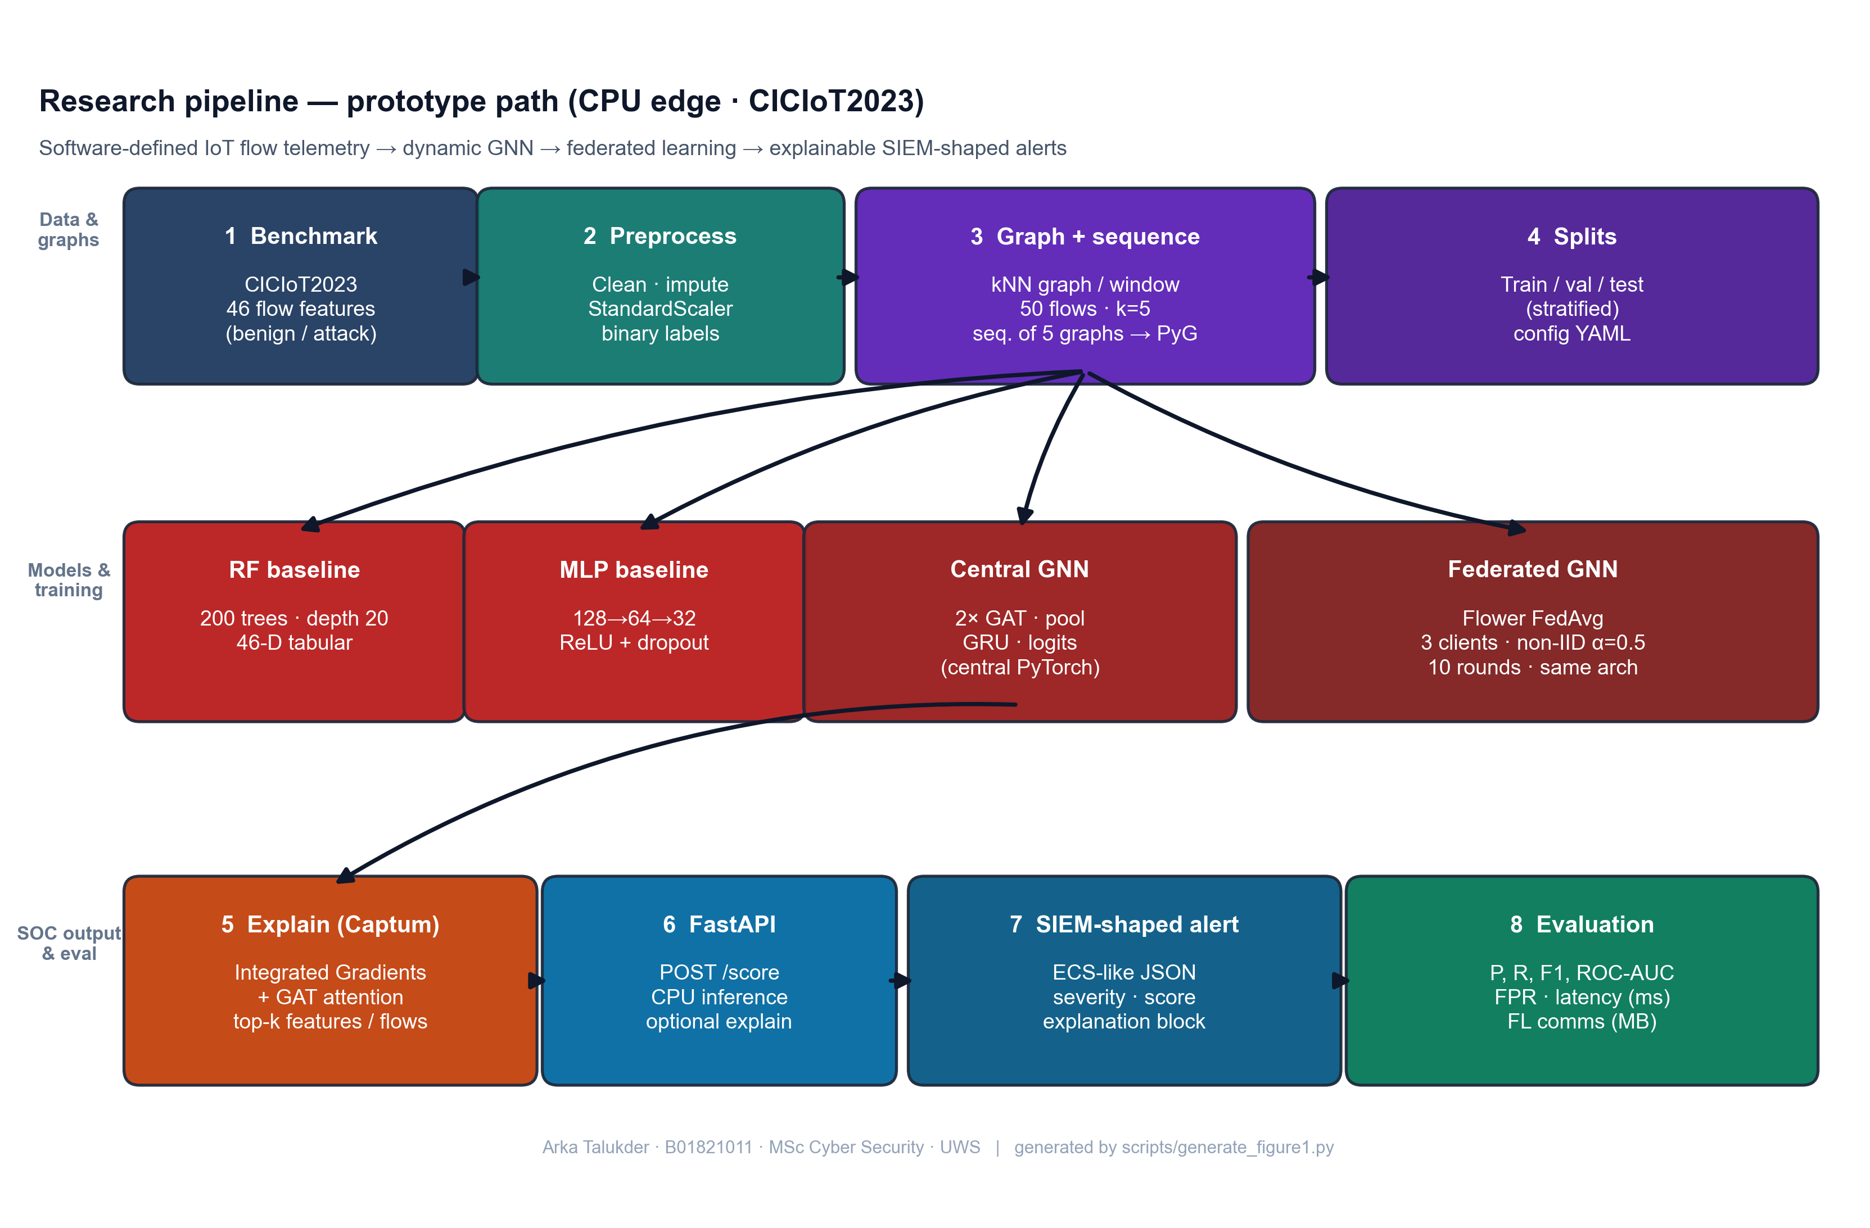
Figure 7: Research pipeline - from raw IoT flow data to explainable SIEM alerts (Chapter 5, Section 5.2)
Source: Author’s own diagram (scripts/generate_figure1.py); reflects the implementation and data path described in Chapters 5–6.

5.3 Graph Design (Flows to kNN Snapshots)
Authoritative section: every other mention of window/k/sequence rules in this thesis points here or to src/data/graph_builder.py / dataset.py (Section 6.4).
The graph is built from flow data to capture structural relationships between network flows within each observation window.
- Nodes: One node per flow; 46 CIC feature columns (Ngo et al. 2025: attribute graphs when IPs are not used publicly).
- Edges: Per window, kNN in Euclidean 46-D space (bidirectional); default k = 5 (Chapter 8 sensitivity).
- Windows and sequences: Flows are grouped into fixed-size windows (e.g. 50 flows per window). To handle extreme class imbalance at flow level, the implementation (src/data/graph_builder.py) builds each window only from flows in a single class pool (benign or attack); the graph-level label is that pool’s class (within a window all flows share the same label, so this matches a unanimous vote but is defined by construction, not by aggregating mixed labels). Benign and attack windows are balanced, then shuffled into one list. Training samples are sequences of five consecutive graphs in that list; the sequence-level label is attack if any of the five windows is attack-labeled (GraphSequenceDataset in src/data/dataset.py). The GRU reads the five graph embeddings in order. Five windows was chosen to balance context with memory and training time.
This design is kept simple so that it can be implemented and tested within the project scope. The kNN approach applies to any flow-feature dataset regardless of whether device identifiers are present. More complex designs (e.g. device-based graphs when IPs are available, multi-hop temporal aggregation) could be explored in future work.

5.4 Research Design and System Architecture
Figure 8 summarises the end-to-end research design: public benchmark flows are preprocessed and turned into temporal graphs; the dynamic GNN can be trained centrally or through Flower FedAvg on non-IID clients; the same checkpoint path supports Captum explanations and FastAPI scoring into SIEM-shaped JSON. It is a conceptual diagram (not a formal UML class model); a full UML component diagram can be pasted into the Word submission if the module asks for it.
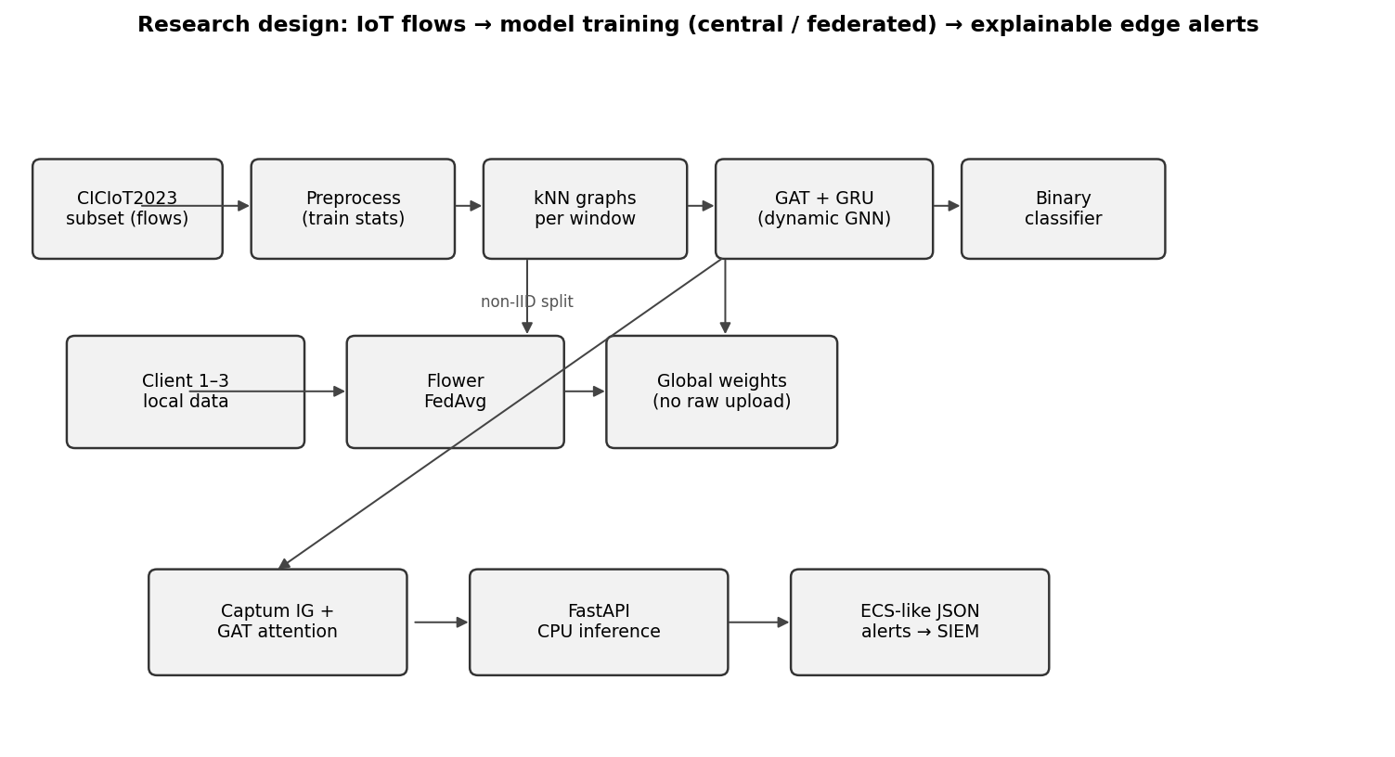
Figure 8: Research design - data flow, federated training, and edge alerting (Chapter 5, Section 5.4)
Source: Author’s own diagram; generated for this dissertation (scripts/draw_research_design.py).

5.5 Conceptual Illustration: Similarity-Based Graph in One Window
Public CICIoT2023 releases do not always include device-level topology, so attribute / similarity-based edges are a standard way to obtain a graph for a GNN (Ngo et al. 2025). Figure 9 is an author-original schematic (drawn with Matplotlib, following the library’s documented style sheets - see Matplotlib gallery): each point is one flow in a window; lines show k nearest neighbours in a 2-D projection of feature space (the real system uses 46 dimensions and Euclidean distance, Section 5.3). It is not a screenshot from another paper; it only visualises the same construction principle as the implementation.
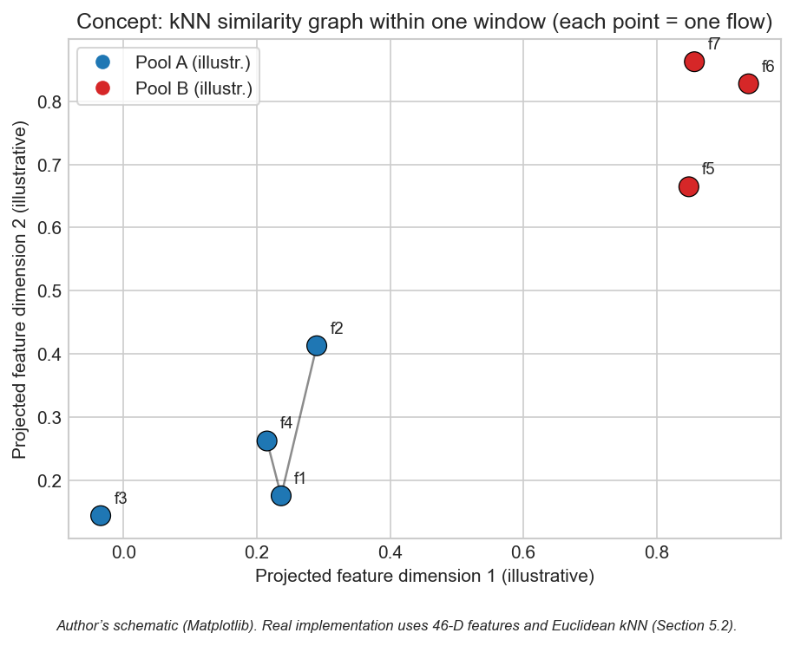
Figure 9: Conceptual kNN similarity graph within one observation window (Chapter 5, Section 5.5)
Source: Author’s own diagram (scripts/generate_similarity_knn_concept.py). Concept aligns with attribute-based graph construction for IoT intrusion detection (Ngo et al. 2025); image is not reproduced from third-party publications.

5.6 Chapter Summary
The design encodes relational (kNN), temporal (window sequences), and SOC-facing outputs in one architecture.

Chapter 6 – Implementation and System Development

6.1 Chapter Overview
This chapter describes how the prototype was implemented: code structure, libraries, training and federated loops, Captum integration, alert formatting, and the FastAPI scoring endpoint. In this project, implementation detail matters a lot, because the claim is not only model accuracy, it is full pipeline feasibility under CPU limits. So I explain where each major function lives and how the modules connect.
The implementation is organised under src/ by responsibility (data, models, federated learning, explainability, SIEM output, evaluation) and is driven by scripts that reproduce end-to-end runs from configuration (scripts/run_all.py and related scripts). Configuration is externalised in YAML so experiments can be re-run without code changes.

6.2 Environment and Tools
Table 5 records the testbed used for the reported CPU-only training, evaluation, and API latency. It is a virtual/laboratory setup (author workstation) rather than a production SOC; the point is to show reproducible hardware class and the absence of GPU shortcuts.
Table 5: Testbed, storage, and runtime stack (Research Method Deployment).
Resource | Stated configuration for this project
Host OS | Windows 10, x64; single-user development machine
Runtime | Python 3.10; virtual environment with pinned dependencies (requirements.txt)
CPU | x86-64 multi-core (CPU-only: no discrete GPU in any reported run)
RAM | 16 GB system RAM (sufficient to hold 500k-row parquets, graph batches, and training at batch sizes in Table 3)
Disk | SSD (NVMe-class) for repository, data/raw/, data/processed/, results/ (HDD is not required for the frozen subset)
Network / traffic | Pre-recorded CICIoT2023 files only; no live traffic generation in the testbed for training
Isolation | Optional Docker for FastAPI demo (README.md); all metrics reproducible on bare Windows + Python
The system is implemented in Python 3.10. PyTorch 2.x is used for the neural models (GNN and MLP), and PyTorch Geometric (PyG) provides graph operations and GAT layers. Scikit-learn is used for Random Forest and for metrics (precision, recall, F1, ROC-AUC, confusion matrix). The Flower framework is used for federated learning (client and server logic). Captum is used for Integrated Gradients. FastAPI is used for the REST API. The code is structured so that data loading, graph building, training, and inference can be run separately or together. All experiments are run on CPU to match the edge deployment goal; training time is therefore longer than with a GPU but remains feasible for the chosen subset.
Configuration is managed via config/experiment.yaml (window size, kNN k, sequence length, model hyperparameters, and FL rounds/epochs) - Table 3 in Section 4.4.1 is the one-line summary of those knobs.

6.3 Data Loading and Preprocessing
The CICIoT2023 subset is loaded from the public train / validation / test CSVs (or equivalent files) as released with the benchmark - not by re-splitting a single pool in this build. The public flow tables provide the 46 numeric features used in this project plus labels; optional endpoint columns are retained only when present in the schema. Missing values are handled and labels are binarised (benign vs. attack) as in src/data/preprocess.py; a global random seed (Table 3) governs shuffling in graph building and model initialisation, not the boundary between splits.
Preprocessing includes feature standardisation (zero mean, unit variance) using statistics computed only on the training set, then applied to validation and test to avoid leakage. For the GNN, flows are windowed and converted to graphs as in Section 6.4. For Random Forest and MLP, the same processed splits are used in tabular form with exactly one row per flow (46 features + binary label), loaded by load_processed_split in src/models/baselines.py - not window aggregates. Graph-sequence construction uses src/data/dataset.py; configuration is in config/experiment.yaml.

6.4 Graph Construction
Implementation follows Section 5.3 exactly: build_graphs_for_split and flows_to_knn_graph in src/data/graph_builder.py build single-class pools, balanced windows, shuffle, Euclidean kNN with bidirectional edges, and graph batches consumed by GraphSequenceDataset in src/data/dataset.py. Default k and window size come from config/experiment.yaml; sensitivity to other (window, k) pairs is in Section 8.8. Baselines read one row per flow from processed parquet via load_processed_split (src/models/baselines.py) - not graph windows.

6.5 Model Implementation
Random Forest: Implemented with scikit-learn on one row per processed flow (46 features + label). The implementation uses 200 trees and max_depth=20; class weights address flow-level imbalance in the training parquet.
MLP: Feed-forward network with three hidden layers (128, 64, 32), ReLU, dropout 0.2; two output logits for benign vs. attack, trained with cross-entropy and Adam (learning rate 1e-3), matching MLPBaseline and the training loop in scripts/run_all.py.
Dynamic GNN (GAT + GRU): Two GAT layers (4 heads, hidden 64) read out each window graph; a two-layer GRU (hidden 64) runs on the five-step embedding sequence; a linear head outputs logits (~128k parameters). The same module is trained centrally or under FedAvg (binary CE; server averages client weights).

6.6 Federated Learning (Flower)
Federated training uses Flower with FedAvg: clients train locally on their partitions for a fixed number of epochs per round and send updated weights to the server; the server aggregates updates and broadcasts the new global model. No raw data is exchanged - only parameters - so communication cost can be approximated from float32 weight traffic (reported in Chapter 8). Implementation details are in src/federated/.

6.7 Explainability
Integrated Gradients: For a given input (e.g. a graph or a feature vector) and the model output, Captum’s Integrated Gradients is called with a suitable baseline (e.g. zero vector or mean feature vector). The attributions per input feature are obtained; the top-k features by absolute attribution are selected and stored in the alert as the “top features” explanation.
Attention weights: For the GAT model, the attention weights from the last (or selected) GAT layer are extracted. They indicate how much each edge or neighbour contributed. These are mapped back to flow identifiers (e.g. source–destination pairs) and the top flows are written into the alert. If the model has multiple layers, a simple strategy (e.g. average or use the last layer) is applied and documented.
Explanations are attached to the alert JSON. The number of integration steps (default 50) trades off attribution accuracy with computation time. The src/explain/explainer.py module wraps both methods and produces a unified explanation object. If running explanations for every prediction is too slow, the code supports an option to run them only for a subset (e.g. when the model confidence is above a threshold).

6.8 Alert Generation and SIEM-Style Output
When the model predicts an attack (or a specific attack type), an alert object is built. It includes: event type (e.g. “alert” or “detection”), timestamp, source and destination (e.g. IP or device ID), predicted label, confidence score, and an explanation object. The explanation object contains the list of top features (from Integrated Gradients) and/or top flows (from attention). The structure follows ECS-like conventions where possible (e.g. event.category, event.outcome, and custom fields for explanation). The alert is returned as JSON. This format is suitable for ingestion into a SIEM or for display in a SOC dashboard. The src/siem/alert_formatter.py module implements the ECS-like structure with fields such as event.category, event.outcome, and a custom explanation object holding top_features and top_nodes or top_flows. Severity levels (low, medium, high) are derived from the confidence score.

6.9 FastAPI Deployment and CPU Inference
A FastAPI application is set up with an endpoint that accepts input (e.g. a single flow, a batch of flows, or a pre-built graph). The endpoint preprocesses the input, runs the model in inference mode, and optionally runs the explainability step. The response is the alert JSON. CPU inference time is measured (e.g. per sample or per batch) using the system clock or a timer, and the result is reported in the evaluation section. No GPU is required; the design targets edge devices with CPU only. The API can be run locally or in a container for demonstration.
The src/siem/api.py service loads a checkpoint, scores sequences on CPU, and returns alerts; latency matches the figures in Chapter 8 (scripts/run_all.py and generate_alerts_and_plots.py reproduce the frozen artefacts in results/).

6.10 Implementation Code Screenshots (Author’s Codebase)
The screenshots below show core fragments only (function bodies, the training-step loop, sequence forward head, Captum IG core, and the /score handler) - not full modules. They are auto-rendered with Pygments (one-dark) at the cited line ranges (scripts/render_chapter6_code_screenshots.py); Appendix A uses the same style for code reference.
flows_to_knn_graph - kNN edges and tensors (core)
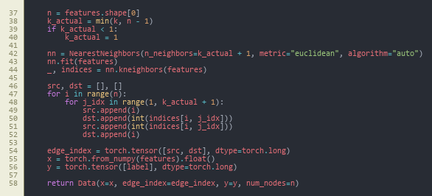
Figure 10: flows_to_knn_graph (core) - NearestNeighbors, bidirectional edges, PyG Data (Chapter 6, Section 6.10)
Source: src/data/graph_builder.py, lines 37–58.
build_graphs_for_split - stratified pools (core)
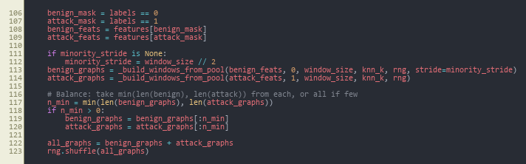
Figure 11: build_graphs_for_split (core) - class pools, balance, merge, shuffle (Chapter 6, Section 6.10)
Source: src/data/graph_builder.py, lines 106–123.
train_one_epoch - central GNN training loop
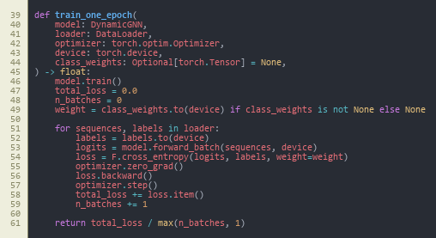
Figure 12: train_one_epoch - class-weighted cross-entropy, backward pass, optimiser step (Chapter 6, Section 6.10)
Source: src/models/trainer.py, lines 39–61.
DynamicGNN.forward - sequence to logits
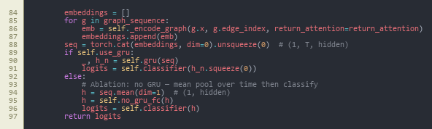
Figure 13: DynamicGNN.forward (core) - stack window embeddings, GRU vs. mean-pool ablation, classifier (Chapter 6, Section 6.10)
Source: src/models/dynamic_gnn.py, lines 84–97.
_ig_wrapper - Integrated Gradients (core)
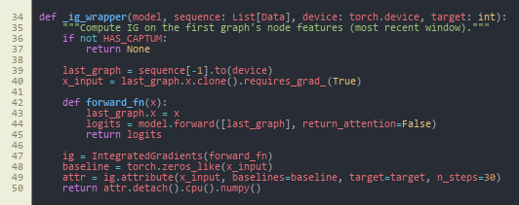
Figure 14: _ig_wrapper (core) - Captum IntegratedGradients on the last window’s node features (Chapter 6, Section 6.10)
Source: src/explain/explainer.py, lines 34–50.
POST /score - FastAPI handler (core)
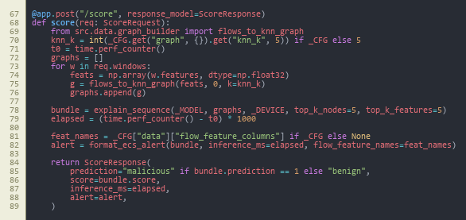
Figure 15: POST /score (core) - build graphs, explain_sequence, ECS-style alert, timing (Chapter 6, Section 6.10)
Source: src/siem/api.py, lines 67–89.
Together, these figures summarise the data → train → forward → attribute → deploy path; federated local training reuses the same train_one_epoch step inside GNNFlowerClient (Appendix A).

6.11 Reproducibility Note
The implementation is fully script-driven from config/experiment.yaml (window size, kNN k, GAT heads, sequence length, FL rounds and clients, Dirichlet alpha, seed). All main experiments use seed 42; the multi-seed study in Section 8.9 uses 42, 123, 456. Entry points are: scripts/run_all.py (preprocessing, baselines, central GNN, evaluation), src.federated.run_federated (Flower server and clients), scripts/run_ablation.py, scripts/run_sensitivity_and_seeds.py, and scripts/generate_alerts_and_plots.py. Every table and figure is backed by a CSV/JSON under results/metrics/ or an image under results/figures/. All runs are CPU-only.

6.12 Chapter Summary
Implementation delivers a modular codebase with scripted reproducibility, covering data through to SIEM-style JSON and CPU inference.

Chapter 7 – Testing and Evaluation

7.1 Chapter Overview
This chapter specifies the evaluation protocol: data validity and reliability (Section 7.4.1), experimental setup (Section 7.4.2), formal metric definitions (Section 7.5), dataset statistics (Section 7.6), and comparison rules (Section 7.7). The purpose is to fix the “test contract” so Chapter 8 can report results as evidence rather than opinion.

7.2 Evaluation Scope
Evaluation answers the three sub-questions and supports the main question (Section 1.3). Setup, hyperparameters, and federated heterogeneity are in Section 7.4; metric definitions in Section 7.5; scale statistics in Section 7.6; decision rules for comparing models in Section 7.7. The plan was fixed before final test reporting so metrics were not tuned to the test set.

7.2.1 Pass Criteria
To make the evaluation a pre-registered contract rather than a post-hoc summary, the following pass criteria were defined before any test-set numbers were generated. Each criterion is tied directly to a research question:
- Pass-1 (sub-question 1): the dynamic GNN achieves F1 ≥ 0.95 and ROC-AUC ≥ 0.95 on the central test set, and matches or exceeds the better of the two baselines (Random Forest, MLP) on F1.
- Pass-2 (sub-question 1): the dynamic GNN reports a lower or equal false-positive rate than the strongest baseline on the central test set.
- Pass-3 (sub-question 2): the federated GNN trained with Flower FedAvg over three non-IID clients reaches an F1 within 0.02 of the centralised GNN on the central test set within ten rounds.
- Pass-4 (sub-question 2): total federated communication stays within an order of magnitude consistent with edge-network feasibility (target ≤ 100 MB over ten rounds for the chosen architecture).
- Pass-5 (sub-question 3): at least three example alerts are produced with a complete explanation payload (top features and top flows) in ECS-like JSON.
- Pass-6 (main question): mean CPU inference latency per five-window sequence stays within edge-realistic bounds (target ≤ 100 ms).

7.2.2 Fail Criteria
A run is treated as a fail for evaluation reporting if any of the following hold:
- Fail-1: evidence of data leakage between train, validation, or test splits.
- Fail-2: F1 of the dynamic GNN below 0.90 on the central test set, or precision below 0.90 with recall held at 1.0 (which would indicate degenerate "always attack" behaviour).
- Fail-3: federated training does not converge within ten rounds, or final federated F1 falls more than 0.05 below the centralised GNN.
- Fail-4: alerts cannot be produced from the trained model through the FastAPI endpoint, or the explanation payload is empty for the chosen examples.
- Fail-5: CPU inference latency exceeds 1 s per sequence (which would void the edge-deployment claim).
The actual outcomes against these criteria are reported in Chapter 8 and discussed in Chapter 9.

7.3 Test Schedule
Table 6 is the multi-scenario execution map: it ties each research question element (baselines, central GNN, FL, ablation, sensitivity, multi-seed, deployment) to a concrete output file in results/. The schedule is staged so that the test split is not re-used for ad hoc tuning.
Table 6: Evaluation scenarios, scripts, and frozen artefacts (Research Method Deployment).
Test phase | Project days | Output artefact | Outcome (vs. criteria)
Baseline RF and MLP on test split | 16–18 | results/metrics/results_table.csv (RF, MLP rows) | Reference set established
Central GNN training and test | 18–22 | results/metrics/results_table.csv (Central GNN row); gnn_training_history.json | Pass-1, Pass-2, Pass-6
Federated GNN (10 rounds, 3 clients) | 22–26 | results/metrics/fl_round_metrics.csv; results/figures/fl_convergence.png | Pass-3, Pass-4
Example alerts via FastAPI /score | 26–28 | results/alerts/*.json | Pass-5
Ablation (GAT-only vs full) | 30–32 | results/metrics/ablation_table.csv | Stability evidence
Sensitivity grid (window x k) | 32–35 | results/metrics/sensitivity_table.csv; results/figures/sensitivity.png | Stability evidence
Multi-seed (42, 123, 456) | 35–38 | results/metrics/multi_seed_summary.json | Stability evidence

7.4 Experimental Setup

7.4.1 Data validity, reliability, and limits on generalisation
Internal validity (whether the test measures what we claim). (i) Label and task definition - the benchmark’s flow-level labels are mapped to a single binary target in config/experiment.yaml so every model optimises the same target. (ii) Split integrity - train / validation / test come from separate CICIoT2023 files; no rows from validation or test fit the StandardScaler (Section 4.3). (iii) Test-set discipline - test is used for one-shot reporting; early stopping and federated monitoring use train + validation or per-round dev metrics, not test (Sections 4.2, 4.4.1). (iv) Metric validity - precision, recall, F1, FPR, and ROC-AUC are defined in Section 7.5 and implement P/R/FPR for the attack-positive class, which is the SOC-relevant failure mode for benign traffic.
Reliability (repeatability and stability). Hyperparameters are frozen in config/experiment.yaml. Seeds (42 primary; 42, 123, 456 in the multi-seed run) control shuffling and initialisation so runs can be re-executed from the repository. Ablation (Table 10), (window, k) sensitivity (Table 11), and multi-seed results (Table 12) are stability checks: they do not convert a lab dataset into a field guarantee, but they show the headline result is not tied to a single ad hoc choice.
External validity (what is not guaranteed). Results are on a CICIoT2023 subset with artificial attack mix; live IoT traffic, concept drift, and adversarial evasion are out of scope (Section 1.4). Societal benefit is therefore argued as plausible impact on analyst workload and data minimisation under federation (Section 9.6), not as a proven national-scale deployment.

7.4.2 Hardware, software, and run configuration
All experiments use the same public train / validation / test split from the CICIoT2023 subset processed for this build. A global random seed (e.g. 42) supports reproducible shuffling and initialisation. Centralised training: Random Forest, MLP, and the dynamic GNN are trained on the training split and evaluated on the test split. Federated training: the same GNN is trained with Flower and FedAvg across 3 clients; the global model is evaluated on the same central test set after each round. No test data is used during training or for choosing hyperparameters; the validation split supports early stopping and monitoring. Graph windows use 50 flows per window and 5 windows per sequence by default; (window, k) alternatives appear in the sensitivity study (Section 8.8).
The federated labelling of clients uses a Dirichlet distribution (alpha = 0.5) over class proportions (Table 3). Table 5 records CPU / RAM / SSD; config/experiment.yaml and Table 3 give the full training budget for fair comparison across models.

7.5 Metrics
Positive class and confusion matrix. All models are evaluated as binary classifiers with attack as the positive class. From the test-set confusion matrix, TP (true positive), TN (true negative), FP (false positive), and FN (false negative) are counted at the same decision rule used in code (e.g. 0.5 threshold on the predicted attack probability, unless a script states otherwise). The headline “how well does the detector do?” in this thesis is not a single unweighted accuracy under a highly imbalanced attack-heavy flow mix (~98% attack at flow level, Table 4), but the F1 and ROC-AUC pair (and FPR where relevant) defined below.
Table: Definitions of the reported metrics (attack = positive).
Metric | Definition and interpretation
Precision | TP / (TP + FP). Share of predicted attacks that are true attacks.
Recall (true positive rate, TPR) | TP / (TP + FN). Share of true attacks that are detected.
False positive rate (FPR) | FP / (FP + TN). Share of true benign items incorrectly flagged as attack (SOC-relevant where benign volume is high).
F1 | Harmonic mean of precision and recall: 2·TP / (2·TP + FP + FN), i.e. 2·Precision·Recall / (Precision + Recall).
ROC-AUC | Area under the receiver operating characteristic curve: TPR plotted against FPR as the classification threshold on predicted attack probability is varied from 0 to 1. A value of 1.0 is perfect rank separation; 0.5 is chance performance.
Where these are applied. src/evaluation/metrics.py and the JSON/CSV under results/metrics/ use these definitions consistently for central and federated runs. For federated training, the same test-set metrics are computed from the global model (unless a note in Chapter 8 states a per-round view). Communication cost is approximated from float32 parameter payload size; CPU inference time comes from the FastAPI path in src/siem/api.py, in milliseconds per flow or per window sequence, as tabulated in Chapter 8.

7.6 Dataset and Experiment Statistics
Table 4 and results/metrics/dataset_stats.json record per-split flow counts; about 2.3% benign at flow level. Stratified windowing gives roughly balanced graph-level classes. The GNN dataset has 920 / 928 / 934 train/validation/test sequences (each sequence: five 50-flow windows; sequence label = attack if any window is attack, per GraphSequenceDataset). RF/MLP consume one row per flow on the same splits; the GNN emits one label per five-window sequence. Federated training uses a Dirichlet(α=0.5) split over class proportions (Section 4.5).

7.7 Comparison Design
Sub-Q1 compares the dynamic GNN to RF/MLP on the same test protocol (F1, ROC-AUC, FPR). Sub-Q2 compares the final federated global GNN to the central GNN. Sub-Q3 uses worked example alerts with explanation payloads; there is no formal user study, only structured author/supervisor judgement of plausibility.

7.8 Chapter Summary
Chapter 7 fixed the setup, metrics, data scales, and comparison protocol used for all models and federated runs. Chapter 8 reports the numerical and graphical outcomes only.

Chapter 8 – Results Presentation

8.1 Chapter Overview
This chapter reports results as tables and figures with brief factual description; interpretation is in Chapter 9 and personal reflection in Chapter 10. Tables keep decimal precision (e.g. 0.9986) and the prose mirrors the same values as percentages. Artefacts are stored under results/metrics/, results/figures/, and results/alerts/.

8.2 Centralised Model Comparison (Sub-Question 1)
The dynamic GNN (GAT + GRU), Random Forest, and MLP were evaluated on the same test set; the federated GNN (final global model) is evaluated on that test set for parity. Table 7 is the authoritative record (decimals; multiply by 100 for headline percentages). In brief, central and federated GNNs report F1 and ROC-AUC of 1.0 on this run; RF and MLP are marginally below on F1. False-positive rate (benign as attack): GNN 0%; RF 4.84% (187 FP); MLP 0.10% (4 FP). Figures 16–22 show confusion matrices, ROC curves, and a per-metric bar view; Figure 27 (Section 8.5) reports inference time alongside F1.
Table 7: Model comparison on CICIoT2023 test set
Model | Precision | Recall | F1 | ROC-AUC | Inference (ms)
Random Forest | 0.9989 | 0.9984 | 0.9986 | 0.9996 | 46.09
MLP | 1.0000 | 0.9885 | 0.9942 | 0.9984 | 0.66
Central GNN | 1.0000 | 1.0000 | 1.0000 | 1.0000 | 22.70
Federated GNN | 1.0000 | 1.0000 | 1.0000 | 1.0000 | 20.99
Source: Author-derived metrics on the fixed CICIoT2023 subset (Pinto et al. 2023); results/metrics/results_table.csv; reproducibility in Chapter 13.
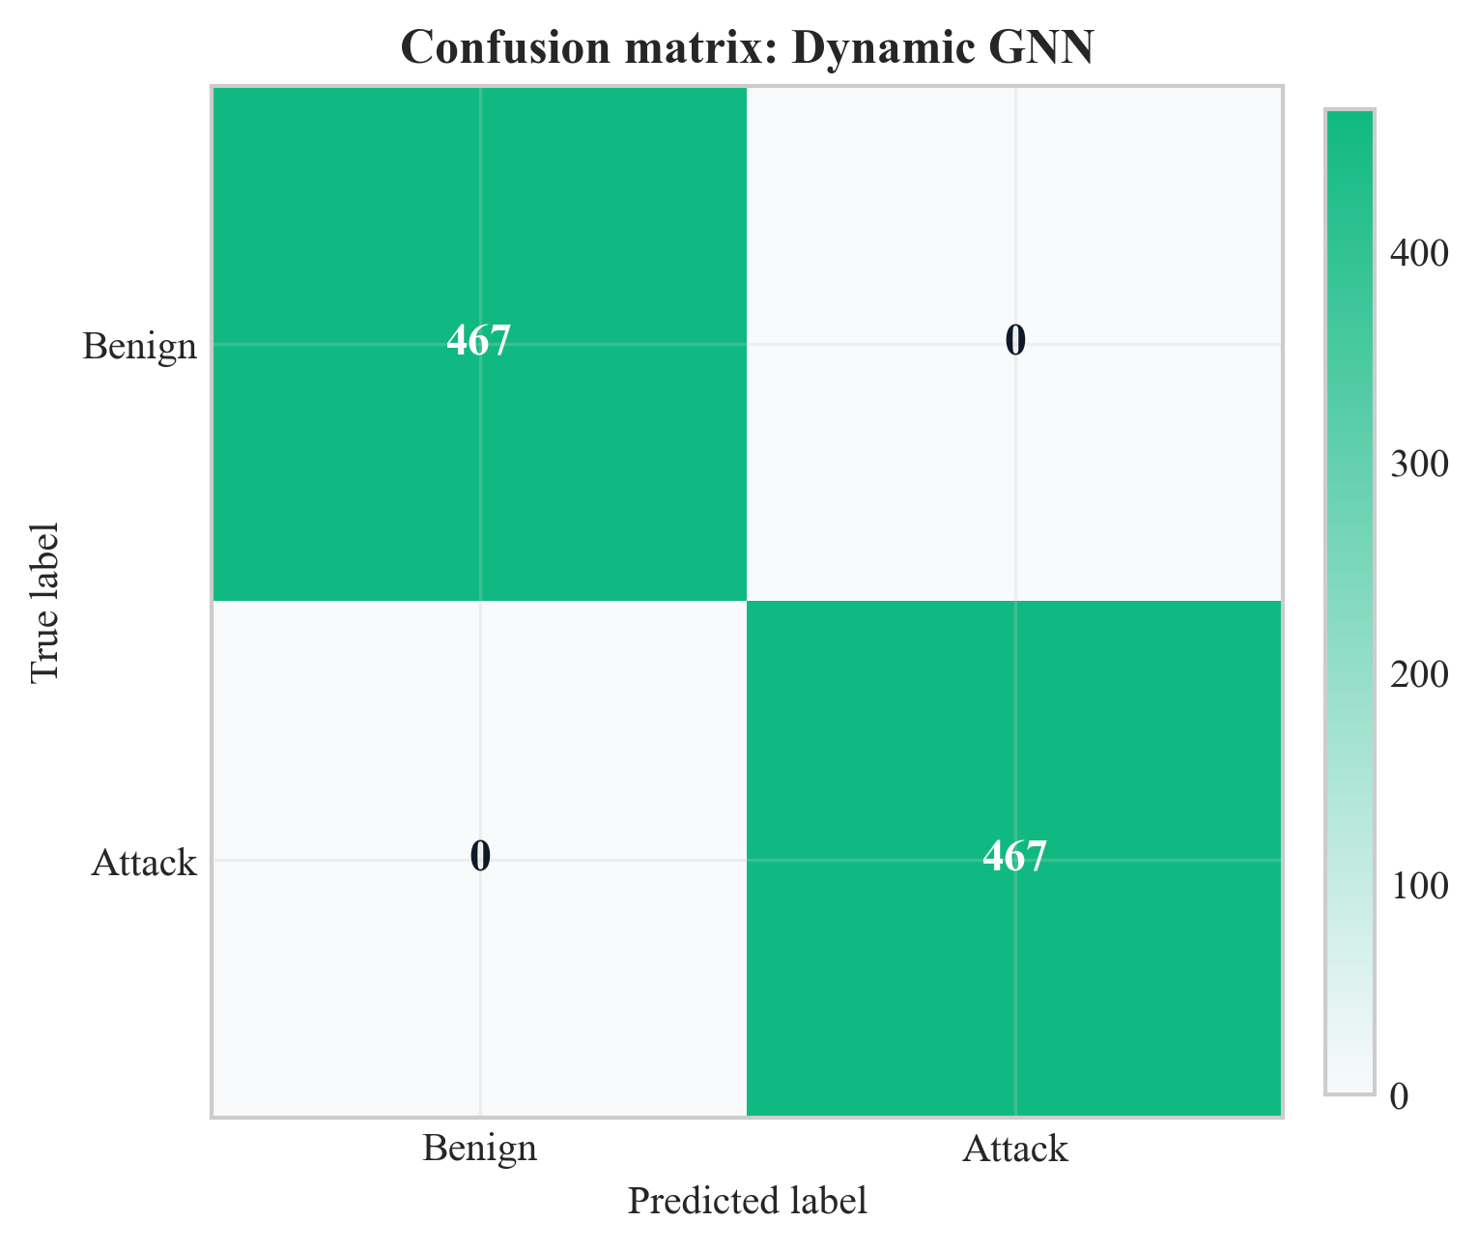
Figure 16: Confusion matrix for Dynamic GNN on test set (Chapter 8, Section 8.2)
Source: Author’s own plot from test-set predictions; data CICIoT2023 (Pinto et al. 2023); scripts/run_all.py.
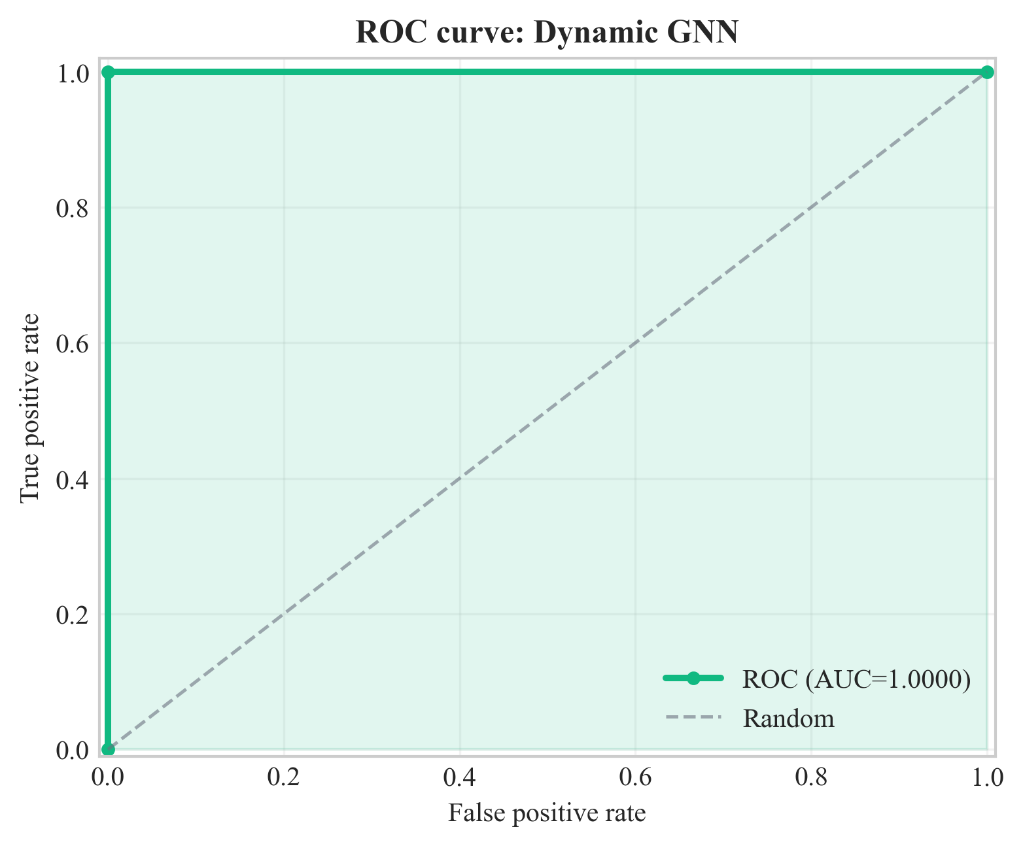
Figure 17: ROC curve for Dynamic GNN on test set (Chapter 8, Section 8.2)
Source: Author’s own plot from test-set scores; data CICIoT2023 (Pinto et al. 2023); scripts/run_all.py.
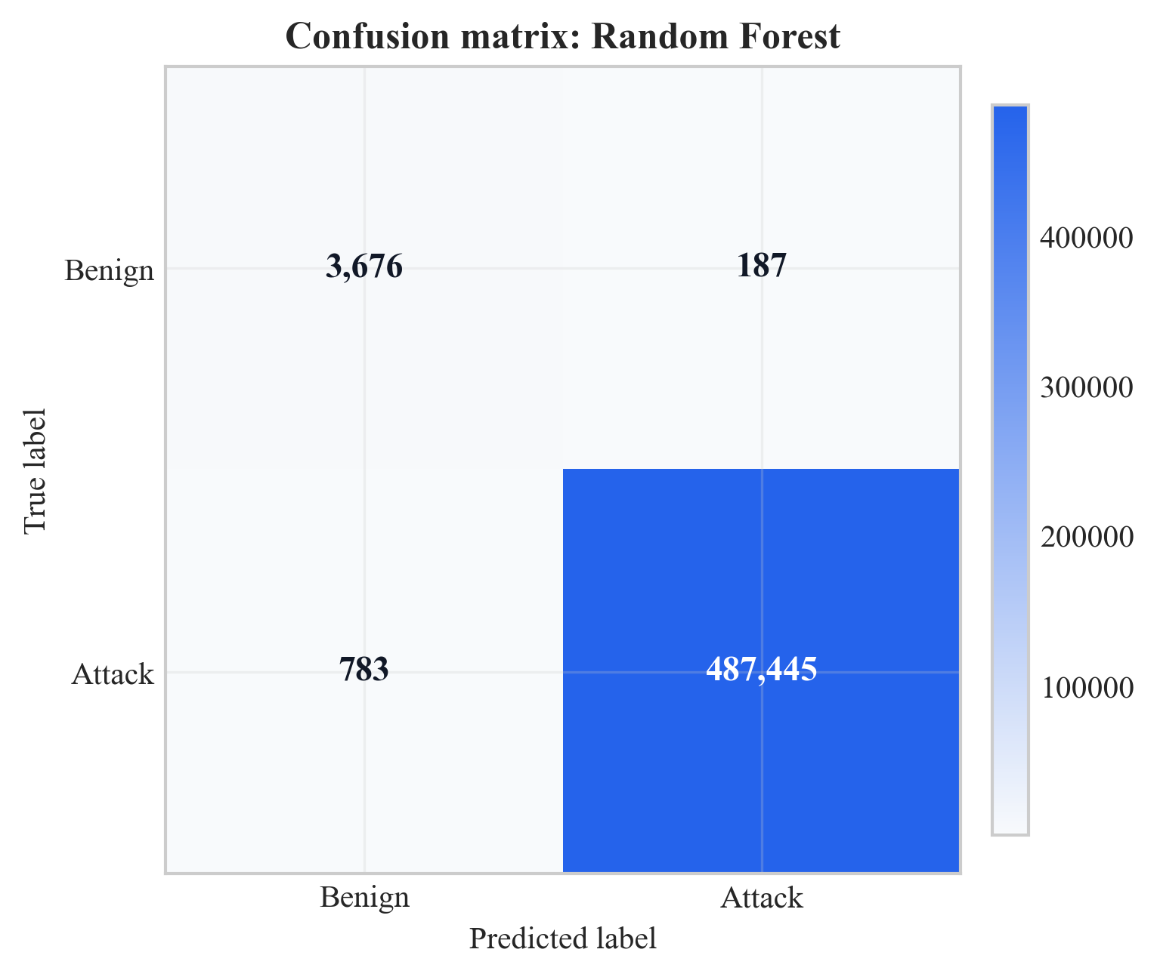
Figure 18: Confusion matrix for Random Forest on test set (Chapter 8, Section 8.2)
Source: Author’s own plot; baseline from scripts/run_all.py; data CICIoT2023 (Pinto et al. 2023).
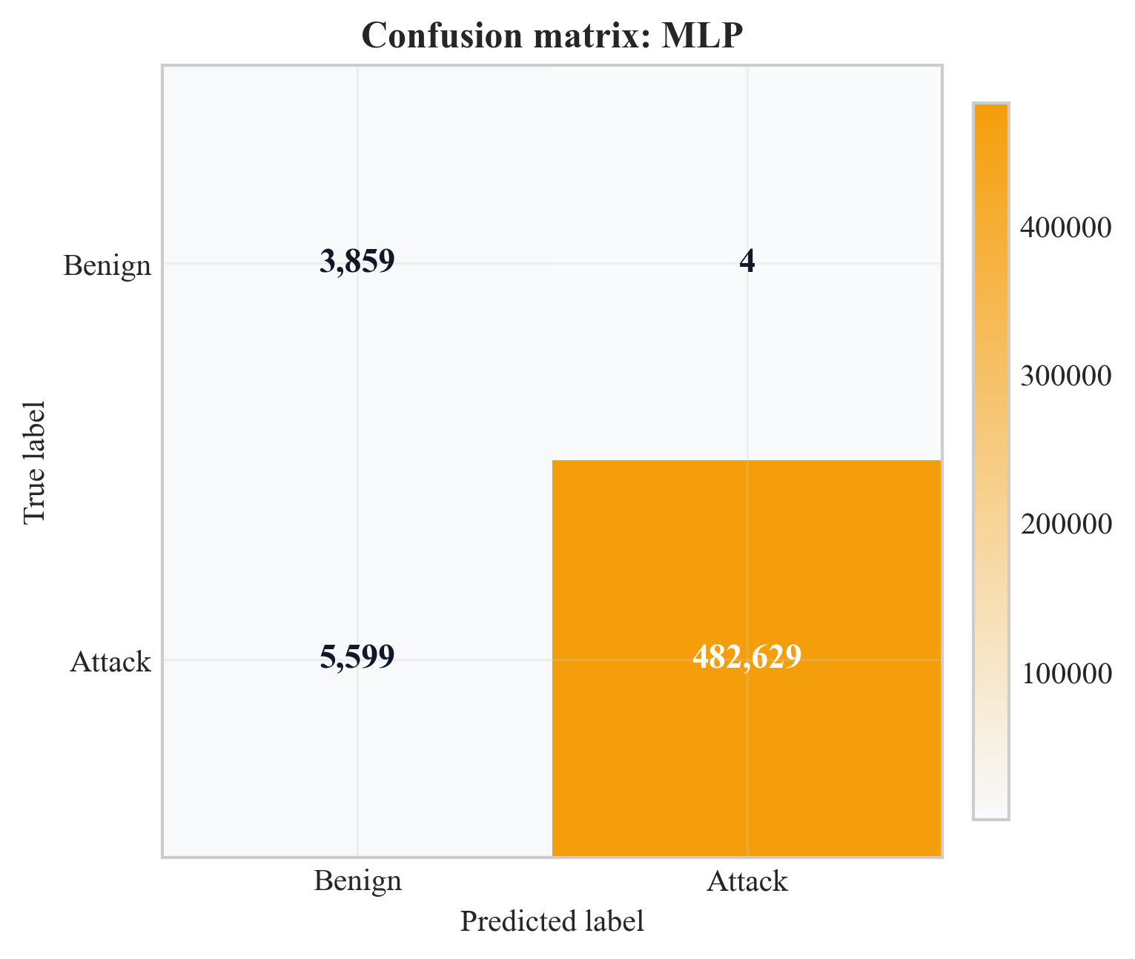
Figure 19: Confusion matrix for MLP on test set (Chapter 8, Section 8.2)
Source: Author’s own plot; baseline from scripts/run_all.py; data CICIoT2023 (Pinto et al. 2023).
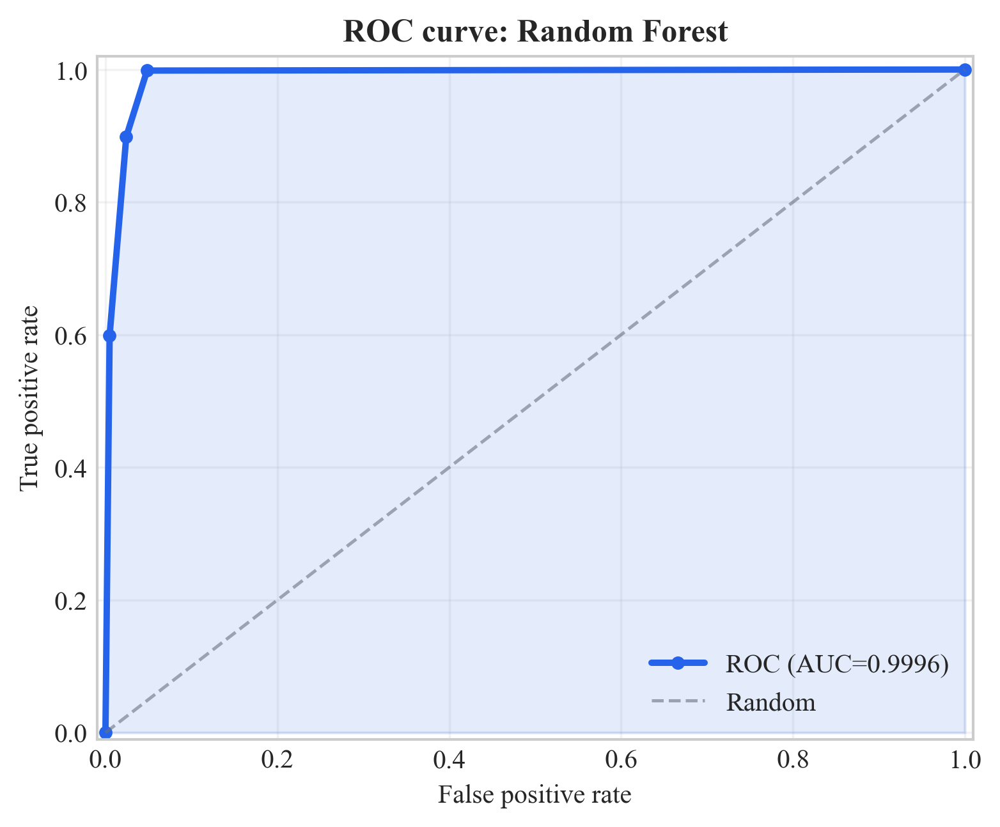
Figure 20: ROC curve for Random Forest on test set (Chapter 8, Section 8.2)
Source: Author’s own plot; baseline from scripts/run_all.py; data CICIoT2023 (Pinto et al. 2023).
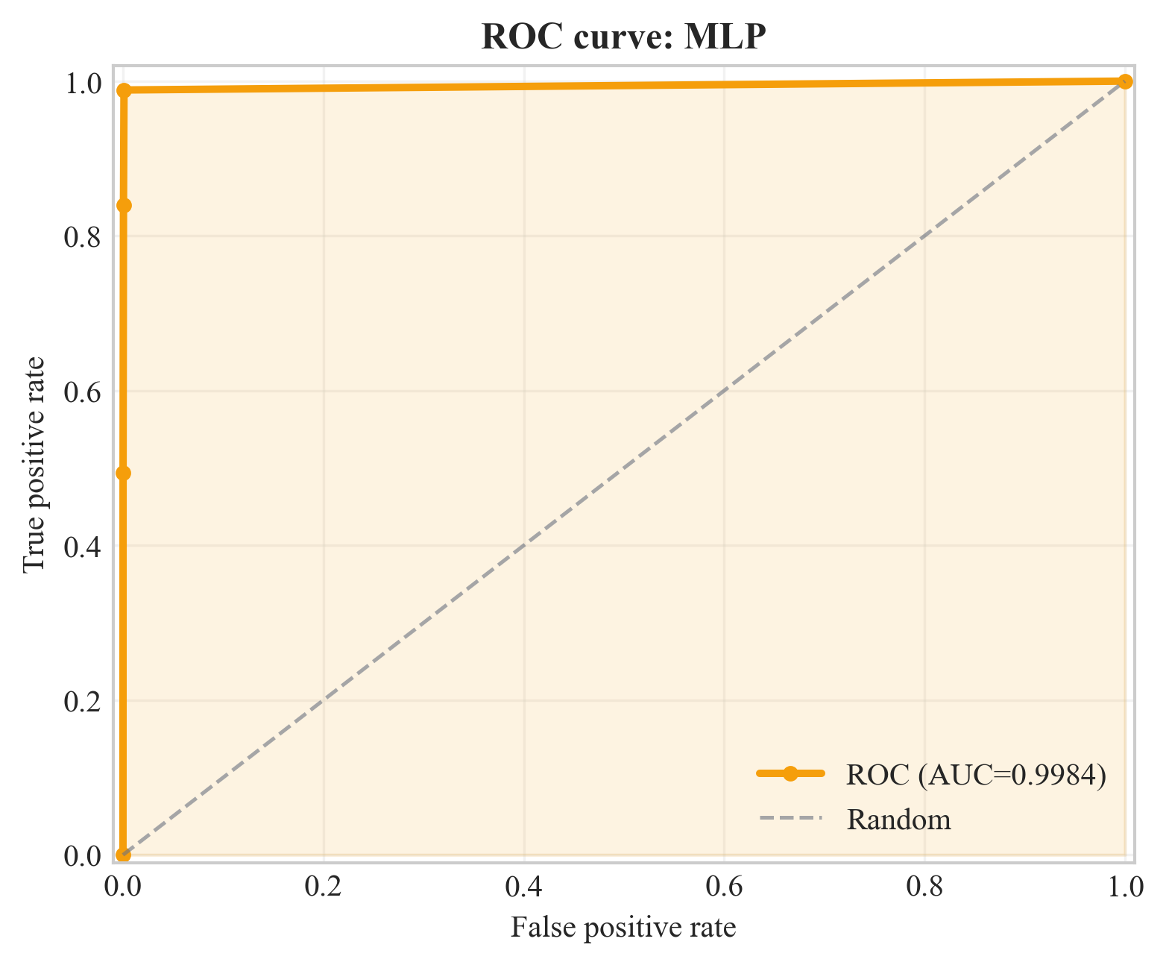
Figure 21: ROC curve for MLP on test set (Chapter 8, Section 8.2)
Source: Author’s own plot; baseline from scripts/run_all.py; data CICIoT2023 (Pinto et al. 2023).
Figures 16, 18, 19: GNN: 0 FP / 0 FN; RF: 187 FP; MLP: 4 FP. ROC curves (17, 20, 21); AUCs in Table 7 (Chapter 9 for triage).
Figure 22: per-metric bars (y-axis 0.97–1.00); GNNs at 1.0; MLP recall 0.9885; RF high but below GNN on F1.
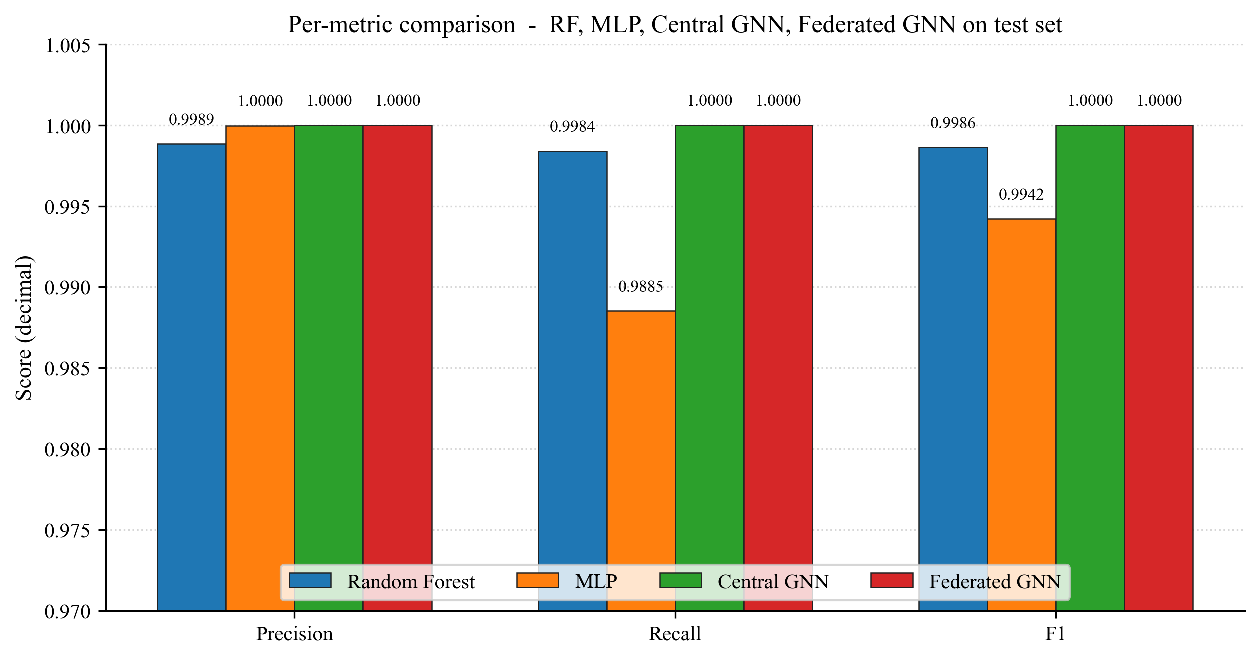
Figure 22: Per-metric comparison across RF, MLP, Central GNN, and Federated GNN on the test set (Chapter 8, Section 8.2)
Source: Author's own plot (scripts/generate_extra_result_figures.py); data from results/metrics/{rf,mlp,central_gnn,federated_gnn}_metrics.json.

8.3 Federated Learning (Sub-Question 2)
10 rounds, 3 clients, non-IID (alpha = 0.5), same test set; Table 8 + Figure 23. Early rounds are weaker (e.g. round 1: F1 98.3%, AUC 55.7%); from round 7, F1 100%; final round F1 = AUC = 100%, matching the central GNN.
Communication cost is approximated from float32 parameter size: 128,002 parameters, order of ~1.0 MB per client upload/download per round; ~3.07 MB per round aggregate messaging is reported, ~31 MB total over 10 rounds with three clients. Interpretation (privacy vs. centralised parity, feasibility) is in Chapter 9.
Table 8: Federated learning round-by-round metrics
Round | Precision | Recall | F1 | ROC-AUC
1 | 0.967 | 1.000 | 0.983 | 0.557
2 | 0.967 | 1.000 | 0.983 | 1.000
3 | 0.967 | 1.000 | 0.983 | 1.000
4 | 0.994 | 1.000 | 0.997 | 1.000
5 | 0.997 | 1.000 | 0.998 | 1.000
6 | 0.990 | 1.000 | 0.995 | 0.973
7 | 1.000 | 1.000 | 1.000 | 1.000
8 | 1.000 | 1.000 | 1.000 | 1.000
9 | 1.000 | 1.000 | 1.000 | 1.000
10 | 1.000 | 1.000 | 1.000 | 1.000
Source: Author-derived round metrics; Flower FedAvg run; results/metrics/ (see Chapter 13).
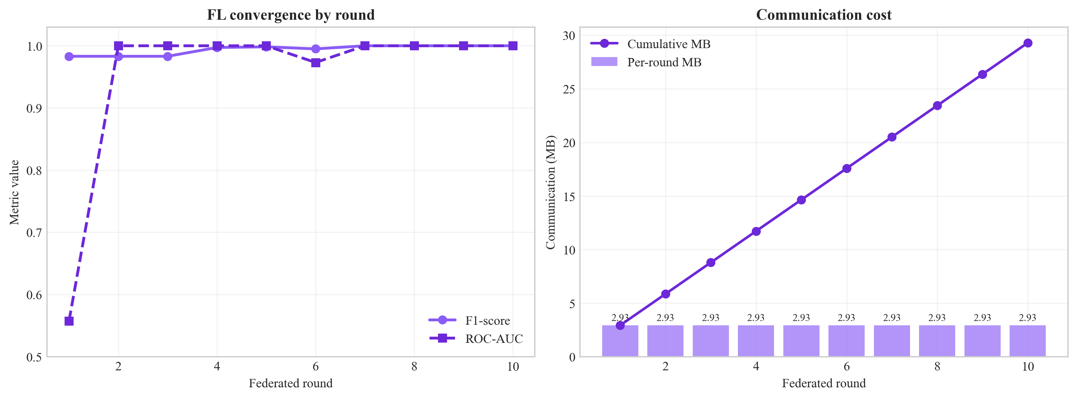
Figure 23: Federated learning convergence (F1 and ROC-AUC vs. round) (Chapter 8, Section 8.3)
Source: Author’s own plot; scripts/generate_alerts_and_plots.py / federated training logs; data CICIoT2023 (Pinto et al. 2023).
Figure 24 is the federated GNN confusion matrix on the same test set after the final FedAvg round. Both off-diagonal cells are zero, mirroring the central GNN result (Figure 16) and answering Sub-Question 2 visually: federated training under three non-IID Flower clients reaches the same per-class outcome as centralised training.
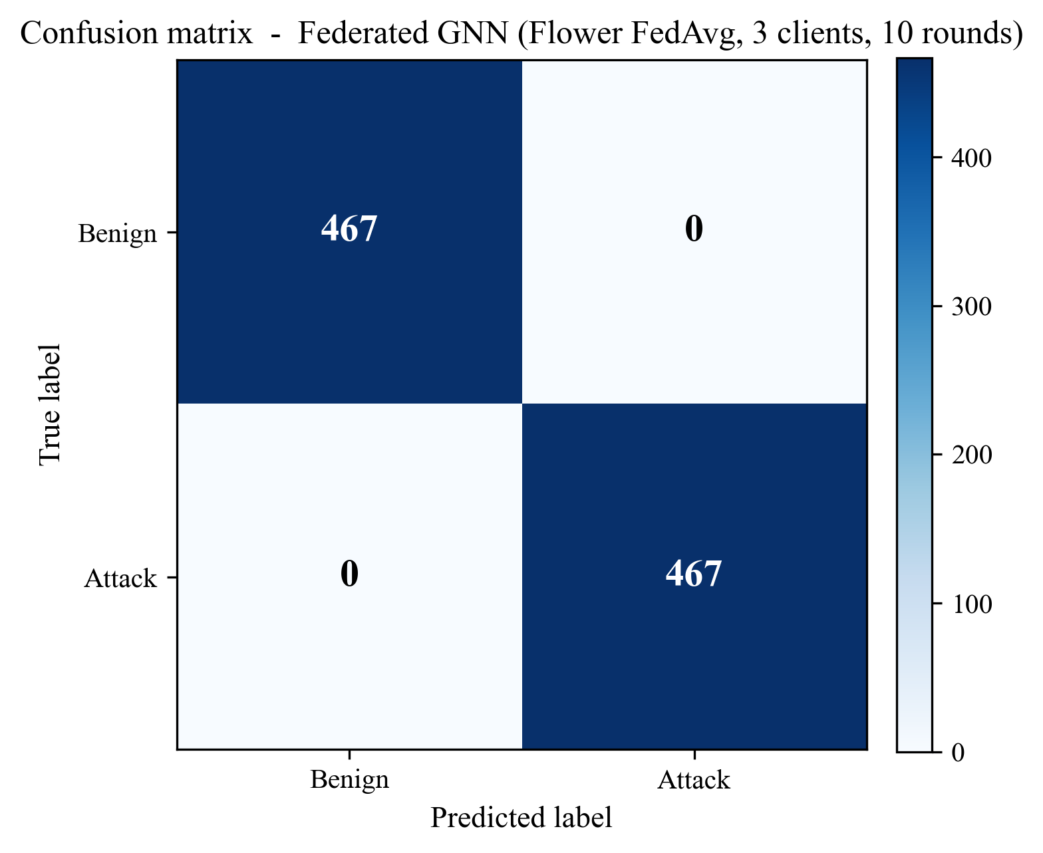
Figure 24: Confusion matrix of the federated GNN (Flower FedAvg, 3 clients, 10 rounds) on the test set (Chapter 8, Section 8.3)
Source: Author’s own plot (scripts/generate_extra_result_figures.py); reconstructed from results/metrics/federated_gnn_metrics.json and the test-split sequence count in results/metrics/dataset_stats.json.
Figure 25 shows the communication cost behind those metrics: ~3.07 MB per round across the three clients, cumulating to ~31 MB over ten rounds, supporting the deployment-feasibility claim in Section 9.6.
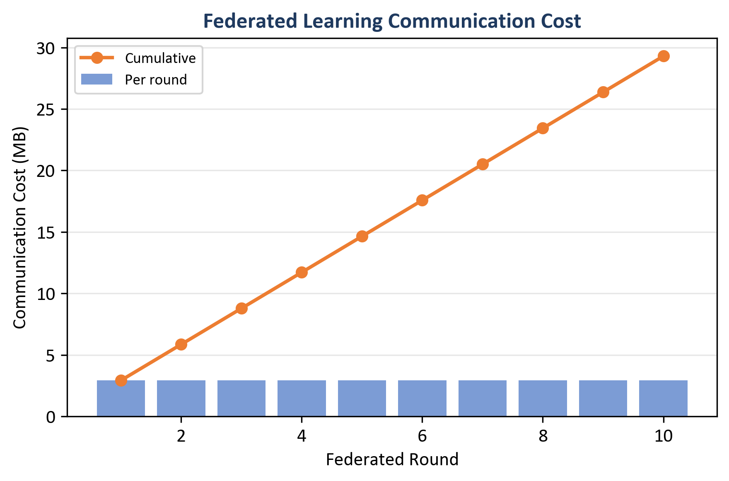
Figure 25: Federated learning communication cost - per round (bars) and cumulative (line) (Chapter 8, Section 8.3)
Source: Author’s own plot (scripts/generate_alerts_and_plots.py); data from results/metrics/fl_rounds.json (comm_bytes).
(Round 1 is weak on ROC-AUC; metrics stabilise from round 2; round 6 shows a small ROC wobble; see Table 8 and Chapter 9 for interpretation.)

8.4 Central GNN Training Convergence
The centralised Dynamic GNN was trained for 6 epochs (with early-stopping configured in the training script). Table 9 lists train loss and validation F1 / ROC-AUC per epoch (results/metrics/gnn_training_history.json). Validation F1 = ROC-AUC = 100.0% from epoch 1 onward on this run; train loss falls from 0.484 to 0.0001 by epoch 4 and stays there through epoch 6.
Table 9: Central GNN training history (loss and validation metrics)
Epoch | Train Loss | Val F1 | Val ROC-AUC
1 | 0.484 | 1.000 | 1.000
2 | 0.023 | 1.000 | 1.000
3 | 0.0002 | 1.000 | 1.000
4 | 0.0001 | 1.000 | 1.000
5 | 0.0001 | 1.000 | 1.000
6 | 0.0001 | 1.000 | 1.000
Source: results/metrics/gnn_training_history.json; central GNN training run (scripts/run_all.py).
Figure 26 plots the training-loss column on a log y-axis. Loss falls from ~4.8 × 10⁻¹ at epoch 1 to ~1 × 10⁻⁴ by epoch 4, then plateaus. Combined with validation F1 = 1.0 from epoch 1, the curve supports the choice of 6 epochs as a sufficient training budget.
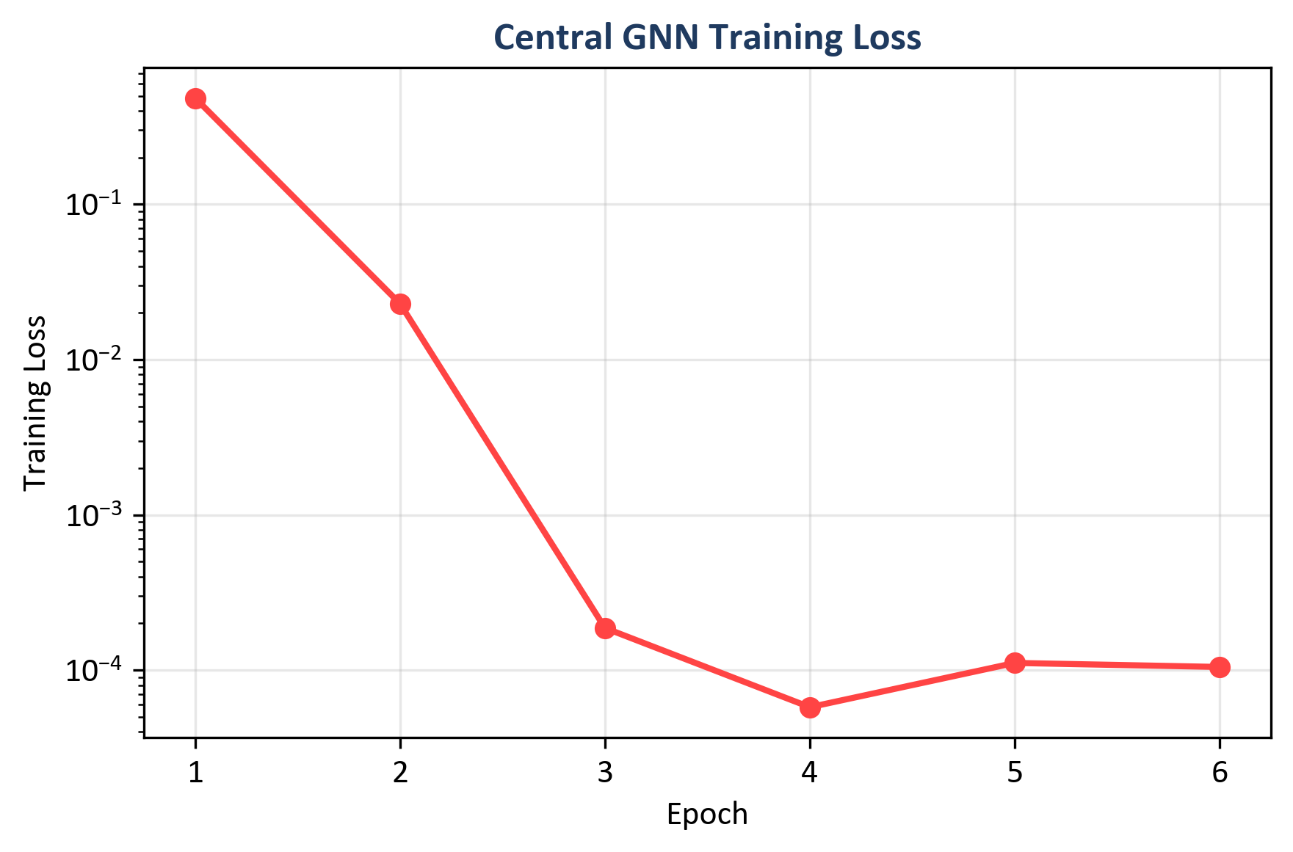
Figure 26: Central GNN training loss across six epochs (log scale) (Chapter 8, Section 8.4)
Source: Author's own plot (scripts/generate_alerts_and_plots.py); data from results/metrics/gnn_training_history.json (train_loss).

8.5 Time-Window and CPU Inference (Sub-Question 2 and Deployment)
CPU inference times (reported in Table 7): Random Forest 46.09 ms per sample; MLP 0.66 ms; central GNN 22.70 ms; federated GNN 20.99 ms (GNN times are per sequence of 5 graph windows). Figure 27 compares F1 and inference time across models.
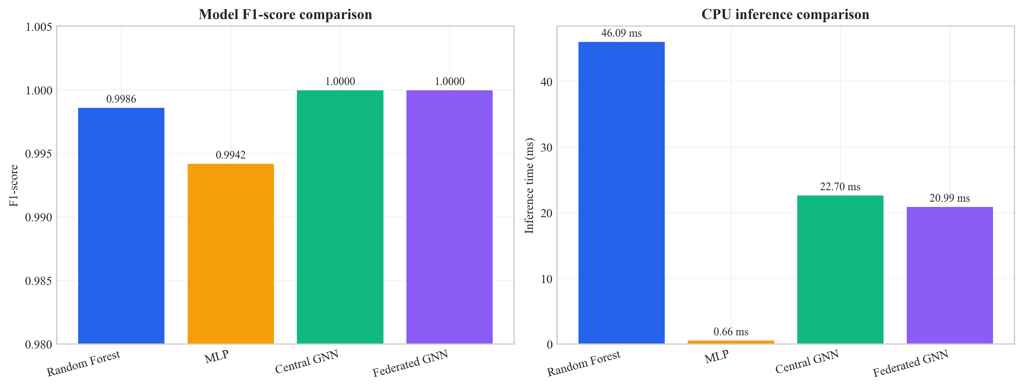
Figure 27: Model comparison - inference time and F1-score (Chapter 8, Section 8.5)
Source: Author’s own plot; metrics from Table 7 and inference timings in results/metrics/; scripts/generate_alerts_and_plots.py.

8.6 Example Alerts with Explanations (Sub-Question 3)
Five example alerts were generated with full explanations (top features from Integrated Gradients and top flows from attention weights), in the same order as results/alerts/example_alerts.json. Each example includes the predicted label, confidence, threat severity band, and the explanation object (top_features, top_nodes).
Example 1 (True negative): Predicted benign; score 0.163 (low severity). Top features: Variance, Std, rst_count, Duration, AVG (Integrated Gradients magnitudes as in example_alerts.json).
Example 2 (True positive): Predicted malicious; score 0.997. Top features: psh_flag_number, ICMP, rst_flag_number.
Example 3 (True positive): Predicted malicious; score 0.996. Top features: rst_flag_number, ICMP, Protocol Type.
Example 4 (False positive): Benign labelled as malicious; score 0.711 (medium). Top features: Variance, rst_count.
Example 5 (False positive): Benign labelled as malicious; score 0.945. Top features: Variance, Std, rst_count.
Each record follows the ECS-like shape: event metadata, rule name, threat indicator, ML prediction and score, and explanation (top_features, top_nodes). Whether these fields are sufficient for SOC triage is discussed in Chapter 9.

8.7 Ablation Studies (Priority 1: Evidence)
To show that both the graph and the temporal parts of the model add value, one ablation was run: the same GAT-based model but with the GRU replaced by mean pooling over time (so the model sees each window’s graph embedding but does not model the sequence with an RNN). This variant is called “GAT only (no GRU)”. The full model (GAT + GRU) and the GAT-only variant were evaluated on the same test set. Table 10 summarises the results. To reproduce the ablation, run: python scripts/run_ablation.py --config config/experiment.yaml; results are saved to results/metrics/ablation_gat_only.json and results/metrics/ablation_table.csv.
Table 10: Ablation on CICIoT2023 test set (centralised GNN variants)
Variant | Precision | Recall | F1 | ROC-AUC | Inference (ms)
Full (GAT + GRU) | 1.0000 | 1.0000 | 1.0000 | 1.0000 | 22.70
GAT only (no GRU) | 0.9923 | 1.0000 | 0.9961 | 1.0000 | 16.06
Source: results/metrics/ablation_table.csv; scripts/run_ablation.py; test split CICIoT2023 (Pinto et al. 2023).
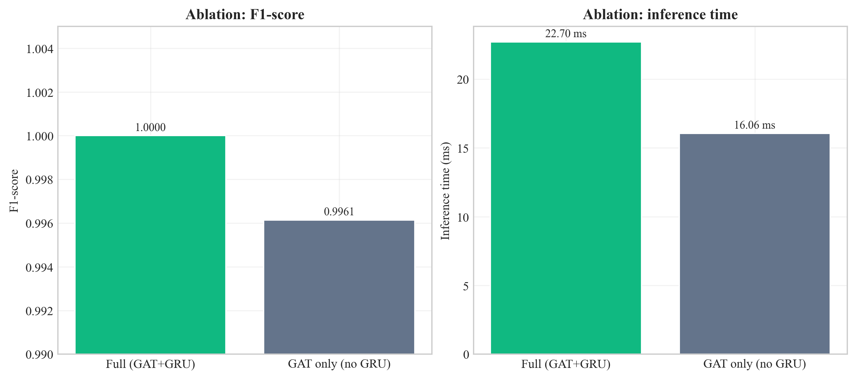
Figure 28: Ablation comparison - full GAT+GRU vs. GAT-only (F1 and inference time) (Chapter 8, Section 8.7)
Source: Author’s own plot; results/metrics/ablation_table.csv; scripts/run_ablation.py.
Interpretation of the temporal (GRU) vs. pooling trade-off is in Section 9.3 and Section 9.6.

8.8 Sensitivity Analysis (Stability of Design Choices)
Sensitivity analysis checks whether the main results hold when key hyperparameters change. Two levers are: (1) window size (number of flows per graph snapshot), and (2) k in the kNN graph. The main experiments use window size 50 and k = 5. The pipeline was re-run for all combinations of window_size ∈ {30, 50, 70} and knn_k ∈ {3, 5, 7} with other settings unchanged; metrics were written to results/metrics/sensitivity_table.csv (script: scripts/run_sensitivity_and_seeds.py).
Table 11: Sensitivity analysis - central GNN on test set (nine configurations)
Window size | k | Precision | Recall | F1 | ROC-AUC | Inference (ms)
30 | 3 | 1.0000 | 1.0000 | 1.0000 | 1.0000 | 12.20
30 | 5 | 1.0000 | 1.0000 | 1.0000 | 1.0000 | 17.42
30 | 7 | 1.0000 | 1.0000 | 1.0000 | 1.0000 | 11.89
50 | 3 | 0.9923 | 1.0000 | 0.9961 | 0.9985 | 15.60
50 | 5 | 1.0000 | 1.0000 | 1.0000 | 1.0000 | 17.00
50 | 7 | 1.0000 | 1.0000 | 1.0000 | 1.0000 | 17.00
70 | 3 | 0.9939 | 1.0000 | 0.9969 | 0.9947 | 19.91
70 | 5 | 0.9939 | 1.0000 | 0.9969 | 0.9895 | 15.49
70 | 7 | 1.0000 | 1.0000 | 1.0000 | 1.0000 | 28.07
Source: results/metrics/sensitivity_table.csv; scripts/run_sensitivity_and_seeds.py; test split CICIoT2023 (Pinto et al. 2023).
Grid interpretation is in Section 9.3.
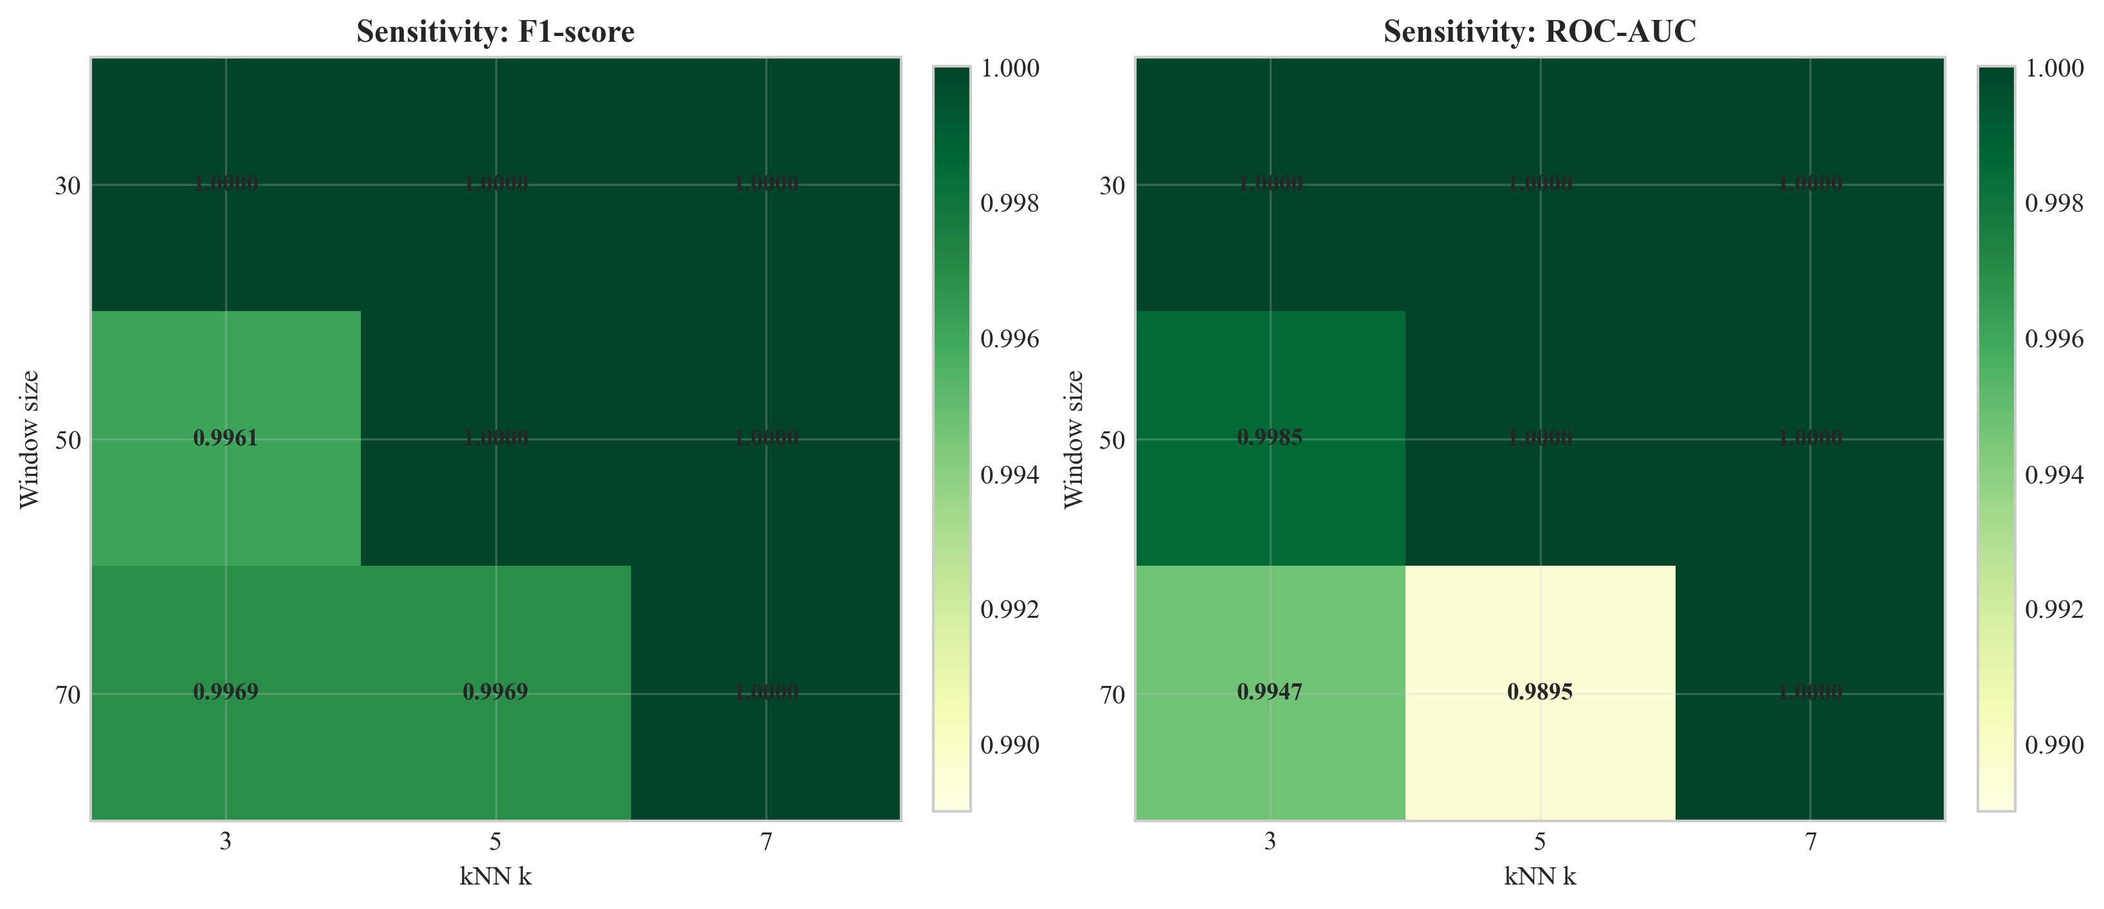
Figure 29: Sensitivity of test F1 and ROC-AUC to window size and kNN k (Chapter 8, Section 8.8)
Source: Author’s own plot; results/metrics/sensitivity_table.csv; scripts/run_sensitivity_and_seeds.py.

8.9 Multi-Seed Stability
To check that the central GNN result is not an accident of one random seed, the same training and evaluation procedure was repeated with seeds 42, 123, and 456 (other config unchanged). Summary statistics are in results/metrics/multi_seed_summary.json.
Table 12: Multi-seed summary (central GNN, test set)
Seed | Precision | Recall | F1 | ROC-AUC | False positives (test)
42 | 1.0000 | 1.0000 | 1.0000 | 1.0000 | 0
123 | 1.0000 | 1.0000 | 1.0000 | 1.0000 | 0
456 | 1.0000 | 1.0000 | 1.0000 | 1.0000 | 0
Mean | 1.0000 | 1.0000 | 1.0000 | 1.0000 | -
Std | 0 | 0 | 0 | 0 | -
Source: results/metrics/multi_seed_summary.json; scripts/run_sensitivity_and_seeds.py; test split CICIoT2023 (Pinto et al. 2023).
Table 12 reports mean F1 = 100.0%, mean ROC-AUC = 100.0%, and zero standard deviation on this test split for all three seeds. Per-seed inference times in the raw logs vary with CPU timing; the headline ~22.7 ms deployment figure is from the primary seed 42 run (Table 7). What this implies for generalisation is discussed in Chapter 9.

8.10 Comparison with Prior Work on CICIoT2023
Table 13 situates this work alongside peer-reviewed CICIoT2023 / IoT-IDS studies: headline F1 (or accuracy where F1 is absent) and architectural family. Setups differ (binary vs. multi-class, sampling, hardware); the table is positioning, not a strict leaderboard.
Table 13: Headline metrics - this dissertation vs. prior work on CICIoT2023 and adjacent IoT flow benchmarks
Study | Architectural family | Federated | Explainable | SIEM-shaped output | Headline metric (binary)
(Pinto et al. 2023) - dataset paper | RF / DNN baselines on CICIoT2023 | No | No | No | RF accuracy ~99% (binary) on full corpus
(Lazzarini et al. 2023) | MLP under FedAvg, IoT IDS | Yes (FedAvg) | No | No | Reported F1 in the upper-90% range under non-IID FedAvg
(Albanbay et al. 2025) | FL IDS for IoT, scaling study | Yes | No | No | Strong FL accuracy on IoT IDS at varying client counts
This dissertation | Dynamic GNN (GAT + GRU) | Yes (Flower FedAvg, 3 clients, non-IID) | Yes (Captum IG + GAT attention) | Yes (ECS-like JSON via FastAPI) | F1 = ROC-AUC = 100.0% on the fixed CICIoT2023 subset (Table 7)
Source: this dissertation; cited works in Chapter 11. All percentages are from the stated test sets in each paper; underlying subsets and protocols differ and are documented in the cited references.
As in Section 2.8, prior work often treats accuracy, FL, and XAI separately; this prototype combines them with SIEM-oriented output (subset metrics - Section 9.4).

8.11 Chapter Summary
Chapter 8 reported metrics, plots, and stability tables; Chapter 9 interprets them against the research questions and limitations.

Chapter 9 – Conclusion, Discussion, and Recommendations

9.1 Chapter Overview
The chapter gives the interpretation of the results, makes correlations with the literature and summarises what the project has been able to accomplish within the scope of the project. It also documents restrictions and constraints to SOC/edge implementation. A conclusion is given in Section 9.2, and in Sections 9.3-9.10, discussed.

9.2 Structured Conclusion
The dissertation addresses SOC-oriented, CPU-edge detection on Software-Defined IoT flow telemetry, with optional federated training when raw flows are not pooled, and explainable SIEM-style output. CICIoT2023 and the literature in Chapter 2 often treat GNNs, FL, and XAI as separate threads; this work integrates them in one pipeline.
The main artefact is end-to-end: kNN graphs over windowed flows, GAT+GRU, Flower FedAvg (three non-IID clients), Captum plus attention, ECS-like JSON via FastAPI. On the fixed subset (Chapters 7–8), central and federated GNNs match strong RF/MLP headlines with low FPR, about 23 ms GNN sequence inference, and modest federated traffic; ablation, sensitivity, and multi-seed runs support the default configuration. Scope: 45-day MSc, lab subset, small FL topology, no formal SOC user study, and 100% metrics that are subset-specific, not universal. Extensions (data scale, live traffic, analyst evaluation, SIEM hardening) are in Section 9.9. The research questions are answered as a documented prototype with explicit limits.

9.3 Answering the Research Questions
Main research question (one paragraph). The primary question was whether an explainable GAT+GRU on kNN graphs of IoT flows, trained with federated learning, could detect attacks and emit SIEM-style CPU-timed alerts. The dissertation demonstrates that this is achievable in an MSc scope as a documented pipeline: Chapters 4–6 give method, code, and configuration; Chapters 7–8 give test metrics, ablation, sensitivity, multi-seed, and example alerts; Chapter 10 states limits of 100% lab metrics. The answer is “yes, under the stated benchmark and resource assumptions”, not “solved for all real-world IoT.”
At a glance: the primary RQ is met by the end-to-end pipeline in Chapters 4–8 (Tables 7–9; example alerts; ~23 ms GNN sequence inference). Novelty is integration + evaluation of graph, FL, and SIEM-shaped outputs on one benchmark, not a new GNN operator alone (Section 2.8; Table 13).
Sub-Q1 (GNN vs. baselines). The central GNN reports higher F1/ROC-AUC on this split than RF/MLP and lower false-positive load on the held-out set (Table 7), consistent with relational–temporal modelling on top of strong flow features (Pinto et al. 2023).
Sub-Q2 (Federation). The federated global model matches the central GNN on the test metrics (Table 8; Figures 23–25), with on the order of 31 MB cumulative parameter traffic over ten rounds (Chapter 8) - feasible at MSc scale, not a large-fleet production proof.
Sub-Q3 (Triage). Worked example alerts in Section 8.6 pair Integrated Gradients feature ranks with GAT node cues; plausibility is argued in Section 9.6, not via a user study.
Stability (Sections 8.7–8.9). Ablation shows a small F1 margin for keeping the GRU (Table 10; Figure 28). Sensitivity: default (50,5) is within a wide good region, with some (70,·) settings dipping on ROC-AUC (Table 11; Figure 29). Multi-seed tables repeat the headline test outcome for three seeds (Table 12), which reduces one-off init luck but does not prove field validity (see Section 7.4.1).

9.4 Strengths and Limitations
Strengths: The dissertation delivers one reproducible path from CICIoT2023 through kNN graphs, GAT+GRU, optional Flower FedAvg, and SIEM-shaped, CPU-timed FastAPI output, with baselines, FL, and stability runs on the same protocol. kNN edges follow the rationale in Ngo et al. (2025) when device IPs are absent; stratified windowing mitigates class skew at flow level. The main contribution is integration (contrast Table 1 and Section 2.8), not a new graph operator in isolation.
Limitations: An MSc time-box and a subset of a lab dataset - no field generalisation claim. kNN is a feature-space proxy, not a physical topology graph. Federated learning is three clients and ten rounds, not a large deployment. Explanations rest on a small set of example alerts and qualitative plausibility review, not a user study. Perfect headline metrics are split-specific; interpret them with Section 7.4.1 and Chapter 10.

9.5 Use of University and Course Materials
This project used UWS module material and the library’s research databases. COMP11023 Research Methods and Design underpinned the design-science framing in Chapter 4 and the test-contract view in Chapter 7; COMP11024 Master’s Project framed milestones and reporting. Dr Raja Ujjan and Muhsin Hassanu (moderator) oversaw project reviews; Dr Daune West supported programme-level milestones. Citations in Chapter 11 use Harvard (author–year) as described by the University of the West of Scotland Library (2025).

9.6 Practical Implications
Why this work matters (societal and organisational importance). Insecure consumer and industrial IoT devices and overloaded SOC queues are a widespread concern: missed intrusions carry safety and continuity risk, while false alarms waste scarce analyst time (Section 1.2; ENISA 2017, Chapter 11). This project does not claim to have “solved” that problem at national scale; it contributes engineering evidence that a CPU-first, explained, and optionally federated detector can be built and measured end-to-end. On the reported test split, the GNN had no benign-as-attack false positives, whereas Random Forest and MLP had non-zero FPR (Table 7) - a pattern that, if it held in production, would reduce analyst noise. Federated training exchanges weights only, supporting data-minimising collaboration when raw flows cannot be pooled, but this is not a substitute for legal or contractual review.
Implications for practice (conditional on pilot validation). (1) Edge deployment: sub-23 ms per GNN sequence on CPU (Section 8.5; Table 7) is consistent with near–real-time scoring on a class of gateways (Table 5). (2) Analyst use: ECS-like JSON and explanation fields are a plausible handover to SIEM pipelines; a formal usability study is out of scope (Section 1.4). (3) Limitation: benefits are inferred from the CICIoT2023 lab run; live traffic, drift, and adversarial evasion need further work (Section 9.9).
Stability and staged adoption. Ablation (Section 8.7), the sensitivity grid (Section 8.8), and multi-seed runs (Section 8.9) are the main reliability arguments for the headline configuration. In production, a sensible path would be passive monitoring, then assisted triage using explanation fields, with human escalation and periodic retraining to handle drift.

9.7 Relation to Literature
The literature (e.g. Velickovic et al. 2018) supports GNNs for network or security data. Through this project, we show that a dynamic GNN can be trained and compared against baselines on IoT flow data. Han et al. (2025) and Ngo et al. (2025) report that graph-based and attribute-based construction can improve detection. This work validates that a kNN feature-similarity graph remains usable when device identifiers are unavailable.
Federated learning using FedAvg (McMahan et al. 2017) is shown to work with Flower, with performance similar to centralised training. Lazzarini et al. (2023) and Albanbay et al. (2025) also report that FedAvg can sustain accuracy in their IoT intrusion-detection settings. Measured Flower runs converged in 7 global rounds, with ≈ 31 MB of cumulative weight traffic over 10 rounds (Chapter 8), which supports a feasibility argument for federated deployment at student scale. Alert output is augmented with explainability through Integrated Gradients (Sundararajan et al. 2017) and GAT attention (Velickovic et al. 2018), in line with calls for more interpretable security ML. Example alerts show highlighted features (e.g. psh_flag_number, ICMP, rst_flag_number) that are consistent with the attack context described by Alabbadi and Bajaber (2025). Within the stated scope, the dissertation instantiates the integration gap identified in Section 2.8 - combining dynamic graphs, Flower FedAvg, XAI, and SIEM-shaped outputs on one benchmark and codebase.

9.8 Summary of the Project
In brief: a CICIoT2023-driven, CPU-feasible pipeline (kNN graphs, GAT+GRU, Flower when needed, Integrated Gradients plus attention, FastAPI) answers the main research question and sub-questions on the documented test contract in Chapter 8. Federated and central GNNs align; alerts carry explanation fields. Stability artefacts are under results/metrics/.

9.9 Recommendations for Future Work
- Scale: larger CICIoT2023 slices or additional IoT datasets; more federated clients and per–attack-type metrics to stress FedAvg under stronger non-IID splits.
- Field validation: permitted live traffic, drift and evasion tests beyond CICIoT2023 lab assumptions.
- Human factors: short SOC user study on explanation usefulness (author and supervisor review caps what can be claimed today).
- Methods: alternative graph construction (not only kNN), other temporal architectures, selective Integrated Gradients (latency versus coverage), other explainers versus attention-only.
- Integration: connect FastAPI to a production SIEM (e.g. Elastic, Splunk) and measure end-to-end triage.
- Ablations: extend Section 8.7 with explicit kNN versus alternatives and Integrated Gradients versus attention-only to firm up design choices.

9.10 Chapter Summary
This chapter answers the main questions within the documentation limits, relates findings to prior work, and points to scaling, evaluation, and publication routes with a credible path forward.

Chapter 10 – Critical Self-Evaluation

10.1 Chapter Overview
This chapter is a critical reflection on the project, which discusses the aspects of the project that went well, which were difficult, what was learned, and what would be done differently in the event the work is repeated. It is a complement (as opposed to a duplicate) of the academic constraints in Chapter 9 as it is process-oriented, time-constrained decisions, and individual development.
I maintain this reflection to the actual build path as opposed to abstract statements. There were good decisions to make. Others were tardy and put pressure. Honest writing of this chapter assists in demonstrating independent judgement and the reasons given as to why there are still limits in the existing version despite the achievement of the technical objectives.

10.2 Planning, Scope, and Risk.
The project was planned to be within a 45-day MSc time frame. I had early chosen to work with an unchangeable subset of CICIoT2023, and to model three federated clients, as opposed to a large fleet. Part of those choices were practical disk, RAM, and training time, but they were also technical: a smaller, controlled sub-set allows one to more easily rerun experiments and to debug the pipeline when things fail. The trade-off becomes clear: higher scores on a subsample may not necessarily translate to the wild. I attempted to address criticism of the toy datasets by (1) clearly indicating the limits in Chapter 9, (2) comparing to strong baselines (RF, MLP) in the same splits, and (3) including ablation, sensitivity and multi-seed runs to ensure that the headline metrics do not represent a fortuitous configuration.
What I would do better with more time: discuss with my supervisor an accurate boundary on the size of a subset and a one-page data contract in the dissertation to ease the process of reading the repo (I can reproduce it, but I would include a one-page data contract to indicate to the reader that the information is in the dissertation).

10.3 Literature and Alignment with the Questions
The literature review was purposely combined with IoT intrusion detection, SIEM / SOC workflows, GNNs, federated learning, and explainable AI. The difference I defended was not that no one used GNNs - many papers do - but that it is still fairly uncommon to have explainable dynamic graphs, federated training, and outputs in the form of SIEM-like alerts in a single CPU-based prototype, even in student-scale work. Staying on track of that storyline during implementation was occasionally not easy: it is so easy to put in all the good ideas (more clients, more attacks, and more explainers). I needed to keep eliminating peripheral ideas, to guard the main questions.
One obvious weakness is still: no official user study involving practising analysts. I assessed usefulness of explanation along with my supervisor and by reading the alert JSON as if I was triaging. That is justifiable of an MSc, but not indicative of practical use. Given a repeat of the project, I would set the three semi-structured interviews with volunteers aside a week (including fellow students performing the role of SOC) and a small Likert questionnaire - not publication-quality, but not necessarily dependent solely on intuition.

10.4 Implementation: What Was Harder Than It Looked
The construction of the pipeline end-to-end consisted of gluing together PyTorch, PyTorch Geometric, Flower, Captum and FastAPI. Libraries are recorded, but not between: batched graph tensor shapes, the same scaler and splits between federated clients, and explainability that can be run on a single sequence without scaling out of memory. The slowest delays were data and graphs: stratified windowing to ensure that the labels on the graphs are balanced, but the data in the flows are highly unbalanced, required multiple iterations to learn to stop collapsing to always attack.
The concept of federated learning was simple (FedAvg) but the operationally fiddly: the server needed to be started first, followed by clients, non-IID partitions need to be trained, and per-round metrics should be logged in a form that I could later plot. I am content that on my federated performance was equal to centralised; I know also that three clients and ten rounds are not a stress test.
On the good side, I organized the code into modules (data, graph, models, federated, explainability, API) to allow me to replace parts - for example, to run ablation by replacing the temporal head without altering the GAT stack. That modularity worked in my favor after I added scripts/run_sensitivity_and_seeds.py: on the whole it re-used the same training entry points with various YAML overrides.

10.5 Results, Honesty, and the “100%” Question
At the point when test F1 and ROC-AUC reached 1.0, I felt relief and secondly I felt suspicious. Perfect metrics typically imply one of: (a) the task on this slice of data is easy, (b) there is leakage (I checked splits carefully: no overlap between train/val/test at sequence level), or (c) the test set is small enough that a small number of mistakes can shift the score. In this case, the test set consists of 934 sequences; there can be 0 errors but that cannot be interpreted as “solved” IoT security. I attempted to make it quite clear in Chapter 9. The ablation was informative: removing the GRU did not increase precision/F1 error much, so the model is not entirely redundant. The sensitivity grid showed that not all (window, k) pairs are equally good - there is more to the story than a single scalar headline.
In case I sound warnings, it is not accidental. I would prefer that a reader has trust in me in terms of transparency than to bragging.

10.6 What I Learned (Skills and Mindset)
Technically, I got to think in graphs (nodes are flows, kNN edges are similarity), in time (sequences of snapshots). I got to know the fundamentals of federated optimisation and that naive assumptions are violated by non-IID data. I came to know the extent of explainability is presentation (what we put in the JSON) as much as it is the algorithm (Integrated Gradients).
Personally, I got to know time-boxing: The sensitivity and multi-seed run was planned late, they ran, but I would start stability experiments earlier next time to avoid that writing-up waits on jobs running at night. Another thing that I learned was to document when coding - save of commit messages, config/experiment.yaml, and CSV output came to my rescue when I had forgotten what run generated what figure.

10.7 Time Management: What I Would Reorder
At the beginning, data loading and graph constructions were underestimated. Federated setup overestimated when the trend was obvious, but the initial week of Flower debugging was a slog. After stabilising, explainability + FastAPI was quicker. With hindsight I would allocate: week 1 - data contract + baseline; week 2 - GNN + central training; week 3 - federated + API; week 4 - explainability + plots; buffer - ablation and sensitivity. I primarily made use of the buffer in stability runs; in a different timeline I could have foregone one of the fancy plots in favor of a user interview.
In general, the project fulfilled my personal criterion: a unified system, evidence-based arguments, and boundaries. It is not even production-ready, but it is earnest research engineering at MSc level and I am proud of the bits that were painful yet functional.

10.8 Chapter Summary
The scoped realism, modularity and honest limits are critical reflection that I would repeat on a subsequent project in research, technical delivery, and planning practice.

Chapter 11 – References
This chapter lists every source cited in the body (Chapters 1–10) in Harvard (author–year) form, with DOIs or stable URLs where available. The list was maintained in a reference manager (single database) so each in-text citation matches one entry below (University of the West of Scotland Library, 2025). The items are the papers, standards, and tools used to support the thesis claims; implementation tools also appear in Chapter 12 where they informed the build but were not used as research evidence in the main argument.
Alabbadi, A. and Bajaber, F. (2025) 'An intrusion detection system over the IoT data streams using eXplainable artificial intelligence (XAI)', Sensors, 25(3), p. 847. Available at: https://doi.org/10.3390/s25030847
Albanbay, N., Tursynbek, Y., Graffi, K., Uskenbayeva, R., Kalpeyeva, Z., Abilkaiyr, Z. and Ayapov, Y. (2025) 'Federated learning-based intrusion detection in IoT networks: performance evaluation and data scaling study', Journal of Sensor and Actuator Networks, 14(4), p. 78. Available at: https://doi.org/10.3390/jsan14040078
Basak, M., Kim, D.-W., Han, M.-M. and Shin, G.-Y. (2025) 'X-GANet: an explainable graph-based framework for robust network intrusion detection', Applied Sciences, 15(9), p. 5002. Available at: https://doi.org/10.3390/app15095002
Cuppens, F. and Miège, A. (2002) 'Alert correlation in a cooperative intrusion detection framework', in Proceedings of the 2002 IEEE Symposium on Security and Privacy, pp. 202-215. Available at: https://doi.org/10.1109/secpri.2002.1004372
Elastic N.V. (2023) Elastic Common Schema (ECS) Reference [Online]. Santa Clara, CA: Elastic. Available at: https://www.elastic.co/guide/en/ecs/current/ (Accessed: 20 April 2026).
ENISA (2017) Baseline security recommendations for IoT in the context of critical information infrastructures. Heraklion: European Union Agency for Network and Information Security. Available at: https://doi.org/10.2824/03228
Han, Z., Zhang, C., Yang, G., Yang, P., Ren, J. and Liu, L. (2025) 'DIMK-GCN: a dynamic interactive multi-channel graph convolutional network model for intrusion detection', Electronics, 14(7), p. 1391. Available at: https://doi.org/10.3390/electronics14071391
Kokhlikyan, N., Miglani, V., Martin, M., Wang, E., Reynolds, J., Melnikov, A., Lunova, N. and Reblitz-Richardson, O. (2020) 'Captum: a unified and generic model interpretability library for PyTorch', arXiv preprint arXiv:2009.07896. Available at: https://doi.org/10.48550/arXiv.2009.07896
Kolias, C., Kambourakis, G., Stavrou, A. and Voas, J. (2017) 'DDoS in the IoT: Mirai and other botnets', Computer, 50(7), pp. 80-84. Available at: https://doi.org/10.1109/mc.2017.201
Lazzarini, R., Tianfield, H. and Charissis, V. (2023) 'Federated learning for IoT intrusion detection', AI, 4(3), pp. 509-530. Available at: https://doi.org/10.3390/ai4030028
Lundberg, S.M. and Lee, S.I. (2017) 'A unified approach to interpreting model predictions', in Advances in Neural Information Processing Systems, 30, pp. 4765-4774. Available at: https://doi.org/10.48550/arXiv.1705.07874
Lusa, R., Pintar, D. and Vranic, M. (2025) 'TE-G-SAGE: explainable edge-aware graph neural networks for network intrusion detection', Modelling, 6(4), p. 165. Available at: https://doi.org/10.3390/modelling6040165
McMahan, H.B., Moore, E., Ramage, D., Hampson, S. and Agüera y Arcas, B. (2017) 'Communication-efficient learning of deep networks from decentralized data', in Proceedings of the 20th International Conference on Artificial Intelligence and Statistics (AISTATS), PMLR 54, pp. 1273-1282. Available at: https://doi.org/10.48550/arXiv.1602.05629
Ngo, T., Yin, J., Ge, Y.-F. and Wang, H. (2025) 'Optimizing IoT intrusion detection - a graph neural network approach with attribute-based graph construction', Information, 16(6), p. 499. Available at: https://doi.org/10.3390/info16060499
Pinto, C., Dadkhah, S., Ferreira, R., Zohourian, A., Lu, R. and Ghorbani, A.A. (2023) 'CICIoT2023: a real-time dataset and benchmark for large-scale attacks in IoT environment', Sensors, 23(13), p. 5941. Available at: https://doi.org/10.3390/s23135941
Qu, Y., Gao, L., Luan, T.H., Xiang, Y., Yu, S., Li, B. and Zheng, G. (2020) 'Decentralized Privacy Using Blockchain-Enabled Federated Learning in Fog Computing', IEEE Internet of Things Journal, 7(6), pp. 5171-5183. Available at: https://doi.org/10.1109/JIOT.2020.2977383
Sundararajan, M., Taly, A. and Yan, Q. (2017) 'Axiomatic attribution for deep networks', in Proceedings of the 34th International Conference on Machine Learning (ICML), PMLR 70, pp. 3319-3328. Available at: https://doi.org/10.48550/arXiv.1703.01365
Velickovic, P., Cucurull, G., Casanova, A., Romero, A., Lio, P. and Bengio, Y. (2018) 'Graph attention networks', in International Conference on Learning Representations (ICLR). Available at: https://doi.org/10.48550/arXiv.1710.10903
Wang, R., Zhao, J., Zhang, H., He, L., Li, H. and Huang, M. (2025) 'Network traffic analysis based on graph neural networks: a scoping review', Big Data and Cognitive Computing, 9(11), p. 270. Available at: https://doi.org/10.3390/bdcc9110270
Yang, S., Pan, W., Li, M., Yin, M., Ren, H., Chang, Y., Liu, Y., Zhang, S. and Lou, F. (2025) 'Industrial Internet of Things intrusion detection system based on graph neural network', Symmetry, 17(7), p. 997. Available at: https://doi.org/10.3390/sym17070997
Zheng, L., Li, Z., Li, J., Li, Z. and Gao, J. (2019) 'AddGraph: Anomaly Detection in Dynamic Graph Using Attention-based Temporal GCN', in Proceedings of the Twenty-Eighth International Joint Conference on Artificial Intelligence (IJCAI-19), pp. 4419-4425. Available at: https://doi.org/10.24963/ijcai.2019/614
Zhong, M., Lin, M., Zhang, C. and Xu, Z. (2024) 'A survey on graph neural networks for intrusion detection systems: methods, trends and challenges', Computers and Security, 141, p. 103821. Available at: https://doi.org/10.1016/j.cose.2024.103821

Chapter 12 – Bibliography
This bibliography lists wider readings, technical documentation, and standards consulted during the project that supported design and implementation decisions but were not directly cited as evidence in the body. Entries are grouped to mirror the topics covered in Chapters 2–8.
Frameworks, libraries, and tooling used in the implementation (Chapter 6).
Beutel, D.J., Topal, T., Mathur, A., Qiu, X., Fernandez-Marques, J., Gao, Y., Sani, L., Li, K.H., Parcollet, T., Gusmão, P.P.B. de and Lane, N.D. (2020) 'Flower: a friendly federated learning research framework', arXiv preprint arXiv:2007.14390. Available at: https://doi.org/10.48550/arXiv.2007.14390
Fey, M. and Lenssen, J.E. (2019) 'Fast graph representation learning with PyTorch Geometric', in ICLR 2019 Workshop on Representation Learning on Graphs and Manifolds. Available at: https://doi.org/10.48550/arXiv.1903.02428
Paszke, A., Gross, S., Massa, F., Lerer, A., Bradbury, J., Chanan, G., Killeen, T., Lin, Z., Gimelshein, N., Antiga, L., Desmaison, A., Köpf, A., Yang, E., DeVito, Z., Raison, M., Tejani, A., Chilamkurthy, S., Steiner, B., Fang, L., Bai, J. and Chintala, S. (2019) 'PyTorch: an imperative style, high-performance deep learning library', in Advances in Neural Information Processing Systems 32 (NeurIPS 2019), pp. 8024-8035. Available at: https://doi.org/10.48550/arXiv.1912.01703
Pedregosa, F., Varoquaux, G., Gramfort, A., Michel, V., Thirion, B., Grisel, O., Blondel, M., Prettenhofer, P., Weiss, R., Dubourg, V., Vanderplas, J., Passos, A., Cournapeau, D., Brucher, M., Perrot, M. and Duchesnay, E. (2011) 'Scikit-learn: machine learning in Python', Journal of Machine Learning Research, 12, pp. 2825-2830. Available at: https://doi.org/10.48550/arXiv.1201.0490
Standards and reference frameworks for the SIEM and SOC context (Chapters 1, 2 and 6).
ENISA (2017) and Elastic N.V. (2023) appear in Chapter 11 because they are cited in the body; they are not repeated here.
Rashid, A., Chivers, H., Lupu, E., Martin, A. and Schneider, S. (2021) The Cyber Security Body of Knowledge (CyBOK), version 1.1. Bristol: National Cyber Security Centre (UK) and University of Bristol. Available at: https://www.cybok.org/media/downloads/CyBOK_v1.1.0.pdf
Strom, B.E., Applebaum, A., Miller, D.P., Nickels, K.C., Pennington, A.G. and Thomas, C.B. (2018) MITRE ATT&CK: design and philosophy. Bedford, MA: The MITRE Corporation. Available at: https://attack.mitre.org/docs/ATTACK_Design_and_Philosophy_March_2020.pdf
Project administration and referencing (Chapters 1, 3, 9, 11).
University of the West of Scotland (2025) Master’s Project (module COMP11024: project administration, assessment, and reporting - 2025/26). Paisley: School of Computing, Engineering and Physical Sciences, University of the West of Scotland.
University of the West of Scotland Library (2025) Harvard (author–year) style guide [Online]. Paisley: UWS Library. Available at: https://libguides.uws.ac.uk/harvard

Chapter 13 – Appendices
This chapter contains the required appendices for submission.

Appendix A: Project code
config/experiment.yaml
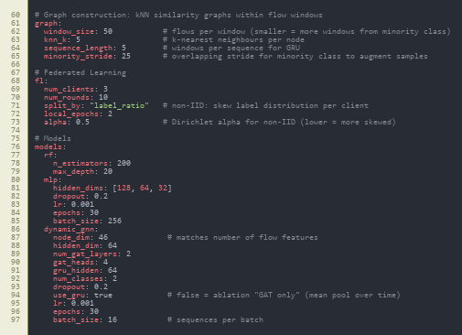
src/data/preprocess.py
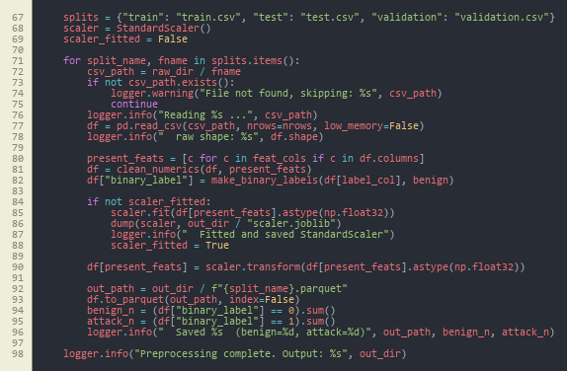
src/data/graph_builder.py - flows_to_knn_graph

src/data/graph_builder.py - build_graphs_for_split

src/data/dataset.py - GraphSequenceDataset
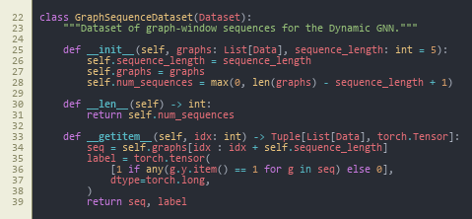
src/data/dataset.py - get_dataloaders
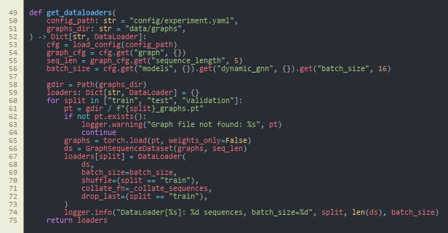
src/models/baselines.py
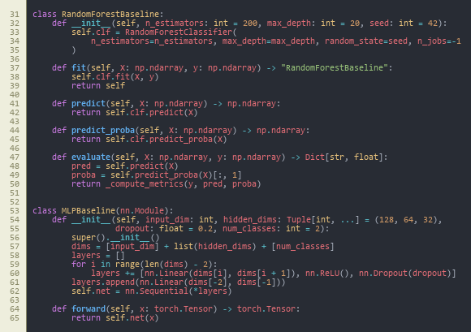
src/models/dynamic_gnn.py - DynamicGNN.forward
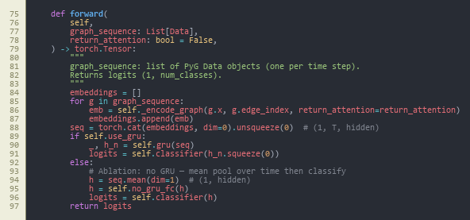
src/models/trainer.py - train_one_epoch

src/explain/explainer.py - explain_sequence
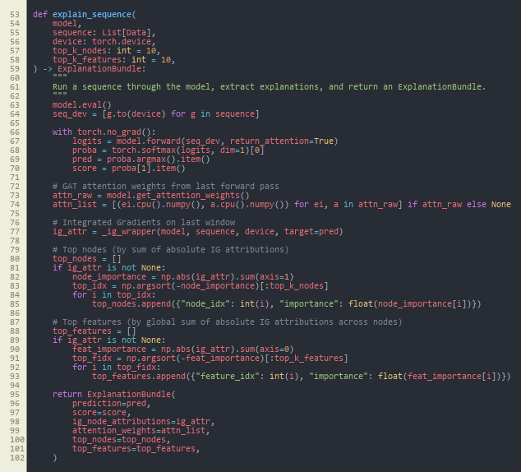
src/federated/run_federated.py
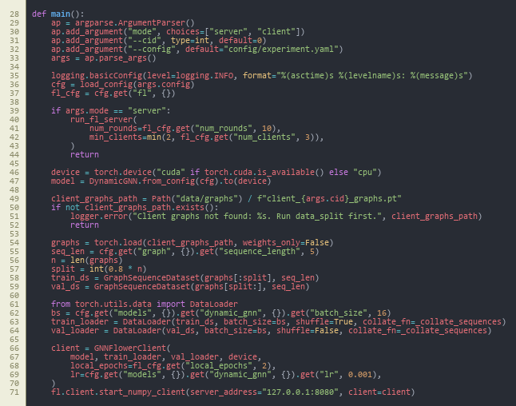
src/federated/client.py - GNNFlowerClient
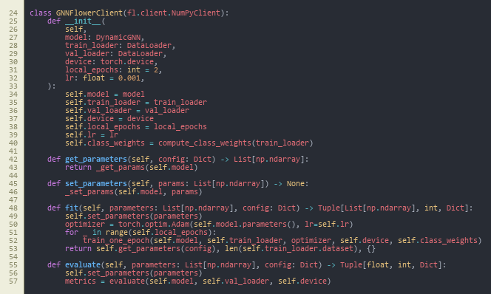
src/federated/server.py - run_fl_server
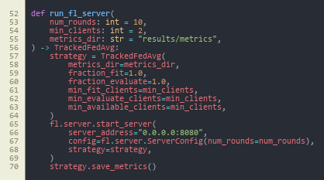
src/siem/api.py - POST /score


Appendix B: Project Process Documents
The following extract reproduces the project process and meeting record as filed for supervision; layout follows the source forms.
MSc PROJECT (COMP11024)
PROJECT PROCESS DOCUMENTATION
Student: Arka Talukder (B01821011) Supervisor: Dr. Raja Ujjan
Meeting Number: 1-6 Date/Time: 29/01/2026 - 06/03/2026
Agenda for meeting:
Project title selection and approval
Project specification and scope discussion
Interim report structure and guidelines
Literature review and research gap alignment
Methodology and experimental design review
Progress on data pipeline and model implementation
Discussion of agenda items:
Throughout all meetings, the project passed through title-selection to interim report completion. The supervisor discussed and approved the project title: Explainable Dynamic Graph Neural Network SIEM of Software-Defined IoT using Edge AI and Federated Learning on 10 and 11 February 2026. Once approved, we made it clear what we wanted. Kaggle- CICIoT2023 flow data, which is a dynamic GNN with GAT and GRU, federated learning with non-IID data, and SIEM alert generation will be used in the project.
Project specification was checked. The four key sections that the supervisor concurred with were dynamic GNN, federated learning, explainability, and SIEM integration. The structure of the interim report was also discussed. It consists of three sections: literature review, methodology and the plan to complete it.
I gave an update on the literature review. The supervisor provided comments on the table of research gap and the way of comparing my project with the related work. We have checked the methodology section. These were graph construction, model architectures (Random Forest, MLP, centralised GNN, federated GNN) and evaluation metrics.
I showed the progress of the implementation. This included the data pipeline, graph builder, all four models, federated learning with Flower, explainability with Captum and the FastAPI SIEM endpoint. According to the supervisor, the implementation is in line with the research objectives. There was a discussion on the interim report draft. I will get competency in the following meeting.
Overview of action plan agreed upon:
- Have interim report approved by the supervisor during the following meeting.
- Make last minute adjustments depending on the feedback of the supervisor.
- Final experiments and results chapter on the dissertation.
- Keep records and repeatability of experiments.
Notes:
Supervisor has insisted on a clear correspondence between research questions, research method and research findings. Good records of experiments and fixed seeds to be used in future were recommended. The project will be completed in good time.
In this reporting period, I had frequent supervisory meetings with Sir Dr. Raja Ujjan to talk about my dissertation project on Explainable dynamic graph neural network SIEM on Software-Defined IoT.
TO BE COMPLETED BY THE STUDENT, WITH COMMENTS FROM THE SUPERVISOR.
Please complete all sections below

Appendix C: Project Specification
Name | Arka Talukder | Student ID | B01821011
Supervisor | Dr. Raja Ujjan | Start Date | 29/01/2026
Mode of Study | Online | Dates of Meetings (include dates of all meetings) | 06/02/2026 (Online) 13/02/2026 (Online) 10/02/2026 (Online) – Title selection 11/02/2026 (Online) – Title approval 20/02/2026 (Online) 06/03/2026 (Online)
Mode of Study | Online | Dates of Meetings (include dates of all meetings)
Description of Meetings | During the initial sessions (6 February), we talked about the scope of project and what should the interim report cover. Both the title of the project and the supervisor approved the project title on 10 and 11 February. Subsequently, we worked on the Explainable dynamic graph neural network SIEM for Software-Defined IoT. The structure of literature review, research gap and methodology design were discussed in later meetings. The supervisor provided feedback on the graph construction, options of the model, and measures of evaluation. We also talked about the way how to organize the interim report and how to be clear in presenting the work. Late meetings revised my progress in the implementation and the draft of the interim report. I have shown the data pipeline, four models (Random Forest, MLP, centralised GNN, federated GNN) and explainability module, and SIEM API. The interim report is about 80% complete. The supervisor will be a final approber in the following week.
--- | ---
Summary of work undertaken this month.
---
During this month, I completed most of the work needed for the interim report. Key achievements include: • Title of the project passed (1011 February 2026) • Written literature review, including the security of the IoT, SDIoT, ML to detect intrusions, GNNs, federated learning, and explainable AI. • Gap table gap research table filled comparing my project and the related work. Methodology section completed: dataset (CICIoT2023), preprocessing, model architectures, evaluation metrics. • Data pipeline deployed: loaded (CICIoT2023 loaded), preprocessed, normalised, exported (as Parquet). • Construction of graphs used: kNN builder, windowing, sequence dataset. All four models used: Random Forest, MLP, centralised dynamic GNN (GAT+GRU), federated GNN. * Federated learning configuration: Flower architecture, non-IID data division, 10 rounds simulation. • Explainability: GAT attention weights and Integrated Gradients ( Captum ) oss: Siem integration: FastAPI endpoint that emits ECS-formatted JSON alerts. Plan to complete section with schedule and contingency plans. • Interim report draft is ready (around 80%); waiting to be approved by the supervisor.
What work will you undertake next month?
---
In the upcoming period, I will focus on: Obtaining supervisor approval for the interim report Finalising any edits based on supervisor feedback Completing final experiments and generating all figures (confusion matrices, ROC curves, FL convergence) Writing the Results and Discussion chapters for the final dissertation Conducting sensitivity analysis if time permits Writing Conclusion and Critical Reflection Final proofreading and submission I remain on schedule for timely completion.
Please detail reasons for any absence including the total number of days absent (annual leave, conference attendance, field research, ill health etc)?
---
I missed 27/02/2026 meeting due to GP appointment
Statement from Supervisor (including any issues which should be brought to the attention of School, indication of satisfactory process thus far and whether or not attendance has been satisfactory)
---
Signed (student) |  | Date | 12/03/2026
--- | --- | --- | ---
Signed (MSc Dissertation Supervisor) |  | Date
University of the West of Scotland
School of Computing, Engineering and Physical Sciences
MSc Cyber Security Project Specification
Student name: Arka Talukder
Banner ID: B01821011
Email: b01821011@studentmail.uws.ac.uk
Project being undertaken on part-time or full-time basis: Full-time
MSc Programme: MSc Cyber Security
MSc Programme Leader: Dr. Raja Ujjan
Approved by supervisor? Yes/No: Yes
Project Title:
Research Question to be answered:
How can an explainable dynamic graph neural network, trained with federated learning, detect attacks in Software-Defined IoT flow data and create SIEM alerts that support SOC work on CPU edge devices?
Sub questions:
1) Does a dynamic graph model improve detection compared to simple baselines?
2) Can federated learning keep similar performance without sharing raw data?
3) Can the model provide clear explanations that help alert triage? |
Outline (overview) and overall aim of project:
Objectives (list of tasks to be undertaken to achieve overall aim of the project and to answer the research question posed):
CyBOK Knowledge Areas (Please check at least two relevant areas your project going to be covered):
Human, Organisational & Regulatory Aspects | Risk Management & Governance
Human, Organisational & Regulatory Aspects | Law & Regulation
Human, Organisational & Regulatory Aspects | Human Factors
Human, Organisational & Regulatory Aspects | Privacy & Online Rights
Attacks & Defences | Malware & Attack Technologies
Attacks & Defences | Adversarial Behaviours
Attacks & Defences | Security Operations & Incident Management
Attacks & Defences | Forensics
Systems Security | Cryptography
Systems Security | Operating Systems & Virtualisation Security
Systems Security | Distributed Systems Security
Systems Security | Formal Methods for Security
Systems Security | Authentication, Authorisation & Accountability
Software and Platform Security | Software Security
Software and Platform Security | Web & Mobile Security
Software and Platform Security | Secure Software Lifecycle
Infrastructure Security | Applied Cryptography
Infrastructure Security | Network Security
Infrastructure Security | Hardware Security
Infrastructure Security | Cyber Physical Systems
Infrastructure Security | Physical Layer and Telecommunications Security
Indicative reading list (references to be correctly presented) and resources:
Marking scheme:
Supervisor:
Moderator:
Programme Leader:
Date specification submitted:
Please complete the ‘ethics’ form below for all projects.
School of Computing, Engineering and Physical Sciences
MSc PROJECT – REQUIREMENT FOR ETHICAL APPROVAL
SECTION 1: TO BE COMPLETED BY THE STUDENT
Does your proposed research involve: research with human subjects (including requirements gathering and product/software testing), access to company documents/records, private or sensitive data, questionnaires, surveys, focus groups and/or other interview techniques? Does your research entail any process which requires ethical approval? (Please enter √ in the appropriate box)
YES |  | You must submit an application for approval to the Ethics Review Manager
NO | No | You do not need to submit an application to the Ethics Review Manager
Name of Student (Print name): Arka Talukder
Signature:
Date: 11/02/2026
SECTION 2: TO BE COMPLETED BY THE PROJECT SUPERVISOR
I understand that the above project does not require ethical approval.
Supervisor (print name): Dr. Raja Ujjan
Signature:
Date: 10/02/2026
IMPORTANT: please note that by signing this form all signatories are confirming that any potential ethical issues have been considered and, where necessary, an application for ethical approval has been/will be made via the Ethical Review Manager software.
Any project requiring ethical approval, but which has not been given approval will not be accepted for marking.
Ethical approval cannot be sought in retrospect.

Appendix D: Optional repository and dataset reference

D.1 Project source code (GitHub)
- Repository: https://github.com/imark0007/Dissertation_Project

D.2 Dataset source used in this project (Kaggle)
- Kaggle dataset page: https://www.kaggle.com/datasets/himadri07/ciciot2023

D.3 Official dataset source (UNB/CIC reference)
- Dataset page: https://www.unb.ca/cic/datasets/iotdataset-2023.html

MSc PROJECT (COMP11024)

PROJECT PROCESS DOCUMENTATION

Student: Arka Talukder (B01821011) Supervisor: Dr. Raja Ujjan

Meeting Number: 1-6 Date/Time: 29/01/2026 - 06/03/2026

Agenda for meeting:
- Project title selection and approval
- Project specification and scope discussion
- Interim report structure and guidelines
- Literature review and research gap alignment
- Methodology and experimental design review
- Progress on data pipeline and model implementation

Discussion of agenda items:
Across all meetings, the project moved from title selection to interim report completion. On 10 and 11 February 2026, the project title: “Explainable Dynamic Graph Neural Network SIEM for Software-Defined IoT using Edge AI and Federated Learning” was discussed and approved by the supervisor. After approval, we clarified the scope. The project will use from Kaggle- CICIoT2023 flow data, a dynamic GNN with GAT and GRU, federated learning with non-IID data, and SIEM alert generation.

The project specification was reviewed. The supervisor agreed with the four main parts: dynamic GNN, federated learning, explainability, and SIEM integration. We also discussed the interim report structure. It has three parts: literature review, methodology, and plan for completion.

I shared progress on the literature review. The supervisor gave feedback on the research gap table and how to compare my project with related work. We reviewed the methodology section. This included graph construction, model architectures (Random Forest, MLP, centralised GNN, federated GNN), and evaluation metrics.

I presented the implementation progress. This covered the data pipeline, graph builder, all four models, federated learning with Flower, explainability with Captum, and the FastAPI SIEM endpoint. The supervisor noted that the implementation matches the research objectives. The interim report draft was discussed. I will seek approval in the next meeting.

Summary of agreed action plan:

• Obtain supervisor approval for the interim report in the next meeting
• Finalise any minor edits based on supervisor feedback
• Proceed with final experiments and results chapter for the dissertation
• Maintain documentation and reproducibility of all experiments

Notes:
Supervisor emphasised clear alignment between research questions, methodology, and results. Careful documentation of experiments and fixed seeds for reproducibility was advised. The project is on track for timely completion.


MSc Dissertation Project Monthly Attendance and Progress Report

TO BE COMPLETED BY THE STUDENT, WITH COMMENTS FROM THE SUPERVISOR.
Please complete all sections below
Name | Arka Talukder | Student ID | B01821011
Supervisor | Dr. Raja Ujjan | Start Date | 29/01/2026
Mode of Study | Online | Dates of Meetings  (include dates of all meetings) | 06/02/2026 (Online)  13/02/2026 (Online)  10/02/2026 (Online) – Title selection  11/02/2026 (Online) – Title approval  20/02/2026 (Online)  06/03/2026 (Online)

Description of Meetings | During this reporting period, I held regular supervisory meetings with Sir Dr. Raja Ujjan to discuss my dissertation project on Explainable dynamic graph neural network SIEM for Software-Defined IoT.  In the first meetings (6 February), we discussed the project scope and what the interim report should include. On 10 and 11 February, the project title was selected and approved by the supervisor. After that, we focused on the project specification. This includes four main parts: dynamic GNN, federated learning, explainability, and SIEM integration.  Later meetings covered the literature review structure, research gap, and methodology design. The supervisor gave feedback on graph construction, model choices, and evaluation metrics. We also discussed how to structure the interim report and present the work clearly.  Recent meetings reviewed my implementation progress and the interim report draft. I presented the data pipeline, all four models (Random Forest, MLP, centralised GNN, federated GNN), explainability module, and SIEM API. The interim report is about 80% complete. I will seek final approval from the supervisor in the next week.

Summary of work undertaken this month.

During this month, I completed most of the work needed for the interim report. Key achievements include:

• Project title approved (10–11 February 2026)
• Literature review written, covering IoT security, SDIoT, ML for intrusion detection, GNNs, federated learning, and explainable AI
• Research gap table completed, comparing my project with related work
• Methodology section written: dataset (CICIoT2023), preprocessing, graph construction, model architectures, evaluation metrics
• Data pipeline implemented: CICIoT2023 loaded, preprocessed, normalised, exported as Parquet
• Graph construction implemented: kNN builder, windowing, sequence dataset
• All four models implemented: Random Forest, MLP, centralised dynamic GNN (GAT+GRU), federated GNN
• Federated learning setup: Flower framework, non-IID data splitting, 10-round simulation
• Explainability: Integrated Gradients (Captum) and GAT attention weights
• SIEM integration: FastAPI endpoint producing ECS-formatted JSON alerts
• Plan for completion section written with timeline and contingency plans
• Interim report draft completed (approximately 80%); awaiting supervisor approval.

What work will you undertake next month?

In the upcoming period, I will focus on:
• Obtaining supervisor approval for the interim report
• Finalising any edits based on supervisor feedback
• Completing final experiments and generating all figures (confusion matrices, ROC curves, FL convergence)
• Writing the Results and Discussion chapters for the final dissertation
• Conducting sensitivity analysis if time permits
• Writing Conclusion and Critical Reflection
• Final proofreading and submission
I remain on schedule for timely completion.

Please detail reasons for any absence including the total number of days absent (annual leave, conference attendance, field research, ill health etc)?

I missed 27/02/2026 meeting due to GP appointment

Statement from Supervisor (including any issues which should be brought to the attention of School, indication of satisfactory process thus far and whether or not attendance has been satisfactory)

Signed (student) |  | Date | 12/03/2026
Signed  (MSc Dissertation Supervisor) |  | Date

University of the West of Scotland
School of Computing, Engineering and Physical Sciences

MSc Cyber Security Project Specification

Student name: Arka Talukder
Banner ID: B01821011
Email: b01821011@studentmail.uws.ac.uk
Project being undertaken on part-time or full-time basis: Full-time
MSc Programme: MSc Cyber Security
MSc Programme Leader: Dr. Raja Ujjan
Approved by supervisor? Yes/No: Yes

Project Title:
Explainable Dynamic Graph Neural Network SIEM for Software-Defined IoT using Edge AI and Federated Learning

Research Question to be answered:
Main question:
How can an explainable dynamic graph neural network, trained with federated learning, detect attacks in Software-Defined IoT flow data and create SIEM alerts that support SOC work on CPU edge devices?
Sub questions:
1) Does a dynamic graph model improve detection compared to simple baselines?
2) Can federated learning keep similar performance without sharing raw data?
3) Can the model provide clear explanations that help alert triage?

Outline (overview) and overall aim of project:
Internet of Things devices are used in homes, health, and industry. Many devices are weak and can be attacked. A Security Operations Centre (SOC) needs alerts that are fast, accurate, and easy to understand.
This project will build a small prototype anomaly and attack detector for Software-Defined IoT networks using network flow logs. Each time window of traffic will be converted into a graph where devices are nodes and flows are edges. A dynamic graph neural network (GNN) will learn patterns across a sequence of graph windows and predict whether the window is benign or malicious.
To reduce data sharing between sites and to match real SOC environments, the model will also be trained with a simple federated learning setup (FedAvg) using 2 to 3 simulated clients. To support SOC triage, the system will generate an explanation for each alert, for example the most important flows and flow features. The prototype will run on CPU and I will measure inference time to check if it is suitable for edge use.
The project will use the CICIoT2023 flow dataset (assumed to be available locally). To keep the work possible in 45 days, the scope is a development-grade SIEM integration: the system will output SIEM-ready JSON alerts (ECS-style fields) and a small FastAPI scoring endpoint. Deploying a full SIEM stack (Elastic or Wazuh) is optional and will be documented as future work.

Objectives (list of tasks to be undertaken to achieve overall aim of the project and to answer the research question posed):
Objectives and tasks:
- Literature review and problem framing
- Carry out a search across IEE, MDPI and sciencedirect(2023-2025)
- Review dynamic GNN intrusion detection, federated learning for security, and explainable AI for SOC.
- Define the final data fields, window size, and evaluation metrics.
- Outcome will be at least two page review and gap analysis.
- Data preparation and graph construction
- Use CICIoT2023 flow records and select a manageable subset for training.
- Build time-window graphs: nodes as devices (IP or device ID), edges as flows, features on edges.
- Create a repeatable preprocessing script and dataset loader.
- Baselines and central DynamicGNN model
- Train simple baselines (Random Forest and small MLP) on tabular features.
- Implement a practical dynamic GNN (graph attention per window plus GRU over windows) and train centrally.
- Federated learning simulation
- Split training data into 2 to 3 clients.
- Train the same model with Flower FedAvg and log round metrics and communication size.
- Explainability and SOC alert output
- Produce explanations for sample alerts using Integrated Gradients (Captum) and attention weights.
- Output an explanation bundle with top features and top flows.
- Create SIEM-style JSON alerts (ECS-like) and a small FastAPI endpoint for scoring.
- Maintaining git repository from data ingestion.
- Evaluation and report writing
- Compare baselines vs central GNN vs federated GNN.
- Report precision, recall, F1, ROC-AUC, and false alarm rate.
- Report CPU inference time and a short SOC workflow example for alert triage.
- outcome will be results notebook, figures, validates CSV, data and report

Evaluation plan:
- Use one fixed train, validation, and test split and keep it the same for all models.
- Include confusion matrices and false positives per time window.
- For federated learning, plot round-by-round performance and estimate total bytes sent.
- Provide 3 to 5 example alerts with explanations and discuss if they are useful for SOC decisions.
Risk control and fall back plan:
- If CICIoT2023 is too large, use a smaller subset of devices and days.
- If federated training is slow, reduce the number of rounds and clients but keep the comparison.
- If Integrated Gradients is slow, run it only on selected alerts and keep attention-based explanations for all alerts.

CyBOK Knowledge Areas (Please check at least two relevant areas your project going to be covered):

Human, Organisational & Regulatory Aspects | ☐ | Risk Management & Governance
 | ☐ | Law & Regulation
 | ☐ | Human Factors
 | ☐ | Privacy & Online Rights
Attacks & Defences | ☐ | Malware & Attack Technologies
 | ☒ | Adversarial Behaviours
 | ☒ | Security Operations & Incident Management
 | ☐ | Forensics
Systems Security | ☐ | Cryptography
 | ☐ | Operating Systems & Virtualisation Security
 | ☐ | Distributed Systems Security
 | ☐ | Formal Methods for Security
 | ☐ | Authentication, Authorisation & Accountability
Software and Platform Security | ☒ | Software Security
 | ☐ | Web & Mobile Security
 | ☐ | Secure Software Lifecycle
Infrastructure Security | ☐ | Applied Cryptography
 | ☒ | Network Security
 | ☐ | Hardware Security
 | ☐ | Cyber Physical Systems
 | ☐ | Physical Layer and Telecommunications Security

Indicative reading list (references to be correctly presented) and resources:
- Albanbay, N., Tursynbek, Y., Graffi, K., Uskenbayeva, R., Kalpeyeva, Z., Abilkaiyr, Z. and Ayapov, Y., 2025. Federated Learning-Based Intrusion Detection in IoT Networks: Performance Evaluation and Data Scaling Study. Journal of Sensor and Actuator Networks, [online] 14(4), p.78. Available at: https://doi.org/10.3390/jsan14040078
- Alabbadi, A. and Bajaber, F., 2025. An Intrusion Detection System over the IoT Data Streams Using eXplainable Artificial Intelligence (XAI). Sensors, 25(3), p.847. Available at: https://doi.org/10.3390/s25030847
- Basak, M., Kim, D.-W., Han, M.-M. and Shin, G.-Y., 2025. X-GANet: An Explainable Graph-Based Framework for Robust Network Intrusion Detection. Applied Sciences, 15(9), p.5002. Available at: https://doi.org/10.3390/app15095002
- Han, Z., Zhang, C., Yang, G., Yang, P., Ren, J. and Liu, L., 2025. DIMK-GCN: A Dynamic Interactive Multi-Channel Graph Convolutional Network Model for Intrusion Detection. Electronics, [online] 14(7), p.1391. Available at: https://doi.org/10.3390/electronics14071391
- Lazzarini, R., Tianfield, H. and Charissis, V., 2023. Federated Learning for IoT Intrusion Detection. AI, [online] 4(3), pp.509–530. Available at: https://doi.org/10.3390/ai4030028
- Luša, R., Pintar, D. and Vranić, M., 2025. TE-G-SAGE: Explainable Edge-Aware Graph Neural Networks for Network Intrusion Detection. Modelling, 6(4), p.165. Available at: https://doi.org/10.3390/modelling6040165
- Ngo, T., Yin, J., Ge, Y.-F. and Wang, H., 2025. Optimizing IoT Intrusion Detection—A Graph Neural Network Approach with Attribute-Based Graph Construction. Information, 16(6), p.499. Available at: https://doi.org/10.3390/info16060499
- Pinto, C., Sajjad Dadkhah, Ferreira, R., Alireza Zohourian, Lu, R. and Ghorbani, A.A., 2023. CICIoT2023: A Real-Time Dataset and Benchmark for Large-Scale Attacks in IoT Environment. Sensors, 23(13), pp.5941–5941. Available at: https://doi.org/10.3390/s23135941
- Wang, R., Zhao, J., Zhang, H., He, L., Li, H. and Huang, M., 2025. Network Traffic Analysis Based on Graph Neural Networks: A Scoping Review. Big Data and Cognitive Computing, 9(11), p.270. Available at: https://doi.org/10.3390/bdcc9110270
- Yang, S., Pan, W., Li, M., Yin, M., Ren, H., Chang, Y., Liu, Y., Zhang, S. and Lou, F., 2025. Industrial Internet of Things Intrusion Detection System Based on Graph Neural Network. Symmetry, [online] 17(7), pp.997–997. Available at: https://doi.org/10.3390/sym17070997
- Zhong, M., Lin, M., Zhang, C. and Xu, Z., 2024. A Survey on Graph Neural Networks for Intrusion Detection Systems: Methods, Trends and Challenges. Computers & Security, 141, pp.103821–103821. Available at: https://doi.org/10.1016/j.cose.2024.103821

Marking scheme:
Introduction | 5%
Context – literature review | 20%
Research Design | 20%
Implementation (practical work) | 25%
Evaluation | 5%
Presentation of results | 5%
Conclusions and recommendations | 10%
Critical self-evaluation | 10%

Supervisor:
Dr. Raja Ujjan

Moderator:
Muhsin Hassanu

Programme Leader:
Dr. Raja Ujjan

Date specification submitted:
11/02/2026

Please complete the ‘ethics’ form below for all projects.

School of Computing, Engineering and Physical Sciences
MSc PROJECT – REQUIREMENT FOR ETHICAL APPROVAL

SECTION 1: TO BE COMPLETED BY THE STUDENT
Does your proposed research involve: research with human subjects (including requirements gathering and product/software testing), access to company documents/records, private or sensitive data, questionnaires, surveys, focus groups and/or other interview techniques? Does your research entail any process which requires ethical approval? (Please enter √ in the appropriate box)

YES |  | You must submit an application for approval to the Ethics Review Manager
NO | No | You do not need to submit an application to the Ethics Review Manager

Name of Student (Print name): Arka Talukder

Signature:
Date: 11/02/2026
SECTION 2: TO BE COMPLETED BY THE PROJECT SUPERVISOR
I understand that the above project does not require ethical approval.

Supervisor (print name): Dr. Raja Ujjan

Signature:

Date: 10/02/2026

IMPORTANT: please note that by signing this form all signatories are confirming that any potential ethical issues have been considered and, where necessary, an application for ethical approval has been/will be made via the Ethical Review Manager software.
Any project requiring ethical approval, but which has not been given approval will not be accepted for marking.

Ethical approval cannot be sought in retrospect.

