<https://bitbucket.org/>

Login with your credential

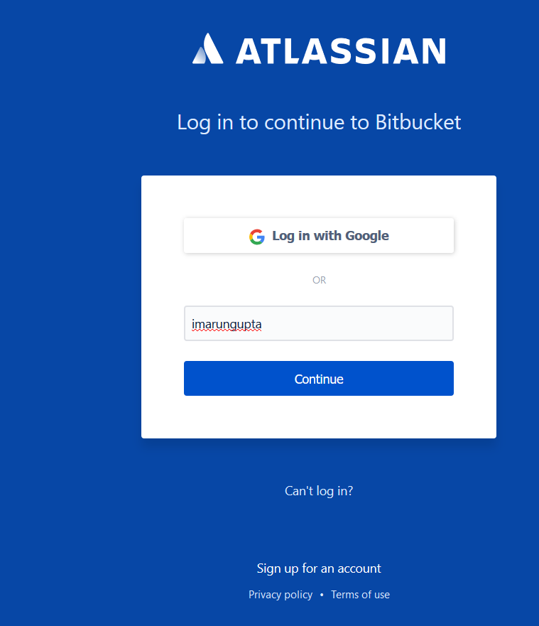

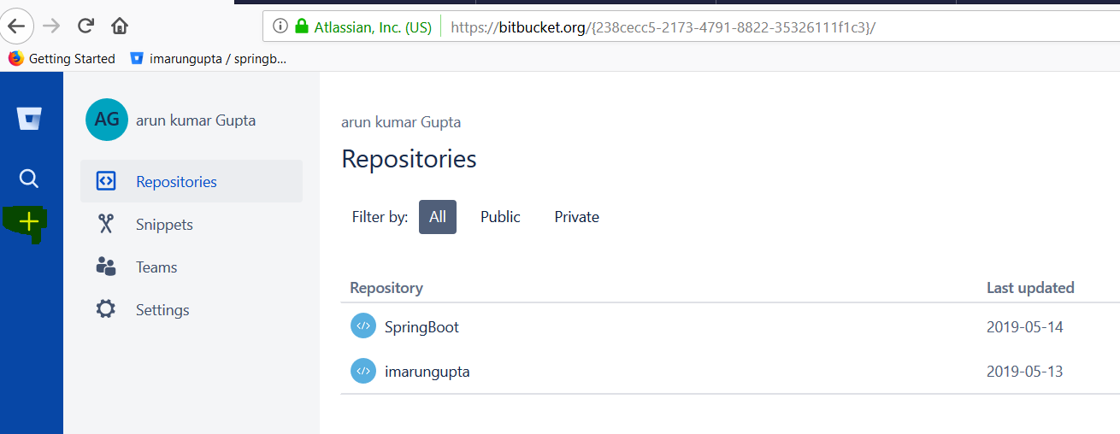

Click on + mark to create new repository.

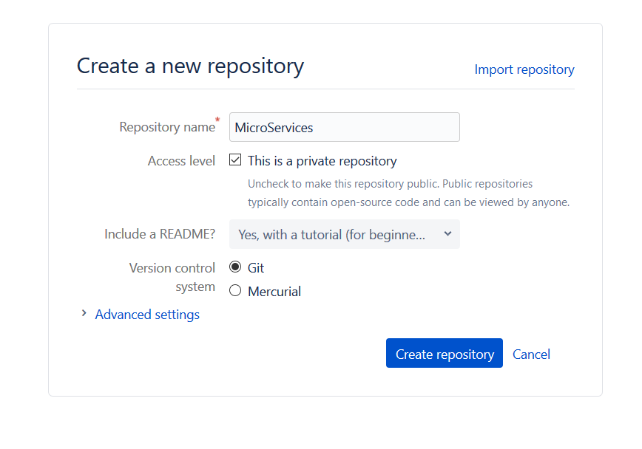

**Give Repository Name and Create Repository.**

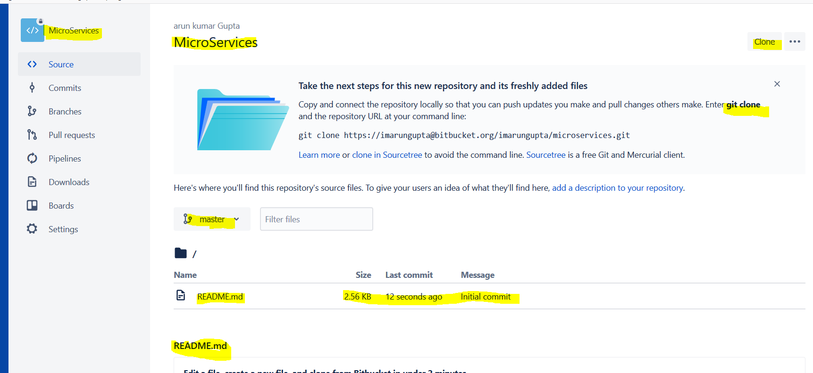

**Click on the Branches on the LHS PAN**

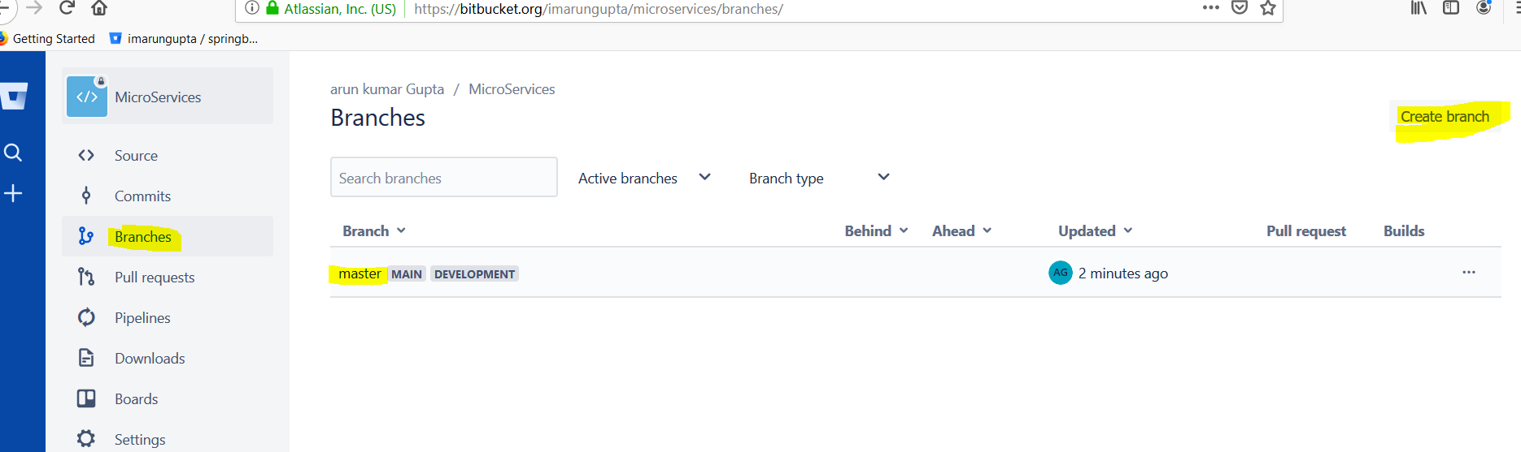

**We have got one Master Branch for production ready project. Click on Create branch on RHS to create some other branch link development Branch for development purpose.**

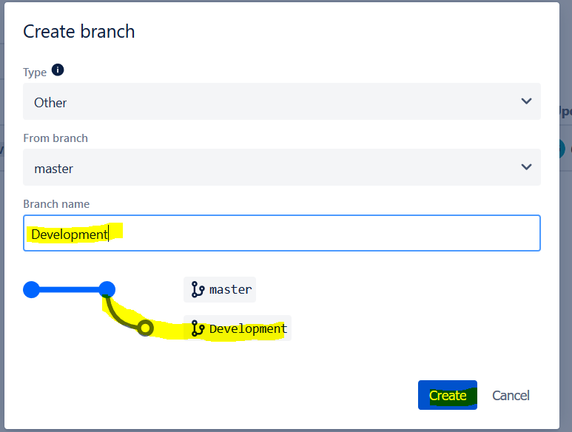

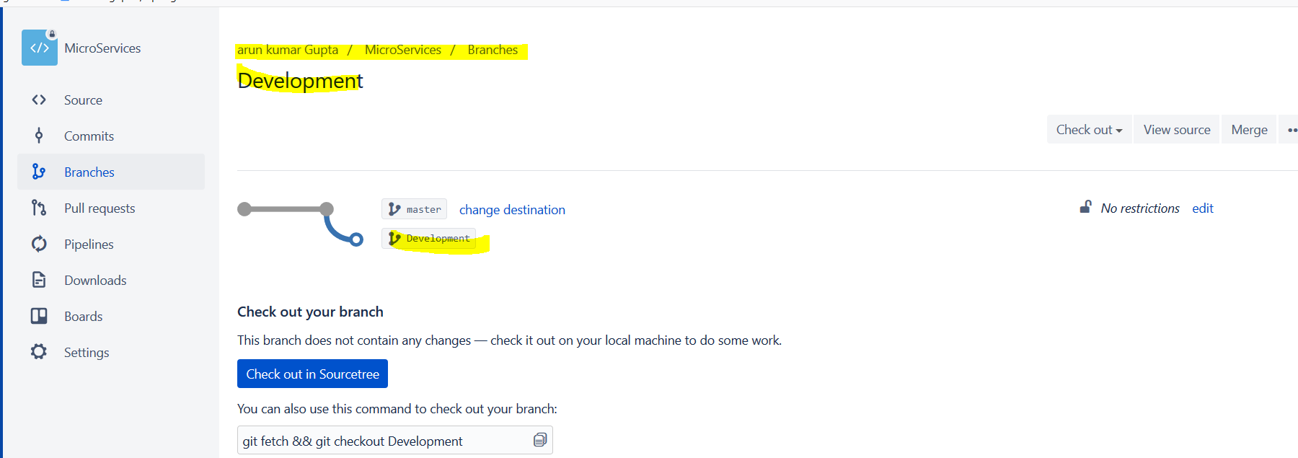

**Now click on Branches and we will get Master and Development Branches.**

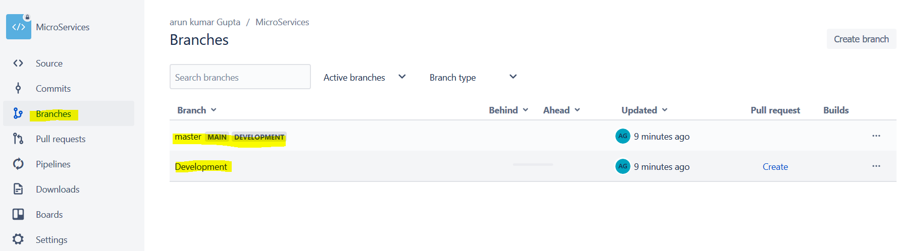

**Now we will clone this repository in the eclipse:**

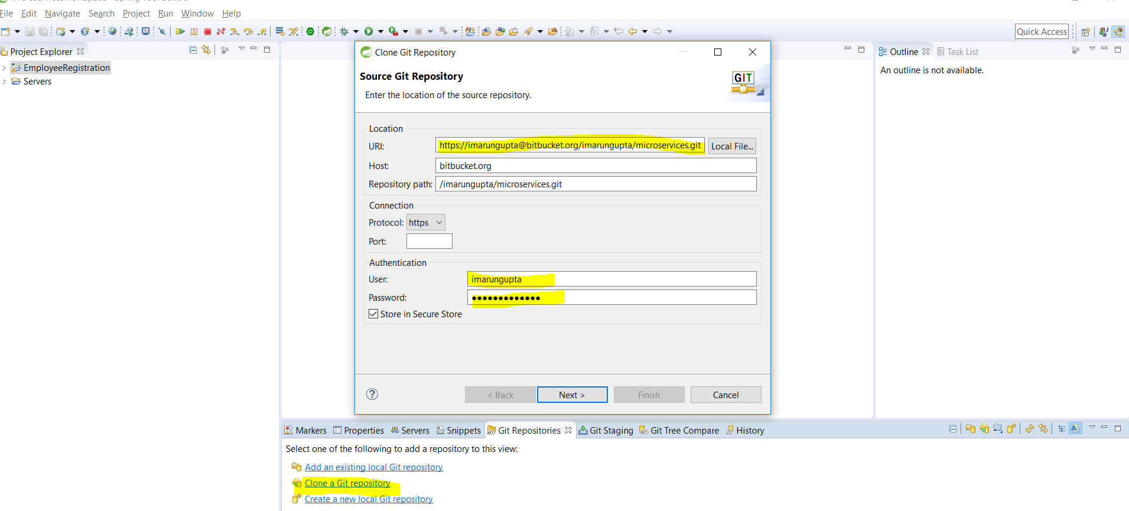

**Click Next**

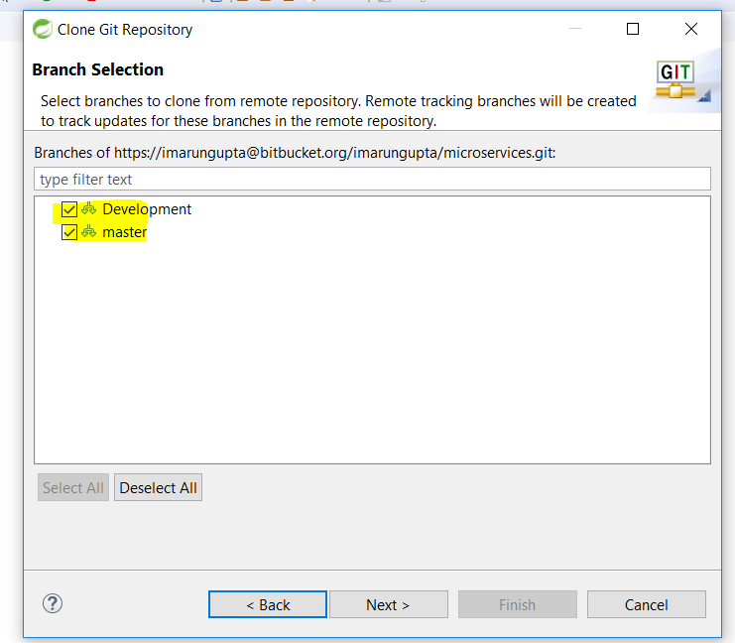

**Select any of the two (Master or Development) Branches.**

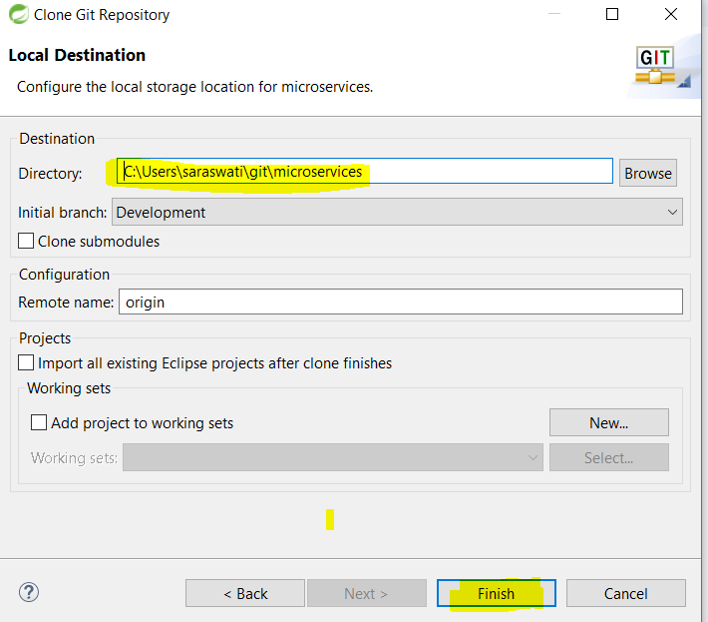

**Click Next and Finish.**

**Finally we will get the clone of the development repository. Now we will create one project and then push the same project into development branch.**

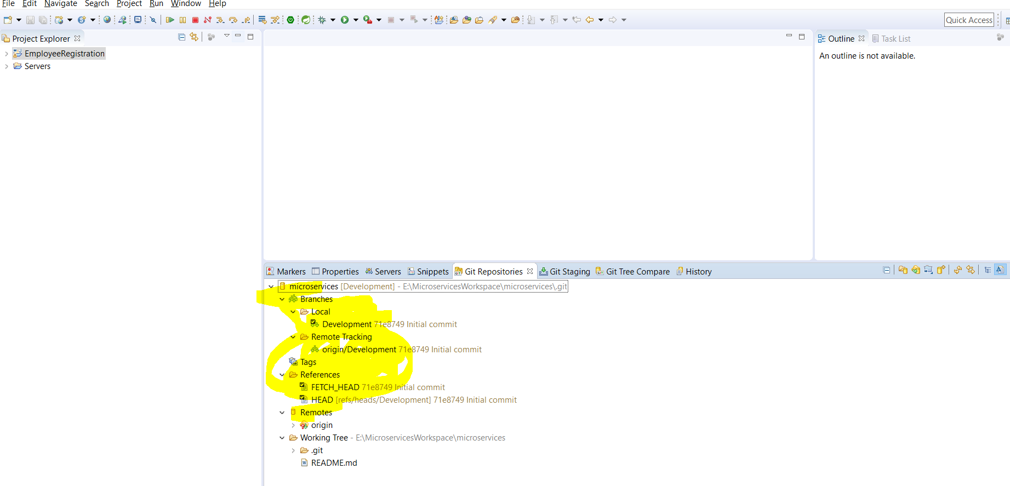

**Create one Maven Project EmployeeRegistration as shown in the above eclipse project.**

**Now push the project in the development branch**

**Right click on the project --- > Team -🡪 Share Project**

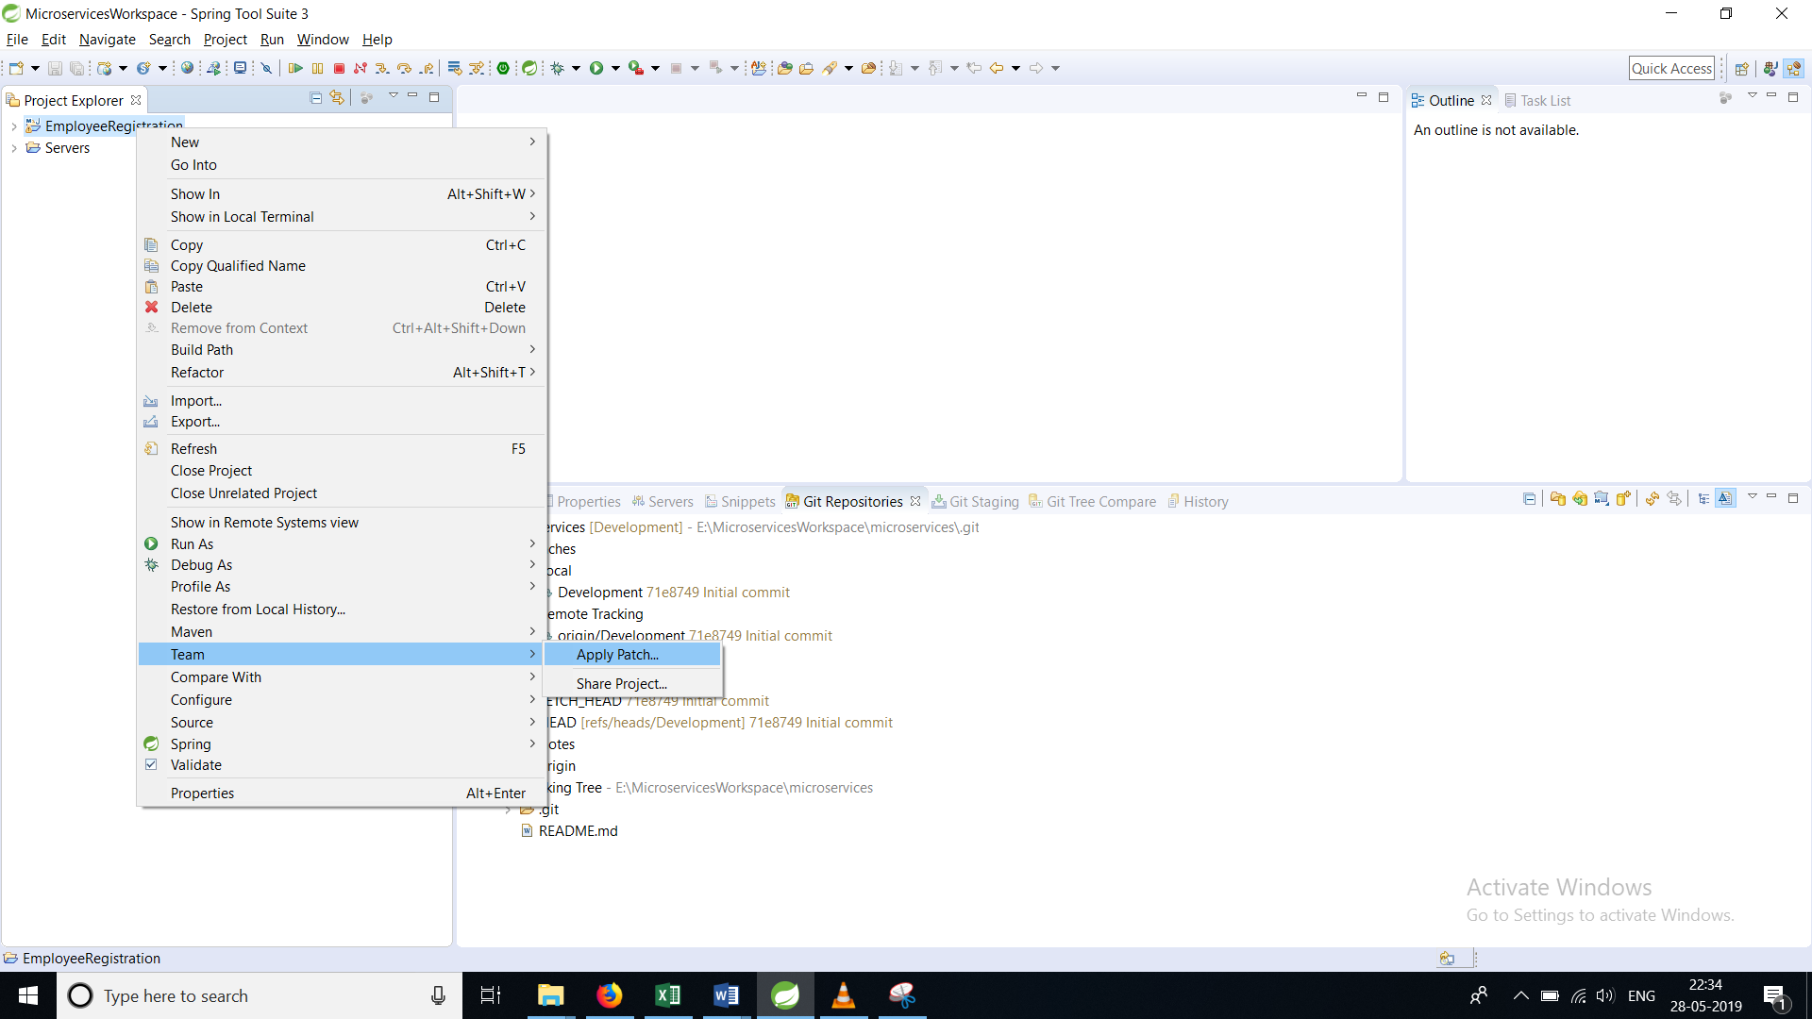

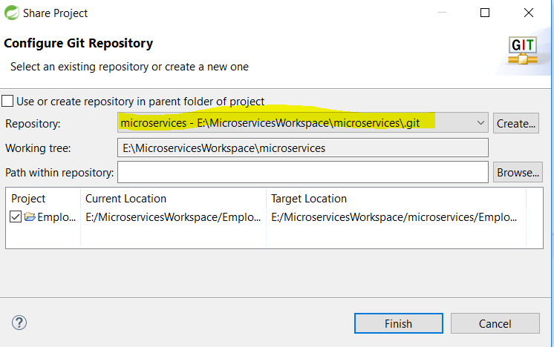

**Select the repository we just cloned. And Click on finish**

**In this way we can create connection between our project and Bit-bucket Repository.**

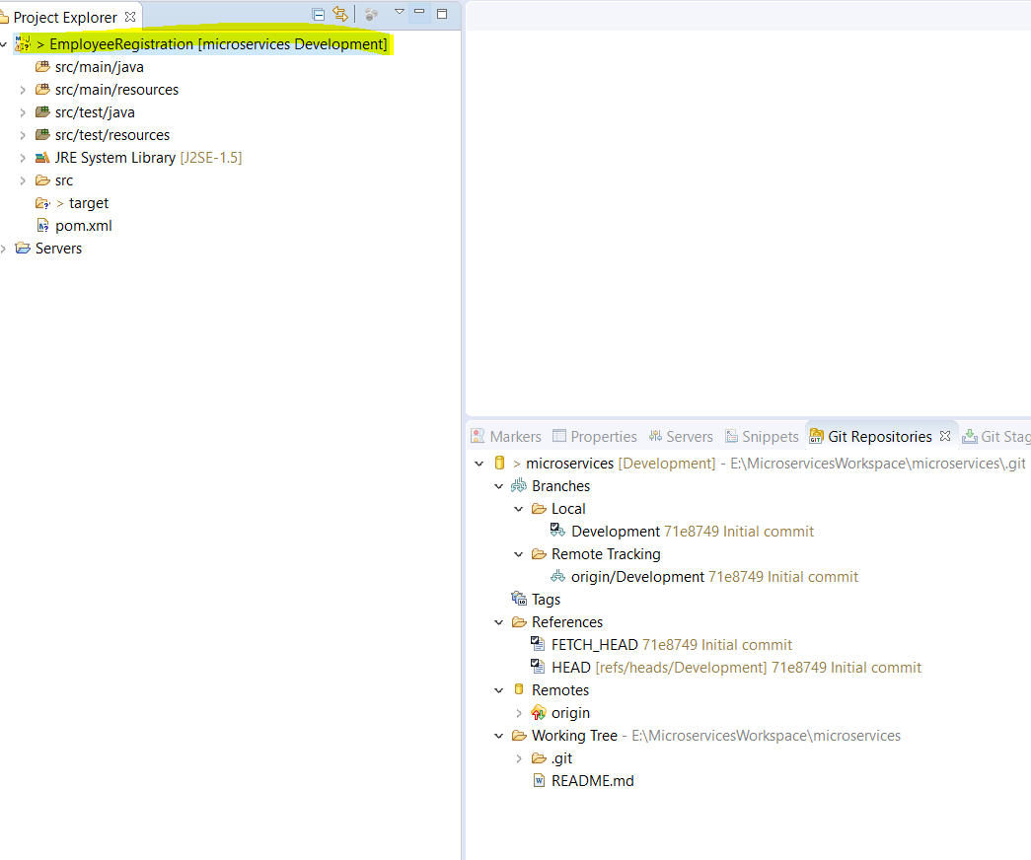

**Now go to Git Staging Area, where we will see an the EmployeeRegistration project related files that we need to push into repository and commit the changes.**

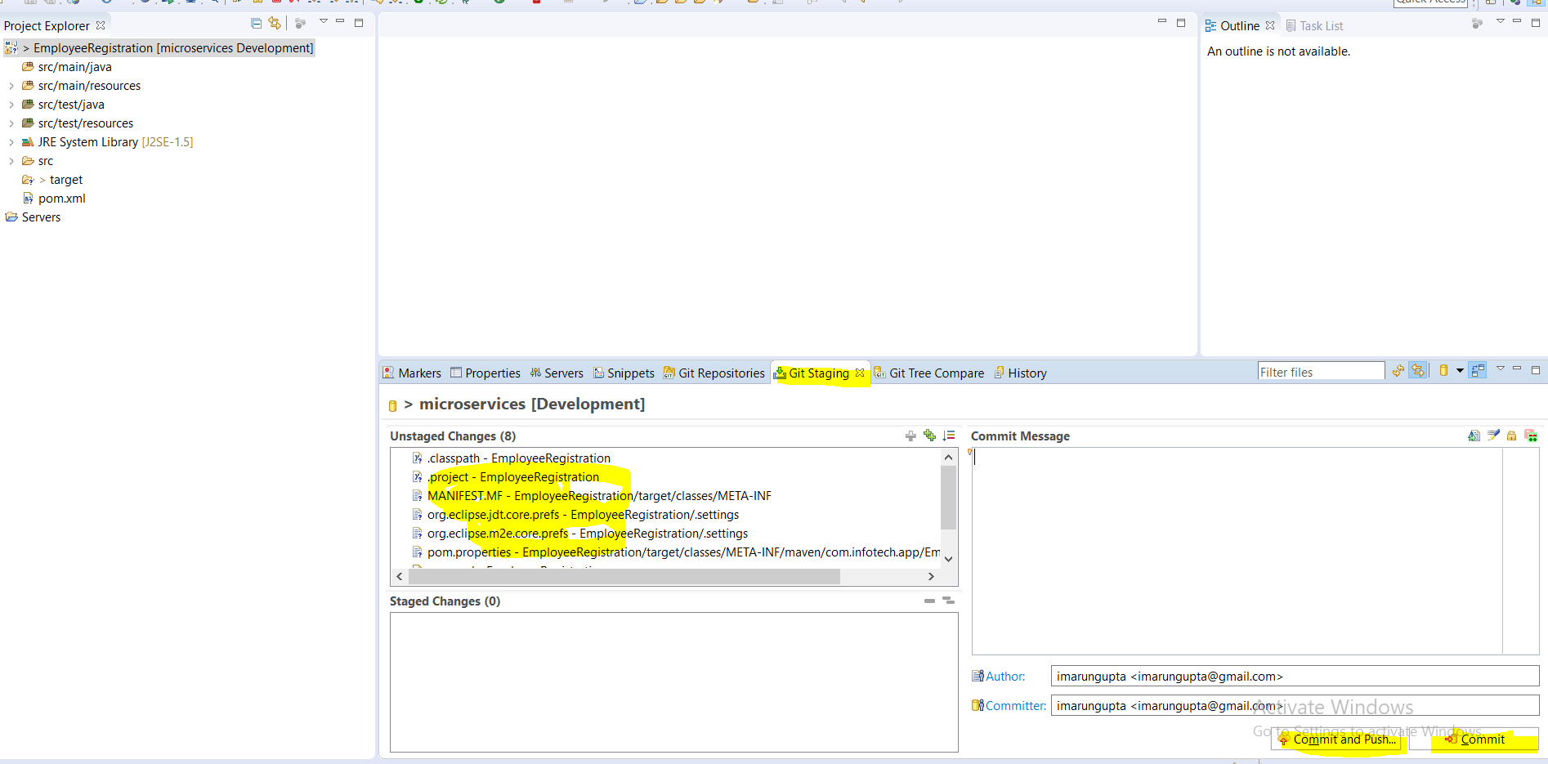

**Select all the files from Unstaged Changes and drag and drop all the files into staged changes area.**

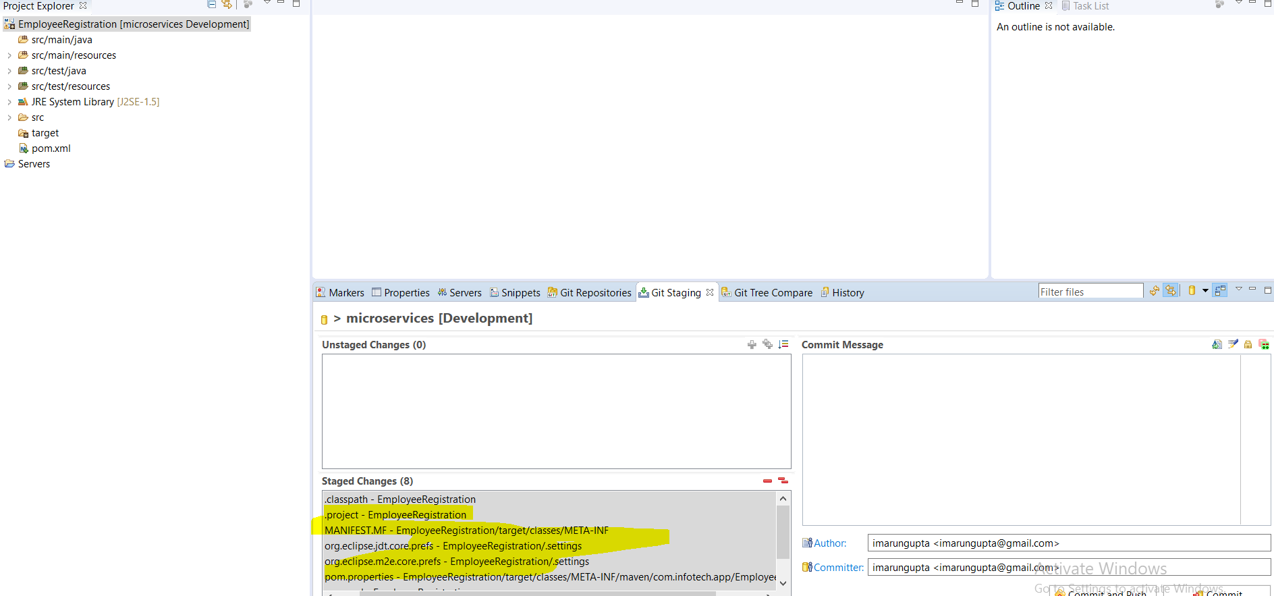

**Give a commit message in the Commit Message box and click on commit.**

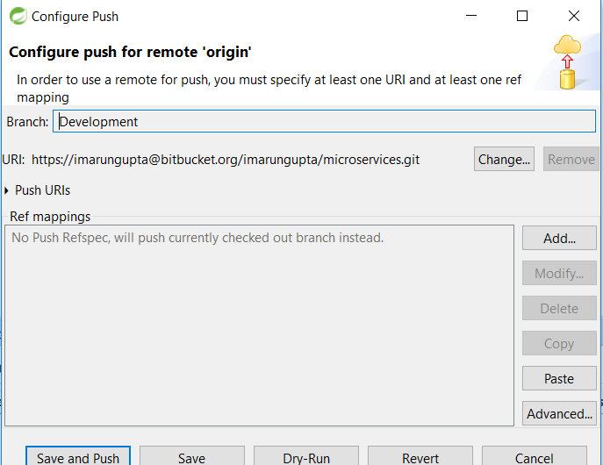

**Now Click on Save and Push**

**And all the code will move to development branch**

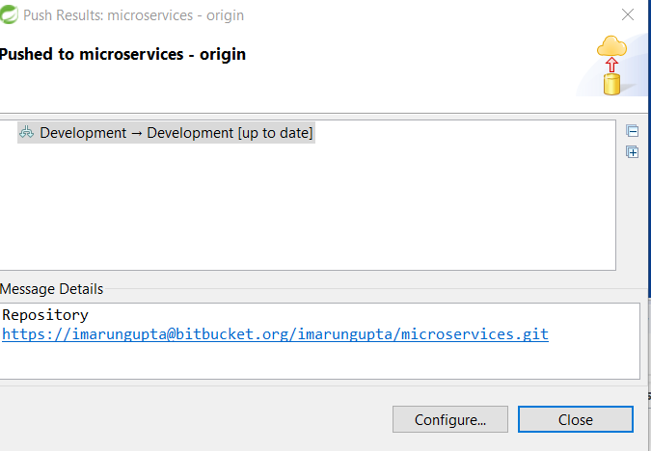

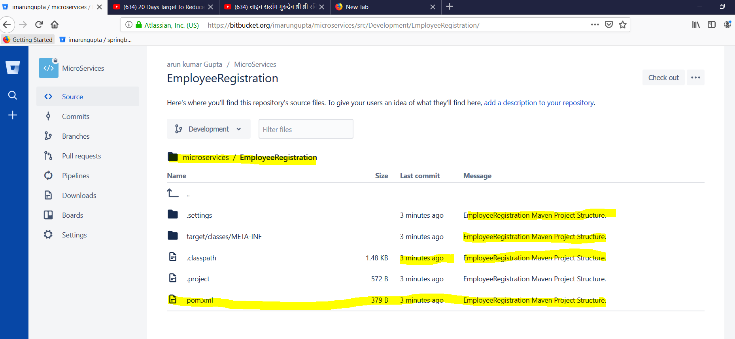

**Now open the bit-bucket development branch and we can see that all the changes moved to development branch with Commit message.**