Quick start guide for the
JEntigrator.
Alexander Imas, 2016, Darmstadt.

1.Requirements.
The JEntigrator is the single-user local file-based data management application implemented as a java program. It is deployed as the jar library file. You need the Java7 runtime environment to start and use the application or the Java7 JDK to modify and adapt the application. The JEntigrator is the open source program published under GNU GPL licence on the GitHub platform. Download the JEntigrator-0.0.1-SNAPSHOT.jar and the
Community-0.0.1-SNAPSHOT.jar from here into the start directory of your choice. You need also to download apache libraries commons-codec-1.1 jar and commons-compress-1.1 jar into the start directory. Open the terminal(on linux) or DOS(on Windows) window , navigate to the start directory and run the application with the command line:
java -cp ./commons-codec-1.10.jar:./commons-compress-1.10.jar:./JEntigrator-0.0.1-SNAPSHOT.jar gdt.jgui.console.JMainConsole

2.First start.
The main application's window appears after the start. Use the menu item File -> New base to create a new database. The application proposes the name of the new database New_base in the text editor windiw. Accept the name and click the Done menu item in the Context menu. Select the directory to save the database in the FileChooser dialog. The applications creates the new database and displays the BaseNavigator in the context panel.
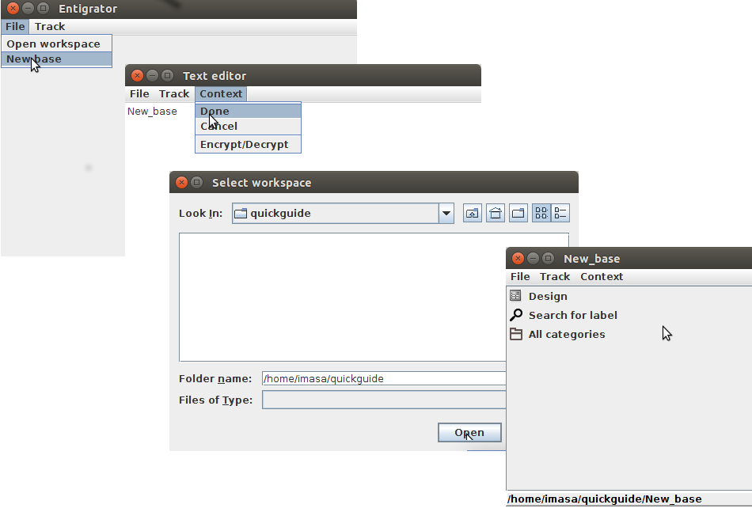
Now we found out that the main application window is a frame containing a menu bar and the context panel. The menu bar contains two permanent menus File and Track and the changeable menu Context. The context panel is a placeholder. It's content depends on the user's activity. The Context menu depends on the current context. The user interacts with the application through the menus and contorls in the context panel.

3.Explore the new database.
The JEntigrator provides some ways to get access to the content of the database. The BaseNavigator context panel lists three of them: Design, Search for label and All categories items. Click on the items puts its context in the context panel.
The Design context displays the multifunctional contol panel for low-level management of the database.
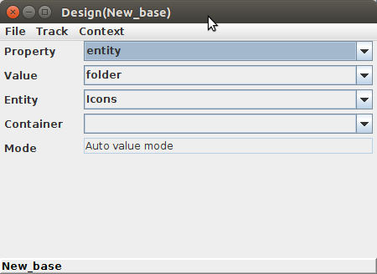

We know, that each database in the JEntigrator contains some unified data objects called entitties. Each entity has two mandatory properties: entity, containing the type of the entity, and the label, containing the unique name of the entity. The Property selector keeps a list of all properties of all entities in the database. The Value selector shows all values of the selected property. The Entity selector contains a list of all entities having the selected value assigned. The Container selector shows the list of all containers of the selected entity if exist. In our case the entity Icons of the type folder is selected. Selection of entities is an important but not sole feature of the Design control. We don't want to consider them here to keep explanations short. Now we can click on the Entity label and display the FacetsPanel context for the selected entity.
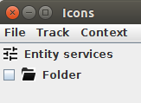

The Search for label context exposes the autocomplete textbox. The user types first letters of the label and the textbox exposes the drop-down list of suggested labels to select the entity. The click on the Open menu item shows the FacetsPanel context for the selected entity.
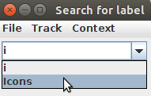
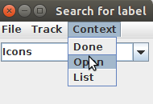
The All categiries context displays the list of all possible entity's types in the database. The New_base contains only one entity Icons of the folder type. Click on the Folder type to show the entity Icons in the Category panel context. Click on the item Icons exposes again the FacetsPanel context for the entity
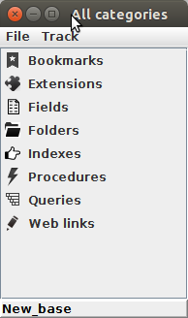
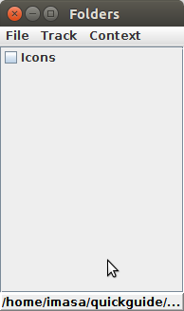

4.Explore an entity.
An entity in the JEntigrator is defined as a collection of facets. A facet is a composition of two components: data and program. The data component is a collection of some fields within entity and the program component (the facet handler) is a code within the JEntigrator processing this data. The FacetsPanel context lists all facets assigned to the entity. Each entity has at least one mandatory facet Entity services that collects standard operations independent on type or content of the entity. The click on the facet item displays its context panel. The picture below shows entity services context. The click om the service item displays its context. The Done menu item from the Context menu close the context.
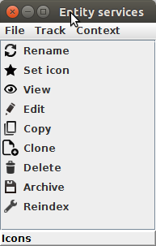
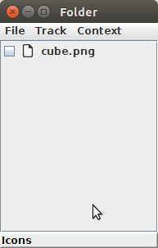

4.Extend the database.
The JEntigrator application originally includes only general-purpose facets. In order to be really useful the application should be adapted to the user's busines area. That can be done using extensions. An extension is a special entity of the extension type containing a library with with new facet handlers and descriptions of these facets. The extension can be imported as any other data object into the database or by starting of the executable jar file from the JEntigrator. The community.jar file extends the database with contact facets.
The installation of othe extension can be done from the BaseNavigator context. Click on the Install extension menu item in the Context menu. Select the community.jar file in the File chooser dialog and click the Open button. Close the application and start the JEntigrator again. In the All categories context you can see now some new entity types.
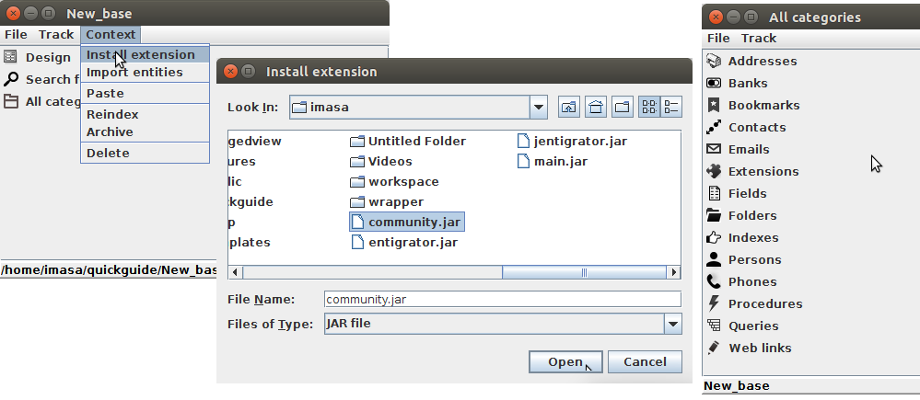

5. Install the sample database community.
The community extension contains the template database communicty. Its archive file community.tar is located in the extension folder. Navigate to the content of community extension and right click the community.tar item. Then the left click on the Extract menu item from the context menu.
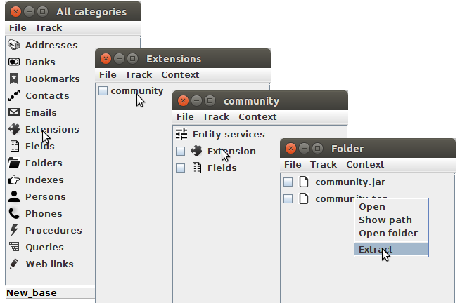
Select the installation directory in the FileChooser dialog and click the Open button.
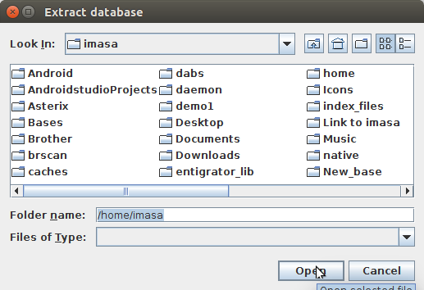

Now we shall open the community database and install the extension there.
- File → Open workspace → Open: select the directory containing the community database in the FileChooser
- Click the community item in the DatabasesList context: open the BaseNavigator context.
- Context → Install extension → Open: select the community.jar extension in the FileChooser and install it in the community database.
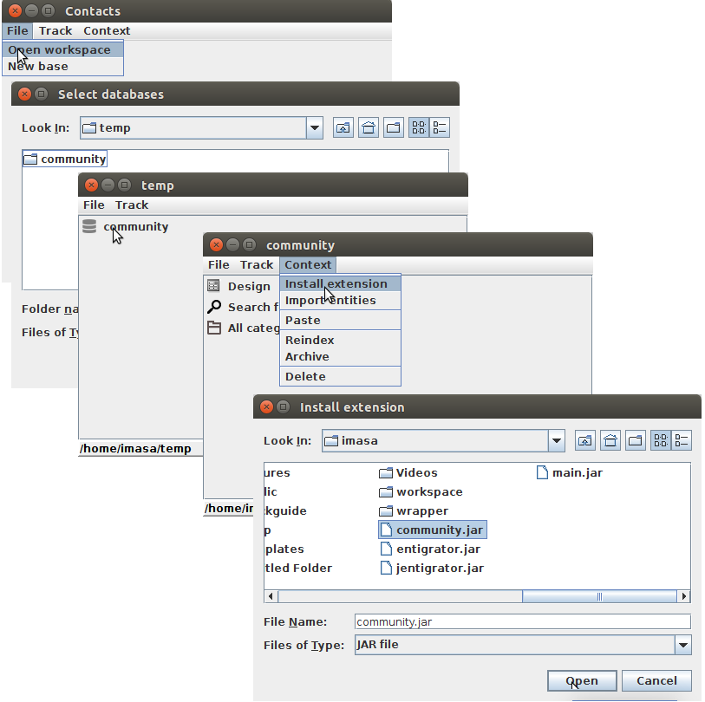

6. Explore the content of the database.
Now it's time to do an overview tour on the content of the community database. The basic entity type there is contact. A contact must have the mandatory unique name ( the label of the entity) and may have some other facets reflecting its properties. These facets may be embedded into the contact entity as properties or tied to the contact as components.

6.1. List contacts in the CategoryPanel context.
Open the BaseNavigator context of the community database as described above. Click the All categories item. Click the Contacts category item.
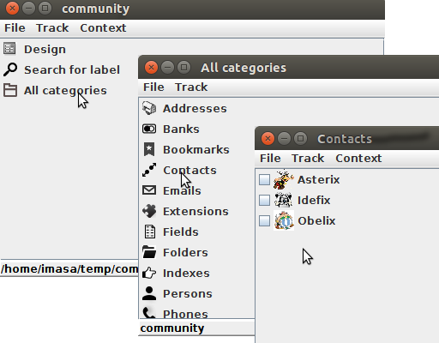

The database contains three sample contacts Asterix, Idefix and Obelix.

6.2. Explore the contact.
An entity in the application is defined as a set of facets. So if you click on the contact item in the list you switch into the FacetsPanel context . The FacetsPanel exposes the list of all facets assigned to the entity.
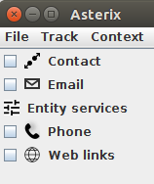

There are another two contexts displaying an entity: Structure and Digest. The Structure shows the container-components tree for the entity. The Digest shows all properties including components. We can switch to another context using the Context menu.
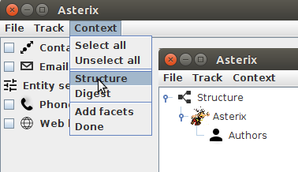

We can see that the Asterix has one component Authors. An entity may have many containers. So you can check that the Authors entity is a component of Idefix and Obelix too. Click the Context menu item Digest to switch into the DigestPanel context. The Digest collects all facet properties of all components and provides the overview of whole information about the Asterix.
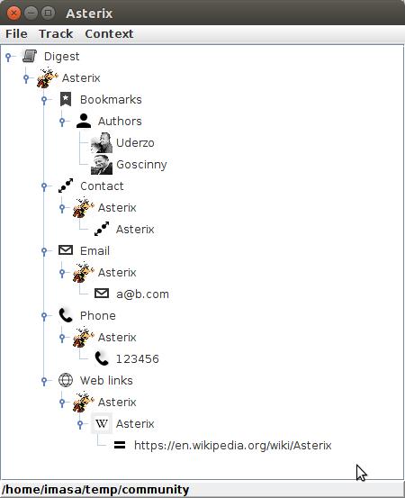

7. Browsing the database .
The GUI of the JEntigrator is built as a set of context panels. A user switches between contexts in order to get access to contols needed for the current task. Practical experience shows that is often necessary to return to already shown contexts. The Track menu makes this work easier. The Back menu item displays the previous context. The Show track menu item lists the serie of previous contexts in the hierarchical order. The click on the list item removes items above the selection and displays the selected context. This policy keeps the track short and clear. The Clear menu item clears the track. Alternatively you can any time open the database from the File menu and navigate using the BaseNavigator context. The JEntigrator saves track on exit and shows the last used context on start.
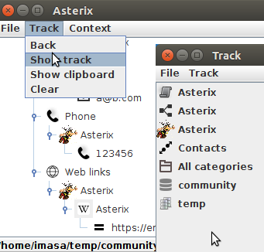

8. Facet management.
An entity evolves in the way that facets can be added or removed from it. To illustrate the procedure we create a new contact and assign facets to it. Navigate to the Contacts category context as described above and click the New menu item from the Context menu. Edit the name in the NewContact context and click Done.
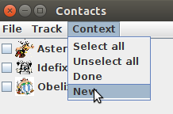
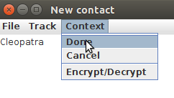

The JEntigrator assigns the phone and email facets to the new contact on default. Edit these values and the Done menu item.

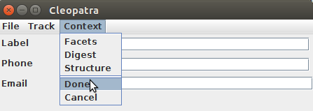

You may want to assign an icon to the Cleopatra. Assume the icon is already copied into the system clipboard. You should paste it into the folder Icons in the database. The picture below shows how to open the folder in the system file manager and paste the file there.
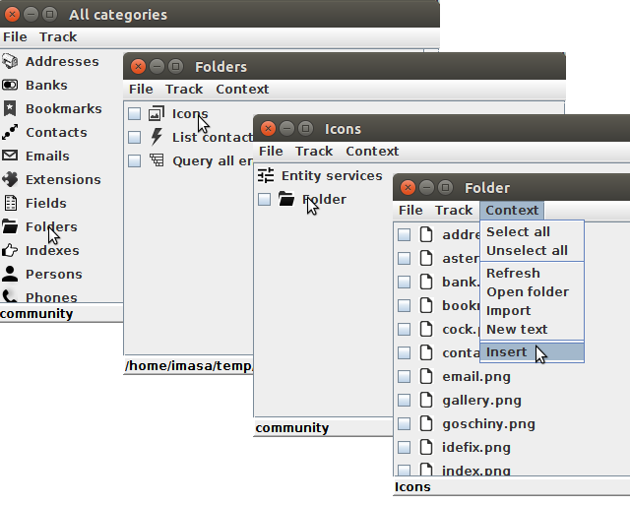
Alternatively you can use the Open folder menu item to open the system file manager and paste the icon there. Now it is possible to assign the item to the Cleopatra. Navigate to CategoryPanel or contacts. The next actions are shown on the picture below.
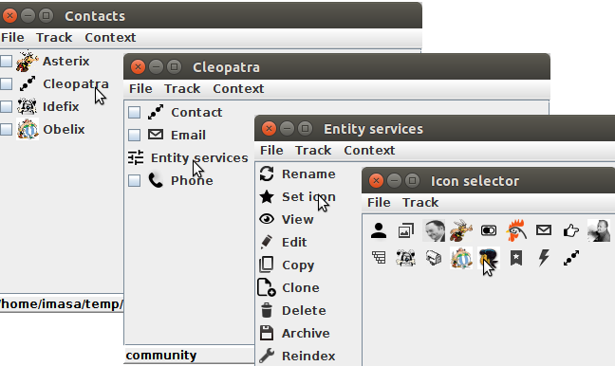
The next step is to add the WebLinks facet to the Cleopatra. Navigate to the FacetsPanel of the Cleopatra. The next actions are shown on the picture below.
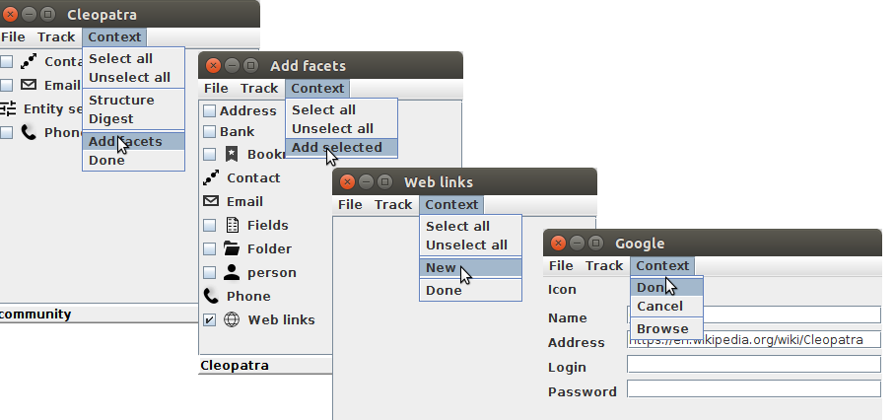
You have to type the name Cleopatra and the address https://en.wikipedia.org/wiki/Cleopatra in the form fields before Done. Any number other links can be added to the entity. To access the web link actions use the right click on the item.
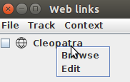

9. Associations.
The JEntigrator provides some ways to unite data in groups. The container-component relation gives the possibility to create complex entities. For example Authors is the component of Asterix.
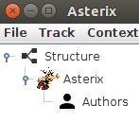

A bookmark facet makes an entity to be a collection of links to entities or/and files within the database. It provides quick access to the certain data selection.
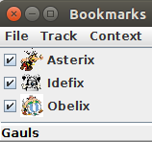

An index is a tree structure of groups containing another groups and links to entities or/and files within the database. A user create indexes according his/her business logic. There can be multiple indexes in the database.
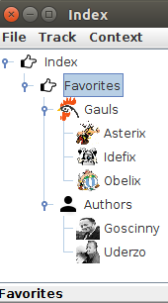

To create a new group use the right click menu.
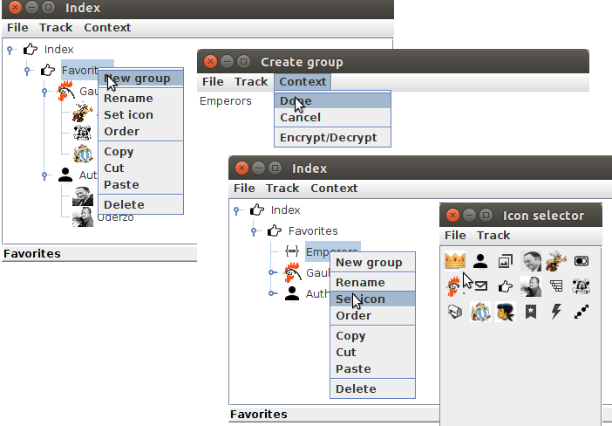
To put a new member into the group use the copy → paste procedure.
- Navigate to the contacts list and copy Cleopatra into the application clipboard.
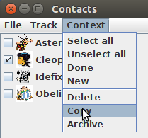

- Navigate to Favorites and paste the entity.
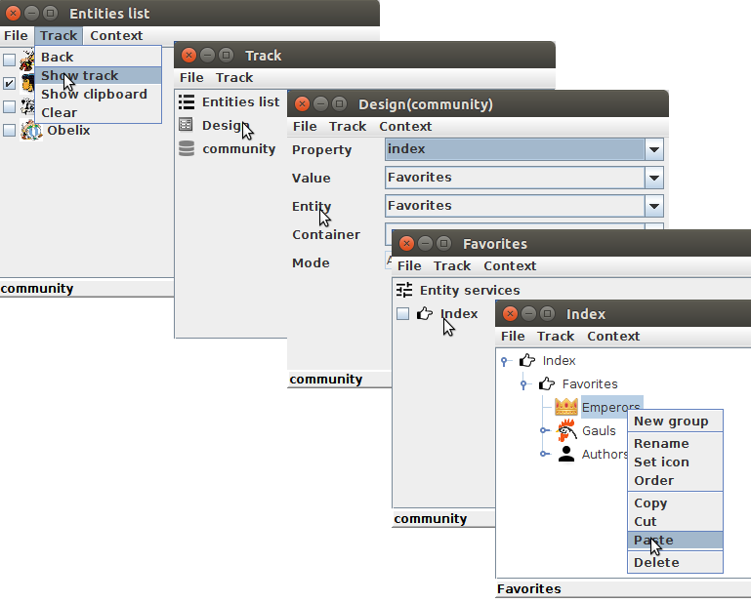
At least a user can create a special property (the tag) and assign it to all entities in the association. Later this tag can be used to retrieve a list of association members.

10. Data transfer.
The data model in the JEntigrator has no schema and data objects are presented as files within the database directory. That means that data objects can be transferred in the same way as any other files. The difference is that together with data objects all referenced entities must be transferred too to keep the target database consistent. The property index of the target database must alse be modified accordingly. The JEntigrator makes this work automatically when pasting entites from another database. The example of copy → paste the Favortes from the community to the New_base is shown below. The Favortes is an index which references some other entities. First we should copy selected entities into the application clipboard. It can be done for example from the entity services context.
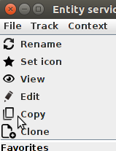

Then we should navigate to the BaseNavigator context of the New_base.
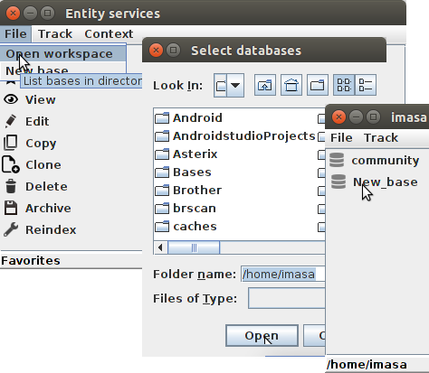

The last step is to paste entites from the clipboard.
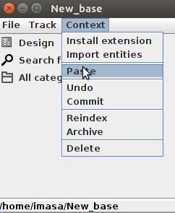

The JEntigrator resolves references and paste all entities into the target database.
It is possible to archive some selected entites into an archive file and import them later into another database. To check it delete the New_base and create a new one. Then archive all contacts into the archive file. Navigate to the CategoryPanel context for Contacts in the community database. Select all items and click the Acrhive menu item. Click the desirable archive type item. Accept the suggestedfile name or type a new one. Select the target directory and save the archive. The archive can be imported from the BaseNavigator context.
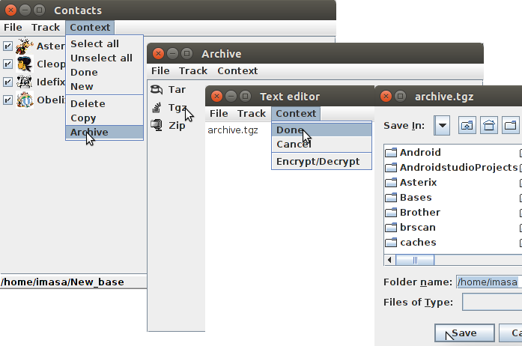

11. Adaptable contexts Query and Procedure.
The JEntigrator includes two facets query and procedure that let users create adaptable controls to fulfil current requirements. These facets relate to corresponding entities of type query or procedure. The entity's folder contains a class file performing the program part of work, the source java file and eclipse project files. A user can modify and compile this file in order to adapt the control . That material is outside the scope of this guide. The facet provides GUI to control the service.
The query facet provides a table view of information . Take a look to the sample Query all entities. Navigate to the FacetsPanel for the Query all entities query. Click the Query item. The QueryPanel context appears. This context comprises two parts: the item selector and the table view. The entity selector of the query is implemented in the query class file _2DOtCo5e_S6ARWU0H_MtyFnnPThE.class located in the entitiy's folder. This class must have the public method select. You may want to check the query source file _2DOtCo5e_S6ARWU0H_MtyFnnPThE.java there:
import java.util.logging.Logger;
import gdt.data.store.Entigrator;
import gdt.jgui.console.JMainConsole;
import gdt.jgui.entity.query.Query;
public class _2DOtCo5e_S6ARWU0H_MtyFnnPThE implements Query {
private final static String ENTITY_KEY="_2DOtCo5e_S6ARWU0H_MtyFnnPThE";
@Override
public String[] select(JMainConsole console,String entihome$){
try{
//Do NOT change this section of the code
Entigrator entigrator=console.getEntigrator(entihome$);
String [] sa;
// Put query code here
sa=entigrator.indx_listEntitiesAtPropertyName("entity");
//Do NOT change this section of the code
return sa;
}catch(Exception e){
Logger.getLogger(getClass().getName());
return null;
} } }
The table view initially lists all entities in the database. A user can modify the table using the context menu and item selector.
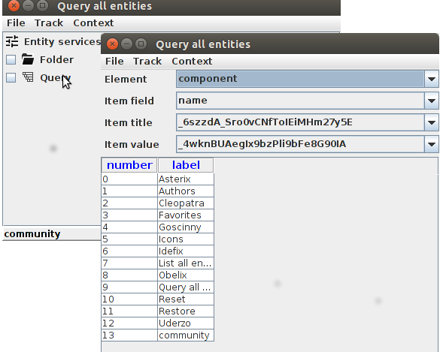
To remove some rows from the table select the numbers and click the context menu item Exclude rows. The selected rows will be removed from the list.

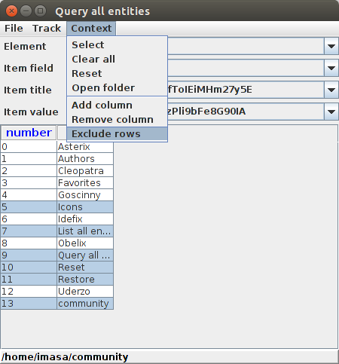

To add a column to the table view you have to select an element of the entity and the field of the core to select. The Item title shows the name of the column and The Item value all values (for all entities). After that click the context menu item Add column. To delete a column select it in the item selector and click the Remove column menu item. The click on the item in the label column displays the FacetsPanel for the entity. The Clear all menu item clears all changes and resets the query in the initial state. The Reset item replaces the query source file with the default default content. All changes will be lost ! Add the element parameter with the core {null, noreset,null} into the query to hide the Reset item.

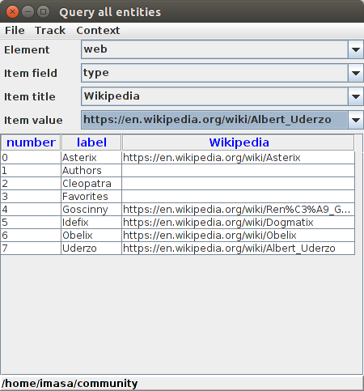

The procedure facet provides the run method to perform certain actions in the database. For example the Reset procedure removes the Cleopatra contact and update the Favorites index. The source file _Vo5ZNvv0Oc0LNE4PTUV36psyGCo.java of the procedure is located in the entity's folder.
import java.io.File;
import java.io.FileOutputStream;
import java.io.OutputStreamWriter;
import java.io.Writer;
import java.text.SimpleDateFormat;
import java.util.Date;
import java.util.Properties;
import java.util.logging.Logger;
import gdt.data.entity.EntityHandler;
import gdt.data.grain.Core;
import gdt.data.grain.Locator;
import gdt.data.grain.Sack;
import gdt.data.store.Entigrator;
import gdt.jgui.console.JConsoleHandler;
import gdt.jgui.console.JMainConsole;
import gdt.jgui.entity.index.JIndexPanel;
import gdt.jgui.entity.procedure.JProcedurePanel;
import gdt.jgui.entity.procedure.Procedure;
import java.util.ArrayList;
import java.util.Collections;
public class _Vo5ZNvv0Oc0LNE4PTUV36psyGCo implements Procedure {
private final static String ENTITY_KEY="_Vo5ZNvv0Oc0LNE4PTUV36psyGCo";
@Override
public void run(JMainConsole console,String entihome$,Integer dividerLocation){
try{
// System.out.println("Reset:run:BEGIN:entihome="+entihome$);
Entigrator entigrator=console.getEntigrator(entihome$);
String label$=entigrator.indx_getLabel(ENTITY_KEY);
//Delete Cleopatra from the database
String cleopatraKey$=entigrator.indx_keyAtLabel("Cleopatra");
System.out.println("Reset:run:Cleopatra key="+cleopatraKey$);
if(cleopatraKey$!=null){
Sack cleopatra=entigrator.getEntityAtKey(cleopatraKey$);
entigrator.deleteEntity(cleopatra);
}else
System.out.println("Reset:run:cannot find Cleopatra");
//Delete Emperors from Favorites
String favoritesKey$=entigrator.indx_keyAtLabel("Favorites");
if(favoritesKey$!=null){
Sack favorites=entigrator.getEntityAtKey(favoritesKey$);
Core[] ca=favorites.elementGet("index.jlocator");
if(ca!=null){
Properties locator;
String title$;
String type$;
String groupKey$;
String nodeKey$;
ArrayList <String>sl=new ArrayList<String>();
//Find Emperors key
String emperorsKey$=null;
for(Core c:ca){
try{
locator=Locator.toProperties(c.value);
title$=locator.getProperty(Locator.LOCATOR_TITLE);
type$=locator.getProperty(JIndexPanel.NODE_TYPE);
nodeKey$=locator.getProperty(JIndexPanel.NODE_KEY);
groupKey$=locator.getProperty(JIndexPanel.NODE_GROUP_KEY);
if("parent".equals(groupKey$)
&&"Emperors".equals(title$)){
emperorsKey$=nodeKey$;
System.out.println("Reset:run:found Emperors key="+emperorsKey$);
sl.add(c.name);
break;
}
}catch(Exception e){
System.out.println("Reset:run:"+e.toString());
}
}
if(emperorsKey$==null){
System.out.println("Reset:run:cannot find Emperors key");
return;
}
//Find Emperors members
for(Core c:ca){
try{
locator=Locator.toProperties(c.value);
title$=locator.getProperty(Locator.LOCATOR_TITLE);
type$=locator.getProperty(JIndexPanel.NODE_TYPE);
nodeKey$=locator.getProperty(JIndexPanel.NODE_KEY);
groupKey$=locator.getProperty(JIndexPanel.NODE_GROUP_KEY);
if(emperorsKey$.equals(groupKey$)){
sl.add(c.name);
break;
}
}catch(Exception e){
System.out.println("Reset:run:"+e.toString());
}
}
if(sl.size()<1){
System.out.println("Reset:run:empty emperors");
return;
}
for(String s:sl)
favorites.removeElementItem("index.jlocator", s);
entigrator.save(favorites);
}else
System.out.println("Reset:run:empty Emperors");
}
else
System.out.println("Reset:run:cannot find Favorites");
File report=new File(entihome$+"/"+ENTITY_KEY+"/report.txt");
if(!report.exists())
report.createNewFile();
Date curDate = new Date();
SimpleDateFormat format = new SimpleDateFormat();
format = new SimpleDateFormat("dd-M-yyyy hh:mm:ss");
String date$= format.format(curDate);
FileOutputStream fos = new FileOutputStream(report, false);
Writer writer = new OutputStreamWriter(fos, "UTF-8");
writer.write("Report: "+label$+"\n");
writer.write(date$+"\n");
writer.write("__________ Reset community base _____________\n");
writer.write("Cleopatra deleted, Favorites updated\n");
writer.close();
JProcedurePanel jpp=new JProcedurePanel();
String jppLocator$=jpp.getLocator();
jppLocator$=Locator.append(jppLocator$, Entigrator.ENTIHOME, entihome$);
jppLocator$=Locator.append(jppLocator$, EntityHandler.ENTITY_KEY,ENTITY_KEY);
jppLocator$=Locator.append(jppLocator$, JProcedurePanel.DIVIDER_LOCATION,String.valueOf(dividerLocation));
JConsoleHandler.execute(console, jppLocator$);
}catch(Exception e){
Logger.getLogger(getClass().getName());
} } }
To run the procedure navigate to the rocedurePanel context and click the Run menu item.
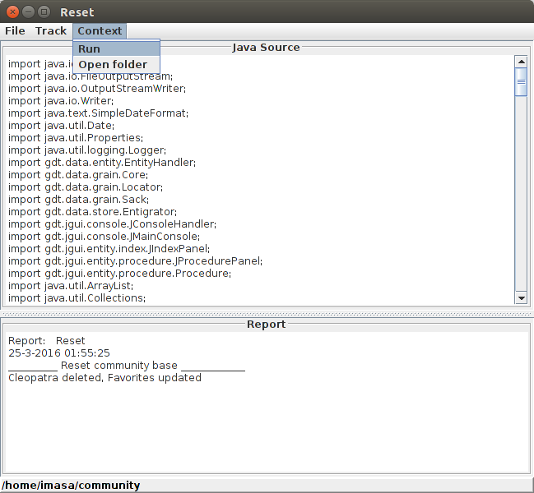
The Restore procedure restores the Cleopatra and Favorites to the original state.

