Revision 3.1.94 global.dat Registers

Global.dat (Part one)

Orders are given in ASCII format, each line represents an order and the lines end with CR + LF. The length of the fields is fixed (every kind of register). The numbers are represented in decimal format encoded in ASCII, if the length of a field is greater than the number, have to fill in the spaces left with zeros.

Orders (records) have the following format:
<Order Code> (A character Ascii)
[<R-M / U>] ((Register-Modification / Unsubscribe) Not in all record types)
<Data of register type>
<CR + LF>

<Order Code>: A character representing the type of record.
<R-M / U>: Indicates perform register or modification if it is "0" or unsubscribe if "1"
<Data Order>: specific information
<CR + LF>: End of line (Chr (13) + Chr (10))

General Note about Families:
Families can be assigned to different counters. In HydraTouch, from the forms, now families can be assigned to different counters but all maintained their position. Since the new record "F" entered in "global.dat" from version 1.9.7, you can assign position on the Family in each of the counters to which it is associated. Maintaining this feature must be from file and not from form.

REGISTERS:

Counter Registration: (Order "0")
FIELD LENGTH Comment.
----- -------- ----------
"0" 1 (Literal) Record type "0"
<R-M / U> 1 ​​digit "0" Register-Modification, "1" Unsubscribe
Section 2 digit Counter to create (01-99)
"000000" 6 (Literal) "000000"
Description 21 CHARAC. Description of Counter
Counter 3 digit Counter to create (001-099)
"1" 1 (Literal) "0"
<CR + LF> 2 CHARAC. End of register

Example:
0001000000Sección 1 0010
0002000000Sección 2 0020

Note: The Unsubscribe of a Counter causes:
- Removal Equipment (HydraTouch Data Base) keeping the Server Scale.
- Marking for Deletion Sellers (HydraTouch Data Base) belonging to the counter
- Marking for Deletion Barcodes (HydraTouch Data Base) belonging to the counter
- Marking for Deletion Families (HydraTouch Data Base) belonging to the counter
- Removal Subsections (hydraTouch Data Base) belonging to the counter
- Marking for Deletion items (HydraTouch Data Base) belonging to the counter
- Removal item’s direct keys (HydraTouch Data Base) belonging to the counter
- Removal item’s texts (HydraTouch Data Base) belonging to the counter

Registration Equipment: (Order “4”)
FIELD LENGTH Comment.
----- -------- ----------
"4" 1 (Literal) Record Type "4"
<R-M / U> 1 ​​digit "0" Register-Modification, "1" Unsubscribe
Counter 2 digit Counter in which to reg. the equipment (01-99)
Equipment No. 2 digits (01-99)
Server or Slave 2 digits (“01” = Server, “00”=Slave)
IP address 15 CHARAC. “XXX.XXX.XXX.XXX”
<CR + LF> 2 CHARAC. End of register

Example:
40010101127.000.000.001
40020200127.000.000.002

Family registration: (Order "2" Create-Modification / Unsubscribe not included)
(Only create Families-Modify this command does not asign position into counter)
FIELD LENGTH Comment.
----- -------- ----------
"2" 1 (Literal) Record Type "2"
Counter 2 digit Counter to which the family (01-99) belongs
Family 2 digits Family (01-99)
Description 30 CHARAC. Description of Family
Image X CHARAC. Image file name, the file must exists in the Scale
<CR + LF> 2 CHARAC. End of register

Example:
20101FRUTAS fruta.png

Family registration: (Order "F" )
FIELD LENGTH Comment.
----- -------- ----------
"F" 1 (Literal) Record Type "F"
<R-M / U> 1 ​​digit "0" Register-Modification, "1" Unsubscribe
Counter 2 digit Counter to which the family (01-99) belongs
Family 3 digits Family (001-999)
Position 3 digits position of the Family into Counter
Description 30 CHARAC. Description of Family
Image X CHARAC. Image file name, the file must exists in the Scale
<CR + LF> 2 CHARAC. End of register

Example:
F001001001FAM.1 IMGFAMILIA1.png
F001002002FAM.2 IMGFAMILIA2.png
F002003001FAM.3 IMGFAMILIA3.png
F003001001FAM.1 IMGFAMILIA1.png
F003002002FAM.2 IMGFAMILIA2.png

Note: unsubscribe a family causes unsubscribe items belonging to

Sellers Registration: (Order "G")
FIELD LENGTH Comment.
----- -------- ----------
"G" 1 (Literal) Record Type "G"
<R-M / U> 1 ​​digit "0" Register-Modification, "1" Unsubscribe
Counter 2 digit Counter (01-99)
Identifier 4 digits Seller’s identifier (0001-9999)
Key 4 digits Seller’s key into Counter (0001 - 9999)
Name 30 charac. Seller’s Name
<CR + LF> 2 CHARAC. End of register

Example:
G00100010001vendedor 1

Registration Articles: (Order “5” Format 1)
FIELD LENGTH Comment.
----- -------- ----------
"5" 1 (Literal) Record Type "5"
<R-M / U> 1 ​​digit "0" Register-Modification, "1" Unsubscribe
Code 6 digit Item Code (000001 to 999999)
Counter 2 digit Counter to which Article (01-99) belongs
PLU 4 digit Correlative PLU into Section (0001-9999)
Subsection 3 digit Unused by Scale. (001-999)
Family 4 digits Family to which Article belongs (0001-9999)
Price 5 digits Selling price (without decimal point)
Sales mode 1 digit Weighted item "W", Unit item “P" or "U"
Expiration days 3 digits Item expiration days (000-999)
"0" 1 (Literal) ( "0")
Descriptive 25 CHARAC. Main description
Tare 5 digits Tare in grams to be applied in Sale
<CR + LF> 2 CHARAC. End of register
Example:
50777777027777000000377777W0100PRUEBA ARTÍCULO 777777-->00015

Registration Articles: (Order “5” Format 2)
FIELD LENGTH Comment.
----- -------- ----------
"5" 1 (Literal) Record Type "5"
<R-M / U> 1 ​​digit "0" Register-Modification, "1" Unsubscribe
Code 6 digit Item Code (000001 to 999999)
Counter 2 digit Counter to which Article (01-99) belongs
PLU 4 digit Correlative PLU into Section (0001-9999)
Subsection 3 digit Unused by Scale. (001-999)
Family 4 digits Family to which Article belongs (0001-9999)
Price 5 digits Selling price (without decimal point)
Sales mode 1 CHARAC. Weighted item "W", Unit item “P" or "U"
Expiration days 3 digits Item expiration days (000-999)
"0" 1 (Literal) ( "0")
Descriptive 25 CHARAC. Main description
Tare 5 digits Tare in grams to be applied in Sale
VAT Type 1 digit VAT (0-4)
"000" 3 (Literal) ( "000")
Best before 3 digits Days of preferential consumption (000-999)
Label 3 digits Item Label
shrinkage 2 digits decrease in percent (0-99)
EAN13 12 CHARAC. Item Barcode EAN13
Preset 2 digits No. of preset package
<CR + LF> 2 CHARAC. End of register

Example:
50999999019999000000199999W0100PRUEBA ARTÍCULO 999999-->0001500000200002534CCCCCCIIII35
50888888018888000000288888W0100PRUEBA ARTÍCULO 888888-->0001500000200002535CCCCCCIIII35

Registration Item Image: (Order “U”)
FIELD LENGTH Comment.
----- -------- ----------
"U" 1 (Literal) Record Type "U"
Code 6 digits Item code (000001 to 999999)
Image X CHARAC. Image file name.
<CR + LF> 2 CHARAC. End of register

Registration Item Bar Code: (Order “W”)
FIELD LENGTH Comment.
----- -------- ----------
"W" 1 (Literal) Record Type "W"
"0" 1 (Literal) "0"
Item Code 6 digits Item (000001 to 999999)
EAN13 13 digits Item EAN13 (Can be 12 digits)
<CR + LF> 2 CHARAC. End of register

Registration Item additional Price : (Order “X”)
FIELD LENGTH Comment.
----- -------- ----------
"X" 1 (Literal) Record Type "W"
Item Code 6 digits Item (000001 to 999999)
Additional Prc.Nr. 2 digits (01 to 10)
Price 7 digits Additional price value
<CR + LF> 2 CHARAC. End of register

Registration Item Label : (Order “E”)
FIELD LENGTH Comment.
----- -------- ----------
"E" 1 (Literal) Record Type "E"
Code 6 digits Item code (000001 to 999999)
Label X CHARAC. Label file name.
<CR + LF> 2 CHARAC. End of register

Registration Item additional Long Text : (Order “T”)
FIELD LENGTH Comment.
----- -------- ----------
"T" 1 (Literal) Record Type "T"
Item Code 6 digits Item (000001 to 999999)
Additional Text Nr. 1 digits (1 to 4)
Text X CHARAC. Additional Text
<CR + LF> 2 CHARAC. End of register

(Next “Z”, “Y”, “M” and “O” orders works with descriptive lines 25 Characters length)
Registration Item Aditional descriptives lines 1 to 10: (Order “Z”)
FIELD LENGTH Comment.
----- -------- ----------
"Z" 1 (Literal) Record Type "Z"
Item Code 6 digits Item Code (000001 to 999999)
Description String X CHARAC. Up to 250 characters. (25 by 25 every text line)
<CR + LF> 2 CHARAC. End of register

Registration Item Aditional descriptives lines 11 to 20: (Order “Y”)
FIELD LENGTH Comment.
----- -------- ----------
"Y" 1 (Literal) Record Type "Y"
Item Code 6 digits Item Code (000001 to 999999)
Description String X CHARAC. Up to 250 characters. (25 by 25 every text line)
<CR + LF> 2 CHARAC. End of register

Registration Item Aditional descriptives lines 21 to 30: (Order “M”)
FIELD LENGTH Comment.
----- -------- ----------
"M" 1 (Literal) Record Type "M"
Item Code 6 digits Item Code (000001 to 999999)
Description String X CHARAC. Up to 250 characters. (25 by 25 every text line)
<CR + LF> 2 CHARAC. End of register

Registration Item Aditional descriptives lines 31 to 40: (Order “O”)
FIELD LENGTH Comment.
----- -------- ----------
"O" 1 (Literal) Record Type "O"
Item Code 6 digits Item Code (000001 to 999999)
Description String X CHARAC. Up to 250 characters. (25 by 25 every text line)
<CR + LF> 2 CHARAC. End of register

Registration Item Direct Key/Family order: (Order “@”)
FIELD LENGTH Comment.
----- -------- ----------
"@" 1 (Literal) Record Type "@"
<R-M / U> 1 ​​digit "0" Register-Modification, "1" Unsubscribe
Type 1 digit "0" by Counter (or Family), "1" by equipment
Eqp./Coun. 2 digits Equipment or Counter (01-99)
Direct Key 3 digits key number (001-999) or position into Family
Item Code 6 digits Item Code (000001 to 999999)
Set 2 or 3 digits Set of direct keys (001-099) or Family
<CR + LF> 2 CHARAC. End of register
Estructuras:
PROGRAMACIONES NUTRICIONALES BASE
Public Type Nutrition_Base
Card As Long
portion_weight As Double
energy_kj_100 As Double
energy_kj_portion As Double
energy_kcal_100 As Double
energy_kcal_portion As Double
fat_100 As Double
fat_portion As Double
saturates_100 As Double
saturates_portion As Double
mono_unsaturates_100 As Double
mono_unsaturates_portion As Double
polyunsaturates_100 As Double
polyunsaturates_portion As Double
carbohydrate_100 As Double
carbohydrate_portion As Double
sugars_100 As Double
sugars_portion As Double
polyols_100 As Double
polyols_portion As Double
starch_100 As Double
starch_portion As Double
fibre_100 As Double
fibre_portion As Double
protein_100 As Double
protein_portion As Double
salt_100 As Double
salt_portion As Double
End Type

PROGRAMACIONES NUTRICIONALES VITAMINAS Y MINERALES
Public Type Nutrition_Vita_Mine
Card As Long
identifier As Long '0 a 26 a continuación descripción de cada identificador
per100 As Double
perportion As Double
End Type

identifier | type | name | units | daily_ref
0 | V | Vitamina A | μg | 800
1 | V | Vitamina D | μg | 5
2 | V | Vitamina E | mg | 12
3 | V | Vitamina K | μg | 75
4 | V | Vitamina C | mg | 80
5 | V | Tiamina | mg | 1,1
6 | V | Riboflavina | mg | 1,4
7 | V | Niacina | mg | 16
8 | V | Vitamina B6 | mg | 1,4
9 | V | Ácido fólico | μg | 200
10 | V | Vitamina B12 | μg | 2,5
11 | V | Biotina | μg | 50
12 | V | Ácido pantoténico | mg | 6
13 | M | Potasio | mg | 2000
14 | M | Cloro | mg | 800
15 | M | Calcio | mg | 800

identifier | type | name | units | daily_ref
16 | M | Fósforo | mg | 700
17 | M | Magnesio | mg | 375
18 | M | Hierro | mg | 14
19 | M | Zinc | mg | 10
20 | M | Cobre | mg | 1
21 | M | Manganeso | mg | 2
22 | M | Flúor | mg | 3,5
23 | M | Selenio | μg | 55
24 | M | Cromo | μg | 40
25 | M | Molibdeno | μg | 50
26 | M | Yodo | μg | 150

Estos datos se introducen por defecto para cada identificador.
PROGRAMACIONES DE FICHAS NUTRICIONALES PARA ARTÍCULOS
Public Type Item_Nutrition_Card
Code As Long
Card As Long
End Type

Funciones Nutrición:
Relación de las funciones nutricionales con las pantallas de programación.
- Base
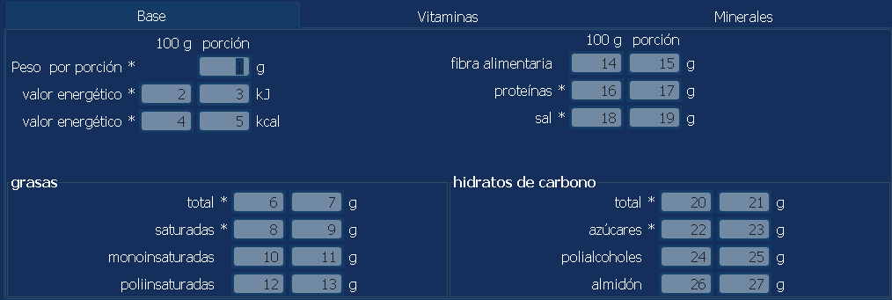

- Vitaminas
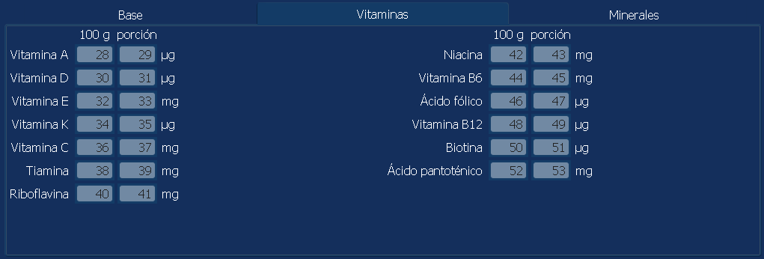

- Minerales
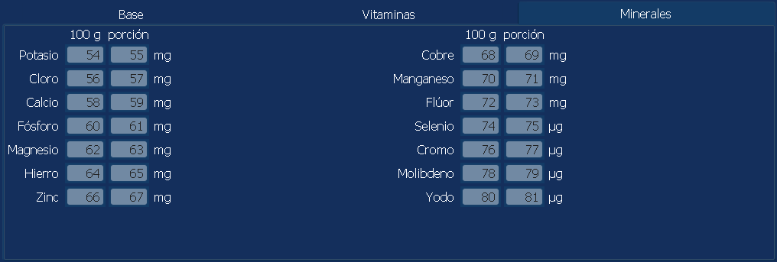
- Programación Ficha Nutricional para un artículo a través de “cadena”:
Public Function ALT_Item_Nutrition_Card_TK(ByVal sItemCard As String) As Long
sItemCard compuesta por 6 dig. Código de artículo y 6 dig. número de Ficha
ejemplo: “000001000020” --> Código artículo 1, Ficha 20

- Programación dato (Identifier) Vitamina/Mineral en una ficha a través de
“cadena”:
Public Function ALT_Nutrition_Vita_Mine_TK(ByVal sVita_Mine As String)
sVita_Mine compuesto por 6 dig. número de ficha, 2 dig. identificador de vitamina o mineral, 6 dig. cantidad por 100g (sin signo decimal, dos dígitos menos significativos serán los decimales) y 6 dig. cantidad por porción (sin signo decimal, dos dígitos menos significativos serán los decimales)
ejemplo: “00002008002500001300”
Ficha: 20
Identificador: 8
cantidad 100g: 25
cantidad porción: 13

- Programación ficha Nutricional Base mediante “cadena”:
Public Function ALT_Nutrition_Base_TK(ByVal sCard As String) As Long
sCard compuesta por 6 dig. número de ficha y a continuación valores con 6 dig. (sin signo decimal, dos dígitos menos significativos serán los decimales) para cada uno de los campos:
carbohydrate_100//carbohydrate_portion//energy_kcal_100//energy_kcal_portion//
energy_kj_100//energy_kj_portion//fat_100//fat_portion//fibre_100//fibre_portion//mono_unsaturates_100//mono_unsaturates_portion//polyols_100//polyols_portion//
polyunsaturates_100//polyunsaturates_portion//portion_weight//protein_100//
protein_portion//salt_100//salt_portion//'saturates_100//saturates_portion//
starch_100//starch_portion//sugars_100//sugars_portion

Correspondencia con Imagen:
"portion_weight" -->1 (Peso por porción)
"energy_kj_100" -->2 (Valor energético en kj por 100g)
"energy_kj_portion" -->3 (Valor energético por porción en kj)
"energy_kcal_100" -->4 (Valor energético en kcal por 100g)
"energy_kcal_portion" -->5 (valor energético por porción en kcal)
"fat_100" -->6 (Total grasas en 100g)
"fat_portion" -->7 (Total grasas en porción)
"saturates_100" -->8 (Grasas saturadas en 100g)
"saturates_portion" -->9 (Grasas saturadas en porción)
"mono_unsaturates_100" -->10 (Grasas moinsaturadas en 100g)
"mono_unsaturates_portion" -->11 (Grasas monoinsaturadas en porción)
"polyunsaturates_100" -->12 (Grasas poliinsaturadas en 100g)
"polyunsaturates_portion" -->13 (Grasas poliinsaturadas en porción)
"carbohydrate_100" -->20 (Hidratos de carbono en 100g)
"carbohydrate_portion” -->21 (Hidratos de carbono en porción)
"sugars_100" -->22 (Azucares en 100g)
"sugars_portion" -->23 (Azucares en porción)
"polyols_100" -->24 (Polialcoholes en 100g)
"polyols_portion" -->25 (Polialcoholes en porción)
"starch_100” -->26 (Almidón en 100g)
"starch_portion" -->27 (Almidón en porción)
"fibre_100" -->14 (Fibra Alimentaria en 100g)
"fibre_portion" -->15 (Fibra Alimentaria en porción)
"protein_100" -->16 (Proteinas en 100g)
"protein_portion" -->17 (Proteinas en porción)
"salt_100" -->18 (Sal en 100g)
"salt_portion" -->19 (Sal en porción)

