**Program Name**

Memory Card Game

**Annotation:**

We present you a beautiful game about My Little Pony and development of your visual memory skills.

**Central repo address:**

https://github.com/imasgo/MemoryGame

**Members & roles**

* Dmitry Vypirailenko - general logic, testing
* Maria Ivanova - part of general logic, secondary logic, testing
* Daria Malyavskaya - UI and testing

**List of classes with description:**

Resources - a folder with all our pictures that we use.

Context.cs - a class where we describe all our Data Base sets (not needed in the current version of the program)

Form1.cs - a windows form where the general gaming process is described and implemented.

HardLevel.cs - a windows form for choosing level difficulty.

Leader.cs - a class where properties for work with text files are described.

LeaderBoardClass.cs - a class for work with the database (not used in the current version)

LeaderBoardDataSet.xsd - an automatically created class for database work.

LeaderBoardForm.cs - a windows form for showing the leaderboard.

MenuForm.cs - a windows form for the main menu.

MenuLauncher.cs - a class for work with MenuForm.

Username.cs - a windows form for entering the user’s name.

**Interface**

**MenuForm.cs**

Loads first after compilation, has 3 options on buttons: Play Game, Leaderboards and Exit.  
  
  
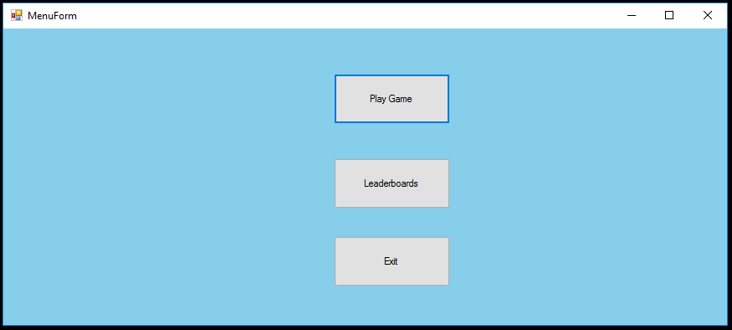

**HardLevel.cs**

You get here after pressing “Play Game” button in Menu.

It is responsible for selecting level of difficulty. Combo Box have three options: hard, medium and easy.

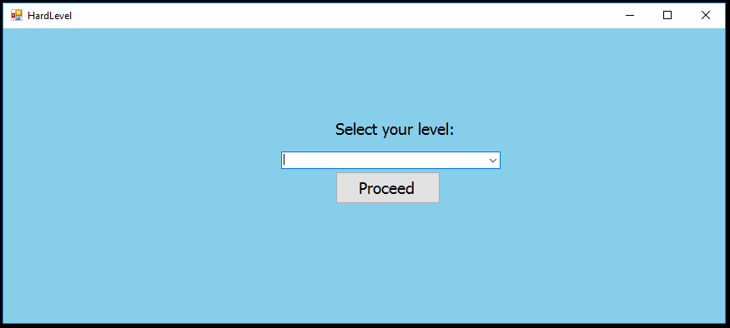  
*After clicking “Play Game”*

**Form1.cs**

After clicking “Proceed” button, you get to the main game window.

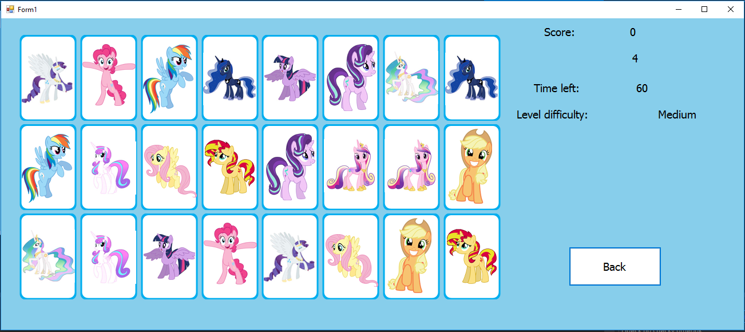

*After selecting Medium difficulty level*

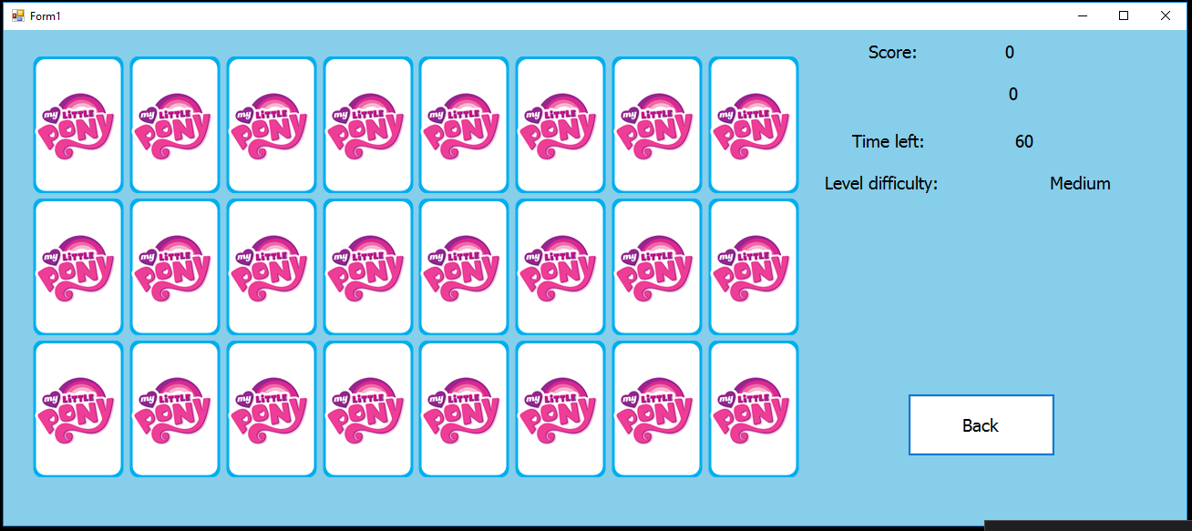  
*After first five seconds*  
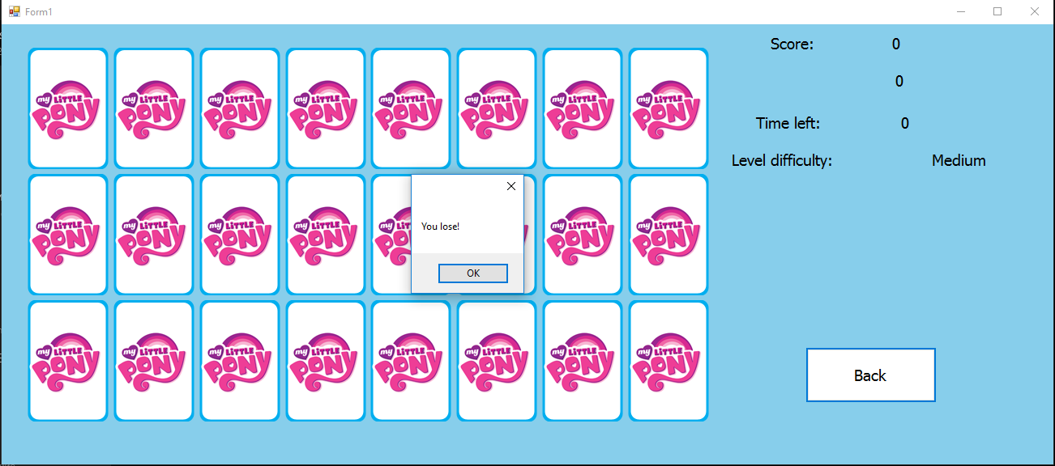*In case of losing (after clicking “OK” it goes back to Menu)*

**Username.cs**

In case of winning, you are allowed to enter your name, which will be reflected in Leaderboards.

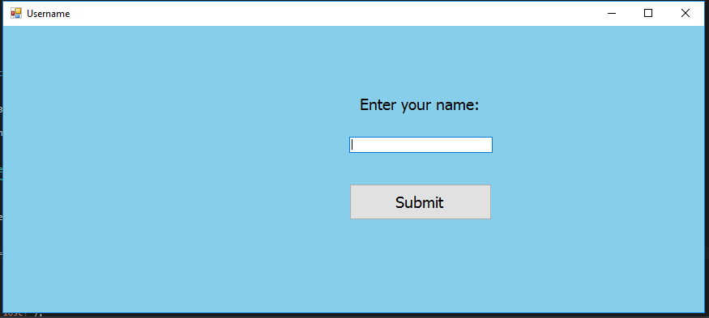  
*In case of winning*

**LeaderList.cs**

You get here after pressing “Leaderboards” button in Menu.

This form allows you to access Leaderboards with all players records (who decided to enter their names).

