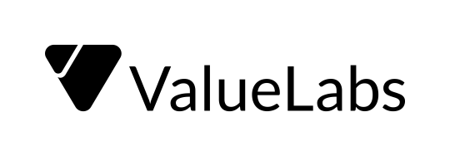

|  |
| --- |
| Daily Status Report |
| **IMS** |

|  |  |
| --- | --- |
| **Date:** | **02/08/2021** |
| **Project:** | **IMS** |

|  |  |  |  |
| --- | --- | --- | --- |
| **S.No.** | **Activity** | **Status** | **Remarks** |
| 1. | Director Role | In Progress | Working on modifications as per the Role |
| 2. | Notifications |  | Need to work on how to send notification to parent application from teacher/admin applications. |
| 3. | Communication between Teacher/Admin App and Parent App | In Progress | Working on creating communication between both the applications regarding Child Information, Notifications, Library, Mini Club, Message Center ….. |
|  |  |  |  |
|  |  |  |  |

|  |  |
| --- | --- |
| **Issues and Concerns** | |
| **S.No.** | **Issue/Dependencies/ Concerns / Risk** |
| 1. | Need to get more details on what changes to be done to Teacher Application. |
|  |  |
|  |  |
|  |  |
|  |  |