

Technical Whitepaper

0mq and Load Distribution

Author: Martin Sustrik

iMatix Corporation
May 2007

Table of Contents
0mq and Load Distribution 1
Abstract 3
Introduction 3
External architecture 3
Alternative 5
Internal architecture 7
Small vs. large actions 7
Actions needed 8
Conclusion 9

Abstract
In environments where messaging traffic is very high, single CPU core, CPU, or even a dedicated server may not be enough to handle all the load. This document discusses how large amount of messaging traffic can be spread over the network in a scalable fashion.
This document is confidential iMatix intellectual property and may not be distributed without the prior agreement of iMatix Corporation. The designs in this document are considered an iMatix Corporation Trade Secret and must be covered by a non-disclosure agreement.

Introduction
To have something to start with, we should consider two use cases, that are usually addressed in different manner, however, both are structurally very similar.
Firstly, there is a problem of how to spread computation load between several processors within a single box. This problem is commonly solved by writing multi-threaded applications. Such an application is able to use several processors at the same time, however, the trade-off is all the thread synchronisation overhead that tends to be quite relevant in middleware domain.
Secondly, if the load it too extensive, server farm can be used instead of single server. Each server hosts a separate broker instance and therefore, administrator/application developer has to explicitly manage the distribution of the load between individual boxes. The problem with this solution is that splitting the load is a non-trivial task.
This paper focuses on the latter approach, considering former one to be just a special case. It proposes to use single-threaded servers, each of them attached to a specific processor core. This way we can get rid of thread synchronisation overhead and at same time use OS feature of dedicating a processor core to a single process. This feature is intended to prevent other processes blocking or slowing down mission critical applications. Both these features are crucial for getting stable low-latency performance.

External architecture
Basic idea is that of having a full-blown single-threaded broker assigned to a processor core:
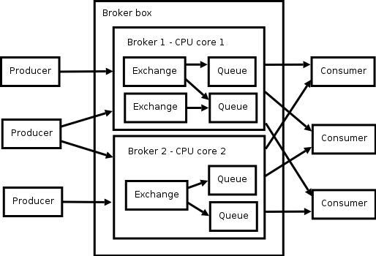
There are two obvious problems with this architecture.
Firstly, clients have to connect to more than one broker. This means that each application either has to explicitly create several AMQP connections or – possibly – that there has to be a directory service incorporated into the client library, that would implicitly map exchange and queue names to a particular connection. Both solutions are workable, however, the latter seems to be better from the administrative point of view – i.e. queues and exchanges can be moved between brokers in a transparent manner without a need to rewrite client applications.
Secondly, what if all the exchanges and queues we use are inseparable in a clear and obvious manner? What if there are bindings between all the exchanges and all the queues? If that is the case, wouldn't it mean that message load cannot be split into disjunct domains and the application would be restricted to a single processor core even if there is box with multiple cores available?
Let's examine the example of market data. Each electronic stock exchange would publish stock quotes to a separate exchange. Each trader would create a private queue and bind it to arbitrary exchanges depending on stocks he wants to trade. This looks like a example of a system that cannot be distributed, simply because you don't know which queues would be bound to which exchanges in advance. However, have a look on following diagram:
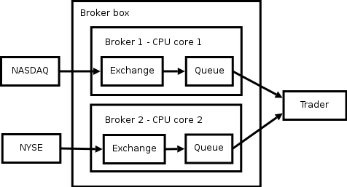
Trader creates two private queues – one on each broker – and consume messages from both of them. That way we can keep NASDAQ and NYSE brokers completely separated with zero mutual intercommunication.
It may seem that there will be a problem with message ordering because we've replaced single queue by two of them. However, note that messages passed via different paths (via different exchanges) have no ordering guarantees anyway, so we are actually don't spoil anything here.

Alternative
In case it turns out that there are non-distributable systems for some reason, say because we would want to restrict number of client/broker connections from N*M to N (where N is number of clients and M is number of processor cores), there is an alternative or – to be more precise – complementary approach.
We can use AMQP backend protocol as described in MEN document (this protocol formalises passing of messages between exchanges and queues using different transport mechanisms) to transfer messages between individual broker instances, from an exchange within one instance to a queue in another instance:

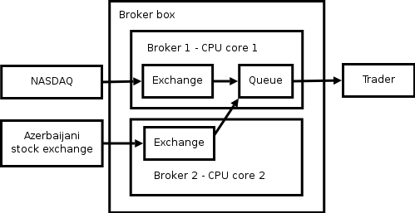
The connection from the exchange on broker 2 to the queue on broker 1 is AMQP backend connection working on top of shared memory transport mechanism.
The obvious question is: We've introduced the single-threaded broker design to get rid of thread synchronisation overhead, however, by using shared memory communication channel we have the overhead back, haven't we?
Yes, that's true in some sense, but note that only stock quotes from Azerbaijani stock exchange experience the overhead. Stock quotes from NASDAQ can still do with no thread synchronisation. And as we expect NASDAQ quotes to be much more numerous than Azerbaijani quotes the design still performs much better than the classic multi-threaded architecture that imposes the overhead on all the messages.
In the worst case – when loads of messages between individual exchanges and queues are totally unpredictable – we can use following design that has the same – but not worse – performance as with classical mutli-threaded broker:

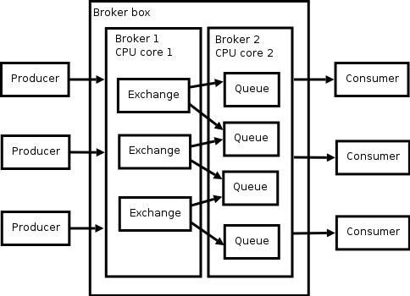

Internal architecture
This section describes how a single-threaded broker can work to get the best performance.
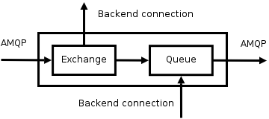
This picture shows internal workflow of the single-threaded broker. AMQP clients publish and receive messages via standard AMQP connection, other components within distributed MEN architecture send messages to queues and receive messages from exchanges via backend connections.
Individual actions are triggered either when connection has data to read, or when connection is ready for writing.

Small vs. large actions
The question is whether each read (or to be written) frame should trigger only a single action or whether it is better to decompose these actions into several smaller consecutive actions.
Decomposing the actions has following consequences:
- latency during the full load is the same
- latency when the load increases is worse
- latency when the load decreases is better
- average latency is the same
However, there are several disadvantages there:
- some latency is added because of switching between individual actions
- memory requirements are higher because there are more threadlets (fibers) being executed at the same time
Therefore, having a single action seems to be the better solution.
Also note that having series of small consecutive actions (as in OpenAMQ broker) is intended to minimise the time when shared resources are locked by an action thus preventing other threads to execute. In the single-threaded design there is no locking, therefore this use case is completely irrelevant.

Actions needed
Following four actions have to be taken into account, each of them being a single and uninterruptible unit of work:

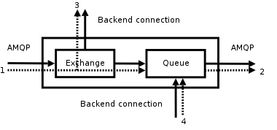
- Message arrives from publisher via AMQP connection => it is routed and stored in all the corresponding queues and backend connection buffers (for definition of 'backend connection buffer' refer to MEN document).
- Consumer on AMQP connection is ready to consume => message is retrieved from a queue and sent to the consumer.
- Backend connection is ready to consume => message is retrieved from backed connection buffer and sent over the backend connection to another MEN component(s).
- Message arrives from another MEN component via backend connection => messages is dispatched (for definition of 'message dispatcher' refer to MEN document) and stored in all the corresponding queues.

Conclusion
Provided that we have enough hardware available we are able to service any load of messages (many millions a second) by distributing the load using architecture described above.
This architecture also decreases the latency by:
- Removing inter-thread synchronisation overhead.
- Allowing to attach single thread (single-threaded broker instance) to a dedicated processor core this way removing the need for OS context switching completely.
- Minimising threadlet (fiber) switching to one action per one external event.
The problem with this approach is that balancing the load between processors/cores in a single machine becomes an administrative task in the same way that balancing the load between different machines is an administrative task currently.

