

Technical Whitepaper

Middleware Enabled Network

Authors: Martin Sustrik, Pieter Hintjens

iMatix Corporation
March 2007

Table of Contents
Middleware Enabled Network 1
Introduction 3
Bandwidth 3
CPU Usage 6
Latency 7
Architectural requirements 7
Distributing the broker 8
Some examples 10
Standard broker 10
Routing distributed to client 11
Queueing distributed to client 11
Brokerless communication 12
Multicast 12
Standalone router 13
Standalone storage 13
Local eventing 13

Abstract
This document describes the “Middleware Enabled Network”, an architecture developed by iMatix for extremely-high performance AMQP-based messaging. MEN is targeted at supporting stock-trading style environments while keeping compatibility with the AMQP protocol.
This document is confidential iMatix intellectual property and may not be distributed without the prior agreement of iMatix Corporation. The designs in this document are considered an iMatix Corporation Trade Secret and must be covered by a non-disclosure agreement.

Introduction
The concept of a “Middleware Enabled Network” (MEN) has evolved from high-performance messaging use cases, such as those encountered in the stock trading business. What follows is an analysis of the bottlenecks encountered in high-performance environments:
- Network bandwidth. There are scenarios that require total network bandwidth exceeding the available bandwidth by entire orders of magnitude. For example, requiring 70Mb/second of bandwidth on a 1Mb/second network.
The solution to solving what appears to be an impossible challenge lies in the observation that in high-volume scenarios with large numbers of clients (the classic stock-trading scenario) the bulk of data is highly redundant. Since large numbers of clients subscribe to the same data feeds, they will often request and receive the same messages. By removing this redundancy we can effectively scale the network bandwidth by several orders of magnitude (100 times or more).
- Hub broker CPU power. When handling many small messages – typical in the scenarios we see – a broker that acts as the hub of a star network may be unable to process the messages fast enough to utilize all available bandwidth.
In a standard middleware architecture, all CPU-intensive computation happens at a single node in the network, namely the broker. Although the network nodes may together have more than enough computational power, an architecture based on a centralised broker unable to use this power. We can build very large broker systems – with multiple cores – but this is an expensive solution that does not solve the real problem.
- Latency. Particularly with the market data, latency is paramount. What clients pay for is an upper bound on message delivery time. Stock quotes become useless very quickly, and automatic trading systems depend on rapid reaction to market shifts.
Latency is introduced by the number of intermediate hops between a producer and a consumer and by the time needed to process the message at each intermediate node. The number of nodes on the path is affected by both administrative concerns (e.g. security) and the AMQP architecture used. As for the time needed to process the message, this involves many factors, such as the number of kernel/user space transitions per message, context switching, possible accesses to relatively slow disk storage for persistent storage and overall performance of the implementation. We must also keep in mind that the message has to cross other intermediate network devices like routers and switches as well as AMQP brokers.

Bandwidth
To decrease bandwidth requirements we must adhere to two rules:
- If there are no consumers for the message, the message should not even be passed to the network. Although this looks obvious, note that a standard messaging architecture does pass messages over the network (from producer to broker) just to be dropped at the broker if there are no subscribers.
- No message should ever be passed over the wire twice. So even if there are ten consumers for the same message, the message should be passed over the network at most once.
The first rule applies to LANs and WANs in the same way. The broker closest to the producer (or even the producer itself) should know whether there are any subscriptions for the message and if not, it should drop it immediately.
The second rule has different implications for LANs and WANs.
On a LAN, current middleware architecture works in the following manner:
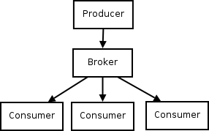
An obvious choice to decrease bandwidth usage would be multicast:
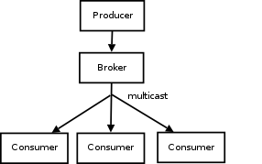
Still, the message is passed over the LAN twice – firstly it is unicast from the producer to the broker, secondly it is multicast from the broker to the consumers. By passing the message directly from the producer to the consumer, we would lower network bandwidth usage by half:

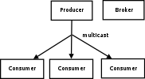
On a WAN the goal of passing messages over the wire exactly once cannot clearly be achieved, since there may be several LANs on the path from the producer to the consumer and the message has to be passed at least once on each LAN. Currently, AMQP architecture looks like this:

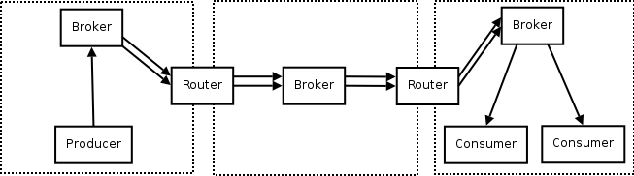
Note that two of the three brokers are optional. You can do the same thing with a single broker. Additional brokers are introduced either for security reasons (so that client does not have to open direct connections to a different LAN) or for network architecture reasons (if the broker in the middle is needed to distribute messages to two different LANs instead of the single one).
To improve bandwidth usage, we should first of all make sure that the message is duplicated as late as possible on its path, ideally just before sending it to consumers:

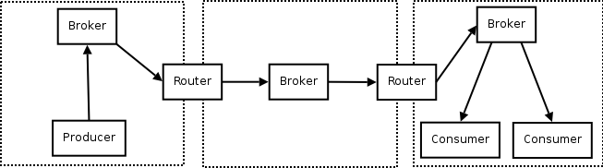
This way we've postponed the message duplication to as late as possible and thus – say – cut four passes over the wire in the LAN in the middle of the picture to just two. However, each message is still passed at least twice over each LAN. Combining a broker and router into a single box would solve this issue:
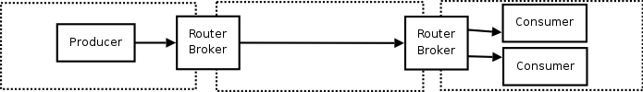
Futher, the two messages passed over the rightmost LAN can be cut down to single one using multicast as already mentioned above:
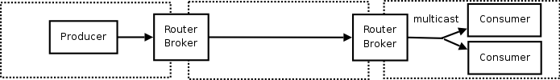

CPU Usage
There are two ways to improve CPU usage:
- Spread CPU usage over the network more evenly instead of having all the load on a central broker.
- Optimise the stack.
For the first point, our assumption is that the mainframe era is definitely over and that client stations are gradually going to be more and more powerful. We would therefore like to distribute some of the work done by the broker to the clients.
Processing commands is not especially CPU intensive, commands form only a small fraction of all the work done – as little as 1% or less of the traffic, in high-volume scenarios. We therefore focus on the processing of messages and move that work to the clients.
Recall the brokerless design (publisher sending messages directly to a consumer) introduced above:

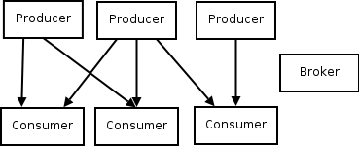
Clearly, with this design, CPU usage on broker is zero. Producers have to do routing, but the CPU load is evenly distributed between individual producers. Consumers have to do queueing (no shared queues are allowed), but the load is distributed among the individual consumers.
As for the second point, optimisation of the stack involves several non-trivial issues. Some suggestions:
- Moving some of the functionality to hardware. For example pre-computing and tagging messages on the producer (based on the routing data), thus allowing routers to route them at wire speed even on high-performance networks like 10Gb Ethernet.
- Moving low level parts of the stack to the OS kernel, thus minimising kernel/user mode transitions. (For example, dropping messages on the consumer need not require any user mode support.)
- Using a fast single-threaded architecture for AMQP implementation. Single threaded processing is dramatically faster when compared to multi-threaded processing, because it involves no context switching and synchronisation or locking. To take advantage of multi-core boxes, we could run one single-threaded instance of the AMQP implementation on each processor core. Individual instances are tightly bound to the particular core, thus running with almost no context switches.
- Providing seamless integration of AMQP with higher level business protocols like FIX. Some of the data from FIX messages can be passed to the AMQP layer, so that FIX can take full advantage of underlying high-performance stack.

Latency
Some of the latency-related work was already introduced in the 'Bandwidth' section. By cutting down the number of times message are passed over the wire we in many cases also minimised the number of network hops, thus considerably improving latency.
The concepts presented in the 'CPU Usage' section also have a positive effect on latency. The less processing power we need to spend on each message, the more messages we are able to process per time unit and the less is the latency.
In some scenarios, where latency is paramount, it can be improved by relaxing reliability and ordering constraints. For example, using UDP as a message transport would decrease latency as it exhibits no head-of-line blocking. However, it would introduce unreliability and unordered delivery as a side effect, and consumers would need to deal with these issues.
Latency can of course be improved by moving producer and consumer to the same physical box or even into the same process. In these cases, message transfer can be done in extremely efficient manner using shared memory or even local memory (passing a simple pointer).

Architectural requirements
What we assume is needed to deal with above issues is a distributed AMQP solution with as much support from hardware as possible. Basically it means breaking the standard AMQP architecture into separate pieces and distributing them on the network in a manner that minimises bandwidth, latency and CPU usage. Each component can be implemented as a different process or device. We call this distributed architecture the “Middleware Enabled Network”, or MEN.
The following concerns need to be addressed in a MEN:
- Wide range of transport mechanisms for messages including UDP and multicast.
- Brokerless message transport (i.e. passing messages directly from producer to consumer).
- Possibility to do routing without queueing (i.e. routers with no storage).
- Possibility to do queueing without routing (i.e. storage devices with no routing support).
- Passing local messages locally (i.e. if producer and consumer reside in the same process, the messages should be passed as simple pointers to local memory).

Distributing the broker
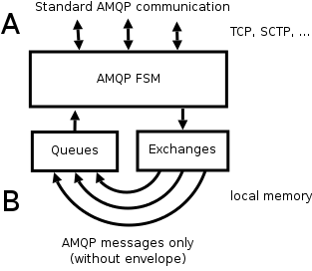
Currently the broker architecture – at least as far as passing messages is concerned – looks like this:
Clients are connected to a broker via standard AMQP connections (A). Messages received on these connections are forwarded to exchanges where they are routed and stripped of their envelope (e.g. Basic.Publish command frame). Afterwards they are passed to the appropriate queue. Transfer from exchange to queue is done in-process, presumably by passing a simple pointer to the message (B). Messages from the queue are passed back to AMQP state machine to be delivered to subscribed consumers via standard AMQP connection (A).
Note that there are important differences between “communication channels” marked as A and B. A is a standard AMQP connection. It is used to transport commands as well as messages. Messages are transported joined with their envelopes. A spans across the network. B is not an AMQP channel, exact character of this channel is out of scope of AMQP specification. It is used to transport messages only. Messages are transported without the envelopes. B is not a network connection. It is a local data flow.
The idea of distributing the broker is to make B a network connection. This connection will be used to transport messages over the network using several different transport mechanisms:
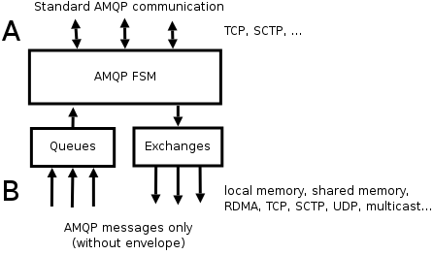
Also, this way we can separate routing and queueing functionality quite easily:

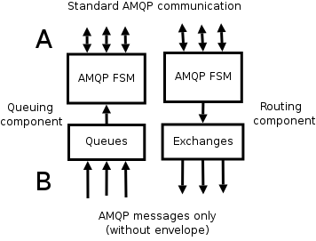
When thinking about B as network connection, we can spot even more differences between A and B.
For A, the following requirements apply:
- The transport is connection-oriented, i.e. communication is stateful. Each party knows that it is communicating with the other party and has some state associated with that communication. If the transport wasn't connection-based, it won't be possible to define individual AMQP state machines, say the one that handles AMQP connection negotiation.
- The transport is bidirectional. If this was not so, it would not be possible to use the request/reply pattern that is currently used quite heavily in AMQP communication (e.g. Queue.Declare and Queue.Declare-Ok).
- The transport works on a one-to-one basis. Having multiple parties on either end of the connection would mean that responses to commands would occur multiple times and break AMQP grammars.
- Commands are delivered in the order they were sent in. If this was not so, a single command delivered out-of-order could cause severe semantic misbehaviour and would ultimately lead to client application malfunction, dead-lock or even crashing.
- Commands are delivered reliably, meaning that no command is dropped silently. It is either delivered to the other party, or the connection is torn down. Missing commands would have exactly the same consequences as commands delivered out of order in the previous point.
For B, it makes sense to relax these requirements:
- The message transport need not be connection-oriented. For example, in a multicast scenario, the sender does not need to be aware of receivers joining and leaving a multicast group.
- The message transport need not be bidirectional. For example, if the client application doesn't require sending messages in both ways, there's no point in having SCTP streams for messages open in both directions. Here we could take advantage of SCTP's ability to use different numbers of streams in each direction.
- The transport need not work on one-to-one basis. IP multicast and PGM are obvious cases of one-to-many transport scenarios.
- We don't necessarily need messages to be delivered in order. In case of UDP we can take advantage of immediate delivery feature that way. Same applies to 'unordered' flag in SCTP.
- We don't necessarily need messages to be delivered in reliable manner. If the information transported in messages is highly transient, it's better to sacrifice some messages instead of loading the network with retransmissions and retransmission requests. Obvious example is UDP as a transport.
Political remark: Note that B is out of scope of the AMQP specification at present. Therefore we can design it in whatever manner we feel appropriate. Later, once the design is mature, we could pass it to the WG for standardisation.
Administrative remark: Although the design would work in the way it is described in this document, it will be necessary to add some initial AMQP handshaking for protocols like TCP & SCTP to be able to do authorisation, version control, etc.

Some examples

Standard broker
This is the diagram we've seen before. B is always a transfer via local memory:
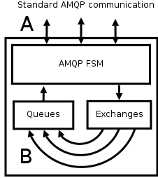

Routing distributed to client
In this scenario, routing is done on the client. The client can potentially route messages to many different brokers.
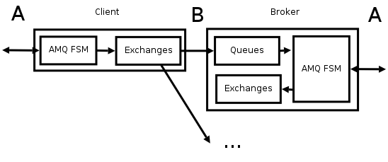
Note: In the above diagram, A is used to describe both standard AMQP communication (on the broker/right side) and client API function calls (on the client/left side). Further in this document we assume the two map to each other in a 1:1 relationship and thus we will not make a distinction between them.

Queueing distributed to client
In this scenario, the client acts as storage for messages. It can potentially receive messages from several brokers.

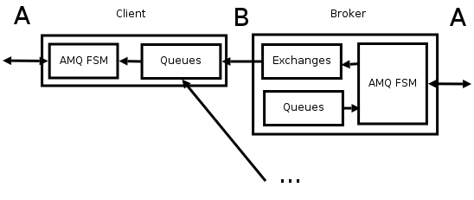
Brokerless communication
Combining the two examples above we arrive at a combination of one client containing the routing component communicating directly to another client containing the queueing component.
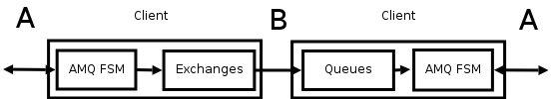
Although brokerless communication is currently out of scope of AMQP, it is an important use case for high-volume scenarios. Later in this document we will show how a brokerless design can be incorporated into AMQP infrastructure.

Multicast
Multicast scenario is prevalent for market data distribution on a LAN in stock trading business. Note that multicast conforms to the relationship between queue and exchange as described by the AMQP specification, i.e. a message is copied to each queue that has an appropriate binding to the exchange.
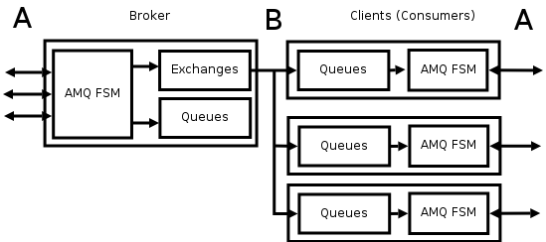
To improve latency and bandwidth usage, multicast can be combined with brokerless communication:
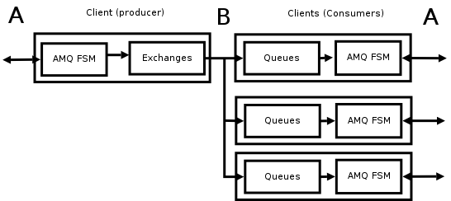

Standalone router
This scenario handles the case where AMQP routing functionality is deployed on network router with few persistent storage/memory resources. Messages are just passed through at wire speed without actually being stored.
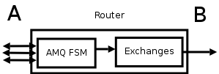

Standalone storage
This scenario is interesting if there are storage servers on the network. Each box can service a set of queues without any need to do routing.
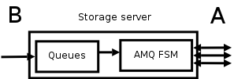

Local eventing
This is a fun scenario, but it demonstrates the flexibility of the design. It uses an AMQP client not to connect to any broker, but to do internal messaging (eventing) for the application.

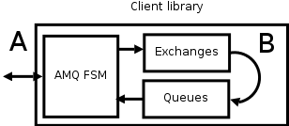

We count the Publish method as a message, not a command.

