**THE MicroBooNE Event Display**

**Tutorial at: https://cdcvs.fnal.gov/redmine/projects/uboone-physics-analysis/wiki/Gallery_Event_Display_-_How_To**

**When first setting up:**

1. (go into SL7 container)

*source /nashome/i/imawby/interactiveContainer_uboone.sh*

2. Clone EVD dir

*git clone https://github.com/davidc1/gallery-framework UBEVD*

3. replace config/setup.sh with

*/exp/uboone/app/users/imawby/UBEVD/config/setup.sh*

*source config/setup.sh*

4. Build (you only have to do this once)

*cd $GALLERY_FMWK_BASEDIR*

*make*

**To run:**

1. Change the resolution of your vnc so the EVD window fits, type this into the uboonegpvm

*xrandr -s 1600x1200*

2. (go into SL7 container)

*source /nashome/i/imawby/interactiveContainer_uboone.sh*

3. source the setup script

*source config/setup.sh*

4. Run event display on reco2 files!

evd.py -T <path_to_file>

**Isobel’s Hacked Together MicroBooNE Event Display**

This takes the form of a Jupyter notebook which runs on files created by my ‘Visualisation analyser’. The intended workflow for this is:

reco2 files of interest -> run analyser -> move output files to computer with jupyter -> run notebook

**DISCLAIMER: I pulled this together in the last few days, and am pretty pants at python so apologies if my notebook makes you sad. If something doesn’t work let me know, it should be easy to fix. I’d appreciate any feedback too!**

**The Analyser**

You can either access the analyser via 1) setting up my local larsoft build on the uboonegpvms or 2) moving my analyser into your local larsoft build

**Option 1:**

1. source my local larsoft build setup script

*source /exp/uboone/app/users/imawby/larsoft_olderVersion/setup.sh*

2. run analyser on events

*lar -c run_VisualiseSlice.fcl <PATH_TO_YOUR_EVENTS>*

You should then end up with a file called **reco_stage_2_hist.root** (sorry I didn’t change the default name…) that’s the one with the tree in!

**Option 2:**

1. Git clone my github repository somewhere in your uboonegpvm area. This repo contains a directory for the analyser and the jupyter notebook (we’ll come to the latter soon). Move the analyser directory into your local build of ubana and build.

*git clone https://github.com/imawby/WarwickuBooNEWorkshop24*

mv EVDDir srcs/ubana/ubana/

*open the CMakeLists.txt that lives inside srcs/ubana/ubana/ and add EVDDir to the list of directories*

*move to a build machine, cross those fingers and build*

*ASIDE: If you don’t have ubana in your local larsoft build:*

*cd scrs*

*mrb g ubana*

*ups active (then find the version of ubana that is currently set up)*

*git checkout tags/PUT_VERSION_HERE -b AWESOME_BRANCH_NAME*

*move to a build machine, cross those fingers and build*

2. run analyser on events

*lar -c run_VisualiseSlice.fcl <PATH_TO_YOUR_EVENTS>*

You should then end up with a file called **reco_stage_2_hist.root** (sorry I didn’t change the default name…) that’s the one with the tree in!

**The Isobel’s Hacked Together MicroBooNE Event Display**

**IMPORTANT: This needs to happen on a computer in which you can open a jupyter notebook. Can this happen on the uboonegpvms? I don’t know. If you do know, put me out of my misery. I usually move over the ana files to my laptop and run things from there. Do this with a classic scp e.g.**

***scp imawby@uboonegpvm02.fnal.gov:/exp/uboone/app/users/imawby/larsoft_olderVersion/junk/reco_stage_2_hist.root ./***

1. ON AN APPROPRIATE MACHINE, git clone my github repository. This repo contains a directory for the analyser and the jupyter notebook (we only care about the latter in this section).

*git clone https://github.com/imawby/WarwickuBooNEWorkshop24*

2. Go into this directory and type

*jupyter notebook*

3. Click on the ‘Visualise.ipyn’ and you should see this beauty

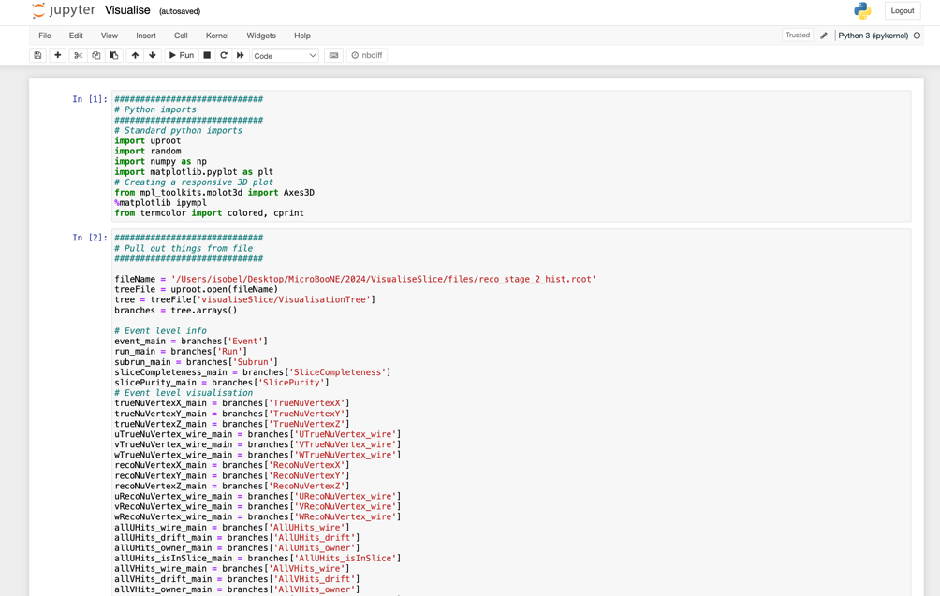

4. Hopefully the instructions in the display are enough to guide you through it, but reacho to me if not!