Serie numero de psajerps

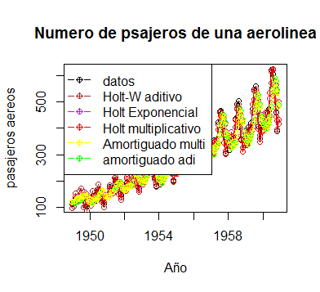

|  |  |  |  |  |  |  |  |
| --- | --- | --- | --- | --- | --- | --- | --- |
|  | **ME** | **RMSE** | **MAE** | **MPE** | **MAPE** | **MASE** | **ACF1** |
| **Holt exponencial** | -3.7146172 | 49.20131 | 36.973718 | -3.3481964 | 12.73939 | 1.1543356 | 0.6872076 |
| **HW aditivo** | -0.2924342 | 16.93602 | 12.709064 | -0.1739289 | 5.269252 | 0.3967825 | 0.1853963 |
| **HW multiplicativo** | 1.2201314 | 10.65457 | 7.895437 | 0.163569 | 2.990183 | 0.246499 | 0.2180419 |
| **Holt lineal** | -1.2378088 | 48.42314 | 36.210789 | -2.3654766 | 12.348553 | 1.1305166 | 0.6839578 |
| **Amortiguado aditivo** | 0.7788695 | 51.28183 | 38.228899 | -0.9280593 | 12.91308 | 1.1935229 | 0.6886747 |
| **Amortiguado aditivo** | 2.4698157 | 50.35858 | 37.582215 | -0.4913804 | 12.660921 | 1.1733331 | 0.6841138 |

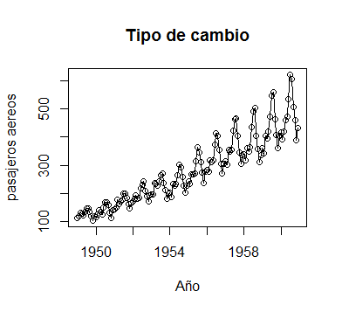

|  |  |  |  |  |  |  |  |
| --- | --- | --- | --- | --- | --- | --- | --- |
|  | **ME** | **RMSE** | **MAE** | **MPE** | **MAPE** | **MASE** | **ACF1** |
| **Holt exponencial** | 0.0003869 | 0.03345367 | 0.02326615 | -0.01858948 | 2.520643 | 0.3107641 | 0.3808996 |
| **HW aditivo** | -0.00224679 | 0.03352146 | 0.02147291 | -0.30921349 | 2.374157 | 0.286812 | 0.5686156 |
| **HW multiplicativo** | -0.00175827 | 0.03358443 | 0.02154993 | -0.25589172 | 2.382086 | 0.2878407 | 0.5696731 |
| **Holt lineal** | 0.00061072 | 0.03718503 | 0.02602223 | 0.06644665 | 2.820541 | 0.3475769 | 0.6690644 |
| **Amortiguado aditivo** | -0.00086653 | 0.03725296 | 0.02582169 | -0.09070034 | 2.789551 | 0.3448982 | 0.6707215 |
| **Amortiguado aditivo** | -0.0001679 | 0.0414637 | 0.03009706 | -0.03686186 | 3.273141 | 0.4020041 | 0.6970865 |