Test site [https://shop.milavitsa.by/#/](https://shop.milavitsa.by/%23/)

* Test case №1. Checking the adaptability of the search string.

1. Follow the link [https://shop.milavitsa.by/#/](https://shop.milavitsa.by/%23/) ;
2. Press “Поиск”;

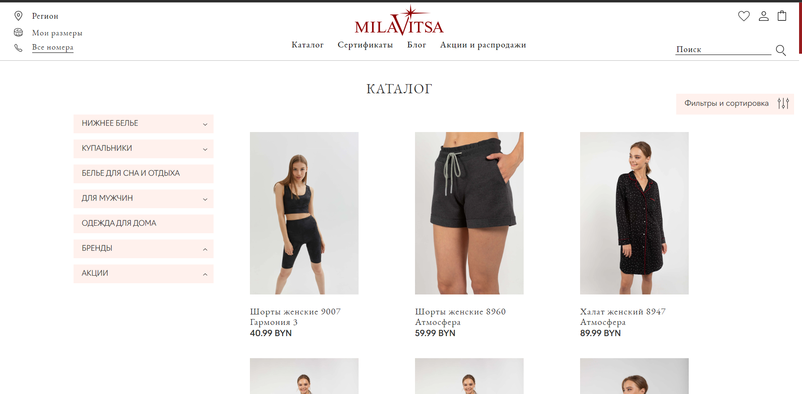

1. Try to enter more then 30 characters;

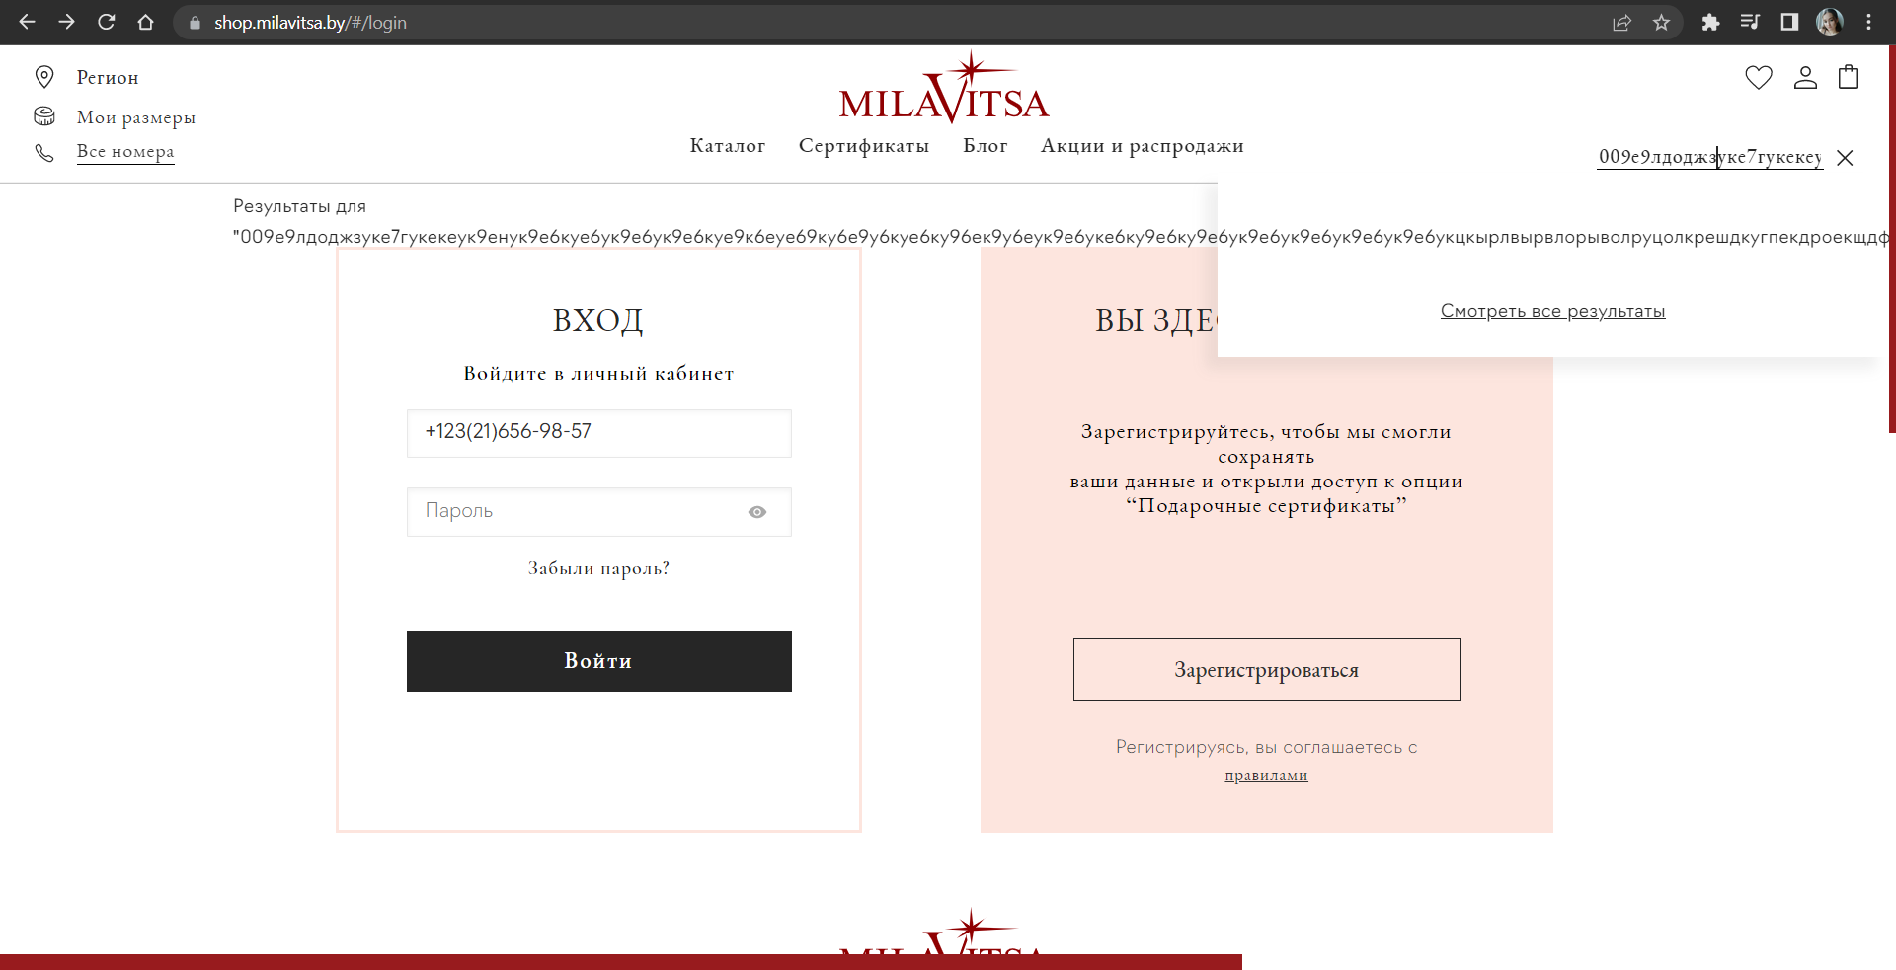

| **Excepted result :** | **The search string adapts to the entered text** |
| --- | --- |
| Actual result : | **The search string doesn’t adapts to the entered text** |
| Test Result : | **Not passed** |

* Test case №2. Checking the adaptability of the site to the size of the browser screen.

1. Follow the link [https://shop.milavitsa.by/#/](https://shop.milavitsa.by/%23/) ;

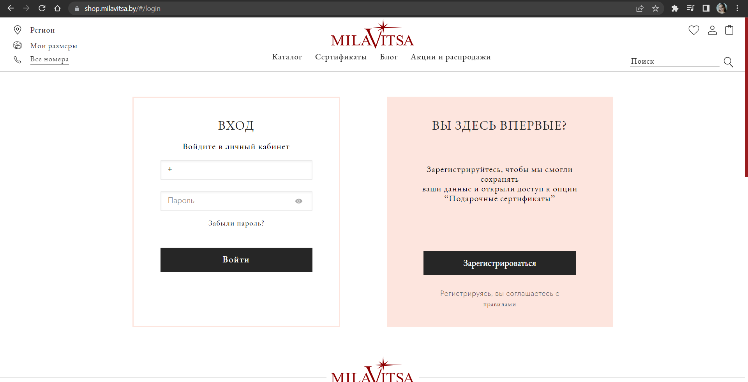

1. Try changing the size of your browser window

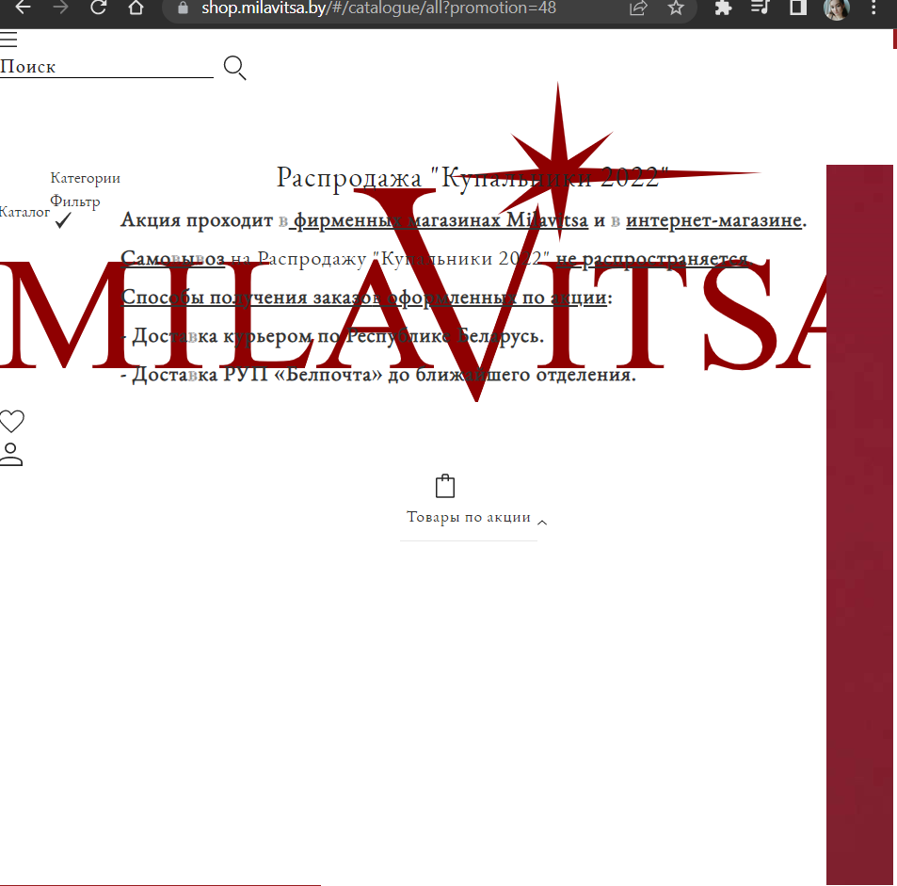

| **Excepted result :** | **The site adapts to the size of the browser screen.** |
| --- | --- |
| Actual result : | **The site doesn’t adapts to the size of the browser screen.** |
| Test Result : | **Not passed** |