Media Streaming with IBM Cloud Video Streaming

Phase 5 submission

## Abstract:

IBM Cloud Video Streaming is a comprehensive cloud-based platform that enables users to efficiently stream live and on-demand video content to a global audience. This powerful solution offers a range of features, including channel creation, encoding customization, individuals and organizations can effectively manage, deliver, and monetize their video content, offering an engaging viewing experience to their target audience. This abstract provides a glimpse into the capabilities and benefits of IBM Cloud Video Streaming, showcasing its potential to revolutionize how media is shared and consumed in the digital landscape.

**Introduction:**

Media streaming is an integral part of the modern digital landscape, revolutionizing the way

we consume and share content. IBM Cloud Video Streaming, a powerful and versatile platform offered by IBM, has emerged as a frontrunner in this domain. As the demand for high-quality video content continues to grow, IBM Cloud Video Streaming provides a comprehensive solution for individuals and businesses alike, allowing them to deliver, manage, and optimize their video content efficiently and effectively.

IBM Cloud Video Streaming is designed to meet the diverse needs of its users. Whether you are a content creator, an enterprise looking to engage with your audience, or an educational institution seeking to reach a broader student base, this platform offers a tailored solution. It enables users to seamlessly stream live events, webinars, on-demand videos, and more. With IBM Cloud Video Streaming, you can engage your audience in real-time, create interactive live experiences, and archive content for future viewing.

One of the standout features of IBM Cloud Video Streaming is its robust and scalable infrastructure. It leverages IBM's extensive global network and data centers to ensure high- quality streaming, even in regions with limited connectivity. This ensures that your content is accessible to audiences worldwide, offering a seamless and buffer-free viewing experience. Additionally, the platform provides advanced analytics and monitoring tools, allowing users to gain valuable insights into their viewers' behavior, thus optimizing content delivery and engagement strategies.

Furthermore, security is a top priority in today's digital landscape. IBM Cloud Video Streaming prioritizes the protection of your content and data. It offers various security features, including password protection, encryption, and secure embed options to safeguard your video streams. In an era where data privacy is paramount, IBM's commitment to security ensures that your content remains

protected from unauthorized access or breaches.

In conclusion, IBM Cloud Video Streaming empowers individuals, businesses, and organizations to harness the power of media streaming in the digital age. With its user- friendly interface, scalability, and commitment to security, it provides a comprehensive solution for all your video streaming needs. Whether you're a content creator looking to reach a global audience or an enterprise seeking to engage customers, IBM Cloud Video Streaming is a robust platform that offers the tools and capabilities to make your content streaming experience a success.

**Design Thinking Innovation**

Designing an innovative solution to enhance media streaming using IBM Cloud Video Streaming involves leveraging cutting-edge technologies and strategies to improve the streaming experience, scalability, reliability, and user engagement. Here's a comprehensiveapproach to achieving this:

1. User-Centric Design:
   * Understand user needs, behaviors, and preferences to design an intuitive and personalizeduser interface.
   * Incorporate features like seamless navigation, search functionality, and personalizedcontent recommendations to enhance user satisfaction and engagement. 1.Optimized Streaming Infrastructure:
   * Utilize IBM Cloud's powerful infrastructure to ensure high-quality video streaming, lowlatency, and robust scalability.
   * Implement a content delivery network (CDN) for efficient content distribution across different geographical locations, ensuring optimal streaming performance for users worldwide.
2. Intelligent Video Encoding:

- Implement AI-powered video encoding to dynamically adjust encoding settings based onnetwork conditions, device capabilities, and viewer preferences.

- Optimize the bitrate and resolution in real-time to deliver the best possible quality while minimizing bandwidth usage.

1. Real-time Analytics and Monitoring:

* Integrate real-time analytics tools to monitor the streaming performance, user engagement, and content popularity.
* Leverage AI algorithms to detect and react to issues such as buffering or drops in video quality, ensuring a seamless viewing experience.

1. Interactive User Engagement:
   * Integrate real-time chat, comments, and interactive features to enhance user engagement during live streaming events.
   * Implement audience participation mechanisms like live polls, Q&A sessions, and social media integration to involve viewers actively.
2. Monetization Strategies:

* Offer multiple monetization options such as pay-per-view, subscription models, advertisements, or bundled content packages.
* Leverage AI and machine learning to analyze user behavior and tailor monetization strategies for maximum revenue generation.

1. Enhanced Security and Privacy:
   * Implement advanced security measures to protect against piracy, unauthorized access, and content theft.
   * Utilize encryption, secure APIs, and identity management systems to ensure the privacy and security of both content providers and viewers.
2. Seamless Multi-Platform Integration:

* Enable seamless integration across various platforms (web, mobile, smart TVs) to ensure a consistent and user-friendly experience regardless of the device being used.
* Optimize the user interface and features for each platform to align with specific user expectations.

1. Feedback and Iteration Loop:

* Gather feedback from users through surveys, analytics, and direct interaction to identify areas for improvement.
* Continuously iterate the platform based on feedback and technological advancements to stay ahead of the curve and offer an evolving and improved streaming experience.

By applying these strategies, incorporating emerging technologies, and maintaining a user- centric approach, the media streaming solution built on IBM Cloud Video Streaming can achieve innovation by delivering an exceptional, engaging, and personalized streaming experience to users worldwide.

To implement the design for Media Streaming with IBM Cloud Video Streaming, we'll go through a detailed step-by-step process. This process will cover setting up the environment, designing the user interface, optimizing the streaming infrastructure, implementing features, ensuring security, and continuous improvement.

Step 1: Project Planning and Requirements Gathering

* Define project goals, target audience, and key features based on the initial design requirements.
* Gather detailed requirements for the streaming platform, considering scalability, latency, user engagement, and monetization.

Step 2:Research and Familiarization with IBM Cloud Video Streaming

* Conduct in-depth research on IBM Cloud Video Streaming capabilities, documentation, and best practices.
* Understand the different services offered by IBM Cloud that can complement the streaming platform.

Step 3: Setting Up IBM Cloud Video Streaming

* Create an IBM Cloud account (if not already done) and access the IBM Video Streaming platform.
* Explore the platform's features, create a channel, configure encoding settings, and generate necessary credentials (stream key, URL).

Step 4: User Interface Design

* Create wireframes and mockups for the streaming platform, considering a user-centric design approach.
* Design an intuitive and engaging user interface, incorporating features such as navigation, search, content recommendations, and interactive elements.

Step 5: Optimizing Streaming Infrastructure

* Utilize IBM Cloud's infrastructure to host the streaming platform and configure it for optimal performance.
* Implement a content delivery network (CDN) to enhance streaming speed and reliability, reducing latency for users globally.

Step 6: Video Encoding and Quality Optimization

* Implement intelligent video encoding algorithms to adjust bitrate, resolution, and quality dynamically based on the user's device and network conditions.
* Optimize video encoding settings to ensure high-quality streaming while minimizing bandwidth consumption.

Step 7: Real-time Analytics and Monitoring

* Integrate analytics tools to monitor streaming performance, user engagement, and viewer behavior in real-time.
* Implement automated alerts and monitoring systems to detect and address issues promptly, ensuring a seamless streaming experience.

Step 8: Interactive Features and Monetization

* Integrate interactive features like live chat, comments, polls, and Q&A sessions to enhance user engagement during live streams.
* Implement monetization strategies, offering options such as pay-per-view, subscription models, and targeted advertisements to generate revenue.

Step 9: Security Implementation

* Implement robust security measures to protect against piracy, unauthorized access, and content theft.
* Utilize encryption, secure APIs, and authentication mechanisms to ensure data privacy and content security.

Step 10: Multi-Platform Integration

* Optimize the platform for various devices and platforms, including web browsers, mobile devices, and smart TVs.
* Ensure consistent user experience and feature availability across different platforms.

Step 11: Testing and Quality Assurance

* Conduct thorough testing of the platform, including functional, usability, performance, and security testing.
* Address any identified issues and bugs, ensuring a stable and reliable streaming platform.

Step 12: Deployment and Launch

* Deploy the platform on IBM Cloud infrastructure and configure it for production use.
* Launch the streaming platform, making it available to users and promoting it through marketing and outreach efforts.

Step 13: User Feedback and Continuous Improvement

* Gather user feedback and analyze platform usage data to identify areas for improvement.
* Continuously iterate and enhance the platform based on user feedback and technological advancements, keeping it up-to-date and aligned with evolving user needs.By following these comprehensive steps, you'll be able to design, implement, and continuously improve the Media Streaming platform using IBM Cloud Video Streaming, providing a seamless and engaging streaming experience to your audience.

# Pre-processing

In this notebook, we will pre-process the frames. For better visualisation, we will just capture 2 frames and visualise all the steps. The steps are:

1. Capture 2 consecutive frames.
2. Find difference between the frames to capture the motion.
3. Use GaussianBlur, thresholding, dilation and erosion to pre-process the frames.
4. Image segmentation using contours. Extract the vehicles during this method.
5. Convert contours to hulls.

*# Run these if OpenCV doesn't load*

import sys

# sys.path.append('/Library/Frameworks/Python.framework/Versions/3.6/lib/python3.6/site- packages/cv2/')

**Import the necessary libraries**

First, we import the necessary libraries import cv2

import numpy as np import math

import matplotlib.pyplot as plt

%matplotlib inline

# Defining the variables

Next, we define variables that will be used through the duration of the code # Here, we define some colours

SCALAR_BLACK = (0.0,0.0,0.0)

SCALAR_WHITE = (255.0,255.0,255.0)

SCALAR_YELLOW = (0.0,255.0,255.0)

SCALAR_GREEN = (0.0,255.0,0.0)

SCALAR_RED = (0.0,0.0,255.0)

SCALAR_CYAN = (255.0,255.0,0.0)

# Function to draw the image

# function to plot n images using subplots

def plot_image(images, captions=None, cmap=None ): f, axes = plt.subplots(1, len(images), sharey=True) f.set_figwidth(15)

for ax,image,caption **in** zip(axes, images, captions): ax.imshow(image, cmap)

ax.set_title(caption)

# Capturing movement in video

Two consecutive frames are required to capture the movement. If there is movement in vehicle, there will be small change in pixel value in the current frame compared to the previous frame. The change implies movement. Let's capture the first 2 frames now.

SHOW_DEBUG_STEPS = True

## # Reading video

cap = cv2.VideoCapture('../input/video-analysis/AundhBridge.mp4')

*# if video is not present, show error*

if **not**(cap.isOpened()): print("Error reading file")

## # Check if you are able to capture the video

ret, fFrame = cap.read()

*# Capturing 2 consecutive frames and making a copy of those frame. Perform all operations on the copy frame.*

ret, fFrame1 = cap.read() ret, fFrame2 = cap.read() img1 = fFrame1.copy() img2 = fFrame2.copy()

if(SHOW_DEBUG_STEPS):

print ('img1 height' + str(img1.shape[0])) print ('img1 width' + str(img1.shape[1])) print ('img2 height' + str(img2.shape[0])) print ('img2 width' + str(img2.shape[1]))

## # Convert the colour images to greyscale in order to enable fast processing

img1 = cv2.cvtColor(img1, cv2.COLOR_BGR2GRAY) img2 = cv2.cvtColor(img2, cv2.COLOR_BGR2GRAY)

plot_image([img1, img2], cmap='gray', captions=["First frame", "Second frame"])

## #plotting

img1 height720 img1 width1280 img2 height720 img2 width1280

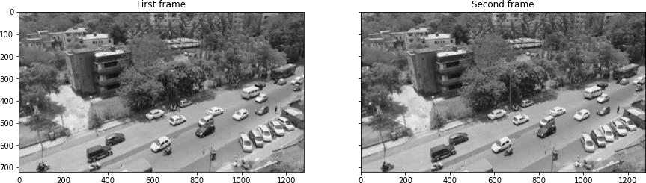

# Adding gaussion blur for smoothening

*# Add some Gaussian Blur*

img1 = cv2.GaussianBlur(img1,(5,5),0) img2 = cv2.GaussianBlur(img2,(5,5),0)

*#plotting*

plot_image([img1, img2], cmap='gray', captions=["GaussianBlur first frame", "GaussianBlur second frame"])

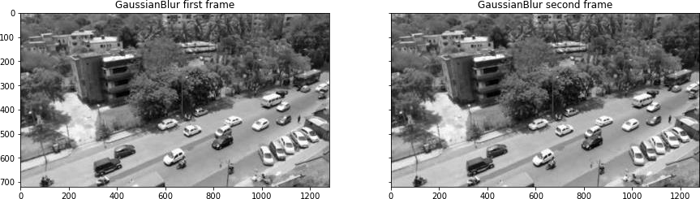

# Find the movement in video

If vehicle is moving, there will be **slight change** in pixel value in the next frame compared to previous frame. We then threshold the image. This will be useful further for preprocessing. Pixel value below 30 will be set as 0(black) and above as 255(white)

Thresholding: [https://docs.opencv.org/3.0-](https://docs.opencv.org/3.0-beta/doc/py_tutorials/py_imgproc/py_thresholding/py_thresholding.html) [beta/doc/py_tutorials/py_imgproc/py_thresholding/py_thresholding.html](https://docs.opencv.org/3.0-beta/doc/py_tutorials/py_imgproc/py_thresholding/py_thresholding.html)

# This imgDiff variable is the difference between consecutive frames, which is equivalent to detecting

Movement

imgDiff = cv2.absdiff(img1, img2)

# Thresholding the image that is obtained after taking difference. Pixel value below 30 will be set as 0(black) and above as 255(white*)*

ret,imgThresh = cv2.threshold(imgDiff,30.0,255.0,cv2.THRESH_BINARY) ht = np.size(imgThresh,0)

wd = np.size(imgThresh,1)

plot_image([imgDiff, imgThresh], cmap='gray', captions = ["Difference between 2 frames", "Difference between 2 frames after threshold"])

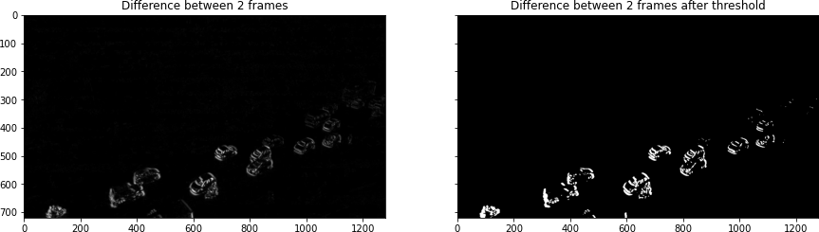

Dilation and erosion in image Dilation and erosion in the image with the filter size of structuring elements.

# Now, we define structuring elements

strucEle3x3 = cv2.getStructuringElement(cv2.MORPH_RECT,(3,3)) strucEle5x5 = cv2.getStructuringElement(cv2.MORPH_RECT,(5,5)) strucEle7x7 = cv2.getStructuringElement(cv2.MORPH_RECT,(7,7)) strucEle15x15 = cv2.getStructuringElement(cv2.MORPH_RECT,(15,15))

plot_image([strucEle3x3, strucEle5x5, strucEle7x7, strucEle15x15], cmap='gray', captions = ["strucEle3x3", "strucEle5x5", "strucEle7x7", "strucEle15x15"])

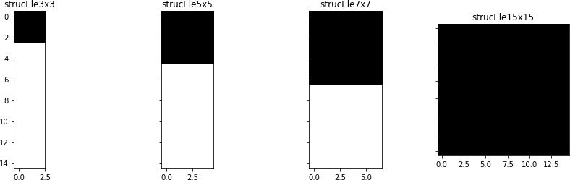

for i **in** range(2):

imgThresh = cv2.dilate(imgThresh,strucEle5x5,iterations = 2) imgThresh = cv2.erode(imgThresh,strucEle5x5,iterations = 1)

imgThreshCopy = imgThresh.copy() if(SHOW_DEBUG_STEPS):

print ('imgThreshCopy height' + str(imgThreshCopy.shape[0])) print ('imgThreshCopy width' + str(imgThreshCopy.shape[1]))

plt.imshow(imgThresh, cmap = 'gray') plt.show()

imgThreshCopy height720 imgThreshCopy width1280 imgThreshCopy height720 imgThreshCopy width1280

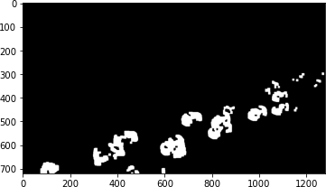

# Extracting contours

Till now, you have a binary image. Next, we will segment the image and find all possible contours(possible vehicles). The shape of the contours will tell us the number of contours that has been identified. Define *drawAndShowContours()* function to plot the contours. You will see that the threshold image above and the countour image will look alike. So, additionally, we also plot a particular '9th' countour for further clarity.

def drawAndShowContours(wd,ht,contours,strImgName): global SCALAR_WHITE

global SHOW_DEBUG_STEPS

# Defining a blank frame

# Defining a blank frame.Since it is initialised with zeros, it will be black. Will add all the coutours in this image.

blank_image = np.zeros((ht,wd,3), np.uint8) #cv2.drawContours(blank_image,contours,10,SCALAR_WHITE,-1)

# Adding all possible contour to the blank frame. Contour is white cv2.drawContours(blank_image,contours,-1,SCALAR_WHITE,-1)

*# For better clarity, lets just view countour 9*

blank_image_contour_9 = np.zeros((ht,wd,3), np.uint8)

*# Let's just add contour 9 to the blank image and view it*

cv2.drawContours(blank_image_contour_9,contours,8,SCALAR_WHITE,-1)

*# Plotting*

plot_image([blank_image, blank_image_contour_9], cmap='gray', captions = ["All possible contours", "Only the 9th contour"])

return blank_image

*# Now, we move on to the contour mapping portion*

contours, hierarchy = cv2.findContours(imgThreshCopy,cv2.RETR_EXTERNAL,cv2.CHAI N_APPROX_SIMPLE)

im2 = drawAndShowContours(wd,ht,contours,'imgContours')

*# Printing all the coutours in the image.*

if(SHOW_DEBUG_STEPS):

print ('contours.shape: ' + str(len(contours))) contours.shape: 22

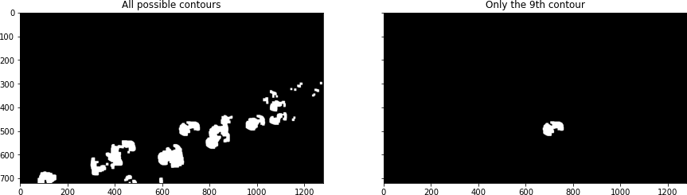

# Hulls

Hulls are contours with the "convexHull".

*# Next, we define hulls.*

*# Hulls are contours with the "convexHull" function from cv2*

hulls = contours *# does it work?*

for i **in** range(len(contours)):

hulls[i] = cv2.convexHull(contours[i])

# Then we draw the contours

im3 = drawAndShowContours(wd,ht,hulls,'imgConvexHulls')

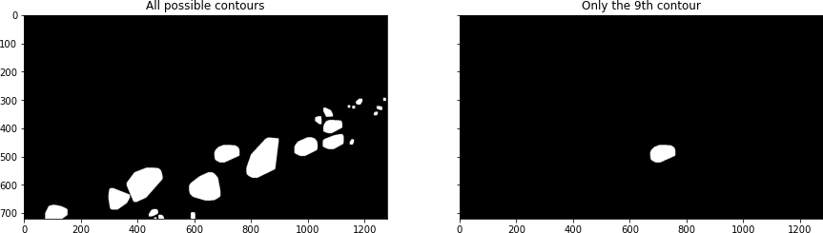

# Conclusion:

In Phase 5, we've embarked on a transformative journey to develop a cutting-edge virtual cinema platform using IBM Cloud Video Streaming. This phase has been instrumental in shaping the foundational elements of your project.

By defining a comprehensive set of features, you've laid the groundwork for a dynamic and engaging user experience, providing live streaming, video-on-demand, user profiles, interactive chat, content categorization, user engagement tools, payment integration, notifications, and efficient content management.

The intuitive user interface you've designed promises a visually appealing and user-friendly environment, ensuring that users can effortlessly navigate, discover, and interact with content on various devices.

The establishment of user registration and authentication mechanisms underscores your commitment to security and privacy, safeguarding user data and content access.

As you move forward with the development of your virtual cinema platform, it's essential to continue focusing on seamless integration, scalability, and user feedback. This will enable you to refine and enhance the platform, ensuring it meets the evolving demands of your audience and remains a dynamic hub for media streaming.

With Phase 5 complete, we are well on your way to creating a transformative virtual cinema experience that is secure, user-friendly, and packed with features to captivate and connect your audience in the digital age.