Programming test:

The file ‘MC32_All_20140401.csv’ is a sample of actual HKEX data that contains all order information of some of the stocks traded. You are required to process the data by simulating an exchange that accept these orders as input and output the orderbook status as set below.

You may assume the exchange orderbook is empty at the start of this file. Tick size of these stocks follows the rule as set out in file ‘tick_size.pdf’. Derivative securities (those with security code>=10000) are not needed and you are free to ignore them.

Input data field definition:

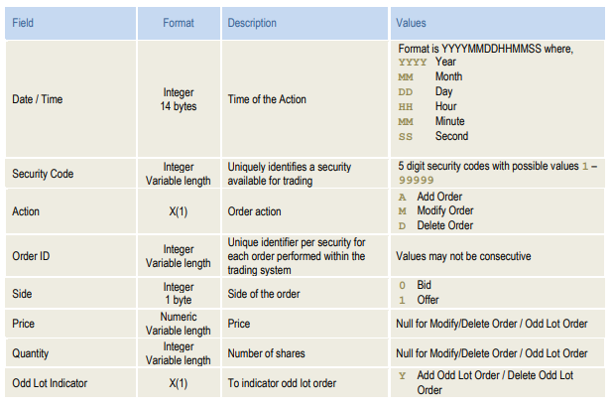

Each entry represents an action to add/modify/delete an order. Added orders are stored in the exchange orderbook until they are deleted or traded. A trade occurs when the price of a new bid order crosses with existing offers or vice versa. You may refer to <https://stackoverflow.com/questions/13112062/which-are-the-order-matching-algorithms-most-commonly-used-by-electronic-financi> under FIFO for a short example of how the exchange works.

Please output a .csv file named ‘[SecurityCode]_20140101.csv’ for every security in the file (except those with code>=10000) that contains a row of data for every second, starting from 09:30:00 and ending at 09:46:00. The columns of the output are defined below:

1. DateTime, same format as input, accuracy to second is enough (as the accuracy of input is millisecond)
2. Best bid price
3. Best offer price
4. Best bid quantity
5. Best offer quantity
6. Average trade price during the second, null if no trade occurs in the second
7. Total quantity traded during the second

Please submit the source code of your program, along with a short 1-page document explaining its logic by the end of next week, i.e. March 18, 2018. You may make assumptions about the input data as you see fit, so long that you state them in the document and they match the sample data. You are free to use any programming language you want.